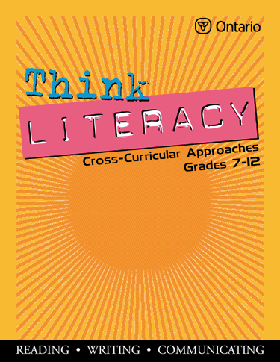
Think Literacy: Cross-Curricular Approaches, Grades 7-12

MATHEMATICS, Grades 7-9

Background
In Summer 2003, Think Literacy: Cross-Curricular Approaches, Grades 7 –12 was developed by a writing team, commissioned by the Expert Panel on Students at Risk (Literacy), to support teachers as they use reading, writing and oral communication approaches in their classrooms.

In Summer 2004, teams of subject experts wrote additional subject-specific examples
to help teachers combine the teaching of reading, writing and oral communication skills with their subject content.

Subject Specific Resources (Summer 2004)
These subject specific resource documents are intended to:
- blend the teaching of subject content and literacy skill development.
- help students in grades 7 - 9 to further develop their communication skills, which, in turn, helps students be more successful in learning subject content.
- serve as a springboard for teachers to design additional classroom resources.
Considerations When Using These Resources
- Based on the students’ background knowledge and current level of performance, teachers select an appropriate instructional approach.
- Timelines for teaching and learning will vary depending on the previous experience of the students and/or the complexity of the content.
- The approaches are not intended to be sequential or interdependent; however when one approach must precede another, specific direction is provided.
- Resources have been carefully labeled for their intended use. Teacher Resources should not be used with students without careful review and necessary revision.
- Student and Student/Teacher Resources may need to be adapted to meet the instructional needs of students.
- Where sample student answers have been included, they may illustrate student misconceptions about a topic and thus become an opportunity for teaching.
- Each subject association has taken responsibility for the accuracy of the content
and has ensured that the recommended instructional approaches and resources are appropriate for students in grade 7 to 9.

