Context Connections – a TIPS Math Trail

Take your math buddy to the photo spot and do some math! All you need is a pencil.

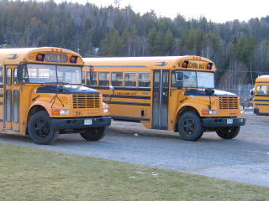 | 1) Knowing Facts and Procedures …
Levack P.S. has a population of 323 students. Forty-three students live close enough to walk. The remainder of the student population is bused.
Students sit two per seat in the bus and there are twelve seats down each side of the bus.
Steve determined a correct answer but when he explained his work he forgot to put brackets into this expression:
323 – 43 ÷2 x 12 x 2
Put the necessary brackets into the expression.
2) Making Connections … | 3) Communicating …
The following table shows the frequency of student absence for the Grade 8 class. Look at the results. What would be important for the classroom teacher to notice from the data? Give reasons for your answer.  October Absences  Why would this information be important in the teachers daily planning? | Desiree is a school bus driver. The data below shows how far she goes and how long it takes.  Data:  The distance she has traveled by 7:45 a.m. is 4 km; by 7:50 am she has gone 1 km further and by 7:55 am she has traveled a total of 9 kms.  Which of the following sequences best represents the data:  - Pick up students, drive, stop  - Drive, pick up students, pick up students  - Drive, pick up students, drive  - Stop, drive, pick up  Give reasons for your answer.
   | Mon. | Tues. | Wed. | Thurs. | Fri.
  Week 1 | 1 | 0 | 1 | 1 | 4
  Week 2 | 2 | 1 | 0 | 0 | 2
  Week 3 | 1 | 1 | 2 | 1 | 5
  Week 4 | 3 | 0 | 0 | 1 | 6
4) Reasoning and Proving … | 5) Literacy link …
To reduce busing incidents and increase safety on the roads the Ministry of Transportation has decided to enforce the placement of seatbelts on all buses for all passengers. The cost to install each seatbelt will be $3.45 for parts and labor. How much will it cost the Ministry of Transportation to put seatbelts in the 263 buses required to transport all students to their schools in the Rainbow District School Board?  Show your work and give reasons for your answer. | A palindrome is a word or number that reads the same forward or backward. If a bus license plate can have up to and including eight characters then which of the following are examples of palindromic bus license plates? Give reasons for your answers.  - 123454321  - 43934  - ROTOR  - 34ATA34
6) Make your own question:
Think about… distances, routes, school trips, luggage or speed.

Context Connections – a TIPS Math Trail

Take your math buddy to the photo spot and do some math! All you need is a pencil.

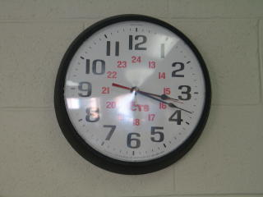 | 1) Knowing Facts and Procedures …
The clock has a circular face.

The formulas for the circumference and area of a circle are:
C = πd A = πr²

The diameter of the clock is 32.5 cm.
Estimate the area and circumference of the clock.

Show your work.
2) Making Connections … | 3) Communicating …
If there are twelve equally spaced points around the circumference of a circle (clock face) then how many different types of polygons can be constructed using some or all of the twelve points as vertices.  Example:  Display and illustrate these shapes. | The numbers which indicate time on the face of this clock are located in the gray shaded area.  Describe how you would find the area of the clock that is shaded.
4) Reasoning and Proving … | 5) Literacy link …
An analog clock shows the minutes and the hours. The hour hand (shorter arrow) is pointing just past the three while the minute hand (longer arrow) is pointing to the eighteenth minute (see the photo above.), How many times will the hands of the clock be directly on top of each other during the next twelve hour time period?  Show your work and describe how you solved the problem. | Looking around the school, list items you find that are circles or have a circle in them. Why do you think a circle was chosen for the items you identified?
6) Make your own question:
Think about…time zones, twenty-four hour clocks or digital clocks.

Context Connections – a TIPS Math Trail

Take your math buddy to the photo spot and do some math! All you need is a pencil.

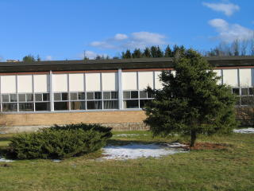 | 1) Knowing Facts and Procedures …
The ratio of the height of the larger tree to the height of the smaller tree is 5:2.

- Express the ratio in fraction form.
- State three equivalent fractions.
2) Making Connections … | 3) Communicating …
The length of David’s shadow is 249 cm.  The length of the tree’s shadow is 996 cm.  David’s height is 166 cm .  David knows that the ratio of the two heights is equivalent to the ratio of the two shadow lengths. Use this information to estimate the height of the tree. Show your work. | The Grade 8s from Levack P.S. would like to plant a small garden around the base of the tree on the front lawn of the school. What information would they need to consider before taking on this task?  Hint:  • costs  • measurements.
4) Reasoning and Proving … | 5) Literacy link …
Daniel knows that the ratio of the lengths of the sides of a triangle is 3:4:5. Is this enough information to determine if the triangle is a right triangle?  Give reasons for your answer. | State one four-term ratio and its application.  Example:  rice:water:butter:salt = 250:500:15:5  is a ratio used when cooking rice.
6) Make your own question:
Think about… landscaping, costs or tree rings.

Context Connections – a TIPS Math Trail

Take your math buddy to the photo spot and do some math! All you need is a pencil.

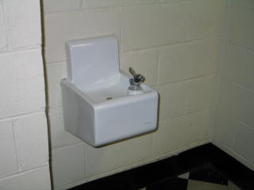 | 1) Knowing Facts and Procedures …
The amount of water wasted from the fountain was recorded each day for a two-week period.
Day | 1 | 2 | 3 | 4 | 5 | 6 | 7
Water  Waste (L) | 0 | 7 | 18 | 23 | 32 | 16 | 0
Day | 8 | 9 | 10 | 11 | 12 | 13 | 14
Water  Waste (L) | 0 | 16 | 19 | 24 | 6 | 26 | 0

Determine the mean, median and mode for the amount of water wasted. Show your work.
2) Making Connections … | 3) Communicating …
Suppose students decide to make a conservation effort and only run the fountain for five seconds at a time, thus reducing the amount of water wasted.  How would that change the mean, median and mode for question 1? Give reasons for your answer. | How would you decide what height the fountains should be in an elementary school? Give reasons for your answer using mathematical terminology.
  Hint:
  What would stay the same?
  What would change?
4) Reasoning and Proving … | 5) Literacy link …
Jenny looked at this water fountain and wondered:  “If the drain of this water fountain was plugged. How long would it take before the water started to overflow onto the floor?”  How would you determine an answer to Jenny’s question? List the steps. | People often place posters or advertisements above fountains for reading while in line or waiting. This is a great location for people to stop and look.  Create a poster to promote water conservation. On your poster consider the amounts of water consumption, waste, running time, etc.  What information will be important to find out and mention on your conservation poster?  For water statistics visit:  www.statcan.ca
6) Make your own question:
Think about… water consumption, waste or running time.

Context Connections – a TIPS Math Trail

Take your math buddy to the photo spot and do some math! All you need is a pencil.

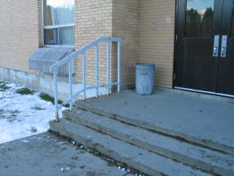 | 1) Knowing Facts and Procedures …
 | Determine the total surface area of the landing at the top of the stairs. Show your work.
2) Making Connections … | 3) Communicating …
When each door fully opens it swings through an angle of 90 degrees. What total area is covered by the bases of both doors as they are both fully opened?  Show your work.  Hint: Find the area of the shaded part. | Each stair is a rectangular prsim.  Will this net form a rectangular prism?  Give reasons for your answer.
4) Reasoning and Proving … | 5) Literacy link …
How many steps (like the ones in the picture) would you need to reach the roof of the building? | “Up the Down Staircase” (1967) is a movie that was directed by Robert Mulligan. Like “Dangerous Minds” (1995), it was filmed in a real school, using real students as extras. In 1967, Sandy Dennis won the Best Actress award at the Moscow International Film Festival for her role as Sylvia Barrett. Ms. Dennis was 30 years old when she played this role.  How old would Ms. Dennis be today?
6) Make your own question:
Think about…garbage can, height of stairs, amount of concrete or landing area.

Context Connections – a TIPS Math Trail

Take your math buddy to the photo spot and do some math! All you need is a pencil.

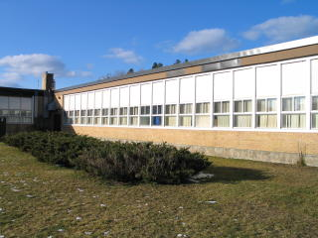 | 1) Knowing Facts and Procedures …
Through fundraising, the Grade 8 class at Levack P.S. has raised enough money to purchase a stained glass window for the upper pane of one window. This was bought for $450.00. Estimate how much it would cost to replace all the upper panes on this wall with stained glass.

Show your work and describe how you found your answer.
2) Making Connections … | 3) Communicating …
The school is going to purchase one stained glass window. A contest is being held for the students to design a window with a pattern that tessellates. Please submit your design for the contest. | A window was broken by accident when a class was playing with a ball outside. They decided that they would replace it. When inquiring about prices, they found different stores gave them varying prices. Explain how you would determine which store offers the best price for the new window?  Store A: $ 0.53 per 50 cm²  Store B: $ 1.04 per m²  Store C: $ 5.06 per 100 cm²  Store D: $ 0.03 per cm²
4) Reasoning and Proving … | 5) Literacy link …
Determine the number of planes of symmetry in the rectangular prism (packing box) that the window came in. Use diagrams to show the planes of symmetry. | Objects with plane symmetry are more common than objects without it because objects with plane symmetry are more useful, easier to balance, and often look better. Use these criteria to compare one object that has plane symmetry and one object that does not.
6) Make your own question:
Think about… scale drawings, height of windows, symmetry or costs.

Grade Seven and Eight Curriculum Expectations for Activities

Bus Activities
- make inferences and convincing arguments that are based on data analysis;
- explain numerical information in their own words and respond to numerical information in a variety of media;
- perform three-step problem solving that involves whole numbers and decimals related to real-life experiences, using calculators;
- justify the choice of method for calculations: estimation, mental computation, concrete materials, pencil and paper, algorithms (rules for calculations), or calculators;
- explain the process used and any conclusions reached in problem solving and investigations;
- reflect on learning experiences and describe their understanding using appropriate mathematical language (e.g., in a math journal);

Clock Activities

- describe measurement concepts using appropriate measurement vocabulary;
- estimate and calculate the radius, diameter, circumference, and area of a circle, using a formula in a problem-solving context;
- demonstrate a verbal and written understanding of and ability to apply accurate measurement strategies that relate to their environment;
- perform multi-step calculations involving whole numbers and decimals in real-life situations, using calculators;

Tree Activities

- solve problems that involve converting between fractions, decimals, percents, unit rates, and ratios (e.g., that show the conversion of 1/3 to decimal form);
- explain numerical information in their own words and respond to numerical information in a variety of media;
- apply the Pythagorean relationship to numerical problems involving area and right triangles;
- evaluate simple algebraic expressions by substituting natural numbers for the variables;

Fountain Activities

- understand that each measure of central tendency (mean, median, mode) gives different information about the data;
- make inferences and convincing arguments that are based on data analysis;
- search databases for information and use the quantitative data to solve problems;
- discuss the quantitative information presented on tally charts, stem-and-leaf plots, frequency tables, and/or graphs;
- ask "what if" questions; pose problems involving fractions, decimals, integers, percents, and rational numbers; and investigate solutions;
- explain numerical information in their own words and respond to numerical information in a variety of media;
- identify the favourable outcomes among the total number of possible outcomes and state the associated probability (e.g., of getting chosen in a random draw);

Stairs Activities

- justify the choice of method for calculations: estimation, mental computation, concrete materials, pencil and paper, algorithms (rules for calculations), or calculators;
- recognize the front, side, and back views of three-dimensional figures;
- sketch front, top, and side views of three-dimensional figures with or without the use of a computer application;

Window Activities

- demonstrate an understanding of and apply unit rates in problem-solving situations;
- perform three-step problem solving that involves whole numbers and decimals related to real-life experiences, using calculators;
- justify the choice of method for calculations: estimation, mental computation, concrete materials, pencil and paper, algorithms (rules for calculations), or calculators;
- construct and analyse tiling patterns with congruent tiles;
- recognize patterns and use them to make predictions;
- present solutions to patterning problems and explain the thinking behind the solution process;

