Resources Summary Chart page 1
Title | Education for All  The Report of the Expert Panel on Literacy and Numeracy Instruction for Students With Special Needs, Kindergarten to Grade 6  2005 | eWorkshop  2006-2007  Format/Media  Flash Player 8  Adobe Acrobat Files | Growing Up Mathematically (“GUM”) Resource  2005  CD - DVD – Booklet*  *presently being revised to be consistent with the Revised Ontario Curriculum Document.
Author(s)/  Development Group | Ontario Ministry of Education | Ontario Ministry of Education and TFO | Ontario Association for Mathematics Education – workgroups  For more information about OAME – see www.oame.on.ca
(Initial) Distribution | Some copies sent directly to schools | On-line | Complimentary copies to OAME Board members
Source/Ordering Information | Available on-line at www.edu.gov.on.ca | www.eworkshop.on.ca | Order from - Ontario Association for Mathematics Education  www.oame.on.ca  E-mail:EDs@oame.on.ca
ISBN/ISSN | 0-7794-8060-0 | N/A | n/a
Purpose/Rationale | This report recommends practices, based on research, that will help teachers to improve and reinforce effective instruction in reading, writing, oral communication, and mathematics to students from Kindergarten to Grade 6 who have special needs. Many practical strategies are provided. | eWorkshop contains user-friendly websites and e-learning modules, which provide comprehensive information through short passages, video clips and lesson plans. New modules are constantly being added to the site. | The Growing Up Mathematically resource package is an interactive Professional Development program, designed for Ontario elementary and secondary schools.  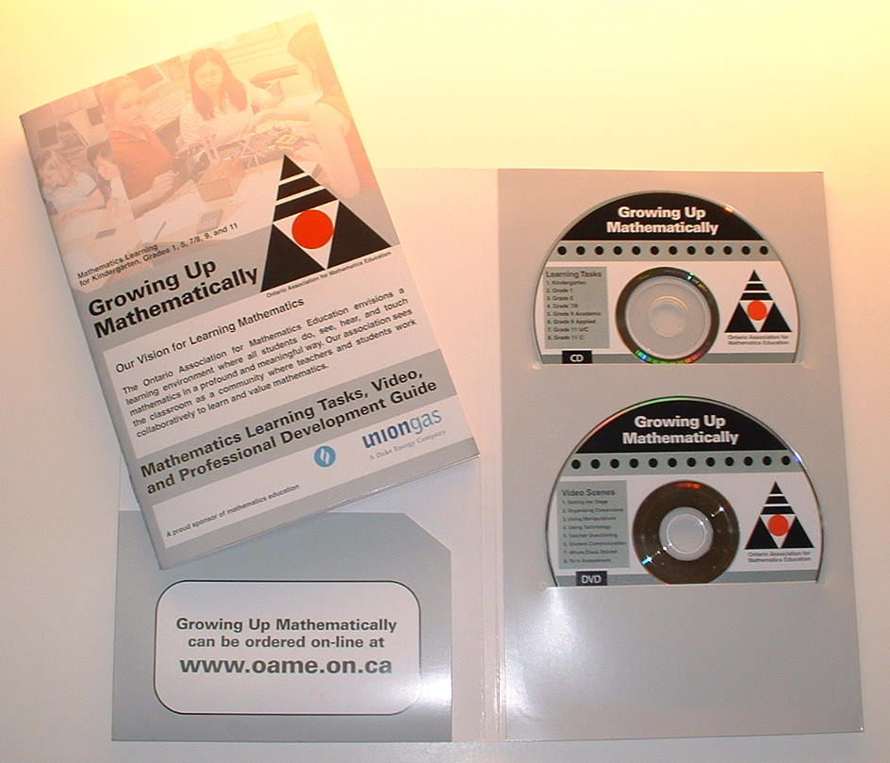
Intended Audience | Teachers of Grades K to 3 and 4 to 6 | Teachers K- 6, classroom teachers and special education teachers | Educators concerned with elementary secondary math education.

Resources Summary Chart page 2
Title | Think Literacy Cross-Curricular Approaches Mathematics Grades 7 – 9 in 2004  and Grades 10 – 12 in 2005 | TIPS4RM – Targeted Implementation and Planning Supports for Revised Mathematics  Print materials  Flash videos  PPT presentations | The Ontario Curriculum Exemplars (for) Mathematics*  *based on the 1999 and 2000 Ontario Curriculum Documents
Author(s)/  Development Group | Ontario Ministry of Education | Ontario Ministry of Education | Ontario Ministry of Education
(Initial) Distribution | Sent directly to schools. | Participants of the TIPS4RM roll out Regional Conferences winter 2006 | Materials distributed to all School Boards and School Authorities, as available during 2000 - 2005
Source/Ordering Information | http://www.curriculum. org/thinkliteracy/library. html#subjects | http://www.curriculum. org/lms/library.html | http://www.edu.gov.on.ca
ISBN/ISSN | 0-7794-7216-0 (Grades 7-9) | n/a | 0-7794-0248-0 (Grade 9)  0-7794-0785-7(Grades1-8)  0-7794-4263-6 (Grade 11)  0-7794-7798-8 (Grade 12)
Purpose/  Rationale | Focus instruction on before, during and after phases of learning.  • Provide students with modeling, teaching, guided practice, and ongoing feedback.  • Explicitly teach literacy strategies, but gradually release responsibility to the learner.  • Encourage risk-taking and view errors as part of the learning process.  • Encourage students to set goals for their own learning.  • Provide accommodations to support the learning. | TIPS and TIPS4RM for Grades 7, 8, and 9 and 10 Applied Math is designed to be useful to teachers in both Public and Catholic schools, and is intended to support beginning teachers, provide new insights for experienced teachers, and help principals and professional development providers as they work to improve mathematics education. Included are lessons, BLMs, and assessments. Teachers are encouraged to adapt this material to meet their students’ needs. | This document has been developed to:  –show the characteristics of student work at each of the four levels of achievement for that grade;  – promote greater consistency in the assessment of student work across the province;  – provide an approach to improving student learning by demonstrating the use of clear criteria applied to student work in response to clearly defined assessment tasks;  – show the connections between what students are expected to learn (the curriculum expectations) and how their work can be assessed using the levels of achievement described in the curriculum policy document for the subject.
Intended Audience | For School Literacy Teams and Math educators. | Mathematics Educators Grades 7 – 12, Administrators, Parents | Teachers and Administrators

Resources Summary Chart page 3
Title | The Kindergarten Program (Revised) | Leading Math Success Mathematical Literacy Grades 7 - 12  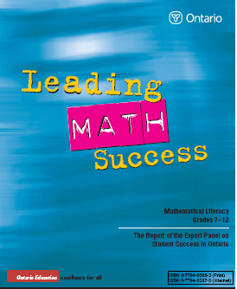 | e-Learning ONTARIO      This site is maintained by the Government of Ontario, Canada.  © 2007 Queen's Printer for Ontario
Author(s)/  Development Group | Ontario Ministry of Education | Ontario Ministry of Education | Ontario Ministry of Education
(Initial) Distribution | Sent directly to schools, one copy for each Kindergarten teacher. | Sent directly to schools | n/a
Source/Ordering Information | On-line pdf version available at www.edu.gov.on.ca | On-line pdf version available at www.edu.gov.on.ca | http://www.elearningontario.ca/
ISBN/ISSN | 1-4249-1466-3 | 0-7794-6386-2
Purpose/Rationale | This document replaces The Kindergarten Program, 1988. It outlines the skills and knowledge that teachers must teach the students in Kindergarten.This document includes sections on the following;  -Building a Learning Community  -The Learning Program  -Assessment, Evaluation and Reporting  -Teaching/Learning Approaches  -Some Considerations for Program Planning  -The Learning Expectations  -Glossary | This resource describes a vision and makes recommendations to help Ontario adolescents who are currently at risk of leaving high school without the mathematics skills and understanding they need to in the twenty-first century. This report emphasizes instructional and assessment strategies that will benefit all students. They state that for struggling students, the use of these strategies is necessary. | This on line tool provides elementary and secondary teachers with resources for student learning. Further, teachers can share teaching material with their colleagues. E-Learning Ontario also includes opportunities for students to take courses on -line.
Intended Audience | Primary teachers | Grade 7 – 12 mathematics teachers, Special Education Teachers, administrators | Teachers K-Grade 12 and students Grade 9 - 12

Resources Summary Chart page 4
Title | Early Math Strategy  The Report of the Expert Panel on Early Math in Ontario  2003 | Teaching and Learning Mathematics; The Report of the Expert Panel on Mathematics Grades 4-6 in Ontario | A Guide to Effective Instruction in Mathematics, Kindergarten to Grade 6, A Resource in Five Volumes
Author(s)/  Development Group | Ontario Ministry of Education | Ontario Ministry of Education | Ontario Ministry of Education
(Initial) Distribution | Sent directly to schools. One copy / primary teacher. | Sent directly to schools. | Sent directly to schools. Two paper copies/school.
Source/Ordering Information | Services Ontario  (416) 326-5300  Toll-free within Canada:  1-800-668-9938 | Services Ontario  (416) 326-5300  Toll-free within Canada:  1-800-668-9938 | Services Ontario  (416) 326-5300  Toll-free within Canada:  1-800-668-9938
ISBN/ISSN | 0-7794-4088-9 |  | Set: 0-7794-8524-6  Volume 1:0-7794-9346-X  Volume 2:0-7794-9347-8  Volume 3:0-7794-9348-6  Volume 4:0-7794-9349-4  Volume 5:0-7794-9350-8
Purpose/Rationale | With the release of The Early Years Report by McCain and Mustard in 1999, the Ministry of Education in Ontario recognized the importance of the first years of schooling on the development of mathematical understanding for young children. This report was assembled to provide information and guidance on how to support teachers in the delivery of mathematics curriculum and to support students in the learning of mathematics. | This document was created to examine, synthesize, and outline the research to date on  teaching mathematics to students in Grades 4–6.  The Expert Panel members read and discussed the research on mathematics instruction and learning. They focused on what they considered to be the important ideas. The report examines these essential ideas and provides a strong vision of effective mathematics instruction and support  for students at the junior level.  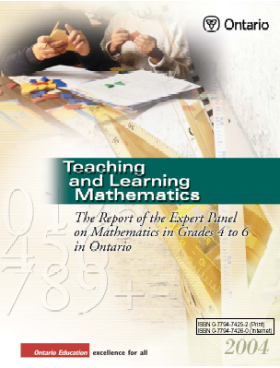 | This five-volume reference guide is a companion document to the Early Math Strategy: The Report of the Expert Panel on Early Math in Ontario, Teaching and Learning Mathematics: The Report of the Expert Panel on Mathematics in Grades 4 to 6 in Ontario and A Guide to Effective Instruction in Math, Grades 4 to 6 Number Sense and Numeration (six volume set). It is designed to provide teachers with the practical information they need to set up a quality mathematics program.
Intended audience | Teachers of Grades K-8 | JK-8 teachers, Special Education Teachers | Teachers of Grades 4 to 6

Resources Summary Chart page 5
Title | A Guide to Effective Instruction in Mathematics  Kindergarten to Grade 3 | A Guide to Effective Instruction in Mathematics, Kindergarten to Grade 3 – Number Sense and Numeration | A Guide to Effective Instruction in Mathematics K- Grade 3 Geometry and Spatial Sense 2007
Author(s)/  Development Group | Ontario Ministry of Education | Ontario Ministry of Education | Ontario Ministry of Education
(Initial) Distribution | Sent directly to schools. One copy/ primary teacher. | Sent directly to schools. One paper copy for each primary teacher. | Sent directly to schools.
Source/Ordering Information | Services Ontario  (416) 326-5300  Toll-free within Canada:  1-800-668-9938 | Services Ontario  (416) 326-5300  Toll-free within Canada:  1-800-668-9938 | Services Ontario  (416) 326-5300  Toll-free within Canada:  1-800-668-9938
ISBN/ISSN |  | 0-7794-5402-2
Purpose/Rationale | This guide is intended to help educators enhance students’ understanding of mathematics in Kindergarten to Grade 3. The approaches, strategies, resources, materials, and supports provided in the guide are designed around two key questions:  - How can current research about teaching and learning mathematics be brought to life in the classroom?  - What skills and knowledge can best help teachers meet their commitment to help every child become mathematically proficient?  Part 1 of the guide focuses on Improving Student Achievement, Part 2 on Effective Instruction, and Part 3 on Teaching Basic Facts and Multidigit Computations | This document is a practical guide that teachers will find useful in helping students to achieve the curriculum expectations. It is a companion document to A Guide to Effective Instruction in Mathematics, K-6.  The document provides:  - An overview of each of the big ideas  - Learning activities/lessons for each grade from K - 3  - Lesson Adaptations /Extensions, Assessment, Home Connections and Black Line Masters  - Organization of the curriculum expectations under the corresponding big idea  - Glossary of definitions of mathematical terms used in the document | This document is a practical guide that teachers will find useful in helping students to achieve the curriculum expectations It is a companion document to A Guide to Effective Instruction in Mathematics, K-6.  The document provides:  - An overview of each of the big ideas  - Learning activities/lessons for each grade from K to 3  - Lesson Adaptations /Extensions, Assessment, Home Connections and Black Line Masters  - Organization of the curriculum expectations under the corresponding big idea  Glossary of definitions of mathematical terms used in the document
Intended audience | JK-8 teachers, Special Education Teachers | JK-8 teachers, Special Education Teachers

Resources Summary Chart page 6
Title | A Guide to Effective Instruction in Mathematics K- Grade 3 Data Management and Probability 2007 | A Guide to Effective Instruction in Mathematics K- Grade 3 Measurement 2007 | A Guide to Effective Instruction in Mathematics K-Grade 3 Patterning and Algebra 2007
Author(s)/  Development Group | Ontario Ministry of Education | Ontario Ministry of Education | Ontario Ministry of Education
(Initial) Distribution | Sent directly to schools. | Sent directly to schools. | Sent directly to schools.
Source/Ordering Information | Services Ontario  (416) 326-5300  Toll-free within Canada:  1-800-668-9938 | Services Ontario  (416) 326-5300  Toll-free within Canada:  1-800-668-9938 | Services Ontario  (416) 326-5300  Toll-free within Canada:  1-800-668-9938
ISBN/ISSN | 978 1 4249 4579 0  07 015 |  | 978 1 4249 4589 4  07 006
Purpose/Rationale | This document is a practical guide that teachers will find useful in helping students to achieve the curriculum expectations. It is a companion document to A Guide to Effective Instruction in Mathematics, K-6.  The document provides:  - An overview of each of the big ideas  - Learning activities/lessons for each grade from K - 3  - Lesson Adaptations /Extensions, Assessment, Home Connections and Black Line Masters  - Organization of the curriculum expectations under the corresponding big idea  - Glossary of definitions of mathematical terms used in the document | This document is a practical guide that teachers will find useful in helping students to achieve the curriculum expectations It is a companion document to A Guide to Effective Instruction in Mathematics, K-6.  The document provides:  - An overview of each of the big ideas  - Learning activities/lessons for each grade from K to 3  - Lesson Adaptations /Extensions, Assessment, Home Connections and Black Line Masters  - Organization of the curriculum expectations under the corresponding big idea  Glossary of definitions of mathematical terms used in the document | This document is a practical guide that teachers will find useful in helping students to achieve the curriculum expectations. It is a companion document to A Guide to Effective Instruction in Mathematics, K-6.  The document provides:  - An overview of each of the big ideas  - Learning activities/lessons for each grade from K - 3  - Lesson Adaptations /Extensions, Assessment, Home Connections and Black Line Masters  - Organization of the curriculum expectations under the corresponding big idea  Glossary of definitions of mathematical terms used in the document
Intended audience | JK-8 teachers, Special Education Teachers |  | JK-8 teachers, Special Education Teachers

Resources Summary Chart page 7
Title | A Guide to Effective Instruction in Mathematics, Number Sense and Numeration, Grade 4 - 6: A Resource in Six Volumes
Author(s)/  Development Group | Ontario Ministry of Education
(Initial) Distribution | Sent directly to schools.
Source/Ordering Information | Services Ontario  (416) 326-5300  Toll-free within Canada:  1-800-668-9938
ISBN/ISSN | 1 4249 2464 2 (set 1-6) 05 055
Purpose/Rationale | Included are lessons and extensions that can be used in the classroom.
Intended Audience | JK-8 teachers, Special Education Teachers

Guides for Effective Instruction in Mathematics can be found at http://www.publications.serviceontario.ca/ecom/

