Unit 7 Grade 8
Surface Area and Volume of Cylinders

Lesson Outline

BIG PICTURE

Students will:
- determine, through investigation, the relationships among the measurable attributes of circles and cylinders;
- develop, through investigation, the formula for the volume of a cylinder;
- develop, through investigation, the formula for the surface area of a cylinder;
- research and report on applications of volume and capacity measurement;
- solve multi-step problems involving volume and surface area of cylinders arising from real-life contexts using a variety of tools and strategies;
- solve problems requiring operations with powers of ten such as converting metric units of volume and capacity.
Day | Lesson Title | Math Learning Goals | Expectations
1 | How Much Space Is Occupied? | - Investigate, using a variety of tools, the relationships between the area, the base, and the volume of a cylinder.  - Research applications of volume and capacity measurement. | 8m32  CGE 3c, 5a
2 | Pump Out the Volume! | - Report on and describe applications of volume and capacity measurement.  - Generalize findings from Day 1 to develop a formula for the volume of a cylinder.  - Solve problems requiring the calculating of the volume of cylinders. | 8m16, 8m32, 8m37, 8m39, 8m62  CGE 2c, 4f
3 | It’s About Capacity | - Solve problems finding the area of the base, the height, the volume, and the capacity of cylinders – sometimes requiring metric unit conversions. | 8m16, 8m18, 8m20, 8m24, 8m33, 8m39, 8m62  CGE 5b, 7b
4 | The Cover Up | - Investigate the surface area of a cylinder. | 8m38  CGE 5a
5 | It’s a Wrap! | - Solve problems requiring the calculation of the dimensions as well as the surface area of cylindrical shapes abstractly and in context. | 8m16, 8m18, 8m20, 8m24, 8m33, 8m39, 8m62  CGE 5b, 7b
6 | It’s All in the Cylinder | - Solve problems abstractly and in context relating the surface area to the volume of cylindrical shapes. | 8m16, 8m18, 8m20, 8m24, 8m33, 8m39, 8m62  CGE 7b, 5g
7 | Summative Assessment

Unit 7: Day 1: How Much Space is Occupied? |  |  | Grade 8
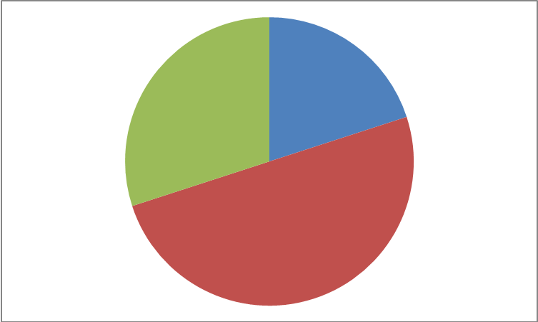 |  | Math Learning Goals  - Students will investigate, using a variety of tools, the relationship between the area, the base, and the volume of a cylinder  - Students will research applications of volume and capacity measurement | Materials  - BLM 7.1.1 & 7.1.2  - Pattern blocks  - Linking cubes  - Variety of cylinders  - Measuring tapes
 | Minds On… | Pairs → Sharing  Give each pair of students a rectangular prism made of linking cubes (various shapes and sizes) and a small stack of pattern blocks (i.e. Group A – 6 yellow hexagons blocks; Group B – 5 green triangles). Ask students to calculate the volume of both right prisms. Have the pairs of students join with another pair to share how they calculated the volume of their prisms.  Whole Class → Brainstorm  - What is volume? [amount of space occupied by an object]  - How did you calculate the volume of your right prisms? [# of blocks used to make it – e.g. 6 hexagon blocks; area of base of prism x height of prism]  Pairs → Turn-&-Talk  Turn to your elbow partner and brainstorm what “capacity” means. Is it the same as or different from “volume”? Why do you think so?  Whole Class → Discussion  Discuss students’ opinions.  [Capacity: the greatest amount that a container can hold]  - What is the capacity of the two right prisms you have in front of you?  [Zero – cannot hold anything because they are solid]  - If your prisms were hollow with very thin walls, what would their capacity be? [Very close to previously calculated volumes]  - When might you find volume and capacity to be different for an object? [Object with thick walls – e.g. thermal container] |  |   Observational data collection of student talk and answers throughout lesson, paying special attention to the level of background knowledge.  Consider what concepts require further investigation, clarification or review.    - Provide rectangular and triangular right prisms for students to use to complete BLM 7.1.1.  - Provide non-standard units appropriate to measure volume and capacity (e.g. measuring cups & sand, rice or plastic rice; cm³ blocks)
 | Action! | Pairs → Exploring  Students work together to complete BLM 7.1.1 using a variety of cylinders (e.g. tubes from bathroom tissue, paper towel, wrapping paper, narrow and wide masking tape rolls). Remember that students have not learned the specific formula for volume of a cylinder at this point. The object of this activity is to assess their understanding of the concepts of volume and capacity. Some students may choose to use the formula based on their background knowledge, but ensure that students who choose another reasonable method (e.g. non-standard units) with estimation or stated assumptions are equally accepted.  Groups of Pairs → Sharing  After 15-20 minutes, have students compare their results with other students. If the responses differ, encourage students to revisit that cylinder and share their thinking with each other, working to come to consensus.
 | Consolidate Debrief | Whole Class → Discussion  Discuss students’ learning from BLM 7.1.1. Key questions to ask:  - Would anyone volunteer to share how you approached this task?  - How did you accomplish the task?  [Look for use of non-standard and standard measurements. If students say that they just used the formula, ask them why they chose to use that method and why it works – i.e. area of base x height. Connect this back to right prisms in ‘Minds On…’ section. Draw out similarities and differences in reasoning and methods.]  - Were there any examples of cylinders where the capacity was significantly different from its volume? What ones? Why were they different? If there are no examples, discuss where they might find examples.
Application |  | Home Activity or Further Classroom Consolidation  Students will complete BLM 7.1.2. Students find real-life examples of objects with volume and capacity. Challenge them to find examples where the volume and capacity of the object are different. |  |   Check understanding of concepts of volume and capacity.

7.1.1: How Much Space Is Occupied? Grade 8
Investigating Cylinders

With your partner, determine the volume and capacity of the provided cylinders. Think about different ways you can find volume and capacity. Can you predict the volume or capacity of any cylinder based on what you already know about a related cylinder (e.g. tissue tube and paper towel tube)?
Name of Object | Dimensions Measured  (if any) | Volume | Capacity | Relationship of Volume & Capacity (same/different)  Why?

7.1.2: How Much Space Is Occupied? Grade 8
Volume and Capacity at Home

Find 5 situations where volume and capacity are used in your home. At least 3 of these examples should be related to cylinders. For each situation: Describe the situation. How is volume used? How is capacity used? Are they the same or are they different? Why?

Situation (describe) | Volume (describe) | Capacity (describe) | Same/  Different? | Explain Why
Example:  Thermal travel mug – looks like one larger cylinder on top of a smaller cylinder with a handle. | Space the whole mug takes up including the base and the handle. | The space that can be filled by the coffee my mom puts in it. | Different | The walls of the mug are thick so its capacity to hold liquid is less than its volume. I would have to subtract the thickness of the walls from the volume to calculate the capacity.

Unit 7: Day 2: Pump Out the Volume! |  | Grade 8
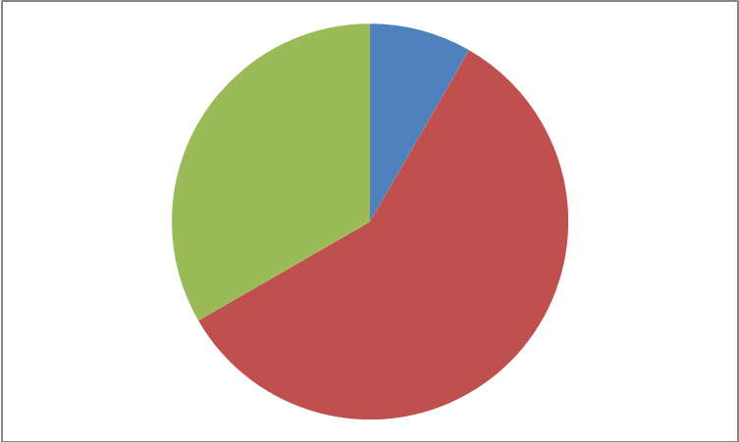 | Math Learning Goals  - Students will report on and describe applications of volume and capacity measurement  - Students will generalize findings from Day 1 to develop a formula for the volume of a cylinder  - Students will solve problems requiring the calculating of the volume of cylinders | Materials  - Chart paper  - Markers  - 4 Signs – Nature, Picture, Act It Out, & Musical
 | Whole Class → Connect to Prior Learning  Prepare two pieces of chart paper or sections on the board – label 1 “Same Volume and  Capacity” and the other “Different Volume and Capacity”. As students enter class, have them record the names of the objects they reported on BLM 7.1.2 under the appropriate title. [Teacher can use tally chart form for Data Management cross-strand integration. Provides visual of most and least common items selected.]  Whole Class → Discussion  Key questions:  - What is volume? What is capacity? Are they the same thing?  - What object did you find that was the most interesting or surprising? Why?  - How did you know when volume and capacity were the same?  - What was the most common reason for volume and capacity being different?  - Why might you want volume and capacity to be different?  - Why might the manufacturer want volume and capacity to be different?  [e.g. increased profit – buyer believes he/she is getting a larger amount; pop bottle – arched bottom prevents suction to tabletop with condensation]  - What objects did you find that are not usually used at full capacity?  [e.g. bathtub – overflow valve prevents full capacity; fish tank; water bottle if frozen; chip bags and cereal boxes – need air to protect contents] | Teaching Tip: Using colour coding on a list of known volume formulas (1 colour for part of formula that is area of base & 2nd colour for height) can help students make connections between the common parts of volume formulas.
Minds On…
 | Whole Class → Reflection
Action! | Reflect on how you calculated the volume of the prisms in the ‘Minds On…’ section of yesterday’s lesson.  What are some common volume formulas that you already know?  [Students may give rectangular & triangular prism formulas.]  What do these formulas have in common? [area of base of prism x height]  Why do these formulas work? [Translating/layering the base to create 3D objects]  Pairs → Investigation  Students work together using their knowledge of other volume formulas to develop the formula for the volume of a cylinder. When pairs think they have a formula that will work in any cylinder situation and can explain the reasoning behind it, have them join up with another pair and compare their proposed formulas.  Whole Class → Guided Discussion  Request a volunteer pair to put their formula on the board. Ask class why this formula makes sense. Will it work in any cylinder situation? Adjust formula based on students’ suggestions if required.  Whole Class → Four Corners  Post Nature/Picture/Act It Out/Music signs in 4 corners of room. Students move to stand in the corner that best represents their preferred learning style. Have students make small groups within their learning preference category. Each group creates a cylinder problem based on its learning preference with required measurements, records its problem on chart paper and posts it. Groups record the solution to their problem on another piece of paper that is placed face down. Groups circulate around the room to solve some of the problems posted by others and check their solutions. Discrepancies should be discussed respectfully between students with each presenting their mathematical thinking and working together to make sense of the problem and reaching common understanding.  Note: Even the Act It Out groups can record their problem in writing but ensure that opportunity is provided for them to present their problem by actually acting it out for the class. | Four Corners activity allows for student choice of learning preference.
Whole Class → Sharing
How many measurements did you need to provide for your readers to be able to calculate the volume of your cylinder? What measurements did you have to have? [Have to have height. Need either radius or diameter (or circumference).]

Consolidate Debrief

Application  Concept Practice  Reflection | Home Activity or Further Classroom Consolidation  Have students pick one of the cylindrical objects at home that they used for the previous night’s homework (or find a new cylindrical object). They should create a sketch of the object, measure and label its diameter and height, and calculate its volume.  Reflection question: What was greatest challenge in completing this task? Why? | Check understanding of how to calculate the volume of a cylinder.

Unit 7: Day 3: It’s About Capacity |  | Grade 8
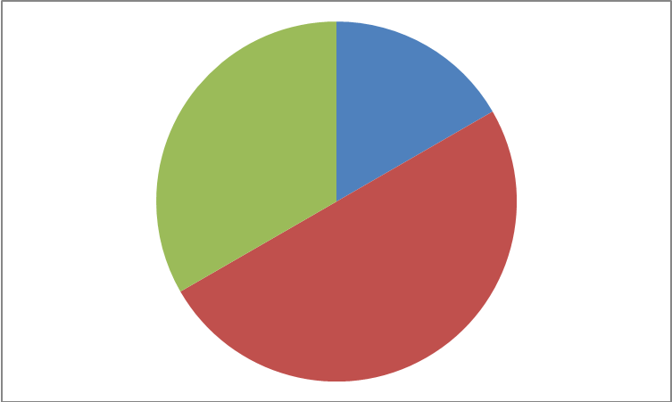 | Math Learning Goals  - Students will solve problems finding the area of the base, the height, the volume, and the capacity of cylinders – sometimes requiring metric unit conversions. | Materials  - BLM 7.3.1  - Optional: cylinders with thicker walls
Whole Class → Activating Prior Knowledge
Discuss the following questions with the class:
- What is the formula for the volume of a cylinder?
- What are the two main parts of this volume and what do they refer to?
Write the formula on the board for students to refer to as they work. Highlight the two main parts [area of base, height].
Discuss reflection questions from homework - What was greatest challenge in finding, measuring cylinder and calculating its volume? Why?
Small Groups → Sharing
Have students share their homework solutions with each other and check each other’s calculations.
Minds On…
 | Individual/Pairs → Parallel Tasks  Present the following problems to all students and allow them to select Option A or B to work on.  Option A [Answer = approx. 8 cm]  A cylindrical tin can has a volume of 500 cm³ and is 10 cm tall. What is the diameter of the can?  Option B [Answer = approx. 4 cm]  A cylindrical candle has a volume of approximately 400 cm³ and is 8 cm tall. What is the radius of the candle?  Consolidating questions to ask to all students without specifying either option:  1. How did you know that your answer would be less than 50?  2. How did you know that your answer made sense?  3. Why did you pick the option that you did?  4. What was the greatest challenge in answering this question?  5. How was answering this question different from the questions you answered yesterday? [Yesterday they were given measurements of cylinder and had to calculate volume by multiplying. Today, they were given volume and 1 measurement and had to calculate the missing/required measurement by dividing.]  Students will work on BLM 7.3.1. Questions A and B can be executed as parallel tasks or students can complete both questions. Consider asking students if there are more possible answers for question A or B. | Observational data collection of student talk and answers throughout lesson  Parallel Tasks provide opportunities for student choice.  Provide cylinders with thicker walls for students to help them visualize the difference between volume and capacity for BLM 7.3.1 question C.
Action!
Whole Class → Guided Instruction (Key Questions)
- If the height of a cylinder stays the same but the radius/diameter/area of the base gets smaller/larger, what happens to the volume of the cylinder? [gets smaller/larger]
- If the radius/diameter/area of the base stays the same but the height gets smaller/larger, what happens to the volume of the cylinder? [gets smaller/larger]
- If the volume of the cylinder stays the same but the height gets smaller, what happens to the area/diameter/radius of the base? [gets larger]
- If the volume of the cylinder stays the same but the height gets larger, what happens to the area/diameter/radius of the base? [gets smaller]
- How are volume and capacity of a cylinder related? [the thinner the walls, the closer volume and capacity are; the thicker the walls, the more different volume and capacity are]
Consolidate Debrief
Application  Concept Practice  Differentiated | Home Activity or Further Classroom Consolidation  BLM 7.3.1 Question C – may be assigned for homework depending on how much time is available in class.  You might wish to develop a question similar to BLM 7.3.1 Question C for formal assessment of learning. Accommodations for students can be made by using friendlier numbers in the question and omitting required conversions.

7.3.1: Volume of a Cylinder Grade 8

- A cylinder has a volume of 10 m³. What might its dimensions be (height, area of base, radius, and diameter)? Give 4 possible cylinders.

Volume = 10 m³ | Height | Area of Base | Radius | Diameter
Cylinder A

Cylinder B

Cylinder C

Cylinder D

How do you know your answers are reasonable?

How many possibilities are there? Why do you think so?

B. A cylinder has a diameter of 10 cm. What might its volume be? Give the radius, area of base and height for 4 possible volumes.

Diameter = 10 cm | Radius | Area of Base | Height | Volume
Cylinder A

Cylinder B

Cylinder C

Cylinder D

How do you know your answers are reasonable?

How many possibilities are there? Why do you think so?

7.3.1: Volume of a Cylinder (cont’d) Grade 8

- Samir’s family has decided to purchase an above-ground cylindrical swimming pool for his backyard. The best space that they have for a pool measures 360 cm across. The tallest pool that they can buy is 120 cm high.

What is the volume of the largest pool that they can buy? Give your answer in cubic centimetres (cm³) and cubic metres (m³).

The walls on the pool inflate to be 10 cm thick but the bottom of the pool is just a thin piece of vinyl. What would the full capacity of this pool be?

The manufacturer’s instructions warn that the pool should only be filled to 90% of its capacity. How much water would it take to fill the pool 90%? Give your answer in cubic centimetres (cm³) and in litres. Note: 1 litre = 1000 cm³.

BLM 7.3.1: Volume of a Cylinder Grade 8
Sample Answers

- A cylinder has a volume of 10 m³. What might its dimensions be (height, area of base, radius, and diameter)? Give 4 possible cylinders.
Volume = 10 m³ | Height | Area of Base | Radius | Diameter
Cylinder A | 1 m | 10 m² | 1.78 m | 3.57 m
Cylinder B | 2 m | 5 m² | 1.26 m | 2.52 m
Cylinder C | 3 m | 3.33 m² | 1.03 m | 2.06 m
Cylinder D | 4 m | 2.5 m² | 0.89 m | 1.78 m

How do you know your answers are reasonable?
As the height of the cylinder gets bigger, the area of the base gets smaller because the volume stays the same. This means that the radius and diameter get smaller too.

How many possibilities are there? Why do you think so?
There are an infinite number of possibilities because I could use fractions or decimals for different heights, which would give me different cylinders all with the same volume.

B. A cylinder has a diameter of 10 cm. What might its volume be? Give the radius, area of base and height for 4 possible volumes.
Diameter = 10 cm | Radius | Area of Base | Height | Volume
Cylinder A | 5 cm | 78.54 cm² | 1 cm | 78.54 cm³
Cylinder B | 5 cm | 78.54 cm² | 2 cm | 157.08 cm³
Cylinder C | 5 cm | 78.54 cm² | 3 cm | 235.62 cm³
Cylinder D | 5 cm | 78.54 cm² | 4 cm | 314.16 cm³

How do you know your answers are reasonable?
The area of the base has to stay the same because the diameter does not change. As the height of the cylinder gets bigger, the volume gets bigger by the same ratio.

How many possibilities are there? Why do you think so?
There are an infinite number of possibilities because I could use fractions or decimals for different heights, which would give me different cylinders all with the same volume.

Sample Answers (cont’d)

C. Samir’s family has decided to purchase an above-ground cylindrical swimming pool for his backyard. The best space that they have for a pool measures 360 cm across. The tallest pool that they can buy is 120 cm high.

What is the volume of the largest pool that they can buy? Give your answer in cubic centimetres (cm³) and cubic metres (m³).

Radius = ½ diameter
Radius = ½ x 360 cm
Radius = 180 cm

V_{cylinder} = ∏r²h [Note: The following calculations are based on using ∏ = 3.14.]
Volume = 3.14 x 180² x 120
Volume = 12 208 320 cm³ or 12.21 m³ (because 1 000 000 cm³ = 1 m³)

The walls on the pool inflate to be 10 cm thick but the bottom of the pool is just a thin piece of vinyl. What would the full capacity of this pool be?

Capacity of pool = volume of inside of pool

Diameter of inside of pool = diameter of outside of pool – thickness of 2 walls
Diameter of inside of pool = 360 cm – (2 x 10) cm
Diameter of inside of pool = 360 cm – 20 cm
Diameter of inside of pool = 340 cm

Radius = ½ of diameter
Radius = ½ x 340 cm
Radius = 170 cm

V_{cylinder} = ∏r²h
Volume of inside of pool (capacity) = 3.14 x 170² x 120
Capacity = 10 889 520 cm³ or 10.89 m³ (because 1 000 000 cm³ = 1 m³)

The manufacturer’s instructions warn that the pool should only be filled to 90% of its capacity. How much water would it take to fill the pool 90%? Give your answer in cubic centimetres (cm³) and in litres. Note: 1 litre = 1000 cm³.

Capacity of pool = 10 889 520 cm³
90% of capacity = 10 889 520 cm³ x 0.9
90% of capacity = 9 800 568 cm³ or 9 800.57 litres

Unit 7: Day 4: The Cover Up |  | Grade 8
 | Math Learning Goals  - Investigate the surface area of a cylinder. | Materials  - BLM 7.4.1,7.4.2  - Decomposing  prism 3-D nets  - Paper  - Tape  - Scissors  - Rulers  - Chart paper  - Markers
 | Whole Class → Warming Up  What is volume? What is capacity? What is surface area? How can you find the surface area for a three-dimensional object? Put the formula for the surface area of a rectangular right prism on the board and ask students what shape it refers to and why they might think so. Guide them with questions like, “What do the various parts of the formula represent on the net?” [Teaching tip: Cut the sides of a cardboard box to make a net. Colour-code its sides cross-referencing the colours to the part of the formula that relate to each side. This can help students make a connection between the formula and the actual object. This can be done for rectangular and triangular prisms and cylinders by the end of the lesson.] Put the formula for the surface area of a triangular right prism on the board and ask students what shape it refers to and why they might think so. What do the various parts of the formula represent on the net? | Check students’ background knowledge of surface area.
Minds On…
 | Pairs → Investigation  Give 2 circles from BLM 7.4.1 and 1 sheet of paper to each pair of students. Students will create a cylinder using the 2 circles as bases and cutting the side of the cylinder from the paper. Students work together in pairs to figure out how they could calculate the surface area of the cylinder they created and to write a surface area formula for any cylinder. They should record their thinking and work on chart paper, which can be posted for other students to examine.  Whole Class → Sharing  Consider having a couple of pairs of students present their thinking to the class.  Key questions  a) What shape did you cut from the paper to complete your cylinder? [rectangle]  b) What dimensions did that rectangle have to be? [1 pair of parallel sides had to be the same as the circumference of 1 of the circles; the other pair of parallel sides could be any length]  c) How did you calculate the surface area for your cylinder?  d) What is the formula for the surface area of a cylinder?  e) Why does this formula make sense? How does it relate to the net for a cylinder?  f) Why do different pairs have different surface areas for their cylinders if we all started with the same size of bases?  Individual/Pairs → Problem Solving  Students will complete BLM 7.4.2. | Create anchor charts with the students for formulas that they know. Include pictures of the objects that the formulas are related to and colour-code the parts of the formulas.
Action!
Whole Class → Discussion
How is calculating the surface area of a cylinder the same/different as calculating its volume? Why is the answer for volume always in cubic units and the answer for surface area is squared?
Consolidate Debrief
Application  Concept Practice  Reflection | Home Activity or Further Classroom Consolidation  Students will calculate the surface area of the cylindrical object from home that they sketched and measured on Day 2.  Reflection: How many measurements do you need to know in order to calculate the surface area of a cylinder?
7.4.1: Making a Cylinder (1 circle per student) Grade 8

7.4.2: The Cover Up Grade 8

- Shahmeen bought her best friend a poster for a present and wants to wrap it up for her as a surprise. Shahmeen rolls the poster up in a cylinder and has just enough wrapping paper to cover the poster and the ends of the cylinder without the wrapping paper overlapping. How much wrapping paper does Shahmeen have if the cylinder is 60 cm long and has a diameter of 4 cm?

- Ms. Calculation, the math teacher, has an 80 cm long rain stick that makes a sound like running water when she turns it upside down. When the students hear its sound, they know that it is a signal for them to be attentive listeners. Her rain stick is made of a big piece of bamboo for the long part of the cylinder and bamboo caps cover each end. It has a circumference of 22 cm. What is the surface area of her bamboo rain stick?

7.4.2: The Cover Up Sample Answers Grade 8

[Note: The following calculations are based on using ∏ = 3.14]

- Shahmeen bought her best friend a poster for a present and wants to wrap it up for her as a surprise. Shahmeen rolls the poster up in a cylinder and has just enough wrapping paper to cover the poster and the ends of the cylinder without the wrapping paper overlapping. How much wrapping paper does Shahmeen have if the cylinder is 60 cm long and has a diameter of 4 cm?

Radius = ½ diameter
Radius = ½ x 4 cm
Radius = 2 cm

SA_{cylinder} = 2∏r² + 2∏rh
SA = 2 x 3.14 x 2² + 2 x 3.14 x 2 x 60
SA = 25.12 + 753.6
SA = 778.72 cm²

- Ms. Calculation, the math teacher, has an 80 cm long rain stick that makes a sound like running water when she turns it upside down. When the students hear its sound, they know that it is a signal for them to be attentive listeners. Her rain stick is made of a big piece of bamboo for the long part of the cylinder and bamboo caps cover each end. It has a circumference of 22 cm. What is the surface area of her bamboo rain stick?

Diameter = Circumference/∏
Diameter = 22 cm/3.14
Diameter = 7.01 cm

Radius = ½ diameter
Radius = ½ x 7.01 cm
Radius = 3.51 cm

SA_{cylinder} = 2∏r² + 2∏rh
Surface Area = 2 x 3.14 x 3.51² + 2 x 3.14 x 3.51 x 80
Surface Area = 77.37 + 1 763.42
Surface Area = 1 840.79 cm²

Unit 7: Day 5: It’s a Wrap! |  | Grade 8
 | Math Learning Goals  - Students will solve problems requiring the calculation of the dimensions as well as the surface area of cylindrical shapes abstractly and in context | Materials  - Lined paper
Whole Class →Connecting
- How many measurements do you need to know in order to calculate the surface area of a cylinder?
- What measurements do you have to have?
[height and either radius, diameter or circumference]
- Is this the same or different from calculating volume?

Pairs → Problem Solving
Pose the following question for the class to solve in pairs:
A cylindrical candle has a surface area of 500 cm². What might its dimensions (height, radius, diameter, circumference) be? Key questions to ask:
a) How did you solve this problem?
b) What dimension did you decide on first? Why did you choose that dimension first?
c) What happens when you choose height and try to solve for radius?
Minds On…
 | Individual/Pairs → Parallel Tasks  Present the following problems to all students and allow them to select Option A or B to work on.  Option A  What are the dimensions of the label on a can of soup that is 12 cm high and 10 cm in diameter (assuming that there is no overlap on the label)?  Option B  I need to paint the outside, including the bottom, of a cylindrical vase that holds flowers. If the vase is 12 cm high and 10 cm in diameter, how much surface area will I paint?  Consolidating questions to ask the whole class:  a) How did you calculate the surface area for your cylinder problem?  b) Did you use the standard formula for surface area of a cylinder? Why or why not?  c) What parts of the formula for surface area of a cylinder did you use?  Small Groups (3 or 4 students):  Students work together to create questions/problems about the surface area of cylinders where some part of the equation is not required (i.e. 1 or 2 open ends). They might also want to include a specified amount of overlap in the case of a label on a cylinder. Students should write their question on one side of a piece of paper and record their full solution on the back of the paper.  Gallery Walk/Museum Tour: The groups of students move around the room solving the other groups’ questions and checking their answers. Any discrepancies should be discussed respectfully between the students, sharing their mathematical thinking and coming to a consensus. | Parallel Tasks provide opportunities for student choice.  Provide visuals for students - a can of soup for Option A; a vase (or cylinder with one open end) for Option B.
Action!
Whole Class → Reflection
Pose the following questions to the class:
- What did you find was the most challenging part of today’s lesson? Why?
- How did you know what part of the formula was not needed to solve the questions?
Consolidate Debrief
Reflection | Home Activity or Further Classroom Consolidation  Quick Write: Give each student a piece of lined paper. The main purposes here are to see what students remember about the topic and to have them write constantly for 3 minutes about math. You may wish to have sentence stems on the board for them to refer to. You can make the topic broad by including volume and surface area of cylinders or just have the students focus on surface area of cylinders. Tell the students, “When I say ‘Go’, you are to start writing about the surface area of cylinders. Try to write until I tell you to stop, which will be at the end of 3 minutes. Remember that the formula is posted for you to refer to. You can write anything you want to about the surface area of cylinders. Any questions?”
Unit 7: Day 6: It’s All in the Cylinder |  | Grade 8
 | Math Learning Goals  - Students will solve problems abstractly and in context relating the surface area to the volume of a cylinder. | Materials  - BLM 7.6.1  - BLM 7.6.2  - Two pieces of identically sized paper
 | Whole Class → Exploration  Hold up two identical pieces of paper to the class (they can be any size, but regular paper will work just fine).  First ask the class how you could create a cylinder using a single piece of paper. The class should come up with the idea of wrapping the paper around.  Once the class has figured out that you can make a cylinder out of a piece of paper, take one of the two identical pieces of paper and create a cylinder with the paper lengthwise (tape it together) and take the other identical piece of paper and create a cylinder with the paper widthwise (again tape it together).  Place them on a surface at the front of the class and ask the class “which one of these two cylinders would hold more sand if we decided to fill them with sand”? Many of the students might think that they will both hold the same.  Next, ask the class to explain their prediction(s). Leave the question with them and it can be revisited at the end of the class. | Teacher Note:  The shorter, wider cylinder will hold more because the radius of the circle base is bigger. In the formula for the volume of a cylinder (V=πr²h), the radius gets squared which increases the volume.
Minds On…
 | Pairs → Expert Groupings  Have half the pairs working on TASK A in BLM 7.6.1 and the other half working on TASK B. Every student should be recording his or her solutions.  After 15-20 minutes, have one group from each task to pair up and switch partners (the new pairs should have one student who worked on TASK A and the other TASK B).  The student working on TASK A is now the expert and explains their strategy for answering TASK A, then the student who worked on TASK B can be the expert and explain their solution to their partner.  Students have the chance to communicate and talk about how they solved their problem and can dispute or challenge answers. | Teacher Tip:  Students may use calculators as they see fit. Tell the class to use 3.14 or the π button on the calculator, which uses 3.14159.  Or you may wish to save this for the consolidation.
Action!

Whole Class → Discussion
Randomly ask one student who worked on TASK A to put their solution on the board and randomly select one student who worked on TASK B to put their solution on the board.
Engage students in a discussion about the surface area and volume of a cylinder and direct them back to the original questions from the ‘Minds On…’ section.

Consolidate Debrief
Application  Concept Practice  Differentiated | Home Activity or Further Classroom Consolidation  BLM 7.6.2 can be used in class or as work to try at home. | Teacher Note:  Question 3 has been “opened up” so that students can work from their own starting point.

7.6.1: Problem Solving with Surface Area Grade 8
and Volume

TASK A A can of soda pop is filled only part way (see the diagram).
r = 3. 3 cm

h = 12 cm

h = 8 cm

Question 1: What is the total volume of the can?

Question 2: What is the volume of soda pop in the can?

Question 3: What is the volume of the empty portion of the can? (Volume of air)

Question 4: What is the ratio of pop to air in the can?

TASK B A company is trying to decide which design to use for its new aluminum container of pie filling. Below are two possible design options.

Option 1 Option 2
r = 4 cm
r = 2 cm

h = 8 cm
Calculate: The volume of each container.

h = 32 cm

Predict: Which pie-filling container do you think will require the most aluminum to build?
Justify: Why do you think it will be the container that you predicted?

Prove: Calculate the Surface Area of each of the pie-filling containers.

7.6.2: Home or In-class Activities Grade 8

- Calculate the Surface Area and the Volume of the given Cylinder.

r = 8 cm h= 31 cm

Surface Area

Volume

- A piston is in an automobile cylinder part way (see diagram). Calculate the volume of air, also called the Clearance Volume, of the cylinder.
PISTON
Clearance Volume (AIR)
r = 2”

8 “
5 “

3. A company needs to design a cylindrical can that uses somewhere between 50 cm² and
100 cm² of aluminum. What might the can look like? Draw a sketch it and calculate its volume.

