Unit 5 Grade 8
Fractions and Percents

Lesson Outline

BIG PICTURE

Students will:
- demonstrate understanding that operations with fractions have the same conceptual foundation as operations with whole numbers;
- use problem-solving strategies like “make a simpler problem,” and “draw a picture”;
- demonstrate understanding that the multiplication and division of fractions can be modelled with area;
- use patterning to determine the “invert and multiply” rule for division by a fraction;
- demonstrate proficiency in operations with fractions;
- represent composite numbers as products of prime factors;
- demonstrate proficiency in using a calculator to determine calculations with up to two fractions;
- solve and explain multi-step problems involving fractions;
- use concrete representations in problem-solving situations;
- represent, compare, and order equivalent representations of numbers, i.e., whole number, integer, fraction, rational, decimal, exponential form, and percent;
- solve problems arising from everyday context involving percent;
- use estimation when solving problems involving operations with numbers in any of the possible forms studied thus far.
Day | Lesson Title | Math Learning Goals | Expectations
1 | Pizza and Cake | - Activate and assess prior knowledge of fractions.  - Reason about fractions from a variety of perspectives and representations. | 8m13, 8m14, 8m15, 8m18  CGE 2c, 3c, 5a
2 | Fraction Frenzy | - Assess for prior learning of fractions. | 8m18  CGE 3c, 4f
3 | Parts Problems | - Use manipulatives and symbols to represent the multiplication of a whole number by a fractional quantity.  - Calculate the product of a whole number and a fractional quantity. | 8m19  CGE 3b, 5a, 5e
4 | Multiplying – Zero to One and Beyond! | - Compare the result of multiplying a number by a fraction between 0 and 1 with the result of multiplying a number by a mixed number greater than 1. | 8m18, 8m19, 8m20  CGE 2b, 3c, 3e
5 | Modelling with Area | - Represent the multiplication of two fractions where both fractions are between 0 and 1. | 8m19  CGE 3c, 4b, 5e
6 | Simply Using Symbols | - Multiply two fractions where both fractions are between 0 and 1 using symbols. | 8m14, 8m19, 8m20  CGE 3b, 4e
7 | Mixed Models | - Multiply mixed fractions. | 8m15, 8m19, 8m20  CGE 2c, 5a, 5g
8 | Let’s Explore Dividing | - Represent the division of two fractions. | 8m16, 8m19, 8m20, 8m29  CGE 2c, 5a
Day | Lesson Title | Description | Expectations
9 | Let’s Think About Dividing | - Use patterning to develop strategies and algorithms for dividing fractions.  - Practise partitive and quotitive division with fractions.  - Use unit rates and ratio tables to solve division of fraction questions. | 8m19, 8m20, 8m29  CGE 3b, 4e, 5a
10 | One More Way | - Develop another strategy for dividing fractions starting with a unit rate model.  - Practise division of fractions. | 8m14, 8m19, 8m20, 8m29  CGE 4e, 5a, 5g
11 | Connecting to Composites | - Express composite numbers as products of prime numbers to find lowest common multiples.  - Solve problems that require the lowest common multiple. | 8m15, 8m20  CGE 3b, 3c
12 | Summative Assessment | - Administer a summative assessment.
13 | Part of a Whole | - Review the concept of percent (including percents greater than 100%) and its relationship to 1 as a representative of a whole (fractions with denominator 100).  - Translate between decimal, fraction, and percent forms of a number.  - Order numbers written in a variety of forms. | 8m13, 8m14  CGE 2c, 5e
14 15 | What Does 110% Mean? | - Solve simple problems, using estimation as well as calculation, involving percents (expressed to one decimal place as well as whole number percents greater than 100%). | 8m17, 8m18  CGE 5g, 7b
16 | Everybody Pays Tax | - Solve problems involving percents arising from everyday contexts familiar to students. | 8m17, 8m18, 8m28  CGE 7b, 5g
17 | Many Paths to Take | - Solve everyday problems involving percents in more than one way. | 8m17, 8m18, 8m28  CGE 7i, 7j
18 | Summative Assessment

Unit 5: Day 1: Pizza and Cake |  |  |  |  | Grade 8
 |  |  | Math Learning Goals  - Activate and assess prior knowledge of fractions.  - Reason about fractions from a variety of perspectives and representations. |  | Materials  - geoboards  - fraction circles  - chart paper  - markers  - BLM 5.1.1, 5.1.2
Assessment
Opportunities
 | Minds On. |  | Small Groups → Exploration/Presentation  Distribute fraction cards (BLM 5.1.1). Explain the task, including the presentation. Tell them that they are to use a variety of strategies and tools, including estimation, manipulatives, diagrams, anchors (of 0, , 1), and equivalent forms (decimals, percents) to complete the task and include in their presentation.  Students find other students who have cards of the same colour, arrange their group’s fractions in order, and discuss their reasoning.  Two groups form a larger group to discuss the strategies and tools they used and plan and make a presentation.  Curriculum Expectations/Observation/Anecdotal Notes: Observe students’ comfort and facility with fractions to determine what fraction experiences are needed in this unit. |  | Students may use a calculator to change each fraction to a decimal.  Students use their knowledge of multiples to determine common denominators.  Students review the factors of composite numbers, as they reduce fractions.  See Think Literacy: Mathematics  pp. 76–81, Graphic Organizers.
 | Action! |  | Small Groups → Modelling  Set up multiple stations with the two activities (BLM 5.1.2).  Students work at one of the stations for half the time, then switch stations. They prepare their solutions on chart paper for a whole-class discussion.
 |  | Consolidate Debrief | Whole Class → Discussion  Use the chart paper solutions to consolidate understanding:  - Equal fraction pieces (same area) can have different shapes.  - Equal fractions can be expressed in different ways.  - Fractions can be expressed with common denominators for addition.  - Fractions can be reduced when numerator and denominator share a common factor greater than 1.  Discuss how to use common denominators and benchmarks (0, , and 1) when comparing fractions.
Reflection |  |  | Home Activity or Further Classroom Consolidation  Make a mind map of things you remember about fractions. Include:  - terminology, e.g., proper, improper  - how to add and subtract fractions using symbols  - how to represent fractions on a number line

5.1.1: Fraction Cards

Cut into vertical strips. This produces sufficient cards for four groups.

5.1.2: Fraction Stations

Pizza Pieces

1. Use circular fraction pieces to create a model for a pizza that has been cut into pieces.
On chart paper:
- draw the model.
- write an equation for the model.
- show that the equation is true.

Example:

Draw the model. | Write the equation. | Show that the equation is true.

2. Create different models using the same procedure.

Different models might have:
- a small number of fraction pieces
- a large number of fraction pieces
- all fraction pieces the same size
- some fraction pieces the same size and some pieces of different size
5.1.2: Fraction Stations (continued)

Pieces of Cake

1. Create a geoboard model for one whole cake that has been cut into pieces.
On chart paper:
- draw the model.
- write an equation for the model
- show that the equation is true.

Example:

Draw the model. | Write the equation. | Show that the equation is true.

2. Create different models using the same procedure.

Different models might have:
- a small number of pieces
- a large number of pieces
- the same size for all pieces
- some pieces of the same size and some pieces of different size

Unit 5: Day 2: Fraction Frenzy |  |  |  |  | Grade 8
 |  |  | Math Learning Goals  - Assess for prior learning of fractions. |  | Materials  - BLM 5.2.1  - pattern blocks  - fraction circles  - geoboards
Assessment
Opportunities
 | Minds On ... |  | Small Groups → Pass It On!  Post graffiti sheets in different locations of the room with the following titles:  1) Show different ways to find  2) Show different ways to find  3) List fraction words and meanings.  4) Show some fractions on a number line. (Include the number lines.)  Students can take their mind maps from the Home Activity as they move in groups to different sheets. Circulate to answer/pose questions. Leave sheets posted during assessment for prior learning. |  |  | Think Literacy: Cross-Curricular Approaches, Grades 7–12,  p. 66, Graffiti  Check that sheets contain correct information. Use “think aloud” to share the class’ collective knowledge of fractions, as shown on the graffiti sheets.
 | Action! |  | Individual → Diagnostic  Review instructions (BLM 5.2.1). Students complete the worksheet.  Curriculum Expectations/Paper-Pencil Assessment/Rubric: Assess students’ knowledge and understanding of fractions and use the information to plan future instruction, e.g., differentiated instruction.
 |  | Consolidate Debrief | Individual → Reflection  Students reflect on their answers to question 8.
Reflection  Application |  |  | Home Activity or Further Classroom Consolidation  Create stories for situations that can be modelled by the expression: .

5.2.1: Fraction Frenzy

Name:
Date:

Instructions

Answer all of the questions as completely as possible. | Speaker  symbol:  <)))
- If you think you can explain your reasoning better by talking or by showing something to me, draw a speaker symbol beside the question. | Speaker  symbol:  <)))
- If you need me to read something to you, show me the sign language symbol for R. | 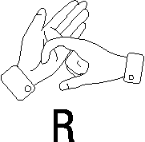
- If you want manipulatives, show me the sign language symbol for M. | 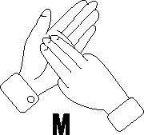
- You may use a calculator for any part.

1. A circle is divided into four parts as shown in the diagram.
One of the parts is shaded.

Which fraction of the whole circle is shaded?

a) one-quarter | b) less than one-quarter | c) more than one-quarter

Give reasons for your answer.

5.2.1: Fraction Frenzy (continued)

2. a) Use the diagram to convince Robyn that of chocolate cake is equivalent to
of the cake.

b) Could you convince Robyn that is equivalent to without using a diagram?
Justify your answer.

3. a) Put a checkmark (✓) in the one column that best describes the given number.

 |  | Between 0 and | Between and 1 | Greater than 1
i)
ii)
iii)

b) Explain your answer for .
5.2.1: Fraction Frenzy (continued)

4. Samuel, Lila, and Mei Ling jog on a track every morning.
Samuel jogs km, Lila jogs km and Mei Ling jogs km.

a) Use the number line to represent the distance that each person jogs.

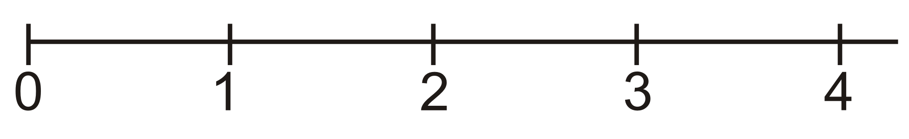

b) How much farther does Mei Ling jog every morning than Samuel? Show your work.

c) How much farther does Mei Ling jog than Lila in one week? Show your work.

5. Calculate. Show your work.
a) | b)

5.2.1: Fraction Frenzy (continued)

6. Both Jay and Ali save a fraction of their weekly allowances.
Compare the fractions to determine who saves the largest fraction of their
allowance each week.

 | Jay’s fraction | Ali’s fraction | Explain your reasoning…
Week 1 |  |  | Who saves the largest fraction? ____________  I know this because…
Week 2 |  |  | Who saves the largest fraction? ____________  I know this because…
Week 3 |  |  | Who saves the largest fraction? ____________  I know this because…

7. a) Deb drew this picture to represent one whole:
Draw a picture to represent of Deb’s whole:

b) Chi drew these five hearts to represent one whole:
Draw a picture to represent of Chi’s whole:

8. Answer one of the following questions clearly, using mathematics vocabulary.
a) Describe how people use fractions in everyday life.
b) I am not comfortable with fractions when…
c) I enjoy working with fractions when…

Unit 5: Day 3: Parts Problems |  |  |  |  | Grade 8
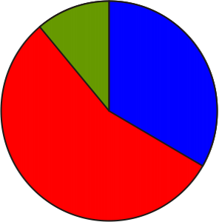 |  |  | Math Learning Goals  - Use manipulatives and symbols to represent the multiplication of a whole number by a fractional quantity.  - Calculate the product of a whole number and a fractional quantity. |  | Materials  - fraction circles  - pattern blocks  - cube links  - graph paper  - BLM 5.3.1
Assessment
Opportunities
 | Minds On... |  | Whole Class→ Sharing  Students share responses to the previous day’s Home Activity. Record and post samples of their responses. Encourage the students to ask each other questions about their stories, if they don’t understand. |  | Example responses  - 6 bottles are each filled with water. How many full bottles of water are there in total?  - Jay walkedof a kilometre. Keri walked 6 times as far. How far did Keri walk?  Sample representations:  1 whole  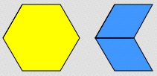  1 whole  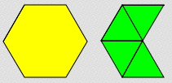  If students use triangles, then , confirmed by .
 | Action! |  | Small Groups → Connecting  Students reflect on the posted stories and choose one that matches the numerical problem, determine the solution, and explain their reasoning. Challenge students who successfully complete the solution to represent the problem using a different manipulative.  Curriculum Expectations/Observation/Anecdotal Notes: Circulate, asking each group reflective questions. Determine if each student can state the representation for one whole – every other representation depends on this.  Whole Class → Instruction  Demonstrate 6 × 4 by putting 6 identical objects in each of 4 bags and also 4 identical objects in each of 6 bags. The total is 24 objects in both cases. Discuss why this is so.  Model. Explain that, while demonstrating 6 × 4 you had to use four “somethings,” and now you will need “two-thirds of something.” The “something” is always a whole, in this case 6, and is just a bit more than half of the whole.  Represent one whole with one hexagonal pattern block piece. Students reproduce the shape (or cover it using overhead pieces) using three identical rhombus pieces. The rhombus piece is one-third of the whole and two rhombus pieces are two-thirds of a whole. Demonstrate by putting two rhombus pieces into each of six bags. Take them all out and count how many one-thirds there are to get twelve-thirds, i.e., . So, .  Write the symbols for the solution and discuss why the answer is and why this is simplified to 4. Demonstrate that the solution is the same if triangles are used instead of the rhombus.  Note if anyone thought that should turn out to be , i.e., . If they did, have them reduce to get . Ask if multiplying should get the same result as ? If they accept that doesn’t make sense, show that is the same as . Now ask how they might work that out.
 |  | Consolidate Debrief | Whole Class → Discussion  As students present and explain their representations highlight a variety of representations. Compare these questions: 5 × 3, 5 cm × 3 cm.  Ask What is the same and what is different when you calculate answers using just the symbols? Summarize student discoveries on multiplying a whole number by a fractional part. Include observations on reducing fractions and changing forms (proper to improper and vice versa).  Students complete BLM 5.3.1.
Application |  |  | Home Activity or Further Classroom Consolidation  Create and solve five questions that involve a whole number multiplied by a fractional part.

5.3.1: Parts Problems

1. Determine a solution to each of the following problems. Show a manipulative representation as well as a symbolic solution.
Problem | Manipulative Solution | Symbolic Solution
a) Dave ate of a mini pizza. John ate 3 times as much.  b) How many mini-pizzas did John eat? | One whole is represented by:  My solution:
b) Farrell spent of an hour doing homework every night for 8 nights in a row.  How many hours did he spend on homework? | One whole is represented by:  My solution:

2. Calculate:
a) | b) | c)

Unit 5: Day 4: Multiplying – Zero to One and Beyond! |  |  |  |  | Grade 8
 |  |  | Math Learning Goals  - Compare the result of multiplying a number by a fraction between 0 and 1 with the result of multiplying a number by a mixed number greater than 1. |  | Materials  - Alice in Wonderland  - BLM 5.4.1  - fraction circles
Assessment
Opportunities
 | Minds On... |  | Whole Class → Discussion  Read or discuss the parts in the story Alice in Wonderland where Alice changes size. Tell students that the author Lewis Carroll was a mathematician named Charles L. Dodgson, then explain that you are going to use mathematics to show what happened to Alice. |  |  | Reference: Making Sense of Fractions, Ratios, and Proportions, 2002 – NCTM Yearbook  If students think that the operation is division, ask:  - Do I get a shorter height by multiplying or by dividing by this fraction?  - If I takeof a pie, do I need more pies (multiplication) or do I have to cut it (division)?  Celebrate all valid strategies whether or not they are “traditional.”
 | Action! |  | Pairs → A answers B  Display the first row of BLM 5.4.1 on an overhead. Ask Partner A to answer the following question to Partner B: If Alice is 120 cm tall and shrinks to of her height, what is her new height?  Ask Partner B to explain and justify the answer to the whole class.  Discuss what mathematical operation could go between Alice’s before height and the effect of the fraction to get Alice’s after height [answer: multiplication]. Continue with the next 3 rows of the chart and record student responses.  Learning Skills/Observation/Mental Note: Assess pairs’ contributions to the task during pair discussions.  Whole Class → Discussion  Students estimate an answer for the last two rows on BLM 5.4.1. Record their estimates, and then calculate. Discuss various approaches they could have tried, including manipulatives.  Help students equate division by 2 and multiplication by ; division by 3 and multiplication by , etc.  Curriculum Expectations/Observation/Mental Note: Circulate and ask probing questions to assess students’ understanding that multiplying a number by a number larger than one results in a product that is larger than the original number.
 |  | Consolidate Debrief | Pairs → Reflection  Sample response:  Multiplying by a mixed number greater than 1 results in a product that is larger than 120 cm. Multiplying by a fraction that is between 0 and 1 results in a product that is smaller than 120 cm.  Help students to generalize this result to any question where a whole number is multiplied by a fraction or mixed number by providing a few more examples.
Application  Concept Practice |  |  | Home Activity or Further Classroom Consolidation  For each of the expressions determine if the answer will be larger or smaller than the first number. Create a word problem for each of the expressions. Calculate the answer. Show your work.  Students respond to the questions:  - What happens when you multiply by a mixed number greater than 1?  - What happens when you multiply by a fraction between 0 and 1? |  |  | Some students may benefit from using fraction circles or strips.
  a) | b) | c)

5.4.1: Alice Grows and Shrinks

Alice’s Height (cm) Before | Change in Height | Alice’s Height (cm) After | Is Alice taller or shorter than her original height?
120 cm
120 cm
120 cm
120 cm
120 cm
120 cm

What pattern do you notice when multiplying Alice’s height of 120 cm by a fraction?

Unit 5: Day 5: Modelling with Area |  |  |  |  | Grade 8
 |  |  | Math Learning Goals  - Represent the multiplication of two fractions where both fractions are between  0 and 1. |  | Materials  - data projector  - Internet  - BLM 5.5.1
Assessment
Opportunities
 | Minds On... |  | Pairs → Problem Solving  Display a question:  Three-quarters of a cake was left over from the Mad Hatter’s Tea Party. Alice ate of the leftover cake. How much of the whole cake did she eat?  Working in pairs, students create a pictorial model that could be used to solve the problem. |  |  | Sample Models:  The length of the rectangle is 3 units and the width is 2 units, so the area is 3 x 2, which equals 6 square units.  The presentation can be modelled using an overhead and a marker. Using the Internet provides more examples.  BLM 5.5.1 can be used if computer access is limited or unavailable.
 | Action! |  | Whole Class → Discussion  Students share responses and discuss different types of models. Would any of the models be more efficient if you had to find an answer to a question like ?  Make the problem simpler as a model for multiplying fractions. Draw this model:  Whole Class → Exploration  Use an area model to show the multiplication of two fractions, e.g.,  http://matti.usu.edu/nlvm/nav/vlibrary.html → Choose Index → Choose Fractions – Rectangle Multiplication – Numbers & Operations (3–5). Model several examples, with students directing your actions.
  Students explain how this rectangular model can be used to show that 2 × 3 = 6. Discussion should lead to understanding that the multiplication of two numbers can be represented by the length and width of a rectangle and the product represents the area of this rectangle.
 |  | Consolidate Debrief | Pairs → Investigation Using Computers  In pairs, students work with virtual manipulatives for fractions of rectangles, (http://matti.usu.edu/nlvm/nav/vlibrary.html). One partner is the “driver,” one partner is the “recorder.” Partners exchange roles for each question. Students record their solutions and submit them for assessment at the end of the activity. Circulate, asking questions to further develop understanding of the area model.  Learning Skills/Staying on Task/Checklist: Assess students’ investigation. Include staying on task and working with other students to interpret instructions.
Concept Practice |  |  | Home Activity or Further Classroom Consolidation  Show this website to someone and explain a solution or share a pictorial model of multiplying fractions using the rectangle model.  OR  Complete worksheet 5.5.1.


5.5.1: What’s My Share?

There is part of one rectangular pizza left over from Friday night’s supper.

The first column in the chart shows the fraction of the pizza that is left over. The second column shows the fraction that you get.

Complete the chart. (The first row is already complete.)

Fraction of pizza that is left over | Your share of the leftovers | Picture solution | Your share as a fraction of the whole pizza | Do you get to eat more or less than one-half of a full pizza?
 |  | 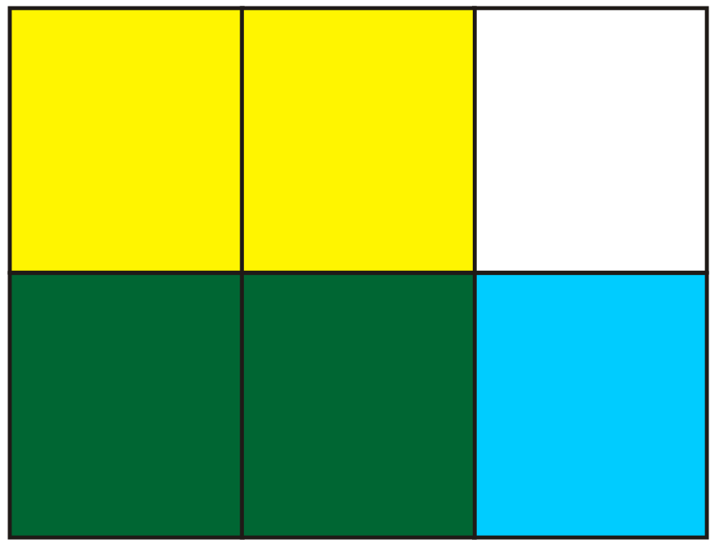 |  | Less
$$\frac{4}{5}$$

Create more questions. Record solutions.

Unit 5: Day 6: Simply Using Symbols |  |  |  |  | Grade 8
 |  |  | Math Learning Goals  - Multiply two fractions where both fractions are between 0 and 1 using symbols. |  | Materials  - sets of number cards  - BLM 5.6.1
Assessment
Opportunities
 | Minds On... |  | Groups of 4 → Game  Students play Fraction Action! (BLM 5.6.1)  Curriculum Expectations/Observation/Mental Note: Circulate and assess for understanding the use of benchmarks and common denominators for comparing fractions. |  |  | Students may need instructions on using calculators to compare fractions.  See Think Literacy: Mathematics, Grades 7–9.
 | Action! |  | Individual → Reasoning and Proving  Ask: Which fraction is larger,?  Will the product of these fractions be larger or smaller than ? larger or smaller than ?  Students individually determine an answer to the problem and explain their reasoning.  Curriculum Expectation/Quiz/Rubric: Provide a short quiz to assess their understanding of relative size of fractions and the size of the product when a number is multiplied by a fraction or mixed fraction.  Whole Class → Discussion  Some students may have used a symbolic solution. Connect their symbolic responses to the rectangular model.  Small Groups → Problem Solving  Brainstorm a list of things to do when problem solving and when working with fractions, e.g., Ask yourself: What is one whole in this question and how can I model it?  Students solve teacher-prepared problems that involve the product of two fractions (both less than one). Example: Robyn’s recipe for salad dressing requirescup of vinegar. Eila thinks she needs only of Robyn’s recipe for her salad. How much vinegar will Eila need?
   | Discuss each number in the symbolic solution. | 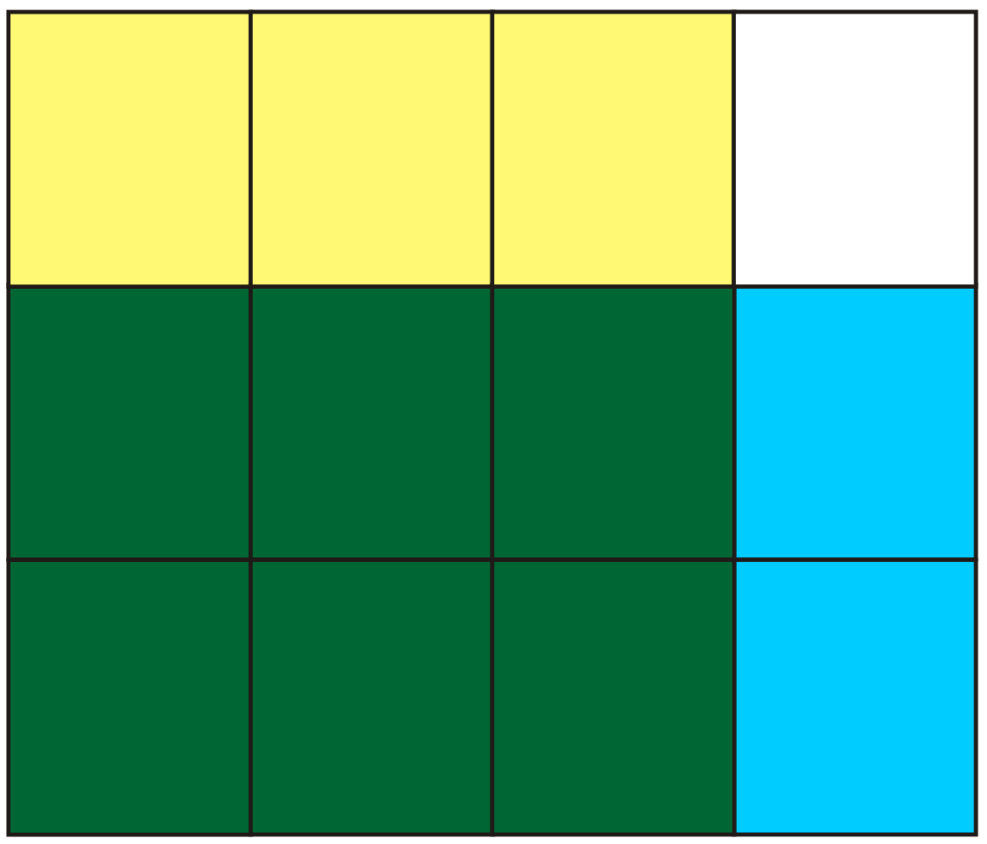
   | Where do we see 6 in the area model?
   | Where do we see 12 in the area model? etc.
 |  | Consolidate Debrief | Whole Class → Summarizing  As a class, develop and post a summary that explains how to find fraction products symbolically.
Concept Practice |  |  | Home Activity or Further Classroom Consolidation  Create and solve fraction questions that involve the product of two fractions that are less than one whole. Record any questions you still have about the multiplication of fractions.

5.6.1: Fraction Action!

Instructions:

Which fraction is larger?

1. Two pairs of students form a group of four.

2. Each group of four students needs one set of cards.

3. One player deals the entire set into two equal stacks of cards, numbers down. Each pair gets one of the stacks.

4. Each person turns over one card from their team’s stack.

5. Each pair forms a fraction by using the smaller card as the numerator and the larger card as the denominator.

6. The pair with the largest fraction claims all of the cards and puts them on the bottom of their stack. The other pair may challenge the claim and check using a calculator, but if the pair loses the challenge, two cards are given to the other team.

7. If a tie occurs, the tie cards are put back into the middle of each pair’s stack.

8. Play can continue until one team has all of the cards or until time is called.

Unit 5: Day 7: Mixed Models |  |  |  |  | Grade 8
 |  |  | Math Learning Goals  - Multiply mixed fractions. |  | Materials  - manipulatives  - Internet  - BLM 5.7.1
Assessment
Opportunities
 | Minds On... |  | Whole Class → Four Corners  Post a different fraction in each corner of the room, e.g., . Distribute one fraction card to each student (BLM 5.7.1). Students go to the corner with the equivalent fraction and discuss how they know that their fractions are equivalent. Have a variety of manipulatives available.  Curriculum Expectations/Observation/Mental Note: Assess students’ understanding in preparation for a whole-group debrief.  Whole Group → Discussion  Students share their corner group work with the class. |  |  | Sample solution with fraction circles:  A representation of using circles is: 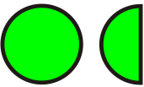  therefore of these can be represented by:  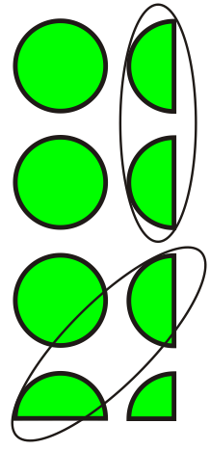  In total there arecircles.  If computer or Internet access is unavailable students can work on paper with the numbers from  BLM 5.7.1.
 | Action! |  | Small Groups → Problem Solving  Students solve the problem, using their understanding of equivalent fractions and manipulatives.  Hal’s recipe for bread calls for cups of flour. Hal wants to make batches of bread. How much flour should he use?  Challenge groups to determine a correct solution to find the answer using different manipulatives and/or pictorial solutions, e.g., measuring cups, pictures of whole and fractional circles or squares.  Whole Class → Discussion  Groups present their solution. Discuss the limitations of manipulatives, e.g., some denominators are difficult to work with; large whole-number parts require too many manipulatives. Demonstrate several examples of how to extend the area model for multiplication so students see how to multiply mixed numbers symbolically.  Small Groups → Developing Understanding  Students work in small groups at the website:  http://matti.usu.edu/nlvm/nav/vlibrary.html → Choose 6–8 → Choose Fractions – Rectangle Multiplication → Choose Improper Fractions. Give each group a different product question (use fractions from Minds On… activity). Each group uses the rectangle model to illustrate its product and represents its concrete model symbolically.  Students post their work as they complete each question.
 |  | Consolidate Debrief | Whole Class → Presentations  One group shares its symbolic representation of multiplication and how it connects to the rectangle model. Model the multiplication of two fractions where the fractions are larger than two.
Concept Practice  Application |  |  | Home Activity or Further Classroom Consolidation  Tanya is 16 years old and just got her G1 driver’s license. For every hour she spends on math at home, her parents will give her hours of practice driving time. This week Tanya spent hours on math. Your challenge is to see how many different ways you can show that Tanya can get hours of practice driving time.

5.7.1: Equivalent Fractions

Unit 5: Day 8: Let’s Explore Dividing |  |  |  |  | Grade 8
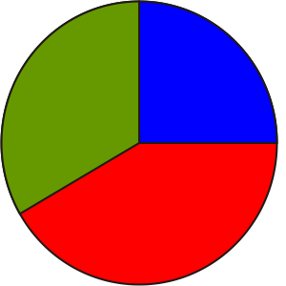 |  |  | Math Learning Goals  - Represent the division of two fractions. |  | Materials  - manipulatives  - BLM 5.8.1 (overhead)
Assessment
Opportunities
 | Minds On... |  | Small Groups → Sharing  Students share solutions from the Home Activity. |  |  | Assign one type of solution to each group for presentation, e.g., symbolic, rectangle model, other manipulative, using decimals, using calculator.  See Think Literacy: Cross-Curricular Approaches, Finding Signal Words.  Share samples of other division problems with students.
 | Action! |  | Small Groups → Problem Solving  Guide students’ thinking about division of fractions by asking: How many quarters are in .  Students respond using pictures, groupings, common denominator, repeated subtraction, clocks, etc.  They should have a variety of manipulatives available to solve the problem. Students may use calculators to check solutions.  Pose the first question on BLM 5.8.1. Debrief by sharing various solutions using manipulatives and pictures and having students talk about their thinking. (This problem is exploring how many shares there are in 3 pizzas).  Pose the second question and debrief in the same way. (This problem is exploring sharing so that each friend gets an equal part.)  Question 3 is a unit rate problem. Students may use ratio tables or unit rates. Question 4 is a measurement problem. Students may use an area array, model, fraction circles, or a common denominator algorithm.  Curriculum Expectations/Observation/Anecdotal: To inform the debrief of each question, observe the strategies and math talk that students are engaged in.
 |  | Consolidate Debrief | Whole Class → Discussion  Discuss each of the questions 1 to 4 as representing a type of division problem.  Demonstrate how making a problem simpler is a strategy that they might find useful when fractions are involved. For example, the first question could become: A group of friends buys 12 pizzas to share equally. Each friend receives 2 pizzas.  If they know that 12 ÷ 2 can be used to find the answer to this question, then they can use this knowledge to conclude that can be used to solve the given question. Share the summary from BLM 5.8.1.
Exploration |  |  | Home Activity or Further Classroom Consolidation  Find a number to replace the question mark. Record strategies that you used.

5.8.1: Let’s Explore Dividing

1. A group of friends buys 3 pizzas to share equally. Each friend receives of a pizza.  Show different ways to find the total number of friends in the group. |  | 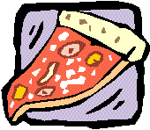
2. Amy, Sue, and Alex bought kg of trail mix to share equally.
Show different ways to determine how much trail mix each person will receive.
3. Sandra’s printer can print 5 pages in of a minute.  Show different ways to determine how many pages Sandra’s printer can print in 1 minute. |  | 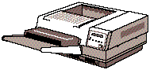
4. The area of a rectangle is square units. The length of the rectangle is units.  Show different ways to determine the width of the rectangle. |  | units
Summary: There are four ways to think about division.
a)  The number of shares of pizza is 8. | b)  The size of each person’s share is .
c)  The rate of printing for one whole minute is pages. | d)  The other dimension of the rectangle is .

Unit 5: Day 9: Let’s Think About Dividing |  |  |  | Grade 8
 |  | Math Learning Goals  - Use patterning to develop strategies and algorithms for dividing fractions.  - Practise partitive and quotitive division with fractions.  - Use unit rates and ratio tables to solve division of fraction questions. |  | Materials  - BLM 5.9.1, 5.9.2  - chart paper  - markers
Assessment
Opportunities
 | Minds On ... | Whole Class → Sharing  Review stories from previous day and connect to Home Activity answers. Compare the division summary of BLM 5.8.1 and multiplication Home Activity. Just note the pattern at this time.  Discuss the role of the numerator and denominator of a fraction. (The denominator of a fraction divides the whole into parts indicating the size of the parts. The numerator shows the number of those parts).  Partners A/B → Exploration  Students explore some properties of multiplying and dividing by fractions (BLM 5.9.1). |  |  | Partitive division:  Determining equal parts or shares of a whole, e.g., share 4 cookies among 3 people  Quotitive division:  How many shares can be measured out of the whole? Four cookies are divided into thirds, e.g., How many shares are there?  Divisions using unit rate: A unit rate is the quantity associated with a single unit of another quantity, e.g., $8 per hour, 45 words per minute. If it takesof a gallon of water to fill a pailfull, how many gallons will fill the pail?  (to fill full thento fillor the whole pail)  Common denominator algorithm:  How many sets ofare in?
 | Action! | Whole Class → Discussion  Take up the answers to BLM 5.9.1 and have students share their reasoning and their hypothesis for properties of fractions. Record and post for reference.  Pairs → Problem Solving  Students solve problems that are partitive divisions, quotitive divisions, and unit rates (BLM 5.9.2). They determine algorithms by reasoning, using unit rates, dividing the numerators/dividing the denominators, and the common denominator algorithm.
 | Consolidate Debrief | Whole Class → Reflection  Students share their reasoning and algorithms for dividing fractions  (BLM 5.9.2). Discuss the types of problems that students have worked on and discuss the algorithms and their ease of use. Do not introduce the invert-and-multiply algorithm yet.
Concept Practice  Skill Drill |  | Home Activity or Further Classroom Consolidation  Complete the practice questions. |  |  | Provide students with appropriate practice questions.

5.9.1: Exploring Properties of Fractions

Multiplying
Partner A answers and Partner B coaches
1. Investigate numbers that you can multiply by to get a whole number answer.
i.e., a whole number
e.g.,

Explain how you determined numbers that worked.

Partner B answers and Partner A coaches
2. Investigate numbers that you can multiply by to get a whole number answer.
i.e., a whole number
e.g.,

Explain how you determined numbers that worked.

Partner A and Partner B work together
3. Investigate fractions that you can multiply by to get a whole number answer.
i.e., a whole number
e.g.,

Explain how you determined fractions that worked.

Partner A and Partner B take turns
4. What fractions can you multiply the following by to get a result of 1?
a) | b) | c) | d)

5.9.1: Exploring Properties of Fractions (continued)

Dividing
Partner A answers and Partner B coaches
5. What number can you divide 2 by to get an answer of 1?
i.e.,

Explain your reasoning.

Partner B answers and Partner A coaches
6. What do you divide 5 by to get an answer of 1?
i.e.,

Explain your reasoning.

Partner A and Partner B work together
7. a) What do you divide by to get an answer of 1?
i.e.,

Explain your reasoning.

b) What number do you divide any number by to get a result of 1?

Partner A and Partner B take turns
8. What fractions can you divide or multiply the following by to get a result of 1?
a) | b) | c) | d)

Partner A and Partner B work together
What do you notice?

Make a hypothesis about dividing by a fraction:

Test your hypothesis on these divisions:
a) | b) | c)

5.9.2: Thinking About Dividing

Part A
For each question explain your thinking. Use words, pictures, or diagrams.

1. Some children left their shoes outside the door before entering the house.
If 10 shoes were left, how many children entered the house?

2. A teacher purchased 72 donuts for a class party.
a) If there are 24 students in the class, how many donuts did each student get?

b) What fraction of the donuts did each student get?

3. A bake shop cuts each pie into 4 equal pieces to sell single servings.
a) If 6 pies were baked, how many servings can they sell?

b) If 8 people wanted to share the 6 pies equally, how many servings would each person get and what fraction of the pies would each person receive?

4. You have been saving quarters. If you have $6, how many quarters have you saved?

5. The local pizza place cuts their pizzas into sixths, so that each slice is of the pizza.
a) How many slices are in an order of 4 pizzas?

b) If 8 people share the four pizzas, how many slices does each person get?
How much of the four pizzas is this?

5.9.2: Thinking About Dividing (continued)

Part B
For each rate question explain your thinking. Use words, symbols, pictures, tables, or diagrams.

1. a) If it takes of an hour to get of the work done, how long does it take to get all the work done?

b) If it takes of an hour to do of the work, how long does it take to do all the work?

c) Describe the parts of a) and b) that are the same and explain what is different.

d) How does using a unit rate help you think about these questions?

2. Sarah found out that if she walks really fast during her morning exercise she can cover
km in of an hour. How far could she walk in one hour at this pace? Use the unit rate idea to solve this problem. [Hint: How far can she walk in of an hour?]

Part C
1. The answers to the division questions are given. Determine a strategy to show how to solve these questions:
a)

b)

c)

2. Use your strategy to solve:
a) | b)
5.9.2: Thinking About Dividing (continued)

Part D
1. The answers to the division questions are given. Determine a strategy to show how to solve these questions:
a) | b) | c)

2. Use your strategy to solve:
a) | b)

Summary
Describe all the ways that you have discovered to think about dividing.

Unit 5: Day 10: One More Way |  |  |  |  | Grade 8
 |  |  | Math Learning Goals  - Develop another strategy for dividing fractions starting with a unit rate model.  - Practise division of fractions. |  | Materials  - BLM 5.10.1, 5.10.2
Assessment
Opportunities
 | Minds On... |  | Whole Class → Discussion  Summarize the strategies for division of fractions using a concept map.  Pose some questions that demonstrate that certain strategies are more useful with some types of questions. Ask: Which strategy is most efficient?  Pose some questions that can be tested and include questions that do not work out nicely. Ask: Will the strategies always work? |  |  | Consider using the Smart Ideas software or create the concept map on chart paper.  This should provide a rationale for exploring to develop one more method.  The ideas needed were explored on Day 9.  An alternative method to help students understand the algorithm is to write the equation in an equivalent form.  A teacher proof is provided and can be shared to challenge students who finish quickly. (BLM 5.10.2)
 | Action! |  | Pair/Share → Problem Solving  Pairs complete BLM 5.10.1. Each pair compares strategies with another pair and describes an algorithm so that they all agree.  To help students understand why the invert-and-multiply algorithm works, start with unit fraction questions and build to unit rate, using ratio tables.  Curriculum Expectations/Observation/Rating Scale: Observe students as they share strategies for division. Probe to highlight different algorithms that can be shared during Consolidate/Debrief.
 |  | Consolidate Debrief | Whole Class → Discussion  Groups share their thinking and the algorithms that they developed. Several groups repeat the explanation in their own words.  Add the new algorithm to the concept map.  Students create a copy of the concept map in their notes. Use the questions in Minds On... that did not work out nicely and verify that the new strategy solves these questions efficiently.
Application  Skill Drill |  |  | Home Activity or Further Classroom Consolidation  Complete the practice questions, using the strategies that you find most efficient. Use your concept map as a reference. |  |  | Provide students with appropriate practice questions.

5.10.1: Finding One More Way

1. Generalizing a rate problem:
If gallon of water is poured into a small pail, it will be full. How many gallons of water will the pail hold if it is filled completely?
a) Determine how many gallons of water it takes for the pail to be full? Explain.

b) Determine how many gallons of water it takes for the pail to then be completely full
( full)? Explain.

Ratio Table
Water Poured | Pail Depth

c) This question can be written as a division problem:
Use the thinking of parts a) and b) to complete the division.

2. Consider the problem:
Write the equation as a multiplication:

To solve this equation: multiply both sides by
Explain the steps and determine the answer.

3. Recall the pattern that you noted in the previous lesson, i.e., and .
Will this pattern work for

4. Use 1, 2, and 3 to create an algorithm for division and use it to solve:
a) | b) | c) | d)
5.10.2: Finding One More Way (Teacher)

Consider this solution:
but
and
so

Explain why this works.

Unit 5: Day 11: Connecting to Composites |  |  |  |  | Grade 8
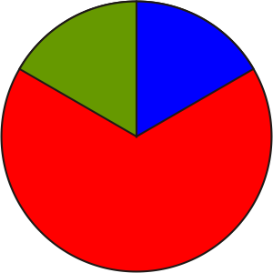 |  |  | Math Learning Goals  - Express composite numbers as products of prime numbers to find lowest common multiples.  - Solve problems that require the lowest common multiple. |  | Materials  - data projector
Assessment
Opportunities
 | Minds On... |  | Pairs → Problem Solving  Students solve this problem:  Jerry spends of his free time playing sports. Harry spends of his free time playing sports. Lui spends more time than Jerry but less time than Harry.  Find different possibilities for the fraction of his free time that Lui spends playing sports. |  |  | To find the LCM  1. Find all the prime factors of both numbers.  2. Multiply all the prime factors of the largest number by those prime factors of the smallest number that are not already included.  The lowest common multiple is 2 × 3² × 5 × 7, which is 630.  Scenario: two cyclical events, one occurring every 210 minutes, the other every 90 minutes. How often will the events occur at the same time? [Answer: every 630 minutes (the LCM)]
 | Action! |  | Whole Class → Guided Exploration  Facilitate a discussion on multiple solutions to the initial activity. Discuss a solution that involves finding a common denominator. Discuss other types of problems that require the lowest common multiple of two numbers.  The planet Zerk has two moons. Tonight the two moons are directly in line with each other and with the planet’s sun. Moon 1 can be viewed in this same location every 10 days. Moon 2 can be viewed in this same location every 15 days. When is the next time that both moons will be in this same location?  In pairs, students find a solution to the Zerk problem. [The answer is 30, i.e., the lowest common multiple.]  Curriculum Expectations/Recorded Solutions/Rubric: Assess students’ solution of The Zerk moons to inform the exploration.  Demonstrate for the class a process for finding the lowest common multiple using the website:  http://matti.usu.edu/nlvm/nav/vlibrary.html → Choose 6–8 → Choose Factor Tree.  Students work in pairs with the virtual activity. One partner is the driver and one partner is the recorder. Students try several examples.
 |  | Consolidate Debrief | Whole Class → Discussion  Summarize the process used in the virtual activity. Write composite numbers as products of primes, using exponents when needed. Discuss how the ability to find an LCM (lowest common multiple) was very important when adding fractions before calculators became common mathematical tools. Illustrate this with an example like: . Students use calculators to check the answer. Discuss why the skill is still important.
Application  Reflection |  |  | Home Activity or Further Classroom Consolidation  Create and solve one “easy” question and one “not-so-easy” question that requires finding either a lowest common multiple or a greatest common factor.  If Internet access is available, show someone the website you used in class and discuss how calculators can be used for fraction arithmetic.  Complete practice questions. |  |  | Provide students with appropriate practice questions.
Unit 3: Day 12: Summative Assessment |  |  |  |  | Grade 8
 |  |  | Math Learning Goals  - Administer a summative assessment. |  | Materials  - manipulatives
Assessment
Opportunities
 | Minds On... |  | Whole Class → Preparing for Assessment  Do a whole-class relaxation/calming activity prior to the assessment.  Distribute the assessment. Students scan the assessment for unfamiliar words/instructions. Remind students that the class Word Wall might be useful during the assessment.  Clarify instructions.  Review the scoring criteria.
 | Action! |  | Individual → Summative Assessment  Students complete the assessment using manipulatives and calculators, as requested.
 |  | Consolidate Debrief | Whole Class → Discussion  Assessments are opportunities for reflection and planning next steps. Discuss how the results of this assessment can help them, you (their teacher), and their parents plan next steps.
Application |  |  | Home Activity or Further Classroom Consolidation  Complete the challenge:  Julia’s mother is a math teacher. She looked at the geoboard model of the “Lasagne” and immediately saw all kinds of fraction problems. Create and solve a fraction problem based on the geoboard model. You will be assessed for creativity, communication, complexity, and correctness … the four Cs of cooking with Math! |  |  | Students who complete the summative assessment task early can begin this assignment.

Unit 5: Day 13: Part of a Whole |  | Grade 8
 | Math Learning Goals  - Students will review the concept of percent (including percents greater than 100%) and its relationship to 1 as a representative of a whole (fractions with denominator 100)  - Students will translate between decimal, fraction, and percent forms of a number.  - Students will order numbers written in a variety of forms. | Materials  - BLM 5.13.1 & 5.13.2  - Chart paper  - Coloured markers  - Sticky notes  - Hundredth charts  - Fraction circles  - Fraction strips  - Percent rings
 | Whole Class → Fractions, Decimal, Percent Review  As students enter room distribute one Percent Partner card (BLM 5.13.1) to each student. Instruct students to find other students whose cards are equivalent to theirs (i.e. have the same value). If some students are unable to find their appropriate grouping, have them gather around you. One at a time, have each student who has not found a group read or describe their card to the class and have the class decide which group that student should join as they explain why that card belongs in that group. Ask the class what percent means (out of 100). When working with percents, what does the “whole” represent? (100%). Why is the “whole” important? Have each group of students explain why they think their cards are equivalent. | Observational data collection of student talk throughout lesson - assessment for learning (to inform future instruction)
Minds On…
 | Groups of 4 → Check for Understanding  Have each group of Percent Partners use their percent from the Minds On activity to create anchor charts describing a strategy of how to change decimals to percents and fractions, how to change percents to decimals and fractions, and how to change fractions to decimals and percents.  Whole Class → Gallery Walk  Post the anchor charts around the room or on groups of desks. Students walk around the room reviewing the other groups’ charts and have the students use sticky notes to record things that they notice are the same or different from what their group recorded on their anchor charts. They might also write a question that they have about the other students’ work or record a positive comment about the other students’ anchor charts. Discuss key insights students have discovered as a whole class. Display anchor charts in the classroom for students and you to refer to over next few days. | Have manipulatives available for the students to use (blank hundredths charts, fraction strips, fraction circles, percent rings, etc)  Teacher Note: The value of the “whole” changes depending on the situation. Students need to be explicitly and frequently be asked what the “whole” is to help them understand that is may be different in different situations.
Action!
Whole Class → Living Number Line
Give each student 1 fraction, decimal or percent from BLM 5.13.2 and have the class create a number line from zero at one end of the classroom to the highest represented amount at the opposite end of the classroom. Start at zero and have the students read their numbers out to the class. As each student reads his/her number, the other students should demonstrate that they agree/disagree by signalling with thumbs up/down. If there is a discrepancy (a mix of thumbs up and down), pause and have students explain their thinking, letting them describe both points of view and allowing them to draw the class to a consensus. Use this opportunity to model and encourage positive talk even when two parties disagree.
Consolidate Debrief
Concept Practice | Home Activity or Further Classroom Consolidation  Have students complete the following question and be prepared to share their ideas with the class:  The following are in ascending order:  0.16, ¼, 45%, 50%, ¾, 0.9, 1.2  Determine a strategy to show that this statement is true.  OR  Have students complete BLM 5.13.3. | Assessment for learning (student understanding of value of fractions, decimals and percents, student development of a strategy to work with different forms of numbers).

BLM 5.13.1: Percent Partners (1 copy - need 1 square per student) Grade 8
45% | 9/20 | .45
70% | 7/10 | .7
32% | 8/25 | .32
91% | 91/100 | .91
12% | 12/100 | .12
27% | 27/100 | .27
84% | 21/25 | .84
66% | 33/50 | .66

BLM 5.13.2: Living Number Line (1 copy - need 1 square per student) Grade 8
.01 | 3/100 | 0.08 | 1/10
13% | 0.16 | 1/5 | 25%
13/50 | 32% | .412 | 9/20
12/25 | 5/10 | 56% | 58%
61/100 | 67% | 0.71 | .75
78% | 17/20 | 22/25 | 0.92
99% | 1 | 100% | 103/100
110% | 1.18 | 2.25 | 300%

BLM 5.13.3: Percent, Fractions, and Decimals Grade 8

1. i) 0.35 ii) 0.08 iii) 0.25
a) Write each decimal as percent. Write a strategy for changing a decimal to percent.

b) Write each decimal as a fraction. Write a strategy for changing a decimal to a fraction.

2. i) 14% ii) 3% iii) 64%
a) Write each percent as a decimal. Write a strategy for changing percent to a decimal.

b) Write each percent as a fraction. Write a strategy for changing percent to a fraction.

3. i) 19/100 ii) 17/25 iii) 13/75
a) Write each fraction as a decimal. Write a strategy for changing a fraction to a decimal.

b) Write each fraction as percent. Write a strategy for changing a fraction to percent.

Unit 5: Day 14 & 15: What Does 110% Mean? |  | Grade 8
120 min | Math Learning Goals  - Students will solve simple problems, using estimation as well as calculation, involving percents (expressed to one decimal place as well as whole number percents greater than 100%) | Materials  - BLM 5.14.1  - Hundredth Charts  - Fraction Circles  - Percent Rings  - Fraction Strips  - Chart paper  - Markers
Small Group → Sharing
Students work in partners to use all of these words and numbers in a sentence:
30, 60, percent, almost
Have partner groups exchange their sentences with other groups to check and discuss.
(e.g. 60 percent of 30 is almost 20)

Think/Pair → Sharing
Tell students to select a fraction and a percent. Have them think about which one is greater and how they know. Then have them turn to an elbow partner and share their thinking. Students move to stand by the anchor chart in the room (developed on Day 13) that best describes the strategy they found most useful in completing this question. Students at each chart discuss their reason for picking that anchor chart with others who also selected it. Discuss reasons for students’ preferences of strategies as a whole class.
Minds On…
 | Individuals/Pairs → Parallel Tasks
Action! | Present the following problems to all students and allow them to select Option A or B to work on  either individually or in pairs.  Option A  A number between 10 and 20 is 80% of a number. What might the numbers be?  [e.g. 16 is 80% of 20]  Option B  A number between 10 and 20 is 150% of a number. What might the numbers be?  [e.g. 18 is 150% of 12]  Whole Class → Discussion  Consolidating questions to ask to all students without specifying either task option:  - How did you find your numbers?  - How did you know which of your numbers was going to be larger?  - Which of your numbers represents the whole? Why?  How could you represent your answer with a picture?  Individuals/Pairs → Gallery Walk  Have students create visual representations of their numbers on chart paper and label them. Post the representations and have students circulate around the room to examine each other’s work. | Differentiation (DI):  Parallel Tasks provide opportunities for student choice.  Have manipulatives available for the students to use (blank hundredths charts, fraction strips, fraction circles, percent rings, etc)
Whole Class → Discussion
Questions to ask to consolidate and scaffold to next activity:
- How are the representations of the students who completed Option A the same as the representations of the students who completed Option B? Why are they the same in these ways? (e.g. Students from both options used arrays.)
- How are the representations of the students who completed Option A different from the representations of the students who completed Option B? (e.g. The students who completed Option A show amounts that are less than a whole while Option B students coloured in 1 whole and ½ of another whole.)
- Why did the students in Option B have to use more than 1 whole in their picture? (e.g. 150% is more than 1 whole; 150% is a whole plus another half of a whole)
- Why does it make sense that you can have more than 100% of something? Have students turn and talk with a partner before sharing with whole class.
- Can you give examples of where you might have more than 100% of something?
(e.g. 1 ¼ cups of milk in a recipe is 125% of a cup)
- Can you give examples of where you cannot have more than 100% of something?
(e.g. cannot score more than 100% on a test)
- What is the smallest percent possible? (zero)
- Is it possible to give 110% effort? Allow students to discuss why this might or might not be possible.

Pairs → Problem Solving
Working in pairs, students will consider the following question and record their thinking on chart paper:
Pick a number. Calculate:
- 0.5% of your number
- 5% of your number
- 50% of your number
- 150% of your number
How do you know that your answers are reasonable?

Whole Class → Discussion
Students share their solutions, posting them in groupings showing different methods of solving the problem. Discuss how solutions are the same/different and the reasons behind the groupings.

Whole Class → Discussion
How is finding a percent that is less than 1, the same/different from finding a percent that is between 1 and 100?
How is finding a percent that is greater than 100, the same/different from finding a percent that is between 1 and 100?
What strategies can you use to check and see if your answers are reasonable?
Consolidate Debrief

Exploration  Concept Practice | Home Activity or Further Classroom Consolidation  Students will complete the following task:  How much is 110%? Give an example of a situation where 110% represents a lot. Give another example of a situation where 110% is a little. Explain your examples with a pictorial representation. How did you decide how much was “a lot” or “a little”?  OR  Have students complete BLM 5.14.1

5.14.1: Practicing Percent Grade 8

1. i) 2.35 ii) 1.08 iii) 4.25
a) Write each decimal as percent. Create a picture to represent each percent.

b) Write each decimal as a fraction. Create a picture to represent each fraction.

2. i) 314% ii) 103% iii) 264%
a) Write each percent as a decimal. Create a picture to represent each decimal.

b) Write each percent as a fraction. Create a picture to represent each fraction.

3. i) 419/100 ii) 57/25 iii) 83/75
a) Write each fraction as a decimal. Create a picture to represent each decimal.

b) Write each fraction as percent. Create a picture to represent each percent.

Unit 5: Day 16: Everybody Pays Tax |  | Grade 8
 | Math Learning Goals  - Students will solve problems involving percents arising from everyday contexts familiar to the students. | Materials  - BLM 5.16.1, 5.16.2, 5.16.3  - Chart paper  - Markers
Individual → Think/Pair/Share
Students answer the following question individually.
You bought an item at a store and saved $6. What was the original price and what was the percent off?
Have students share their answers with a partner. Have partners share with the whole class what was the same/different about how they calculated the percent off. You might wish to create an ordered list from the students’ examples so they can see an emerging pattern.
Group students who used similar strategies together and have them create a chart that shows how they used that strategy to calculate the percent discount. Post the charts.

(Notice with the class that a discount can be calculated in more than one way. E.g., multiplying the original price by the percent discount and then subtracting this from the original price to get the sale price OR subtracting the percent discount from 100 and multiplying this by the original price to get the sale price. )

Minds On…
 | Whole Class → Discussion  What other percent calculations are needed when you buy something? What is sales tax? Why do we have sales tax? How much is sales tax? Why is it important to know how to calculate sales tax? How is calculating sales tax different from calculating percent discount?  Small Homogeneous Groups → Problem Solving and Reflecting  From the teacher’s observations throughout this unit, create groups based on the students’ level of understanding of the concepts. Groups requiring assistance with the concepts taught work on BLM 5.16.1. Groups who require additional practice can work on BLM 5.16.2. Groups who are ready to be challenged can work on BLM 5.16.3.  OR  Allow students to select which the tasks/group that they prefer. | Teacher Note: Consider discussing sales tax and aboriginal people.
Action!
Whole Class → Discussion
Take up the solutions to the exploring problems.
Use the chart paper solutions to consolidate understanding:
- When finding the percent “of” a number, write the percent as a decimal and multiply by the number. (“of” means “multiply”)
- When finding the sales price you can either multiply the original price by the percent discount and then subtract this discount amount from the original OR subtract the percent discount from 100% and multiply this amount by the original price.
- Discount reduces the original price, sales taxes increase the original price.

Consolidate Debrief
Application  Concept Practice | Home Activity or Further Classroom Consolidation  In Ontario, people often pay a provincial sales tax (PST) of 8% and a federal sales tax (GST) of 5% when they make a purchase. Does it matter which is calculated first? Explain your reasoning.

5.16.1: Discount and Tax Activities Grade 8

Choice A

For each item below, calculate the PST, the GST, and the total cost (including taxes).

a) $2 b) $7 000
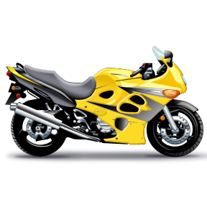
*Remember to use the GST and PST rates are posted in your classroom.

A laptop is regularly priced at $1 000 but is on sale for 20% off. Calculate the sale price of the laptop.

Discuss with your group members: Why is it important to round money amounts to the nearest hundredth of a dollar? Explain your answer on the chart paper.

5.16.2: Discount and Tax Activities Grade 8

Choice B

For each item below, calculate the PST, the GST, and the total cost (including taxes).

a) $5.99 b) $7 850
*Remember to use the GST and PST rates are posted in your classroom.

A laptop is regularly priced at $995 but is on sale for 20% off. Calculate the final price of the laptop.

*Remember to use the GST and PST rates are posted in your classroom.

Discuss with your group members: Why is it important to round money amounts to the nearest hundredth of a dollar? Explain your answer on the chart paper.

5.16.3: Discount and Tax Activities Grade 8

Choice C

For each item below, calculate the PST, the GST, and the total cost (including taxes).

a) $5.99 b) $7 852.88

Tyla paid $899.48 for a laptop. The laptop was discounted 20%. Taking into consideration that Tyla received this discount and paid GST and PST, what was the original price of the laptop?

Discuss with your group members: Why is it important to round money amounts to the nearest hundredth of a dollar? Explain your answer on the chart paper.

Unit 5: Day 17: Many Paths to Take |  | Grade 8
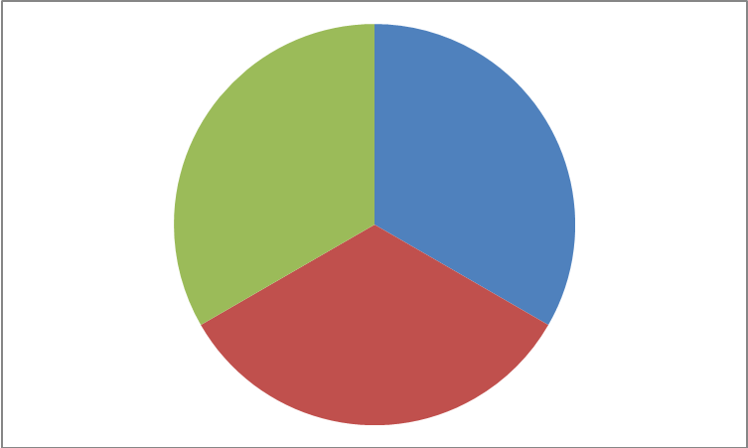 | Math Learning Goals  - Students will solve everyday problems involving percents in more than one way. | Materials  - Chart paper  - Coloured markers
Pairs → Share
Another common percent calculation is for a tip. What types of jobs are there where people earn some of their money from tips? What is a customary percent for a tip when a person does a good job serving you? (15%)
Have pairs of students come up with ways that they could calculate 15% tips using mental math. Together with the class, create anchor charts of students’ solutions.
Minds On…
Individual → Mathematical Process (Reasoning and Proving)
Students work to solve the following problem:

Daniel is purchasing a pair of jeans that is on sale for 25% off (or has a sales discount of 25%). As the sales person is calculating the final price, Daniel asks her to take the discount off before adding the sales tax so that he gets the best price. The salesperson states that by adding on the tax and then removing the discounted amount, the price will be lower.
Who is correct? Why does your answer make sense? Show your work on chart paper and prepare to present it to the class.

Challenge students who successfully complete the task to prove that this always works and to explain why it works.

Action!
Whole Class → Discussion
Students share their solutions. Post them in groupings showing different methods of solving the problem.

Discussion Focus:
1. Different methods of calculating percent discount and sales tax demonstrated by students.
2. Why doesn’t it matter which is calculated first? (A product does not change when the order of its factors changes – e.g., $100 x .75 x 1.13 = $100 x 1.13 x .75)
Consolidate Debrief
Reflection | Home Activity or Further Classroom Consolidation  Sales tax is a percent increase. Being “on sale” is a percent decrease. What is the same/different about percent increases and percent decreases? What is the same/different about how you calculate percent increases and percent decreases?

