Unit 4 Grade 8
Lines, Angles, Triangles, and Quadrilaterals

Lesson Outline

BIG PICTURE

Students will:
- investigate the properties of quadrilaterals, triangles, intersecting and parallel lines;
- investigate the relationships within quadrilaterals, triangles, intersecting and parallel lines;
- solve angle-relationship problems involving triangles, intersecting lies, and parallel lines crossed by a transversal;
- make use of dynamic geometry software as well as manipulatives and pencil and paper to carry out these investigations.
Day | Lesson Title | Math Learning Goals | Expectations
1, 2 | Ancient Structures | - Classify quadrilaterals by properties related to sides and angles (review only).  - Investigate the properties of the diagonals of each of the quadrilaterals. | 8m43  CGE 3b, 3c, 3e
3, 4 | That Proves It! | - Investigate which properties will, by themselves or in combination, be sufficient to determine each of the quadrilaterals. | 8m43  CGE 4b, 4f
5 | Living with Quadrilaterals | - Investigate and describe applications of the properties of quadrilaterals in the real world. | 8m45  CGE 5a, 5b
6 | Crossing Paths | - Investigate the angle relationships for intersecting lines using a variety of tools.  - Solve missing angle problems involving intersecting lines. | 8m47, 8m48  CGE 5a, 5e, 7b
7 | Separated No Longer | - Investigate the angle relationships for parallel lines cut by a transversal.  - Solve missing angle problems involving parallel lines cut by a transversal. | 8m47, 8m48  CGE 3c, 5b, 7b
8 | That Sums It Up! | - Determine the sum of the interior angles of a triangle.  - Solve missing angle problems involving the interior angles of a triangle. | 8m47, 8m48  CGE 5g, 7b
9,10 | What’s My Angle? | - Solve simple missing angle problems.  - Solve angle relationship word problems involving lines and triangles. | 8m48  CGE 2b, 3c, 5b
11 | Sort and Classify | - Investigate the geometric properties of quadrilaterals with two pairs of parallel sides (squares, rectangles, parallelograms, rhombi) or one pair of parallel sides with two non-parallel sides (trapezoid). | 8m43  CGE 3b, 3c, 5a
12 | Unit Review
13 | Summative Assessment

Unit`4: Day 1: Ancient Structures |  | Grade 8
 | Math Learning Goals  • Students will classify quadrilaterals by properties related to sides and angles (review only)  • Students will investigate the properties of the diagonals of each of the quadrilaterals | Materials  - Whiteboards  - BLM 4.1.1 to produce paper strip diagonals or geo-strips  - Brass fasteners  - BLM 4.1.2  - BLM 4.1.3
 | Individual/Small Groups → Discovering Relationships, Reasoning  On a piece of paper or a whiteboard, students will sketch two perpendicular line segments (similar to making a lowercase ‘t’). Next, students will join their endpoints and describe the quadrilateral that is formed (depending on the line segment length and if the diagonals bisect each other or not, students will have created either squares, rectangles or kites)  Ask students to group their quadrilaterals according to their type. Prompt students:  - Describe the properties for this diagonal.  - Do the diagonals bisect each other?  - Are there other possible ways the diagonals could intersect? | Word Wall:  -Perpendicular  -Diagonals  -Intersection  -Bisector
Minds On…
 | Pairs/Expert Groups → Investigation  Using BLM 4.1.1, pairs of students will prepare a set of tag board paper strips if geo-strips are not available.  Using BLM 4.1.2, students will explore all of the ways that two intersecting paper strips or geo-strips can be positioned to create different quadrilaterals. | Class/Group collaboration to complete BLM 4.1.2 or each pair selects one quadrilateral from the chart to create using the paper strips.    Alternatively or as an extension if further consolidation is required,  Diagonals to Quadrilaterals on-line dynamic software can be used either as a whole-class activity or with pairs of students working on a computer
Action!

 | Whole Class→Math Congress  As pairs share the answers from the BLM 4.1.2 chart, other students are responsible for questioning the pair for their reasoning as well as for clarity. Probe students for responses about their conclusions. For instance, the teacher might ask:  - Why does it make sense that knowing the diagonals of a quadrilateral are perpendicular is not enough to prove that the quadrilateral is a rhombus?  Answer: The diagonals can be perpendicular without bisecting each other; so, the quadrilateral may be a kite and not a rhombus.  - Explain using diagonals why a square is both a rhombus and a rectangle.  Answer: A rhombus has diagonals that are both perpendicular and bisecting each other. A rectangle must have diagonals that are the same length and bisect each other. So, a square has diagonals that are congruent perpendicular bisectors. It is both a rhombus and a rectangle.  - Explain using diagonals why a square is always a rhombus but a rhombus is not always a square.  Answer: A square has diagonals that are congruent perpendicular bisectors. A rhombus has diagonals that are perpendicular bisectors. Thus, the diagonals of a square fulfil the requirements for the diagonals of a rhombus: perpendicular bisectors. However, the diagonals of a rhombus need not be congruent. So, the diagonals of a rhombus do not fulfil one of the requirements for the diagonals of a square: congruency. | 
Consolidate Debrief
Home Activity or Further Classroom Consolidation
Puzzle: Which Quadrilateral Am I?
Challenge students to the following: I am a quadrilateral. My diagonals are perpendicular. Which quadrilateral am I?
Is this sufficient information to name one specific quadrilateral? Each student creates one puzzle card from BLM 4.1.3. Students have the choice to include up to 3 conditions for the diagonals (congruence, bisecting, perpendicular). Using a highlighter, students highlight the specific condition(s) for the diagonals of their quadrilateral. On the back of the card, students illustrate their quadrilateral in a real-world context (i.e. window for a rectangle). Students challenge each other to guess which quadrilateral am I?

4.1.1: Paper Strips for Diagonals Grade 8
Photocopy BLM 4.1.1 onto a tagboard and punch a hole to correspond to each of the holes along each strip
Each pair will require: 2 – 30 cm tagboard strips
2 cm 1 – 20 cm tagboard strip
1 brass fastener to join 2 strips

2 cm

30 cm 20 cm

4.1.2: From Diagonals to Quadrilaterals Grade 8

- Explore all of the ways that you can position two intersecting paper strips or geo-strips.
- For each shape that you make, mark a point in the four end holes of the strips. What polygon is formed when you draw line segments to join these points?
- Position your diagonals to make the following quadrilaterals and complete the chart:
Quadrilateral | Sketch | Length of diagonals  (same/congruent or different) | Do the diagonals bisect each other? | Perpendicular: Are the diagonals at right angles where they cross?
Rectangle

Trapezoid

Parallelogram

Rhombus

Kite

Other?

4.1.3: Which Quadrilateral Am I? Grade 8

I am a quadrilateral.  My diagonals are/are not congruent.  My diagonals do/do not bisect each other.  My diagonals are/are not perpendicular.  Which quadrilateral am I? | I am a quadrilateral.  My diagonals are/are not congruent.  My diagonals do/do not bisect each other.  My diagonals are/are not perpendicular.  Which quadrilateral am I?
I am a quadrilateral.  My diagonals are/are not congruent.  My diagonals do/do not bisect each other.  My diagonals are/are not perpendicular.  Which quadrilateral am I? | I am a quadrilateral.  My diagonals are/are not congruent.  My diagonals do/do not bisect each other.  My diagonals are/are not perpendicular.  Which quadrilateral am I?
I am a quadrilateral.  My diagonals are/are not congruent.  My diagonals do/do not bisect each other.  My diagonals are/are not perpendicular.  Which quadrilateral am I? | I am a quadrilateral.  My diagonals are/are not congruent.  My diagonals do/do not bisect each other.  My diagonals are/are not perpendicular.  Which quadrilateral am I?
I am a quadrilateral.  My diagonals are/are not congruent.  My diagonals do/do not bisect each other.  My diagonals are/are not perpendicular.  Which quadrilateral am I? | I am a quadrilateral.  My diagonals are/are not congruent.  My diagonals do/do not bisect each other.  My diagonals are/are not perpendicular.  Which quadrilateral am I?
I am a quadrilateral.  My diagonals are/are not congruent.  My diagonals do/do not bisect each other.  My diagonals are/are not perpendicular.  Which quadrilateral am I? | I am a quadrilateral.  My diagonals are/are not congruent.  My diagonals do/do not bisect each other.  My diagonals are/are not perpendicular.  Which quadrilateral am I?

Unit`4: Day 2: Ancient Structures |  | Grade 8
 | Math Learning Goals  • Students will classify quadrilaterals by properties related to sides and angles (review only)  • Students will investigate the properties of the diagonals of each of the quadrilaterals | Materials  - Tangrams  - GSP®4 software  - BLM 4.2.1  - Acetates  - Write on/wipe off markers  - Optional: geoboards
 | Groups of 4 → Guided Investigation  Students create as many different types of quadrilaterals as they can with tangrams. They will draw sketches and note:  - sum of interior angles;  - side lengths.  - evidence of parallel sides  To reinforce students’ understanding of the characteristics of quadrilaterals, ask them to sort and label the different types of quadrilaterals (e.g. square, rectangle, trapezoid, rhombus, etc.) | Sum of the Interior Angles of a Triangle and a Quadrilateral can be demonstrated as a review using GSP®4 and a  data projector.
Minds On…
Review from Gr. 7 Unit 6

 | Pairs → Exploring/Discovering Relationships  Art, architecture and mathematics are intricately connected. Ancient structures from different cultures are based on the mathematics of quadrilaterals and their diagonals.  Place an acetate overlay on the picture of the ancient structures on BLM4.2.1. Select any vertex of your polygon. Draw as many diagonals as possible from that vertex. Record the number of triangles that are created in the interior. Repeat for each of the structures. From what you remember of the sum of the angles of a triangle, what conclusion can you make regarding the sum of the angles of a quadrilateral? Of any polygon? | Rationale/Research   Differentiate content based on interest in order to give students choice by having students research ancient structures and provide alternatives to those pictures found in BLM 4.2.1  Differentiate process based on interest in order to give students choice by having students use a geo-board to create polygons where additional bands can be used to create the diagonals
Action!
Whole Class → Graffiti Board
As a class, create a ‘What We Know’ concept map to summarize everything that has been learned about the properties of quadrilaterals. Each student has an opportunity to add artefacts to the graffiti board including pictures, numbers, words and GSP print-outs. This dynamic graffiti board remains posted throughout Unit 4 to add to the word wall words, definitions, etc. and as a forum to consolidate new learning.
Consolidate Debrief
Exploration | Home Activity or Further Classroom Consolidation  Modern Structures Students go on a hunt for triangles, quadrilaterals and other polygons in modern architecture at home and school. Students compile a digital photography portfolio of structures that can be used to supplement the study of quadrilaterals, triangles and angles in this unit. | Video  What the Ancients Knew: Geometry in Egypt http://videos.howstuffworks.com/science-channel/29229-what-the-ancients-knew-geometry-in-egypt-video.htm

4.2.1: BLM Ancient Structures Grade 8
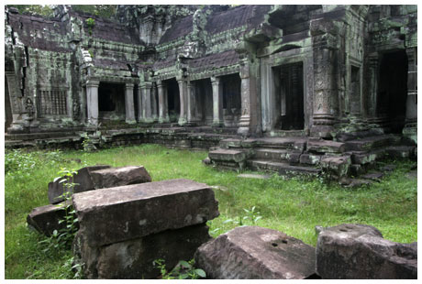

Ta Prohm Temple, Siem Reap, Cambodia

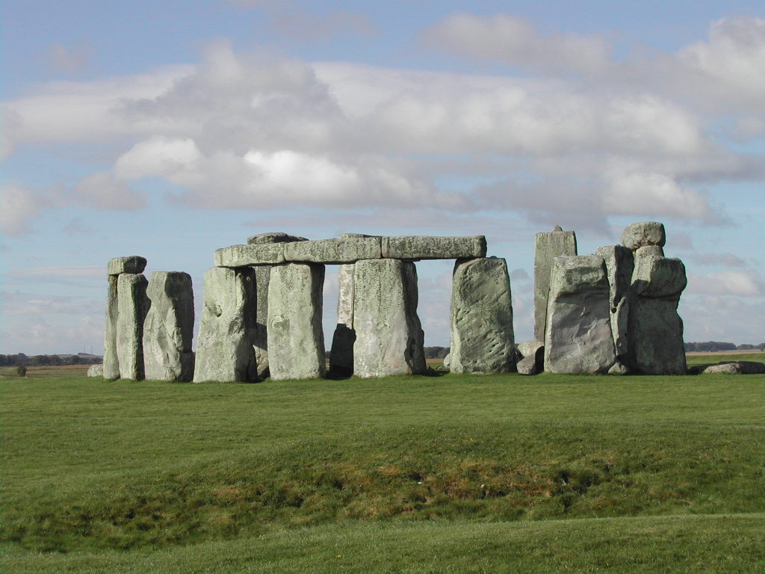

Stonehenge near Amesbury, England, UK

Parthenon Leaning Tower of Pisa Fibonacci http://www.mcs.surrey.ac.uk/Personal/R.Knott/Fibonacci/fibInArt.html?www.mvdaily.com#parthenon

Greek Architecture http://milan.milanovic.org/math/english/golden/golden4.html

Parthenon http://educ.queensu.ca/~fmc/october2001/GoldenArc.htm

Aztec

Unit 4: Day 3: That Proves It! |  | Grade 8
 | Math Learning Goals  - Students will investigate which properties will, by themselves or in combination, be sufficient to determine each of the quadrilaterals | Materials  - Paper  - Pencil  - Protractor  - Ruler  - Geometer’s Sketchpad or similar program  - BLM 4.3.1  - BLM 4.3.2
 | Whole Class → Guided Exploration  Review the different types of quadrilaterals, from Day 2, before proceeding to have students open Geometer’s Sketchpad.  Guide students, who are in pairs, through opening GSP, and then through the tools available (select, point, straightedge, compass and text tools).  Have student then create a few different shapes, investigating how to create parallel and perpendicular lines among other components of the program (make sure to show students how to measure angles and side lengths). | Word Wall  -bisector  -perpendicular bisector  -similarity  -congruency  -diagonal  Students may be able to work independently or in pairs depending upon computer availability.
Minds On…
 | Individual → Investigation  Students use Geometer’s Sketchpad and BLM 4.3.1 to create a square and its diagonals, focussing on the properties of the square.  Students need to consider what properties of the square can be determined through the diagonals.  Students will need to measure the length of the line segments, the diagonals, the angles, and perhaps the area of each triangle made by the diagonals within the square in determining the properties of the square.  Once students have created a square in GSP they will create a rectangle and a parallelogram. Following the same principles of the square, the students will begin to determine the properties of the rectangle and parallelogram.  Students will then compare the properties of the square, rectangle and parallelogram using the Venn diagrams provided in BLM 4.3.2 and be prepared to prove their observations in consolidation. Students may choose to print their work on the square, rectangle, and parallelogram to support this proof. (Note: If students are not ready to investigate three quadrilaterals you may choose to have students investigate and compare only two quadrilaterals) | See instructions BLM 4.3.1 for how to create a square, rectangle, and parallelogram in GSP  Pre-made square, rectangle, and parallelogram are available through the following links:  Square.gsp  Rectangle.gsp  Parallelogram.gsp  Depending upon student readiness, a review of Grade 7 Unit 6 Day 1 may be necessary
Action!
Whole Class → Discussion
Have groups share their findings from the investigations, focusing on the properties of the quadrilaterals and the role of the diagonals in proving this (ex. There are four congruent triangles created by the diagonals of a square and rectangle, the diagonals create perpendicular bisectors in the square and rectangle). Create a class Venn Diagram to record the class ideas. As well, focus on the conclusions you can draw from bisecting an angle.

Consolidate Debrief
Exploration  Practice  Reflection | Home Activity or Further Classroom Consolidation  Students will create two different squares and two different rectangles, focusing their observations on the properties discussed in class and will write a reflective journal as to the similarities and differences between diagonals in squares and rectangles. | The teacher may choose to have students create two different parallelograms as well and compare the three different quadrilaterals.

4.3.1: That Proves It! Grade 8

Constructing a Rectangle in Geometer’s Sketchpad

- Open a new sketch
- Create a straight line using the Straightedge tool, and label the endpoints A and B
- In order to create a perpendicular line to AB, select the line segment, and Points A and B
- Choose Construct from the tool bar and then Perpendicular Lines
- Make sure to deselect, then place Point C on the vertical line directly below Point B
- To draw a parallel line to AB, select the line segment and Point C
- Choose Construct → Parallel Line and then add Point D where the lines intersect directly below Point A
- To hide all lines, select Display → Hide Lines
- Select Points A, B, C, D in order and choose Construct → Line Segments
- Voila, you should have a rectangle

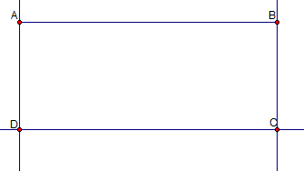

4.3.1: That Proves It! Grade 8

Constructing a Square in Geometer’s Sketchpad

- Open a new sketch
- Use the Compass tool to create a circle
- Using the Text tool, label the centre point of the circle A and insert a point labelled Point B on the edge of the circle
- Next, you will need to create two lines that are perpendicular to AB
- In order to do this, select Point A, Point B, and line segment AB
- Now choose Construct from the tool bar, and Perpendicular Lines
- Make sure to deselect, then using the Point tool place Point C on the perpendicular line that goes through Point A and is on the edge of the circle
- Construct a perpendicular line to the line through A and C by selecting that line and Point C
- Choose Construct → Perpendicular Lines
- With the Point tool, place a point where the two perpendicular lines intersect
- To hide the lines and the circle, choose Display→ Hide Path Objects
- Select Points A, B, C, D in order and choose Construct → Line Segments
- Voila, you should have a square

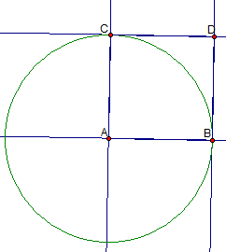

4.3.1: That Proves It! Grade 8

Constructing a Parallelogram in Geometer’s Sketchpad

- Open a new sketch
- Create a straight line using the Straightedge tool, and label the endpoints A and B
- Using the Point tool, place a Point C below and to the right or left of Point B
- In order to create a parallel line to AB, select the line segment and Point C
- Choose Construct → Parallel Line
- In order to create a parallel line to BC, select the line segment and Point A
- Choose Construct → Parallel Line
- Add a Point, D, at the intersection of the lines that go through Points A and C
- To hide all lines select Display→ Hide Lines
- Select Points A, B, C, D in order and then choose Construct → Line Segments
- Voila, you should have a parallelogram

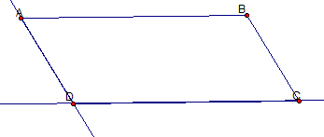

4.3.2: That Proves It! Grade 8

Square Rectangle
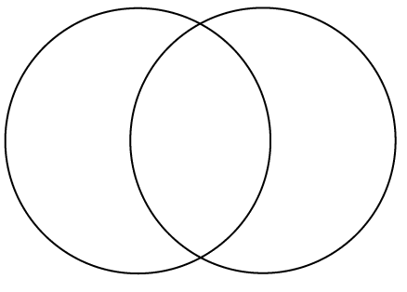

Square Parallelogram

4.3.2: That Proves It! Grade 8

Parallelogram Rectangle

Square
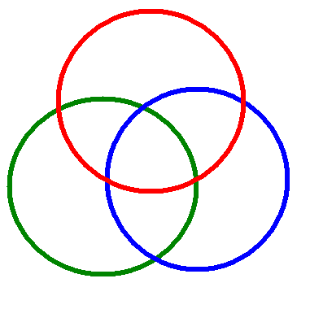
Parallelogram Rectangle

Unit 4: Day 4: That Proves It! |  | Grade 8
 | Math Learning Goals  - Students will investigate which properties will, by themselves or in combination, be sufficient to determine each of the quadrilaterals | Materials  - Paper  - Pencil  - Protractor  - Ruler  - BLM 4.4.1  - BLM 4.4.2
Whole Class → Discussion
Students will discuss their findings of the Day 3 At Home Activity, finalizing their thoughts as to whether or not all parallelograms, squares and rectangles have the same properties of diagonals, regardless of their dimensions.
Any additional findings should be added to the class Venn diagram created on Day 3.
Minds On…
 | Pairs → Investigation  As a continuation of Day 3, students will use BLM 4.4.2 to investigate the properties of a trapezoid, an isosceles trapezoid, a kite, and a rhombus. Students will use the quadrilaterals provided on BLM 4.4.1 or they can create their own by hand or using Geometer’s Sketchpad.  Students will use BLM 4.4.2 to investigate the properties of the quadrilaterals after the diagonals are drawn. Once the students have investigated all of the quadrilaterals, they will make a conjecture as to whether they believe the properties they have investigated are true for all dimensions of the quadrilateral chosen (For example, investigating whether a rectangle with a length of 3 cm and a width of 4 cm will have the same properties as a rectangle with a length of 6 cm and a width of 8 cm).  Students will then create an additional quadrilateral of their choice (e.g. A trapezoid) that has different dimensions than the one used in the original investigation and compare their findings.  Pairs → Discussion  Students will then find another group of students that investigated the same quadrilateral and discuss their findings. The result of the investigation should show that the side lengths do not change the properties of the quadrilateral. | A review of Pythagorean theorem may help students be able to determine the length of the diagonal, a more efficient strategy than measuring.  Ex. Students may believe that not all diagonals of a rectangle will mutually bisect, creating four congruent triangles
Action!
 | Whole Class → Discussion  A class template should be constructed based upon BLM 4.4.2 that shows the findings of the investigations from Days 3 & 4, encompassing all quadrilaterals. Students can make changes to their BLM throughout the discussion period.  Questions:  - How many types of quadrilaterals can you make in which the diagonals bisect each other?  - How many quadrilaterals have perpendicular bisectors?  - If the diagonals of a quadrilateral bisect each other, what type of quadrilateral is it?  - Which types of quadrilaterals have the diagonals create symmetrical triangles?  A focus on what properties are always true for each shape should be considered as well (ex. The diagonals of a square are always perpendicular bisectors). |   To demonstrate student understanding, have them prove their answers to the questions posed
Consolidate Debrief
Concept Practice | Home Activity or Further Classroom Consolidation  Students will solve the following questions to demonstrate consolidation of their understanding of diagonals in quadrilaterals  - Draw at least two quadrilaterals with a perimeter of 24 cm where the diagonals bisect each other and are equal in length.  - Draw at least one quadrilateral that has one set of parallel lines and the diagonals do not bisect each other perpendicularly.  - Draw a quadrilateral that has only one diagonal that is a perpendicular bisector. | You may choose to provide some students with specific shapes and have them prove the properties if they are not able to create their own shapes

4.4.1: That Proves It! Grade 8

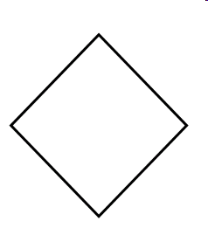
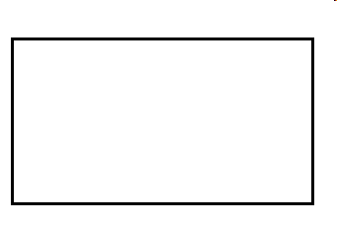

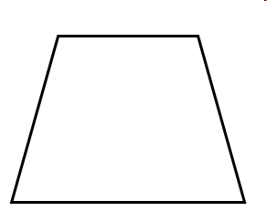
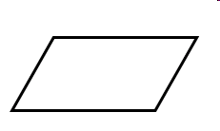
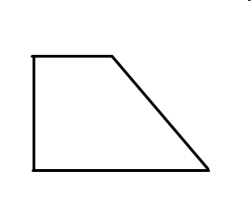

4.4.1: That Proves It! Continued Grade 8

4.4.2: That Proves It! Grade 8

 | Square | Rectangle | Parallelogram | Trapezoid | Isosceles Trapezoid | Kite | Rhombus
Two diagonals
(Yes/No)

All sides are equal length

Diagonals meet at 90°
(2 perpendicular bisecting diagonals)
Mutually bisecting diagonals?

Diagonals create congruent triangles? How many?
Diagonals create similar triangles?
Angles?
(4 right angles, adjacent interior angles are supplementary)
Both pairs of opposite angles are congruent

Unit 4: Day 5: Living with Quadrilaterals |  | Grade 8
 | Math Learning Goals  - Students will investigate and describe applications of the properties of quadrilaterals in the real world | Materials  - Pencil  - Ruler  - Protractor  - BLM 4.5.1  - BLM 4.5.2
Pairs → Brainstorm
In pairs, students will brainstorm where they may have seen diagonals used in the real world (samples may included bridges, wall supports, fence gates).

Whole Class → Discussion
As a class, discuss how diagonals of quadrilaterals are used in the real world, primarily to help provide support to structures, but also for aesthetic appeal. Show a sample photo (there are samples included in BLM 4.5.1).
Minds On…
 | Pairs → Investigation Practice  Provide the students with BLM 4.5.1 to show them some real world use of diagonals in quadrilaterals.  Students will identify the shapes created by the diagonals in the bridges and fence gates.  Through problem solving, students will need to determine the length of material used in creating the diagonal. Also, they will solve for the number of linear metres of material needed to construct each segment of bridge/gate. Finally, students will be asked to determine the total amount of material used to build the bridge and gate all together.  Individual → Practice  Students will then solve the questions posed in BLM 4.5.2. | Depending upon student readiness and their experience with Pythagorean Theorem, they may be able to delve deeper into problem solving for the total amount of steel needed to build the bridge etc. Some students may simply be ready to only measure each length in centimetres on the photos provided.
Action!
Whole Class → Discussion
Consolidate student responses (for example: all designs create congruent triangles and had angle bisectors)
Total lengths of wood or steel needed will vary depending upon the sample selected.
A final discussion referring to the various properties of diagonals is recommended.

Consolidate Debrief
Application | Home Activity or Further Classroom Consolidation  Students are encouraged to explore their neighbourhood looking for other real world examples where diagonals are used to support a structure.

4.5.1: Living with Quadrilaterals Grade 8

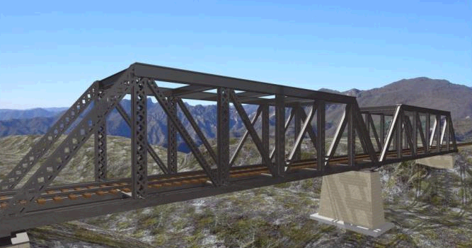

If each section of the bridge is 3 metres wide and 4 metres high, how much steel is needed to create each section of the bridge? How much steel is needed in total? How many triangles are created in the design? Are the triangles congruent? Prove your work.

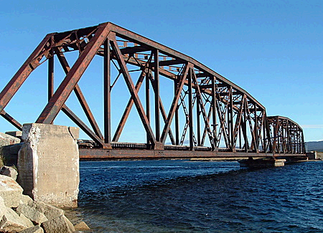

If each section of the bridge is 4 metres wide and 6 metres high, how much steel is needed to create each section of the bridge? How much steel is needed in total? How many triangles are created in the design? Are the triangles congruent? Prove your work.

4.5.1: Living with Quadrilaterals Continued Grade 8
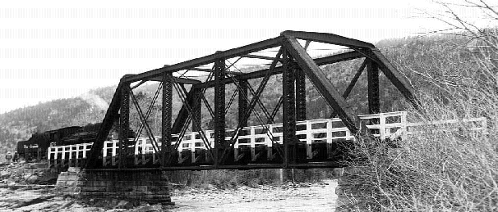

If each section of the bridge is 3 metres wide and 5 metres high, how much steel is needed to create each section of the bridge? How much steel is needed in total? How many triangles are created in the design? Are the triangles congruent? Prove your work.

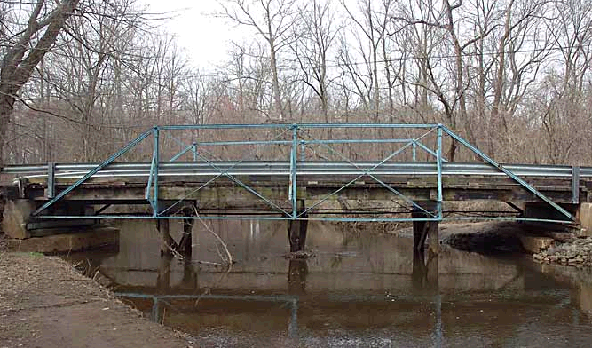

If each section of the bridge is 4 metres wide and 3 metres high, how much steel is needed to create each section of the bridge? How much steel is needed in total? How many triangles are created in the design? Are the triangles congruent? Prove your work.

4.5.1: Living with Quadrilaterals Continued Grade 8

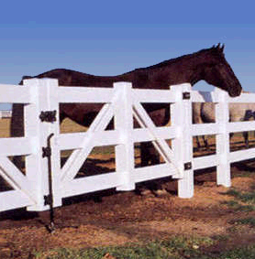

If each section of the vinyl fence gate is 2 metres wide and 1.5 metres high, how much vinyl fence rail is needed to create each section of the bridge? How much vinyl fence rail is needed in total for the two gates? How many triangles are created in the design? Are the triangles congruent? Prove your work.

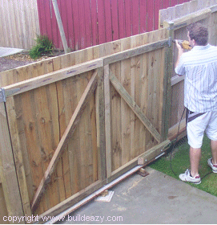
If each section of the fence gate is 1 metre wide and 1.5 metres high, how much wood is needed to create each section of the gate? How much wood is needed in total? How many triangles are created in the design? Are the triangles congruent? What is the purpose of the diagonals in the fence design?
Prove your work.

4.5.2: Living with Quadrilaterals Grade 8

1) A local contractor was hired to build a shed. The shed was to be 6 metres wide by 8 metres long. He showed up on Monday morning to build the shed. When the homeowner came home after work on Monday the four walls of the shed were in place but they did not look even. How could the homeowner check that the walls were in fact square?

2) A bridge contactor was hired to replace a truss bridge in a local town. The bridge needed to have 6 square sections replaced. When asked how much steel was needed for one section he said, “24 linear metres”. What were the dimensions of each section? Did he really need 24 linear metres of steel per section? Explain.

Unit 4: Day 6: Crossing Paths |  | Grade 8
 | Math Learning Goals  - Students will investigate the angle relationships for intersecting lines using a variety of tools  - Students will solve missing angle problems involving intersecting lines | Materials  - Straight line materials to create intersecting lines (optional)  - BLM 4.6.1
 | Pairs → Investigation  Students will determine that intersecting lines create two sets of opposite angles and four supplementary angles (or four complementary angles) by working on the following problem:  Using only two lines, create four angles with two different measurements.  Whole Class → Discussion  The class will come to a single understanding of the angles created when two lines intersect. At this point, the teacher will prompt for or teach the correct terminology (opposite angles & supplementary angles). | Give Students Choice:  Use popsicle sticks/ metre sticks etc. for the lines or use Geometer’s Sketchpad (or another computer application) to create the angles or use pencil and paper or use geoboards
Minds On…
 | Small Groups → Application  In groups of three to four students, students will solve the questions involving intersecting lines and missing angles found in BLM 4.6.1. For the purpose of sharing solutions with the class later, groups should use chart paper for their solutions (or use a document camera or other technological device if available). | Readiness:  Some students may require a diagram with the degrees in place; students can then come to a conclusion about what they see (e.g. opposite angles being equal)
Action!
 | Whole Class → Discussion  As students present a solution, emphasise these points:  - Intersecting lines create angles  - Opposite angles are equal  - Angles on a straight line have a sum of 180° (supplementary); angles that have a sum of 90° are complementary. | A As groups are solving the problems, observe to check understanding
Consolidate Debrief
Concept Practice | Home Activity or Further Classroom Consolidation  Students will create an angle problem for a classmate. They will include the solution for their problem on a separate page. |   The questions that students create, along with the clarity of the solution will allow the teacher to assess what degree of understanding has occurred.

4.6.1: Crossing Paths Grade 8

1. Two roads cross at an intersection. If one of the angles created is 50°, what are the other three angles? Explain your answer.
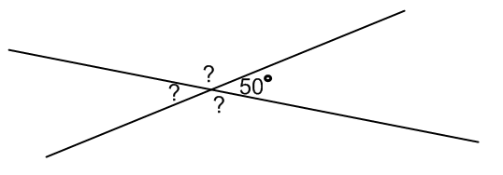

2. Three roads cross at an intersection. What is the minimum number of angles you would need to know to be able to solve for all angles in the diagram below? Prove your answer.
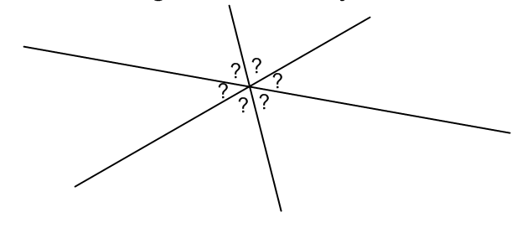

- In what job or career would this knowledge be useful?
Look around the classroom; identify where knowledge of intersecting lines would have been applied in the development or construction of something you see.

4.6.1: Crossing Paths Solutions Grade 8
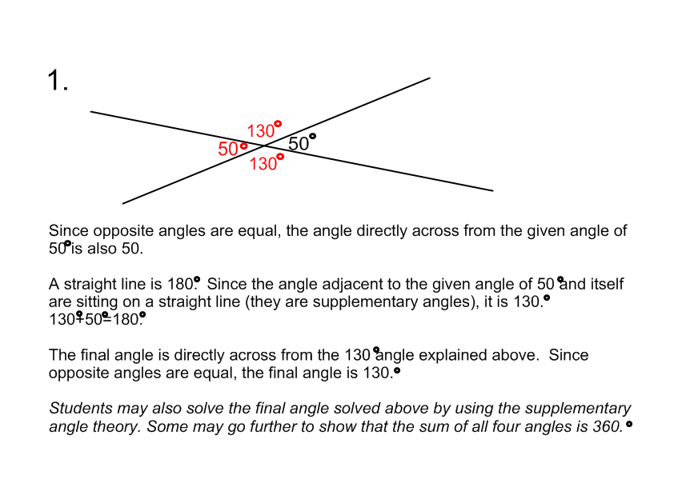
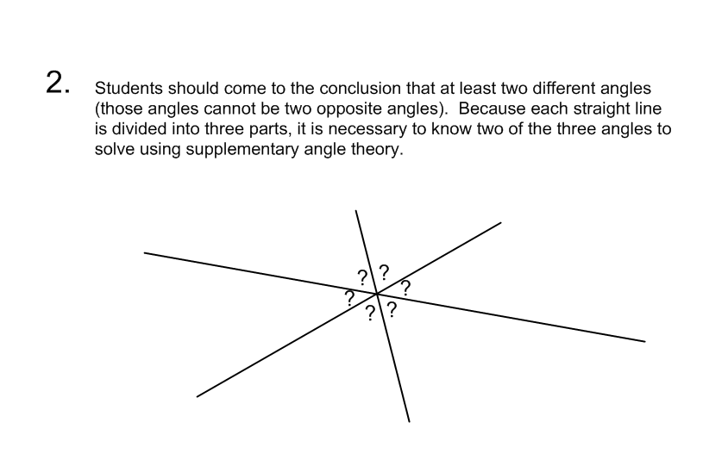
3. Answers will vary.

Unit 4: Day 7: Separated No Longer |  | Grade 8
 | Math Learning Goals  - Students will investigate the angle relationships for parallel lines cut by a transversal  - Students will solve missing angle problems involving parallel lines cut by a transversal | Materials  - GSP  - Protractors  - Trace paper  - BLM 4.7.1  - BLM 4.7.2
 | Pairs → Brainstorm  Have students recall intersecting lines from Day 6. In pairs, students will discuss the idea of two lines that never cross or intersect and give as many real-world examples as possible. Examples may include but are not limited to: railroad tracks, traffic lanes, sports court/field lines, garden rows, home siding, floor tiling, etc. Students will either say, draw or write their example on the board to share with the entire class. | 1) Observation will be used as an assessment strategy.  2) Teacher may wish to make anecdotal notes for reference when pairing students
Minds On…
 | Groups of 3 → Investigation  Students will follow the instructions stated in BLM 4.7.1 for various investigations involving angle relationships for parallel lines cut by a transversal. It is important that students complete these handouts and instructions in sequential order.  Teachers will have various “check points” (see Assessment For Learning side note) during the student investigations to assess and monitor student understanding and provide appropriate scaffolding or challenges where appropriate. Anecdotal notes should be made for those students who are either struggling or quickly moving though the assignment. Teachers may also wish to prepare GSP files for investigation using 65 degree and 115 degree angles as an alternative or compliment to Question 3 from BLM 4.7.1. | To see how much time to spend on BLM 4.7.2, check BLM 4.7.1 for:  a) understanding of the terms ‘parallel’ and ‘transversal’  b) connections  c) generalizations
Action!
 | Whole Class → Discussion/Consolidation  Give the students a copy of the Summary Chart on BLM 4.7.2. Have them colour in the angles according to the instructions. Have the students tell you what they observed for each of the four angle theorems. Record all student ideas which are relevant on the blackboard and as a class, come up with ONE or TWO key points to summarize each of the four angle relationships. Record only those key points directly on the chart. Ask the students what they would name each relationship using one word, then give them the correct word (if they do not correctly identify it). | Higher level students can draw parallel lines and transversal given 65 and 115 degree angles. Some students may need to be given angle measurements.
Consolidate Debrief
Problem Solving  Concept Practice | Home Activity or Further Classroom Consolidation  Students will create two questions using a different angle relationship for each question, pretending they would have to give it to another classmate to try. On one side of the page, they will draw the parallel lines and the transversal, and leave an angle missing so that the student would be able to solve it using the angle relationships. On the other side of each page, they will include the solution to the problem.

4.7.1: Separated No Longer Grade 8

Predict

1. Lines AB and CD are parallel lines which have been intersected (or crossed) by a transversal, represented by line EF. Highlight or trace the pair of parallel lines in one colour and the transversal in another colour. Recall that a transversal is simply a line that crosses two or more lines.

2. Each symbol below represents an angle. Match the following angles to where you think that they belong. Do not forget about INTERSECTING LINES from your previous lesson!
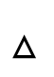

4.7.1: Separated No Longer Continued Grade 8

Investigate

3. a) Trace the parallel lines and transversal below on trace paper (or a transparency) .
b) Make sure that you label your trace using the same letters as on the original.
c) Place your trace on top of the original and move it around. Are any of the angles the same? Record your observations in the box at the bottom of this page.

NOTE: Be consistent when describing the angles. The marked angle below should be written as angle EGB, with the vertex of the angle in the middle.

OBSERVATIONS

4.7.1: Separated No Longer Continued Grade 8

4. Measure all 8 angles on the diagram below using Geometers Sketchpad, or a protractor, or both! Your teacher will tell you exactly which to use.

Record all 8 of the measured angles in the circles on the diagram below:

5. Observe the following pairs of angles:
EGB & AGH EGA & BGH GHD & CHF GHC & DHF

What do they have in common?

In general, what is true about the angles created by two intersecting lines?
__________________________________________________________________________________________________________________________________________________________________________________________________________________.

6. Angle EGB + Angle EGB = ______°
Angle AGH + Angle BGH = ______°
Angle GHC + Angle GHD = ______°
Angle CHF + Angle DHF = ______°

In general, when you have a straight line separated into two angles, the angles sum to

______°

4.7.1: Separated No Longer Continued Grade 8

7. From your investigation, and using the diagram below, what do you notice about the following pairs of angles?

a) Angle 2 and Angle 6 c) Angle 1 and Angle 5
b) Angle 4 and Angle 8 d) Angle 3 and Angle 7

I noticed that . . .

__________________________________________________________________________________________________________________________________________________________________________________________________________________.

8. Using the same diagram in Question 3 above, what do you notice about the following pairs of angles?

a) Angle 3 and Angle 6 b) Angle 4 and Angle 5

I noticed that . . .

__________________________________________________________________________________________________________________________________________________________________________________________________________________.

4.7.2: Angle Relationships Summary Chart Grade 8

Choose four different colours to represent the different angles: X, O, *, and #, found in the chart below. Colour in each of the circles. Complete the chart as a class:

DIAGRAM | DESCRIPTION OF ANGLE RELATIONSHIPS |  | NAME
 |  |  | OPPOSITE ANGLES
 |  |  | SUPPLEMENTARY ANGLES
CORRESPONDING
ANGLES
(“F” Pattern)
ALTERNATE ANGLES
(“Z” Pattern)

Unit 4: Day 8: That Sums It Up! |  | Grade 8
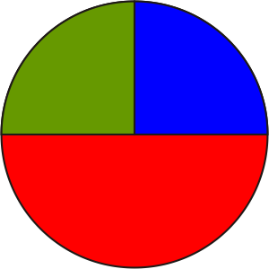 | Math Learning Goals  - Students will determine the sum of the interior angles of a triangle  - Students will solve missing angle problems involving the interior angles of a triangle | Materials  - Triangles of various sizes  - Chart paper or other large paper BLM 4.8.1  - BLM 4.8.2  - BLM 4.8.3
 | Small Group → Investigation  Students will come to the conclusion that the sum of interior angles of any triangle is 180° by sorting triangles based on the sum of their interior angles:  In groups of 3-4, students will sort a variety of triangle from BLM 4.8.1 (isosceles, right, equilateral, scalene) according to the sum of the interior angles. Sorting categories will be: < 180°, 180°, or >180° | Readiness/Time Saving: Students create a variety of triangles then measure the angles or students are given the triangles and measure the angles or students are given the triangles and the three angles are labelled.
Minds On…
 | Pairs → Application  On large pieces of paper, students will work in small groups to solve the problem in BLM 4.8.1 involving interior angles of a triangle. Knowledge from Days 6 & 7 will be useful in this problem. Students should solve this question through problem solving and not by using a protractor as the illustration is not to scale. | Geometer’s Sketchpad or another computer application can be used to create the triangles.  To sort the triangles, use a SMART Board, overhead projector, chalkboard headings or labelled bins.
Action!
 | Whole Class → Consolidate  Teacher will look for groups that differ in the way they have solved the problem (three or four groups) and have these groups present their solutions to the class. Highlight strategies used by the groups. Ask remaining groups if their problem solving method is similar to any that were presented. If any group believes their solution is totally unique to those presented, have that group share their solution. | Teacher will observe the conversation and interaction of group members throughout the problem solving process
Consolidate Debrief
Skill Drill | Home Activity or Further Classroom Consolidation  At the end of the lesson, students complete the exit card, BLM 4.8.3.

4.8.1: That Sums It Up! Grade 8

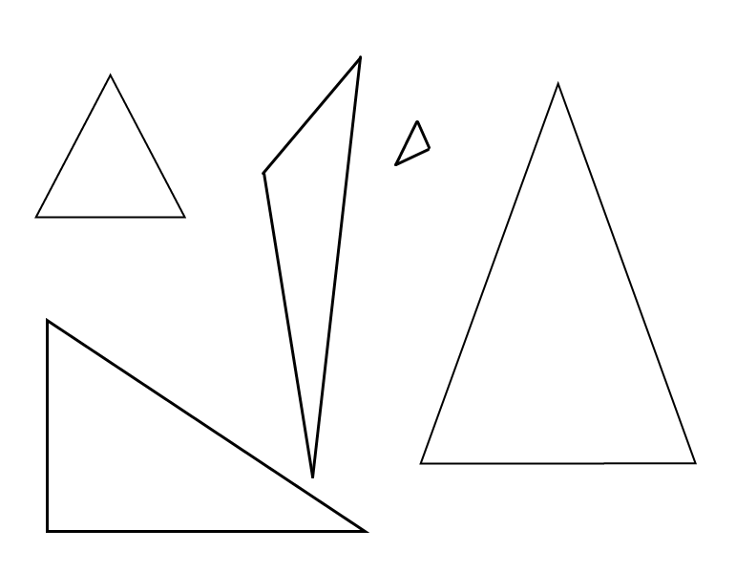

4.8.2: That Sums It Up! Grade 8

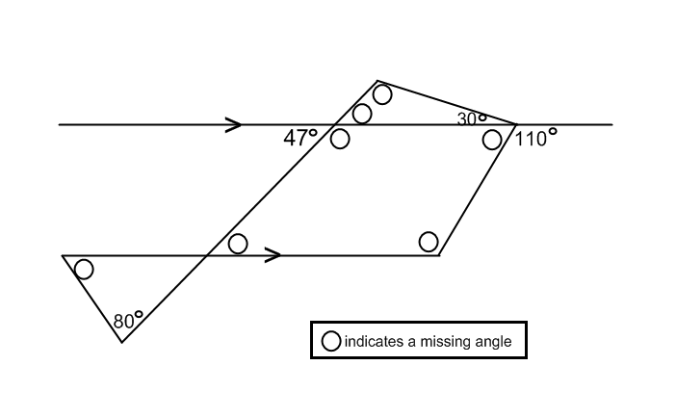

A new sign is being designed for the city’s skate park. Knowing the exact angles is necessary for fitting the sign where it will hang. The architect started to write in the angles, but went home sick before she could finish. It is up to you to fill in the missing angles. For 4 of the 8 missing angles, explain your answer.

4.8.2: That Sums It Up! Solutions Grade 8

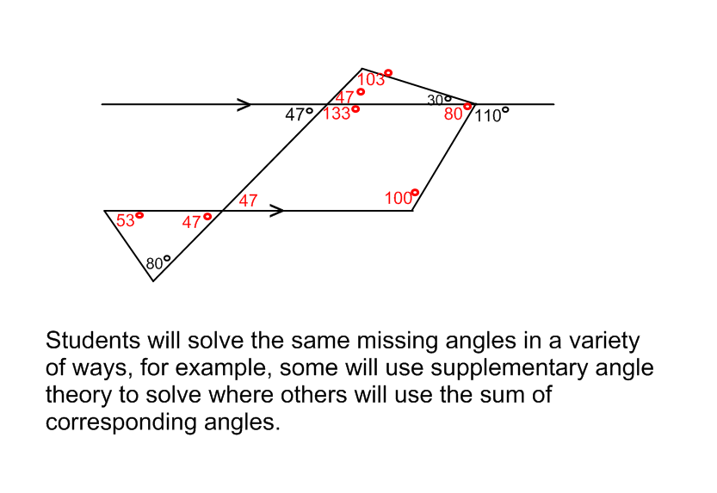

4.8.3: That Sums It Up! Grade 8

Exit Card

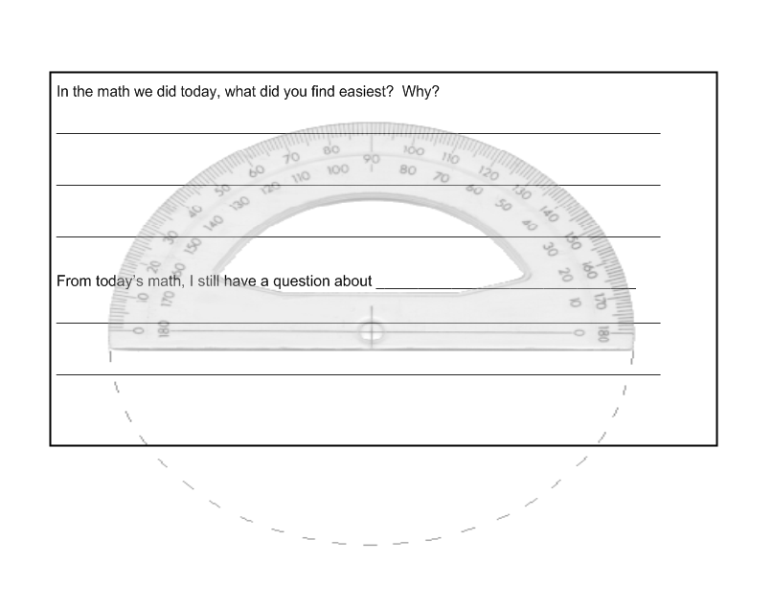

Unit 4: Day 9: What’s My Angle? |  | Grade 8
 | Math Learning Goals  - Students will solve simple missing angle problems | Materials  - Calculator  - BLM 4.9.1  - BLM 4.9.2
 | Small Groups → Reflect  Students will review the previously learned angle relationships by playing the matching game on BLM 4.9.1. Teacher will take up the sheet with the class to ensure everyone understands the proper concepts. | Assessment:  1) Use a checklist to assess group work skills  2) A score out of 9 can be recorded for BLM 4.9.1.
Minds On…
 | In Pairs → Problem Solving  Students will follow the instructions to complete BLM 4.9.2. After completing the last question, the pairs will join up with another group to compare strategies. If the strategy used was different than their own group, students will record the strategy. As a group of 4, students will discuss alternate approaches to the last question on BLM 4.9.2.  The teacher should circulate the classroom to ensure the strategies are reasonable. |   Use the scores from BLM 4.9.1 as a “quiz” mark  Anecdotal notes can be made from observations and students ability to work with others
Action!
Whole Class→ Discussion
Students will share cases where problems were solved differently, yet answers were the same and correct. The idea that there may be more than one way to solve each problem should be emphasized. This will prepare students for the next lesson, which has more problems involving angle relationships relating to lines and triangles.

Consolidate Debrief
Problem Solving | Home Activity or Further Classroom Consolidation  Students can exchange the questions they created from Day 7’s At Home Activity.

4.9.1: Angle Matching Grade 8

Match each of the diagrams in the chart to the correct angle relationship and angle solution from the lists below. The unknown angle(s) are marked by the letter A or B. Some diagrams have more than one unknown angle and others do not have any. One point is awarded for the correct solution and one point will be awarded for matching the correct angle relationship. The maximum score for this game is 9.

Angle Relationship: Interior Angles Possible Angle Solutions: 50°
(use each term only once) Alternate Angles 115°
Supplementary Angles 130°
Opposite Angles 30°
Corresponding Angles

DIAGRAM | POSSIBLE ANGLE SOLUTION | ANGLE RELATIONSHIP | TOTAL POINTS
A =

B =
 | A =

4.9.1: Angle Matching Continued Grade 8

DIAGRAM | SOLUTION | RELATIONSHIP | TOTAL POINTS
 | A =
FINAL SCORE =
(MAXIMUM IS 9!)

4.9.1: Angle Matching Solutions Grade 8

Match each of the diagrams in the chart to the correct angle relationship and angle solution from the lists below. The unknown angle(s) are marked by the letter A or B. Some diagrams have more than one unknown angle and others do not have any. One point is awarded for the correct solution and one point will be awarded for matching the correct angle relationship. The maximum score for this game is 9.

Angle Relationship: Interior Angles Possible Angle Solutions: 50°
(use each term only once) Alternate Angles 115°
Supplementary Angles 130°
Opposite Angles 30°
Corresponding Angles

DIAGRAM | SOLUTION | RELATIONSHIP | TOTAL POINTS
 | A = 50°  B = 130° | Opposite  Angles | Max 3 Points
 | A = 33° | Interior Angles | Max 2 Points
 | NO  UNKNOWN  ANGLE | Corresponding  Angles  (F Pattern) | Max 1 Point

DIAGRAM | SOLUTION | RELATIONSHIP | TOTAL POINTS
 | A = 115° | Supplementary  Angles | Max 2 Points
 | NO  UNKNOWN  ANGLE | Alternate  Angles  (Z Pattern) | Max 1 Point
FINAL SCORE = 9
(Maximum Score is 9)

4.9.2: From Every Angle Grade 8

For each question, you and a partner will solve for the unknown angle(s) marked by each letter. Do not use a protractor or any other method to try to measure the angles. Clearly show your steps and describe which angle relationship(s) was chosen to solve for the unknown angles.

(Angle Relationships Include: opposite angles, sum of interior angles of a triangle, supplementary angles, corresponding angles/ “F” pattern, alternate angles/ “Z” pattern)

4.9.2: From Every Angle Continued Grade 8

After completing the following question with a partner, compare your solution with another pair of students. If your method for solving the problem is different, copy down an alternative solution. As a group of four, can you think of any other approaches to come up with the correct solution? Record as many as you can think of.

Unit 4: Day 10: What’s My Angle? |  | Grade 8
 | Math Learning Goals  - Students will solve angle relationship word problems involving lines and triangles | Materials  - Calculator  - BLM 4.9.1  - BLM 4.10.1  - BLM 4.10.2
 | Whole Class → Reflect  Teacher will review the Consolidation Debrief section from Day 9 to reinforce that there is often more than one way to come up with the solution with these types of angle relationships. Students will complete BLM 4.9.1 to try to improve their previous score. | Record marks from BLM 4.9.1 to see if there was improvement
Minds On…
 | Pairs → Applying Concepts  Students will complete BLM 4.10.1 in pairs. Pairs may then wish to consolidate ideas with other groups, having a maximum of four in a group at one time. Student solutions must be thorough and organized so that if asked, they could explain step-wise how each problem was completed. | BLM 4.10.2 (Rubric) can be used to assess any or all questions from 4.10.1.
Action!
Whole Class → Debrief
Teacher will take up the solutions with the class depending on how many the majority of the class has completed. Solutions to BLM 4.10.1 are provided for the teacher.

Consolidate Debrief
Problem Solving  Exploration | Home Activity or Further Classroom Consolidation  Students will complete BLM 4.10.1 for homework if they do not finish during class time. Students may also create their own problem, including as many of the angle relationships in one question as possible. Solutions to the created problem should also be included. They may exchange questions with a classmate the next day for the ‘Minds On...’ activity.

4.10.1: The Right Angle Grade 8

1. Two angles are supplementary. If one of the angles measures 40 degrees, what is the measure of the other angle?

2. One interior angle of a triangle measures 55 degrees. The other interior angle has a supplementary angle of 118 degrees. What are the other two interior angles in the triangle? Include a diagram with your answer.

3. You wish to build a model pyramid made of gold paper to represent the bricks. You start by making the first layer, but you need to know which angle to cut the bricks so they will align with the sides of the triangle. Using the diagram below, determine the unknown angle(s), assuming the dotted lines are parallel. Be sure to justify your answer using the appropriate angle relationship(s).

4.10.1: The Right Angle Continued Grade 8

4. A student is putting together a bookshelf for her room. For support, the top and the bottom of the bookshelf must have a brace, which goes from corner to corner, forming an X shape. Assume the top and bottom of the bookshelf are parallel to one another with 90 degree angles at each corner. What angle does the brace make with the top and bottom of the bookshelf?

5. A gardener wants to ensure that the walking paths between his rows of planted carrots are straight. He measures one angle to be 125 degrees. What must the measure of the other unknown angle be in order for each walking path to be straight? (Assume the dashed lines are parallel.)

4.10.1: The Right Angle Solutions Grade 8

1. Two angles are supplementary. If one of the angles measures 40 degrees, what is the measure of the other angle?

ANSWER = 180 - 40
= 120

2. One interior angle of a triangle measures 55 degrees. The other interior angle has a supplementary angle of 118 degrees. What are the other two interior angles in the triangle? Include a diagram with your answer.

ANSWER

JUSTIFICATION:
1. 180 – 118 = 62 SUPPLEMENTARY ANGLES
2. 180 – 62 - 55 = 63 SUM OF INTERIOR ANGLES OF TRIANGLE

3. You wish to build a model pyramid made of gold paper to represent the bricks. You start by making the first layer, but need to know which angle you are to cut the bricks that will align with the sides of the triangle. Using the diagram below, determine the unknown angle(s), assuming the dotted lines are parallel. Be sure to justify your answer using the appropriate angle relationship(s).

POSSIBLE JUSTIFICATION:
1. 47 DEGREEANGLES BECAUSE THEY ARE CORRESPONDING ANGLES, LYING ABOVE THE PARALLEL LINES CROSSED BY THE TRANSVERSAL
2. 86 DEGREE ANGLE BECAUSE OF THE SUM OF INTERIOR ANGLES OF A TRIANGLE RELATIONSHIP 180 – 47 – 47 = 86

4.10.1: The Right Angle Solutions Continued Grade 8

4. A student is putting together a bookshelf for her room. For support, the top and the bottom of the bookshelf must have a brace, which goes from corner to corner, forming an X shape. Assume the top and bottom of the bookshelf are parallel to one another with 90 degree angles at each corner. What angle does the brace make with the top and bottom of the bookshelf?

5. A gardener wants to ensure that the walking paths between his rows of planted carrots are straight. He measures one angle to be 125 degrees. What must the measure of the other unknown angle be in order for each walking path to be straight? (Assume the dashed lines are parallel.)

4.10.2: Rubric for 4.10.1 “The Right Angle” Grade 8
Reasoning and Proving

Criteria | Level 1 | Level 2 | Level 3 | Level 4
Degree of clarity in explanations and justifications in reporting angle relationships | Explanations and justifications are partially understandable | Explanations and justifications are understandable by me, but would likely be unclear to others | Explanations and justifications are clear for a range of audiences | Explanations and justifications are particularly clear and detailed
Justifying solutions through reporting various angle relationships | Justification of the answer presented has a limited connection to the problem solving process and models presented | Justification of the answer presented has some connection to the problem solving process and models presented | Justification of the answer presented has a direct connection to the problem solving process and models presented | Justification of the answer has a direct connection to the problem solving process and models presented, with evidence of reflection
Connecting

Making connections among mathematical concepts and procedures | Makes weak connections | Makes simple connections | Makes appropriate connections | Makes strong connections
Communicating

Ability to read and interpret mathematical language and graphs | Misinterprets a major part of the information, but carries on to make some otherwise reasonable statements | Misinterprets part of the information, but carries on to make some otherwise reasonable statements | Correctly interprets the information, and makes reasonable statements | Correctly interprets the information, and makes subtle or insightful statements
Appropriate use of mathematical vocabulary | Sometimes uses mathematical vocabulary correctly when expected | Usually uses mathematical vocabulary correctly when expected | Consistently uses mathematical vocabulary correctly when expected | Consistently uses mathematical vocabulary correctly, recognizing novel opportunities for its use
Integration of narrative and mathematical forms of communication | Either mathematical or narrative form is present, but not both | Both mathematical and narrative forms are present, but the forms are not integrated | Both mathematical and narrative forms are present and integrated | A variety of mathematical forms and narrative are present, integrated and well chosen
Representing (Extension Exercise Only)

Creation of a graphical model to represent the data | Creates a model that represents at least one angle relationship | Creates a model that represents two angle relationships | Creates a model that represents 3 or 4 angle relationships | Creates a model that represents all angle relationships

Unit 4: Day 11: Sort and Classify |  | Grade 8
 | Math Learning Goals  - Students will investigate the geometric properties of quadrilaterals with two pairs of parallel sides (squares, rectangles, parallelograms, rhombi) or one pair of parallel sides with two non-parallel sides (trapezoid) | Materials  - BLM 4.11.1  A variety of quadrilaterals  - BLM 4.11.2  Cards with names of quadrilaterals on them  - BLM 4.11.3 Cards with a property on them
 | Whole Class → Classification  Students will review the names of a variety of quadrilaterals. Hand each student a quadrilateral, a name card or a property card (BLM 4.11.1-4.11.3). Because there are only 15 cards in total, pair some students up or have remaining students be the ones who decide if the groupings are correct. Students will have 3-5min to create groups of three based on what they have been given. Teacher will ensure groupings are correct (refer to solutions). A chart with the correct matching (either displayed on a SMART Board, overhead transparency, bulletin board display, or sheets for individual students) will then be available in the classroom for reference in the ‘Action!’ section. | If the students are not able to walk around and find one another (i.e. If this is a class that works better seated), have students work in small groups; give each group a set of cards that they can sort.  Readiness:  There may be students to whom you will give the answer to the question. They will show (rather than prove) why one of those quadrilaterals answers the riddle.
Minds On…
 | Small Group → Investigation  The quadrilaterals used in the ‘Minds On...’ section will be used to answer the following riddle. Students will solve and prove this in small groups.  We are the quadrilaterals that have diagonals that bisect each other perpendicularly. Which quadrilaterals are we? | Observe and take note of the terminology being used and proof method (e.g., are properties of quadrilaterals being discussed for solving)
Action!
Whole Class → Discussion
Groups will volunteer (or be chosen) to present the solution to one of the questions. Other groups may give their opinion on the solution once the group has finished presenting (i.e. they may wish to say that their group agrees with the quadrilateral chosen for the answer, but they went about their proof in a different manner; they may say their group chose a different quadrilateral because… etc.).
Consolidate Debrief
Application | Home Activity or Further Classroom Consolidation  A video (Inventing With Polygons) from The Futures Channel will give one example of why understanding properties of geometric figures is important. Copy and paste the following link into a URL.  http://www.thefutureschannel.com/dockets/hands-on_math/inventing_with_polygons/

4.11.1: Sort and Classify Grade 8



4.11.2: Sort and Classify Grade 8

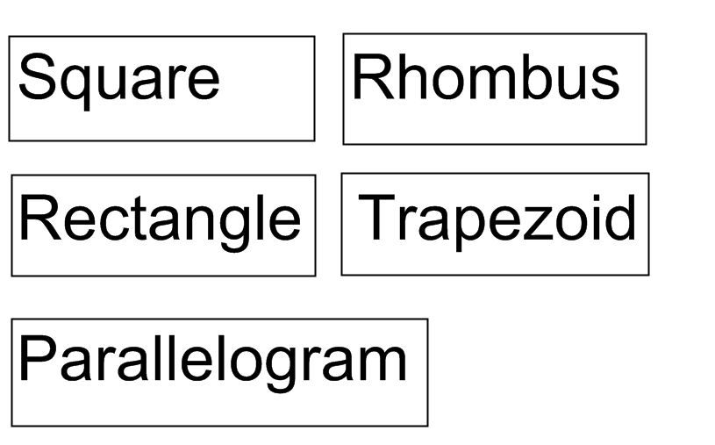

4.11.3: Sort and Classify Grade 8

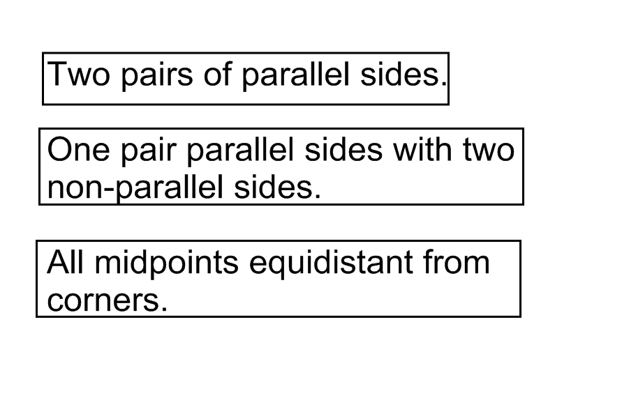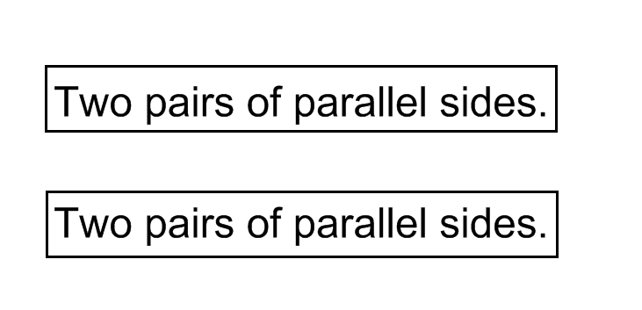

4.11.1/ 4.11.2/4.11.3: Sort and Classify Solutions Grade 8

