Unit 3 Grade 8
From Powers to Circles

Lesson Outline

BIG PICTURE

Students will:
- appreciate that numbers can appear in various numerical forms;
- represent whole numbers in expanded form using powers of ten;
- develop rules for multiplying and dividing by powers of 10 with positive exponents;
- apply rules for multiplying and dividing by powers of 10 to mentally solve problems;
- appreciate the need to find square roots;
- use calculators to estimate the square root of a number;
- draw circles and measure radii, diameters, and circumferences using concrete materials;
- investigate the relationship between the diameter and circumference of a circle to discover the constant ratio π;
- develop and use formulas for circumference and area of circles;
- solve problems relating to the radius, diameter, circumference, and area of a circle;
- understand and apply the order of operations and use of π key on calculators.
Day | Lesson Title | Math Learning Goals | Expectations
1 | Value of the Place | - Review value of the place and correct reading of large and small numbers from 0.001 to 999 999 999.  - Represent whole numbers using expanded form and expanded form with powers. | 8m11, 8m12  CGE 5b
2 | Powering Up with Powers of 10 | - Observe patterns when multiplying and dividing by powers of 10 with positive exponents.  - Develop a set of rules for multiplying and dividing by powers of 10 with positive exponents. | 8m11, 8m12, 8m73, 8m78  CGE 5b, 7b
3 | Perfect Square Patterns | - Review area of squares.  - Recognize perfect squares. | 8m43, 8m70, 8m78  CGE 4b, 4e
4 | Finding the Root of the Problem | - Determine square roots of perfect square numbers and non-perfect square numbers.  - Show that squaring and square rooting are inverse operations. | 8m11, 8m25  CGE 4b, 5a, 5b
5 | Talking About Circles  GSP®4 file:  Circles | - Use circle terminology.  - Measure parts and describe features of a circle.  - Investigate the relationship between the circumference and the diameter of a circle, i.e., C ÷ d = π. | 8m34, 8m35, 8m70, 8m73, 8m79  CGE 2b, 3b
6 | Mysterious Circles  GSP®4 file:  Investigating Regular Polygons | - Develop and apply formulas for the circumference of a circle.  - Practise metric conversions. | 8m24, 8m33, 8m34, 8m35, 8m36, 8m44, 8m70, 8m73, 8m74, 8m79  CGE 4b, 5b

Day | Lesson Title | Math Learning Goals | Expectations
7 | Circulating Problems | - Develop and apply the formula for the area of a circle.  - Use inquiry and communication skills. | 8m16, 8m18, 8m20, 8m36, 8m44  CGE 3c, 4f
8 | Parts and Wholes | - Apply formulas for circumference and area of circles in problem-solving situations. | 8m16, 8m34, 8m36, 8m68  CGE 3c, 5b
9 | Unusual Dart Board | - Apply formula for area of circles in problem-solving situations. | 8m16, 8m17, 8m18, 8m33, 8m36, 8m68, 8m73  CGE 2c, 5e, 5g
10 | Composition with Circles  GSP®4 file: Skateboard Park | - Apply formulas for circumference and area of circles in problem-solving situations involving composite shapes. | 8m16, 8m33, 8m36  CGE 2b, 5b
11 | Summative Assessment

Unit 3: Day 1: Value of the Place |  |  |  |  | Grade 8
Error: Reference source not found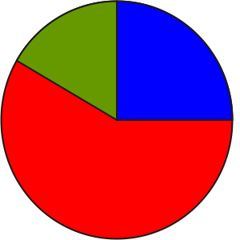 |  |  | Math Learning Goals  - Review value of the place and correct reading of large and small numbers from 0.001 to 999 999 999.  - Represent whole numbers using expanded form and expanded form with powers. |  | Materials  - place value mats  - centicubes  - BLM 3.1.1, 3.1.2
Assessment
Opportunities
 | Minds On… |  | Whole Class → Connecting  Pose these questions: What everyday examples involve the use of very large numbers? What is being measured by these very large numbers?  Students volunteer their ideas and record the answers on the board. |  | Among the possibilities are income, cell or bacteria counts, distances in outer space, and astronomy.  Students could use place value mats and base-ten blocks.  Students should be familiar with these three forms from previous grades.  It may be helpful to use base-ten blocks or calculators.
 | Action! |  | Whole Class → Instruction  Using an overhead of BLM 3.1.1 prompt students to name the columns with place values from hundred millions on the left to thousandths on the right of the decimal column. Write a number on BLM 3.1.1 and students say the number correctly e.g., 2.47 – two and forty-seven hundredths.  Point out that when reading numbers aloud it is important to remember “and” is used to express a decimal point, e.g., sixteen and eight-tenths – 16.8, fourteen and nine-thousandths – 14.009. Note: “and” is not used in one thousand forty – 1040.  Form of the Number → Representations  Standard form: 574  Word form: five hundred seventy-four  Expanded form: 500 + 70 + 4 = 5 × 100 + 7 × 10 + 4 × 1  (The final form of 574 in expanded form with powers of 10:  5 × 10² + 7 × 10¹ + 4)  Standard form: 603.12  Word form: six hundred three and twelve hundredths  Expanded form: 600 + 3 + 0.1 + 0.02 = 6 × 100 + 3 × 1 + 1 × + 2 ×  (The final form of 603.12 in expanded form with powers of 10:  6 × 10² + 3 + 1 ÷ 10 + 2 ÷ 10²)  Introduce another form which expresses the expanded form with powers.  Model how to represent the following:  100 as a power of 10  [100 = 10 × 10 = 10²]  100 000 as a power of 10 [100 000 = 10 × 10 × 10 × 10 × 10 = 10⁵]  Use questions such as the following to reinforce the meaning of powers of 10.  Ask:  - What do you notice about the exponent?  - How many times did you multiply by 10?  - Add the heading Powers of 10 to BLM 3.1.1 beside the Value of the Place column.  Curriculum Expectations/Oral Question and Answer/Mental Note: Ask students to represent numbers in a variety of forms. Provide immediate feedback.
 |  | Consolidate Debrief | Students complete two or three more examples to reinforce their understanding of the different forms.  Individual → Practice  Students work on BLM 3.1.2 individually.
Concept Practice |  |  | Home Activity and Further Classroom Consolidation  Complete worksheet 3.1.2.

3.1.1: Place Value Chart

Name:
Date:

Sample Numbers |  |  |  |  |  |  |  | Value of the Place
 |  |  |  |  |  |  |  | Hundred millions
 |  |  |  |  |  |  |  | Ten thousands
 |  |  |  |  |  |  | 3
 |  |  |  |  |  |  | 5
 |  |  |  |  |  |  | 2
 |  |  |  |  |  |  | 9 | Units
 |  |  |  |  |  |  | • | Decimal
 |  |  |  |  |  |  | 6

3.1.2: Value of the Place and Representing Numbers

Name:
Date:

Complete the charts.

Standard Form | 894 | 87.65 | 1 000 326
Word Form
Expanded Form
Expanded Form with Powers
Standard Form
Word Form | five hundred million and four-tenths | forty-seven and  six-tenths | seventy-eight million
Expanded Form
Expanded Form with Powers
Standard Form
Word Form |  |  | seven-thousandths
Expanded Form | 2 × 1000 + 4 × 10 + 7
Expanded Form with Powers |  | 6 × 10² + 8

Unit 3: Day 2: Powering Up with Powers of 10 |  |  |  |  | Grade 8
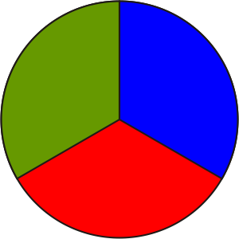 |  |  | Math Learning Goals  - Observe patterns when multiplying and dividing by powers of 10 with positive exponents.  - Develop a set of rules for multiplying and dividing by powers of 10 with positive exponents. |  | Materials  - place value mats  - centicubes  - algeblocks  - BLM 3.2.1
Assessment
Opportunities
 | Minds On… |  | Whole Class → Review Multiplying by Powers of 10  Students share their responses from the Home Activity in Day 1. Record and post the correct answers. Students order the numbers from smallest to largest.  Note if students understand the meaning of the decimal.
 | Action! |  | Think/Pair/Share → Building Algorithmic Skills  Students individually complete Part A of BLM 3.2.1. In pairs, they check results and look for patterns to complete Part B. Students test the strategies on new examples and then check their answers with calculators.  Curriculum Expectations/Question and Answer/Mental Note: Ask students to give answers to multiplying and dividing by powers of 10 without the use of a calculator.
 |  | Consolidate Debrief | Whole Class → Summarizing  Summarize the process:  1. When multiplying by powers of 10 the number gets larger, so shift the decimal to the right the same number of places as the exponent in the power of 10. Fill in any blanks in front of the decimal with zeros.  2. When dividing by powers of 10, the number gets smaller, so shift the decimal to the left the same number of places as the exponent in the power of 10. Fill in the blank places behind the decimal with zeros and add a zero to the left of the decimal if there is no other digit to the left of the decimal.
Application Concept Practice |  |  | Home Activity or Further Classroom Consolidation  Complete the practice questions. |  | Provide students with appropriate practice questions.

3.2.1: Finding a Pattern – Multiplying and Dividing
Using Powers of 10

Name:
Date:

Part A
Complete the chart, using a calculator.
Number | Instruction | Calculation | Result
1. a) 35.2 | Multiply by 10 | 35.2 × 10  = 35.2 × 10¹ | 352
b) 35.2 | Multiply by 100 | 35.2 × 100  = 35.2 × 10²
c) 35.2 | Multiply by 1000
d) 35.2 | Multiply by 10 000
e) 35.2 | Multiply by 100 000
2. a) 35.2 | Divide by 10 | 35.2 ÷ 10  = 35.2 ÷ 10¹ | 3.52
b) 35.2 | Divide by 100
c) 35.2 | Divide by 1000
d) 35.2 | Divide by 10 000
e) 35.2 | Divide by 100 000

Part B
Look for patterns:
1. When multiplying by powers of 10, the number gets.

2. If a number is multiplied by 10³, the decimal shifts
to the of its original position.

3. If a number is divided by 10², the decimal shifts
to the of its original position.

Unit 3: Day 3: Perfect Square Patterns |  |  |  |  | Grade 8
Error: Reference source not found |  |  | Math Learning Goals  - Review area of squares.  - Recognize perfect squares. |  | Materials  - 5 × 5 geoboards  - overhead geoboard  - BLM 3.3.1, 3.3.2, 3.3.3
Assessment
Opportunities
 | Minds On… |  | Whole Class → Orienting Students to an Activity  Look into a box or an envelope and say: I’m looking at a quadrilateral (four-sided polygon). I think it is a square. How do I know if it really is a square?  Discuss properties of squares using an overhead 3 × 3 dot grid (BLM 3.3.1), and ask how many different-sized squares can be drawn.  Students draw the different squares. Repeat the question with the 4 × 4 dot grid, so that they see the overlapping nature of 2 × 2 squares on a 4 × 4 dot grid.  If students cannot come up with more than 14 squares, challenge them to confirm that the shapes constructed using diagonal sides are squares. Challenge them to confirm this in several ways. |  | Diagonal squares should not be counted in this task.
 | Action! |  | Pairs → Shared Exploration  Students determine all the different-sized squares they can construct on a 5 × 5 geoboard. Students record their findings on BLM 3.3.2. Students who finish early can explore the total number of squares that can be generated on a 5 × 5 grid. This includes counting all squares with the same area. For example, there are twenty-five 1 × 1 squares.  Individual → Making Connections  Students complete BLM 3.3.3, illustrating the patterns they found and explaining how they applied this reasoning to answering question 3.
 |  | Consolidate Debrief | Whole Class → Sharing  Students share their responses (BLM 3.3.3).  Learning Skill (Class Participation, Initiative)/Presentation/Checklist: Observe the students’ participation in the activity and contributions to the solution of the problem.
Application Concept Practice |  |  | Home Activity or Further Classroom Consolidation  In your math journal, write the squares of all the numbers from 1 to 20 and note the patterns.

3.3.1: Overhead Grid Dot Paper – (Teacher)

● | ● | ● |  | ● | ● | ● |  | ● | ● | ●
● | ● | ● |  | ● | ● | ● |  | ● | ● | ●
● | ● | ● |  | ● | ● | ● |  | ● | ● | ●

● | ● | ● | ● |  | ● | ● | ● | ●
● | ● | ● | ● |  | ● | ● | ● | ●
● | ● | ● | ● |  | ● | ● | ● | ●
● | ● | ● | ● |  | ● | ● | ● | ●

● | ● | ● | ● |  | ● | ● | ● | ●
● | ● | ● | ● |  | ● | ● | ● | ●
● | ● | ● | ● |  | ● | ● | ● | ●
● | ● | ● | ● |  | ● | ● | ● | ●
3.3.2: 5 × 5 Grids

Name:
Date:

Use the grids below to record the results of your work.

● | ● | ● | ● | ● |  | ● | ● | ● | ● | ●
● | ● | ● | ● | ● |  | ● | ● | ● | ● | ●
● | ● | ● | ● | ● |  | ● | ● | ● | ● | ●
● | ● | ● | ● | ● |  | ● | ● | ● | ● | ●
● | ● | ● | ● | ● |  | ● | ● | ● | ● | ●

● | ● | ● | ● | ● |  | ● | ● | ● | ● | ●
● | ● | ● | ● | ● |  | ● | ● | ● | ● | ●
● | ● | ● | ● | ● |  | ● | ● | ● | ● | ●
● | ● | ● | ● | ● |  | ● | ● | ● | ● | ●
● | ● | ● | ● | ● |  | ● | ● | ● | ● | ●

● | ● | ● | ● | ● |  | ● | ● | ● | ● | ●
● | ● | ● | ● | ● |  | ● | ● | ● | ● | ●
● | ● | ● | ● | ● |  | ● | ● | ● | ● | ●
● | ● | ● | ● | ● |  | ● | ● | ● | ● | ●
● | ● | ● | ● | ● |  | ● | ● | ● | ● | ●
3.3.3: Squares in Patterns

Name:
Date:

1. How many squares in total can you find in each of the following?

a)

b)

c)

d)

2. The diagrams are the first terms in a sequence. Describe at least one pattern you observe to define the relationship between the number of the term and the total number of squares.

3. Explain how you would find the total number of squares for a 10 × 10 grid.
3.3.3: Squares in Patterns (continued)

Answers
1.
a) |  | 1

b) |  |  | four 1 × 1 + one 2 × 2 = 5 squares

c) |  |  |  | nine 1 × 1 + four 2 × 2 + one 3 × 3 = 14 squares  Encourage students to trace the different-sized squares in their notes.

d) |  |  |  |  | 16 + 9 + 4 + 1 = 30  There are sixteen 1 × 1 squares, plus nine 2 × 2 squares,  plus four 3 × 3 squares, plus one 4 × 4 square in a  4 × 4 grid.

2. The total number of squares for a term is the sum of the perfect square numbers
1² + 2² + 3² +… up to and including the term number squared.

3. There will be:
10² 1 × 1 squares, plus 9² 2 × 2 squares, plus 8² 3 × 3 squares, plus… 1² 10 × 10 square or 10² + 9² + 8² + … + 1² = 100 + 81 + 64 + 49 + 36 + 25 + 16 + 9 + 4 + 1 = 385 squares.

Unit 3: Day 4: Finding the Root of the Problem |  |  |  |  | Grade 8
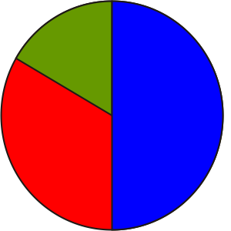 |  |  | Math Learning Goals  - Determine square roots of perfect square numbers and non-perfect square numbers.  - Show that squaring and square rooting are inverse operations. |  | Materials  - 5 × 5 geoboards  - BLM 3.4.1
Assessment
Opportunities
 | Minds On… |  | Whole Class → Connecting  Share and discuss students’ responses to the Home Activity on Day 3. |  |  | Familiarity with perfect square numbers significantly helps when exploring other applications, e.g., Pythagorean relationship.  The square root of a non-perfect square whole number is an irrational number. It can never be expressed as a fraction, and is a decimal that never ends or repeats, e.g.,
 | Action! |  | Whole Class → Modelling  Revisit the different squares generated on the 5 × 5 geoboard.  Demonstrate the relationship between the number squared, the area, and the perfect square, e.g., 2² is represented by the area model 2 × 2 as 4 represents an area and the perfect square.  Discuss the connection of squaring and taking the square root as inverse operations.
 |  | Consolidate Debrief | Pairs → Application  Students play Root Magnet, BLM 3.4.1. Ask students to determine the length of the side of the square using their list of squares from 1 to 20, e.g., 49, 225, 144. Discuss the “What if” problem: What if we want to determine the side of the square whose area is 30?  Students estimate using their list and verify using their calculator. Introduce the key, and discuss calculator procedures so they can determine how their calculators work.  Curriculum Expectations/Application/Checkbric: Provide immediate feedback to students as they play Root Magnet.
Application Concept Practice |  |  | Home Activity or Further Classroom Consolidation  Complete the practice questions. |  |  | Provide students with appropriate practice questions.

3.4.1: Root Magnet

Names:
Date:

Consult your list of squares to 20. Work in pairs.

How to Play
Each player selects three areas of squares from 1 to 500 and enters them on their opponent’s score sheet. Each player then estimates to find the length of the side of the square.

Make an estimate for all three side lengths. Use a calculator to determine estimate squared for Rounds 1 and 2 or the square root of area for Rounds 3 and 4.

Your score is the difference between Area of the Square and the square of your estimate. The score is the total of all the differences. The player with the lowest score is declared the Root Magnet!

Example: Rounds One and Two

Area of Square | Estimate Side of Square | Side Estimate Squared | Score
12 | 3.4 | 11.56 | 0.44
450 | 21 | 441 | 9
2 | 1.3 | 1.69 | 0.31
Player A |  | Total | 9.75

Example: Rounds Three and Four

Area of Square | Estimate Side  of Square | Square Root of  Area | Score
18 | 4.2 | 4.24 | 0.04
119 | 10.8 | 10.9 | 0.1
350 | 18.3 | 18.7 | 0.4
Player A |  | Total | 0.54

3.4.1: Root Magnet (continued)

Let’s Play
Round One
Area of Square | Side Estimate Side of Square | Side Estimate Squared | Score |  | Area of Square | Side Estimate Side of Square | Side Estimate Squared | Score
Player: |  | Total |  |  | Player: |  | Total

Round Two
Area of Square | Side Estimate Side of Square | Side Estimate Squared | Score |  | Area of Square | Side Estimate Side of Square | Side Estimate Squared | Score
Player: |  | Total |  |  | Player: |  | Total

Round Three
Area of Square | Estimate Side of Square | Square Root of Area | Score |  | Area of Square | Estimate Side of Square | Square Root of Area | Score
Player: |  | Total |  |  | Player: |  | Total

Round Four
Area of Square | Estimate Side of Square | Square Root of Area | Score |  | Area of Square | Estimate Side of Square | Square Root of Area | Score
Player: |  | Total |  |  | Player: |  | Total

Unit: 3 Day 5: Talking About Circles |  |  |  |  | Grade 8
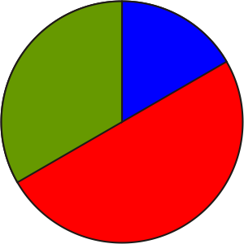 |  |  | Math Learning Goals  - Use circle terminology.  - Measure parts and describe features of a circle.  - Investigate the relationship between the circumference and the diameter of a circle, i.e., C ÷ d = π. |  | Materials  - cylindrical objects  - flexible measuring tape  - string  - calipers  - BLM 3.5.1, 3.5.2  - highlighters
Assessment
Opportunities
 | Minds On ... |  | Small Groups → Placemat  Students complete a placemat with the central question: What are some of the different parts and features of a circle? They write a collective response in the centre of the placemat.  Facilitate a whole-class discussion, and then students complete a diagnostic (BLM 3.5.1).  Curriculum Expectations/Quiz/Marking Scheme: Assess prior knowledge of circle terminology (BLM 3.5.1). |  |  | Circles.gsp  When returning diagnostic, highlight where different answers are possible for the same diagram.  Ways to measure circumference:  flexible tape measure, string/ruler, rolling edge along a ruler  Circles.gsp can be used to demonstrate parts of a circle and construction and measurement of features of a circle.  Students should see that the only possible relationship is  C ÷ d.
 | Action! |  | Whole Class → Instruction  Discuss different ways that parts of a circle can be measured, e.g., using a ruler, using The Geometer’s Sketchpad®4, using a string/ruler combination.  Discuss how to accurately measure a diameter. Show a pair of calipers. Students think about and suggest how these might be used to measure diameters. Demonstrate how to use calipers to measure the diameter of a circular object.  Pairs → Investigation  Number a collection of objects with circular faces and display them in one location in the classroom. Each pair selects one type of item, e.g., cans, paper plates, cups.  Explain the instructions (BLM 3.5.2), stressing careful measurement. Students record their observations to the nearest tenth. Students exchange the item after measuring it. They take measurements for at least six items before starting the calculations.
 |  | Consolidate Debrief | Whole Class → Summarizing  Compare the data collected. Remeasure and recalculate data that doesn’t seem to fit. Discuss responses to question 6. Guide students to see that there is a relationship between the circumference and diameter.
Concept Practice  Differentiated  Exploration |  |  | Home Activity or Further Classroom Consolidation  Find other circular objects that have a very large diameter, e.g., vehicle tire, tree stump. Confirm that the relationship works for these objects.

3.5.1: Looking at Circles

Highlight the indicated feature on each diagram.

centre | radius | diameter
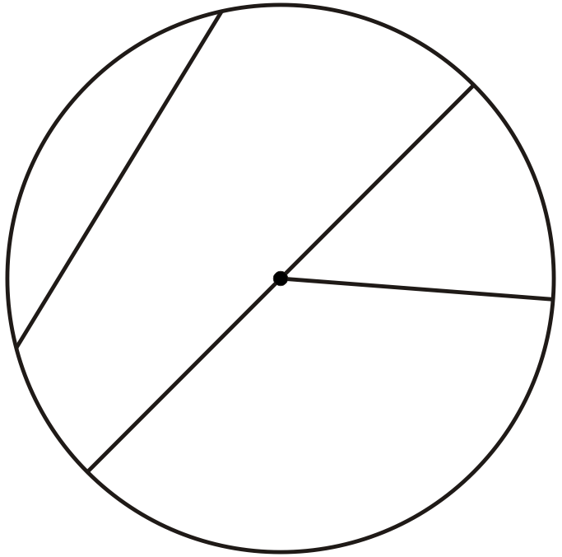
chord | circumference | area
arc | sector | segment

3.5.2: Exploring Relationships within the Circle

1. Select an object with a circular face.

2. Measure the circumference (C) to the nearest 0.1 cm. Record the measurement.

3. Measure the diameter (d) to the nearest 0.1 cm. Record the measurement.

4. Repeat the first three steps with different objects.

5. Do the calculations indicated in the chart. Use a calculator and round answers to the nearest one-hundredth.

Object | C | d | Calculations
Object | C | d | C − d | C + d | C ÷ d | C × d

6. Examine the four Calculations columns. Describe any patterns that you see.

Circles (GSP®4 file)
Circles.gsp

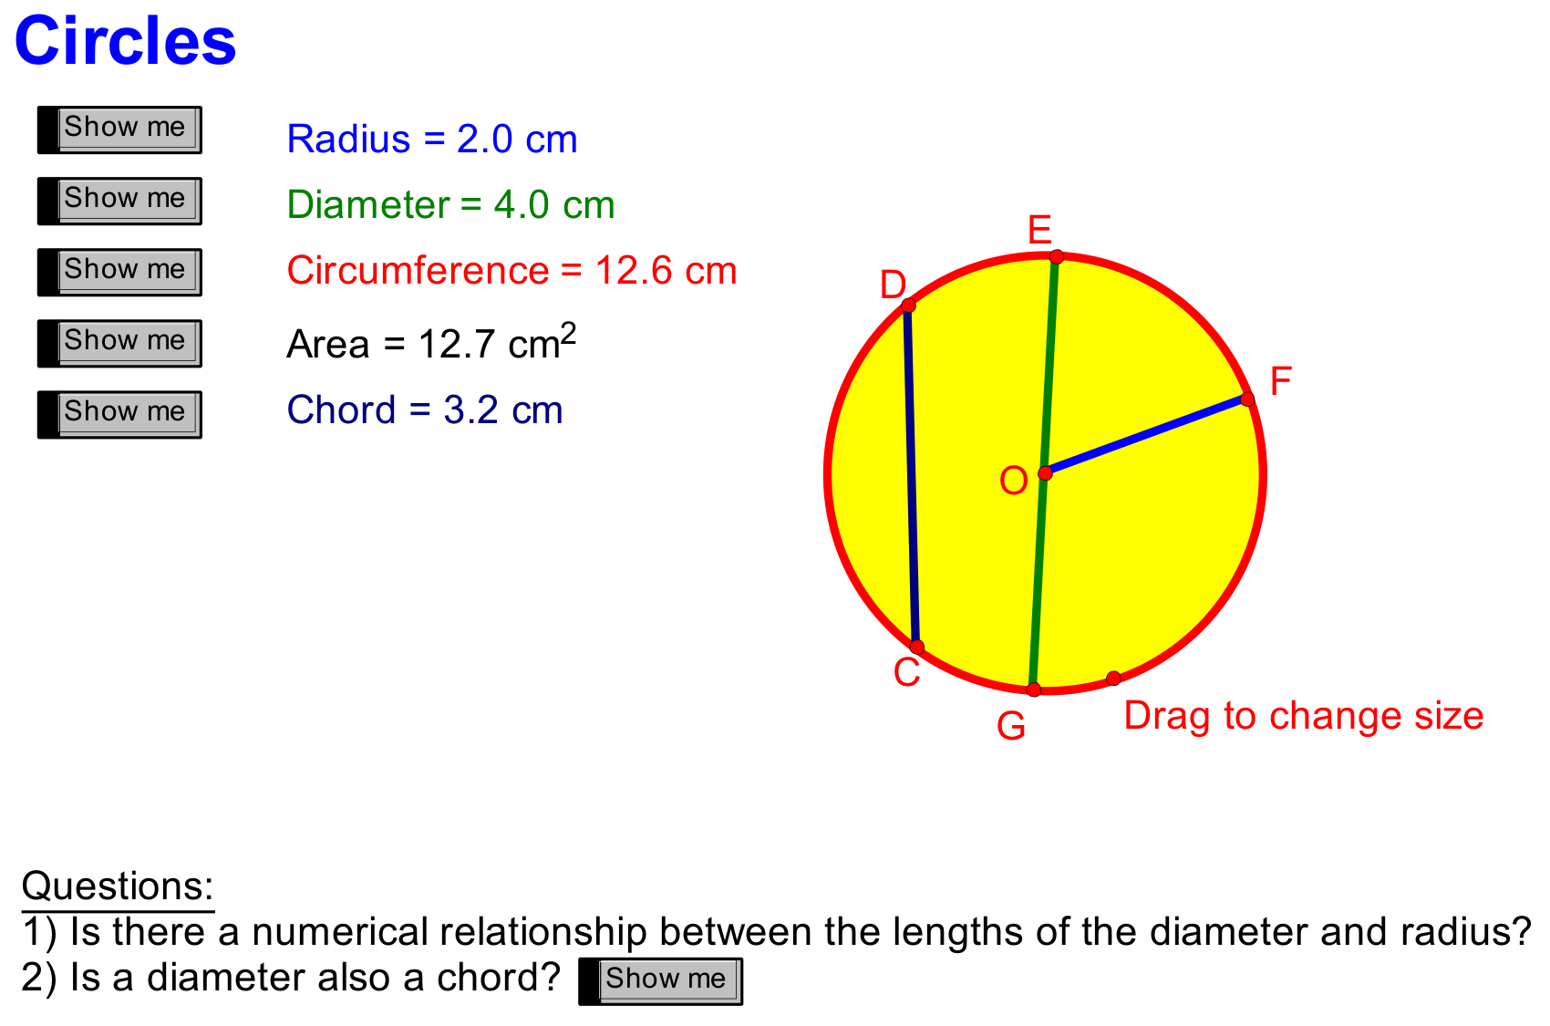

Unit 3: Day 6: Mysterious Circles |  |  |  |  | Grade 8
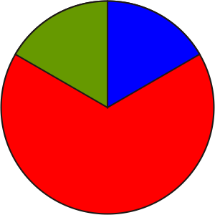 |  |  | Math Learning Goals  - Develop and apply formulas for the circumference of a circle.  - Practise metric conversions. |  | Materials  - computer  - BLM 3.6.1, 3.6.2
Assessment
Opportunities
 | Minds On ... |  | Whole Class → Discussion  Discuss students’ observations from the investigation (Day 5). Guide them to the hypothesis that the ratio of the circumference to the diameter in any circle is a constant.  The number 3.14 is an approximation for π. Students should also explore how the calculations in Day 5 Home Activity change when the π key is used on the calculator. |  |  | Investigating Regular Polygons.gsp  This GSP file includes dynamic sketches that can be used to show another method for approximating the value of π.  Students should know how to use the π key on a calculator.  Word Wall  - value of π (pi)  - formula for finding circumference (given d) and for finding the diameter (given C)  Did you know? …Einstein’s birthday is on π Day – March 14. Ask students why March 14 is called π day and why celebrations occur at 1:59 p.m.
 | Action! |  | Pairs → Exploration  Explain that this computer exploration will simulate what students did during their investigation (Day 5). Students construct a circle in The Geometer’s Sketchpad®4 to explore the ratio (BLM 3.6.1). They collect data that confirms or denies the hypothesis.  Whole Class → Discussion  Demonstrate that the dynamic exploration confirmed the hypothesis that the ratio of the circumference to the diameter in any circle is a constant. Name the constant as π (pi).  Compare the two different exploration methods. The dynamic exploration results in a greater degree of accuracy.  Demonstrate how greater accuracy can be shown on The Geometer’s Sketchpad®4 by changing the measurement properties.  Practise some metric conversions as you show the measurement properties.  Ask: If you know the diameter or radius, how can you determine the circumference? Share a few examples.  Ask: If you know the circumference, how can you find the diameter or area? Share a few examples. State the relationship in a formula for the circumference of a circle.  Pairs → Practice  Students work in pairs to complete BLM 3.6.2.  Curriculum Expectations/Observation/Mental Note: Assess understanding of how to use the circumference formula.
 |  | Consolidate Debrief | Whole Class → Discussion  Discuss responses to BLM 3.6.2. Discuss how the formulas for finding the circumference and the diameter would change if the radius were used.  Students explain how they could construct a circle if the circumference is given.
Exploration |  |  | Home Activity or Further Classroom Consolidation  Start your π project, A Taste of Pi. Your project can take the form of a report, poster, letter to the editor, or introductory letter. Include some interesting π facts and history. List the first twenty digits of π. Include an explanation of why π is called an irrational number. Two websites you can visit for information are:  http://www.ualr.edu/lasmoller/pi.html  http://www.geom.uiuc.edu/~huberty/math5337/groupe/welcome.html  Your project will be assessed for accuracy and effective communication.

3.6.1: Investigating the Relationship between C and d
Using The Geometer’s Sketchpad®4

1. Construct a circle.
Draw a line segment from the centre of the circle to the outside edge and label it “r” to represent the radius.
Construct a line perpendicular to r through the centre of the circle.
Construct points where the perpendicular line and circumference meet.
Hide the perpendicular line.
Draw a line segment between the two points.
Label the new line segment “d” for diameter.
Label the circumference “C.”

2. Measure the length of the radius (r) and diameter (d).
Measure the circumference (C).
Calculate: C ÷ d.
Highlight the four calculated values and create a table with appropriate labels.
Change the size of the circle by dragging the size control point.
Double click on the table to enter another value.
Repeat this step 5 times, then look for a pattern in one of the columns.

Investigating the Relationship between C and d
Using The Geometer’s Sketchpad®4

1. Construct a circle.
Draw a line segment from the centre of the circle to the outside edge and label it “r” to represent the radius.
Construct a line perpendicular to r through the centre of the circle.
Construct points where the perpendicular line and circumference meet.
Hide the perpendicular line.
Draw a line segment between the two points.
Label the new line segment “d” for diameter.
Label the circumference “C.”

2. Measure the length of the radius (r) and diameter (d).
Measure the circumference (C).
Calculate: C ÷ d.
Highlight the four calculated values and create a table with appropriate labels.
Change the size of the circle by dragging the size control point.
Double click on the table to enter another value.
Repeat this step 5 times, then look for a pattern in one of the columns.
3.6.2: Circus of Circles

Calculate the missing measures. Use a calculator. Show your work.

a) hoop | b) surface of drum | c) surface of circular barrel
 |  | 
d) base of tent | e) hoop waist | f) unicycle wheel
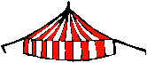 | 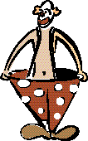 | 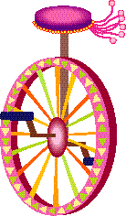

The unicycle wheel in part (f) made 1000 complete revolutions as it traveled down a road.
What distance did the rider travel?
State your answer in units that are more appropriate than centimetres.
Investigating Regular Polygons (GSP®4 file)
Investigating Regular Polygons.gsp

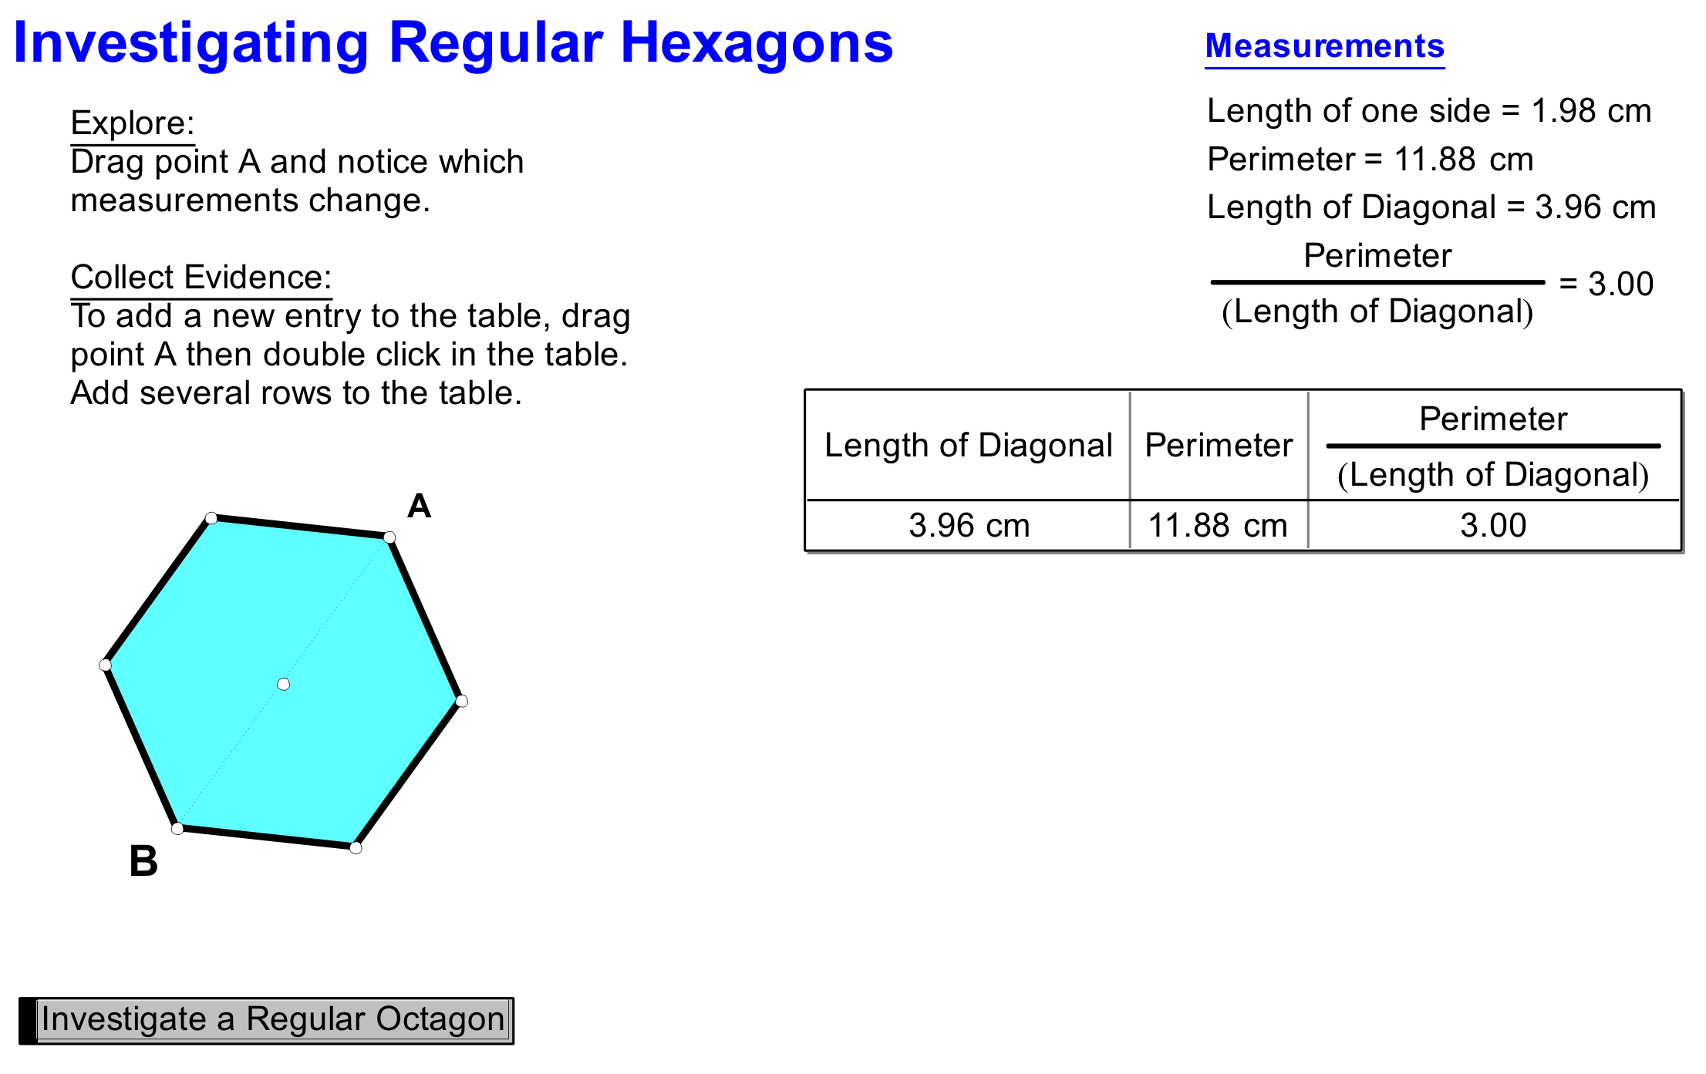

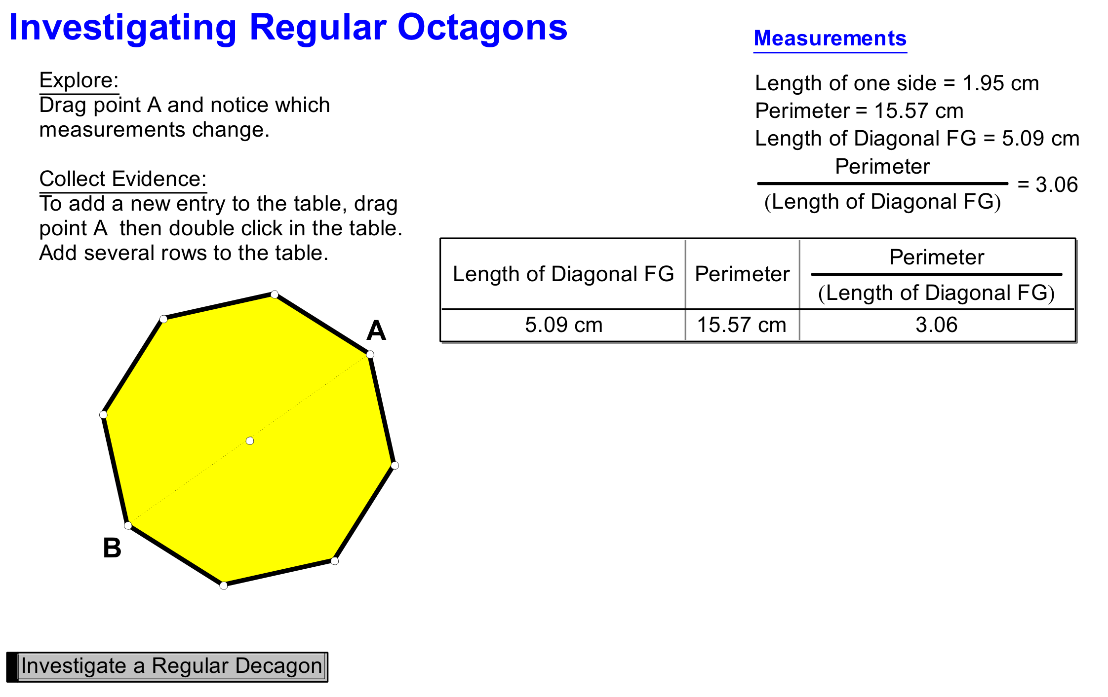

Investigating Regular Polygons (GSP®4 file continued)

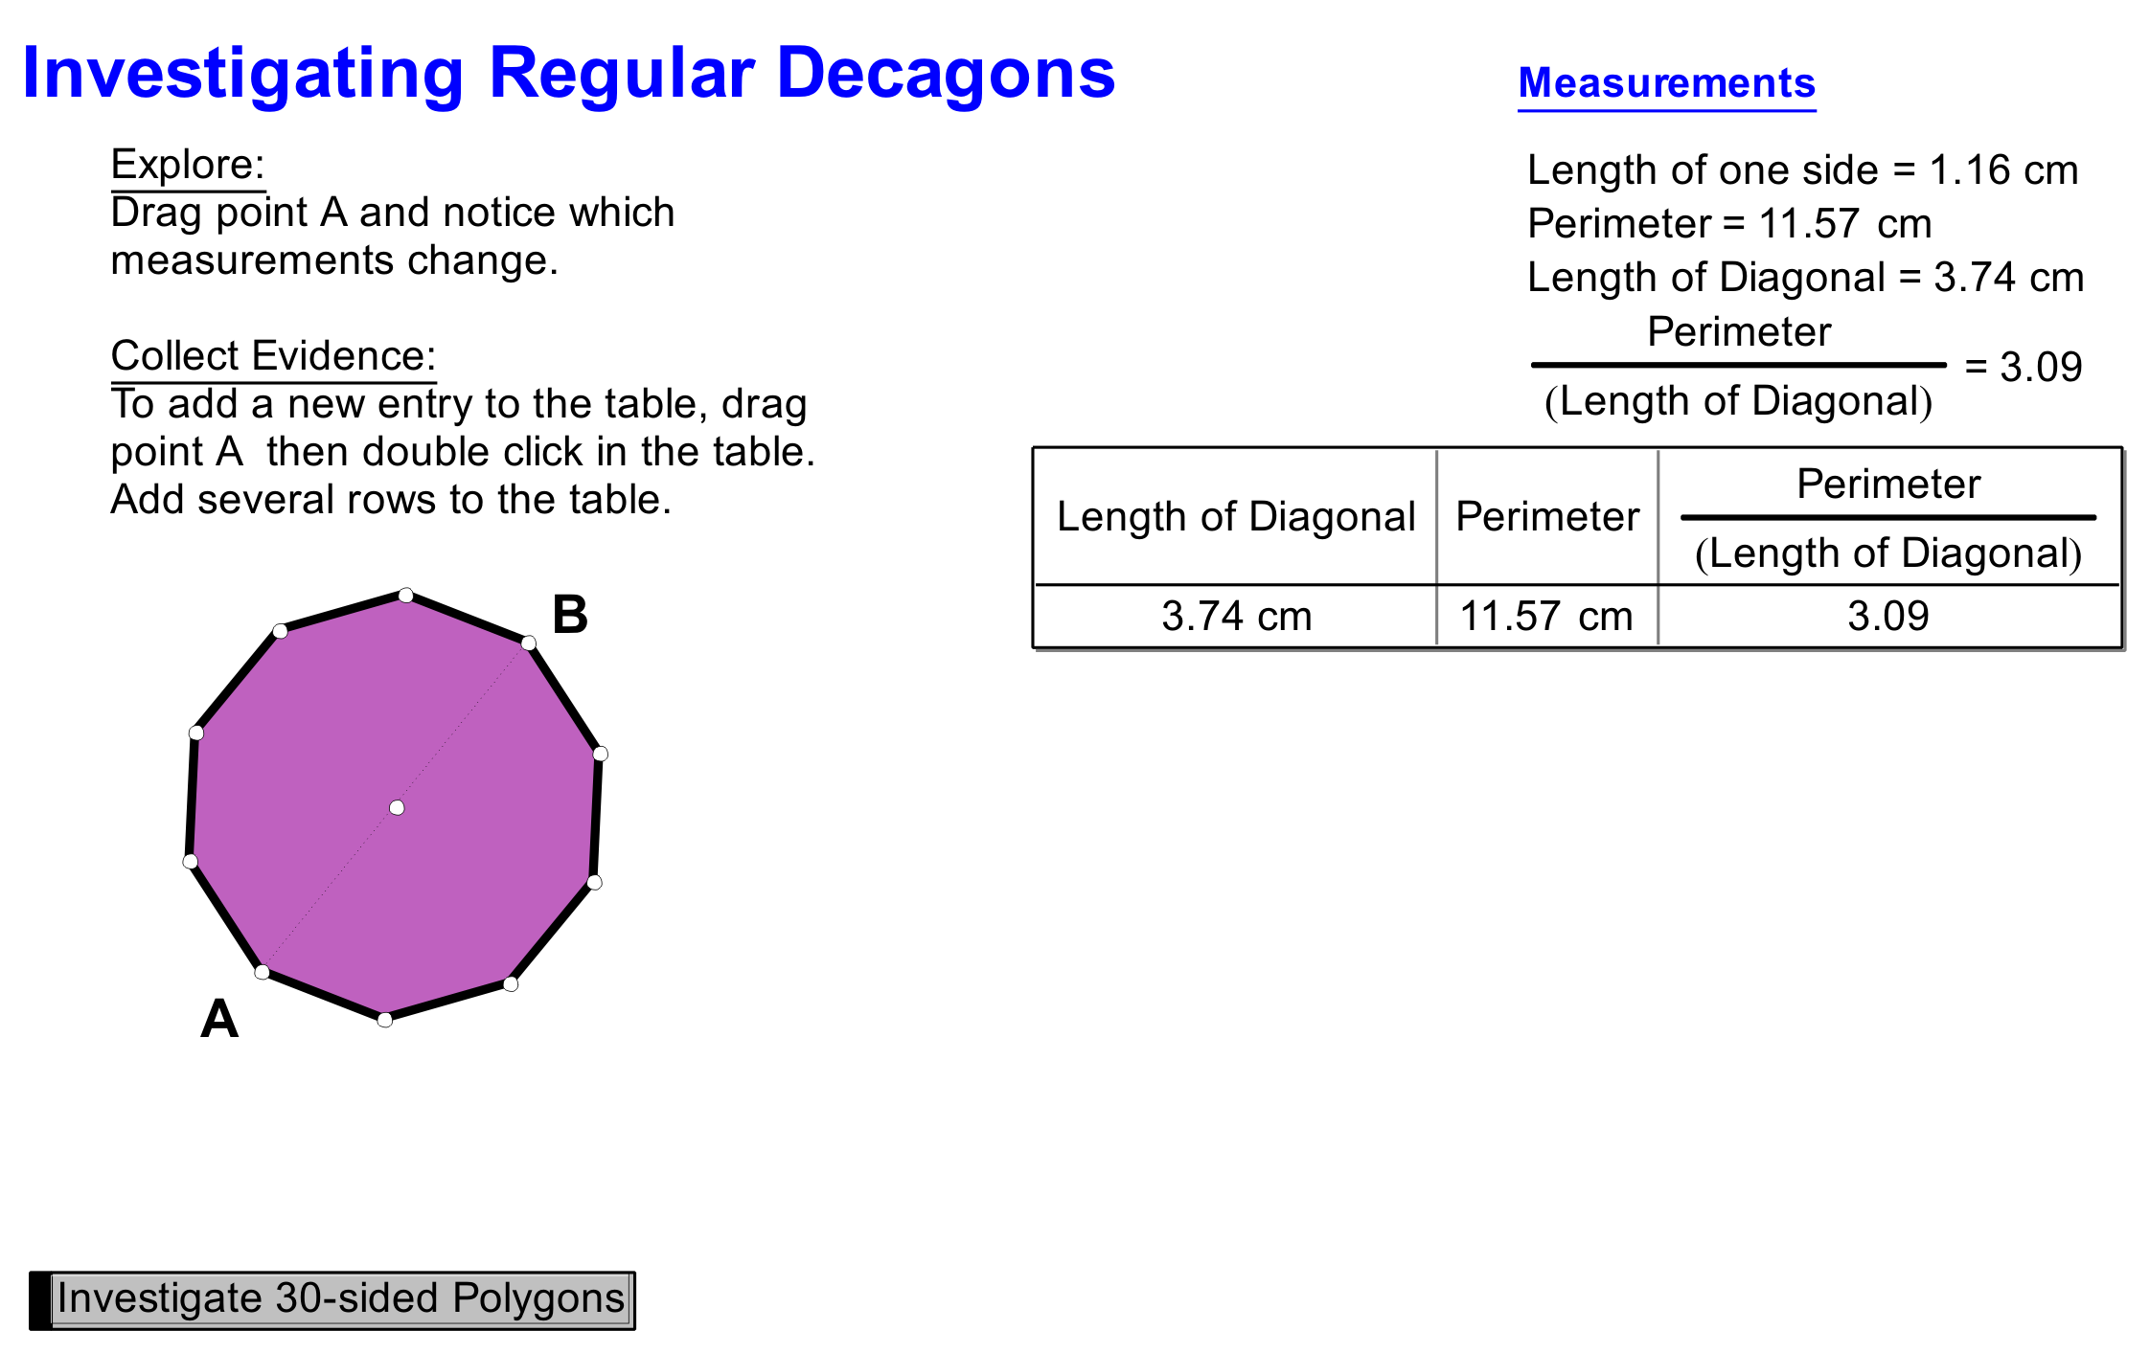

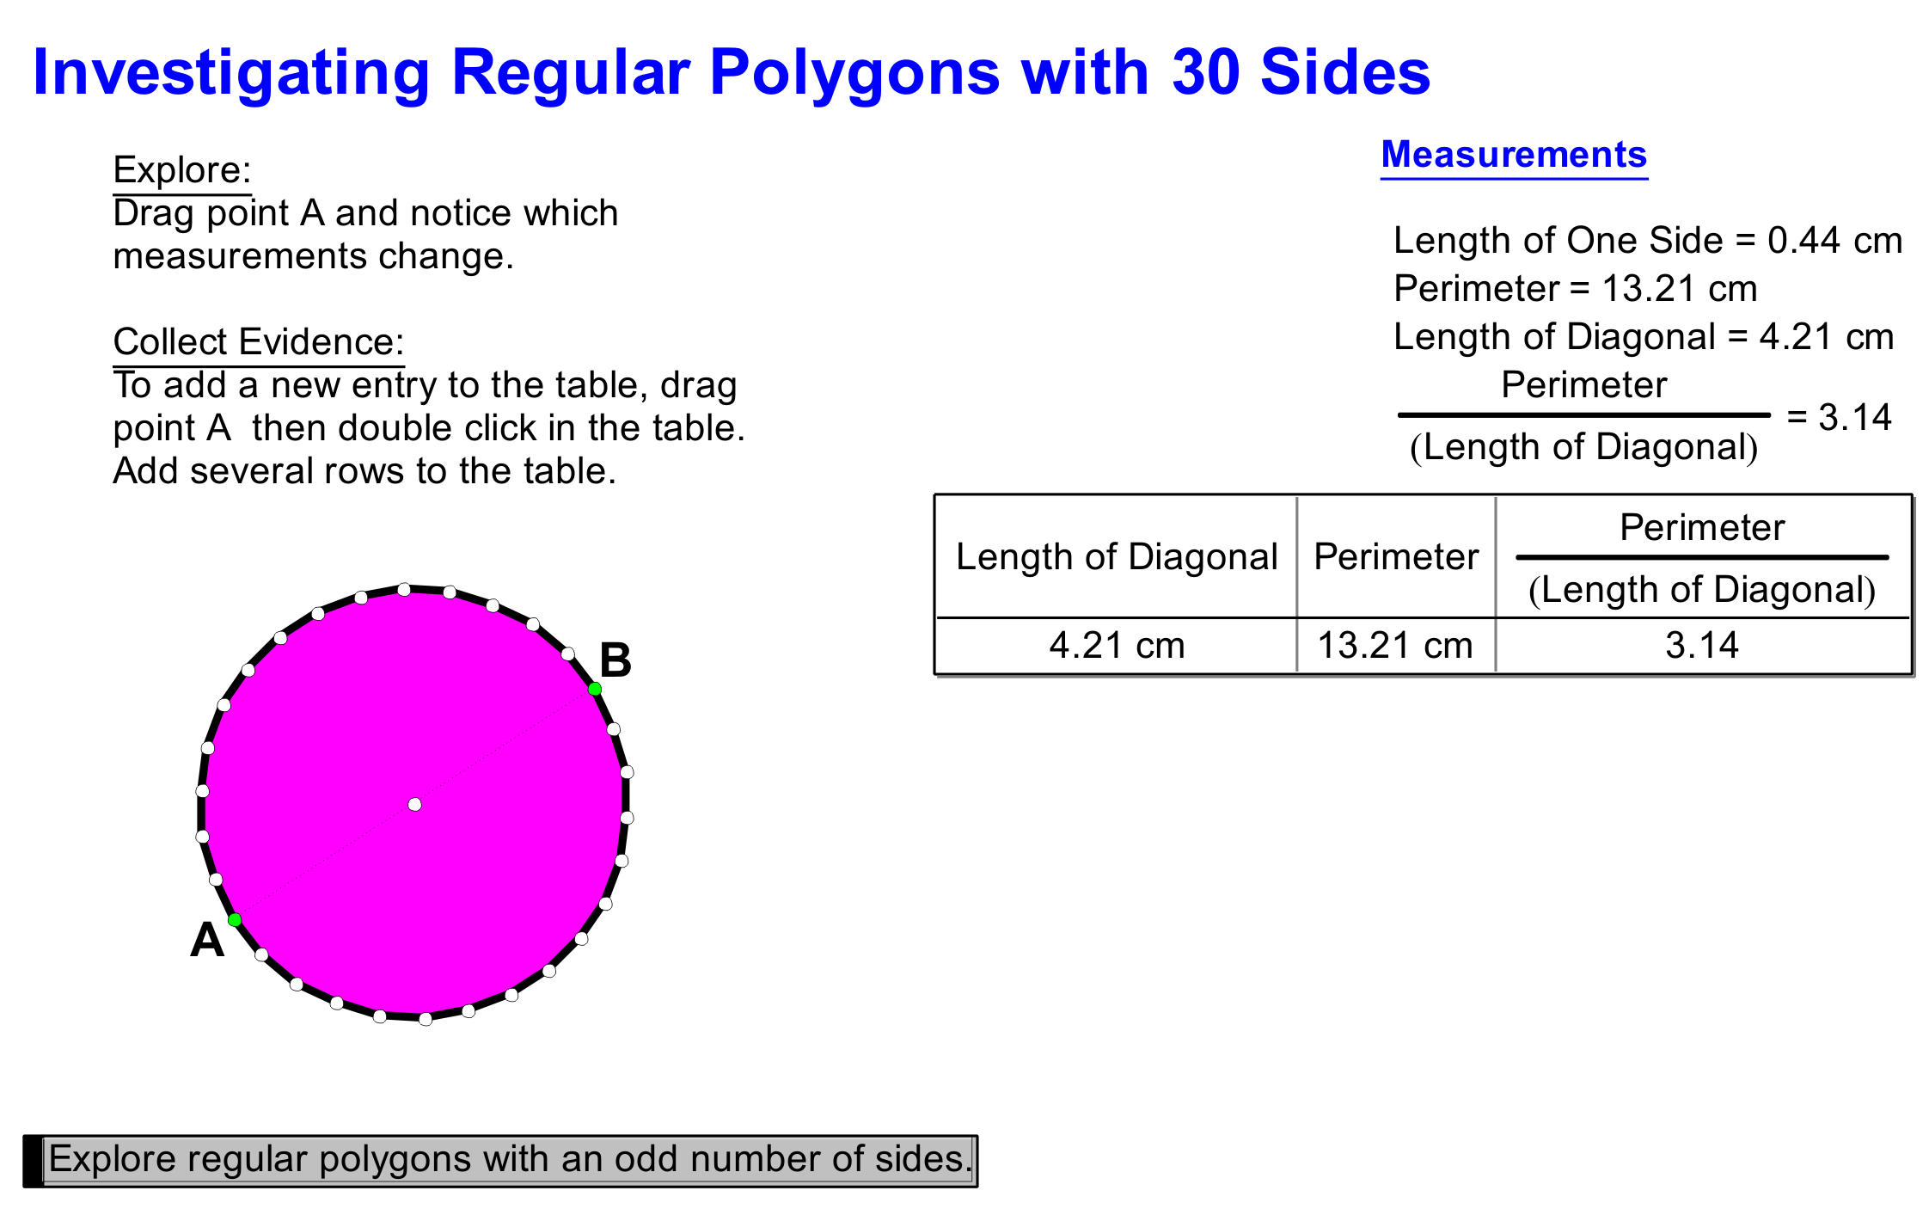
Investigating Regular Polygons (GSP®4 file continued)

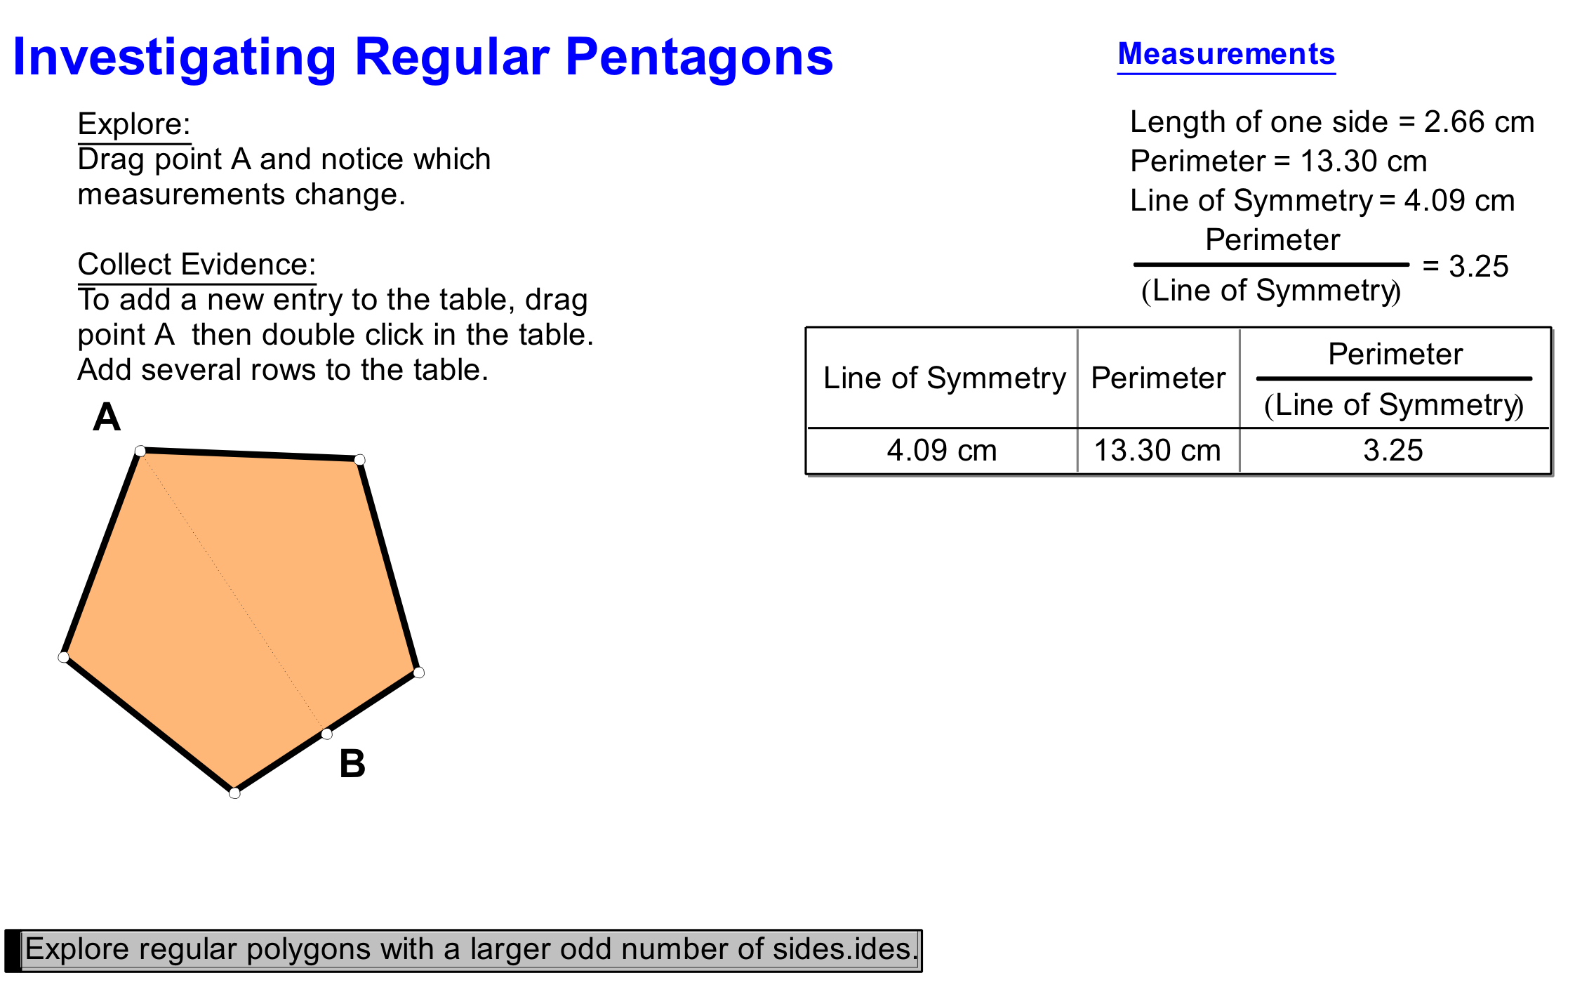

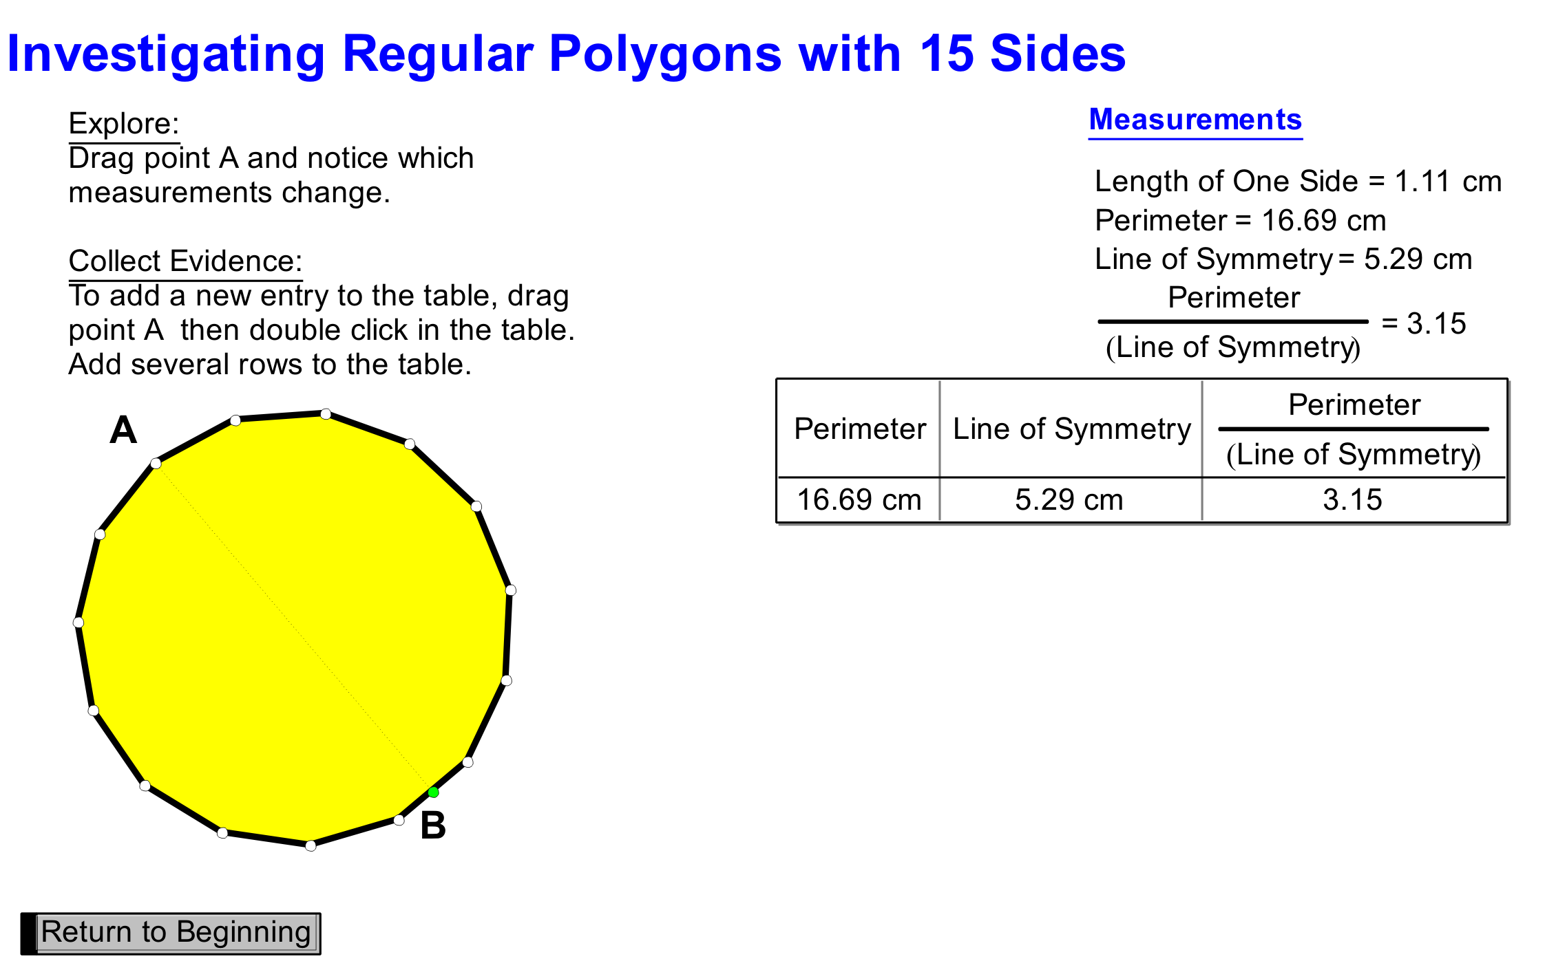

Unit 3: Day 7: Circulating Problems |  |  |  |  | Grade 8
 |  |  | Math Learning Goals  - Develop and apply the formula for the area of a circle.  - Use inquiry and communication skills. |  | Materials  - scissors  - tape/glue  - fraction circles  - grid paper  - BLM 3.7.1, 3.7.2
Assessment
Opportunities
 | Minds On ... |  | Small Groups → Brainstorm → Investigation  Pose the following problem:  A dog is on a rope that is attached to a stake in the ground. The area that the dog can access is badly damaged and the grass needs to be replaced with sod. How can you estimate the amount of sod needed?  Model this problem so students can see that the dog has access to a circular area. Compare this to a circumference problem. Small groups complete  BLM 3.7.1. |  | On the board, use string and chalk to represent the stake and the dog, to provide a visual representation.  Word Wall  - A = πr²
 | Action! |  | Small Groups → Exploration  The first three activities on BLM 3.7.2 involve the exploration of the area of a circle. Each group works on one of the three and summarizes their activity.  Curriculum Expectations/Observation/Mental Note: Assess communication and inquiry skills.
 |  | Consolidate Debrief | Whole Class → Discussion  Discuss the mathematical reasoning students used in each activity. Discuss the pros and cons of each estimation method for determining the area of a circle. Guide students to the conclusion that the formula for the area of a circle is  A = πr².  Model how to use the formula by determining the area of the circle found on BLM 3.7.1.
Exploration |  |  | Home Activity or Further Classroom Consolidation  Complete Activity 4 on worksheet 3.7.2.

3.7.1: Who Gets Wet?

It is a hot day in June and to cool off, the class decides to use its outside activity break to play a sponge toss. The students line up in rows as shown with ‘fair ground’ anywhere within the rectangular outline shown. The person near the middle of the field gets to toss the first sponge. He can throw it far enough to reach the person standing one row ahead of him, one place to the right, for example. Construct a circle to show all possible ‘fair’ landing locations for the sponge.

The person standing in the upper right corner of the diagram can throw the sponge the same distance. Construct a model of the possible ‘fair’ landing area for her sponge.

What is the total possible ‘fair’ landing area for the sponge from tosses of the two sponges? How many students might get wet from these two sponges?

2 m
2 m

3.7.2: Estimating the Area of a Circle

Activity 1: Circles Inscribed in Squares

Materials
Circle inscribed in a square, scissors, tape or glue, highlighter

Instructions
Using the diagram on the next page, shade the small square as illustrated in the diagram on the left.
- What is the length of one side of the small square?
- What is the area of the small square?
Use words to compare the area of the small square to the area of one-quarter of the circle, i.e., greater than, less than, equal to.
Shade a congruent small square adjacent to the first small square as illustrated in the diagram.
Use words to compare the area of the two small squares to the area of one-half of the circle.
Shade a third congruent small square adjacent to the second small square as illustrated.
Use words to compare the area of the three small squares to the area of three-quarters of the circle.

Cut away the three shaded areas covered by the small squares which are not part of the inside of the circle. Fit the cut-out shaded area pieces onto the remaining quarter of the circle. The pieces may need to be cut into smaller pieces to fit inside the circle.

Compare the area of 3 squares to the area of the circle.
Do the shaded pieces completely cover the remaining part of the circle?

Jason said: The area of a circle is just a little more than three times its radius squared.
(Area of a circle) > 3r²

Confirm or deny his statement based on your exploration.

3.7.2: Estimating the Area of a Circle (continued)

3.7.2: Estimating the Area of a Circle (continued)

Activity 2: Circles and Parallelograms

Materials
Fraction circles

Instructions

Arrange the eight one-eighth fraction pieces to form a “curvy” parallelogram.
Arrange the twelve one-twelfth fraction pieces to form a different “curvy” parallelogram.
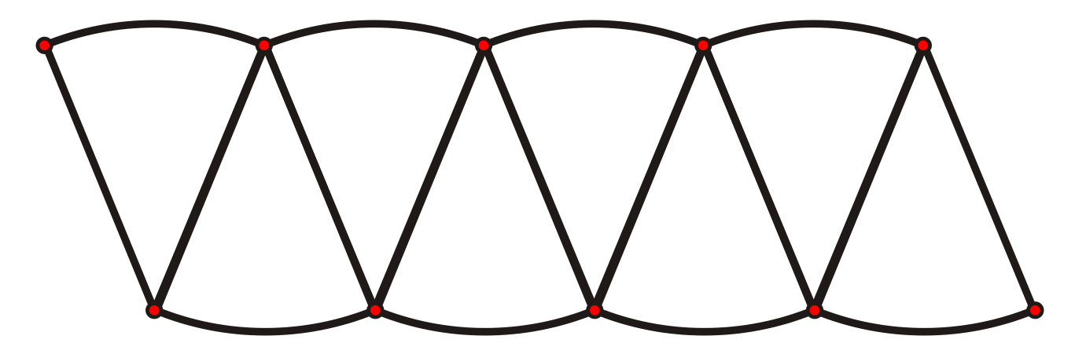

Jessie recalls that the area of a parallelogram is (base × height).

She considers the arrangement of fraction pieces to be a parallelogram and she reasons that the height of the parallelogram is the radius (r) of the full circle.

She further reasons that the base of the parallelogram is half the circumference of the circle,
i.e., (2πr ÷ 2), which is πr.

With all of this information, Jessie concludes that the area of the parallelogram is πr².

Jessie concludes that the area of a full circle is πr².

Do you agree or disagree with Jessie’s reasoning?

Give reasons for your answer.

3.7.2: Estimating the Area of a Circle (continued)

Activity 3: Circles on Grid Paper

Trace the circle below onto centimetre grid paper.

Colour the squares it completely covers.

Estimate the area of the circle, thinking about the partially covered squares.

How could you use a similar method to get a more accurate answer?

3.7.2: Estimating the Area of a Circle (continued)

Activity 4: Triangles from Squares on Circles

Diagram 1
The length of the side of the square is the same as the length of the radius of the circle.

Diagram 2
Kim cut the square into 4 congruent triangles and placed the triangles onto the circle as shown in the second diagram.

Questions
How many squares will Kim need to completely cover the circle?
(Notice that part of each triangle extends outside the circle.)

If the side of the square is 5.0 cm long, then
a) what is the area of one square?
b) what is the area of one circle?
Give reasons for your answer.

Unit 3: Day 8: Parts and Wholes |  |  |  |  | Grade 8
 |  |  | Math Learning Goals  - Apply formulas for circumference and area of circles in problem-solving situations. |  | Materials  - fraction circles  - chart paper, marker  - index cards
Assessment
Opportunities
 | Minds On ... |  | Whole Class → Sharing  Students write one or two interesting points about π that they learned as part of their Day 6 Home Activity on an index card. Collect the completed worksheets from the Home Activity. Students keep the index cards.  Using Inside Outside Circles, students share one interesting point from their card with a partner, then the partner shares one interesting point from his/her card. Students find new partners and repeat the process.  Draw the “dog on a rope” problem on the board, attaching the rope to a corner of a rectangular doghouse. Illustrate a length of rope that is less than either the width and length of the doghouse.  Students calculate the area that the dog has access to.  Students calculate the circumference of the circle. |  | Consider completing a few index cards in advance for students who did not complete the assignment but who can benefit from the activity using Inside Outside Circle.  r  r  r  When estimating, students use π ≈ 3. Review calculator keystrokes, as needed.
 | Action! |  | Pairs → Practice  Students estimate the top surface area of a penny, dime, and quarter (or top surfaces of round objects in the classroom) and then check by calculation.  Curriculum Expectations/Observations/Mental Note: Assess the use of the area formula and the calculator for order of operations.  Small Groups → Investigation  Give each group one piece of chart paper, a marker, and one fraction piece from a set of fraction circles. Groups find the perimeter and area of their fraction piece. Prompt students to add the radii lengths when calculating the perimeter of fraction pieces, as necessary.
 |  | Consolidate Debrief | Small Groups → Presentations  Each group presents its solutions.  Ask how groups could have calculated their answers quickly by knowing just one other group’s answers.
Application  Differentiated |  |  | Home Activity or Further Classroom Consolidation  Extend the doghouse problem by making the rope length longer than the side length of the doghouse. For example: The doghouse is 2 m × 3 m and the rope is 4 m long. What is the perimeter of the shape that the dog’s rope will reach if the rope is kept tight? What is the area of grass the dog can walk on?

Unit 3: Day 9: Unusual Dart Board |  |  |  |  | Grade 8
 |  |  | Math Learning Goals  - Apply formula for area of circles in problem-solving situations. |  | Materials  - BLM 3.9.1, 3.9.2  - scissors  - glue  - grid paper
Assessment
Opportunities
 | Minds On ... |  | Whole Class → Small Group  Students discuss their Home Activity questions, explaining their reasoning, and write up a solution to share. The class goes on a gallery walk to view the various solutions.  Curriculum Expectations/Quiz/Marking Key: Students complete quiz  (BLM 3.9.1).
 | Action! |  | Small Groups → Activity  Discuss the game of darts and how scoring works to set the context for the problem. Use dart board problem from Continuum and Connections – Perimeter, Area, and Volume, pp. 25–31. Select groups to record then solve on chart paper (BLM 3.9.2).
 |  | Consolidate Debrief | Whole Group → Discuss  Groups present their solutions. Share as many solutions as possible.  Individual → Response Journal  Students reflect on all the different ways that the dart board problem was solved by writing up at least two different solutions.
Application  Differentiated |  |  | Home Activity or Further Classroom Consolidation  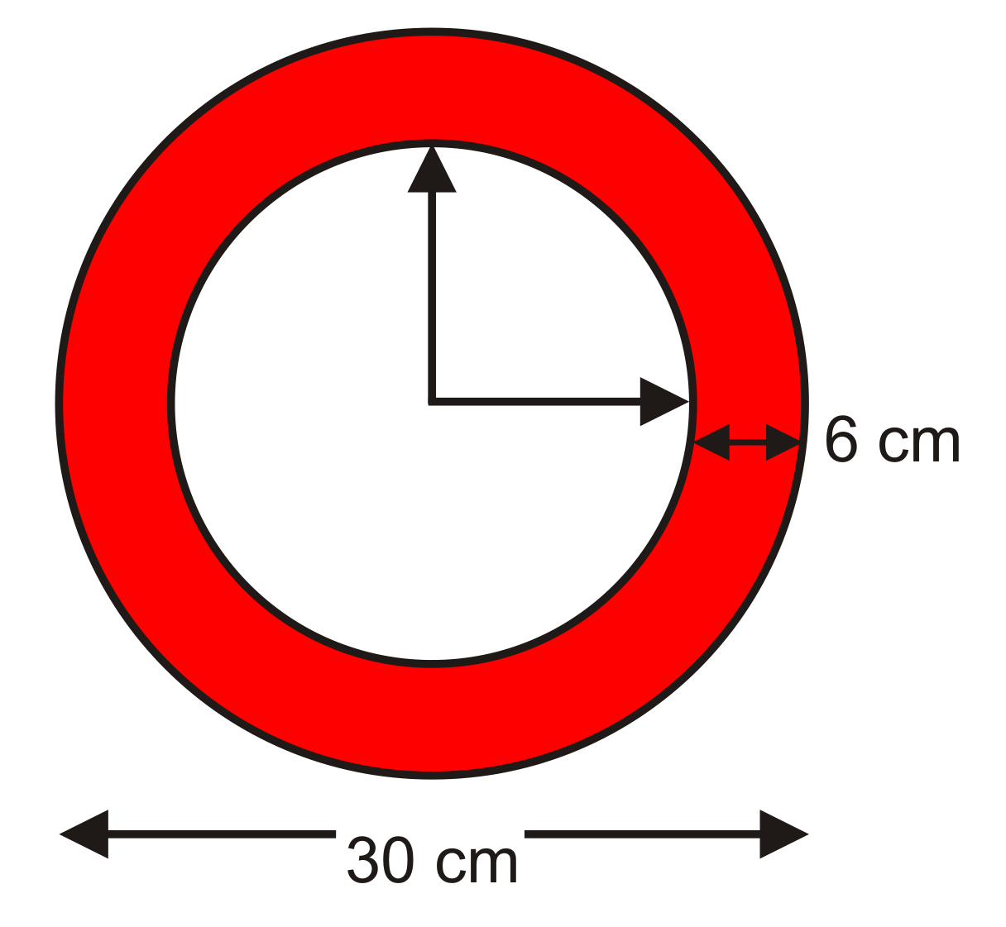  1. The clock in a classroom has the dimensions shown. Explain how you would determine the surface area of the frame of the clock.  2. Describe how you would determine what percentage of the surface area is the face of the clock.

3.9.1: Area and Perimeter Proficiency Quiz

Name:
Date:

1. Determine the area of each shape. Show your work.
a) | Answer:
b) | Answer:

2. Determine the perimeter of each shape. Show your work.
a) | Answer:
b) | Answer:

3.9.2: Unusual Dart Board

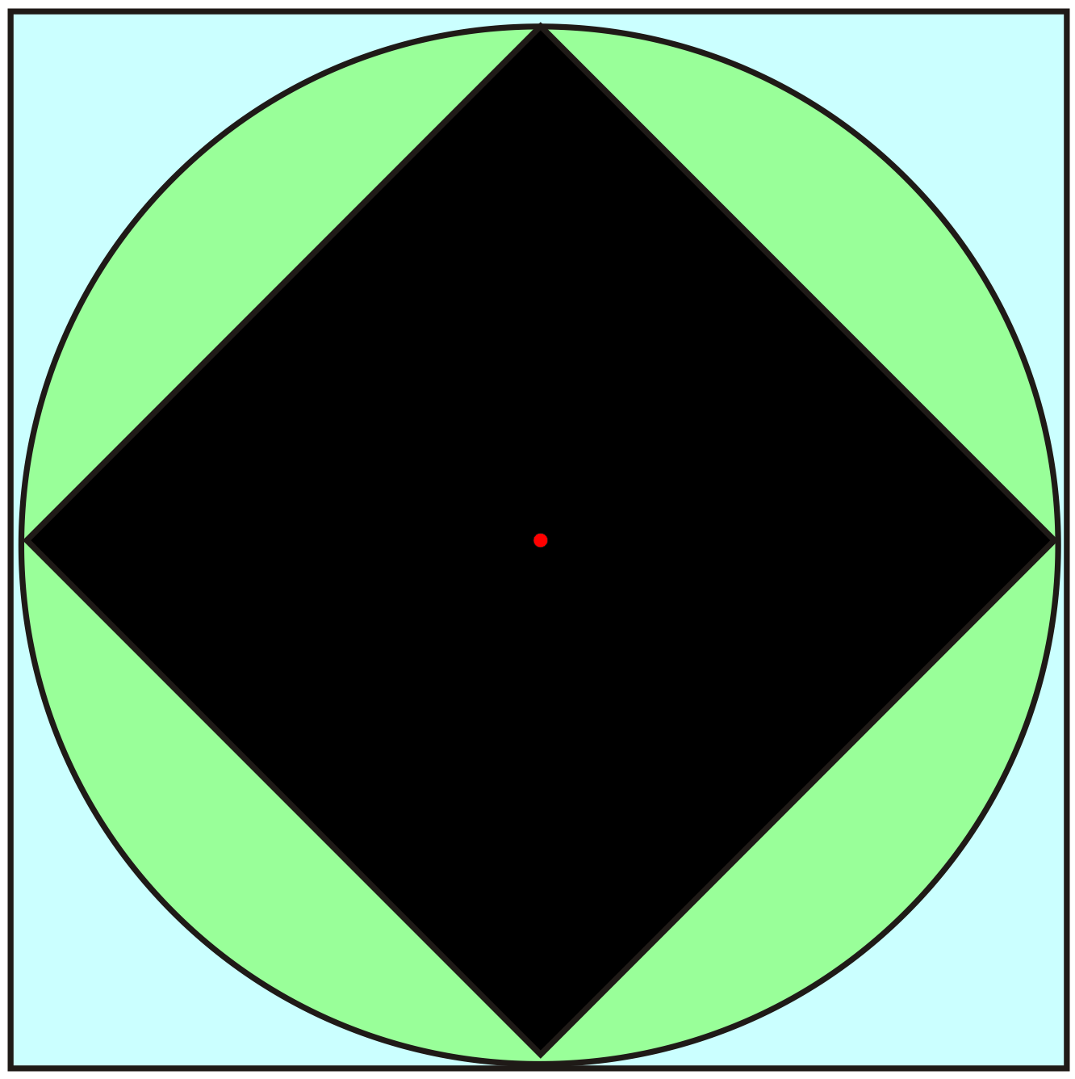
This dart board is designed with a square inside a circle and a square outside the same circle.

Assign numerical values of 2, 5, and 8 to the three coloured regions on the dart board such that regions with smaller areas are assigned higher scores.

Justify your solution.

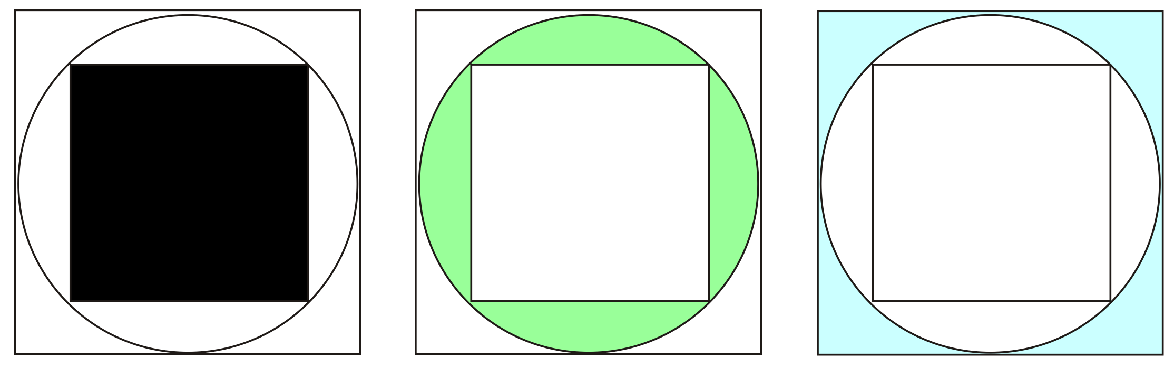

Unit 3: Day 10: Composition with Circles |  |  |  |  | Grade 8
 |  |  | Math Learning Goals  - Apply formulas for circumference and area of circles in problem-solving situations involving composite shapes. |  | Materials  - BLM 3.10.1, 3.10.2, 3.10.3  - graph paper
Assessment
Opportunities
 | Minds On ... |  | Individual → Questioning  Students create a circular airplane using the piece of paper (see BLM 3.10.1). They write one or two questions they still have about circles before they build the plane.  Students fly their airplane, possibly during an outdoor activity break. They estimate the distance between themselves and the location their plane landed and calculate the possible “landing area” if the estimated distance is the maximum distance their plane could fly.  Students deconstruct the plane that lands closest to them. They read the hidden question and write a response. Volunteers share questions and responses to the questions.  Whole Class → Brainstorm  Brainstorm a list of shapes that have circular parts, giving examples from everyday life.  Lead a discussion about why one might need to know the area or perimeter of the shape. |  | Skateboard Park.gsp  See Think Literacy: Cross-Curricular Approaches – Mathematics, p. 92, for the reading strategy Following Instructions.  The level of difficulty of the questions in the pairs activity allows for differentiating by readiness.  Skateboard Park GSP can be used to create similar composite shapes.
 | Action! |  | Pairs → Creating Measuring Problems  Make cards using BLM 3.10.2. Distribute cards or pairs draw a card from an envelope.  Pairs verify the area or perimeter of the shape on their card and create a problem for the answer using a familiar context, e.g., doghouse. Students record their solutions individually. When a pair finishes a problem, they select a new card to work on. Continue as time allows.  Curriculum Expectations/Observation/Mental Note: Assess conceptual and procedural knowledge.  Whole Class → Measuring Area  In preparation for Day 11, visit the school playground, field, or parking area. Tell students that the selected area is now going to become a mini-track for jogging and races. Measure the dimensions of the area using a trundle wheel. Alternatively, use a scale drawing of a local area and a trundle wheel demonstration.
 |  | Consolidate Debrief | Whole Class → Discussion  Discuss the connection between the circumference of a trundle wheel and using a trundle wheel to measure distances.  Lead a discussion on the decomposition of the figure in preparation for the Home Activity (BLM 3.10.3).
Application  Concept Practice  Differentiated |  |  | Home Activity or Further Classroom Consolidation  Determine the area of the model of the skateboard park on worksheet 3.10.3.  Create a model of the area for the track.

3.10.1: How to Build a Circular Paper Airplane

Instructions
1. Fold the paper in half horizontally then re-open the paper.
This fold is the half-line.

2. Fold the bottom half of the paper in half horizontally to the half-line.
The new fold line is the quarter-line. Do not unfold this time.

3. Fold the top of the new “flap” to the bottom at the quarter-line fold.
This fold line is the eighth-line.

4. Hold the three layers of paper at each end. Flip the whole sheet over so that the folds are now face down.

5. Fold the bottom folded edge to the half-line. (See folded side view below.)
Then re-fold the half-line.
Your paper will have four folds in it, and you should see only half of the sheet.

6. Write the questions that you have about circles on the folded paper.

7. Now roll the paper lengthwise into a loop so that the folded edges meet. Then, slide the folded ends into each other and overlap approximately 5 cm. This will hold your plane together.

Throw your circular paper airplane like a football with the folds forward.

Top “unfolded” view of sheet and folds

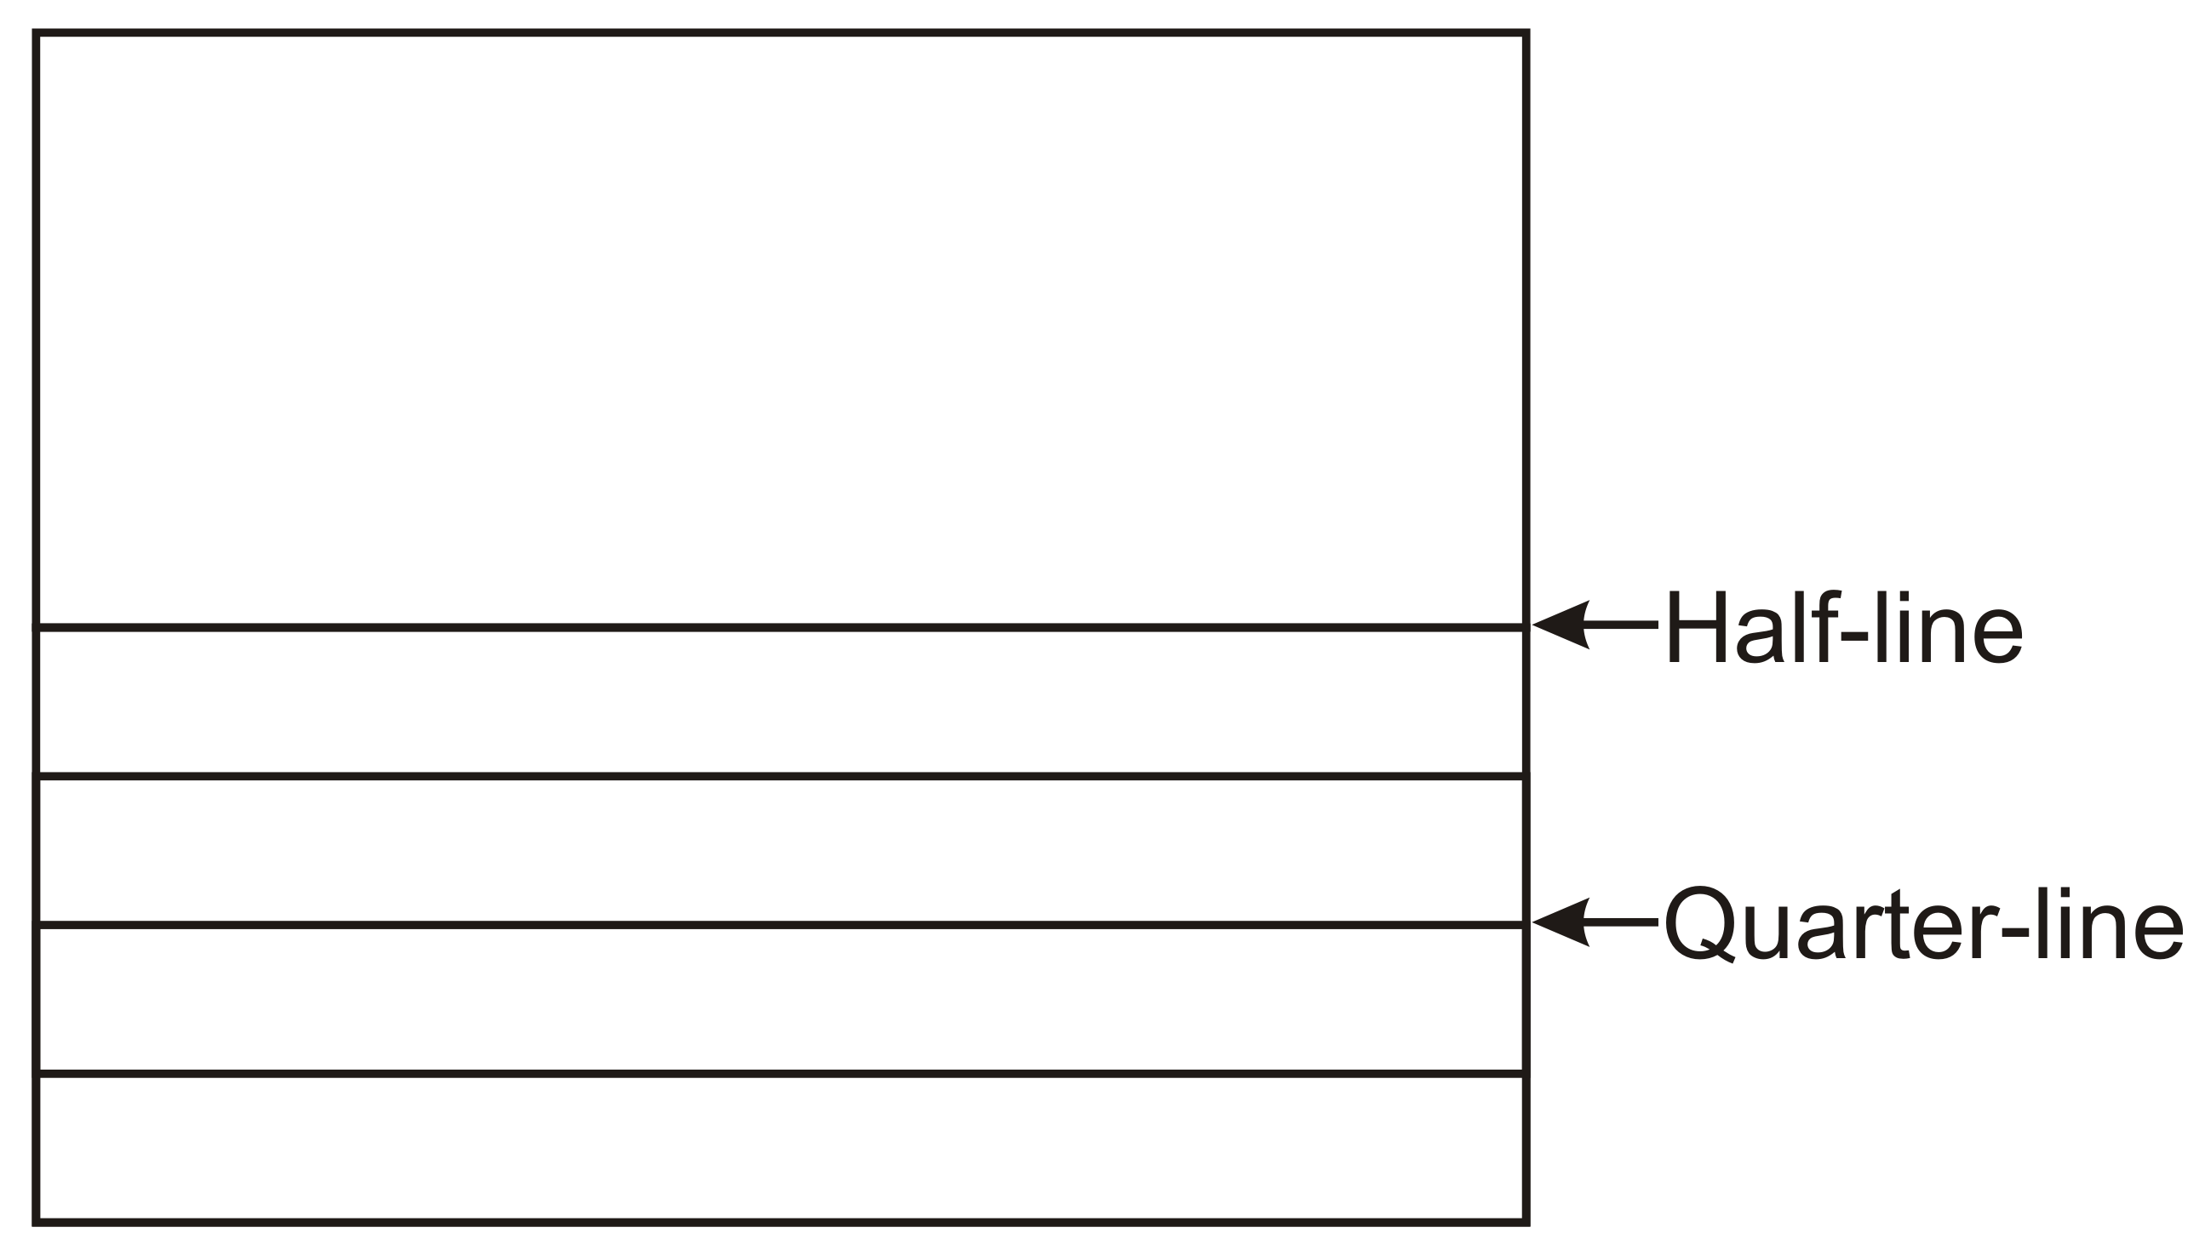

Side “folded” view of sheet and folds

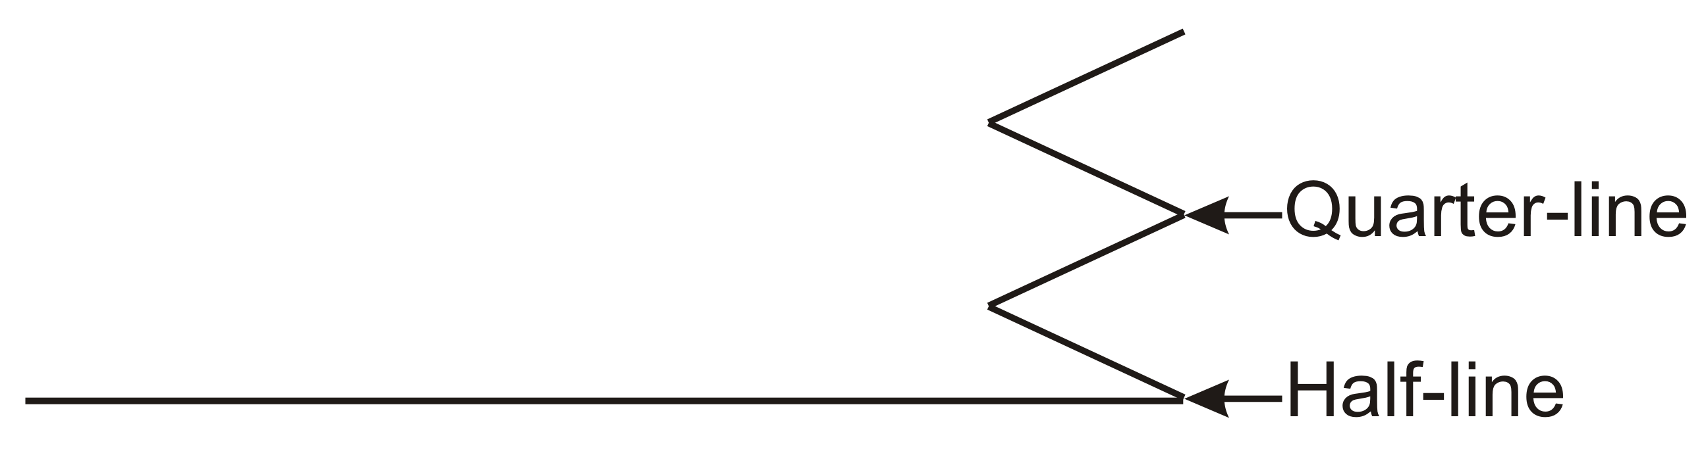
3.10.2: Composite Figures

1) Area (A) Circumference (C) | 2) Area (A) Circumference (C)
3) Area (A) Perimeter (P) | 4) Area (A) Perimeter (P)
5) | 6)
7) Area (A) Perimeter (P) | 8)
3.10.3: Skateboard Park – A Composite Shape

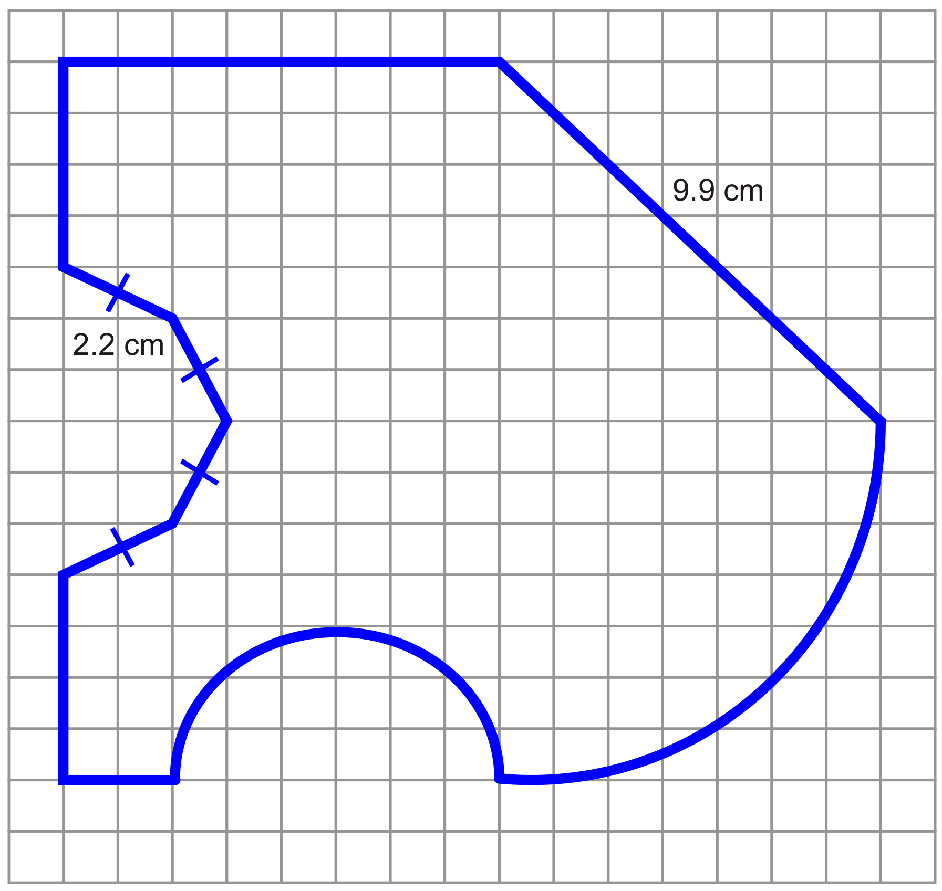

Each square is 1 cm by 1 cm.
When calculating, round all values to the nearest tenth.

1. Calculate the perimeter of this figure. (Show all of your work.)
Hint: Label all the unknown line segments and arcs.

2. Calculate the area of this figure. (Show all of your work.)
Hint: Try to find shapes that you already know, then add or subtract the area, as required.

Skateboard Park (GSP®4 file)
Skateboard Park.gsp

