Unit 2 Grade 8

Representing Patterns in Multiple Ways

Lesson Outline

BIG PICTURE

Students will:
- represent linear growing patterns (where the terms are whole numbers) using graphs, algebraic expressions, and equations;
- model linear relationships graphically.
Day | Lesson Title | Math Learning Goals | Expectations
1 | What Do Patterns Tell Us? | - Review patterning in real contexts, e.g., weather patterns, quilt patterns, patterns of behaviour, patterns in a number sequence or codes.  - Develop an understanding that all patterns follow some order or rule, and practice verbally expressing patterning rules. | 8m56  CGE 2c, 3e
2 | Different Representations of the Same Patterns | - Examine (linear) patterns involving whole numbers presented in a variety of forms e.g., as a numerical sequence, a graph, a chart, a physical model, in order to develop strategies for identifying patterns. | 8m56, 8m57, 8m60, 8m78  CGE 3b, 5a
3 | Finding the n^{th} Term | - Determine and represent algebraically, the general term of a linear pattern (n^{th} term).  - Determine any term, given its term number, in a linear pattern represented graphically or algebraically.  - Check validity by substituting values. | 8m57, 8m58, 8m60, 8m62, 8m63, 8m78  CGE 5b, 7j
4 | Exploring Patterns | - Determine any term given its term number in a linear pattern represented algebraically.  - Examine patterns involving whole numbers in a variety of forms.  - Explore and establish the difference between linear and non-linear patterns. | 8m57, 8m58, 8m60, 8m63, 8m73  CGE 3c, 4a
5 | Space Race: Graphic Representations | - Record linear sequences using tables of values and graphs.  - Draw conclusions about linear patterns. | 8m58, 8m63, 8m78  CGE 4f, 5a
6 | When Can I Buy This Bike? | - Solve problems involving patterns.  - Use multiple representations of the same pattern to help solve problems.  - Model linear relationships in a variety of ways to solve a problem. | 8m56, 8m57, 8m58, 8m73, 8m60, 8m63, 8m78  CGE 3c, 4f
7 | Determining the Term Number | - Determine any term, given its term number, in a linear pattern represented graphically or algebraically.  - Determine the term number given several terms. | 8m58, 8m61  CGE 3c, 4b, 4f

Unit 2: Day 1: What Do Patterns Tell Us? |  |  |  | Grade 8
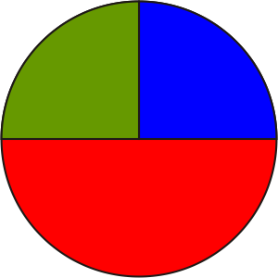 |  | Math Learning Goals  - Review patterning in real contexts, e.g., weather patterns, quilt patterns, patterns of behaviour, patterns in a number sequence or code.  - Develop an understanding that all patterns follow some order or rule and practice verbally expressing patterning rules. |  | Materials  - chart paper  - variety of everyday patterns  - variety of manipulatives  - BLM 2.1.1, 2.1.2
Assessment
Opportunities
 | Minds On… | Small Groups → Graffiti  Based on class size, set up three stations with different patterning examples at each station, e.g., atlases/maps (landforms, weather), artwork, pine cones, nautilus shells, bird migration patterns. Student groups at each station record all the patterns they discover in 1–2 minutes. Students rotate through all three stations.  Student groups summarize their findings and each group presents a brief summary to the class. |  | Students should be in heterogeneous groupings.  A recorder can be assigned in each group or all students may be involved in recording.  Encourage multiple representations of patterns.
 | Action! | Think/Pair/Share → Demonstration  Using manipulatives, e.g., linking cubes, display the following patterns:  4, 8, 12, 16... and 1, 4, 7, 10.... Students determine a pattern and share with their partner.  In a class discussion students express the pattern in more than one way, e.g., the first pattern increases by 4 each term, or the pattern is 4 times the term number, the pattern is multiples of 4; the second pattern increases by 3 each term, the pattern is 3 times the term number subtract 2.  Individual → Practice  Students complete BLM 2.1.1, extending the pattern and expressing it in words.  Content Expectations/Observation/Journal/Mental Note: Circulate to assess for understanding of representing patterns.
 | Consolidate Debrief | Whole Class → Presentation  Students represent the patterns visually and explain them.
Exploration  Reflection |  | Home Activity or Further Classroom Consolidation  Find a pattern that you like. Record the pattern in your math journal in pictures and words. |  | Provide examples of patterns within the class.

2.1.1: Pattern Sleuthing

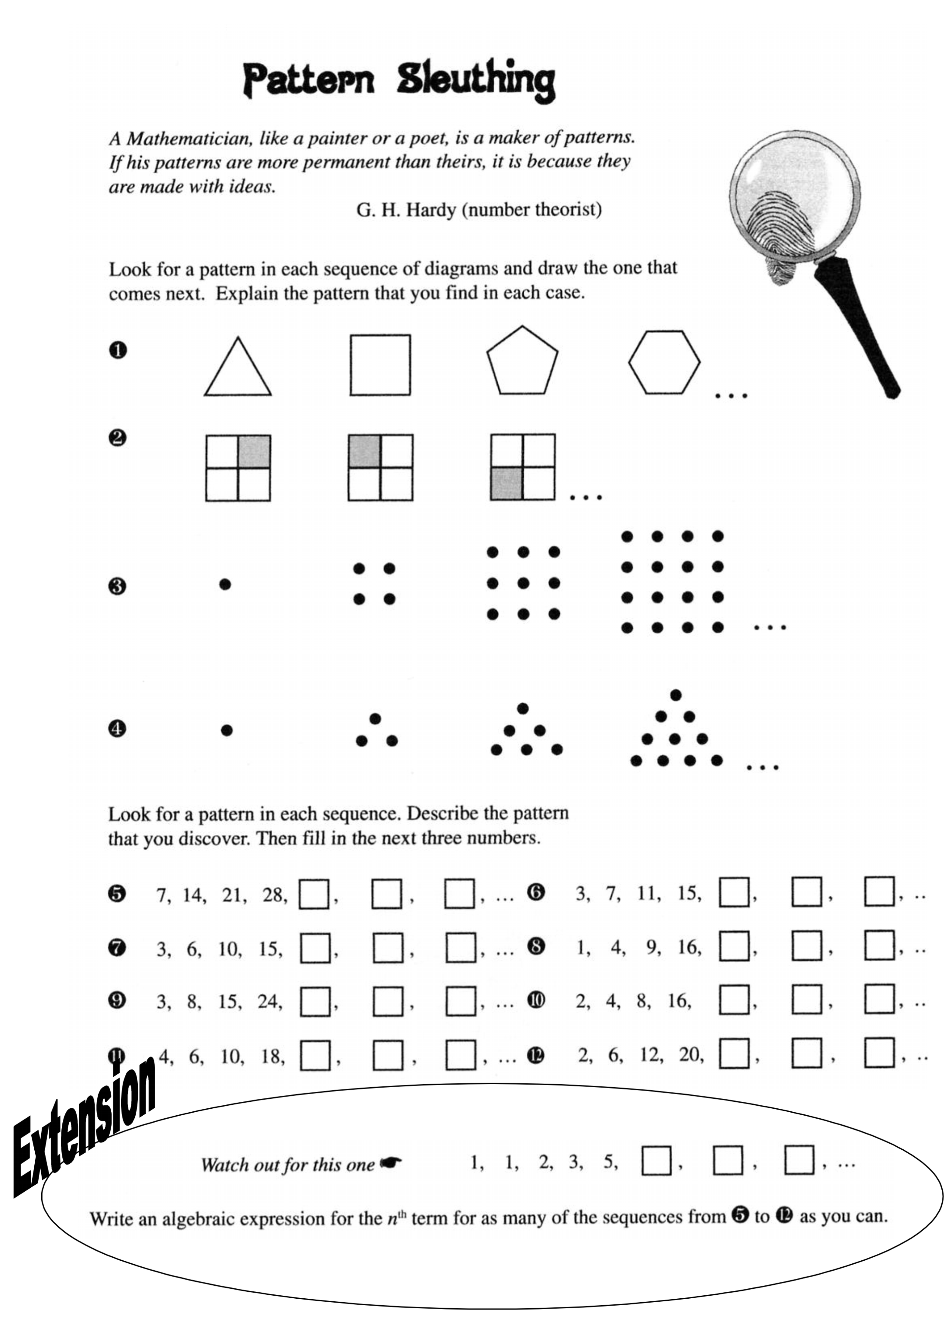

Impact Math: Patterning and Algebra p. 16
2.1.2: Pattern Sleuthing (Teacher)

Possible student answers:

1. Number of sides increases on each polygon, with each term (next shape heptagon)
2. Shaded square location rotating counter-clockwise around square pattern (next diagram shaded in lower right area)
3. Increasing by odd numbers (3,5,7…) or square numbers (next term 25 dots)
4. Adding a row to the bottom of the diagram, with one more dot (next term row added with 5 dots)
5. Each term increasing by 7 (35, 42, 49) – extension answer: 7n
6. Each term increasing by 4 (19, 23, 27) – extension answer: 4n –1
7. Increasing by 3, by 4, by 5, etc. Related to question 3 – extension answer:
8. Increasing by consecutive odd numbers (25, 36, 59) – extension answer: n²
9. Increasing by consecutive odd numbers (35, 58, 73) – extension answer: n² + 2n or n(n + 2)
10. Each number is doubled (32, 64, 128) – extension answer: 2^{n}
11. Increasing by 2, by 4, by 8, by 16 (34, 66, 130) – extension answer: 2^{n} + 2
12. Increasing by 4, by, 6, by 8 or by consecutive even numbers (30,42, 56)
– extension answer: n² + n or n(n + 1)

Extension:
This question is the Fibonacci sequence. The pattern is:
1, 1, 2, 3, 5, 8, 13, 21, 34, 55, 89, 144, 233, 377, 610, 987.

See the following websites:
http://www.mcs.surrey.ac.uk/Personal/R.Knott/Fibonacci/fib.html
http://www.fuzzygalore.biz/articles/fibonacci_seq.shtml
http://en.wikipedia.org/wiki/Fibonacci_number

Unit 2: Day 2: Different Representations of the Same Pattern |  |  |  | Grade 8
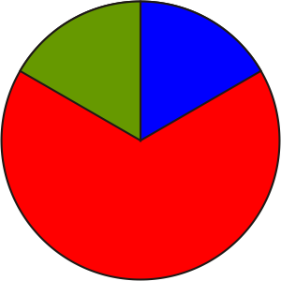 |  | Math Learning Goals  - Examine (linear) patterns involving whole numbers presented in a variety of forms, e.g., as a numerical sequence, a graph, a chart, a physical model, in order to develop strategies for identifying patterns. |  | Materials  - a visual pattern  - BLM 2.2.1, 2.2.2, 2.2.3  - linking cubes  - rulers
Assessment
Opportunities
 | Minds On… | Pair/Share → Patterning  Model how to share a visual pattern, e.g., art, nautilus shell, in both words and pictures. Student A shares the pattern in words and pictures with Student B. Student B shares the pattern in words and pictures with Student A. Regroup pairs to form groups of four.  Student A in each pair will share Student B’s pattern with the group. Student B in each pair will share Student A’s pattern with the group. |  | Interesting visual patterns can be found by doing an online image search.
 | Action! | Small Groups → Investigation  In heterogeneous groups, students rotate through the stations (BLM 2.2.1) They record their work on BLM 2.2.2. (The empty circle area on this BLM is used on Day 3.)  Whole Class → Connecting  Students share their findings and record any corrections on their worksheet. They label the four rectangular sections as: Numerical Model, Graphical Model, Patterning Rule, Concrete Model (BLM 2.2.2).  Lead students to the conclusion that all of these representations show the same pattern:  - What do you notice about the table of values and the concrete representation?  - What are the similarities? (i.e., they are all representations of the same pattern)  Curriculum Expectations/Observation/Checklist: Circulate to assess understanding that the representations all show the same pattern.
 | Consolidate Debrief | Whole Class → Four Corners  Post charts in the four corners of the room labelled as: Graphical Model, Patterning Rule, Concrete Model, Numerical Model. Below each label, draw a rough diagram to aid visual learners.  Pose the question: For which model did you find it easiest to extend the pattern?  Students travel to the corner that represents their answer and discuss why they think that they found that method easier. One person from each corner shares the group’s findings.
Practice |  | Home Activity or Further Classroom Consolidation  Complete the practice questions. |  | Provide students with appropriate practice questions showing multiple ways of representing linear patterns.

2.2.1: Stations for Small Group Investigations

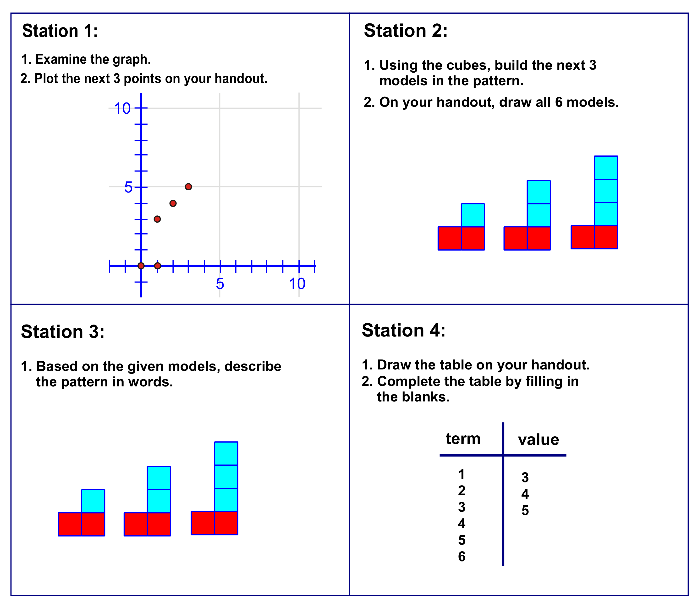

2.2.2: Small Group Investigation Record Sheet

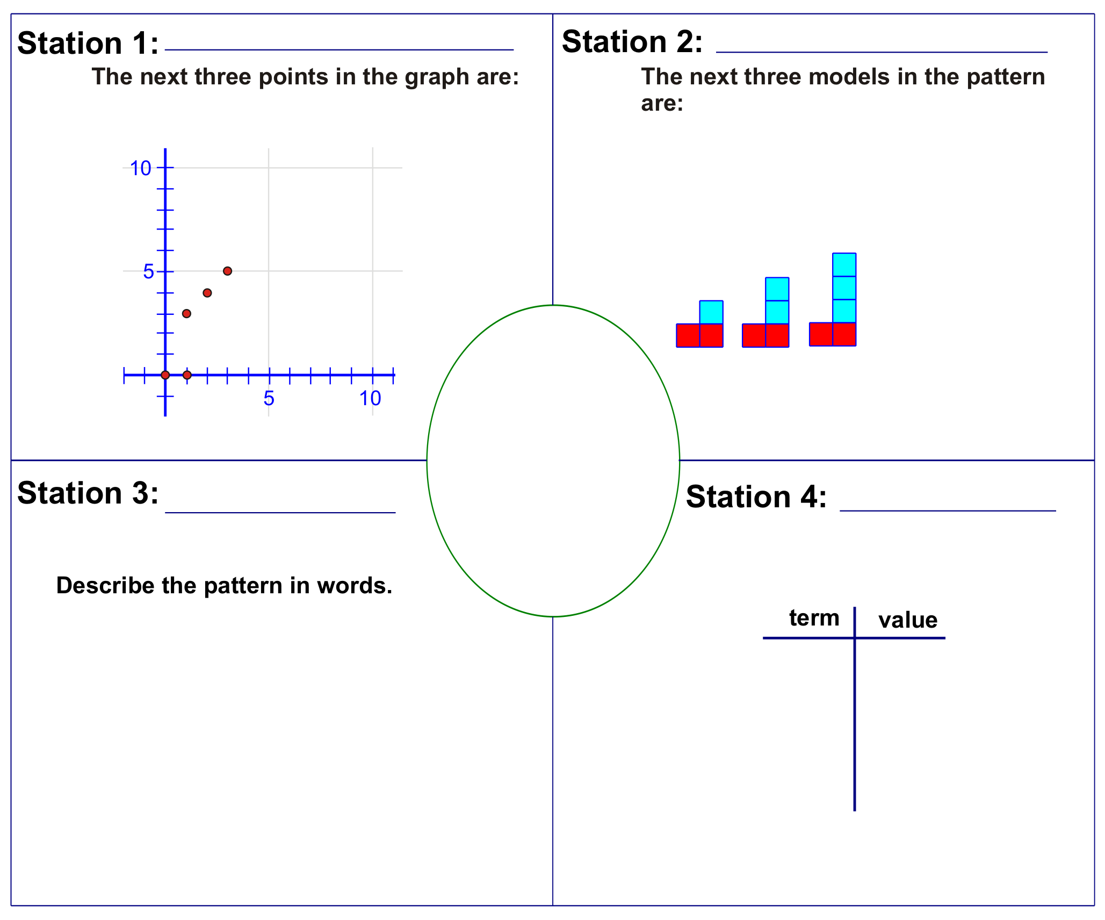

2.2.3: Small Group Investigation (Answers)

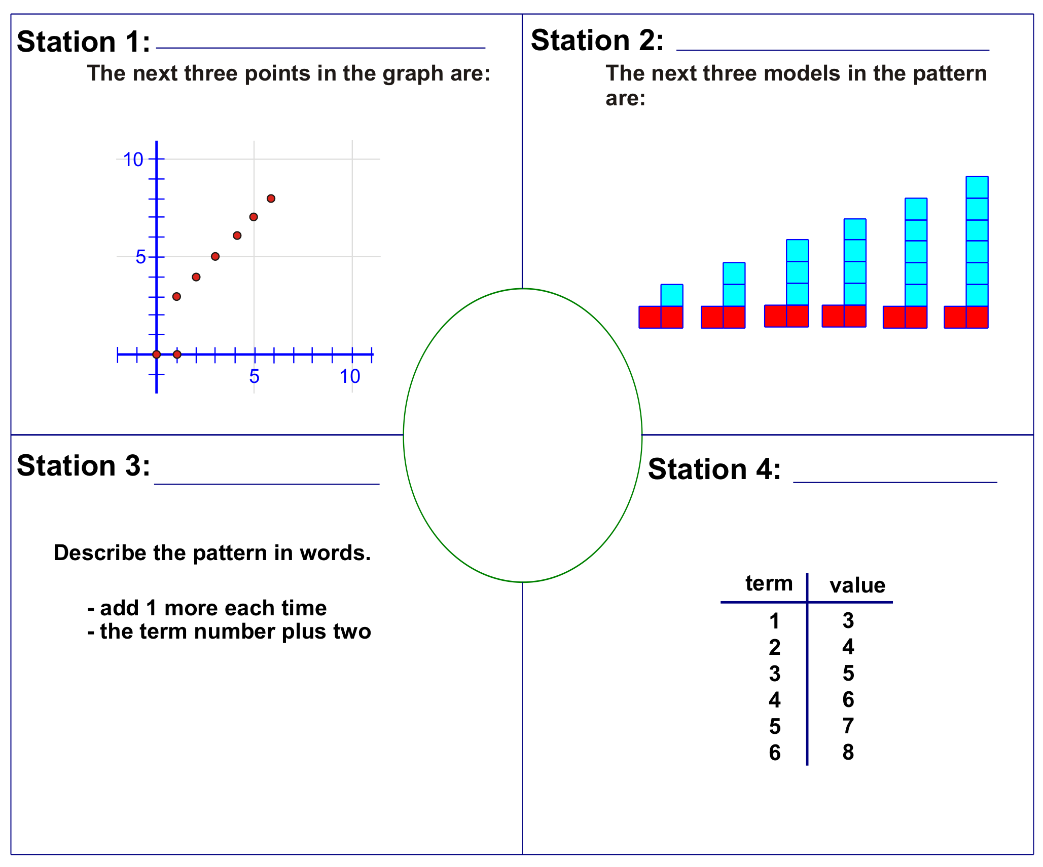

Unit 2: Day 3: Finding the n^{th} Term |  |  |  | Grade 8
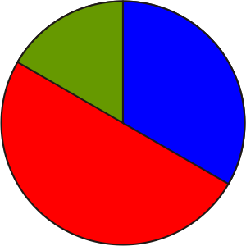 |  | Math Learning Goals  - Determine, and represent algebraically the general term of a linear pattern  (n^{th} term).  - Determine any term, given its term number, in a linear pattern represented graphically or algebraically.  - Check validity by substituting values. |  | Materials  - BLM 2.3.1, 2.3.2, 2.3.3  - linking cubes
Assessment
Opportunities
 | Minds On… | Whole Class → Four Corners  Give each student a card. Students travel to the corner that corresponds to the representation on their card, e.g., A student with a card that has a graph goes to the graphical model representation corner. Students discuss “What is challenging about changing from one representation of a pattern to another?” Choose one person from each corner to share the group’s conclusions.  Pose the following scenario: Armando has a CD collection. He currently owns 2 CDs. Each week, he purchases a new CD for his collection. How could you represent this in a model? Students in each corner describe the scenario, using the model represented in their corner. |  | Cut BLM 2.3.1 into individual cards.  Collect the cards from students to use in a future activity.  Word Wall  - term number  - term value
 | Action! | Small Groups → Investigation  With the class, model the results to the problem using two colours of linking cubes (2 red and 1 green for the first term, 2 red and 2 green for the second term, and so on). Discuss why the first term has 3 CDs in it. Students use linking cubes to build the concrete model of the pattern up to the 6th term and complete  BLM 2.3.2 in groups.  Guide a class discussion about students’ findings (BLM 2.3.3).  Representing/Oral Questions/Mental Note: Observe students as they work on the small-group activity.
 | Consolidate Debrief | Whole Class → Algebraic Representation  Ask:  - How can we think about the algebraic expression in another way? Decide what the n^{th} term represents (unknown term; a method to find any term; a “formula”).  - How might you find the 12th term of the pattern?  - Is it possible to find the 12th term without extending the table?  - Find the 12th term. Can you use the same method to find the 100th term?  - How can you determine if your n^{th} term is correct? (Substitute the term numbers in for n and the resulting answers should be the term values.) Students record this algebraic representation of the pattern in the circle on the placemat from Day 2 (BLM 2.2.2).
Application  Exploration  Reflection |  | Home Activity or Further Classroom Consolidation  Complete the practice questions. |  | Provide students with appropriate practice questions.

2.3.1: Four Corners Cards

Patterning Rule:  Add one to the term number | 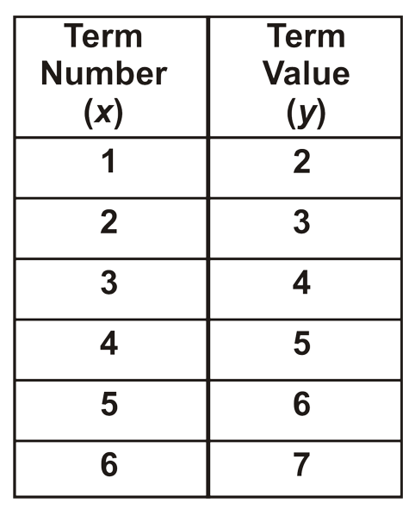 | 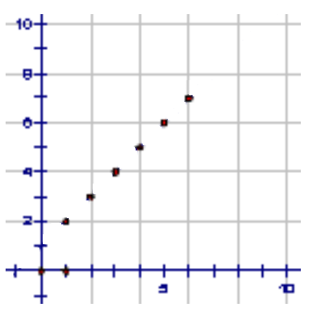 | 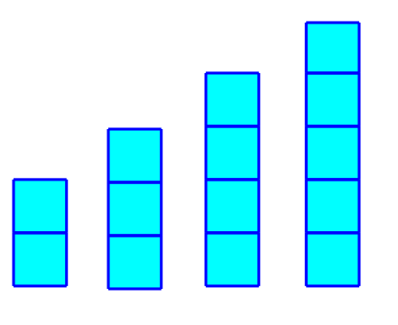
Pattern Rule:  One plus three times a term number | 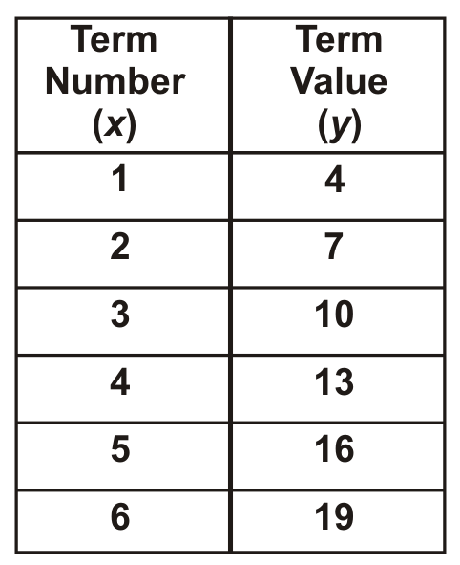 | 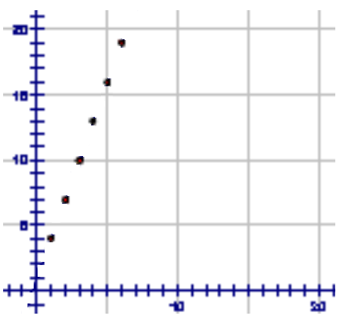 | 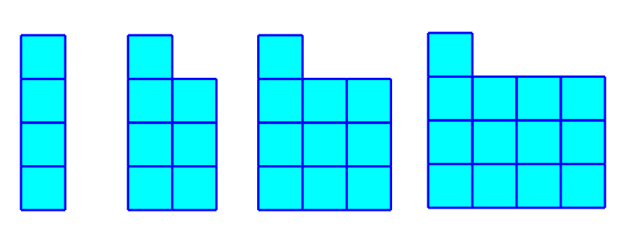
Pattern Rule: Subtract one from the term number | 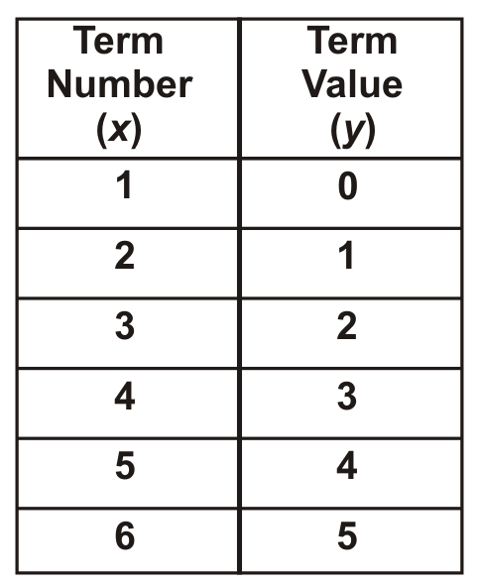 | 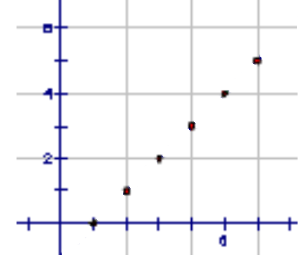 | 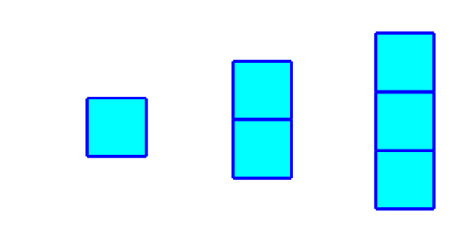
Patterning Rule: Multiply the term number by three and subtract one | 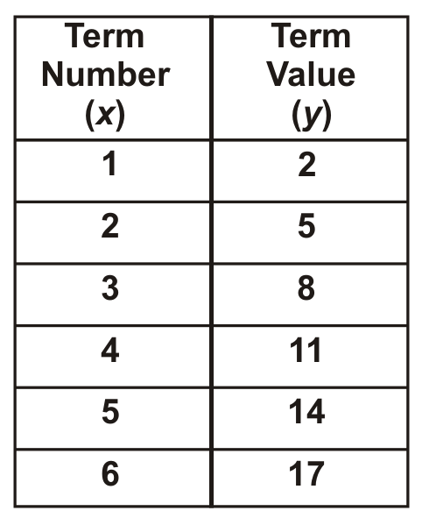 | 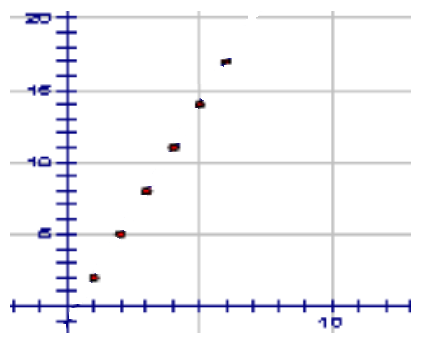 | 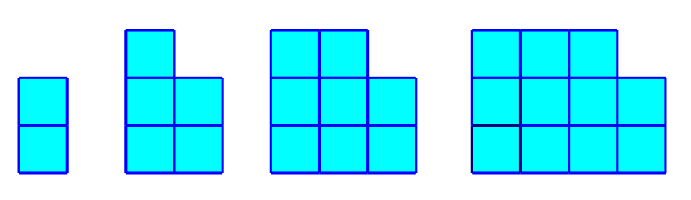
Pattern Rule: Multiply the term number by two and add one | 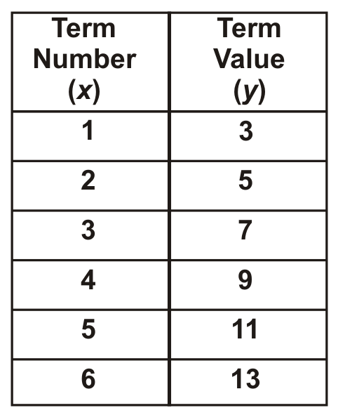 | 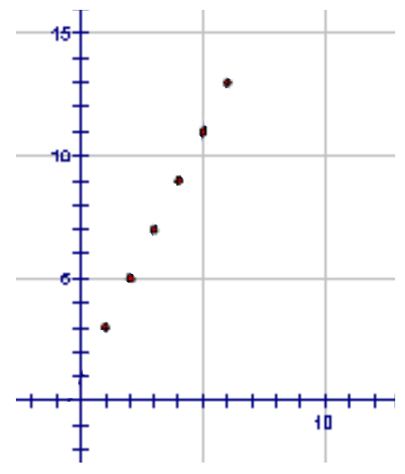 | 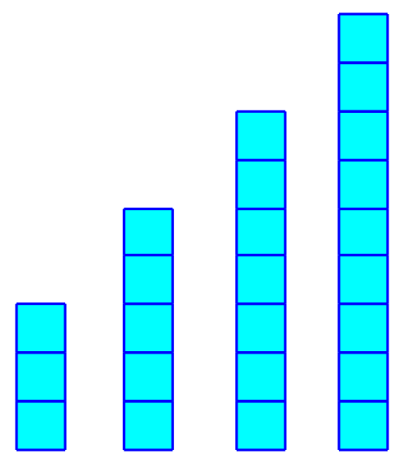

2.3.2: Patterns – Finding the n^{th} Term

Term Number (n) | Number of Red Cubes  ( ) | Number of Green Cubes  ( ) | Total Number of Cubes (Term Value)
1
2
3
4
5
6
12
n

1. In your groups, complete the values for terms 1 through 6 on the chart using models.

2. Which colour has the same number of cubes all the way through the chart? This is called the constant because it does not change. Indicate this in the brackets under the appropriate heading.

3. Which colour has a different number of cubes in each model? This is called the variable because it varies or changes. Please indicate this in the brackets under the appropriate heading.

4. How is the variable related to the term number?

5. In words, describe the pattern.

6. If the term number is n, how could you figure out how many cubes are in that model?

2.3.3: Patterns – Finding the n^{th} Term Answers (Teacher)

Term Number (n) | Number of Red Cubes (Constant) | Number of Green Cubes (Variable) | Total Number of Cubes (Term Value)
1 | 2 | 0 | 2
2 | 2 | 1 | 3
3 | 2 | 2 | 4
4 | 2 | 3 | 5
5 | 2 | 4 | 6
6 | 2 | 5 | 7
12 | 2 | 11 | 13
n | 2 | n – 1 | 2 + n – 1 or n + 1 or 1 + n

1. In your groups, complete the values for terms 1 through 6 on the chart using your models.

2. Which colour has the same number of cubes all the way through the chart? This is called the constant because it does not change. Indicate this in the brackets under the appropriate heading.
There is always the same number of red cubes.

3. Which colour has a different number of cubes in each model? This is called the variable because it varies or changes. Please indicate this in the brackets under the appropriate heading.
The number of green cubes changes each term.

4. How is the variable related to the term number?
The variable is 1 less than the term number.

5. In words, describe the pattern.
The value is 2 more than 1 less than the term number.

6. If the term number is n, how could you figure out how many cubes are in that model?
2 + n – 1 or n + 1 or 1 + n

Unit 2: Day 4: Exploring Patterns |  |  |  | Grade 8
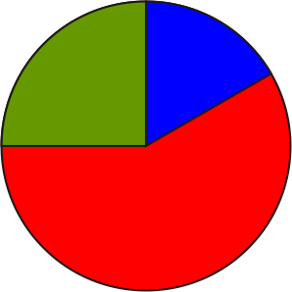 |  | Math Learning Goals  - Determine any term given its term number in a linear pattern represented algebraically.  - Examine patterns involving whole numbers in a variety of forms.  - Explore and establish the difference between linear and non-linear patterns. |  | Materials  - BLM, 2.4.1, 2.4.2, 2.4.3
Assessment
Opportunities
 | Minds On… | Whole Class → Summarizing  Review the terms constant and variable, using an example from Day 3. |  | Think Literacy: Mathematics, Grades 7–9,  pp. 40–41  Make available the following materials at each station: linking cubes, geoboards, toothpicks and/or other appropriate materials.  Word Wall  - variable  - constant  If time permits, demonstrate what linear and non-linear patterns look like graphically using GSP®4, FathomTM, or spreadsheet software to give meaning to the terms linear and non-linear. Use discrete examples so it is consistent with their work.
 | Action! | Small Groups → Exploration  Students rotate through stations (BLM 2.4.2).
 | Consolidate Debrief | Whole Class → Summarizing  Discuss the patterns students found during their station work.  Pose questions:  - Which patterns did you find more logical to extend and represent another way?  - Why do you think some were more logical than others?  Create class Frayer models for constant and variable. Formulate a working definition for each term. See BLM 2.4.1.  Define that linear patterns form a straight line that can be shown using a ruler but non-linear patterns do not form a line.  In small groups, students sort the different patterns into two groups: linear and non-linear. Groups justify their sorting to the class.  Curriculum Expectations/Communicating/Observation: Listen as students discuss their choices and justify their reasoning as they sort.
Differentiated  Reflection |  | Home Activity or Further Classroom Consolidation  In your journal, compare linear patterns to non-linear patterns, use as many representations as possible.  - How are they similar?  - How are they different? |  | Make available the GSP®4 take-home version for students who may wish to produce their sketches using software.

2.4.1: The Frayer Model (Teacher)

Definition  - numerical value that stays the same (is fixed)  - example: x + 1 ( the number 1 is the constant)  - a quantity that does not change | Facts/Characteristics  - fixed  - does not change for different terms
Examples  - constant pain always the same  - 5x + 3 (the number 3 is the constant)  - speed of light | Non-examples  constant  - variable  - can represent more than one number  - n = 1,2,3,4  - 5x (the value of the term 5x changes for different values of x)

Definition  - place holder for the unknown value  - example 3x + 1 (x represents the variable)  - a quantity capable of assuming a set of values | Facts/Characteristics  - value changes as term number changes  - represents a range of values  - any letter of the alphabet could be used to represent the variable
Examples  - equations: 3 + x = 7, (x is a variable)  - formulas: A = lw (l and w can change)  - spreadsheets: cells B = A + 1  - expressions 3x + 1 (x is the variable)  - stock prices  - interest rates | Non-examples  variable  Constant  Constant

2.4.2: Exploring Patterns

Station 1  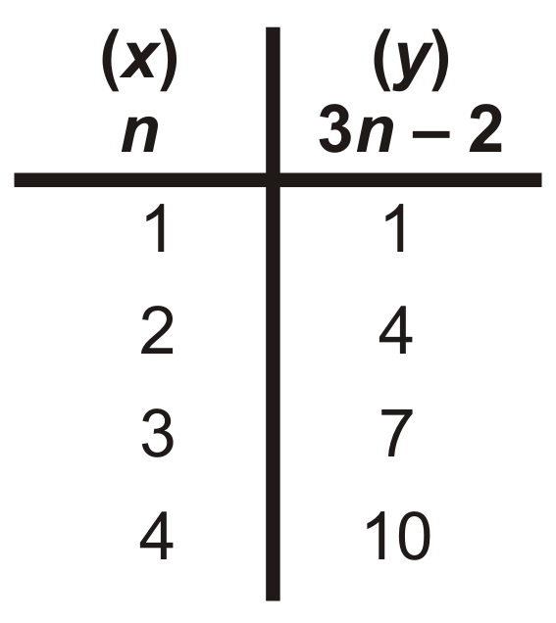  Name the constant.  Name the variable. | Graph this pattern on the Cartesian plane.  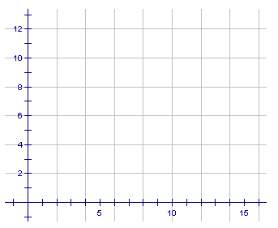

Station 2  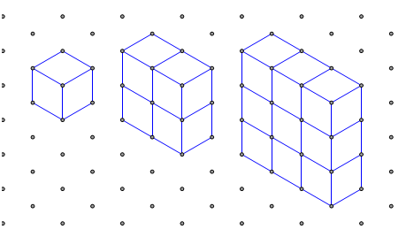 | Create a table of values. | Write an expression for the n^{th} term.  Name the constant.  Name the variable.

2.4.2: Exploring Patterns (continued)

Station 3  Note the toothpick pattern below.   | Build the next two terms in the pattern using toothpicks.  Draw them here: | Create the table of values using the number of toothpicks.  Write an expression for the n^{th} term.  Name the constant.  Name the variable.

Station 4  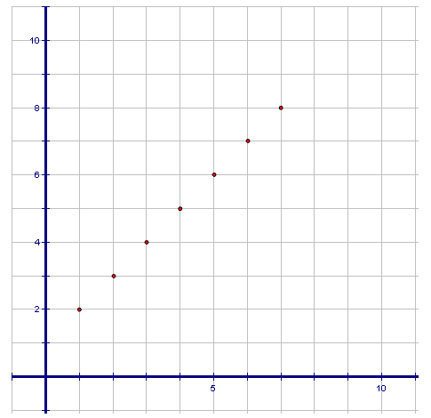 | Create a table of values. | Write an expression for the n^{th} term.  Name the constant.  Name the variable.

2.4.2: Exploring Patterns (continued)

Station 5  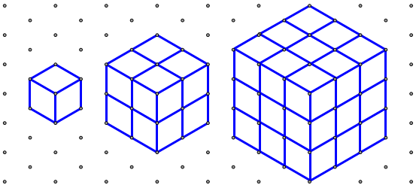 | Create a table of values.
Plot the points from your table of values. What do you notice?
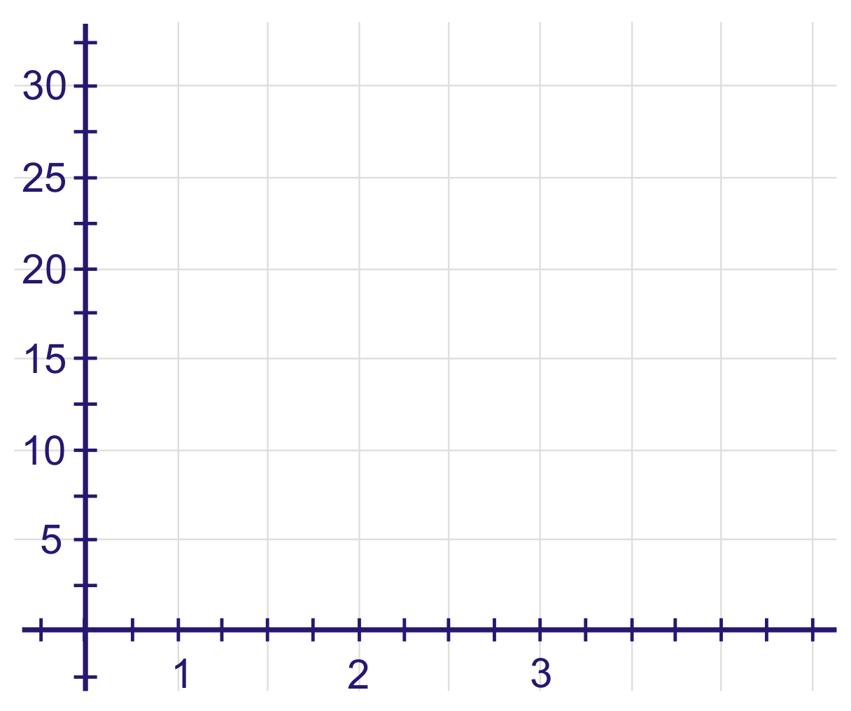

Name the constant.

Name the variable.

2.4.2: Exploring Patterns (continued)

Station 6  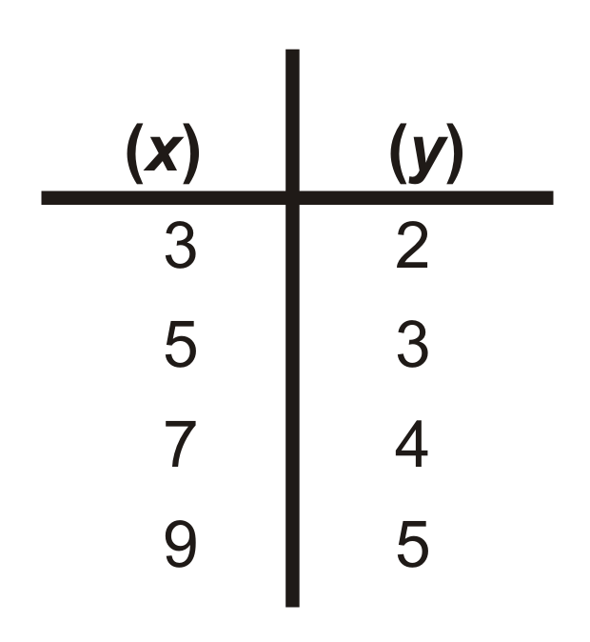 | Write an expression for the n^{th} term.  Name the constant.  Name the variable.
Graph this pattern on the Cartesian plane.

2.4.3: Answers to Student Centres

Station 1  Variable: n  Constant: –2 | Graph this pattern on the Cartesian plane.  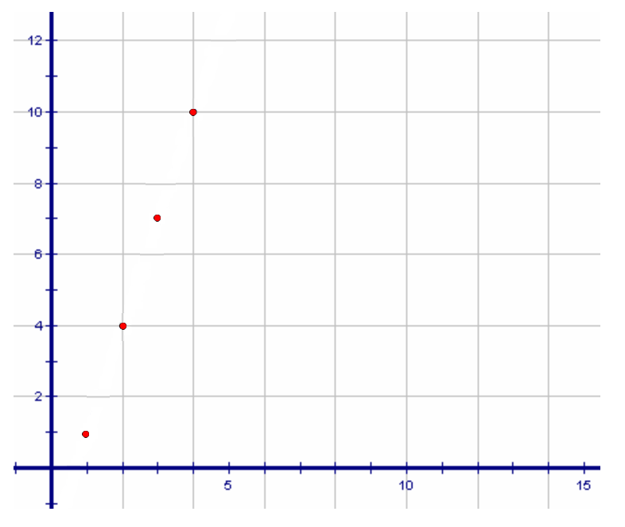

Station 2 | Create a table of values. | Write an expression for the n^{th} term.  n^{th} term = n²  Variable: n  Constant: 0
  1 | 1
  2 | 4
  3 | 9

Station 3  Note the toothpick pattern below. | Build the next two terms in the pattern using toothpicks.  Draw them here:  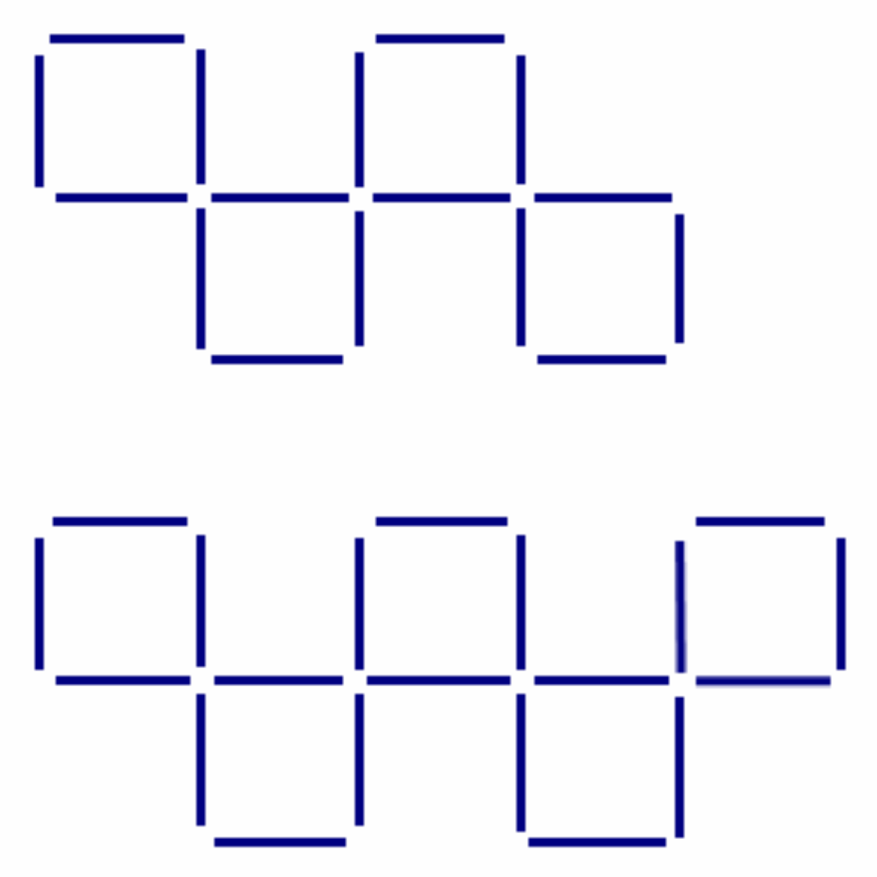 | Create the table of values using the number of toothpicks.  Write an expression for the n^{th} term.  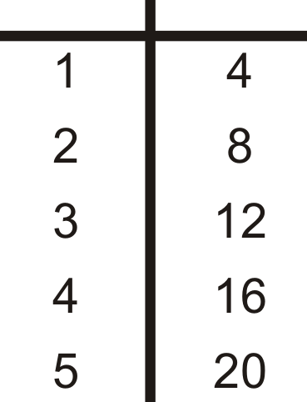  n^{th} term = 4n  Variable: n  Constant: 0

2.4.3: Answers to Student Centres (continued)

Station 4  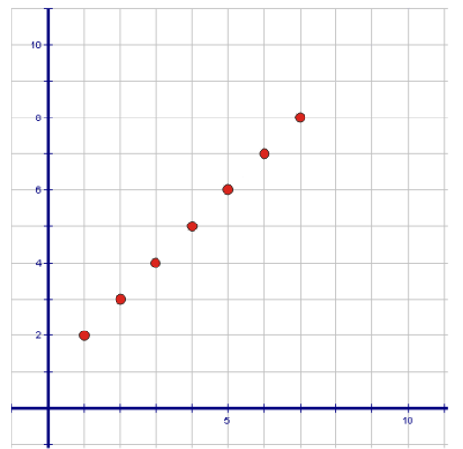 | Create a table of values.  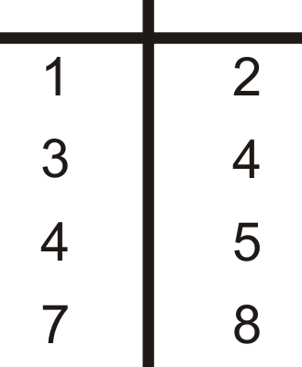 | Write an expression for the n^{th} term.  n^{th} term = n + 1  Variable: n  Constant: 1

Station 5 | Create a table of values.  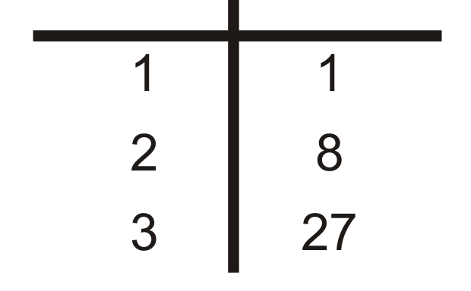
Plot the points from your table of values. What do you notice?
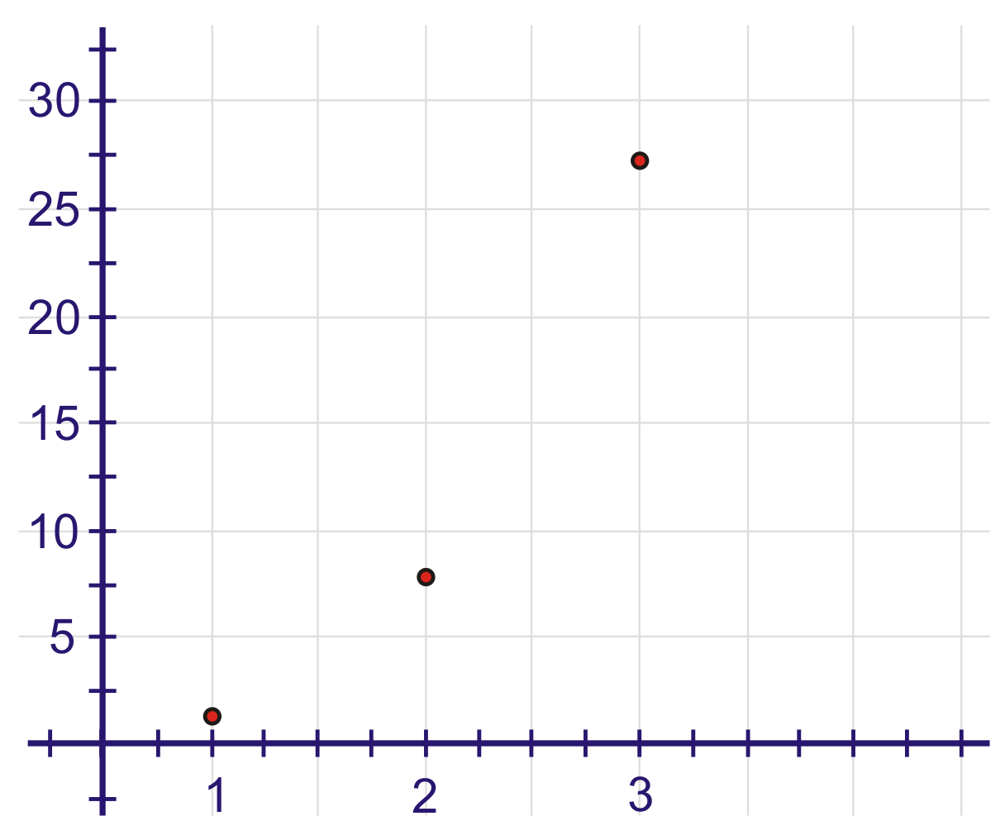 |  | Variable: n  Constant: 0

Station 6 | Write an expression for the n^{th} term.  n^{th} term  Variable: n  Constant: | Graph this pattern on the Cartesian plane.  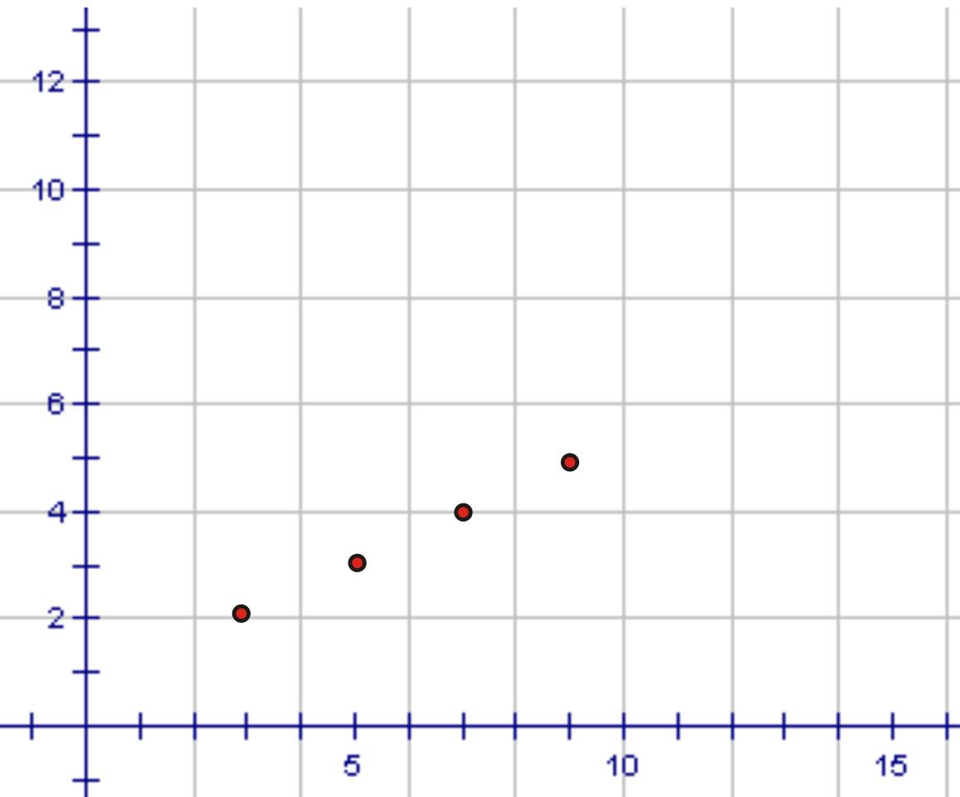

Unit 2: Day 5: Space Race: Graphic Representations |  |  |  | Grade 8
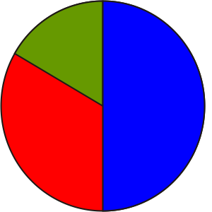 |  | Math Learning Goals  - Record linear sequences using a table of values and graphs.  - Draw conclusions about linear patterns. |  | Materials  - BLM 2.5.1, 2.5.2
Assessment
Opportunities
 | Minds On… | Whole Class → Connecting to Prior Learning  Create a Venn diagram using the comparison from the Home Activity, Day 4 (BLM 2.5.1).
 | Action! | Whole Class → Simulation Using Graphs  Using their prior knowledge of linear and non-linear patterns, groups create physical representations of the two types of patterns.  Pose the problem: Using all the people in your group demonstrate what a linear graph would look like.  Observe and comment on how students demonstrate different representations.  Pose a second problem: Using all the people in your group demonstrate what a non-linear graph could look like.  Note how students demonstrate different representations.  Students share their feedback or observations.
 | Consolidate Debrief | Individual → Interpreting Graphs  Students complete BLM 2.5.2.  Curriculum Expectations/Procedural Knowledge: Students submit BLM 2.5.2 for feedback.
Practice |  | Home Activity or Further Classroom Consolidation  Complete the practice questions. |  | Provide students with appropriate practice questions.

2.5.1: Possible Venn Diagram Answers

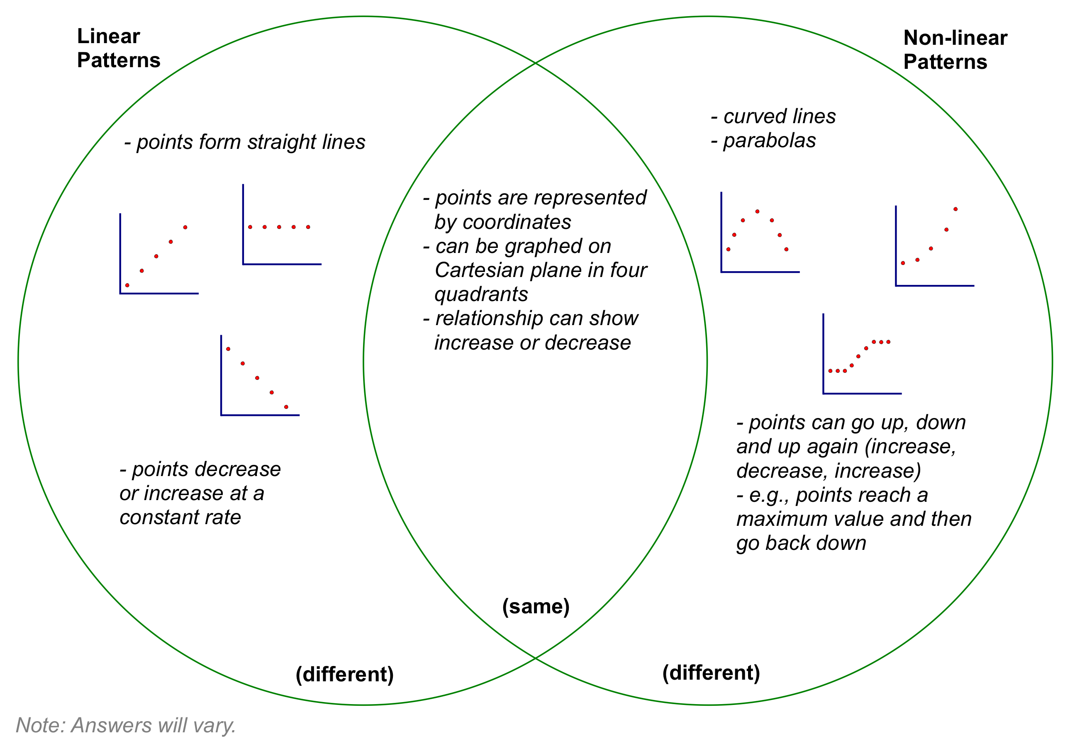
2.5.2: Interpreting Graphs

Name:

For each graph below create a table of values and determine the n^{th} term.

1.  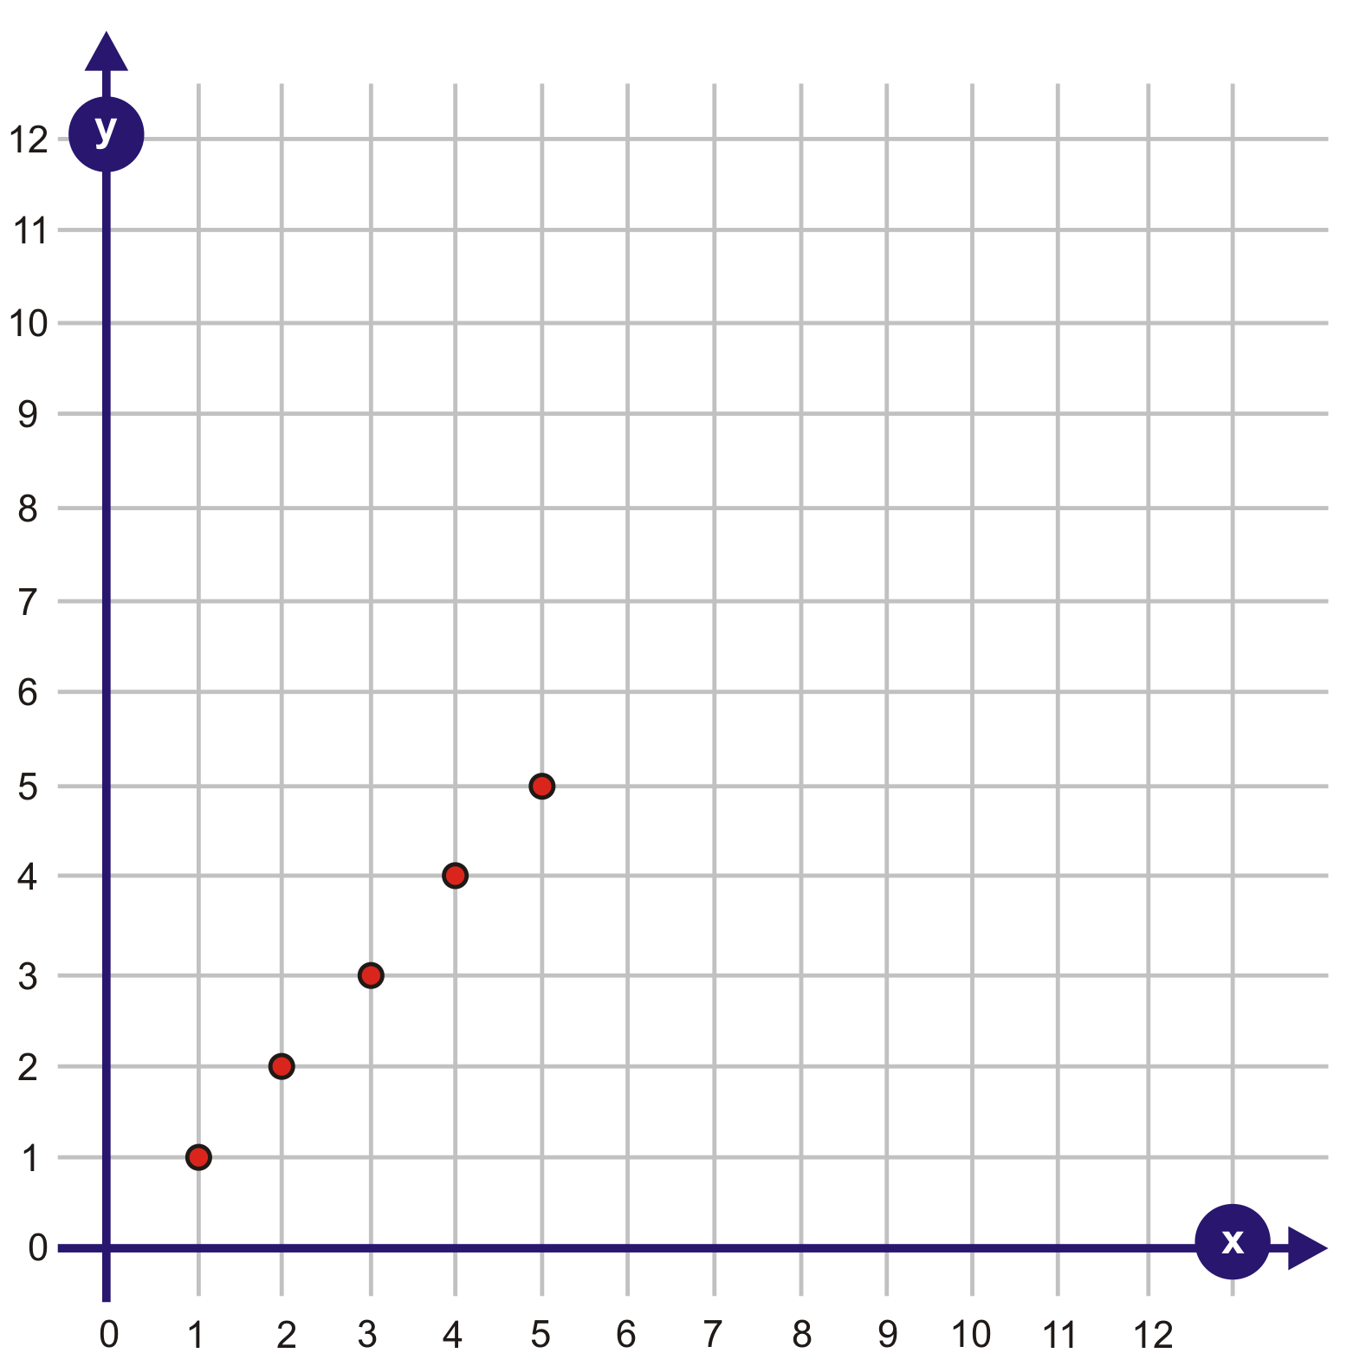 | 2.  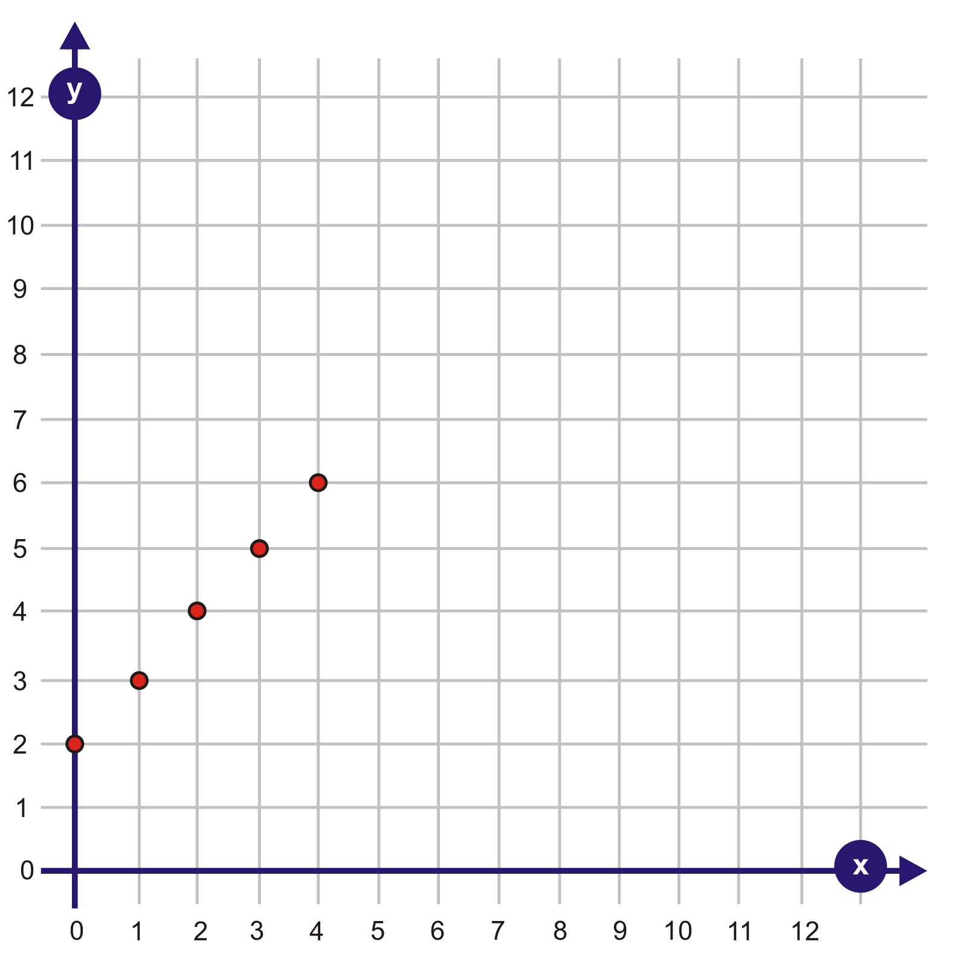
3.  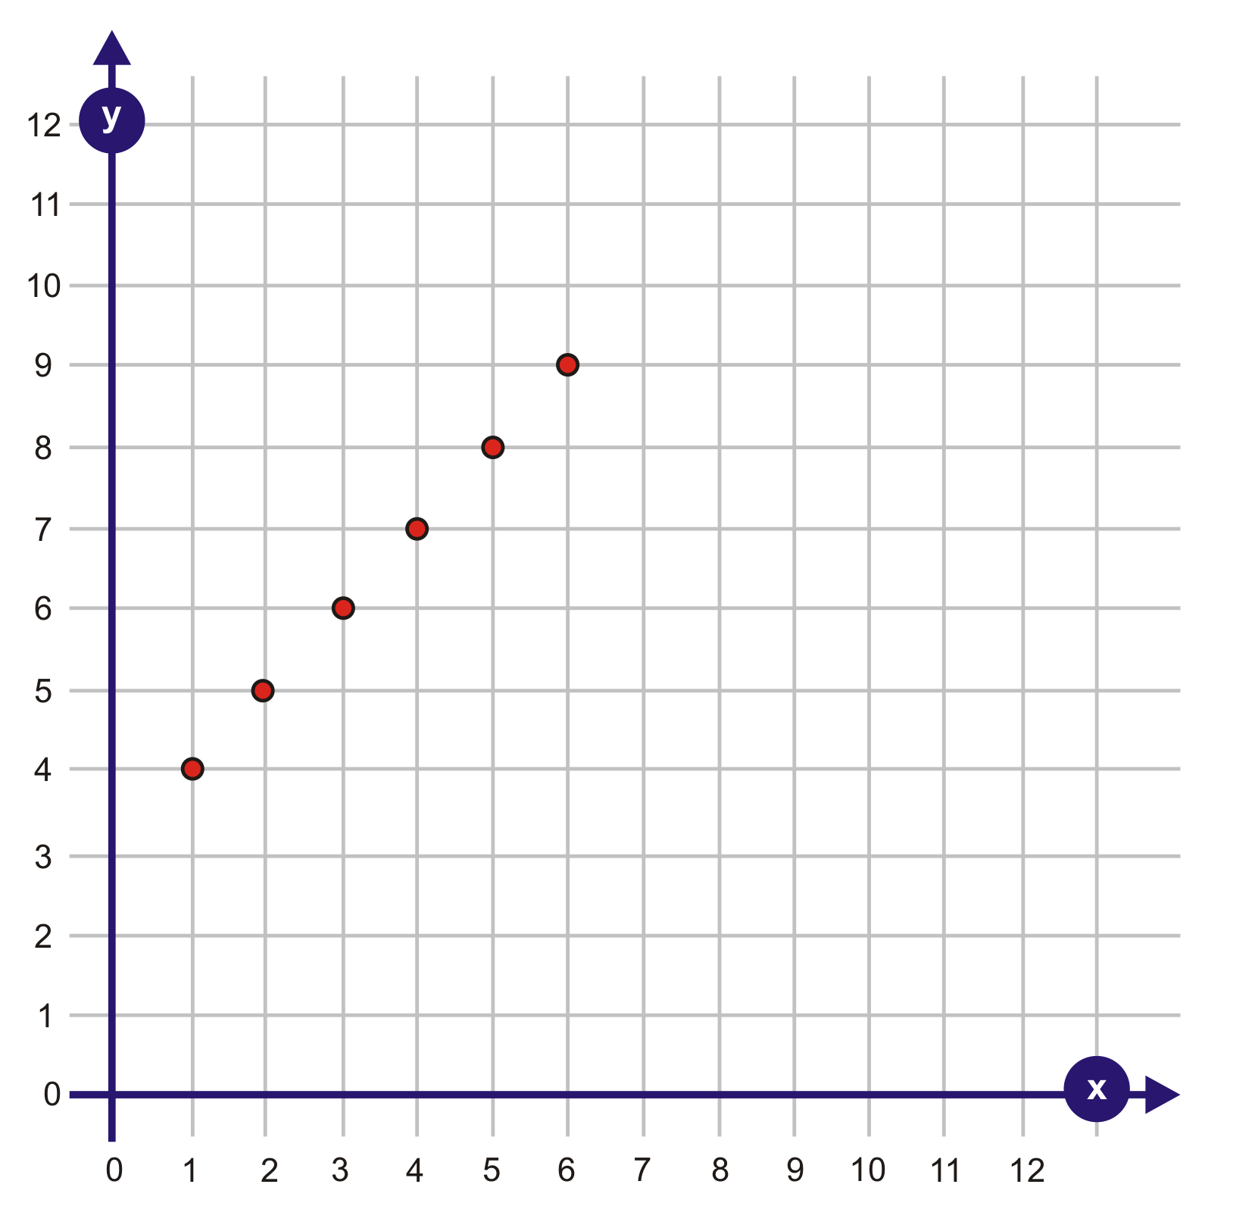 | 4.  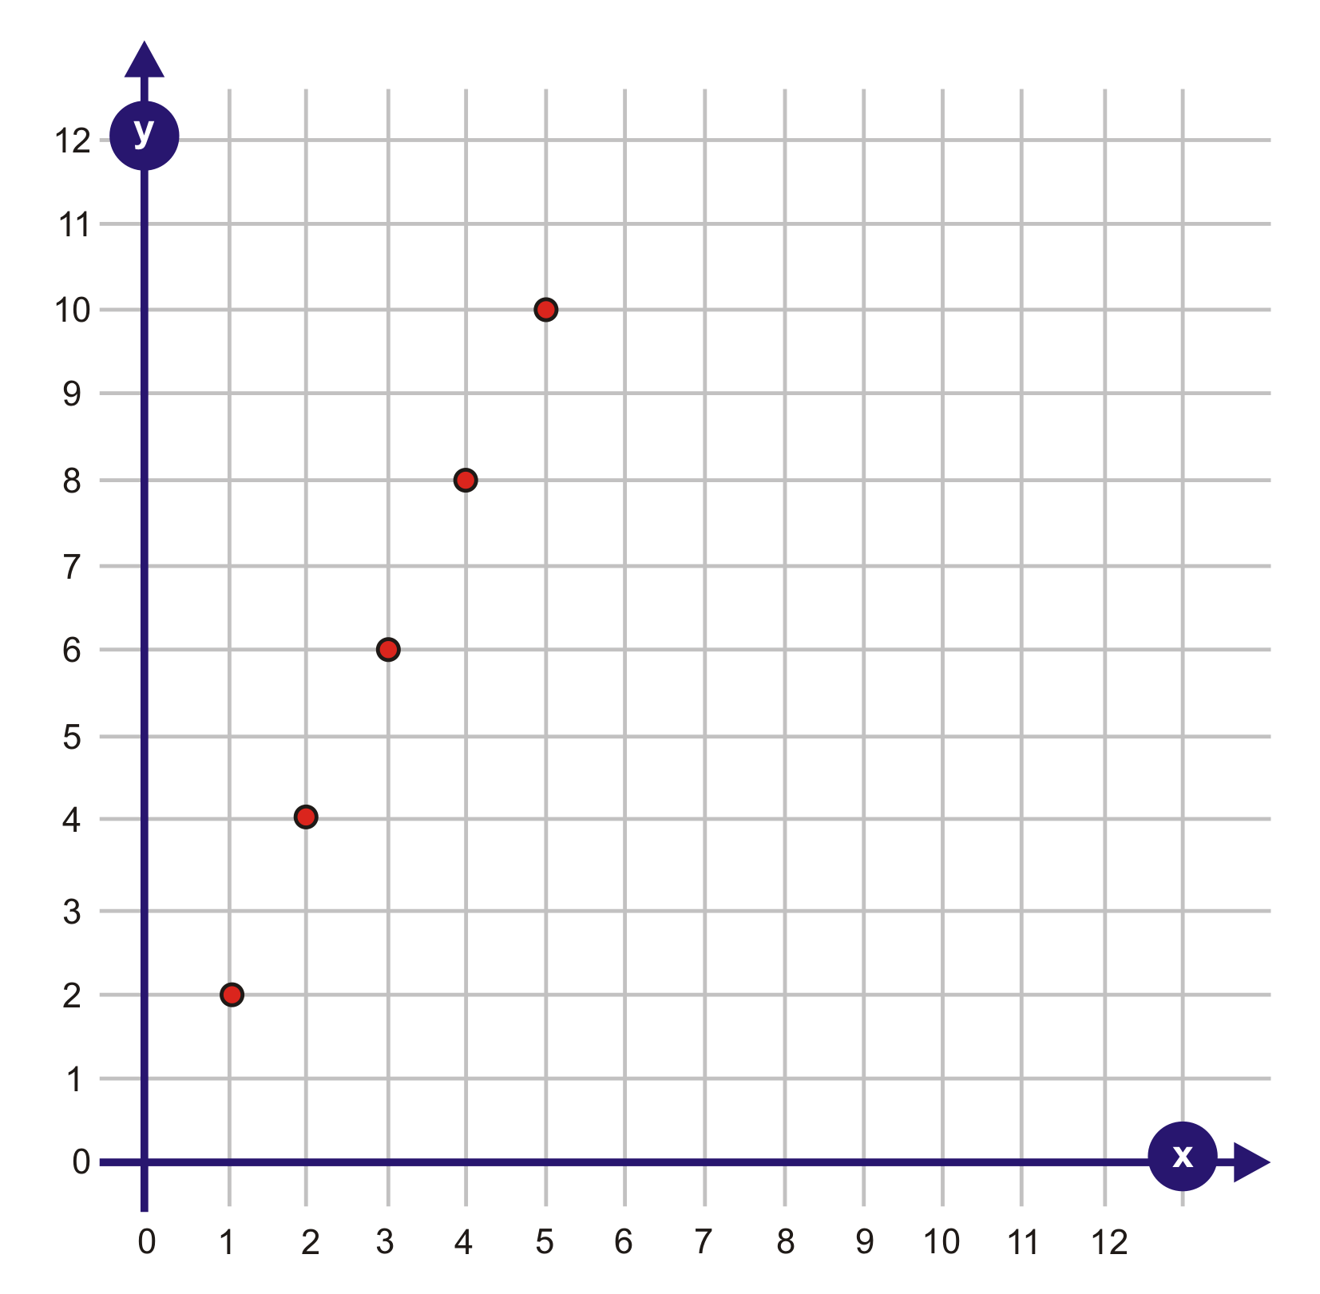

2.5.2: Interpreting Graphs (continued)

5.  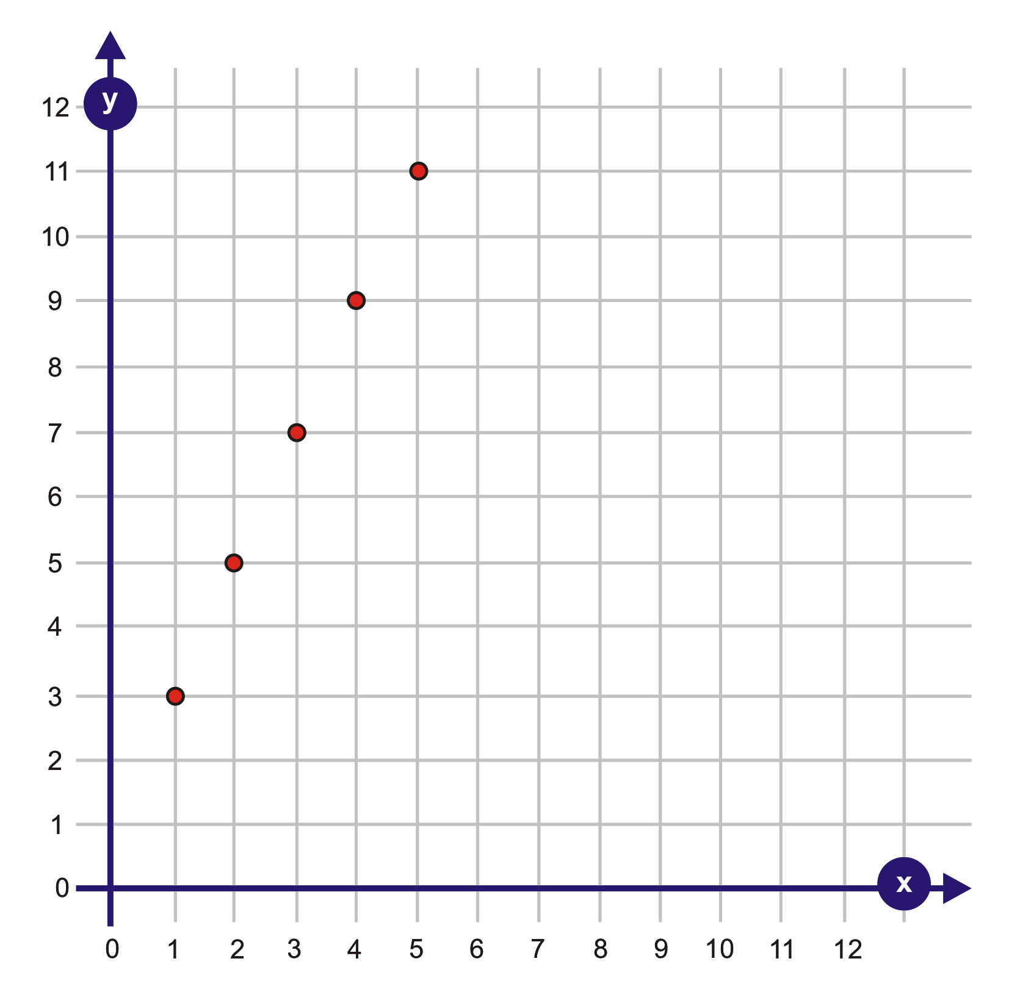 | 6.  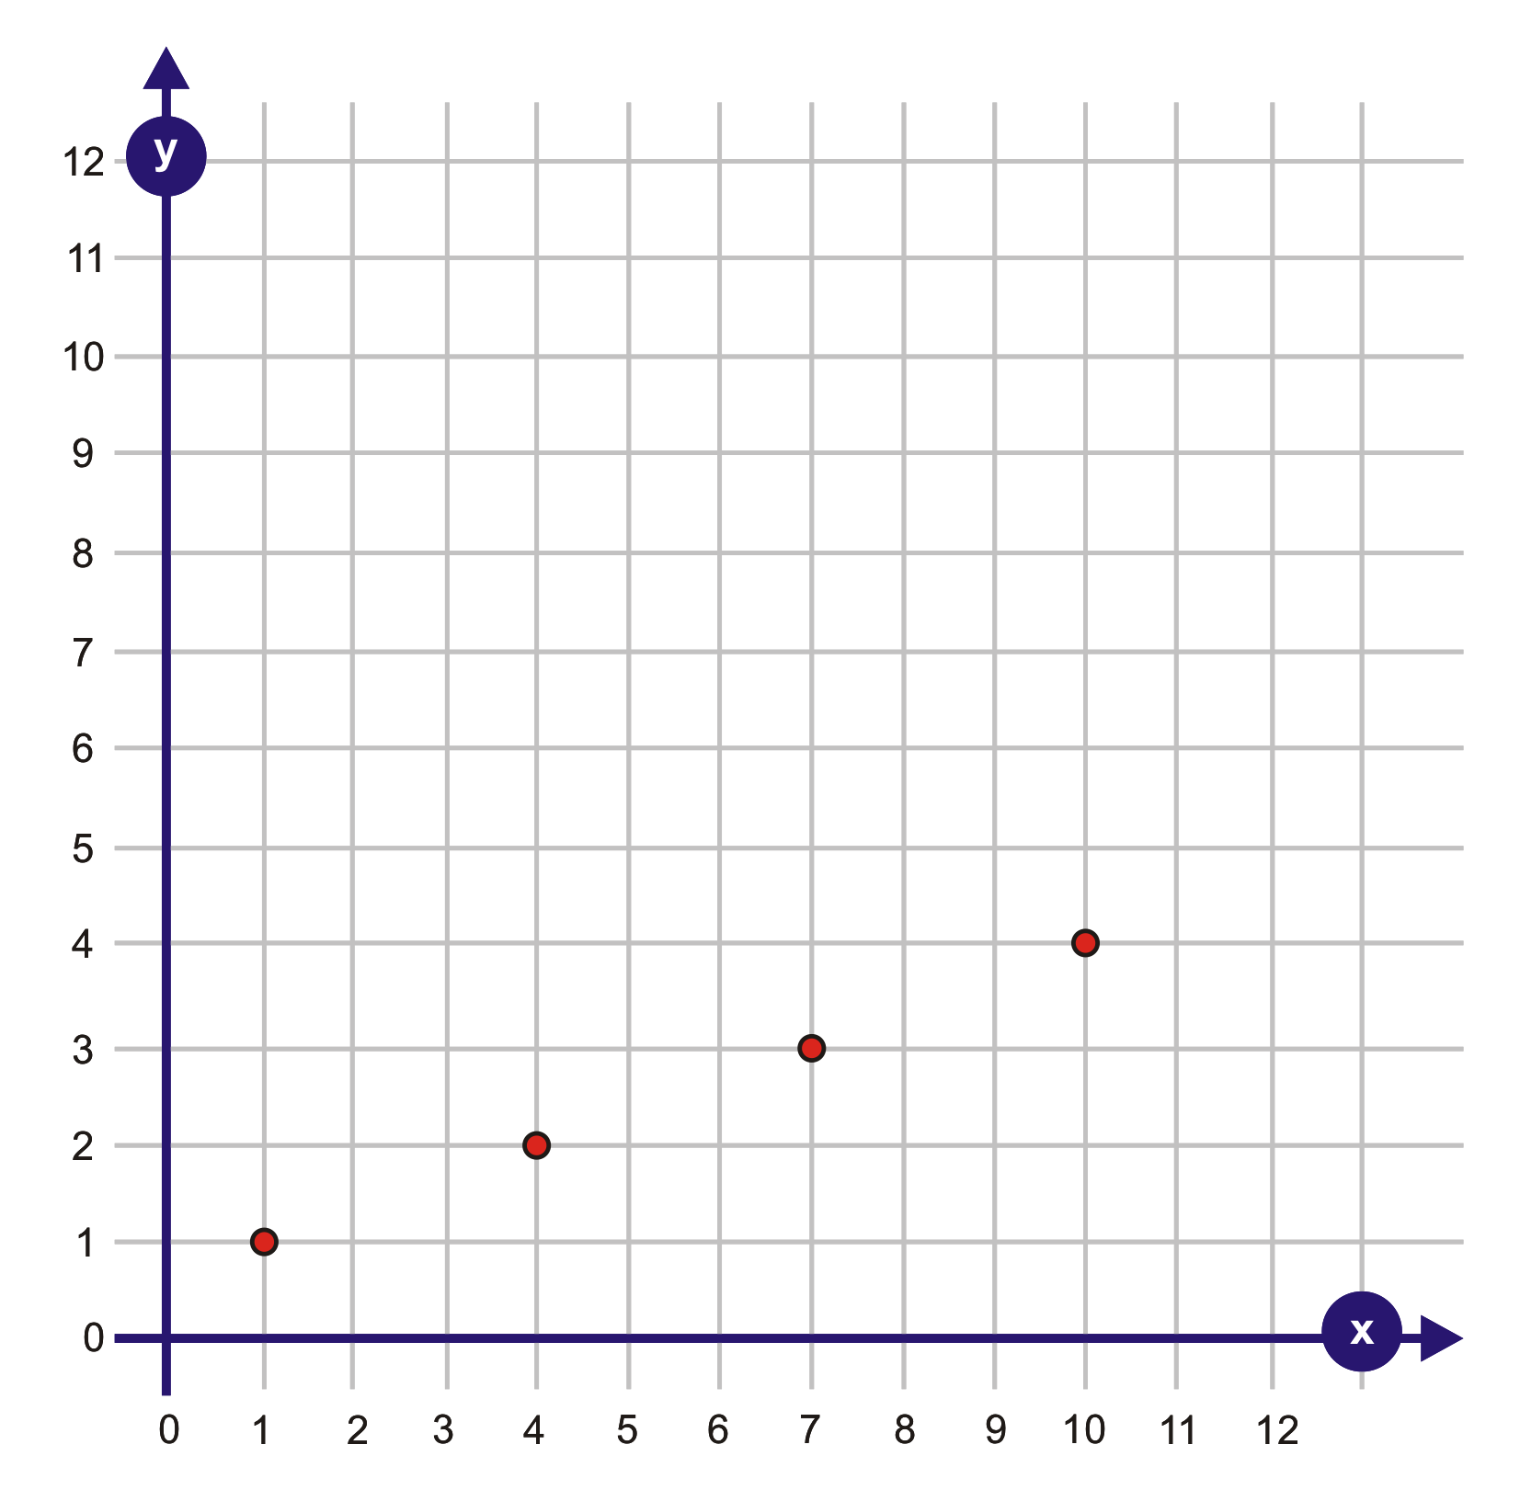
7.  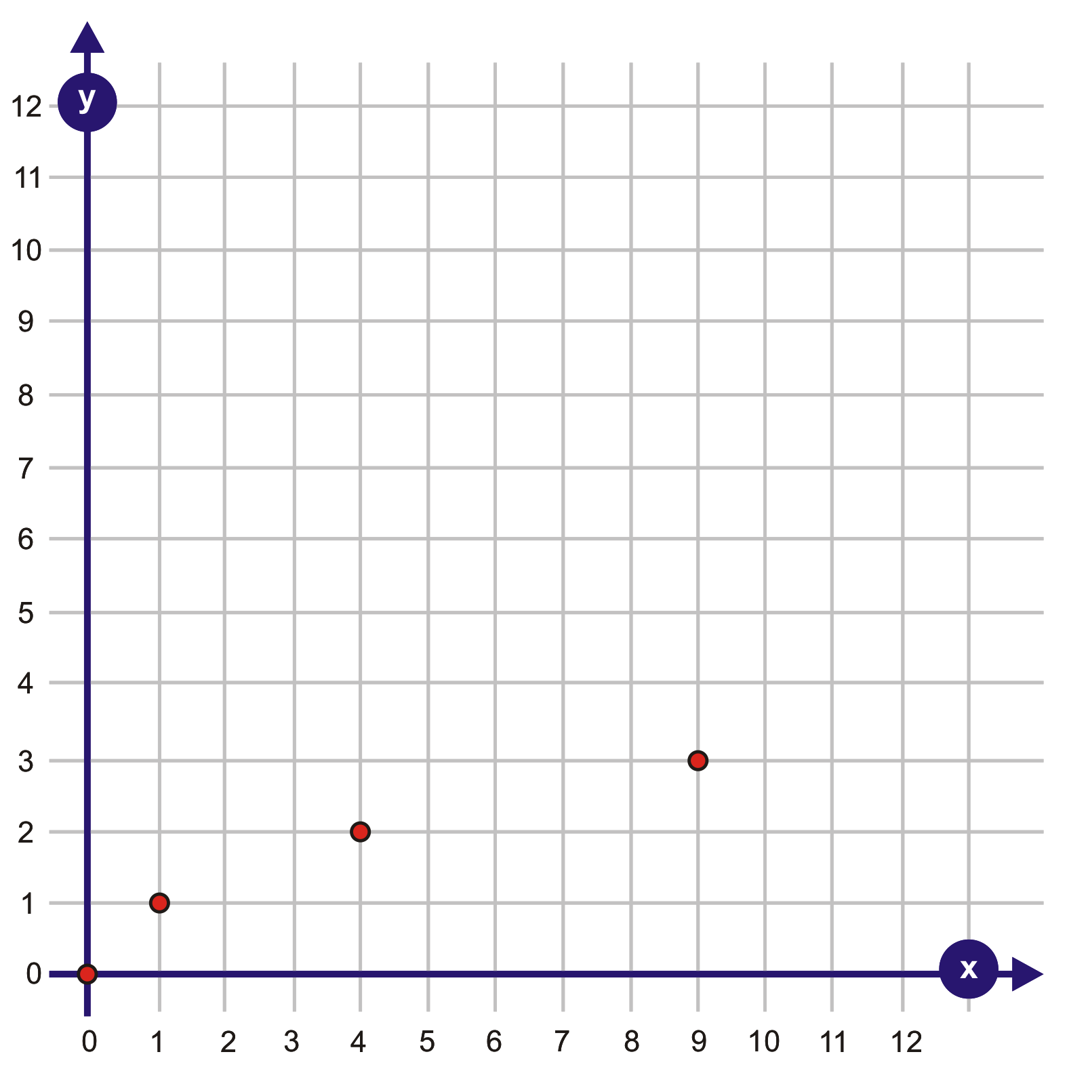 | 8.  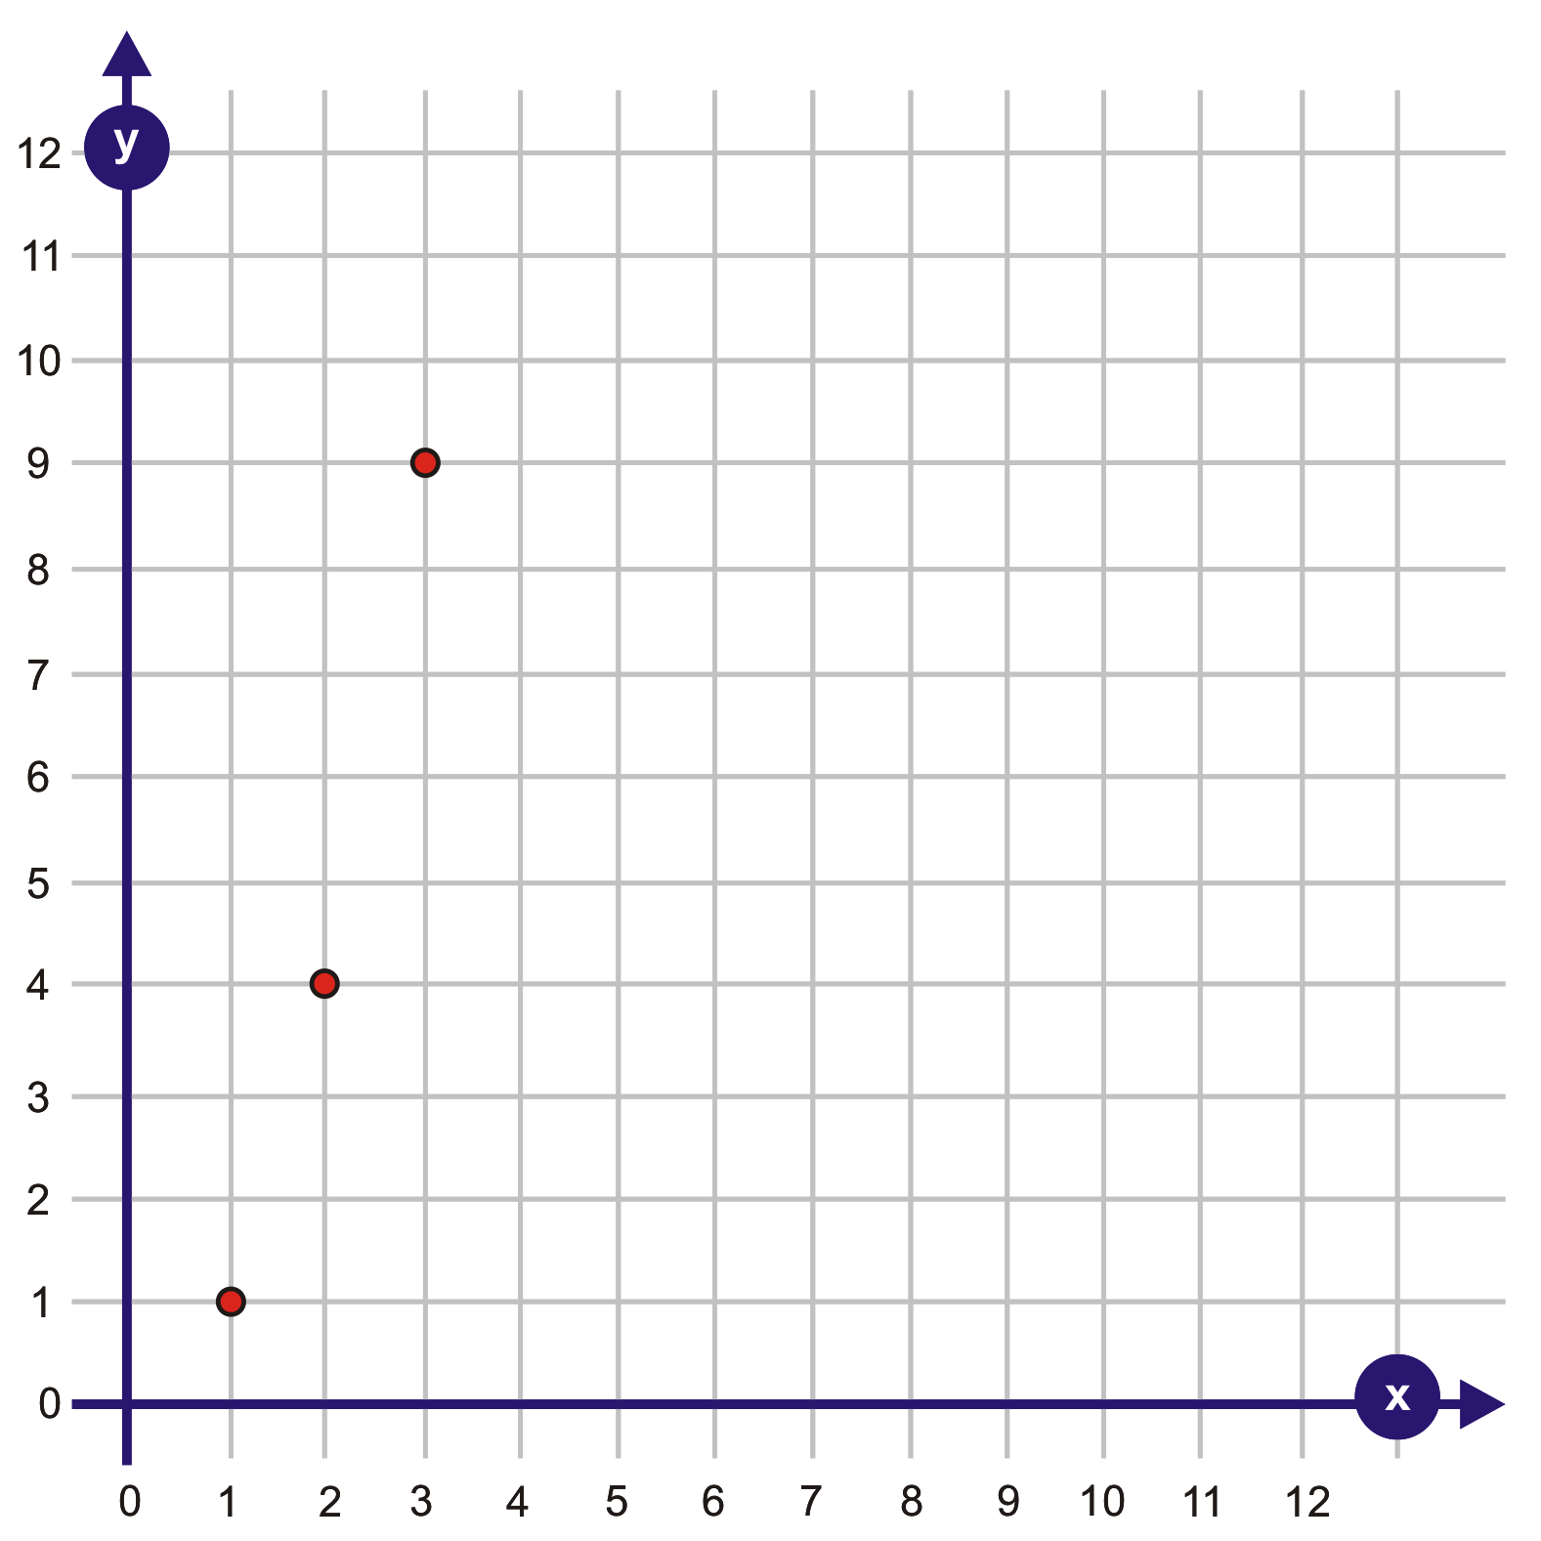

Unit 2: Day 6: When Can I Buy This Bike? |  |  |  | Grade 8
 |  | Math Learning Goals  - Solve problems involving patterns.  - Use multiple representations of the same pattern to help solve problems and prove that the solution is correct.  - Model linear relationships in a variety of ways to solve a problem. |  | Materials  - BLM 2.6.1
Assessment
Opportunities
 | Minds On… | Whole Class → Review  Hand each student a card (Day 3, BLM 2.3.1). Students find the other members of their group by matching all representations of the same pattern (patterning rule, numerical, graphical, and pictorial).  In their groups, students develop an algebraic expression for their pattern. One student from each group shares the response. (If a group finishes before the others, challenge them to find a story that fits the pattern.) |  | Possible Assumptions:  - bike stays the same price  - babysitting money stays the same  - she doesn’t spend any of the money she saves  Think Literacy: Cross Curricular Approaches, Grades 7–12, pp. 76–80, Mind Maps.  Mind maps can be done by hand or with software such as Smart Ideas (Ministry Licensed).  Provide a variety of manipulatives and technology.
 | Action! | Small Groups → Discussion  Explain the task (BLM 2.6.1) and discuss assumptions students must make: What assumptions are you making in order to consider solving this problem?  Students highlight or underline key words in the problem, e.g., costs $350, received $300, $12, per week.  Students use the problem-solving model (understand the problem, make a plan, carry out the plan, look back at the solution) to complete the task and submit their work.  Individual → Performance Task  Students complete this activity using BLM 2.6.1.  Problem Solving/Observation/Checkbric: Circulate to ask probing questions during the performance task.
 | Consolidate Debrief | Whole Class → Discussion  Students reflect on the problem-solving model: What strategies did you use for each part of the model? Students share many different strategies and representations.
Reflection |  | Home Activity or Further Classroom Consolidation  Complete a mind map/web to summarize what you learned in this unit. Use the appropriate vocabulary. |  | This activity can be used as a review or as an assessment tool.

2.6.1: A Problem-Solving Model: When Can I Buy This Bike?

Name:

Mackenzie has found the bicycle that she always wanted. It costs $350.00. She received $300 dollars as a gift from her family. How long would it take her to save enough money to purchase the bike if she earns $12 a week babysitting?

Using the problem-solving method (Understand the Problem, Make a Plan, Carry out the Plan, Look Back at the Solution) solve the problem above. Explain your thinking using pictures, numbers, and words. You may use manipulatives and a variety of tools to help you determine the solution. If you need more space to show your solution use the back of the page.

Understand the Problem
Read and re-read the problem. Using a highlighter, identify the information given and what needs to be determined.
Write a sentence about what you need to find.

Make a Plan
Consider possible strategies.
Select a strategy or a combination of strategies. Discuss ideas to clarify which strategy or strategies will work best.

Carry Out the Plan
Carry out the strategy, showing words, symbols, diagrams, and calculations.
Revise your plan or use a different strategy, if necessary.

Look Back at the Solution

Does your answer make sense?
Is there a better way to approach the problem?
Describe how you reached the solution and explain it.

Unit`2: Day 7: Determining the Term Number |  | Grade 8
 | Math Learning Goals  - Students will determine any term, given its term number, in a linear pattern represented graphically or algebraically  - Students will determine the term number given several terms | Materials  - BLM 2.7.1  - BLM 2.7.2
 | Whole Class → Game  Play the ‘What’s the Rule?’ Game from BLM 2.7.1.  One student acts as the equation machine. He/she is given one of the algebraic expression cards from BLM 2.7.1. One at a time, classmates call out possible term numbers between -5 and +5. Using mental math or a calculator, the equation machine student responds with the term value resulting from plugging in the class suggested term number into the expression on the card. Another student records the data in a table of values on the board. After two sets of values are recorded, students may volunteer to guess the pattern rule. Play for that card continues until the pattern rule has been named.    Alternatively, go to http://www.shodor.org/interactivate/activities/fm/index.html and play the Function Machine game on-line. |   Differentiation of content or process (calculator) based on readiness in order to save time:  Students create their own pattern rule game cards for the game.
Minds On…
 | Small Groups → Discussion/Highlight Word Wall Vocabulary  Compare the mind maps that were created in the Reflection Activity from Day 6. Highlight key vocabulary that should be included that will be relevant to today’s Minimum Wage Rates performance task: linear, term number, term value, n^{th} value, expression, etc.  Individual → Performance Task  Students will complete the activity from BLM 2.7.2. |     Problem Solving/  Observation /Checkbric: Circulate to ask probing questions during the performance task.
Action!
Whole Class →Discussion
Pose the following questions to the class:
- What assumptions have we made regarding Minimum Wage Rate trends? (i.e.: Is it reasonable to assume that this data has always been or will always remain linear?)
- What economic influences would impact changes in wage rates?
- Why is it necessary for governments to enforce a minimum wage?
Consolidate Debrief
Exploration | Home Activity or Further Classroom Consolidation  Students share Minimum Wage Rate data with family members to determine what wage rates were when parents were younger.  Opportunity for real-world cross-curricular connections with:  - Economic Systems in Gr. 8 Geography  - Science by having students design and experiment to see what relationships exist between two variables:  - Relationship between the number of drops of water and the diameter of the spot on a paper towel  - Relationship between the number of students and their arm spans  - Relationship of the distance a toy car will travel relative to the height of the ramp  - Relationship of the height of a bean plant compared to the number of days since sprouting  - Relationship of the height of a liquid relative to the volume in different sized containers | Explicitly identify opportunity for differentiation and extension of content or product based on interest or learning preference in order to give students choice

2.7.1: What’s the Rule? Equation Cards Grade 8

n+2  Add 2 to any number given | n+1  Add 1 to any number given | n - 2  Subtract 2 from any number given
n - 1  Subtract 1 from any number given | 2n  Double any number given | 2n+1  Double any number given, then add 1
2n+2  Double any number given, then add 2 | 2n -1  Double any number given, then subtract 1 | 2n - 2  Double any number given, then subtract 2
½ n  Halve any number | 3n  Triple any number | 5n  Multiply any number by 5

2.7.2: Minimum Wage Rates Grade 8

Minimum Wage Rate | March 31, 2007 | March 31, 2008 | March 31, 2009 | March 31, 2010
General Minimum Wage | $8.00  per hour | $8.75  per hour | $9.50  per hour | $10.25  per hour
Students under 18 and working not more than 28 hours per week during the school year or working during a school holiday | $7.50  per hour | $8.20  per hour | $8.90  per hour | $9.60  per hour
These are the minimum wage rates from the Ontario Ministry of Labour.

- Explain why both the General Minimum Wage rate and the ‘Student’ rate are linear patterns.

- Given this pattern of rate increase, what was the date when the General Minimum wage was $5.00? Show your work.

- If a student worked the maximum of 28 hours in a week in 2007, what was his/her weekly wage? Show your work.

- Who would earn more…
A 15 year old working 8 hours in 2012 or a 20 year old working 11 hours in 2007? Explain.

- Select either the General Minimum wage or the ‘Student’ wage. Write an expression for the nth term.

- If the wage increase continues in this same pattern, what will the General Minimum Wage be when you turn 18? Show your work.

