Unit 11 Grade 8
Design and Carry Out an Experiment

Lesson Outline

BIG PICTURE

Students will:
- explore everyday situations to gather data;
- collect, organize, display and analyse data;
- distinguish between types of data, e.g., primary, secondary, discrete, continuous, census, sample;
- add histograms and scatter plots to their repertoire of data display techniques;
- develop an appreciation for the differences in display-effect of various forms of data display as it relates to poorer or better communication of information;
- determine appropriate measures of central tendency;
- learn to use data in supporting inferences and making convincing arguments;
- pose a question and design and carry out an experiment to test it.
Day | Lesson Title | Math Learning Goals | Expectations
1 | A Picture Is Worth a Thousand Words | - Read and interpret the information shown on a variety of graphs.  - Redisplay the data imbedded in several given graphs using tables/charts as well as different forms of graphs.  - Investigate through discussion which forms of display communicate the contained information best. | 8m71, 8m73, 8m75, 8m77  CGE 2b, 2c
2–4 | Reliable Data? | - Design and conduct a census of one or more classes on some measurable attribute, e.g., shoe size.  - Record collected measurements and calculate the mean, median, and mode.  - Create a new record using a sample only of the original collected data and again calculate the mean, median, and mode.  - Determine which measure of central tendency was most appropriate in each case.  - Discuss census, representative sample, sample size, and population. | 8m68, 8m72, 8m74  CGE 4b, 5e, 7f
5 | Did We Count or Measure? | - Show examples of graphs displaying categorical data, i.e., data that is labelled or in categories, e.g., hair colour, gender, opinions about favourite music (usually summarized using percents or proportions).  - Show examples of graphs that display discrete data, i.e., data collected by counting, e.g., scatter plots showing number of times students are late for class, the number of successful shots a basketball player takes from various distances away from the basket.  - Show examples of graphs that display continuous data, i.e., data collected by measuring, e.g., cholesterol levels, heights, time.  - Find, collect, and organize examples of categorical, discrete, and continuous data.  - Identify the collected data as primary or secondary. | 8m68, 8m70, 8m75  CGE 4b, 3c
Day | Lesson Title | Math Learning Goals | Expectations
6, 7 | Different Displays for Counting and Measuring | - Investigate the similarities and differences in samples of primary and secondary data that have been displayed as histograms and bar graphs.  - Find and graph data that is spread over a wide range.  - Discuss the differences associated with primary and secondary data. | 8m69, 8m75  CGE 3c, 7f
8 | Is There a Relationship Here? | - Design a survey (or experiment) to compare two attributes or characteristics.  - Collect, organize, and graph the data using a scatter plot.  You are the Researcher: http://www19.statcan.ca/02/02_037_e.htm  Sample student projects: http://www19.statcan.ca/02/02_036_e.htm  Make an argument based on the analysis of the data in its various forms of display, e.g., table, graph. | 8m76, 8m78, 8m79  CGE 5e, 5g
9–11 | Summative Assessment | - Students pose a question/hypothesis and design and carry out an experiment to answer/test it.

Unit 11: Day 1: A Picture Is Worth a Thousand Words |  | Grade 8
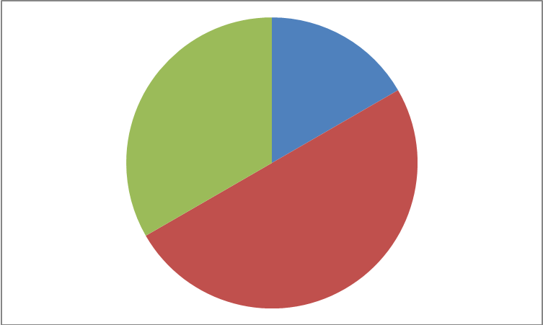 | Math Learning Goals  - Students will read and interpret the information shown on a variety of graphs  - Students will redisplay the data imbedded in several types of graphs using tables and/or charts  - Students will investigate, through discussion, which types of graphs can best represent the data set(s) of interest | Materials  - BLM 11.1.1  - BLM 11.1.2  - BLM 11.1.3  - BLM 11.1.4  - BLM 11.1.5  - Scissors  - Glue
Pairs → Think/Pair/Share
Distribute BLM 11.1.1. Students will individually read over the handout and answer the questions provided. Have them circle the information that is most useful for answering each question to help them build a connection between the features of the graph and the data set used to create the graph.

Each student must individually reflect on the statement “A Picture Is Worth A Thousand Words”.

Upon completion, students will explain their reasoning to a partner. Students will volunteer to share their reflections with the class.
Minds On…
 | Small Groups→ Investigation  Explain the instructions for the task and distribute BLM 11.1.2, BLM 11.1.3, and BLM 11.1.4. Be sure to highlight the *.  Students will need to cut and paste to arrange the graphs and tables onto a separate piece of paper. They should record their ideas using an organized format. | 
Action!
Whole Class→Discussion
Groups will discuss their findings for each graph and table. As you discuss each graph, post each graph on an overhead and show any missing information that needed to be added. Discuss the different types of graphs they have previously studied, and review when each is an appropriate choice.

Consolidate Debrief
Exploration | Home Activity or Further Classroom Consolidation  Students are to find a graph in some form of media (newspaper, magazine, or internet) and include the following information: The type of graph, explanation of the data displayed in the graph, two relevant conclusions, and why the type of graph was chosen to display the data.

11.1.1: A Picture Is Worth a Thousand Words Grade 8

Question # | Table | Graph | Question
1 |  | 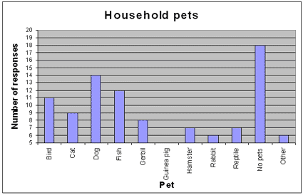 | Which household pet is most popular?  Circle the information you used to answer this question.
  Household Pets
  Pet | # of Students
  Bird | 11
  Cat | 9
  Dog | 14
  Fish | 12
  Gerbil | 8
  Guinea Pig | 5
  Hamster | 7
  Rabbit | 6
  Reptile | 7
2 |  | Number of students who like chocolate chip cookies best  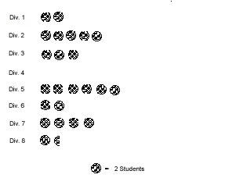 | In which division did no student select chocolate chip as the cookie they liked best?  Circle the information you used to answer this question.
  Students Who Like Chocolate Chip Cookies Best in Each Division
  Division | # of Students
  1 | 4
  2 | 10
  3 | 6
  4 | 0
  5 | 12
  6 | 4
  7 | 8
  8 | 3
3 |  | Music preferences in young adults 14 to 19  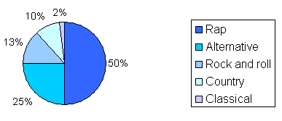 | What type of music does one quarter of young adults prefer?  Circle the information you used to answer this question.
  Music Preferences
  Music Type | # of Students
  Rap | 100
  Alternative | 50
  Rock and Roll | 26
  Country | 20
  Classical | 4
4 | Reflection: How does the saying “A picture is worth a thousand words” relate to this activity?

11.1.2: A Picture Is Worth A Thousand Words Grade 8

Action!:
- Match each graph on BLM 11.1.3 with the appropriate table on BLM 11.1.4 by cutting each out and pasting them together below and on the backside of this page. Explain how you knew that the 2 items were a match.*
- State the type of graph.
- Add any missing information directly on to the graph (titles, labels, etc.)
- Draw 2 relevant conclusions about each group of data.

* Note: One table has been displayed in 2 different graphical formats. Determine which table this is. Complete steps 1-4, and then circle the graph that is the most appropriate representation of the data. Justify your reasoning.

11.1.3: A Picture Is Worth A Thousand Words Grade 8
Graph A | Graph B
Graph C | Graph D

Graph E

11.1.4: A Picture Is Worth A Thousand Words Grade 8
Table 1  Fun Run Fundraiser – Participant’s Age and Distance Completed in km | Table 2  Instruments Students Learn to Play  Table 3  Homework Time Spent on Each Subject  Table 4  Daily Maximum Temperatures for 2 Weeks in January
  Age (years) | Distance (km)
  28 | 30
  63 | 20
  46 | 35
  37 | 15
  38 | 12
  29 | 25
  33 | 16
  54 | 5
  43 | 15
  23 | 8
  60 | 11
  47 | 6
  48 | 16
  51 | 12
  40 | 19
  31 | 10
  20 | 5
  30 | 25
  36 | 27
  35 | 22
  36 | 16
  65 | 13
  60 | 27
  57 | 10
  68 | 12
  32 | 20
  38 | 15
  42 | 20
  62 | 11
  15 | 9
  35 | 15
  25 | 15
  18 | 10
  17 | 17
  18 | 25
  26 | 7
  Instrument | Girls | Boys
  Drums | 7 | 9
  Classical Guitar | 5 | 8
  Electric Guitar | 8 | 10
  Piano | 10 | 7
  Harp | 1 | 0
  Clarinet | 5 | 1
  Violin | 2 | 3
  Bagpipes | 4 | 2
  Subject | Percent
  French | 15
  Math | 30
  Spelling | 25
  History | 10
  Science | 20
  January | Temp (˚ C)
  1 | -3
  2 | 5
  3 | 4
  4 | -1
  5 | 0
  6 | 6
  7 | 3
  8 | 5
  9 | -2
  10 | 0
  11 | 5
  12 | 8
  13 | -4
  14 | 2

11.1.5: A Picture Is Worth A Thousand Words Grade 8

Answers to Action! (BLM 11.1.2, BLM 11.1.3, BLM 11.1.4)

Table 1 goes with Graph D (Scatter Plot) – Students should add a title, label the x-axis ‘Age’ and label the y-axis ‘Distance Completed’ in km

Table 2 goes with Graph E (Double Bar Graph) – Students should add a title, label the x-axis ‘Instrument’ and label the y-axis ‘Frequency or # of Students’

Table 3 goes with Graph B (Circle Graph) – Students should add a title and label the percentages in each sector

Table 4 goes with Graph A (Bar Graph) and Graph C (Broken-Line Graph) – Students should add a title to both graphs, label the x-axis ‘January’ and label the y-axis ‘Temperature’ in ˚ C

* Students should circle Graph C as the most appropriate format to display this data as it shows a change in temperature over a period of time.

Unit 11: Day 2: Reliable Data? |  | Grade 8
 | Math Learning Goals  - Students will design and conduct a census of one or more classes on some measurable attribute, e.g., shoe size  - Students will record collected measurements and calculate the mean, median and mode | Materials  - Ruler  - BLM 11.2.1
 | Small Group → Discovery  Divide the class into groups of two or three and have them perform the following task:  Come up with a set of data that has the following attributes:  N = 8 Median = 10  Mean = 12 Mode = 9  Note to teacher: These attributes can be changed as you see fit. If you decide to do this with your class again, you can change the values of N, Mean, Median and Mode.  Whole Class → Sharing  Once the students have completed the question in pairs they can share their strategies with the class. | Collect Day 1 At Home Activity to be assessed.  Word Wall  -Mean  -Median  -Mode
Minds On…
Whole Class → Investigation
Students measure an attribute (i.e. the length of their shoe in millimetres, their height in mm, the distance they can jump from a standing position in mm, etc.) and record it on a chart on the blackboard. Each student will record the class results for the attribute they chose on BLM 11.2.1.
Students will need to add their own title for the BLM as well as a title for the chart and headings based on their attribute.
Each student will calculate the mean, median and mode of the data showing their work.

Students could be asked to estimate what they think the values for mean, median and mode will be before they actually calculate it.
Action!
Whole Class → Summarizing
Summarize the process:
- When calculating the mean, add the numbers in the data set together and divide by the total number in the set
- When calculating the median, list the numbers in the data set in numerical order and locate the middle number. In the case of an even number in the data set, find the mean of the middle 2 numbers.
- When calculating the mode, find the number that occurs most frequently in the data set.

Consolidate Debrief
Exploration | Home Activity or Further Classroom Consolidation  Students will find at least 5 people other than the students in their class (family members, friends, neighbours etc.) and measure the attribute they have chosen and record the results on BLM 11.2.1. Students need to add a title and headings to the chart.

11.2.1: Recording Sheet Grade 8

Table 1:

Calculate the mean of the data.

Calculate the median of the data.

Calculate the mode of the data.

At Home Activity: Measure your chosen attribute of at least 5 additional people (family members, friends, neighbours etc.) and record them in the chart below.

Table 2:

Unit 11: Day 3: Reliable Data? (continued) |  | Grade 8
 | Math Learning Goals  - Students will explore the effect of adding new data to an original sample by recalculating the mean, median and mode  - Students will determine which measure of central tendency was most appropriate in each case | Materials  - BLM 11.2.1  - BLM 11.3.1
Whole Class → Connecting
Share and discuss students` responses to the At Home Activity recorded in Table 2 from BLM 11.2.1. Students will indicate the range of results they found and whom they surveyed for their results.
Minds On…
 | Pairs → Calculating  Each pair of students will take one set of data from Table 2 of the At Home Activity in BLM 11.2.1 and add it to the original data set from Table 1 in BLM 11.2.1. Pairs will calculate the new mean, median and mode of the data (Data set C).  Students will calculate the mean, median and mode of just the At Home Activity data set (Data set B). They will then have 3 sets of central tendencies.  Pairs of students will compare the new central tendencies to the original central tendencies (Data set A).  The students will record their results on BLM 11.3.1 | 
Action!
Whole Class → Application
Post the central tendencies from the original data set and from each partnership on the board to compare to the original central tendencies.

Pose these questions:
- Which central tendency, mean, median or mode was most appropriate or representative in the original data set? Justify your choice.
- Which central tendency was the most representative for the data set that contained the additional At Home Activity?
- If we only had the data from the At Home Activity, would that be a good representation of the data set? Why or why not?
- Which measure of central tendency was most changed by the addition of the data set from the At Home Activity? Why do you think may be the case?

Consolidate Debrief
Application  Exploration | Home Activity or Further Classroom Consolidation  Write in your journal two occupations or jobs that would require measurement of central tendencies. Justify your answer.

11.3.1: Changing our Tendencies Grade 8

Data Set A: Record the mean, median and mode that was calculated on Day 2 for the original data set using Table 1 in BLM 11.2.1.

MEAN:

MEDIAN:

MODE:

Data Set B: Calculate the mean, median and mode of just the At Home Activity data set from Table 2 in BLM 11.2.1. Show your method of calculating the central tendencies.

MEAN:

MODE:

MEDIAN:

Data Set C: In partners, take one set of data from the At Home Activity and add it to the original data set from Day 2. Calculate the new mean, median and mode of the data. Show your method of calculating the central tendencies.

NEW MEAN:

NEW MODE:

NEW MEDIAN:

Unit 11: Day 4 Reliable Data? (continued) |  | Grade 8
 | Math Learning Goals  - Students will discuss census, representative sample, sample size and population | Materials  - BLM 11.4.1  - Dictionaries  - Computer with Internet access
 | Individual → Investigating  Students will use any resource available to them (math dictionaries, online resources etc.) to write down the definitions of the following terms:  - Census  - Population  - Sample size  - Representative sample size | Word Wall  -Census  -Representative Sample  -Sample Size  -Population
Minds On…
Pairs → Problem Solving
Cut up cards from BLM 11.4.1, and distribute one card to each pair. Each pair will be responsible for coming up with a solution to their card and presenting it to the class.

Students will have to decide if their card presents a viable sampling technique. If not (and they hopefully will decide not), then they need to decide why it is not a good sampling technique and then they need to suggest a way to improve the sampling technique.

Action!
Whole Class → Discussion
After the groups finish presenting, reinforce each definition from the ‘Minds On...’ section and place the definition on the board or chart paper. Lead a discussion about how the terms relate to the sampling techniques they explored using BLM 11.4.1 in the ‘Action!’ section. Keep the chart paper displayed for the rest of the unit.

Consolidate Debrief
Application | Home Activity or Further Classroom Consolidation  Students will complete the following questions regarding the previous two lessons in their math journal:  1. If you added data to Table 1 from BLM 11.2.1, which would be most affected: the census, the population or the sample size? Explain your opinion.  2. For your attribute, was the data collected from a representative sample? Explain your opinion.

11.4.1: Sampling Techniques Grade 8

CARD A
Joe is trying to find out the most popular lunch destination for students in grade 7 & 8 at his school.

To do this, he decides to stand outside Pizza Pizza at lunchtime on Friday. He surveys every other student that walks into Pizza Pizza.

- What is wrong with Joe’s technique?
- How could you improve it?

CARD B
Carla is trying to decide what the favourite rock band is for grade 7 & 8 students at her school.

To do this, she posts a note on Facebook and asks people to respond to her question: What is your favourite rock band?

- What is wrong with Carla’s technique?
- How could you improve it?

CARD C
Arun wants to know the most popular sport for grade 7 & 8 students in his school.

To do this, he decides to ask all the players on his soccer team what their favourite sport is.

- What is wrong with Arun’s technique?
- How could you improve it?

CARD D
Ariel would like to decide what colour to use to decorate the grade-8 graduation.

To do this, she brings a form to every class in her school and asks the teacher to poll the class. Whichever two colours are the most popular are the two she is going to decorate with.

- What is wrong with Ariel’s technique?
- How could you improve it?

Unit 11: Day 5: Did We Count or Measure? |  | Grade 8
 | Math Learning Goals  - Students will show examples of graphs displaying categorical data, i.e., data that is labelled or in categories, e.g., hair colour, gender, opinions about favourite music (usually summarized using percents or proportions)  - Students will show examples of graphs that display discrete data, i.e., data collected by counting, e.g., scatter plots showing number of times students are late for class, the number of successful shots a basketball player takes from various distances away from the basket  - Students will show examples of graphs that display continuous data, i.e., data collected by measuring, e.g., cholesterol levels, heights, time  - Students will find, collect, and organize examples of categorical, discrete, and continuous data  - Students will identify the collected data as primary or secondary | Materials  - BLM 11.5.1  - BLM 11.5.2  - BLM 11.5.3  - BLM 11.5.4  - Dice
 | Whole Class → Four Corners  Have students consider the following statement:  The amount of time spent playing computer games affects school grades.  Encourage students to carefully ponder the question for a minute or two, and make a personal decision as to whether they strongly agree, agree, disagree, or strongly disagree. Ask students to move to the corner that best represents their stance. Direct students to get into groups of 3 if possible, to discuss reasons for their choices. Call upon various groups to share information gathered in small-group discussions with the whole class. | See Think Literacy Mathematics: Grades 7-9, Four Corners, p. 106.
Minds On…
Whole Class → Instruction
Using information contained on BLM 11.5.1, review the different types of data. Also review the difference between primary and secondary data.

Whole Class → Four Corners
Display graphs from BLM 11.5.2 one at a time and have students move to the corner that best represents the graph type: Categorical – Nominal, Categorical – Ordinal, Discrete, or Continuous. Students explain how each graph displays a particular type of data. Answers have been provided on BLM 11.5.4.

Action!
Individual → Practice
Students work on BLM 11.5.3 individually.
Questions from worksheet have been adapted from:
http://www.statcan.gc.ca/edu/power-pouvoir/ch8/exer/5214812-eng.htm
Answers:
http://www.statcan.gc.ca/edu/power-pouvoir/ch8/answers-reponses/5214811-eng.htm#A1a

Consolidate Debrief
Concept Practice | Home Activity or Further Classroom Consolidation  Students will complete BLM 11.5.3.

11.5.1: Did We Count or Measure? Grade 8

The following information was taken from: Statistics Canada, http://www.statcan.gc.ca/pub/12-593-x/2007001/4124941-eng.htm , July 27, 2009.

Types of data
Particular questions produce particular types of data, which in turn lend themselves to particular types of graphs.
There are two main types of data: categorical and numeric.

Categorical data
The question 'What colour is your hair?' produces categorical data, which fit into categories 'brown,' 'blonde,' 'black,' 'red' or 'other.' Categorical data can be broken down into nominal and ordinal sub-types.
See the table below for each categorical sub-type and its associated graph types.

Table 1: Categorical data
Types of data | Sub-types | Examples from Census at School Database | Appropriate Graphs
Categorical: Data fit into various categories of responses to a question. | Nominal: These data are identified by particular names or categories. These data cannot be organized according to any 'natural' order. | Gender: male, female | Bar graph, circle graph, pictograph
 |  | Favourite subject: math, history, gym, music, etc. | Bar graph, circle graph, pictograph
 |  | Eye colour: brown, blue, green, other | Bar graph, circle graph, pictograph
 |  | Pets: cats, dogs, birds, fish, etc. | Bar graph, circle graph, pictograph
 | Ordinal: These data are identified by categories that can be placed in a specific order or ordered in some 'natural way.' | Schoolwork pressure: none, very little, some, a lot | Bar graph, circle graph, pictograph

11.5.1: Did We Count or Measure? (Continued) Grade 8

Numeric data
The question, 'How many people live in your home?' produces numeric data, which can be broken down into discrete and continuous sub-types. See the chart below for each sub-type and its associated graph types.

Table 2: Numeric data
Types of data | Sub-types | Examples from Census at School Database | Appropriate Graphs
Numeric: Data are represented by real numbers. Also known as quantitative data. | Discrete: Data that can only assume a finite number of different responses. For example, the numbers of people in a household are discrete data because you can only answer using whole numbers from 1 to 10 or more. You cannot include all the decimals or fractions in between as possible answers. For example, it's impossible to have 2.5 or 3.75 people. | Age in years: 7, 8, 9, 10, 11, etc. | Bar graph, line graph, circle graph, histogram
 |  | Number of people in the household: 1, 2, 3, 4, 5, etc. | Bar graph, line graph, circle graph, histogram
 |  | Number of days during which you did an intense physical activity last week: 0, 1, 2, 3, 4, 5, 6, 7, etc. | Bar graph, line graph, circle graph, histogram
 | Continuous: Data that can assume an infinite number of different responses. The answers have infinite possibilities since they can include decimal responses. For example, a student's height may be 1.57923 metres. | Height, arm span, wrist circumference: It's impossible to list all the possibilities. Note: In the Census at School survey, students are required to round their answers to the nearest centimetre or millimetre, so in effect their responses are discrete data. | Line graph, histogram
Notes: To make continuous data easier to handle, they are often grouped into class intervals. Grouping data is part of the process of organizing data so that the information becomes useful. For example, instead of displaying every height measured in a class of students, it is more effective to display grouped categories such as 120 to 129 cm, 130 to139 cm, 140 to 149 cm, etc.
Discrete data may be grouped or ungrouped. Grouping data makes them easier to handle, but with a small number of responses, it can be just as clear to leave them ungrouped. Note: Sometimes numbers can represent scales of response (e.g., 0=none, 1=very little, 2=some, etc.). In this case, the responses are considered ordinal categorical data, not numeric data, even though they are represented by a number.

11.5.2: Did We Count or Measure? Grade 8

Identify each graph as one of the following: Categorical, Discrete or Continuous.

Figure 1: Pressure from School Work
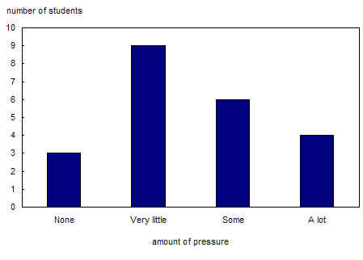

Figure 2: Example of line graph showing relationship between two variables: Height by age
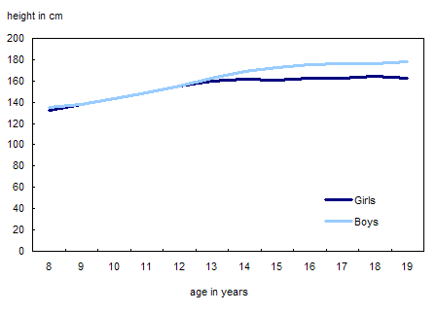

11.5.2: Did We Count or Measure? (Continued) Grade 8

Figure 3: Pressure from School Work
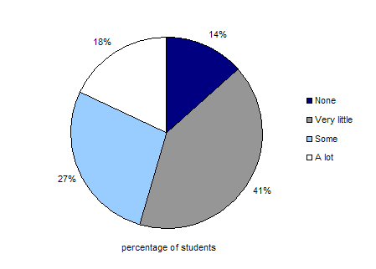

Figure 4: Example of histogram: Distribution of students in a Grade 6 class by height

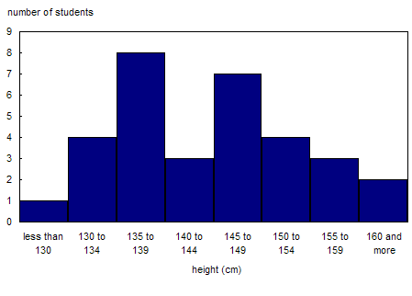

11.5.2: Did We Count or Measure? (Continued) Grade 8

Figure 5: Example of histogram: Frequency of scores for a 10-question math quiz

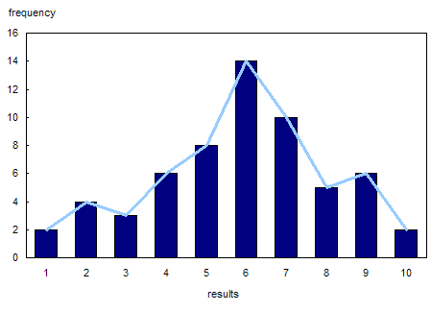

Figure 6: Example of a scatter graph showing a positive correlation: Height versus arm span

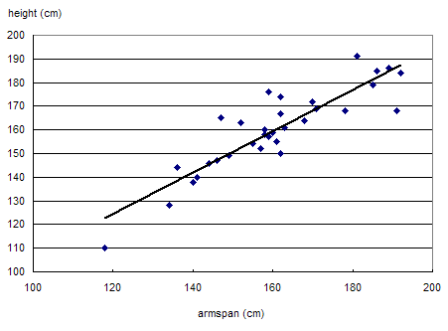

11.5.3: Did We Count or Measure? Grade 8
Adapted from Statistics Canada.
- Indicate whether each of the following variables is categorical, discrete or continuous:
- the time it takes for you to get to school _____________________
- the number of Canadian couples who were married last year ________________
- the speed of a bicycle ___________________________
- the favourite type of music of grade 8 students_____________________
- the annual income of an individual _____________________________
- the number of brothers and sisters you have ________________________
- the distance between your house and school ________________________
- the number of pages in a dictionary _______________________
2. A local convenience store owner records how many customers enter the store each day over a 25-day period. The results are as follows:
20, 21, 23, 21, 26, 24, 20, 24, 25, 22, 22, 23, 21, 24, 21, 26, 24, 22, 21, 23, 25, 22, 21, 24, 21
- Are these discrete or continuous variables? ____________________
- Present these data in a frequency distribution table.
# of customers | Tally | Frequency
- Which result occurs most frequently? ______________
- Is this primary or secondary data? _____________________
11.5.3: Did We Count or Measure? Continued Grade 8
3. Complete the following experiment. Throw one die 30 times. Using a frequency distribution table, record the result of each throw.
Number Rolled | Tally | Frequency

- Are these discrete or continuous variables? ________________________
- What result occurs most frequently? _____________________________
- Is this primary or secondary data? ______________________
- Do any outliers exist? If so, give a reason for their presence.

- What conclusions can you draw from the analysis?

11.5.4: Did We Count or Measure? Answers Grade 8

Answers for BLM 11.5.2

Figure 1 – categorical

Figure 2 – continuous

Figure 3 – categorical

Figure 4 – continuous

Figure 5 – discrete

Figure 6 – continuous

Answers for BLM 11.5.3

1a. continuous
b. discrete
c. continuous
d. categorical
e. continuous
f. discrete
g. continuous
h. discrete

2a. discrete
b.
# of customers | Tally | Frequency
20 |  | 2
21 |  | 7
22 |  | 4
23 |  | 3
24 |  | 5
25 |  | 2
26 |  | 2
Total |  | 25
c. The observation that occurs most frequently is 21.
d. This is secondary data.

3. Answers will vary depending on individual student results.

Unit 11: Day 6: Different Displays for Counting and Measuring |  | Grade 8
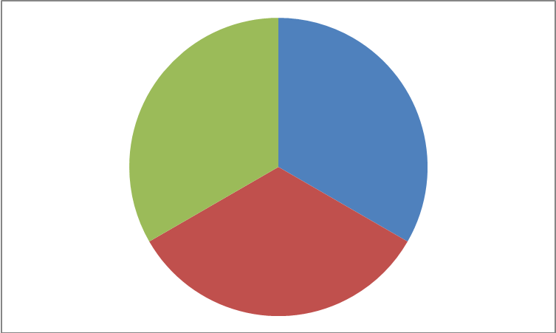 | Math Learning Goals  - Students will investigate the similarities and differences in samples of primary and secondary data that have been displayed as histograms and bar graphs  - Students will find and graph data that is spread over a wide range  - Students will discuss the differences associated with primary and secondary data | Materials  - BLM 11.6.1  - BLM 11.6.2  - BLM 11.6.3
Individual → Problem Solving
Students will look at the 2 graphs on BLM 11.6.1 and compare them using the Venn Diagram on BLM 11.6.2.
Minds On…
Pairs → Application
Students will work in partners and use BLM 11.6.2 to fill in the Sentence Stems at the bottom of the page. Students will develop a definition for the first stem and at least 5 features for the second stem.

Action!
Individual → Application
Students will complete BLM 11.6.3 individually based on their findings from looking at BLM 11.6.1 and completing BLM 11.6.2.

Consolidate Debrief
Exploration | Home Activity or Further Classroom Consolidation  Find an example of a bar graph or histogram in a newspaper or magazine and cut it out to bring to class. Glue the example in your math journal. List the critical features from BLM 11.6.2 and indicate whether the graph you cut out has all the critical features.

11.6.1: Bar Graphs and Histograms Grade 8

Bar Graph

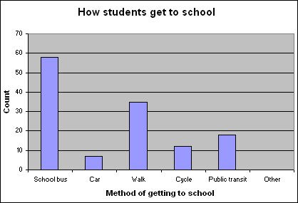

Histogram

Average Salary of Office Workers

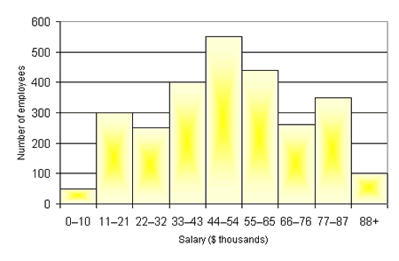

11.6.2: Bar Graphs versus Histograms Grade 8

Complete the sentence stems.

1. A histogram is ……

2. Five critical features of histograms are….

11.6.2: Bar Graphs versus Histograms Answers Grade 8

- Title
- Axes labelled
- Even increments on the axes
- Colour
- Straight lines (ruler)

Histogram
- Bars are connected
- Know how many employees are in each interval, but not the exact values of data
Bar Graph
- Bars are separated
- Each method has an exact value

Complete the sentence stems.

1. A histogram is……a vertical bar graph that shows frequencies of data organized into intervals; the intervals line up side by side without gaps

2. Five critical features of histograms are….
- bars represent data
- no gaps between bars
- label on x-axis
- label on y-axis
- title
- intervals are even

11.6.3: Bar Graphs or Histograms? Grade 8

You learned about bar graphs and histograms during the last lesson. Based on the tables below, would you create a bar graph or histogram to display each set of data?

TABLE 1: Average Number of Hours Students Spend Watching TV Weekly

Day of the Week | Average number of hours spent watching TV
Sunday | 6
Monday | 2
Tuesday | 1.5
Wednesday | 2.5
Thursday | 3
Friday | 3.5
Saturday | 5

TABLE 2: Number of CDs Owned by People Living in Mississauga

Age Group (in years) | Number of CDs
3-6 | 3
7-10 | 8
11-14 | 23
15-18 | 46
19-22 | 57
23-26 | 45
27-30 | 68

1. For Table 1, would you display the data using a bar graph or histogram? Justify your choice.

2. For Table 2, would you display the data using a bar graph or histogram? Justify your choice.

11.6.3: Bar Graphs or Histograms? You decide. Grade 8
Answers

You learned about bar graphs and histograms during the last lesson. Based on the tables below, would you create a bar graph or histogram to display each set of data?

TABLE 1: Average Number of Hours Students Spend Watching TV Weekly

Day of the Week | Average number of hours spent watching TV
Sunday | 6
Monday | 2
Tuesday | 1.5
Wednesday | 2.5
Thursday | 3
Friday | 3.5
Saturday | 5

TABLE 2: Number of CDs Owned by People Living in Mississauga

Age Group (in years) | Number of CDs
3-6 | 3
7-10 | 8
11-14 | 23
15-18 | 46
19-22 | 57
23-26 | 45
27-30 | 68

1. For Table 1, would you display the data using a bar graph or histogram? Justify your choice.

Bar graph because there are no intervals, each day has a distinct number associated with it.

2. For Table 2, would you display the data using a bar graph or histogram? Justify your choice.

Histogram because there are intervals, it can be drawn with bars, the intervals are even.

Unit 11: Day 7: Different Displays for Counting and Measuring (Continued) |  | Grade 8
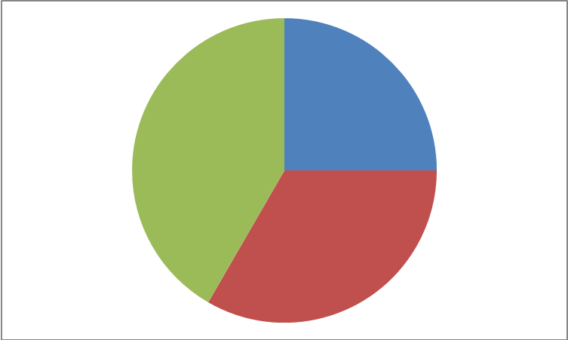 | Math Learning Goals  - Students will find and graph data that is spread over a wide range  - Students will discuss the differences associated with primary and secondary data | Materials  - BLM 11.7.1  - Graph paper
Whole Class → Discussion (4 corners)
Students will go to one of the four corners set up within the room (All features are met, One feature is missing, Two features are missing, Three or more features are missing). Based on the graph they found and glued into their journals from the At Home Activity on Day 6, the students will move to the corner that applies to their graph.
For the groups where the graphs were missing features, students will determine if the feature(s) that were missing are consistent (i.e. Were they all missing a title or an axis label?). For the group that was not missing any features, they can share and explain their graphs.

Minds On…
Small Group → Problem Solving
Students will be given BLM 11.7.1 that focuses on stem-and-leaf plots as a review (may have been covered in grade 7). In groups of 3 or 4, students will read over the instructions and complete the tasks.
Action!
Whole Class → Discussion
Class will discuss the displayed results from the BLM 11.7.1 stem-and-leaf plot and discuss which central tendency they think will be most affected.
The class will also discuss whether they were plotting primary (data collected by oneself) or secondary data (data collected by someone else).
Remind the students of the data collected from the At Home Activity from Day 2, and ask whether it was primary of secondary data.

Consolidate Debrief
Practice | Home Activity or Further Classroom Consolidation  In their math journals, students will take the data from Day 2 and create a stem-and-leaf plot as well as graphing the data as a histogram.

11.7.1: Stem-and-Leaf Plots Grade 8

One way to get a quick picture of a set of data is to use a stem-and-leaf plot. We can use the stem-and-leaf plot to analyse data.

Example: The following list shows the number of games won by the Toronto Blue Jays in their first 21 years in Major League Baseball from 1977-1997.

54 59 53 67 37 78 89 89 99 86 96 87
89 86 91 96 95 55 56 76 88

In order to create a stem-and-leaf plot, first record the stem and then record the leaf beside its stem. Finally, arrange the leaves in order from smallest to largest.

Stem | Leaves |  | Blue Jays Wins
3 | 7 |  | 3 | 7
5 | 4, 9, 3, 5, 6 |  | 5 | 3, 4, 5, 6, 9
6 | 7 |  | 6 | 7
7 | 8, 6 |  | 7 | 6, 8
8 | 9, 9, 6, 7, 9, 6, 8 |  | 8 | 6, 6, 7, 8, 9, 9, 9
9 | 9, 6, 1, 6, 5, |  | 9 | 1, 5, 6, 6, 9

Activity:

Heather MacLean, an Olympic hopeful, recorded the following times, in seconds, for 20 swimmers in the 100-m front crawl.

113 124 108 89 93 92 132 98 88 104 99 103 114 125 136 79 123 91 93 133

1. Use the data above to create a stem-and-leaf plot.

2. Using graph paper, draw a histogram that displays the data.
3. What are the mean, median and mode of the data?
4. Heather recorded a time of 56 seconds in her race in Montreal. Which central tendency will be most affected by adding her time to the data? How do you know?

11.7.1: Stem-and-Leaf Plots Answers Grade 8

Activity:

Heather MacLean, an Olympic hopeful, recorded the following times, in seconds, for 20 swimmers in the 100-m front crawl.

113 124 108 89 93 92 132 98 88 104 99 103 114 125 136 79 123 91 93 133

1. Use the data above to create a stem-and-leaf plot.
Stem | Leaves
7 | 9
8 | 8, 9
9 | 1, 2, 3, 3, 8, 9
10 | 3, 4, 8
11 | 3, 4
12 | 3, 4, 5
13 | 2, 3, 6

2. Using graph paper, draw a histogram that displays the data.
Graphs will vary depending on the increments on the y-axis

3. What are the mean, median and mode of the data?

Mean=113+124+108+89+93+92+132+98+88+104+99+103+114+125+136+79+123+91 +93+133 ÷ 20
=2137 ÷ 20
=106.85 seconds

Median: 79, 88, 89, 91, 93, 93, 98, 99, 103, 104, 108, 113, 114, 123, 124, 125, 132, 133, 136 (mean of the middle 2 numbers is (104+108) ÷ 2 = 212 ÷ 2 = 106 seconds

Mode: 93

4. Heather recorded a time of 56 seconds in her race in Montreal. Which central tendency will be most affected by adding her time to the data? How do you know?

New mean = (2137+56) ÷ 21
=2193 ÷ 21
=104.42 seconds

New Median: =104

Mode stays the same

∴ the mean changed the most.

Unit 11: Day 8: Is there A Relationship Here? |  | Grade 8
 | Math Learning Goals  - Students will design a survey (or experiment) to compare two attributes or characteristics. | Materials  - A variety of different sized maple leaves  - Rulers  - Graph paper  - BLM 11.8.1  - BLM 11.8.2
 | Small Group → Placemat  Divide students into small groups of 4 or 5. Have students discuss relationships found during the At Home Activity from Day 7.  Distribute chart paper. Ask students to divide the chart paper into sections equal to the number of students in the group, leaving a rectangle in the centre of the chart for later recording of the group consensus. Students will take a few minutes to individually write down what they know about scatter plots in their own section. Give a signal for students in each group to discuss their ideas and to agree upon a response to be shared with the entire class, and record it in the rectangular centre. Charts can be posted after sharing takes place. See BLM 11.8.1 for template and an example. | See Think Literacy Mathematics: Grades 7-9, Placemat, p. 102.  Assessment for learning  (inform future instruction)
Minds On…
 | Individual→ Problem-Solving  Pose the problem: Do maple leaves grow proportionally? Have students compare the length and width of different sized leaves from a maple tree to determine if leaves grow proportionately. What generalizations can be made?  Students will be required to solve the problem independently and submit their response for evaluation. Distribute the rubric on BLM 11.8.2 to be handed in with each student response. |   Assessment of learning  (student achievement).
Action!
Whole Class→ Discussion
Check in to see how students are doing with their investigation. Guide a discussion to remind the students that they are comparing 2 attributes, and that a scatter plot is an appropriate choice of graph to determine whether there is a relationship. You may need to review the key features of a scatter plot, and how one knows whether or not a scatter plot suggests a relationship.

Consolidate Debrief
Application | Home Activity or Further Classroom Consolidation  Complete the maple leaf problem from the ‘Action!’ section:  Do maple leaves grow proportionally?

11.8.1: Is There a Relationship Here? Grade 8

Template:

Write quietly on your own in your section of the border for several minutes.
Through group sharing, summarize the key ideas and information for the question or concept in the centre.

Sample:
Take a few minutes to think about and then individually write down what you know about the scatter plots (reviewing/summarizing concepts).

Points on a graph  Label axes, write title  Line of best fit  Extend line  Curve of best fit |  | Ordered pairs on a graph  Shows trends  Interpolate  Extrapolate
Scatter plots
Graphical model used to determine if a relationship exists between two variables. It is also used to make predictions based on the given data.
Points  2 variables  Used to show data  Can make predictions  Compares 2 sets of data |  | Graph points  Put line of best fit through points  Make predictions  Strong or weak correlation  Positive or negative correlation

11.8.2: Is there a Relationship Here Continued Grade 8

Rubric for problem – Do maple leaves grow proportionately?

Criteria | Level 1 | Level 2 | Level 3 | Level 4
Communicating
Expression and organization of ideas and mathematical thinking(e.g., clarity of expression, logical organization) using visual and written forms (e.g., graphic, numeric) | Expresses and organizes mathematical thinking with limited effectiveness | Expresses and organizes mathematical thinking with some effectiveness | Expresses and organizes mathematical thinking with considerable effectiveness | Expresses and organizes mathematical thinking with a high degree of effectiveness
Representing
Creation of a model to represent the data (e.g., numerical, graphical, by hand or using technology) | Creates a model that represents little of the range of data | Creates a model that represents some of the range of data | Creates a model that represents most of the range of data | Creates a model that represents the full range of data
Reasoning and Proving
Making inferences, conclusions and justifications | Justification of the answer presented has a limited connection to the problem solving process and models presented | Justification of the answer presented has some connection to the problem solving process and models presented | Justification of the answer presented has a direct connection to the problem solving process and models presented | Justification of the answer presented has a direct connection to the problem solving process and models presented, with evidence of reflection

Unit 11 Day 9:Summative Assessment |  | Grade 8
 | Math Learning Goals  - Students will pose a question/hypothesis and design and carry out an experiment to answer/test it | Materials  - BLM 11.9.1  - BLM 11.9.2
Whole Class → Guided Discussion
Set the context for the assessment task by asking:
- If you were an exchange student visiting our school, what would you want to know about the typical grade 8 student?
- To get this information, what type of questions would you need to ask?
- For your sample to be representative, how many students would you need to survey?
Questions to Pose:
- What are some strategies for selecting a representative sample?
- What does the word ‘random’ mean?
- How have you ensured that your survey was conducted in a random manner?
- What components of your survey are not random?
- Does any one know what the word ‘bias’ means?
- What if your survey was conducted using only your 10 best friends? Do you think that would influence your results?

Minds On…
Small Groups → Introducing the Problem
In groups of four or five, students will read the problem (BLM 11.10.1) and underline or highlight the key ideas.

Observe students as they work in groups. Ask questions so that they can explain their thinking and discuss any misunderstandings.

Action!
Consolidate Debrief
Exploration | Home Activity or Further Classroom Consolidation  Students will complete their survey.

11.9.1: Hosting an Exchange Student Grade 8

Your Task: Imagine that an exchange student is going to come to our school as a student for the month of June. Your job is to collect data to share with the exchange student that will give them a good description of a typical grade 8 student.

1. Brainstorm with your group information you would want to know about a typical student.
2. Decide what specific information you will gather while completing the survey.
3. Each student will design survey questions and be responsible for gathering that data. Your group’s data collection must include at least one categorical question, one discrete question and one continuous question.
4. The data collected must be representative of the grade 8 population.
5. Write your survey question below and set up your tally chart.
6. The survey results must be completed by the beginning of next class.

SURVEY QUESTION: ____________________________________________________

________________________________________________________________________

TALLY CHART

11.9.2: Self Checklist and Rubric Grade 8

Task | Completed

Survey Question

Survey Results

Graph

Report

Criteria | Level 1 | Level 2 | Level 3 | Level 4
Exploring and Reflecting
Collection of data and exploration of the problem | Gathers data that is connected to the problem, yet is inappropriate for the inquiry | Gathers data that is appropriate and connected to the problem, yet is missing many significant cases | Gathers data that is appropriate and connected to the problem, including most significant cases | Gathers data that is appropriate and connected to the problem, including all significant and extreme cases
Representing
Creation of a model to represent the data (e.g., numerical, graphical, by hand or using technology) | Creates a model that represents little of the range of data | Creates a model that represents some of the range of data | Creates a model that represents most of the range of data | Creates a model that represents the full range of data
Communicating
Expression and organization of ideas and mathematical thinking(e.g., clarity of expression, logical organization) using visual and written forms (e.g. graphic or numeric) | Expresses and organizes mathematical thinking with limited effectiveness | Expresses and organizes mathematical thinking with some effectiveness | Expresses and organizes mathematical thinking with considerable effectiveness | Expresses and organizes mathematical thinking with a high degree of effectiveness

Unit 11 Day 10: Summative Assessment |  | Grade 8
 | Math Learning Goals  - Students will pose a question/hypothesis and design and carry out an experiment to answer/test it | Materials  - Graph paper  - BLM 11.5.1  - BLM 11.10.1
Small Group → Sharing
Students will share their results from their survey question focussing on whom they surveyed and any difficulties they encountered. They may wish to discuss how their results are representative of the grade 8 population.

Give scenarios of “fake” students who conducted their surveys. Each “fake” students’ survey has a flaw in it. Allow students to determine the flaw. The scenarios are given in BLM 11.10.1
Minds On…
Whole Class → Discussion
Review the types of graphs that are most appropriate to represent different types of data collected (refer to BLM 11.5.1).

Individual → Representing
Students will chose the type of graph and draw the graph that best represents their results.

Action!
Whole Class → Discussion
Remind the students of the criteria for a graph (title, label the axis, use of ruler etc.)

Consolidate Debrief
Concept Practice | Home Activity or Further Classroom Consolidation  Students will complete the graph for homework.

11.10.1: Sample Survey Techniques Grade 8

Joe’s Sampling Technique

Joe is really into sports. He wants to let the exchange student know what the favourite sport is for grade 8’s at his school. To collect his survey results, Joe does the following:
- He decides that he is going to survey 6 students.
- Because six boys from his class are also on his rep baseball team, he decides that these are the six people he will use to survey. That way he can get his survey over with at tonight’s game.

Find at least three things wrong with Joe’s sampling technique.

Carla’s Sampling Technique

Carla is really into music. She wants to let the exchange student know what the favourite song is for grade 8’s at her school. To collect her survey results, Carla does the following:
- She decides that she is going to survey 14 students.
- She writes down every student in her class on a list.
- She then rearranges all the students from youngest to oldest.
- She then goes down her list and puts a check mark beside every other name on the list. (For example, the first person gets a check mark; the second person does not; the third gets a check mark; the fourth does not; and so on….).
- All the names on the list with a check mark beside them are the ones that she is going to ask what their favourite song is.

Find at least three things in Carla’s technique that will lead to representative results.

Damian’s Sampling Technique

Damian is really into cars. He wants to let the exchange student know what the favourite sport’s car is for grade 8’s at his school. To collect his survey results, Damian does the following:
- He decides that he is going to survey 12 students.
- He asks the 12 students that he likes the best to take part in his survey.
- To add to the effect of the survey, he wears his shirt with the picture of a corvette on it on the day he gives out the survey.
- He gives out the survey to each of the 12 students and asks them to write down their answers on the piece of paper (without putting their name on it).

What is good about Damian’s technique? What parts of his technique could be improved upon?

Unit 11 Day 11: Summative Assessment |  | Grade 8
 | Math Learning Goals  - Students will pose a question/hypothesis and design and carry out an experiment to answer/test it | Materials  - BLM 11.9.1  - Student’s completed graph
Small Group → Analyze
Students discuss and analyze each other’s graphs to formulate conclusions about a typical grade 8 student.

Minds On…
Individual → Communicating
Students will prepare a report/letter for the exchange student that summarizes their findings on a typical grade 8 student at their school.

Action!
Consolidate Debrief
Exploration  Concept Practice | Home Activity or Further Classroom Consolidation  Students will complete their report and gather BLM 11.9.1, their graph and the report to be submitted for the due date.

