Unit 10 Grade 8
Visualizing Geometric Relationships

Lesson Outline

BIG PICTURE

Students will:
- develop geometric relationships involving right-angled triangles, and solve problems involving right-angled triangles geometrically.
Day | Lesson Title | Math Learning Goals | Expectations
1 | Building Squares | - Activate prior knowledge.  - Explore the Pythagorean relationship, using manipulatives (tangrams, chart paper). | 8m49  CGE 3c, 5a
2 | Squared From All Sides  GSP®4 file: Pythagorean Puzzle | - Explore and investigate, using concrete materials, the relationship between the area of the squares on the legs and the area of the square on the hypotenuse of a right-angled triangle. | 8m49  CGE 3c, 4f, 5e
3 | Challenges Are Shaping Up…  GSP®4 file:  N-agon Areas | - Investigate the relationship of the areas of semi-circles drawn on the sides of a right-angled triangle. | 8m49  CGE 5g, 7b
4 | Pythagoras In Proportion | - Solve problems involving right-angled triangles geometrically, using the Pythagorean relationship and proportionality.  - Hypothesize and investigate the relationship between the area of similar figures drawn on the sides of a right-angled triangle. | 8m50  CGE 5b
5 | Instructional Jazz
6 | Mathematics in Early Greece | - Investigate the definition and historical study of polyhedra.  - Construct the five Platonic solids. http://matti.usu.edu/nlvm/nav/vlibrary.html  Index → Platonic Solids → Geometry (6–8) | 8m51  CGE 7f
7 | What’s the Connection? | - Record and organize data consisting of the number of faces, vertices, and edges for each platonic solid.  - Conjecture a possible relationship between the number of faces, vertices, and edges of a polyhedra. | 8m51, 8m61, 8m68, 8m70, 8m73, 8m78  CGE 3c, 5b
8 | Impossible Shapes | - Test the hypothesis from Day 2 by constructing and examining non-Platonic solids.  - Using the relationship formula developed, investigate impossible polyhedra shapes. | 8m62, 8m78  CGE 3b, 3c
9 | Instructional Jazz
10 | Please Move | - Investigate and report on real-world examples of translations, reflections, and rotations. | 8m53  CGE 5b, 7f
11 | Shifty Business | - Translate single points and sets of points horizontally, vertically, and through a combination of both directions.  - Identify how the type of transformation affects the original point’s coordinates. | 8m52  CGE 3c, 4b, 5a
Day | Lesson Title | Math Learning Goals | Expectations
12 | Points to Reflect Upon | - Reflect single points and sets of points in the x-axis, and in the  y-axis.  - Identify how the type of transformation affects the original point’s coordinates. | 8m52  CGE 3c, 4b, 5a
13 | A New Slant on Reflection | - Reflect single points and sets of points in the line that forms the angle bisector of the x- and y-axes and passes through the first and third quadrants.  - Identify how the type of transformation affects the original point’s coordinates. | 8m52  CGE 3c, 4b, 5a
14 | Getting Dizzy | - Rotate single points and sets of points through 90, 180, and 270 degrees about the origin.  - Identify how the type of transformation affects the original point’s coordinates. | 8m52  CGE 3c, 4b, 5a
15 | Summative Assessment

Unit 10: Day 1: Building Squares |  |  |  | Grade 8
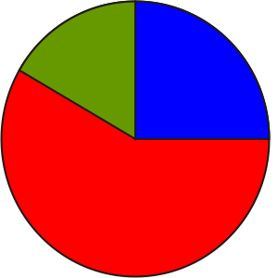 |  | Math Learning Goals  - Activate prior knowledge.  - Explore the Pythagorean relationship, using manipulatives (tangrams, chart paper). |  | Materials  - 3 sets of tangram pairs  - chart paper  - BLM 10.1.1, 10.1.2
Assessment
Opportunities
 | Minds On… | Whole Class → Brainstorm  List examples of, or references to, the use of right-angled triangles, e.g., bridges, trusses, flags.  Ask: How do we identify a right-angled triangle? Students use specific vocabulary in responding: e.g., legs, hypotenuse, vertices, right angle. |  | Use paper cut-outs of tangram pieces as an alternative.  Word Wall  - leg  - hypotenuse  - vertices  - right angle
 | Action! | Pairs → Investigation  Explain the task:  Select one large triangular tangram piece and identify it as the central piece. Using the remaining tangram pieces, construct 3 perfect squares off the legs and hypotenuse. Trace each piece onto blank paper.  Determine if there is a relationship between the pieces of the tangram on the legs and the pieces on the hypotenuse.  Post students’ work.  Learning Skills/Initiative/Rating Scale: Observe how students interact with their peers.
 | Consolidate Debrief | Whole Class → Discussion  Students explain their solutions.  Ask:  - What did you discover?  - Which pieces did you use?  - How are the pieces related?  Determine how the pieces of the square on the legs fit onto the pieces of the square on the hypotenuse.  Ask: What does this tell you about right-angled triangles?
Application  Exploration |  | Home Activity or Further Classroom Consolidation  - Create your own piece-puzzles, using worksheet 10.1.1. Make a right-angled triangle and construct squares on the legs and hypotenuse of it. Cut the squares on the legs into pieces so that they fit exactly onto the square on the hypotenuse.  - Research two interesting notes about Pythagoras’ life, unrelated to mathematics. |  | See BLM 10.1.2 for solutions.  Students’ research is due for Day 5.

10.1.1: Tangram Squares

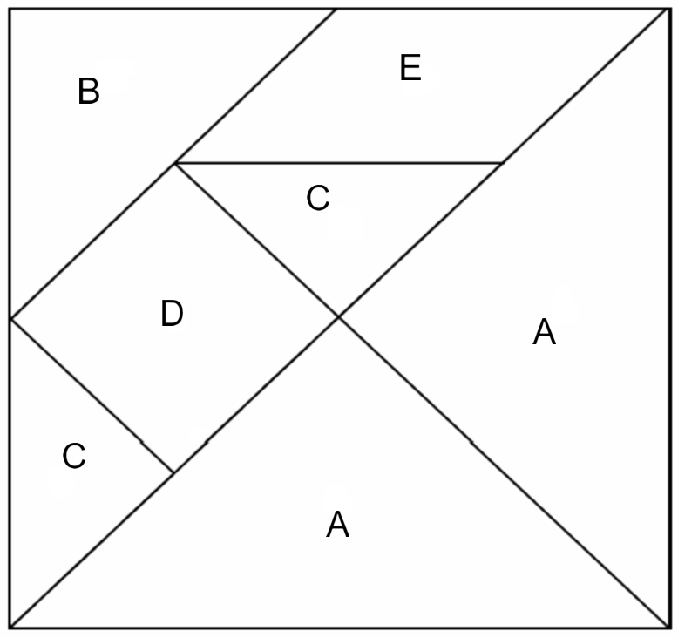

10.1.2: Tangram Squares (Solutions)

Solution 1
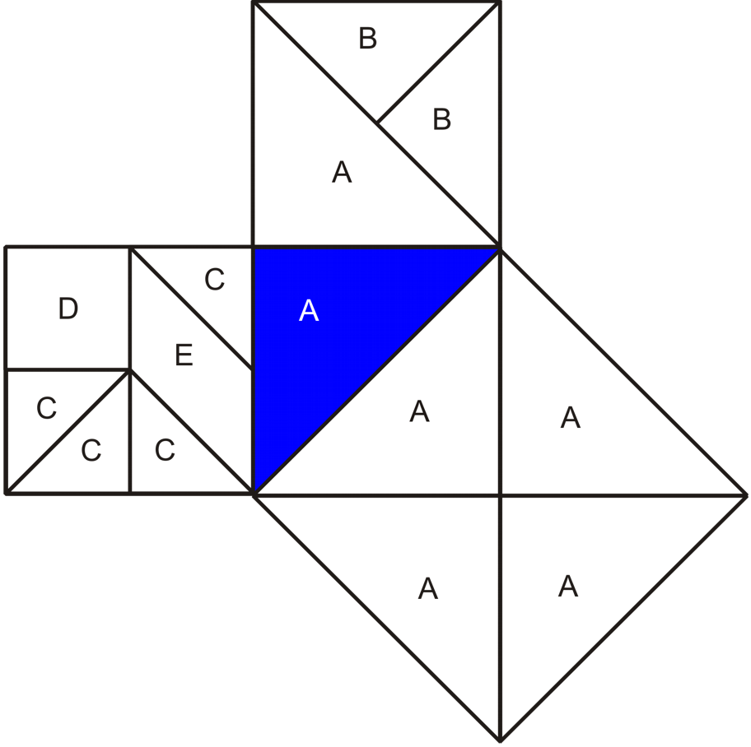

Tangrams on the legs fit on the square on the hypotenuse.

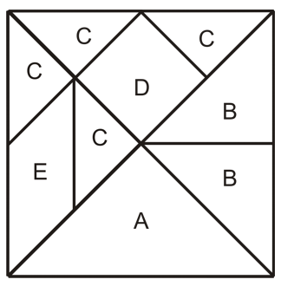
10.1.2: Tangram Squares (Solutions)

Solution 2
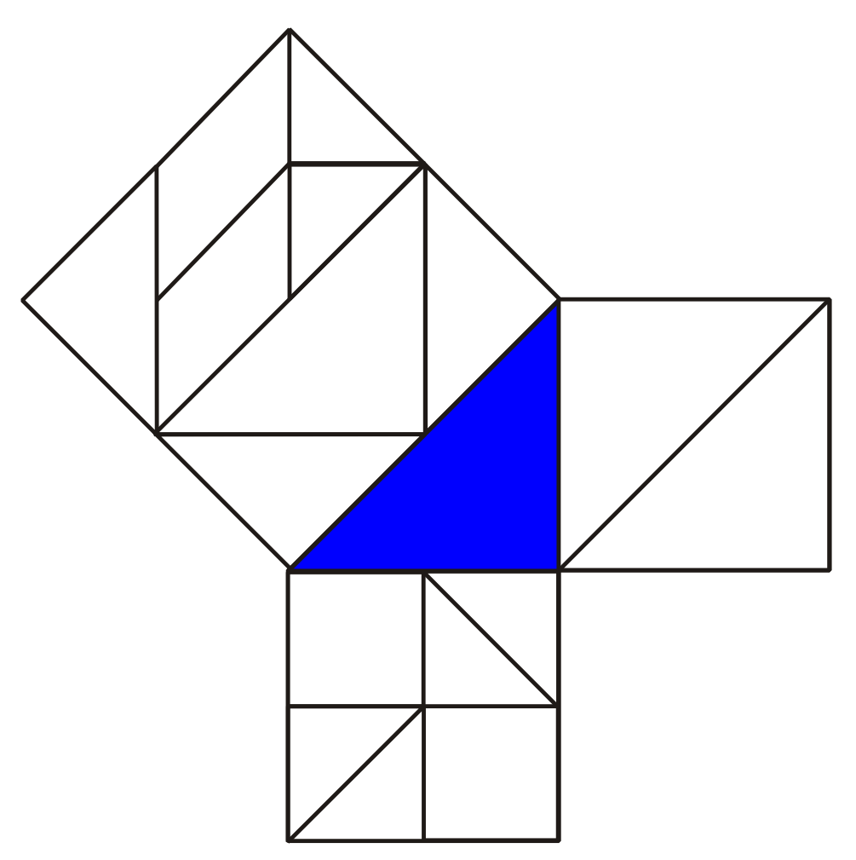

Unit 10: Day 2: Squared From All Sides |  |  |  | Grade 8
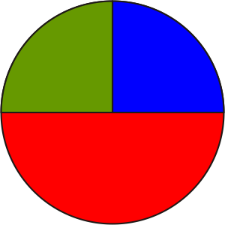 |  | Math Learning Goals  - Explore and investigate, using concrete materials, the relationship between the area of the squares on the legs and the area of the square on the hypotenuse of a right-angled triangle. |  | Materials  - BLM 10.2.1, 10.2.2, 10.2.3, 10.2.4
Assessment
Opportunities
 | Minds On… | Whole Class → Discussion  Review students’ solutions to their Home Activity puzzles. Use an available representation, e.g., chart to be left up for display, poster, overhead representation using transparent tangram, Pythagorean Puzzle GSP®4. Connect results to work with tangrams on Day 1. Ask: Is there a pattern?  Individual → Journal  Draw the standard diagram for illustrating the relationship of the squares drawn on the sides of a right-angled triangle, identifying legs and hypotenuse titled Pythagorean Relationship.  Think/Pair/Share → Anticipation Guide  Students highlight key words, then complete the Before column on the Anticipation Guide (BLM 10.2.1) and explain their reasoning to a partner. |  | Pythagorean Puzzle.gsp  Demonstrate the method for determining 90°, using the corner of a sheet of paper or a grid.  Answer key for right-angled triangles:  - AYE  - WRG  - ZPF  - HSM  - PSZ  For triangles that are not right-angled, answers will vary, e.g., WHG, WHM  This relationship works in only right-angled triangles.  Word Wall  - Pythagorean relationship
 | Action! | Pairs → Investigation  Pairs investigate which combinations of squares will successfully form a right-angled triangle and which will not form a right-angled triangle.  Students cut out 12 different squares and arrange them in groups of three such that the side lengths create triangles. Using graph paper, they determine if the triangle is a right-angled triangle. They glue down the squares and create their own chart, using BLM 10.2.2.  Reasoning & Proving/Observation/Checklist: Observe how students talk about and record their thinking during the investigation.
 | Consolidate Debrief | Whole Class → Summarizing  Consolidate the investigation by completing a class summary chart.  Summarize the Pythagorean relationship: In a right-angled triangle, the sum of the areas of the squares on the legs equals the area of the square on the hypotenuse.  Students copy the Pythagorean relationship into the summary (BLM 10.2.3).  Students complete the After column on the Anticipation Guide for questions 1–3.
Practice |  | Home Activity or Further Classroom Consolidation  Complete worksheet 10.2.4. |  | Students hand in their completed worksheet for assessment.

10.2.1: Anticipation Guide for Right-Angled Triangles

Instructions:

- Check Agree or Disagree beside each statement in the Before column.
- Compare your choice and explanation with a partner.
- Revisit your choices at the end of the task.
- Check Agree or Disagree beside each statement in the After column.
- Compare the choices that you would make after the task with the choices that you made before the task.

Before |  | Statement | After
Agree | Disagree | Statement | Agree | Disagree
 |  | 1. Right-angled triangles can sometimes be isosceles.
 |  | 2. There is a special relationship between the squares of the three sides of a right-angled triangle.
 |  | 3. There is a special relationship between the squares of the sides for any triangle.
 |  | 4. There is a special relationship between the areas of similar shapes that fit on the sides of a right-angled triangle.

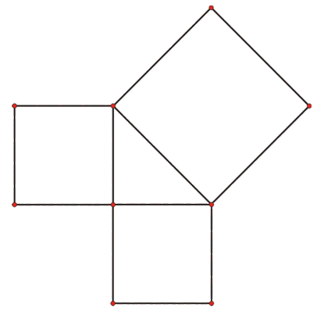
10.2.2: Pythagorean Puzzle

Cut out the squares.
Explore which combinations of squares will successfully form a right-angled triangle.
Use graph paper to make sure your right angle is exactly 90°.
Glue down the squares.

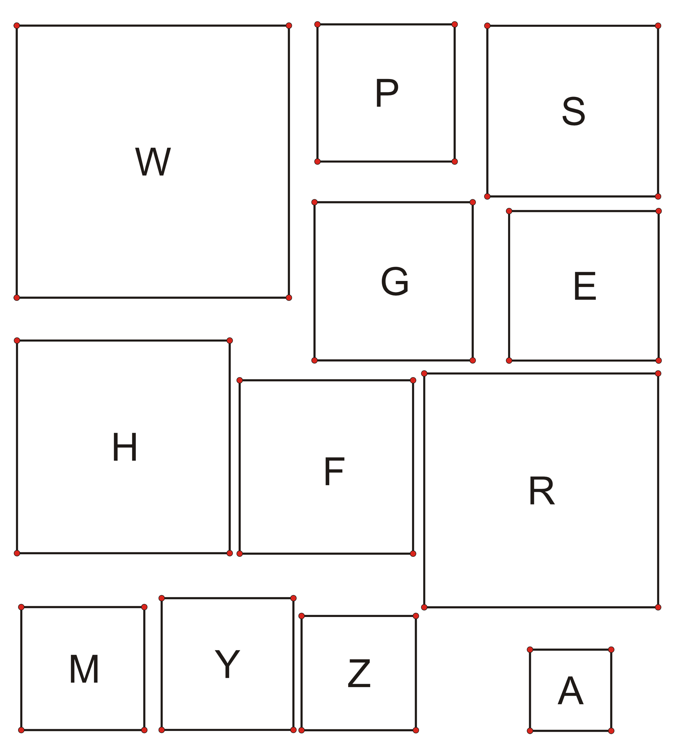
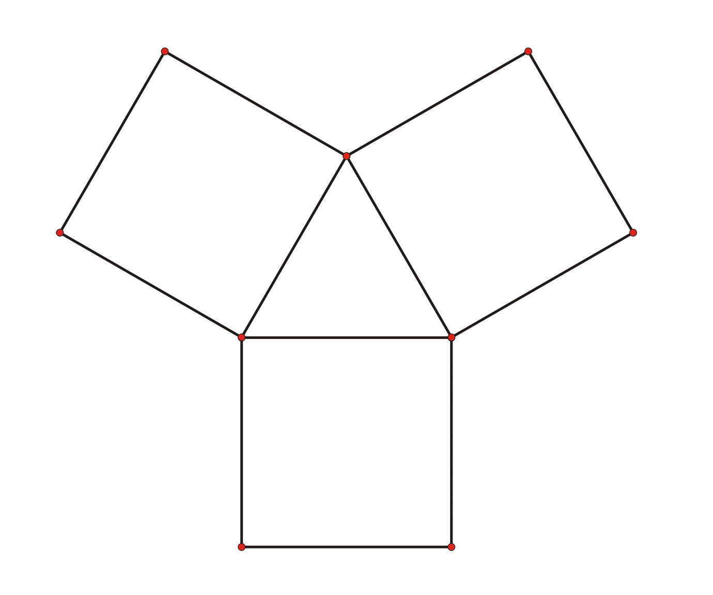
10.2.2: Pythagorean Puzzle (continued)

Cut out the squares.
Explore which combinations of squares will NOT form a right-angled triangle.
Use grid (graph) paper to make sure your angle is NOT 90°.
Glue down the squares.

10.2.3: Squared From All Sides Summary Chart

Name:

Part A: Squares that form a right-angled triangle
Triangle # | Label of Square on Leg 1 | Area of Square on Leg 1 | Label of Square on Leg 2 | Area of Square on Leg 2 | Label of Square on Hypotenuse | Area of Square on Hypotenuse | Area Part C

Part B: Squares that do not form a right-angled triangle
Triangle # | Label of Square on Leg 1 | Area of Square on Leg 1 | Label of Square on Leg 2 | Area of Square on Leg 2 | Label of Square on Hypotenuse | Area of Square on Hypotenuse | Area Part C

Part C: Investigate
Add the area of the square on Leg 1 to the area of the square on Leg 2.
What pattern to you notice?

Summary
Pythagoras was a famous Greek philosopher, Olympic coach, and mathematician. He was born on the island of Samos sometime in the sixth century b.c.e. He is credited with discovering the Pythagorean relationship, which states:
10.2.4: Follow-Up Chart for Pythagorean Relationship
Investigation

Fill in the blanks on the chart.

Right-Angled Triangle | Area of Square on Leg 1 | Area of Square on Leg 2 | Area of Square on Hypotenuse
ABC | 9 cm² | 16 m²
DEF |  | 15 mm² | 64 mm²
STU | 121 cm² | 36 cm²
XYZ | 100 cm² | 30.25 cm²
LMN | 16 cm² |  | 100 cm²

Pythagorean Puzzle (GSP®4 file)
Pythagorean Puzzle.gsp
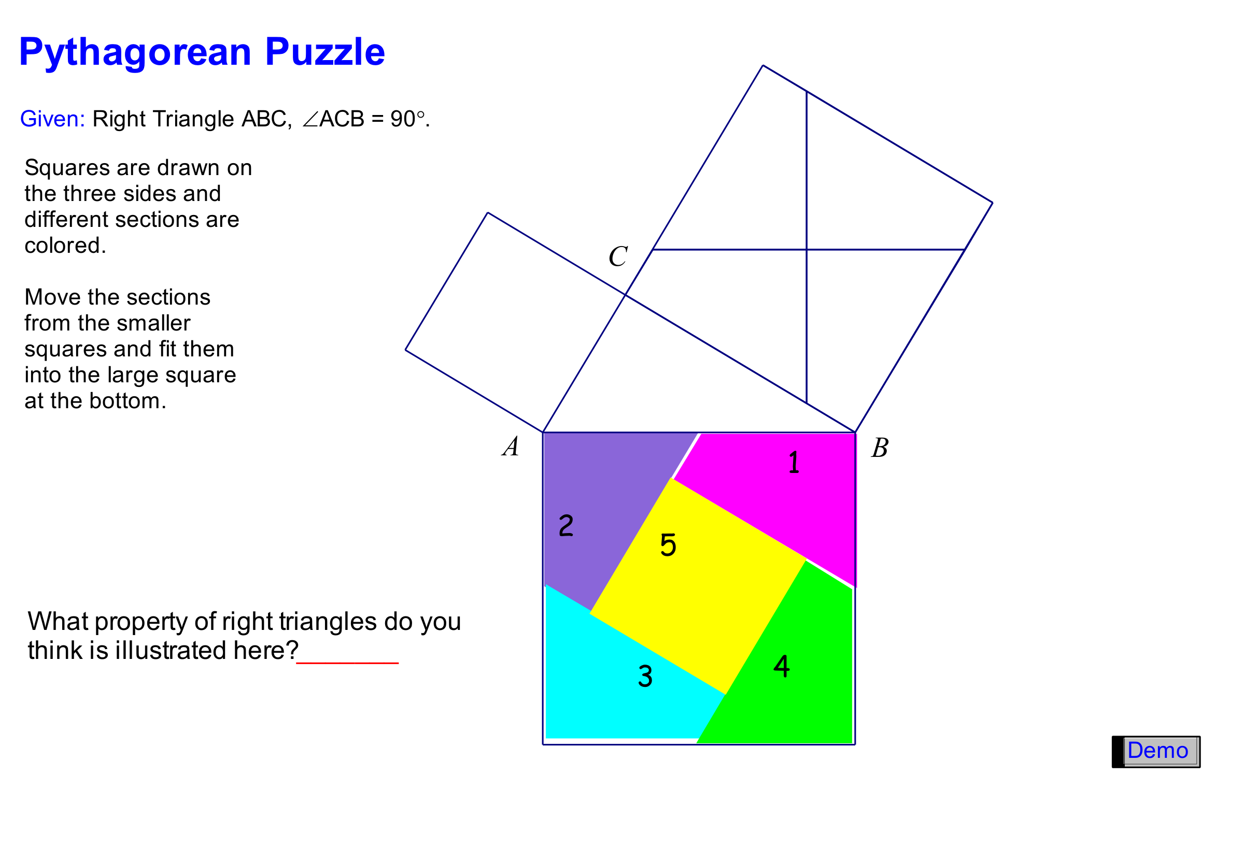

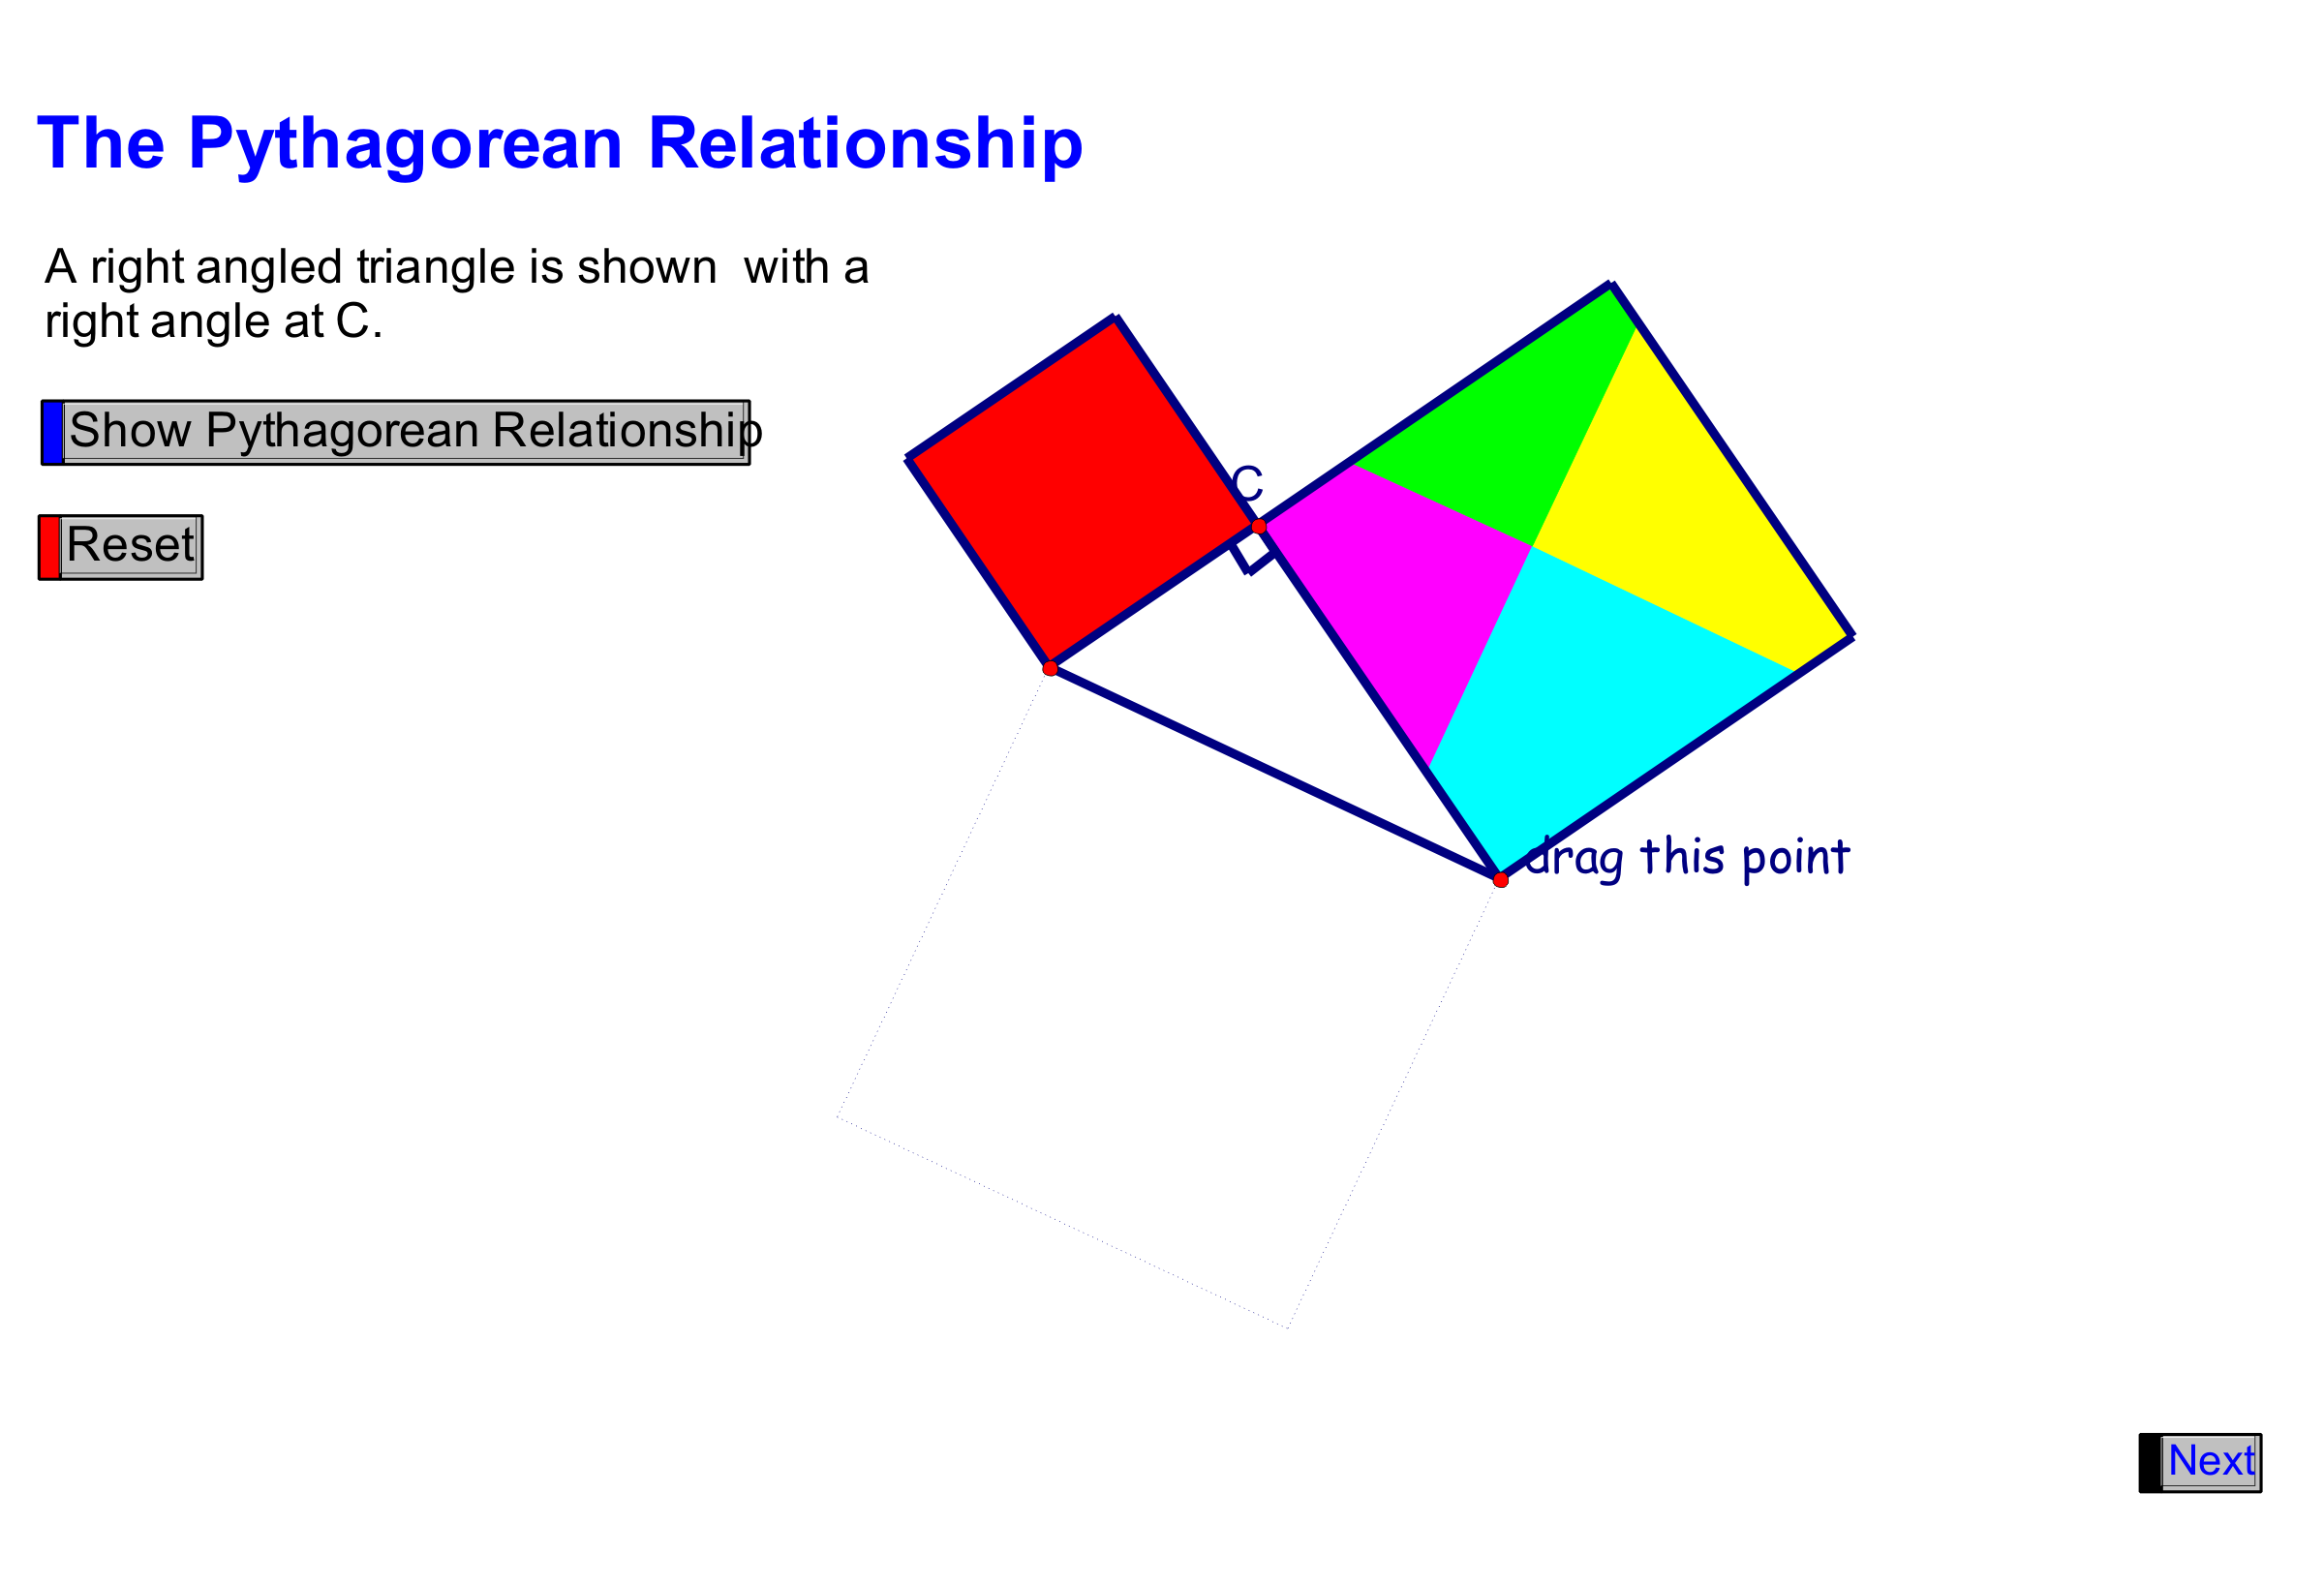
Pythagorean Relationship (GSP®4 file continued)

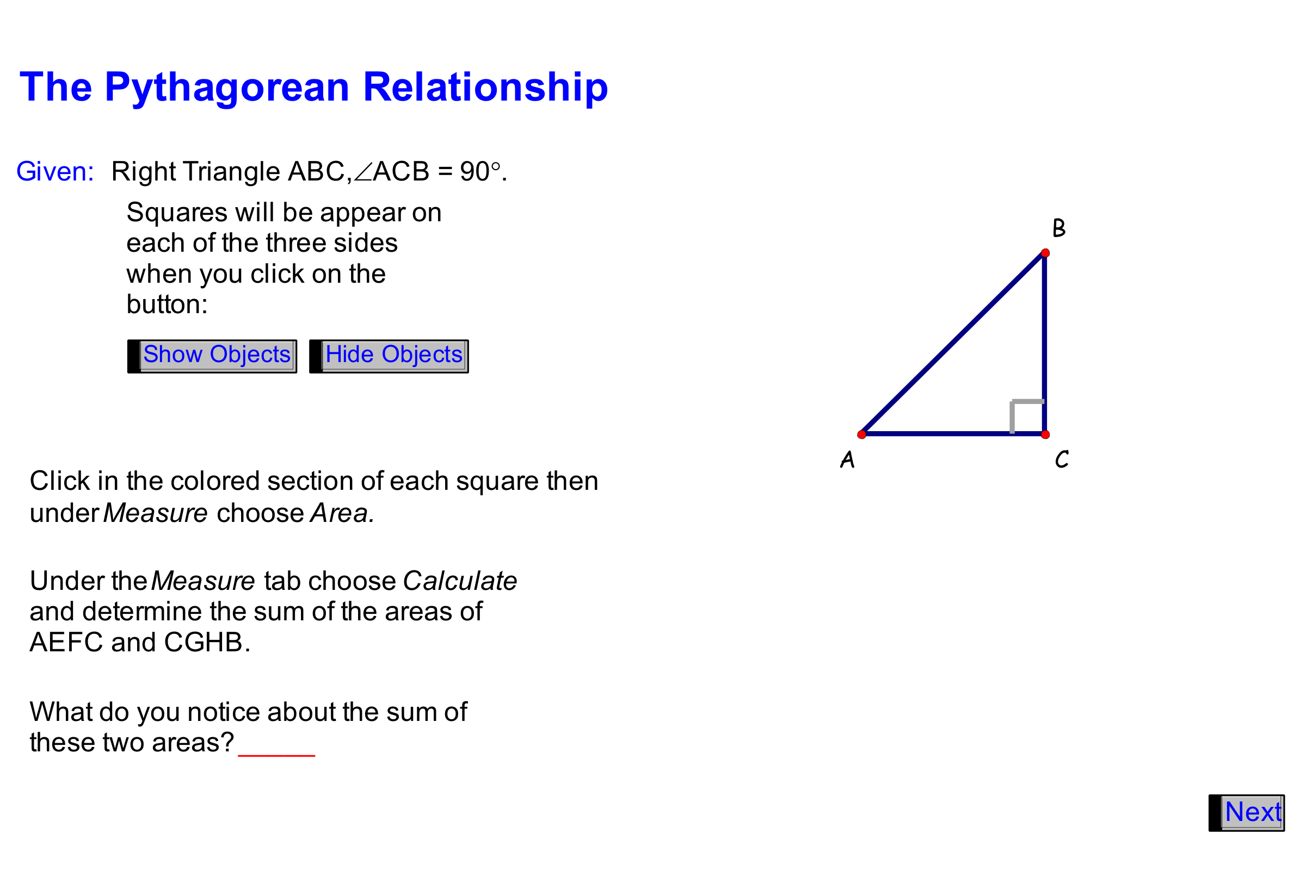

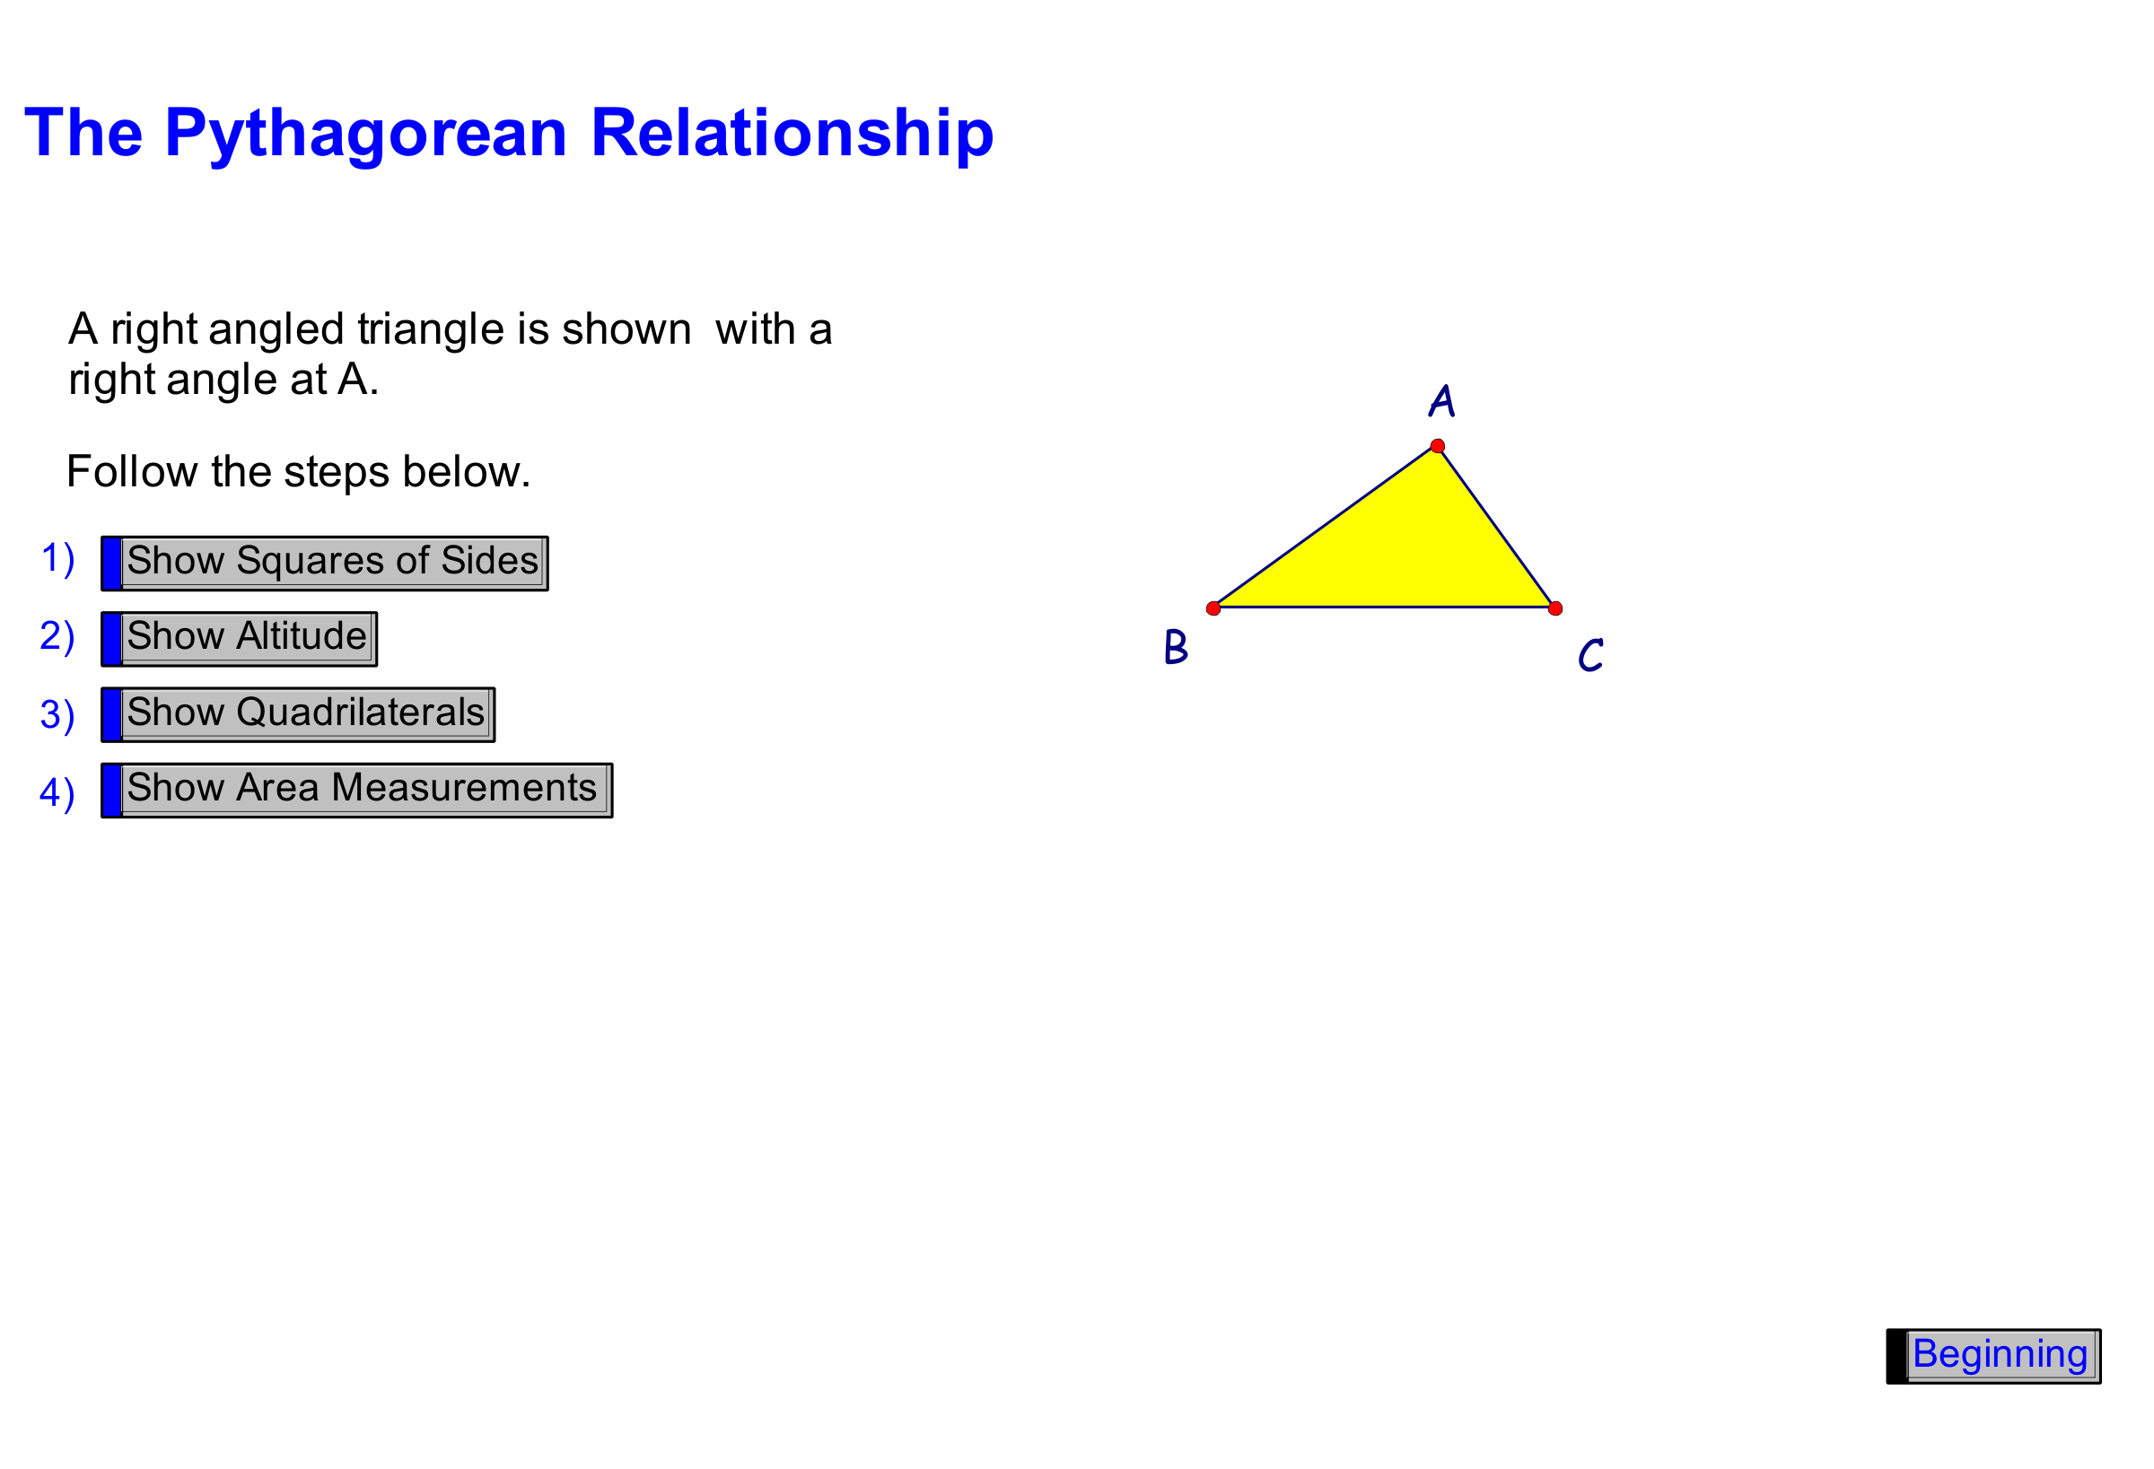
Unit 10: Day 3: Challenges Are Shaping Up… |  |  |  | Grade 8
 |  | Math Learning Goals  - Investigate the relationship of the areas of semi-circles drawn on the sides of a right-angled triangle. |  | Materials
Assessment
Opportunities
 | Minds On… | Whole Class → Discussion  Collect the Home Activity for assessment.  Using a sketch, reinforce the concept of the Pythagorean relationship. Stress that the relationship is true for right-angled triangles only.  Ask: Does this relationship work with shapes other than squares drawn on the right sides of a right-angled triangle? |  | N-agon areas.gsp  This GSP®4 sketch can be used to explore or consolidate.  Review how to determine the area of a circle.  Do not answer these questions – this is a brainstorm only.
 | Action! | Pair/Share → Investigation  Using grid paper, students draw a right-angled triangle. They construct semi-circles on the legs and hypotenuse of the triangle and calculate the areas of each semi-circle to determine the relationship the same way they did with squares on Day 2. Students share their work with another pair and explain their reasoning.  Reasoning & Proving/Observation/Checklist: Observe students as they explain their reasoning.
 | Consolidate Debrief | Whole Class → Discussion/Brainstorm  Summarize the findings of their investigation. The sum of the area of the semi-circles on the legs is equal to the area of the semi-circle on the hypotenuse. Pythagorean relationship works for a right-angled triangle using squares and semi-circles drawn on the sides.  Ask:  - What other shapes will work?  - Under what conditions will other shapes work?  Students complete the After column for question 4 of the Anticipation Guide  (Day 2 BLM 10.2.1).
Exploration  Practice |  | Home Activity or Further Classroom Consolidation  Draw a right-angled triangle with the length of legs being whole numbers. On each side of the triangle draw a rectangle (no squares are allowed!). Calculate the areas of the three rectangles. Does this demonstrate the Pythagorean relationship? Explain. Repeat with two more triangles.

N-agnon Areas (GSP®4 file)
N-agon Areas.gsp

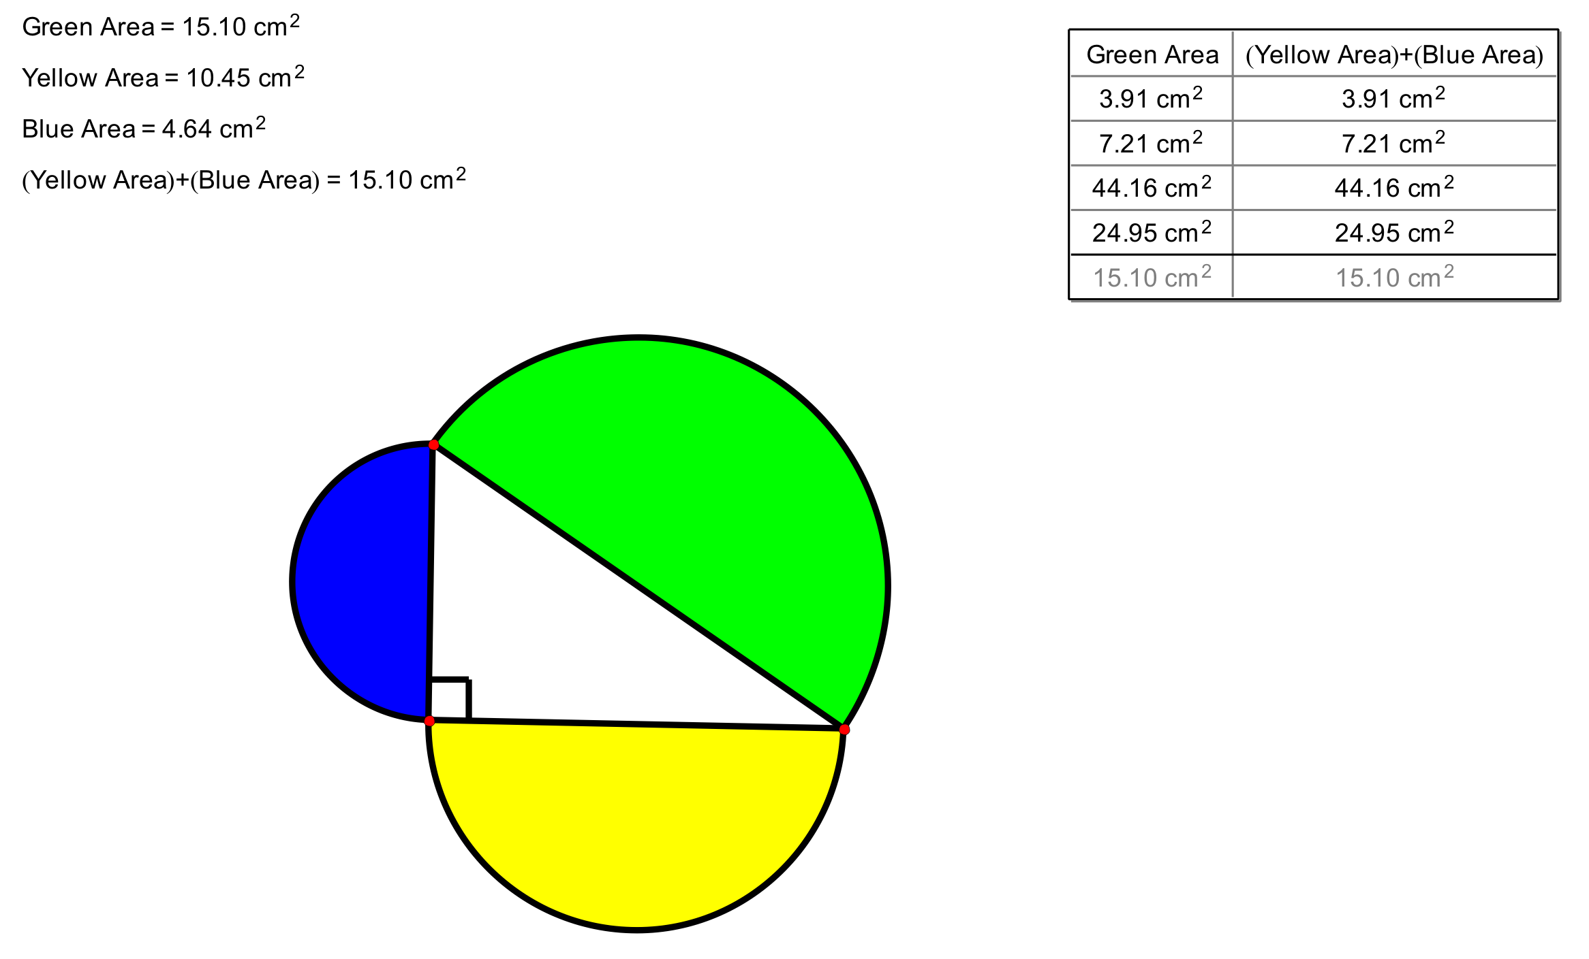

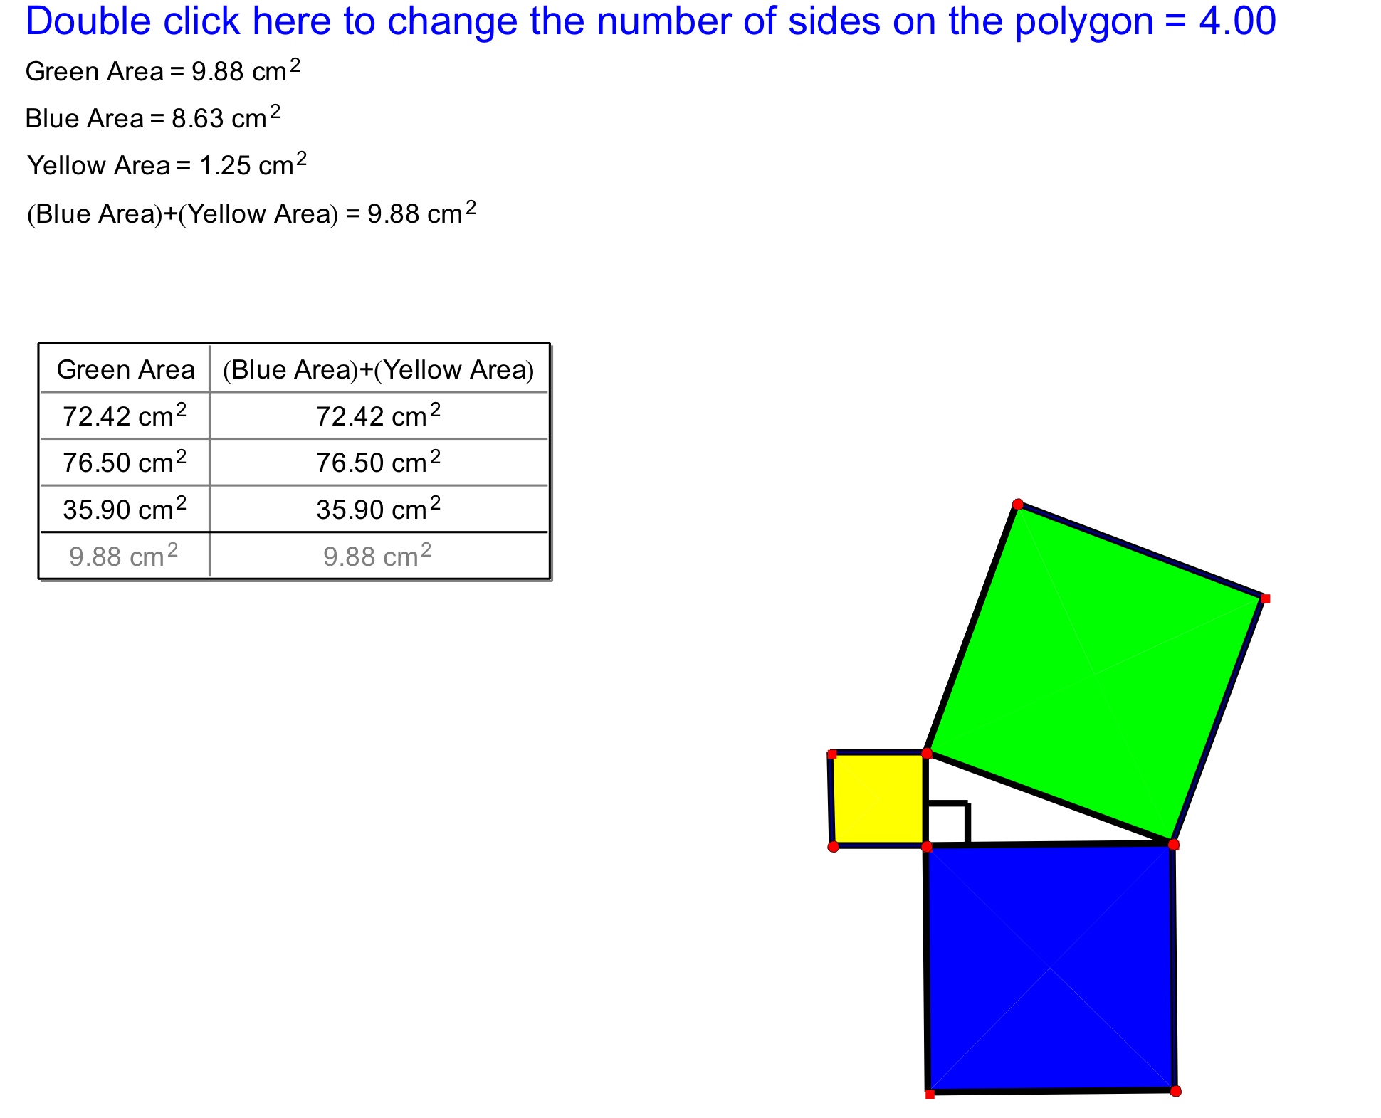
N-agnon Areas (GSP®4 file continued)

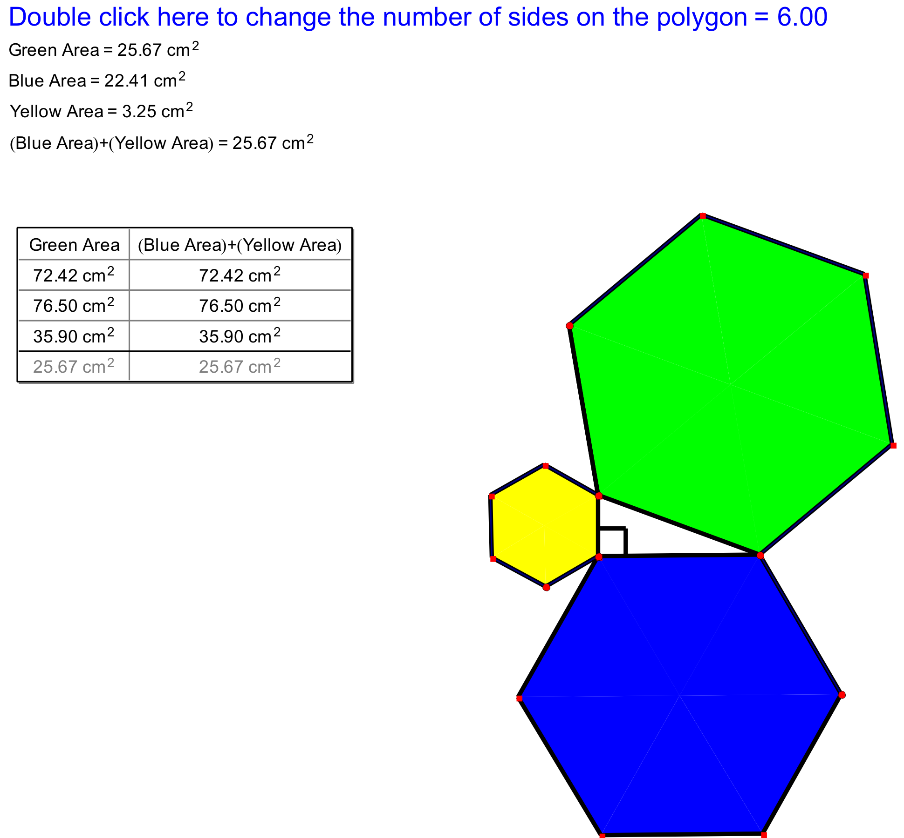

Unit 10: Day 4: Pythagoras In Proportion |  |  |  | Grade 8
 |  | Math Learning Goals  - Solve problems involving right-angled triangles geometrically, using the Pythagorean relationship and proportionality.  - Hypothesize and investigate the relationship between the areas of similar figures drawn on the sides of a right-angled triangle. |  | Materials  - BLM 10.4.1, 10.4.2
Assessment
Opportunities
 | Minds On… | Whole Class → Discussion  Students share the results of their Home Activity. Volunteers record their area measurements and sketches on the board. Discuss why their investigation did not show a Pythagorean relationship. Why do squares and semi-circles work? Stress similar shapes. |  | N-agon areas.gsp (See Day 3.)
 | Action! | Pairs → Investigation  Pairs use a GSP®4 sketch to investigate the hypothesis: Areas of similar figures drawn on the sides of a right-angled triangle show a Pythagorean relationship.  They record observations and patterns, and explain their reasoning.  Reasoning & Proving/Exploration/Checklist: Observe as students’ investigate and look for opportunities to probe for generalization of the relationship. |  | N-agon areas.gsp (See Day 3.)
 | Consolidate Debrief | Small Group → Reflection  Identify which type of polygon can be used on the sides of a right-angled triangle to create the Pythagorean relationship. Guide students to discover that only similar polygons fulfill the relationship.  Students include one of the GSP®4 sketches they investigated, along with a general statement about the Pythagorean relationship and similar polygons.  Create a class Frayer Model on the Pythagorean relationship. Post titles in four different locations of the room: Definition, Facts/Characteristics, Examples,  Non-examples. Working in small groups, students respond at each station, phrasing or rephrasing and adding to the previous group’s work. Assemble a large poster to display as a Frayer Model (BLM 10.4.2). |  | N-agon areas.gsp (See Day 3.)
Exploration |  | Home Activity or Further Classroom Consolidation  Complete worksheet 10.4.1.

10.4.1: Test a Triangle – Is It a Right-Angled Triangle? (Teacher)

Test each of the following triangles and determine if the triangle is a right-angled triangle:

Side 1 | Side 2 | Longest side | Areas | Is this a  right-angled triangle? | How do  you know?
3 | 4 | 5
4 | 6 | 7
5 | 12 | 13
8 | 15 | 17
7 | 10 | 13
8 | 12 | 15
9 | 40 | 41

10.4.1: Test a Triangle – Is It a Right-Angled Triangle? (continued)

Side 1 | Side 2 | Longest side | Areas |  | Is this a right-angled triangle? | How do  you know?
3 | 4 | 5 |  |  | yes
4 | 6 | 7 |  |  | no
5 | 12 | 13 |  |  | yes
8 | 15 | 17 |  |  | yes
7 | 10 | 13 |  |  | no
8 | 12 | 15 |  |  | no
9 | 40 | 41 |  |  | yes

Unit 10: Day 6: Mathematics in Early Greece |  | Grade 8
 | Math Learning Goals  - Students will investigate the definition and historical study of polyhedra.  - Students will construct the five Platonic solids. | Materials  - Polydrons or other plastic building sets  - Chart paper or overhead projector  - BLM 10.6.1  - BLM 10.6.2  - BLM 10.6.3
 | Think/Pair/Share →Polygon Match-up  Students will individually match each term to its ‘best’ representation on BLM 10.6.1.  Pose discussion questions such as:  - Are there any other representations of this term?  - What are its minimally defining characteristics?  - Which term was the most difficult for you?  - Can you draw a different representation for each term?  - How did you choose a representation for “congruent”?  Students may refer to congruent angles or sides, e.g. “In the diamond, the opposite angles are congruent |   Understanding of key terms  Word Wall  -Polygon  -Regular polygon  -Congruent  -Polyhedra
Minds On…
 | Small Groups →Investigation  Students will work in small groups to apply the definition of ‘Platonic solids’ (BLM 10.6.2). Using Polydrons or another building set for solids, students will try to build as many different solids as possible that fit the criteria. They will record their work using BLM 10.6.2  Teacher Note: If you don’t have access to plastic building sets, you could have students fold using nets (see Day 7, BLM 10.7.2) or create the solids with equal length straws and pieces of pipe cleaner as joints. | Scaffold investigation by providing a systematic approach (e.g. begin with triangles, then squares, then pentagons. Try 3 faces at one vertex, and then four, etc.
Action!
Whole Class →Summarizing
Present BLM 10.6.3 to the class on an overhead or chart paper. Using the Greek prefixes for the number of faces, have the students try to guess the correct name for each Platonic solid.
Ask groups to share some of the solids they found that were completely regular.
Each student should record in their notebook a final summary (list) of all five Platonic solids, along with a sketch of their construction or a brief description of each:
Tehedron, Hexahedron (Cube), Octahedron, Dodecahedron, Icosahedron
Consolidate Debrief
Concept Practice | Home Activity or Further Classroom Consolidation  Math Journal Question:  Why are there more than one regular polyhedra using triangles but we can only make one regular polyhedron using squares? | 

10.6.1: Polygon Match-up Grade 8

Match each geometry term on the left with the best representation on the right.

When you are finished, compare your answers with a partner. Discuss any differences in your answers. Who is right (or could both of you have a correct answer)? Why?

A. Triangle

B. Polygon

C. Congruent

D. Pentagon

E. Irregular hexagon

10.6.2: Which Solids are Platonic? Grade 8

A polyhedron is a 3-D shape made of 2-D shapes (polygons*).

In a regular polyhedron every face of the 3D shape is a regular polygon and there are the same number of faces meeting at each vertex. These are also called Platonic Solids**.

Build a 3D shape that meets the following criteria for a Platonic Solid:
1) Choose only one regular polygon (ex. only squares)
2) The same numbers of faces have to meet at each vertex

Build as many Platonic solids as you can, using the building sets provided.

Fill in the chart below as you go:
Type of polygon used  e.g. equilateral triangle | # of polygons used  e.g. 4 | # of faces meeting at each vertex  e.g. 3 | Sketch of possible Platonic solid  Sketch your constructions

*A polygon is a closed shape formed by 3 or more line segments (triangle, square etc.)
**Platonic Solids are named after the ancient Mathematician Plato who lived around 360 BCE

10.6.3: It’s All Greek To Me Grade 8

Many geometry terms have Greek origins. Ancient mathematicians systematically named things and we still use many of those names today. For example: a pentagon and an octagon.

penta - gon octa - gon
meaning 5 short for polygon meaning 8 short for polygon

Try to use the Greek prefixes below to correctly name each polyhedron constructed by your group. (Hint: choose a prefix and add -hedron)

1 mono-
2 di-
3 tri-
4 tetra-
5 penta-
6 hexa-
7 hepta-
8 octa-/octo-
9 ennea-
10 deca
12 dodeca
20 icosa
100 hecto-

Unit 10: Day 7: What’s the Connection? |  | Grade 8
 | Math Learning Goals  - Students will record and organize data consisting of the number of faces, vertices, and edges for each Platonic solid  - Students will form a conjecture of a possible relationship between the number of faces, vertices and edges for a polyhedra | Materials  - SMART Board, laptop, projector (whole class) or  - Computer lab with internet access (individual)  - Building kits  - Calculators  - BLM 10.7.1  - BLM 10.7.2
Whole Class→Discussion
Ask the students to share some journals responses from Day 6’s At Home Activity.
Ask: How many faces met at each vertex when we constructed tetrahedron? A dodecahedron? An icosahedron?
Minds On…
 | Individual →Investigation  Use the virtual manipulatives at http://nlvm.usu.edu/→ Geometry (6-8) → Platonic Solids  The side panel shows instructions for counting the faces, edges and vertices of each solid. Click on ‘New Shape’ to investigate each solid. Students will count and record (in their notebooks) their data for the tetrahedron, cube, octahedron, dodecahedron and icosahedron.  Note: In order to avoid Euler’s Theorem popping up, encourage students NOT to count the number of faces. They can record the number of faces based on Day 6’s discussion of how the solids are named (or from memory).  Pairs→Conjecture  Students will work with a partner to look for patterns in their data.  Prompt the students with questions like:  - Did you and your partner get the same data for each solid?  - What relationships or patterns can you see in the data? For example, the tetrahedron has the same number of vertices and faces, but this is not true for the other solids so this is not a constant relationship.  - Which number is consistently the biggest? Look for relationships that are sums or differences. | See BLM 10.7.1 for solutions in order to check student work during the investigation.  Provide access to a variety of investigational tools, including the solids from Day 6 (and building kits), the virtual solids, calculators, nets (BLM 10.7.2).  Value all patterns/relation-ships described.
Action!
Whole Class→Euler’s Formula
Euler (pronounced “oiler”) proved the relationship between vertices, edges and faces of the five Platonic solids: Vertices - Edges + Faces = 2

Guide a class discussion by posing the following questions:
- What relationships did your group conjecture?
- Does your data fit Euler’s formula?
- Are there any solids you need to re-check?
- Did anyone find another way of expressing this relationship?
Consolidate Debrief
Problem Solving | Home Activity or Further Classroom Consolidation  Last year, a student found a pattern using Platonic solids. She concluded that if she adds two to the number of edges, it is the same as the sum of the number of vertices and faces. Is her conclusion consistent with Euler’s formula? Why or why not? | Students may show their reasoning algebraically or using their data from the investigation

10.7.1: Solutions for Platonic Grade 8
Solids Investigation

Platonic Solid | # of Vertices (V) | # of Faces (F) | # of Edges (E)
Tetrahedron | 4 | 4 | 6
Cube | 8 | 6 | 12
Octahedron | 6 | 8 | 12
Dodecahedron | 20 | 12 | 30
Isocahedron | 12 | 20 | 30

Euler’s Formula

V – E + F = 2 or V + F = E + 2

10.7.2: Nets for Platonic Solids Grade 8

INCLUDEPICTURE "http://www.mathsisfun.com/geometry/images/tetrahedron-net.gif" \* MERGEFORMATINET 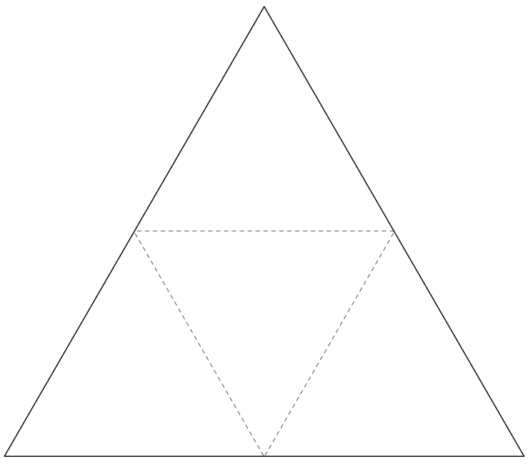

10.7.2 Nets for Platonic Solids Grade 8 Continued

INCLUDEPICTURE "http://www.mathsisfun.com/geometry/images/cube-net.gif" \* MERGEFORMATINET 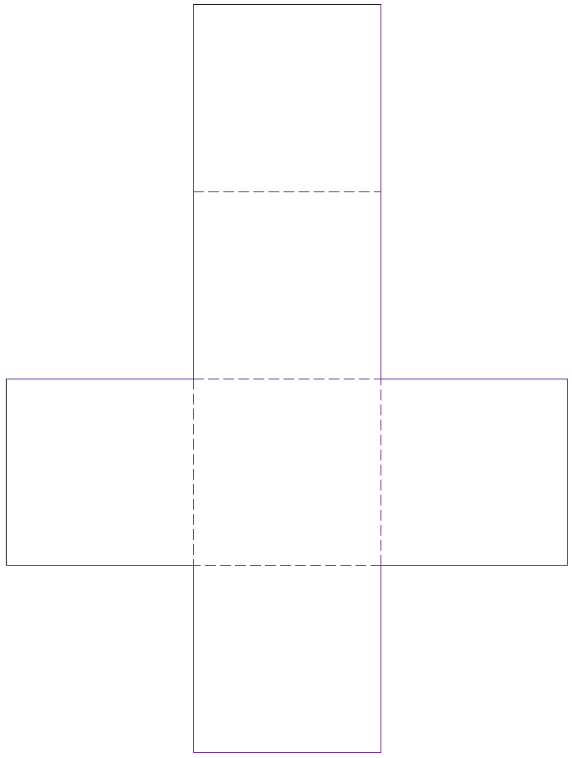

10.7.2 Nets for Platonic Solids Grade 8 Continued

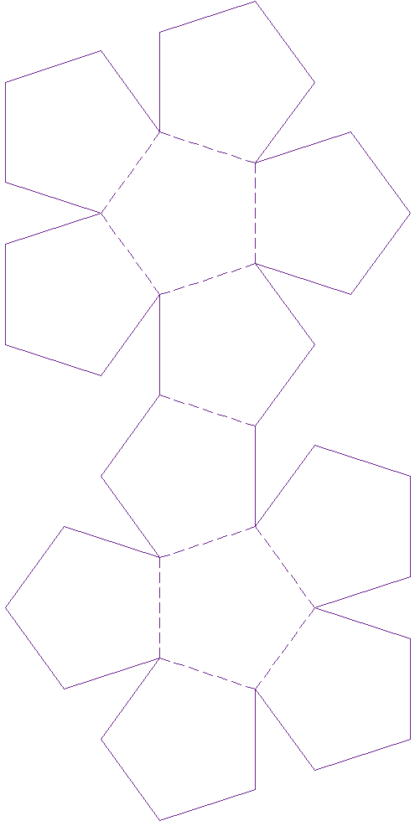
INCLUDEPICTURE "http://www.mathsisfun.com/geometry/images/octahedron-net.gif" \* MERGEFORMATINET 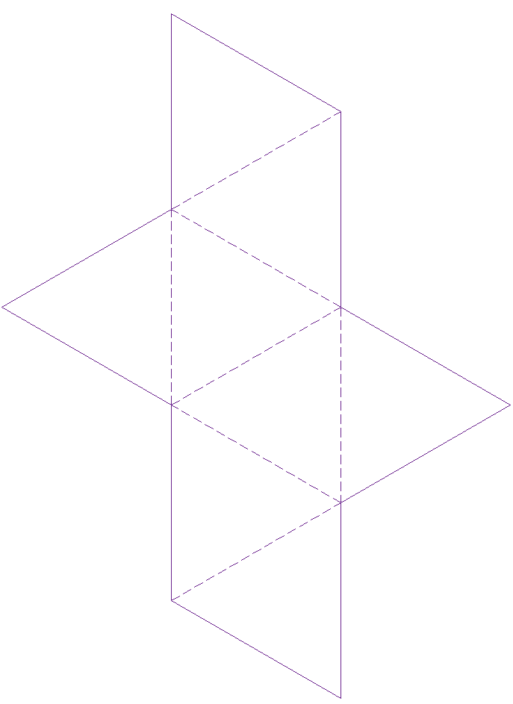

10.7.2 Nets for Platonic Solids Grade 8 Continued

INCLUDEPICTURE "http://www.mathsisfun.com/geometry/images/icosahedron-net.gif" \* MERGEFORMATINET 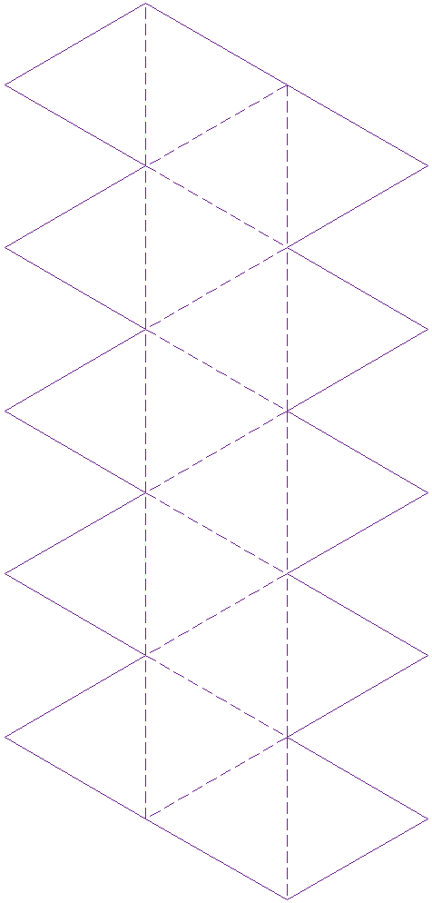

Unit 10: Day 8: Impossible Shapes |  | Grade 8
 | Math Learning Goals  - Students will test the hypothesis from Day 7 by constructing and examining non-Platonic solids.  - Students will use the relationship formula developed to investigate impossible polyhedra shapes | Materials  - Polydrons or other plastic building sets  - BLM 10.8.1  - BLM 10.8.2
 | Pairs → What solid is it anyway?  Using BLM 10.8.1, give students a list of a variety of 3-D shapes to sort into three categories (regular polyhedral, irregular polyhedral and non polyhedral) in order to practice distinguishing between Platonic and non-Platonic solids. You may use the list at the bottom of the page or use solids you have on hand.  To save time, you may want to do this activity in centres and have groups share their results during a whole class discussion at the end of the class. | You may wish to use objects in the classroom that students can visually check (e.g. tissue box, can, filing cabinet)  Are they demonstrating their understanding of ‘regular’ polyhedra?
Minds On…
 | Small Groups → Investigation  Students will investigate whether Euler’s formula works for non-Platonic solids (it does!), and then investigate impossible polyhedra shapes.  Students will work in small groups to examine solids from the middle and last column of BLM 10.8.1. Have them place a checkmark beside the entry if Euler’s formula worked, and an ‘x’ to indicate if the number of faces, edges and vertices did not comply with Euler’s formula. | Teacher Tip:  Choose from solids already constructed on Days 6 and 7, Polydrons or plastic sets, nets, and everyday objects to investigate.
Action!
 | Whole Class→Discussion & Sharing  Share and compare results.  Consider asking the following questions:  - Which solids were sorted into which categories?  - Did Euler’s formula always work? | Teacher Note:  If using Polydrons, students may have forced impossible polyhedra to fit together by ‘flexing’ the faces. Clarify that these are not really polyhedra (Euler’s formula will not work).
Consolidate Debrief
Exploration | Home Activity or Further Classroom Consolidation  Students will complete BLM 10.8.2. They will apply Euler’s formula to data about different solids to find out if they are polyhedra.

10.8.1: What solid is it anyway? Grade 8

Part A Write the solids listed below in the appropriate column.

Rectangular prism Triangular prism Triangle-based pyramid

Cone Cube Rectangle-based pyramid

Octahedron Sphere Tetrahedron

Dodecahedron Icosahedron Cylinder

Tissue box Recycling bin (no top) Pop can

Chalkboard eraser Party hat Ball

Part B Investigate if we can apply Euler’s Formula to each solid (V-E+F=2)

Regular Polyhedra  (Platonic Solid) | Irregular Polyhedra  (non-Platonic Solid) | Not Polyhedra  (Impossible Solid)

10.8.2: Applying Euler’s Formula Grade 8

Use the observations about each solid below to apply Euler’s formula.
Recall that if V-E+F=2, then it is a polyhedron.

# of Edges (E) | # of Vertices (V) | # of Faces (F) | Is it a polyhedron?
8 | 4 | 4
12 | 8 | 6
10 | 6 | 8
6 | 4 | 2
30 | 12 | 20

10.8.2: Applying Euler’s Formula Grade 8
Solutions

# of Edges (E) | # of Vertices (V) | # of Faces (F) | Is it a polyhedron?  V - E + F = 2
8 | 4 | 4 | 4-8+4 = 0  Not a polyhedron
12 | 8 | 6 | 8-12+6 = 2  Yes, it’s a polyhedron
10 | 6 | 8 | 6-10+8 = 4  Not a polyhedron
6 | 4 | 2 | 4-6+2 = 0  Not a polyhedron
30 | 12 | 20 | 12-30+20 = 2  Yes, it’s a polyhedron

Unit 10: Day 10: Please Move |  | Grade 8
 | Math Learning Goals  - Students will investigate and report on real-world examples of translations, reflections and rotations.  - Materials Note: If computer access is limited, you can print out information from the research websites and provide copies for research centres 1 and 4 | Materials  - Pattern blocks (station 2)  - Computers with internet access (stations 1 and 4)  - BLM 10.10.1  - BLM 10.10.2  - BLM 10.10.3  - BLM 10.10.4
 | Whole Class → Brainstorm  Review types of transformations (e.g. how can we mathematically describe movement of objects? Answer: Reflection, rotation, translation, symmetry)  Students may also bring up location in this discussion (e.g. coordinate systems, longitude and latitude, left/right, above/below, etc.). Encourage them to describe movement as objectively as possible.  Prompt them with questions like:  - What is the problem with describing something as being “on the left”? | Word Wall:  -Translation  -Reflection  -Rotation  -Symmetry
Minds On… |  | Word Wall:  -Translation  -Reflection  -Rotation  -Symmetry
 | Expert Groups → Research Stations  Divide class into groupings for Jigsaw-type activity. Group members will decide who is going to which station (there should be one group member at each station, 1-4).  Station 1: See BLM 10.10.1 – “Giant’s Causeway”  http://wikipedia.org  www.giantscausewayofficialguide.com  Station 2: See BLM 10.10.2 – “Penrose Tiling”  Station 3: See BLM 10.10.3 – “Artisans”  Station 4: See BLM 10.10.4 – “The Mystery of Bimini Road”  http://wikipedia.org  www.wildernessclassroom.com  Experts work together to research the above examples of real-world transformations. They will work together to attempt to describe the examples using appropriate mathematical language. | Groupings can be differentiated by learning style (e.g. stations 1 and 4 require analysis of written material, while station 2 is kinesthetic)  Alternatively, you could have each group rotate through each station and then consolidate with the whole class at the end.
Action!
 | Home Groups → Sharing  Each expert will return to their home group from the ‘Action!’ section (made up of at least one expert from each station) to share some interesting facts and a real-life example of transformations from their research stations.  Focus on identifying or developing correct use of mathematical terms to describe movement. | You may want home groups to record their discussion onto chart paper to post in the classroom.
Consolidate Debrief
Application  Exploration | Home Activity or Further Classroom Consolidation  Name and describe two examples of transformations you can see in (or near) your own home.

10.10.1: Giant’s Causeway Grade 8

INCLUDEPICTURE "http://upload.wikimedia.org/wikipedia/commons/thumb/c/c0/Causeway-code_poet-4.jpg/800px-Causeway-code_poet-4.jpg" \* MERGEFORMATINET INCLUDEPICTURE "http://upload.wikimedia.org/wikipedia/commons/thumb/c/c0/Causeway-code_poet-4.jpg/800px-Causeway-code_poet-4.jpg" \* MERGEFORMATINET 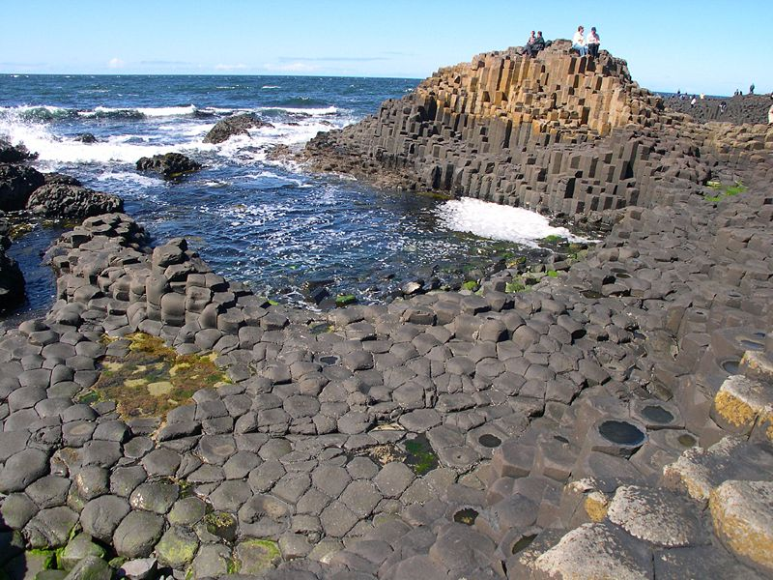

Research this place and answer the following questions:

- Where is the Giant’s Causeway?
- How was it made or formed?
- How is it an example of transformations? (Describe it using as much mathematical vocabulary as you can)
- Name two or more interesting facts about Giant’s Causeway.

Suggested websites:
http://wikipedia.org
www.giantscausewayofficialguide.com
http://whc.unesco.org/en/list/369

10.10.2: Penrose Tiling Grade 8

Sir Roger Penrose investigated a set of non-periodic tilings in the 1970’s. Here is one example:
INCLUDEPICTURE "http://upload.wikimedia.org/wikipedia/commons/thumb/1/1a/Penrose_Tiling_(Rhombi).svg/500px-Penrose_Tiling_(Rhombi).svg.png" \* MERGEFORMATINET INCLUDEPICTURE "http://upload.wikimedia.org/wikipedia/commons/thumb/1/1a/Penrose_Tiling_(Rhombi).svg/500px-Penrose_Tiling_(Rhombi).svg.png" \* MERGEFORMATINET 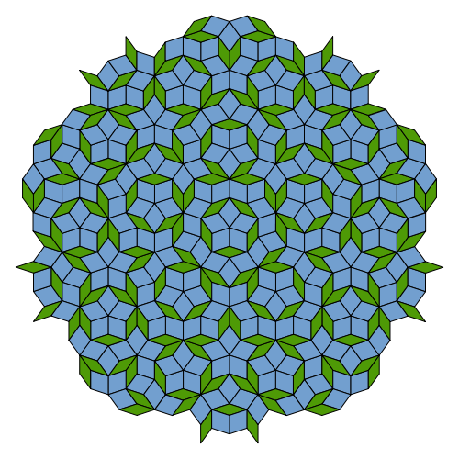
Use pattern blocks to recreate part of this tessellation.
Question 1: How much of the tiling do you need to create before you can repeat patterns by using transformations?

These tilings are called non-periodic because they do not have translational symmetry. (You cannot shift a copy horizontally or vertically and produce the exact same pattern).
They do, however, have reflectional and rotational symmetry.

Question 2: Describe, using mathematical terms, how to reflect one part of the tiling to produce another part. Then describe the rotational symmetry (it might help to put your pencil point in the centre and physically rotate the page to check for this symmetry).

10.10.3: Artisans’ Station Grade 8

- Tessellations (also called tilings) are 2-D designs created by translations, rotations and reflections of shapes. They must cover a plane without gaps or overlaps.
- The word comes from ‘tessella’ – a small square of clay, stone or glass used to make mosaics. These designs are aesthetically pleasing and we can see many examples in wallpaper, decorative art, textiles, tiles, brickwork, etc.
- For each illustration, describe the transformations using as much mathematical language as you can (shapes, translations, rotations and/or reflections).

Street brickwork:
INCLUDEPICTURE "http://upload.wikimedia.org/wikipedia/commons/thumb/6/6a/Wallpaper_group-p3-1.jpg/625px-Wallpaper_group-p3-1.jpg" \* MERGEFORMATINET INCLUDEPICTURE "http://upload.wikimedia.org/wikipedia/commons/thumb/6/6a/Wallpaper_group-p3-1.jpg/625px-Wallpaper_group-p3-1.jpg" \* MERGEFORMATINET 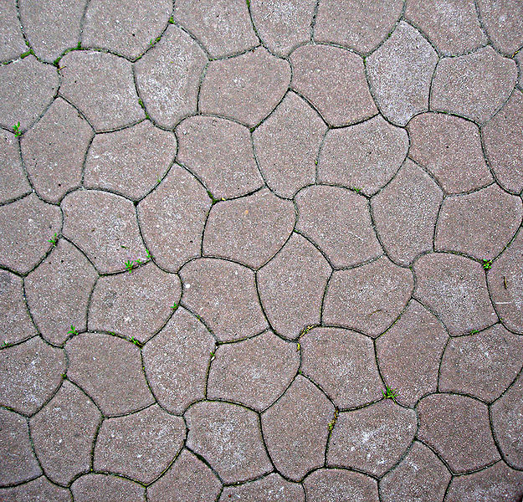

The ceiling of an Egyptian tomb:
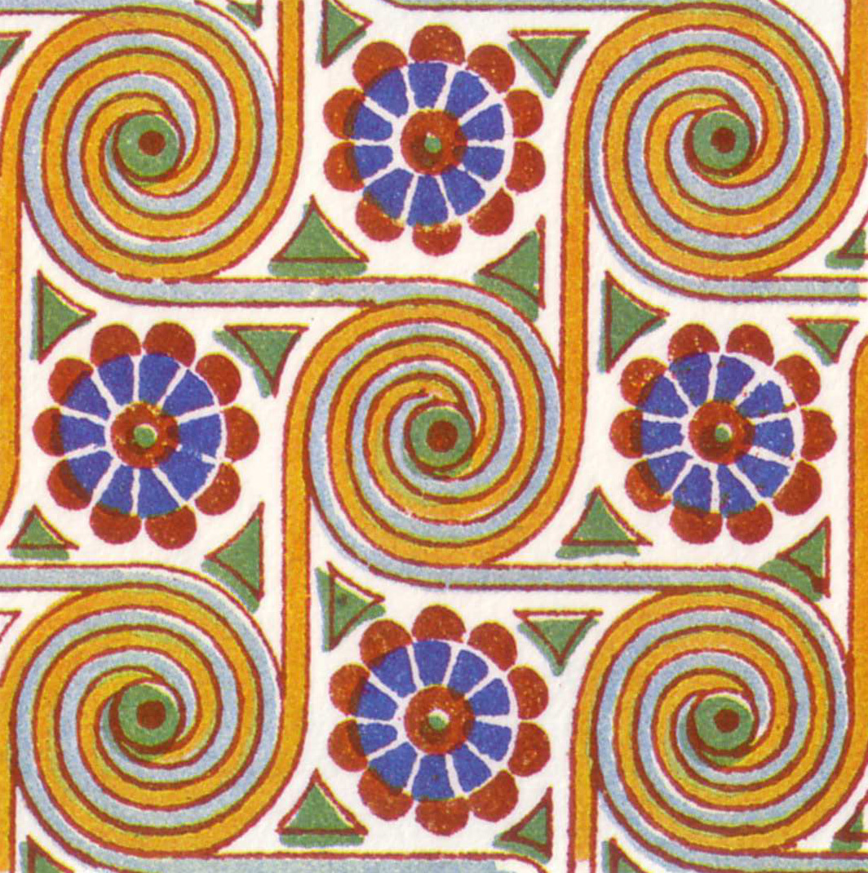

A dish from Turkey:
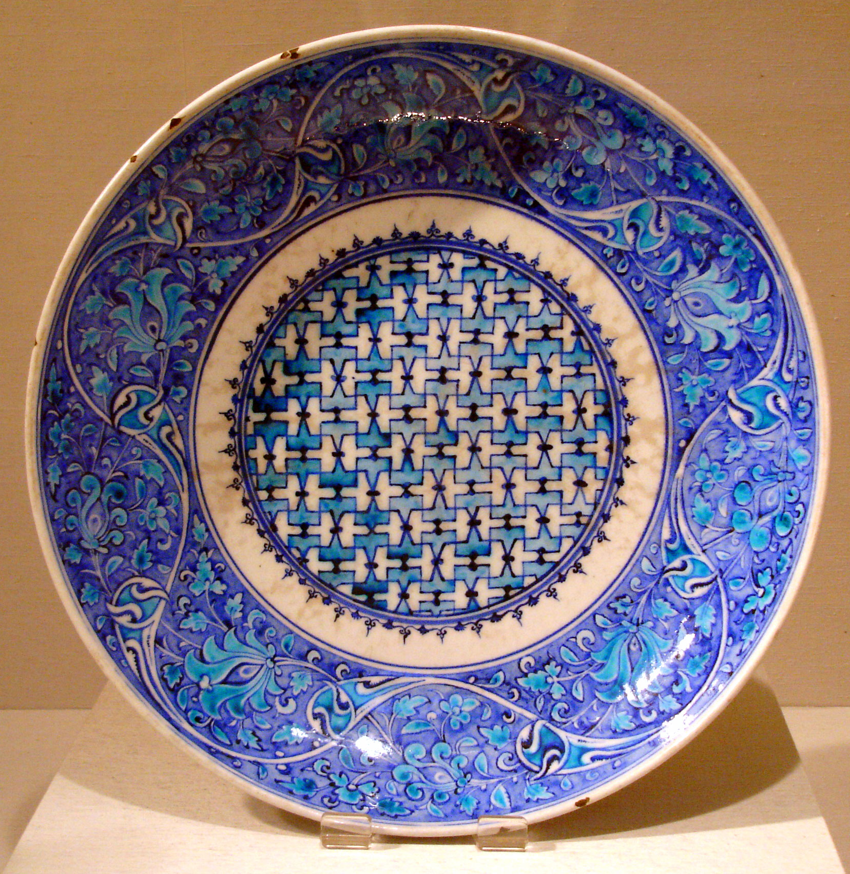 INCLUDEPICTURE "http://upload.wikimedia.org/wikipedia/commons/thumb/1/11/Wallpaper_group-cmm-6.jpg/584px-Wallpaper_group-cmm-6.jpg" \* MERGEFORMATINET EMBED Word.Picture.8

10.10.4: The Bimini Road Mystery Grade 8

Bimini Road is an underwater rock formation in the Bahamas. In 1968, a diver near North Bimini island discovered an underwater rock formation that consisted of a
0.8 km “road” of roughly rectangular limestone blocks.

Over time, this site has been explored by many divers including archaeologists, marine biologists and geologists, who have tried to discover how Bimini Road was formed. Some groups believe it is evidence of the existence of the legendary Atlantis.

Is this a natural tessellation or is it man-made?

Research this formation and answer the following questions:

- What evidence is there that it was man-made?
- What evidence is there that it is a natural geological feature?
- How is it an example of transformations? (Describe it using as much mathematical vocabulary as you can)
- Name two or more interesting facts about Bimini Road.

Suggested websites:

http://wikipedia.org
www.wildernessclassroom.com
www.crystalinks.com/biminiroad.html

Unit 10: Day 11: Shifty Business |  | Grade 8
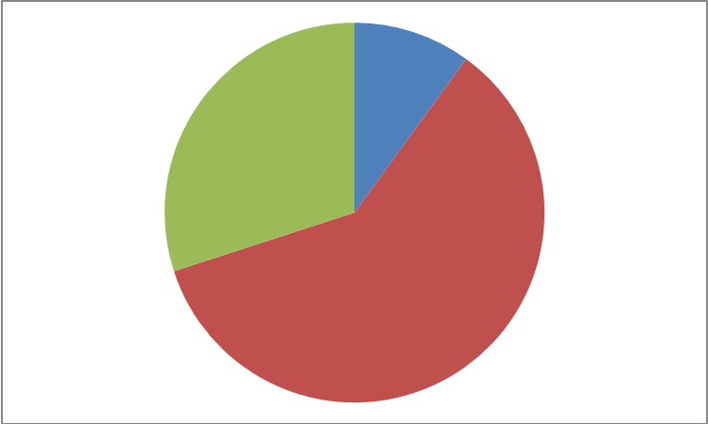 | Math Learning Goals  - Students will translate single points and sets of points horizontally, vertically, and through a combination of both directions  - Students will identify how the type of transformation affects the original point's coordinates | Materials  - BLM 10.11.1  - BLM 10.11.2  - BLM 10.11.3
 | Whole Class → Brainstorm  Present the class with a point A at (-1,5) and its A' image at (3,-2) marked out on a coordinate grid system on the board.  Ask the class to consider how point A can shift to its A' image by moving only horizontally and vertically.  Possible solutions:  - move right 4 and move down 7,  - move down 4 and right 7  - or one of several zigzagging patterns involving a combination of slides from point A to its A' image.  Reinforce appropriate language including translation, ordered pairs, horizontal, vertical, positive, and negative. Refer to the quadrant numbers 1, 2, 3 and 4 (e.g. The point starts in quadrant 2 and its image is in quadrant 4).  Emphasize the fact that the horizontal number is first and positive “moving right”, and the vertical number is second and is negative “moving down”.  All solutions are equivalent to a translation of (4,-7).  Student will identify how the translation of (4,-7) affects the original (-1,5) to result in (3,-2). Leave this question with them and revisit it at the end of class. | Teacher Tip:  The story of a painter moving a ladder might help to reinforce that the horizontal number must come first. The painter must move along the ground first before climbing the ladder.
Minds On…
 | Individual Discovery → Tiered lesson  Present 3 different tasks to the students (BLM 10.11.1, BLM 10.11.2, BLM 10.11.3) allowing them a moment to decide which “Tier” they wish to pursue. Introduce each by reading the first few lines. Each student will get a worksheet matching his or her choice. Allow 15-20 minutes for each student to complete his or her sheet.  Note: For Tier 3 you may choose to label quadrants 4 and 2 for clarity.  Remind students that translations moving left or down will include negative integers. Encourage students to look for unique answers (unlike their neighbours') as each tier allows for multiple solutions. Any students who are done early can look for more than one solution to their own task.  When the students are ready, select two or three solutions from each tier to showcase to the class during the consolidation sharing activity. Choose strategically to showcase a variety of solutions. | Teacher Note:  Each task includes a place for the original coordinates, the translation ordered pair, and the image coordinates. This will help students to consider the second learning goal during the consolidation of the task.
Action!
Whole Class → Sharing
While showcasing each solution, engage the students in a discussion about how they solved their specific question.
- For tier 1 ask why the translation ordered pair must be a positive followed by a negative.
- For tier 2 ask why the translation ordered pair must be two negatives.
- For tier 3 ask why the translation ordered pair must be a negative followed by a positive.
Refer back to the original question by asking how the translation affects the original point's coordinates.
Consolidate Debrief
Reflection | Home Activity → Journal Entry  As a home activity, students will reflect on the activity and describe in their own words how the translation affects the original point's coordinates. Ask them to mention specifically how the numbers change from the original to the image.  Have them write notes at the bottom of each worksheet (BLM 10.11.1, BLM 10.11.2, BLM 10.11.3) given out during the ‘Action!’ section.

10.11.1: Shifty Business Tier 1 Grade 8

A
B
C

A triangle starts in quadrant 2. After a translation the image has one point at (6,-1).
What translations would give this result? Draw one possible solution including all three points of the image.

What are the original coordinates for the triangle?
A = ( , ) B = ( , ) C = ( , )

List the translation as an ordered pair: ( , )

A' = ( , ) B' = ( , ) C' = ( , )

Above, list the coordinates of the image. One of the three points must be (6,-1).

NOTES:

10.11.2: Shifty Business Tier 2 Grade 8

A
B
C

A triangle starts on the axis between quadrant 1 and 4. After a translation the image is on the axis between quadrant 4 and 3.

Consider what translations would give this result. Draw one possible solution.

What are the original coordinates for the triangle?
A = ( , ) B = ( , ) C = ( , )

List the translation as an ordered pair: ( , )

A' = ( , ) B' = ( , ) C' = ( , )

List the coordinates of the image above. The image lays on the axis between quadrant 4 and 3.

NOTES:

10.11.3: Shifty Business Tier 3 Grade 8
A triangle starts entirely in quadrant 4. After a translation the image is entirely in quadrant 2.
Consider what translations would give this result. Draw one possible solution including the original triangle and its image. Be sure the vertices are on points.

What are the original coordinates for the triangle?
A = ( , ) B = ( , ) C = ( , )

List your translation as an ordered pair: ( , )

A' = ( , ) B' = ( , ) C' = ( , )

Above, list the coordinates of the image. The image is entirely in quadrant 2.

NOTES:

Unit 10: Day 12: Points to Reflect Upon |  | Grade 8
 | Math Learning Goals  - Students will reflect single points and sets of points in the x-axis, and in the y-axis  - Students will identify how the type of transformation affects the original point's coordinates | Materials  - BLM 10.12.1  - BLM 10.12.2  - BLM 10.12.3
 | Whole Class → Brainstorm  Present the class with point A at (-3,4) and point B at (-1,3) marked out on a coordinate grid system on the board.  Ask the class to offer suggestions as to where you could place point C to create a triangle, when C is in quadrant 3. Mark point C [ex. (-2,-1)] but do not draw the triangle.  Remind students of the transformation from last lesson and suggest that we are going to transform these points using a reflection, not a translation.  Pose the following question, 'What is needed to have a reflection?'  When a student answers 'a mirror', tell them that in this case our mirror will be the y-axis.  With the class, find the images A', B' and C'.  Present the solutions in a table: original: A=(-3,4) B=(-1,3) C=(-2,-1)  reflection on y-axis  images : A=(3,4) B=(1,3) C=(2,-1)  Lastly, ask the class if they can identify how a reflection on the y-axis affects the original coordinates. Create the rule now or leave this question with them and revisit it at the end of class. | Teacher Note:  For C, any combination of two negative numbers will work.  Teacher Tip:  Students might suggest that the rule is; the first number becomes positive. In fact the rule is the first number changes signs.
Minds On…
Pairs → Investigation
Post the two options on the board (BLM 10.12.1, BLM 10.12.2) allowing students a moment to decide which option they wish to pursue. Clarify the difference between the two if necessary.
Hand out BLM 10.12.3. It can be used for both options. One sheet per pair.
Allow 20 minutes for each pair of students to complete their sheet.
Observe the students as they look for solutions to their task.
Any pairs completed early can look for more than one solution to their own task or look to solve the second option.
For the 'rule' section, ask the students if their rule will always work for any point. Suggest points in other quadrants to assess their understanding.
When the students are ready, select two different solutions from each option to showcase to the class and move to the sharing.
Action!
Whole Class → Present and Share
While showcasing solutions, allow each pair of students to present their own. Encourage questioning and discussion about how they solved their specific question.
For option 1, ask if there are any other possible isosceles triangles that were not presented.
There are an infinite number of possibilities for C.
For option 2, highlight the rule (the second number changes signs) and compare it to the rule for the y-axis in option 1.
Clearly post the rules and examples for the students to reference. Clarify any questions that may arise.
Consolidate Debrief
Journal Entry | Home Activity or Further Classroom Consolidation  Assign a RAFT activity as a journal response to today's activities.  Role: A confused point  Audience: A line of reflection (x-axis or y-axis)  Format: A cell phone text or written letter  Topic: When I look at you, half of me gets all mixed up  Further exploration: Provide students with the opportunity to play online at: nlvm.usu.edu  Click: Geometry>>Transformation-reflection>>Activities

10.12.1: OPTION 1 Grade 8

An isosceles triangle (∆DEF) is reflected on the y-axis.

D=(-4,1) and E=(-3,-2)

Choose a point F, and find the image after the reflection.

10.12.2: OPTION 2 Grade 8

An obtuse triangle (∆DEF) is reflected on the x-axis.

D=(-4,1) and E=(-3,-2)

Choose a point F, and find the image after the reflection.

10.12.3: Reflection Worksheet Grade 8

D
E
What are the original coordinates for the triangle?
D = ( , ) E = ( , ) F = ( , )

The line of reflection ___- axis

D' = ( , ) E' = ( , ) F' = ( , )

Above, list the coordinates of the image.

How does the reflection affect the original points' coordinates?
Create a rule in your own words

Unit 10: Day 13: A New Slant on Reflection |  | Grade 8
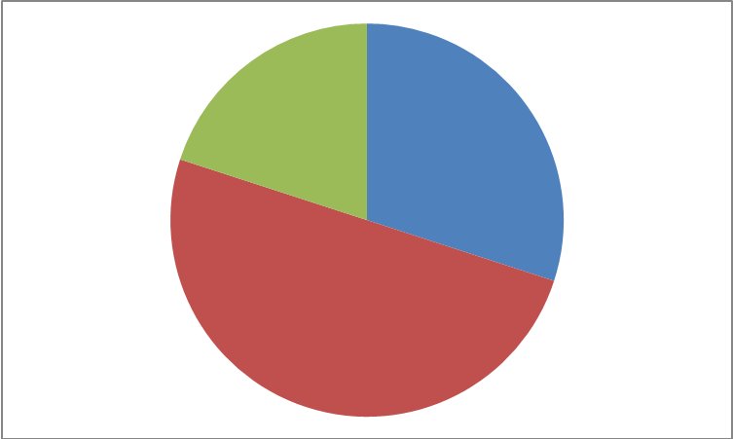 | Math Learning Goals  - Students will reflect single points and sets of points in the line that forms the angle bisector of the x- and y-axes and passes through the first and third quadrants  - Students will identify how the type of transformation affects the original point's coordinates | Materials  - BLM 10.13.1  - BLM 10.13.2
 | Whole Class → Brainstorm: Appetizer  Present the class with the following series of points and images on one coordinate grid system on the board.  A = (1,3) A' = (3,1)  B = (-1,3) B' = (3,-1)  C = (-3,1) C' = (1,-3)  D = (-3,-1) D'= ?  Ask the class to consider what mirror line would reflect the points into the image position. Remind the students that yesterday's lesson they saw two different lines of reflection (x-axis and y-axis) but that a line of reflection can be placed anywhere. Once one of the students can describe the mirror line (the diagonal line that goes through quadrants 1 and 3) ask the class if anyone can spot the rule for this transformation. Then ask them where the image of D is. Mark D' when they have answered. | Teacher Note:  This lesson is set up to be given as a menu.  ‘Minds On...’, is the appetizer.  ‘Action!’ will have a main and two side dishes for choice.  ‘Consolidate Debrief’ will be the dessert.
Minds On…
 | Individual → Main and Two Sides  Present the students with “The Main”, BLM 10.13.2. The task is to find all the image points after a reflection y= - x.  Ask them to choose one of the two “sides”.  SIDE DISH 1: Write all the points and images in the Main. Connect the points with their respective images to make a line except for points (-5,-1) and (-4,-2). Those points should not be connected to its image, but rather connected to themselves. Then they can proceed to close each rectangle (and one trapezoid) to produce the image in the solution BLM 10.13.1. Students will need some guidance to make the form. If completed correctly it should look like a traditional Inukshuk.  SIDE DISH 2: Create your own sets of points that when reflected on y= - x, produce a design. Record the points in a chart form. | Teacher Tip:  You may want to indicate that the mirror line is y=-x, depending on if they're comfort with linear equations. Another name is the angle bisector of the x- and y-axes that passes through the first and third quadrants.
Action!
Whole Class → Dessert
Each student should be able to identify how the reflection affects the original point's coordinates. Have the students offer the rule in their own words and discuss with the class what wording would work best. Post the rule in the classroom for student reference. Compare and contrast this rule with other rules from the last two days.

Consolidate Debrief
 | Home Activity or Further Classroom Consolidation

10.13.1: The Main – Solution Grade 8

10.13.2: The Main Grade 8

Unit 10: Day 14: Getting Dizzy |  | Grade 8
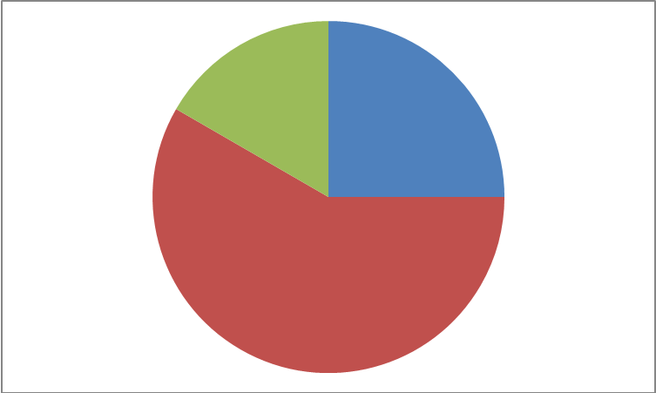 | Math Learning Goals  - Students will rotate single points and sets of points through 90,180, and 270 degrees about the origin  - Students will identify how the type of transformation affects the original point's coordinates | Materials  - BLM 10.14.1  - BLM 10.14.2  - BLM 10.14.3  - BLM 10.14.4  - BLM 10.14.5  - BLM 10.14.6  - Grid Paper
 | Whole Class → Brainstorm  Present the class with the 3 rotations: BLM 10.14.1, 10.14.2, and 10.14.3.  Ask the class to decide which transformation these examples showcase. Look for the answer Rotations or Turns. Be sure to clarify that these specific examples are rotating around a certain point, in this case, the origin (0,0).  Play a short mix and match game with your students using BLM 10.14.4, asking them to place the appropriate sign with its corresponding diagram. Ask the class to look at the top of the number “1” in BLM 10.14.1 and decide where that point is located on the grid. Look for answers close to (1,4). Now ask the class to look at the image of the number “1” in the same diagram. Ask where the image point is located. Look for answers close to (4,-1).  Have a discussion as to what the rule might be for the 90 degree CW rotation.  Answer: (1,4) becomes (4,-1).  In a 90 degree CW rotation, the numbers switch positions and the original first number changes signs. | Teacher Tip:  You may choose to mark a red dot when following the point on the number “1”.  Note that the axis contains no numbers, leaving room for guessing.
Minds On…
Individual Discovery → Tic Tac Toe
Present the class with the Tic Tac Toe activity from BLM 10.14.5. Each student should choose 3 mini tasks to create a winning line on the Tic Tac Toe board (3 horizontal, 3 diagonal, or 3 vertical). Observe the students as they choose and as they work on their tasks. Provide some grid paper as they solve their tasks.

As they solve their mini tasks you may want to revisit the ‘Minds On...’ activity that was done at the beginning of the class. However, this time, showcase a point on the number “2” and see where the image of that point ends up. Have a discussion as to what the rule might be for the 180 degree rotation.

Repeat for the number “3”.

Action!
Whole Class → Sharing
Set up a large version of a Tic Tac Toe board at the front of the class (on chart paper or on the board). While giving some students time to finish up, call on students to fill in the board with their solutions. Take a moment to discuss each, making corrections if necessary. Refer to BLM 10.14.6 for possible solutions.

Consolidate Debrief
Explore | Home Activity or Further Classroom Consolidation  Further exploration: Provide students with the opportunity to play online at: nlvm.usu.edu  Click: Geometry>>Transformation-rotations>>Activities

10.14.1: Rotation 1 Grade 8

1

1

10.14.2: Rotation 2 Grade 8

2

2

10.14.3: Rotation 3 Grade 8

3

3

10.14.4: Rotations Grade 8

90 degrees CW

180 degrees

270 degrees CW

Cut out the three solutions and use them in the mix and match activity.
Use the fourth rotation to show that 270 CW is equivalent to 90 CCW.

90 degrees CCW

10.14.5: TIC TAC TOE Grade 8
Write the rule for a 90 degree clockwise rotation about the origin. | Identify the rotation.  The dark shape is the original. | Create a triangle on a grid. Identify and record the 3 points of the triangle.  Rotate the 3 points 270 degrees CW about the origin.  Record the 3 points of the image.
Identify the rotation.  The dark shape is the original. | Create an isosceles triangle on a grid. Identify and record the 3 points of the triangle.  Rotate the 3 points 90 degrees CCW about the origin.  Record the 3 points of the image. | Write the rule for a 180 degree rotation about the origin.
Create a scalene triangle on a grid. Identify and record the 3 points of the triangle.  Rotate the 3 points 90 degrees CW about the origin.  Record the 3 points of the image. | Write the rule for a 90 degree counter clockwise rotation about the origin. | Identify the rotation.  The dark shape is the original.

10.14.6: TIC TAC TOE - Solutions Grade 8
90 degree clockwise rotation  The two numbers switch position and the original first number changes signs. | 90 degree counter clockwise rotation | Answers will vary
90 degree clockwise rotation | Answers will vary | 180 degree rotation  The two numbers switch position and both numbers change signs.
Answers will vary | 90 degree counter clockwise rotation  The two numbers switch position and the original second number changes signs. | 180 degree rotation

