Unit 9 Grade 7
Ratio and Rate

Lesson Outline

BIG PICTURE

Students will:
- deepen their understanding of proportional relationships as they apply ratios and rates;
- model relationships and solve problems involving constant rates using a table of values, graphs, and algebraic expressions.
Day | Lesson Title | Math Learning Goals | Expectations
1  2 | Ratio | - Understand that ratios compare two quantities.  - Represent ratios using a variety of forms, e.g., 3 to 4; 3:4,  or .75.  - Investigate the relationship among decimals, fractions, and percents as ratios.  - Connect ratio to percent. Describe percent as a special kind of ratio in which the second quantity is always 100, e.g., 7% means 7 out of 100. | 7m27, 7m29  CGE 2c, 3c
3 | Rate | - Understand that rate is a comparison of two quantities that have different units of measure.  - Recognize commonly used rates and explain why they are rates, e.g., speed is a rate that compares distance and time; 110 km/h; hourly wage is a rate that compares money to time; $9.50/h.  - Recognize personal rates, e.g., walking rate, reading rate. | 7m29  CGE 2c, 3c
4 | Modelling Rates | - Create a table of values and a graph based on a personal rate, e.g., make a table of values for 0 to 10 minutes for a heart rate of 68 beats per minute, then graph the relationship.  - Pose and solve problems based on the graph.  - Write an algebraic expression to describe the rate, e.g. total heartbeats = 68 × time in minutes, or H = 68t.  - Make connections between graphs of rates and graphs of linear relationships. | 7m29, 7m30, 7m64, 7m65  CGE 2b, 4c, 5b
5 | Unit Rate | - Understand that a unit rate is a rate where the second term is one unit, e.g., $6.50 /1 h, $3.99/1 doz.  - Recognize familiar unit rates.  - Calculate and compare unit rates.  - Solve problems involving unit rates. | 7m29, 7m30, 7m64, 7m65  CGE 3a, 3c
6 | Scale as a Unit Rate or Ratio | - Illustrate that measurements, on scale diagrams are unit rates or ratios, e.g., 1 cm = 100 km; 1:100 000.  - Analyse and interpret the scales used on blueprints and maps.  - Solve problems based on scale diagrams. | 7m27, 7m29, 7m30  CGE 3c, 4f
7 | Determining the Best Rate | - Apply unit rates  - Solve problems that require determining the best price by calculating unit rates to compare costs of two differently priced items, e.g., school supplies, snacks, personal grooming products, season’s passes. | 7m29, 7m30  CGE 3c, 3e
8 | Assessment  (lesson not included) | - Demonstrate an understanding of ratio and rate.  - Apply rates to solve problems in everyday contexts.

Unit 9: Day 1: Relating to Ratios |  | Grade 7
 | Math Learning Goals  - Students will understand that ratios are a comparison of two quantities  - Students will represent ratios using a variety of forms, e.g. 3 to 4, 3:4, 3/4, or 0.75  - Students will investigate the relationship between decimals, fractions, and percent as ratios.  - Students will connect ratio to percent. Describe percent as a special kind of ratio in which the second quantity is always 100, e.g. 7% means 7 out of 100 | Materials  - BLM 9.1.1  - BLM 9.1.2  - BLM 9.1.2 (Teacher notes)  - Colour tiles (or manipulative of choice)
Whole Group → Investigation
Students will use ratios to describe their class in as many ways as possible while the teacher records their suggestions. Separate the ideas into part to part (e.g. the number of boys to the number of girls, brown eyes to other coloured eyes, blue jeans to not) and part to whole groupings (e.g. the number of boys to whole class, girls to whole class, blue eyes to whole class etc).

Think/Pair/Share → Brainstorm
Pose questions like “when do you use ratios to describe something using parts of a whole or parts of a part?”
Have students brainstorm individually, and then in pairs, examples of ratios they’ve seen outside of class that fit into each category (part to whole, and part to part).
(You may need to give them a starting point. e.g. Parts of a whole: dentist commercials, 9 out of 10 dentists recommend some toothpaste brand, Part to part: punch recipes – for every 2 cups of water, add one scoop of juice crystals)
To take this up with the class, ask for 1 example from each pair and organize their answers under the headings ‘Part to Whole’ and ‘Part to Part’. Then ask the students to describe when each type of representation is used (part to part and part to whole).
Minds On…
 | Individual → Activity  Give each student one card from BLM 9.1.1 and tell them to use colour tiles to represent the ratio, fraction, decimal or percent given on their card. (e.g. they could use 3 blue and 4 red tiles to represent 3:4) and then add a sketch of their representation to their card.  Whole Group → Investigation  When you give a signal, students should pair up with someone who has a different form of the same ratio – they can use their drawings/manipulatives to help them find others with a similar picture. They should then record both forms on BLM 9.1.2. Repeat the activity 3 times until all the forms have been located. |   Teachers may wish to give the easier ratios to struggling math learners.
Action!
Whole Group → Discussion
Share results with the whole group by recording examples in a table.
Ratio | Fraction | Decimal | Percent
Pose the question, “How are the ways to express a ratio similar to or different from each other?” Have the students reflect back to the ‘Minds On...’ activity and express the ratios generated there in ratios, fractions, percents and decimals, helping to consolidate the idea that students can use any form to get the same solution.
Explain that percent is a special kind of ratio in which the second quantity is always 100.
Consolidate Debrief
Reflection | Home Activity or Further Classroom Consolidation  Using BLM 9.1.3 students will complete a Frayer Model to consolidate their learning of ratio. | 

9.1.1: Ratio Cards (Teacher) Grade 7

1:2 | ½ | 0.5 | 50%
1:4 | 1/4 | 0.25 | 25%
1:3 | 1/3 | 0.33 | 33%
1:5 | 1/5 | 0.2 | 20%
1:10 | 1/10 | 0.1 | 10%
3:4 | 3/4 | 0.75 | 75%
2:5 | 2/5 | 0.4 | 40%
7:10 | 7/10 | 0.7 | 70%

9.1.2: Representing Ratios Grade 7

Write your ratios below the appropriate heading.

Record the other forms of writing a ratio in the same row.

The other rows are for later!

Ratio | Fraction | Decimal | Percent

Ratio Frayer Model
Definition
Facts & Characteristics
Examples
Non-Examples

Ratio

9.1.2: Representing Ratios Teacher Notes Grade 7
Possible solutions to the Frayer model – students should revisit this model regularly to add any new ideas /understandings

Definition
Compares two or more quantities that are measured in the same unitFacts & Characteristics
Could be written as a ratio, decimal fraction or percent part to part or part to wholeExamples

1:2
75%
3 out of 4
5 to 7Non-Examples

15
length x width (i.e. 4cm x 8cm)
7km/h

Ratio

Unit 9: Day 2: Relating to Ratios - Continued |  | Grade 7
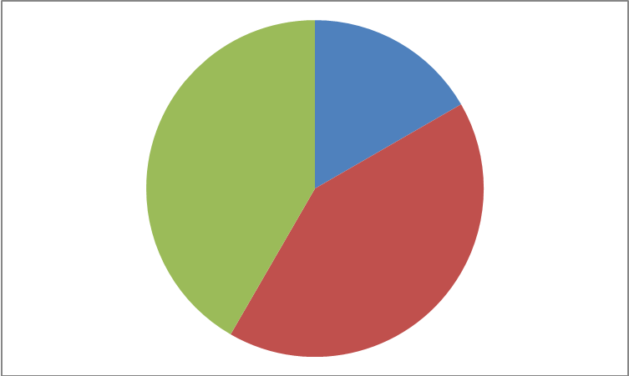 | Math Learning Goals  - Students will understand that ratios are a comparison of two quantities  - Students will represent ratios using a variety of forms, e.g. 3 to 4, 3:4, 3/4, or 0.75  - Students will investigate the relationship between decimals, fractions, and percents as ratios.  - Students will connect ratio to percent. Describe percent as a special kind of ratio in which the second quantity is always 100, e.g. 7% means 7 out of 100 | Materials  - BLM 9.2.1 (on transparency)  - BLM 9.2.2  - BLM 9.2.3  - BLM 9.2.4  - Projector
 | Individual → Parallel Question  Show BLM 9.2.1 using a projector and give students time to answer the question.  Whole Group → Discussion  Follow-up the parallel questions by asking these questions of the class:  - What was the biggest similarity you noticed? Why? Biggest difference? Why?  - If the squares were the same size and made of colour tiles, would they require the same number of blue and red tiles?  - Could you describe the similarities using ratios? Fractions? Percents? How?  Whole Group → Brainstorm  Ask students to think of all the ways they could explain to someone how much of the big square is blue (highlight answers like: half blue half red, 1:1 or 3:7 ratio blue to red, 50% or 70% blue, 50 (or 70) out of 100 blue)  Think/Pair/Share → Discussion  Ask the question “why would someone argue that 70% or 50% is really a ratio in disguise?” (70% means that 70 out of 100 tiles were blue which was equivalent to saying 7 out of every 10 tiles were blue.)  Highlight that percent is a ratio (part to whole) where the second quantity is 100. | Students choose which pair of squares to work with  
Minds On…
Groups of 4 → Activity
Handout one copy of BLM 9.2.2 to each group and instruct them to use only 1 pencil to complete the activity.
Whole Group → Discussion
Ask volunteers to explain their answers to each question; as you go, ask the class “why do you think the ratios in each row are called ‘equivalent ratios’?”
Whole Group → Demonstration
Introduce students to a ratio table to create equivalent ratios – see BLM 9.2.3 for lesson examples and further questions.
Independent → Practice
Handout BLM 9.2.4 for students to complete. Circulate as students complete the worksheet to assess their level of difficulty and assist them where needed.
Action!
Whole Group → Discussion
Take up the handout BLM 9.2.4. Discuss alternate approaches.

Consolidate Debrief
Application | Home Activity or Further Classroom Consolidation  Recipe A for punch calls for 2 cans of fruit concentrate and 3 cans of ginger ale.  Recipe B for punch calls for 3 cans of fruit concentrate and 4 cans of ginger ale.  Question: Which punch recipe is stronger? Explain how you know. | 

9.2.1: Minds On Grade 7
Option 1:

What is similar about the following two squares?
What is different?

Option 2:

What is similar about the following two squares? What is different?

9.2.2: Ratio Grids Grade 7

Please follow the steps given below carefully:
- Each group member will choose and complete one question.
- Shade the grid on the right so that the ratio of shaded squares to total squares is the same as the ratio in the grid on the left.
- Write the ratios of shaded squares to the whole number of squares beside each grid.
- Explain your thinking to your group members as you go.

1a. | 1b.
2a. | 2b.
3a. | 3b.
4a. | 4b.

9.2.2: Ratio Grids Answers Grade 7

Please follow the following steps carefully:
- Each group member will complete one question.
- Shade the grid on the right so that the ratio of shaded squares to total squares is the same as the ratio in the grid on the left.
- Write the ratios of shaded squares to the whole number of squares beside each grid.
- Use the space to explain your thinking.

1a. 4:10 | 1b. 8:20  Students may use equivalent numbers or solve the problems by investigation.
2a. 1:4 | 2b. 3:12
3a. 7:25 | 3b. 14:50
4a. 2:10 | 4b. 5:25

9.2.3: Lesson – Equivalence Tables (Teacher Notes) Grade 7

Discuss how question #4 from the ratio grids worksheet could have been solved multiplicatively using a ratio table:

2 out of 10 shaded squares in the first column is equivalent to ? out of 25 shaded squares in the second column
÷2 ×5
2 | 1 | 5
10 | 5 | 25
÷2 ×5

Complete several examples, like the ones shown below, with students.
4:2 and 5:? 3:4 and ?:16
÷2 ×5 ×3 add 3&9
4 | 2 | 10 |  |  |  | 3 | 9 | 12
2 | 1 | 5 |  |  |  | 4 | 12 | 16
÷2 ×5 add 4&12
? = 10 ?=12

Ask students how ratio tables can be used to determine if two ratios are equivalent.
E.g. Is 2:6 equivalent to 5:12?

Answer: No. Students could argue why they are not equivalent using many methods.
They can use equivalence tables by looking at 2:6 and 5:? and solve to see if ? is 12.

9.2.4: Equivalent Ratios Practice Grade 7

Working with a partner, use equivalent tables to determine which cookie pans have the same ratio of chocolate chips to cookie.

Tray 1

Tray 2

Tray 3

Tray 4

Tray 5

Tray 6

Tray 7

Tray 8

9.2.4: Equivalent Ratios Answers Grade 7

Working with a partner, use equivalent tables to find which cookie pans have the same ratio of chocolate chips to cookie.

Trays 1,6 and7 are equivalent. Trays 2,3 and 5 are equivalent. And trays 4 and 8 are equivalent.

Tray 1 cookie:chip = 1: 4

Tray 2 cookie:chip = 2: 5
Tray 4 cookie:chip = 1:3

Tray 5 cookie:chip = 1: 2.5

Tray 6 cookie:chip = 3:12
Tray 7 cookie:chip = 1.5: 6

Tray 8 cookie:chip = 2: 6

Tray 3 cookie:chip = 4: 10

Unit 9: Day 3: The Rate Race |  | Grade 7
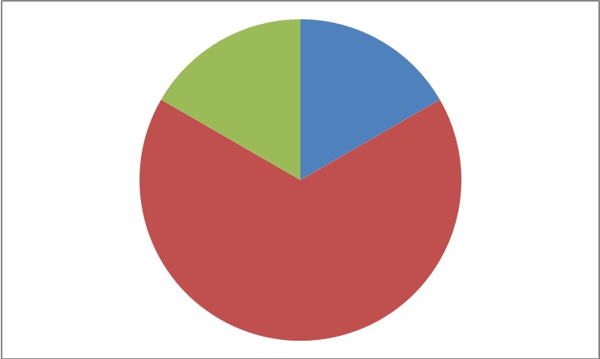 | Math Learning Goals  - Students will understand that rate is a comparison of two quantities that have different units of measure  - Students will recognize commonly used rates and explain why they are rates, e.g. speed is a rate that compares distance and time; 110km/h; hourly wage is a rate that compares money to time; $9.50/h  - Students will recognize personal rates, e.g. walking rate, reading rate | Materials  - BLM 9.3.1  - BLM 9.3.2
Pairs → Activity
Give each student a ratio card from BLM 9.3.1. Their challenge is to find their partner by matching equivalent ratios. Observe students and ask questions of struggling students to help them find their partner (e.g. what would your ratio look like if you use a manipulative? Are you thinking of your ratio as part-to-part or part-to-whole?)
Once everyone has found their partner, ask volunteers to share their strategies for finding their partners.
Minds On…
 | Whole Group → Discussion  Use concept attainment to introduce the idea of rate. Use a chart, such as the one below, to show examples and non-examples of rates. After introducing each example and non-example, ask the class what they think rate is.  Check their understanding by having the students brainstorm other examples and non-examples of rates using the popcorn technique. When they give an example of a rate, have them explain why they think it is a rate or not a rate. Once the lists are well populated, have students help you sort the rate list into 2 categories personal rates and other rates.  Think/Pair/Share → Summarizing  Pose the following two questions to be answered using think-pair-share:  - What is rate? (Answer: Rate is a comparison of two quantities that have different units of measure)  - Is rate a ratio? (Answer: Yes – still comparing two things)  - Is a ratio a rate? (Answer: Sometimes –if the things being compared in the ratio have different units) | Teacher Tip:  The popcorn technique is a brainstorming method where students make suggestions out loud without raising their hand or being called upon. Although this can be noisy, it increases class participating by allowing the students to feel comfortable generating ideas without judgement.
  Examples of rates | Examples that are not rates
  A car drives at 200km in 2h | boys:girls = 9:10
  Minimum wage is now $9.50/h | Average test score: 80%
  My resting heart rate is 81beats/minute | For every hour spent studying I spend 1.5 hours playing soccer
  Wilt Chamberlain led the NBA with an average of 22.9 rebounds/game | My banana muffins recipe calls for ¾ of a cup of bananas
  I typed 150 words in 3 minutes | I babysat for 5 hours yesterday
Action!
 | Pairs → Activity  Students will work with their partner from the ‘Minds On...’ activity to record personal rates from the popcorn activity that interests them. They should be encouraged to select 3 or 4 activities as time allows. | Differentiate by student choice.
Consolidate Debrief
Application | Home Activity or Further Classroom Consolidation  Using BLM 9.3.2, find and record examples of rates used around your home and community.

9.3.1: Equivalent Ratios (Teacher) Grade 7

Cut out the following ratios and hand one ratio card to each student.
$$\frac{4}{6}$$ | 8:12 | $$\frac{\text{10}}{\text{12}}$$ | 5:6
2:5 | 6:15 | $$\frac{4}{7}$$ | $$\frac{8}{\text{14}}$$
1:3 | 9:27 | $$\frac{4}{\text{14}}$$ | $$\frac{8}{\text{28}}$$
27:50 | 44% | $$\frac{7}{8}$$ | $$\frac{\text{21}}{\text{24}}$$
2:4 | 1:2 | 1:4 | 5:20
$$\frac{6}{\text{10}}$$ | 30:50 | 8:3 | 24:9
16:20 | 8:10 | 5:20 | 15:6
2.5:9 | 5:18 | 1.5:1 | 3:2

9.3.2: Using Rate Grade 7

Record examples of rate used in your home and your community. Explain how the rate is used.

Example of Rate | Place of use  (home, work, community) | Use of Rate.
e.g. $0.98/Litre | Community | Price of gas per litre.

Unit 9: Day 4: Modelling Rates |  | Grade 7
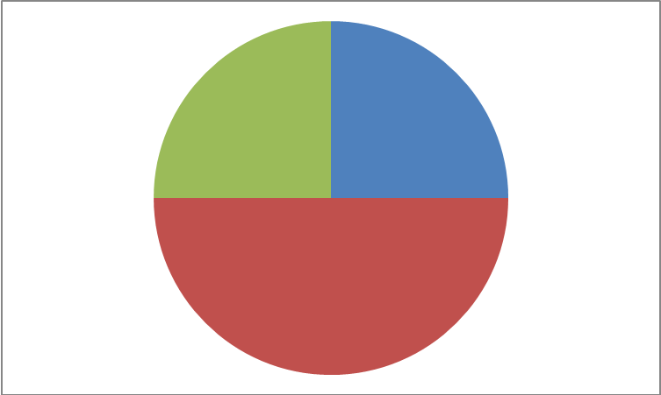 | Math Learning Goals  - Students will create a table of values and a graph based on a personal rate, e.g. make a table of values from 0 to 10 minutes for a heart rate of 68 beats per minute, and then graph the relationship  - Students will pose and solve problems based on graphically represented data  - Students will write an algebraic expression to describe the rate,  - e.g. Total heartbeats = 68 x time in minutes, or H = 68t.  - Students will make connections between graphs of rates and graphs of linear relationships. | Materials  - BLM 9.4.1  - BLM 9.4.2  - Timers/ Stop watches
Whole Group →Activity Instructions
Introduce the activity by modelling the creation of a table of values from 0 to 10 minutes for a heart rate of 68 beats per minute.
e.g. Sample table for the first 2 minutes
Time (min) | Beats
0 | 0
1 | 68
2 | 136
Using think/pair/share, graph the data and have students create an expression to describe the rate. (Total heartbeats = 68 x time in minutes, or H = 68t)
Minds On…
 | Pairs → Activity  Handout BLM 9.4.1. Working with the same partners as in Day 3, students will select one of the personal rates they tested to create a table of values, a graph and an algebraic expression on the BLM. Both partners should select the same personal rate for comparison. | Student choice
Action!
Whole Group → Gallery Walk
The teacher will have the students post their completed BLM 9.4.1 around the classroom and invite the students to take a gallery walk to look at the whole classes’ graphs.

While viewing, students are encouraged to observe similarities and differences between the expressions and graphs for the different personal rates in the class. Students should notice that the graphs are all straight lines and the graphs of their rates are linear relationships.
Consolidate Debrief
Practice | Home Activity or Further Classroom Consolidation  Students will complete BLM 9.4.2 to consolidate their knowledge of graphing rates and linear relationships. | Student choice

9.4.1: Modelling Rates Grade 7
Name: ____________________________ Partner’s Name: __________________________

Personal Rate Modelled: _______________________________________________________

- Create a table of values for your rate from 0 to 10 minutes. | - Graph your data. Be sure to label the graph carefully.

- Write an algebraic expression to describe your graph.

- Assuming the rate is constant, answer the following questions about your graph.

- How many (e.g. beats, words, etc.) would you have after:

9 minutes? ___________ 4.5 minutes? ____________ 1 hour? _____________

- How much time would need to pass for your answer (beats, words etc) to reach 40? ___________
- Compare your graph with your partners. Describe how they are similar and how they are different.

9.4.2: Modelling Rates Grade 7

PART A: Select one of the following rates to complete the table of values, graph and create an expression.
- Bob swam 25 m in a minute.
- A student types 63 words per minute.
- A plane flew 150 km in 15 minutes.

- Create a table of values for the rate from 0 to 10 minutes. | - Graph the data. Be sure to label the graph carefully.

- Write an algebraic expression to describe the graph: ____________________________

PART B: The graph shows the distance travelled by a car travelling over 5 hours.

- How far did the car travel in 1 hour?

- What is the average speed of the car?

- Explain how you answered question 2.

9.4.2: Modelling Rates Solutions Grade 7

Select one of the following rates to complete the table of values, graph and create an expression.
- Bob swam 25 m in a minute.
- A student types 63 words per minute.
- A plane flew 150 km in 15 minutes.

- Create a table of values for the rate from 0 to 10 minutes. | - Graph the data, labelling carefully.
  Minutes | m or words or km
  0
  1
  2
  3
  4
  5
  6
  7
  8
  9
  10

- Write an algebraic expression to describe the graph.
D = 25 X t
W = 63 X t
D = 600 X t

The graph shows the distance travelled by a car travelling over 5 hours.

- How far did the car travel in 1 hour? 80km

- What is the average speed of the car? 80 km/h

- Explain how you know. Linear pattern showing constant rate of change or created a table of values.

Unit 9: Day 5: Unit Rate |  | Grade 7
 | Math Learning Goals  - Students will understand that a unit rate is a rate where the second term is one unit, e.g. $6.50/1 h, $3.99/1 doz  - Students will recognize familiar unit rates  - Students will calculate and compare unit rates  - Students will solve problems involving unit rates | Materials  - BLM 9.5.1  - BLM 9.5.2
 | Whole Class → Discussion  Discuss students’ solutions to the activity last day. In particular, discuss answers to the last question so that students can share how they solved that problem. Review the concept of rate.  Think/pair/Share → Activity  Pose the following problem to the class:  Student council needs to hire a DJ for a 3-hour school dance. They have two quotes: Quote A: $75 per hour Quote B: $200 for 3 hours.  Which quote should the student council accept?  Which quote has the best hourly rate?  The students work with their elbow partner to determine which quote should be accepted. Call on pairs to share their ideas. Guide student responses with the following questions:  How did you know which quote was the best?  What did you have to do in order to determine which quote was the best? | Definition:  Unit Rate – a rate where the second term is one unit
Minds On…
Whole Class → Discussion
Explain that the hourly rate is called a unit rate and have the class develop a definition for unit rate. Have student volunteer ideas for a list of examples and non – examples (or non-unit rates, e.g. $200 for 3 hours) to check for understanding. Start the list by placing the two quotes from the ‘Minds On...’ section under the appropriate headings.

Think/Pair/Share → Discussion
Have students discuss with an elbow partner how items from one list can be used to create items from the other. (i.e. to make $200 for 3 hours a unit rate, divide both parts of the rate by 3, or to make $75 per hour a non unit rate, multiply both parts by a number) Ask students the following two questions:
- Why do you think unit rates are important in the real world?
- How many ways can a unit rate be transformed into a non-unit rate?
- Answer: infinite number of ways

Pairs → Coaching
Students will complete BLM 9.5.1 in pairs. This is a co-operative activity where the students will alternate answering questions and giving feedback to their partners.
Action!
Whole Class → Discussion
Take up BLM 9.5.1 as a class. Answer any questions the students might have. Pose the following question as an extension:
Often the ‘better buy’ in a store is the larger package. Why might people purchase the smaller package anyway? (i.e. refer to the envelopes in question #5)
Consolidate Debrief
Concept practice  Problem solving | Home Activity or Further Classroom Consolidation  Complete BLM 9.5.2.

9.5.1: Unit Rate Grade 7

Work through the following questions with your elbow partner. Partner A begins by solving question 1 and explaining the solution to Partner B. Partner B may ask any questions for clarification, or may offer suggestions if the answer is incorrect. Both partners need to agree on the final answer. Partner B then solves question 2 and proceeds in the same manner. Continue with the rest of the questions on the page.

Partner A Partner B

Calculate the unit price Calculate the unit price

1. 4 kg of apples for $5.20 2. 2 lemons for $0.99

3. 15 envelopes cost $0.70 4. 45 envelopes cost $1.26

5. Discuss with your partner which package of envelopes is the better buy. Why?

9.5.1: Unit Rate Solutions Grade 7

Work through the following questions with your elbow partner. Partner A begins with question 1. Solve the question on the page. Explain your solution to Partner B. Partner B may ask any questions for clarification, or may offer suggestions if the answer is incorrect. Both partners need to agree on the final answer. Partner B then solves question 2 and proceeds in the same manner. Continue with the rest of the questions on the page.

Partner A Partner B

Calculate the unit price Calculate the unit price

1. 4 kg of apples for $5.20 2. 2 lemons for $0.99

$5.20/4 kg $0.99/2 lemons
Unit rate: $1.30/kg Unit rate: $0.495/lemon

3. 15 envelopes cost $0.70 4. 45 envelopes cost $1.25

$0.70/15 $1.25/45
Unit rate: $0.05/envelope Unit rate: $0.03/envelope

Discuss with your partner which package of envelopes is the better buy? Why?

The 45 envelopes are the better deal. The envelopes are 2 cents cheaper.

9.5.2: Unit Rate Problems Grade 7

1. Sue and Jim are driving on the highway. Sue takes 24 minutes to drive 40 km. If Jim drives at the same rate, how long will it take for him to drive 115 km?

2. You are downloading songs for your mp3 player. Six songs cost $5.94. You want to buy 4 songs, how much would that cost? How much would it cost for 8 songs?

9.5.2: Unit Rate Problems Solutions Grade 7

1. Sue and Jim are driving on the highway. Sue takes 24 minutes to drive 40 km. If Jim drives at the same rate, how long will it take for him to drive 115 km?

Sue takes 24 min. to drive 40 km. Her driving rate is 0.6min/km.
Jim drives at the same rate. 115 km x 0.6 min/km = 69 minutes

It will take gym 69 minutes to drive 115 km.

3. You are downloading songs for your mp3 player. Six songs cost $5.94. You want to buy 4 songs, how much would that cost? How much would it cost for 8 songs?

One song costs $5.94 ÷ 6 = $0.99/song
6 songs would cost 6 x $0.99 = $5.94
8 songs would cost 8 x $0.99 = $7.92

Unit 9: Day 6: Scale as a Unit Rate or Ratio |  | Grade 7
 | Math Learning Goals  - Students will illustrate that measurements on scale diagrams are unit rates or ratios, e.g. 1 cm = 100 km; 1:100 000  - Students will analyse and interpret the scales used on blueprints and maps  - Students will solve problems based on scale diagrams | Materials  - BLM 9.6.1  - BLM 9.6.2  - Atlas, roadmaps, blue prints, etc.  - Graph paper
Whole Group → Demonstration
Show the students several examples of scales (atlas, road map, blue prints, etc.) and ask the following questions. Ask for several answers and their explanations:
Why is a scale a type a rate or ratio? (Follow-up with: is it a type of unit rate?)
What can scales on maps be used for?
Interpret the meanings of the ratios by calculating the distance between locations and the size of the buildings in the samples.
Minds On…
Small Groups → Practice
Handout BLM 9.6.1 to each group. Instruct students to each complete one question and explain their solution to the rest of the group as they go.

Circulate as they work, and ask questions to gain insight into each student’s level of understanding.

Action!
Whole Group → Discussion
Take up BLM 9.6.1, discussing problem solving strategies as you go.

Consolidate Debrief
Application | Home Activity or Further Classroom Consolidation  Students will select an image from BLM 9.6.2 to enlarge or decrease using a scale factor. | Student choice of image and enlargement or decrease.

9.6.1: Scale as a Unit Rate or Ratio Grade 7

Names of Group Members: __________________________________________________

Solve the following scale problems.
- Measure the length of the car. Use the scale to calculate the actual length.  Scale 1:90 | - Calculate the height of the boat using a scale of 1:100.
- The triceratops is said to have grown to 9m in length. What is the scale of this graphic? | - How long and how tall is the mosquito?  1: 0.3

9.6.1: Scale as a Unit Rate or Ratio Grade 7

Solutions

Names of Group Members:

Solve the scale problems.
- Measure the length of the car. Use the scale to calculate the actual length.  Scale 1:90  Approximately 450cm or 4.5m | - Calculate the height of the boat using a scale of 1:100.  Approximately 400cm or 4m
- The triceratops is said to have grown to 9m in length. What is the scale of this graphic?  1:180 | - How long and how tall is the mosquito?  1: 0.3  Approximately 18mm or 1.8cm long and 9mm or 0.9 cm high

9.6.2: Scale as a Unit Rate or Ratio Grade 7

Marine Flags: Signal flags are used to communicate messages, at times because radio silence is required.

- Choose one of the flags to copy onto cm grid paper and then enlarge or decrease its size by a scale factor of 1:5, 1:10 or 1:0.5.
- Use the Internet to research the meaning of the flag you selected.





Unit 9: Day 7: Determining the Best Rate |  | Grade 7
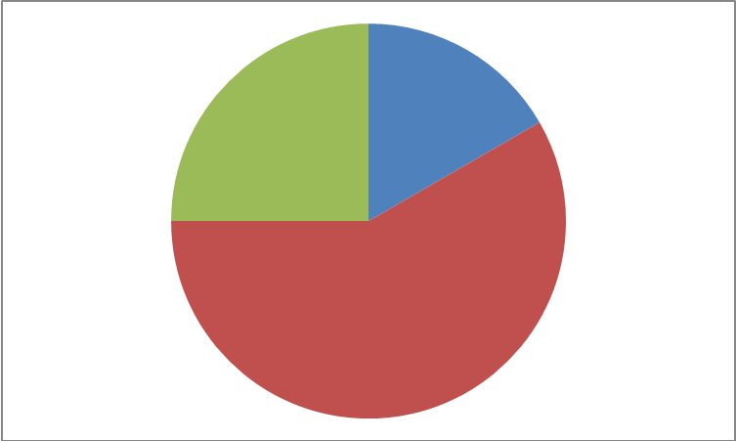 | Math Learning Goals  - Students will apply unit rates  - Students will solve problems that require determining the best price by calculating unit rates to compare the costs of two differently priced items, e.g. school supplies, snacks, personal grooming products, season’s passes | Materials  - BLM 9.7.1  - BLM 9.7.2  - Chart paper or  - SMART Board or  - Overhead sheets
Whole Class → Investigation
Review unit rate from Day 5. Focus on reviewing the solution to the last question on BLM 9.5.1.
Students will solve the following problem and then share their solution(s) with the class.
- You can purchase 10 candies from bulk store A for $1.12. At store B you can purchase 7 candies for $0.77. Which store has the better deal?
(Answer: store B has the better deal – candy costs $0.11/candy at store B as opposed to $0.112/candy at store A)
- How do you know it is a better deal?

Notice that at first glance, students may round answers to the nearest penny; however, if they do not round, they should notice that store B has the better deal by $0.002 – discuss why the 0.2¢ makes no difference when purchasing one candy, but a bigger difference when purchasing many. Ask them to calculate the price difference when buying 100 candies.

Stress organizing the answer logically. Reinforce that questions should be answered with an explanation and mathematical support.

Minds On…
 | Small Groups → Problem Solving  Divide the class into 8 co-operative groups.  Explain to the students that they will be working in their co-operative groups to answer four problems in BLM 9.7.1. Stress that all members of the group must understand the answer as each group will be presenting their solution to one of the problems. Both the question and the presenting group member will be randomly selected. Students may present on chart paper, overhead sheets, SMART Board, etc.  Circulate throughout the activity to assess students on their group work skills. | You may wish to give basic rate questions to the students that struggle with this activity.
Action!
Whole Class → Group Presentation
Each question will be presented by two groups. Check for and highlight different approaches to solving the problems. If possible, select groups who solved the problem differently to present to the class.

Consolidate Debrief
Concept practice  Problem solving | Home Activity or Further Classroom Consolidation  Assign BLM 9.7.2 for homework.

9.7.1: Rate Problems Grade 7

Solve the following problems in your co-operative group. Organize your solutions neatly. Make certain each member of the group understands the solution. You will be called upon randomly to present a question.

1. You are purchasing pop for a birthday party. The bottles come in different sizes and costs. A 2L bottle costs $2.20; a 1L bottle is on sale for $1.39 and a 500mL bottle costs $0.95. Which bottle(s) will you purchase for your party? Show your calculations and explain your thinking.

2. You are shopping for a cell phone. The number of text messages you can send will be the determining factor for which plan you choose. Plan A offers you 600 texts for $15. Plan B offers you 800 texts for $25. Which plan will you choose? What other factors might help you determine which plan to go with?

3. Which package is more economical?
300 g of jujubes for $2.50, or 500 g of jujubes for $3.20

4. A grocery store sells a case of 24 – 500mL bottles of water for $2.99. They also sell a case of 6 – 1.5L bottles for $2.99. Which bottles are the best buy? How much are you saving per litre?

9.7.1: Rate Problems Solutions Grade 7

Solve the following problems in your co-operative group. Organize your solution neatly. Make certain each member of the group understands the solution. You will be called on randomly to present a question.

1. You are purchasing pop for a birthday party. The bottles come in different sizes and costs. A 2L bottle costs $2.20; a 1L bottle is on sale for $1.39 and a 500 mL bottle costs $0.95. Which bottles will you purchase for your party? Show your calculations and explain your thinking.

2L bottle – unit price = $1.20/L
1 L bottle – unit price = $1.39/L
500 mL bottle – unit price = $1.90/L
We will purchase the 2L bottles for the party, as they are the best price per L.

2. You are shopping for a cell phone. The number of text messages you can send will be the determining factor for which plan you choose. Plan A offers you 600 texts for $15. Plan B offers you 800 texts for $25. Which plan will you choose? What other factors might help you determine which plan to go with?

Plan A: $15 ÷ 600 = $0.25/text
Plan B: $25 ÷ 800 = $0.31/text

Plan A is the better plan.

3. Which package is more economical?
300 g of jujubes for $2.50, or 500 g of jujubes for $3.20

$2.50 ÷ 3 = $0.83/100g
$3.20 ÷ 5 = $0.64/100g
The 500 g back of jujubes is the better deal.

4. A grocery store sells a case of 24 – 500mL bottles of water for $2.99. They also sell a case of 6 – 1.5L bottles for $2.99. Which bottles are the best buy? How much are you saving per litre? 500 mL = 0.5 L

Case: 24 x 0.5 L = 12 L
Cost of the case is $2.99/12 L
Unit cost = $0.25/L

Case: 6 x 1.5 L = 9 L
Cost of the case is $2.99/9L
Unit cost = $0.33/L

The case of 24 is the best buy. You would save $0.08/L.

9.7.2: Determining the Best Rate Grade 7

Answer the following question. Show your solution. Explain your answer.

The school wishes to purchase 2500 pens and have discovered that 3 stores sell the same model pen. Which store has the best buy?

Store A sells 15 pens for $0.50.
Store B sells 50 pens for $1.70.
Store C sells 30 pens for $0.90.

9.7.2: Determining the Best Rate Solutions Grade 7

Answer the following question. Show your solution. Explain your answer.

The school wishes to purchase 2500 pens. They will purchase the pens with the lowest price. Which store has the best price?

Store A sells 15 pens for $0.50.
Store B sells 50 pens for $1.70.
Store C sells 30 pens for $0.90.

Solution:

Store A – cost $0.0333.../pen
Store B – cost $0.034/pen
Store C – cost $0.03/pen

Store C has the best price per pen.

