Unit 8 Grade 7
Similarity, Congruency, and Transformations

Lesson Outline

BIG PICTURE

Students will:
- understand location using four quadrants of the coordinate axis;
- investigate and apply transformations and tessellations;
- investigate dilatations and their relationship to the characteristics of similar figures;
- investigate and compare congruent triangles and similar triangles;
- investigate, pose, and solve problems with congruent shapes.
Day | Lesson Title | Math Learning Goals | Expectations
1 | From One Point to Another  Presentation file:  Points and Their Coordinates | - Plot points on the Cartesian coordinate axis. | 7m54  CGE 5a
2, 3 | 4-Quadrant Game | - Plot points on the Cartesian coordinate axis.  - Students make a game, such as Treasure Hunt or Find My Location, that requires finding points on the 4-quadrant grid. | 7m54  CGE 5a
4 | Investigating Transformations Using Grid Paper | - Use various transformations to “move” a shape from one position and orientation to another on grid paper. | 7m56  CGE 3c
5 | Investigating Transformations Using The Geometer’s Sketchpad®4 | - Explore reflections, rotations, and translations using The Geometer’s Sketchpad®4. | 7m56  CGE 4a, 4f
6 | Pentominoes Puzzle | - Analyse designs, using transformations. | 7m56  CGE 3c
7 | Investigating Dilatations Using a Variety of Tools | - Investigate dilatations, using pattern blocks and computer websites. | 7m52, 7m55  CGE 2c, 3a
8 | Applying Transformations: Tessellations | - Tessellate the plane, using transformations and a variety of tools. | 7m56, 7m57  CGE 5e, 5f
9 | Will It Tessellate?  GSP®4 file:  Tiling | - Form and test a conjecture as to whether or not all triangles will tessellate.  - Apply knowledge of transformations to discover whether all types of triangles will tessellate. | 7m56, 7m57  CGE 3c
10 | Which Polygons Tesselate? | - Form and test a conjecture as to whether or not all polygons will tessellate.  - Identify polygons that will/will not tessellate. | 7m56, 7m57  CGE 3a, 3c
Day | Lesson Title | Math Learning Goals | Expectations
11 | Creating Similar Figures Through Dilatations | - Plot similar triangles on the Cartesian plane.  - Investigate similar triangles by comparing longest sides of each triangle; shortest sides; remaining sides; and corresponding angles of the triangles.  - Make conclusions that dilatations create similar triangles.  - Explore dilatated figures to determine that enlargements and reductions always create similar figures. | 7m52, 7m54, 7m55  CGE 3c, 3e
12 | Investigating Similar Figures Using Geometers Sketchpad®4 | - Draw a triangle and create several similar triangles by enlarging and reducing it using GSP®4.  - Understand relationships between the sides of similar triangles (e.g., If one side is doubled in length after enlargement, then all three sides are doubled in length. All angles remained the same measures after enlargement.). | 7m52, 7m54, 7m55  CGE 3c
13 | Congruent and Similar Shapes in Transformations | - Investigate, using grid paper or GSP®4 which transformations (translation, reflection, rotation, dilatation) create congruent or similar shapes.  - Determine the relationship between congruent shapes and similar shapes. | 7m52, 7m53  CGE 3c, 4c
14 | Investigating Congruency | - Construct congruent shapes.  - Measure and compare lengths, angles, perimeter, and area pairs of congruent shapes, and draw conclusions about congruent shapes. | 7m5, 7m50  CGE 3c, 4c
15 | Exploring Congruency | - Pose and solve congruency problems (e.g., Are two triangles with the same areas congruent? Are triangles with equal bases and heights congruent?) | 7m51  CGE 3c
16 | Investigating the Conditions That Make a Triangle Unique | - Determine the conditions that will make a unique triangle, e.g., Students conduct a number of investigations, using concrete materials such as:  - using two different lengths  - using two lengths and one angle  - using triangles given 3 side lengths, 3 angles, two angles, and one side, etc.  - determining when 3 lengths will and will not form a triangle, e.g., straws of lengths of 4 cm, 5 cm, and 10 cm, will not form a triangle because 4 + 5 < 10, thus the sides are too short to make a closed figure. | 7m50, 7m51  CGE 2c, 4e
17 | Investigating When Triangles Will Be Congruent | - Determine if triangles are congruent given certain conditions, e.g., Two triangles have side lengths 3 cm and 5 cm. The triangles each have a 60° angle, but not in the same location. Are the triangles congruent? | 7m50, 7m51  CGE 2c, 4e
18 | Summative Performance Task

Unit 8: Day 1: From One Point to Another |  |  |  | Grade 7
 |  | Math Learning Goals  - Plot points on the Cartesian coordinate axis. |  | Materials  - BLM 8.1.1  - graph paper  - data projector
Assessment
Opportunities
 | Minds On ... | Whole Class → Demonstration  Sketch a thermometer (vertically) on the board. Ask students where to place zero on the thermometer so there is room for positive and negative temperatures to be displayed.  A student marks zero on the thermometer; another student adds the temperatures 1, 2, 3…; and a third student labels negative temperatures –1, −2, −3…  Draw a horizontal number line through zero.  Students place the positive and negative integers on this line. The intersection of these two integer lines creates 4 quadrants and is called the Cartesian coordinate system.  Show the electronic presentation: Points and Their Coordinates to illustrate plotting points in the xy-plane. |  | Points and Their Coordinates.ppt  Students graphed ordered pairs in the first quadrant only in Grade 6.  Relate the story of René Descartes and why the Cartesian plane is named after him.  Word Wall  - x-axis  - y-axis  - origin  - horizontal axis  - vertical axis  - ordered pair  - x-coordinate  - y-coordinate  - quadrant  - Cartesian coordinate system  Students should consult with their partner to solve problems before they ask for assistance.
 | Action! | Whole Class → Guided Instruction  A student describes, in words, the path taken to a point, starting at the origin, e.g., move two units to the right, then four units down. A second student plots the appropriate point on a grid. A third student writes the ordered pair. Repeat, but in a different order each time, e.g., plot the point, show the path, state the path in words.  Pairs/Individual → Practice  Students practise ordering pairs with positive, negative, and zero coordinates.  Students complete question 1 of BLM 8.1.1 with a partner and then individually complete the remaining questions. Circulate and provide help, as needed.  Curriculum Expectations/Observation/Mental Note: Assess students’ understanding of plotting points and movement in the xy-plane, using up/down; right/left to indicate the direction.
 | Consolidate Debrief | Pairs → Sharing  Students exchange their code from question 4 and construct each other’s picture. Students assist each other, correcting any errors.
Application  Skill Drill |  | Home Activity or Further Classroom Consolidation  On a piece of graph paper, draw lines to make your initials.  Label the coordinates of several points.  On a separate piece of paper, list the coordinates in the order that will spell out your initials.  Do not include your name on the set of ordered pairs, as one of your classmates will solve this puzzle.

8.1.1: Plotting Points

1. Plot these points.  Connect the points in order.  Name the polygon.  (1, – 1), (2, 1), (1, 3), (– 1, 4), (– 3, 3),  (– 4, 1), (–3, –1), (–1, – 2), (1, – 1)  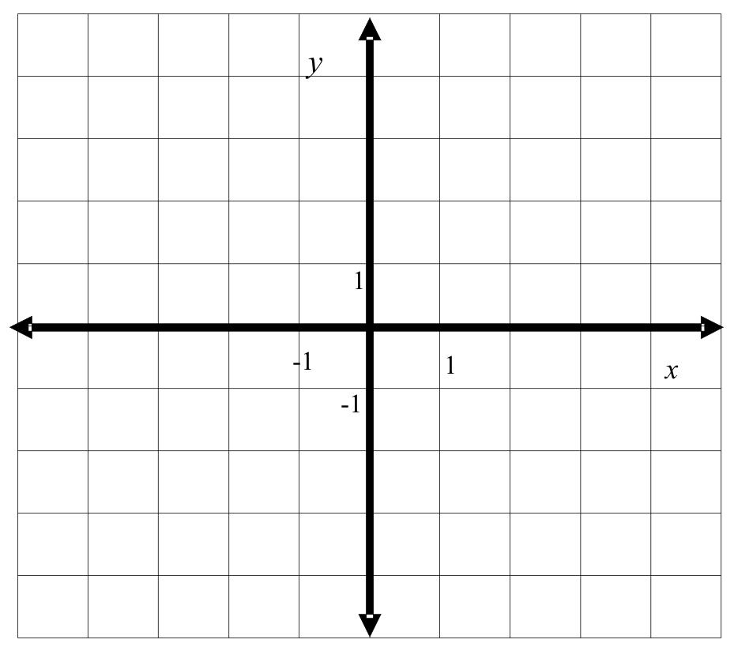 | 2. Plot each set of points on the grid below.  Join the points to form a quadrilateral.  Identify the quadrilateral.  Set 1: A(1, 1), B(1, 5), C(– 3, 5), D(– 3, 1)  Set 2: J(1, – 3), K(5, 1), L(8, 1), M(4, – 3)  Set 3: P(– 3, 0), Q(– 6, – 2), R(4, – 4), S(10, 0)  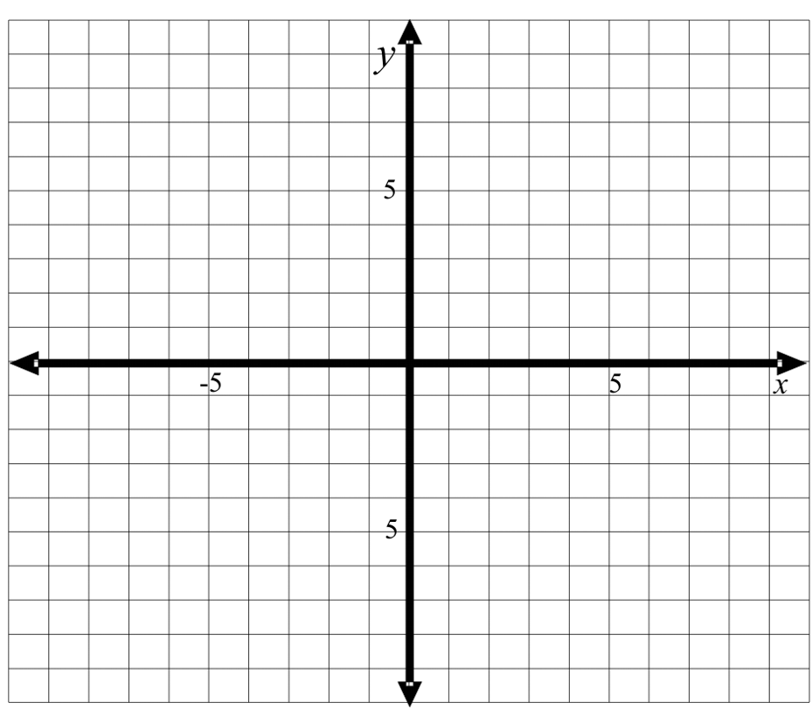
3. Plot these points.  Connect the points in order.  What picture do you see?  (2, 1), (5, 5), (1, 2), (0, 5), (– 1, 2), (– 5, 5),  (– 2, 1), (– 5, 0), (– 2, – 1), (– 5, – 5),  (– 1, – 2), (0, – 5), (1, – 2), (5, – 5),  (2, – 1), (5, 0), (2,1)  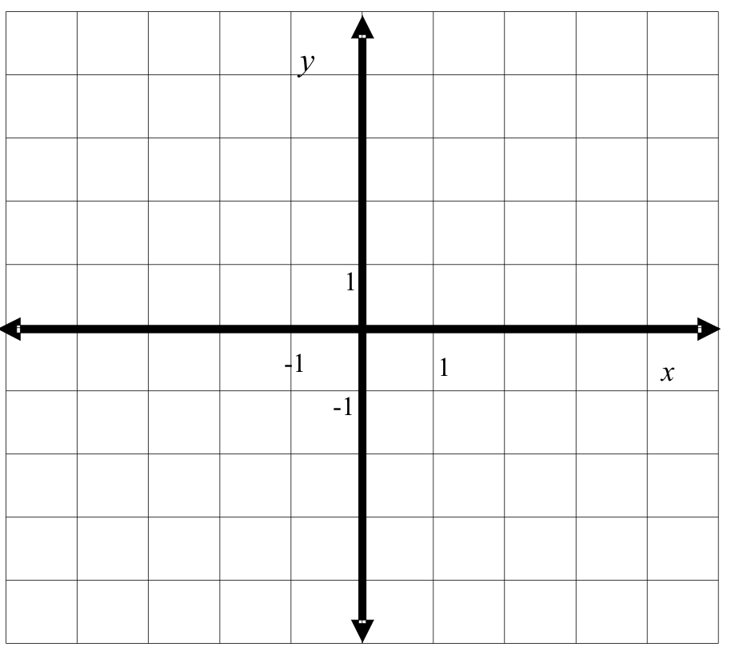 | 4. Make your own picture. Record the points in order. Exchange your picture code with a classmate and construct each other’s picture.  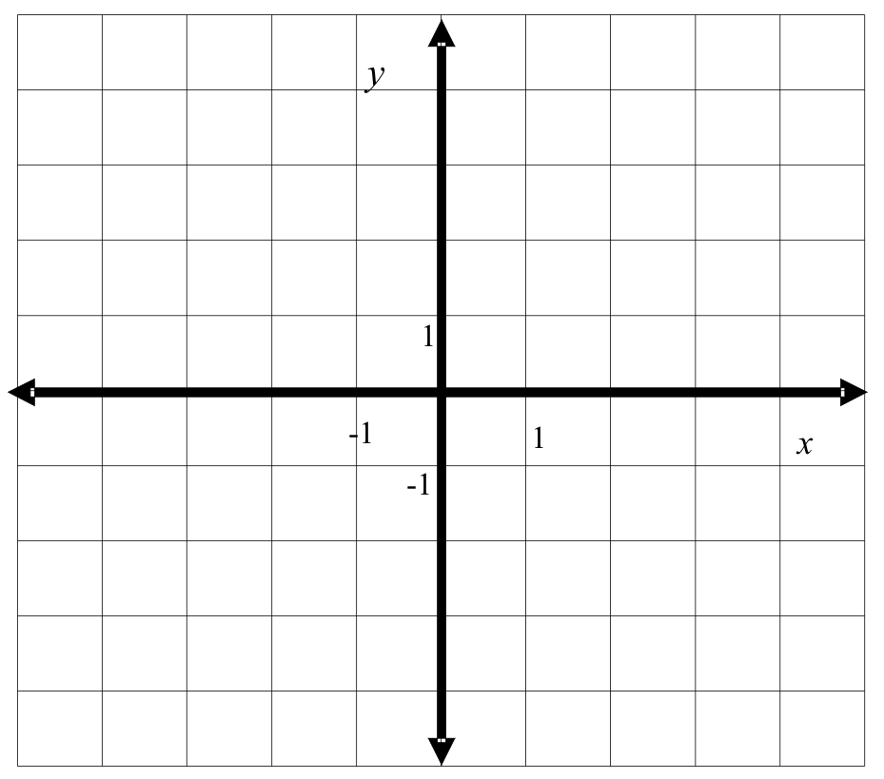
Points and Their Coordinates (Presentation software file)

Points and Their Coordinates.ppt

Unit 8: Day 2 & 3: Four-Quadrant Game |  | Grade 7
 | Math Learning Goals  - Students will plot points on the Cartesian coordinate axis.  - Students make a game, such as Treasure Hunt or Find My Location that requires finding points on the 4-quadrant grid. | Materials  - OHP Cartesian grid  - BLM 8.2,3.1  - BLM 8.2,3.2
 | Whole Class → Exploration  Teachers will review plotted coordinates on a Cartesian coordinate axis using BLM 8.2,3.1.  Ask students if they know any activity where ordered pairs are used. Create a class list of activities that use the concept of ordered pairs. For example: BINGO, Battleship, maps, create a shape.  Helpful websites:  http://www.mathplayground.com/locate_aliens.html  http://www.funbrain.com/cgi-bin/co.cgi?A1=s&A2=0  http://illuminations.nctm.org/LessonDetail.aspx?id=L296 |   Can students locate the coordinates?  Teacher Tip:  Metaphor:  Finding points is like reading a piece of text.  “As you read horizontally you make your way down the page.”
Minds On…
 | Pairs → Investigation  Students will create an activity that incorporates ordered pairs. Students need to include the proper mathematical terminology when explaining how to play their game.  Provide the students with BLM 8.2,3.2 to use as a guide when developing their game. |   Use BLM 8.2,3.2 as a rubric for assessment
Action!
 | Whole Class → Sharing  Students will present their game to the class. Give students the opportunity to play the games. | Did student explain the games properly?  Are students playing the games correctly?
Consolidate Debrief
Exploration  Reflection | Home Activity or Further Classroom Consolidation  Journal entry: Select one of the games that you played. Create and explain how you would make another version of the game.

8.2,3.1 The Fur Trade Tycoon Grade 7

The establishment of the fur trade was essential for the control of New France. The popularity of beaver pelts for fashion was the number one status symbol amongst the Europeans. Great wealth could be made by establishing fur trade posts in New France. Competition was great among the English and the French.

TEAM FRANCE
The French and the Hurons

TEAM ENGLAND
The English, Dutch, and Iroquois.

Rules:
1. Establish your Fur Trading Forts, and avoid detection by your opponent. Below you will find the Trading Forts of different sizes:

O O O
O O O O
O O O O O

Small Trading Fort Medium Trading Fort Large Trading Fort

2. After both sides have placed their forts, the battle commences! Take turns attacking different areas of your opponent’s grid, trying to hit their forts by using ordered pairs. If you manage to attack each section of a fort, you successfully overtake that fort, and take another step closer to becoming a Fur Trading Tycoon.
y

x
-10
-10
+10
+10

8.2,3.2 Game Outline and Rubric Grade 7

Use the following outline to complete your 4-Quadrant Game. Place a check mark in the boxes as you complete each criterion.

- Select a title for your game. Include an introduction for the game.
- Instructions how to play: Be sure to use correct mathematical vocabulary.
- Create a game board.
- Create an advertisement for the game.

Assessment Rubric

Criteria | Level 1 | Level 2 | Level 3 | Level 4
Are the instructions easy to follow?
Does the game allow for participant to use ordered pairs and the Cartesian axis?
Is the game challenging?
Is the game unique and fun to play?

Comments:

Unit 8: Day 4: Investigating Transformations Using Grid Paper |  |  |  |  | Grade 7
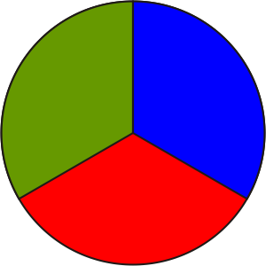 |  |  | Math Learning Goals  - Use various transformations to “move” a shape from one position and orientation to another on grid paper. |  | Materials  - BLM 8.4.1
Assessment
Opportunities
 | Minds On … |  | Whole Class → Activating Prior Knowledge  Place two congruent triangles (Δ1 and Δ 2) on overhead dot paper. Ask: What different types of transformations could be used to move Δ1 to the orientation shown by Δ 2? List transformation names on the board.  Students move Δ1 onto Δ2 several times using different combinations and/or sequences of transformations each time.  Review the precision needed for describing transformations. For example,  Reflect Δ1 in the vertical line going through C, then translate it 2 units right and 1 unit down.  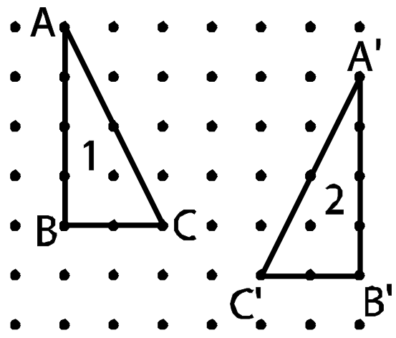  OR  Translate Δ1 down 1 unit and right 6 units, then reflect it in side AB.  Demonstrate that different types of transformations can result in the same image. |  |  | Shapes other than triangles could be used.  If a shape is rotated, the description should identify the centre of rotation.  If a shape is reflected, the description should identify the line of reflection.  The diagram below illustrates ΔABC being rotated 180° about point P to ΔCB'A  Cut-outs of Shape 1 for each question BLM 8.4.1 may be helpful for students to do this activity.
 | Action! |  | Pairs → Exploration  Students transform Δ1 onto Δ 2 using translations, reflections, and rotations and record all transformations (BLM 8.4.1).  Prompt students’ thinking:  - What different types of transformations are there?  - Which combinations have you tried?  - How can you perform the transformation in [specific number] moves?  Curriculum Expectations/Oral Questioning/Mental Note: Assess students’ understanding of transformations.
 |  | Consolidate Debrief | Pairs → Making Connections and Summarizing  Student pairs check another pair’s descriptions by following the description to see whether the intended image results.  Students record more than one way to describe at least two of the examples on  BLM 8.4.1.
Application  Concept Practice |  |  | Home Activity or Further Classroom Consolidation  Create your own transformation challenge.  Complete your transformations in several ways.

8.4.1: Transformations Recording Chart

Transformation Diagram  Sketch each step in the transformation from figure 1 to figure 2. | Description of Transformations  Describe in words the transformation used for each sketch.
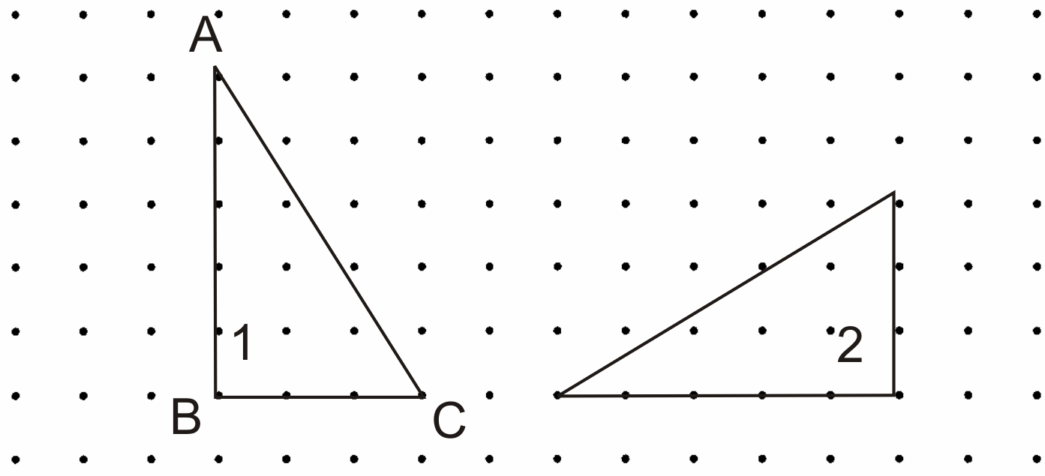
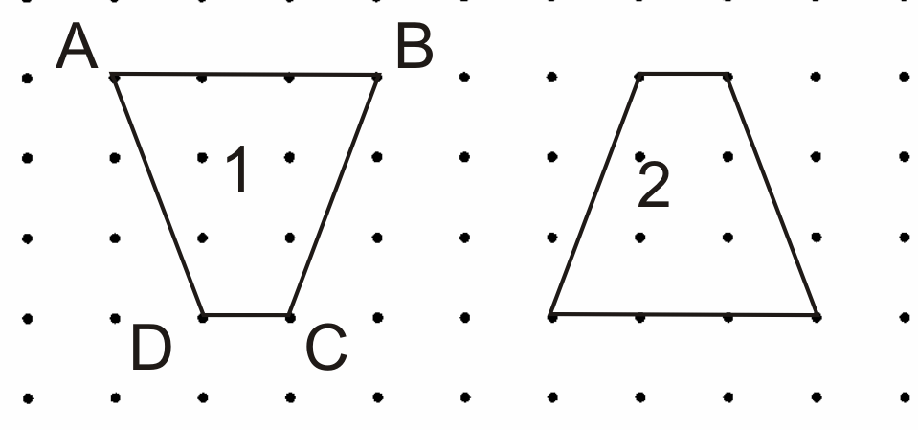
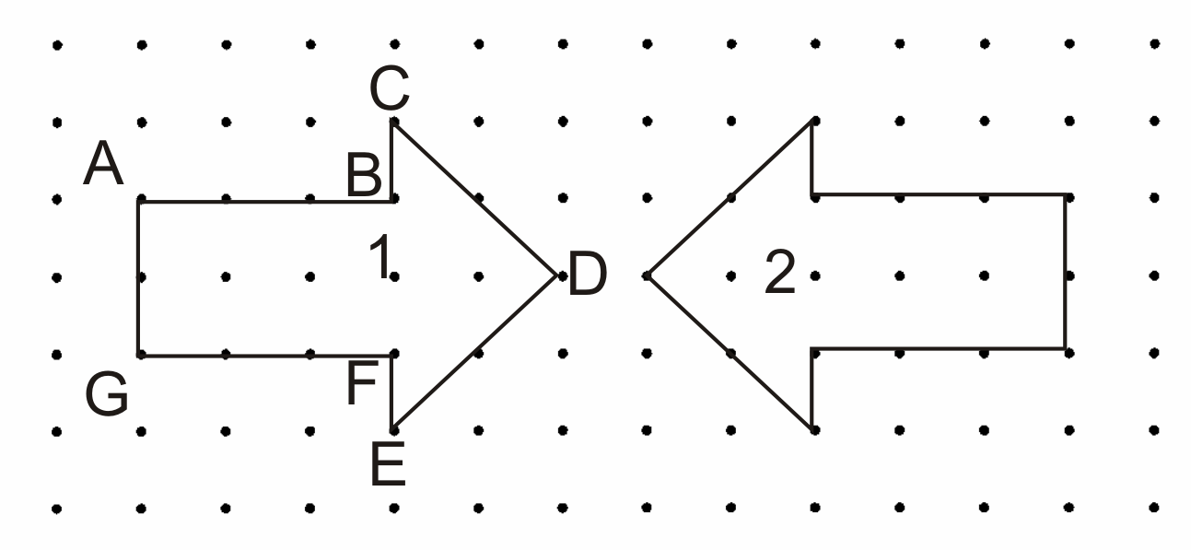
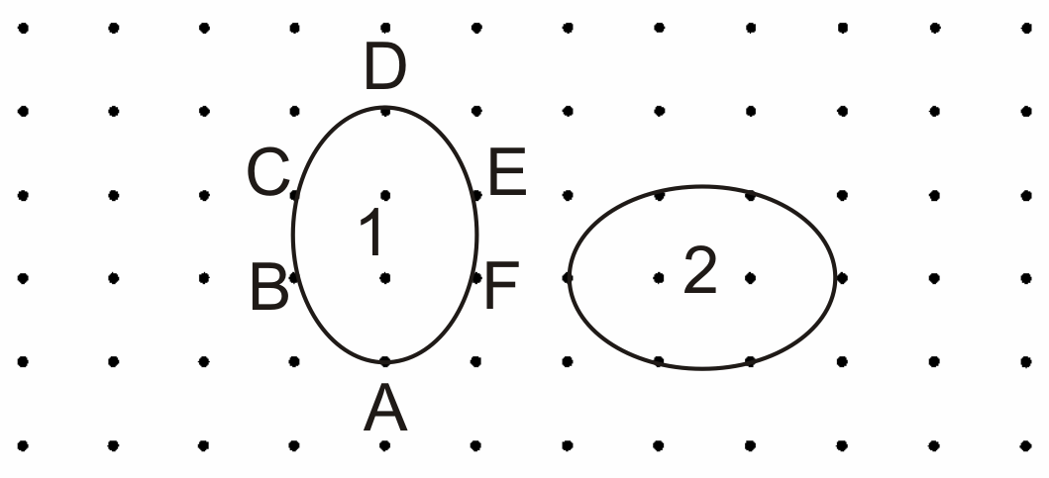

Unit 8: Day 5: Investigating Transformations  Using The Geometer’s Sketchpad®4 |  |  |  |  | Grade 7
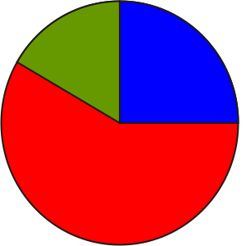 |  |  | Math Learning Goals  - Examine reflections, rotations, and translations using the Geometers’ Sketchpad®4. |  |  | Materials  - The Geometer’s Sketchpad®4  - BLM 8.5.1, 8.5.2
Assessment
Opportunities
 | Minds on … |  | Pairs → Teacher Guided  Mixed-ability pairs work together at a computer with The Geometer’s Sketchpad®4 (GSP®4) to construct a regular pentagon using BLM 8.5.1. Pairs share their understanding. |  |  | Refer to Think Literacy: Cross Curricular Approaches - Mathematics, Grades 7–9, Following Instructions  pp. 70−72.
 | Action! |  | Pairs → Guided Exploration  In mixed-ability pairs, students use Geometer’s Sketchpad®4 to work with various types of transformations (BLM 8.5.2, Parts A–D). Students who complete the task can do Part E on BLM 8.5.2.  Learning Skills (Cooperation)/Observation/Anecdotal Note: Assess students’ cooperation.
 |  | Consolidate Debrief | Whole Class → Demonstrating Understanding  Discuss student responses to the questions.
Application Concept Practice |  |  | Home Activity or Further Classroom Consolidation  Create and describe several different designs based on transformations of a single shape.  Name your design to suggest the type of transformation(s) used in developing the design, e.g., Tilted Tiles, Spun Petals.

8.5.1: Constructing a Regular Pentagon

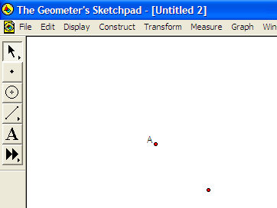 | Using the Point Tool, construct 2 points on the screen as shown.  Select the Arrow Tool, click on any white space to deselect everything.  Click on point A; from the Transform Menu, select Mark Center.  Click on the other point.
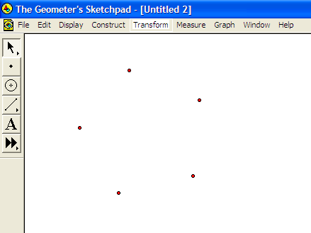 | In Transform Menu, select Rotate; type 72 into the degree box, click on Rotate.  Select Rotate again; in the Rotate Box, click on Rotate, repeat 2 more times.  Click on point A; in the Display Menu, select Hide Point.
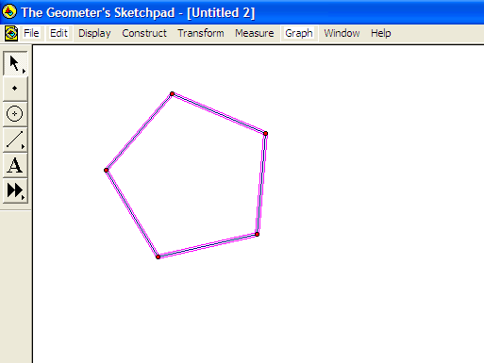 | Select each of the 5 points in order clockwise.  In the Construct Menu, select Segments.
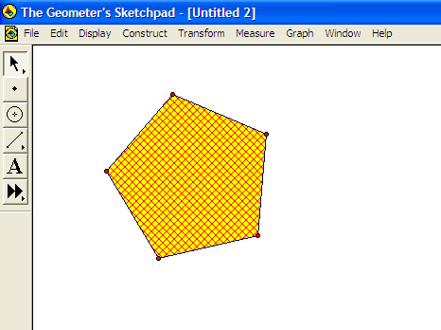 | Deselect the segments and select each of the 5 points.  In the Construct Menu, select Interior.  Save your sketch.
8.5.2: Transformations in The Geometer’s Sketchpad®4

Part A: Translations

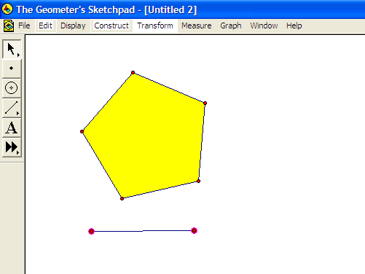 | Open the Pentagon Sketch that you saved, select the Segment Tool and draw a segment under your Pentagon.  Select the Arrow Tool; deselect the segment, then select each of the two end points. From the Transform Menu, select Mark Vector.  Select the entire Pentagon. From the Transform Menu, select Translate. In the Translate Box click Translate.  Describe in your notes what happened.
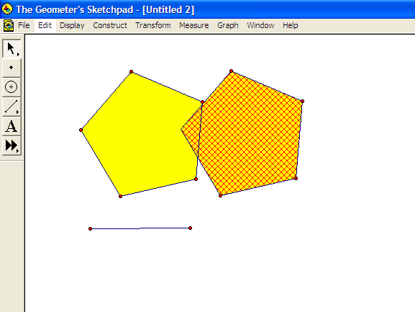 | Select the right most point on your line and drag the point.  Compare the Translated image to the original by describing how they are the same and how they are different.

Part B: Rotations

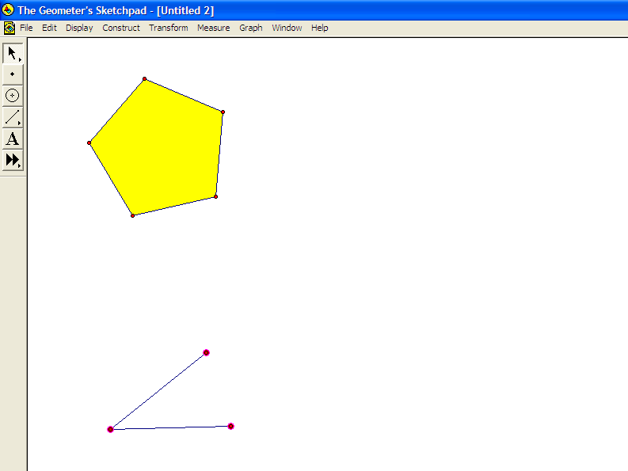 | Open the Pentagon Sketch that you saved.  Using the Segment Tool, construct an angle below your Pentagon. Select the Arrow Tool, deselect the segment.  Select the 3 points of the angle in order counter-clockwise. In the Transform Menu, select Mark Angle.  Select the vertex of the angle and in the Transform Menu select Mark Center.
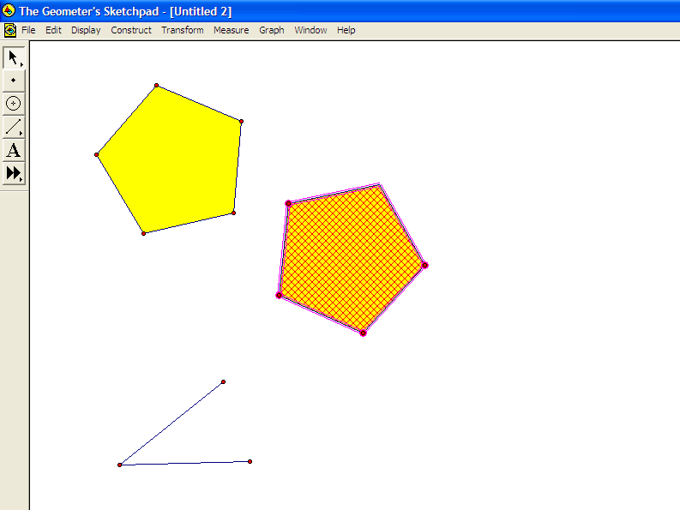 | Select the entire Pentagon. In the Transform Menu, select Rotate. In the Rotate box, click Rotate.  Describe in your notes what happened.  Select one of the end points on your angle and drag it.  Compare the translated image to the original by describing how they are the same and how they are different.
Part C: Reflections

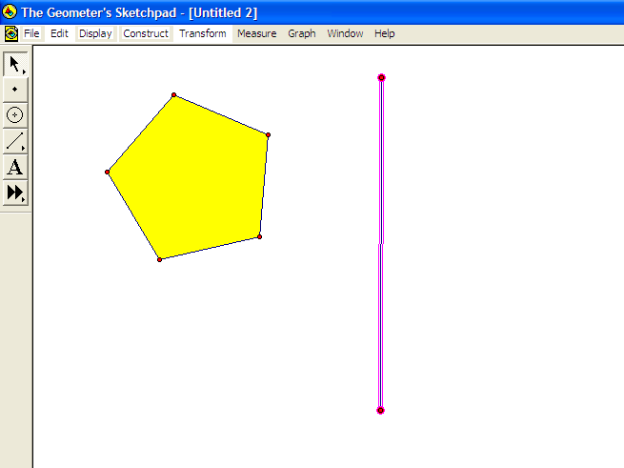 | Open the Pentagon Sketch that you saved.  Using the Segment Tool, construct a segment to the right of your Pentagon. In the Transform Menu, select Mark Mirror.  Select the Arrow Tool. Select your entire Pentagon  In the Transform Menu, select Reflect.  Describe in your notes what happened.
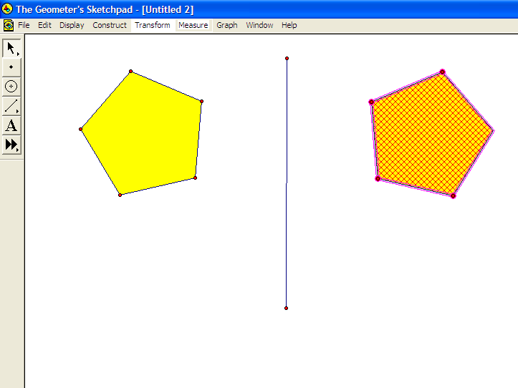 | Select your mirror line and drag it.  Compare the translated image to the original by describing how they are the same and how they are different.

Part D: Put It All together

Open the Pentagon Sketch that you saved.  Repeat each of the above transformations, this time not opening a new sketch each time. For each transformation select the image and change it to a different colour.  Your final sketch may have the images overlapping. You may need to drag your mirror line to achieve something similar to the screen shown.  Considering the three images, explain whether it is possible for any of the three images to lie directly on top of one another. Experiment by dragging different parts of your sketch. | 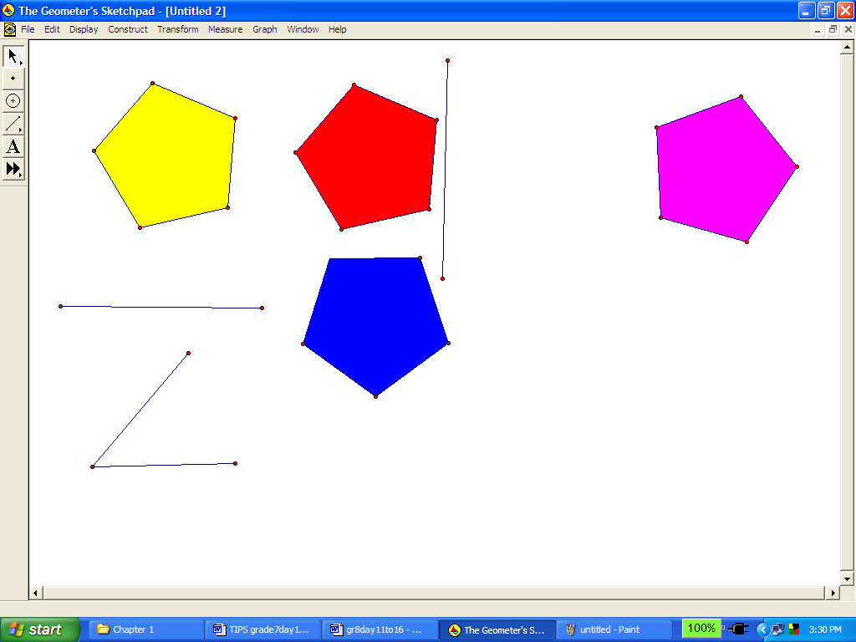

Part E: Explore More

Use various combinations of transformations to create a design.
Reflect an image over a line.
Create a second reflection line parallel to the first line.
Reflect the image over the second line.
Describe a single transformation that alone would have created the second reflected image. Repeat using two mirror lines that intersect.
Make up your own combination of transformations that could also be created by a single transformation.

Unit 8: Day 6: Pentominoes Puzzle |  |  |  |  | Grade 7
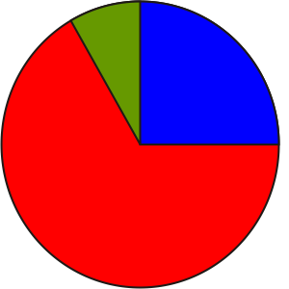 |  |  | Math Learning Goals  - Analyse designs using transformations. |  |  | Materials  - square tiles  - BLM 8.6.1, 8.6.2  - dot paper
Assessment
Opportunities
 | Minds On … |  | Whole Class → Demonstration  Create different shapes using five square tiles or five linking cubes. Demonstrate one shape that can be made using the five squares.  Construct a congruent shape as it would appear under a transformation, explaining that these two shapes are considered to be the same shape. |  |  | If square tiles are not available, copy BLM 8.6.1 onto card stock and have students cut out the squares to be used.  There are 12 different pentomino shapes.  The translation will vary depending on the centre of the rotation.  Using cut-outs of the pentomino shapes may help students during their task.  Encourage students to communicate clearly, using mathematical terminology.
 | Action! |  | Pairs → Exploration  Students find different pentomino shapes and draw them on the dot paper.  Whole Class → Guided Investigation  Use an enlarged overhead copy of BLM 8.6.2 to guide students in identifying A and 1 as a congruent pair under a rotation of 90° clockwise, followed by a translation.  Students fill in the chart. Students complete the chart in the following sequence:  - identify all of the pairs of congruent pentominoes;  - identify whether a rotation or reflection is needed;  - describe the amount and direction of rotation or the type of reflection;  - mark the centre of rotation or the reflection line, and the direction of translation.  Pairs → Problem Solving  Students work on the next 11 pairs individually and in pairs share their results and discuss any differences.
 |  | Consolidate Debrief | Whole Group → Presentation  Students explain a pair that they found, using an overhead of BLM 8.6.2. One student could write the description while the other student demonstrates the transformation with cut-outs.  For each pair of pentomino shapes, students describe the transformation differently, and explain it.  Communicating/Presentation/Checklist: Assess student’s ability to demonstrate, orally and visually, their understanding of transformations.
Concept Practice |  |  | Home Activity or Further Classroom Consolidation  Find another arrangement of pentominoes that form a rectangle.

8.6.1: Square Tiles

8.6.2: Pentominoes

Two different rectangular arrangements of the 12 pentomino pieces:

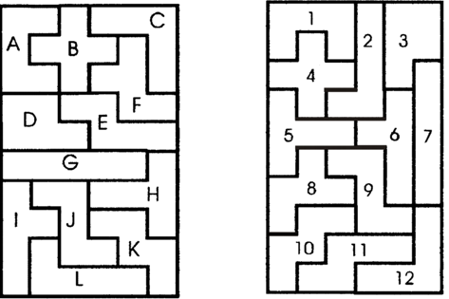

Find all pairs of congruent pentomino pieces and describe the transformation that you applied.

Pairs | Description of Transformation
A and ___
B and ___
C and ___
D and ___
E and ___
F and ___
G and ___
H and ___
I and ___
J and ___
K and ___
L and ___

Unit 8: Day 7: Investigating Dilatations Using a Variety of Tools |  |  |  |  | Grade 7
 |  |  | Description  - Investigate dilatations using pattern blocks and computer websites. |  |  | Materials  - pattern blocks  - BLM 8.7.1  - data projection unit
Assessment
Opportunities
 | Minds On … |  | Whole Class → Presentation  Draw a triangle or polygon on overhead acetate. Shine the overhead onto the board and trace the shape with chalk. Students suggest what will happen when the overhead is moved closer/farther from the board, using the vocabulary of dilatations. Move the overhead and trace the new shape.  Pairs → Discussion  Students make predictions about the relationships between the original and the image angles and the orientation of the original and image sides. They record their predictions in their journals.  Whole Class → Guided Exploration  Project examples of enlargements and reductions, e.g., maps found on the Internet.  Examine parallel streets and right-angled intersections. Point out that the angles keep the same measurements throughout dilatations and that parallel and perpendicular sides remain. |  |  | Word Wall  • enlargement  • reduction  • dilatation  • similar figures  • congruent  angles  • image  http://www.mapquest.com  http://earth.google.com  Challenge those students who finish early to create their own dilatations to further verify their findings.
 | Action! |  | Pairs → Investigation  Students investigate the predictions they made about angles and orientation of sides, using pattern blocks (BLM 8.7.1).  They should note that angles remain congruent throughout a dilatation. Some students might notice the relationship between side length and number of pattern blocks used.  Curriculum Expectations/Observation/Anecdotal Note: Assess students’ ability to identify, analyse, and describe dilatations.
 |  | Consolidate Debrief | Whole Class → Discussion  Students describe their findings and note if their original predictions were accurate.  Discuss where they have seen dilatations used in daily life.
Application |  |  | Home Activity or Further Classroom Consolidation  Complete the practice questions. |  |  | Provide students with appropriate practice questions.

8.7.1: Investigating Dilatations

Use pattern blocks to enlarge each of these shapes. Examine and measure the image shape and complete the table.

Shape | Dilatation to be performed | Compare original angles to image angles | Compare original sides to image sides
 | Side length enlarged by two times
 | Enlarge the rhombus’ sides by three times
 | Enlarge the square’s sides by five times
Draw the original shape | This shape’s sides have been reduced by four times

What conclusions can you make about the effect of dilatations on a shape’s angles and sides?

What other interesting patterns do you notice?

Unit 8: Day 8: Applying Transformations: Tessellations |  |  |  |  | Grade 7
 |  |  | Math Learning Goals  - Tessellate the plane using transformations and a variety of tools. |  |  | Materials  - The Geometer’s Sketchpad®4  - BLM 8.8.3  or  BLM 8.8.1, 8.8.2  - coloured pencils
Assessment
Opportunities
 | Minds On … |  | Whole Class → Demonstration  Explain the meaning of tessellate and tessellation. Ask: Will all shapes tessellate? Demonstrate how to use rotations to create an object and tessellate it using translations. Use a design completed in The Geometer’s Sketchpad®4.  Alternatively, explain how they are to create a shape on dot paper and then tessellate it on the dot paper (BLM 8.8.1, 8.8.2). |  |  | Have one completed GSP®4 design on a computer for students to see.  Students working collaboratively on one computer take turns manipulating the tessellation and giving advice or feedback.  Challenge those students who finish early to create their own tessellation in  GSP®4.
 | Action! |  | Pairs→ Exploration  Students explore tessellations, using GSP®4 (BLM 8.8.3). Alternately, students create the tessellation illustrated on BLM 8.8.3, using dot paper.
 |  | Consolidate Debrief | Whole Class → Discussion  Initiate discussion by asking: What are some criteria needed for a geometric shape to tessellate the plane?  Students describe some of the “problems” and “fun” they had creating the tessellations.  Discuss where they have seen tessellations used.  Communicating/Oral Questioning/Mental Note: Assess students’ ability to communicate, using geometric language.
Application  Concept  Practice |  |  | Home Activity or Further Classroom Consolidation  Create a tessellation using more than one shape.  Colour the results to create an interesting piece of art.  Find examples where tessellations have been used around your home, neighbourhood, in art, at school.

8.8.1: Isometric Dot Paper

8.8.2: Orthographic Dot Paper


8.8.3: Tessellations with The Geometer’s Sketchpad®4

Create a regular hexagon: Using the Point Tool construct two points on the screen. Select the Arrow Tool, click on any white space to deselect everything. Click on the leftmost point. Using the Transform Menu, select Mark Center. Click on the other point. In the Transform Menu, select Rotate and type 60 into the degree box; click on Rotate. Select Rotate again and click on Rotate; repeat three more times.

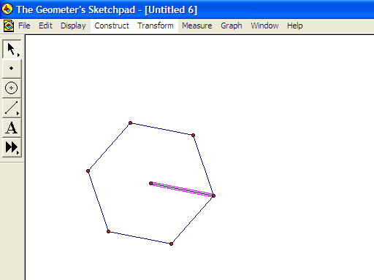 | Select each of the 6 points in order clockwise. In the Construct Menu, select Segments.  Create a cube.  Select the centre point and one other point. Construct the segment.
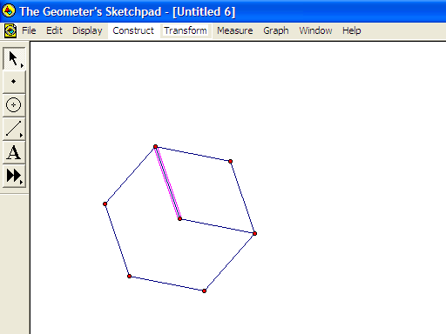 | Select the centre point and not the next point but the one after it; construct the segment.
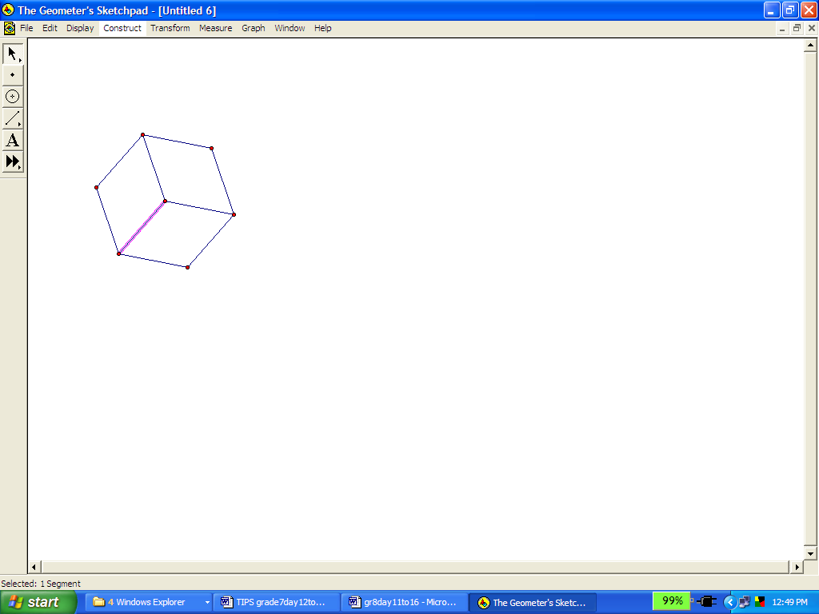 | Repeat to complete the cube.
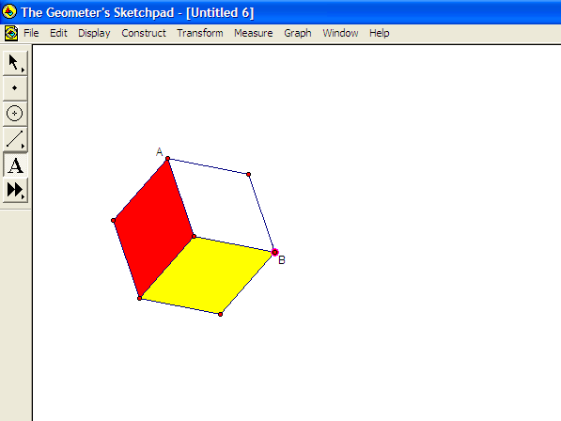 | Select the four points that form the vertices of one of the square faces you have represented. In the Construct Menu, select Quadrilateral Interior. Repeat for another square. Change the colour of the second square using the Display Menu.  Select the two diagonal points of the top square shown on the screen as  A and B; in the Transform Menu select Mark Vector.
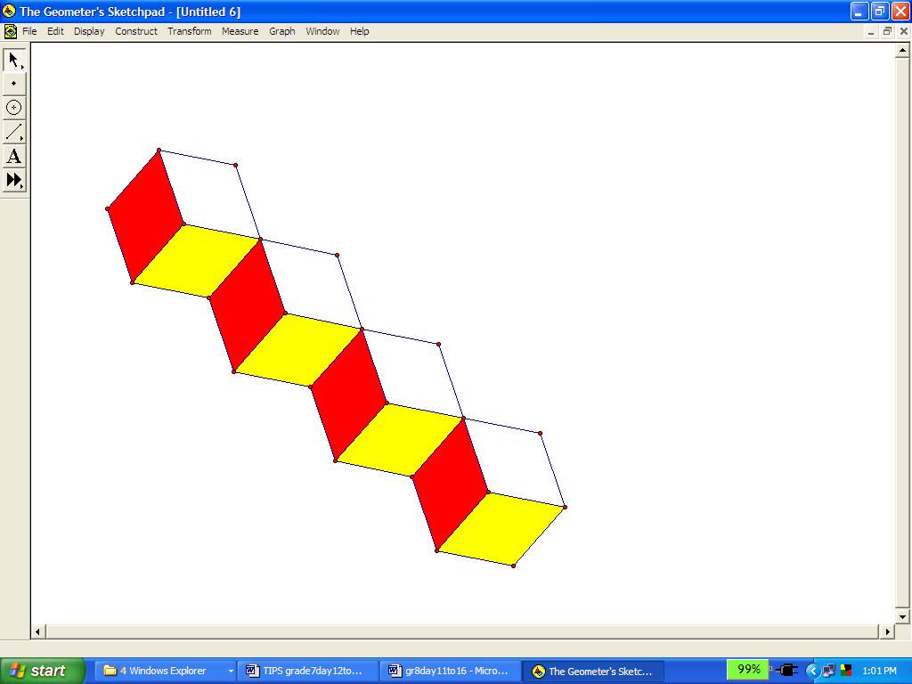 | Select the entire cube and from the Transform Menu, select Translate. Repeat a few more times.
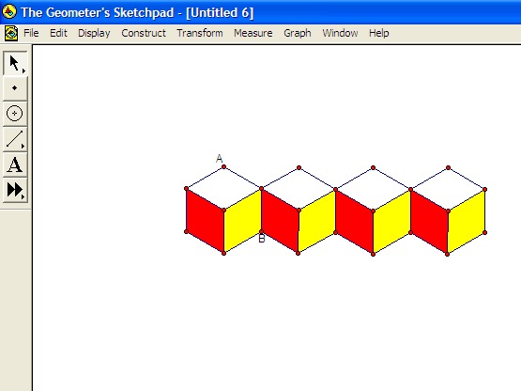 | Drag the leftmost corner of the original cube and “straighten” out the line of cubes.  Mark a vector by selecting the two points indicated on screen as A and B.
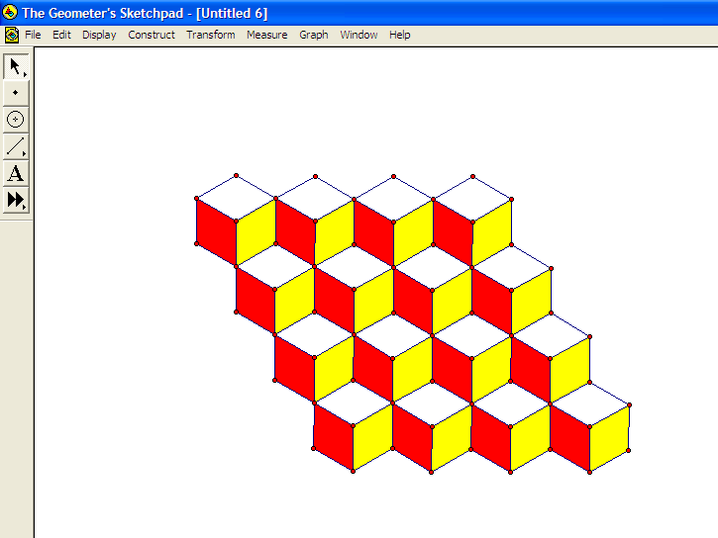 | Select all the cubes and translate them. Repeat a few times.  Describe the different shapes and effects you see in your diagram.

Unit 8: Day 9: Will It Tessellate? |  |  |  |  | Grade 7
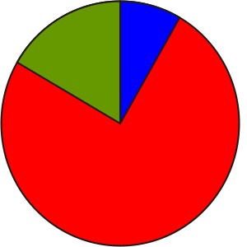 |  |  | Description  - Form and test a conjecture as to whether or not all triangles will tessellate.  - Apply knowledge of transformations to discover whether all types of triangles will tessellate. |  |  | Materials  - BLM 8.9.1  - geoboards,  - dot paper,  - grid paper  - pattern blocks  - The Geometer’s Sketchpad®4
Assessment
Opportunities
 | Minds On … |  | Whole Class → Anticipation Guide  Present the problem: Is this statement true? – All types of triangles will tile a plane.  Students complete the Before column of an Anticipation Guide before beginning the discussion and activity.  Groups of 4 → Brainstorm  Students brainstorm various ways in which they can solve the problem with materials and tools that are available.  Learning Skills/Observation/Mental Note: Circulate, noting students’ contributions to the discussion. |  |  | See Think Literacy Mathematics, Grades 7–9, Anticipation Guide pp. 10–14  GSP®4 demonstration of tessellations:  Tiling.gsp  Possible manipulatives: pattern blocks, polydron, grid paper, The Geometers’ Sketchpad®4.  To fill the plane, the sum of the angles that meet must add to 360°.
 | Action! |  | Pairs → Problem Solving  Students solve the problem several ways using the ideas generated during their brainstorm.  Students complete the After column of their Anticipation Guide.
 |  | Consolidate Debrief | Whole Class → Discussion  Students present their conclusions. Students should realize that any triangle will tile the plane, and should understand why this is the case.  Mathematical Processes/Self-Reflection/Checklist: Students reflect on their problem-solving process, using the criteria of the checklist (BLM 8.9.1).
Reflection |  |  | Home Activity or Further Classroom Consolidation  Reflect on your solution to the problem and complete worksheet 8.9.1.

8.9.1: Will All Types of Triangles Tile a Plane?

Name:
Date:

Criteria | Yes | No | Comments
Selecting Tools:
I used different tools to test for tiling (e.g., pattern blocks, grid paper, computer software, polydron, concrete materials).
Reasoning and Proving:
I tested several different types of triangles (e.g., scalene, isosceles, equilateral, right angled, obtuse angled, acute angled).
I made a convincing argument, explaining and justifying my conclusions.
Communicating:
I used mathematical language (including words, pictures, diagrams, charts, etc.), to clearly explain the process I used.
Reflecting:
I monitored my thinking (e.g., by assessing how effective my strategy was, by proposing an alternate approach, by verifying my solution).

Tiling (GSP®4)

Tiling.gsp

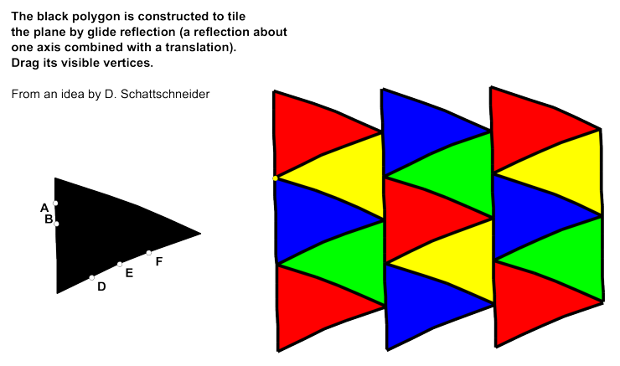

Unit 8: Day 10: Which Polygons Tessellate? |  |  |  |  | Grade 7
 |  |  | Description  - Form and test a conjecture as to whether or not all polygons will tessellate.  - Identify polygons that will/will not tessellate. |  |  | Materials  - geoboards  - dot paper  - grid paper  - pattern blocks  - The Geometer’s Sketchpad®4
Assessment
Opportunities
 | Minds On … |  | Whole Class → Posing the Problem  Recall the problem from Day 9: Will all types of triangles tile a plane? Present today’s problem: Will all polygons tessellate?  Students write down their conjecture. Ask If they don’t all tile the plane, which types of polygons (or combinations of two or three polygons) will tile a plane? Consider convex polygons only.  Groups of 4 → Brainstorm  Students brainstorm various ways in which they can solve the problem with materials and tools that are available. |  |  | Teachers may need to explain convex polygon.  Possible manipulatives: pattern blocks, polydron, grid paper, The Geometer’s Sketchpad®4.
 | Action! |  | Individuals → Problem Solving  Students work independently to solve the problem in several ways, using the ideas generated during their brainstorm.  Curriculum Expectations/Demonstration/Checkbric: Assess students’ ability to investigate polygons that tile a plane.
 |  | Consolidate Debrief | Whole Class → Discussion  Students present their original conjectures and their conclusions after the investigation. Students should realize that not all polygons will tile the plane.  Comment on the students’ strengths and next steps that they can take to improve performance.
Reflection |  |  | Home Activity or Further Classroom Consolidation  Reflect on your solution to the problem and answer the following questions in your math journal:  - Did you have a plan before you started the task? What was it?  - Did you make an hypothesis? How can an hypothesis help you to plan your strategy?  - Did you reflect on your thinking to examine how effective you were being? Did this cause you to select an alternative strategy?

Unit 8: Day 11: Creating Similar Figures through Dilations |  | Grade 7
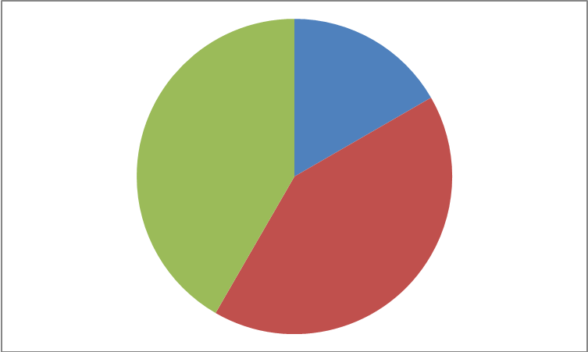 | Math Learning Goals  - Students will plot similar triangles on the Cartesian plane  - Students will investigate similar triangles by comparing longest sides of each triangle; shortest sides; remaining sides; and corresponding angles of triangles  - Students will make conclusions that dilations create similar triangles  - Students will explore dilated figures to determine that enlargements and reductions always create similar figures | Materials  - OHP dot grid  - Dot paper  - BLM 8.11.1
 | Whole Class → Exploration  Students will create a triangle with the following vertices: A (2,5) B (2,2) C (6,2). Ask the students what type of triangle they created (Answer: right angle triangle).  Allow them to check their response by measuring each side (AB=3, BC=4, AC=5).  Ask the students to draw 3 lines that pass through the origin and through each of the vertices.  Asks students to draw the following right angle triangles that correspond to the following points:  DEF D (4,10) E (4, 4) F (12, 4)  GHI G (6,15) H (6,6) I (18,6)  Ask students:  - What similarities do you notice about the ordered pairs?  (Answer: All points are located on the extended lines)  - What similarities do you notice about the corresponding sides?  (Answer: They all have the same proportion)  - Are the points the same? (Answer: no)  - Are the lengths the same? (Answer: no)  - Are the angles the same? (Answer: yes) | Can students locate the coordinates?    Use BLM 8.11.1 for those students having difficulties locating the points.
Minds On…
Pairs → Investigation
Students repeat the whole class activity in pairs using different types of triangles (i.e., scalene, equilateral, isosceles).

Students answer the following questions while completing their dilation.
- Measure the corresponding angles of the two similar shapes. What do you notice?
- Measure the lengths of the corresponding sides. Record the ratios for each side. What do you notice about the ratios?
Action!
 | Whole Class → Discussion  Students share their findings with the class. | Check for students’ understanding of the term ‘similar’  Select points that use whole numbers.
Consolidate Debrief
Concept Practice  Exploration | Home Activity or Further Classroom Consolidation  Journal Entry: Myles states, “All dilated images have all sides that are increased or decreased by the same proportion.” Do you agree with Myles? Use diagrams to support your answer.

8.11.1 Dilation of a Triangle Grade 7

A
B
C

Unit 8: Day 12: Investigating Similar Figures Using GSP4 |  | Grade 7
 | Math Learning Goals  - Students will draw a triangle and create several similar triangles by enlarging and reducing its size using GSP4  - Students will understand relationships between the sides of similar triangles (e.g. If one side is doubled in length after enlargement, then all three sides are doubled in length. All angles remained the same measures after enlargement). | Materials  - Computer  - GSP  - Geoboards  - Grid paper  - Elastics  - BLM 8.12.1
 | Whole Class → Exploration  Have students use Geoboards or grid paper to create the following triangles:  - AB=3 BC=4 AC=5  - DE=6 EF=8 FD=10  - GH=9 HI=12 GI=15  What are the measurements of the interior angles? Answer: Same.  What do you notice about the side lengths? Answer: Proportional.  Teacher asks students the characteristics of similar triangles.  Two triangles are similar if the three angles of the first triangle are congruent to the corresponding three angles of the second triangle and the lengths of their corresponding sides are proportional. | Do students understand how to label sides?  Check for students’ understanding of similar triangles
Minds On…
 | Pairs → Investigation  Students repeat the whole class activity from the ‘Minds On...’ section in pairs using GSP4.  - Measure the corresponding angles of the similar triangles. What do you notice?  - Measure the lengths of the corresponding sides. Record the ratios for each side. What do you notice about the ratios? | Check for students understanding of the software.
Action!
Whole Class → Discussion
Students share their findings with the class.
Consolidate Debrief
Concept Practice  Skill Drill | Home Activity or Further Classroom Consolidation  1) How is solving similar triangle problems the same as solving equivalent fraction problems?  2) In the triangle XYZ shown below, X’Z’ is parallel to XZ. Find the missing lengths a and b. Show your work. See BLM 7.12.1.  X  12  a  X’  30  16  Z’  b  Z  Y  36 | Students can create their own fractions and triangles.

8.12.1 Similar Triangles Grade 7

In the triangle XYZ shown below, X’Z’ is parallel to XZ. Find the missing lengths labelled as a and b. Show your work.

X
12
a
X’
30
16
Z’
b
Z
Y
36

Unit 8: Day 13: Congruent and Similar Shapes in Transformations |  | Grade 7
 | Math Learning Goals  - Students will investigate, using grid paper or GSP4 which transformations (translation, reflection, rotation, dilation) create congruent or similar shapes.  - Students will determine the relationship between congruent shapes and similar shapes. | Materials  - BLM 8.13.1 “Battle for Acadia”  - BLM 8.13.2  - Pentominoes  - Overhead projector (OHP) grid
 | Whole Class → Discussion  Teacher reviews the terms for transformations with students. Teacher explains how to play “Battle for Acadia” and ensures that all students clearly understand the rules. Teacher plays a practice game with the students on the OHP. | Can students locate the coordinates?
Minds On…
 | Pairs → Investigation  Students play the game in groups of four using the game board in BLM 8.13.2. | Are students playing the games correctly?
Action!
 | Whole Class → Discussion  Ask the class:  - Why do you miss a turn when you choose a dilation card?  - What were some of the difficulties that you encountered in the game?  Discuss some of the strategies that the groups used to play the game. Make an anchor chart of the responses. | Encourage students to communicate clearly, using mathematical terminology
Consolidate Debrief
Reflection | Home Activity or Further Classroom Consolidation  Journal entry: How would you improve “The Battle for Acadia”? Explain 3 things you liked about the game and 3 things for improvement.

8.13.1 The Battle for Acadia Grade 7

The colony of Acadia was a very important place in Canada’s history. The French and English saw Acadia as the key to power, wealth, and status. Both nations fought to gain control of Acadia. The battle went back and forth. Battles were fought and forts were built and destroyed. Using your understanding of transformations, you will be attempting to overtake your opponent’s habitation. The objective is to move the pentominoes towards your opponent’s fort and cover each of your opponent’s pieces. Once that has been completed, you have taken over the fort, defeated your opponent and won the battle for Acadia!

Game Instructions:
- Both Team One and Team Two select 4 pentominoes to create their fort.
- Team One must give Team Two the same 4 pentominoes that they used. Team Two randomly places the pentominoes on their side of the game board (grid paper); and vice versa.
- Team One rolls the number cube. The number they get will determine the number of cards they select from the translation pile.
- Team One then must decide if they will use all, some or none of the translations to move their pentomino pieces. Team One can use the translations on one or as many different pieces as they want. The transformation cannot move the pentomino off the playing area.
- Team Two, repeat steps 3) and 4)
- The game continues until all pentominoes are on top of their opponent’s fort, claiming the fort to be theirs!

Rotate 90º CW | Reflect using the y axis | Dilation. Miss a turn. | Translate (+1,+1) | Translate (+1,-1)
Rotate 90º CCW | Reflect using the x axis | Dilation. Miss a turn. | Translate (+2,+2) | Translate (+2,-2)
Rotate 180º CW | Reflect using the y axis | Dilation. Miss a turn. | Translate (+3,+3) | Translate (+3,-3)
Rotate 180º CCW | Reflect using the x axis | Dilation. Miss a turn. | Translate (+4,+4) | Translate (+4,-4)
Rotate 270ºCW | Reflect using the y axis | Dilation. Miss a turn. | Translate (+5,+5) | Translate (+5,-5)
Rotate 270ºCCW | Reflect using the x axis | Dilation. Miss a turn. | Translate (+6,+6) | Translate (+6,-6)
Translate (-1,-1) | Translate (-1,+1) | Translate. Roll the dice twice for your ordered pairs. | Translate. Roll the dice twice for your ordered pairs. | Translate. Roll the dice twice for your ordered pairs.
Translate (-2,-2) | Translate (-2,+2) | Translate. Roll the dice twice for your ordered pairs. | Translate (+3,+4) | Translate (+2,-7)
Translate (-3,-3) | Translate (-3,+3) | Translate. Roll the dice twice for your ordered pairs. | Translate (+2,+8) | Translate (+0,-8)
Translate (-4,-4) | Translate (-4,+4) | Translate. Roll the dice twice for your ordered pairs. | Translate (-1,-0) | Translate (-0,+9)
Translate (-5,-5) | Translate (-5,+5) | Translate. Roll the dice twice for your ordered pairs. | Translate (-0,-2) | Translate (-5,+2)
Translate (-6,-6) | Translate (-6,+6) | Translate. Roll the dice twice for your ordered pairs. | Translate. Roll the dice twice for your ordered pairs. | Translate. Roll the dice twice for your ordered pairs.

8.13.2 GAME BOARD: Battle for Acadia Grade 7
+10
+10
+10
+10
FRENCH
ENGLISH

Unit 8: Day 14: Investigating Congruency |  | Grade 7
 | Math Learning Goals  - Students will construct congruent shapes  - Students will measure and compare lengths, angles, perimeter, and area pairs of congruent shapes, and draw conclusions about congruent shapes. | Materials  - B.L.M. 8.14.1  - Protractors  - Rulers  - Manipulatives  - Data Projector
 | Whole Class → Modelling  Using an OHP, display the Frayer Model outlined on B.L.M. 8.14.1 and review the definition of ‘congruency’ as a class.  Get suggestions from the students to fill in the Frayer model and ensure understanding from the last lesson.  Review the difference between congruency and similar shapes.  Ask the students: What is the difference between a congruency and similarity?  Ensure that students understand the congruent figures are those that have the same size and shape while similar figures have the same shape but not necessarily the same size  (if necessary, do an example as a class). | Teacher Note:  B.L.M. 8.14.1 can also be done in pairs or triads  Word Wall  -Congruency  -Similarity  See Think Literacy  Mathematics Pg. 38-42 for more information on Frayer Model
Minds On…
 | Pairs/Triads → Exploration  Pose the following questions to the students:  (1) Do congruent figures have corresponding angles?  (2) Do congruent figures have corresponding equal sides?  (3) How can we prove this?  Ask the students to discuss these questions and come up with a hypothesis and method.  Provide students with manipulatives to explore and to use to construct their own congruent shapes.  Encourage students to measure lengths, angles, perimeter, and areas of shapes. | Circulate as students work and pose questions to assist or direct their learning  Record anecdotal observations  Possible manipulatives include: pattern blocks, polydron, grid paper, GSP
Action!
 | Whole Class → Sharing  Students will share their strategies and findings with the class.  Students should have an understanding that congruent figures have corresponding angles and the length of corresponding sides is equal.  Note: Superimposing figures is one way to test for congruency; another is by measuring sides and angles. | Work with students who are having difficult measuring angles or sides  Review of calculating area or perimeter may be required
Consolidate Debrief
Application | Home Activity or Further Classroom Consolidation  Have students think about or make a list of congruent figures they can find in their homes, world, and/or community. Students can also be asked to find similar shapes.  Students can record these in their Math Journals. Students can be asked to trace or sketch the object and show the measurements of the angles, sides, perimeter or areas.

8.14.1: Frayer Model for Congruency Grade 7
Definition for Congruency  Congruency | Fact/Characteristics
Examples | Non Examples

Unit 8: Day 15: Exploring Congruency |  | Grade 7
 | Math Learning Goals  - Students will pose and solve congruency problems (e.g. Are two triangles with the same areas congruent? Are triangles with equal bases and height congruent?) | Materials  - BLM 8.15.1  - BLM 8.15.2  - Data projector  - Rulers  - Protractors  - Manipulatives
 | Pairs → Review of Prior Learning  Teacher will put up BLM 8.15.1 on an overhead and hand out one copy per pair of students.  As a class, discuss if the shapes are congruent. How can we find out? Reflect on yesterday’s lesson.  Allow the students to solve the problems in pairs. When finished, invite the students to share their solutions with the class.  Try to encourage multiple ways of solving the problem. Encourage the students to use mathematical vocabulary in their responses.  Share the congruency symbol with the class | Teacher Tip: Include congruency markings on the shapes    Have students switch papers and evaluate another groups response for communication  (Peer Evaluation)
Minds On…
 | Whole Class → Posing the problem  Pose the following questions to the class:  - Are two triangles with the same areas congruent?  - Are triangles with equal bases and heights congruent?  Pairs → Think/Pair/Share  Allow students to work through the problems in pairs. Encourage them to use math manipulatives including geoboards, GSP, pattern blocks, dot paper, or grid paper.  Encourage multiple representations of responses. | Teacher Note:  You may need to review how to calculate the area of a triangle  Word Wall  -Base  -Height  -Area  Teacher Hint:  Use manipulatives that you have available and that you feel will best assist your students
Action!
 | Whole Class → Sharing  Invite student responses from the ‘Action!’ section and discuss as a class.  Use the examples from BLM 8.15.2 for further consolidation.  Teacher may need to review types of triangles (isosceles, scalene, equilateral, right, acute and obtuse). Encourage students to use mathematical vocabulary in their answers. | Teacher Tip:  Have students share in small groups of four prior to taking it up as a class  Students could record solutions on chart paper and then do a Gallery Walk in the classroom
Consolidate Debrief
Concept Practice | Home Activity or Further Classroom Consolidation  Have students answer the question(s) below as part of their Math Journal:  - Are two triangles with the same area congruent? OR  - Are triangles with equal bases and heights congruent?  Encourage them to use mathematical vocabulary as well as pictures, numbers and words in their responses. | Students could self evaluate their own mathematical journals and their ability to communicate using mathematical language.

8.15.1: Congruency Review Grade 7

Are the following two trapezoids congruent or similar?
Provide evidence using pictures, numbers and words in your response.

8.15.2: Sample Solutions Part 1 Grade 7

The triangles below have identical areas. Are they congruent triangles?
Triangle 1:
A= Base x Height/ 2
A= (5 cm x 6cm)/2
A= 30 cm/2
A =15 cm²

5.0 cm
10.0 cm
6.0
cm

3.0 cm
Triangle 2:
A= Base x Height/2
A= (10cm x 3cm)/2
A= 30 cm/2
A= 15 cm²

Explanation:

Two triangles with the same area are not always congruent. In both of the triangles above the area equals 15 cm² however, both triangles are not congruent. Congruent means that both shapes should be the same size and shape and that all corresponding angles and lengths of corresponding sides are equal. Triangle 1 is an isosceles triangle, while Triangle 2 is scalene triangle. Triangle 1 is an acute triangle and Triangle 2 is right triangle. Therefore, while two triangles with the same area could be congruent, this is not always true. Congruency depends on the type of triangles.

8.15.2: Sample Solutions Part 2 Grade 7

Are triangles with equal bases and heights congruent?
Triangle 1

Triangle 2

4 cm

4 cm

3 cm
3 cm

Explanation:

Triangles with equal bases and heights are not always congruent. Both triangles above have the same 3 cm base and 4 cm height, however, they are not congruent. Congruent means that all corresponding angles and the length of the corresponding sides are equal. In the above examples, Triangle 1 is a right angle and a scalene triangle, while Triangle 2 is an acute triangle and an isosceles triangle.

Note: Students may have other ways of explaining. This is just one example of a possible solution.

Unit 8: Day 16: Investigating the Conditions That Make a Triangle Unique |  | Grade 7
60 min | Math Learning Goals  - Through investigation using concrete materials, students will determine the conditions that will make a unique triangle; such as:  -Using two different lengths  -Using two lengths and one angle  -Using triangles given 3 side lengths, 3 angles, two angles, and one side, etc.  -Determining when 3 lengths will and will not form a triangle | Materials  - Protractors  - Rulers  - BLM 8.16.1  - BLM 8.16.2  - Geoboards  - Dot paper  - Geometer’s Sketchpad
 | Whole Class → Shared Math Journals  Have students share their Math Journals from the ‘At Home Activity’ from Day 15 with a partner.  Invite students to share their examples (or collect journals prior to the lesson and place a few on overheads to share with the class- be sure to remove student names)  Discuss the journals as a class and ensure understanding.  Ask the class if they know or can guess what a unique triangle is. Allow time for them to discuss this with an elbow partner.  Tell the students that today they will be investigating the conditions that make a unique triangle. Share the following definition with the class:  Unique triangles are triangles that do not have an equivalent so there is not another triangle that has the exact dimensions or shape.  Divide the class into groups of three to four students. | Teacher Tip:  Photocopy a communication rubric and evaluate students journals as a formative assessment or do this with the students as a class  Word Wall  -unique triangle
Minds On…
 | Small groups→ Exploration  Students will work in groups of three or four to determine the conditions that will make a unique triangle given certain conditions. Provide each student with a copy of BLM 8.16.1 and read through it to ensure understanding. Students will work through each station around the room where different manipulative can be set up.  Examples:  - Station 1: Create triangles using two different lengths (Geoboards)  - Station 2: Create triangles using two lengths and one angle (Dot paper)  - Station 3: Create triangles using triangles given 3 side lengths, 3 angles, 2 angles and 1 side (Geometer’s Sketchpad)  - Station 4: Create triangles determining when 3 lengths will and will not form a triangle (Straws)  Have each group report their findings as a class or get into groups if using the jigsaw technique. | This activity can be done as a jigsaw  Students could rotate through groups throughout the class period or more than one class period  Use a variety of manipulative at each station depending on availability (examples are provided)
Action!
Whole Class → Sharing
Have students share their ideas with the class. Have the class record and discuss each response. Encourage multiple representations from the students. Have students complete the assessment tool for group work skills found in BLM 8.16.2.

Consolidate Debrief
Problem Solving | Home Activity or Further Classroom Consolidation  Ask students to think about how they can determine if two triangles are congruent. Ask them to consider what we covered in class. Have them share or record ideas.  Alternatively, students could complete 8.16.1 at home or finish in class.

8.16.1 Investigating the Conditions Grade 7

That Make a Triangle Unique

Unique Triangles: Triangles that do not have an equivalent. This means that there is not another triangle that has the exact dimensions or shape.

For example: I can draw many triangles if I’m only told the length of one side, but there’s only one triangle I can draw if you tell me the lengths of all three sides.

A triangle has a base width of 5 cm and side lengths of 4 cm. The triangle must look like this.
4 cm

4 cm

5 cm

Answer the following questions with your group by providing an example. Use the materials provided to assist you in coming up with responses.

Station #1
Can you make a unique triangle if given two different lengths?

Station #2
Can you construct a unique triangle using two lengths and one angle?

8.16.1 Investigating the Conditions that Grade 7

Make a Triangle Unique Continued

Station#3
Can you construct a triangle given 3 angles? What about two angles? How about one angle?

Station #4
Can you construct a unique triangle with three pieces of straw that measure 4cm, 5 cm, and 10 cm? Why or Why not explain?

8.16.2 Team Work Assessment Tool Grade 7

Evaluate yourself based on the categories below and how you worked in groups.

Learning Skills | Needs Improvement | Satisfactory | Good | Excellent
Did I work willingly and cooperatively with others? | I demonstrated limited cooperation when working with others. | I sometimes worked cooperatively with others. | I consistently worked cooperatively with others. | I always worked cooperatively with others.
Did I listen attentively without interrupting? | I rarely listened attentively without interrupting. | I sometimes listened attentively without interrupting. | I consistently listened attentively without interrupting. | I always listened attentively without interrupting.
Did I show respect for the ideas and opinions of others in my group? | I had limited listening skills and often interrupted. | I sometimes listened attentively without interrupting. | I consistently listened attentively without interrupting. | I always listened attentively without interrupting.

Student comments:

Is there anything you would do differently next time when working in groups?

Teacher comments and feedback:

Unit 8: Day 17: Investigating When Triangles Will Be Congruent |  | Grade 7
60 min | Math Learning Goals  - Students will determine if triangles are congruent given certain conditions, e.g. two triangles have side lengths 3 cm and 5 cm. The triangles each have a 60 degree angle, but not in the same location. Are the triangles congruent? | Materials  - BLM 8.17.1  - BLM 8.17.2  - Protractors  - Rulers
 | Whole Class → Sharing  Place BLM 8.17.1 on an overhead or make copies for each student.  Ask the class, ‘Are these two triangles congruent? How do you know? Explain.’  Allow students to work in pairs to determine if the examples are congruent.  Encourage students to use proper marking and symbols to indicate congruency and to communicate effectively when providing reasons. | Teacher Tip:  For students who are having difficulty or are on modified programs, use BLM 8.17.2  Teacher may need to model how to make triangles first before using 8.17.1  Students can also make triangles using Geoboards or GSP
Minds On…
 | Whole Class → Sharing  Take up the examples as a class and encourage shared responses by using chart paper or an overhead of BLM 8.17.1  Encourage students to look for patterns when determining the congruency of triangles. | Teacher Tip:  Review congruency symbols and how to indicate if shapes are congruent
Action!
 | Whole Class → Sharing  Have students share their ideas with the class. Record and discuss.  Discuss that triangles are congruent if:  - All three sides of one triangle are the same length as all three sides in the other triangle (Side-Side-Side, SSS)  - Two angles of a side of triangle are equal to the corresponding two angles and sides of another triangle (Angle-Side-Angle, ASA)  - An angle between two sides of a triangle is equal to the corresponding angle in the other triangles and the sides are equal (Side-Angle-Side, SAS) | Teacher Tip:  See BLM 8.17.2 for teacher reference  World Wall  -SSS  -ASA  -SAS  Teacher Tip:  Also see Triangles.gsp in samples of GSP program
Consolidate Debrief
Exploration  Concept Practice | Home Activity or Further Classroom Consolidation  Have students visit this website as a tutorial. (http://www.youtube.com/watch?v=NAhcmPS5k9g)  Have student’s record various ways of proving congruency in their mathematical notebooks providing examples of each of them.  Encourage students to think of other methods/postulates of determining congruency (ie.AAS Angle-Angle-Side). | See http://regentsprep.org/Regents/math/geometry/GP4/Ltriangles.htm  See  http://www.mathopenref.com

8.17.1 Investigating When Triangles Grade 7

Will be Congruent

The following two triangles have side lengths of 3 cm and 5 cm. The triangles each have a 60° angle, but not in the same location.

Are these two triangles congruent?

8.17.2 Methods of Proving Triangles Grade 7

Will be Congruent

Side-Side-Side (SSS) | Side-Side-Side is when the three sides of one triangle are congruent to three sides of another triangle. | Example:
Side-Angle-Side (SAS) | Side-Angle-Side is when  two sides and the included angle of one triangle are congruent to the corresponding parts of another triangle. | Example:
Angle-Side-Angle (ASA) | Angle-Side-Angle is when two angles and the included side of one triangle are congruent to the corresponding parts of another triangle. | Example:

Unit 8: Day 18: Summative Performance Task |  | Grade 7
60 min | Math Learning Goals  - Students will create and analyse designs involving translations, reflections, dilations and/or simple rotations of two-dimensional shapes | Materials  - BLM 8.18.1  - BLM 8.18.2  - Large Art Paper  - Pencils  - Markers or Pencil Crayons
 | Whole Class → Introduction to the Culminating Task  Let students know that they will be creating a tessellation as the summative task for the unit.  Introduce the class to the work of M.C. Esher  Identify transformation that may be observed in architecture or in the artwork of M.C. Escher (see http://www.mcescher.com/) | Teacher Tip:  Find images on line and use a projector to show the class. MC Escher calendars can also be found at various stores
Minds On…
 | Individual → Summative Task  Students will create the object that they will be using to tessellate (See BLM 8.18.1).  Student will begin by using their shape to create their Tessellations in pencil.  Students will then colour in their tessellation once the teacher has had a chance to provide formative feedback.  As part of the assessment, the teacher could hold interviews with students and ask them to explain how they created their tessellations or have them record this as a mathematics journal. | This will take several class periods  Summative Assessment  See BLM 8.18.2  Teacher should work with students who are struggling individually
Action!
 | Whole Class → Sharing/Gallery and Reflection  Students will share their tessellations through a classroom art gallery. Other students or classes can be invited to visit. Students can explain how they made their tessellations to the gallery visitors.  The teacher should pay attention to appropriate use of mathematical language and terminology during the presentations. | Teacher Tip:  This assignment can be combined as a Visual Arts assessment  Teacher could also offer students the chance to create a dilation instead by providing a cartoon or sketch
Consolidate Debrief
Reflection | Home Activity or Further Classroom Consolidation  Students can take their tessellations home to share with family and friends

8.18.1: Summative Task – Tessellations Grade 7

You will create your own tessellation

Step 1: Begin with a square (this can also be done with an equilateral triangle)

Step 2: Draw a simple shape on one side of the square

Step 3: Trace the shape on a piece of tracing paper, and slide it to the opposite side of the square

Step 4: Draw a simple shape on top of the square

8.18.1: Summative Task – Tessellations Grade 7

Continued

Step 5: Trace the shape on top of the square onto a piece of tracing paper and slide it to the opposite side of the square.

Step 6: Trace the whole figure and translate it horizontally. There should not be any space between the two shapes and they should interlock.

Step 7: Continue to trace the entire figure, and translate the tracing horizontally and vertically to create a tessellation that fills your page. Decorate and colour your tessellation.

8.18.2 Summative Task Unit 8

You will be evaluated using the criteria below:

Criteria | Level 4 | Level 3 | Level 2 | Level 1
Knowledge and Understanding: Did I demonstrate considerable knowledge of content? | I demonstrated thorough knowledge of content | I demonstrated considerable knowledge of content | I demonstrated some knowledge of content | I demonstrated limited knowledge of content
Thinking: Did I use planning skills by making a plan for solving the problem? | I used planning skills with a high degree of effectiveness | I used planning skills with a considerable degree of effectiveness | I used planning skills with some effectiveness | I used planning skills with limited effectiveness
Communication: Did I communicate by using conventions, vocabulary, and terminology of the discipline in oral/visual/written form? | I communicated using conventions, vocabulary, and terminology of the discipline with a high degree of effectiveness. | I communicated using conventions, vocabulary, and terminology of the discipline with considerable effectiveness. | I communicated using conventions, vocabulary, and terminology of the discipline with some effectiveness. | I communicated using conventions, vocabulary, and terminology of the discipline with limited effectiveness.
Application: Did I make connections within and between various contexts (e.g. Mathematics and Art or Mathematics and Architecture)? | I make connections within and between various contexts with a high degree of effectiveness. | I make connections within and between various contexts with considerable effectiveness | I make connections within and between various contexts with some effectiveness | I make connections within and between various contexts with limited effectiveness

Teacher Comments:

