Unit 6 Grade 7

Geometry

Lesson Outline

BIG PICTURE

Students will:
- investigate geometric properties of triangles, quadrilaterals, and prisms;
- develop an understanding of similarity and congruence.
Day | Lesson Title | Math Learning Goals | Expectations
1 | Measuring and Bisecting Angles | - Construct acute, obtuse, right, and reflex angles.  - Estimate angle sizes and measure with a protractor.  - Bisect angles using a variety of methods, e.g., protractor, compass, paper folding, Mira. | 7m46, 7m48  CGE 2a, 2c, 3f, 5a
2 | Investigating and Classifying Triangles | - Classify triangles by their sides and angles (scalene, isosceles, equilateral, acute, obtuse, right)  - Investigate triangle properties, e.g., the largest angle in a triangle lies across from the longest side.  - Classify triangles by the number of lines of symmetry they possess. | 7m47  CGE 4c, 5b
3 | Building and Classifying Quadrilaterals | - Classify and name quadrilaterals and illustrate their characteristics.  - Classify quadrilaterals based on geometric properties, e.g., symmetry, number of equal sides, number of equal angles.... | 7m47  CGE 2b, 3c
4 | Investigating Polygon and Quadrilateral Properties | - Investigate the relationship between the number of sides in a regular polygon and the number of lines of symmetry it possesses.  - Investigate the relationship in a quadrilateral between the number of lines of symmetry and if it has 180º or 90º rotational symmetry. | 7m47, 7m56  CGE 2b, 3c
5 | Construct related lines | - Construct lines that intersect at 30°, 40°, and 60°, using a variety of tools and strategies. | 7m46  CGE 2c, 3c
6 | Investigating Perpendicular Bisectors and Angle Bisectors | - Construct perpendiculars and the perpendicular bisector of a line using a variety of tools and strategies.  - Use appropriate symbols to mark 90º angles and equal line segments.  - Investigate perpendicular bisectors and angle bisectors of triangles. | 7m46, 7m47, 7m48  CGE 2a, 2b, 2c, 3c, 3f
7 | Investigating Parallel Lines | - Construct parallel lines using a variety of tools.  - Determine angle properties created by parallel lines.  - Use angle properties to construct parallel lines.  - Investigate angles in a parallelogram. | 7m46, 7m47  CGE 2c, 3c, 4c
8 | Investigating Related Lines Using The Geometer’s Sketchpad®4 | - Create basic constructions using The Geometer’s Sketchpad®4  - Review skills using dynamic geometry software (midpoints and the midpoint line, perpendicular lines and perpendicular bisectors, bisecting angles). | 7m46, 7m47, 7m48  CGE 4f
Day | Lesson Title | Math Learning Goals | Expectations
9 | Investigating Quadrilaterals Using The Geometer’s Sketchpad®4 | - Students use The Geometer’s Sketchpad®4 to classify quadrilaterals based on their sides and angles.  - Students make hypotheses related to triangles and quadrilaterals, investigate using tools and strategies, and support their findings with data or find a counter-example. | 7m47  CGE 3c, 4f
10 | Examining Geometry Properties Using the Coordinate System  (Alternate Lesson included) | - Plot points on the coordinate plane in the first quadrant.  - Draw a triangle using ordered pairs in the first quadrant.  - Distinguish between similar shapes and congruent shapes. | 7m48, 7m53, 7m54  CGE 2c, 2d

Unit 6: Day 1: Measuring and Bisecting Angles |  |  |  | Grade 7
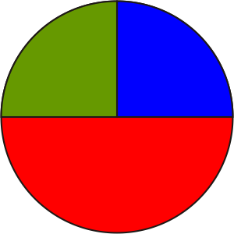 |  | Math Learning Goals  - Construct acute, obtuse, right, and reflex angles.  - Estimate angle sizes and measure with a protractor.  - Bisect angles using a variety of methods, e.g., protractor, compass, paper folding, Mira. |  | Materials  - compasses  - protractors  - Miras  - BLM 6.1.1, 6.1.2, 6.1.3
Assessment
Opportunities
 | Minds On… | Whole Class → Demonstration  Develop four different ways to describe a straight angle using the headings: mathematical characteristics, everyday examples, diagram, and explanation. (See BLM 6.1.1 for sample responses.)  Groups of 4 → Exploring Angles  Post eight pieces of chart paper around the room. In groups of four, students focus on a specific angle, i.e., acute, right, obtuse, and reflex. Each angle is done twice. They define the angle and show examples, using available resources, books, Internet, etc.  Facilitate a class discussion using prompts such as:  - How did each group classify the angle? (by its degree range)  - Which angle(s) seems most common in the everyday world?  - Reflect on and explain why. (responses will vary) |  | Alternatively, use the Frayer model (BLM 5.1.1).  It is important that all four angles are represented.  Word Wall  - bisect  - acute angle  - obtuse angle  - right angle  - reflex angle  - estimate  Lesson may vary depending on what protractors are available (360° or 180°).  Copy protractors on overhead acetates and cut up for Home Activity.
 | Action! | Groups of 4 → Practice  Students complete Part A (BLM 6.1.2) and reflect after each measurement:  - Do we need to revise our estimates?  - Are our estimates within 10º?  Whole Class → Demonstration  Demonstrate how to bisect using a Mira, a compass, paper folding, and a protractor and mark equal angles using proper notation. Students complete each bisection, marking equal angles on BLM 6.1.2, Part B.  Individual → Reflection  Students reflect, using guiding questions:  - What happened to the original angle? (bisected)  - What does bisect mean? (divides angle into two equal parts)  - How does this method compare to the others, i.e., compass, Mira, paper folding, and protractor? (responses will vary)
 | Consolidate Debrief | Individual → Practice: Bisecting Angles  Students complete BLM 6.1.3, Part C.  Ask:  - What do you notice about the two new angles created after bisecting the original angle? (They are equal.)  - What conclusions can you draw? (Bisecting an angle divides it into two new equal angles.)  Curriculum Expectations/Observation/Mental Note: Assess students’ ability to bisect angles using at least two methods.  Demonstrate paper folding using a prepared angle on a piece of paper.
Practice |  | Home Activity or Further Classroom Consolidation  Using a protractor, a compass, and paper folding, complete the worksheet 6.1.3.

6.1.1: Straight Angles (Teacher)

Angle Type: Straight

Mathematical Characteristics  Angle is composed of two rays that meet at a common end point (vertex). The straight angle always measures 180º. | Everyday Example  Cereal Box  ∠MNO = 180°
Diagram  ∠KJL = 180° | Explanation  A straight angle is 180º. It lies on any point along a straight line segment. Therefore any straight line has a straight angle.

6.1.2: Estimating, Measuring, and Marking Angles

Part A
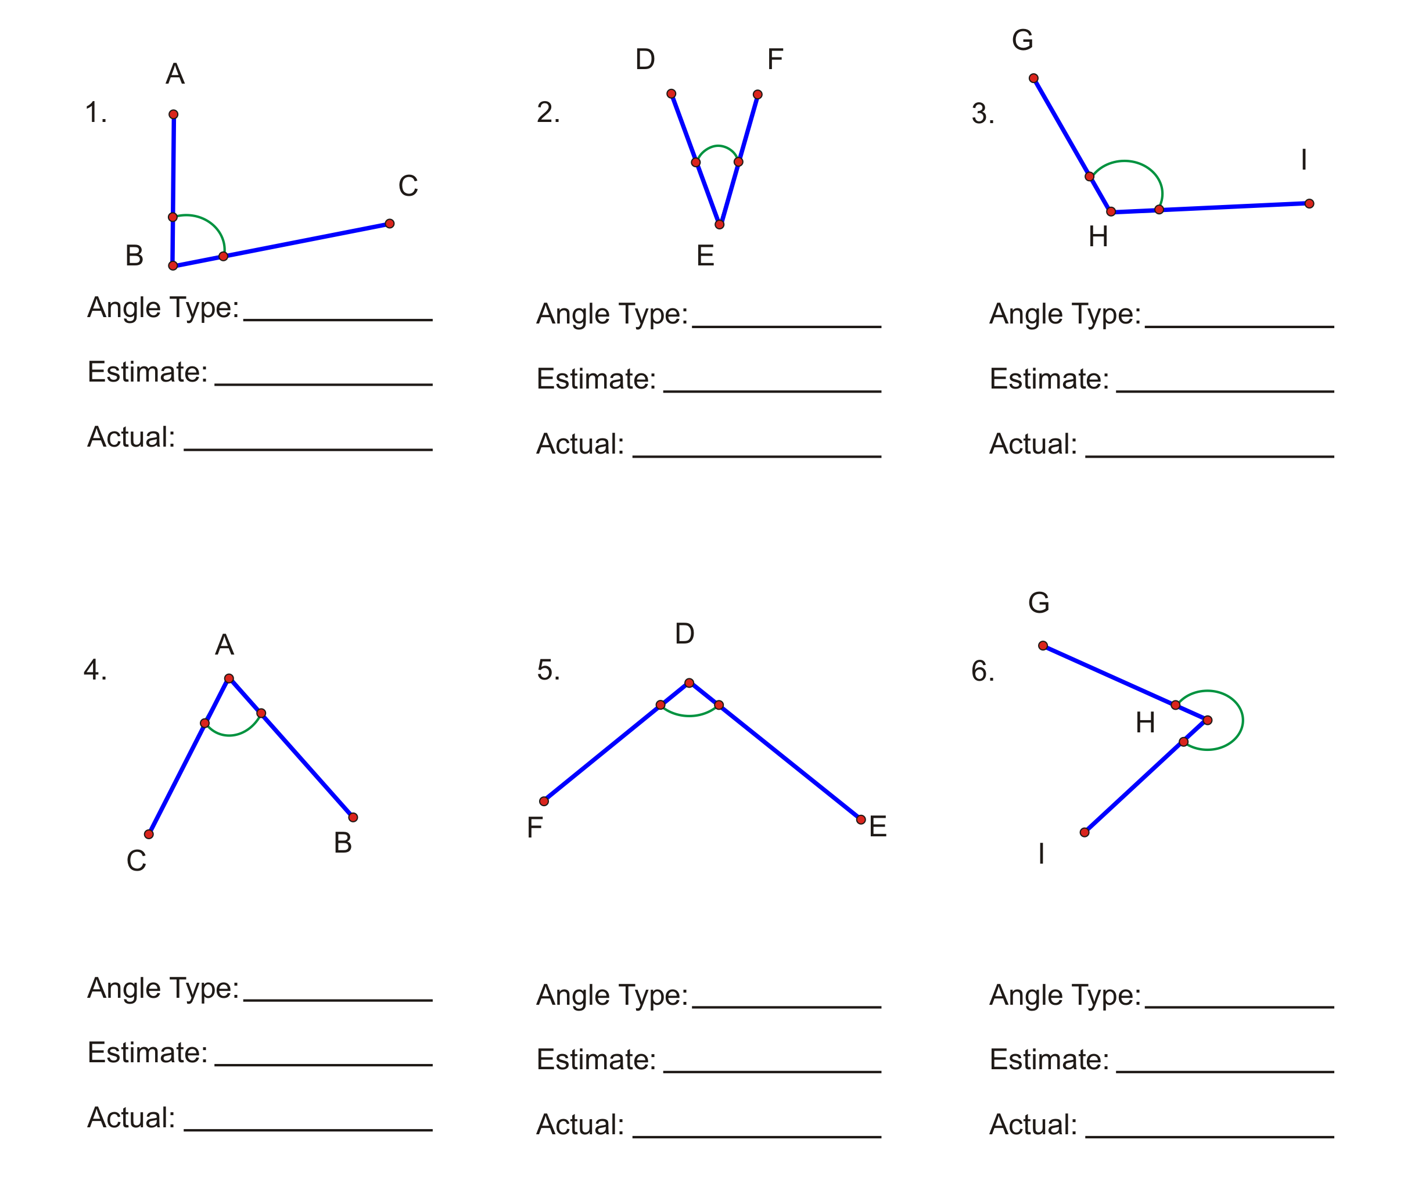

Part B
Bisecting Angles
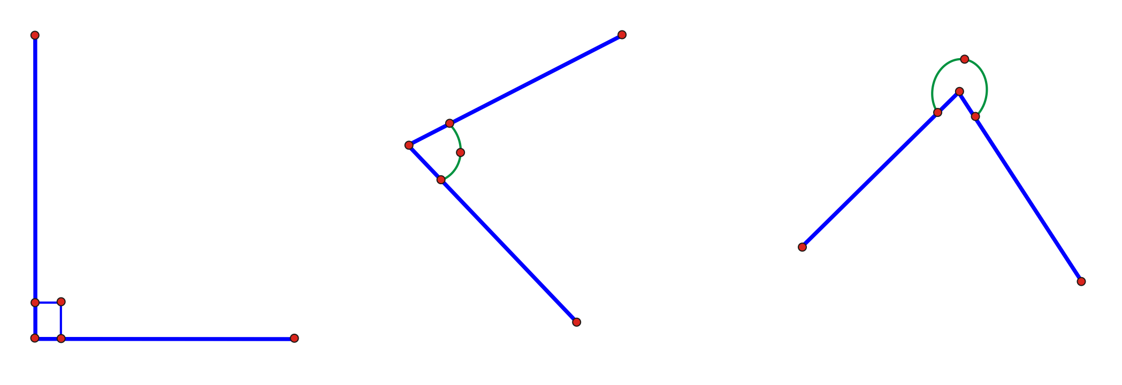

Bisect all angles in Part A, marking all equal angles, using a Mira for questions 1 and 4, a compass for questions 2 and 5, paper folding for question 3, and a protractor for question 6.
6.1.3: Bisecting Angles

Part A
Use a compass to bisect and measure the following angles. Mark equal angles.
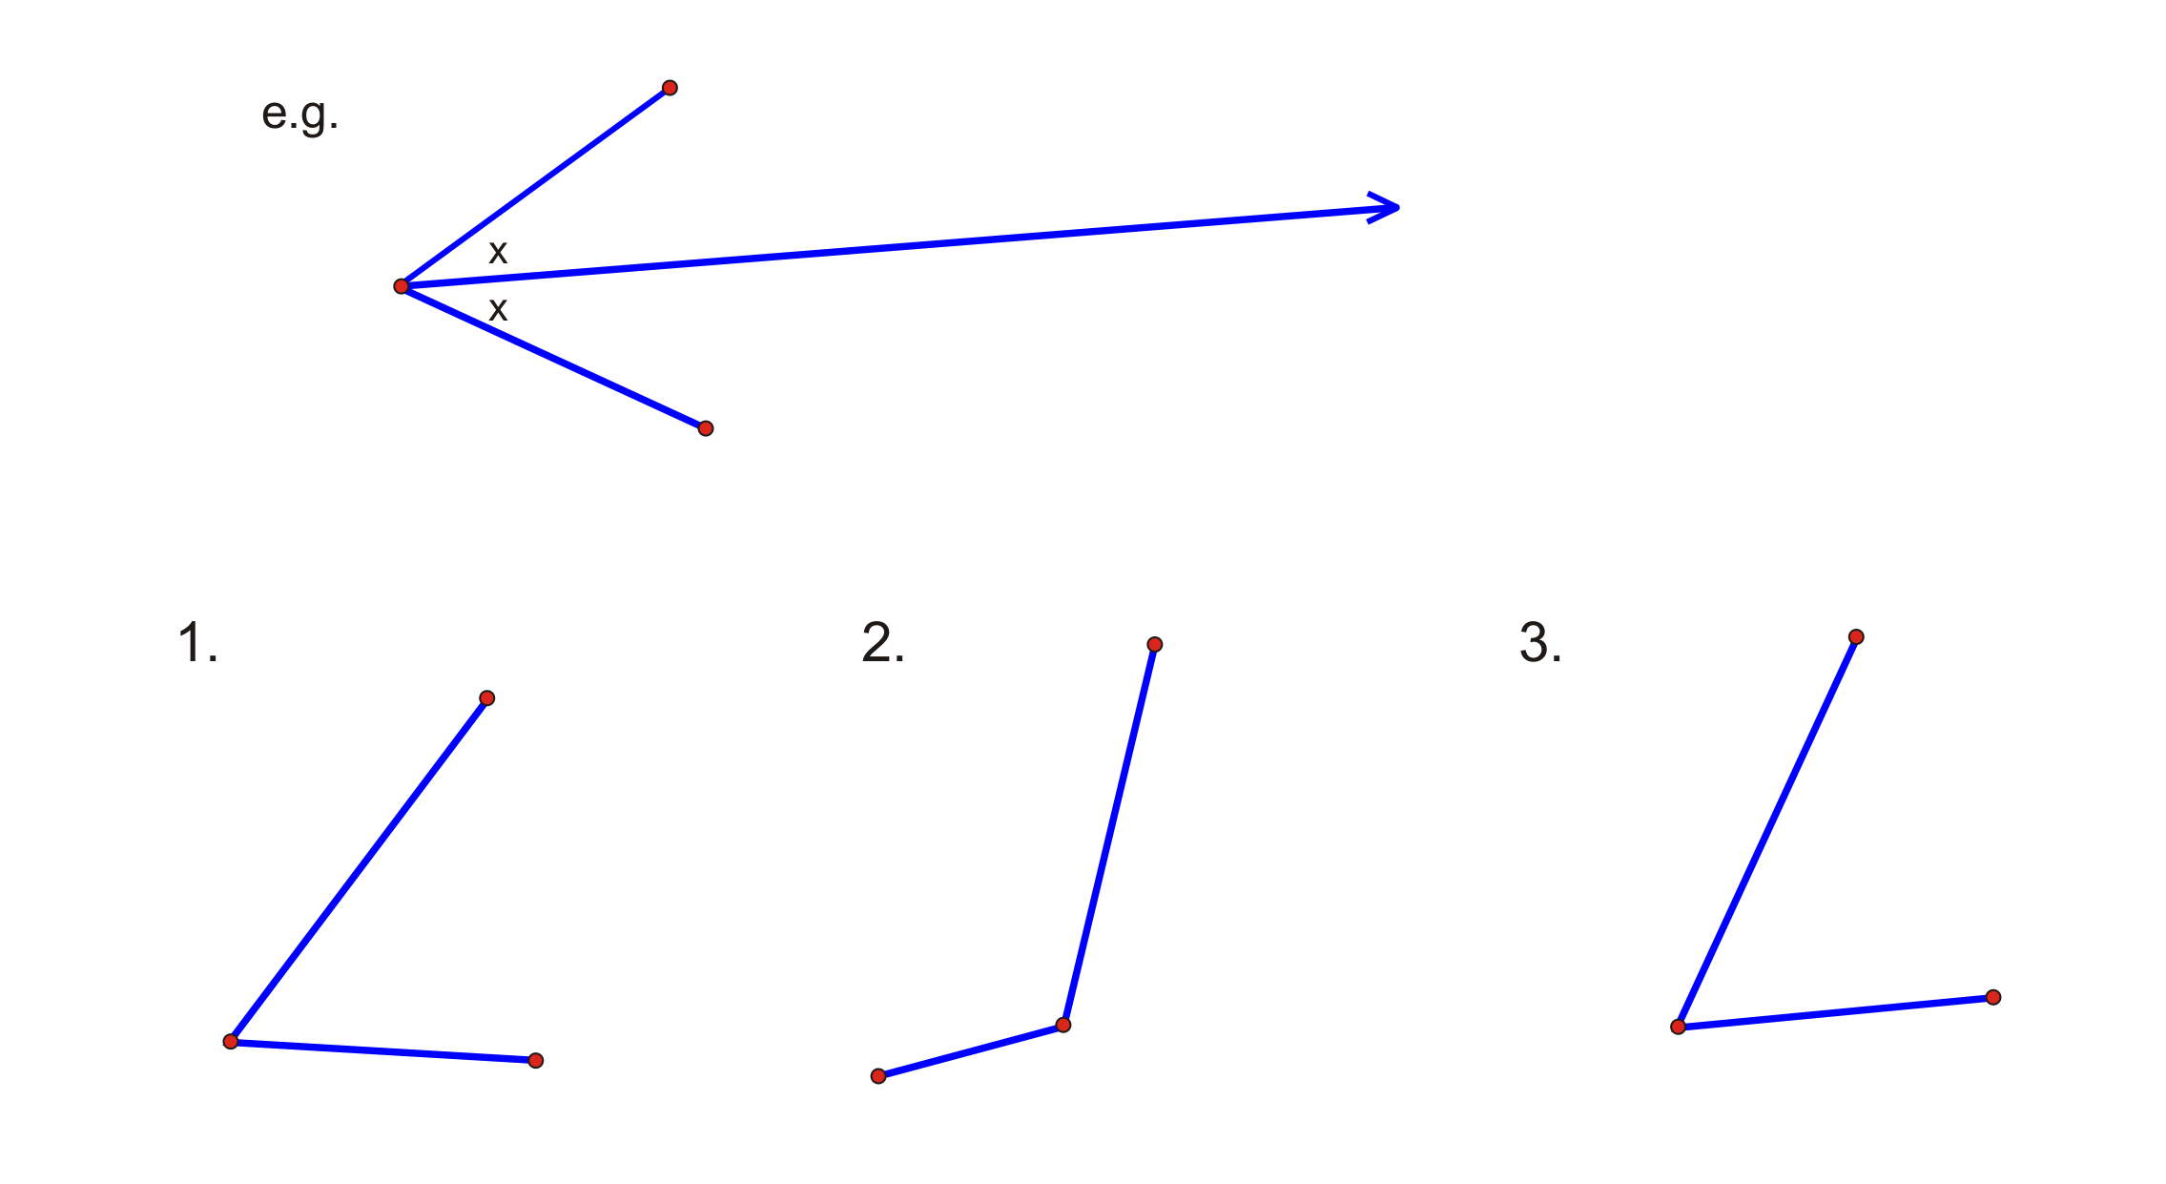

Part B
Use a protractor to bisect and measure the following angles. Mark equal angles.
1. | 2. | 3.
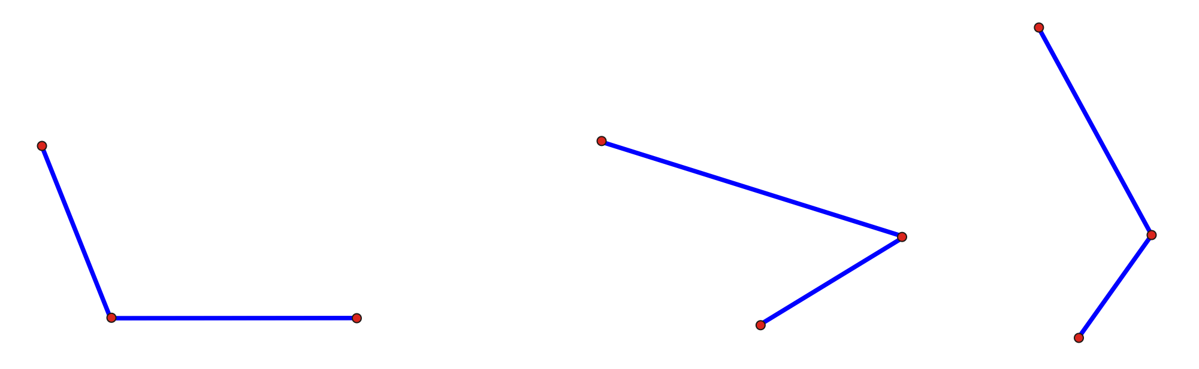

Part C
On the back of this sheet draw 3 different types of angles and bisect by folding paper. Mark equal angles.

Unit 6: Day 2: Investigating and Classifying Triangles |  |  |  | Grade 7
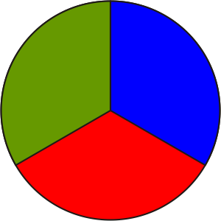 |  | Math Learning Goals  - Classify triangles by their sides and angles (scalene, isosceles, equilateral, acute, obtuse, right).  - Investigate triangle properties (e.g., the largest angle in a triangle lies across from the longest side).  - Classify triangles by the number of lines of symmetry they possess. |  | Materials  - geoboards  - straws  - paper strips  - protractor  - BLM 6.2.1
Assessment
Opportunities
 | Minds On… | Pairs → Word and Picture Sort  Students sort the set of cards into categories and explain their reasoning and criteria for the sort. Students then sort the cards in a different way, using different criteria (BLM 6.2.1).  Whole Class → Discussion  Discuss lines of symmetry and how this relates to the type of triangle. |  | Focus the students’ attention on what proving, reasoning, reflecting, and communicating “looks like” and “sounds like.”  Record types of triangles on Word Wall.
 | Action! | Pairs → Investigation  Students create a variety of triangles to determine the relationship between length of sides and angle sizes. Students can use geoboards, straws, paper strips, or  GSP®4 to help them investigate the relationship.  Focus the students’ attention on looking for the relationship between side length and opposite angle sizes: What relationship can you find between the length of the sides in a triangle and the size of the opposite angle?  Students sketch a triangle, measuring and recording the size of each angle and the length of each side. They create enough triangles to notice a relationship and record their observations, e.g., the largest angle lies across from the longest side; the smallest angle lies across from the smallest side; if two angles are equal, then the two opposite sides are equal. Circulate, taking note of which students to ask to share in the whole-class discussion.  Reasoning and Proving/Oral Questions/Checklist: Assess students’ ability to determine triangle properties through investigation.
 | Consolidate Debrief | Whole Class → Discussion  Students choose a triangle to share with the class and cut it out for posting. One student shares a sample triangle, then another student shares a different type of triangle. Continue until there are enough samples to discuss the relationship.  Post their samples in categories (scalene; equilateral; isosceles; obtuse; right; 1, 2, 3 lines of symmetry). Discuss and record the relationships students discovered. Connect to lines of symmetry as well.
Reflection |  | Home Activity or Further Classroom Consolidation  - Write a journal report about discoveries you made about the relationship between the length of the sides in a triangle and the size of the opposite angle. Illustrate your report with diagrams.  - Find pictures of quadrilaterals used in daily life and bring them to class. |  | Collect and assess students’ journal entries.

6.2.1: Classifying Triangles Word Sort

Cut apart and place the set of cards in an envelope. Make sufficient copies for students to work in pairs.
 | 1 line of symmetry | Equilateral triangle
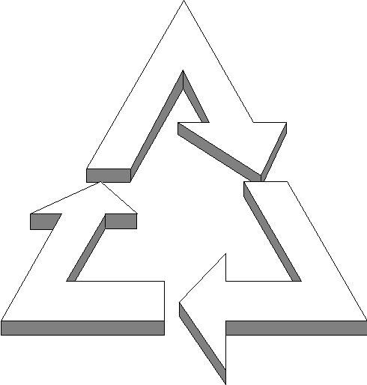 | All three angles are equal |  | Obtuse-angled triangle
All three angles are acute | Right-angled triangle | 3 lines of symmetry | 
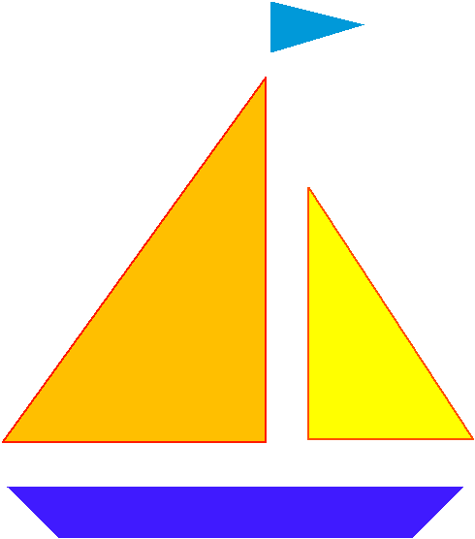 | Two sides are equal | Isosceles triangle | Three sides  are equal
Acute-angled triangle | Two angles  are acute |  | 0 lines of symmetry
Scalene triangle |  |  | 1 angle  is obtuse

Unit 6: Day 3: Building and Classifying Quadrilaterals |  |  |  | Grade 7
 |  | Math Learning Goals  - Classify and name quadrilaterals and illustrate their characteristics.  - Classify quadrilaterals based on geometric properties, e.g., symmetry, number of equal sides, number of equal angles.... |  | Materials  - pattern blocks  - BLM 6.3.1
Assessment
Opportunities
 | Minds On… | Whole Class → Demonstration and Sharing  Connect the concepts studied about triangles (Day 2) to quadrilaterals, using regular-shaped pattern blocks. Place two triangles together to form a quadrilateral. Students join various pattern block shapes to create their own quadrilaterals.  Share images students brought in, depicting various places that quadrilaterals occur, e.g., road signs, paper, cereal boxes, labels.  Individual → Anticipation Guide  Students complete the Before column on the Anticipation Guide (BLM 6.3.1).  Curriculum Expectations/Observation/Mental Note: Assess students’ prior knowledge of characteristics of quadrilaterals. |  | If pattern blocks are unavailable, students can use geometric shapes on coloured construction paper.  Word Wall  - quadrilaterals  - lines of symmetry  - interior angles
 | Action! | Groups of 4 → Guided Investigation  Students create as many different types of quadrilaterals as they can with pattern blocks. They draw sketches and note:  - the number of lines of symmetry;  - sum of interior angles;  - side lengths.  To reinforce students’ understanding of the characteristics of quadrilaterals, ask them to share their sketches and post these examples under lines of symmetry, sum of interior angles, and length of sides.  Name the quadrilaterals, e.g., square, rectangle, trapezoid, rhombus.
 | Consolidate Debrief | Individual → Anticipation Guide  Students complete the After column and compare it to the Before column on their anticipation guide. Discuss the answers.
Application  Concept Practice  Reflection |  | Home Activity or Further Classroom Consolidation  Choose one of the quadrilaterals used in class. Apply what you know about “similarity” to this situation by drawing a small, medium, and large example. Explain how the characteristics apply regardless of the size of the quadrilateral.

6.3.1: Anticipation Guide

Name:
Date:

 | Before | Statement | After
1. | Agree/Disagree | The sum of all interior angles in a quadrilateral is equal to 360 degrees. | Agree/Disagree
2. | Agree/Disagree | In a quadrilateral there is a relationship between the number of lines of symmetry and the number of pairs of equal sides. | Agree/Disagree
3. | Agree/Disagree | In a quadrilateral the number of equal sides is always related to the number of equal angles. | Agree/Disagree

Name:
Date:

 | Before | Statement | After
1. | Agree/Disagree | The sum of all interior angles in a quadrilateral is equal to 360 degrees. | Agree/Disagree
2. | Agree/Disagree | In a quadrilateral there is a relationship between the number of lines of symmetry and the number of pairs of equal sides. | Agree/Disagree
3. | Agree/Disagree | In a quadrilateral the number of equal sides is always related to the number of equal angles. | Agree/Disagree

Unit 6: Day 4: Investigating Polygon and Quadrilateral Properties |  |  |  | Grade 7
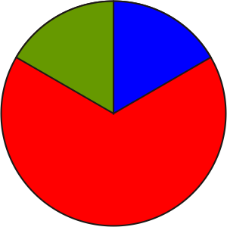 |  | Math Learning Goals  - Investigate the relationship between the number of sides in a regular polygon and the number of lines of symmetry it possesses.  - Investigate the relationship in a quadrilateral between the number of lines of symmetry and if it has 180° or 90° rotational symmetry. |  | Materials  - BLM 6.4.1, 6.4.2  - overhead pattern blocks  - construction paper  - scissors  - fastener pins
Assessment
Opportunities
 | Minds On… | Whole Class → Discussion  Using an overhead and overhead pattern blocks demonstrate rotational symmetry. Ask:  - How many degrees are in a full rotation? (360º)  - How many degrees are in a quarter rotation? (360 ÷ 4 = 90°)  - How many degrees are in an eighth of a rotation?  Pairs → Investigation  Begin with two congruent squares. Ask: If I rotate one square on top of the other square, how many times would the squares match in one full rotation? (4)  Students repeat this process with a regular triangle and a regular hexagon using pattern blocks.  Relate rotational symmetry to degrees, fractions, and time, e.g., a quarter of an hour is 15 minutes, which is a 90º rotation of the minute hand. It is also called a quarter turn.  Students work with a partner to find the number of lines of symmetry in a square, a regular triangle, and a regular hexagon (BLM 6.4.1). They consider how the lines of symmetry relate to rotational symmetry. |  | Their timer should indicate when a full rotation has occurred (one hour).  Provide students with a variety of materials to create their timer: construction paper, scissors, fastener pins, etc.  Remind students to use pictures, words, numbers, and terminology when responding.
 | Action! | Groups of 3 → Representing/Modelling  Students create a design for three different timing devices involving rotational symmetry and quadrilaterals – a 15-minute timer (90º rotational symmetry), a  30-minute timer (180º rotational symmetry), and a 60-minute timer (360º rotational symmetry). When the quadrilaterals rotate and match, the timer goes off (BLM 6.4.2).  Reflecting/Demonstration/Checklist: Assess students’ ability to make conclusions from the results of a task.
 | Consolidate Debrief | Whole Class → Discussion  Pose questions to guide the discussion:  - What shapes did you use for a 15-minute timer, for a 30-minute timer, for a  60-minute timer?  - How did you use lines of symmetry to help you choose the quadrilaterals?  Discuss the responses to BLM 6.4.2 to reinforce students’ understanding of the relationship between lines of symmetry and rotational symmetry.
Application  Exploration  Practice |  | Home Activity or Further Classroom Consolidation  Choose a regular polygon other than a quadrilateral and answer the following question:  If you were to create a timer using another regular polygon, how long would students be able to stay on the computer? Include the timer’s rotational symmetry and the lines of symmetry. |  | Students refer to their work on  BLM 6.4.2.

6.4.1: Lines of Symmetry and Rotational Symmetry

Number of Lines of Symmetry: ______  How many times do the shapes match in one full rotation?  Rotational Symmetry: ____° | Number of Lines of Symmetry: ______  How many times do the shapes match in one full rotation?  Rotational Symmetry: ____° | Number of Lines of Symmetry: ______  How many times do the shapes match in one full rotation?  Rotational Symmetry: ____°

Number of Lines of Symmetry: ______  How many times do the shapes match in one full rotation?  Rotational Symmetry: ____° | Number of Lines of Symmetry: ______  How many times do the shapes match in one full rotation?  Rotational Symmetry: ____° | Number of Lines of Symmetry: ______  How many times do the shapes match in one full rotation?  Rotational Symmetry: ____°
6.4.2: Who’s On the Computer?

Your task is to develop a system to make sure each student has equal opportunity and time to use the computers.

Use three different quadrilaterals to develop a system based on rotational symmetry for
15-minute (square: 90° rotation), 30-minute (rectangle: 180°), and 60-minute (360°) activities.

Type of Quadrilateral | Lines of Symmetry | Rotational Symmetry (Degrees)

Questions for Reflection:

1. Is there a relationship between the number of lines of symmetry and degrees of rotational symmetry? Explain your reasoning.

2. Describe other quadrilaterals that you did not experiment with that might be used for the
15-minute, 30-minute, or 60-minute activities? Explain how they can be used.

Unit 6: Day 5: Constructing Related Lines |  | Grade 7
 | Math Learning Goals  - Student will construct lines that intersect at 30°, 45°, and 60° using a variety of tools and strategies. | Materials  - BLM 6.5.1  - BLM 6.5.2  - BLM 6.5.3  - Class set of compasses (or one per pair)  - Pencil  - Class set of protractors  - Rulers
Pairs | Pairs → Think/ Pair /Share  Each student will receive a copy of BLM 6.5.1. They will individually attempt to match the drawn angles with the angle measures. When they are finished, they will compare with their partner to discuss and resolve any discrepancies.  Teacher can ask for strategies from the entire class.  Sample Question: “How did you decide that that angle was 89°”?
Minds On…
 | Pairs → Investigation  Each student should receive a copy of BLM 6.5.2 and BLM 6.5.3 as well as a compass (for each pair at least). Students can work together but should be filling in their own copies of BLM 6.5.3.  The activity involves the students making constructions with a pencil and a compass. They will be constructing angles of 30°, 45°, 60°, and 90° without the use of a protractor.  At the end of each angle construction, they can measure them with a protractor to ensure validity. | Teacher Tip:  Time permitting, you may wish to ask students to draw 30, 45, 60 and 90-degree angles using only a ruler. Then they can measure their attempts with a protractor to see how close they came.
Action!
Individual → Reflective Journal Entry
Ask students to write a journal entry, detailing what they did today. Prompt them with specific questions like:

1. What does it mean to be a bisector?
2. Why do you think that today’s methods worked?
3. Do you think you could bisect any angle now if you were given a compass and ruler?

Consolidate Debrief
Practice | Home Activity or Further Classroom Consolidation  Only one thing to do. This could be used as an exit pass.  Have students attempt to bisect a 45° angle. They can either redraw one using the techniques from the ‘Action!’ section or if time is limited, they can use the protractor to draw a 45° angle and then bisect it using only the compass and a ruler.

6.5.1: Constructing Related Lines Grade 7

The following angle measures are the measurements of one of the drawn angles on this page. Write down the proper measurement below the picture of the angle. Be prepared to defend your choices to your partner and to your teacher! Note that not all angles drawn are the inner angles, unless shown otherwise.
80° 350° 10° 185° 255° 46° 89° 95°

________________
________________
________________
________________
________________
________________
________________
________________

6.5.2: Constructing Related Lines Grade 7
Construct a 60˚ angle, and then construct an angle bisector to obtain a 30˚ angle.
The figure shows a point B on a straight line. The ultimate goal is to construct an angle of 30 ˚ at point B.
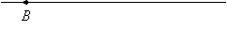
Step 1: Stretch the compass to any width. Put the sharp end of the compass at point B and draw an arc on the line. Label the point where the arc intersects the line as point C.
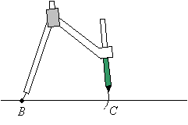
Step 2: While keeping the sharp end of the compass at point B, move the compass away from C and draw a second arc above the line about mid-way between points B and C.
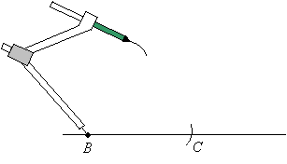
Step 3: Without changing the width of the compass, place the sharp end of the compass at point C and draw an arc to intersect the second arc.
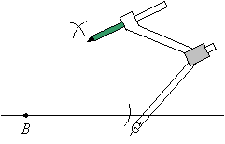
Step 4: Draw a line from point B to the point of intersection of the 2 arcs. Angle ABC is 60˚. Measure it to check.
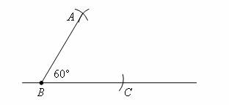
Step 5: We now need to Bisect angle ABC. Put the sharp end of your compass at point B and make one arc on the line BC (point S) and another arc on line AB (point T).
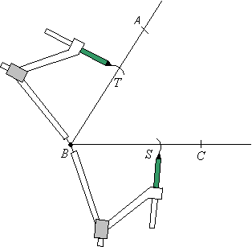

Step 6: Without changing the width of your compass, put the sharp end of the compass at S and make an arc within the lines AB and BC. Do the same at T and make sure that the second arc intersects the first arc.
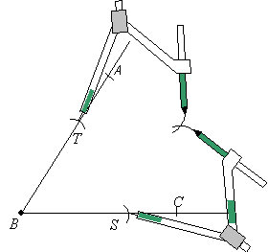

Step 7: Draw a line from point B to the points of intersection of the 2 arcs. This line MB bisects . Angle MBC is 30 degrees.
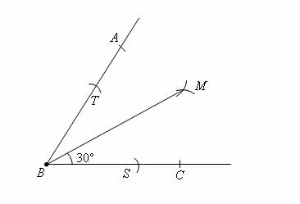

6.5.2: Constructing Related Lines Grade 7
Construct a 90˚ angle, and then construct an angle bisector to obtain a 45˚ angle.
Step 1: Stretch your compass until it is more then half the length of AB. Put the sharp end at A and mark an arc above and another arc below line segment AB.
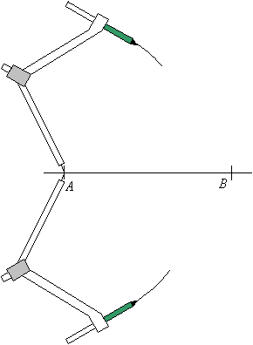

Step 2: Without changing the width of the compass, put the sharp end at B and mark arcs above & below the line segment AB that will intersect with the arcs drawn in step 1.
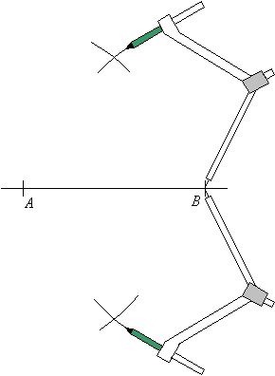

Step 3: Join the two points where the arcs intersect with a straight line. This line is the perpendicular bisector of AB. P is the midpoint of AB.
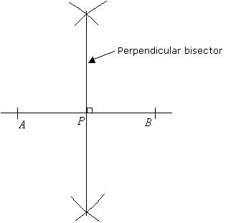

Step 4: Bisect (just like you did with the 60° angle earlier) the 90 degree angle to form a 45 degree angle.
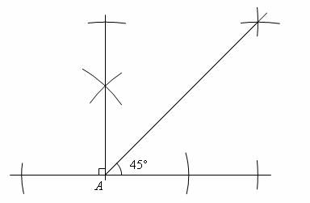

6.5.3: Graph Paper for Construction Grade 7

 | Unit 6: Day 6: Investigating Perpendicular Bisectors and Angle Bisectors |  |  |  |  |  |  |  |  |  |  |  |  |  |  |  |  |  |  |  |  |  |  |  | Grade 7
 | 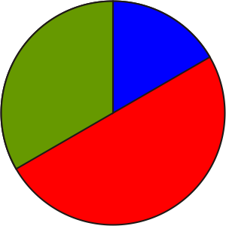 |  |  |  |  | Math Learning Goals  - Construct perpendiculars and the perpendicular bisector of a line using a variety of tools and strategies.  - Use appropriate symbols to mark 90° angles and equal line segments.  - Investigate perpendicular bisectors and angle bisectors of triangles. |  |  |  |  |  |  |  |  |  |  |  |  |  |  |  |  |  |  | Materials  - board compass  - protractor  - board protractor  - Mira  - BLM 6.6.1
Assessment
Opportunities
 |  | Minds On… |  |  |  | Whole Class → Guided Investigation  Guide students through a series of investigations to help them understand that there are similarities and differences between a perpendicular line and perpendicular bisectors (BLM 6.6.1).  Curriculum Expectation/Mental Note: Observe students’ understanding of perpendicular lines and bisectors. |  |  |  |  |  |  |  |  |  |  |  |  |  |  |  |  |  |  | A perpendicular line is not necessarily a perpendicular bisector.  Word Wall  - perpendicular lines  - bisector  - perpendicular bisector
 |  | Action! |  |  |  | Groups of 3 → Investigation  Use a cut-out sample of a triangle to demonstrate how to find the perpendicular bisector of one of the sides of a triangle.  Problem to Investigate  What are the special properties of the perpendicular bisectors of the 3 sides of a triangle?  Students investigate what happens when they draw the perpendicular bisector for all three sides of an isosceles triangle and individually record what they notice, including a description, a diagram, and characteristics. They repeat this investigation with scalene and equilateral triangles to determine if other triangles have the same properties.  Individual → Investigation  Problem to Investigate  What are the special properties of the 3 angle bisectors of a triangle?  Students investigate what happens when the angles of an isosceles, an equilateral, and a scalene triangle are bisected, and record their findings.  Problem Solving/Observation/Anecdotal Note: Assess how students apply the problem-solving process during the investigation.
 |  | Consolidate Debrief |  |  |  | Whole Class → Discussion  Record students’ findings on an overhead under Description, Diagram, and Characteristics. Students add to and edit what they have included.
 | Exploration  Practice |  |  |  |  | Home Activity or Further Classroom Consolidation  Write a journal entry to describe what you learned about perpendicular bisectors and line bisectors.

6.6.1: Investigating Perpendicular Bisector and
Angle Bisectors (Teacher)

Part A: Perpendicular to a Line
1. Review the meaning of perpendicular lines.
2. Ask what tools they could use to create a perpendicular to a line segment. (Mira, paper folding, protractor, etc.)
3. Students draw a line segment using a pencil and ruler and create a perpendicular line segment by folding paper.
4. Demonstrate how to check if the line segment is perpendicular? (Use the corner of a ruler, the corner of a book, a protractor.)
5. Ask: Is there another line perpendicular to this line segment? Demonstrate another perpendicular.
6. Students find other perpendiculars to their line segment by paper folding, using a Mira, or using a protractor.
7. Ask:
- What is the relationship between these perpendicular lines? (They are parallel.)
- What kinds of angles are created when a perpendicular line segment is created?
8. Mark it on the sample on the board.
9. Students mark these on their own diagram.
10. Ask: Does the perpendicular always cut the line in half? (No, it just creates a 90° angle.)
11. Demonstrate using folding and using a board protractor.

Part B: Perpendicular Bisector
1. Ask:
- What does it mean when we bisect a line segment or an angle?
- How can we create a perpendicular bisector of a line segment? (folding, using a ruler, using a protractor, etc.)
2. Students, draw another line segment and create a perpendicular bisector, using paper folding.
3. Ask:
- How many perpendicular bisectors can you create for any given line segment?
- How do you know?
- How is this different from creating perpendicular lines?
4. Demonstrate how to mark 90° and equal line segments.
5. Students mark the 90° and equal line segments on their line.

Part C: Finding the Perpendicular Bisector Using a Compass
Demonstrate how to find the perpendicular bisector with a compass as an alternative way to find a perpendicular bisector.

Unit 6: Day 7: Investigating Parallel Lines |  |  |  | Grade 7
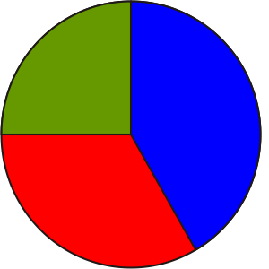 |  | Math Learning Goals  - Construct parallel lines using a variety of tools.  - Determine angle properties created by parallel lines.  - Use angle properties to construct parallel lines.  - Investigate angles in a parallelogram. |  | Materials  - sticky notes (two colours)  - geoboards  - compasses  - protractors  - blank paper
Assessment
Opportunities
 | Minds On… | Whole Class → Review  Provide students with two different-coloured sticky notes. Post the following statements in columns:  - Perpendicular bisectors meet inside triangles: (1st colour)  - all the time  - sometimes  - never  - Angle bisectors meet inside the triangle: (2nd colour)  - all the time  - sometimes  - never  Students place the sticky note on the columns they deem as correct. Facilitate a whole-class discussion around student responses.  Whole Class → Demonstration  Using a board compass, demonstrate how to construct parallel lines using a compass and ruler. Discuss the properties of parallel lines used to do this construction. Construct a parallelogram.  Students practise constructing parallel lines. |  | Answer:  Perpendicular bisectors: sometimes (obtuse triangles do not meet inside triangles).  Angle bisector: all the time  These answers can be demonstrated using GSP®4 and a data projector.  Ask students how to ensure that the paper folding has created parallel lines. (Measure the distance between the lines at each end, perpendicularly, with a ruler.)  Students should discover angle relationships in F, Z and C patterns. The terminology corresponding, alternate and interior angles are Grade 8 expectations.
 | Action! | Pairs → Investigation  Students fold a blank paper to create two parallel lines, and then trace the lines with a ruler and pencil (make parallel lines approximately 10 cm apart). They then draw a diagonal line, called a transversal, that crosses the parallel lines at an angle (not 90º). Students measure and compare all angles and compile a list of all angle patterns they discover. They verify their results by making two parallel lines on a geoboard with a transversal and repeating their angle measurements.  Selecting Tools/Demonstration/Anecdotal Note: Assess students’ selection and use of tools to measure angles.
 | Consolidate Debrief | Whole Class → Discussion  Use a diagram of two parallel lines intersected by a transversal at 45º to initiate discussion. Discuss and record student findings.  Ask:  - What do you notice?  - How can this angle property (F pattern or Z pattern) be used to construct a third parallel line? (I know that the transversal cuts both parallel lines at 45°, so I could draw a third parallel line that intersects with the diagonal at 45°. This new line is now parallel to the original two parallel lines.)
Concept Practice |  | Home Activity or Further Classroom Consolidation  Construct parallelograms using pairs of parallel lines created by paper folding or by using a compass. Measure the interior angles of the parallelogram to determine any angle relationships that exist.  Verify findings by constructing another parallelogram with a different orientation and measuring its angles. Describe your findings in a journal entry. Include well-labelled diagrams. |  | Assess individual student reasoning and proving and communication from the written journal entries.

Unit 6: Day 8: Investigating Related Lines Using the Geometer’s Sketchpad |  |  | Grade 7
 | Math Learning Goals  - Students will create basic constructions using the Geometer’s Sketchpad 4 program  - Students will review skills using dynamic geometry software (midpoints, angle bisectors, perpendicular lines, parallel lines, perpendicular bisectors). |  | Materials  - Attached GSP file  gr7Unit6Lesson8.gsp  - Computer Lab with working printer is optimal
 | There is no ‘Minds On…’ section for this lesson as the entire lesson is a series of Geometer’s Sketchpad investigations to be done in the computer lab or a similar place where students can be working on a computer.
Minds On…
 | Individual/ Pairs (depending on computer availability) → Investigation  Students will work through the first 9 pages of a GSP file named  gr7Unit6Lesson8.gsp  to investigate basic constructions and skills of this piece of dynamic geometry software.  Throughout this activity, students will be constructing line segments, angles, triangles, parallel and perpendicular lines. The students will also have to measure lengths, angles, perimeters and areas. It is recommended that the teacher go through this file first before the class when the students are engaged. This way the teacher can circulate the computer lab and help students when needed. |  | Teacher Tip:  It is recommended that the teacher go through this file first, before the class.
Action!

Individual → Consolidation
Page 10 of the GSP file gives students a chance to practice what they learned on the previous 9 pages. At all times, students are able to go back to any of the pages to refresh memories and get the required help.
Consolidate Debrief
Application  Concept Practice  Differentiated | Home Activity or Further Classroom Consolidation  The last page (page 11) of the GSP file is a page that can be used as assessment. Students can work through the tasks and it is up to the teacher how to check the finished product – the teacher could simply have a checklist and walk around to each student and check off the tasks that the student successfully completed OR the teacher could have the students print the final page (page 11) when they feel that they have completed the task. |  |   Students are able to look back at the previous pages of the GSP for reminders on how to perform constructions, etc.
Unit 6: Day 9: Investigating Quadrilaterals Using the Geometer’s  Sketchpad |  |  |  | Grade 7
 |  | Math Learning Goals  - Students use the Geometer’s Sketchpad 4 to classify quadrilaterals based on their sides and angles  - Students make hypotheses related to triangles and quadrilaterals to investigate using appropriate tools and strategies |  | Materials  - Computer Lab with Geometer’s Sketchpad.  - GSP file quadrilaterals gr7Unit6Lesson9.gsp
 |  | Pairs → Think Pair Share  The first page of the GSP file is a ‘Minds On…’ activity in which the students need to classify a group of 12 quadrilaterals. First, they will need to classify them into 2 groups. The teacher can be circulating the class/lab and asking students how they decided to classify their quadrilaterals.  Students will then be asked to classify the 12 quadrilaterals into at least 4 different groups. Again teacher can be circulating asking questions: “Why did you decided to put those quadrilaterals together in a group”?  Possibilities for student responses are endless (e.g. “Because they all have a 90 degree angle in them”). |  |   Teacher can be circulating the class with a checklist .By asking questions, make note of students who are using correct terminology and who can communicate effectively.
Minds On…
 |  | Individual or Pairs (depending on computer availability) → Exploration  Students will continue working through pages 1 to 6 of the GSP file  quadrilaterals gr7Unit6Lesson9.gsp  This file has students measuring side lengths, angles and diagonal lengths of 6 different types of quadrilaterals (squares, rectangles, rhombuses, parallelograms, trapezoids, and kites). Students will explore and make conjectures about the properties of these 6 types of quadrilaterals. |  | Teacher Note:  Students and teachers should have some experience using GSP for this activity. The previous day’s lesson is a good place to get this experience.
Action!
 |  | Individual → Reflection  Students will have a journal entry/written response that needs to be recorded into their math workbooks or journals after each page of the 6-page activity above. Each entry will act as a consolidation for the properties of the six different types of quadrilaterals that they have explored in this lesson.  Time permitting; students may share some of their journal entries with their classmates. |  | Journal entries may be collected.  Depending on previous work done in the unit.
Consolidate Debrief
 |  | Home Activity or Further Classroom Consolidation

Unit 6: Day 10: Examining Geometric Properties, Using the  Coordinate System |  |  |  | Grade 7
 |  | Math Learning Goals  - Plot points on the coordinate plane in the first quadrant.  - Draw a triangle using ordered pairs in the first quadrant.  - Distinguish between similar shapes and congruent shapes. |  | Materials  - BLM 6.10.1  - overhead geoboard  - grid paper
Assessment
Opportunities
 | Minds On… | Whole Class/Pairs → Demonstration  Demonstrate on an overhead geoboard, as students work with a partner using a student geoboard, how to create a right-angled triangle using the ordered pairs (0,0), (0,4), and (4,0).  - Where would the midpoints be located on the sides of the triangles?  - Name the ordered pairs: (2,0), (2,2), (0,2).  - Using geoboards, join the midpoints.  Discuss the shape created by joining the midpoints.  What else do you notice? Some sample responses: (4 triangles created are congruent; creates 3 pairs of parallel sides; numerous equal angles; interior triangle sides are half the exterior side length; several similar triangles).  Reinforce concepts related to similarity, congruency, and proportional reasoning. |  | Note: Work in the first quadrant only.  Teacher labels scale on the sides of the geoboard to indicate the x-axis and the y-axis with (0,0) at the lower left corner.  Some students may benefit from a review of graphing with ordered pairs.  Students familiarize themselves with the Cartesian grid.
 | Action! | Pairs → Investigation  Students work with a partner to encourage mathematical talk. They draw the y-axis and the x-axis (first quadrant only) on their grid paper, and label the scale. They draw a triangle and determine the ordered pairs of the triangle’s vertices.  Students complete BLM 6.10.1.  Communicating/Observation/Mental Note: Assess students’ ability to correctly identify coordinate points in the first quadrant.
 | Consolidate Debrief | Think/Pair/Share → Discussion  Students take turns sharing their findings. Partner 1 states one finding and how he/she knows the finding is true. Partner 2 states a different finding and states how he/she knows the finding is true.  Continue the process back and forth so students can share some of their findings.  As a class record the overall findings on a two-column chart labelled Property and Proof, e.g., the line joining the midpoint of 2 sides of a triangle is parallel to the third side and I know this because I used a ruler to measure the perpendicular distance between the lines at either end.
Exploration  Practice |  | Home Activity or Further Classroom Consolidation  Repeat your investigation of the midpoints using a quadrilateral. Select four points on the coordinate system, determine the midpoints, and join the midpoints to create the interior quadrilateral. Describe the patterns that you find.

6.10.1: Triangle Investigation Using Grid Paper and Midpoints

1. Draw in the y-axis and the x-axis on your grid paper, and label the scale.

2. Draw a triangle.

3. Label the ordered pairs of the triangle’s vertices.

4. Find the midpoints of the sides of the triangle using a ruler or by paper folding. Join the midpoints to create an interior triangle.

5. Label the midpoint ordered pairs to the nearest tenth.

6. Investigate the new characteristics:
a) Mark parallel sides.

b) Mark equal angles.

c) Mark the lengths of the sides.

d) What relationship exists between the newly created triangles? How do you know?

7. Record all your findings.

Unit 6: Day 10: Examining Geometry Properties Using the Coordinate System (Alternate Lesson) |  | Grade 7
 | Math Learning Goals  - Students will plot points on the coordinate plane in the first quadrant  - Students will draw a triangle using ordered pairs in the first quadrant  - Students will distinguish between similar shapes and congruent shapes | Materials  - BLM 6.10.1  - BLM 6.10.2  - BLM 6.10.3  - BLM 6.10.4
Pairs → Think/Pair/Share
Students will work with a partner to try to locate key destinations at an amusement park. They will be given a map of an amusement park that has the first quadrant superimposed over it. Their goal is to describe to their partner the route that someone would take to reach various destinations. Each student should receive a copy of BLM 6.10.1 but only partner A should receive the instructions at the bottom of BLM 6.10.1.

Partner A will get some instructions in words and will attempt to describe the route taken by a person at the amusement park. Their descriptions cannot include mention of any of the words on the map (For example they could say: person starts at 1across, 2up, then moves right3 and down1, then the person moves to position 6across, 9up).
Partner B will trace out the route on their map. Once completed they can check the route and discuss.
Minds On…

Whole Class → Discussion
Welcome to the coordinate system. Teacher can take BLM 6.10.2 and put it on the overhead/SMART Board or something similar. Students will work through their versions of BLM 6.10.2 with teacher guidance. Ask the class for ideas on where each of the 6 objects is located. It is during this time that discrepancies can be discussed and justified. For example, students may not realize that we state the across position (x value) before the up position (y value); this can be clarified for the students here. Emphasize that places on the co-ordinated system are called POINTS and all points are labelled (x,y).

Pairs
Students will then continue working with a partner on BLM 6.10.3.
Action!
 | Whole Class → Sharing  Teacher should be circulating the room to see how students are progressing. Solutions can be shared with the class.  Students should be given the opportunity to explain their choices of classifying in BLM 6.10.3.  Eventually students should be introduced to the differences between Congruent Shapes and Similar Shapes. | Teacher Tip:  Students need to sort shapes. One pair of the triangles is similar, another pair is congruent, and the third is neither.
Consolidate Debrief
Application  Concept Practice  Differentiated  Reflection | Home Activity or Further Classroom Consolidation  Students will be given an exit pass within 5 minutes to the end of class. The exit pass is located in BLM 6.10.4  Collect the exit pass and glance through them to see if any misconceptions remain.

6.10.1 (Alternate): Examining Geometry Properties Grade 7

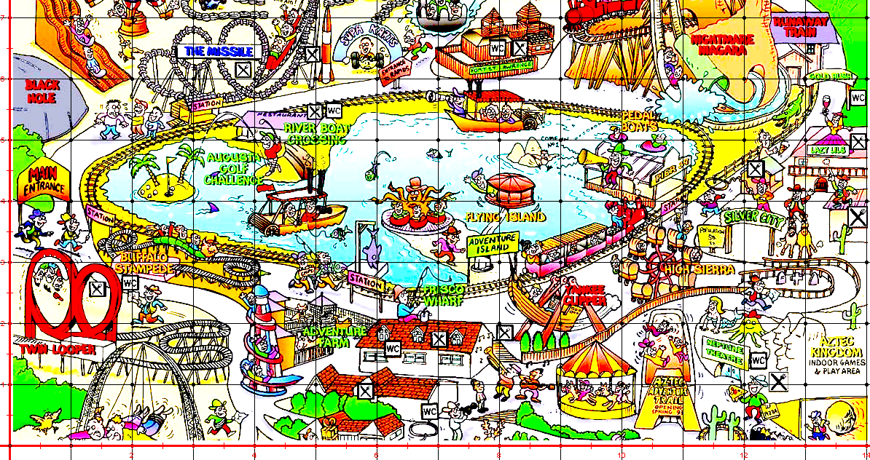
0 1 2 3 4 5 6 7 8 9 10 11 12 13 14
7
6
5
4
3
2
1
0

Only one partner should receive these instructions.

Partner A: It is your job to describe to your partner where Joe walked. You are not allowed to use any of the words from the map – only the numbers on the side and bottom of the map. For example, you can say that Joe started at 10across and 1up, but you cannot say that he started at the merry-go-round. Good luck.

Joe’s Walk
Joe starts at the Flying Island.
Next he goes to The Missile.
Next he goes to the Buffalo Stampede.
Lastly he goes to Runaway Train.

6.10.2 (Alternate): Examining Geometry Properties Grade 7

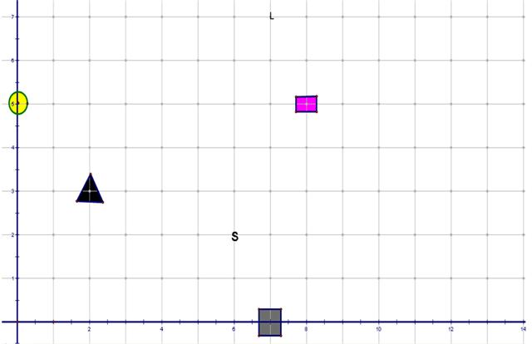

Provide coordinates to describe where the following objects located.

- Triangle ______________________________________

- Square _______________________________________

3. S _________________________________________

4. Rectangle _____________________________________

5. L __________________________________________

- Circle ________________________________________

6.10.3 (Alternate): Examining Geometry Properties Grade 7

Take the following directions and draw some shapes on the coordinate graph paper that follows.
For each of the coordinate positions below, place a dot. After you have placed the dots, connect the dots for each object with a straight line. To begin, you will have to put a scale on the y-axis.

Object A (2, 11), (5, 11), (2, 15)

Object B (5, 7), (7, 7), (7, 5)

Object C (9, 5), (9, 2), (10, 5)

Object D (14, 13), (16, 13), (16, 15)

Object E (14, 8), (20, 8), (20, 0)

Object F (20, 11), (22, 10), (22, 16)

Once you have drawn each object, pair them up based on their similarities to one another. You must state a reason of your choice. For example, you might think that Object A and E should be paired up because they are both right-angled triangles. Only two objects can be grouped together with a reason.

Objects Grouped Together | Reason

Define the following Terms:

Congruent Shapes _____________________________________________________

______________________________________________________________________

Similar Shapes ________________________________________________________

______________________________________________________________________

6.10.3 (Alternate): Examining Geometry Properties Grade 7

Co-ordinate System Graph Paper
y

x
0 1 2 3 4 5 6 7 8 9 10 11 12 13 14 15 16 17 18 19 20

6.10.4 (Alternate): Examining Geometry Properties Grade 7

Exit Pass Name ____________________________________

Graph the following triangles and state whether they are congruent, similar, or neither.

Triangle 1 (0, 4), (1, 4), (1, 1)

Triangle 2 (4, 9), (4, 0), (6, 0)

Similar Congruent Neither

Reason:

