Unit 5 Grade 7
Solving Equations

Lesson Outline

BIG PICTURE

Students will:
- model linear relationships verbally, numerically, algebraically and graphically;
- understand the concept of a variable;
- solve simple algebraic equations using inspection, guess and check, concrete materials, and calculators.
Day | Lesson Title | Math Learning Goals | Expectations
1 | Using Variables in Expressions | - Use a variable to generalize a pattern.  - Write algebraic expressions to describe number patterns.  - Evaluate algebraic expressions by substituting a value into the expression. | 7m23, 7m60, 7m61, 7m62, 7m65, 7m66, 7m67, 7m68,  CGE 4b, 4c
2 | Models of Linear Relationships | - Given concrete models of linear growing patterns, create verbal, numerical, graphical, and algebraic models.  - Investigate why some relationships are described as “linear.” | 7m60, 7m62, 7m63, 7m67  CGE 3c, 4b
3 | Evaluating Algebraic Expressions with Substitution | - Substitute numbers into variable expressions.  - Evaluate algebraic expressions by substituting a value into the expression.  - Make connections between evaluating algebraic expressions and finding the n^{th} term of a pattern. | 7m23, 7m60, 7m61, 7m62, 7m63, 7m68  CGE 3c, 4b
4 | Modelling Linear Relationships | - Model relationships that have constant rates, where the initial condition is zero.  - Illustrate linear relationships graphically and algebraically. | 7m23, 7m60, 7m61, 7m62, 7m64, 7m65, 7m67  CGE 5a
5 | Solving Equations  GSP®4 file:  Solving Equations by Guess and Check | - Solve equations, using inspection and guess and check, with and without technology. | 7m23, 7m67, 7m69  CGE 3c, 5b
6 | Translating Words into Simple Equations | - Represent algebraic expressions with concrete materials and with algebraic symbols.  - Use correct algebraic terminology.  - Translate between algebraic expressions and equations and the statement in words.  - Solve equations | 7m23, 7m64, 7m65, 7m66, 7m69  CGE 2c, 2d
7 | Assessment Activity | Include questions to incorporate the expectations included in this unit.

Unit 5: Day 1: Using Variables in Expressions |  |  |  | Grade 7
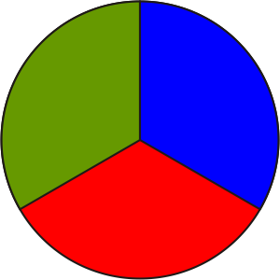 |  | Math Learning Goals  - Use a variable to generalize a pattern.  - Write algebraic expressions to describe number patterns.  - Evaluate algebraic expressions by substituting a value into the expression. |  | Materials  - BLM 5.1.1, 5.1.2, 5.1.3
Assessment
Opportunities
 | Minds On… | Small Groups → Brainstorm/Investigation  Groups complete a Frayer model to learn about different terms: variable, constant, expression, pattern, using various resources, e.g., texts, glossaries, dictionaries, Word Walls, Internet (BLM 5.1.1).  Each group presents the information contained on its Frayer model. Guide revision, as needed. Add revised Frayer models to the Word Wall. |  | In Unit 2, students learned to:  - extend a pattern  - describe a pattern in words  - use a pattern to make a prediction  - determine a specific term (such as the 100th term) by referencing the term number rather than the previous term  - use appropriate language to describe the pattern  Emphasis should be placed on using variables to replace changing numbers in algebraic expressions.
 | Action! | Individual → Make Connections  Students work individually on BLM 5.1.2. Circulate to identify students who are and are not successfully generalizing patterns using variables, and pair students to discuss their responses.  Students share ideas and solutions with a partner. Circulate to ensure that students are discussing why they arrived at a particular expression and that all pairs have correct answers for the three given patterns on BLM 5.1.2 (4t, 5p, 6c). Provide assistance, as needed.  While circulating, identify patterns for use during whole class discussion.  Representing/Demonstration/Anecdotal Note: Assess students’ ability to represent pattern algebraically.
 | Consolidate Debrief | Whole Class → Practice  Invite selected students to share their patterns and generalizations, visually and orally. Students question any examples they do not agree with. One or two students per pattern demonstrate how to compute the 50th term in that pattern, showing their work so that others can follow. Provide feedback on the form used, modelling good form where necessary. Students brainstorm the advantages of using variables, e.g., easier to calculate the 50th term using a variable expression than to use 50 steps on a table of values.
Application  Concept Practice |  | Home Activity or Further Classroom Consolidation  Complete worksheet 5.1.3. |  | Collect and assess students’ completed worksheets.

5.1.1: The Frayer Model – Templates for Two Versions

Essential Characteristics | Non-essential Characteristics
Examples | Non-examples

Definition | Facts/Characteristics
Examples | Non-examples

5.1.2: Using a Variable to Generalize a Pattern

A chef bakes one dozen muffins. The number of muffins is 12 × 1. Later that day, she bakes two dozen muffins. The total number of muffins baked can be represented by the mathematical expression 12 × 2. If she baked seven dozen muffins, the mathematical expression would be
12 × 7.

This unchanging number is called the constant. | The variable is the part that changes.
(there are 12 in every dozen) |  | (n is number of dozen muffins baked)
The expression 12 × n describes the relationship
between the total number of muffins baked and the number of dozen she baked.

Complete the expressions by identifying the pattern for the situation given:
Number legs on…
One Table | Three Tables | Fifteen Tables | Any Number
4 × 1 legs | __ × __ legs | __ × __ legs | __ × __ legs
Number of sides on…
One Pentagon | Five Pentagons | Twenty Pentagons | Any Number
__ × __ sides | __ × __ sides | __ × __ sides | __ × __ sides
Number of faces on…
Two Cubes | Ten Cubes | Fifty Cubes | Any Number
__ × __ faces | __ × __ faces | __ × __ faces | __ × __ faces

Create three patterns of your own that follow this model:

5.1.3: Using Variables to Find an Unknown Number

Show all work when simplifying each of the following problems.

1. Each student at school is given 7 folders on the first day of school. The number of folders provided to students could be expressed as 7n (where n = number of students).
a) If there are 120 students in the school, the number of folders would be
___ × ___ = ___________ folders.

b) If there are 204 students in the school, the number of folders would be

c) If there are 455 students in the school, the number of folders would be

2. Five players are needed to enter a team in the Algebra Cup. Therefore the number of participants in the tournament could be expressed as 5t, where t = the number of teams.
a) If 13 teams enter the Algebra Cup, what would be the number of players in the tournament?

b) If 18 teams enter the Algebra Cup, what would be the number of players in the tournament?

c) If 22 teams enter the Algebra Cup, what would be the number of players in the tournament?

3. A package of blank CDs contains 9 disks.
a) Write an expression to represent the number of disks found in p packages.

b) Calculate the number of disks that will be found in 25 packages.

4. Eggs are sold by the dozen.
a) Write an expression to determine the number of eggs in d dozen.

b) Determine the number of eggs in 6 dozen.

c) A gross is defined as “one dozen dozen.” How many eggs would this be?

5. Create a question of your own that can be described using a variable. Use the variable expression to solve the question.

Unit 5: Day 2: Models of Linear Relationships |  |  |  | Grade 7
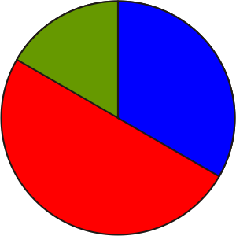 |  | Math Learning Goals  - Given concrete models of linear growing patterns, create verbal, numerical, graphical, and algebraic models.  - Investigate why some relationships are described as “linear.” |  | Materials  - BLM 5.2.1, 5.2.2  - toothpicks
Assessment
Opportunities
 | Minds On… | Whole Class → Brainstorm  Activate prior knowledge by orally completing BLM 5.2.1. Lead students to use the term number to create the general term, e.g., term n is 4 × n. Use the general term to find unknown terms. |  | Students should not connect the points they plot, as a line would be indicative of a continuous measure of data, which is not the case in this scenario.  Patterns that graph as lines or have a constant value added to each successive term are called linear relationships. The root word of linear is “line.”  All examples except the fourth and sixth are linear.
 | Action! | Small Groups → Investigation  Students determine the first five terms of the pattern using toothpicks and create a table of values which compares the term number with the total number of toothpicks used (BLM 5.2.2). Each group creates a graph from the table of values.  Whole Class → Discussion  Students examine the pattern of the points they plotted, i.e., a line, and explain why that toothpick pattern would produce that graph. Make the connection between patterns of uniform growth and linear relationships.  Curriculum Expectations/Demonstration/Mental Note: Assess students’ ability to recognize and understand linear growing patterns.
 | Consolidate Debrief | Pairs → Investigation  Students create tables of values and graphs to determine if there are linear relationships between:  1. wages and time for a babysitter earning $7 an hour  2. distance driven and time when driving 70 km per hour for several hours  3. number of adults and number of students on a school field trip requiring one adult for every 12 students  4. number of pennies and number of days when the number of pennies starts at one on day 1, then doubles each day  5. number of pizzas recommended and number of children in pizza take-out stores recommending one pizza for every five children  6. area of a square and side length s A = s × s
Practice |  | Home Activity or Further Classroom Consolidation  Create one linear relationship of your own. Explain, using words, the two items you are comparing; create a table of values; and graph the relationship to prove it is linear.

5.2.1: Patterns with Tiles

1. Build the first five terms of this sequence using tiles.

2. Complete the following table.
Term Number | Number of White Tiles | Understanding  in Words | Understanding  in Numbers
1
2
4
5

3. How many white tiles are there in the 10th term? Explain your reasoning.

4. How many white tiles are there in the 100th term? Explain your reasoning.

5. Describe a strategy for working out how many white tiles are in any term.

5.2.2: Toothpick Patterns

1. Build this pattern with toothpicks.
Term 1 |  | Term 2 |  |  | Term 3

2. Build the next two terms in the pattern.

3. Complete the chart. Put a numerical explanation of the number of toothpicks required in the Understanding column.
Term | Number of Toothpicks | Understanding
1
2
3
4
5

4. Complete a table of values 5. Plot the points on a grid:
for this relationship:

Term Number | Number of Toothpicks | 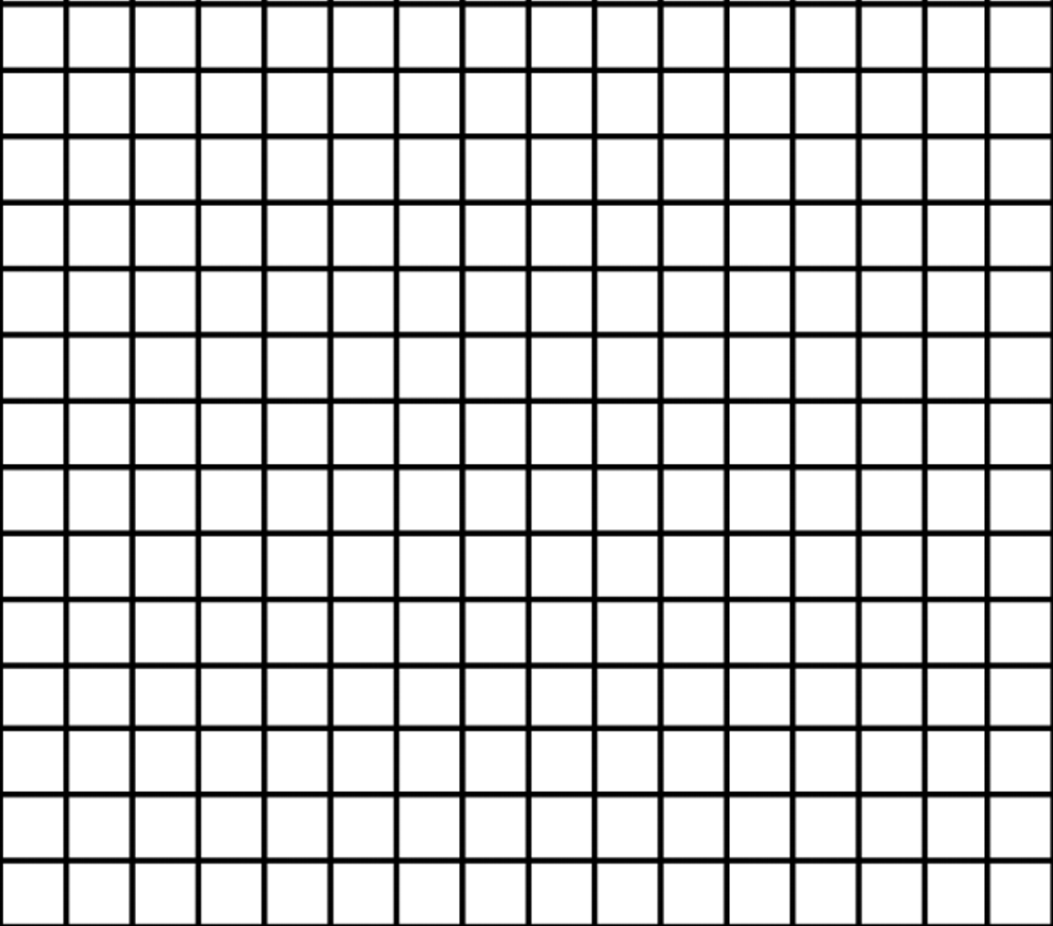
1
2
3
4
5
6

Unit 5: Day 3: Evaluating Algebraic Expressions with Substitutions |  |  |  | Grade 7
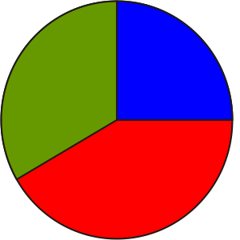 |  | Math Learning Goals  - Substitute numbers into variable expressions.  - Evaluate algebraic expressions by substituting a value into the expression.  - Make connections between evaluating algebraic expressions and finding the n^{th} term of a pattern. |  | Materials  - linking cubes  - BLM 5.3.1
Assessment
Opportunities
 | Minds On… | Small Groups → Forming a Variety of Representations  Present this scenario to the class: A group of students is making a bicycle/ skateboard ramp. The first day, they build the support using one brick. On each successive day, they add one brick to the base and one to the height of the support, making the support an L shape. (Day 2 uses 3 bricks, Day 3 uses 5 bricks, etc.)  Working in small groups, students represent the L-shaped supports in the following sequence:  - a physical representation using linking cubes  - a table of values (numerical representation)  - formula (algebraic representation)  Once students have established the rule algebraically, assist them in making the connection between the general term, e.g., (2n – 1), (1 + 2(n – 1)) and the term number, n. Groups determine the number of blocks used on the 5th, 10th, 24th, 50th day by substituting into the general term formula. |  | Students make connections to prior learning while substituting variables with numbers.  Note: order of operations is important.  Possible answers could include:  - costs of production  - sports scores  - travel costs  - transportation costs
 | Action! | Pairs → Investigation  Model how to find the word value of “teacher” to help students determine the algebraic expression that they can use for finding the word values (BLM 5.3.1). Students individually find the point value for each word and check with their partners. Encourage students to develop and evaluate numerical expressions in the form 3 (the number of consonants) + 2 (the number of vowels) in question 1 and to generalize this pattern as 3c + 2v in question 2.  Whole Class → Presentation  Students present their words from question 3 and the class calculates the word’s value.  Curriculum Expectations/Observation/Anecdotal Note: Assess students’ ability to substitute numbers for variables and evaluate algebraic expressions.
 | Consolidate Debrief | Whole Class → Make Connections  Students brainstorm life connections for substitution into algebraic equations. Ask:  What are some common formulas? (e.g., P = 2l + 2w, Area = b × h)  How many variables are in the formula P = 2l + 2w? (3)  If we want to know the perimeter, P, for how many variables will we have to substitute measures? (2 – l and w)  If we want to know the length, l, for how many variables will we have to substitute? (2 – P and w)  What are some of the advantages and disadvantages of using equations?
Application  Concept Practice |  | Home Activity or Further Classroom Consolidation  Vowels are worth 2 points and consonants are worth 3 points. Create and evaluate a numerical expression for the point value of five of your classmates, e.g., The point value for the name John would be 2(1) + 3(3) = 11.

5.3.1: Word Play
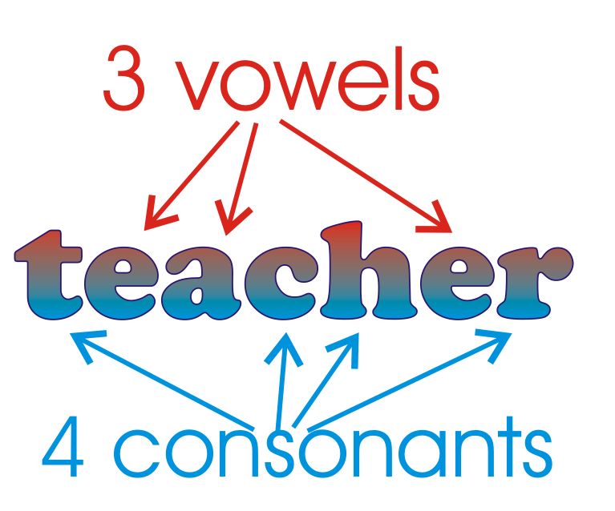

In this word game, you receive 2 points for a vowel, and 3 points for a consonant.

Word Value = 3 × the number of consonants + 2 × the number of vowels

The word teacher would be scored as 4 consonants worth 3 points each, plus 3 vowels worth 2 points each.

Word Value = 3(4) + 2(3)
= 12 + 6
= 18

1. Determine the value of each of the following words. Show your calculations.
a) Algebra

b) Variable

c) Constant

d) Integer

e) Pattern

f) Substitute

2. Write an algebraic expression that you could use to find the point value of any word.

3. Use your expression to calculate the value of six different words. Can you find words that score more than 30 points?
a)

b)

c)

d)

e)

f)

Unit 5: Day 4: Modelling Linear Relationships |  |  |  | Grade 7
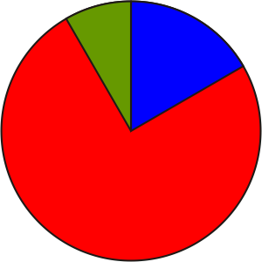 |  | Math Learning Goals  - Model relationships that have constant rates, where the initial condition is zero.  - Illustrate linear relationships graphically and algebraically. |  | Materials  - BLM 5.4.1, 5.4.2
Assessment
Opportunities
 | Minds On… | Whole Class → Brainstorm  With the students, brainstorm and compile a list of everyday relationships that involve a constant rate, e.g., a person’s resting heart rate, a person’s stride length, speed of a car driving at the speed limit, rate of pay at a job that involves no overtime, hours in a day. |  | Some students may experience difficulty in determining the algebraic model.  Students with the same heart rate should have the same numerical and algebraic representations, but not necessarily the same intervals on their graphs.
 | Action! | Whole Class → Demonstration  Using the context of stride length, measure one student’s stride length, e.g., 25 cm. Complete a table of values for 0–8 strides for this person and calculate the distance walked. Graph the relationship between this person’s stride length and the distance walked. (There is no correct answer to the question.) Ask: Should “stride length” or “distance walked” be on the horizontal axis?  Discuss the meaning of:  - constant rate (same value added to each successive term, e.g., 25 cm);  - initial condition (the least value that is possible, e.g., zero);  - linear relationship.  Illustrate how to determine an equation for this relationship (d = 25s).  Together, calculate values that are well beyond the values of the table, e.g., what distance would 150 strides cover?  Discuss the advantages and disadvantages of the table of values, the graph, and the algebraic equation.  Representing/Observation/Anecdotal Note: Assess students’ ability to represent a linear pattern in a chart and in a graph.  Pairs → Investigation  Students complete question 1 on BLM 5.4.1 and BLM 5.4.2.
 | Consolidate Debrief | Small Groups → Presentation  By a show of hands, determine which students have the same heart rates. These students form small groups and present their tables, graphs, and algebraic expressions to each other. Groups discuss any results that differ and determine the correct answers.
Reflection  Practice |  | Home Activity or Further Classroom Consolidation  Complete questions 2 and 3 on worksheets 5.4.1 and 5.4.2.

5.4.1: Getting to the Heart of the Math

1. a) Determine your heart rate for 1 minute at rest:
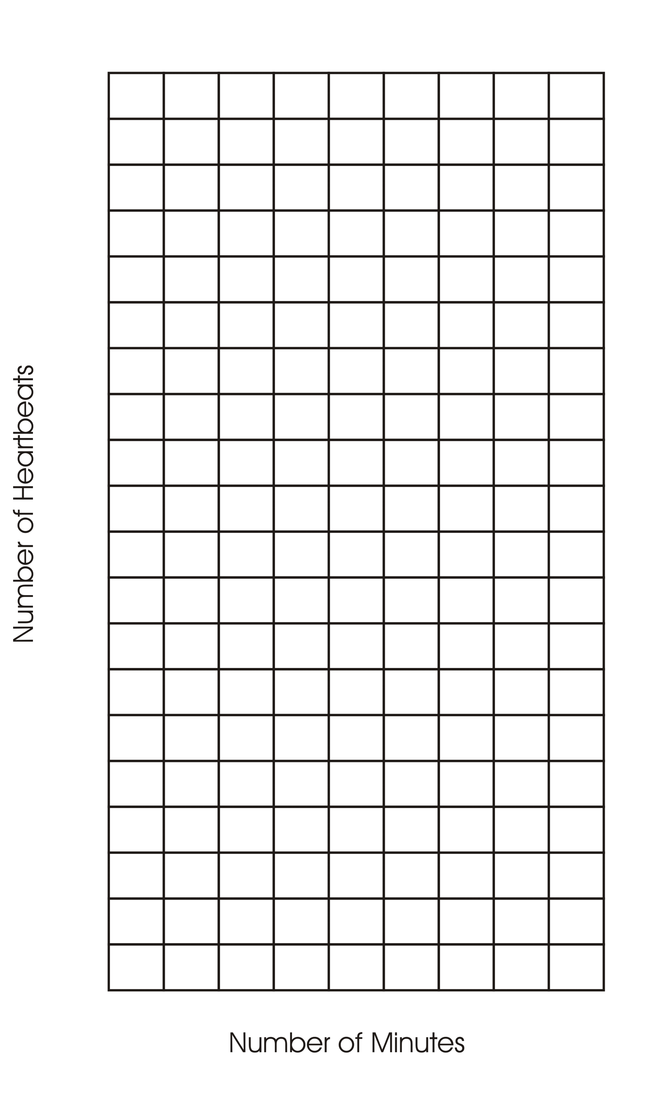
_____ beats per minute.

b) Complete a table of values to display the number of heartbeats, H, for t minutes.

Number of Minutes | Number of Heartbeats
0
1
2
3
4
5
6
7
8

c) Graph the relationship. Choose suitable intervals for each axis.

d) Write an algebraic expression for the relationship:

e) How many times will your heart beat during:
i. 30 minutes:

ii. 45 minutes?

iii. 1 hour?

iv. 90 minutes?

2. After one minute of vigorous exercise, e.g., running on the spot, take your pulse to determine your heart rate after exercise. Complete a table of values for your increased heart rate, and graph the relationship on the grid.

3. In your journal, compare the two graphs. Include “initial condition” and “constant rate of change.”

5.4.2: The Mathematics of Life and Breath

1. a) Determine your breathing rate for one minute at rest:
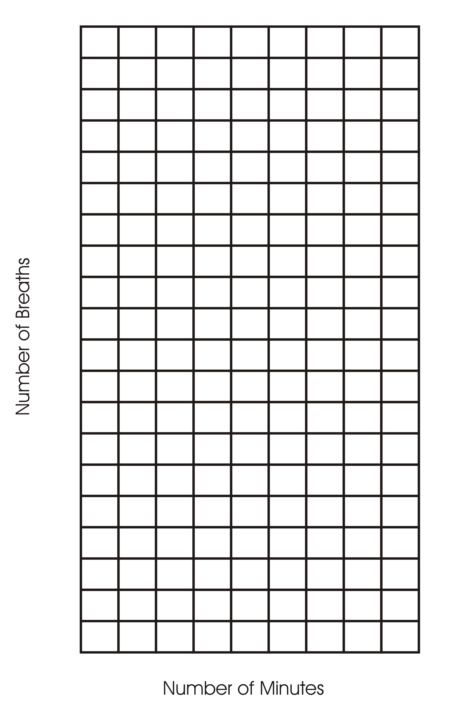
_____ breaths per minute.

b) Complete a table of values to display the number of breaths, B, for t minutes.

Number of Minutes | Number of Breaths
0
1
2
3
4
5
6
7
8

c) Graph the relationship. Choose suitable intervals for each axis.

d) Write an algebraic expression for the relationship:

e) How many breaths will you take during:
i. 30 minutes?

ii. 45 minutes?

iii. 1 hour?

iv. 90 minutes?

2. After one minute of vigorous exercise, e.g., running on the spot, determine your breathing rate after exercise. Complete a table of values for your increased breathing rate and graph the relationship on the grid.

3. In your journal, compare the two graphs. Include “initial condition” and “constant rate of change.”

Unit 5: Day 5: Solving Equations |  |  |  | Grade 7
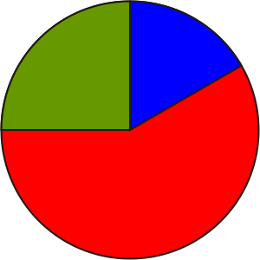 |  | Math Learning Goals  - Solve equations using inspection and guess and check, with and without technology. |  | Materials
Assessment
Opportunities
 | Minds On… | Whole Class → Demonstration  Orally solve some simple equations using the inspection method, e.g., 3 + x = 7. Students should recognize that x = 4. Introduce the concept of guess and check to solve an equation where the answer is not immediately obvious by doing a few questions.  Demonstrate the guess and check or “systematic trial strategy” using the GSP®4 activity. From the menu, select and complete orally the problems found on Main, Activity 1, and Activity 2.  To model the process, verbalize the thinking behind the guess and check as it happens, e.g., I know 3 × 4 is close to 11, so I’ll start by trying 4. |  | Solving Equations by Guess and Check.gsp  Some students may require a calculator.  While students are guessing and checking, they verbalize their thinking so the guessing steps can be discussed.
 | Action! | Pairs → Practice  Examine the five types of questions found in the Practice section and point out that they vary from questions requiring inspection to questions that use guess and check and a calculator.  Students complete six questions from each of the five different types found on the Practice page in the GSP®4 file, recording their guesses on the student handout (found in bottom menu) or on a chart in their notebooks.  If students complete all five types of problems on the Practice page, they try the extensions with decimals and large numbers.  Reflecting/Observation/Mental Note: Assess students’ ability to revise their guess as they develop a systematic process for solving equations.
 | Consolidate Debrief | Whole Class → Discussion  Students share strategies they used and why they selected them.
Concept Practice  Practice |  | Home Activity or Further Classroom Consolidation  Complete the practice questions. |  | Provide students with appropriate practice questions that use a combination of solving by inspection and by using guess and check.

Solving Equations by Guess and Check (GSP®4 file)
SolvingEquationsbyGuessandCheck.gsp
Solving Equations by Guess and Check (continued)

Unit 5: Day 6: Translating Words into Simple Equations |  |  |  | Grade 7
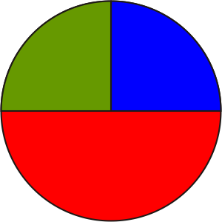 |  | Math Learning Goals  - Represent algebraic expressions with concrete materials and with algebraic symbols.  - Use correct algebraic terminology.  - Translate between algebraic expressions and equations and the statement in words.  - Solve equations. |  | Materials  - BLM 5.6.1, 5.6.2, 5.6.3, 5.6.4, 5.6.5  - algebra tiles  - counters
Assessment
Opportunities
 | Minds On… | Whole Class → Demonstration  Orally guide students through a number puzzle (Activity 1 BLM 5.6.1).  Model how to translate a problem using manipulatives (Activity 2 BLM 5.6.1). Connect manipulatives to the algebraic representation.  Take this opportunity to demonstrate correct syntax, brackets, and order of operation. |  | The algebraic representations may be beyond the students. Do not expect proficiency at this time.  Students could put their responses on sticky notes on chart paper. Place the lists on the Word Wall.
 | Action! | Small Groups → Brainstorm  Students brainstorm mathematical vocabulary used in solve problems (BLM 5.6.2). Assign each group a section to complete. Students share their responses with the whole class, who add suggestions to the list.  Pairs → Practice  Students practise writing mathematical expressions for word problems (BLM 5.6.4). Remind students of the difference between an expression and an equation.  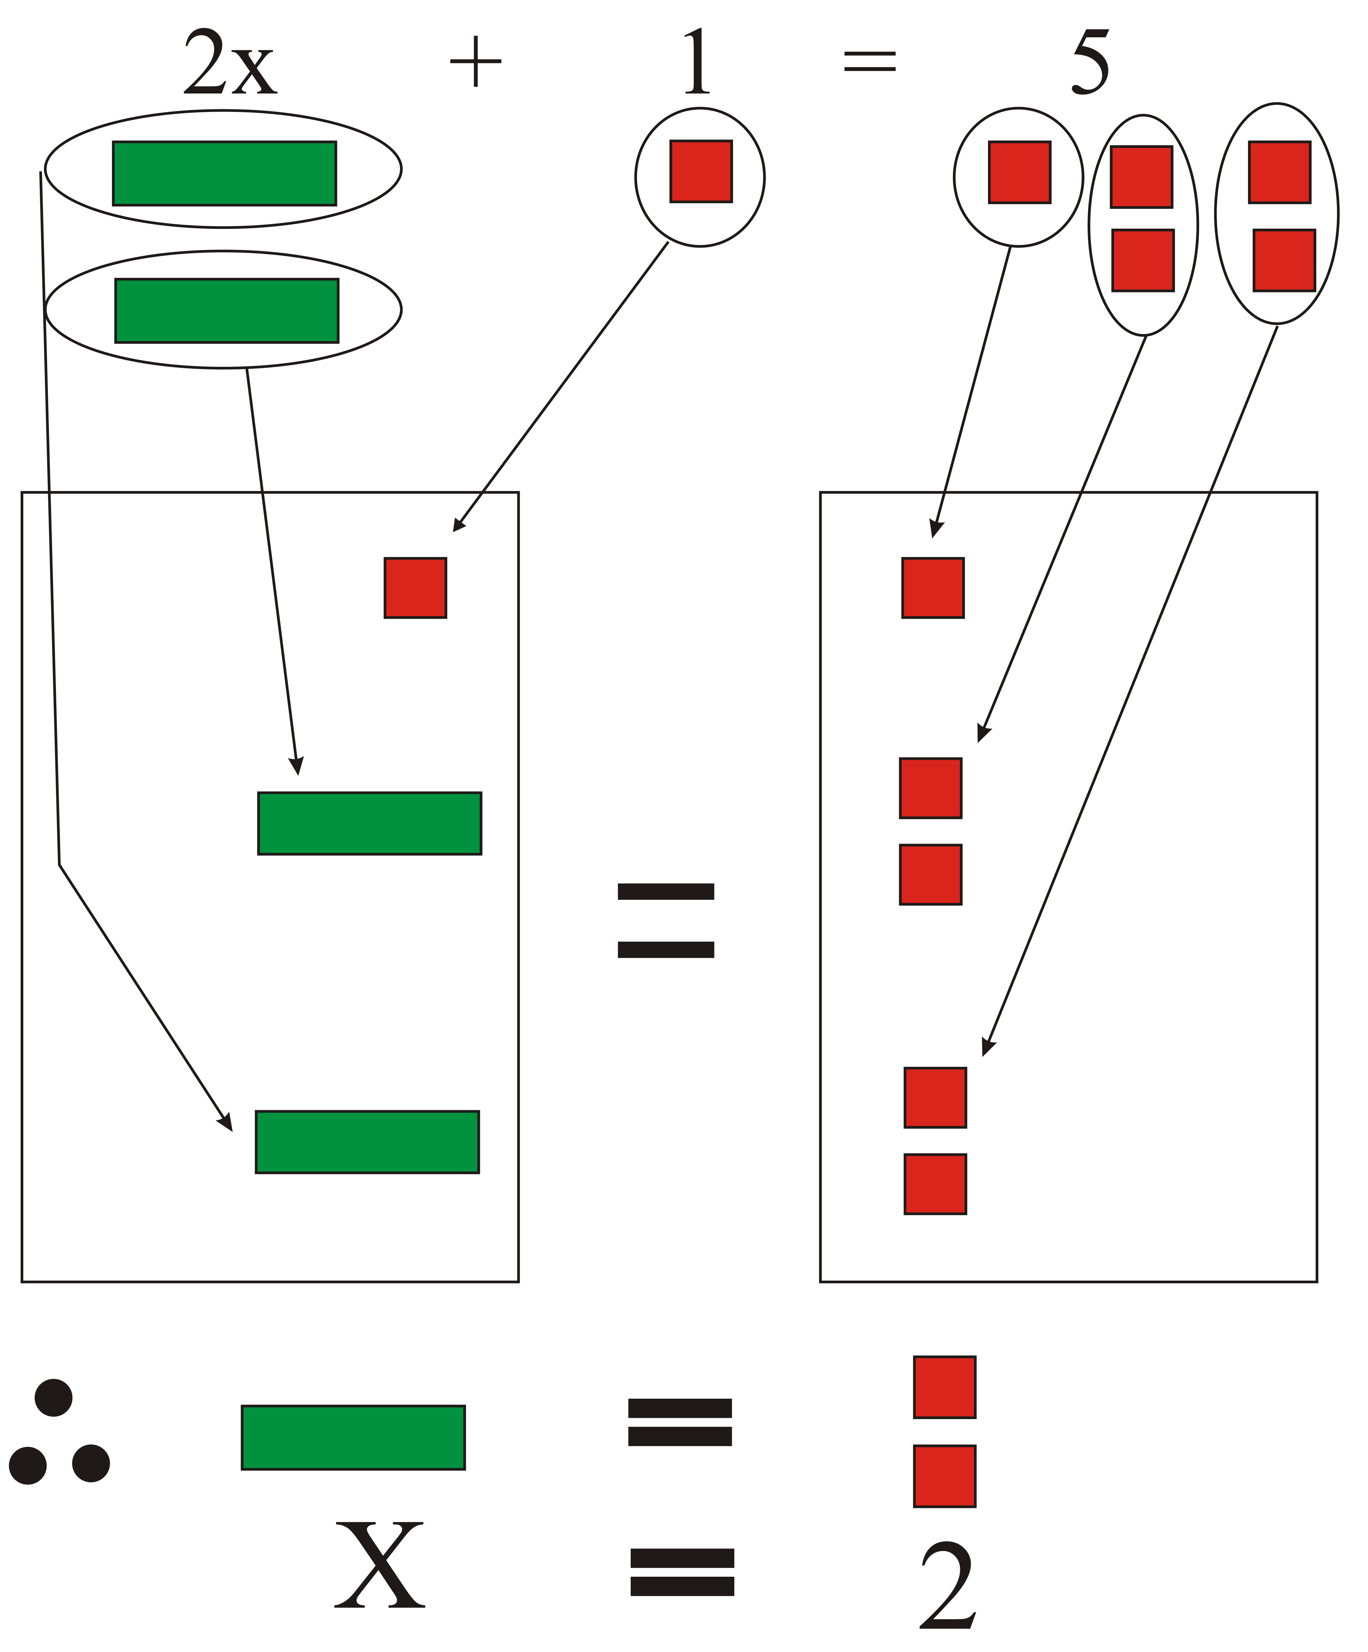  Students can use manipulatives, e.g., algebra tiles, counters, to model the expressions and solve the equations.  Selecting Tools/Observation/Anecdotal Note: Assess students’ ability to choose the tool that best assists them in solving the equation.
 | Consolidate Debrief | Whole Class → Discussion  Orally, complete the remaining Activities 3–6 on BLM 5.6.1 and then discuss how to use mathematical symbols and vocabulary in problems. Focus on the concrete representation and the reasoning.
Application  Differentiated  Practice |  | Home Activity or Further Classroom Consolidation  Design a number trick activity based on algebraic reasoning.  Make concrete representations for each step.

5.6.1: A Number Puzzle (Teacher)

Activity 1
a) Use a calculator to demonstrate the number trick, using any 7-digit phone number.
(Exclude area code.)
1. Key in the first 3 digits of any phone number
2. Multiply by 160
3. Add 1
4. Multiply by 125
5. Add the last 4 digits of the phone number
6. Add the last 4 digits of the phone number again
7. Subtract 125
8. Divide by 2

b) Repeat this activity by changing question 2 from 160 to 40 and by changing question 4 and question 7 from 125 to 500.

c) Repeat this activity by changing question 2 from 160 to 80 and by changing question 4 and question 7 from 125 to 250.

Activity 2
Model how to translate this problem using manipulatives.

Students complete the activity, using calculators, if needed.
Algebraic Representation
[n + (n + 1) + 9] ÷ 2 – n
= [(2n + 10) ÷ 2] – n
= n + 5 – n
= 5
1. Pick any number
2. Add to it the number that follows it (next consecutive number)
3. Add 9
4. Divide by 2
5. Subtract the starting number

Students check their results with their peers and discuss their findings.
(Result is always 5).

Repeat this activity, using 7 as the starting number, using students rather than manipulatives (24 students are needed for the demonstration).
Algebraic Representation
[t + (t + 1) + 9] ÷ 2 – t
= [7 + (7 + 1) + 9] ÷2 – 7
= (7 + 8 + 9) ÷ 2 – 7
= 24 ÷ 2 – 7
= 12 – 7
= 5
Start with 7 students.
Add 8 students.
Add 9 students.
Remove half of the students.
Remove 7 more students.
Five students are remaining.

Repeat, starting with 4 students.

5.6.1: A Number Puzzle (continued)

Activity 3
Model how to translate this problem using manipulatives.
- Select a number
Algebraic Representation
[(n + 3)2 + 4] ÷ 2 – n
= [(2n + 10) ÷ 2] – n
= n + 5 – n
= 5
- Add 3
- Double
- Add 4
- Divide by 2
- Take away the number you started with

What did you end up with? Why is the answer always the same?

Activity 4
Enter the number 55 on a calculator. Add four different numbers to end up with 77.
What four numbers could be used? What are other possibilities?

55 + w + x + y + z = 77
To reinforce negative integers do: 55 + w + x + y + z = –20 and
–55 + w + x + y + z = –77

Possible strategy: Guess and check
Students can begin by entering 55 and then adding any other four numbers, and then decide whether to increase or decrease one, two, three, or all of the four numbers.

Activity 5
Use manipulatives.
Three children shared 18 crackers amongst themselves. Kari took double the amount of crackers than Gaston. Soonja took triple the amount of crackers than Gaston.
How many crackers did Gaston take?
Algebraic Representation
x + 2x + 3x = 18

Possible strategy: Use counters to represent crackers and distribute them among the three children according to the clues given in the problem.

Activity 6
A number is multiplied by its double. The product is 5618.
What is the number?
Possible strategy: Guess and check (connect this to students’ understanding of squares and square roots)

Algebraic Representation
(n)(2n) = 5618
2n² = 5618
n² = 2809
n = 53
Try 50 and 100 to get 5000. Therefore 50 is too small.
Try 55 and 110 to get 6050. Therefore 55 is too big.

5.6.2: Vocabulary of Problem Solving

Mathematic Symbols | Vocabulary
any lowercase letter
(e.g., x, y, b, p, m)
+
x + 4
−
s – 11
×
16y
÷
=
2c = 24
5.6.3: Vocabulary of Problem Solving – Solutions (Teacher)

Mathematic Symbols | Vocabulary
any lowercase letter (e.g., x, y, b, p, m) | a variable, a number, a certain amount, a quantity, a mass, a volume, etc.
+ | add, plus, increase, larger than, greater than
x + 4 | - a number plus four  - four added to a number  - a number increased by four  - four greater than a number, etc.  - the sum of a number and four
− | minus, subtract, decrease, reduce, smaller than, less than
s − 11 | - a number minus eleven  - eleven less than a number  - a number decreased by eleven  - a number subtracted by eleven, etc.  - the difference between a number and eleven
× | times, multiply, of, product
16y | - sixteen times a number  - a number times sixteen, etc.  - the product of sixteen and a number
÷ | divided by, split into a certain number of equal parts
 | a number is divided by seven, etc.
= | equal, is, gives you, results in, makes
2c = 24 | - the product of a number and two is twenty-four  - a number doubled is twenty-four  - two times a number equals twenty-four  - if a number is doubled, the result is twenty-four, etc.

5.6.4: Problem Solving Using Equations

Using variables, write mathematical expressions for the following.
Use different variables for each expression.

1. A number: _______________
2. A number tripled: _______________
3. A number is decreased by seven: _______________
4. Three larger than a number: _______________
5. Eighteen increased by a number: _______________
6. A number subtracted by another number: _______________
7. Three times a number: _______________
8. A number is divided by 15: _______________
9. A number less than twelve: _______________
10. Three consecutive numbers: _______________

Translate these sentences into equations.
Solve for “the number” in the equation.

11. Ten less than triple a number is twenty-one. _______________; ____ = ____
12. If a number is doubled the result is sixty. _______________; ____ = ____
13. Seven plus a number reduced by two gives you eighteen. _____________; ____ = ____
14. Three times a number is sixty-three. _______________; ____ = ____
15. Increase the product of two and a number by 4 to obtain 56. ___________; ____ = ____
16. The sum of nine times a number and five is one hundred eighty-five. ________; __ = __
17. A number divided by six is twenty-one. _______________; ____ = ____
18. Double a number plus five is seventy-five. _______________; ____ = ____
19. You get ten when subtracting sixteen from twice a number. ____________; ____ = ____
20. If a number is tripled and then reduced by nine, the result is sixty-six. ______; ___ = ___
5.6.5: Problem Solving Using Equations – Sample Answers

(Teacher)

Using concrete materials, write mathematical expressions for the following.
Use different variables for each expression.

1. A number: any letter

2. A number tripled: 3s

3. A number is decreased by seven: b − 7

4. Three larger than a number: c + 3

5. Eighteen increased by a number: 18 + w

6. A number subtracted by another number: x − y

7. Three times a number: 3d

8. A number is divided by 15:

9. A number less than twelve: 12 − p

10. Three consecutive numbers: k, k + 1, k + 2

Translate these sentences into equations. Solve the equation. (Any letter is acceptable.)

11. Ten less than triple a number is twenty-one. 3m − 10 = 21; m = 11

12. If a number is doubled the result is sixty. 2t = 60; t = 30

13. Seven plus a number reduced by two gives you eighteen. 7 + b − 2 = 18; b = 13

14. Three times a number is sixty-three. 3y = 63; y = 21

15. Increase the product of two and a number by 4 to obtain 56. 2g + 4 = 56; g = 26

16. The sum of nine times a number and five is one hundred eighty-five. 9h + 5 = 185; h = 20

17. A number divided by six is twenty-one. x ÷ 6 = 21; x = 126

18. Double a number plus five is seventy-five. 2y + 5 = 75; y = 35

19. You get ten when subtracting sixteen from twice a number. 2m − 16 = 10; m = 13

20. If a number is tripled and then reduced by nine, the result is sixty-six. 3z − 9 = 66; z = 25

