Unit 3 Grade 7
Collect, Organize, and Analyse Data

Lesson Outline

BIG PICTURE

Students will:
- organize and display data using different graphical representations;
- analyse data to form hypotheses and create convincing arguments;
- recognize that data and graphs can be misinterpreted and can be misleading;
- understand measures of central tendency and the effect of outliers.
Day | Lesson Title | Math Learning Goals | Expectations
1 | What’s the Story? | - Make inferences and arguments based on the analysis of data.  - Distinguish between primary and secondary data.  - Distinguish between a census and a sample.  - Identify bias in data collection methods. | 7m27, 7m74, 7m76, 7m77  CGE 2b, 2c, 3c, 5a, 5b, 5e
2 | Designing and Conducting a Valid Survey | - Identify bias in data collection.  - Collect primary data by conducting a survey.  - Organize primary data into a tally chart. | 7m73, 7m74, 7m77  CGE 2b, 2c, 3c, 5b, 5e
3 | Organizing, Displaying, and Presenting Data | - Interpret, display, graph, and draw conclusions from primary data. | 7m74, 7m75, 7m77, 7m78  CGE 2c, 4b, 5a, 5b, 5e
4 | Creating a Spreadsheet from a Database | - Collect secondary data from a database (manually and/or electronically).  - Organize secondary data using a spreadsheet.  - Identify correct data management terminology. | 7m74  CGE 3c, 5a, 5b, 7i
5 | Who’s the Author? | - Determine the purpose of a sample of graphs.  - Draw bar graphs, choosing appropriate scale and intervals for given data.  - Examine the effect of changing scales and intervals, etc.  - Examine and interpret misleading graphs (bias). | 7m74, 7m75, 7m79  CGE 2c, 3c, 4f, 5a, 5b
6 | Three Types of Data | - Distinguish between types of graphs that compare quantities (bar graph, double bar graph) and those that show change over time (broken line, continuous line, multiple line graphs).  - Distinguish between discrete, categorical, and continuous data. | 7m74, 7m75  CGE 3c, 4f, 5b
7 | Introduction to Circle Graphs | - Create circle graphs, using different methods.  - Estimate the percents, fractions, and degrees found in circle graphs.  - Understand that a circle graph represents parts of a whole. | 7m15, 7m22, 7m74  CGE 4b, 4f, 5e, 5g
8 | Calculating Percents/Angles for Circle Graphs | - Create a circle graph by calculating percentages to determine the central angles.  - Use a protractor to measure the central angles. | 7m15, 7m23, 7m46, 7m74  CGE 2c, 3c, 5b, 7i
Day | Lesson Title | Math Learning Goals | Expectations
9 | Which Graph Is Best? | - Illustrate the same set of data using a tally sheet, frequency table, bar graph, line graph, pictograph, and circle graph.  - Determine which graph best conveys the information (consider bias, audience).  - Compare features of each type of graph that would lend themselves best to support a statement. | 7m15, 7m25, 7m74, 7m75, 7m79  CGE 4b, 4f, 5b
10 | Going Around in Circles | - Display data using a circle graph.  - Identify inaccuracies and bias in data. | 7m15, 7m23, 7m46, 7m74, 7m75, 7m77, 7m76  CGE 3c, 5a, 5e, 5g
11 | Investigating Mean, Median, and Mode, and Outliers | - Investigate mean, median, and mode and the effect of outliers on the measures of central tendency.  - Create stem-and-leaf plots to organize data. | 7m80  CGE 2b, 2c, 5b
12 | And the Data Says… | - Distinguish between facts and inferences.  - Analyse graphs to extract information from the data, find relationships within the data, and use data to draw conclusions.  - Interpolate to make predictions within the graphed region. | 7m78, 7m81, 7m82  CGE 2b, 2c, 3c, 4b, 4f, 5b
13 | Trends of Generosity | - Identify trends found in data and graphs.  - Extend a graph to make predictions (extrapolate) beyond the graphed area.  - Determine if the extrapolated data makes sense. | 7m78, 7m81, 7m82  CGE 2c, 3c, 5b, 5g

Unit 3: Day 1: What’s the Story? |  |  |  | Grade 7
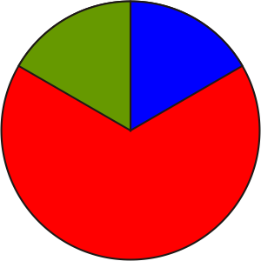 |  | Math Learning Goals  - Make inferences and arguments based on the analysis of data.  - Distinguish between primary and secondary data.  - Distinguish between a census and a sample.  - Identify bias in data collection methods. |  | Materials  - BLM 3.1.1
Assessment
Opportunities
 | Minds On… | Whole Class → Brainstorm  Create a mind map with “data management” in the middle, and “sports” and “music” in two corners. Elicit answers that lead to creating some connections among these three ideas, e.g., What data could we collect from the Internet about music? (secondary data) or by surveying our class? (primary data)  Connecting/Oral Questioning/Observation/Mental Note: Assess students’ ability to connect the use of data to situations in their world. |  | Think Literacy: Mathematics, Grades 7–9, p. 2–4.  Point out the difference in the two surveys (one is a census of the class, the other is a survey).  Word Wall  - census  - sample  - primary/secondary data  - bias
 | Action! | Groups of 4 → Investigation  Students examine and analyse the data and answer the questions (BLM 3.1.1).  Ask specific questions from the chart to relate the data to the headings.  Groups answer the questions on BLM 3.1.1.  Note: Use this activity as a beginning for a discussion that graphs, data, and statistics are a math tool for organizing and analysing large amounts of information, i.e., data helps to tell a story.  Whole Class → Discussion  Discuss the discrepancy between the number of men vs. women who lost their lives.  To demonstrate a census vs. a sample, survey the class, by a show of hands, posing the question: Is the “women and children first” rule fair? Generalize from the data obtained that x % of the class thinks it is fair, and then survey the girls only. Introduce the term bias in data collection.
 | Consolidate Debrief | Whole Class → Discussion  Revisit the terms introduced during Minds On… and Action! Students give evidence of when they were used during the lesson.
Application |  | Home Activity or Further Classroom Consolidation  Find current statistics in a newspaper, a magazine, on television, or on the Internet to answer the following question about the data: What story might the data tell?

3.1.1: The Sinking of the Titanic
(Adapted from http://curriculum.qed.qld.gov.au/kla/eda/
© Education Queensland, 1997)
Below is a summary of some data about the people sailing on the Titanic.
Look at data on the chart and answer these questions:
1. What was the total number of females aboard the Titanic? _______ Males? _______
2. Were there more female or male deaths in the High Income category? _______________
3. Which category (High/Middle/Low Income) did most children belong to aboard the Titanic? ___
Data Organized by Economic Status and Gender
Economic Status | Number of people on the Titanic |  |  | Number of deaths resulting from  the sinking of the Titanic
Economic Status | Male | Female | Total | Male | Female | Total
High Income | 180 | 145 | 325 | 118 | 4 | 122
Middle Income | 179 | 106 | 285 | 154 | 13 | 167
Low Income | 510 | 196 | 706 | 422 | 106 | 528
Other | 862 | 23 | 885 | 670 | 3 | 673
Total | 1731 | 470 | 2201 | 1364 | 126 | 1490

Data Organized by Economic Status and Age
Economic Status | Number of people on the Titanic |  |  | Number of deaths resulting from  the sinking of the Titanic
Economic Status | Adult | Child | Total | Adult | Child | Total
High Income | 319 | 6 | 325 | 122 | 0 | 122
Middle Income | 261 | 24 | 285 | 167 | 0 | 167
Low Income | 627 | 79 | 706 | 476 | 52 | 528
Other | 885 | 0 | 885 | 673 | 0 | 673
Total | 2092 | 109 | 2201 | 1438 | 52 | 1490

4. Compare the number of female deaths in the high and low income female category.
Use ratios or percents to make your comparison. Explain why you think the results are different.

5. Is this data primary or secondary data? (Circle one)

6. Is this data a census or a sample? Explain.

Unit 3: Day 2: Designing and Conducting a Valid Survey |  |  |  | Grade 7
 |  | Math Learning Goals  - Identify bias in data collection.  - Collect primary data by conducting a survey.  - Organize primary data into a tally chart. |  | Materials  - BLM 3.2.1, 3.2.2  - overhead protractor
Assessment
Opportunities
 | Minds On… | Small Groups → Discussion  Students share stories from the Home Activity, Day 1.  Whole Class → Survey  Survey the class by a show of hands the number of minutes that should be required for homework time: Should homework in Grade 7 be limited to 15 minutes per day? Record the responses on a yes-no tally chart.  Ask: Is this a “fair” or biased sample? |  | Teachers should choose an example that is geographically or culturally appropriate for their group.
 | Action! | Whole Class → Discussion  Lead a discussion of the criteria required to conduct a valid survey by asking student volunteers to read the five scenarios on an overhead of BLM 3.2.1. Pause after each scenario to consider bias, sample size, phrasing of the question, and method of data collection.  Student volunteers read aloud the descriptions of the four rides on an overhead of BLM 3.2.2. By a show of hands, students select their favourite ride. Record results on a tally chart.  Discussion Questions  - How reliable are these results for the decision being made?  - What are some other ways data could be collected?  Small Groups → Investigation  Students investigate reasons why they might want to collect data, e.g., music at a dance, fundraising, school uniforms. They share some of their suggestions with the class.  Small groups decide on a topic for which they would like to collect data and design a survey.  Students consider:  - How will the information collected be used?  - How and why is this important?  - What collection methods will be used?  - What is an appropriate sample size?  - Are questions appropriately phrased?  Students conduct their survey by passing the survey questions between groups.
 | Consolidate Debrief | Whole Class → Discussion  Lead a discussion to identify possible uses of the data collected in their surveys, making the point that surveys should inform a decision of some type.  Reflecting/Application/Rating Scale: Individually student write a reflection about the kinds of decisions that could be made based on their survey data.
Application  Reflection |  | Home Activity or Further Classroom Consolidation  Write a journal response:  We live in the Information Age. An informed citizen needs to be able to collect, organize, display, interpret information, and identify bias. How can our study of data management help you become an informed decision maker?

3.2.1: Collecting Data

In each case, circle which type of sampling technique you would choose to collect data.

1. A donor gives the school $500 to spend on the students. The principal asks your class to create a survey to determine where to spend the money. Should your class:
a) ask everyone who stayed after school for the basketball tryouts?
b) ask people going in and out of the library at lunch?
c) randomly select 5 people from each class?

Justify your selection.

2. To determine what students at your school think about starting a lunch hour chess club, would you:
a) ask everyone in Grade 4?
b) ask the teachers?
c) ask every tenth student as they enter the school in the morning?

Justify your selection.

3. To determine the most watched TV shows, would you:
a) ask all the students in Grade 2?
b) call households between 4 and 6 p.m.?
c) send home a survey with each student?

Justify your selection.

Change the questions to match the purpose of the survey.

4. Anthea was carrying out a survey on favourite magazines. She asked “Do you like reading magazines?”

5. Mike wants to find out what type of music people like to listen to. He asks “Do you like rap or pop music?”
3.2.2: Paramount Canada’s Wonderland

Scenario: Paramount Canada’s Wonderland is considering opening an additional amusement park. They need to know which ride they should promote as a key attraction for ages 11–13.

Cliffhanger: Cliffhanger is Paramount Canada’s Wonderland’s new super swing with attitude and altitude. Cliffhanger takes passengers through snap rollovers and unyielding 360 degree twists and turns as they are propelled through moments of zero gravity and finally quenched by an inescapable wall of water.

Meteor Attack: At Action F/X Theatre, there are non-stop thrills with Meteor Attack. Passengers are taken on the flight of their lives, as they become the last line of defense against a full-scale alien invasion. Passengers are transformed into unsuspecting pilot trainees of the 23rd century, who are to save Rocketstation Outpost 769.

Drop Zone Stunt Tower: Drop Zone is Canada’s tallest free-fall thrill ride: 23 stories high. It features a colourful, free-standing tower with open cockpit seats that drop at a speed of 100 km/hour. Manufactured in Switzerland, five cars drop at a speed of 488 cm/second and down a 70 m drop. Drop Zone has an hourly capacity of 800 riders.

Water Park: Water Park is a million gallons of heated water fun! Bring your bathing suit and ride the waves at Canada’s largest outdoor wave pool. Gently float 1.5 km on The Lazy River, or choose from over 16 thrilling water slides.

Adapted from Canada’s Wonderland website
Unit 3: Day 3: Organizing, Displaying, and Presenting Data |  |  |  | Grade 7
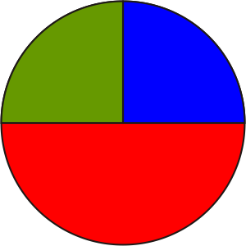 |  | Math Learning Goals  • Interpret, display, graph and draw conclusions from primary data. |  | Materials  - BLM 3.3.1  - chart paper  - markers
Assessment
Opportunities
 | Minds On… | Pair/Share → Discussion  Students share and discuss their journal entries from the previous day.  Whole Class → Brainstorm  Brainstorm on how students’ primary data collected on tally charts from their group surveys could be displayed (Day 2). On chart paper record possible types of displays, e.g., relative frequency table, stem-and-leaf, bar graph, line graph.  Briefly review key features of each. |  | Accept all responses about types of displays.  Dynamic statistical software such as TinkerPlots® may be used to display and analyse data.  Word Wall  - frequency table
 | Action! | Whole Class → Demonstration  Lead a discussion on the most appropriate type of graph for the tally chart of Canada’s Wonderland data from Day 2. Demonstrate how to produce a relative frequency table and an appropriate type of graph (stem-and-leaf and/or bar graph).  Small Groups → Practice Graphing  Each group creates a presentation to communicate the results of their survey conducted on Day 2 (see BLM 3.3.1). Emphasize the importance of group cooperation, time management, and delegation of tasks among all group members.  Communicating/Presentation/Checkbric: Assess students’ ability to display data graphically, to explain the purpose and results of their survey.
 | Consolidate Debrief | Small Groups → Presentation  Each small group presents its results to the class. Students use the criteria on  BLM 3.3.1 as a checklist for observing the presentations of others.  After each presentation, peers comment on criteria met and provide suggestions for improvement.  Model positive review comments, e.g., Your survey may have been more accurate if you had worded your survey question in the following way....
Reflection |  | Home Activity or Further Classroom Consolidation  Complete worksheet 3.3.2 to reflect on your participation within your group.  Learning Skills (Teamwork)/Reflection/Anecdotal Notes: Assess students’ self-reflection.

3.3.1: Presentation of Primary Survey Data

Share the results of your survey with the class.
Create a presentation on chart paper that includes a relative frequency table, an appropriate graph, and a clear survey question.

Use the following criteria as a checklist to ensure your presentation is complete:

- Our question/purpose of the survey is clearly stated.

- We can explain how we attempted to eliminate bias in our data collection method.

- Our frequency table is clearly displayed.

- All parts of our graph are labelled properly.

- Our graph summarizes our results.

- Our presentation takes between 2 and 3 minutes.

Presentation of Primary Survey Data

Share the results of your survey with the class.
Create a presentation on chart paper that includes a relative frequency table, an appropriate graph, and a clear survey question.

Use the following criteria as a checklist to ensure your presentation is complete:

- Our question/purpose of the survey is clearly stated.

- We can explain how we attempted to eliminate bias in our data collection method.

- Our frequency table is clearly displayed.

- All parts of our graph are labelled properly.

- Our graph summarizes our results.

- Our presentation takes between 2 and 3 minutes.
3.3.2: Reflecting on Your Work in the Group

Divide your circle into sections that reflect how much time you spent on each part of the group activity. Label each section and justify the amount of the circle you have given to each section.

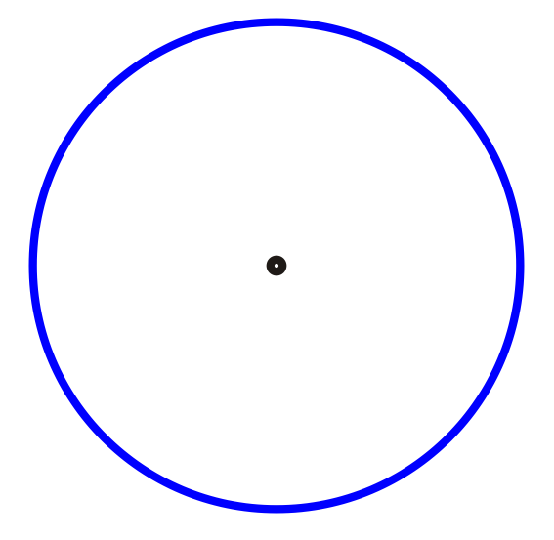
Group Activity | My Participation
Discussing with group members
Doing the work
Checking group work and revising
Off-task behaviour

Reflection
How could you improve your project and presentation in the future?

Divide your circle into sections that reflect how much time you spent on each part of the group activity. Label each section and justify the amount of the circle you have given to each section.

Group Activity | My Participation
Discussing with group members
Doing the work
Checking group work and revising
Off-task behaviour

Reflection
How could you improve your project and presentation in the future?

Unit 3: Day 4: Creating a Spreadsheet from a Database |  |  |  | Grade 7
 |  | Math Learning Goals  - Collect secondary data from a database (manually and/or electronically).  - Organize secondary data using a spreadsheet.  - Identify correct data management terminology. |  | Materials  - computer or hard copy database
Assessment
Opportunities
 | Minds On… | Whole Class → Discussion  Pose questions to students about sources of data:  - How would you make a doctor’s appointment (phone call and get the number using a phonebook);  - How would you decide what to pack for a camping trip? (e.g., atlases, newspaper statistics, and electronic databases).  Ask:  - What is a database?  - What do electronic and hard copy databases have in common?  - How are they helpful?  Emphasize that a database is an organized collection of data.  Students give other examples of both electronic and hard copy databases. |  | Database Examples  - Statistics Canada  - Environment Canada  Word Wall  - database  - field  - spreadsheet  - cells  - rows  - columns
 | Action! | Pairs → Exploration  Demonstrate the features of a database. Introduce the term field and how it relates to the database. Select a topic for electronic data collection or provide data in hard copy.  Students explore the database.  Pairs → Recording Data  Show an example of a spreadsheet and model the transfer of data into it. Introduce database vocabulary and how it relates to spreadsheets.  Introduce features of an electronic spreadsheet, e.g., sort, sum, formulas, etc. Students electronically transfer data into a spreadsheet or manually record the data on a chart.
 | Consolidate Debrief | Whole Class → Discussion  Pose questions:  - Why are databases created?  - Why would someone transfer data from a database to a spreadsheet?  - What can you do with data when it is in a spreadsheet format?  Connecting/Oral Questioning/Mental Note: Note students’ ability to make connections between spreadsheets, organizing data, and graphing.
Concept Practice  Reflection |  | Home Activity or Further Classroom Consolidation  Analyse the spreadsheet you created.  - What do you notice about the data you have collected?  - How could you or someone else use this data?  - Why would someone want to create a spreadsheet?

Unit 3: Day 5: Who’s the Author? |  |  |  | Grade 7
 |  | Math Learning Goals  - Determine the purpose of a sample of graphs.  - Draw bar graphs, choosing appropriate scale and intervals for given data.  - Examine the effect of changing scales and intervals, etc.  - Examine and interpret misleading graphs (bias). |  | Materials  - BLM 3.5.1, 3.5.2
Assessment
Opportunities
 | Minds On… | Think/Pair/Share → Reading Graphs  Students examine the graphs on BLM 3.5.1 to hypothesize which of the characters listed is telling the story.  Students share their conjectures giving the reasons for their choices. |  | Word Wall  - scale  - interval  - misleading  - breaks in scale  Students may identify line graphs as the best way to display the homework data.  Students can use TinkerPlots® software for this activity
 | Action! | Whole Class → Discussion  Discuss how the same set of data can be used to support many different views. Students compare the graphs to determine which features (scales, intervals, breaks in scale, etc.) were modified for each graph to support a different view. Why was this done? Which of the graphs misrepresent the data? Explain.  Groups of 4 → Investigation  Assign each group a different role – Grade 7 teacher, Grade 7 student, parent of a Grade 7 student, principal. They present a different perspective on the data as determined by their assigned role (BLM 3.5.2).  Each group designs a graph that displays some or all of the data from the point of view of the assigned role. Make a statement that the chosen data supports.  The group presents its graph statement on a poster without revealing what its original perspective or motivation was.  For example, Parents might choose Sept, May, and June for the horizontal axis and show minutes watching television, during these months. The statement could be: Students in Grade 7 watch about 1 hour of television a day.
 | Consolidate Debrief | Individual → Journal  Students choose two or three of the posters displayed around the room and decide what role the group who produced each of the graphs may have held, e.g., a parent, a principal. They justify their choices by analysing different features of the graph. Their statement should include any misleading aspects of the graph.  Reasoning and Proving/Demonstration/Rating Scale/Journal/Scoring Guide: Assess students’ ability to provide evidence based on the information in the graphs.
Concept Practice |  | Home Activity or Further Classroom Consolidation  Set up a recording sheet for collecting data on the amount of time you spend on homework over the next week.

3.5.1: Whose Story Is It?

Examine the four graphs below. Which of the Titanic characters below do you think could have prepared each graph?

Director of White Star Lines: Conclusion: “Lots of people were saved.”

Suzie Moneypenny: Conclusion: “Most of the people who died were poor.”

Lord I. M. Gallant: Conclusion: “The males were brave.”

Jay Crew (a cook on board): Conclusion: “Working on ships is safe.”

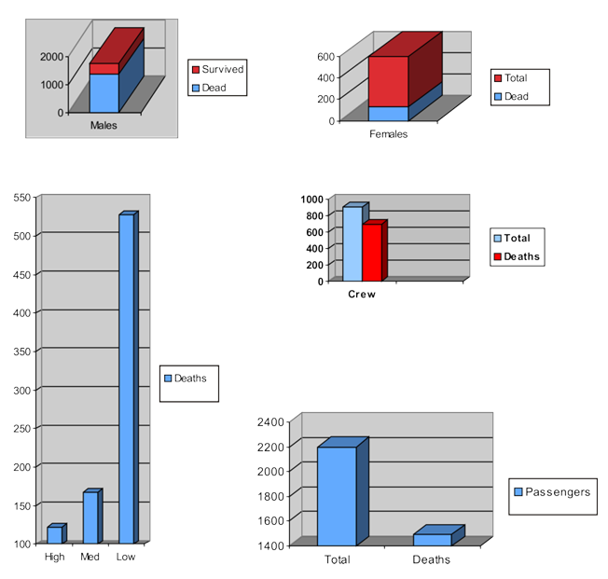

(Adapted from http://curriculum.qed.qld.gov.au/kla/eda/
© Education Queensland, 1997)
3.5.2: Homework Data

 | Time Spent Daily on Homework (min.) | Average Grade for the Class  (%) | Amount of Time Spent Daily Watching TV (min.) | Amount of Time Spent Daily Doing Chores (min.)
September | 85 | 73% | 64 | 30
October | 79 | 73% | 116 | 35
November | 48 | 75% | 183 | 32
December | 15 | 70% | 212 | 37
January | 39 | 68% | 205 | 29
February | 8 | 66% | 215 | 28
March | 10 | 69% | 198 | 32
April | 14 | 70% | 168 | 33
May | 26 | 72% | 83 | 28
June | 3 | 71% | 45 | 20

Unit 3: Day 6: Three Types of Data |  |  |  | Grade 7
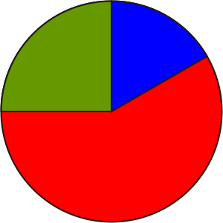 |  | Math Learning Goals  - Distinguish between types of graphs that compare quantities (bar graph, double bar graph) and those that show change over time (broken line, continuous line, multiple line graphs).  - Distinguish between discrete, categorical, and continuous data. |  | Materials  - BLM 3.6.1
Assessment
Opportunities
 | Minds On… | Individual → Analyse Various Representations of Data  Cut BLM 3.6.1 into 16 pieces and ask each student to choose one piece. Students form groups of four by matching their representation of a set of data with other representations of the same data.  To help students decide whether they have discrete, continuous, or categorical data, ask:  - Which group has a broken line graph? What does this mean about the possibility of points between, before, or after the given values? (Answer: It is possible to have values here, i.e., any value is possible) (continuous data.)  - Why can’t other sets of data be presented as a broken line graph? (Answer: Only certain values will be possible) (discrete data)  - Which group has data that has been collected according to a grouping or a category? Describe the groupings or categories. (categorical data)  - Which of the discrete data is also categorical? |  | First two datasets are categorical. Third dataset is continuous. Last dataset is discrete.  Ensure that all three types are chosen.
 | Action! | Whole Class → Guided Experiment  Ask students for examples of questions that would provide data that was continuous, discrete, and categorical, using the topic of soup.  Record and organize their responses under the headings: continuous, discrete, and categorical.  Some possible answers:  - Continuous: How many ml of soup does your bowl contain?  - Discrete: How many times per week do you have soup?  - Categorical: What type of soup do you like best?  Students give examples of questions that would provide data that was continuous, discrete, and categorical, using the topic of shoes.  Organize and record their responses under the headings: continuous, discrete, and categorical.  Some possible answers:  - Continuous: What is the length of your shoe?  - Discrete: How many eyelets are in each of your shoes?  - Categorical: What colour are your shoes?  Groups of 4 → Collecting Data  Each group selects one of the three types of data and decides how to collect data, using the questions generated for the shoes experiment. They collect and represent their data for sharing with the class.  Curriculum Expectations/Demonstration/Checkbric: Assess students’ ability to organize data and explain their reasoning for displaying it using their choice of graph.
 | Consolidate Debrief | Groups of 4 → Presentation  Students compare the data they collected and the ways in which they organized recorded the data. Students explain why their graphical representation is consistent with the type of data they collected.
Application  Concept Practice |  | Home Activity or Further Classroom Consolidation  Identify some data. Choose a topic such as growth of plants, sports, clothes. Provide examples of all three types of data, and explain how you would collect and organize this data.

3.6.1: Discrete, Categorical, and Continuous Data
January  January  December  March  April  June  June  June  August  December  March  June | March  February  December  August  August  June  June  July  September  January  March  June  October |  |  | Therefore, most people were born in the month of June.
  Birth Month | Frequency
  January | 3
  February | 1
  March | 4
  April | 1
  May | 0
  June | 7
  July | 1
  August | 3
  September | 1
  October | 1
  November | 0
  December | 3

Winter (M)  Winter (F)  Autumn (M)  Winter (F)  Spring (M)  Spring (M)  Spring (M)  Spring (F)  Summer (M)  Autumn (F)  Winter (M)  Spring (F) | Winter (M)  Winter (M)  Autumn (F)  Summer (M)  Summer (F)  Spring (M)  Spring (M)  Summer (M)  Summer (M)  Winter (F)  Winter (M)  Spring (M)  Autumn (F) |  |  | Therefore, more boys than girls were born in the first half of the year.
  Season | Frequency
  Season | Male | Fem.
  Winter | 5 | 3
  Spring | 6 | 2
  Summer | 4 | 1
  Autumn | 1 | 3

 | First week 12  Second week 10  Third week 8 |  | Therefore, the plant has been growing steadily over three weeks.
  Height of the Plant (cm)
  Oct. 7 | 16
  Oct. 9 | 22
  Oct. 11 | 28
  Oct. 14 | 36
  Oct. 15 | 40
  Oct. 17 | 46
  Oct. 21 | 52
  Oct. 24 | 56
  Oct. 26 | 60

 | First week 78  Second week 126  Third week 117 |  | Therefore, Allyson read more towards the end of the three weeks than at the beginning, except for the last day.
  The Thief Lord (book)
  Oct. 7 | 36
  Oct. 9 | 17
  Oct. 11 | 25
  Holes (book)
  Oct. 14 | 42
  Oct. 15 | 36
  Oct. 17 | 48
  Maniac Magee (book)
  Oct. 21 | 51
  Oct. 24 | 52
  Oct. 26 | 14

Unit 3: Day 7: Introduction to Circle Graphs |  |  |  | Grade 7
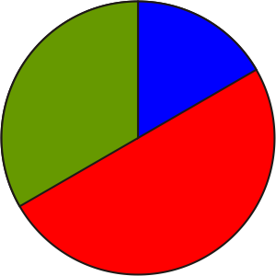 |  | Math Learning Goals  - Create circle graphs using different methods.  - Estimate the percents, fractions, and degrees found in circle graphs.  - Understand that a circle graph represents parts of a whole. |  | Materials  - string  - masking tape  - coloured sticky notes  - BLM 3.7.1
Assessment
Opportunities
 | Minds On… | Whole Class → 4 Corners  Pose the question: Do you think school uniforms should be mandatory? Students proceed to a corner of the room based on their opinion (agree, agree but, disagree, disagree but). Provide a different colour sticky note at each corner. To identify their opinion, they wear a sticky note, e.g., agreeing students wear a green stickynote.  Whole Class → Kinaesthetic Graphing  Students line up to make a human bar graph based on their opinion. Point out this is one way to represent their (categorical) data. Students think of another method.  The whole class forms a circle, keeping opinion groups (same colour sticky notes) together on the circumference of the circle. Place tape on the floor to show central angles. Place the ends of four long strings to the floor at the centre of the circle, and extend them to the circle at each point where the opinions change.  Ask: How is this new graph similar to the bar graph? different? What does it show?  Discuss characteristics of the circle graph with a focus on the relationship of the parts to a whole. Record data for future use. |  | Lead students to say a circle graph, if necessary.  Word Wall  • circle graph  • central angle  Reinforce the idea that circle graphs are used to represent and compare parts of a whole.
 | Action! | Whole Class → Discussion  Students record characteristics of a circle graph. Ask:  - If the whole class agreed that school uniforms should be mandatory, how many degrees would that be? (360 degrees)  - If the whole class was in disagreement with school uniforms being mandatory, what percent of the class would that be? (100%) How many degrees is that on a circle graph? What if half the students agreed? (percent, degrees, fraction, etc.)  Students represent selected parts of the circle (e.g., , , , , ) as a fraction, decimal, and percent on BLM 3.7.1.  Use the school opinion data to create a sample circle graph as a model for students, on an overhead of BLM 3.7.1.  Individual → Graphical Representation  Students use spreadsheet data collected in Day 4 or use other data provided, to create a circle graph (BLM 3.7.1). They include a title, label percents, etc. Students provide a written description of the story the data tells and explain and justify how they divided their circle.  Representing/Demonstration/Checkbric: Assess students’ ability to represent data and explain their reasoning.
 | Consolidate Debrief | Whole Class → Discussion  Discuss strategies for comparing and connecting, fractions, percentages, and central angles. Ask: What is a circle graph used for?  Students respond with examples of when a circle graph is used to display data.
Application  Practice |  | Home Activity or Further Classroom Consolidation  Represent the data with a circle graph and write an explanation of the story the data tells. Be prepared to share your ideas with the class. |  | Select textbook questions that are on a total of 100 cases, and result in simple fractions (e.g.,).

3.7.1: Template for Circle Graph

Unit 3: Day 8: Calculating Percents/Angles for Circle Graphs |  |  |  | Grade 7
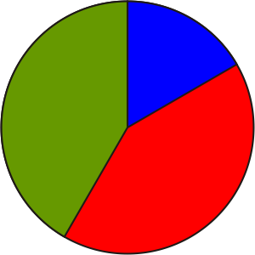 |  | Math Learning Goals  - Create a circle graph by calculating percentages to determine the central angles.  - Use a protractor to measure the central angles. |  | Materials  - BLM 3.8.1  - fraction circles  - protractors
Assessment
Opportunities
 | Minds On… | Small Groups → Discussion  Students share their circle graphs and explanations from previous day’s Home Activity. Circulate to identify students who may have selected a strategy that can be used when uncommon fractions are involved, (to calculate central angles).  Whole Class → Demonstration  Using an overhead, demonstrate the steps and strategies to create a circle graph. Use fraction circle pieces to reinforce the connection between fractions, percents, and degrees. Once they have calculated the degrees they use a protractor to accurately measure and construct central angles of the circle graph. |  | This leads to methods for angle calculation:  Central angle with degrees = (fraction of the whole) × 360 or central angles in degrees = (percent of whole) × 360.
 | Action! | Pairs → Constructing Circle Graphs  Students display data represented in a relative frequency table (BLM 3.8.1) as a circle graph (BLM 3.7.1). Students relate frequencies to fractions, to percents, and to angles.  Curriculum Expectations/Application/Checkbric: Assess students’ ability to apply their understanding of the relationships between fractions, percents and the central angle in a circle graph.  Differentiated Instruction  - Provide circle graphs showing percents by 10% increments around the diameter.  - Provide circle graphs showing degrees in increments of 10%.
 | Consolidate Debrief | Whole Class → Discussion  Reinforce the strategies and steps used to create a circle graph. Include probing questions such as:  - If the calculated percentages add up to 110, what does this indicate?  - If the total calculated degrees have a sum of 340 degrees, what should you do?  Reinforce the concepts that the sum for the percents must be 100 and the sum of the angles must be 360 degrees.
Application  Concept Practice  Reflection |  | Home Activity or Further Classroom Consolidation  Choose some data and create a circle graph. List the steps you took to make the circle graph and prove with more than one strategy that your circle graph is accurate. |  | Suggest newspapers, magazines, textbooks, etc., as sources of data.  Or, provide various sets of data from which students make a selection.

3.8.1: Creating a Circle Graph

Survey results of favourite sports in Grade 7.
Subject | Frequency | Fraction | Percent | Degree Calculation
Hockey | 25
Soccer | 50
Lacrosse | 10
Basketball | 10
Other
Totals | 100

Survey results for the favourite types of music of students in Grade 7.
Type of Music | Frequency | Fraction | Percent | Degree Calculation
Country | 8
Pop | 20
Rap | 8
Other | 4
Totals | 40

Survey results of number of siblings.
Number of Siblings | Frequency | Fraction | Percent | Degree Calculation
0 | 50
1 |  |  | 50%
2 | 150
3+
Totals | 500

Unit 3: Day 9: Which Graph Is Best? |  |  |  | Grade 7
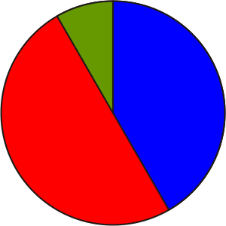 |  | Math Learning Goals  - Illustrate the same set of data using a tally sheet, frequency table, bar graph, line graph, pictograph, and circle graph.  - Determine which graph best conveys the information (consider bias, audience).  - Compare features of each type of graph that would lend themselves best to support a statement. |  | Materials  - BLM 3.9.1  - computers with spreadsheet program (optional)  - chart paper
Assessment
Opportunities
 | Minds On… | Think/Pair/Share → Anticipation Guide (1 oral question only)  Pose the statement, I can use any type of graph I wish to represent data. Agree or disagree? Students indicate agreement or disagreement. Quickly record the data from this survey.  Whole Class → Orientation to the Problem  Using an overhead of the data (on BLM 3.9.1), have the problem read aloud.  Pose the questions:  - What point do you want to make?  - What type of graph would you use? Why? |  | Possible themes for the letter to the editor include:  - gas prices are rising  - gas pricing favours Location B residents
 | Action! | Pairs → Analysing Graphs  Students examine several types of graphs on the same data, using BLM 3.9.1. In pairs, they discuss the pros and cons of each.  Reasoning and Proving/Application/Rating Scale: Assess students’ ability to choose a particular graph to display data, noting the reasoning related to their choice.
 | Consolidate Debrief | Whole Class → Discussion  Develop a Venn diagram on the differences and similarities between two types of graphs or data representation tools, e.g., a line graph and a tally sheet. Students revisit the Anticipation Guide. Ask the oral question from Minds On… again.  Individual → Representing  Students complete an individual Venn diagram on two different types of graphs or data representation tools of their choice. Collect these and provide individual feedback, as required.
Exploration  Reflection |  | Home Activity or Further Classroom Consolidation  Find examples of graphic representation of data (in textbooks, newspapers, Internet, magazines, etc.) Reflect on whether that is the best representation for the data, considering the audience and the title (statement).

3.9.1: Average Gas Prices

Analyse the data and decide what statement you want to make about gas prices. Choose the graph that best supports your statement and justify your choice. Write a letter to the newspaper editor to support your statement. Include the graph.

Data
 | Location A  ¢ / L | Location B  ¢ / L
June 27 | 87.2 | 87.2
June 28 | 89.0 | 86.6
June 29 | 87.0 | 86.2
June 30 | 87.2 | 85.4
July 1 | 86.6 | 85.4
July 2 | 84.0 | 85.3
July 3 | 85.5 | 84.2
July 4 | 84.5 | 84.3
July 5 | 86.7 | 86.6
July 6 | 89.1 | 87.8
July 7 | 89.5 | 87.6
July 8 | 93.9 | 90.0
July 9 | 91.9 | 89.1
July 10 | 92.6 | 89.1
July 11 | 93.7 | 89.6

3.9.1: Average Gas Prices (continued)
Representations
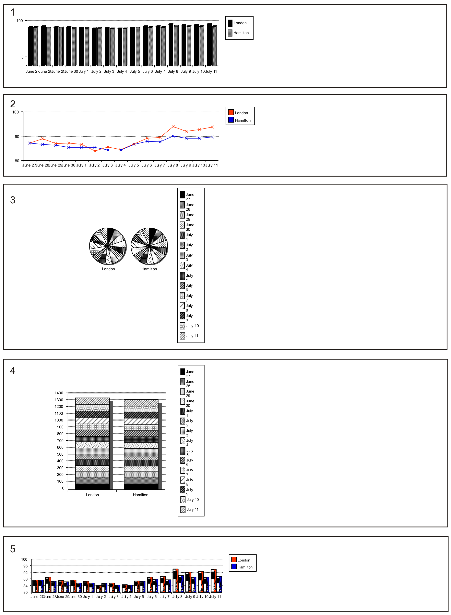
Unit 3: Day 10: Going Around in Circles |  |  |  | Grade 7
 |  | Math Learning Goals  - Display data using a circle graph.  - Identify inaccuracies and bias in data. |  | Materials  - BLM 3.10.1  - a spreadsheet program
Assessment
Opportunities
 | Minds On… | Groups of 4 → Activating Prior Knowledge  Cut out and place the 10 bottom cells on BLM 3.10.1 in envelopes. Distribute one envelope to each group. Groups sort the descriptions under the proper category in the chart.  Whole Class → Discussion  Use Day 5’s collection of data on the amount of time spent on homework to discuss where there could have been sources of inaccuracy or bias in the data collection, e.g., Does “homework time” include time spent off task, such as getting a snack, taking a phone call?  Lead a discussion: Based on the data you have collected, could I surmise that the students in our school, on the average, spend x minutes on homework?”  Discuss how this may be biased since only Grade 7 was surveyed.  Discuss that the data that is a census for the class data (if all students provided data) now represents a sample for the rest of the school, rather than a census. |  | Alternate suggestion:  Students compare homework data from Tuesday through Friday.  Collect and provide feedback to individual students as required  See Think Literacy topic Shared Writing.
 | Action! | Individual → Practice  Students use a spreadsheet program or create a circle graph by hand based on the data collected about homework, e.g., percentage of the day, proportion of the homework time actually on task, time spent on each subject.  They write “the story” that the graph tells, and the conclusions that can be drawn from the graph. They include the graph with it.  Communicating/Demonstration/Checkbric: Assess students’ ability to interpret a graph and to describe it in words.
 | Consolidate Debrief | Whole Class → Summarizing  Prepare a shared writing note to summarize bias in data collection, the use of circle graphs, and data that represents either a sample or a census, depending on the population under consideration.  Revisit the earlier discussion about increasing accuracy of the data concerning amount of time spent on homework to collaboratively set criteria for the next round of data collection.
Application  Exploration |  | Home Activity or Further Classroom Consolidation  Set up a recording sheet based on the criteria for time spent on homework identified in class, and collect detailed data on exactly how the time is used. Bring the data to share with the class.  Prepare a circle graph.

3.10.1: What Doesn’t Fit?

Sort
Feature of a circle graph | Not a feature of a circle graph

- - - - - - - - - - - - - - - - - - - - - - - - - - - - - - - - - - - - - - - - - - - - - - - - - - - - -

Displays categorical data | Has a scale
Has a vertical axis | Represents data with pictures
Has a title | A graph that shows data points
Displays continuous data | Uses fractions or percents
Compares the parts to the whole | Divides a circle into categories

Unit 3: Day 11: Investigating Mean, Median, Mode, and Outliers |  |  |  | Grade 7
 |  | Math Learning Goals  - Investigate mean, median, and mode and the effect of outliers on the measures of central tendency.  - Create stem-and-leaf plots to organize data. |  | Materials  - BLM 3.11.1  - measuring tapes  - calculators  - linking cubes
Assessment
Opportunities
 | Minds On… | Whole Class → Review  Review mean, median, and mode and informally assess prior knowledge of the topic using an overhead of the data on BLM 3.11.1.  Discuss how measures of central tendency help us to interpret data. Use coloured linking cubes in columns of 3, 4, 5, 6, 7 to represent these quantities and to demonstrate mean, median, and mode. Rearrange columns of cubes to clearly illustrate the concepts of mean, median, and mode.  Add a sixth column of 30 cubes. Recalculate mean, median, and mode. Rearrange cubes to visually reinforce the large increase in mean and minimal increase in median. Note that mean is significantly altered by extreme values (outliers), while the median is not significantly affected by outliers.  Curriculum Expectations/Oral Questioning/Mental Note: Assess students’ prior knowledge of measures of central tendency. |  | See LMS website “My Professional Practice” for a video clip example.  Word Wall  - outlier  Construction of stem-and-leaf plot may need to be reviewed.  Students may want to update this data with the most recent NBA data for professional basketball players.  The discussion and answers will vary depending on the size of each data set.
 | Action! | Whole Class → Data Gathering  Students gather data on the height of adults – musicians, hockey players, relatives, teachers in the school, etc. – and record it in centimetres.  Individual → Constructing Stem-and-Leaf Plots  Students use collected data to construct a stem-and-leaf plot, calculating mean, median, and mode for the data set. Add heights of basketball players to the stem-and-leaf plot. Recalculate mean, median, and mode.  Possible NBA data: George Muresan, 231 cm; Mugsy Bogues, 160 cm; Yao Ming, 229 cm; Shaquille O’Neil, 216 cm; LeBron James, 203 cm.
 | Consolidate Debrief | Whole Class → Discussion  Discuss the effect of adding heights of basketball players (outliers) on each measure of central tendency.  Ask:  - Was each measure affected equally?  - Which measure would be the most accurate representation of the expanded data set?  Students justify their answers.
Application  Concept Practice  Reflection  Practice |  | Home Activity or Further Classroom Consolidation  The following test marks were collected: 75, 68, 47, 55, 88, 76, 82, 73, 79, 80, 70, 64, 76, 55, 73, 76, 68.  Create a stem-and-leaf plot and calculate the mean, median, and mode. Three students wrote the test late. Their marks were 98, 92, 94.  Did the new outliers affect the median more than the mean? What is the best measure of central tendency for this data? Explain your thinking.

3.11.1: Mean, Median, Mode

Measures of Central Tendency

Definitions and Examples

MEAN: (Average)
e.g., the mean of 4, 7, 13, 17, 19 is
MODE: the number that occurs most often in the data set
e.g., for 3, 4, 6, 6, 6, 7, 7, 9 the mode is 6
MEDIAN: obtained by arranging the numbers in order and choosing the middle number; where there is a even number of numbers, take the mean of the two middle numbers
e.g., for 1 3 7 9 13, the median is 7

The measure of central tendency you use depends on the situation and what you are trying to discover from the data.

Coach has two strong basketball players. She needs to review both of their free-throw records as part of their MVP evaluation.

Robin’s record for the last 11 games:
2 6 6 8 0 2 6 10 6 6 4

Sam’s record for the last 11 games:
0 10 9 10 0 0 1 4 5 9 8

Calculate the mean, median, and mode for both basketball records.
What is the best record?

How do you know?

Unit 3: Day 12: And the Data Says... |  |  |  | Grade 7
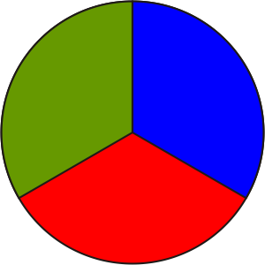 |  | Math Learning Goals  - Distinguish between facts and inferences.  - Analyse graphs to extract information from the data, find relationships within the data, and use data to draw conclusions.  - Interpolate to make predictions within the graphed region. |  | Materials  - BLM 3.12.1, 3.12.2
Assessment
Opportunities
 | Minds On… | 4 Corners → Brainstorm  Place one of the following statements in each of the four corners of the room: Data is like a light…camera…library…music CD because ... Students go to one of the four corners, based on their choice. In their corners, groups discuss the analogy, and then share their reasons and ideas with the larger group.  Groups of 4 → Reading Graphs  Form groups of four with one student from each of the corners, if possible. Groups discuss and complete the BLM 3.12.1, justifying their answers.  Whole Class → Discussion  Guide a discussion on the labelling of the axes in each scenario, e.g., The person’s distance from John’s house.  Students place appropriate units on each axis.  Ask:  - Are the speeds represented by these graphs realistic?  - What facts can we be sure about by looking at the graphs, and what inferences can be made? |  | All answers are correct – focus on the reasoning.  Sample answers: Facts after labelling axis: took 2 minutes to get to the store, stayed there for 2 minutes, took 5 minutes to get back. Inference: travelled to the store and back at a steady rate. After 1 minute Jared is halfway to the store.
 | Action! | Expert Groups → Jigsaw  In the same groups of four, each student selects one of graphs A–D. All the As, Bs, etc., form groups, and interpret the meaning of the “straight line” parts of the graph. The groups list inferences and make convincing arguments based on the graph. Students return to their original groups and report on the discussion.  Groups of 4 → Investigation  Students discuss and complete the questions on BLM 3.12.2 to consolidate the concept of fact versus inference, and interpolate to make predictions within the graph.  Curriculum Expectations/Observation/Checkbric: Observe students’ ability to analyse graph and extract information from the data.
 | Consolidate Debrief | Whole Class → Discussion  Discuss answers from 3.12.2, paying particular attention to Part A, questions 3  and 4, and Part B, questions 4 and 5.
Application  Concept Practice |  | Home Activity or Further Classroom Consolidation  Create a graph to tell the story of your trip to and from school. Write the story in words.

3.12.1: Where Are They Going?

Match each graph to a story below. Write each letter beside its story.

A | 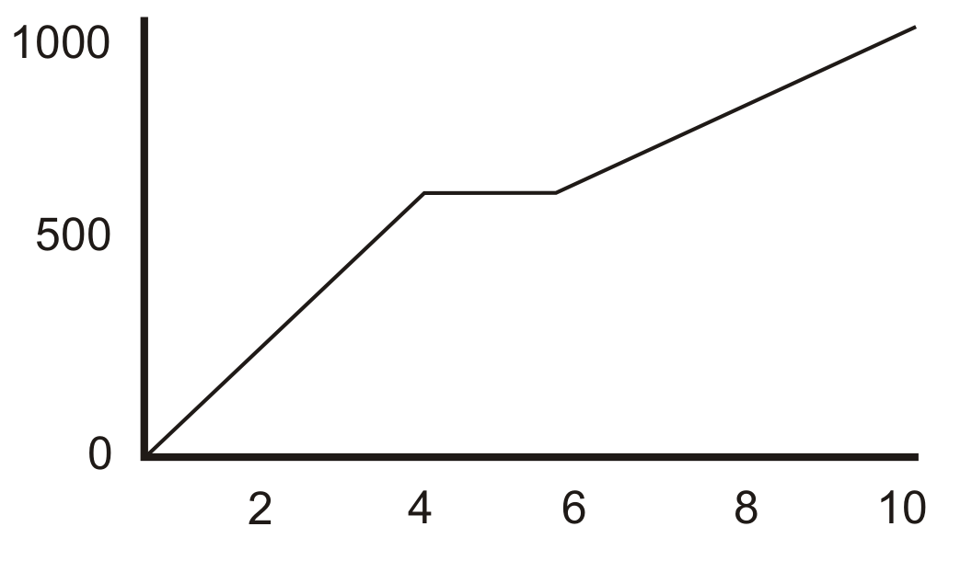 | B | 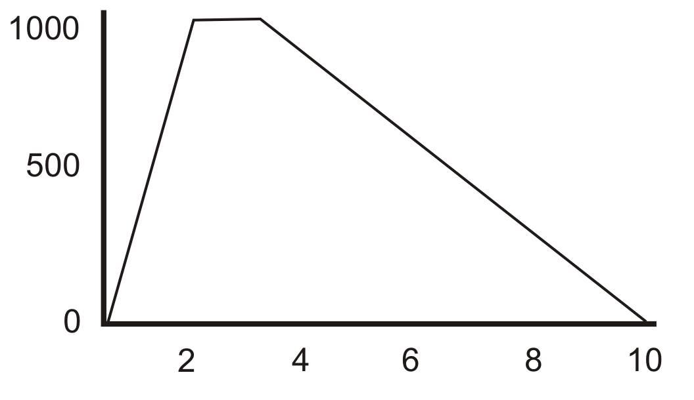
C | 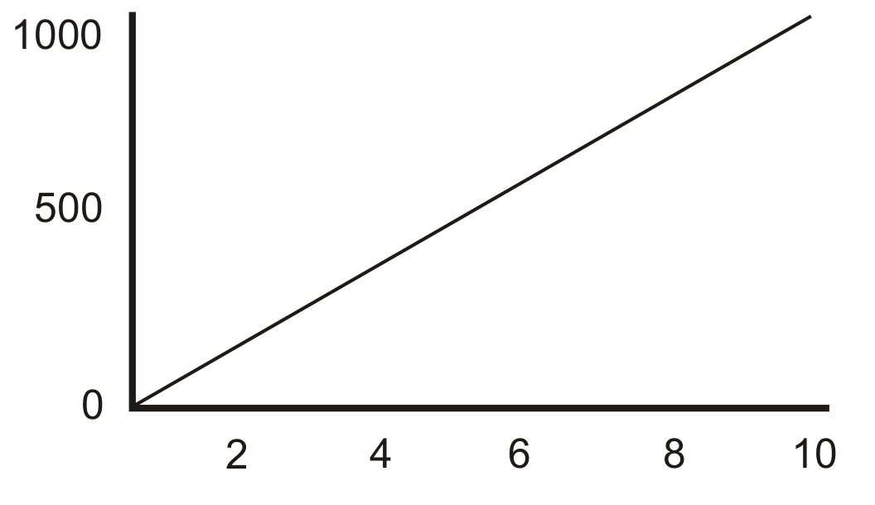 | D | 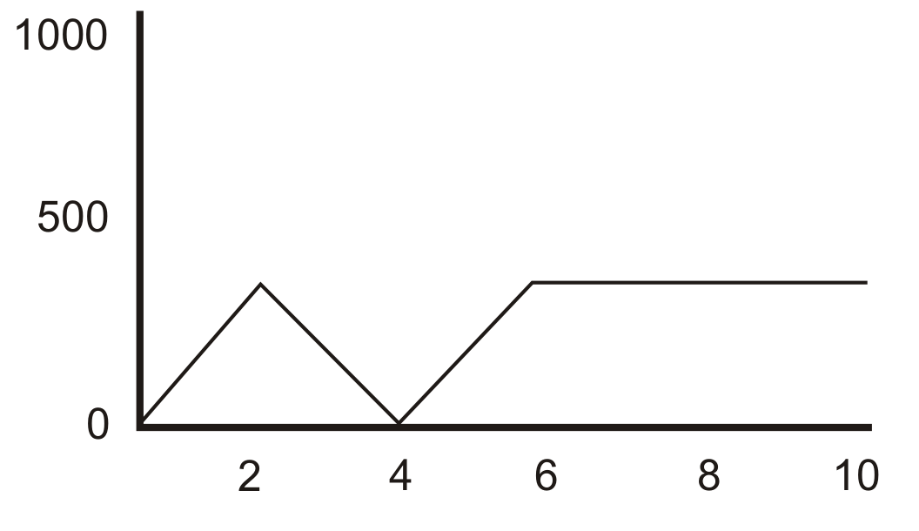

_____ Jared hurries to the store before it closes, buys milk, then drives home more slowly.

_____ Mona bikes to her work, but then remembers that she has forgotten her purse. She bikes back home, picks up the purse, and bikes back to work.

_____ Tanika engages in her choice of daily physical education by jogging to school at a constant rate of speed.

_____ John gets a ride to a friend’s house, waits while his friend gets ready, then walks to school with his friend.

3.12.2: Mona’s Bicycle Ride from Home to Work

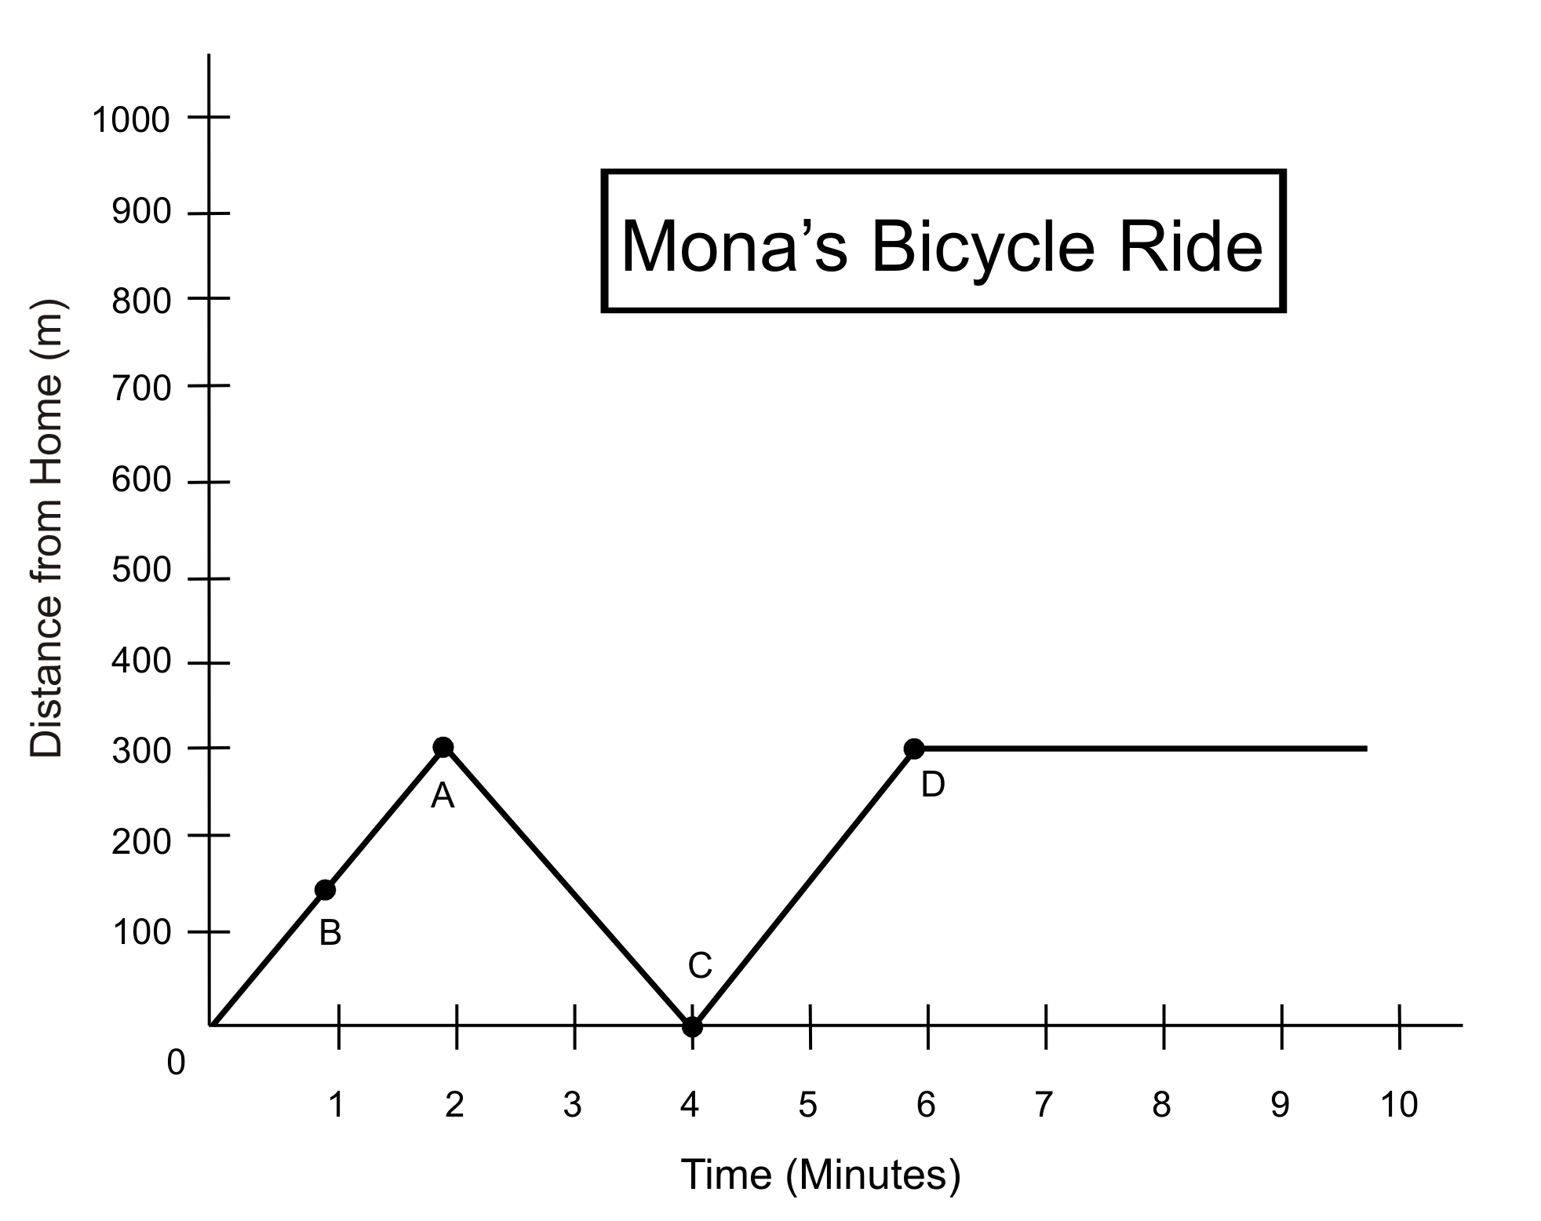

Part A: Interpolating to Determine Facts
Use information from the graph to help you determine the answers to the following questions.

1. How far did Mona ride in the first 2 minutes (point A)?
How do you know?

2. How long, after returning home, did it take Mona to travel 300 m (point D)?
How do you know?

Make up your own questions about points B and C:
3.

4.
3.12.2: Mona’s Bicycle Ride from Home to Work (continued)

Part B: Inferences
1. Are there any stop signs between Mona’s house and her work?
How do you know?

2. Was the purse close to the door?
How do you know?

3. Could Mona come home for lunch?
How do you know?

4. Work with your group to make up your own inference about Mona’s bike ride.

5. Based on these questions and on your answers, what do you think is the difference between a fact and an inference?

Part C: Tony Has a Glass of Milk

Are the following statements facts or inferences?

1. Tony drank the entire glass of milk. ____________

2. Tony likes milk. ____________

3. The glass was refilled only halfway. ____________

4. Tony asked for more milk after drinking the first glass. ____________

5. State a fact about Tony’s drink of milk.

6. State an inference about Tony’s drink of milk.

Unit 3: Day 13: Trends of Generosity |  |  |  | Grade 7
 |  | Math Learning Goals  - Identify trends found in data and graphs.  - Extend a graph to make predictions (extrapolate) beyond the graphed area.  - Determine if the extrapolated data makes sense. |  | Materials  - BLM 3.13.1  - placemat  - overhead of 3.13.1
Assessment
Opportunities
 | Minds On… | Groups of 4 → Placemat  Present the following data about test scores: “Test 1 – 89%, Test 2 – 93%,  Test 3 – 97%. Based on these test scores, what mark can I expect to get on  Test 8?” Justify your answer.  Each student responds to the question individually, then they consolidate their responses in the centre space.  Each group shares their group’s response. Compare responses.  Lead students to understand that extending data to make prediction has limitations. |  | See Think Literacy: Mathematics, Grades 7–9, pp. 2, 6
 | Action! | Small Groups → Exploration  Students preview and orally identify features of the text on BLM 3.13.1.  Ask leading questions to help students locate the information.  Students individually fill in all of the missing information as indicated by shaded areas. They read the information that is given to complete the graphs or charts and write the textual information that is missing, based on data in charts or graphs. Students who finish early can make an overhead of their graph for question 2.  Curriculum Expectations/Application/Rubric/Marking Scheme: Assess students’ ability to interpret and represent data. |  | See Think Literacy: Mathematics, Grades 7–9, pp. 2, 6
 | Consolidate Debrief | Whole Class → Discussion  Discuss the answers from BLM 3.13.1 using a variety of student graphs.  Lead students to realize that questions 2, 3, 5, and 6 will have a variety of correct answers. |  | See Think Literacy: Mathematics, Grades 7–9, pp. 2, 6
Concept Practice |  | Home Activity or Further Classroom Consolidation  Write a note that summarizes and illustrates the use of data to identify trends. Create a concept map using all of the words on our Word Wall. |  | Concept map (see Think Literacy Mathematics, Grades 7–9, p. 76)

3.13.1: Generosity in Canada

Generosity in Canada: Trends in Personal Gifts and Charitable Donations over Three Decades, 1969 to 1997

How generous are Canadians? How much of our incomes do we give to others? Are there differences in the generosity of people in different regions? Has our generosity changed over the past 30 years?
These are some of the questions addressed in a research report prepared by Senior Social Scientist Paul B. Reed as part of Statistics Canada’s Nonprofit Sector Knowledge Base Project.

Findings

1. Average Giving for All Canadian Homes
Over the past ______ years, the total average gifts or contributions per Canadian home rose steadily from $______ in 1969 to $2018 in 1997 (includes money and gifts).

Year | 1969 | 1978 | 1982 | 1986 | 1992 | 1996 | 1997
Amount | $1293 | $1063 | $1151 | $1427 | $1751 | $2292 | $2018

2. The graph below shows the information above in graph form, and extends the data to show the trend all the way to the present. (Make a graph by hand or electronically.)

3. Having data given in this way allows us to make inferences about charitable donations in Canada.
It would be unreasonable to make the inference that in 10 years donations will double; however, here are some inferences that we made, based on the data given:

3.13.1: Generosity in Canada (continued)

Data by Region

4. The chart below shows average donations for some of the regions of Canada.

Year | Atlantic ($) | Ontario ($) | Prairies ($)
1969 | 805 | 1176 | 1068
1978 |  | 1312 | 1482
1982 | 1109 | 1580 | 1580
1986 | 1490 |  | 1997
 |  | 1678 | 1928
1996 | 1546 | 2020 | 2036
Mean | 1235 | 1575

This is a graphical representation of the same data.

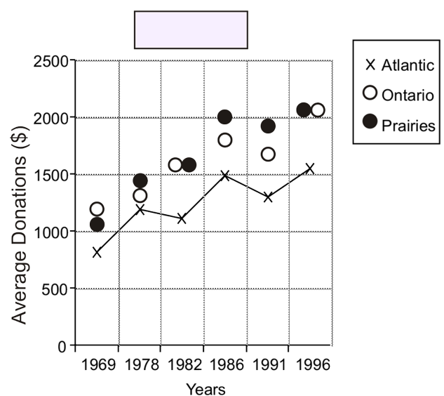

5. Here are some other interesting facts about the data above:

6. Are there any aspects of the presentation of this data that may be misleading?

Adapted from Statistics Canada: Nonprofit Sector, Catalogue no. 75F0033MIE, Issue no. 4

