Unit 2 Grade 7

Describing Patterns and on to Integers

Lesson Outline

BIG PICTURE

Students will:
- explore and generalize patterns;
- develop an understanding of variables;
- investigate and compare different representations of patterns;
- develop an understanding of integers (representation, ordering, addition and subtraction);
- develop strategies to add integers with and without the use of manipulatives;
- develop strategies to subtract integers with the use of manipulatives;
- recognize the use of integers in everyday life.
Day | Lesson Title | Math Learning Goals | Expectations
1 | Toothpick Patterns | - Represent linear growing patterns.  - Make predictions about growing patterns.  - Explore multiple representations. | 7m60, 7m61, 7m63  CGE 3c, 4f
2 | Patterns with Tiles | - Represent linear growing patterns.  - Make predictions about growing patterns.  - Compare pattern rules. | 7m1, 7m2, 7m60, 7m61, 7m63  CGE 4b
3 | Pattern Practice | - Represent linear growing patterns.  - Make predictions about growing patterns.  - Develop and represent the general term of a pattern. | 7m5, 7m60, 7m61, 7m62, 7m63  CGE 2c, 5e
4 | Pattern Exchange | - Use a variety of representations to describe a pattern (numbers, words, expressions).  - Represent linear growing patterns.  - Make predictions about growing patterns  - Develop and represent the general term of a pattern. | 7m6, 7m60, 7m61, 7m62, 7m63  CGE 2c, 5e
5 | Performance Task  (lesson not included) |  | 7m1, 7m6, 7m7, 7m60, 7m61, 7m62, 7m63  CGE 5g
6 | Patterning to Integers | - Extend understanding of patterns to addition and subtraction of integers. | 7m1, 7m2, 7m3, 7m26  CGE 3e
7 | What Are Integers? | - Investigate where integers appear in our daily lives. | 7m13, 7m14  CGE 4e, 5e
8 | The Zero Principle | - Represent integers with integer tiles.  - Recognize that “zero” may be represented as an equal number of positive and negative tiles, e.g., five positives (+5) and five negatives (−5) (i.e., the zero principle).  - Represent any integer in multiple ways. | 7m8, 7m14, 7m26  CGE 2a, 4a
9 | All Integers Come to Order | - Use correct integer notation (positive/negative, brackets).  - Order integers on an integer line. | 7m14  CGE 2c, 5a, 5e, 5d
Day | Lesson Title | Math Learning Goals | Expectations
10 | Add Some Colour | - Add integers using integer tiles.  - Apply the zero principle.  - Use correct integer notation (positive/negative, brackets). | 7m14, 7m26  CGE 5a, 4f
11 | What’s Right About Adding and What’s Left to Count?  GSP®4 file:  Integer | - Consolidate integer addition with integer tiles.  - Add integers using number lines.  - Compare the two methods for addition of integers. | 7m14, 7m26  CGE 3c, 5e
12 | Adding On! | - Add integers using integer tiles, number lines, and symbols.  - Investigate the effect on mean, median, and mode of adding or removing a value. | 7m14, 7m26, 7m80  CGE 2c, 5a, 5e, 5g
13 | Carousel | - Add integers using a variety of tools. | 7m14, 7m26  CGE 3c, 4e
14 | What’s the Difference? | - Investigate how subtraction is related to addition.  - Subtract integers using integer tiles. | 7m14, 7m26  CGE 4b, 5e
15 | Integer Fun | - Add and subtract integers using a variety of tools. | 7m14, 7m26  CGE 3c, 4a
16 | Summative Assessment Task – Part 1  (lesson not included) |  | 7m14, 7m26  CGE 2b, 3c, 4e, 4f
17 | Summative Assessment Task – Part 2  (lesson not included) |  | 7m14, 7m26  CGE 2b, 3c, 4e, 4f

Unit 2: Day 1: Toothpick Patterns |  |  |  |  | Grade 7
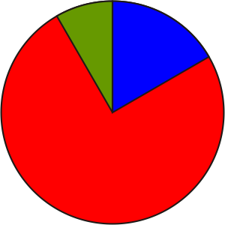 |  |  | Math Learning Goals  - Represent linear growing patterns.  - Make predictions about growing patterns.  - Explore multiple representations. |  | Materials  - toothpicks  - BLM 2.1.1
Assessment
Opportunities
 | Minds On ... |  | Whole Class → Discussion  Students contribute to a class concept map about patterning. Based on their experiences with patterning, they may identify types of patterns, materials for patterns, sample numerical or geometrical patterns, or applications of patterns.  Discuss why the ability to identify and discuss patterns is important. Ask a student to present a pattern on the board and another student to present a different type of pattern. Other students add the next term to each pattern and explain their thinking. Include different types of patterns, e.g., number, geometric, colour.  Curriculum Expectations/Oral Questioning/Mental Note: Assess students’ understanding of patterns, and their confidence in using them to help plan further instruction. |  |  | Distinguish between a growing or diminishing pattern and a constant design.  People use patterns to investigate and represent complex relationships existing in many areas, including nature and science.  See LMS Library, My Professional Practice, Multiple Representations – Pattern Building.  Note: The “n^{th} term” might be new to students.
 | Action! |  | Pairs → Exploration  On an overhead, create the first two terms of the toothpick pattern presented on BLM 2.1.1. Ask a student to create the third term.  In pairs, students continue the pattern with their toothpicks, and complete  BLM 2.1.1.  Encourage students to look at different ways to build the 5th term, the 25th term, the n^{th} term, etc. There is no right way to formulate the construction of a term.  Students discuss solutions with their partners. Stress that each partner may have a different entry in the Understanding column but should have the same value in the Number of Toothpicks column (BLM 2.1.1).
 |  | Consolidate Debrief | Whole Class → Discussion  Students share their approaches.  Discuss different entries in the Understanding column, highlighting the validity of all representations. Students should represent their patterns using words and numbers, but may not be using variables at this point.  It is important that students understand the limitation of recursive representations, e.g., add three to the last term. Students should move to more sophisticated patterning, e.g., predicting the number of toothpicks required by consideration of the term number.
Concept Practice |  |  | Home Activity or Further Classroom Consolidation  Design another toothpick pattern, building and recording the first three terms. Explain your pattern.  Consider how many toothpicks would be required to build the 100th term in the pattern.

2.1.1: Toothpick Patterns

Name:

Date:

1. Build this pattern with toothpicks.

Term 1 |  | Term 2 |  |  | Term 3

2. Build the next two terms in the pattern.

3. Complete the chart. Put a numerical explanation of the number of toothpicks required in the Understanding column.

Term | Number of Toothpicks | Understanding
1
2
3
4
5

4. How many toothpicks would you require to build the 100th term? Explain your thinking.

5. Explain how to build the 100th term another way.

Unit 2: Day 2: Patterns with Tiles |  |  |  |  | Grade 7
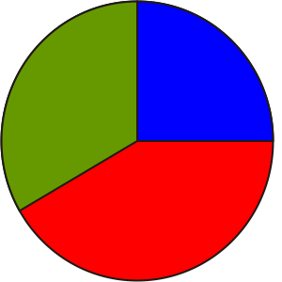 |  |  | Math Learning Goals  - Represent linear growing patterns.  - Make predictions about growing patterns.  - Compare pattern rules. |  | Materials  - colour tiles  - BLM 2.2.1
Assessment
Opportunities
 | Minds On ... |  | Whole Class → Review  Review concepts related to patterns, and that pattern building can be expressed in different ways.  Selected students share patterns that they developed (Home Activity, Day 1). students share their predictions about the number of toothpicks required for the 100th term and the strategies for verifying their responses.  Students reflect on how they built each term in the pattern.  Curriculum Expectations/Presentation/Checkbric: During the discussion collect diagnostic information on:  - which students are developing and using simplistic patterns;  - which students are developing more complex patterns;  - which students are ready to use variables. |  |  | Using a variable in reference to a term number contrasts use of a variable as a placeholder for a single unknown value in a linear equation.  Not all students will be ready for the formal use of a variable early in  Grade 7, but most students should be comfortable with this later in  Grade 7.  Some students may choose to use variables.  Word Wall  - term  - term number  - variable
 | Action! |  | Pairs → Investigation  Based on observations from the class discussion, pair students homogeneously according to their development level to allow for targeted assistance during the activity.  Student pairs complete BLM 2.2.1. Circulate, inviting each partner to share her/his description.
 |  | Consolidate Debrief | Whole Class → Discussion  A pair models one representation for the tile pattern, writing the pattern clearly in words.  Students compare the various descriptions of the pattern, as well as the different representations (words vs. numeric vs. algebraic) and discuss the advantages of each. Students should see that the various descriptions all represent the same situation, and they should look for connections between the descriptions.
Concept Practice  Exploration  Skill Drill |  |  | Home Activity or Further Classroom Consolidation  Revisit your toothpick pattern. Find two other ways to express your pattern. Consider other rules for generating the same pattern and/or express the pattern using variables, if appropriate.  In your math journal, answer one of the following:  - Describe how you use patterns in your hobbies.  - Look around your neighbourhood. Describe the patterns you see, either numeric or geometric.  - Consider art, poetry, or music, and give examples of where patterns are used in one of these arts.

2.2.1: Patterns with Tiles

Name:

Date:

1. Build the first five terms of this sequence using light and dark tiles.

2. Complete the table.

Term Number | Number of  Light Tiles | Understanding | Term Number | Number of  Dark Tiles | Understanding
1 |  |  | 1
2 |  |  | 2
3 |  |  | 3
4 |  |  | 4
5 |  |  | 5

3. a) How many dark tiles are there in the 10th term? Explain your reasoning.

b) How many light tiles are there in the 10th term? Explain your reasoning.

4. How many light tiles are there in the 100th term? Explain your reasoning.

5. Describe a strategy for working out how many dark tiles and how many light tiles are needed to build any term.

Unit 2: Day 3: Pattern Practice |  |  |  |  | Grade 7
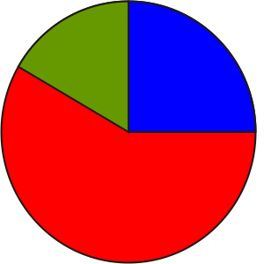 |  |  | Math Learning Goals  - Represent linear growing patterns.  - Make predictions about growing patterns.  - Develop and represent the general term of a pattern. |  | Materials  - manipulatives, e.g., tiles, toothpicks  - BLM 2.3.1, 2.3.2
Assessment
Opportunities
 | Minds On ... |  | Groups of 4 → Placemat  To heighten their awareness of linkages between mathematics and life experiences, students share the ideas they determined about using patterns (Home Activity Day 2). |  |  | Some students may move to abstract representations, while others may continue to use concrete materials.  It is important to value a variety of responses to set the stage for algebraic manipulations introduced when one representation is more appropriate for particular applications.  Students should recognize that some representations should be based on the term number, not the value of the previous term (i.e., functional, not recursive).
 | Action! |  | Small Group → Practice  Students work in groups of three to complete BLM 2.3.1. Provide assistance, as required. The table provided may help students identify patterns.  On chart paper or on the board, students record their responses to b) and c) for each of the patterns.  Allow a portion of the class for students to add their method for describing the 20th and the n^{th} terms.  Students determine which patterns are generated by adding/subtracting or multiplying/dividing by a constant to obtain the next term.  Note: Students may respond using a variety of representations (words and/or algebraic expressions). Students’ descriptions of their pattern and their representations may vary; however, their representations should be equivalent.
 |  | Consolidate Debrief | Pairs → Sharing  Students read the responses posted from one section of BLM 2.3.1, make some individual interpretations, and ask clarifying questions of each other.  Students identify equivalent expressions that look significantly different and explain how they determined equivalency. Students could discuss the equivalency of different representations and expressions, e.g., different but equivalent representations may be “double the number” or “add the number to itself” or “multiply the number by two” or “2n.”  Representing/Oral Questioning/Anecdotal Note: Assess their ability to recognize and express patterns using different but equivalent representations.
Concept Practice |  |  | Home Activity or Further Classroom Consolidation  Complete worksheet 2.3.2. Have an adult answer your three questions. Pay close attention to the process that they use to answer these questions. Record their process in your math journal and identify if it is the same or different from your process.  Bring your worksheet to class.

2.3.1: Pattern Practice

Name:

Date:

For each example below:
a) build the first few terms of the pattern
b) write at least two different ways to describe how to build the 20th term
c) write at least two different ways to describe how to build the n^{th} term
d) determine which patterns are generated by adding, subtracting, multiplying, or dividing by a constant to get the next term

1. Use square tiles:

Term Number | Number Tiles/ Picks/Cubes | Description
1
2
3
20
n

2. Use square tiles:

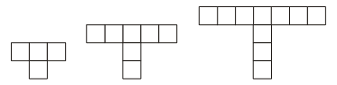
Term Number | Number Tiles/ Picks/Cubes | Description
1
2
3
20
n
2.3.1: Pattern Practice (continued)

3. Use toothpicks:


Term Number | Number Tiles/ Picks/Cubes | Description
1
2
3
20
n

4. Determine the number of faces that you can see in each term:
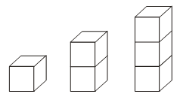

Term Number | Number Tiles/ Picks/Cubes | Description
1
2
3
20
n

2.3.2: Pattern Posing


Name:

Date:

Create your own pattern using tiles, toothpicks, or another material.

Materials used:

A drawing of the first three terms of my pattern.

Three questions someone could answer about my pattern:
1.

2.

3.

Term Number | Number Tiles/ Picks/Cubes | Description
1
2
3
20
n

Unit 2: Day 4: Pattern Exchange |  |  |  |  | Grade 7
 |  |  | Math Learning Goals  - Use a variety of representations to describe a pattern (numbers, words, expressions).  - Represent linear growing patterns.  - Make predictions about growing patterns.  - Develop and represent the general term of a pattern |  | Materials  - colour tiles  - toothpicks  - BLM 2.4.1
Assessment
Opportunities
 | Minds On ... |  | Individual → Represent the Pattern  Present a pattern using interlocking cubes:  - a rectangular prism of base 4 and height 1;  - a rectangular prism of base 4 and height 2;  - a rectangular prism of  base 4 and height 3, etc.  Students record their responses.  Whole Class → Discussion  Students examine some equivalent expressions and justify that they are.  Curriculum Expectations/Observation/Anecdotal Note: Identify students who are still defining patterns recursively in order to provide some direct assistance. |  |  | By generating multiple responses for one question, the teacher shows that reasoning and proving is valued, and also that correct answers and a variety of representations are important.  Students should go to the author for clarification, rather than the teacher.
  Term Number | Number Tiles/ Picks/Cubes | Description
 | Action! |  | Individual → Applying Understanding  Use a chain to redistribute the students’ completed BLM 2.3.2. (See Differentiated Instruction, below.)  Students record their responses to the questions (BLM 2.4.1). They write the name of the person whose questions they are answering. Use a chain to redistribute questions again so that another student responds to the patterns.  Differentiated Instruction  The sharing of BLM 2.3.2 could happen within three groups in the classroom. The first group can consist of students who are comfortable creating general terms and who may use algebraic representation. The second group can consist of those students who encounter slight difficulty with the concept but are usually able to express a general term, perhaps using words. The third group could be made up of the students identified by the teacher in the Minds On… section who are identifying the terms recursively only. The teacher may choose to work directly with the third group on the process for generating a rule based on the term number.
 |  | Consolidate Debrief | Whole Class → Discussion  Students share interesting patterns that they encountered and some of the dialogue that occurred during the activity.
Reflection  Concept Practice |  |  | Home Activity or Further Classroom Consolidation  In your math journal, reflect on your individual skill development.  Can you:  - extend a pattern?  - describe a pattern in words?  - use a pattern to make a prediction?  - determine a specific term (such as the 100th term) by referencing the term number rather than the previous term?  - use appropriate language to describe the pattern?  Complete the practice questions.
 |  |  |  |  |  | Provide students with appropriate practice questions.

2.4.1: Pattern Posing

Name:
Term Number | Number Tiles/ Picks/Cubes | Description
1
2
3
20
n

Name:
Term Number | Number Tiles/ Picks/Cubes | Description
1
2
3
20
n

Unit 2: Day 6: Patterning to Integers |  |  |  | Grade 7
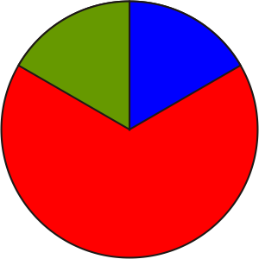 |  | Math Learning Goals  - Extend understanding of patterns to addition and subtraction of integers. |  | Materials  - BLM 2.6.1
Assessment
Opportunities
 | Minds On… | Whole Class → Discussion  Curriculum Expectation/Demonstration/Marking Scheme: Using the students’ responses to the Home Activity Day 5, assess their understanding of patterns.  Discuss number patterns that exist in the world, e.g., house numbers.  Provide a list of numbers and have students predict the next number. |  | It may be helpful to display an integer number line –10 to 10.  This is intended for students to recognize that patterning is a reliable way to “discover” how to do something they have not been taught.  This is not a replacement for the concrete development and conceptual understanding of the addition and subtraction of integers.  Students do not need to memorize these rules, but they should keep the page for future reference.
 | Action! | Pairs → Investigation  Each pair creates a number pattern, and writes a strategy to describe how to get the terms. They trade with another pair to find the next five terms in the pattern and then determine a rule or strategy. They compare strategies.  Students fill in the columns for questions 1 and 2 (BLM 2.6.1). They should know the first few results from previous knowledge; they complete the pattern to fill in the columns.  Discuss the results and the student-generated rules and strategies with the class for questions 1 and 2 before they complete question 3. Then discuss the results of question 3 and the student-generated rules and strategies.
 | Consolidate Debrief | Whole Class → Discussion  Lead the class in a discussion about how patterning is one strategy that can be used to solve problems. Explain that in mathematics patterns are often used to understand other concepts, e.g., adding and subtracting integers.
Application  Reflection |  | Home Activity or Further Classroom Consolidation  - Look in the newspaper, on the Internet, or in magazines to find examples of negative numbers being used in the world. Include these examples in your journal.  OR  - List as many situations as you can think of where integers are used.

2.6.1: Patterns in Integer Operations

1. Look for a pattern to complete the chart. Fill in the first few columns using your knowledge of addition.
Starting Number | Operation: Addition (+) | Add to | Result:
2 | + | 3 | 2 + 3 = 5
2 | + | 2 | 2 + 2 =
2 | + | 1 | 2 + 1 =
2 | + | 0 | 2 + 0 =
2 | + | –1 | 2 + (–1) =
2 | + | –2 | 2 + (–2) =
2 | + | –3 | 2 + (–3) =
2 | +
2 | +

Starting Number | Operation: Addition (+) | Add to | Result:
1 | + | 3 | 1 + 3 =
1 | + | 2
1 | + | 1
1 | + | 0
1 | + | –1
1 | + | –2 | 1 + (–2) =
1 | + | –3
1 | +
1 | +

a) What pattern did you use to get your results when you got past a result of zero?

b) Look at the pattern. Describe a rule or strategy you could use for adding a positive number to a negative number.

2.6.1: Patterns in Integer Operations (continued)

2. Look for a pattern to complete the chart. Fill in the first few rows using your knowledge of addition and subtraction.
Starting Number | Operation: Subtraction (–) | Subtract | Result:
5 | – | 3 | 5 – 3 =
5 | – | 2
5 | – | 1
5 | – | 0
5 | – | –1
5 | – | –2 | 5 – (–2)
5 | – | –3
5 | – | –4

Starting Number | Operation: Subtraction (–) | Subtract | Result:
3 | – | 3
3 | – | 2 | 3 – 2 =
3 | – | 1
3 | – | 0
3 | – | –1 | 3 – (–1) =
3 | – | –2
3 | – | –3
3 | – | –4

a) What pattern did you use to get your results when you got past the first four rows?

b) Look at the pattern. Describe a strategy you could use for subtracting a negative number from a positive number.

2.6.1: Patterns in Integer Operations (continued)

3. Look for a pattern to complete the chart. Fill in the first few rows using your knowledge of addition and subtraction.
Starting Number | Operation: Subtraction (–) | Subtract | Result:
2 | – | 0 | 2 – 0 =
 |  | 1 | 2 – 1 =
 |  | 2 | 2 – 2 =
 |  | 3 | 2 – 3 =
 |  | 4 | 2 – 4 =
 |  | 5 | 2 – 5 =
 |  | 6
 |  | 7

Starting Number | Operation: Subtraction (–) | Subtract | Result:
4 | – | 0
 |  | 1
 |  | 2
 |  | 3
 |  | 4
 |  | 5
 |  | 6
 |  | 7

a) What pattern did you use to get your results when you had to subtract a larger number from a smaller number?

b) Describe a strategy you could use for subtracting a larger number from a smaller number.

Unit 2: Day 7: What Are Integers? |  |  |  |  | Grade 7
 |  | Math Learning Goals  - Investigate where integers appear in our daily lives. |  |  | Materials  - thermometer transparency  - BLM 2.7.1, 2.7.2  - number line  –20 to 20
Assessment
Opportunities
 | Minds On… | Small Groups → Brainstorm  Students suggest where numbers below zero are used in daily life, e.g., temperature, golf, above/below sea level, football, stock market, banking, hockey statistics. Students should refer to journal entries from Day 6.  Present students with an integer, either positive or negative, and discuss possible meanings of that number. For example:  - What does it mean if a person’s bank account is $50.00?  - If a person were at –5 m in the ocean, what would this mean? What might the person be doing?  - If it were +30º C, would a person need to wear a jacket? Why or why not? |  | Placemat or Pass the Paper are effective strategies.  In a game of Teams A vs. B with the score at 2 to 1 for team A, an A player who was on the ice for both goals would have +2, but if he were also on the ice when team B scored, his rating would drop to +1, i.e., +2 + (–1).  Teachers may have students search for recent data or data on their favourite team instead of using BLM 2.7.2.
 | Action! | Whole Class → Guided Investigation  On the overhead projector, display BLM 2.7.1.  Ask:  - What information does the chart show?  - Which city had the highest temperature?  - Which city had the lowest temperature?  - Which city had the greatest temperature difference? How do you know?  - Which city had the smallest temperature difference? Explain.  - Which city had a change in temperature of 50 degrees? Explain.  Students respond to the questions.  Pairs → Find points on a number line  Introduce the number line and identify some + and – values. Clarify what the +/– ratings on a hockey roster mean (BLM 2.7.2). The ratings reflect the season up to the last game played. The + means that a player has been on the ice when more goals were scored for/by the team than against the team. The − means that a player has been on the ice when more goals were scored against the team than for/by the team. Using the data on BLM 2.7.2, students work in pairs to order the players according to their +/– score on a number line.  Curriculum Expectations/Observation/Mental Note: Observe students for understanding of positive and negative integers on a number line.  Whole Class → Discussion  Students’ respond to the following:  Your team is trailing by one goal and you have pulled your goaltender. Which six players would you put on the ice? Justify your decision using the +/– rating from your number line. How did the number line help? What does a +/– of zero mean?
 | Consolidate Debrief | Individual → Response Journal  Students summarize their learning, e.g., I learned…, I discovered…. They write a definition for positive and negative integers.
Application  Exploration |  | Home Activity or Further Classroom Consolidation  Explore these topics at the school or community library or on the Internet:  Find the elevations of the following locations:  Order them and determine the differences in heights.  - Visit the Environment Canada website (www.ec.gc.ca) to find the highest and lowest temperatures recorded in Canada. Record the date and the community in which these events occurred. Find the highest and lowest temperature recorded for your community. How do they compare?  OR  - Use the data on worksheet 2.7.1 to locate the cities and explain the varying temperatures in relation to their geographic location.
  a) Your city or town | b) Mount Everest
  c) Grand Canyon | d) Amsterdam

2.7.1: Temperature Extremes in Canadian Cities

April | Extreme High | Extreme Low | Difference in Temperature
Calgary | 29 | –30
Edmonton | 31 | –28
Halifax | 25 | –13
Iqualuit | 7 | –34
Montreal | 31 | –15
Ottawa | 31 | –17
Regina | 33 | –6
St. John’s | 29 | –15
Toronto | 31 | –17
Vancouver | 25 | –3
Whitehorse | 21 | –29
Winnipeg | 34 | –26
Yellowknife | 20 | –41

1. What information does the chart show?
2. Which city had the highest temperature?
3. Which city had the lowest temperature?
4. Which city had the greatest temperature difference? How do you know?

5. Which city had the smallest temperature difference? Explain.

6. Which city had a change in temperature of 50 degrees? Explain.

2.7.2: Hockey Statistics (from ESPN)

Name:
Date:

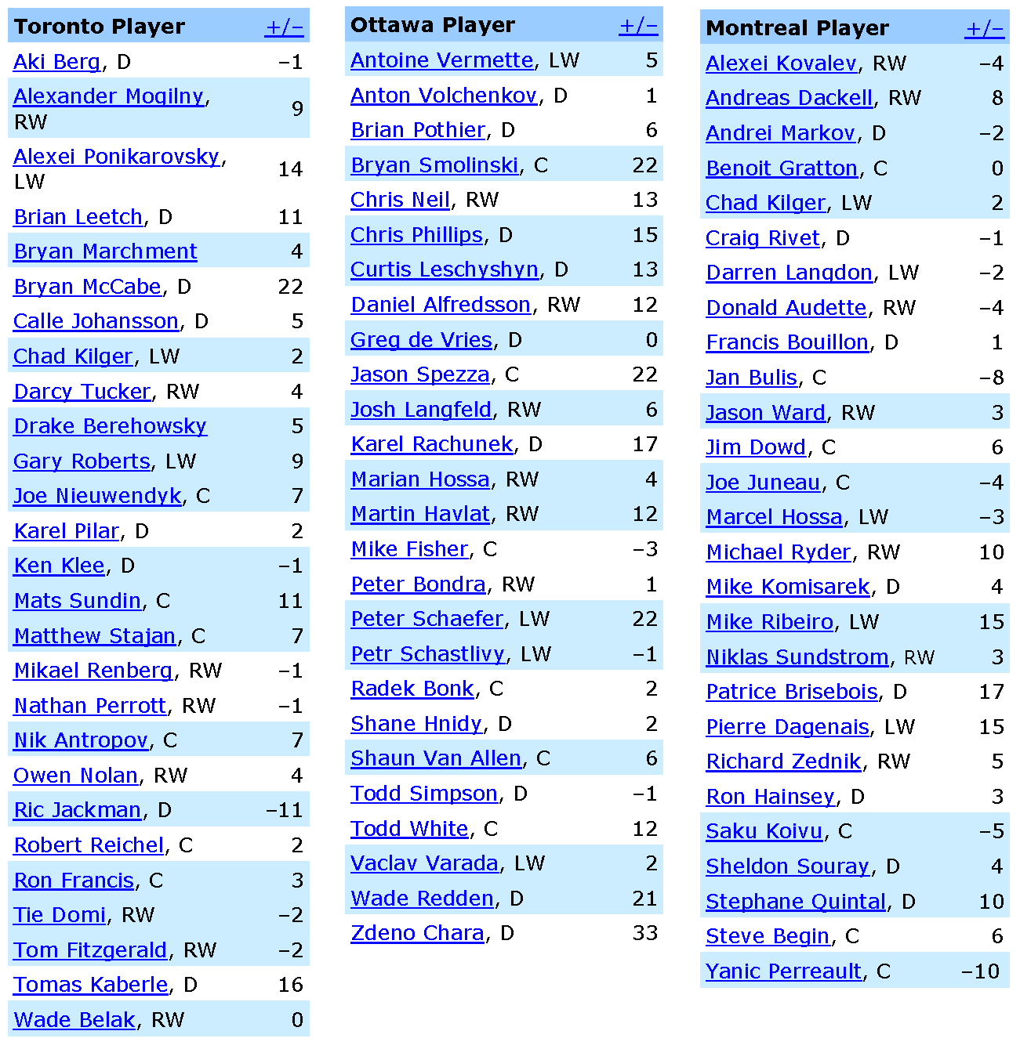

Unit 2: Day 8: The Zero Principle |  |  |  |  |  | Grade 7
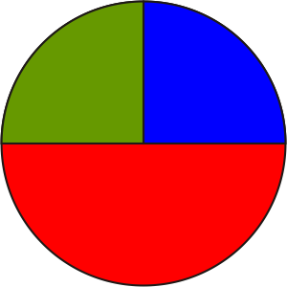 |  | Math Learning Goals  - Represent integers with integer tiles.  - Recognize that “zero” may be represented as an equal number of positive and negative tiles, e.g., five positives, (+5) and five negatives (–5) (i.e., the zero principle).  - Represent any integer in multiple ways. |  |  |  | Materials  - integer tiles: double-sided, two-colour  (red +, blue –) disks
Assessment
Opportunities
 | Minds On… | Whole Class → Guided Exploration  Show students a positive and a negative integer tile. State that they represent  +1 (red) and –1 (blue).  Show three red tiles and ask what integer is represented (+3). Show four blue tiles and ask what integer is represented (–4). Continue until students are clear about the concepts of value and sign.  Students use integer tiles to respond to the following questions:  - How could we represent zero (0)?  Students should offer multiple models using the tiles (+1 and –1, +2 and –2, etc). Recall the hockey roster activity and the meaning of zero.  - How would you represent three (+3)?  Guide students toward not only 3 positive tiles, but also a combination of positives and negatives, e.g., 5 red and 2 blue. Connect solutions to the “zero principle” when it applies. |  |  |  | Transparent overhead integer tiles are effective for modelling.
 | Action! | Pairs → Investigation  Using integer tiles, students model the integers –2 and +1, three different ways each. They record their models.  Whole Class → Discussion  Ask: How many different ways did you find for representing these integers? Guide students toward the understanding that there is an infinite number of ways. Lead students to accept “equal numbers of red and blue tiles” as a model of zero.  Pairs → Problem Solving  Students select three numbers and create three different ways to represent each number. They share their solutions and reasoning with their partner. Partners check for correctness.
 | Consolidate Debrief | Whole Class → Presentation  Partners share one number and representation with the rest of the class. Students who had the same number with different representation can add theirs to the list.  Curriculum Expectations/Presentation/Anecdotal Note: Note students’ understanding of different models of zero.
Application  Exploration  Reflection |  | Home Activity or Further Classroom Consolidation  Find everyday instances of “opposites” that produce a result of 0. For example, in banking a balance of 0 means that deposits and withdrawals are equal. Filling a tank with gas, then using it, produces a result of 0.  For each scenario, identify the meaning of positive, negative, and zero.
Unit 2: Day 9: All Integers Come to Order |  |  |  |  | Grade 7
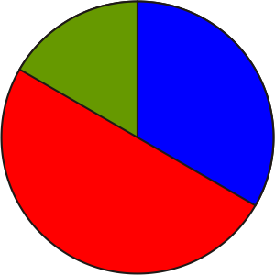 |  | Math Learning Goals  - Use correct integer notation (positive/negative, brackets).  - Order integers on an integer line. |  |  | Materials  - integer cards  - BLM 2.9.1  - thermometer on overhead
Assessment
Opportunities
 | Minds On… | Small Groups → Discussion  Groups discuss the questions:  - Which is greater: –5 or 2? Justify your response with an everyday example.  - When can a two-digit integer be greater that a three-digit integer?  Pairs → Think/Pair/Share  Students briefly think about and record independently, the process that they would use to find the greater of two integers. They share strategies with a partner and then they share them with the whole class. |  |  | Students should have considered all possibilities, i.e., – –, – +, + –, + +  Prepare integer cards with enough consecutive integers for the entire class, e.g., –15 to +15.  Show students how to use the +/– or the (–) key on the calculator. Point out that the calculator does not explain how the answer was determined. They could use the calculator as a checking device.  Q represents Quotients, or rational numbers.  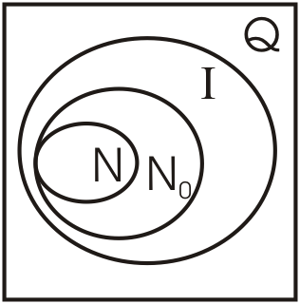  Two- and three-digit numbers appear on both the left- and right-hand sides of the number line, but the value of the left-hand side number is very small. Values increase going to the right, but decrease going to the left.
 | Action! | Whole Class → Guided Practice  - Each student is given a different integer card. Students order themselves in a line according to the integer on their card.  Use a thermometer placed horizontally with the negative numbers to the left to demonstrate the concept visually. Ask: Which integer is closest to zero? Which side of the zero has the negative integers? Which side has the positive integers?  - One pair at a time holds up its integer cards. Students determine which is greater or smaller and the number of spaces from one integer to the other.  - One student shows his/her number. Ask: Who has the integer 3 less? The student who has that card stands up and the first student sits down. Ask: Who has the integer that is 2 more? And so on.  - Illustrate how brackets are sometimes used around integers to keep them separate from the mathematical operations of addition and subtraction. Include a discussion of the inclusionary nature of number sets. (Rational numbers – fractions, decimals include integers, which in turn include whole numbers, which in turn include natural numbers.)  - Draw a large Venn diagram, and assign different types of numbers to different students. Students show and explain where on the Venn diagram their number belongs.
 | Consolidate Debrief | Whole Class → Discussion  Review the concept that integers can represent a comparison between a number and a standard or baseline. Discuss the use of integers to represent above and below, left and right, and less and more.  Discuss the placement of numbers along a number line.  Individual → Quiz  Students complete BLM 2.9.1.  Curriculum Expectations/Quiz/Marking Scheme: Students self-assess using BLM 2.9.1.
Exploration  Reflection |  | Home Activity or Further Classroom Consolidation  Write a journal entry about understanding of integers and the number line and include an explanation of how a set of random integers could be placed in order according to value. Use a real context in your explanation.

2.9.1: Integer Check

Name:
Date:

1. Circle the correct response to each of the following questions and explain your reasoning.

a) Integers, including zero, can be represented in many ways.

Always | Sometimes | Never

b) Which of the following situations could involve integers? (Circle as many as are correct.)

Banking | Temperature | Elevation | Sports

c) Each integer has an opposite, and the two numbers add to zero.
(Circle as many as are correct.)

Always | Sometimes | Never

d) Integers include the following number sets. (Circle as many as are correct.)

Whole Numbers | Natural Numbers | Fractions

2. Explain the meaning of zero in one of the following situations.

a) +/– in a hockey roster

b) golf scores

c) elevation

d) a bank account

3. Place the following set of integers in order from smallest to largest.
2, | –5, | 20, | 0, | –125, | 120, | –120, | 3, | –1, | –2, | 5
___ | ___ | ___ | ___ | ___ | ___ | ___ | ___ | ___ | ___ | ___

Unit 2: Day 10: Add Some Colour |  |  |  |  | Grade 7
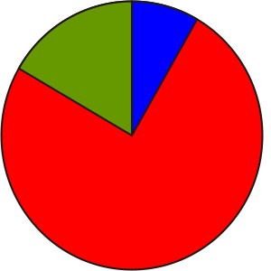 |  | Math Learning Goals  - Add integers using integer tiles.  - Apply the zero principle.  - Use correct integer notation (positive/negative, brackets). |  | Materials  - overhead integer tiles  - sets of integer tiles or two-coloured counters
Assessment
Opportunities
 | Minds On… | Whole Class → Discussion  Recall that banks use positive numbers to signify amounts deposited into an account, and negative numbers to signify amounts withdrawn. Lead a discussion based on the following scenarios: My bank account has $30.00 in it. If I deposit $5.00 today, how much will be in the bank account? If I withdraw $10.00 tomorrow, how much will be in the bank account?  Remind students of the hockey rating discussions from Day 7. At the start of one game, a player who had a +1 rating was on the ice when his team scored three goals. What was his rating after the game? (+4) In the next game, the same player with a rating of +4 had one goal scored against his line. What was his rating then? (+3) |  |  | Model these discussions using the overhead integer tiles.  Any two colours can be used for the integer tiles, but once decided, stay with those same colours.  Display questions and model on the overhead for clarity.  Line up a + and – tile to make zero before taking the pair away together from the demonstration.  Encourage variations in patterns such as  –5, –4, –2, 1, (add 1, then add 2, then add 3, etc.) or 2, 1, 3, 0, 4, –1, … (add –1, then add 2, then add –3, etc.).
 | Action! | Pairs → Guided Exploration  In pairs, students use integer tiles to represent the following integer addition questions: (+2) + (+6); (+1) + (+4); (–1) + (–3); (–5) + (–2), etc.  Discuss similarities and differences between adding two positive integers and adding two negative integers. Is their sum ever zero?  Pairs → Investigation  Students add integers with different signs.  Remind students that two counters, one of each type, are opposites and balance each other, making zero. For example: If there are 7 blues (–) and 5 reds (+), then there are two blues with 5 zero pairs, or –2. Demonstrate further addition questions on the overhead, using two-coloured tiles.  Students work in pairs to represent the following integer addition questions:  (–2) + (+6); (–1) + (+4); (+1) + (–3); (+5) + (–2), etc.  Pairs (A/B) → Exploration  Introduce the number pattern 5, 2, –1, –4, ….  Model the progression with tiles, i.e., continually adding three blue tiles, and note the results. One partner (A) models a new pattern with tiles, while the other partner (B) writes the pattern symbolically with integers. Some students demonstrate their work using the concrete materials.  Learning Skills (Teamwork)/Observation/Anecdotal Note: Observe students’ cooperation with others.
 | Consolidate Debrief | Whole Class → Discussion  Discuss other models of representing integer addition.  - Could a hockey player’s +/– rating be displayed by a line graph?  - Could banking deposits and withdrawals be represented by a bar graph? Link the zero principle to each graph.
Differentiated  Exploration Application  Connections |  | Home Activity or Further Classroom Consolidation  - Make up number patterns that include negative integers that can be verified using tiles.  OR  - Construct graphs to display examples discussed to date, including the number patterns.

Unit 2: Day 11: What’s Right About Adding and What’s Left to Count? |  |  |  | Grade 7
 |  | Math Learning Goals  - Consolidate integer addition with integer tiles.  - Add integers using number lines.  - Compare the two methods for addition of integers. |  | Materials  - BLM 2.11.1  - sets of integer tiles  - large cards with numbers –4 to 4
Assessment
Opportunities
 | Minds On… | Whole Class → Problem Solving  Pose the problem: If a spider climbs 3 metres up a water spout during the day, then slides back down 2 metres every night, how many days does it take to reach the top of a 10-metre spout?  Discuss multiple ways to model and solve this problem. Using the integer addition sentence (+10) + (+20), prompt students to ask a question related to everyday life whose answer could be determined by this addition sentence, e.g., if the spider climbed 10 metres up the water spout today, and 20 m tomorrow, how high will the spider be?  Pairs → Connecting  Write five symbolic representations of addition sentences on the board. In pairs, students write corresponding questions. |  |  | Answer:  It takes eight days for the spider to reach the top.  A diagram, number line, integer tiles, integer addition, and graphs are useful.  Technology alternative for any part of lesson:  Integer.gsp  Add further visual cues, such as having the +3 person and the +1 person hold their hands up.  OR  model the trip with a visual drawing on the board.  Addition on the number line: start at 0, show first arrow, second arrow begins where first one ends, resulting destination is the sum.  See Elementary and Middle School Mathematics: Teaching Developmentally by John A. Van de Walle, p. 425, for more information on the coloured arrow techniques.  Students should use the word sum as the result of addition.
 | Action! | Whole Class → Modelling/Discussion  Nine volunteers line up, evenly spaced, facing the class to form a human number line. The 5th (middle) person represents 0. Students display numbers corresponding to their position. (–4 through 4)  Another student stands in front of the person represents 0 and then walks three places in the positive direction to stand in front of the person at +3.  Ask: What integer can represent the move so far? (+3) Record the response. This student walks one more place in the positive direction. Ask: What integer can represent this second move? (+1) Record this beside the previous answer. Demonstrate that the “trip” so far can be represented by the addition sentence (+3) + (+1), whose answer can be determined by looking at the volunteer’s current location. (+4)  Use a similar procedure for demonstrating addition of two negative integers, then a positive and a negative integer.  Connect the use of a number line to show integer addition to the questions on BLM 2.11.1 – always start at 0, use red arrows pointing to the right for positive integers, and blue arrows pointing to the left for negative integers.  Individual → Problem Solving  Students complete BLM 2.11.1, representing the addition questions with blue and/or red arrows, and determining answers.
 | Consolidate Debrief | Small Groups → Discussion  Students compare each of their answers against those of other group members and share their strategy for addition. Discuss as a class. Compare and connect to the strategies students developed on Day 6.  Curriculum Expectations/Self-Assessment/Checklist: Students reflect on their competency with addition of positive and negative integers, using a number line.
Concept Practice  Reflection  Problem Solving |  | Home Activity or Further Classroom Consolidation  Explain to another person the similarities and contrasts between using number lines vs. integer tiles to perform integer addition. Record thoughts in your math journal, along with your personal preference.

2.11.1: Integer Addition Using Number Lines

Name:
Date:

Show each number in the addition with a coloured arrow on the corresponding number line. Draw a third arrow to indicate the sum. The first one is done for you.

1. (+2) + (+6) = 8

–8 |  | –7 |  | –6 |  | –5 |  | –4 |  | –3 |  | –2 |  | –1 |  | 0 |  | 1 |  | 2 |  | 3 |  | 4 |  | 5 |  | 6 |  | 7 |  | 8

2. (–3) + (–4) =

–8 |  | –7 |  | –6 |  | –5 |  | –4 |  | –3 |  | –2 |  | –1 |  | 0 |  | 1 |  | 2 |  | 3 |  | 4 |  | 5 |  | 6 |  | 7 |  | 8

3. +5 + (–6) = (Note: Brackets around an integer are needed only after an operation symbol.)

–8 |  | –7 |  | –6 |  | –5 |  | –4 |  | –3 |  | –2 |  | –1 |  | 0 |  | 1 |  | 2 |  | 3 |  | 4 |  | 5 |  | 6 |  | 7 |  | 8

4. –7 + (+2) =

–8 |  | –7 |  | –6 |  | –5 |  | –4 |  | –3 |  | –2 |  | –1 |  | 0 |  | 1 |  | 2 |  | 3 |  | 4 |  | 5 |  | 6 |  | 7 |  | 8

5. +2 + (–2) =

–8 |  | –7 |  | –6 |  | –5 |  | –4 |  | –3 |  | –2 |  | –1 |  | 0 |  | 1 |  | 2 |  | 3 |  | 4 |  | 5 |  | 6 |  | 7 |  | 8

6. –5 + (+4) + (–3) =

–8 |  | –7 |  | –6 |  | –5 |  | –4 |  | –3 |  | –2 |  | –1 |  | 0 |  | 1 |  | 2 |  | 3 |  | 4 |  | 5 |  | 6 |  | 7 |  | 8

7. +1 + (–2) + (+3) + (–4) + 5 =

–8 |  | –7 |  | –6 |  | –5 |  | –4 |  | –3 |  | –2 |  | –1 |  | 0 |  | 1 |  | 2 |  | 3 |  | 4 |  | 5 |  | 6 |  | 7 |  | 8

Describe a strategy for adding integers.

Integer (GSP®4 file)

Integer.gsp

1  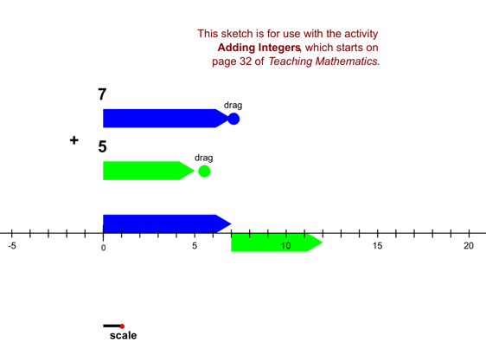 | 2  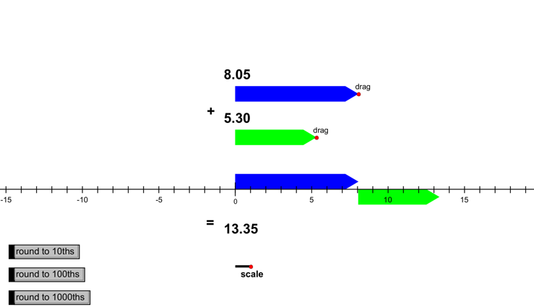
3  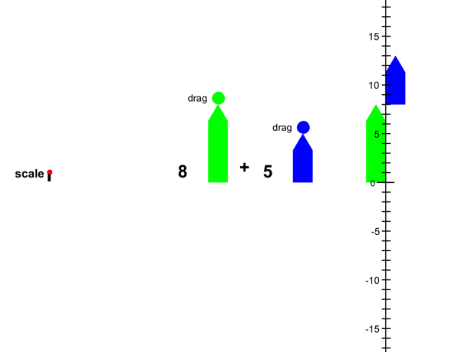 | 4  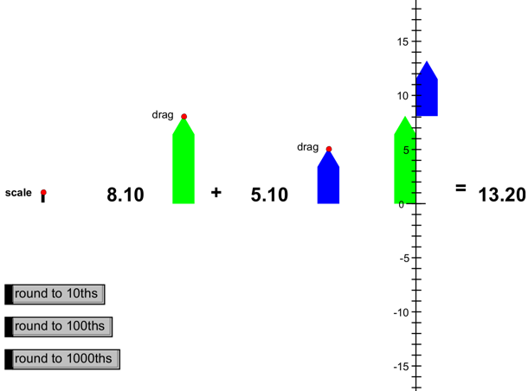

Unit 2: Day 12: Adding On! |  |  |  | Grade 7
 |  | Math Learning Goals  - Add integers using integer tiles, number lines, and symbols.  - Investigate the effect on mean, median, and mode of adding or removing a value. |  | Materials  - BLM 2.12.1, 2.12.2  - integer tiles
Assessment
Opportunities
 | Minds On… | Whole Class → Review  Review the definitions and differences between mean, median, and mode.  - Mean: arithmetic average  - Median: middle item in an ordered list  - Mode: the most frequently occurring item |  | Word Wall  - mean  - median  - mode  - par (even)  - birdie (–1, one under par)  - bogey (+1, one over par)  A more comprehensive study of the mean, median, and mode will be done in the next unit of study.
 | Action! | Pairs → Investigation  Discuss terminology and general ideas for the game of golf, e.g., par, birdie, bogey. Ask students what is meant by the numbers on the “leader board” at major golf tournaments such as –5, –3, even, +2.  Students work with their partners to complete BLM 2.12.1. Circulate to clarify and observe progress.  Student volunteers periodically fill in entries on an overhead version of the handout for students to check their progress.
 | Consolidate Debrief | Small Groups → Presentations  In groups of three or four, students share their responses and formalize justifications. Groups present their rationale to the remainder of the class.  Curriculum Expectations/Quiz/Marking Scheme: Assess addition of integers with or without manipulatives (BLM 2.12.2).
Application  Concept Practice  Reflection |  | Home Activity or Further Classroom Consolidation  Create a simple game that uses integers. It could include spinners, sets of cards, markers, number cubes, etc.

2.12.1: Fore!

Name:
Date:

Two students in your class are comparing their golf scores over and under par. Each claims to be the better golfer. Your task is to use your knowledge of integers and statistics to help make the decision of “Who is the better golfer?”

Note: All scores are relative to PAR on each hole. Therefore, +1 is one over par (bogey) and
–1 is one under par (birdie). Gord’s score on the 6th hole was the result of hitting his ball into the marsh.

Comparison to Par card:

Hole | 1 | 2 | 3 | 4 | 5 | 6 | 7 | 8 | 9 | PAR  (+/–)
Lisa | 0 | +1 | +2 | +3 | –1 | +2 | +3 | 0 | –1
Gord | –1 | +1 | 0 | +1 | –1 | +8 | +2 | –1 | –2

1. Who won the round? (low score wins) ___________

2. Who won the greatest number of holes? ___________

3. Determine the mean score for each golfer. Lisa: _____ Gord: _____

4. Who had the better mean score? ___________

5. Determine the mode score for each golfer. Lisa: _____ Gord: _____

6. Who had the better mode score? ___________

7. Determine the median for each player. Lisa: _____ Gord: _____

8. Who had the better median score? ___________

9. Using the information gathered, decide who you believe is the better player.
Justify your choice.

2.12.2: Integer Quiz

Name:
Date:

Use integer tiles, a number line, or your strategy to complete the following.

1. (+4) + (+2) = | 2. (–3) + (–5) =
3. +3 + (–7) = | 4. –5 + 0 =
5. –1 + (+6) = | 6. +8 + (–8)=
7. –5 + (–2) + (+8) = | 8. 4 + (–1) +(–2) + (+3) =

9. The temperature one morning was –6° C. It rose 13 degrees by the end of the day.
What was the high temperature? Make a number statement and state the answer.

10. On the first four games in the hockey season, Jane’s +/– results were +2, –1, –2, and –1.
What was her +/– score at that point in the season?

Unit 2: Day 13: Carousel |  |  |  | Grade 7
 |  | Math Learning Goals  - Add integers using a variety of tools. |  | Materials  - integer tiles  - BLM 2.13.1, 2.13.2, 2.13.3
Assessment
Opportunities
 | Minds On… | Whole Class → Instructions  Divide the class into groups and explain the carousel activity.  Remind students to record their answers for each station only on the Carousel Stations Response Sheet (BLM 2.13.2) and to wait for a signal to move to the next station. |  | Decide whether groups will be heterogeneous or homogeneous by demonstrated achievement in this unit. If the groups are homogeneous, the size of the groups could vary.  Place answers to one station at the next station so that groups can check their work as they move from station to station.  Select one station and create a checklist of proficiency skills that can be observed.
 | Action! | Small Groups → Carousel Activity  Groups rotate through all five stations, completing the required tasks. They complete their self-assessment sheet after each station.  Stations:  1. Integer Tile Addition – five questions to model integer addition with tiles  2. Number Line Integer Addition – five questions to model integer addition on a number line  3. Application Problems – four integer problems to solve in context  4. Make Up a Problem – diagram or graph showing positive and negative values that could represent an everyday situation  5. Symbolic Integer Addition – five questions to demonstrate their understanding of integer addition symbolically  Curriculum Expectations/Self-Assessment/Rating Scale: Students self-assess their understanding of integers (BLM 2.13.1).  Curriculum Expectations/Observation/Checkbric: Observe students for competency with integer models and applications.
 | Consolidate Debrief | Pairs → Game  Students play the integer games they created. They write comments suggesting what is good about the game and how it might be improved.
Reflection |  | Home Activity or Further Classroom Consolidation  - Complete a journal entry:  - What I understand about integer addition…  - What I need to improve upon…  - My plan is to…  OR  - Revise your game using your classmates’ feedback. Play the game again with a friend or family member.

2.13.1: Self-Assessment: Check Line

Name:
Date:

When you have finished the activity at each station, place an “X” on the appropriate line to indicate your assessment of your proficiency at the given task.

Station 1: Integer Tile Addition

I need more practice |  |  |  |  | Given time, I can do this |  |  |  |  |  |  |  | I’m an expert

Station 2: Number Line Integer Addition

I need more practice |  |  |  |  | Given time, I can do this |  |  |  |  |  |  |  | I’m an expert

Station 3: Application Problems

I need more practice |  |  |  |  | Given time, I can do this |  |  |  |  |  |  |  | I’m an expert

Station 4: Make Up a Problem

I need more practice |  |  |  |  | Given time, I can do this |  |  |  |  |  |  |  | I’m an expert

Station 5: Symbolic Integer Addition

I need more practice |  |  |  |  | Given time, I can do this |  |  |  |  |  |  |  | I’m an expert

Overall Reflection
I understand…

I need help with…

My plan is…
2.13.2: Carousel Stations Response Sheet

Name:
Date:

You may not be starting at Station 1, so be sure you are completing the appropriate part of this sheet at each station.

Station 1: Integer Tile Addition
Use the integer tiles to determine the sums. Record your answers below.

a) answer: ______

b) answer: ______

c) answer: ______

d) answer: ______

e) answer: ______

Complete the self-assessment for Station 1 on handout 2.13.1.

Station 2: Number Line Integer Addition
Use the number lines to determine the sums at this station. Record your answers.

a) answer: ______

-8 |  | -7 |  | -6 |  | -5 |  | -4 |  | -3 |  | -2 |  | -1 |  | 0 |  | 1 |  | 2 |  | 3 |  | 4 |  | 5 |  | 6 |  | 7 |  | 8

b) answer: ______

-8 |  | -7 |  | -6 |  | -5 |  | -4 |  | -3 |  | -2 |  | -1 |  | 0 |  | 1 |  | 2 |  | 3 |  | 4 |  | 5 |  | 6 |  | 7 |  | 8

c) answer: ______

-8 |  | -7 |  | -6 |  | -5 |  | -4 |  | -3 |  | -2 |  | -1 |  | 0 |  | 1 |  | 2 |  | 3 |  | 4 |  | 5 |  | 6 |  | 7 |  | 8

d) answer: ______

-8 |  | -7 |  | -6 |  | -5 |  | -4 |  | -3 |  | -2 |  | -1 |  | 0 |  | 1 |  | 2 |  | 3 |  | 4 |  | 5 |  | 6 |  | 7 |  | 8

e) answer: ______

-8 |  | -7 |  | -6 |  | -5 |  | -4 |  | -3 |  | -2 |  | -1 |  | 0 |  | 1 |  | 2 |  | 3 |  | 4 |  | 5 |  | 6 |  | 7 |  | 8

Complete the self-assessment for Station 2 on worksheet 2.13.1.
2.13.2: Carousel Stations Response Sheet (continued)

Station 3: Application Problems
Use the integer tiles or the number lines below to help solve the application problems. Record your answers.

-8 |  | -7 |  | -6 |  | -5 |  | -4 |  | -3 |  | -2 |  | -1 |  | 0 |  | 1 |  | 2 |  | 3 |  | 4 |  | 5 |  | 6 |  | 7 |  | 8

-8 |  | -7 |  | -6 |  | -5 |  | -4 |  | -3 |  | -2 |  | -1 |  | 0 |  | 1 |  | 2 |  | 3 |  | 4 |  | 5 |  | 6 |  | 7 |  | 8

-8 |  | -7 |  | -6 |  | -5 |  | -4 |  | -3 |  | -2 |  | -1 |  | 0 |  | 1 |  | 2 |  | 3 |  | 4 |  | 5 |  | 6 |  | 7 |  | 8

a) R.U. Ready’s score: ______ I.M. Set’s score: ______ Wynn Lots’s score: ______

The winner is ____________.

b) i) The next four integers are: _____, _____, _____, _____

ii) The next four integers are: _____, _____, _____, _____

c) i) The temperature in four hours: ______

ii) The temperature four hours ago: ______

Complete the self-assessment for Station 3 on worksheet 2.13.1.

Station 4: Make Up a Problem
Describe below an everyday situation that could be modelled by each graph at this station.

a)

b)

Complete the self-assessment for Station 4 on worksheet 2.13.1.
2.13.2: Carousel Stations Response Sheet (continued)

Station 5: Symbolic Integer Addition
Use the strategy you created for adding integers to determine the sums. Record your answers.

a) answer: ______

b) answer: ______

c) answer: ______

d) answer: ______

e) answer: ______

Complete the self-assessment for Station 5 on worksheet 2.13.1.

2.13.3: Carousel Stations

Station 1: Integer Tile Addition

Use the integer tiles to determine the sums.

a) (–5) + (+3)

b) (–5) + (–3)

c) +2 + (–6)

d) –4 + (–1) + (+6)

e) +1 + (+3) + (–4)

Check your answers at the next station.



Station 2: Number Line Integer Addition

Use the number lines provided for Station 2 on your copy of worksheet 2.13.2 to determine the sums.

a) (2) + (–6)

b) (–2) + (–6)

c) +4 + (–7)

d) +2 + (–1) + (+5)

e) –3 + (+8) + (–5)

Check your answers at the next station.
2.13.3: Carousel Stations (continued)

Station 3: Application Problems
Use integer tiles or the number lines provided for Station 3 on your copy of worksheet 2.13.2 to help solve the application problems.

a) Which person won the four-round golf tournament? (lowest score wins)
 | Round 1 | Round 2 | Round 3 | Round 4 | Final
R.U. Ready | –2 | 3 | –1 | –2
I.M. Set | 3 | –2 | –2 | –1
Wynn Lots | 1 | 0 | –2 | –2

b) What are the next four numbers in the following numerical patterns?
i) 4, 1, –2, –5
ii) –10, –5, –1, 2

c) The temperature is dropping at a rate of 2Cº per hour. If the present temperature is –8ºC, determine:
i) the temperature in 4 hours.

ii) the temperature 4 hours ago.

Check your answers at the next station.



Station 4: Make Up a Question
Describe, in the space provided for Station 4 on your copy of worksheet 2.13.2, an everyday situation that could be modelled by each graph.
a) b)

2.13.3: Carousel Stations (continued)

Station 5: Symbolic Integer Addition

Use the strategy you created for adding integers to find the sums.
a) (–8) + (–6)

b) (+5) + (–7)

c) –3 + (+9)

d) +5 + (–2) + (–3)

e) –6 + (+8) + (–4)

Check your answers at the next station.



Answers to Carousel Stations (Teacher)

Station 1  a) –2  b) –8  c) –4  d) +1  e) 0 | Station 2  a) –4  b) –8  c) –3  d) +6  e) 0 |  | Station 3  a) –2, –2, –3, Wynn Lots  b) i) –8, –11, –14, –17  ii) 4, 5, 5, 4  c) i) –16ºC  ii) 0ºC
Station 4  Answers will vary. |  | Station 5  a) –14  b) –2  c) +6  d) 0  e) –2

Unit 2: Day 14: What’s the Difference? |  |  |  | Grade 7
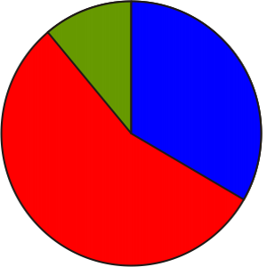 |  | Math Learning Goals  - Investigate how subtraction is related to addition.  - Subtract integers using integer tiles. |  | Materials  - overhead integer tiles  - sets of integer tiles  - BLM 2.14.1, 2.14.2  - number cubes
Assessment
Opportunities
 | Minds On… | Whole Class → Discussion  Use everyday examples to introduce integer subtraction, e.g., banking – withdrawals; football – yard losses; temperature – dropping.  Guide students to understand that subtraction can be used to find the second part if the whole and a first part are known. |  | Some students may recognize that they have already completed similar questions using addition, e.g., 6 – 4 can be 6 + (–4).  Students should use the word difference for the result of subtraction.  Reinforce the zero principle.  Number cubes can be differentiated as + or – by size or markings if differently coloured cubes are not available.  Differentiate the activity by providing different pairs with various types of number cubes (four-sided, eight-sided, sixteen-sided).  Students may begin to formalize strategies. Check for conceptual understanding.
 | Action! | Whole Class → Demonstration  Model several integer subtraction questions with the overhead integer tiles:  - questions where tiles for the first part of the whole are available to be removed, e.g., +6 – (+4) or –6 – (–2);  - questions where tiles for the first part of the whole are not immediately available to be removed and must be introduced, e.g., –4 – (+2) or +5 – (–3).  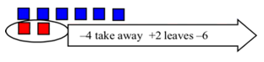  - Introduce the necessary tiles using the zero principle.  For –4 – (+2), the tiles for +2 are not available, so introduce (+2 and –2 = 0) then the +2 can be removed from –4, leaving –6.  Pairs → Game  Students practise subtraction using integer tiles (BLM 2.14.1). The student who has the greatest difference (total of the Difference column) after a set amount of time is the winner.  Connecting/Application/Mental Note: Observe how students connect their understanding of addition of integers to subtraction of integers.
 | Consolidate Debrief | Whole Class → Discussion  Ask:  - When you were using the number cubes, which two numbers gave you the greatest amount of difference? How did you know?  - Which two numbers gave you the least amount of difference? Explain.  - Could you roll two numbers that would give you a difference of 0? Explain.  Pairs → Practice  Each student records a strategy for subtraction and shares it with a partner. As a class, discuss the essential ideas that should be included. Students apply their strategy as they complete the questions on BLM 2.14.2.
Concept Practice  Reflection |  | Home Activity or Further Classroom Consolidation  Consider the questions:  Draw conclusions regarding the operations and numbers involved and the result. Revise the rule or procedure you developed with your partners to include this outcome, if it doesn’t already.  Create another three sets of questions (with answers) that follow this same pattern. |  | Students should be able to model the questions using tiles.
  +3 – (+5) | and | +3 + (–5);
  –1 – (+2) | and | –1 + (–2);
  +4 – (–3) | and | +4 + (+3).

2.14.1: An Integers Game

Name:
Date:

Game Rules
- Shake the two number cubes, and without looking, release the cubes one at a time.
- Record the value of the first cube in the first column and the value of the second cube in the second column. Remember that blue represents negative and red represents positive.
- Use integer tiles to determine the difference between the first integer and the second. The first example has been done for you.
Example
If the 1st cube is blue and the 2nd cube is red, then –4 goes in the first column and 2 or +2 goes in the second column.

Place four blue integer tiles on your desk to represent –4.
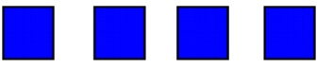
To calculate the difference, you will need to remove two red tiles (representing positive 2) but there are none. So add two zeros (two blue tiles and two red tiles).
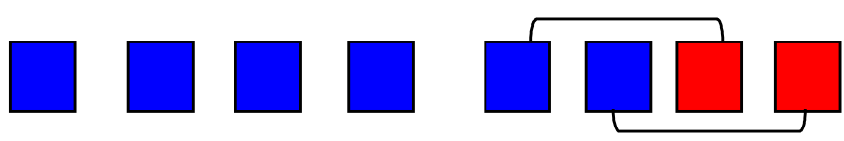
Now you can remove the two red tiles (representing positive 2).

What remains represents the difference (–6). Write this number in the third column.
1st Number Cube | 2nd Number Cube | Difference
–4 | +2 | –4 – (+2) = –6
Total of Differences
2.14.2: Integer Subtraction Using Integer Tiles

Name:
Date:

Model the following integer addition and subtraction questions using your integer tiles. Draw a pictorial representation of the operation and write the answer in each case.
1. (+5) – (+3) = | 2. (–6) – (–2) =
3. 4 – 1 = | 4. 4 + (–1) =
5. –7 – (–3) = | 6. –7 + (+3) =
7. 3 + (+2) = | 8. 3 – (–2) =
9. –5 – (–4) = | 10. –2 – (+4) =
11. –1 – (–3) = | 12. 4 – (+5) =

Unit 2: Day 15: Integer Fun |  |  |  | Grade 7
 |  | Math Learning Goals  - Add and subtract integers using a variety of tools. |  | Materials  - integer tiles  - number lines  - markers  - BLM 2.15.1, 2.15.2
Assessment
Opportunities
 | Minds On… | Whole Class → Review  Complete two or three practice questions to review addition and subtraction models. Use one or two operations per question. |  | Provide integer tiles and number lines.  Use the random number generator on a scientific calculator to generate the numbers. Skip any repeats.  [21 × RND + 1: ignore any decimal part].
 | Action! | Individual → Practice  Students fill in their game cards (BLM 2.15.1) using integers ranging from  –20 to +20. No number should be repeated. Students may use one or two cards.  Display each question selected from BLM 2.15.2, allowing students time to calculate the answer in a manner of their choosing.  If they have that answer, students mark the square with the answer. When they have a row, a column, a T, an X, or a full square, they call out “integer.” Check answers.  Learning Skills (Work Habits)/Observation/Mental Note: Observe students’ perseverance as they work.
 | Consolidate Debrief | Individual → Journal  Students reflect on their understanding of integer subtraction and addition, including their strengths and concerns. They include solutions, using their preferred strategy.  Help students identify the components of an effective record of how to add and subtract integers.
Concept Practice  Reflection  Skill Drill |  | Home Activity or Further Classroom Consolidation  In your journal, write some specific questions and answers for addition and subtraction of integers. Illustrate each one, either with tiles or a number line.

2.15.1: Adding and Subtracting Integers – A Game

Name:
Date:

Show your work.

2.15.2: Integer Game Questions

Question | Answer |  | Question | Answer
+10 + (–30) | –20: |  | –8 – (+6) + (+15) | 1:
–14 – (+5) | –19: |  | –7 + (+3) + (+6) | 2:
–25 + (+7) | –18: |  | –4 – (–6) – (–1) | 3:
–30 – (–13) | –17: |  | +12 – (+3) + (–5) | 4:
+8 – (+24) | –16: |  | +4 – (–10) – (+9) | 5:
+6 + (–21) | –15: |  | –2 – (+8) – (–16) | 6:
–5 – (+9) | –14: |  | +6 + (+6) – (+5) | 7:
–20 – (–7) | –13: |  | +1 – (+10) – (–17) | 8:
–14 + (+2) | –12: |  | –15 + (+20) + (+4) | 9:
+5 – (+16) | –11: |  | –12 – (–22) | 10:
–6 + (–4) | –10: |  | –14 + (+25) | 11:
+4 + (–10) + (–3) | –9: |  | +6 – (–6) | 12:
+7 – (+3) + (–12) | –8: |  | +18 – (+5) | 13:
–3 – (+8) – (–4) | –7: |  | +21 + (–7) | 14:
–2 + (–9) + (+5) | –6: |  | –5 + (+20) | 15:
+5 + (+5) – (+15) | –5: |  | –8 – (–24) | 16:
–9 – (–8) + (–3) | –4: |  | +9 + (+8) | 17:
+6 – (+10) + (+1) | –3: |  | +20 – (+2) | 18:
–8 – (–1) – (–5) | –2: |  | +19 – 0 | 19:
–10 + (+4) + (+5) | –1: |  | –10 + (+30) | 20:
+4 – (–7) – (+11) | 0:

Note: Track the questions in the order given to the students.

