Unit 10 Grade 7

Volume of Right Prisms

Lesson Outline

Big Picture

Students will:
- develop and apply the formula: Volume = area of the base × height to calculate volume of right prisms;
- understand the relationship between metric units of volume and capacity;
- understand that various prisms have the same volume.
Day | Lesson Title | Math Learning Goals | Expectations
1 | Exploring the Volume of a Prism | - Develop and apply the formula for volume of a prism, i.e., area of base × height.  - Relate exponential notation to volume, e.g., explain why volume is measured in cubic units. | 7m17, 7m34, 7m36, 7m40  CGE 5d, 5e
2 | Metric measures of Volume | - Determine the number of cubic centimetres that entirely fill a cubic decimetre, e.g., Use centimetre cubes to determine the number of cm³ that cover the base. How many layers are needed to fill the whole dm³?  - Determine how many dm³ fill a m³ and use this to determine how many cm³ are in a m³.  - Solve problems that require conversion between metric units of volume. | 7m35, 7m42  CGE 3b, 4a
3 | Metric Measures of Capacity and Mass  (See Metric Capacity and Mass – My Professional Practice) | - Explore the relationship between cm³ and litres, e.g., cut a 2-litre milk carton horizontally in half to make a 1-litre container that measures 10 cm × 10 cm × 10 cm. This container holds 1 litre or 1000 cm³.  - Determine that 1 cm³ holds 1 millilitre.  - Solve problems that require conversion between metric units of volume and capacity. | 7m35, 7m42  CGE 3b, 4a
4 | Volume of a Rectangular Prism | - Determine the volume of a rectangular prism, using the formula  Volume = area of the base × height.  - Solve problems involving volume of a rectangular prism. | 7m34, 7m40, 7m42  CGE 4b, 4c
5 | Volume of a Triangular Prism | - Determine the volume of a triangular prism, using the formula  Volume = area of the base × height.  - Solve problems involving volume of a triangular prism that require conversion between metric measures of volume. | 7m34, 7m40, 7m42  CGE 3c, 5d
6 | Volume of a Right Prism with a Parallelogram Base | - Determine the volume of a parallelogram-based prism, using two methods.  - Determine that the volume of the parallelogram-based prism can be calculated, using the formula: Volume = area of the base × height.  - Solve problems involving volume of a parallelogram-based prism. | 7m35, 7m40, 7m42  CGE 5f
7 | Volume of a Trapezoid-Based Prism | - Determine the volume of a trapezoidal-based prism.  - Solve problems involving volume of trapezoidal-based prisms. | 7m23, 7m34, 7m38, 7m40, 7m42  CGE 5f

Day | Lesson Title | Math Learning Goals | Expectations
8 | Volume of Other Right Prisms | - Determine the volume of right prisms (with bases that are pentagons, hexagons, quadrilaterals, composite figures), using several methods. | 7m23, 7m34, 7m40, 7m42  CGE 3b
9 | Linking Surface Area and Volume | - Apply volume and area formulas to explore the relationship between triangular prisms with the same surface area but different volumes.  - Estimate volumes. | 7m23, 7m42  CGE 4c, 5a
10 | Surface Area and Volume of Right Prisms  GSP®4 file: PaperPrism.gsp | - Investigate the relationship between surface area and volume of rectangular prisms. | 7m23, 7m42  CGE 4c, 5a
11 | Summative Performance Tasks  (lesson not included) | - Assess students’ knowledge and understanding of volume of prisms with polygon bases. | CGE 3a, 3c
12 | Summative Performance Task  (lesson not included) | - Skills test | CGE 3a, 3c

Unit 10: Day 1: Exploring the Volume of a Prism |  |  |  | Grade 7
 |  | Math Learning Goals  - Develop and apply the formula for volume of a prism, i.e., area of base × height.  - Relate exponential notation to volume, e.g., explain why volume is measured in cubic units. |  | Materials  - linking cubes  - BLM 10.1.1, 10.1.2  - isometric dot paper  (BLM 8.8.1)
Assessment
Opportunities
 | Minds On… | Whole Class → Guided Instruction  Show a cube and ask: If the length of one side is 1 unit:  - What is the surface area of one face? (1 unit²)  - What is the volume? (1 unit³)  - Why is area measured in square units?  - Why is volume measured in cubic units?  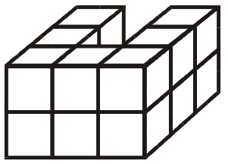  Using a “building tower” constructed from linking cubes, lead students through a discussion based on the model:  - Why is this a right prism?  - What is the surface area of the base?  - What is the height of the building?  Count the cubes to determine the volume of the building. |  | A prism has at least one pair of congruent, parallel faces.
 | Action! | Pairs → Investigation  Invite students to ask clarifying questions about the investigation (BLM 10.1.1). Students create several more irregular prisms of various sizes, using BLM 10.1.1, Building Towers. Students display their findings in the table.  After investigating the problem with several samples, state a general formula for the volume of a prism:  Volume = area of the base × height  Students test their formula for accuracy by constructing two other towers.  Curriculum Expectations/Oral Questioning/Anecdotal Note: Assess students’ understanding of the general formula Volume = area of the base × height. |  | A prism has at least one pair of congruent, parallel faces.
 | Consolidate Debrief | Whole Class → Student Presentation  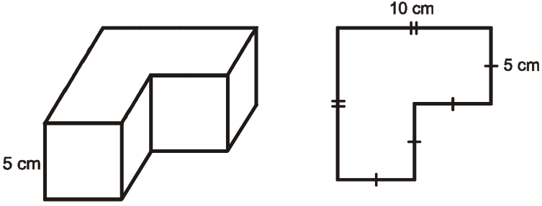  As students present their findings, summarize the results of the investigation on a class chart.  Orally complete a few examples, calculating the volume of prisms given a diagram.  Reinforce the concept of cubic units. |  | A prism has at least one pair of congruent, parallel faces.
Concept Practice Application  Skill Drill |  | Home Activity or Further Classroom Consolidation  A prism has a volume of 24 cm³. Draw prisms with this volume. How many possible prisms are there with a volume of 24 cm³ with sides whose measurements are whole numbers? |  | If students use decimal and fractional measures, an infinite number of prisms is possible.

10.1.1: Building Towers

Name:
Date:

Each tower pictured here is a prism. Build each prism and determine the volume of each building by counting cubes.
Tower A | Tower B | Tower C

1. Complete the table of measures for each tower:
Tower | Area of Base | Height of Tower | Volume  (by counting cubes)
A
B
C

2. What relationship do you notice between volume, area of the base, and height?

3. State a formula that might be true for calculating volume of a prism when you know the area of the base and the height of the prism.

4. Test your formula for accuracy by building two other prism towers and determining the volume. Sketch your towers. Show calculations on this table.
Tower | Area of Base | Height | Volume  (by counting cubes) | Volume  (using your formula)
D
E

5. Explain why your formula is accurate.

Unit 10: Day 2: Metric Measures of Volume |  | Grade 7
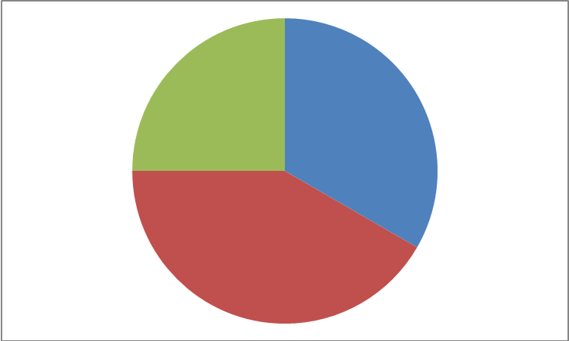  60 min | Math Learning Goals  - Students will determine the number of cubic centimetres that entirely fill a cubic decimetre, e.g. determining the number of centimetre cubes that will cover the base of an object. How many layers are needed to fill the whole dm³?  - Students will determine how many dm³ fill a m³ and use this to determine how many cm³ are in a m³.  - Students will solve problems that require conversion between metric units of volume. | Materials  - Centimetre cubes  - BLM 10.2.1  - BLM 10.2.2  - BLM 10.2.3
Small Groups → Review
Students work in co-operative groups to review metric conversions using BLM 10.2.1

Some students may need assistance to complete the personal benchmark part.

Here are a few examples:
mm = thickness of a dime; cm = width of a pinkie finger; dm = width of their palm
Minds On…
Pairs → Investigation
Students complete BLM 10.2.2 in pairs to discover that:
1dm² = 100cm² and 1dm³ = 1000 cm³
Distribute centimetre cubes for them to use as a manipulative to verify their predictions and solutions to the questions.

Action!
Whole Class → Discussion
Take up BLM 10.2.2. Reinforce the process for converting metric units of volume. When converting between dm and cm, use 10 as the ‘conversion number’.

When converting between:
dm³ to cm³ → multiply by 10 x 10 x 10 or 10³.
dm³ to cm³ → multiply by 1000 (10³)

e.g. 3 dm³ = _______ cm³ (Answer: 3000)

Consolidate Debrief
Concept Practice  Application | Home Activity or Further Classroom Consolidation  Complete BLM 10.2.3. | 

10.2.1: Metric Conversions Grade 7

Complete the following in your co-operative grouping. Make certain all members of the group understand the work.

1. 1 cm = _____ mm 1 dm = _______ cm
1 m = ______ cm 1 m = ______ dm

2. Complete the following conversions. For each one, show what you are thinking.

_{x 100}

e.g. 3 m = _______ cm

3m = 300 cm

10 mm= ______ cm 450 cm = _______ dm
4 m = ______ dm 50 dm = _______ m

3. For the following measurements, think about something in real life that would help you remember and visualize that measurement (e.g. 1mm = thickness of a dime)

1 cm = ___________________________________________

1 dm = ___________________________________________

10.2.1: Metric Conversions Answers Grade 7

Complete the following in your co-operative grouping. Make certain all members of the group understand the work.

1. 1 cm = 10 mm 1 dm = 10 cm
1 m = 100 cm 1 m = 10 dm

2. Complete the following conversions. For each one, show what you are thinking.

_{x 100}

e.g. 3 m = _______ cm
3 m = 300 cm

10 mm = 100 cm 450 cm = 45 dm
4 m = 40 dm 50 dm = 5 m

3. For the following measurements, think about something in real life that would help you remember and visualize that measurement. (e.g. 1mm = thickness of a dime)

1 cm = width of your pinkie finger

1 dm = width of your palm

10.2.2: Converting Metric Units of Volume Grade 7

Part A - Estimations
1. Estimate the area of each of the following in cm²:
This page _________________ Your desk _____________________
An item of your choice ____________ Item name ________________

2. Estimate the volume of each of the following in cm³:
The inside of your desk ___________________ The classroom _____________________
An item of your choice __________________ Item name ________________

Part B - How many cm² are there in a dm²?
Complete the measurements on each side of the square to show what its dimensions are in decimetres and in centimetres.
_______ dm = _________ cm
_______ dm = _________ cm

The square is called a decimetre square (dm²), why do you think it is called that?

Fill the inside of the square with centimetre cubes.

How many cm cubes fit inside of the decimetre square?

Area = ______________cm²

This means that

1dm² = __________ cm²

Approximate the area of each item from Part A in dm² using the decimetre square you created.

This page _________________ Your desk _____________________

An item of your choice ____________

Use each of your answers in dm² to determine the area of each item in cm². How close were your estimations?
10.2.2: Converting Metric Units of Volume (cont.) Grade 7

Part C - How many cm³ are there in a dm³?
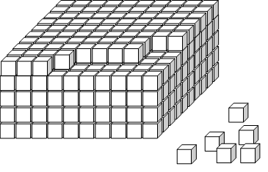
Create a decimetre cube using your centimetre cubes.

How many cm cubes did you use? __________________

Volume of the decimetre cube = ______________cm³

This means that

1dm³ = __________ cm³

Approximate the volume of the items from Part A in dm³ using the decimetre cube you created.

The inside of your desk ___________________ The classroom _____________________

An item of your choice __________________

Use each of your answers in dm³ to determine the volume of each item in cm³. How close were your estimations?

In summary

1dm = ______cm 1dm² = ____________cm² 1dm³ = ______________cm³

How can you use your new knowledge to help you make better estimations for areas and volumes?
10.2.3: Converting Units of Volume Grade 7

1. 3 dm³ = ___________ cm³ 5 dm² = ____________ cm²

53500 cm³ = _________ dm³ 457 dm² = ___________ cm²

2. The area of the base of a storage container is 1500 dm². The height is 30 dm.
a) What is the volume of the container in cm³?

3. a) Can you picture a 1 metre cube created out of centimetre cubes? How many cubes would it hold?

b) The volume of container A is 0.25 m³. The volume of container B is 45 000 cm³. Which container is larger? By how many cm³ is it larger?

10.2.3: Converting Units of Volume Answers Grade 7

1. 3 dm³ = 3000 cm³ 5 dm² = 500 cm²
53500 cm³ = 53.5 dm³ 457 dm² = 45700 cm²

2. The area of the base of a storage container is 1500 dm². The height is 30 dm.
a) What is the volume of the container in cm³?

V = 1500 x 30 = 45000dm³
multiply by 1000 to convert to cm³
V = 45000000cm³

3. a) Can you picture a 1 metre cube created out of centimetre cubes? How many cubes would it hold?

1m = 100cm by 100cm by 100cm
= 1,000,000 cm³

b) The volume of container A is 0.25 m³. The volume of container B is 45 000 cm³. Which container is larger? By how many cm³ is it larger?

_{x100}³

Container A : 0.25 m³ = 250 000 cm³

∴ Container A is larger by 205 000 cm³.

Unit 10: Day 3: Metric Measures of Capacity and Mass |  | Grade 7
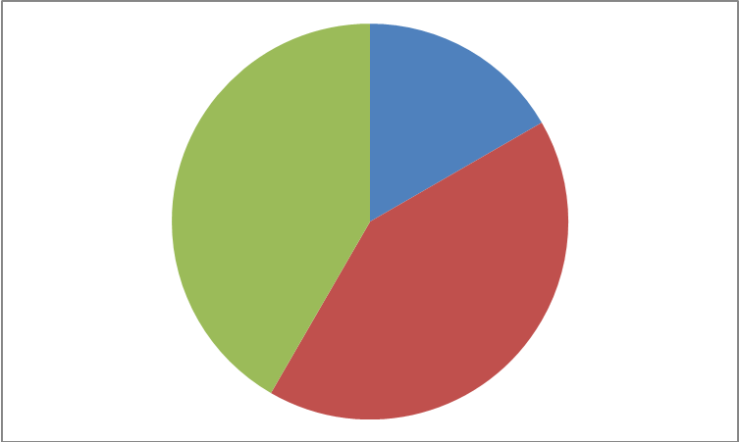  60 min | Math Learning Goals  - Students will explore the relationship between cm³ and litres, e.g. cut a 2-litre milk carton horizontally in half to make a 1-litre container that measures  10 cm x 10 cm x 10 cm. This container holds 1 litre or 1000 cm³ of liquid  - Students will discover that a container with a volume of 1 cm³ can hold 1 millilitre of liquid  - Students will solve problems that require conversion between metric units of volume and capacity | Materials  - Centimetre cubes  - 2 L milk carton  - BLM 10.3.1
Whole Class → Guided Instruction
Show the milk carton to the class, pointing out the measurement on the carton.
- What is the measurement? (Answer: 2L)
- What is this a measure of? (Answer: capacity)

Cut a 2-litre milk carton in half. Introduce the term capacity as being the amount a container can hold. The capacity of the original container is 2 litres (2L)
- What is the capacity after the carton is cut in half? (Answer: 1L)

Ask students for suggestions for determining the volume of the carton in cm³.
(Possibilities: students could use unit cubes and fill it, and then count – could use cubes from last day and compare, or they could measure the dimensions of the carton). Use methods suggested to determine the volume of the half container. (Answer: 1000 cm³)

Minds On…
 | Small Groups → Discussion  Have students work in co-operative groupings to answer the questions below. Remind them that volume is the amount of space an object takes up.  - What is the relationship between capacity and volume? (Students should discuss that the measurements have to be related in some way as they are giving a quantity to the same container).  - What is the volume of 1 cm³ ? (Answer: 1 mL = 1 cm³)  Whole Class → Note Taking  Summarize the results of the above questions with the entire class and then do a few conversions, similar to the following examples:  500 mL = _____ cm³ (Answer: 500); 5 cm³ = _____ mL (Answer: 5);  450 cm³ = _____ L (Answer: 0.45); 3.5 L = _____ cm³ (Answer: 3500) | Teacher Recommendation:  Do a brief consolidation after each question.
Action!
Whole Class → Discussion
Reinforce that:
1 litre = 1000 cm³ = 1 dm³ = 1000mL
1 mL = 1 cm³
1 000 000 cm³ = 1000dm³ = 1m³ = 1kL
Point out objects in the classroom that will help students recognize the volumes that are equivalent
Consolidate Debrief
Concept practice | Home Activity or Further Classroom Consolidation  Complete BLM 10.3.1

10.3.1: Metric Measures of Capacity and Mass Grade 7

1. Fill in the following chart.

Volume | 10 cm³ | 6 m³ | ___ m³ | ___ cm³ | 250 mm³ | ___ m³ | 3 m³
Capacity | ____ mL | _____ L | 6 kL | 3 L | ____ mL | 500 L | ____ mL

2. a) A prism has a base with an area of 20 cm², and a height of 2 cm. Calculate the volume of the prism in cm³.

b) Calculate the capacity of the prism in millilitres (mL).

3. The cargo hold of a truck has a base with an area of 25 m², and a height of 4 m.
How many 5-litre containers can the truck carry?

4. Will the milk in a 2 L container fit into 5 glasses if each glass has a volume of 350 cm³?
Explain your answer.

10.3.1: Metric Measures of Capacity and Mass Grade 7

Answers

1. Fill in the following chart.
Volume | 10 cm³ | 6 m³ | 6 m³ | 3000 cm³ | 250 cm³ | 0.5 m³ | 3 m³
Capacity | 10 mL | 6000 L | 6 kL | 3 L | 250 mL | 500 L | 300000 mL

2. a) A prism has a base with an area of 20 cm², and a height of 2 cm. Calculate the volume of the prism.

Volume = area of base x height
= 20 cm² x 2 cm
= 40 cm³

b) Calculate the capacity of the prism in millilitres (mL).

We know 1000 cm³ = 1000 mL
So 40 cm³ = 40 mL
The capacity of the prism is 40mL.

3. The cargo hold of a truck has a base with an area of 25 m², and a height of 4 m.
How many 5-litre containers can the truck carry?

Volume = area of base x height
= 25 m² x 4 m
= 100 m³
100 m³ = 100 000 000 cm³ = 100 000 L
100 000L/ 5 L = 20 000 containers.

4. Will the milk in a 2 L container fit into 5 glasses if each glass has a volume of 350 cm³?
Explain your answer.

Glass
V = 350 cm³
Capacity of each glass is 350 mL.
5 glasses would hold 5 x 350 mL = 1750 mL

So, 2 L container (2000 mL) would not fit into the 5 glasses.
250 mL will be left over.

OR

Container
V = 2L
= 2000mL
= 2000cm³
Number of glasses needed = 2000cm³/350cm³
= approx. 5.7 glasses needed. 0.7 glasses short
Therefore, you would need one more glass to hold all of the milk in the container.
Unit 10: Day 4: Volume of a Rectangular Prism |  |  |  | Grade 7
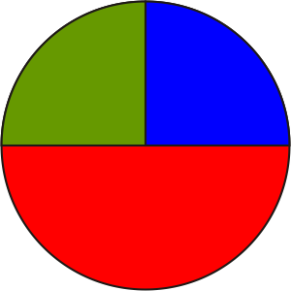 |  | Math Learning Goals  - Determine the volume of a rectangular prism using the formula  Volume = area of the base × height.  - Solve problems involving volume of a rectangular prism. |  | Materials  - models of rectangular prisms  - linking cubes
Assessment
Opportunities
 | Minds On… | Whole Class → Sharing/Discussion  Students share their diagrams and solutions for prisms with a volume of 24 cm³ (Day 1). Students build these with linking cubes (assume the prisms are using integer dimensions). Relate the dimensions to the factors of 24.  Using concrete samples of a rectangular prism, ask students:  - Will the volume be the same or different when the prisms are oriented vertically or horizontally?  - Is the base of a rectangular prism clearly defined or can it change?  - What do we mean by “dimensions of a prism?” |  | For any prism:  V = area of base × height  For rectangular prisms:  V = (l × w) h  When calculating volume of a rectangular prism, any of its faces can be thought of as the base.
 | Action! | Pairs → Investigation  Students use a rectangular prism to show that the “base” is interchangeable but the volume remains the same (based on the general formula of Volume = area of the base × height). They investigate how to use the formula to calculate volumes of several examples of horizontally and vertically oriented prisms, and show their calculations to justify their conclusions.  Curriculum Expectations/Oral Questioning/Anecdotal Note: Assess students’ understanding of the general formula Volume = area of the base × height.
 | Consolidate Debrief | Whole Class → Reflection  Students share their investigation and justify their explanations, using diagrams and calculations.
Exploration  Concept Practice |  | Home Activity or Further Classroom Consolidation  - Make two or three sketches of rectangular prisms with whole number dimensions with volume:  a) 27 cm³? b) 48 cm³?  - Why are there many more prisms of volume 48 cm³ than 27 cm²?  - Choose a volume for a rectangular prism that can be generated by several different sets of measurements with whole number dimensions. Explain.  - Complete the practice questions. |  | Provide students with appropriate practice questions.

Unit 10: Day 5: Volume of a Triangular Prism |  |  |  | Grade 7
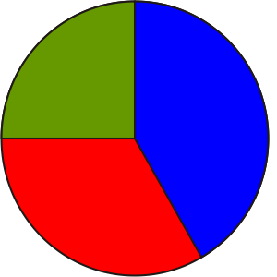 |  | Math Learning Goals  - Determine the volume of a triangular prism using the formula  Volume = area of the base × height.  - Solve problems involving volume of a triangular prism that require conversion between metric measures of volume. |  | Materials  - models of triangular prisms  - BLM 10.5.1
Assessment
Opportunities
 | Minds On… | Whole Class → Sharing  Students share their sketches of prisms with volumes 27 cm³ and 48 cm³ and the responses to the questions. Students should use the term factors when explaining the relationship of the measures. Make a list of rectangular prisms that can be generated by several different sets of measurements. Discuss the relationship of these measures to the factors of a number.  Whole Class → Discussion  Using concrete samples of a triangular prism, ask students:  - What can be altered in the volume of a prism formula to make the formula specific for a triangular prism?  - Will the volume be the same or different when the prism is oriented vertically or horizontally?  - What do we need to think about when applying the volume formula to a triangular prism? |  | For any prism:  V = area of base × height  For triangular prisms:  V = bh × H  When calculating the volume of a triangular prism, its base is one of the triangles, not one of the rectangles.  Some students may need the physical model to assist their understanding.  When assigning triangular prism questions from a textbook, ensure that no questions require the use of the Pythagorean theorem.
 | Action! | Pairs → Investigation  Students use a triangular prism to develop a formula specific to their prism (based on the general formula of Volume = area of the base × height.) They investigate how to use this formula to calculate volume of several horizontally and vertically oriented prisms, and show their calculations to justify their conclusions.  Curriculum Expectations/Oral Questioning/Anecdotal Note: Assess students’ understanding of the general formula Volume = area of the base × height.
 | Consolidate Debrief | Whole Class → Reflection  Students share their investigation findings. Focus discussion on the need to identify the triangular face as the “base” when using the formula V = area of  base × height for a triangular prism. Connect this discussion to the idea of stacking triangles either vertically or horizontally to generate the triangular prism.  Discuss the need for h and H in the formula for volume: h is perpendicular to b and refers to the triangle’s height, H is the perpendicular distance between the triangular bases. Discuss each of these in relationship to rectangular prisms. If students understand that all right prisms have a Volume = (area of base) (height) they should not get confused by multiple formulas.  Students complete BLM 10.5.1.
Concept Practice |  | Home Activity or Further Classroom Consolidation  Sketch and label the dimensions of a triangular prism whose whole number dimensions will produce a volume that is:  a) an even number b) an odd number c) a decimal value  Explain your thinking in each case.

10.5.1: Volume of Triangular Prisms

Show your work using good form and be prepared to tell how you solved the problem.

1. Determine the volume of the piece of cheese.
Create a problem based on the volume.

Picture | Skeleton | Base
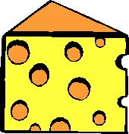
 | H = height of prism = 5.0 cm  length of rectangle = 6.3 cm | height of triangle = 6.0 cm  base of triangle = 4.0 cm

2. Determine the volume of the nutrition bar.
Create a problem based on the volume.

Picture | Skeleton | Base
 | Length of rectangle = 5.0 cm | Equilateral triangle with:  height = 3.0 cm  base = 3.5 cm

10.5.1: Volume of Triangular Prisms (continued)

3. Determine the volume of air space in the tent.
The front of the tent has the shape of an isosceles triangle.
Create a problem based on the volume.

4. a) If you could only have 1 person per 15 m³ to meet fire safety standards, how many people could stay in this ski chalet?
.
Hint:
Think about whether the height of the chalet is the same as the height of the prism.

Which measurements are unnecessary for this question?

b) How much longer would the chalet need to be to meet the safety requirements to accommodate 16 people?

Unit 10: Day 6: Volume of a Right Prism with a Parallelogram Base |  |  |  | Grade 7
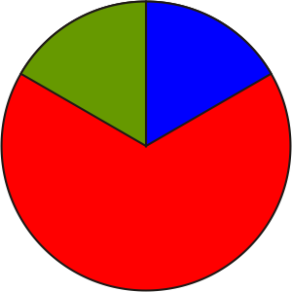 |  | Math Learning Goals  - Determine the volume of a parallelogram-based prism using two methods.  - Determine that the volume of the parallelogram-based prism can be calculated using the formula: Volume = area of the base × height.  - Solve problems involving volume of a parallelogram-based prism. |  | Materials  - BLM 10.6.1  - calculators
Assessment
Opportunities
 | Minds On… | Whole Class → Demonstration  Display two triangular prisms with congruent bases, e.g., use polydron materials or two triangular prism chocolate bars, or two triangular prisms cut from the net on BLM 10.6.1.  Students measure and calculate the volume of one of the prisms. Demonstrate how the two triangular prisms can be fitted together to make a parallelogram-based prism. |  | Seeing the two triangular prisms physically fitted together to make a parallelogram-based prism can help students visualize the various shapes and build their spatial thinking.  Two methods:  a) Multiply the triangular prism’s volume by 2  b) Use the volume formula: area of the base × height
 | Action! | Pairs → Investigation  Students respond to the question: How can the volume of the parallelogram-based prism be determined, knowing the volume of one triangular prism?  They find a second method for calculating the volume of a parallelogram-based prism and compare the two methods.  They verify that their findings are always true by creating several other parallelogram-based prism measurements.  The volume of a parallelogram-based prism can always be determined by decomposing it into two triangular prisms. (The formula Volume = area of base × height will determine the volume for any right prism.)
 | Consolidate Debrief | Whole Class → Discussion  Debrief the students’ findings to help them understand that the volume of a parallelogram-based prism can be determined by determining the area of the parallelogram base, which is composed of two congruent triangles and is (b × h) multiplied by the height (H) of the prism. The volume of the parallelogram-based prism can also be determined using the formula:  Volume = area of the base × height of the prism.  Model the solution to an everyday problem that requires finding the volume and capacity of a parallelogram-based prism.
Concept Practice |  | Home Activity or Further Classroom Consolidation  - Write a paragraph in your journal: There is one formula for all right prisms. It is… Here are some examples of how it is used….  OR  - Complete the practice questions. |  | Curriculum Expectations/ Demonstration/ Marking Scheme: Assess students’ understanding of the general formula for right prisms.  Provide students with appropriate practice questions.

10.6.1: Triangular Prism Net

Unit 10: Day 7: Volume of Trapezoidal-Based Prism |  |  |  | Grade 7
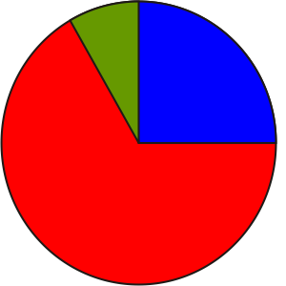 |  | Math Learning Goals  - Determine the volume of a trapezoidal-based prism using several methods for using the formula Volume = area of the base × height to determine if there is a relationship.  - Solve problems involving volume of trapezoidal-based prisms. |  | Materials  - BLM 10.7.1
Assessment
Opportunities
 | Minds On… | Whole Class → Review  Review the definition and characteristics of a trapezoid. Recall methods for calculating the area of a trapezoid. |  | The most common ways to decompose a trapezoid are into:  a) one rectangle and two triangles  b) two triangles  c) one parallelogram and one triangle.  Students may choose to do the calculations using a 2-D diagram of the trapezoid. Other students may need to build the 3-D shapes to visualize the solution.  Order of operations is important to calculate correctly.
 | Action! | Pairs → Investigation  Students complete the investigation:  Can the formula Volume = area of the base × height of the prism be used to determine the volume of trapezoid-based prisms instead of decomposing the trapezoid?  Investigate to determine the volume of a trapezoid-based right prism by decomposing the trapezoid into triangles and rectangles, using different decompositions.  Compare the solutions from the decomposition method to the volume calculated using the standard formula.  Write your findings in a report. Include diagrams and calculations.  Prompt students who are having difficulty decomposing the trapezoid by suggesting some of these possibilities:  Problem Solving/Application/Checkbric: Assess students’ problem solving techniques, as well as their communication in the report.
 | Consolidate Debrief | Whole Class → Discussion  Discuss the need for h and H in the formula and the importance of the order of operations.  Focus the discussion on the fact that the standard formula Volume = area of the base × height of the prism always works for right prisms. Volume can also be calculated by decomposing into composite prisms.
Concept Practice |  | Home Activity or Further Classroom Consolidation  Complete worksheet 10.7.1.

10.7.1: Designing a Box

A local pet food company wishes to package their product in a box. The preliminary box design is shown on the left.
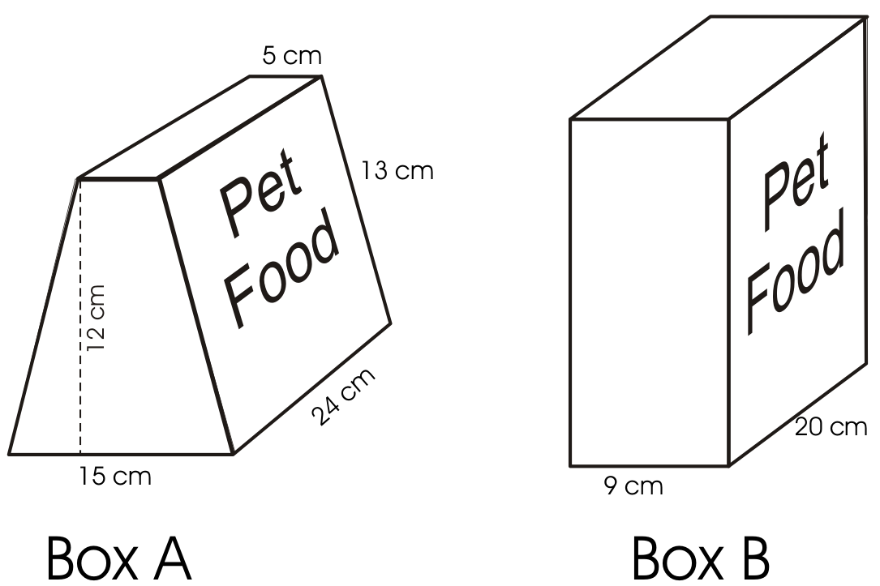

1. Determine the volume of the box on the left. Verify your calculation using an alternate method.

2. Box B has the same volume as Box A. What is the height of Box B? Explain how you know.

3. Design a new box, Box C, with the same volume as the two boxes above.

Alternate
Build Box A and B. Be sure B has the same volume as A. Fill them up to check for equal volume.

Unit 10: Day 8: Volume of Other Right Prisms |  |  |  | Grade 7
 |  | Math Learning Goals  - Determine the volume of right prisms (with bases that are pentagons, hexagons, quadrilaterals, composite figures), using several methods. |  | Materials  - BLM 10.8.1
Assessment
Opportunities
 | Minds On… | Whole Class → Presentations  Students discuss the solution to the homework problem. Some students share their design for Box C. The class checks the dimensions for correctness.  If students built Boxes A and B, have them explain their method and prove that their volumes were the same. |  | Have some of the previously constructed figures available for student reference.  Composite shapes for the base of the prism.
 | Action! | Whole Class → Brainstorming  Use a mind map to brainstorm a list of other possible shapes that could form the base of a right prism.  Students sketch the 2-D shapes on the board – pentagons, hexagons, quadrilaterals, and composite figures.  Learning Skills (Class Participation)/Observation/Mental Note: Assess students’ participation during the brainstorm.  Pairs → Practice  Students decompose the shapes displayed into triangles and rectangles. They discuss how they would determine the area of the shape of the base in order to calculate the volume of that prism, e.g., V = area of base × height; decompose the prism into other prism shapes with triangular and rectangular bases.  Pairs → Problem Solving  Students complete BLM 10.8.1.
 | Consolidate Debrief | Whole Class → Presentation  Students present and explain their solutions.
Concept Practice |  | Home Activity or Further Classroom Consolidation  Design two right prisms with bases that are polygons. The prisms must have an approximate capacity of 1000 mL.

10.8.1: Designing a Gift Box

Determine the volume of the gift box designed by the students from Trillium School.

Shape of the base of the box: Side view of the box:

Volume of the box:

Capacity of the box:

Unit 10: Day 9: Linking Surface Area and Volume |  |  |  | Grade 7
 |  | Math Learning Goals  - Apply volume and area formulas to explore the relationship between triangular prisms with the same surface area but different volumes.  - Estimate volumes. |  | Materials  - rectangular tarp or sheet  - connecting cubes  - BLM 10.9.1
Assessment
Opportunities
 | Minds On… | Small Groups → Discussion/Presentation  Students share solutions for homework questions assigned on Day 8 for volume of right prisms with polygon bases. Each small group presents one solution to the whole class.  Whole Class → Investigation  Place a large tarp on the floor/ground. Invite six students to become vertices of a triangular prism tent. Four of the students are to keep their vertices on the ground. They stand on the corners of the tarp. The remaining two students stand on opposite sides of the tarp, equidistant from the ends, to become the fifth and sixth vertices. These two vertices gradually raise the tarp until a tent is formed. Note that the “ground” vertices have to move. Invite two or three other students to be campers.  Students verbalize observations about the tent’s capacity as the tent’s height is increased and decreased. Ask: Does it feel like there is more or less room? |  | This activity might be done outside or in a gymnasium. Consider using a rope to hold the peak of the tent in place.  Students might investigate changes when the fold is moved from lengthwise to widthwise.  From the model making activity, students should have a sense that the statement is not always true. Since the areas of the triangular ends of the tent prisms were not investigated, encourage students to question the importance of these measurements when considering the statement.
 | Action! | Pairs → Model Making  Students simulate the tent experiment using a sheet of paper and connecting cubes. Data may be collected in a two-column chart – height of the tent vs. number of connecting cubes that will fit inside the tent without bulging the sides.
 | Consolidate Debrief | Think/Pair/Share → Discussion  In pairs, students respond to the question: Is the following statement sometimes, always, or never true?  Two triangular prisms with the same surface area also have the same volume.  Ask probing questions to ensure that students realize that investigation of this statement differs from the tent investigation since the floor and the triangular sides were ignored in the tent scenario, but cannot be ignored in this question.  Ask students if their conclusion would be the same for closed and open-ended prisms.  Whole Class → Discussion  Discuss how an experiment might be designed to confirm or deny hypotheses about the relationship between surface area and volume.
Skill Practice |  | Home Activity or Further Classroom Consolidation  On worksheet 10.9.1, make two folds using the two solid lines. Form a triangular prism. Imagine that it also has paper on the two triangular ends. Sketch the prism and its net. Take the measurements needed to calculate the surface area (including the two triangular ends) and volume. Label the diagrams with the measurements. Calculate the surface area and volume. Repeat the process for the prism formed using the two broken lines.  Make a statement regarding your findings that relates surface area and volume. |  | Curriculum Expectations/ Application/Marking Scheme: Assess students’ ability to calculate the area and volume of triangular prisms.

10.9.1: Triangular Prisms

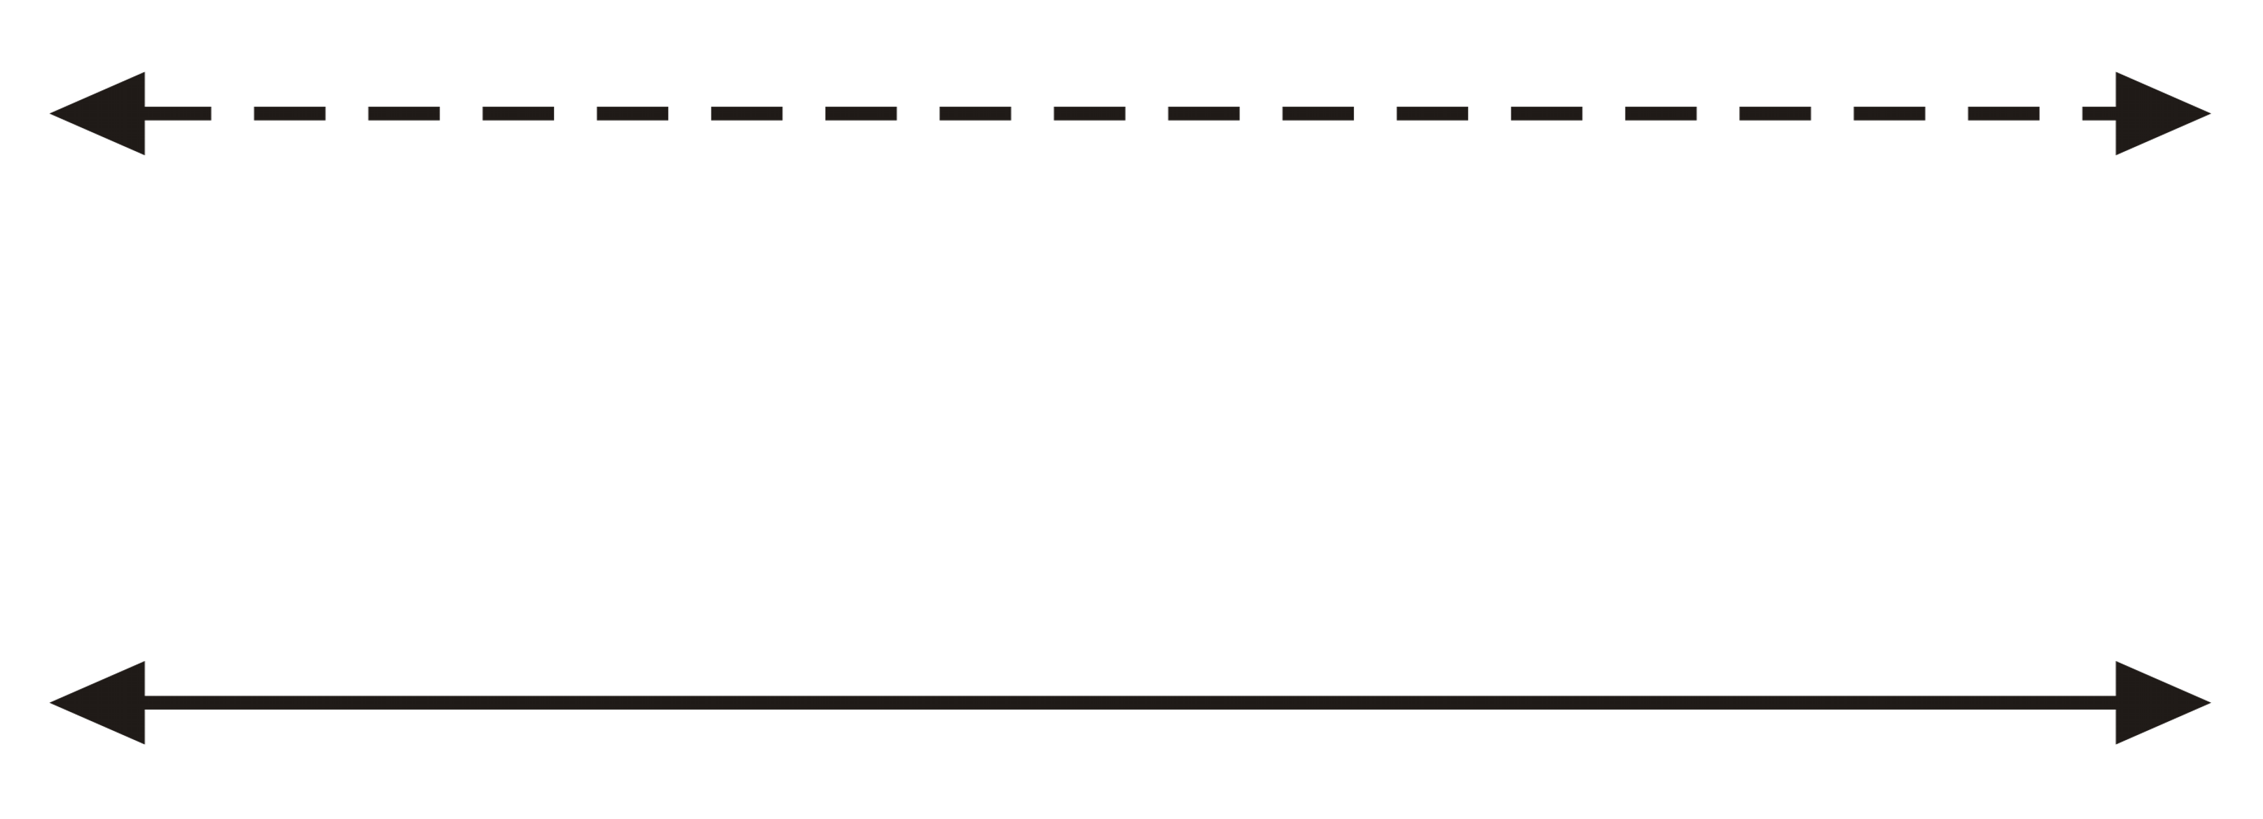

Unit 10: Day 10: Surface Area and Volume of Rectangular Prisms |  |  |  | Grade 7
 |  | Math Learning Goals  - Investigate the relationship between surface area and volume of rectangular prisms. |  | Materials  - BLM 10.10.1  - interlocking cubes
Assessment
Opportunities
 | Minds On… | Whole Class → Discussion  Use GSP®4 file Paper Folding To Investigate Triangular Prisms to check student responses and investigate additional scenarios (Day 9 Home Activity). |  | PaperPrism.gsp  Provides a dynamic model of the paper folding activity.  Students might benefit from having interlocking cubes to help them visualize the various shapes and sizes of boxes.  Solution  The more elongated the prism, the greater the surface area. The closer the prism becomes to being cube-shaped or spherical, the less surface area it has.
 | Action! | Pairs → Investigation  Pose the question:  If two rectangular prisms have the same volume, do they have the same surface area?  Students investigate, using BLM 10.10.1:  a) For prisms with the same volume, is the surface area also the same? (no)  b) What shape of rectangular prism has the largest surface area for a given volume?  Individual → Written Report  Students individually prepare a written report of their findings.  Communicating/Presentation/Rating Scale: Assess students’ ability to communicate in writing and visually their understanding of surface area and volume as a result of their investigation.
 | Consolidate Debrief | Whole Class → Student Presentations  Students present their findings and apply the mathematics learned in the investigation to answer this question:  Why would a Husky dog curl up in the winter to protect himself from the cold winds when he is sleeping outdoors? (If the dog remains “long and skinny” he has greater surface area exposed to the cold. If he curls up, he has less surface area exposed to the cold, and thus he would lose much less body heat. Although his volume stays the same, his surface area decreases as he becomes more “cube-ish,” or spherical.)
Concept Practice |  | Home Activity or Further Classroom Consolidation  Complete the practice questions. |  | Provide students with appropriate practice questions.

10.10.1: Wrapping Packages

Three different rectangular prism-shaped boxes each have a volume of 8 cubic units.
Does each box require the same amount of paper to wrap? Let’s investigate!

1. a) Verify that each rectangular prism illustrated above has a volume of 8 cubic units.
b) Draw the net for each rectangular prism box.
c) Determine the amount of paper required by calculating the surface area.
(Ignore the overlapping pieces of paper you would need.)
d) Describe your findings.

2. a) How many different rectangular prism boxes can be designed to have a volume of 24 cubic units?
b) Draw several of the boxes, labelling the dimensions.
c) How much paper is required to wrap each box?
d) Describe your findings.

3. Investigate wrapping rectangular prism boxes with a volume of 36 cubic units.
Determine the dimensions of the rectangular prism with the greatest surface area.

4. Write a report of your findings. Include the following information, justifying your statements.
- Describe how surface area and volume are related, when the volume remains the same.

- Describe the shape of a rectangular prism box that uses the most paper for a given volume.

- Describe the shape of a rectangular prism box the uses the least paper for a given volume.
Paper Folding to Investigate Triangular Prisms (GSP®4 file)
PaperPrism.gsp

