Unit 1 Grade 7
Celebrating 7

Lesson Outline

BIG PICTURE

Students will:
- recognize the importance of problem solving and investigation in learning mathematics;
- recognize and apply the seven mathematical processes;
- practise appropriate learning skills, e.g., listening to classmates, legitimizing errors as part of the learning process, tolerating ambiguity, demonstrating perseverance.
Day | Lesson Title | Math Learning Goals | Expectations
1 | Celebrating 7 | - Investigate patterns. | 7m12, 7m16  CGE 3c, 4a, 4e
2 | Tangram Tune-Up | - Sort and classify triangles and quadrilaterals.  - Identify perpendicular bisectors.  - Create 2-D composite shapes.  - Compare similar shapes and congruent shapes. | 7m39, 7m47, 7m48, 7m53  CGE 2c, 4f
3 | Summer Survival | - Collect data by conducting a survey.  - Select an appropriate type of graph to represent a set of data.  - Identify bias. | 7m73, 7m75, 7m77  CGE 2c, 5a
4 | Can-Do Puzzles | - Solve problems involving patterning, 2-D shapes and 3-D figures, calculations, and probability. | 7m47, 7m61, 7m81  CGE 3c, 5a, 5e

Unit 1: Day 1: Celebrating 7 |  |  |  |  | Grade 7
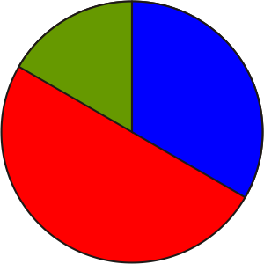 |  |  | Math Learning Goals  • Investigate patterns. |  |  | Materials  - BLM 1.1.1, 1.1.2  - coloured markers
Assessment
Opportunities
 | Minds On ... |  | Whole Class → Discussion  To set the stage for the development of positive attitudes toward mathematics, briefly identify how the class learning community will operate by reviewing key succinct messages for posters.  Students suggest why the rules or procedures are necessary.  Whole Class → Brainstorm  Ask: Where do we find 7 in our world?  Accept all answers and have students explain their response. |  |  | Students may mention the Seven Wonders of the World.  Calculators may not display the repeating decimals as they may round the last digit or display fewer than eight digits.  To encourage quick recall of previous learning, individual students might make a list – “Number facts about 7 that I know.”  Model appropriate ways to discuss errors or consider alternate descriptions.  Word Wall  - patterns  - prime numbers  - perfect square
 | Action! |  | Pairs → Investigation  Pairs of students use a calculator and BLM 1.1.1 to discover patterns involving the number 7.  Pose the question: Could there be more than six digits in the length of the period of these decimals? Explain.  Students create other 7-related patterns or statements, using a calculator.  Clarify the term perfect square, linking it to measurement activities from previous years.  Students complete BLM 1.1.2 and record the solutions on overheads using different colours. Overlay the overheads so they can see the overall patterns  Selecting Tools and Computational Strategies/Observation/Checklist: Observe students, watching their calculator use and patterning skills.
 |  | Consolidate Debrief | Whole Class → Student Presentations  Students report on their findings from BLM 1.1.1 and 1.1.2.  Encourage communicating using oral or written presentations that include precise language, diagrams, and charts.
Exploration |  |  | Home Activity or Further Classroom Consolidation  Summarize your activities using sentence stems, e.g., I learned…, I discovered…, I remembered…, Our class will be great if we all…, I wonder why….

1.1.1: Celebrating 7

Name:
Date:

1. Calculate
63 × 12 = 63 × 123 =

63 × 1234 = 63 × 12345 =

Identify and analyse the pattern.
Use your pattern to predict the next 4 terms in the sequence.
Check using a calculator

2. Find the values of

7 × 77 = 7 × 777 = 7 × 7777
Identify and analyse the pattern and extend it 3 terms without a calculator.
Check using a calculator.

3. Calculate each of the following products.
15 873 × 7 = 15 873 × 14 = 15 873 × 21

Use the pattern to guess
15873 × 28 = 15 873 x 35 = 15 873 x 42 =

Check using a calculator.

4. Convert each of the following fractions to decimal form. Identify the digits that occur repeatedly within each decimal. Count the number of digits in the sequence.
$\frac{1}{7}$= $\frac{2}{7}$= $\frac{3}{7}$= $\frac{4}{7}$= $\frac{5}{7}$= $\frac{6}{7}$=

1.1.2: Prime Patterns

Name:
Date:

Complete the spiral of numbers and then shade in each square that shows a prime.
Using a different colour, shade in all of the perfect squares.

Record all the patterns you notice about prime and composite numbers.

 |  |  | 16 | 15 | 14 | 13
 |  |  | 5 | 4 | 3 | 12
 |  |  | 6 | 1 | 2 | 11
 |  |  | 7 | 8 | 9 | 10

1.1.2: Prime Patterns – Prime (Answers)

100 | 99 | 98 | 97 | 96 | 95 | 94 | 96 | 92 | 91
65 | 64 | 63 | 62 | 61 | 60 | 59 | 58 | 57 | 90
66 | 37 | 36 | 35 | 34 | 33 | 32 | 31 | 56 | 89
67 | 38 | 17 | 16 | 15 | 14 | 13 | 30 | 55 | 88
68 | 39 | 18 | 5 | 4 | 3 | 12 | 29 | 54 | 87
69 | 40 | 19 | 6 | 1 | 2 | 11 | 28 | 53 | 86
70 | 41 | 20 | 7 | 8 | 9 | 10 | 27 | 52 | 85
71 | 42 | 21 | 22 | 23 | 24 | 25 | 26 | 51 | 84
72 | 43 | 44 | 45 | 46 | 47 | 48 | 49 | 50 | 83
73 | 74 | 75 | 76 | 77 | 78 | 79 | 80 | 81 | 82

1.1.2: Prime Patterns – Perfect Squares (Answers)

100 | 99 | 98 | 97 | 96 | 95 | 94 | 96 | 92 | 91
65 | 64 | 63 | 62 | 61 | 60 | 59 | 58 | 57 | 90
66 | 37 | 36 | 35 | 34 | 33 | 32 | 31 | 56 | 89
67 | 38 | 17 | 16 | 15 | 14 | 13 | 30 | 55 | 88
68 | 39 | 18 | 5 | 4 | 3 | 12 | 29 | 54 | 87
69 | 40 | 19 | 6 | 1 | 2 | 11 | 28 | 53 | 86
70 | 41 | 20 | 7 | 8 | 9 | 10 | 27 | 52 | 85
71 | 42 | 21 | 22 | 23 | 24 | 25 | 26 | 51 | 84
72 | 43 | 44 | 45 | 46 | 47 | 48 | 49 | 50 | 83
73 | 74 | 75 | 76 | 77 | 78 | 79 | 80 | 81 | 82

Unit 1: Day 2: Tangram Tune-Up |  |  |  | Grade 7
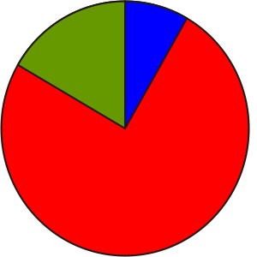 |  |  | Math Learning Goals  - Sort and classify triangles and quadrilaterals.  - Identify perpendicular bisectors.  - Create 2-D composite shapes.  - Compare similar shapes and congruent shapes. | Materials  - square paper  - BLM 1.2.1, 1.2.2, 1.2.3, 1.2.4, 1.2.5, 1.2.6, 1.2.7  - tangram set
Assessment
Opportunities
 | Minds On ... |  | Whole Class → Reflection  Ask several students to share their math journal entries from Day 1. |  | To activate prior knowledge, use geometry, fraction, and measurement vocabulary.  Note: BLM 1.2.7, Tangram Puzzles.  Word Wall  - midpoint  - perpendicular bisector
 | Action! |  | Whole Class → Model Making  Using a transparency of BLM 1.2.1, model how to make tangram pieces.  1. After making the first cut, ask: What shapes have been made?  2. After the second cut, ask: How are these triangles the same as the larger triangle?  3. Point out the fold between the midpoints of the shorter sides of the remaining large triangle. Ask: What kind of shapes, lines, and angles do you see?  4. Show the perpendicular bisector (lines of symmetry) of the trapezoid.  Ask: How are these smaller trapezoids different from the larger one?  5. Indicate steps 5 and 6 on BLM 1.2.1, asking about the shapes as they are cut out and labelled.  Students make their own tangram pieces, using plain square paper.  Scaffold: Provide a tangram ready to be cut out and ask students to describe the pieces as they are cut out (BLM 1.2.2).  Small Groups → Discussion  Students complete selected activities from BLM 1.2.3 and 1.2.4 and describe the shapes, using precise vocabulary.  Show solutions on an overhead (BLM 1.2.5).  Pairs → Game  Partner A creates a figure using the tangram pieces, and then provides instructions so that Partner B can recreate the figure with another tangram set. Partner B may not ask questions for clarification, but may only respond to Partner A’s directions.  Students compare the two figures and assess the quality of Partner A’s instructions. The partners exchange roles and work together on BLM 1.2.6.  Communicating/Observation/Mental Note: Focus on communicating fluent, accurate, and effective use of mathematics vocabulary.
 |  | Consolidate Debrief | Whole Class → Note Making  List the mathematics terminology and represent the meaning of each term, using words and diagrams.
Exploration |  |  | Home Activity or Further Classroom Consolidation  Challenge someone at home or in class with tangram puzzles (BLM 1.2.7). Ask if he/she knows any paper-folding techniques. Practise the activities to show the class the next day.

1.2.1: Constructing a Tangram from a Square

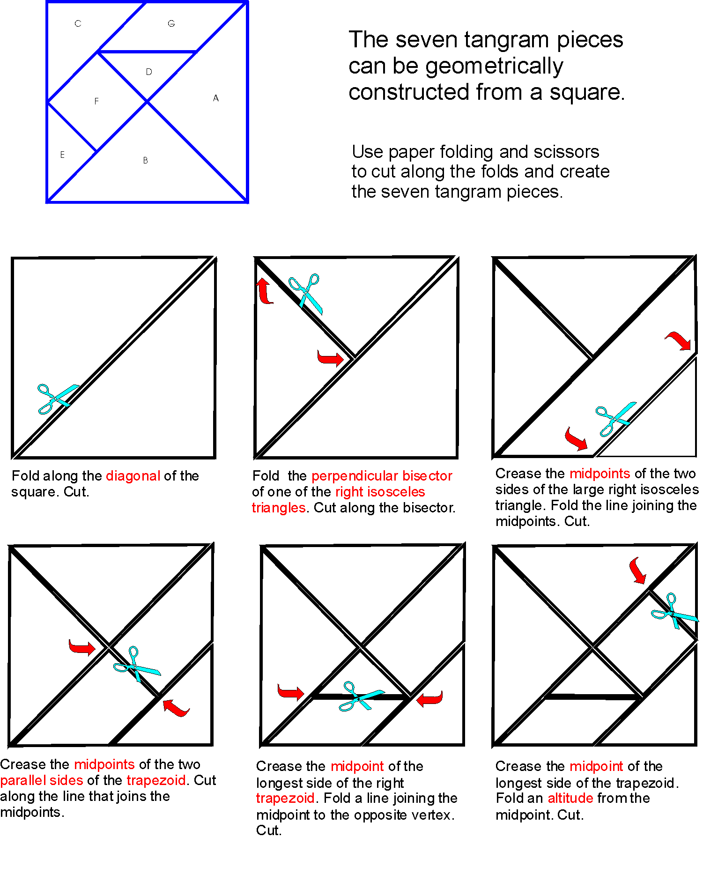

1.2.2: Constructing a Tangram from a Square – Pattern

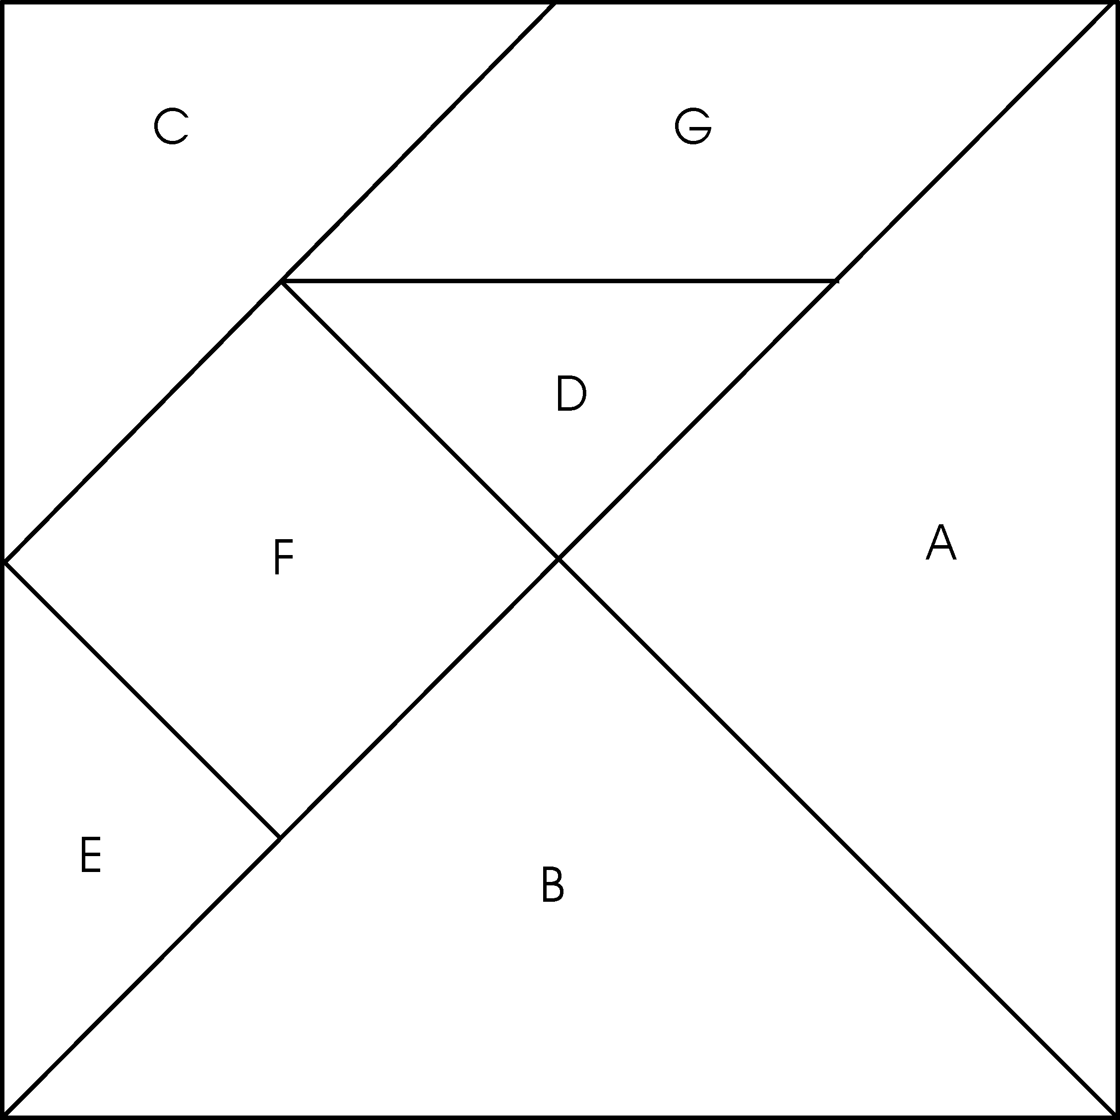

1.2.3: Creating Squares Using Tangram Pieces

Name:
Date:

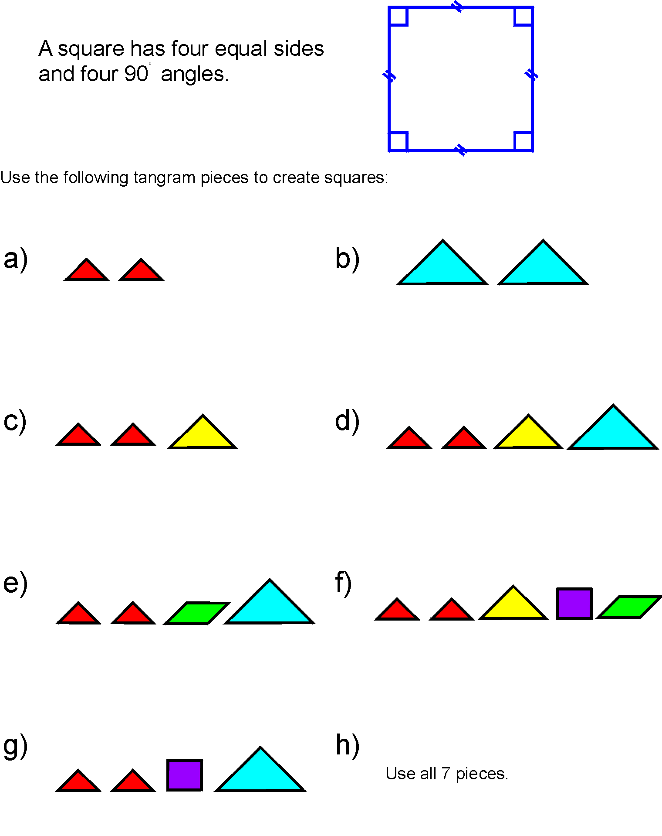

1.2.4: Creating Right-Angled Isosceles Triangles
Using Tangram Pieces

Name:
Date:

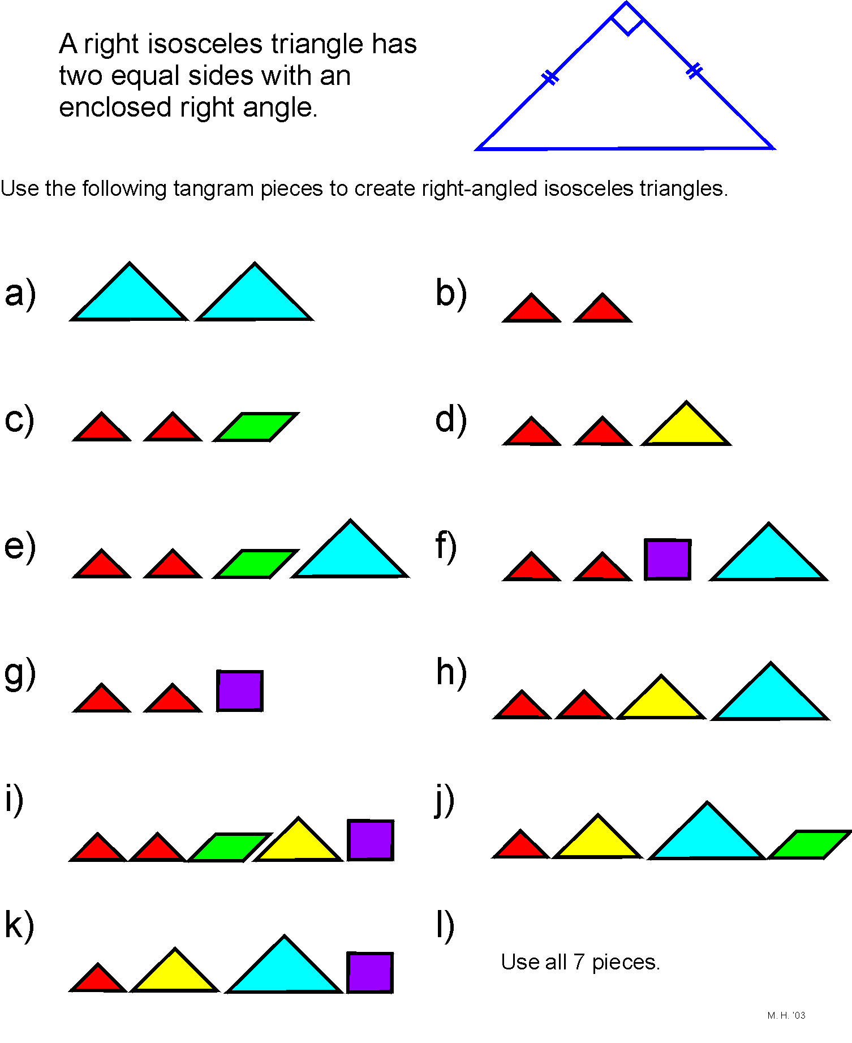

1.2.5: Squares and Right-Angled Isosceles Triangles
(Answers to BLM 1.2.3 and 1.2.4)

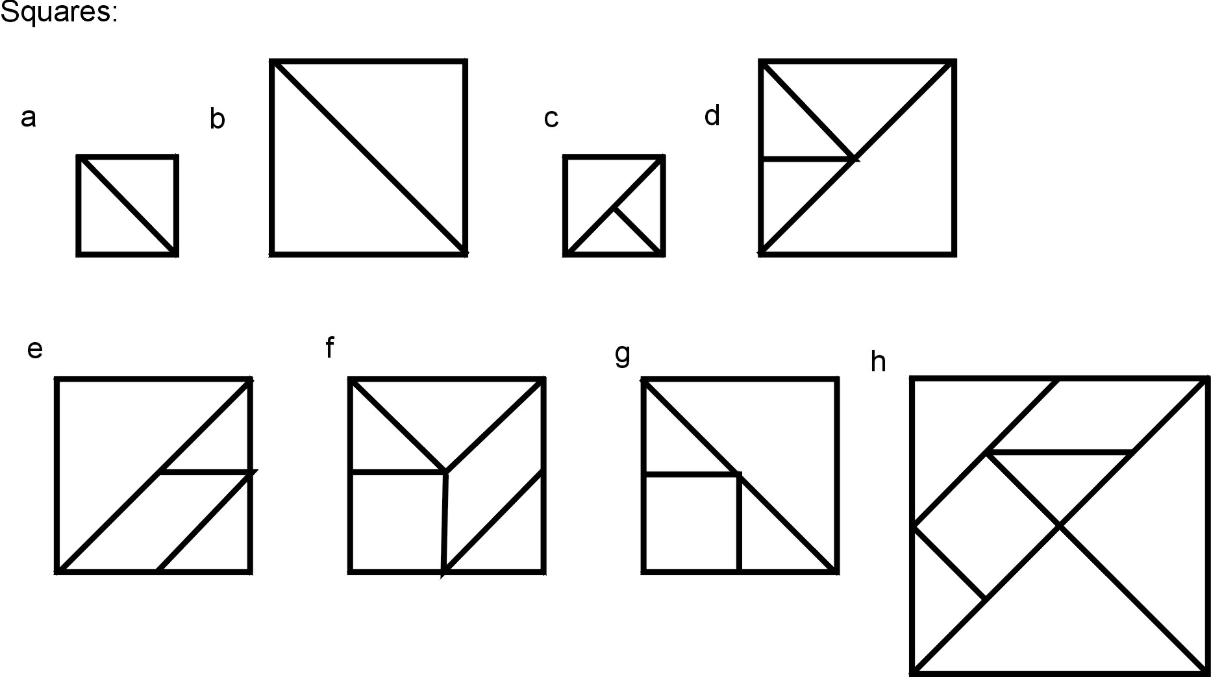

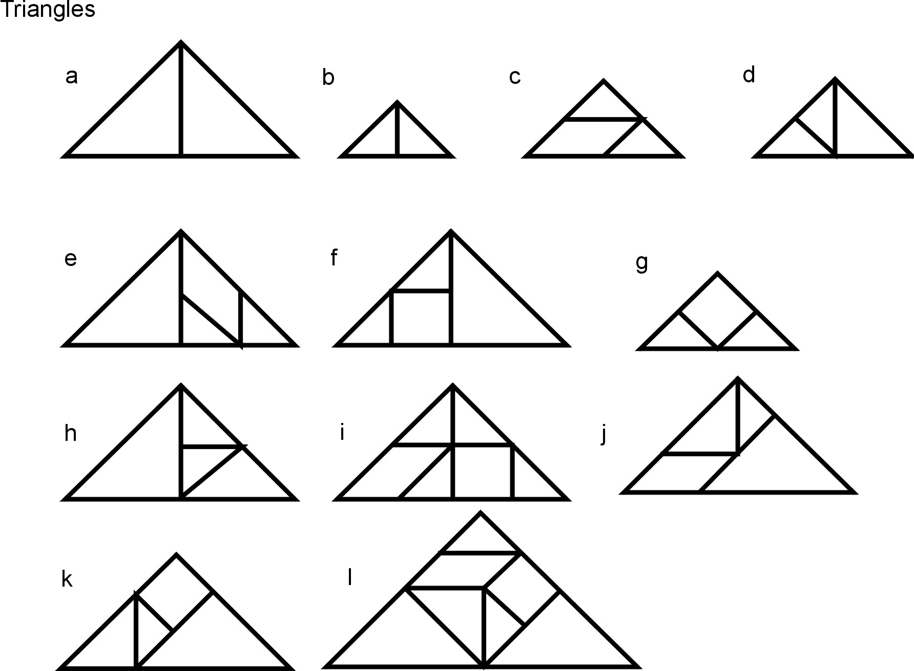

1.2.6: Shape Challenge Using Tangram Pieces

Name:
Date:

1. Using your set of tangram pieces, identify:
- a square
- a rectangle
- a triangle
- a parallelogram
- a trapezoid

2. Use two tangram pieces to create as many of the shapes listed above as possible.

3. Use three tangram pieces to create as many of the shapes listed above as possible.

4. Use four, five, six, and seven pieces to create as many shapes as possible.

5. Put two or more tangram pieces together to form a shape that is congruent with another tangram piece.

6. Use the two small triangle pieces to make three different shapes.

7. Make a pentagon using two tangram pieces.

8. Make a hexagon using five tangram pieces.

9. Use the five smallest tangram pieces to make a square.

10. Place the two large triangles around the square to form a triangle, a parallelogram, and a trapezoid.

1.2.7: Tangram Puzzles

Name:
Date:

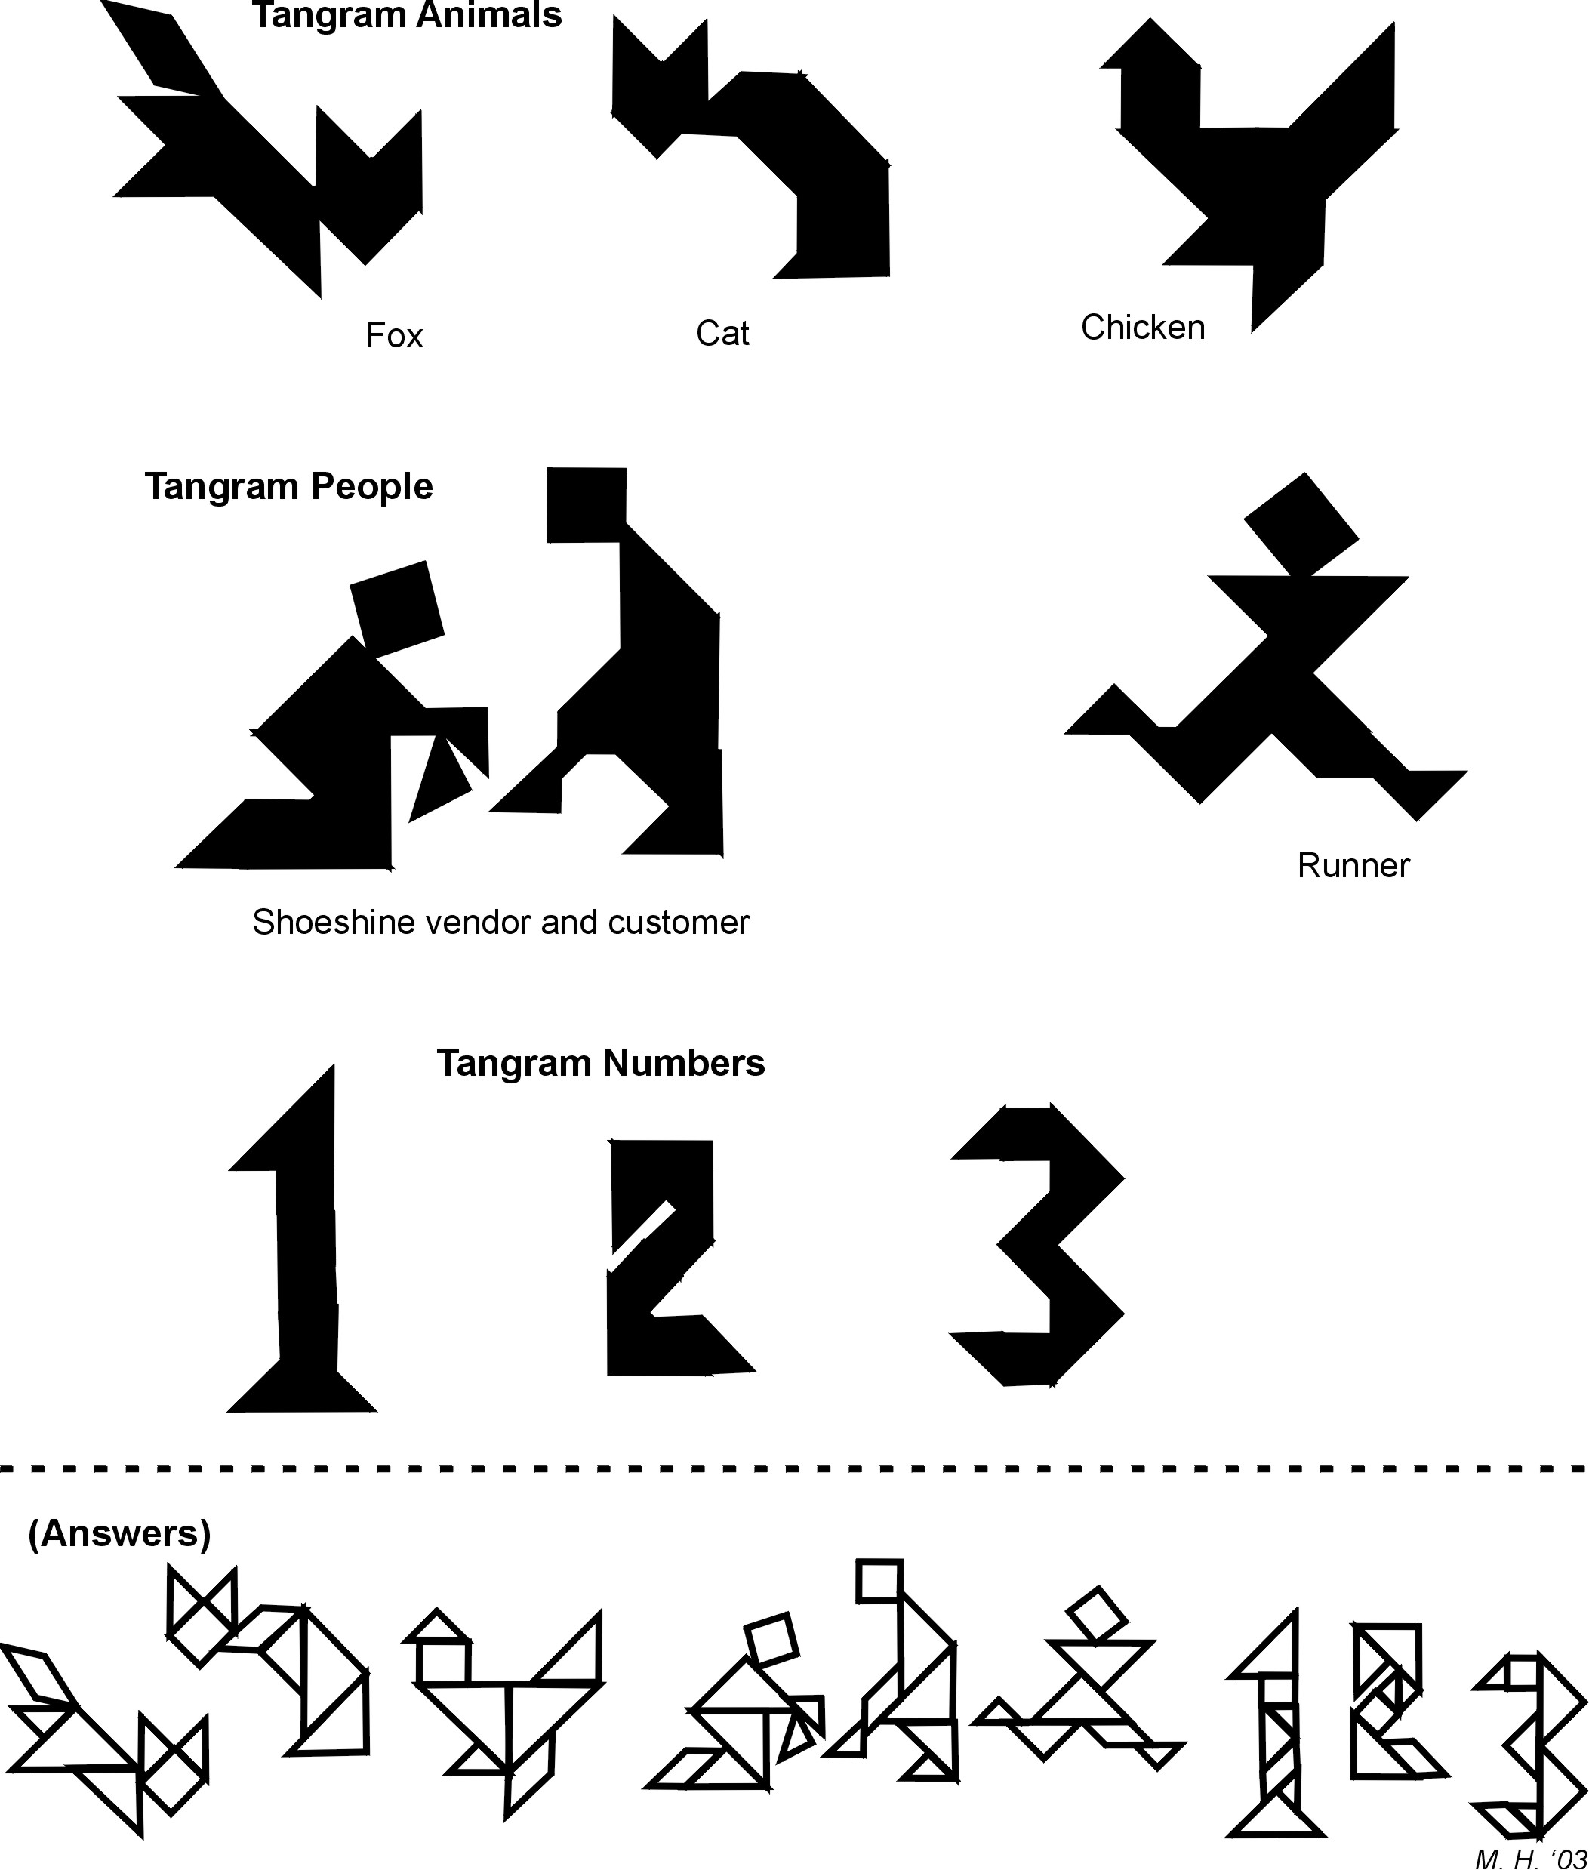

Unit 1: Day 3: Summer Survival |  |  |  |  | Grade 7
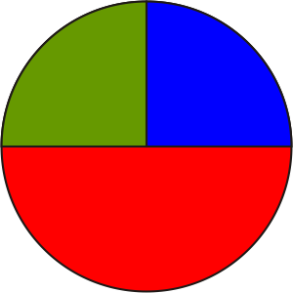 |  |  | Math Learning Goals  - Collect data by conducting a survey.  - Select an appropriate type of graph to represent a set of data.  - Identify bias. |  | Materials  - graph paper  - graphing software
Assessment
Opportunities
 | Minds On ... |  | Whole Class → Review  Ask several students to report on their tangram activities.  Recall kinds of graphs and their different purposes, e.g., circle graph shows parts of a whole, line graph shows change, bar graph shows relationship between separate items. Review important parts of a graph such as titles, labels, and scales.  Discuss how one event might prompt several questions for which different graphs might be appropriate, e.g., going to the beach.  - What type of graph would we use to show the number of students likely to be at the beach at different times during a day? (pictograph or line graph)  - What type of graph would we use to show the portion of time spent at the beach swimming, playing volleyball, and/or sunbathing? (circle graph)  - What type of graph would we use to show attendance at favourite local beaches? (bar graph) |  |  | Word Wall  - circle graph  - pictograph  - bar graph  - line graph
 | Action! |  | Small Groups → Brainstorm  Brainstorm seven topics that relate to summer activities. Discuss the importance of avoiding bias, asking clear questions, and having a fair sample in a survey.  Each group prepares survey questions for one of the topics, and shares its questions. The class critiques them for suitability as part of a survey.  Pairs → Data Gathering → Graphing  Each pair selects and writes one survey question on a piece of paper with their names at the top. In a chain from student to student, allowing seven seconds, circulate the questions for the class to respond to. A student at the end of the chain walks the paper to the other end of the chain. Stop the rotation of questions once enough data has been collected. Return papers to the pairs who posed the questions. Each pair chooses an appropriate graph type to display the data.  Learning Skills (Teamwork)/Observation/Rating Scale: Assess cooperation and class participation.
 |  | Consolidate Debrief | Whole Class → Sharing  Pairs show their graph and explain why they chose that type of graph.  Ask:  - Were the results as predicted?  - How would rewording the question change the graph?  - Was there any bias in the questioning or in the display? Explain.
Concept Practice |  |  | Home Activity or Further Classroom Consolidation  Present the data from your survey question in an alternative form, e.g., different scale, using technology.  Look for several types of graphs in print media and make a display.
Day 4: Can-Do Puzzles |  |  |  |  | Grade 7
 |  |  | Math Learning Goals  - Solve problems involving patterning, 2-D shapes and 3-D figures, calculations and probability. |  | Materials  - dot paper  - number cubes  - cubes
Assessment
Opportunities
 | Minds On ... |  | Whole Class → Reflection  Several students show their original and their revised graphs from the previous task, highlighting the changes. Discuss which graph best displays the data, with reasons.  Whole Class → Discussion  Ask: What does “doing mathematics” involve?  Develop a concept map including problem solving, looking for or creating patterns, working with 2-D shapes or 3-D figures, and performing calculations. |  |  | Consider setting up permanent centres based on strands or other criteria.
 | Action! |  | Small Groups → Review  Prepare stations that might include:  - tangram puzzles;  - crossword puzzles, using geometric vocabulary;  - building seven-cube structures, using cubes, and recording them on dot paper;  - numerical skill improvement, e.g., game;  - using geometric shapes to create a personal logo;  - experiments; e.g., When will a sum of 7 result, if two number cubes are thrown? In 50 throws, how often will 7 occur? Predict the result in 1000 throws.  At each station, provide explicit written instructions to help students understand the task. Groups move through several different stations.  Learning Skills/Observation/Anecdotal Note: Assess students’ initiative and teamwork.
 |  | Consolidate Debrief | Whole Class → Reflection  Students choose one task and write about the mathematics that they used, referring back to the concept map.  Select students to share their responses.
Reflection |  |  | Home Activity or Further Classroom Consolidation  Make a math journal entry.  - How have you experienced success during these four days?  - Which were the most interesting activities?  - Which activities would you like to continue or do again?  Show someone at home the mathematics you completed.  - How do they use the skills of problem solving and communicating in their daily lives (job, hobby, household)?  - What mathematical knowledge do they use frequently?  Make notes on their comments to share with the class. |  |  | Respond to the student directly on the math journal page.

