Unit 3 Calculus and Vectors
Applying Properties of Derivatives

Lesson Outline

Day |  |  | Lesson Title |  | Math Learning Goals | Expectations
1, 2, 3, |  |  | The Second Derivative  (Sample Lessons Included) |  | • Define the second derivative  • Investigate using technology to connect the key properties of the second derivative to the first derivative and the original polynomial or rational function (increasing and decreasing intervals, local maximum and minimum, concavity and point of inflection)  • Determine algebraically the equation of the second derivative f ”(x) of a polynomial or simple rational function f(x), and make connections, through investigation using technology, between the key features of the graph of the function and those of the first and second derivatives | B1.1, B1.2, B1.3
4 |  |  | Curve Sketching from information  (Sample Lesson Included)  * New – Jan 08 |  | • describe key features of a polynomial function and sketch two or more possible graphs of a polynomial function given information from first and second derivatives – explain why multiple graphs are possible. | B1.4
5, 6 |  |  | Curve Sketching from an Equation  (Sample Lesson Included)  * New – Jan 08 |  | • Extract information about a polynomial function from its equation, and from the first and second derivative to determine the key features of its graph  • Organize the information about the key features to sketch the graph and use technology to verify | B1.5
7 |  |  | Jazz Day (Sample Assessment included)
8 |  |  | Unit Summative  (Sample Included)
 | Unit 3: Day 4 – Curve Sketching from Information
 | Minds On: 10 |  |  | Learning Goals:  Students will  - describe key features of a polynomial function, given information about its first and/or second derivatives, (e.g., the graph of a derivative, the sign of a derivative over specific intervals, the x-intercepts of a derivative),  - sketch two or more possible graphs of the function that are consistent with the given information, and explain why multiple graphs are possible |  |  |  | Materials  - graphing calculators  - BLM.3.4.1  - BLM.3.4.2  - BLM.3.4.3  - BLM.3.4.4  - BLM.3.4.5
 | Action: 40
Consolidate:
25
 | Total=75 min
Assessment
Opportunities
 |  | Minds On… |  | Pairs → Connect to and Reflect on Prior Learning  Have students work in pairs to complete BLM3.4.1. |  |  |  | To save time, different groups could work on different parts of BLM3.4.3
 |  | Action! |  | Small Groups→ Guided Exploration  Have students work in small groups to complete BLM3.4.2 and BLM3.4.3.  Learning Skills/Observation/Checklist:  Observe and record student group work skills.  Mathematical Process Focus: reflecting, connecting
 |  | Consolidate  Debrief |  | Whole Class→ Teacher Led Discussion  Using BLM3.4.4 as a guide, demonstrate how key features of a polynomial function can be described given information about its first and second derivatives and how two or more graphs can be drawn using the given information about the key features of a polynomial function.
 | Exploration  Application |  |  | Home Activity or Further Classroom Consolidation  Complete BLM3.4.5.

BLM.3.4.1 First and Second Derivatives of Polynomial Functions

1. Determine the first derivative function and second derivative function for each function.

a) $f(x)=x^{2}+7x−3$ $f^{'}(x)=$  $f^{''}(x)=$ | b) $f(x)=4x^{3}−5x^{2}+3x−5$  $f^{'}(x)=$  $f^{''}(x)=$
c) $f(x)=5x^{4}−7x^{3}+3x^{2}−4x+2$  $f^{'}(x)=$  $f^{''}(x)=$ | d) $f(x)=6x−5$  $f^{'}(x)=$  $f^{''}(x)=$

2. Graph each function in the same viewing screen of a graphing calculator. Sketch the graphs.

a) $f(x)=x^{2}−2x−4$ $f^{'}(x)=2x−2$  $f^{''}(x)=2$ | b) $f(x)=−x^{2}+2x−4$ $f^{'}(x)=−2x+2$  $f^{''}(x)=−2$
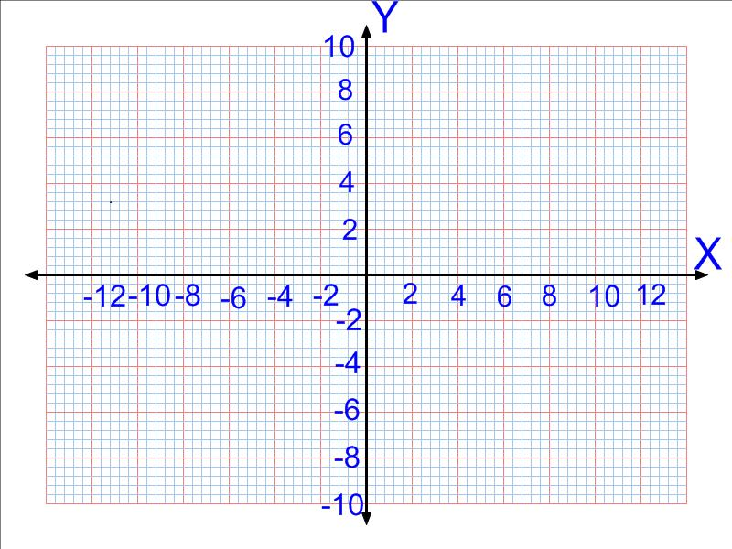

BLM.3.4.2 Constantly Different!

1. Determine the first and second derivative functions for each function.

a) $f(x)=x^{2}+2x−4$ $f^{'}(x)=$  $f^{''}(x)=$ | b) $g(x)=x^{2}+2x−2$  $g^{'}(x)=$  $g^{''}(x)=$
c) $p(x)=x^{2}+2x$  $p^{'}(x)=$  $p^{''}(x)=$ | d) $q(x)=x^{2}+2x+2$  $q^{'}(x)=$  $q^{''}(x)=$

2. a) How are the given polynomial functions in question 1. similar? How are they different?

b) What do you notice about the first derivative and second derivative functions?

3. a) For each set of polynomial functions in question 1, graph the polynomial function, the first derivative function, and the second derivative function in the same viewing screen of a graphing calculator. Compare the graphs.

BLM.3.4.3 Same Derivatives

1. A polynomial function is given in Y₁. Check that the function in Y₂ is the first derivative function of the polynomial function in Y1, and that the function Y₃ is the second derivative function. Then use a graphing calculator to graph the three polynomial functions in the same viewing screen. (The graph in part a) is provided.)

a)

(i) The function $f(x)=x^{2}−4x−4$ is a parabola opening _______________.

(ii) The coordinates of the vertex of $f(x)=x^{2}−4x−4$ are ( , ).

(iii) The first derivative of the function $f(x)=x^{2}−4x−4$is the function ____________________.

(iv) The graph of the first derivative function is a ____________ line with slope _______
and y-intercept _____.

(v) The x-intercept of the first derivative function is x = _______.

(vi)The second derivative of the function $f(x)=x^{2}−4x−4$ is the function _____________________.

(vii) Describe the graph of the second derivative function.

(viii) Since the second derivative is ________________ for all real values of x, therefore the function $f(x)=x^{2}−4x−4$ opens _______________.

(ix) What does the second derivative tell you about the local minimum of the function $f(x)=x^{2}−4x−4$?
BLM.3.4.3 Same Derivatives(cont.)
- Analyse the function $f(x)=x^{2}−4x−2$using part a) as a model.
Sketch the function and its derivatives.
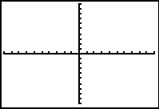

BLM.3.4.3 Same Derivatives(cont.)
c) Analyse the function $f(x)=x^{2}−4x$ using part a) as a model.
Calculate the 1st and 2nd derivatives .
and enter them in Y₂ and Y₃ Sketch the function and its derivatives
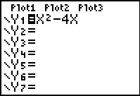

BLM.3.4.3 Same Derivatives (cont.)
- Analyse the function $f(x)=x^{3}+3x^{2}+3x+1$ using part a) as a model.
Calculate the 1st and 2nd derivatives .
and enter them in Y₂ and Y₃ Sketch the function and its derivatives
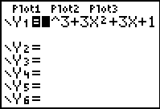

BLM.3.4.4 From the Derivatives to the Function

1. a) Use the information given about the first and second derivatives of an unknown polynomial function to describe its key features (in the right column of the table).

Information about Derivatives of the Function → | Key Features of the (Polynomial )Function
The graph of the first derivative function is a straight line with slope 2 and x-intercept at the  point (1, 0). | There will be a local maximum point or a local minimum point at the point ___________
For x < 1, the first derivative of the function is negative. | For x < 1, The function is a(n) _________________ function
For x > 1, the first derivative of the function is positive. | For x > 1The function is a(n) _________________ function
The graph of the second derivative does not have an x-intercept. | The function does not have a point of ________________.
The second derivative of the function is always positive. | The function is concave __________.
At the point where x = 1, the first derivative is equal to zero and the second derivative is positive. | There will be a local ______________ point at the point where x = 1
b) Sketch a graph of the polynomial function.

c) Is more than one graph of each polynomial function possible? Justify your answer.

BLM.3.4.4 From the Derivatives to the Function (cont.)
b) Complete the right column of the table based on the information on the left side.
Information about Derivatives of the Function → | Key Features of the (Polynomial )Function
The graph of the first derivative function is a parabola with x-intercepts at the points (−1, 0) and (1, 0) and vertex at the point (0, −3).

For x < -1, the first derivative of the function is positive.
For -1 < x < 1 the first derivative of the function is negative.
For x > 1 the first derivative of the function is positive.
The x-intercept of the second derivative is the point (0, 0)
For x < 0, the second derivative of the function is negative.
For x > 0, the second derivative of the function is positive.
At the point where x = −1, the first derivative is equal to zero and the second derivative is negative.
At the point where x = 1, the first derivative is equal to zero and the second derivative is positive.

BLM.3.4.5 Graphing Polynomial Functions from Derivative Information

1. Sketch and label the graph of the function$g\left(x\right)$, which is a straight line with slope 2 and x-intercept at the point (2, 0).

b) Suppose$g\left(x\right)$ is the derivative of $f\left(x\right)$, and $f\left(0\right)=6$. Sketch the graph of $f\left(x\right)$ on the same grid.

c) Suppose $g\left(x\right)$ is given as$g\left(x\right)=2\left(x−2\right)$. Determine the equation of $f^{''}\left(x\right)$ and describe some key features of the function $f\left(x\right)$.

2. Sketch and label the graph of the function$g\left(x\right)$, which is a straight line with slope −2 and x-intercept at the point (2, 0).

b) Suppose$g\left(x\right)$ is the derivative of$f\left(x\right)$, and $f\left(0\right)=−6$. Sketch the graph of $f\left(x\right)$ on the same grid as the function $g\left(x\right)$.

c) Suppose $g\left(x\right)$ is given as $g\left(x\right)=−2\left(x−2\right)$. Determine the equation of $f^{''}\left(x\right)$ and describe some key features of the function $f\left(x\right)$.

BLM.3.4.5 Graphing Polynomial Functions from Derivative

Information (cont.)

3. Sketch and label the graph of the function$g\left(x\right)$, which is a parabola with vertex at the point (2, −4), and x-intercepts 0 and 4.

b) Suppose that$g\left(x\right)$ is the derivative of $f\left(x\right)$, and $f\left(0\right)=3$. Sketch the graph of $f\left(x\right)$ on the same grid.

c) Suppose $g\left(x\right)$ is given as $g\left(x\right)=x\left(x−4\right)$. Determine the equation of $f^{''}\left(x\right)$ and describe some key features of the function $f\left(x\right)$.

Unit 3: Day 5: Curve Sketching from an Equation
Minds On: 15 |  | Math Learning Goals:  - Extract information about a polynomial function from its equation, and from the first and second derivative to determine the key features of its graph |  | Materials  - BLM 3.5.1  - BLM 3.5.2  - Device with CAS (e.g., Nspire, TI-89, TI-92, Voyage2000, Maple)
Action: 50
Consolidate:10
Total=75 min
Assessment
Opportunities
 | Minds On… | Small Groups → Placemat Activity  Have students complete a placemat activity to review the role of the first and second derivatives in determining information about a function.  Whole Class → Discussion  Have students share their centre note from their placemats by creating a class note on the board/overhead/interactive whiteboard. |  | This lesson is modified, with permission, from TI instructional materials.  Detailed instructions for this lesson using TI—Nspire CAS or TI-89s are provided in a separate file. They may be distributed to students if they are new to the technology.  Placemat activity.  See pages 30-33 of Think Literacy: Cross-Curricular Approaches, Grades 7-12 for more information on graphic organizers
 | Action! | Pairs → Activity  Students work in pairs to complete BLM 3.5.1. Review some of the functions of the handheld device beforehand, if necessary.  Process Expectations/Observation/Rubric:  Observe and listen to students as they engage in problem solving and reasoning and proving.  Mathematical Process Focus: Reasoning – Students will make logical connections between the properties of functions and their derivatives.
 | Consolidate Debrief | Whole Class → Discussion  Have students share their findings from BLM 3.5.1. Students should highlight the key information in a graphic organizer or note.  Small Groups → Activity  Students begin work on BLM 3.5.2. This can be finished for homework or worked on in small groups. For the third equation, students may want to use the Factor command (the expression factors over the integers).
Application |  | Home Activity or Further Classroom Consolidation  Complete BLM 3.5.2 for next class.

3.5.1: Analyze that Function!

In this activity, you will analyze a cubic function. You will determine the intercept(s), turning points and points of inflection by using a Computer Algebra System (CAS).

Part A – Observations

- In the graphing window, define the function f(x) = 2x³ – 6x² – 6x + 12.

- Choose an appropriate window for the function. Your window should allow you to see the intercept(s) and turning points. Record your window settings:
Window Settings:

- Estimate the location of each of the following:
- The y-intercept | - The x-intercept(s)
- The local maximum | - The local minimum
  - The point of inflection

Part B – Analysis

Show the command that you used to accomplish each of the following. You do not need to list the menus and options that you accessed.

- Define the function f(x) = 2x³ – 6x² – 6x + 12.

- Determine the y-intercept by substituting x = 0 into the function.

3.5.1: Analyze that Function! (cont.)

- Use the Solve command to find the x-intercept(s). The device will likely give you far more accuracy than you need. If you choose, you could reduce the number of digits displayed on your device.

- Define a new function, f1(x), to be the derivative of f(x).

- Display the first derivative function on your screen.

    - How many roots are you expecting to find?

    - Use the Solve command to determine the roots of f1(x).

    - What do these results represent?

    - Most CAS devices allow you to copy portions of the results from the previous screen. Use this feature to substitute into the function to find the y-coordinate corresponding to the x-value(s) found in #6. You may need your teacher to assist with this step.

    - Use the first derivative test to classify each of the points found above as either a local maximum or a local minimum for f(x).

3.5.1: Analyze that Function! (cont.)

- Define a new function, f2(x), to be the second derivative of f(x).
    - You may do this in two different ways – can you explain how?

- Display the second derivative function on your screen.

    - How many roots are you expecting to find?

    - Use the Solve command to find the root(s) of the second derivative.

    - What do these results represent?

- Substitute the x-value(s) (roots of the 2nd derivative) found in #7 into the function f(x) to find the corresponding y-coordinates.

- Use the second derivative test to determine if the point(s) discovered in #8 represent a point or points of inflection.
3.5.2: More Analysis

Determine the intercept(s), turning points and points of inflection by using a Computer Algebra System (CAS) or by pencil and paper. Explain your reasoning.

1. $−3x^{3}−4\text{.}5x^{2}+7$

2. $6\text{.}1x^{3}−0\text{.}8x+\text{11}\text{.}4$

3. $x^{4}+2x^{3}−\text{13}x^{2}−\text{14}x+\text{24}$

