Unit 6: Day 5: Project Renovation |  |  |  | MCT 4C
Minds On: 10 |  | Math Learning Goals:  - Solve problems involving the areas of rectangles, parallelograms, trapezoids, triangles, and circles and related composite shapes arising from a real-world application.  - Make connections between different mathematical concepts.  - Select appropriate formulas to solve measurement problems |  | Materials  - BLM 6.5.1-6.5.3
Action: 55 |  |  |  | Materials  - BLM 6.5.1-6.5.3
Consolidate:10 |  |  |  | Materials  - BLM 6.5.1-6.5.3
Total=75 min |  |  |  | Materials  - BLM 6.5.1-6.5.3
Assessment
Opportunities
 | Minds On… | Groups of 4 → Brainstorm  Refer to activity from Lesson 8 of Unit 3 where students investigated different occupations that may require mathematically modelling. Students are to brainstorm occupations that require calculating area, surface area and volume of regular and irregular figures on a regular basis. Students are to fill in their portion of place mat quietly for a few minutes. Students are to then share responses with rest of group. Common responses are to be recorded in centre of place mat.  Whole Class → Discussion  Groups share responses recorded in centre of each place mat. Discuss how those occupations use measurement skills on a regular basis.  Individual → Whole Class → Activity  Students complete BLM 6.5.2. Reponses are discussed as a class. |  | Literacy strategy: Place Mat (Think Literacy: Mathematics, Grade 7-12; pp.66-70)  Place mat can be copied on ledger or legal size paper to provide more space for students.  Remind students that the diagram is not to scale.  Teacher solutions are included for BLM 6.5.3.
 | Action! | Whole Class → Discussion  Pre-read activity on BLM 6.5.3with class. Highlight the overall goals of the task and the important pieces of information.  Pairs → Activity  Students complete BLM 6.5.3.  Curriculum Expectations /BLM 6.5.3 /Mental Note: Listen to students as they through activity to determine misconceptions. Select students to present their solutions during debrief.  Mathematical Process Focus: Connecting – Students make connections between concepts involving measurement and quadratic equations.
 | Consolidate Debrief | Whole Class → Discussion  Pre-selected students present their solutions to BLM 6.5.3. Discuss their presentations.  Questions to guide discussion:  - Are there other ways to solve the problems?  - What assumptions are being made when we solve these problems?  Pairs → Activity  Ask each pair of students to create a problem using the floor plan from the activity that would require finding area. Ask each pair to submit their problem with their names written on it. Distribute the created problems from each pair back to the class (making sure no pair receives the problem they created).
Application |  | Home Activity or Further Classroom Consolidation  Outline the steps necessary to solve the problem you were given.  Solve the problem you were given (show all necessary steps).  If you have difficulty solving the problem, explain why (eg. The question does not give you all necessary information to solve it). |  | Optional: Collect this assignment next day to provide feedback to students.

6.5.1: Occupations Requiring Calculation of Area and Perimeter

Through group sharing, record the occupations that were most common to all group members.

6.5.2: Formulae for Success

Rectangle equilateral circle right-angled perimeter trapezoid area parallelogram

Fill in the blanks with the correct word or formula from the box above.

- The area of a square can be represented by and the perimeter can be represented by _____________.

- An ______________________triangle has three equal sides and the interior angles are all __________________.

- In a _____________ the set of all points are equidistant from the centre. The area is represented by ______________.

- A quadrilateral with two pairs of equal opposite sides and four right angles is known as a ____________. Its area is represented by _______________ and its perimeter is represented by _________________ or ______________.

- The Pythagorean Theorem can only be applied to ____________ triangles. The formula __________________ is used to find the length of one side if the other two sides are known.

- The formula _________ is used the find the area of a triangle. It can also be expressed as _______________.

- A ________________ is a quadrilateral with one pair of parallel sides. The area can be represented by _________________ or ____________________.

- A quadrilateral with two pairs of equal opposite sides that are parallel is a _______________________. Its area is represented by _____________.

- The distance around the outside of a figure is the _______________.

- The number of square units contained in a 2-dimensional figure is the ___________.
6.5.3: Renovations Needed

Note: Your newly purchased loft diagram is not to scale.
Kitchen
Living/Dining Room
Closet
Washer/ Dryer
Fridge
Dishwasher
Bedroom
Balcony
Sliding Doors
Front Entrance
Bathroom
Closet
Den

6.5.3: Renovations Needed (continued)

You recently bought a loft but it needs some renovations. You decide to replace the lighting in the living/dining room and to do some decorating in your den.

Part A: Lighting the Living/Dining Room

- To increase lighting in the loft, you decide to add pot lights along the length of the room.
- You know that each pot light illuminates a circular area of 1.13 m².
- The dimensions of the room are 6.1 m by 4.3 m.

How many pot lights are required to light up the length of the room?

- Make a detailed plan to solve this problem including all required steps.

- Determine the number of pot lights required to light up the length of the room (i.e. the outside wall). Justify your answer.

- What assumptions did you make when you were determining the number of pot lights to use?

6.5.3: Renovations Needed (continued)

Part B: Decorating the Den

- You replaced the carpet with hardwood flooring.
- You want to purchase an area rug for the den, where half the area of the floor is exposed.
- The rug will be placed in the centre of the room so that there is a uniform width of hardwood exposed.
- The dimensions of the room are 3.8 m by 3.2 m.

What are the dimensions of the rug?

- Make a detailed plan to solve this problem including all required steps.

- Determine the uniform width.

- What are the dimensions of the rug?
6.5.3: Renovations Needed – Teacher Solutions

You recently bought a loft but it needs some renovations. You decide to replace the lighting in the living/dining room and to do some decorating in your den.

Part A: Lighting the Living/Dining Room

- To increase lighting in the loft, you decide to add pot lights along the length of the room.
- You know that each pot light illuminates a circular area of 1.13 m².
- The dimensions of the room are 6.1 m by 4.3 m.

How many pot lights are required to light up the length of the room?

- Make a detailed plan to solve this problem including all required steps.

  - Determine the radius of illumination by dividing the area of illumination by π, then taking the square root of the quotient.
  - Multiply the radius by 2 to determine the diameter of illumination.
  - Divide the length of the room by the diameter to determine the number of pot lights required.

- Determine the number of pot lights required to light up the length of the room.

A = π r ²  1.13 = π r ²  0.359 690 ≐ r ²  0.599 741 753≐ r  d = 2r  d ≐ 2(0.599 741 753)  d ≐ 1.199 483 508 | number of potlights  ≐  ≐ 5.085 522 194  Therefore, 5 pot lights are required to light up the room.

- What assumptions did you make when you were determining the number of pot lights to use?

Since the room has a large patio door, it will have some natural light. Also, electricity charges will be cheaper if there are 5 lights instead of 6.

6.5.3: Renovations Needed – Teacher Solutions (continued)

Part B: Decorating the Den

- You replaced the carpet with hardwood flooring.
- You want to purchase an area rug for the den, where half the area of the floor is exposed.
- The rug will be placed in the centre of the room so that there is a uniform width of hardwood exposed.
- The dimensions of the room are 3.8 m by 3.2 m.

What are the dimensions of the rug?

- Make a detailed plan to solve this problem including all required steps.

  - Determine the area of the room.
  - Determine the area of the carpet.
  - State the area of the carpet algebraically using the uniform width.
  - Set the area of the carpet equal to the algebraic equation for the area of the carpet and solve the equation.
  - Eliminate inadmissible answers

- Determine the uniform width.

Let x represent the uniform width.
Let (3.8 - 2x) represent the length and (3.2 - 2x) represent the width of the carpet.
A _{room} = (3.8) (3.2)  = 12.16 | A _{carpet} = (0.5)(12.16)  = 6.08  (Since area of the carpet is equal to the area of the exposed hardwood.)

6.08 = (3.8 - 2x) (3.2 - 2x)
0 = 4x ² - 14x + 6.08
x ≐ 2.991 974 235  (inadmissible since the length and width would become negative) | OR x ≐ 0.508 025 765

Therefore, the width of hardwood around the carpet is approximately 0.39 m.

- What are the dimensions of the rug?

Length = 3.8 - 2x  ≐ 2.783 948 47 | Width = 3.2 - 2x  ≐ 2.183 948 47

Therefore, the rug is approximately 2.8 m by 2.2 m.
Unit 6: Day 6: Cake Decorating |  |  |  | MCT 4C
Minds On: 5 |  | Math Learning Goals:  - Solve problems involving the volumes and surface areas of spheres , right prisms, and cylinders, and related composite figures drawn from a real-world application.  - Make connections between mathematical concepts and phenomena drawn from real-world applications.  - Reflect on strategies used to solve problems. |  | Materials  - BLM 6.6.1-6.6.5  - Chart paper (half sheets/group).  - Markers
Action: 50
Consolidate:20
Total=75 min
Assessment
Opportunities
 | Minds On… | Whole Class → Activity  Distribute to each student one of the cut out cells from BLM 6.6.1. Students group themselves into three by finding the connected cards for a figure (Shape, Volume/Perimeter and Surface Area/Area).Once groups have been formed, they create a formula sheet for their figure on the given chart paper and post these around the room.  Review the formulae for all the figures with the class. Students fill in BLM 6.6.2 using posted formulas as needed  Use these groupings for the Action portion of the lesson. |  | Note: Cut up the chart from BLM 6.6.1 into its individual cells. This will provide for five groups of three students. For larger groups, repeat as needed.  Refer to www.dippidee.com/weddingcakes/images/wcake9.jpg for a diagram of a cake involving composite volume and surface area.  Some students may need hint: that given the dimensions of the square-based prism, they need to determine the hypotenuse to get the diameter of the cylinder.  Clarify that icing is only placed on the exposed surface of the cake.
 | Action! | Groups of 3 → Activity  There are two versions of the activity (BLM 6.6.4 and BLM 6.6.5). Each version provides a different construction for a wedding cake. Display BLM 6.6.3 on an overhead for students to discuss in their groups.  Elicit individual hypothesis from students to share with the whole class.  Reasoning/Observation /Mental Note: Listen to students’ reasoning as they justify their thinking.  Distribute copies of BLM 6.6.4 and BLM 6.6.5 so that there are an equal number of groups doing each. Students pre-read activity with opportunity for clarification before starting to solve the problems. Circulate and provide guidance as necessary.  Connecting/Observation /Checkbric: Assess students’ ability to select and sequence steps to solve problems as they work through the activity.
 | Consolidate Debrief | Whole Class → Discussion  Students share solutions to BLM 6.6.4 and BLM 6.6.5. Students compare the solutions from version 1 and version 2. Questions to guide discussion:  - What were the similarities and differences?  - Did one require more icing than the other? Did one require more batter than the other?  - Is there a design that you think would require less icing?  - Is there a design that would provide a greater volume (within the restrictions stated)?  Reflecting/Observation /Mental Note: Assess students’ ability to reflect as they compare solutions and strategies.
Exploration  Application |  | Home Activity or Further Classroom Consolidation  Find at least two examples of composite figures in daily life. Sketch the examples or provide a photograph of the examples. Describe in detail the steps you would need to complete in order to find the volume and surface area of each example.

6.6.1: 3D and Me – Teacher Template

Shape and Diagram | Volume / Perimeter | Surface Area / Area
Cylinder  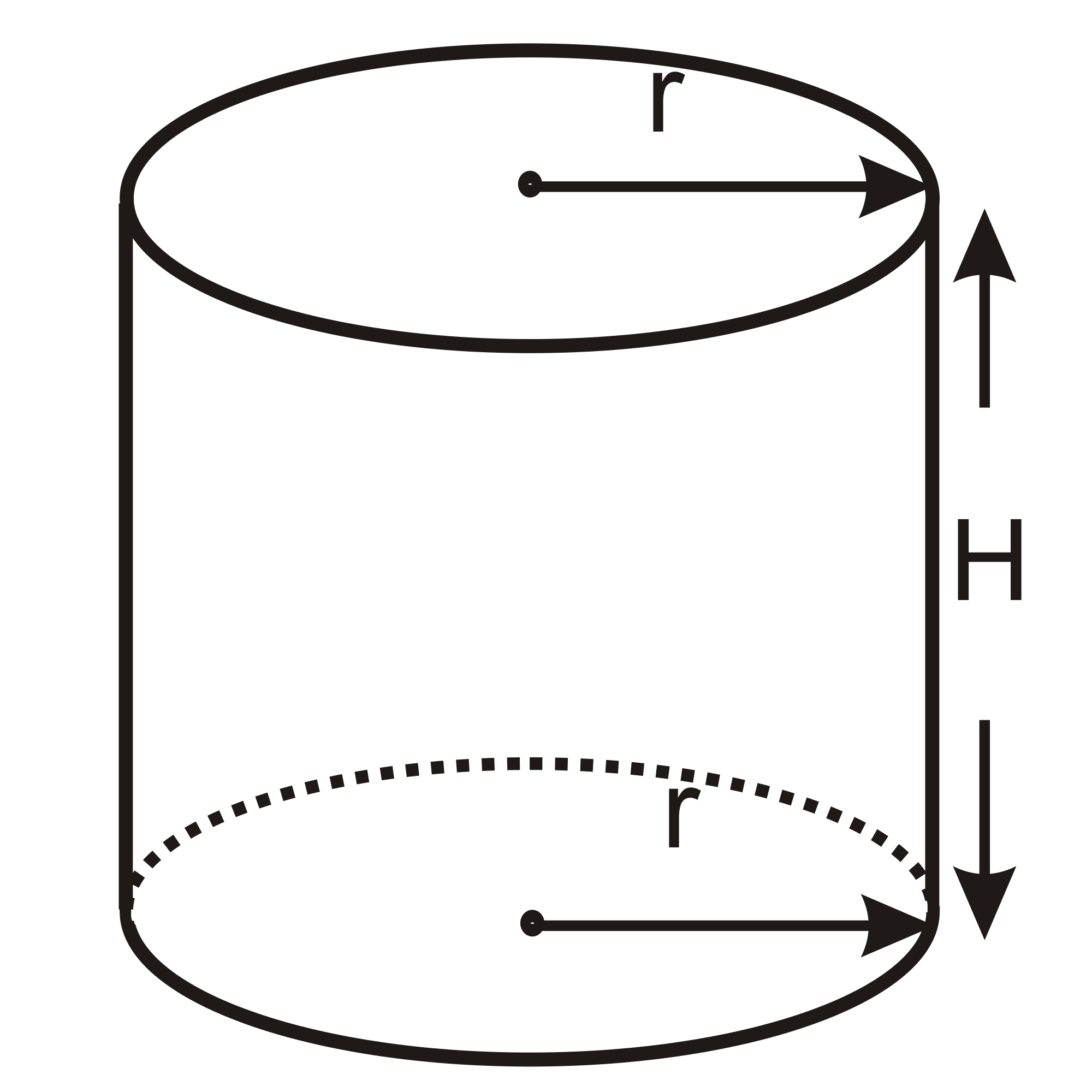 |  | $$\begin{aligned}\text{SA}=\text{top} + \text{bottom} +\text{side} \\ =(π r^{2})+(π r^{2})+(\text{2π} r H) \\ =(\text{2π} r^{2})+(2 π r H)\end{aligned}$$
Square – based prism

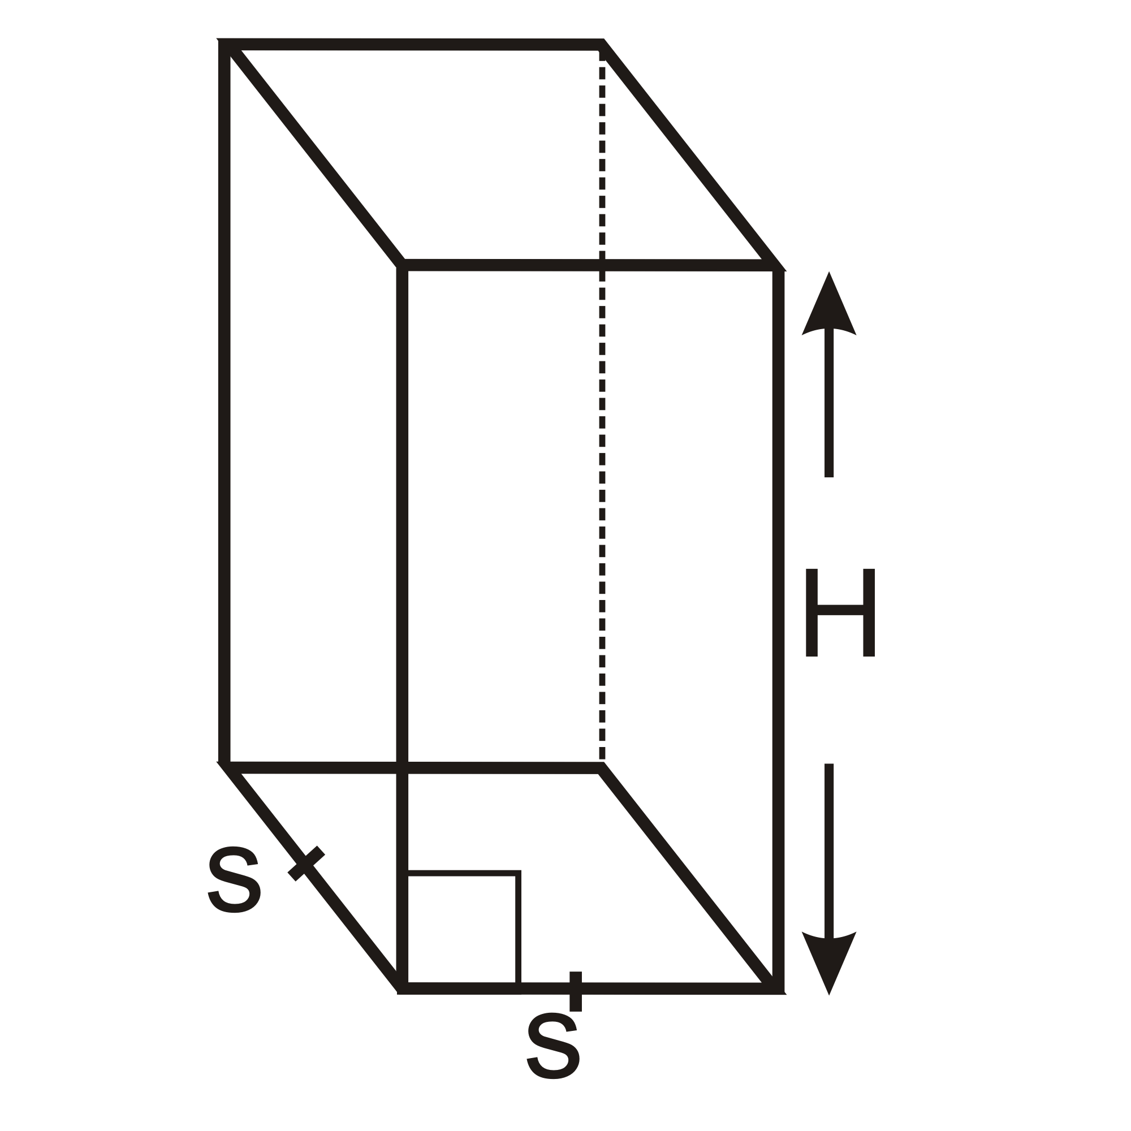
Circle

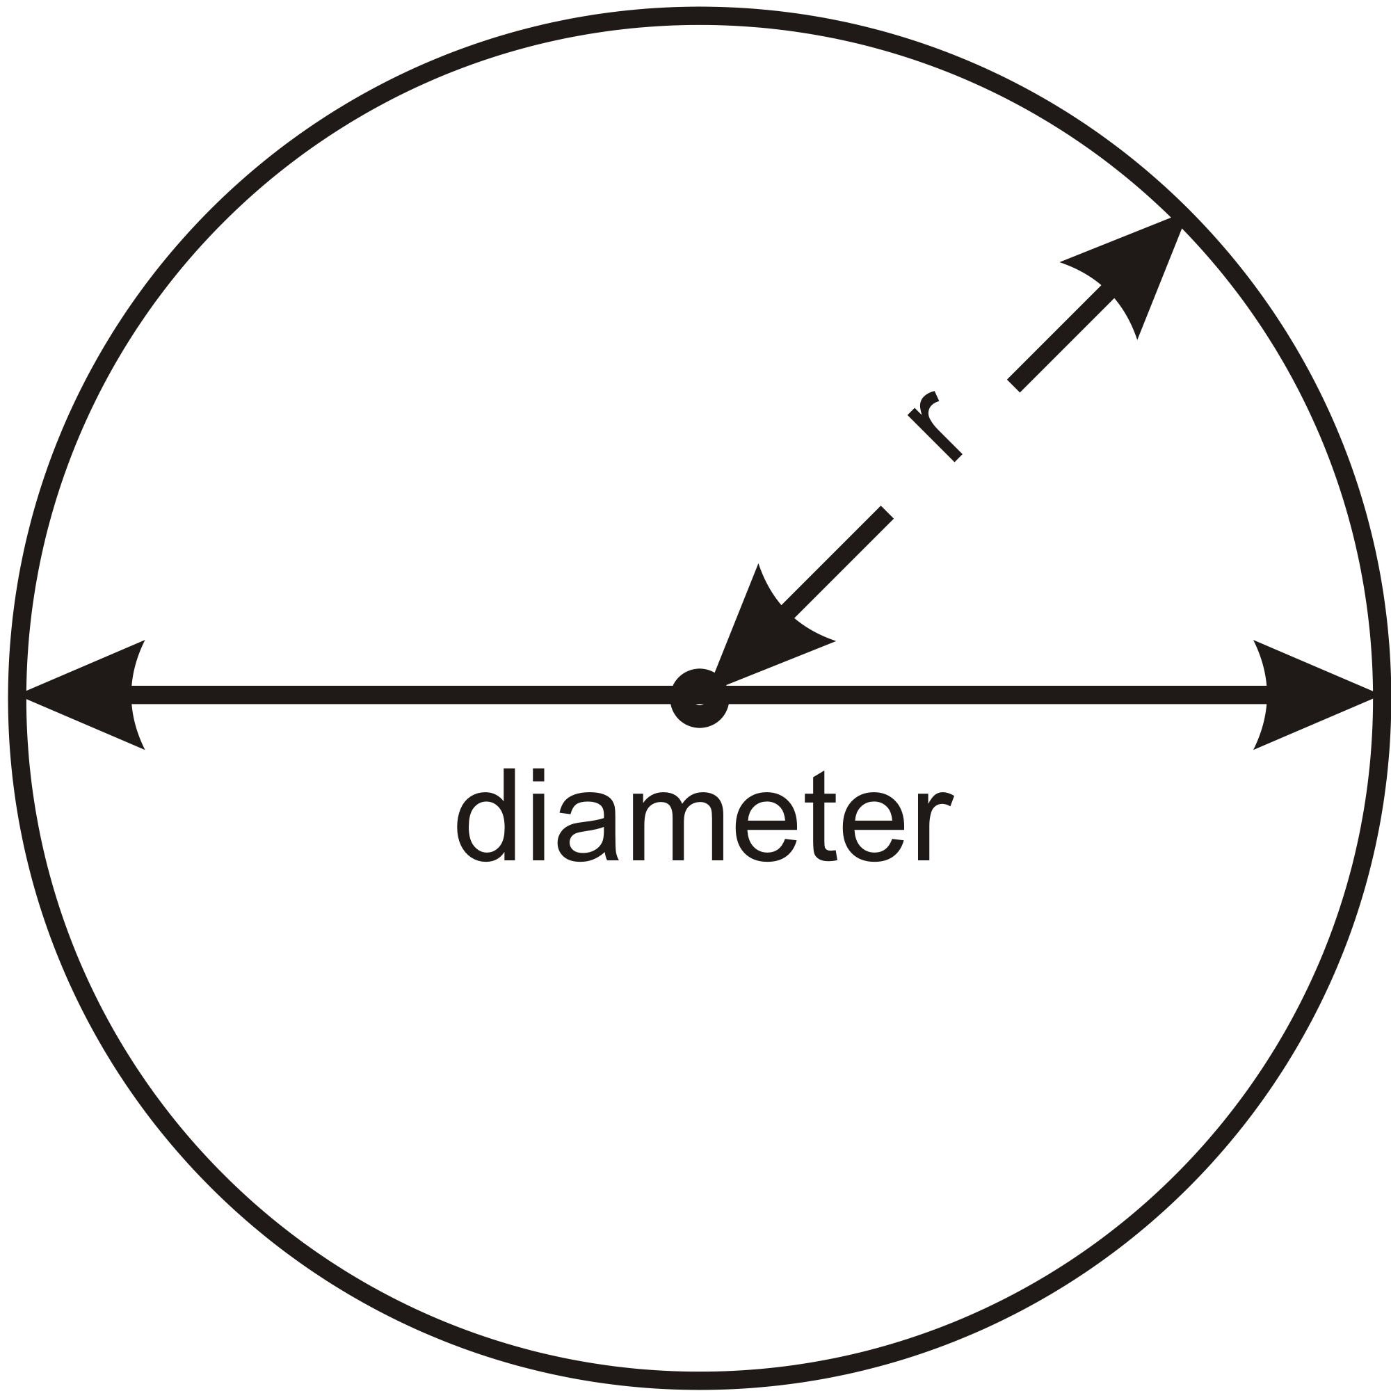

Triangular Prism  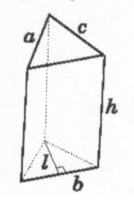 | $$\begin{aligned}V=(\text{basearea})h \\ =(\frac{1}{2}\text{bl})h \\ =\frac{\text{blh}}{2}\end{aligned}$$ | $$\begin{aligned}\text{SA}=\text{bases}+\text{sides} \\ =2(\frac{1}{2}\text{bl})+\text{ah}+\text{bh}+\text{cl} \\ =\text{bl}+\text{ah}+\text{bh}+\text{cl}\end{aligned}$$
Sphere
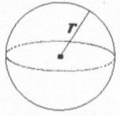

6.6.2: 3D and Me

Shape and Diagram | Volume / Perimeter | Surface Area / Area
Cylinder

Square – based prism

Circle

Triangular Prism
Sphere
6.6.3: It’s a Cake not Pi

Version 1 | Version 2

You own a bakery which specializes in custom orders. A customer requests to have a three-tiered cake made.
You offer the customer 2 different versions.
Consider the following with your group. Justify your reasoning:

- Are there similarities and differences? If so, what are they?

- Will one require more icing than the other? Will one require more batter than the other?

- Is there a design that you think would require less icing?

- Is there a design that would provide a greater volume (within the restrictions stated)?
6.6.4: It’s a Cake not Pi – Version 1

You own a bakery which specializes in custom orders. A customer requests to have a three-tiered cake made. The requirements are as follows:

- Each tier is 15 cm high.
- The bottom tier is a square – based prism with a side length of 45 cm.
- The middle tier is a cylinder. It must be positioned so that it touches the four edges of the bottom tier.
- The top tier is another square – based prism inscribed in the middle tier.
Refer to the diagrams at right.

Part A: Determining the dimensions and volume of the tiers.

- State the dimensions of the bottom tier.

- What is the diameter of the cylinder?
Top View

- How could you use the diameter of the cylinder to determine the dimensions of the top tier? (Remember, the length and width of the prism are the same.)

- Determine the dimensions of the top tier.

6.6.4: It’s a Cake not Pi – Version 1 (continued)

- Summarize your findings in the table below. Then, calculate the volume.

Tier | Dimensions (cm) | Volume (cm³)
Bottom | l =  w =  h =
Middle | d =  r =  h =
Top | l =  w =  h =

- You know that 250 mL of raw batter will produce 625 mL of cake. How much raw batter is required for this cake? Note: 1 mL = 1 cm³.

6.6.4: It’s a Cake not Pi – Version 1 (continued)

Part B: The icing on the cake

What is the minimum amount of icing required?
Things to consider:
- The bottoms of the tiers are not iced.
- You must ice the top layer of each cake and then position the tiers before you finish icing.

  - How much icing is required for the bottom tier?

  - How much icing is required for the middle tier?

  - How much icing is required for the top tier?

  - What is the minimum amount of icing required?

6.6.5: It’s a Cake not Pi – Version 2

You own a bakery which specializes in custom orders. A customer requests to have a three-tiered cake made. The requirements are as follows:

- Each tier is 15 cm high.
- The bottom tier is a cylinder with a diameter of 45 cm.
- The middle tier is a square – based prism. It must be positioned so that its corners touch the circumference of the bottom tier.
- The top tier is another cylinder inscribed in the middle tier.
Refer to the diagrams at right.

Part A: Determining the dimensions and volume of the tiers.

- Determine the dimensions of the bottom tier.
Top View

- How could you use the diameter of the bottom tier to determine the dimensions of the middle tier? (Remember, the length and width of the prism are the same.)

- What is the diameter of the top cylinder?

- Determine the dimensions of the top tier.

6.6.5: It’s a Cake not Pi – Version 2 (continued)

- Summarize your findings in the table below. Then, calculate the volume.

Tier | Dimensions (cm) | Volume (cm³)
Bottom | d =  r =  h =
Middle | l =  w =  h =
Top | d =  r =  h =

- You know that 250 mL of raw batter will produce 625 mL of cake. How much raw batter is required for this cake? Note: 1 mL = 1 cm³.

6.6.5: It’s a Cake not Pi – Version 2 (continued)

Part B: The icing on the cake

What is the minimum amount of icing required?
Things to consider:
- The bottoms of the tiers are not iced.
- You must ice the top layer of each cake and then position the tiers before you finish icing.

  - How much icing is required for the bottom tier?

2. How much icing is required for the middle tier?

3. How much icing is required for the top tier?

4. What is the minimum amount of icing required?

