Unit 2 - Two-variable data analysis MAP 4C

Foundations for College Mathematics

Lesson Outline

BIG PICTURE

Students will:
Personalize the course, and capitalize on their interests, post-secondary and career pathways
Collect, analyze, and summarize two-variable data using a variety of tools and strategies, and interpret and draw conclusions from the data
Distinguish situations requiring one-variable and two-variable data analysis
Analyze the use and misuse of data in the media
Day | Lesson Title | Math Learning Goals | Expectations
1 |  | - Create a graphical summary of two-variable data using a scatter plot without technology  - Describe possible interpretations of the line of best fit of a scatter plot and reasons for misinterpretations  - Determine whether a linear model is appropriate given a set of two-variable data, by assessing the correlation between the two variables | DM1.4, 1.5, 1.7  MM2.1, 2.2
2 |  | - Create a graphical summary of two-variable data from a secondary source using a scatter plot with technology → graphing calculators  - Determine an algebraic summary of the relationship between two variables  - Determine whether the line of best fit for a scatter plot is an appropriate summary of a set of two-variable data  - Describe possible interpretations of the line of best fit of a scatter plot and reasons for misinterpretations  - Make and justify conclusions from the analysis of two-variable data | DM1.3, 1.4, 1.5, 1.6, 1.7, 1.8  MM2.1, 2.2
3 | Using E-Stat to Create Scatter Plots and Lines of Best Fit  Lesson Included *New Jan/08* | - Create a graphical summary of two-variable data from a secondary source using a scatter plot with technology → Statistics Canada’s E-STAT  - Determine whether the line of best fit for a scatter plot is an appropriate summary of a set of two-variable data  - Describe possible interpretations of the line of best fit of a scatter plot and reasons for misinterpretations  - Make and justify conclusions from the analysis of two-variable data | DM1.3, 1.4, 1.6, 1.7, 1.8  MM2.1, 2.2
4 |  | - Jazz Day
5 |  | - Determine an algebraic summary of the relationship between two variables that appear to be linearly related and solve related problems (interpolate/extrapolate) | DM1.5
6 | Indices  Lesson Included *New Jan/08* | - Describe examples of indices used by the media and solve problems by interpreting and using indices | DM2.2  MM2.1, 2.2
7-8 | Using Fathom to create scatter plots and Lines of Best Fit  Lesson Included *New Jan/08* | - Use data available from Census at School (secondary source) and technology (Fathom) in order to summarize properties (e.g. dependent and independent variables, line of best fit, correlation, etc.)  - Determine an algebraic summary of the relationship between two variables and solve related problems  - Make and justify conclusions from the analysis of two-variable data | DM1.3, 1.4, 1.5, 1.6, 1.7, 1.8  MM2.1, 2.2
9 |  | Jazz Day
10 | Analysing Two-Variable Data  Lesson Included *New Jan/08*  *M.O. | Summative Activity

Unit 2: Day 3: Using E-STAT to Create Scatter Plots & Lines of Best Fit
Minds On: 15 |  | Math Learning Goals:  - Collect two-variable data from a secondary source  - Create a graphical summary of two-variable data using a scatter plot with technology  - Determine whether the line of best fit for a scatter plot is an appropriate summary of a set of two-variable data |  | Materials  - BLM 2.3.1  - Computer with internet access and a printer
Action: 50
Consolidate:10
Total=75 min
Assessment
Opportunities
 | Minds On… | Whole Class → Brainstorming  Engage students in a brainstorming discussion on the various sources of reliable two-variable data. Ensure that the student’s brainstorming covers both primary and secondary sources of data.  Whole Class → Discussion  Introduce Statistics Canada as the Canadian government’s department responsible for collecting and storing data about Canada’s population, economy, environment and more. Statistics Canada makes this data available through various means, included E-STAT.  Mathematical Process Focus: Reasoning and Proving - students will apply their understanding of two-variable statistics to identify sources they believe would be reliable and available for providing ‘real life’ data. |  | Electronic resources: Website: http://estat.statcan.ca  Literacy strategies:  Brainstorming
 | Action! | Independent E-STAT Activity  Assign students to work on the E-STAT activity in BLM 2.3.1. Students must work through the instructions to print the three required graphs. Then, they answer the questions at the end of the activity.  Learning Skills/Observation/Mental Note: Observe students for amount of time on task.  Mathematical Process Focus: Representing – students use E-STAT technology to graphically represent two-variable relationships.
 | Consolidate Debrief | Small Groups → Discussion  Draw the attention of students to the three questions at the end of the activity. Divide students into small groups and have them discuss possible answers to the questions.  Expectations/Observation/Verbal Feedback: Circulate to all groups to assess their learning. Do students understand? Clarify misunderstandings with the whole class as needed.
Exploration  Application  Reflection |  | Home Activity or Further Classroom Consolidation  Complete the three required graphs at home if they are not yet complete.  Complete the three questions at the end of the activity. |  | Students need an E-STAT ID and password to access from home. School boards usually have one ID and password that is used by all students.

2.3.1: E-STAT: Scatter Plot & Line of Best Fit

In this activity you will decide if you think there is a relationship between the number of Canadians 65 years and over and retail sales of drugs, vitamins and other health supplements in Canada.

#1 First you will look at the number of Canadians 65 years and over.
Go to http://estat.statcan.ca
→ English
→ Population and demography (in People)
→ Population estimates and projections
→ Table 051-0001: Estimates of population, by age group and sex, Canada, provinces and territories, annual (persons), 1971 to 2006
Select: →Canada for Geography
Both sexes for Sex
65 years and over for Age group (scroll down to the bottom of the list)
Select the earliest date to the latest date. ** Notice the data is annual. **
→ Retrieve as individual time series
Select Screen output: scatter graph from the table
Scroll down to the bottom of the page and press Retrieve now
Scroll down and select Modify Graphic to add your name. Print the graph.

For this scatter graph of the number of Canadians 65 years and over:
Independent variable (x-axis):
Dependent variable (y-axis):

#2 Now you will look at retail sales of drugs, vitamins and supplements.

Go back to the main E-STAT Table of Contents
→ Retail and wholesale (in Economy)
→ Retail sales by type of product
→ Table 080-0009: Survey of large retailers, monthly (dollars), Jan 1997 to Apr 2007
Select: →Canada for Geography
Drugs (prescription and over-the-counter), vitamins and other health supplements for Retail Commodity Classification
Unadjusted for Adjustments
Select the earliest date to the latest date. ** Notice the data is monthly. **
→ Retrieve as individual time series
Select Screen output: scatter graph from the table
Scroll down to the bottom of the page and press Retrieve now
Scroll down and select Modify Graphic to add your name. Print the graph.

For this scatter graph of retail sales of drugs, vitamins and supplements:
Independent variable (x-axis) :
Dependent variable (y-axis) :
2.3.1: E-STAT: Scatter Plot & Line of Best Fit (Continued)

#3 Creating a Scatter Graph & Line of Best Fit

You now need to make a scatter graph with:
Independent variable (x-axis): number of Canadians 65 years and over
Dependent variable (y-axis): retail sales of drugs, vitamins and supplements

Go back one screen to the page where you select the type of graph.
Scroll down to the bottom of the page.
→ Add more series. E-STAT has several methods to find other data sets of interest.
→ Browse by subject.
→ Population and demography
→ Population estimates and projections
→ Table 051-0001: Estimates of population, by age group and sex, Canada, provinces and territories, annual (persons), 1971 to 2006
Select: →Canada for Geography
Both sexes for Sex
65 years and over for Age group (scroll down to the bottom of the list)
Select the earliest date to the latest date. ** Notice the data is annual. **
→ Retrieve as individual Time Series. You can see both of your selections at the top of the next page.
Select: Screen output: Scatter graph with line of best fit (linear regression) from the table
→ Scroll down and press Retrieve now.
You will see the following message: ERROR
Series must all be of the same frequency.
The data for the number of Canadians 65 years and over is annual but the data for retail sales of drugs, vitamins and supplements is monthly. They don’t match!
→ Press OK.
→ Scroll down. Click on Manipulate data.
→ Under frequency of data, select Annual (sum). This adds together all of the monthly data for one year of retail sales to make an annual value. Now the data will match!
→ Scroll down. Select Retrieve now.
The graph is displayed.
Scroll down and select Modify Graphic to add your name. Print the graph.

TO HAND IN

Your 3 graphs AND answers to these questions:
- Based on your graph and the line of best fit, are the number of Canadians 65 years and over and retail sales of drugs, vitamins and health supplements correlated? Justify your answer.
- Do you feel that Canadians 65 years and over and retail sales of drugs, vitamins and supplements have a causal relationship? This means that the number 65 years and over is directly causes the retails sales. Justify your opinion.
- What other factors could affect the retails sales of drugs, vitamins and supplements reported in the data?
Unit 2: Day 6: Indices
Minds On: 15 |  | Math Learning Goals:  - Analyze graphs representing indices and use them to make predictions  - Determine how indices relate to everyday life |  | Materials  - BLM 2..6.1-2.6.5
Action: 55 |  |  |  | Materials  - BLM 2..6.1-2.6.5
Consolidate: 5 |  |  |  | Materials  - BLM 2..6.1-2.6.5
Total=75 min |  |  |  | Materials  - BLM 2..6.1-2.6.5
Assessment
Opportunities
 | Minds On… | Whole Class →Discussion  Lead students in a discussion about the concept of inflation. Introduce the Consumer Price Index as a measure of inflation and indices in general.  Pair/Share→ Brainstorming  Hand out the article from BLM 2.6.1 and ask students to read. Students should list the different consumer products from the article that are measured by the CPI. Then ask the students list and to reflect on the following:  - the way in which inflation reflects their lives or their families’ lives  - the way that inflation will influence their future decisions  - why the CPI may not reflect their personal consumer experiences  Expectations/Observation/Anecdotal comments:  Circulate while students discuss Inflation and the CPI and give them feedback and encouragement. Also monitor whether or not further class discussion is needed. |  | Your Guide to the Consumer Price Index can be found at  http://www.statcan.ca/english/freepub/62-557-XIB/62-557-XIB1996001.pdf  Point out that the CPI is a measures the inflation across Canada.
 | Action! | Whole Class →Discussion  Show the historical graph of the CPI from BLM 2.6.2 and discuss the important dates listed below the graph, as well as what factors affect the CPI. Point out that it is impossible to summarize the information on the graph over such a long period of time.  Whole Class →Teacher Directed Lesson  Distribute and work through BLM 2.6.3 with the students on an overhead.  Individual→ Activity  Handout BLM 2.6.4 and introduce the New Housing Price Index as one component of the CPI. Ask students to reflect on how the New Housing Price Index may affect their lives in the future. Have students complete BLM 2.6.4 using BLM 2.6.3 as reference.  Mathematical Process Focus: Reflecting– students will reflect on how the CPI and the New Housing Price Index will affect their lives.
 | Consolidate Debrief | Whole Class →Teacher Directed  Take up BLM 2.6.4 and ask the students to consider how the New Housing Price Index will affect their lives in the future.
Exploration  Reflection |  | Home Activity or Further Classroom Consolidation  Lists way in which you can prepare for the increase in housing prices and why a house may be a good investment or a bad investment. Complete BLM 2.6.5 for homework.
2.6.1 Inflation Article

Inflation eases to 2.2% but core inflation jumps to 4-year high
Last Updated: Thursday, May 17, 2007 | 11:45 AM ET

http://www.cbc.ca/money/story/2007/05/17/inflation-april.html

CBC News
Canada's annual inflation rate edged down to 2.2 percent in April from 2.3 percent the month before, Statistics Canada reported Thursday. Analysts had expected inflation to come in a touch lower at 2.1 percent. But the core inflation rate — which excludes volatile items in the consumer price index — rose to 2.5 percent from 2.3 percent in March. That's its highest level in more than four years. Analysts noted that the upward pressure on core inflation was broadly based, suggesting that interest rate hikes may come later this year.

"The Bank of Canada … will probably be forced to acknowledge the growing upside risk to inflation with an eye to possible rate hikes in the future," said TD economist David Tulk. The Canadian dollar jumped almost half a cent to 91.05 cents US in late morning trading.

The year-over-year rise in the cost of living was driven by increases in housing costs, as prices for new homes rose and consumers paid more in mortgage interest. Gasoline, for once, wasn't a major culprit in the annual inflation rate, as prices at the pump were actually lower in April than they were a year earlier. Natural gas was also cheaper year-over-year, as were computers and video equipment. Food, however, costs more. Consumers paid 3.8 percent more for food than they did in April 2006. Fresh vegetables were 12.9 percent more expensive.

Alberta's housing boom once again gave it the dubious honour of having the highest inflation rate in the country — 5.5 percent. Homeowners' replacement costs in that province have shot up by more than 29 percent in the past year.

On a month-over-month basis, prices rose 0.4 percent from March to April — a marked slowdown from the 0.8 percent rise seen in the previous month. Prices for gasoline and natural gas rose in April; prices for non-alcoholic beverages and women's clothing fell.

2.6.1 Inflation Article (Teacher Notes)

Consumer Price Index Definition

The CPI is defined as an indicator of the changes in consumer prices experienced by Canadians. It is obtained by comparing, through time, the cost of a fixed basket of commodities purchased by Canadian consumers in a particular year. Since the basket contains commodities of unchanging or equivalent quantity and quality, the index reflects only pure price movements.

The CPI is one of many price change measures available to the public. It reflects the experience of Canadian consumers buying consumer goods and services.

It is important, however, to understand that the CPI measures the average change in retail prices encountered by all consumers in Canada.

Over 600 items representative of typical Canadian purchases are included in the CPI’s basket of goods and services. Major groupings include:
1. Food
2. Shelter
3. Household operations and furnishings
4. Clothing and footwear
5. Transportation
6. Health and personal care
7. Recreation, education and reading
8. Alcoholic beverages and tobacco products

2.6.2 Historical Graph of CPI in Canada

1 World War I
2 Recession
3 Great Depression
4 Recession in the U.S.A
5 World War II
6 Price Controls
7 Explosion of Pent-up Demand
8 Korean War
9 Credit Controls
10 Period of Sustained Growth
11 First Oil Crisis
12 Anti-inflation Board
13 Second Oil Crisis
14 Wage Controls and Recession
15 Goods and Services Tax (GST)
16 Cigarette Tax Reduction

Obtained from: Your Guide to the Consumer Price Index (http://www.statcan.ca/english/freepub/62-557-XIB/62-557-XIB1996001.pdf)
2.6.3 Predicting Prices using the CPI

Below is a graph of the CPI in Canada from 1987 to 2007. The solid line represents the line of best fit.
- Describe the trend over time. Are time and the CPI index correlated?

- Calculate the annual rate of change of the graph using the point (1987, 72) and the point (2007, 108).

- The price of a pair of jeans in 2002 was $64.99. Based on the CPI, estimate what the same pair of jeans would cost in 2007?

- If an Mp3 player costs $129.99 in January 2007, according to the CPI, what would the same Mp3 player have cost in 1997? (If Mp3 players had existed back then!)

2.6.3 Predicting Prices using the CPI (Teacher Notes)

Below is a graph of the CPI in Canada from 1987 to 2007. The solid line represents the line of best fit.
- Describe the trend over time. Are time and the CPI correlated?
The CPI is increasing at a steady rate. Time and the CPI are positively correlated since the value of the CPI increases as time increases.

- Calculate the rate of change of the graph using the point (1987, 72) and the point (2007, 108).
Annual Rate of Change =$\frac{\text{108}−\text{107}}{\text{2007}−\text{1987}}=1\text{.}8$
Therefore the Annual Rate of Change is 1.8 points per year.

- The price of a pair of jeans in 2002 was $64.99. Based on the CPI, estimate what would the same pair of jeans cost 2007?
2007 CPI is 108.
Therefore an 8% increase from the base year of 2002.

108% of 64.99 = $70.19

- If an Mp3 player costs $129.99 in January 2007, according to the CPI, what would the same Mp3 player have cost in 1997? (If Mp3 players had existed back then!)
- 1997 CPI is 90 and 2007 CPI is 108. Find the percent increase.
$\frac{\text{108}−\text{90}}{\text{90}}=\text{.}2$ , therefore a 20% increase.
120% of price in 1997 is $129.99, therefore 129.991.20 = 108.33

2.6.4 The New Housing Price Index

Below is a graph and the data for the New Housing Price Index for Canada from January 1996 to January 2007.

Year | Index
1996 | 98
1997 | 98.1
1998 | 102.4
1999 | 104.8
2000 | 108.2
2001 | 113.5
2002 | 117.6
2003 | 125.3
2004 | 133.9
2005 | 142.4
2006 | 148.3
2007 | 153.5

- Find the mean of each variable and plot the point $(\bar{x},\bar{y})$on the graph.

- Draw a line of best fit on the graph above. Remember that the line must pass through the mean point $(\bar{x},\bar{y})$.

- Choose two points on the line of best fit and use them to determine the rate of change of the New Housing Price Index.

2.6.4 The New Housing (continued)

- How does the annual rate of change in the New Housing Price Index compare to the annual rate of change for the CPI?

- If I bought my house in 2004 for $140 000, based on the New Housing Price index, what would this house sell for if I sold it three years later in 2007?

- If I bought my house in 1996 for $125 500, based on the New Housing Price Index, what would this house sell for if I sold it in 2003? In 2007?

- If a house costs $250 000 in 2007, based on the New Housing Price Index, what would this house have sold for in 2000?

2.6.4 The New Housing Price Index (Teacher Notes)

Below is a graph and the data for the New Housing Price Index for Canada from January 1996 to January 2007.

Year | Index
1996 | 98
1997 | 98.1
1998 | 102.4
1999 | 104.8
2000 | 108.2
2001 | 113.5
2002 | 117.6
2003 | 125.3
2004 | 133.9
2005 | 142.4
2006 | 148.3
2007 | 153.5

- Find the mean of each variable and plot it on the graph $(\bar{x},\bar{y})$.

$\begin{aligned}\bar{x}=\frac{\text{24018}}{\text{12}} \\ \bar{x}=\text{2001}\text{.}5\end{aligned}$ $\begin{aligned}\bar{y}=\frac{\text{1446}}{\text{12}} \\ \bar{y}=\text{120}\text{.}5\end{aligned}$

- Draw a line of best fit on the graph above. Remember that the line must pass through the mean point $(\bar{x},\bar{y})$.

- Choose two points on your line of best fit. Estimate the coordinates of these points and use them to determine the annual rate of change of the New Housing Price Index.

(2007,145) and (1998.5,105)
Annual Rate of Change $\begin{aligned}\frac{\text{145}−\text{105}}{\text{2007}−\text{1998}\text{.}5}=4\text{.}\text{71} \\ \end{aligned}$
Therefore the Annual Rate of Change is approx. 4.71 points per year.
2.6.4 The New Housing Price Index (Teacher Notes)

- How does the annual rate of change for the New Housing Price Index compare to the annual rate of change for the CPI?

Based on the rate calculated in 3, the annual rate of change is much greater for the New Housing Price Index

- If I bought my house in 2004 for $140 000, based on the New Housing Price Index, what would this house sell for if I sold it three years later in 2007?

2004 Index is 133.9 and 2007 Index is 153.5. Find the percent increase.
$\frac{\text{153}\text{.}5−\text{133}\text{.}9}{\text{133}\text{.}9}=\text{.}\text{1464}$ , therefore a 14.64% increase.
114.64% of price in 2004 is $140 000 x 1.1464 = 160 960

- If I bought my house in 1996 for $125 500, based on the New Housing Price Index, what would this house sell for if I sold it in 2003? In 2007?

1996 Index is 98 and 2003 Index is 125.3. Find the percent increase.
$\frac{\text{125}\text{.}3−\text{98}}{\text{98}}=\text{.}\text{2786}$ , therefore a 27.86% increase.
127.86% of price in 1996 is $125 500 x 1.2786 = $160 464.30

1996 Index is 98 and 2007 Index is 153.5. Find the percent increase.
$\frac{\text{153}\text{.}5−\text{98}}{\text{98}}=\text{.}\text{5663}$ , therefore a 56.63% increase.
156.63% of price in 1996 is $125 500 x 1.5663 = $196 570.65

- If a house costs $250 000 in 2007, based on the New Housing Price index, what would this house have sold for in 2000?

2000 Index is 108.2 and 2007 CPI is 153.5. Fnd the percent increase.
$\frac{\text{153}\text{.}5−\text{108}\text{.}2}{\text{108}\text{.}2}=\text{.}\text{4187}$ , therefore a 41.87% increase.

141.87% of price in 2000 is $250 000,
therefore 250 000141.87 = $176 217.66

2.6.5 How Much Can You Expect to Pay

Below is the average New House Price for various cities in Canada.

Standard Two Storey
Market | Q1 2007 Average
Halifax | 200,000  Note: Average house prices are based on an average of all sub-markets examined in the area, except for the smaller markets of Charlottetown, Moncton, Fredericton, Saint John and Victoria.  FROM: http://www.royallepage.ca/CMSTemplates/AboutUs/Company/CompanyTemplate.aspx?id=1506
Charlottetown | 175,000
Moncton | 132,000
Fredericton | 187,000
Saint John | 210,400
St. John's | 200,000
Atlantic | 176,750
Montreal | 338,857
Ottawa | 294,667
Toronto | 489,889
Winnipeg | 220,714
Regina | 159,500
Saskatoon | 257,500
Calgary | 411,456
Edmonton | 384,750
Vancouver | 837,500
Victoria | 418,000
National | 378,148

- The New Housing Price Index in 2007 is 153.5. Use the rate of change from BLM 2.6.4 to predict what the New Housing Price Index will be in;

  - 5 years

  - 10 years

- Using the values calculated in question 1, calculate each percent increase from 2007;

  - 5 years

  - 10 years

- From the list above, choose a city where you can see yourself living in 5 or 10 years. Use the average price for your city in 2007 and the information from questions 2 and 3 to calculate what you can expect to pay for a new house in;

  - 5years
  - 10 years

- How much will you need to save if you are going to make a 10% down payment?

  - In 5 years

  - In 10 years

2.6.5 How Much Can You Expect to Pay (Teacher Notes)

Below is the average New House Price for various cities in Canada.

Standard Two Storey
Market | Q1 2007 Average
Halifax | 200,000  Note: Average house prices are based on an average of all sub-markets examined in the area, except for the smaller markets of Charlottetown, Moncton, Fredericton, Saint John and Victoria.  FROM: http://www.royallepage.ca/CMSTemplates/AboutUs/Company/CompanyTemplate.aspx?id=1506
Charlottetown | 175,000
Moncton | 132,000
Fredericton | 187,000
Saint John | 210,400
St. John's | 200,000
Atlantic | 176,750
Montreal | 338,857
Ottawa | 294,667
Toronto | 489,889
Winnipeg | 220,714
Regina | 159,500
Saskatoon | 257,500
Calgary | 411,456
Edmonton | 384,750
Vancouver | 837,500
Victoria | 418,000
National | 378,148

- The New Housing Price Index in 2007 is 153.5. Use the rate of change from BLM 2.6.4 to predict what the New Housing Price Index will be in;

- 5 years
- 10 years

4.71 points per year 4.71 points per year
Therefore 5 x 4.71 =23.55 Therefore 10 x 4.71 =47.10
153.5 + 23.55 = 177.05 153.5 + 47.10 = 200.6

- Using the values calculated in question 1, calculate each percent increase from 2007;

- 5 years

- 10 years

$\frac{\text{177}\text{.}\text{05}−\text{153}\text{.}5}{\text{153}\text{.}5}=0\text{.}\text{1539}$ $\frac{\text{200}\text{.}6−\text{153}\text{.}5}{\text{153}\text{.}5}=0\text{.}\text{3068}$
15.34% 30.68%

- From the list above, choose a city where you can see yourself living in 5 or 10 years. Use the average price for your city in 2007 and the information from questions 2 and 3 to calculate what you can expect to pay for a new house in;

- 5years
- 10 years

Toronto $489,889 Therefore $489 889 x 1.3068
Therefore $489 889 x 1.1539 =$565 282.92 =$640 186.95

- How much will you need to save if you are going to make a 10% down payment?

- 5 years

- 10 years

10% of $565 282.92 is $569 528.29 10% of $640 186.95 is $64 018.70

Unit 2: Days 7 & 8:
Using Fathom to Create Scatter Plots & Lines of Best Fit
Minds On: 15 |  | Math Learning Goals:  - Use data available from Census at School (secondary source) and technology (Fathom) in order to summarize properties (e.g. dependent and independent variables, line of best fit, correlation, etc.)  - Determine an algebraic summary of the relationship between two variables and solve related problems  - Make and justify conclusions from the analysis of two-variable data |  | Materials  - BLM 2.7.1  - Computer with Fathom and a printer  - Copies of current data printed from http://www19.statcan.ca/r000_e.htm
Action: 105
Consolidate:30
Total=150 min
Assessment
Opportunities
 | Minds On… | Whole Class → Discussion  Introduce the use of Census at School as a secondary source of data. Census at School data is gathered from students in participating classes across Canada and internationally. This activity uses data about Canadian boys.  Ask the class to consider if the data gathered by the Census at School project can be used to interpolate/extrapolate values about all Canadian boys. Create a list of variables they predict can be calculated reliably using the Census at School data.  Mathematical Process Focus: Reasoning and Proving – students will apply their understanding of two-variable statistics to make conjectures about the usefulness and reliability of the Census at School data. |  | You will need to copy a current set of the Census at School data from http://www19.statcan.ca/r000_e.htm for each student. When at the Census at School site, look for Canadian results – Canadian summary tables. Print Average height by age, Average length of forearm by age, Average length of hand by age, Average length of foot by age.  Assessment ‘as’ learning strategy:  Self evaluation of solutions  Students who complete their work early can be encouraged to choose 2 pieces of data from the census at school site that they think are related, download the data and test their hypothesis.
 | Action! | Independent → Fathom Activity  Assign students to work on the Fathom activity in BLM 2.7.1. On Day 7, instruct students to follow the Part 1 instructions to create the required graph and then answer the questions that follow. On Day 8, students should complete Part 2 and Part 3.  Learning Skills/Observation/Mental Note:  Observe students for amount of time on task.  Mathematical Process Focus: Representing – Students use Fathom technology to graphically represent two-variable relationships.
 | Consolidate Debrief | Small Groups → Discussion  At the end of each day, divide students into small groups and have them compare answers to the questions. Student should identify differing answers and verify their solutions by checking their data and their calculations. They should make corrections as needed.  Expectations/Presentation/Verbal Feedback:  Circulate to all groups to assess their learning. Do students understand? Clarify misunderstandings and “problem” questions with the whole class as needed.
Application  Differentiated |  | Home Activity or Further Classroom Consolidation  Complete the interpolation and extrapolation calculations at home, if you have not completed them yet.  If you have completed today’s activity:  Create 5 new questions that require interpolation/extrapolation. Exchange your questions with another student. Then, trade solutions and correct the answers.

2.7.1: Fathom & Line of Best Fit

This activity introduces you to a software package called Fathom. You will use Fathom and some data from Census at School to determine the equation of a line of best fit and then use it to interpolate and extrapolate measurements for boys.

PART 1: Hand Length vs. Height
- Launch Fathom.
- Create a case table: Data is stored in a case table. Move your cursor over the table icon on the main toolbar. Click on the table and drag it onto the main document.
- Enter the variable name: Click on the word <new> and type the word “hand_length” instead. Repeat this in the next cell to replace <new> with “height”.
- Enter the data: In the “hand_length” column, enter the data in order from youngest to oldest for the hand length of the boys. In the “height” column, enter the data in order from youngest to oldest for the height of the boys. The hand length and height of each age should be side-by-side in the table.
- Drag a graph on the document: Move your cursor over the graph icon on the main toolbar. Click on the graph and drag it onto a blank space in the main document.
- Graph the data: To create a scatter plot with hand length as the independent variable and height as the dependent variable, first click on “hand_length” in the case table and drag it onto the graph’s x-axis. Then, click on “height” in the case table and drag it onto the graph’s y-axis. Fathom will automatically create the scatter plot.
- Create the least-squares line (line of best fit): Right-mouse-click in the graph to open a drop-down menu. Select “least-squares line” from the menu. Fathom will create the line of best fit on the graph, and display the equation of the line below the graph.
- Arrange the data and graph on the page so it will print properly on a single sheet of paper. Leave space at the bottom of the page to answer the questions below.
- Add your name in a text box.
- Print.

Now use the equation of the line of best fit to answer these questions. You must show your work! You may answer the questions neatly on the page you just printed.
  - Describe the correlation of the hand length and height of boys.
  - Is the line of best fit a good fit for the data? Justify your answer.
  - Interpolate the height of a boy with a hand length of 15.0 cm.
  - Interpolate the hand length of a boy who is 162 cm tall.
  - Extrapolate the height of a boy with a hand length of 6cm. Does this seem realistic?
  - Extrapolate the height of a boy with a hand length of 20 cm. Does this seem realistic?
  - Find Michael Jordan’s height in centimetres by searching on-line. Use this height to extrapolate his hand length. Does this seem realistic?
  - Is this line of best fit reliable for predicting hand lengths and heights of boys? Are there any restrictions for using it?
  - Why it is important to use only one gender (in this case, boys) when creating and analyzing this scatter plot?
2.7.1: Fathom & Line of Best Fit (Continued)

PART 2: Forearm Length vs. Foot Length
- Open a new Fathom page.
- Repeat the steps in Part 1 to create a scatter plot with forearm length as the independent variable and foot length as the dependent variable.
- Create the least-squares line (line of best fit).
- Arrange the data and graph on the page; add your name in a text box, and print.

Now use the equation of the line of best fit to answer these questions. You must show your work! You may answer the questions neatly on the page you just printed.

  - Describe the correlation of the forearm length and foot length of boys.
  - Is the line of best fit a good fit for the data? Justify your answer.
  - Interpolate the foot length of a boy with a forearm length of 24.25 cm.
  - Interpolate the forearm length of a boy with a foot length of 25 cm.
  - Extrapolate the foot length of a boy with a forearm length of 30 cm. Does this seem realistic?
  - Extrapolate the forearm length of a boy with a foot length of 18 cm. Does this seem realistic?
  - Is this line of best fit reliable for predicting forearm lengths and foot lengths of boys? Are there any restrictions for using it?

PART 3: Age vs. Height
- Open a new Fathom page.
- Create a scatter plot with age as the independent variable and height as the dependent variable.
- Create the least-squares line (line of best fit).
- Arrange the data and graph on the page; add your name in a text box, and print.

Now use the equation of the line of best fit to answer these questions. You must show your work! You may answer the questions neatly on the page you just printed.

  - Describe the correlation of the age and height of boys.
  - Is the line of best fit a good fit for the data? Justify your answer.
  - Interpolate the height of a boy who is 11½ years old.
  - Interpolate the age of a boy with a height of 171 cm.
  - Extrapolate the height of a boy who is 6 years old. Does this seem realistic? Why or why not?
  - Extrapolate the height of a boy who is 30 years old. Does this seem realistic? Why or why not?
  - Is this line of best fit reliable for predicting ages and heights of boys? Are there any restrictions for using it?
2.7.2: Fathom & Line of Best Fit – Teacher Notes

Following is the data used for the 2007-2008 school year. It is the Canadian Census at School results for 2006-2007. The equation of each line of best fit as well as the interpolation and extrapolation answers are also provided for the 2006-2007 data.

***You will need to copy a current set of the Census at School data from http://www19.statcan.ca/r000_e.htm for each student. When at the Census at School site, look for Canadian results – Canadian summary tables. Print Average height by age, Average length of forearm by age, Average length of hand by age, Average length of foot by age.***

PART 1: Hand Length vs. Height
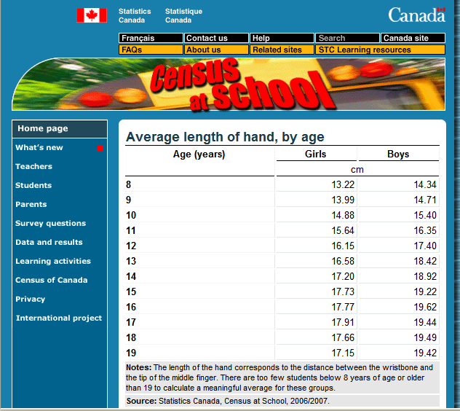
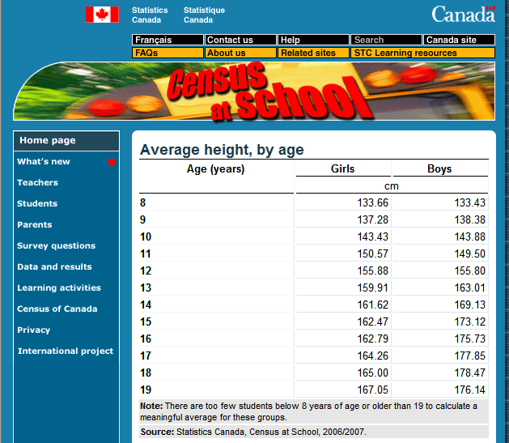

Equation: height = 8.10 hand_length + 17.6
Answers: c) 139.1 cm d) 17.8 cm e) 66.2 cm f) 179.6 cm
- Using 198 cm gives 22.3 cm

**Note: 1. For Part “g) Find Michael Jordan’s height in centimetres by ...”
You may wish to change Michael Jordan to another tall athlete that your class knows well.
2. For the other 2 parts, you may wish to have half of the class look at boys data and the other half look at girls data and have them compare the results. This may also help them answer i from Part 1

2.7.2: Fathom & Line of Best Fit – Teacher Notes (Continued)

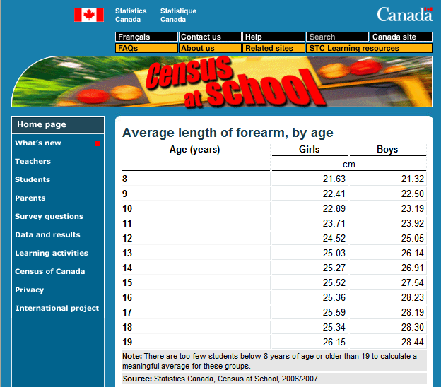
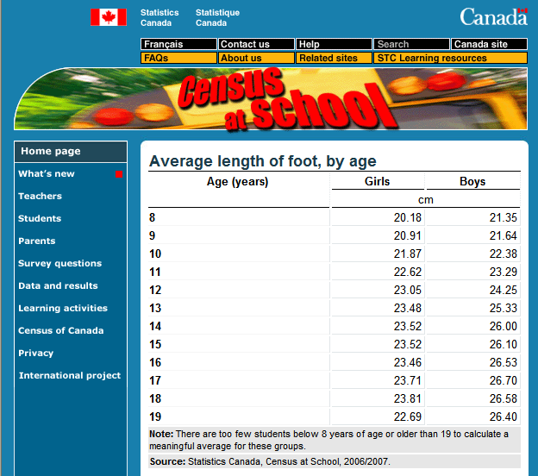
PART 2: Forearm Length vs. Foot Length

Equation: foot length = 0.80 forearm + 4.1
Answers: c) 23.5 cm d) 26.1 cm e) 28.1 cm f) 17.4 cm

PART 3: Age vs. Height

Equation: height = 4.40 age + 101.8
Answers: c) 152.4 cm d) 15.7 cm e) 128.2 cm f) 233.8 cm

