Unit 6: Modelling with More Than One Function MHF4U

Lesson Outline

Big Picture

Students will:
- consolidate understanding of characteristics of functions (polynomial, rational, trigonometric, exponential, and logarithmic);
- create new functions by adding, subtracting, multiplying, dividing, or composing functions;
- reason to determine key properties of combined functions;
- solve problems by modelling and reasoning with an appropriate function (polynomial, rational, trigonometric, exponential and logarithmic) or a combination of those functions.
Day | Lesson Title | Math Learning Goals | Expectations
1 | Under Pressure  GSP® file:  Under Pressure | - Solve problems involving functions including those from real-world applications.  - Reason with functions to model data.  - Reflect on quality of ‘fit’ of a function to data. | D3.1, 3.3  CGE 2b
2 | Solving Inequalities  Presentation file: Inequalities | - Understand that graphical and numerical techniques are needed to solve equations and inequalities not accessible by standard algebraic techniques.  - Make connections between contextual situations and information dealing with inequalities.  - Reason about inequalities that stem from contextual situations using technology. | D3.1, 3.2, 3.3  C4.1, 4.2, 4.3
3 | Growing Up Soy Fast!  GSP® file:  The Chipmunk Problem | - Model data by selecting appropriate functions for particular domains.  - Solve problems involving functions including those from real-world applications.  - Reason with functions to model data.  - Reflect on quality of ‘fit’ of phenomena to functions that have been formed using more than one function over the domain intervals. | D3.1, 3.3  CGE 5a
4 | Combining Functions Through Addition and Subtraction | - Make connections between the key features of functions to features of functions created by their sum or difference  (i.e., domain, range, maximum, minimum, number of zeros, odd or even, increasing/decreasing behaviours, and instantaneous rates of change at a point).  - Make connections between numeric, algebraic and graphical representations of functions that have been created by addition or subtraction.  - Reason about the connections made between functions and their sums or differences. | D2.1, 2.2, 2.3, 3.1  CGE 4b, 5g
5 | Combining Functions Through Multiplication | - Connect key features of two given functions to features of the function created by their product.  - Represent functions combined by multiplication numerically, algebraically, and graphically, and make connections between these representations.  - Determine the following properties of the resulting functions: domain, range, maximum, minimum, number of zeros, odd or even, increasing/decreasing behaviours, and instantaneous rates of change at a point. | D2.1, 2.3, 3.1  CGE 4b, 5g
Day | Lesson Title | Math Learning Goals | Expectations
6 | Combining Functions Through Division  Presentation file: Asymptote Becomes A Hole | - Connect key features of two given functions to features of the function created by their quotient.  - Represent functions combined by division numerically, algebraically, and graphically, and make connections between these representations.  - Determine the following properties of the resulting functions: domain, range, maximum, minimum, number of zeros, odd or even, increasing/decreasing behaviours, and instantaneous rates of change at a point. | D2.1, 2.3, 3.1  CGE 4b, 5g
7 | Composition of Functions Numerically and Graphically | - Determine the composition of functions numerically and graphically.  - Connect transformations of functions with composition of functions.  - Explore the composition of a function with its inverse numerically and graphically, and demonstrate that the result maps the input onto itself. | D2.4, 2.7  CGE 4f
8 | Composition of Functions Algebraically | - Determine the composition of functions algebraically and state the domain and range of the composition.  - Connect numeric graphical and algebraic representations.  - Explore the composition of a function with its inverse algebraically. | D2.5, 2.7  CGE 4f
9 | Solving Problems Involving Composition of Functions  Winplot file: U6L7_8_9.wp2 | - Connect transformations of functions with composition of functions.  - Solve problems involving composition of two functions including those from real-world applications.  - Reason about the nature of functions resulting from the composition of functions as even, odd, or neither. | D2.5, 2.6, 2.8  CGE 4f
10 | Putting It All Together (Part 1) | - Make connections between key features of graphs  (e.g., odd/even or neither, zeros, maximums/minimums, positive/negative, fraction less than 1 in size) that will have an affect when combining two functions from different families.  - Identify the domain intervals necessary to describe the full behaviour of a combined function.  - Graph a combined function by reasoning about the implication of the key features of two functions.  - Understand graphs of combined function by reasoning about the implication of the key features of two functions, and make connections between transformations and composition. | D3.1  CGE 4f
11–12 | Putting It Altogether (Part 2) | - Consolidate applications of functions by modelling with more than one function.  - Consolidate procedural knowledge when combining functions.  - Communicate about functions algebraically, graphically, and orally  - Model real-life data by connecting to the various characteristics of functions.  - Solve problems by modelling and reasoning. | Overall D2, D3  CGE 2b, 2c, 3c, 5g
13 | Jazz Day
14 | Summative Assessment

Unit 6: Day 1: Under Pressure |  |  |  |  | MHF4U
  75 min |  | Math Learning Goals  - Solve problems including those from real-world applications.  - Reason with functions to model data.  - Reflect on quality of ‘fit’ of a function to data. |  |  | Materials  - BLM 6.1.1  - computers with GSP® software
Assessment
Opportunities
 | Minds On… | Whole Class → Discussion  Introduce the lesson using the context of a leaky tire and discuss why it is important to know tire pressure when driving.  Tire pressure is a measure of the amount of air in your vehicle’s tires, in pounds per square inch or kPa (1 psi = 6.89 kPa). If tire pressure is too high, then less of the tire touches the ground. As a consequence, your car will bounce around on the road. When your tires are bouncing instead of being firmly planted on the road, you have less traction and your stopping distance increases. If tire pressure is too low, then too much of the tire’s surface area touches the ground, which increases friction between the road and the tire. As a result, not only do your tires wear prematurely, but they also could overheat. Overheating can lead to tread separation — and a serious accident.  Think/Pair/Share → Discussion  Individually, students use the data in to hypothesize a graphical model (BLM 6.1.1 Part A). Student pairs sketch a possible graph of this relationship.  Invite pairs to share their predictions with the entire class.  Lead a discussion about the meaning of ‘tolerance’ in the context of “hitting” a point on the curve.  Some people suggest that traditional two-sided tolerances are analogous to “goal posts” in a football game: This implies that all data within those tolerances are equally acceptable. The alternative is that the best product has a measurement which is precisely on target. |  | http://cars.cartalk.com/content/advice/tirepressure.html  http://en.wikipedia.org/wiki/Pressure  http://en.wikipedia.org/wiki/Tolerance_(engineering)
 | Action! | Pairs → Investigation  Students use BLM 6.1.1 Parts B and C and the GSP® file to manipulate each function model using sliders. They determine which model – linear, quadratic, or exponential – best fits the data provided and form an equation that best fits the data.  Students discuss with their partner other factors that would limit the appropriateness of each model in terms of the context and record their answers (BLM 6.1.1 – Part C). Circulate and assist students who may have difficulty working with the GSP® sketch.  Reasoning/Observation/Mental Note: Observe students facility with the inquiry process to determine their preparedness for the homework assignment.
 | Consolidate Debrief | Whole Class → Discussion  Students present their models for the tire pressure/time relationship and determine which pair found the “best” model for the data. This could be done using GSP® or an interactive whiteboard. Discuss the appropriateness of each model in this context, including the need to limit the domain of the function.  Curriculum Expectations/BLM/Anecdotal Feedback: Provide feedback on student responses (BLM 6.1.1).
Exploration  Application |  | Home Activity or Further Classroom Consolidation  Complete the follow up questions in Part C, if needed, and Part D “Pumped Up” on Worksheet 6.1.1. |  | (Possible Answer:  52 pumps)

6.1.1: Under Pressure

Part A – Forming a Hypothesis
A tire is inflated to 400 kilopascals (kPa) and over a few hours it goes down until the tire is quite flat. The following data is collected over the first 45 minutes.

Time, t, (min) |  | Pressure, P, (kPa) |  | 
0 |  | 400
5 |  | 335
10 |  | 295
15 |  | 255
20 |  | 225
25 |  | 195
30 |  | 170
35 |  | 150
40 |  | 135
45 |  | 115
 | 1 psi = 6.89 kPa

Create a scatterplot for P against time t. Sketch the curve of best fit for tire pressure.

Part B – Testing Your Hypothesis and Choosing a Best Fit Model
The data is plotted on The Geometer’s Sketchpad® in a file called Under Pressure.gsp.
Open this sketch and follow the Instructions on the screen.

Enter your best fit equations, number of hits, and tolerances in the table below.

 | Linear Model |  |  | Quadratic Model | Exponential Model
Your Best Fit Equations
Number of Hits
Equation of the best fit model: |  | ◻
6.1.1: Under Pressure (continued)

Part C – Evaluating Your Model
1. Is the quadratic model a valid choice if you consider the entire domain of the quadratic function and the long term trend of the data in this context? Explain why or why not.

2. Using each of the 3 “best fit” models, predict the pressure remaining in the tire after 1 hour.
How do your predictions compare? Which of the 3 models gives the most reasonable prediction? Justify your answer.

3. Using each of the 3 “best fit” models, determine how long it will take before the tire pressure drops below 23 kPA? (Note: The vehicle in question becomes undriveable at that point.)

4. Justify, in detail, why you think the model you obtained is the best model for the data in this scenario. Consider more than the number of hits in your answer.

Part D: Pumped Up
Johanna is pumping up her bicycle tire and monitoring the pressure every 5 pumps of the air pump. Her data is shown below. Determine the algebraic model that best represents this data and use your model to determine how many pumps it will take to inflate the tire to the recommended pressure of 65 psi.

Number of Pumps | Tire Pressure (psi)
0 | 14 |  | 1 psi = 6.89 kPa
5 | 30
10 | 36
15 | 41
20 | 46
25 | 49

Unit 6: Day 2: Solving Inequalities |  |  |  |  | MHF4U
  75 min |  | Math Learning Goals  - Understand that graphical and numerical techniques are needed to solve equations and inequalities not accessible by standard algebraic techniques.  - Make connections between contextual situations and information dealing with inequalities.  - Reason about inequalities that stem from contextual situations using technology. |  |  | Materials  - BLM 6.2.1 or graphing technology  - graph paper or graphing technology  - computer and data projector for presentation
Assessment
Opportunities
 | Minds On… | Think/Pair/Share → Whole Class → Discussion  Individually students identify three ways to solve the equation then share with a partner.  Debrief strategies as a whole class.  Lead a discussion about the numerical, algebraic and graphical methods of solving this problem, using the first six slides of the Inequalities presentation to visually demonstrate the graphical solution. |  | Inequalities.ppt.  See the notes in the first slide.  Students could use graphing technology to sketch the graph of the equation, and then they use reasoning to identify the solution to the inequality from the graph.  Alternative Approach  Divide class into groups; each group investigates a different inequality. Each group presents to the class. Debrief by showing the presentation.
 | Action! | Pairs → Investigation → Whole Class → Discussion  With a partner, students investigate three ways to solve  Lead a discussion about the numerical, algebraic and graphical methods of solving this problem, using slide 7 to visually demonstrate the graphical solution.  Lead a discussion on the graphical solution of using slides 8 and 9.  In pairs, students investigate the graphical solution toand  Lead a discussion of the solution using slides 10 and 11.  Reasoning/Observation/Mental Note: Observe students’ reasoning to solve the inequality once the graph is established.  Repeat the pairs investigation, discussion, using the graphs of and
 | Consolidate Debrief | Whole Class → Discussion  Emphasize the value of multiple representations in the light of some inequalities being unsolvable without the graphical representation.  Provide a contextual problem:  $1000 is invested at 5% compounded annually. $750 is invested at 7% compounded annually. When will the $750 investment amount surpass the $1000 investment amount?  Students express this question algebraically (Answer:) Demonstrate how easy it is to solve graphically by displaying the graph (BLM 6.2.1).
Consolidation  Application |  | Home Activity or Further Classroom Consolidation  Solve the inequalities involving quadratics and cubics both algebraically and graphically.  Solve the some inequalities involving rational, logarithmic, exponential and trigonometric functions graphically, using technology, as needed. Determine some contexts in which solving an inequality would be required.

6.2.1: Solution to CONSOLIDATE Problem

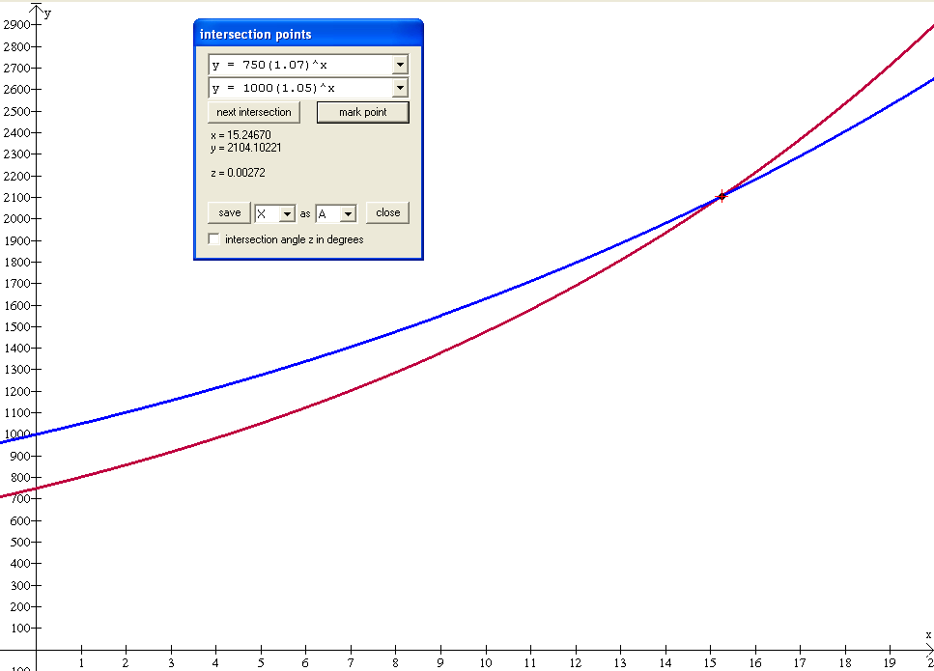

An investment of $750 will exceed an investment of $1000 in about 15.25 years.

Unit 6: Day 3: Growing Up Soy Fast! |  |  |  |  | MHF4U
  75 min |  | Math Learning Goals  - Model data by selecting appropriate functions for particular domains.  - Solve problems involving functions including those from real-world applications.  - Reason with functions to model data.  - Reflect on quality of ‘fit’ of phenomena to functions that have been formed using more than one function over the domain intervals. |  |  | Materials  - BLM 6.3.1, 6.3.2, 6.3.3, 6.3.4, 6.3.5  - graphing calculators  - computer with GSP® software
Assessment
Opportunities
 | Minds On… | Individual → Exploration  Students hypothesize about the effects of limiting fertilizer on the growth of the Glycine Max (commonly known as the soybean plant), under the three given conditions (BLM 6.3.1). They sketch their predictions and rationales (5 minutes).  Small Group → Discussion  Students discuss their choice of model and share their reasoning. They can change their models after reflection. |  | The initial discussion of the different models students think would be appropriate is important to help them properly connect the context to the mathematical characteristics of the functions they have been studying.  Modelling with functions becomes more relevant when students recognize that rarely does a single function serve as an appropriate model for a real-world problem.  Other relationships involving more than one function can be found at the E-STAT website http://estat.statcan.ca  Sample files: v737344, v151537 and v130106.
 | Action! | Pairs → Investigation  Students use their knowledge of function properties and the data (BLM 6.3.2) to determine function models for each scenario in the experiment.  (See BLM 6.3.4.)  Scenarios two and three provide an opportunity to model relationships by separating the domain into intervals, and by using different functions to model the data for each interval.  Students reflect back to their original predictions (BLM 6.3.1).  Reasoning/Observation/Mental Note: Listen to students’ reasoning for appropriate function selections and domain intervals to identify student misconceptions.
 | Consolidate Debrief | Pairs/Whole Group → Discussion  Identify pairs to present their models to the class. Presenters justify their reasoning by responding to questions.  Discuss the “fit” to their original predictions.
Consolidation  Application |  | Home Activity or Further Classroom Consolidation  Using graphing technology, determine a model that could describe the given relationship by separating the domain into intervals and by using different functions for each interval (Worksheet 6.3.3). |  | Solution provided in Chipmunk Problem.gsp  See BLM 6.3.5.

6.3.1: Growing Up Soy Fast!

Your biology class is studying the lifecycle of Glycine max (the plant more commonly known as soybean). You will investigate the effects of limiting the amount of food (fertilizer) used for the plants’ growth.
- Group A fertilizes its plants regularly for the first week, does not give any fertilizer for the
2nd week, and then returns to the regular amounts of fertilizer for the 3rd week of the study.
- Group B feed its plants regularly for the first week, and then a regularly increased amount of fertilizer until the end of the study.
- Group C slowly increases the amount of fertilizer for the first 10 days, then feeds its plants regularly for the remainder of the study.
Make predictions about the relationship between each day (from beginning of study) and the plant height (cm) for each of the groups. Sketch your predictions below and explain your reasoning.
Group A
Sketch |  | Rationale
Group B
Sketch |  | Rationale
Group C
Sketch |  | Rationale
6.3.2: Growing Up Soy Fast!

The heights of the plants were measured throughout the study and the following data was taken by each group:
Scenario A |  |  | Scenario B |  |  | Scenario C
Day | Height (cm) |  | Day | Height (cm) |  | Day | Height (cm)
1 | 3.7 |  | 1 | 3.5 |  | 1 | 4.4
2 | 9.5 |  | 3 | 6 |  | 3 | 5.8
5 | 24.0 |  | 5 | 8.5 |  | 4 | 6.7
6 | 26.4 |  | 7 | 10 |  | 7 | 10.4
8 | 28.5 |  | 9 | 14.1 |  | 8 | 12.0
11 | 30.1 |  | 11 | 18.2 |  | 10 | 15.9
14 | 33.1 |  | 12 | 22.3 |  | 13 | 31
16 | 37.7 |  | 15 | 26.4 |  | 15 | 40.9
18 | 45.6 |  | 17 | 30.5 |  | 16 | 46
20 | 58.2 |  | 20 | 34.6 |  | 19 | 61.1
21 | 66.4 |  | 21 | 38.7 |  | 21 | 71

Analysing the Data for Scenario A

1. Use your graphing calculator to construct a scatterplot for the Scenario A data. Sketch the scatterplot you obtained and label your axes.

Height
Day

2. Perform an analysis of the data and, selecting from the functions you have studied, identify the type of function that you think best models it.

3. Use your knowledge of function properties to determine a function model that best fits the data.

My function model is:

6.3.2: Growing Up Soy Fast! (continued)

Analysing the Data for Scenario B

4. Enter the data for Scenario B into the graphing calculator and construct a scatterplot for the data. Complete both of the screen captures below using the information from your calculator.

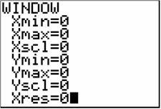 | Height | 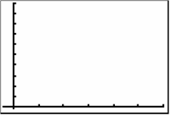
 | Day

5. A member working with Scenario B decided to use intervals of two different functions to fit the data where the first function was used to model the first seven days and then the second function to model the next 14 days. Determine the two functions you feel best fits the data for the domain intervals identified.
First Function Model: ______________________
Second Function Model: _____________________

Analysing the Data for Scenario C

6. Enter the data for Scenario C into the graphing calculator and construct a scatterplot for the data. Complete both of the screen captures below using the information from your calculator.

Height
Day

7. Determine a function model(s) to best fit the data. If using different function models, identify the domain interval appropriate for each function. Justify your reasoning for your choice of model(s).

6.3.3: The Chipmunk Explosion

Chipmunk Provincial Park has a population of about 1000 chipmunks. The population is growing too rapidly due to campers feeding them. To curb the explosive population growth, the park rangers decided to introduce a number of foxes (a natural predator of chipmunks) into the park. After a period of time, the chipmunk population peaked and began to decline rapidly.

The following data gives the chipmunk population over a period of 14 months.

Time  (months) | Population  (1000s)
1 | 1.410
2 | 1.970
3 | 2.690
5 | 5.100
6 | 5.920
7 | 5.890
9 | 4.070
9.5 | 3.650
10 | 3.260
11 | 2.600
12 | 2.090
13 | 1.670
14 | 1.330

Use graphing technology to create a scatter plot of the data.

1. Determine a mathematical function model that represents this data. It may be necessary to use more than one type of function. Include the domain interval over which each type of function applies to the model.

2. Determine when the population reaches a maximum and what the maximum population is.

3. Determine when the population will fall to less than 100 chipmunks.

6.3.4: Solutions

Analysing the Data for Scenario A

1.  Height | 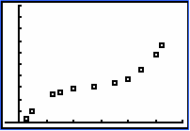
 | Day

2. The type of function is cubic.

3. My function formula is:

Analysing the Data for Scenario B

4. | Height | 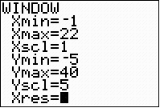 | Height | 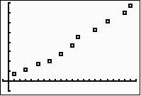
 |  | Day |  | Day

5. First Function Model:
Second Function Model:
Note: On a graphing calculator this would be entered as:
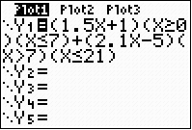 | Height | 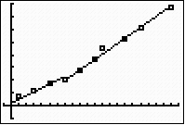
 |  | Day
6.3.4: Solutions (continued)

Analysing the Data for Scenario C

6.
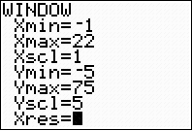 | Height | 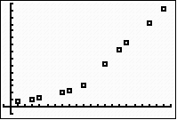
 | Height | Day

7. , and,.
Note: On a graphing calculator this would be entered as:

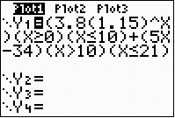 | Height | 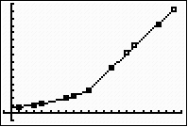
 | Height | Day

6.3.5: Solutions – The Chipmunk Problem

Using the Graphing Calculator
Stat Plot |  | Functions
Height | 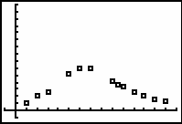 | 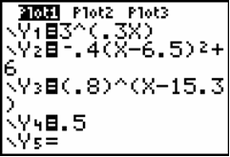
Day

1. Stat Plot with Functions: | Height | 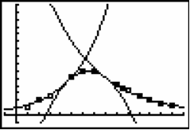
1. Stat Plot with Functions: | Height | Day

2. Maximum Population: | Height | 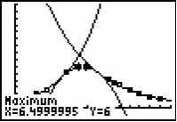
Maximum population is 6000 at 6.5 months. | Height | Day

3. Determination of when population reaches 500:
Height | 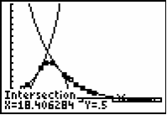 |  | Population reaches 500 at about 18.4 months.
 | Day
Height
 | Day
6.3.5: Solutions – The Chipmunk Problem (continued)

Using GSP®

Unit 6: Day 4: Combining Function Through Addition and Subtraction |  |  |  |  | MHF4U
  75 min |  | Math Learning Goals  - Make connections between the key features of functions to features of functions created by their sum or difference (i.e., domain, range, maximum, minimum, number of zeros, odd or even, increasing/decreasing behaviours, and instantaneous rates of change at a point).  - Make connections between numeric, algebraic and graphical representations of functions that have been created by addition or subtraction.  - Reason about connections made between functions and their sums or differences. |  |  | Materials  - BLM 6.4.1–6.4.5  - graphing calculators
Assessment
Opportunities
 | Minds On… | Whole Class à Demonstration  Demonstrate the motion a child on a swing by swinging a long pendulum in front of a CBR. Students anticipate the graph of the distance of the pendulum from the CBR over 15 seconds. They use the CBR to capture the graph of the pendulum motion. (Note: It will be a damped sinusoidal function.)  Students compare their anticipated graph with the actual graph. They graph its motion if it were to continue and tell what function represents this motion.  Lead them to the understanding that no one function would “work,” but 2 different functions could be combined to produce this particular graph. (Answer: A sin function divided by an exponential function). See Day 6 for further investigation.  Groups of 3 or 4 → Activity  Distribute one function from BLM 6.4.1, to each group and the blank template (BLM 6.4.2). Bring to their attention that the graphing window used for each function was: and. The functions used:  Students identify the type of function and its key features and properties. They post their function and its properties (BLM 6.4.2).  Assign each group to check the work of two other groups. Students add to or correct as they check the two assigned functions.  Pairs → Anticipation  Distribute one function (BLM 6.4.3) to each pair of students and BLM 6.4.4. Each function is a combination of the ones posted. Students look at their combination and predict which two combined to produce it.  Pairs share their offspring and the two functions they think combined to produce their offspring giving reasons for their response. |  | Note: A polynomial of degree 4 that is even could be included to enrich the activities.  Some pairs will have identical combinations. Additional combinations can be generated and used.  Possible Check Assignments  F 1 checks 5 and 6  F 2 checks 3 and 7  F 3 checks 2 and 4  F 4 checks 1 and 6  F 5 checks 3 and 7  F 6 checks 2 and 5  F 7 checks 1 and 4  Alternate Questioning  If this is the offspring function, which of these functions might be its parents?  Combinations  Offspring 1 = F1 + F2  Offspring 2 = F6 + F7  Offspring 3 = F2 + F3  Offspring 4 = F5 + F4  Offspring 5 = F2 + F4
  Function 1: y = –(x – 1)² + 3 | Function 2 : y = 2x – 1
  Function 3: y = (x + 2)(x – 1)x | Function 4: y =
  Function 5: | Function 6:
  Function 7: y =

Unit 6: Day 4: Sum Kind of Function (continued) |  |  |  |  | MHF4U
Assessment
Opportunities
 | Action! | Pairs à Investigation  Pairs investigate the addition of two functions in detail to connect the algebraic, numeric, and graphical representations (BLM 6.4.5). They share their results and make generalizations, if possible. As Pair A, B, C, or D students determine which pair of functions they will investigate.  Circulate, address questions, and redirect, as needed. Identify pairs of students to present their results and generalization.  Reasoning/Observation/Mental Note: Observe students facility with the inquiry process to determine their preparedness for the homework assignment. |  | Alternate investigation combining functions http://demonstrations.wolfram.com/CombiningFunctions/
 | Consolidate Debrief | Whole Class → Discussion  Pairs present their solution to the class.  Lead a discussion to make conclusions about the connection between the algebraic, graphical, and numeric representations of the sums of functions. Discuss key properties and features of their sum; how they relate to the original functions; strategies used that were useful; and any misconceptions.
Exploration  Application |  | Home Activity or Further Classroom Consolidation  Examine the differences in your pair of functions. |  | Assign a different pair of functions to each student.

BLM 6.4.1: The Mamas and the Papas

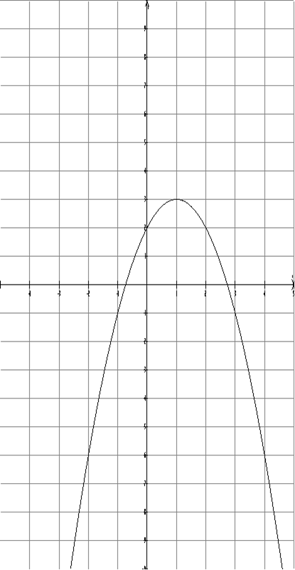  Function 1 | 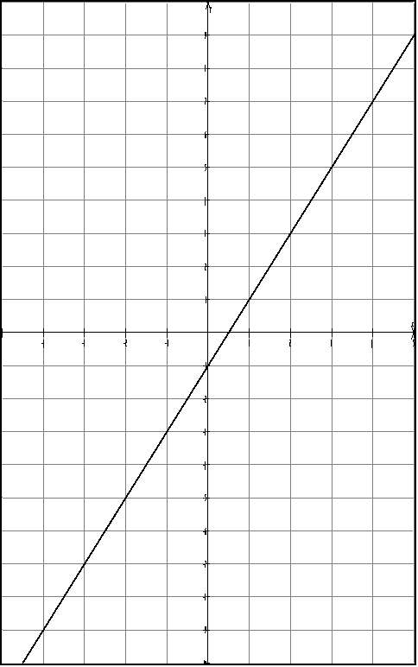  Function 2
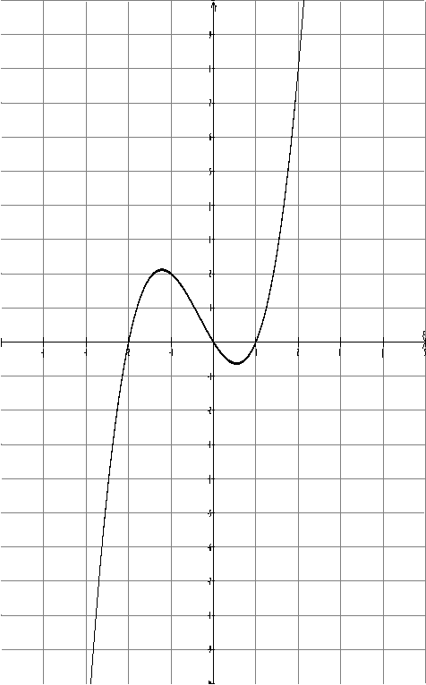  Function 3 | 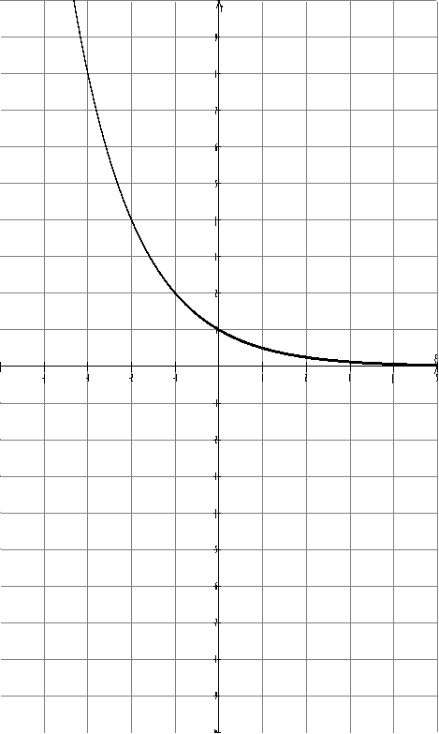  Function 4
BLM 6.4.1: The Mamas and the Papas (continued)

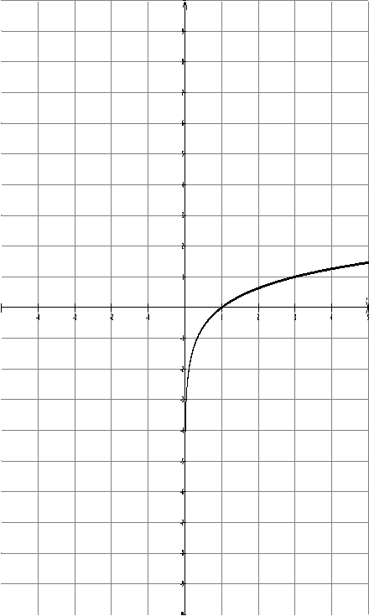  Function 5 | 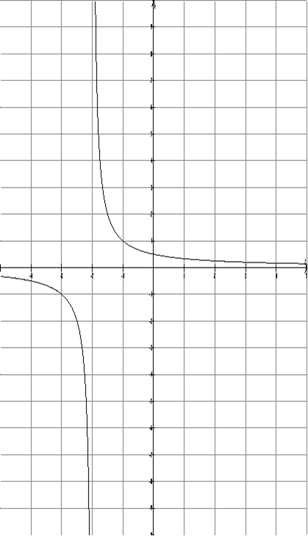  Function 7
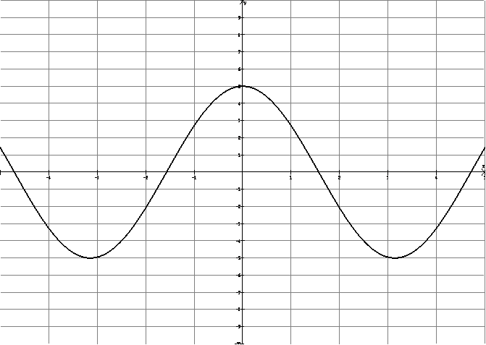
Function 6
BLM 6.4.2: The Key Features of the Parents

Fill in the chart for the function your group has been assigned. Post the function and chart.

Function Type:
Zeros:
Maxima/Minima:
Asymptotes:
Domain:
Range:
Increasing/Decreasing Intervals:
General Motion of Curve:
BLM 6.4.3: The Offspring Functions

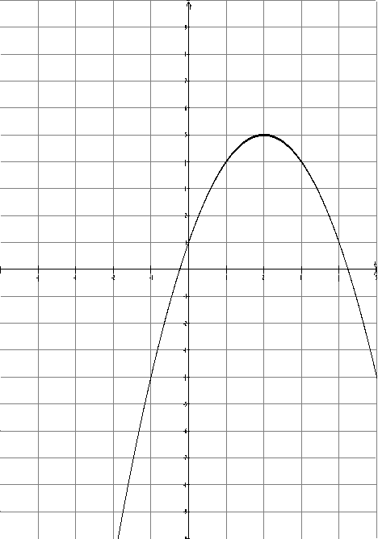  Offspring 1 | 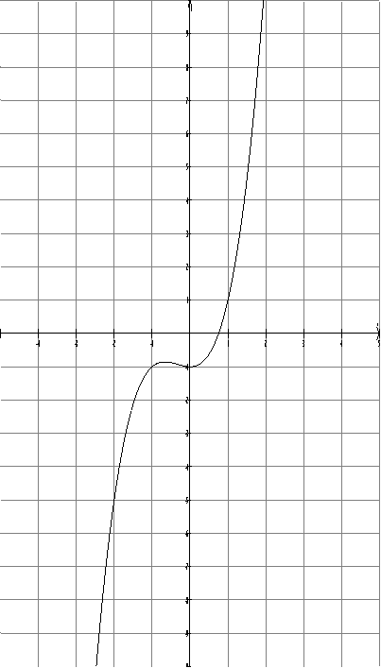  Offspring 3
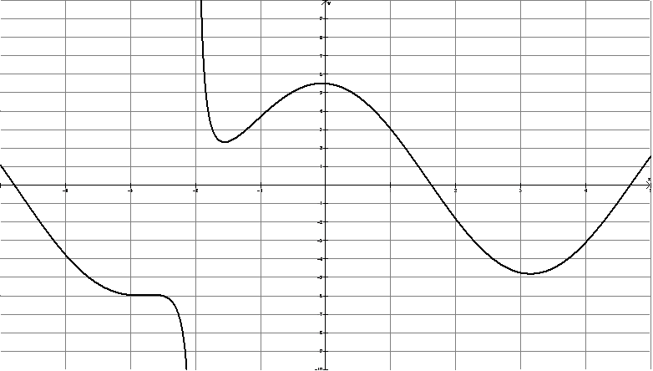
Offspring 2
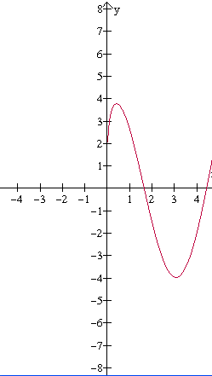  Offspring 4 | 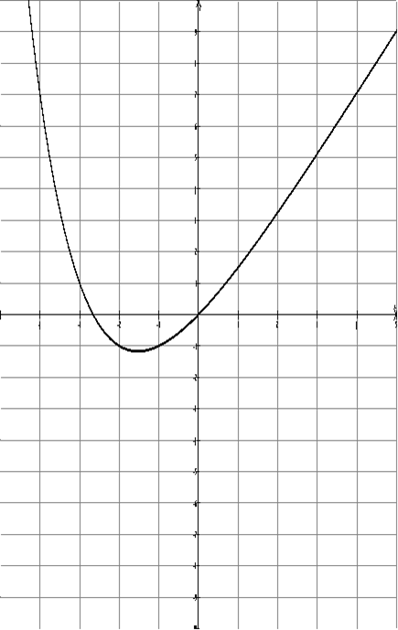  Offspring 5
BLM 6.4.4: Who Made Who?

Offspring ______

What type of function does it look like?

If this function is a combination of two of the functions posted around the room, which two might it be? Which one can it not be? Give reasons.

Consider the key features of the function and the ones that you think combined to make it, what is similar between them?

BLM 6.4.5: Investigating Addition of Functions
Pair A
1. Fill in the following table of values
x | –2 | –1 | 0 |  | 1 | 2 | 3
a)
b)
c)

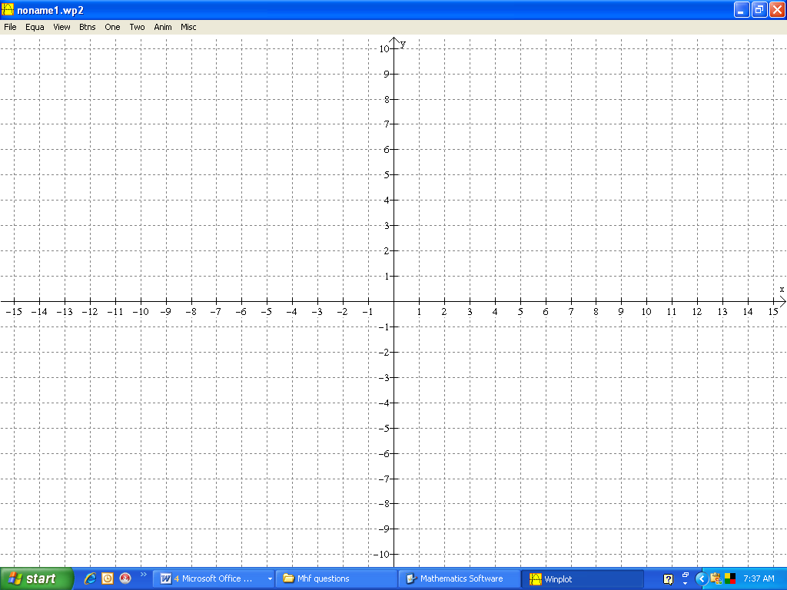
2. a) Plot the points for .
Sketch and label the graph.
b) Similarly, sketch and label the graphs of.
c) Use your table values and reasoning to sketch and label the graph of.

3. Determine algebraically.
Verify 3 of your results from c) numerically using this expression.

4. Using graphing technology to sketch 3. Compare this graph to your sketch from 2c.
Why does this make sense that the points found in c) and 3 are on your graph?

5. What are some of the key features (domain, range, maximum/minimum, number of zeros) and properties (increasing/decreasing) of the sum? Consider the original functions in your answer.

6. Use graphing technology to determine and. How do these values compare?

7. Compare your results with another group who added the same pair of functions.
BLM 6.4.5: Investigating Addition of Functions (continued)
Pair B
1. Fill in the following table of values
x | –4 |  | –2.5 | –2 |  | –1 | 0 | 1 |  |  | 4
a)
b)
c)

2. a) Plot the points for.
Sketch and label the graph.
b) Similarly, sketch and label the graphs of.
c) Use your table values and reasoning to sketch and label the graph of.

3. Determine algebraically.
Verify 3 of your results from c) numerically using this expression.

4. Using graphing technology to sketch 3. Compare this graph to your sketch from 2c.
Why does this make sense that the points found in c) and 3 are on your graph?

5. What are some of the key features (domain, range, maximum/minimum, number of zeros) and properties (increasing/decreasing) of the sum? Consider the original functions in your answer.

6. Use graphing technology to determine, and. How do these values compare?

7. Compare your results with another group who added the same pair of functions.
BLM 6.4.5: Investigating Addition of Functions (continued)
Pair C
1. Fill in the following table of values
x | –3 | –2 | –1 | 0 |  | 1 | 2 | 3
a)
b)
c)
2. a) Plot the points for .
Sketch and label the graph.
b) Similarly, sketch and label the graphs of.
c) Use your table values and reasoning to sketch and label the graph of.

3. Determine algebraically.
Verify 3 of your results from c) numerically using this expression.

4. Using graphing technology to sketch 3. Compare this graph to your sketch from 2c.
Why does this make sense that the points found in c) and 3 are on your graph?

5. What are some of the key features (domain, range, maximum/minimum, number of zeros) and properties (increasing/decreasing) of the sum? Consider the original functions in your answer.

6. Use graphing technology to determine and . How do these values compare?

7. Compare your results with another group who added the same pair of functions.
BLM 6.4.5: Investigating Addition of Functions (continued)
Pair D
1. Fill in the following table of values
x | –4 | –3 | –2 | –1 | 0 | 1 | 2 | 3 | 4
a)
b)
c)

2. a) Plot the points for .
Sketch and label the graph.
b) Similarly, sketch and label the graphs of.
c) Use your table values and reasoning to sketch and label the graph of.

3. Determine algebraically.
Verify 3 of your results from c) numerically using this expression.

4. Using graphing technology to sketch 3. Compare this graph to your sketch from 2c.
Why does this make sense that the points found in c) and 3 are on your graph?

5. What are some of the key features (domain, range, maximum/minimum, number of zeros) and properties (increasing/decreasing) of the sum? Consider the original functions in your answer.

6. Use graphing technology to determine and. How do these values compare?

7. Compare your results with another group who added the same pair of functions.
Unit 6: Day 5: Combining Functions Through Multiplication |  |  |  |  | MHF4U
  75 min |  | Math Learning Goals  - Connect key features of two given functions to features of the function created by their product.  - Represent functions combined by multiplication numerically, algebraically, and graphically, and make connections between these representations.  - Determine the following properties of the resulting functions: domain, range, maximum, minimum, number of zeros, odd or even, increasing/decreasing behaviours, and instantaneous rates of change at a point. |  |  | Materials  - BLM 6.5.1
Assessment
Opportunities
 | Minds On… | Small Group → Discussion  Students compare solutions with others who worked on the same two difference functions from during the Home Activity.  Discuss as a class key properties and strategies for a difference of functions.  Compare to sum of functions from Day 4.  (Possible Observations: When subtracting two functions, the x-intercept is the intersection point of the original two functions.)  Students reason if each statement is always, sometimes, or never true, and justify their answer using examples and/or reasoning that can be described with the help of a graph.  1. When addingand, at the x-intercept of, the sum will (always, sometimes, never) be a point on the graph of.  2. When adding and, at the place where and intersect the sum will (always, sometimes, never) be a point on.  3. (always, sometimes, never) equals. |  | Answer  1. Always; since at this point, the sum  2. Sometimes; only true when the intersection of and occurs on the x-axis; otherwise not true.  3. Always; addition is commutative.  The functions will be selected from throughas per Day 4.
 | Action! | Pairs → Investigation  Student pairs numbered A, B, C, or D, determine for which pair of functions they will investigate products (BLM 6.5.1). Students compare work with another pair who has worked on the same set of functions.  Circulate to identify pairs to present their solutions and address questions.  Reasoning/Observation/Mental Note: Observe students’ facility with the inquiry process to determine their preparedness for the homework assignment.
 | Consolidate Debrief | Whole Class → Discussion  Identified pairs present their work to the class.  In a teacher-led discussion, make some conclusions about the connection between the algebraic, graphical, and numeric representations of the quotient of functions.  Discuss key properties and features of the product, and how they relate to the original functions.
Consolidation  Application |  | Home Activity or Further Classroom Consolidation  1. Journal Entry  - When subtracting two functions, what is the significance of the intersection point of the graphs?  - Compare the significant points and characteristics to consider when graphing the sum and difference of functions. Which are the same? Which are different? Explain.  - Summarize the important points and intervals to consider when multiplying functions.  2. Graph the product of the new functions. |  | Assign two new functions.

6.5.1: Investigating the Product of Functions
Pair A
1. Fill in the following table of values
x | –2 | –1 | 0 |  | 1 | 2 | 3
a)
b)
c)
2. a) Plot the points for .
Sketch and label the graph.
b) Similarly, sketch and label the graph of.
c) Use your table values and reasoning to sketch and label the graph of.

3. Determine algebraically.
Verify 3 of your results from c) numerically using this expression.

4. Use graphing technology to sketch 3. Compare this graph to your sketch from 2c.
Why does this make sense that the points found in 1c) and 3 are on your graph?

5. What are some of the key features (domain, range, positive/negative, maximum/minimum, number of zeros) and properties (increasing/decreasing) of the product? Consider the original functions in your answer.

6. Use graphing technology to determine,, and . How do these values compare?

7. Compare your results with another group who multiplied the same pair of functions.
6.5.1: Investigating the Product of Functions (continued)
Pair B
1. Fill in the following table of values
x | –4 |  | –2.5 | –2 |  | –1 | 0 | 1 |  |  | 4
a)
b)
c)
2. a) Plot the points for .
Sketch and label the graph
b) Similarly, sketch and label the graphs of.
c) Use your table values and reasoning to sketch and label the graph of.

3. Determine algebraically.
Verify 3 of your results from c) numerically using this expression.

4. Use graphing technology to sketch 3. Compare this graph to your sketch from 2c.
Why does it make sense that the points found in 1c) and 3 are on your graph?

5. What are some of the key features (domain, range, positive/negative, maximum/minimum, number of zeros) and properties (increasing/decreasing) of the product? Consider the original functions in your answer.

6. Use graphing technology to determine, , and . How do these values compare?

7. Compare your results with another group who multiplied the same pair of functions.
6.5.1: Investigating the Product of Functions (continued)
Pair C
1. Fill in the following table of values.
x | –4 |  | –2 | –1 | 0 |  | 1 |  |  | 4
a)
b)
c)
2. a) Plot the points for .
Sketch and label the graph.
b) Similarly, sketch and label the graph of.
c) Use your table values and reasoning to sketch and label the graph of.

3. Determine algebraically.
Verify 3 of your results from c) numerically using this expression.

4. Use graphing technology to sketch 3. Compare this graph to your sketch from 2c.
Why does this make sense that the points found in 1c) and 3 are on your graph?

5. What are some of the key features (domain, range, positive/negative, maximum/minimum, number of zeros) and properties (increasing/decreasing) of the product? Consider the original functions in your answer.

6. Use graphing technology to determine, and. How do these values compare?

7. Compare your results with another group who multiplied the same pair of functions.
6.5.1: Investigating the Product of Functions (continued)
Pair D
1. Fill in the following table of values.
x | –3 | –1 | 0 | 1 |  | 3 | 9
a)
b)
c)
2. a) Plot the points for .
Sketch and label the graph.
b) Similarly, sketch and label the graph of.
c) Use your table values and reasoning to sketch and label the graph of.

3. Determine algebraically.
Verify 3 of your results from c) numerically using this expression.

4. Use graphing technology to sketch 3. Compare this graph to your sketch from 2c.
Why does this make sense that the points found in 1c) and 3 are on your graph?

5. What are some of the key features (domain, range, positive/negative, maximum/minimum, number of zeros) and properties (increasing/decreasing) of the product? Consider the original functions in your answer.

6. Use graphing technology to determine,, and . How do these values compare?

7. Compare your results with another group who multiplied the same pair of functions.
Unit 6: Day 6: Combining Functions Through Division |  |  |  |  | MHF4U
75 min |  | Math Learning Goals  - Connect key features of two given functions to features of the function created by their quotient.  - Represent functions combined by division numerically, algebraically, graphically, and make connections between these representations.  - Determine the following properties of the resulting functions: domain, range, maximum, minimum, number of zeros, odd or even, increasing/decreasing behaviours, and instantaneous rates of change at a point. |  |  | Materials  - BLM 6.6.1  - computer and data projector for presentation
Assessment
Opportunities
 | Minds On… | Whole Class → Discussion  Discuss what is occurring in each of these situations by considering and reflecting on the numeric, graphical, and algebraic representations.  Ask: For which values of x will the following functions result in:  Emphasize the difference between an asymptote and a “hole” in the graph. |  | Asymptote becomes a hole.ppt  Functions should be different from the previous day’s assignment.
  a) a positive | b) negative | c) a very small number
  d) a very large number | e) result is 0 | f) undefined
  (i) | (ii) | (iii) | (iv)
 | Action! | Pairs à Investigation  Student pairs numbered as A, B, C, or D, (BLM 6.6.1) determine for which pair of functions they will investigate quotients. Students compare work with other pairs who have worked on same set of functions. Circulate to address questions and identify pairs to present their solutions on the overhead.  Reasoning/Observation/Mental Note: Observe students’ facility with the inquiry process to determine their preparedness for the homework assignment.
 | Consolidate Debrief | Pairs à Whole Class à Discussion  Identified pairs present their work to the class. Lead a discussion to make some conclusions about the connection between the algebraic, graphical, and numeric representations of the quotient of functions. Discuss key properties and features of the product, and how they relate to the original functions.
Consolidation  Application |  | Home Activity or Further Classroom Consolidation  Journal Entry:  - Compare the significant points and characteristics to consider when graphing the product and quotient of functions.  - Which are the same? Which are different? Explain.  - Summarize the important points and intervals to consider when multiplying or dividing functions. |  | Assign students two functions from which they will graph the quotient.

6.6.1: Investigating the Division of Functions
Pair A
1. Fill in the following table of values.
x | –2 | –1 | 0 |  | 1 | 2 | 3
a)
b)
c)

2. a) Plot the points for .
Sketch and label the graph.
b) Similarly, sketch and label the graph of.
c) Use your table values and reasoning to sketch and label the graph of.

3. Determine algebraically.
Verify 3 of your results from c) numerically using this expression.

4. Use graphing technology to sketch 3. Compare this graph to your sketch from 2c.
Why does it make sense that the points found in 1c) and 3 are on your graph?

5. What are some of the key features (domain, range, positive/negative, maximum/minimum, number of zeros) and properties (increasing/decreasing) of the quotient? Consider the original functions in your answer.

6. Use graphing technology to determine ,, and . How do these values compare?

7. Compare your results with another group who divided the same pair of functions.
6.6.1: Investigating the Division of Functions (continued)
Pair B ,
1. Fill in the following table of values
x | –4 |  | –2 | –1 | 0 |  | 1 | 1 |  |  | 4
a)
b)
c)
2. a) Plot the points for .
Sketch and label the graph.
b) Similarly, sketch and label the graphs of.
c) Use your table values and reasoning to sketch and label the graph of.
3. Determine algebraically.
Verify 3 of your results from c) numerically using this expression.

4. Use graphing technology to sketch 3. Compare this graph to your sketch from 2c.
Why does it make sense that the points found in 1c) and 3 are on your graph?

5. What are some of the key features (domain, range, positive/negative, maximum/minimum, number of zeros) and properties (increasing/decreasing) of the quotient? Consider the original functions in your answer.

6. Use graphing technology to determine,, and. How do these values compare?

7. Compare your results with another group who divided the same pair of functions.
6.6.1: Investigating the Division of Functions (continued)
Pair C
1. Fill in the following table of values
x | –4 |  | –2 | –1 | 0 |  | 1 |  |  | 4
a)
b)
c)
2. a) Plot the points for .
Sketch and label the graph.
b) Similarly, sketch and label the graph of.
c) Use your table values and reasoning to sketch and label the graph of.
3. Determine algebraically.
Verify 3 of your results from c) numerically using this expression.

4. Use graphing technology to sketch 3. Compare this graph to your sketch from 2c.
Why does it make sense that the points found in 1c) and 3 are on your graph?

5. What are some of the key features (domain, range, positive/negative, maximum/minimum, number of zeros) and properties (increasing/decreasing) of the quotient? Consider the original functions in your answer.

6. Use graphing technology to determine,, and. How do these values compare?

7. Compare your results with another group who divided the same pair of functions.
6.6.1: Investigating the Division of functions (continued)
Pair D ,
1. Fill in the following table of values
x | –1 | 0 |  | 1 | 2 | 3 | 9
a)
b)
c)

2. a) Plot the points for .
Sketch and label the graph.
b) Similarly, sketch and label the graph of.
c) Use your table values and reasoning to sketch and label the graph of.
3. Determine algebraically.
Verify 3 of your results from c) numerically using this expression.

4. Use graphing technology to sketch 3. Compare this graph to your sketch from 2c.
Why does it make sense that the points found in 1c) and 3 are on your graph?

5. What are some of the key features (domain, range, positive/negative, maximum/minimum, number of zeros) and properties (increasing/decreasing) of the product? Consider the original functions in your answer.

6. Use graphing technology to determine, , and . How do these values compare?

7. Compare your results with another group who divided the same pair of functions.
Unit 6: Day 7: Compositions of Functions Numerically and Graphically |  |  |  |  | MHF4U
75 min |  | Math Learning Goals  - Determine the composition of functions numerically and graphically.  - Connect transformations of functions with composition of functions.  - Explore the composition of a function with its inverse numerically and graphically, and demonstrate that the result maps the input onto itself. |  |  | Materials  - BLM 6.7.1, 6.7.2, 6.7.3  - chart paper  - graphing technology
Assessment
Opportunities
 | Minds On… | Whole Class à Discussion  Model the use of a function machine presented on BLM 6.7.1 with an example.  Pairs → Investigation  Assign each pair of students 2 values of “x” from the given domain on BLM 6.7.1 which demonstrates:  1) function machines,  2) numerical and graphical representation of composition,  3) versus.  Students plot the results of their work on a large graph with and already plotted (BLM 6.7.1).  Whole Class → Discussion  Each student plots ordered pairs (Input(A), Output(B)) akafrom the class graph on their individual graph on BLM 6.7.1.  Lead a discussion that includes ideas such as: domain and range of all three functions, the relationship of the composition graph to originals and versus. |  | Introduce the notation to represent composition of two functions, the output of the table.  Complete plotting and discussion for  before completing (BLM 6.7.1, p. 2).  Students will do further exploration using algebra on Day 8.  Discuss solutions  on Day 8 (see BLM 6.8.2).  See Winplot file on Day 9.  This will be re-visted on Day 9.
 | Action! | Pairs à Exploration  Pairs complete BLM 6.7.2 using graphing technology, as required.  Reasoning/Observation/Mental Note: Observe students’ facility with the inquiry process to determine their preparedness for the homework assignment.  Whole Class → Discussion  Reinforce earlier findings and explore the question:  “When is?” using the results of BLM 6.7.2.
 | Consolidate Debrief | Pairs à Discussion  Students consolidate key concepts of Day 7 (BLM 6.7.3).  Model an example of a question requiring the answer of Always, Sometimes, or Never (e.g., When you subtract you always get less than you started with).  Explore the following statement by analysing the class graphs and activating prior knowledge re: transformations of parabolas. The composition,, of a linear function of the form with a quadratic function, , will always result in a horizontal translation of “B” units. Ask: What if the composition was? Extend the discussion to include linear functions of the form. How does the linear function predict the transformation that occurs in the composition?  Curriculum Expectations/Anecdotal Feedback: Observe student readiness for future discussion about the relationship between linear transformations and composition.
Exploration  Application |  | Home Activity or Further Classroom Consolidation  Complete the Worksheet and be prepared to discuss your solutions.

6.7.1: Great Composers!

Partner A: You are
- Determine the value of for a given value of x.
- Give the value of to Partner B.

Partner B: You are
- Partner A will give you a value.
- Determine the value of for this value of x.

REPEAT the above steps for your second value of x.

Once you have completed your work, record your values in the Input – Output table and graph the ordered pair (input(A), output(B)) on the grid below. Plot additional ordered pairs from the class graph, as available.
Input(A)  x | Output(A)→Input(B) | Output(B)
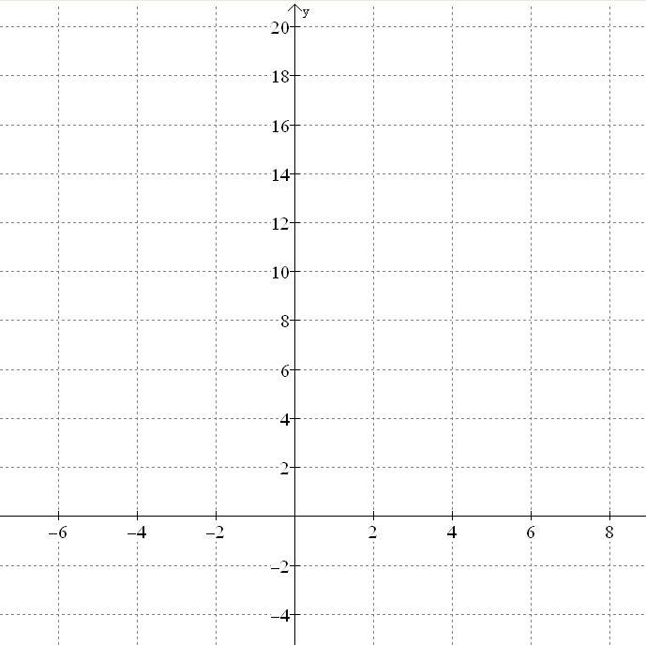
-3
-2
-1
0
1
2
3
5
6
7
4
f(x) = x - 2
g(x) = x² - 5
?
?
?
?
6.7.1: Great Composers! (continued)

Partner A: You are
- Determine the value of for a given value of x.
- Give the value of to Partner B.

Partner B: You are
- Partner A will give you a value.
- Determine the value of for this value of x.

REPEAT the above steps for your second value of x.

Once you have completed your work, record your values in the Input – Output table and graph the ordered pair (input(A), output(B)) on the grid below. Plot additional ordered pairs from the class graph, as available.

-3
-2
-1
0
1
2
3
5
6
7
4
g(x) = x² - 5

f(x) = x - 2
?
Input(A)  x | Output(A)→Input(B) | Output(B)

6.7.1: Great Composers! (Teacher)

The domain of the composite function is and the range of the composite function is. Provide a large grid and table of values that captures this domain and range. Include the graphs of the original functionsandfor comparisons.

Graphs of,
and.

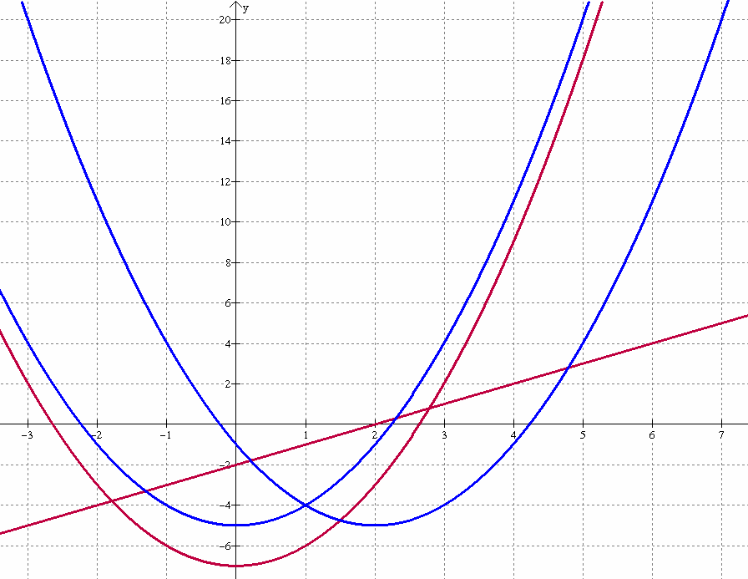

6.7.2: Graphical Composure

1. Using the model of the function machine below, complete the table of values for the specified functions.
x
0
f(g(x))
x
g(x) = cos(x)

f(x) = 2^{x}
g(x)

2. Sketch the graphs of the functions, and on the grid below.

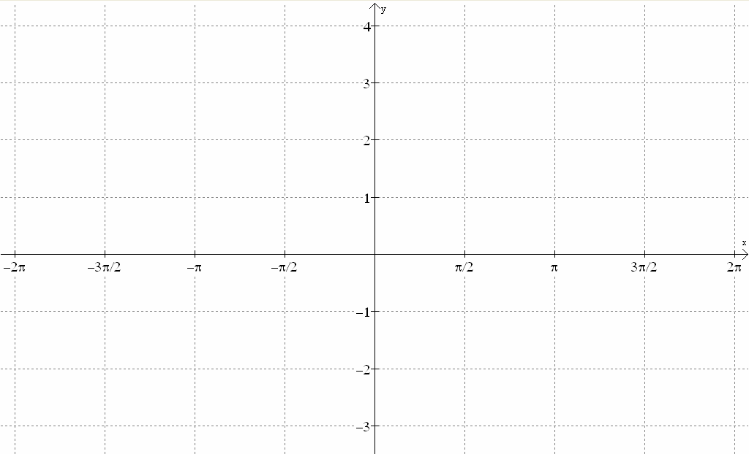
6.7.2: Graphical Composure (continued)

3. Using the table values and your sketch from Question 2, predict the graph of. Sketch your prediction on the previous grid.

4. Plot the values of from your table on the previous grid. Compare with your prediction.

5. Use graphing technology to graph. Sketch a copy of this graph on the grid below and compare it to your predicted graph.

6. If your graph is different from the one created using technology, analyse the differences and describe any aspects you did not initially think about when making your sketch. Explain what you understand now that you did not consider.

7. If your graph is the same as the one created using technology, explain how you determined the domain and range.

8. Use graphing technology to determine the validity of the following statement:
“The graph of , when , and .
Compare and discuss your answer with a partner.

6.7.2: Graphical Composure (Teacher)

Note: The curves are not congruent. The rates of change differ.

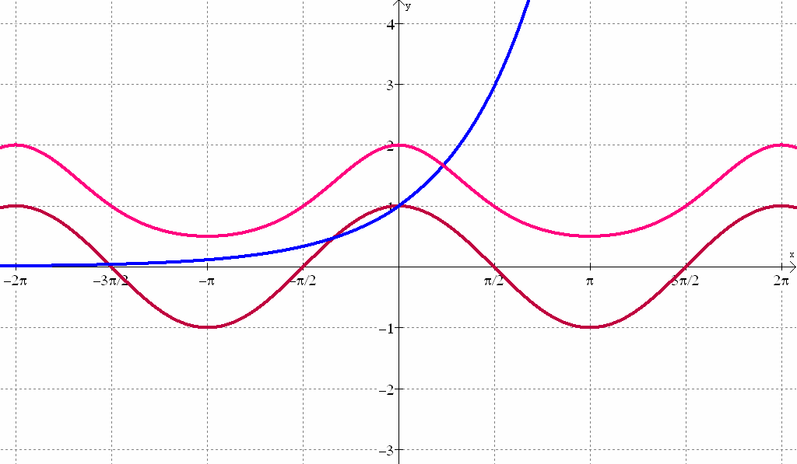

6.7.3: How Did We Get There?

With a partner, answer each of the following questions.

1. If the ordered pairs listed below correspond to the points on the curves and respectively, complete the second column of the chart for.

(0, -3) |  | (0, 10)
(1, 5) |  | (1, 2)
(2, 7) |  | (2, 2)
(3, 9) |  | (3, 10)
(4, 11) |  | (4, 26)
(5, 13) |  | (5, 50)
(6, 15) |  | (6, 82)

2. Given two functionsand such that and.
Determine _______.

3. State if each of the following statements is:
always true (A), sometimes true (S), or never true (N).

Justify your answer using examples or reasoning. (Graphing technology is permitted)

a) The composition, of a linear function of the form  with an exponential, logarithmic, polynomial or sinusoidal function,, will result in a horizontal translation of “a” units. | A S N
b) For the composition, the range ofis the domain of . | A S N
c) | A S N
d) If then | A S N
e) The composition of two even functions will result in an even function. | A S N

Unit 6: Day 8: Composition of Functions Algebraically |  |  |  |  | MHF4U
  75 min |  | Math Learning Goals  - Determine the composition of functions algebraically and state the domain and range of the composition.  - Connect numeric graphical and algebraic representations.  - Explore the composition of a function with its inverse algebraically. |  |  | Materials  - BLM 6.8.1, 6.8.2  - graphing technology
Assessment
Opportunities
 | Minds On… | Whole Class → Discussion  Debrief solutions from Home Activity question 3 (BLM 6.7.3).  Identify three corners of the room to represent A (Always True), S (Sometimes True), and N (Never True). One at a time, students go to the corner that matches their solution to that part of the Home Activity question and discuss in their groups. A volunteer shares the groups’ reasoning with students in other corners.  Pairs → Exploration  Students explore function evaluation connecting to algebraic composition (BLM 6.8.1). |  | Four Corners Strategy – see p. 182, Think Literacy: Cross-Curricular Approaches Grades 7-12.  Students can switch positions after listening to the reasoning.  Review finding the inverse of a function algebraically and graphically.
 | Action! | Whole Class → Instruction  Establish the procedure for composing two functions algebraically. Clarify possible restrictions on the domain and range under composition. Use the functions from Day 7 to demonstrate algebraic composition. Point out the connections between the graphical representation and the algebraic representation of composition.  Pairs → Investigation  Students complete BLM 6.8.2 using graphing technology as required.  Learning Skills (Teamwork)/Observation/Checklist: Observe and record students’ collaboration skills.  Whole Class → Instruction  Complete the composition of the functions algebraically, noting the restrictions on the domain of (BLM 6.8.2).
 | Consolidate Debrief | Whole Class → Discussion  Explore further examples and lead discussion to generalize the results and, namely, (BLM 6.8.2). Examine possible restrictions on the domain and range.
Exploration  Application |  | Home Activity or Further Classroom Consolidation  Complete additional procedural questions to determine,,, and .

6.8.1: Evaluating Functions

1. Evaluate the functions and by completing the table of values below.

x |  |  | x
–2 |  |  | –2
3 |  |  | 3
a |  |  | –a
–b |  |  | b + 2
☺ |  |  | ☺
☺² |  |  | ☺ – 4
x² |  |  | x + 3

2. Discuss with your partner the meaning of the notation. Summarize your understanding below. Use examples, as necessary.

3. Compare the entries in the last two rows of the table for if you were given specific numerical values of x. Does your answer change for the last two rows of the table for? Explain.

6.8.2: Maintain Your Composure

1. Use the model of the function machine below, complete the table of values for the specified functions for values of x such that.
f(g(x))
x
g(x) = 10^{x}

f(x) = log(x)
g(x)
x

2. What is the relationship between the domain and range of?

3. Use graphing technology to graph and.
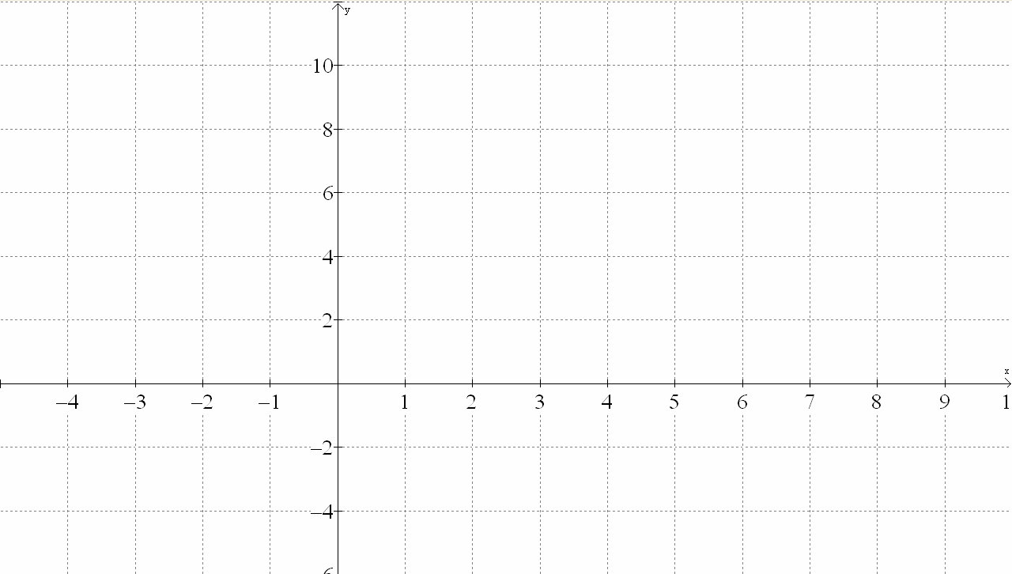

6.8.2: Maintain Your Composure (continued)

4. Draw a line on the graph that would reflect the graph ofonto.
What is the equation of this line?

5. How is the equation of the line you drew related to?

6. Use your prior knowledge of these functions and the function machine model given in Step 1 to explain the relationship between the input value and the output value for.

7. Identify another pair of functions that have the same result as Step 6.

8. Is the following statement always true, sometimes true or never true?
Discuss your answer with a partner.

Given two functions, andsuch that, then.
A S N

9. Use graphing technology to graph the composition identified at the beginning. Compare this graph to the graph of in Step 3. Explain why the domain and range of the graphs are different.

6.8.2 Maintain Your Composure (Teacher)

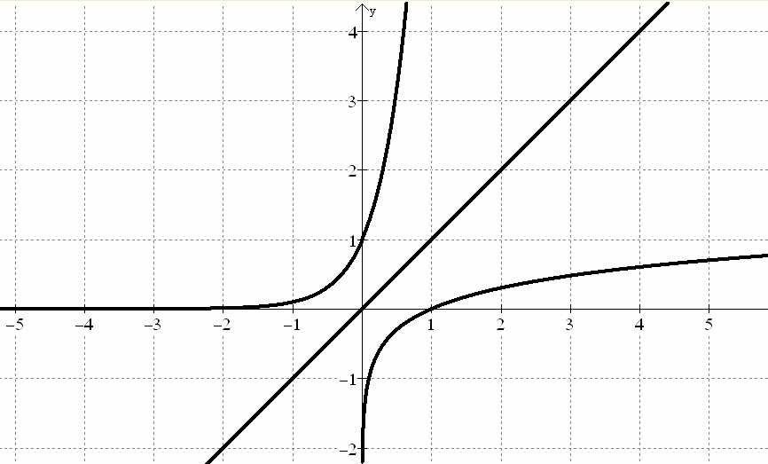

Unit 6: Day 9: Solving Problems Involving Composition of Functions |  |  |  |  | MHF4U
  75 min |  | Math Learning Goals  - Connect transformations of functions with composition of functions.  - Solve problems involving composition of two functions including those from  real-world applications.  - Reason about the nature of functions resulting the composition of functions as even, odd, or neither. |  |  | Materials  - BLM 6.9.1  - graphing technology
Assessment
Opportunities
 | Minds On… | Whole Class → Discussion  Determine algebraically the composition of the functions, and from Day 7. Discuss the graphical transformations of the parabola which resulted from the composition of the quadratic function with the linear function.  Small Group → Investigation  Students use graphing technology to explore the results of the composition of, whereandis one of the following functions: polynomial, exponential, logarithmic, or sinusoidal. Extend the exploration for linear functions of the form.  Recall the statement and question posed on Day 7: The composition,, of a linear function of the formwith a quadratic function, will always result in a horizontal translation of “B” units.  Ask: What if the composition was? Extend the discussion to include linear functions of the form. How does the linear function predict the transformation that occurs in the composition? What is their position on this statement now? Discuss.  Reasoning and Connecting/Observation/Checkbric: Listen to students’ reasoning as they investigate composed functions with respect to transformations and make connections to the original functions. |  | Note: The relationship between transformations and composition involving a linear function was explored on Day 7 with a quadratic function.  Use Winplot file for class demonstration.  U6L7_8_9.wp2
 | Action! | Individual → Investigative Practice  Students complete BLM 6.9.1.  Circulate to clarify and guide student work.
 | Consolidate Debrief | Whole Class → Discussion  Consolidate the concepts developed on composition of functions. Share solutions (BLM 6.9.1, particularly Question 6). Make conclusions about even/odd nature of the composition as related to the even/odd nature of the original functions.  Reasoning and Connecting/Observation/Checkbric: Listen to students’ reasoning as they investigate composed functions with respect to even/odd behaviour and make connections to the original functions.
Application |  | Home Activity or Further Classroom Consolidation  Graph the composition of two functions using graphing technology and solve this problem involving a real-life application. |  | Provide additional questions and a problem.

6.9.1: Solving Problems Involving Composition

1. If, determine expressions for and where.

2. Given, determine algebraically. Show that.
Explain this result numerically and graphically.

3. If and:
a) Determine algebraically and. Verify that.
b) Demonstrate numerically and graphically whether or not the functions resulting from the composition are odd, even, or neither. Compare this feature to the original functions.
Verify your answer algebraically and graphically.
c) Describe the transformations of the parabola that occur as a result of the composition, . Use a graphical or algebraic model to verify your findings.
d) Using graphing technology generalize your findings for part (c) for a linear function
.

4. Consider the functions, and:
a) Determine algebraically and.
b) Using graphing technology demonstrate numerically and graphically whether or not the functions resulting from the composition are odd, even or neither.
Compare to the original functions.

5. The speed of a car, v kilometres per hour, at a time t hours is represented by
. The rate of gasoline consumption of the car, c litres per kilometre,
at a speed of v kilometres per hour is represented by.
Determine algebraically, the rate of gasoline consumption as a function of time. Determine, using technology, the time when the car is running most economically during a four-hour trip.
6.9.1: Solving Problems Involving Composition (continued)

6. Explain the meaning of the composition, for each of the following function pairs. Give a possible “real-life” example for each.

Velocity is a function of Time | Consumption is a function of Velocity
Consumption is a function of Velocity | Cost is a function of Consumption
Earnings is a function of Time | Interest is a function of Earnings
Cost is a function of Consumption | Interest is a function of Cost
Height is a function of Time | Air Pressure is a function of Height
Depth is a function of Time | Volume is a function of Depth
Sum of the Angles of a regular polygon  is a function of the Number of Sides | Size of each Angle is a  function of the Sum
Radius is a function of Time | Volume is a function of Radius

6.9.1: Solving Problems Involving Composition (Teacher)

Solution to Question 4

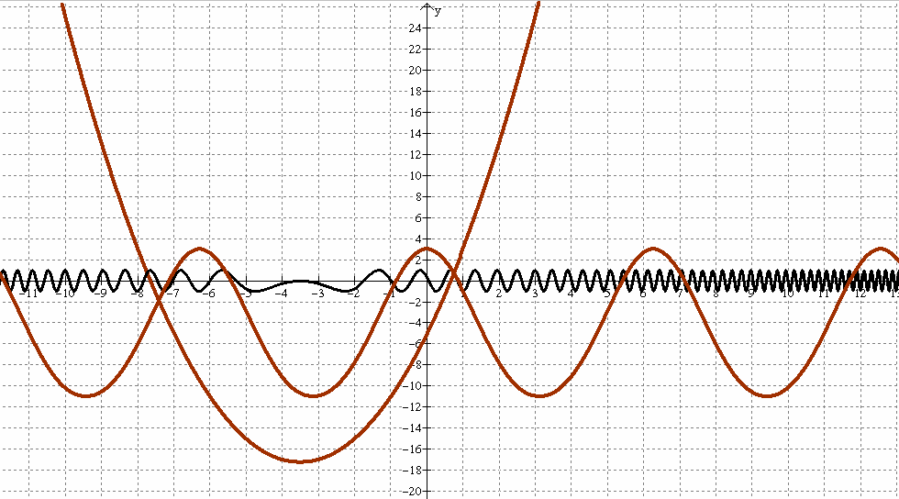

Unit 6: Day 10: Putting It All Together (Part 1) |  |  |  |  | MHF4U
75 min |  | Math Learning Goals  - Make connections between key features of graphs (e.g., odd/even or neither, zeros, maximums/minimums, positive/negative, fraction less than 1 in size) that will have an affect when combining two functions from different families.  - Identify the domain intervals necessary to describe the full behaviour of a combined function.  - Understand graphs of combined function by reasoning about the implication of the key features of two functions, and make connections between transformations and composition. |  |  | Materials  - BLM 6.10.1, 6.10.2  - graphing technology
Assessment
Opportunities
 | Minds On… | Whole Class → Discussion  Present the plan for Days 10, 11, and 12.  Discuss the purpose of these days, details of each station, and the structure of the “math congress:” each group presents to another group one of the assigned combination or composition of functions (BLM 6.10.1).  Determine which question to present for assessment of the mathematical processes. The “receiving” group assesses knowledge and understanding. Questions are posed and answers are given between the groups.  Share rubrics for teacher and peer assessment (BLM 6.11.6 and 6.11.7) or develop with the class.  Assign each group of four their three questions. |  | Math congress questions have some overlap so teachers can select groups to present to each other accordingly.  Some math congress questions are intentionally the same as the function combinations on the card game on Day 11.  Groups B, E, and H of the math congress each contain a composition of functions that assesses expectation D2.8.
 | Action! | Groups → Discussion and Planning  Groups work on their three assigned questions (BLM 6.10.1) making connections to their prior knowledge on even and odd functions and select appropriate tools to justify their results graphically.  Groups discuss, organize, and plan their presentation.  Connecting/Observation/Mental Note: Observe students facility to connect prior learning on even and odd functions with combination of functions.
 | Consolidate Debrief | Whole Class → Discussion  Lead a discussion of even and odd functions as they relate to the combination or composition of the functions.  Select two groups to present to one another’s group (Station 4) at the congress at the beginning of Day 11.  Assign two groups to each Station 1, 2, and 3 for the beginning of Day 11.
Exploration  Application |  | Home Activity or Further Classroom Consolidation  Complete and prepare to discuss with the group solutions to the congress questions.

6.10.1: Math Congress Questions

For each of your identified questions:
- Fully analyse the combination of the functions algebraically and graphically by considering appropriate domain, zeros, intercepts, increasing/decreasing behaviour, maximum/minimum values, relative size (very large/very small) and reasoning about the implications of the operations on the functions.
- Identify whether the original functions are even, odd, or neither, and whether the combined function is even, odd, or neither, algebraically and graphically.
- Hypothesize a generalization for even, or odd, or neither functions and their combination.
- Be prepared to discuss one of your question groups to a panel of peers for the math congress.
- Be prepared to respond to and ask questions of a panel of peers as they present one of their questions to you.

Group A | Group B
1.  2.  3. | 1.  2.  3.
Group C | Group D
1.  2.  3. | 1.  2.  3.
Group E | Group F
1.  2.  3. | 1.  2.  3.
Group G | Group H
1.  2.  3. | 1.  2.  3.

6.10.2: Composition Solutions for Math Congress Questions (Teacher)

The graphs of the composition of functions are for the math congress presentation.
Students may use technology to generate these graphs. They are assessed on the analysis of the result.

Note: Graphs for the math congress questions for addition, subtraction, multiplication, and division are on the BLM 6.11.5 (Teacher).

Example to use with class:

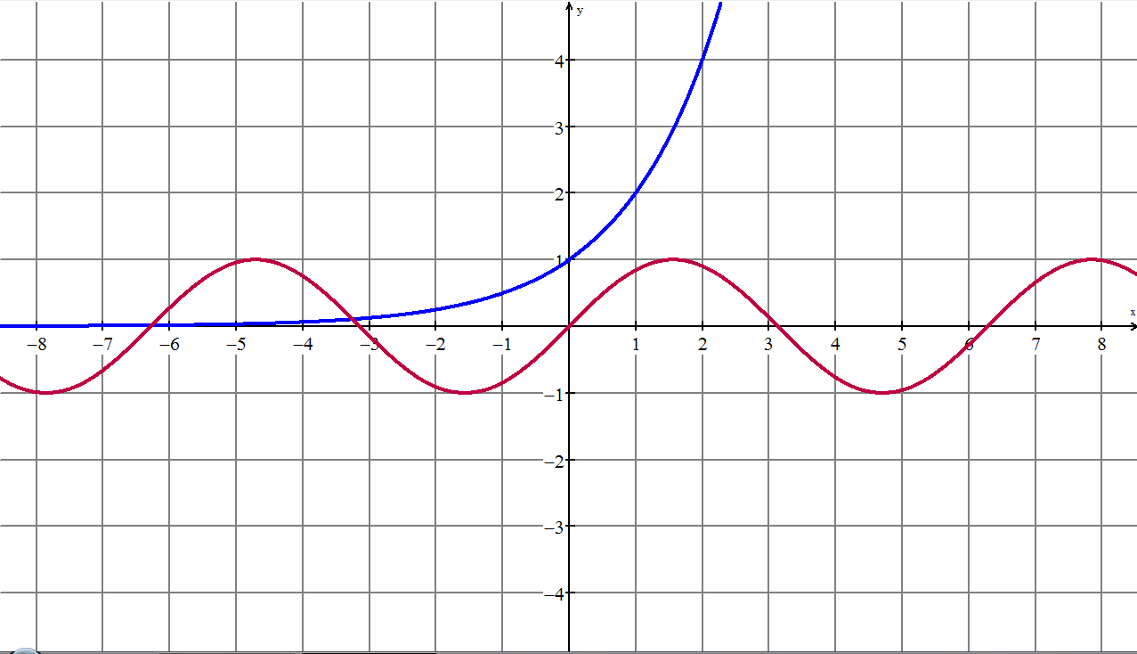 | 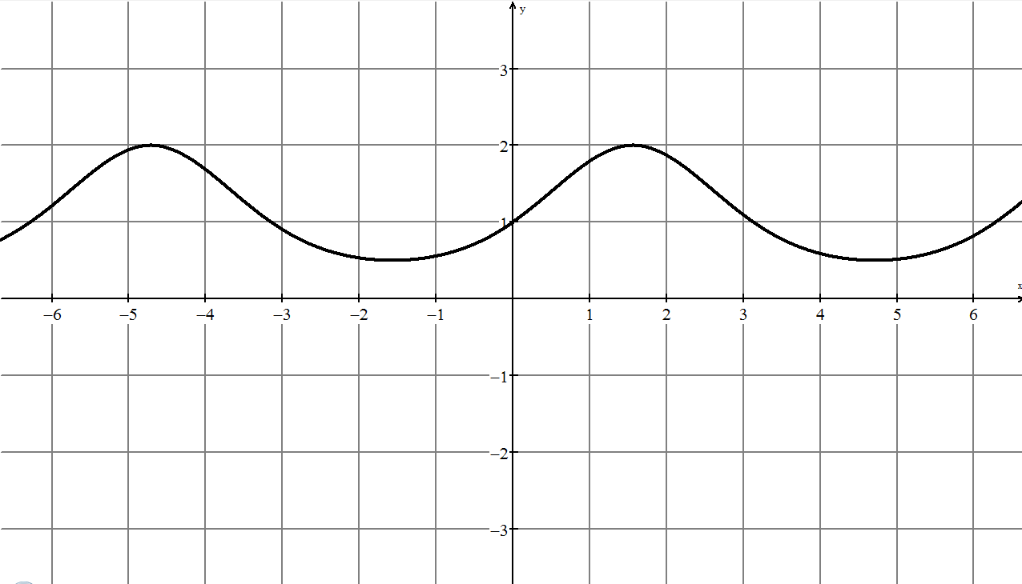

- The exponent of the composition isthus the value of the exponent is between –1 and 1, therefore the y-values of the composition function will oscillate betweenand over the same interval.
- When the y-value of the composed function is 1, it corresponds to the x-intercepts of the sine function, i.e., 2°.
- The cyclic nature of the composition connects to the cyclic nature of the i.e., same period.

6.10.2: Composition Solutions for Math Congress Questions (continued)

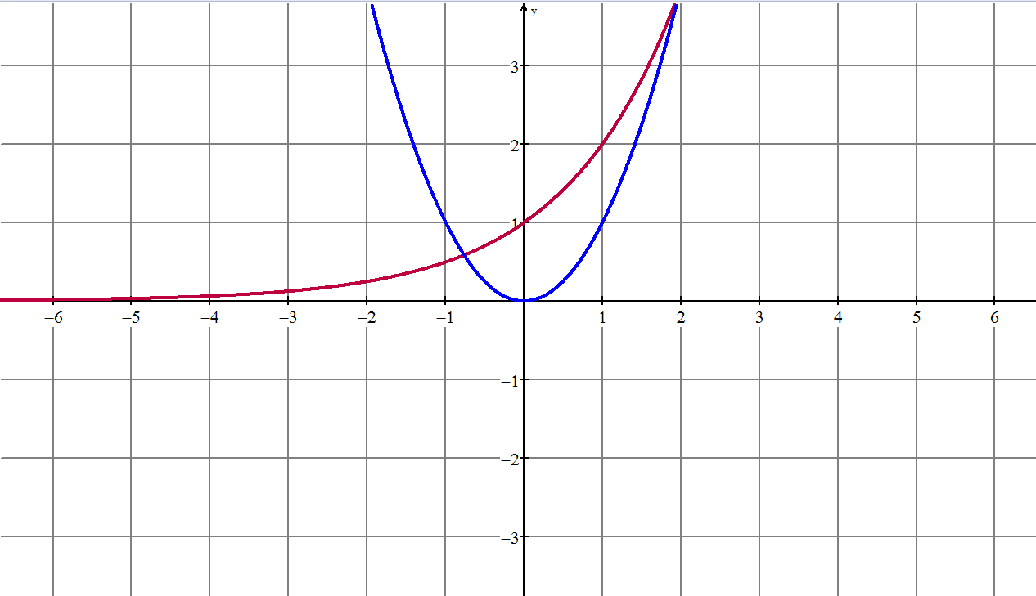 | 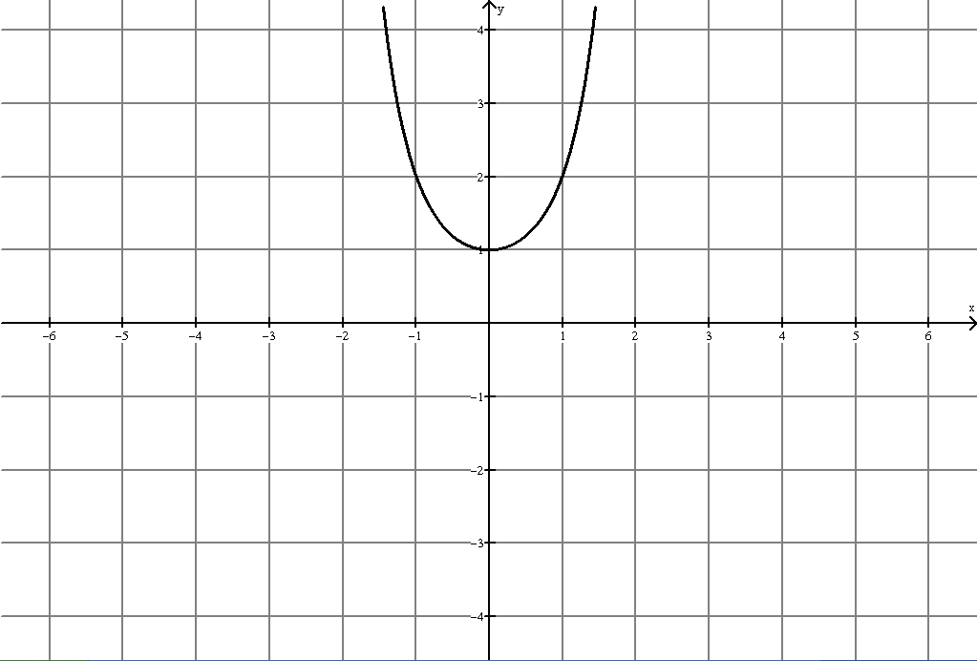
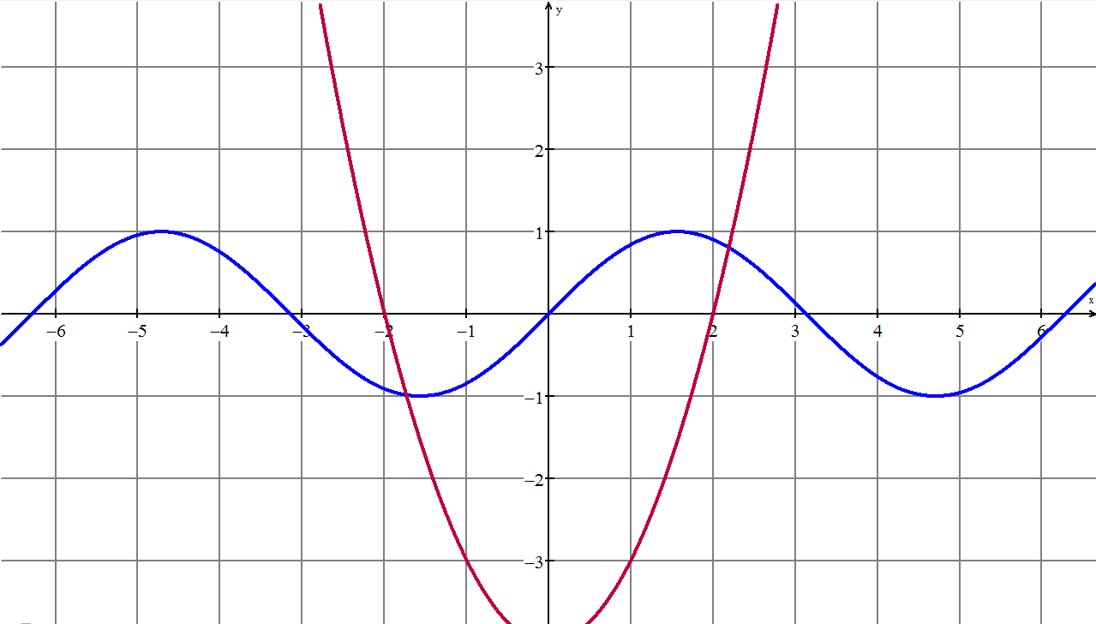 | 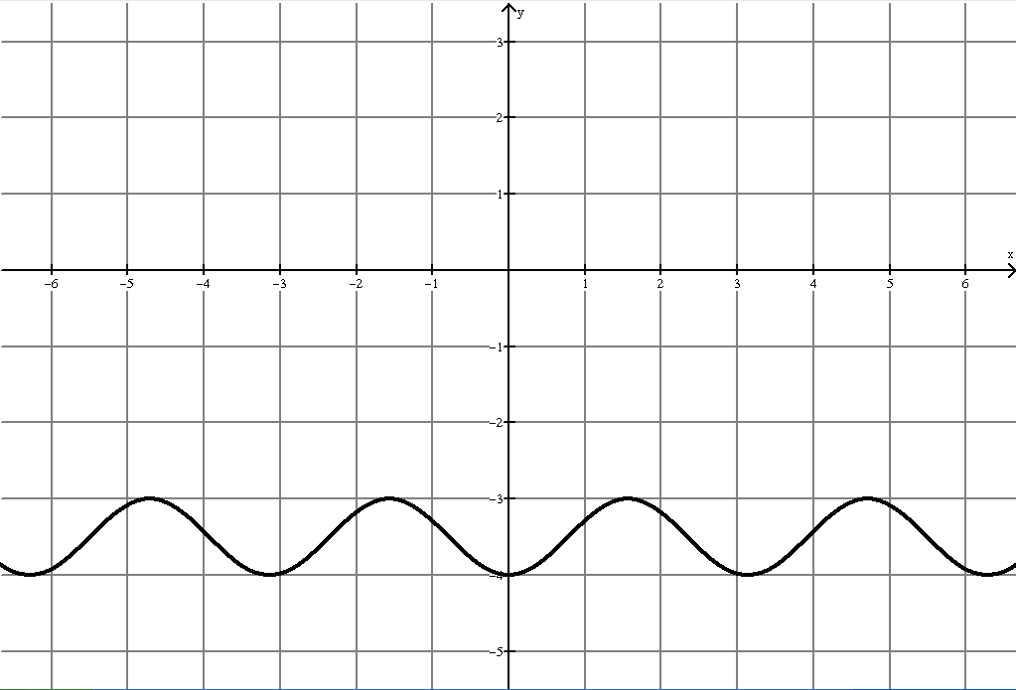
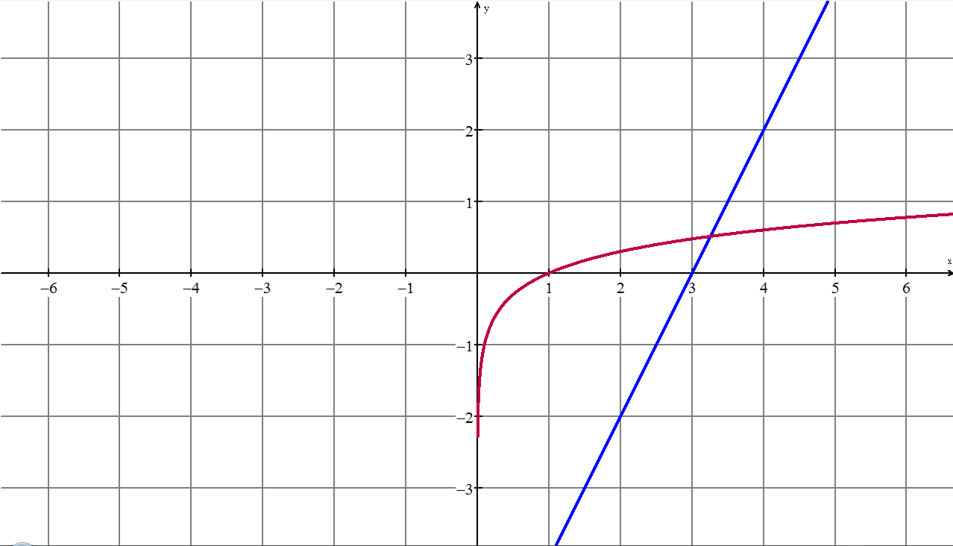 | 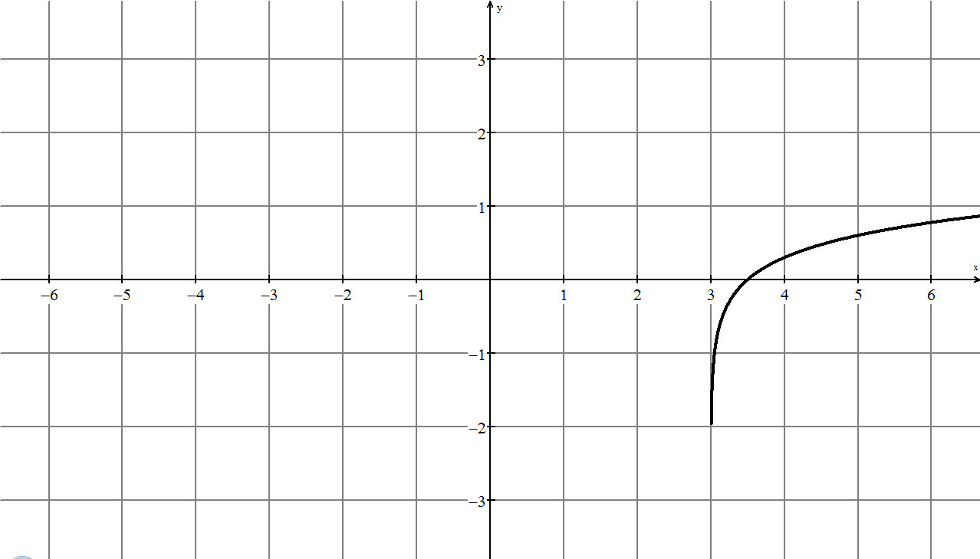

6.10.2: Composition Solutions for Math Congress Questions (continued)

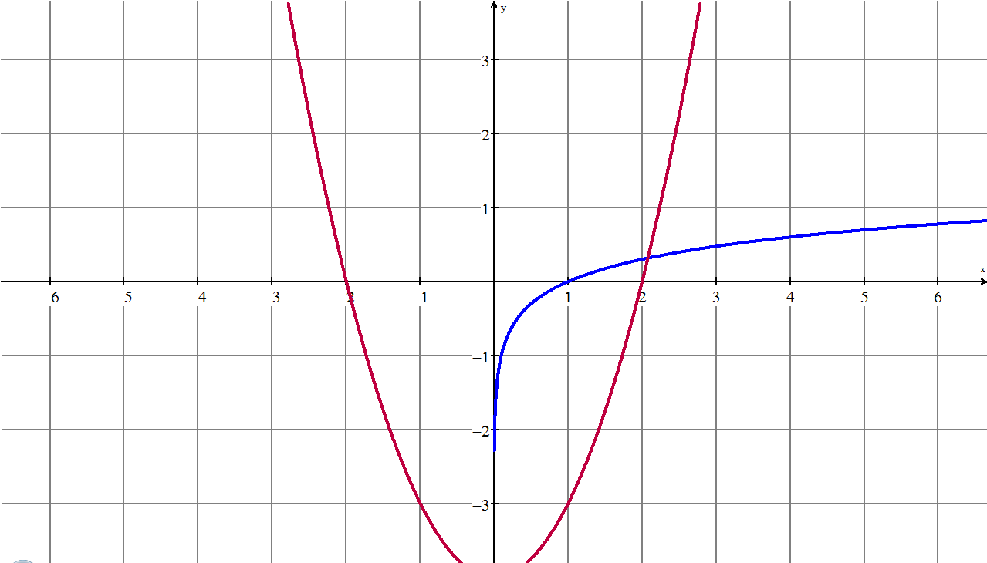 | 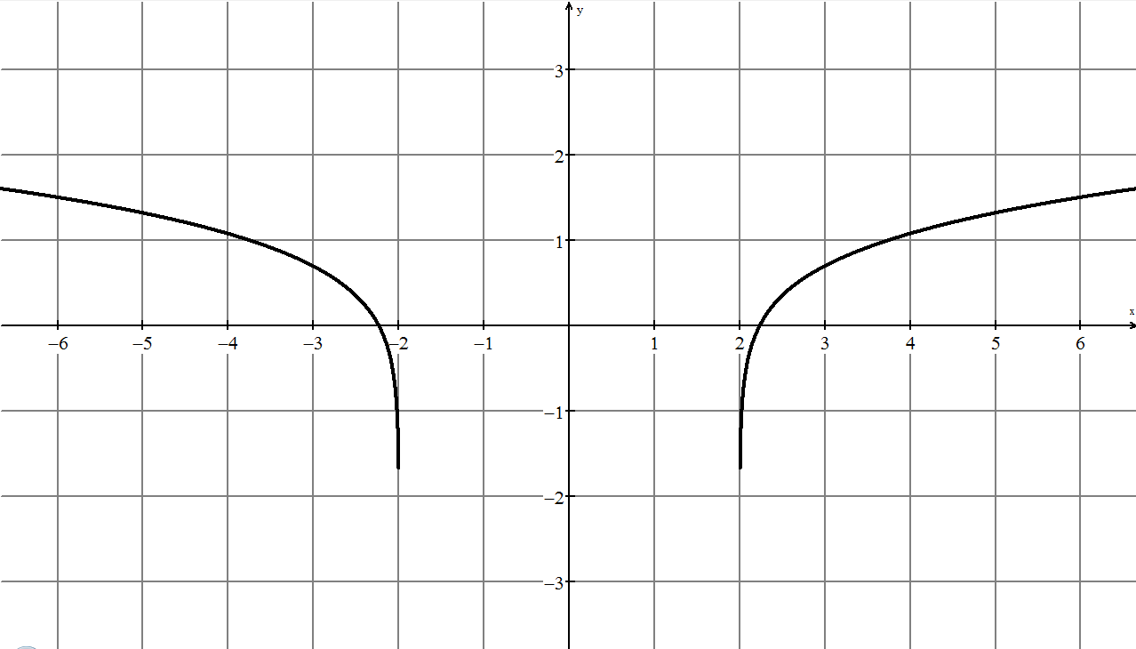
 | 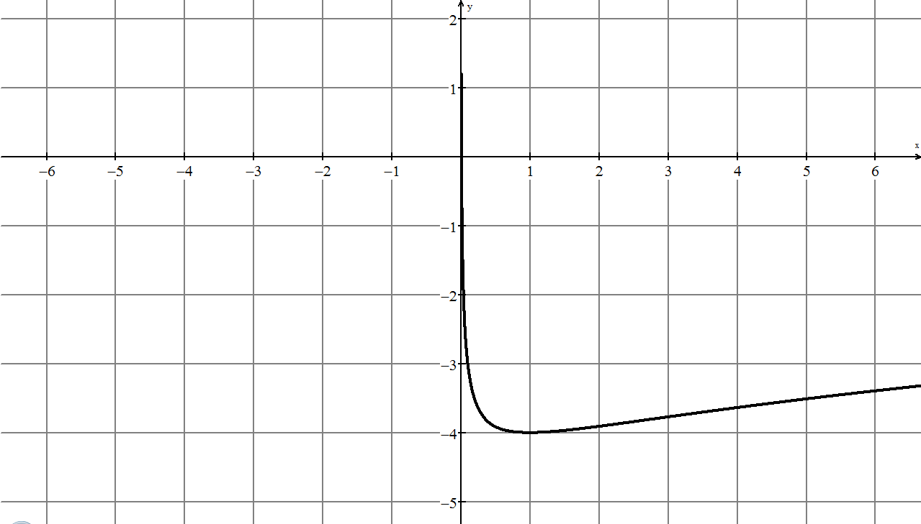
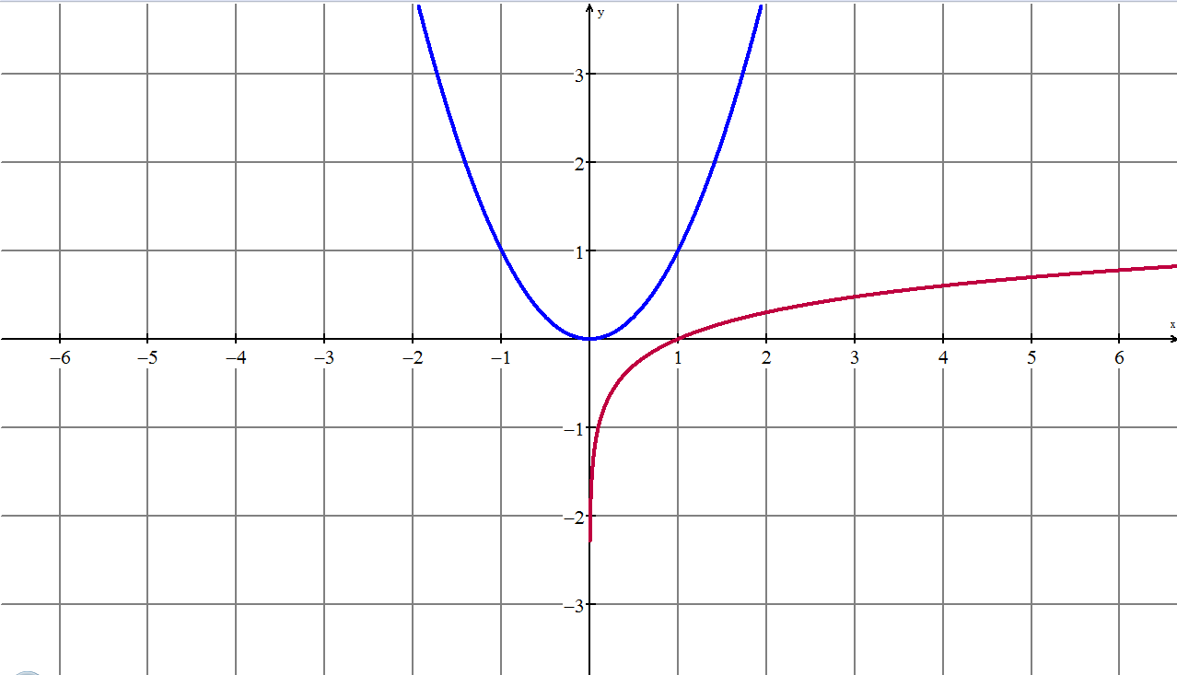 | 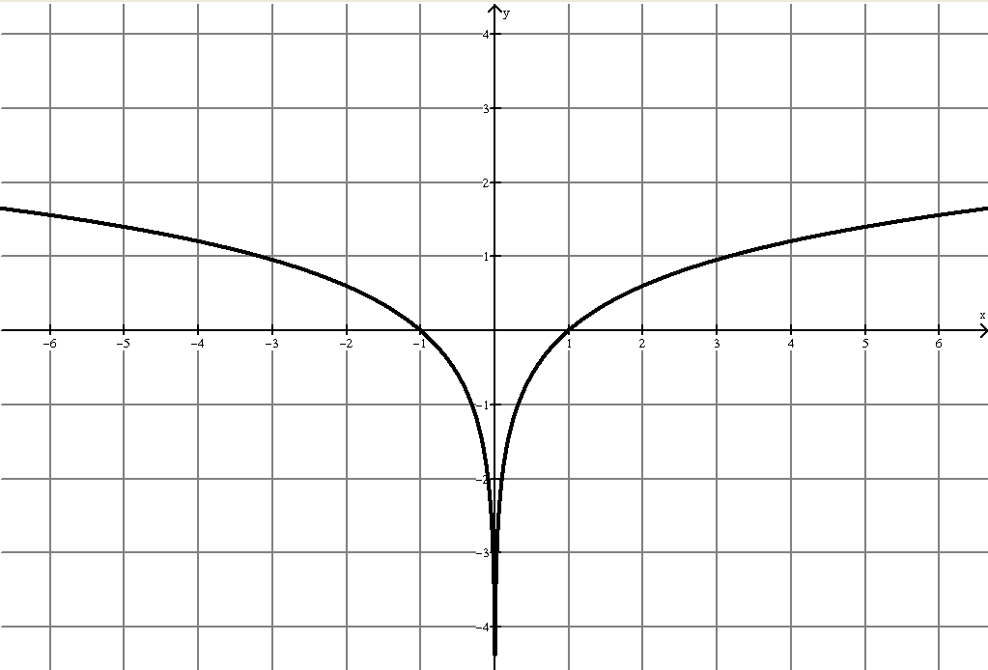

6.10.2: Composition Solutions for Math Congress Questions (continued)

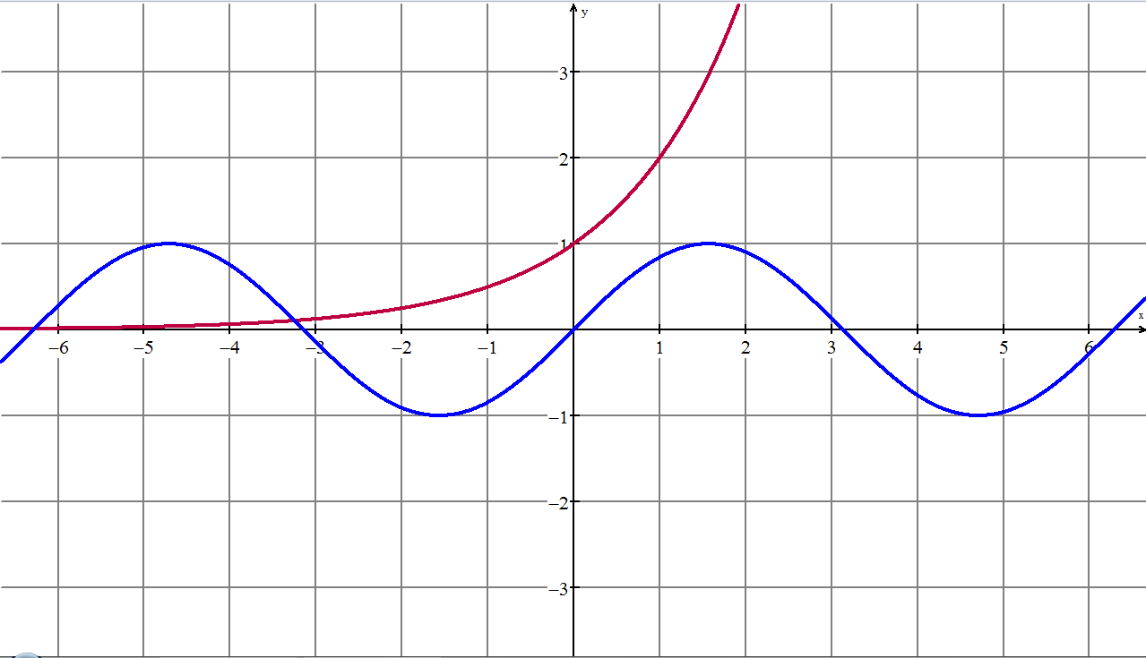 | 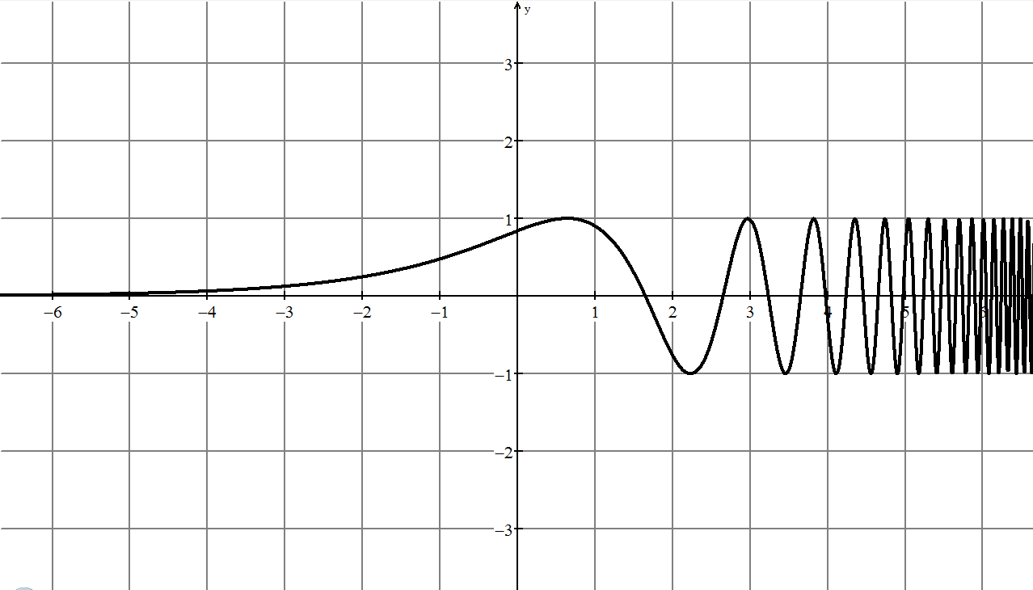
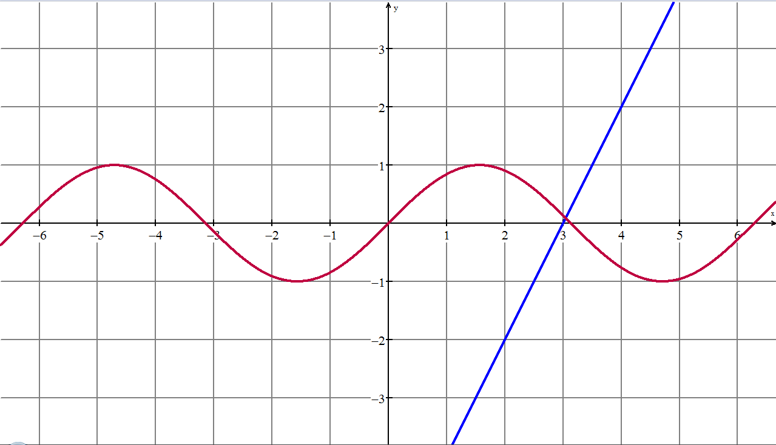 | 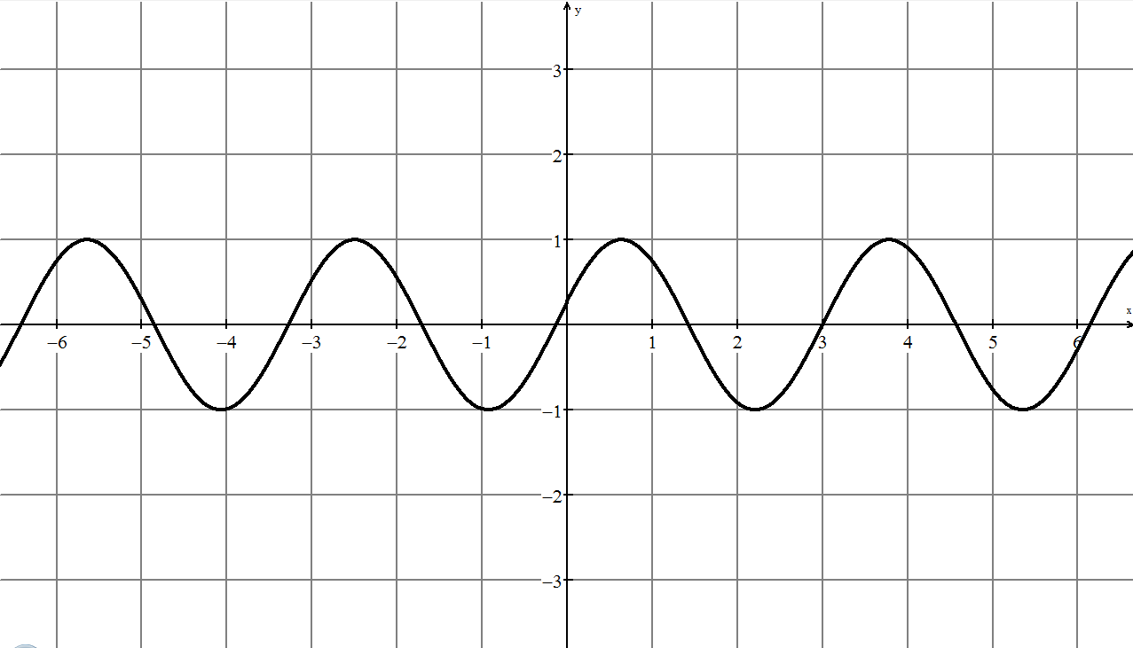
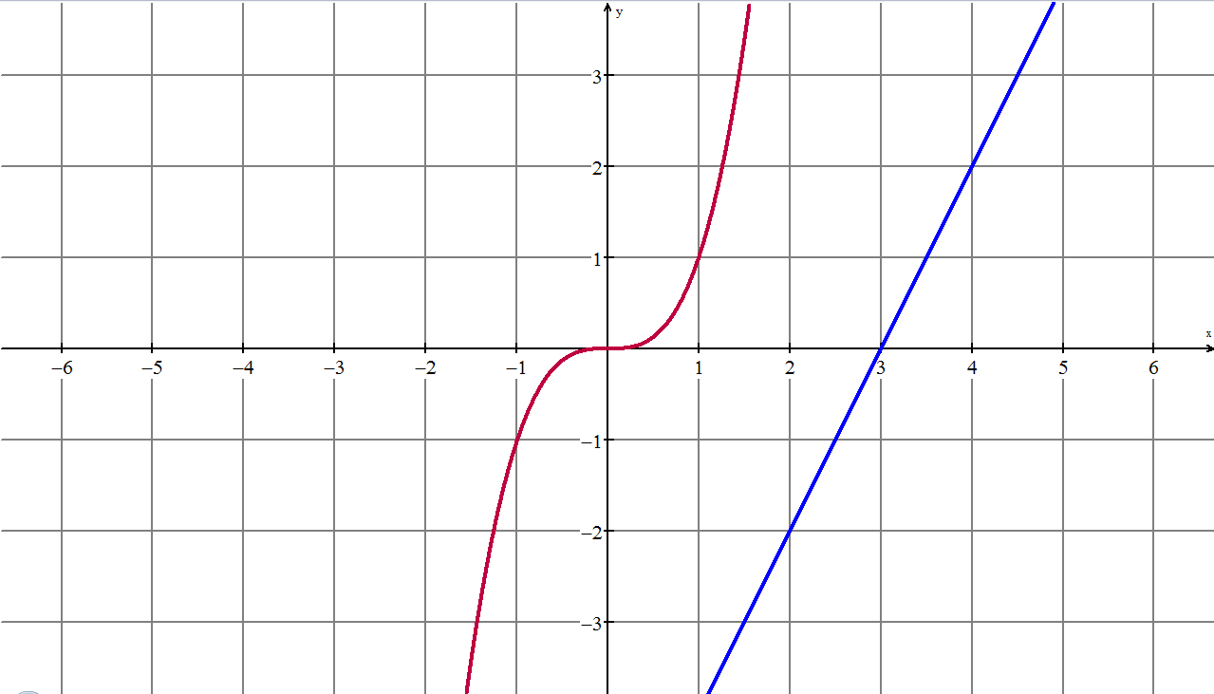 | 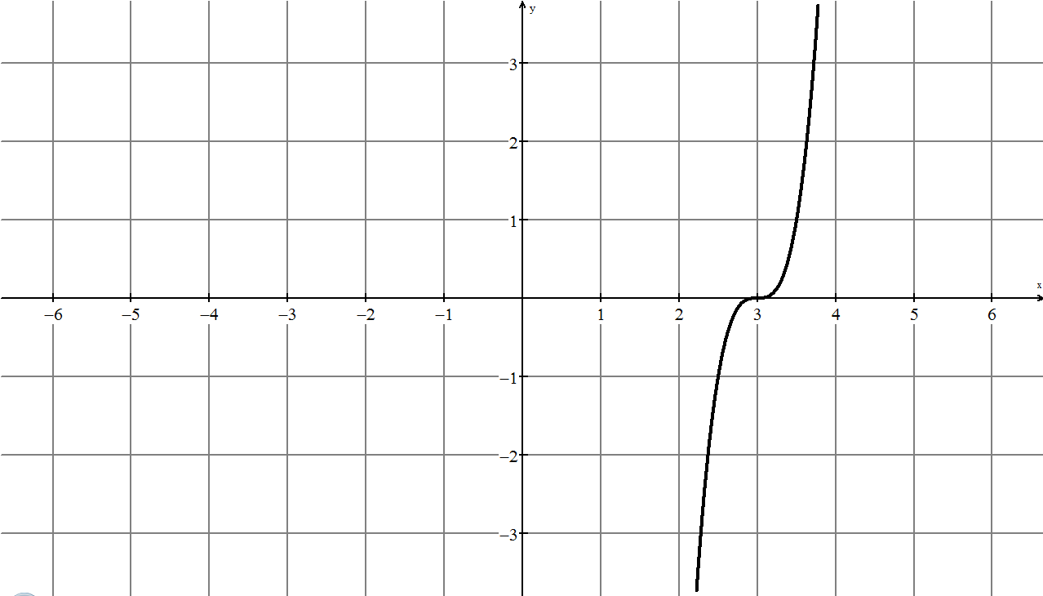

Unit 6: Days 11 and 12: Putting It All Together (Part 2) |  |  |  |  | MHF4U
  75 min |  | Math Learning Goals  - Consolidate applications of functions by modeling with more than one function.  - Consolidate procedural knowledge when combining functions.  - Communicate about functions algebraically, graphically and orally  - Model real-life data by connecting to the various characteristics of functions.  - Solve problems by modelling and reasoning. |  |  | Materials  - graphing technology  - BLM 6.11.1–6.11.8  - CBR  - pendulum  - interactive white board, overhead, or chart paper
Assessment
Opportunities
 | Minds On… | Small Group → Organization  Students gather at Stations 1, 2, 3, or 4 as assigned on Day 10 – two groups per station. (See BLM 6.11.1–6.11.5.)  Demonstrate an example of the card game at Station 3 for the whole class (BLM 6.11.4).  Review the purpose of these days, the structure of the “math congress,” and details of each Station:  1. Data modeling with more than one function (Application; 30 minutes).  2. Procedural/practice questions (Knowledge; 30 minutes)  3. (i) Card game to identify pairs of cards that represent the combination of functions graphically and algebraically. (Communicating, Representing, and Reasoning; 15 minutes)  (ii) Prepare for “congress.” Each group presents to another group one of the assigned combination or composition of functions. (Communicating, Representing, and Reasoning; 15 minutes)  4. Presentations through math congress (Knowledge and Processes; 30 minutes) |  | See BLM 6.11.6 – Game Answers.  Note: The first groups presenting will not have additional time during class to prepare their presentation. The teacher may rearrange times to allow for this.
 | Action! | Small Group → Task Completion  Groups discuss, plan, and work at their assigned station for the allowed time.  During the congress, each group presents to the other (15 minutes each), and asks and answers questions.  Alert the class to rotate after 30 minutes.  Reasoning and Representation/Rubric/Anecdotal Notes: Listen to the presentation of combined functions as students present to their peers (BLM 6.11.7 and 6.11.8).  Communicating and Reflecting/Observation/Anecdotal Notes: Listen to the questions posed and reflections made on the presentation as students articulate questions to the presenting group.
 | Consolidate Debrief | Whole Class → Discussion  Clarify questions, if needed.  Review the Day 12 plan to continue working in stations not visited or prepare for course performance task and exam.  To prepare for the environmental context of the course performance task have students brainstorm some words dealing with natural disasters. See Course Performance Task Day 1 for samples.
Exploration  Application |  | Home Activity or Further Classroom Consolidation  Generate words dealing with the environment to post on the word wall.  Review for the course summative performance task and exam.

6.11.1: Station Materials (Teacher)

Teacher arranges the room setup with materials for four Stations:

1. BLM 6.11.2, CBR and pendulum.
Data source for Q.2- E-STAT Table 053-0001, V62, http://estat.statcan.ca

2. BLM 6.11.3 with additional questions created using course resources/texts.

3. BLM 6.11.4–6.11.6. Game cards are reproduced without the algebraic representation – included for teacher reference only.
Functions in the game can be repurposed by comparing all combinations of graphs from a given pair of graphs.

4. Tables, chairs and resources set up for congress presentations and questioning

6.11.2: Station 1: Application of Combination of Functions

1. Gathering Data: Pendulum Swing
- Hypothesise the graph of the distance of the pendulum from CBR as it swings over a time of 15 seconds.
- Arrange the CBR and pendulum so the motion of the pendulum is captured in the CBR. Record the motion for 15 seconds.
- Sketch the graph of the motion of the pendulum and compare to your hypothesis.
- Discuss the result and any misconceptions you may have had.
- What two types of functions are likely represented by the motion of the pendulum? Determine the combination of those functions to fit the graph as closely as possible.

2. Data and graphs “Baby Boom Data”
The data represents the quarterly number of births during the peak of the baby boom.
- What two types of functions are likely represented here?
- Determine the combination of those functions to fit the graph as closely as possible.
- If the graph were to continue, when would the number of births fall below 10 000?

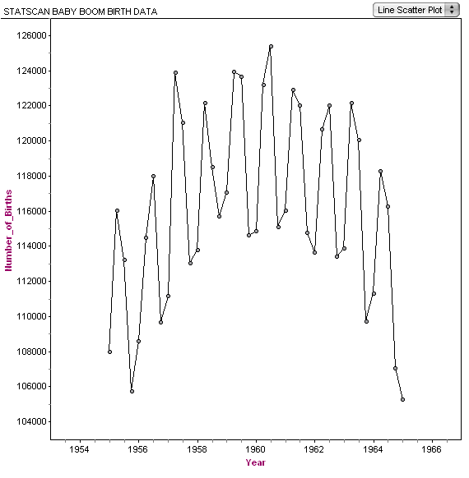 | 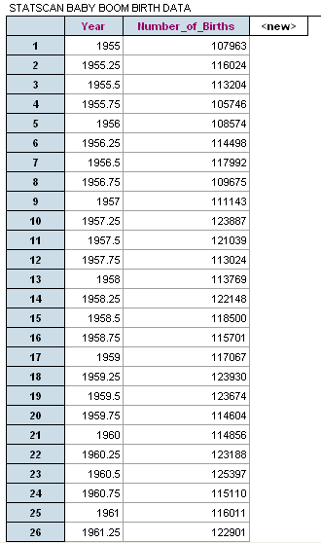
Reference – http://www.statcan.ca/english/edu/mathmodel.htm  Data source: E-STAT. Table 053-0001, vector v62, http://estat.statcan.ca | 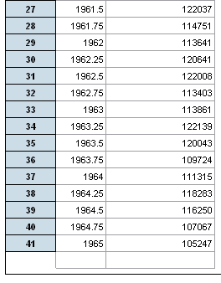
6.11.2: Station 1 (continued)

3. Let represent the number of female college students in Canada in year t and represent the number of male college students in Canada in year t. Let represent the average number of hours per year a female spent communicating with peers electronically. Let represent the average number of hours per year a male spent communicating with peers electronically.

a) Create the functionto represent the number of students in college in Canada in year t.

b) Create the function to represent the number of hours all female college students spent communicating with peers electronically in year t.

c) Create the function to represent the number of hours all male college students spent communicating with peers electronically in year t.

d) Create a function to represent the total number of hours college students spent communicating with peers electronically in year t.

4. The graph shows trends in iPods sales since 2002.

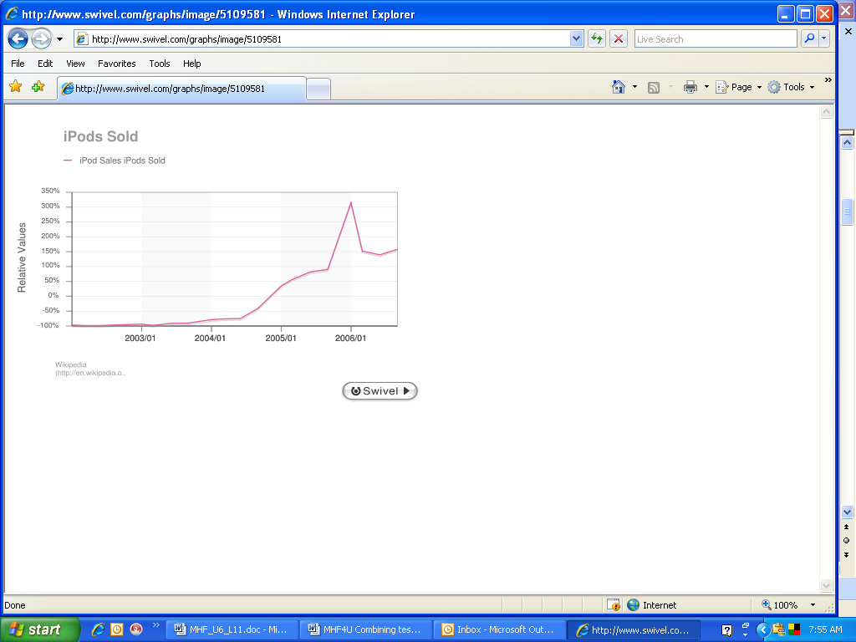

a) According to this data, when did the peak sales occur? Hypothesize why this was the peak during this time period.

b) Over what 4-month period was the greatest rate of change?

c) If you were to describe this data algebraically, into what intervals would you divide the graph and what function type would you choose for each interval? Justify your answers.

6.11.3: Station 2: Procedural Knowledge and Understanding

1. Given determine the following and state any restrictions on the domain:

a)

b)

c)

2. Given determine Show thatin more than one way, using graphing technology.

3. Solve graphically and algebraically:

6.11.4: Station 3: Card Game: Representations

Your team must find a pair of matching cards. To make a matching pair, you find one card that has the graphs of two functions that correspond with a card that shows these functions combined by an operation (addition, subtraction, multiplication, or division).
When you find a matching pair, state how the functions were combined. Discuss why you think it is a match.
Check the answer (BLM 6.11.5) and reflect on the result, if you had an error.
Continue until all the cards are collected.
Some of the features to observe in finding a match are:
- intercepts of combined and original graphs
- intersections of original graphs
- asymptotes
- general motions, e.g., periodic, cubic, exponential
- large and small values
- odd and even functions
- nature of the function between 0 and 1, 0 and –1
- domain and range

Examples
The initial graph of and can be combined to produce the graphs shown below it. Determine what operations are used to combine them and explain the reasoning. Check answers after you have determined how the functions were combined.

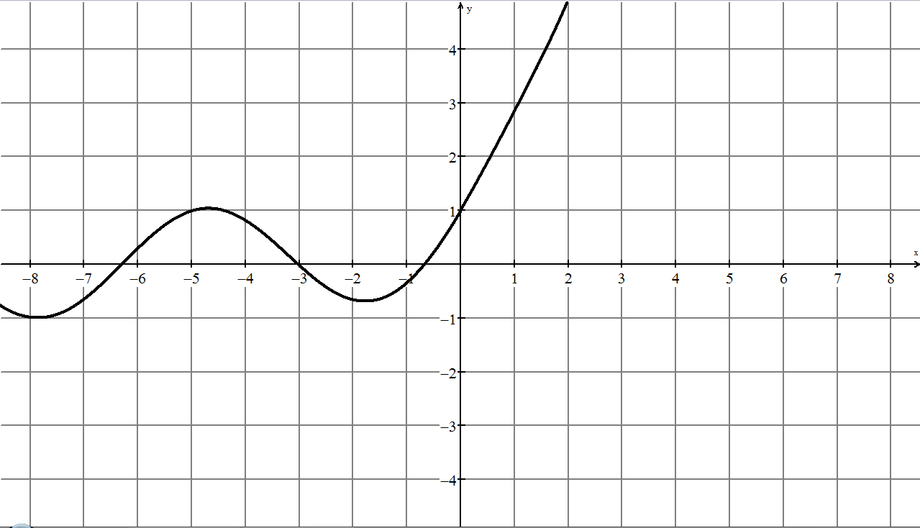 | 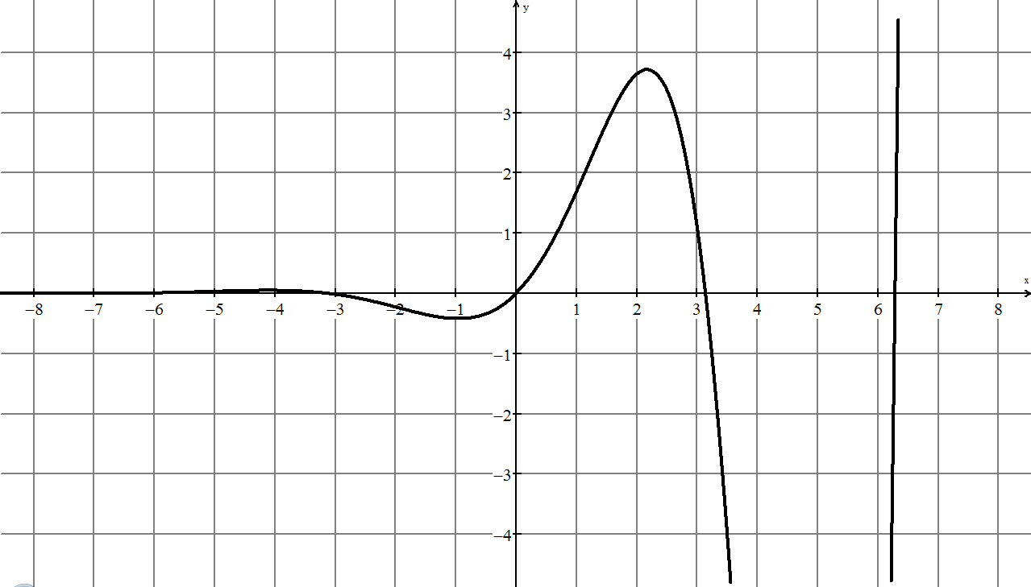
6.11.4: Station 3: Card Game: Representations (continued)

Answers

- Periodic suggests sine or cosine  - Dramatic change for positive x-values, not existing for negative x-values, suggests exponential  - y-intercept of 1 can be obtained by adding the y-intercepts of each of the original graphs, only addition will produce this | - Periodic suggests sine or cosine  - Dramatic change for positive x-values, not existing for negative x-values, suggests exponential  - x-intercepts correspond to the  x-intercepts of the sine function therefore multiplication or division.  - Division by exponential would result in small y-values in first and fourth quadrant, division by sinusoidal would result in asymptotes, therefore must be multiplication.

6.11.5: Card Masters for Game

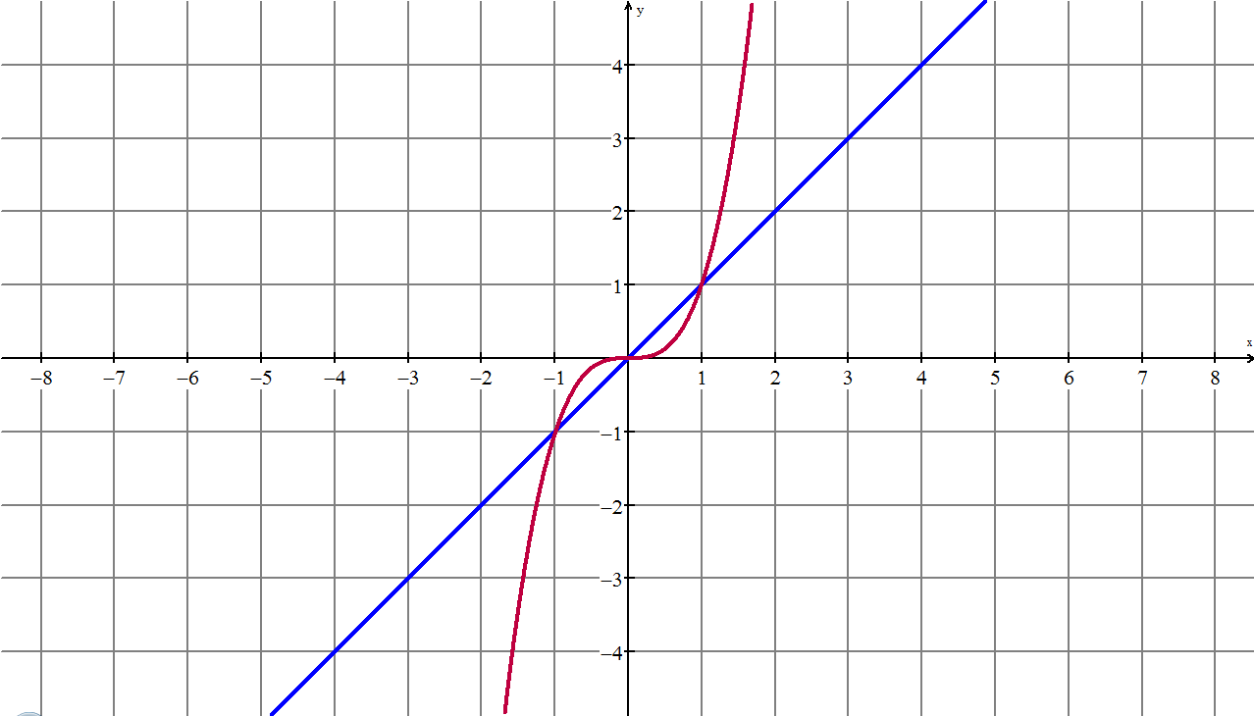  J  P  L  G  S  4  3  2 | 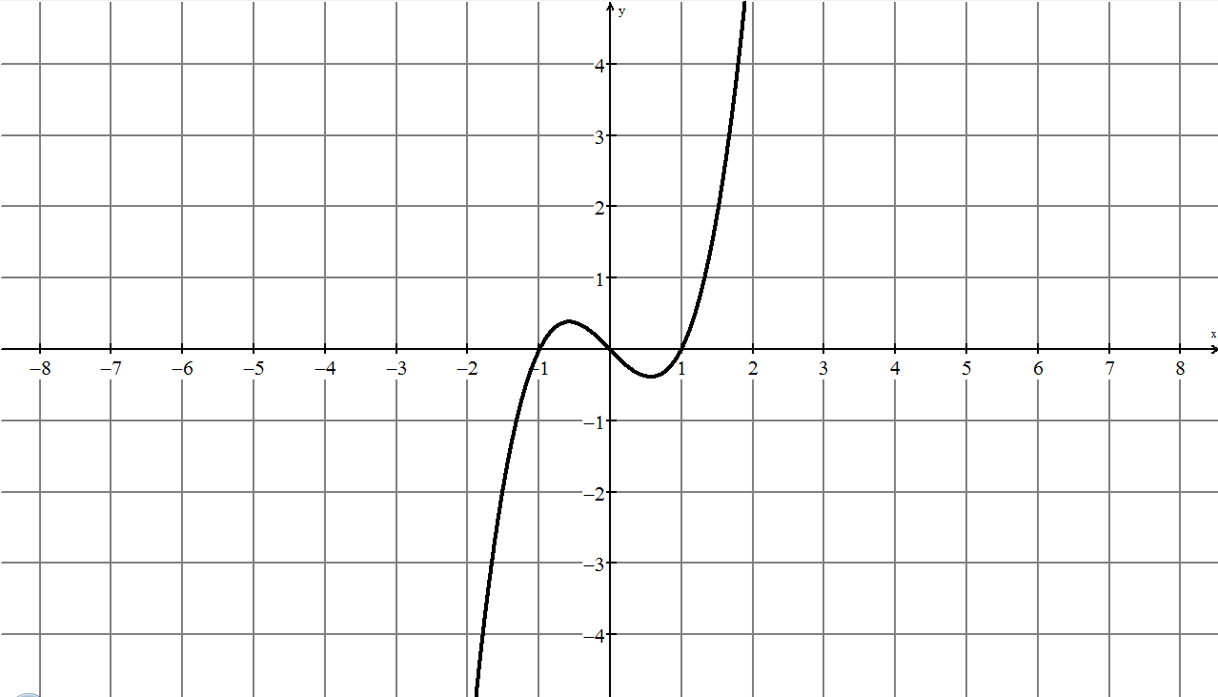
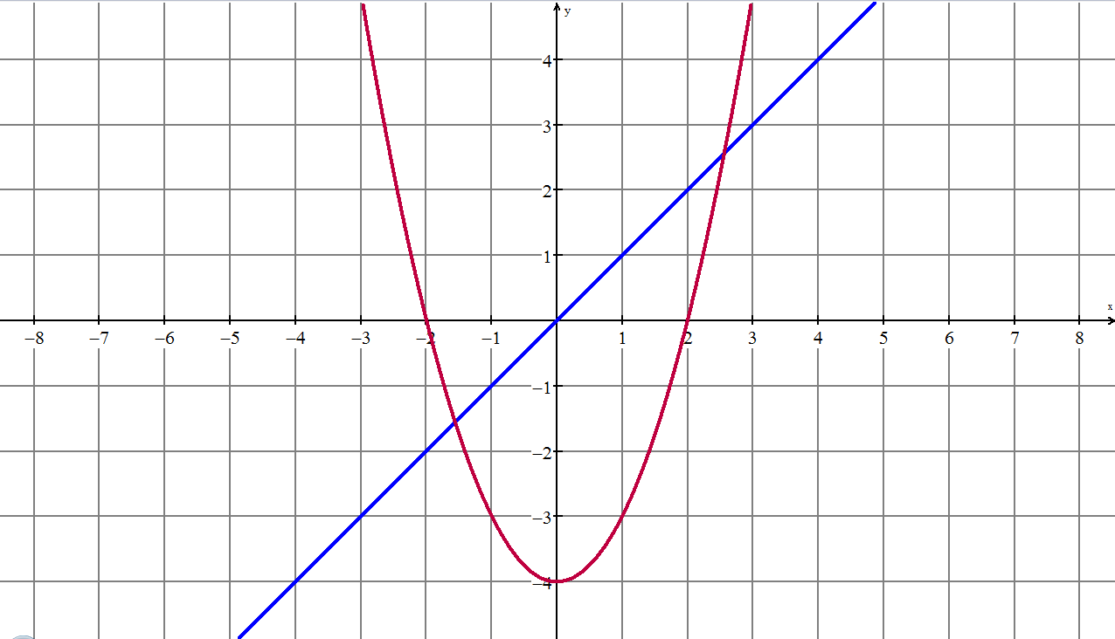 | 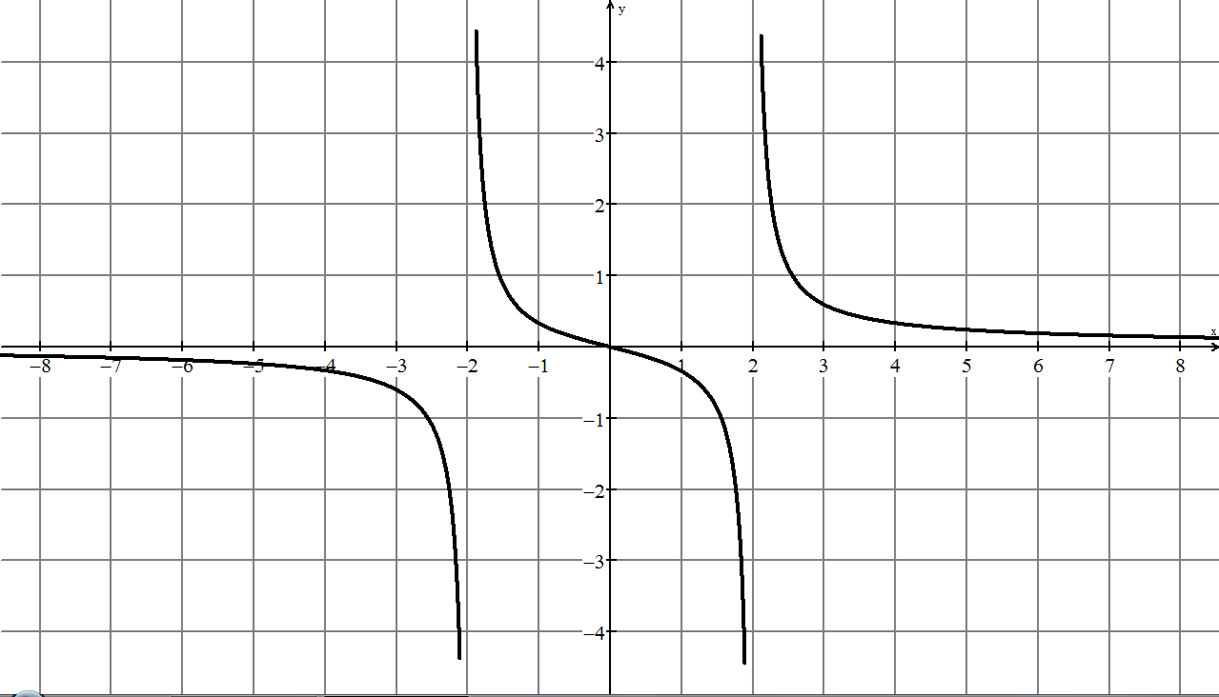
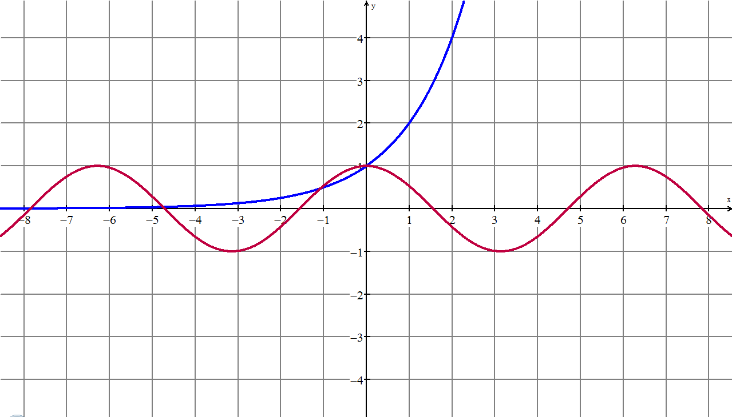 | 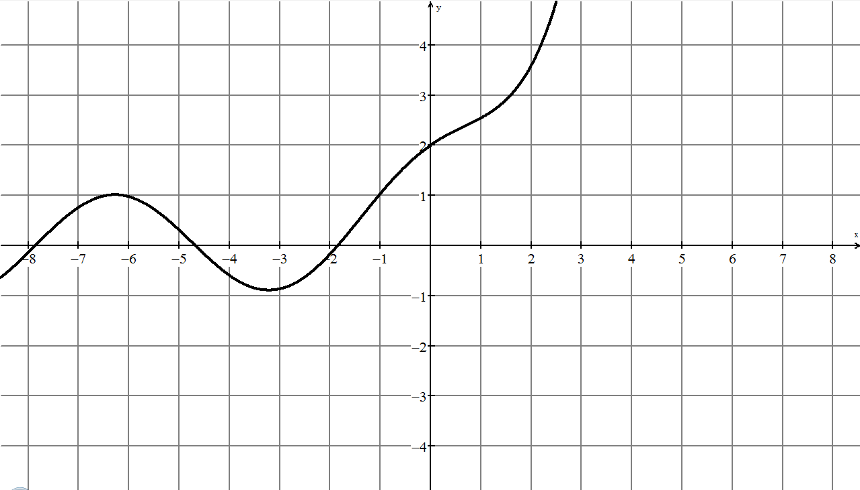
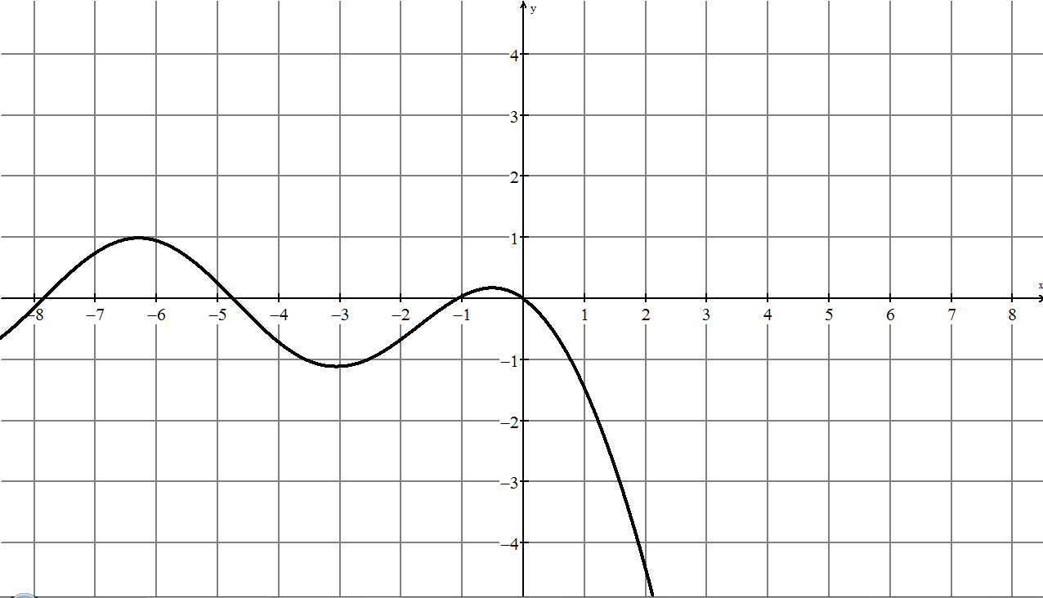 | 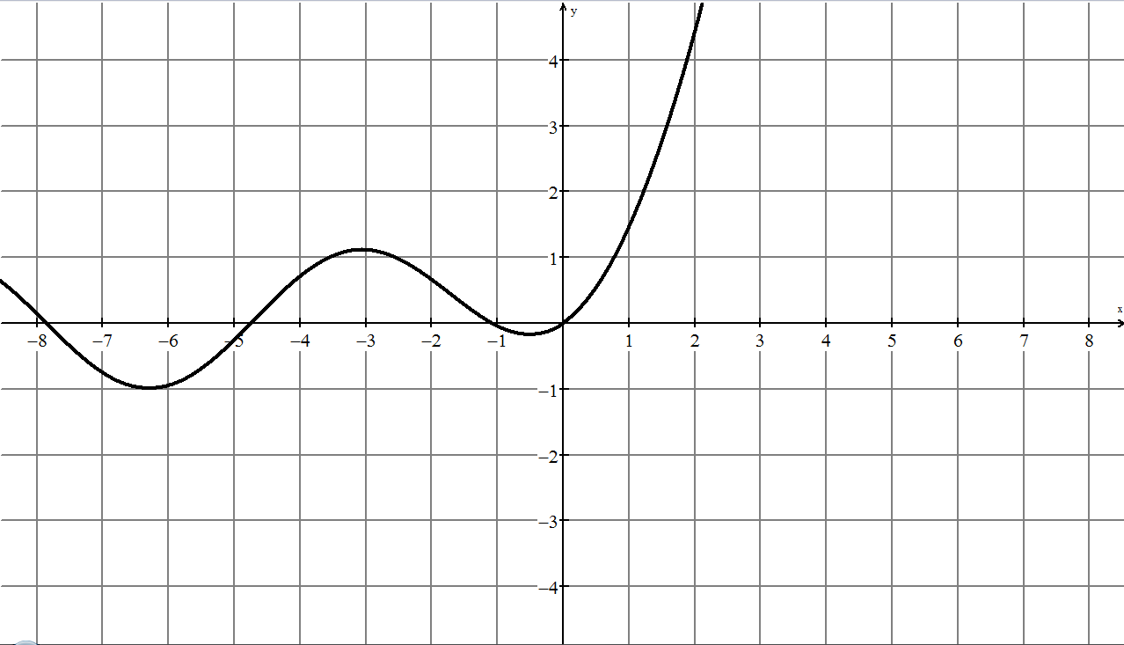

6.11.5: Card Masters for Game (continued)

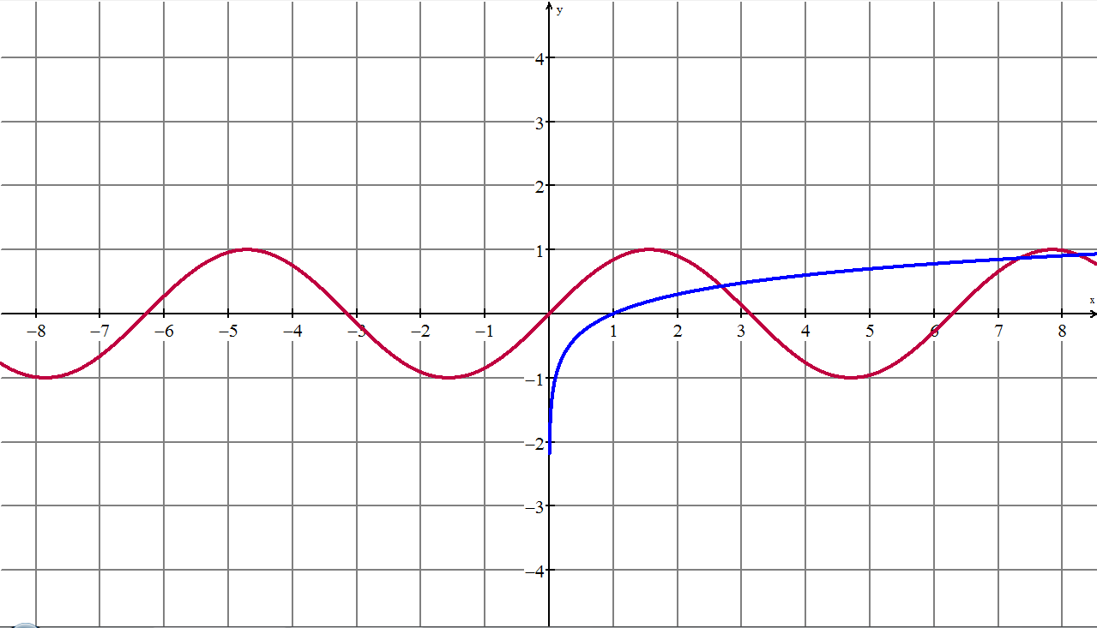  T  H  F  R  7  6  M  5 | 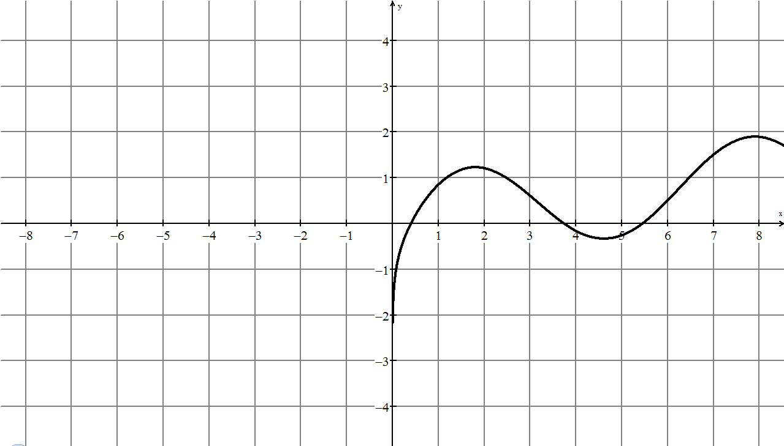
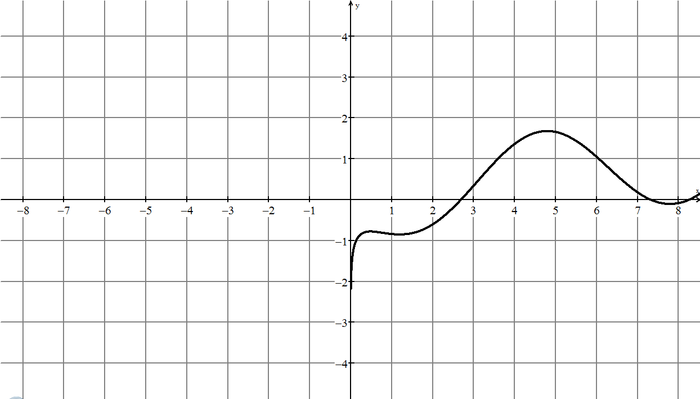 | 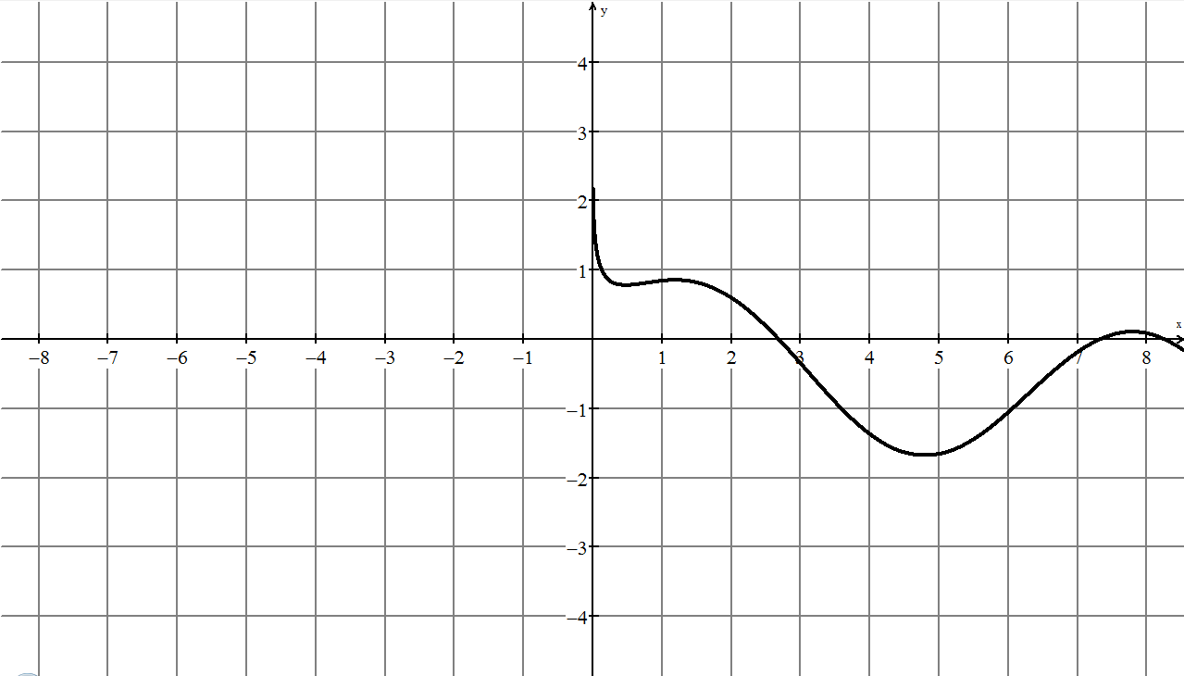
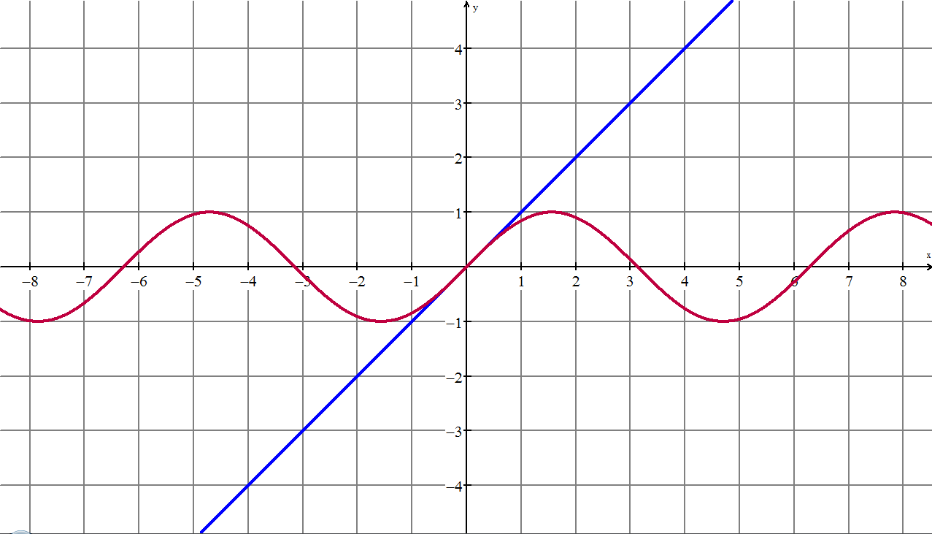 | 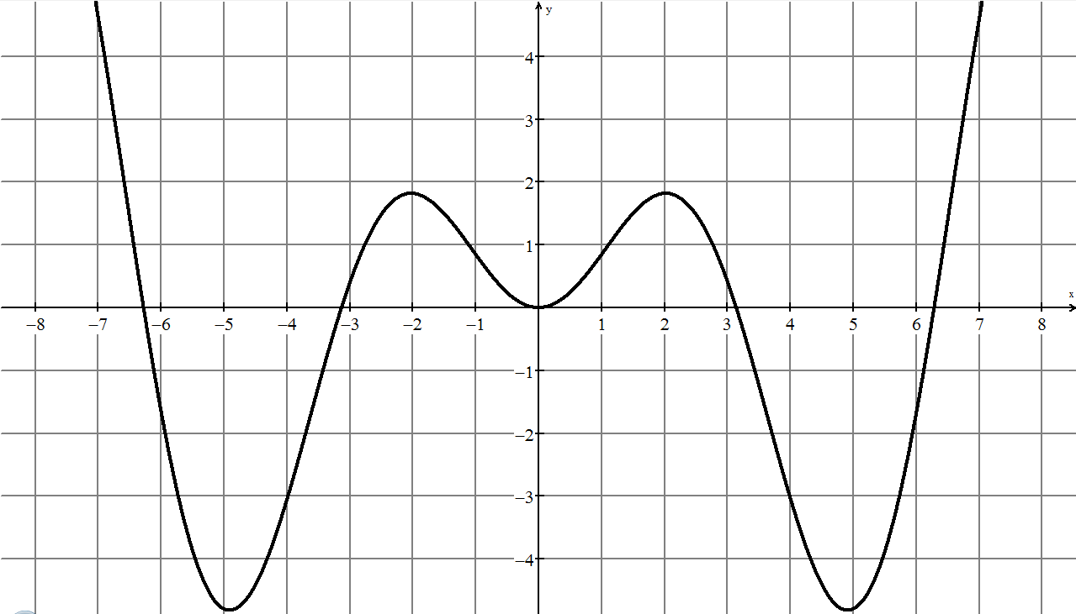
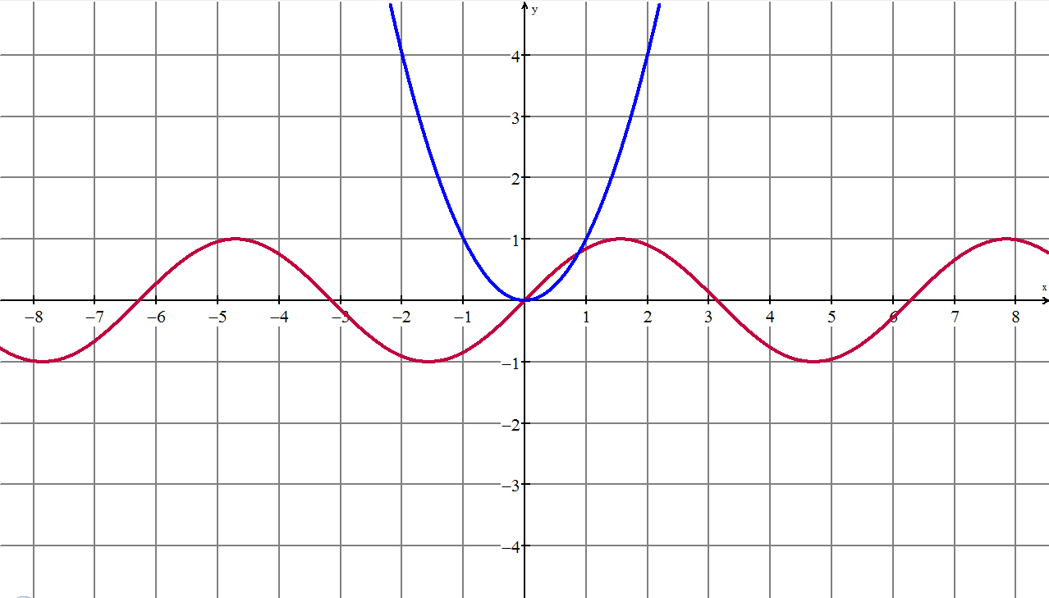 | 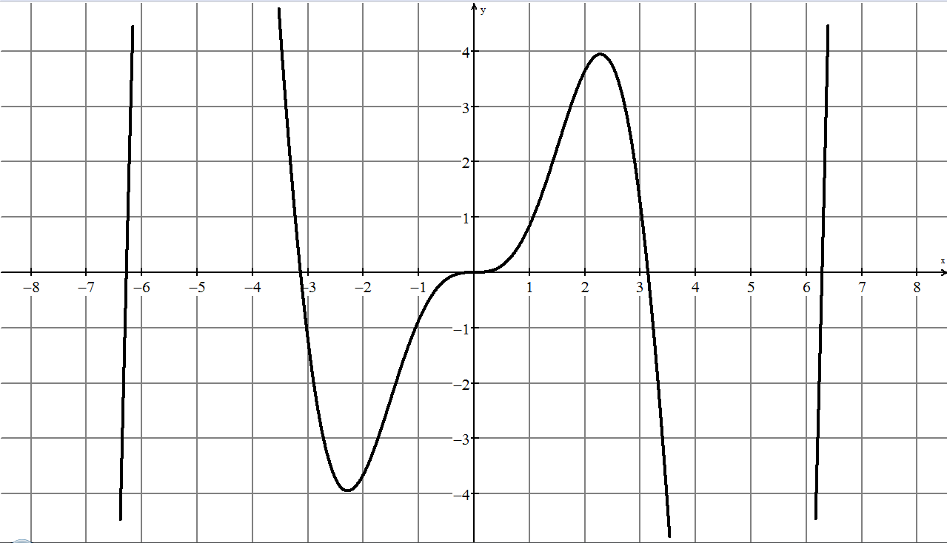

6.11.5: Card Masters for Game (continued)

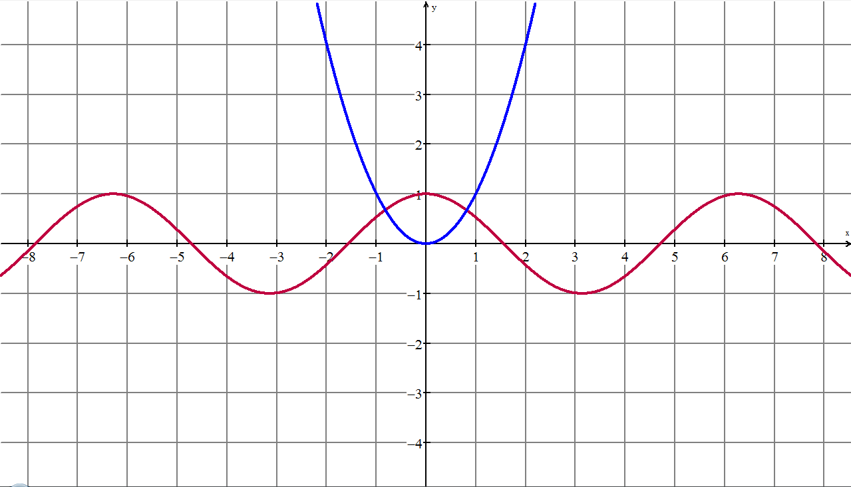  N  K  Q  9  8 | 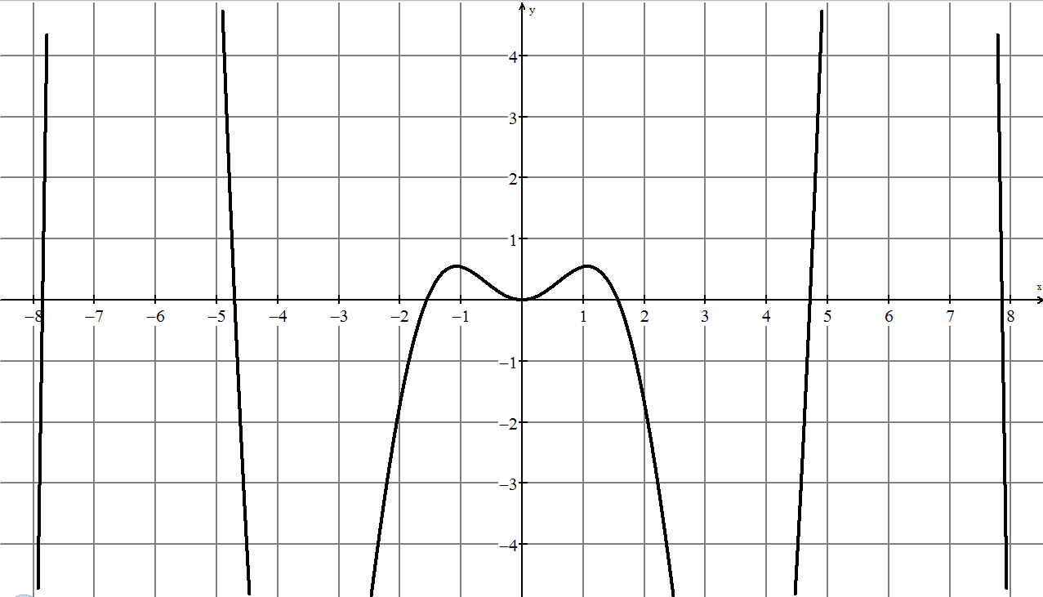
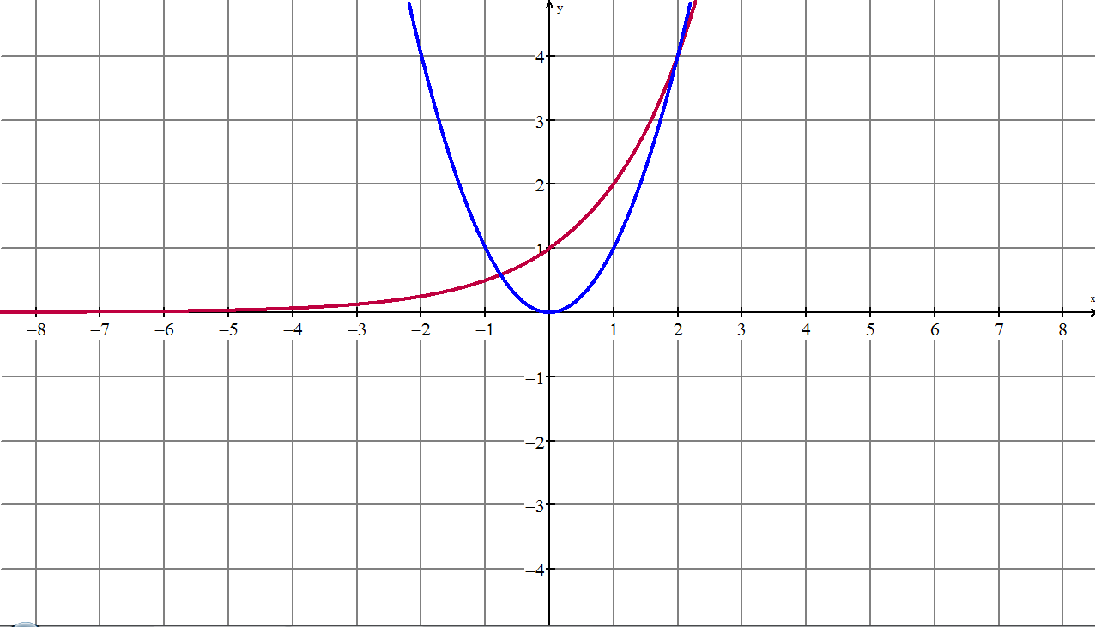
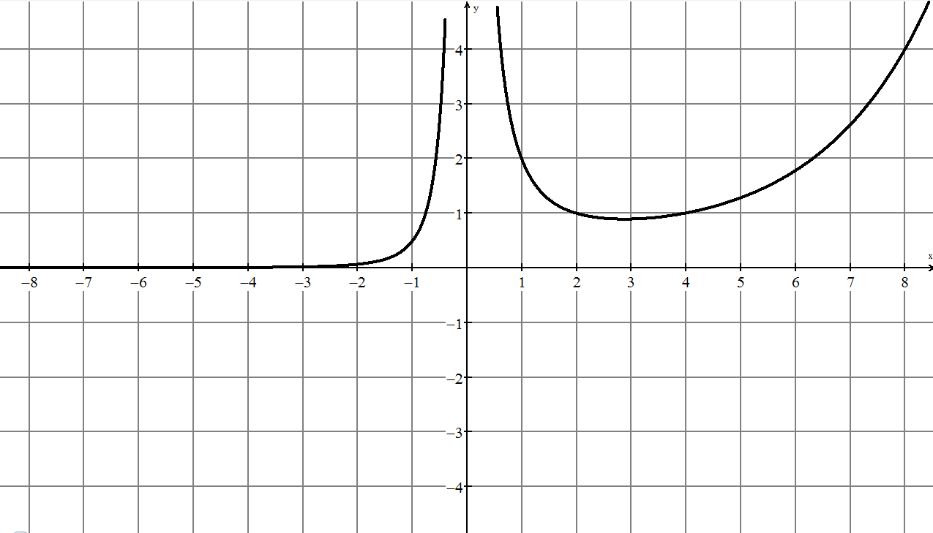
9
4
4

6.11.5: Card Masters for Game (continued)

5
5

6.11.6: Game Answers

Individual Graphs | Combined Graphs | Key features to help with identification.  These are not intended to be a sufficient, necessary or inclusive list of features; they are a list of “observations” to assist with matching.
- difference of odd functions is an odd function
- cannot be multiplication since odd multiplied by odd is even
- general motion is cubic, result is cubic
- is a point on both originals and combination
- cannot be division since no asymptote occurs
- x-intercepts occur where the graphs intercept, implying subtraction
- asymptotes at 2 and –2 suggests division by
- division results in y-values of 1 on the combined graph for values of x where the original graphs intersect
- when the y-values of the combined graph becomes large, and when the
y-values of the combined graph becomes small
- is a point on the combined graph giving information about the numerator
- odd function divided by an even function is an odd function

6.11.6: Game Answers (continued)

Individual Graphs | Combined Graphs | Key features to help with identification.  These are not intended to be a sufficient, necessary or inclusive list of features; they are a list of “observations” to assist with matching.
- periodic suggests sine or cosine
- dramatic change for positive x-values, not existing for negative x-values, suggests
- exponential
- y-intercept of 2 can be obtained by adding the
y-intercept of 1 of each of the original graphs, only addition will produce this result
- periodic suggests sine or cosine
- dramatic change for positive x-values, not existing for negative x-values, suggests exponential
- y-intercept of 0 can be obtained by subtracting the y-intercept of 1 of each of the original graphs
- x-intercepts are where the original graphs intersect, implying subtraction
- as x-increases, the combination decreases quickly, suggesting subtraction of an exponential
- periodic suggests sine or cosine
- dramatic change for positive x-values, not existing for negative x-values, suggests exponential
- y-intercept of 0 can be obtained by subtracting the y-intercept of 1 of each of the original graphs
- x-intercepts are where the original graphs intersect, implying subtraction
- as x-increases, the combination increases quickly, suggesting subtraction of the periodic from the exponential
6.11.6: Game Answers (continued)

Individual Graphs | Combined Graphs | Key features to help with identification.  These are not intended to be a sufficient, necessary or inclusive list of features; they are a list of “observations” to assist with matching.
- periodic suggests sine or cosine function
- domain suggests log function
- decreasing graph suggests something is being “taken away,” thus subtraction
- x-intercepts are where the original graphs intersect implying subtraction
- when log is very small (or large negative), the combined graph becomes very large, implying subtraction the log values
- periodic suggests sine or cosine function
- domain suggests log function
- x-intercepts are where the original graphs intersect implying subtraction
- when log is very small, the combined graph remains small, implying subtraction from the log
- periodic suggests sine or cosine function
- domain suggests log function
- when log is very small, the combined graph remains small, implying log is not being subtracted
- the sine curve is increasing, implying something is being added to the sine.
6.11.6: Game Answers (continued)

Individual Graphs | Combined Graphs | Key features to help with identification.  These are not intended to be a sufficient, necessary or inclusive list of features; they are a list of “observations” to assist with matching.
- periodic suggests sine or cosine function
- x-intercepts exist wherever there is an x-intercept in either of the original functions, suggesting multiplication
- odd function multiplied by an odd function, results in an even function
- periodic suggests sine or cosine function
- x-intercepts exist wherever there is an x-intercept in either of the original functions, suggesting multiplication
- even function multiplied by an odd function, results in an odd function
- periodic suggests sine or cosine function
- x-intercepts exist wherever there is an x-intercept in either of the original functions, suggesting multiplication
- even function multiplied by an even function, results in an even function
6.11.6: Game Answers (continued)

Individual Graphs | Combined Graphs | Key features to help with identification.  These are not intended to be a sufficient, necessary or inclusive list of features; they are a list of “observations” to assist with matching.
 | 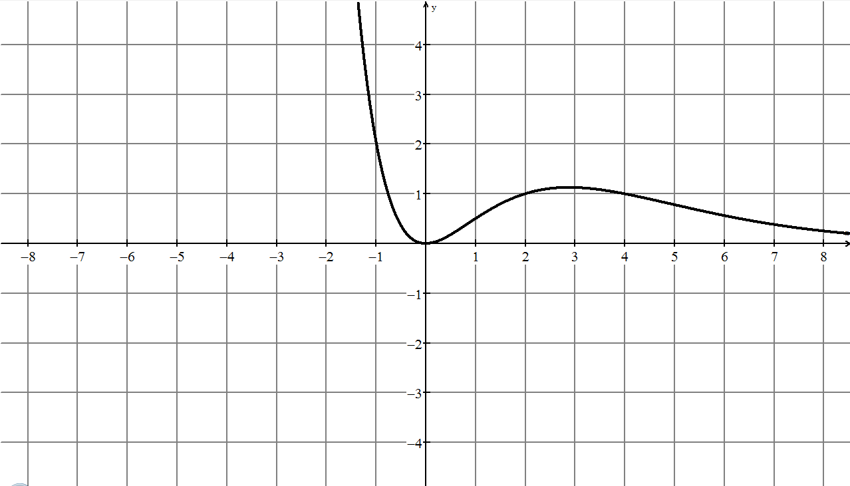 | - x-intercept occurs at x-intercept ofsuggesting multiplication or division  - where is small the combined graph is large and vise versa, suggesting division by  - where the graphs intersect at division produces the point
- asymptote at y-axis suggests division by a function going through the origin
- combined function is small as x gets small, and is large as x gets large, suggest exponential

6.11.7: Station 4 Rubric for Math Congress (Teacher)

Connecting
Criteria | Below Level 1  Specific Feedback | Level 1 | Level 2 | Level 3 | Level 4
Makes connections between information in the chart and the graph. |  | - makes weak connections between information in the chart and the graph | - makes simple connections between information in the chart and the graph | - makes appropriate connections between information in the chart and the graph | - makes strong connections between information in the chart and the graph
Gathers data that can be used to solve the problem [e.g., select critical  x-values and intervals for the chart]. |  | - gathers data that is connected to the problem, yet inappropriate for the inquiry | - gathers data that is appropriate and connected to the problem, yet missing many significant cases | - gathers data that is appropriate and connected to the problem, including most significant cases | - gathers data that is appropriate and connected to the problem, including all significant cases, including extreme cases
Reasoning and Proving
Interprets graphs. |  | - misinterprets a major part of the given graphical information, but carries on to make some otherwise reasonable statements | - misinterprets part of the given graphical information, but carries on to make some otherwise reasonable statements | - correctly interprets the given graphical information, and makes reasonable statements | - correctly interprets the given graphical information, and makes subtle or insightful statements
Makes inferences in the chart about the required graph. |  | - makes inferences that have a limited connection to the properties of the given graphs | - makes inferences that have some connection to the properties of the given graphs | - makes inferences that have a direct connection to the properties of the given graphs | - makes inferences that have a direct connection to the properties of the given graphs, with evidence of reflection
Representing
Creates a graph to represent the data in the chart. |  | - creates a graph that represents little of the range of data | - creates a graph that represents some of the range of data | - creates a graph that represents most of the range of data | - creates a graph that represents the full range of data

6.11.8: Station 4 Rubric for Peer Assessment of
Math Congress (Student)

Communicating
Criteria | Level 1 | Level 2 | Level 3 | Level 4
Expresses and organizes mathematical thinking with clarity and logical organization using oral and visual forms. | - expresses and organizes mathematic thinking with limited clarity (helpfulness) | - expresses and organizes mathematic thinking with some clarity (helpfulness) | - expresses and organizes mathematic thinking with considerable clarity (helpfulness) | - expresses and organizes mathematic thinking with a high degree of clarity (helpfulness)
Knowledge and Understanding
Interprets key features of the graphs of the functions and of the combined function. | - misinterprets a major part of the graphical aspects of the functions and of the combined function information, but carries on to make some otherwise reasonable statements | - misinterprets part of the given graphical information, but carries on to make some otherwise reasonable statements | - correctly interprets the given graphical information, and makes reasonable statements | - correctly interprets the given graphical information, and makes subtle or insightful statements
Makes inferences in the chart about the required graph. | - makes inferences that have a limited connection to the properties of the given graphs | - makes inferences that have some connection to the properties of the given graphs | - makes inferences that have a direct connection to the properties of the given graphs | - makes inferences that have a direct connection to the properties of the given graphs, with evidence of reflection
Representing
Creates a graph to represent the data in the chart. | - creates a graph that represents little of the range of data | - creates a graph that represents some of the range of data | - creates a graph that represents most of the range of data | - creates a graph that represents the full range of data

