MHF 4U Unit 5 –Exponential and Logarithmic Functions– Outline

Day | Lesson Title | Specific Expectations
1 – 2  (Lessons Included) | Characteristics of the Exponential Function and its Inverse, the Logarithmic Function | A1.1, 1.3, 2.1, 2.2
3  (Lesson Included) | Evaluation of Logarithms | A1.1, 1.2, 1.3
4 – 5  (Lessons Included) | Laws of Exponents and Logarithms | A1.4, 3.1
6 – 7  (Lessons Included) | Rates of Change of Exponential and Logarithmic Functions | D1.4 - 1.9 inclusive
8  (Lesson Included) | Solving Real World Problems Graphically | A2.4
9  (Lesson Included) | Solving Exponential and Logarithmic Equations | A3.2, 3.3
10 | Log Or Rhythm | A2.3
11  (Lesson Included) | Solving Real World Problems Algebraically | A3.4
12-13 | JAZZ DAY
14 | SUMMATIVE ASSESSMENT
TOTAL DAYS: |  | 14

Unit 5: Days 1&2: Characteristics of the Exponential Function and its Inverse, the Logarithmic Function |  |  |  | MHF4U
Minds On: 10 |  | Learning Goal:  - Describe key features of the graphs of exponential functions (domain, range, intercepts, increasing/decreasing intervals, asymptotes)  Define the logarithm of a number to be the inverse operation of exponentiation, and demonstrate understanding considering numerical and graphical examples  Using technology, graph implicitly, logarithmic functions with different bases to consolidate properties of logarithmic functions and make connections between related logarithmic and exponential equations (e.g., graph x=a^{y} using Winplot, Graphmatica or graph a reflection in y=x using GSP™) |  | Materials  - BLM 5.1.1, 5.1.2, 5.1.3, 5.1.3A, 5.1.4, 5.1.5, 5.1.6  - Computer lab for Activity 4, equipped with Winplot
Action: 100
Consolidate:40
Total=150 min
Assessment
Opportunities
 | Minds On… | Whole Class → Brainstorm  Students will respond to the question, “What do you remember about powers?” by brainstorming. The teacher captures responses on the blackboard. Responses may include a review of the exponent laws. A placemat strategy would also work well in this introduction to the unit. |  | Activity #1:  The teacher should review the concept of asymptotes, which should have been introduced in an earlier unit.  Activity #2 allows students to quickly find the relationship between log x and x while also developing skill in finding common logarithms on their own calculators.  Activity #3: The teacher should help students make the distinction that x = a^{y} and y = log_{a}x are equivalent and represent the inverse of y = a^{x}.  Literacy Strategies:  Timed Retell
 | Action! | Activity 1: (Pairs) Students examine a series of graphs of various non-linear functions such as quadratic, cubic, exponential (BLM 5.1.1 and 5.1.2) and identify key features.  Activity 2: (Individual and pairs) Students perform a calculator activity to develop an understanding of the relationship between numerical values of powers and their corresponding logarithms. (BLM 5.1.3)  Activity 3: (Pairs) Students examine a series of graphs of logarithmic functions (BLM 5.1.4)  Activity 4: (Individual) Students plot a series of equations in Winplot or on graphing calculators and record key features of each (BLM 5.1.5)  Mathematical Process Focus: Reasoning and proving, connecting, and representing.
 | Consolidate Debrief | Whole Class → Discussion  Students will  - Summarize their understanding orally in pairs in a timed retell activity.  The teacher can ask a general question such as, “Tell your partner what you have learned about exponential and logarithmic functions today.” One partner speaks while the other listens without interrupting. They change roles and the second speaker adds to the first speaker’s comments.
Home Activity or Further Classroom Consolidation
Day 1: 5.1.3A
Day 2: BLM 5.1.6
NOTE TO TEACHER: BREAK THE TWO DAYS AS YOU SEE FIT FOR YOUR STUDENTS
A-W 11 | McG-HR 11 | H11 | A-W12 (MCT) | H12 | McG-HR 12
 |  |  | 7.1, 7.2, 7.6, 7.7 | 6.2, 6.3, 7.1 | 7.1, 7.2
Teacher Notes

- Activity #1 could be differentiated with respect to readiness by having weaker students provide information about the graphs of linear and quadratic functions. Extensions for stronger students might require them to make predictions about the effect of transformations on graphs of exponential functions. In the paired activities, it might be beneficial to pair students of differing abilities together to enhance discussions and improve understanding.

- The teacher should take some time at the end of Activity #2 to build consensus on the generalizations around exponential functions.

- Rather than consolidate the entire first day’s lesson in the last 20 minutes of class, the teacher may prefer to consolidate the work from BLM 5.1.1 and 5.1.2 before “changing gears” and moving from graphs of exponential functions to developing a definition for a logarithm. It will be important to make connections between these two key ideas before moving into the following day’s activities.

- A key understanding in Activity #3 is that the inverse of y = a^{x} is x = a^{y}. Students must also make the distinction that the expressions x = a^{y} and y = log_{a}x are equivalent.

5.1.1 Features of Mathematical Functions

The graphs below represent a series of different mathematical functions. Using your knowledge of linear and non-linear functions, identify the key features in the graphs shown. Record your list in your notes and include the following:
- Nature of the relationship (linear, non-linear, type)
- Specific features: domain, range, x- and y-intercepts, increasing/decreasing intervals

Graph #1 Graph #2

Graph #3 Graph #4

Turn over the page.
5.1.1 Features of Mathematical Functions (Continued)

Compare Graphs #1-4 with that shown below. In addition to the domain, range, intercepts, and increasing/decreasing intervals, what additional feature is shown in Graph #5?

Graph #5

Write a definition for the additional feature:

Summary: Comparison of Graphs of Polynomial and Exponential Functions
 | Function Type
Feature | Linear | Quadratic | Polynomial (Degree ≥ 3) | Exponential
Domain
Range
x-intercept
y-intercept
Asymptotes

5.1.1 Features of Mathematical Functions (Answers)

Write a definition for the additional feature:
Responses will vary. The asymptote of a curve is the line which the curve approaches more and more closely without actually touching.

Summary: Comparison of Graphs of Polynomial and Exponential Functions

 | Function Type
Feature | Linear | Quadratic | Polynomial (Degree ≥ 3) | Exponential
Domain
Range
x-intercept |  |  | Varies by function | N/A
y-intercept |  |  | Varies by function | (0, 1)
Asymptotes | N/A | N/A | N/A
5.1.2 Features of Exponential Functions

Consider the graphs of the three exponential functions shown below:

Which features are the same and which are different in these graphs?

What other form of the equation for could you use? What reason can you give to explain why the curve of differs from the other two graphs?

Based on what you have learned about the graphs of exponential functions today, what generalizations can you make about exponential functions in the form ? List your generalizations and then compare them with those of a classmate.

5.1.2 Features of Exponential Functions (Answers)

Which features are the same and which are different in these graphs? Responses will vary. All three graphs have the same form of the equation: y = a^{x}. They all have the same y-intercept and asymptote. They all have the same domain and range . The only thing that is different is that one graph decreases as x increases, and the other two increase as x increases.

What reason can you give to explain why the curve of differs from the other two graphs? Responses will vary. It must be because the value of a is less than 1 but greater than 0.Moreover indicative of a reflection in the y-axis of

Based on what you have learned about the graphs of exponential functions today, what generalizations can you make about exponential functions in the form? List your generalizations and then compare them with those of a classmate. Responses will vary but should include the main features of the graphs as noted in the answer to the first question.

5.1.3 What is a Logarithm?

This activity is designed to help you find out what the LOG key on your calculator does. Logarithms can be set to any base. The LOG key represents log₁₀, which is known as the “common logarithm.” Record the results in the space provided and retain this page for later reference. The first example is done for you.

Logarithm | Value
Log 100 = 2 | 10² = 100
Log 10
Log 1000
Log 0.01 =
Log 0.0001 =
Log =
Log
Log
Log 0
Log -3
Log -31
Log 6.74
Log 67.4
Log 6740
Log 20
Log 2000
Log 53
Log 471
Log 5

When you have completed the table, compare your results with that of a partner. With your partner, determine the relationship between log x and x. Record your conclusions and answer the following question.

Which word best describes a logarithm? Explain your answer.

Test your theory with the following:

If log₃8 = 2, what is the corresponding power?

If log₂32 = 5, what is the corresponding power?

5.1.3: What is a Logarithm? (Answers)

This activity is designed to help you find out what the LOG key on your calculator does. Logarithms can be set to any base. The LOG key represents log₁₀, which is known as the “common logarithm.” Record the results in the space provided and retain this page for later reference. The first example is done for you.

Logarithm | Value
Log 100 = 2 | 10² = 100
Log 10 = 1 | 10¹ = 10
Log 1000 = 3 | 10³ = 1000
Log 0.01 = -2 | 10⁻² = 0.01
Log 0.0001 = -4 | 10⁻⁴ = 0.0001
Log = 0.5 | 10^{0.5} =
Log = 2 | 10² =
Log = -1.5 | 10^{-1.5} =
Log 0 = Undefined | N/A
Log -3 = Undefined | N/A
Log -31 = Undefined | N/A
Log 6.74 = 0.82866 | 10^{0.82866} = 6.74
Log 67.4 = 1.82866 | 10^{1.82866} = 67.4
Log 6740 = 3.82866 | 10^{3.82866} = 6740
Log 20 = 1.30103 | 10^{1.30103} = 20
Log 2000 = 3.30103 | 10^{3.30103} = 2000
Log 53 = 1.724276 | 10^{1.724276} = 53
Log 471 = 2.67302 | 10^{2.67302} = 471
Log 5 = 0.69897 | 10^{0.69897} = 5

Which word best describes a logarithm? Explain your answer.
Responses will vary. The best word to describe a logarithm is that it is an exponent. A logarithm is the exponent to which a base is raised to obtain a value.

Test your theory with the following:

If log₃8 = 2, what is the corresponding power? 2³ = 8

If log₂32 = 5, what is the corresponding power? 2⁵ = 32

5.1.3A Home Activity: Exponential and Logarithmic Functions

- Convert the following from exponential to logarithmic form and logarithmic to exponential form, depending on what is provided.

  - 27 = 3³ becomes ________________ in logarithmic form.
  - 4 = log₃ 81 becomes ______________ in exponential form.
  - 3 = log₁₀ 1000 becomes ______________ in exponential form.
  - becomes ___________________ in logarithmic form.
  - -2 = log₃ becomes __________________ in exponential form.
  - becomes __________________ in logarithmic form.

- Express in exponential form.
a) b) c)
d) e) f)

- Express in logarithmic form.
a) 5² = 25 b) c)
d) 10⁵ = 100 000 e) f)

- Evaluate.
a) b) c)
d) e) f)
f) g) h)
Answers:
1 a) b) c) d) e) f)
2. a) b) c) d) e) f)
3. a) b) c)
d) e) f)
4.a) 0 b) 2 c) 1 d) 3 e) 2 f) 0 g) h) 8 h)

5.1.4 Features of Logarithmic Functions

Consider the graphs below and record key features in the table provided:

Function
Feature
FunctionType
Domain
Range
x-intercept
y-intercept
Asymptotes

- What do you notice about the graphs of and ?

- What do you notice about the graphs of and ?

- What would you expect to see in a graph comparing and ?

- What test can you make to see if your theory is correct?
5.1.4 Features of Logarithmic Functions (Answers)

 | Function
Feature
FunctionType | Logarithmic | Logarithmic | Exponential | Exponential
Domain
Range
x-intercept | (1, 0) | (1, 0) | N/A | N/A
y-intercept | N/A | N/A | (0, 1) | (0, 1)
Asymptotes

- The graphs of and are mirror images through the line.
- The graphs of and are mirror images through the line.
- Graphs of and should be mirror images through the line .
- The test you could make would be to draw in the line and see if the curves are reflections.

5.1.5 Properties of Logarithmic Functions

Graphing Instructions for Winplot:
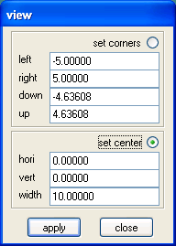
Open Winplot.
Select WINDOW, then 2-dim. You should see an empty grid.
Select VIEW, then View. You should see this dialogue box:
Select “set corners” and then set the scale for the grid by entering values for the x- and y-axes. When finished, click on “apply.”

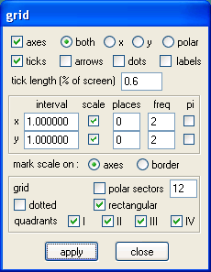
After setting the scale, select VIEW, then Grid. You should see the dialogue box shown below.

You can vary the scale on each axis by selecting the scale, number of decimal places, and frequency of labels on the axis. Select “rectangular” grid for a Cartesian plane. Click on “apply” and then “close.”

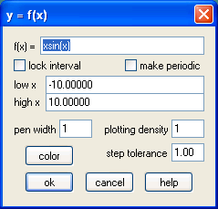
If you wish to graph an equation of the form “y = …”, then select EQUA from the toolbar, and click on “Explicit.” You should then see the dialogue box on the left.

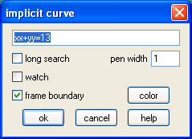
However, if you wish to graph an equation of the form “x = …,” then you must select “Implicit” from the list in EQUA. You should then see the dialogue box shown on the right.

5.1.5 Properties of Logarithmic Functions (Continued)

Student Activity:
To graph a logarithmic function with base other than 10, you must enter an alternate format into the “Explicit” equation dialogue box.
Example: For y = log₂ x , enter log(2, x). You do not need to enter the “y = .”

Use Winplot or other graphing software to create graphs of the following exponential and logarithmic functions. Graph pairs of functions on the same grid.

- a)
b)
Compare the two pairs of graphs. What do you notice?

- a)
b)
Compare the two pairs of graphs. What do you notice?

- Graph the following functions on one grid.
Record the key features of these functions in the table below.

Function
Feature
Domain
Range
x-intercept
y-intercept
Asymptotes

- a) Summarize the relationship between y = a^{x} and x = a^{y}.
b) What is the relationship between y = log_{a} x and x = a^{y}?

- Summarize the properties of logarithmic functions. What effect does the base of the function have on its graph? How is the graph of a logarithmic function related to the graph of a corresponding exponential function?

5.1.6 Home Activity

Consider the two figures below. Figure #1 shows the graph of and its inverse. Figure #2 shows the graph of and its inverse. Refer to the graphs when answering the questions below.

Figure #1 Figure #2

- Write the equation for the inverse of in both of its forms.
- What is the equation for the inverse of?
- Complete the following table:

 | Function
Feature |  | Inverse of |  | Inverse of
Type of Function
Domain
Range
x-intercept
y-intercept
Asymptotes

Sketch the graphs of and its inverse on the same grid. Include the line in your diagram. What is the purpose of including the line in your graph?
5.1.6 Home Activity (Answers)

- Write the equation for the inverse of in both of its forms.
The inverse of is, or .
- What is the equation for the inverse of?
The inverse of is .

- Complete the following table:

 | Function
Feature |  | Inverse of |  | Inverse of
Type of Function | Exponential | Logarithmic | Logarithmic | Exponential
Domain
Range
x-intercept | N/A | (1, 0) | (1, 0) | N/A
y-intercept | (0, 1) | N/A | N/A | (0, 1)
Asymptotes

- Sketch the graphs of and its inverse on the same grid. Include the line in your diagram. What is the purpose of including the line in your graph?

The line is the line of reflection for the two inverse functions.
Unit 5: Day 3: Evaluation of Logarithms |  |  |  | MHF4U
Minds On: 10 |  | Learning Goals:  Investigate the relationship between y = 10^{x} and y = b^{x} and how they relate to y = log x and y = log _{b} x, respectively  Evaluate simple logarithmic expressions  Approximate the logarithm of a number with respect to any base using a calculator  Solve simple exponential equations, involving base 10, by rewriting them in logarithmic form  Make connections between related logarithmic and exponential equations |  | Materials  BLM 5.3.1  BLM 5.3.2  BLM 5.3.3
Action: 50 |  |  |  | Materials  BLM 5.3.1  BLM 5.3.2  BLM 5.3.3
Consolidate:15 |  |  |  | Materials  BLM 5.3.1  BLM 5.3.2  BLM 5.3.3
Total=75 min |  |  |  | Materials  BLM 5.3.1  BLM 5.3.2  BLM 5.3.3
Assessment
Opportunities
 | Minds On… | Individual → Challenge  Students will recall the definition of an inverse function from Grade 11 math, and find inverses for a series of functions.  Example: Recall from grade 11 mathematics that we find the inverse of a function by interchanging the dependent and independent variables in the equation of the function.  Find the inverses of the following functions:  a) y = x + 5 b) y = 2 – x c) y = x² d) y = 4 – x²  e) f) y = 4^{x} g) y = -2^{x} |  | Use the Minds On challenge to provide students with an opportunity to access prior knowledge.  Differentiation opportunities:  - The teacher may provide a template of how to find the inverse of a function for students who find this activity difficult  - BLM 5.3.3 could be amended to include a worked example  Oral communication strategy used: Placemat  If time permits, the teacher may assess group work skills during the consolidation using a checklist
 | Action! | Whole Class → Discussion  Activity #1: The teacher leads a brief lesson relating powers and logarithms, and demonstrates how to convert an exponential equation to a logarithm, and vice-versa.  Activity #2: Students work through BLM 5.3.1 to evaluate simple logarithmic expressions. This activity should be taken up before proceeding to the next.  Activity #3: The teacher leads a brief lesson on the power law for logarithms and uses it to develop the relationship, . Students consolidate their understanding with BLM 5.3.2 and check their answers before completing the debrief.  Mathematical Process Focus: Reflecting, Connecting, and Communicating
 | Consolidate Debrief | Small Groups → Placemat  Record key ideas from today’s class on a placemat template  Share individual ideas to develop a consensus  Follow up with a whole class discussion to highlight key understandings and where difficulties exist
 |  | Home Activity or Further Classroom Consolidation  BLM 5.3.3: Solve simple exponential equations, involving base 10, by rewriting them in logarithmic form |  | BLM 5.3.3 could be evaluated against a marking scheme or used formatively to assess student progress.

A-W 11 | McG-HR 11 | H11 | A-W12 (MCT) | H12 | McG-HR 12
 |  |  | 7.3, 78 | 6.4, 7.1, 7.5 | 7.3, 7.4

Teacher Notes

From the previous day’s work, students should see that x = 5^{y} and y = log₅x produce the same graph. Therefore, they must be the same function. Replace symbols with words to illustrate the relationship

Value = Base ^{Exponent} Exponent = log _{Base} Value

Or by substitution,

Exponent = log _{Base} (Base ^{Exponent})

Students should realize by now that a logarithm is an exponent and that the logarithm is the answer to the question:

To what power must the base be raised to produce a specific value?

5.3.1 Evaluating Simple Logarithmic Expressions

Evaluate simple logarithmic expressions using the relationship between powers and logarithms. One strategy is to replace the value with its equivalent power.
Value = Base ^{Exponent} Exponent = log _{Base} Value

Examples: log₂16 = log₂ (2⁴) log₅25 = log₅ (5²)
= 4 = 2

Exercises

1. Evaluate each logarithm.
a) log₂ 4 b) log₃ 27 c) log₂ 32

d) log₇ 49 e) log₅ (1/5) f) log₆1

2. Write each logarithm in exponential form.
a) log₂ 8 = 3 b) log₆ 36 = 2 c) log₁₆ 4 = ½

d) log₅ 625 = 4 e) log₃ 3 = 1 f) log₁₀1 = 0

3. Write each exponential equation in logarithmic form.
a) 3⁷ = 2187 b) 6⁶ = 46656 c) 5⁻² = 0.04

d) 7³ = 343 e) 8⁴ = 4096 f) 16^{1.5} = 64
5.3.2 Evaluating Logarithms to Any Base

Use the relationship to evaluate logarithms to any base. The most common strategy here is to take the logarithm of each side of the exponential equation, apply the power law for logarithms, and solve for the unknown variable.

Example:

Exercises

Solve for x, to two decimal places.

a) 6^{x} = 55 b) 13^{x} = 27 c) 4^{x} = 512

d) 2^{x} = 0.125 e) 7^{x} = 125 f) 5^{2x} = 39

5.3.1 Evaluating Simple Logarithmic Expressions (Answers)

1. a) log₂ 4 = 2 b) log₃ 27 = 3 c) log₂ 32 = 5

d) log₇ 49 = 2 e) log₅ (1/5) = -1 f) log₆1 = 0

2. a) log₂ 8 = 3 b) log₆ 36 = 2 c) log₁₆ 4 = ½
2³ = 8 6² = 36 16^{1/2} = 4

d) log₅ 625 = 4 e) log₃ 3 = 1 f) log₁₀1 = 0
5⁴ = 625 3¹ = 3 10⁰ = 1

3. a) 3⁷ = 2187 b) 6⁶ = 46656 c) 5⁻² = 0.04
log₃ 2187 = 7 log₆ 46656 = 6 log₅ 0.4 = -2

d) 7³ = 343 e) 8⁴ = 4096 f) 16^{1.5} = 64
log₇ 343 = 3 log₈ 4096 = 4 log₁₆ 64 = 1.5

5.3.2 Evaluating Logarithms to Any Base (Answers)

a) 6^{x} = 55 b) 13^{x} = 27 c) 4^{x} = 512
x = 2.2365 x = 1.285 x = 4.5
d) 2^{x} = 0.125 e) 7^{x} = 125 f) 5^{2x} = 39
x = -3 x = 2.4813 x = 1.1381
5.3.3 Home Activity

Solving Exponential Equations to Base 10
- Solve each equation, to two decimal places, by rewriting them in logarithmic form.

a) 10^{x} = 0.3 b) 10^{x} = 1.072 c) 10^{x + 4} = 7

d) 10^{x} = 0.0050 e) 10^{2(x + 1)} = 6.8 f) 10^{-x} = 0.006

Evaluating Simple Logarithmic Expressions
- Evaluate each logarithm.

a) log₃ 81 b) log₄ 64 c) log₅ 125

d) log₂ 128 e) log₃ 729 f) log₉ 729

Evaluating Logarithms to Any Base
- Solve for x, to two decimal places.

a) 7^{x} = 123 b) 8^{x} = 71 c) 3^{x} = 300

d) 5^{x} = 40 e) 7^{x} = 109 f) 4^{3x} = 43

5.3.3 Home Activity (Answers)

Solving Exponential Equations to Base 10
a) 10^{x} = 0.3 b) 10^{x} = 1.072 c) 10^{x + 4} = 7
log₁₀ 0.3 = x log₁₀ 1.072 = x log₁₀ 7 = x + 4

d) 10^{x} = 0.0050 e) 10^{2(x + 1)} = 6.8 f) 10^{-x} = 0.006
log₁₀ 0.0050 = x log₁₀ 6.8 = 2(x + 1) log₁₀ 0.006 = -x

Evaluating Simple Logarithmic Expressions
- Evaluate each logarithm.

a) log₃ 81 = 4 b) log₄ 64 = 3 c) log₅ 125 = 3

d) log₂ 128 = 7 e) log₃ 729 = 6 f) log₉ 729 = 3

Evaluating Logarithms to Any Base
- Solve for x, to two decimal places.

a) 7^{x} = 123 b) 8^{x} = 71 c) 3^{x} = 300
x = 2.473 x = 2.0499 x = 5.192

d) 5^{x} = 40 e) 7^{x} = 109 f) 4^{3x} = 43
x = 2.292 x = 2.4109 x = 0.9044
Unit 5: Day 4&5: Laws of Exponents and Logarithms |  |  |  | MHF4U
Minds On: 10 |  | Learning Goal:  - Explore graphically and use numeric patterning in order to make connections between the laws of exponents and the laws of logarithms  Explore the graphs of a variety of logarithmic and exponential expressions to develop the laws of logarithms  Recognize equivalent algebraic expressions involving logs and exponents  Use the laws of logarithms to simplify and evaluate logarithmic expressions |  | Materials  Computer lab equipped with The Geometer’s Sketchpad  BLM 5.4.1  BLM 5.4.2  BLM 5.5.1  BLM 5.5.2
Action: 120
Consolidate:20
Total =150 min
Assessment
Opportunities
 | Minds On… | Whole Class → Discussion  Complete a journal entry to summarize their understanding of the learning from the previous day’s class  Example: “A classmate missed yesterday’s math class. Describe how you would explain the lesson to him/her. Include specific examples, including any areas in which you are still having difficulty.”  The teacher should encourage a few students to share their ideas before proceeding to the first activity. |  | The Minds On… activity may present an opportunity for the teacher to group students heterogeneously to address any difficulties highlighted in the journal entries.  Literacy strategies: Journal writing  Log3x.gsp  The teacher may choose to collect the summary note from the end of Day 5 and assess it formatively or evaluate it against a communication rubric.
 | Action! | Small Groups → Experiment  Collaborate in small groups to develop the laws of logarithms for products and quotients (Reference: BLM 5.4.1)  Work through proofs of the laws of logarithms for products and quotients in a teacher-led lesson (Reference: 5.4.2 Teacher Notes)  Use graphing technology to sketch and compare graphs of equivalent algebraic expressions involving logarithms and exponents
 | Consolidate Debrief | Pairs → Journal entry  At the end of Day 5, students will  Work in pairs to create a summary note which reviews the connections between the exponent laws and laws of logarithms, algebraically and graphically.
Home Activity or Further Classroom Consolidation

Complete BLM 5.5.2

A-W 11 | McG-HR 11 | H11 | A-W12 (MCT) | H12 | McG-HR 12
 |  |  | 7.3p.344-5#9-17,20,21 | 6.1, 7.2 | 7.3p. 435-6#3-8,10,11

Teacher Notes

Laws of Logarithms for Products and Quotients

The teacher should split the class in half and into heterogeneous student groups of no more than four students per group. Half of the class will verify the product law for logarithms (BLM 5.4.1 Investigation A) while the other half verifies the quotient law for logarithms (BLM 5.4.1 Investigation B). After completing the activity, each group should create their own numerical examples to verify the law, using a minimum of one example per student.

When all groups of four have verified the law using their own numerical examples, they should join together and discuss their results. Two or three spokespersons from each half of the class should present their findings to the rest of the class.

Following this activity, the teacher demonstrates the proofs of the laws of logarithms for products and quotients. The law of logarithms for powers was discussed on Day 3.
5.4.1 Laws of Logarithms

Investigation A

Use a calculator to evaluate the following logarithms (all to base 10):
Log 4 =
Log 40 =
Log 400 =
Log 4000 =

What would you expect the answer to be for log 40 000? ______________

How did you arrive at that answer?

Use a calculator to evaluate the following common logarithms:
Log 1 =
Log 10 =
Log 100 =
Log 1000 =

If you rewrite log 40 as log (10 x 4), how would you rewrite its numerical value, so as to take into account the product (10 x 4)?

Rewrite the following:
Log 400 =
=
Log 4000 =
=

Write a generalization for the pattern:

Given the values of log 24 and log 4, how could you find the value of log 96?

How could we rewrite the general case, ?

5.4.1 Laws of Logarithms (Continued)

Investigation B

Use a calculator to evaluate the following logarithms (all to base 10):
Log 40 000 =
Log 4000 =
Log 400 =
Log 40 =

What would you expect the answer to be for log 4? ______________

How did you arrive at that answer?

Use a calculator to evaluate the following common logarithms:
Log 1000 =
Log 100 =
Log 10 =
Log 1 =

If you rewrite log 4 as log (40 ÷ 10), how would you rewrite its numerical value, so as to take into account the quotient (40 ÷ 10)?

Rewrite the following:
Log 4000 =
=
Log 400 =
=

Write a generalization for the pattern:

Given the values for log 96 and log 4, how could you find the value of log 24?

How could we rewrite the general case, ?
5.4.1 Laws of Logarithms (Answers)

Investigation A

Use a calculator to evaluate the following logarithms (all to base 10):
Log 4 = | 0.602059991
Log 40 = | 1.602059991
Log 400 = | 2.602059991
Log 4000 = | 3.602059991

What would you expect the answer to be for log 40 000? _4.602059991__

How did you arrive at that answer?

(Responses will vary): I noticed that every time the value increased by a factor of 10, its logarithm increased by one, so I added 1 to 3.602059991 to get 4.602059991.

Use a calculator to evaluate the following common logarithms:
Log 1 = | 0
Log 10 = | 1
Log 100 = | 2
Log 1000 = | 3

If you rewrite log 40 as log (10 x 4), how would you rewrite its numerical value, so as to take into account the product (10 x 4)?

Rewrite the following:
Log 400 =  = | Log (100 x 4)
Log 400 =  = | 2 + 0.602059991
Log 4000 =  = | Log (1000 x 4)
Log 4000 =  = | 3 + 0.602059991

Write a generalization for the pattern: (Responses will vary):
When a value can be rewritten as a product, its logarithm is the sum of the logarithms of the factors of the product.

Given the values of log 24 and log 4, how could you find the value of log 96?
Solution: log 96 = log (24 x 4)
= log 24 + log 4

How could we rewrite the general case, ?
5.4.1 Laws of Logarithms (Answers continued)

Investigation B

Use a calculator to evaluate the following logarithms (all to base 10):
Log 40 000 = | 4.602059991
Log 4000 = | 3.602059991
Log 400 = | 2.602059991
Log 40 = | 1.602059991

What would you expect the answer to be for log 4? _0.602059991__

How did you arrive at that answer? (Responses will vary)
I noticed that as the value decreased by a factor of 10, the logarithm decreased by one, so I subtracted 1 from log 40.

Use a calculator to evaluate the following common logarithms:
Log 1000 = | 3
Log 100 = | 2
Log 10 = | 1
Log 1 = | 0

If you rewrite log 4 as log (40 ÷ 10), how would you rewrite its numerical value, so as to take into account the quotient (40 ÷ 10)?

Rewrite the following:
Log 400 =  = | Log (4000 ÷ 10)
Log 400 =  = | 3.602059991 – 1
Log 40 =  = | Log (400 ÷ 10)
Log 40 =  = | 2.602059991 - 1

Write a generalization for the pattern: (Responses will vary)

When a value can be rewritten as a quotient, its logarithm is the difference of the logarithms of the numerator and denominator.

Given the values for log 96 and log 4, how could you find the value of log 24?
Solution: log 24 = log (96 ÷ 4)
= log 96 – log 4
How could we rewrite the general case, ?
5.4.2 Exponent and Logarithm Laws (Teacher Notes)
(Note: There is no BLM for this activity)

Recall the exponent laws and laws of logarithms:

Law | Exponents | Logarithms
Products | $$a^{m}x a^{n}= a^{m+n}$$ | $${\text{log}}_{a}\left(\text{mn}\right)= {\text{log}}_{a}m+{\text{log}}_{a}n$$
Quotients | $$\left(\frac{a^{m}}{a^{n}}\right)=a^{m−n}$$ | $${\text{log}}_{a}\left(\frac{m}{n}\right)={\text{log}}_{a}m−{\text{log}}_{a}n$$
Powers | $${\left(a^{m}\right)}^{n}=a^{\text{mn}}$$ | $${\text{log}}_{a}m^{n}=n⋅{\text{log}}_{a}m$$
Zero Exponents | $$a^{0}=1$$ | $${\text{log}}_{a}1=0$$
Negative Exponents | $$a^{−m}=\left(\frac{1}{a^{m}}\right)$$ | $${\text{log}}_{a}\left(\frac{1}{a^{m}}\right)=−m$$

Law of Logarithms for Products

Recall the relationship between powers and logarithms:
Value = Base ^{Exponent} Exponent = Log _{Base} Value

If we represent the relationship using symbols,

Therefore, the product can be written as

(Product law for exponents)

If we take the logarithm of each side of the last equation, then

5.4.2 Exponent and Logarithm Laws (Teacher Notes continued)
(Note: There is no BLM for this activity)

Law of Logarithms for Quotients

Applying the same logic as above, we can prove the law of logarithms for quotients.

The quotient can be written as

(Quotient law for exponents)

By taking the logarithm of each side of the last equation, we see that

5.5.1 Laws of Logarithms

Part I:
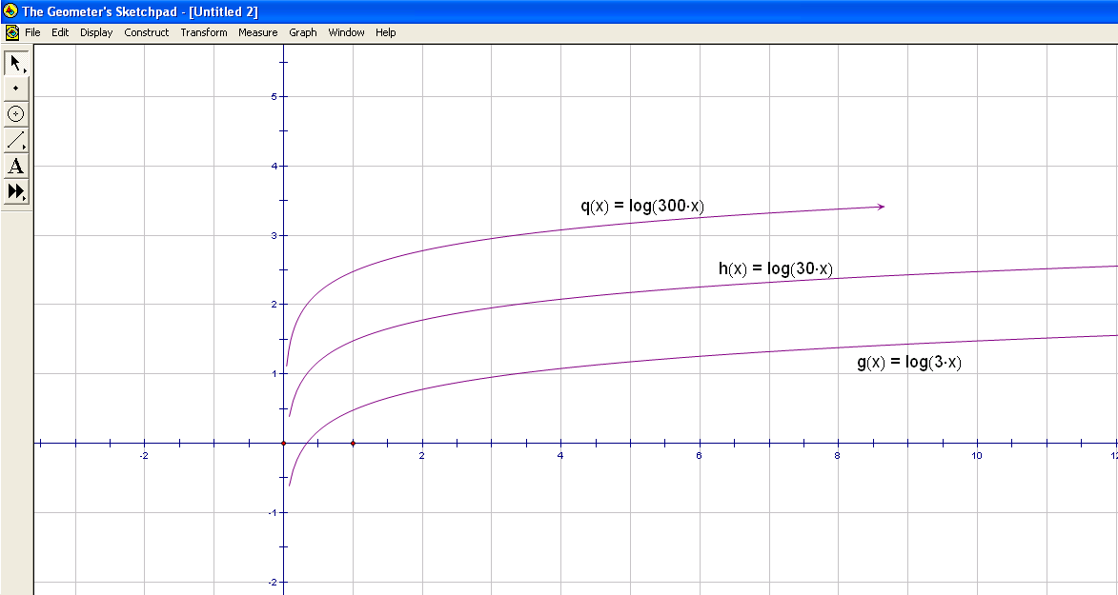
- Open the file named Log3x. You will see a graph of log₁₀(3x). Select “Plot New Function” from the Graph menu. Enter log(30x) and click on OK. Plot log(300x) and click on OK. You should see an image similar to that below.

- Compare the three graphs. What is the same and what is different?

- Sketch the graph of f(x) = log 3000x by hand on the grid above. Explain your reasoning for putting the graph where you did.

- Use the laws of logarithms to simplify algebraically the following expressions:
- y = log₁₀(30x)
- y = log₁₀(300x)
- y = log₁₀(3000x)

- Open a new file in GSP and plot all three of the simplified versions on a new grid. Compare the new grid to that shown above. Write a comparison of the two grids.
5.5.1 Laws of Logarithms (Continued)

Part II:
- Open a new copy of the file named Log3x. This time, plot the following new functions on the existing grid: h(x) = log (0.3x) and q(x) = log (0.03x)

- Compare the three graphs.

- Sketch in the graphs of h(x) = log (0.3x) and q(x) = log (0.03x) on the grid provided. Predict the location of the graph of f(x) = log (0.003x) and provide reasons for your answer.
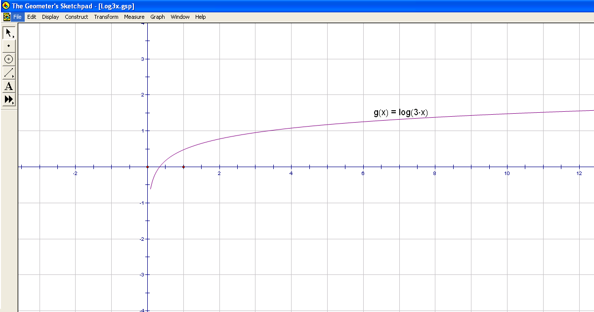
- Use the laws of logarithms to simplify algebraically the following expressions:
- y = log₁₀(0.3x)
- y = log₁₀(0.03x)
- y = log₁₀(0.003x)

- Open a new file in GSP and plot all three of the simplified versions on a new grid.
Add graphs of the new, simplified functions to the grid above.

- What can you conclude from this activity? Be specific.
5.5.1 Laws of Logarithms (Answers)

Part I:
- Open the file named Log3x. You will see a graph of log₁₀(3x). Select “Plot New Function” from the Graph menu. Enter log(30x) and click on OK. Plot log(300x) and click on OK. You should see an image similar to that below.

- Compare the three graphs. What is the same and what is different?
Responses will vary. The three graphs appear to be identical in shape and differ only by where they meet the y-axis.
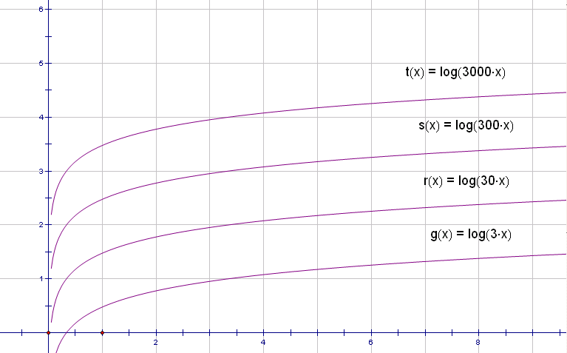
- Sketch the graph of f(x) = log 3000x by hand on the grid above.

- Students should see that
a) y = log₁₀(30x)
= log₁₀10 + log₁₀(3x)
= 1 + log₁₀(3x)
- y = log₁₀(300x)
= log₁₀100 + log₁₀(3x)
= 2 + log₁₀(3x)
- y = log₁₀(3000x)
= log₁₀1000 + log₁₀(3x)
= 3 + log₁₀(3x)

- Open a new file in GSP and plot all three of the simplified versions on a new grid. Compare the new grid to that shown above. Write a comparison of the two grids.

The graph of y = log (300x) is identical to the graph of y = 2 + log (3x).
The graph of y = log (30x) is identical to the graph of y = 1 + log (3x).
5.5.1 Laws of Logarithms (Answers continued)

Part II:
- Open a new copy of the file named Log3x. This time, plot the following new functions on the existing grid: h(x) = log (0.3x) and q(x) = log (0.03x)

- Compare the three graphs. Responses will vary. The graphs appear to be identical in shape and differ in their intercepts.

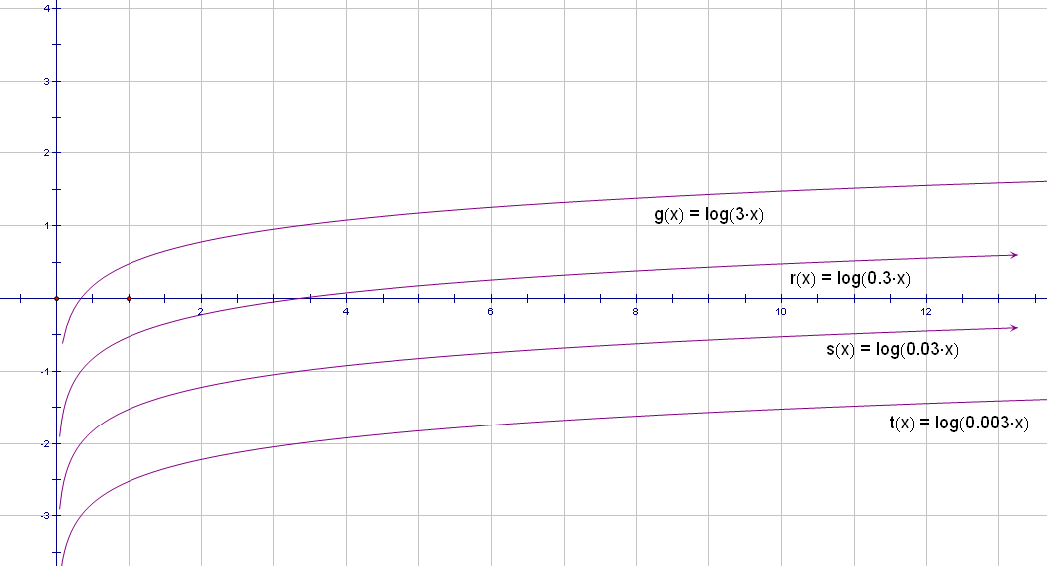
- Sketch in the graphs of h(x) = log (0.3x) and q(x) = log (0.03x) on the grid provided. Predict the location of the graph of f(x) = log (0.003x) and provide reasons for your answer.

- Students should see that
a) y = log₁₀(0.3x)
= log₁₀(3x ÷ 10)
= log₁₀(3x) - 1
b) y = log₁₀(0.03x)
= log₁₀(3x ÷ 100)
= log₁₀(3x) - 2
- y = log₁₀(0.003x)
= log₁₀(3x ÷ 1000)
= log₁₀(3x) - 3

- Open a new file in GSP and plot all three of the simplified versions on a new grid.
Add graphs of the new, simplified functions to the grid above.

- What can you conclude from this activity? Be specific.
Responses will vary. Students should observe that, as in Part I, the new, simplified functions are identical to the original functions. They should make connections between graphical representations of the laws of logarithms and the algebraic work completed in the previous day’s activity.
5.5.2 Home Activity: Logarithm Laws

Answer the following questions using the laws of logarithms for products, quotients, and powers, as applicable. Write full solutions showing all steps.

- Evaluate.

- Write as a single logarithm. Do not solve.

- Simplify. Evaluate where possible.

5.5.2 Home Activity (Answers)

Answer the following questions using the laws of logarithms for products, quotients, and powers, as applicable. Write full solutions showing all steps.

- Evaluate.

- 3

- 12

- 6

- 2

- 12

- 3

- Write as a single logarithm. Do not solve.

- Simplify. Evaluate where possible.

Unit 5: Days 6&7: Rates of Change of Exponential and Logarithmic Functions |  |  |  | MHF4U
Minds On: 10 |  | Learning Goal:  Solve problems involving average and instantaneous rates of change using numerical and graphical methods for exponential and logarithmic functions  Solve problems that demonstrate the property of exponential functions that the instantaneous rate of change at a point of an exponential function is proportional to the value of the function at that point |  | Materials  Overheads of the graphs “Douglas Fir Mean Ring Width” and “Raging River”  Computer lab equipped with Excel, Fathom, or GSP software  TI83+ or TI84+  BLM 5.7.1, 5.7.2
Action: 120
Consolidate:20
Total =150 min
Assessment
Opportunities
 | Minds On… | Whole Class → Discussion  Engage in a brief debate as to which type of curve is most appropriate as the curve of best fit for data introduced by the teacher (polynomial, exponential, or logarithmic) |  | Literacy Strategies:  Four Corners (Minds On – see teacher notes)  Computer Files:  DouglasFirRing.xls  DouglasFirRing.ftm  RagingRiver.xls  RagingRiver.ftm  Process Expectation: Connecting: Students are connecting between the math they know and the real world situations they are presented.
 | Action! | Individual → Technology  Fit a curve (by hand or using technology) to the graph of data (provided) and answer a series of questions about the data (Ref: DouglasFirRing and RagingRiver data files)  Use numerical and graphical methods to investigate the average and instantaneous rates of change of bacterial growth data (BLM 5.7.1)
 | Consolidate Debrief | Whole Class → Discussion  Respond to guiding questions from the teacher about the connections between secants and average rates of change, and tangents and instantaneous rates of change  Discuss the relative value of the methods used to find average and instantaneous rates of change
Home Activity or Further Classroom Consolidation
Complete BLM 5.7.2

A-W 11 | McG-HR 11 | H11 | A-W12 (MCT) | H12 | McG-HR 12

Teacher Notes

Minds On… The activities on Day 6 are designed to serve a wide range of teacher and student experience with the use of technology. We suggest beginning with the Douglas Fir Ring data set. Note that the data sets “Douglas Fir Rings” and “Raging River” are provided in two formats: Excel and Fathom. The line of best fit can be added by hand (a flexible curve will be useful in this application) or with technology. In our experience, adding a trend line in Excel was not as effective as fitting the curve using sliders in Fathom or GSP.

The data set should stimulate a rich discussion as to which curve of best fit is most appropriate. The teacher may wish to conduct a debate with students taking formal positions as to whether the curve is polynomial, exponential, or logarithmic. This could provide an opportunity for differentiation of product, in that students make their argument orally instead of in writing. Students should be given some time to study the graph individually before stating their preference for the curve of best fit. A “Four Corners” oral communication strategy could also be employed in this introduction to the lesson.

Action!
Day 6: Once the class has reached a consensus as to which type of curve best fits the data, students should fit the curve to the data. Fitting the curve by hand will take less time in class than if students use technology. If there is time, a second data set is available for students to conduct a similar activity with more autonomy. Suggested guiding questions follow:

- Find the curve of best fit for the data, either by hand or using technology.
- What name best describes the shape of the curve of best fit?
- Use the graph to identify the periods of time during which:
- the average rate of change was greatest
- the average rate of change was lowest
- Use the graph to identify the year in which each of the following occurred
- the greatest instantaneous change in mean width
- the smallest instantaneous change in mean width

Question 4 will generate some discussion as to the most appropriate way to determine the instantaneous change in mean width. At this stage, it would be appropriate to discuss the differences between tangents and secants. Students could draw tangents and secants by hand onto copies of the graph, justifying their choices and debating the merits of this method with respect to accuracy and precision. Should they be drawing a tangent to the actual data set or to the curve of best fit?

Day 7: (Refer to BLM 5.7.1). The activity itself is very straightforward. Once students have completed both methods of determining instantaneous rates of bacterial growth, the teacher could conduct a whole-class discussion comparing the values obtained for average rates of growth with those for instantaneous rates of growth.
- Clearly, the rate of change is not constant throughout the experiment. Why might that be?
- Is there any inherent error in the data that could contribute to the differences seen?
- Using the equation of the regression curve, you could calculate values for fractional portions of an hour.
- What do you notice as you reduce the length of time over which you calculate the average rate of change?
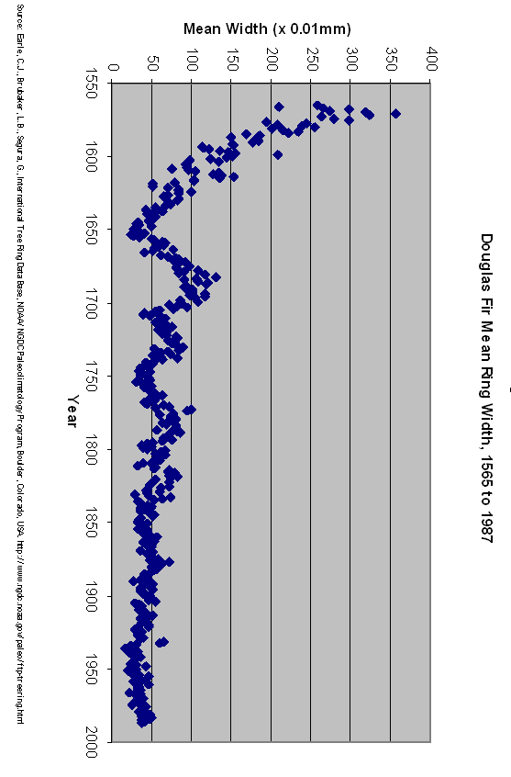
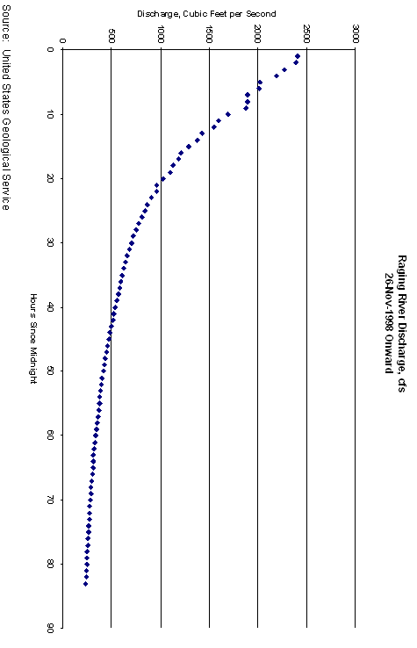

Data Sets

Quantitative Environmental Learning Project: Tree Ring Widths in a Douglas Fir
http://seattlecentral.edu/qelp/sets/056/056.html
Files: DouglasFirRings.xls and DouglasFirRings.ftm
As trees grow in age a layer of wood cells are produced each year that usually extends around the entire perimeter of the tree. This annual ring of growth consists of thin-walled cells formed early in the growing season (earlywood) and thicker-walled cells produced later in the growing season (latewood). From the start of earlywood growth to the end of the latewood growth constitutes one annual tree ring. Because new wood is also added upwards, the number of rings through cross sections of the trunk will decrease with height. Thus to determine the age of the tree, a tree ring researcher (dendrochronologist) typically counts the number of annual rings near the base or at "belt height". Ideally, to determine the age of a tree a researcher will saw through the tree to get a cross section. To preserve living trees, researchers use an increment borer, which is a hollow auger-like device that is twisted into the trunk. When the borer, about a centimeter in diameter, reaches the center of the tree, the interior plug or core of wood is removed. The core is then taken to the lab where tree wood and rings are analyzed. In practice, at least 2 samples are usually taken from the same tree to reduce the amount of variability in the tree ring data.
It's a general rule that tree ring widths decrease as the tree ages. This fact is well supported by the data, especially in the first 100 years of growth. Overall we see annual fluctuations in tree growth most likely due to seasonal differences in climate variables such as temperature and precipitation. What's really interesting is the periodic fluctuations beginning around 1650 and continuing through 3-4 cycles into the mid 1800's. Are these an indication that there were 50-year fluctuations in climate in the Pacific Northwest during this period? If so, what climate variables were limiting factors during periods of slow growth? An excellent exercise for the student is to determine the best fitting curve through the time series or analyze the differences in variation between the two samples.
The study that uses tree rings to reconstruct the past climate of an area is called dendroclimatology, a subfield of dendrochronology -- the science of using tree ring dating to analyze patterns in physical and social sciences. Other subfields of dendrochronology include dendroarchaelogy (using tree rings to date wooden artifacts), dendrohydrology (using tree rings to study changes in river flow, surface runoff, and lake levels), and dendropyrochronology (using uses tree rings to study past and present changes in wildfires). An excellent source on dendrochronology is Henri D. Grissino-Mayer's Ultimate Tree Ring Web Pages.
Source of the data: Earle, C.J., Brubaker, L.B., Segura, G., International Tree Ring Data Base, NOAA/NGDC Paleoclimatology Program, Boulder, Colorado, USA.

Data Sets (Continued)

Quantitative Environmental Learning Project: Raging River Discharge
http://seattlecentral.edu/qelp/sets/071/071.html
Files: RagingRiver.xls and RagingRiver.ftm
About Raging River discharge:
The Raging River is a modest tributary to the much larger Snoqualmie River in western Washington State, draining the western Cascades. The Raging drains an area of about 35 square miles (90 square kilometers) and is fed predominantly by groundwater from rainfall and a little snowmelt at the upper end of the drainage basin. The Raging River's drainage basin has been impacted by a number of human activities, including logging, roadbuilding, and construction of artificial levees along the lower stretch of the river.
The size of a river can be measured by discharge, the volume of water passing by a fixed point along the river in a given amount of time. Discharge is typically expressed in either cubic feet per second (cfs) or cubic meters per second (cms). For example, at the mouth of the Amazon River, the mean discharge is approximately 200,000 cms or 6 million cfs. Discharge is typically calculated by measuring the width and mean depth of the river channel, as well as the mean velocity. Multiplying these three variables together gives the discharge.
Discharge varies depending upon the amount of precipitation in the drainage basin. Rainfall saturating the ground flows into thousands of tiny rivulets in the drainage basin, and then into ever bigger tributaries that make up the intricate branching stream network. At the end of the summer drought, in September, the discharge on the Raging River at the lone USGS gaging station (about 2 miles from the mouth of the Raging) can be less than 10 cfs. The record discharge at this same gaging station is over 4000 cfs, obviously related to some serious storms on top of already saturated ground.
The data show discharge as a function of time at gauging station # 12145500 on the Raging River in late November 1998, a typically rainy period in western Washington when the ground is mostly saturated. Only part of the hydrograph is shown. The data begin at peak discharge of about 2500 cfs following an intense rainstorm and illustrate the decrease in discharge as water is flushed out of the system. The rainstorm that generated this hydrograph dumped a lot of water in the basin, then passed on quickly. Thus the hydrograph is showing the Raging River's response to a very discrete rainstorm event.
The data show a very well behaved decrease in discharge as a function of time, which can be modelled by the student using exponential, power or logarithmic models. All three of these functions fit the data well, though the logarithmic model yields the best shape. A modified exponential model, "logistic decay", where the exponent decreases with time, might yield some interesting results.
Modelling these discrete storm events is important for quantifying the response characteristics for different drainage basins. For example, the Raging River has a steep sided basin with a lot of near-surface bedrock, which is very impervious. Water falling on the basin is quickly transferred to the Raging River; the river has a very short response time. The student can be asked: how will the parameters of an exponential model (for example) differ between a short response basin like the Raging and a long response basin? How will the parameters of an exponential model differ between a small versus large storm event?
Source: United States Geological Survey. Faculty and students are encouraged to study streams and rivers near their college. The USGS provides near real-time discharge data for thousands of streams around the US. Go to http://water.usgs.gov/realtime.html
5.7.1 Bacterial Growth
Data Source: http://www.fiu.edu/~makemson/Growth.pdf

A culture of bacteria was serial diluted and spread plated to get the following titers once an hour:

Time | Hours | Titer (cells/ml)
8 AM | 0 | 2 × 10⁷
9 AM | 1 | 2.1 × 10⁷
10 AM | 2 | 2.3 × 10⁷
11 AM | 3 | 3.25 × 10⁷
Noon | 4 | 6.6 × 10⁷
1 PM | 5 | 1.4 × 10⁸
2 PM | 6 | 2.92 × 10⁸
3 PM | 7 | 6.1 × 10⁸
4 PM | 8 | 1.1 × 10⁹
5 PM | 9 | 1.23 × 10⁹
6 PM | 10 | 1.3 × 10⁹

In this activity, we are interested in determining some average rates of growth as well as the instantaneous rate of growth at a specific time during the experiment. We can calculate the average rate of growth by dividing the difference in titer for a given time period by the number of hours in the time period.

- Calculate the average rate of growth over the 10 hours of the experiment.

- Calculate the average rate of growth over the first five hours of the experiment? Is it the same, less, or greater than the average for the entire experiment?

- Calculate the average rate of growth over the last five hours of the experiment? Is it the same, less, or greater than the average for the first half of the experiment? Can you suggest reasons for any differences?

- How could you calculate the instantaneous rate of growth at the exact half-way point in the experiment (1 pm)?

The answer to the last question is that there is more than one way to estimate the instantaneous rate of growth at exactly 1pm. We will take two different approaches today; first, a numerical approach, and second, a graphical approach. In both cases, we will work with graphing calculators.

5.7.1 Bacterial Growth (Continued)

Numerical Method

Instructions
- Enter the data from the “Hours” and “Titer” columns into a list on a graphing calculator.
- Plot the data using STATPLOT.
- Perform a regression on the data to obtain an approximate equation for the function. The calculator will automatically plot the regression curve on the same grid as the original plot.
- Record the equation for future reference.
- Turn off STATPLOT, and ensure that the graph displays only the regression curve.
- Using the TRACE function, position the cursor on the curve at Hours = 5. Make sure the MODE is FLOATING so you have the maximum number of decimal places displayed.
- Record the coordinates of the cursor at Hours = 5.
- ZOOM IN on the graph until the visible part of the graph appears linear.
- Position the cursor so it is just to the right or left of Hours = 5. You should see a value such as 5.0016622 or 4.9998834. The cursor should be very close to the point of tangency we are interested in.
- Estimate the slope of the visible part of the graph at Hours = 5 this way:

Since the visible part of the curve appears linear at this point, we can approximate the equation of the curve immediately around our point of interest using y = mx + b.

We can calculate the slope using the two point method: .
Point P₁ is the original point on the curve at Hours = 5 before zooming.
Point P₂ is the point shown on the curve after zooming, with coordinates just slightly different from those of P₁.

Complete the calculation and record the value obtained. That value is an approximation of the instantaneous rate of bacterial growth at exactly 1pm, in cells/ml/hour.

Graphical Method

Instructions
- Go back to the graph of the regression curve for the bacterial growth data.
- Position the cursor at Hours = 5 using the TRACE function.
- Draw a tangent to the curve at Hours = 5 by pressing the 2nd key followed by PRGM then 5:TANGENT, then ENTER. You should see a tangent line drawn on the graph as well as an equation for the tangent line. It will be in the form y = mx + b. Read the slope of the tangent from the equation. Its value represents the instantaneous rate of bacterial growth at 1pm.

5.7.1 Bacterial Growth (Answers)
Data Source: http://www.fiu.edu/~makemson/Growth.pdf

- Calculate the average rate of growth over the 10 hours of the experiment.
Solution: .
The average rate of growth over 10 hours is 1.28 x 10⁸ cells/ml/h.

- Calculate the average rate of growth over the first five hours of the experiment. Is it the same, less, or greater than the average for the entire experiment?
Solution:
The average rate of growth over the first 5 hours of the experiment is 2.4 x 10⁷ cells/ml/h. It is less than average for the entire experiment.

- Calculate the average rate of growth over the last five hours of the experiment. Is it the same, less, or greater than the average for the first half of the experiment? Can you suggest reasons for any differences?
Solution:
The average rate of growth over the last 5 hours is 2.32 x 10⁸ cells/ml/h. It is greater than the average for the experiment. It makes sense that the growth would be faster in the second half of the experiment because as more bacteria grow, more are available to multiply. This suggests an exponential growth rate.

- How could you calculate the instantaneous rate of growth at the exact half-way point in the experiment (1 pm)?

The answer to the last question is that there is more than one way to estimate the instantaneous rate of growth at exactly 1pm. We will take two different approaches today; first, a numerical approach, and second, a graphical approach. In both cases, we will work with graphing calculators.

5.7.2 Home Activity

This assignment requires the use of a graphing calculator or graphing calculator simulation software.

The data in the table below shows the number of bacteria grown over a 10 hour period in a laboratory. It assumes a zero death rate.

Time (hours) | Number of bacteria
0 | 1
0.5 | 2
1 | 4
1.5 | 8
2 | 16
2.5 | 32
3 | 64
3.5 | 128
4 | 256
4.5 | 512
5 | 1 024
5.5 | 2 048
6 | 4 096
6.5 | 8 192
7 | 16 384
7.5 | 32 768
8 | 65 536
8.5 | 131 072
9 | 262 144
9.5 | 524 288
10 | 1 048 576

- Calculate the average rate of growth for the following periods:
  - The entire 10 hours of the experiment
  - The last 5 hours of the experiment
  - The first 5 hours
  - The middle 5 hours (2.5 to 7.5 hours)

- Predict the highest instantaneous rate of growth and when it occurred.

- Determine the instantaneous rate of growth for the following times:
  - At time = 3.5 hours
  - At time = 7 hours
  - At time = 8.5 hours
  - At time = 10 hours

- Without recounting the actual steps, provide an overview of the differences in calculating average and instantaneous rates of change in exponential applications.
5.7.2 Home Activity (Answers)

- a) 1 048 576 bacteria/h

b) 209 510 bacteria/h

c) 205 bacteria/h

d) 3270 bacteria/h

- The highest instantaneous rate of growth will be the last value we can calculate. We can see from the table of values that the bacteria are doubling every 30 minutes, so the growth rate at 10 hours will be the highest.

- (Numerical method)
  - Approximately 171 bacteria/h at 3.5 h
  - Approximately 23050 bacteria/h at 7 h
  - Approximately 188 570 bacteria/h at 8.5 h
  - Approximately 1411590 bacteria/h at 10 h

Student responses should note that average growth occurs over a time period, and can be calculated using the slope of the secant on a graph, or algebraically using the two point method. Instantaneous growth occurs at an instant in time, and can be calculated using the two point method, using data points immediately on each side of the data point in question. Students should acknowledge that this method is at best an approximation and report results accordingly.

Unit 5: Day 8: Solving Real World Problems Graphically |  |  |  | MHF4U
Minds On: 10 |  | Learning Goal:  Pose and solve problems using given graphs of logarithmic functions arising from real world applications |  | Materials  Television and VCR or DVD player OR  Computer and projector  BLM 5.8.1  BLM 5.8.2  BLM 5.8.3  BLM 5.8.4  BLM 5.8.5
Action: 55
Consolidate:10
Total = 75 min
Assessment
Opportunities
 | Minds On… | Student Pairs → Discussion  View a short video clip of a pitcher throwing pitches from the mound, from a feature film about baseball  Or,  Read a short newspaper article about the speed at which pitchers throw baseballs in major league baseball  Or,  View a short video clip of a news report of a recent major league baseball pitcher’s arm injury  The teacher should follow up this brief introduction by asking relevant questions about the advantages and disadvantages of being a major league pitcher, such as: Is a major arm injury worth the salary that pitchers are paid? |  | Literacy Strategies:  Reading Different Text Forms: Reading Graphical Texts
 | Action! | Small Groups → Experiment  Solve problems relating to several real world applications of exponential and logarithmic functions (Reference: BLMs 5.8.1, 5.8.2, 5.8.3, 5.8.4). See Teacher Notes.
 | Consolidate Debrief | Whole Class→ Discussion  Describe the advantages and disadvantages of using graphs to obtain information about real world applications  The teacher should ensure that students consider the precision and accuracy of information obtained from graphs. What considerations must be made when working with graphs? This could lead to a discussion about misleading or confusing graphs, such as the baseball example.
Exploration  Application |  | Home Activity or Further Classroom Consolidation  Conduct an Internet search to find graphical examples of real world applications of exponential and logarithmic functions. Write a description of the application to accompany the graph. Cite any sources. BLM 5.8.5 |  | Evaluate against an Application rubric.

A-W 11 | McG-HR 11 | H11 | A-W12 (MCT) | H12 | McG-HR 12

Teacher Notes

BLM 5.8.1: It is very likely that students will have difficulty understanding this graph when they first see it. This is an excellent opportunity for teachers to refer to the Think Literacy documents, specifically Cross-Curricular Approaches, Grades 7-12, Mathematics Subject-Specific Examples Grades 7-9. Pages 62-64 contain tips for assisting students in reading graphical texts.

This activity is meant to introduce students to graphical representations of real world applications of exponential and logarithmic functions. The following series of guiding questions should help students get “into” the graph:

- What does the title tell you about the information in the graph?
- There are three very different lines or curves on this graph. What does each one represent?
- Why are there two different vertical scales on the graph? How can you tell which line goes with which scale?
- How does the legend help you read the graph?
- The author used the dark, curved trend line to predict that a pitcher with a consistent Workload Stress factor of 30 has a 20% chance of suffering a major arm injury at some point in his career. Find that point on the curve.
- What chance does a pitcher with a stress factor of 25 have of suffering a major arm injury at some point in his career? What about a stress factor of 40?
- Which pitchers have the highest chance of injury?
- What questions do you have about this context after using the graph? Can you find the answers to your questions using the graph?

BLM 5.8.2 and 5.8.3: These graphs provide information about a common application of logarithms: pH and pOH. Students should be encouraged to pose their own questions about the graphs as a follow-up to those provided on the blackline masters.

BLM 5.8.4: Students may require extra time and more support to successfully work with this application

5.8.1 Probability of Baseball Pitcher Injury
The Pitcher Abuse Point system (PAP) first appeared in Baseball Prospectus 1999. It was developed by Rany Jazayerli as a common sense quantification of the idea that a pitcher who throws high pitch counts is at significant risk for injury and/or ineffectiveness.
Abuse Points are awarded to a starting pitcher after he has thrown 100 pitches in a start. At first, one Abuse Point is awarded for each pitch, but at each successive plateau of 10 pitches, the penalty for each pitch rises by one. In other words:
- Pitches 1-100: no PAP awarded
- Pitches 101-110: 1 PAP per pitch
- Pitches 111-120: 2 PAP per pitch
- Pitches 121-130: 3 PAP per pitch, and so on
Author Keith Woolner used the PAP to develop what he called a “Workload Stress Metric” to predict the probability of player injury as a function of workload stress. He calculated workload stress as the ratio of PAP to number of pitches in a season for starting pitchers. After some manipulation of data to account for player age and other factors, Woolner generated this graph:
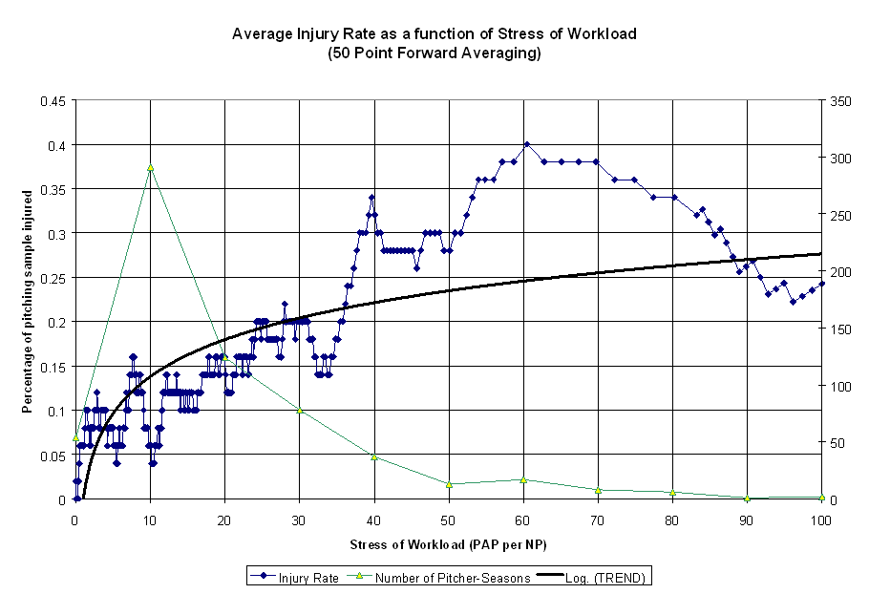

The author used the dark, curved trend line to predict that a pitcher with a consistent Workload Stress factor of 30 has a 20% chance of suffering a major arm injury at some point in his career.

5.8.2 The pH Scale

A chemist prepares a stock solution of hydrochloric acid, HCl, for use in a series of experiments. The solution pH is 1.00. The graph below displays the relationship between pH and concentration of hydrogen ion, represented by [H⁺].
pH
[H⁺], moles per litre

Use the graph to answer the following questions.

1. What is the hydrogen ion concentration, [H⁺] in moles/litre for a solution with:
- pH = 1.5
- pH = 3.0
- pH = 2.5

2. If hydrogen ion concentration is a measure of the strength of an acid, how much stronger is the acid at pH 1.5 than 3.0?

3. Describe the relationship between pH and hydrogen ion concentration.
5.8.3 The pOH Scale

A lesser known measurement sometimes used in chemical laboratories is pOH, which is analogous to pH. The pOH of very dilute basic solutions provides a means of measuring small concentrations of hydroxide ion, OH⁻. The sum of the pH and pOH of a solution is 14 under standard laboratory conditions.

The graph below represents the relationship between hydroxide ion concentration, [OH⁻] and pH and pOH for a solution of sodium hydroxide, NaOH.
[OH⁻], moles per litre
pOH
pH
The upper curve displays pH vs. [OH⁻]. The curve below displays pOH vs. [OH⁻].

Use the graph to answer the following questions:
1. Determine the pH and pOH of a solution with hydroxide ion concentration of:
- 0.05 mol/L b) 0.01 mol/L
- 0.005 mol/L d) 0.001 mol/L
2. If hydroxide ion concentration is a measure of the strength of the base, how much stronger is the solution at
- 0.05 mol/L than at 0.01 mol/L
- 0.05 mol/L than at 0.005 mol/L
3. Determine the hydroxide ion concentration in mol/L of a solution have the following:
- pH = 12.0
- pH = 10.5
- pOH = 2.5
- pOH = 1.2

5.8.2 The pH Scale (Answers)

1. What is the hydrogen ion concentration, [H⁺] in moles/litre for a solution with:
- pH = 1.5 Answer: 0.0325 mol/l
- pH = 3.0 Answer: 0.001 mol/l
- pH = 2.5 Answer: 0.003

2. If hydrogen ion concentration is a measure of the strength of an acid, how much stronger is the acid at pH 1.5 than 3.0?

Answer:
An acid with pH 1.5 is about 32.5 times stronger than an acid with pH 3.0.

3. Describe the relationship between pH and hydrogen ion concentration.

Answers may vary. Ideally, students will make reference to the shape of the curve and describe the curve as either exponential or logarithmic. In fact, the relationship between pH and hydrogen ion concentration is logarithmic.

5.8.3 The pOH Scale (Answers)

1. Determine the pH and pOH of a solution with hydroxide ion concentration of:
- 0.05 mol/L Answer: pH =12. 7 pOH = 1.3
- 0.01 mol/L Answer: pH = 12.0 pOH = 2.0
- 0.005 mol/L Answer: pH = 11.7 pOH = 2.3
- 0.001 mol/L Answer: pH = 10.7 pOH = 3.3

2. If hydroxide ion concentration is a measure of the strength of the base, how much stronger a base is the solution at
- pOH 1.5 than at pOH 2.0?
Answer: 0.03 mol/l ÷ 0.01 mol/l = 3. It is about 3 times stronger a base.
- pH 13.0 than at pH 11.7?
Answer: 0.11 mol/l ÷ 0.005 mol/l = 22. It is about 22 times stronger a base.

3. Determine the hydroxide ion concentration in mol/L of a solution have the following:
- pH = 12.0 Answer: 0.01 mol/l
- pH = 10.5 Answer: 0.0005 mol/l
- pOH = 2.5 Answer: 0.003 mol/l
- pOH = 1.2 Answer: 0.07 mol/l
5.8.4 Industrial Water Treatment

In industry, it is critical that system water be tested on a regular basis to prevent corrosion of machinery and equipment. One example is that of industrial boilers. Many boilers operate at extremely high temperatures and pressures and must be maintained to ensure their metal structures are not weakened by corrosion from water that is too acidic or basic.

The graph below is typical of that used to calculate the amount of free carbon dioxide in industrial feed water. The presence of free carbon dioxide is a concern because it ionizes in water to create corrosive carbonic acid, H₂CO₃. Industrial water treatment consultants recommend that high pressure boiler feed water contain less than 10 parts per million (ppm) of free carbon dioxide. Free carbon dioxide removal is accomplished by passing condensed steam through ion exchangers before reboiling it to evaporate any remaining gas.

Free CO₂ Content in Boiler Feed Water vs. pH for Varying Total Alkalinities
pH
Free CO₂ (ppm)
100 ppm Total Alkalinity as CaCO₃

50 ppm Total Alkalinity as CaCO₃

20 ppm Total Alkalinity as CaCO₃

5.8.4 Industrial Water Treatment (Continued)

To determine the free carbon dioxide using the graph above, locate the intersection of the vertical line for the system pH with the curved line for the system total alkalinity. Read horizontally to the left to determine the free carbon dioxide content in parts per million (ppm).
Use the graph to answer the following questions:

- Complete the following table:

Methyl Orange Total Alkalinity, ppm | System pH | Free CO₂ Content, ppm
100 | 6.75
20 | 7.25
20 |  | 130
50 | 6.50
 | 6.88 | 75
50 | 5.75
20 | 6.00
 | 5.63 | 230
100 | 7.50

- In your role as water treatment consultant you are required to make recommendations about the levels of system pH and total alkalinity your client should aim for in the water treatment program. Using the graph and completed table above, provide recommendations for system pH and total alkalinity that will ensure a free carbon dioxide content of less than 10 ppm.

- After reflecting upon your recommendations, what conclusions can you draw about the relationships among total alkalinity, pH, and safe levels of free carbon dioxide in this industrial boiler feed water example?
5.8.4 Industrial Water Treatment (Answers)

Use the graph to answer the following questions:

- Complete the following table:

Methyl Orange Total Alkalinity, ppm | System pH | Free CO₂ Content, ppm
100 | 6.75 | 96-98
20 | 7.25 | 5
20 | 5.88 | 130
50 | 6.50 | 65-67
100 | 6.88 | 75
50 | 5.75 | 385
20 | 6.00 | 100
20 | 5.63 | 230
100 | 7.50 | 15-17

- In your role as water treatment consultant you are required to make recommendations about the levels of system pH and total alkalinity your client should aim for in the water treatment program. Using the graph and completed table above, provide recommendations for system pH and total alkalinity that will ensure a free carbon dioxide content of less than 10 ppm.

Responses may vary. Ideally, students will recognize that there are three total alkalinities to be considered, therefore there will be three corresponding system pH recommendations to make as well.

Since the system must maintain a free carbon dioxide level below 10 ppm, we are only dealing with the extreme right hand portion of the curves.

Total Alkalinity 20 ppm : pH must be maintained above 7.00
Total Alkalinity 50 ppm: pH must be maintained above approximately 7.35
Total Alkalinity 100 ppm: pH must be maintained above approximately 7.75

- After reflecting upon your recommendations, what conclusions can you draw about the relationships among total alkalinity, pH, and safe levels of free carbon dioxide in this industrial boiler feed water example?

Students should notice that as the total alkalinity increases, so does the required system pH. Therefore, total alkalinity must have a negative effect on free carbon dioxide levels.
5.8.5 Home Activity
Conduct an Internet search to find graphical examples of real world applications of exponential and logarithmic functions. Write a description of the application to accompany the graph. Cite any sources.

Sample Response
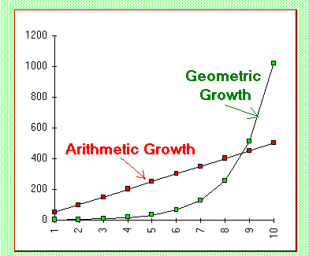
This graph compares linear and exponential growth. As you can see, the linear relation is labelled “arithmetic growth” and the exponential relation is labelled “geometric growth.” The graph of exponential growth was copied from an article about population growth. Population growth is caused by increases in the birth rate and immigration and is offset by the death rate of a population. The article points out that the reason population growth is exponential is because as time elapses, the size of the “pool” of subjects able to reproduce keeps increasing.

Elapsed time | Year | Human Population
~2,000,000 | 10,000,000 BC | 5 - 10 million
10,000 | 1 A.D. | 170 million
1,800 | 1800 | 1,000,000,000
 | 1930 | 2,000,000,000
 | 1960 | 3,000,000,000
 | 1975 | 4,000,000,000
 | 1987 | 5,000,000,000
 | 1999 | 6,000,000,000
 | 2050 | 8,500,000,000

The table to the right was included in the same article. It is interesting because it shows a comparison of world human population over time. From the table, we can predict that the world’s population will be an estimated 8.5 billion people by the year 2050. Of course, that prediction only holds true if the rate of growth demonstrated by the table of values holds true.

If we calculate the average and instantaneous rates of growth for human population at a given point in time, we can easily see that they will not be the same.

5.8.5 Home Activity (Continued)

Since there is an inverse relationship between exponential and logarithmic functions, even though this is a graph showing exponential growth, it could be looked at in the context of logarithms. For example, if the equation for growth was given as where a is the base for the exponential function and t represents time, we could rearrange it to show the inverse, and find that .

Source: Indiana University – Purdue University Indianapolis, Department of Biology Course Notes, N100H, Population Ecology, April 17, 2000. Retrieved August 4, 2007 from http://www.biology.iupui.edu/biocourses/N100H/ch39pop.html

5.8.5 Home Activity (Continued)

Internet Assignment - Real World Applications of Exponential and Log Functions
Students will conduct an Internet search to find a graphical example of a real world application of exponential and logarithmic functions. They will write a description of the application to accompany the graph. Students must cite any sources, using appropriate format.
Specific Expectations
AF3.05
Pose and solve problems related to models of exponential functions drawn from a variety of applications, and communicate the solutions with clarity and justification
© Queen's Printer for Ontario, 1999. Reproduced with permission.
Level 2
(60% - 69%)
Level 3
(70% - 79%)
Level 1
(50% - 59%)
Level 4
(80% - 100%)
Criteria
Communication
Communicates findings using an integration of essay and mathematical forms with limited clarity
Communicates findings using an integration of essay and mathematical forms with some clarity
Communicates findings using an integration of essay and mathematical forms with considerable clarity
Communicates findings using an integration of essay and mathematical forms with a high degree of clarity
Communicate findings using an integration of essay and mathematical forms
Description of key features of a given graph of a function demonstrate thorough knowledge
Description of key features of a given graph of a function demonstrate considerable knowledge
Description of key features of a given graph of a function demonstrate some knowledge
Description of key features of a given graph of a function demonstrate limited knowledge
Describe key features of a given graph of a function
Describes the graphical implications of changes in parameters in the given equation with thorough knowledge
Describes the graphical implications of changes in parameters in the given equation with considerable knowledge
Describes the graphical implications of changes in parameters in the given equation with some knowledge
Describes the graphical implications of changes in parameters in the given equation with limited knowledge
Describe the graphical implications of changes in parameters in the given equation
Describes the significance of exponential growth or decay in given problems with thorough understanding
Describes the significance of exponential growth or decay in given problems with considerable understanding
Describes the significance of exponential growth or decay in given problems with some understanding
Describes the significance of exponential growth or decay in given problems with limited understanding
Describe the significance of exponential growth or decay in given problems
Unit 5: Day 9: Solving Exponential and Logarithmic Equations |  |  |  | MHF4U
Minds On: 15 |  | Learning Goals:  Solve exponential equations by finding a common base  Solve simple logarithmic equations  Solve exponential equations by using logarithms |  | Materials  Copies of Minds On examples on overhead transparencies  Overhead projector  BLM 5.9.1  BLM 5.9.2  BLM 5.9.3  BLM 5.9.4
Action: 40
Consolidate:20
Total = 75 min
Assessment
Opportunities
 | Minds On… | Whole Class → Discussion  Students will  - Attempt to solve problems posed by the teacher  Examples:  MHR 11 pp. 19-20 Investigate & Inquire or AW 11 p.48 Example #3  MHR 12 p. 438 Example #4 or Nelson 12 p. 144 Example #1  MHR 12 p. 436 Example #1 or AW 12 (MCT) p. 384 Example #1  The teacher may wish to post all three problems on the board and assign different groups of students to work on each. This allows for differentiation by readiness, and full flexibility as to homogeneity of grouping. The outcome of this introduction will determine the extent to which a teacher-led lesson is required. |  | Opportunities to differentiate instruction:  - Grouping by readiness and assigning tasks by readiness in the Minds On activity  - Pairing by oral communication skills in the Debrief activity  Literacy Strategy: Timed Retell
 | Action! | Whole Class→ Teacher-led Lesson  Listen and make note of a demonstration by the teacher of the various strategies employed in solving exponential and logarithmic equations
 | Consolidate Debrief | Pairs → Timed Retell  Practise their listening and speaking skills in a timed retell that summarizes their understanding of the strategies used to solve exponential and logarithmic equations  Write a summary of the discussion; or,  Briefly recount the discussion for the rest of the class
Exploration  Application |  | Home Activity or Further Classroom Consolidation  Complete BLM 5.9.4

A-W 11 | McG-HR 11 | H11 | A-W12 (MCT) | H12 | McG-HR 12
1.6 | 1.3 | 4.6, 4.7 | 7.9 | 6.1, 7.3 | 7.4

Teacher Notes

Many of the textbook resources released between 2001 and 2002 contain ample examples and exercises for demonstrating and practising the skills in this lesson. Following is a summary table of resources:

Resource | Learning Goal
Resource | Solve exponential equations by finding a common base | Solve simple logarithmic equations | Solve exponential equations by using logarithms
Nelson 11 (Functions) | Exercises p. 94 #3, 4, 7-9
Harcourt 11 (Functions) | Exercises p. 123 #1-9
AW 11 (Functions) | Exercises  p. 51 #9-12  p. 73 #20  p. 76 #15
MHR 11 (Functions) | Exercises  p. 23 #1-11, 13-20  p. 26 #1-2
MHR 12 (AFIC) |  | Examples pp. 438-9, #4-6  Exercises p. 441 #5-7 | Examples pp. 436-8 #1-3  Exercises p. 441 #3, 4, 8
AW 12 (MCT) |  | Examples pp. 388-90  Exercises p. 390 #1-10 | Examples pp. 385-6  Exercises p. 387 #2-9
Nelson 12 (AFIC) |  | Examples pp. 144-5  Exercises p. 146 #1-9, 14-19
Harcourt 12 (AFIC) |  | Examples pp. 273-4  Exercises p. 274 #1-5; p. 294 #26

5.9.1 Solving Exponential Equations Using a Common Base (Teacher Notes)

Example 1: Solve the equation

Solution: Since 4 and 8 are both powers of 2, they can be rewritten as such:

Use the power law for exponents to simplify the new equation:
Since the bases of the equation are equal, their exponents must be equal as well:

Simplify and solve for x as the final step in the solution:

Example 2: Solve the equation

Solution: Convert 125 to a power of 5, use the power law for exponents to simplify, set exponents equal, and solve for x as the final step:

5.9.2 Solving Simple Logarithmic Equations (Teacher Notes)

Example 1: Solve

Solution: Since both logs have the same base, the equation can be simplified:

Example 2: Solve

Solution: The solution to this logarithmic equation requires use of the law of logarithms for products.

Recall and use this relationship to convert the equation to its exponential form:
Value = Base ^{Exponent} Exponent = log _{Base} Value

Rearrange the equation and solve the resulting quadratic equation.

Do both solutions satisfy the original equation?

Sub in x = 16:
Since and are both defined, x = 16 satisfies the equation.

Sub in x = -4:
Since neither , nor are defined, x = -4 does not satisfy the equation. Therefore, the solution to is x = 16.
    - Solving Exponential Equations Using Logarithms
(Teacher Notes)

Example 1: Solve .
There are two approaches to solving this equation. One uses common logarithms (base 10) and the other uses base-4 logarithms. Both approaches are shown below.

Solution A: Using Common Logarithms

Use the law of logarithms for powers to simplify.

Divide each side by log 4 to simplify and solve for x

Solution B: Using Base-4 Logarithms

Take the base-4 logarithm of each side

Simplify using the properties and laws of logarithms

Example 2: Solve .

Solution: This approach uses common logarithms and the laws of logarithms. Exact values are not determined until the final step in the solution.
.
5.9.4 Home Activity

- Solve the following exponential equations.
a) b) c)

d) e) f)

- Solve.
a)

b)

c)

d)

e)

- Solve in exact form.
a) b) c) d)

Answers:
- a) b) c) d) e) f)

- a) b) c) d) e)

- a) b) c) d)

Unit 5: Day 11: Solving Real World Problems Algebraically |  |  |  | MHF4U
Minds On: 5 |  | Learning Goal:  - Solve problems using graphs or equations of logarithmic functions arising from real world applications |  | Materials  Computer with Internet connection  Computer projector  BLM 5.11.1 - 5.11.4
Action: 50
Consolidate:20
Total = 75 min
Assessment
Opportunities
 | Minds On… | Whole Class → Discussion  View a video clip of an earthquake (e.g., Banda Aceh province in Indonesia on Boxing Day 2004, San Francisco earthquakes of 1906 and 1989)  The teacher can start the lesson by showing a short clip of an earthquake, prompting discussion around the destruction caused by earthquakes, the relative magnitude of earthquakes, leading to how seismologists measure the magnitude of earthquakes. |  | Video clips of several earthquakes can be found by searching The History Channel,  www.history.com  by show under “Mega Disasters.” Many clips range from 1 to 5 minutes in length.  BLM Sample Problems:  Richter Scale  AW 12 (MCT), p. 357  Example 2  Decibel Scale  Harcourt 12, p. 279 Example 3  pH Scale  Harcourt 12, p. 281  Example 4  BLM Additional Problems:  Richter Scale  AW 12 p. 359 #10  Decibel Scale  AW 12 p. 360 #16  pH Scale  AW 12 p. 361 #19
 | Action! | Small Groups → Jigsaw  Read a short description of a logarithmic scale and solve some sample problems with the other members of their expert group  Explain the logarithmic scale to their home group and demonstrate how to solve problems involving that particular scale  Extension: A particularly strong group should be encouraged to develop their own problems, which can then be posed to the rest of the class.
 | Consolidate Debrief | Whole Class → Discussion  Compare the applications of Richter, decibel, and pH scale with respect to the strategies used to solve problems involving these applications
Home Activity or Further Classroom Consolidation

Complete BLM 5.11.4

A-W 11 | McG-HR 11 | H11 | A-W12 (MCT) | H12 | McG-HR 12
 |  |  |  | 7.4 | 7.4-7.5

Teacher Notes

The most common examples of logarithmic scales are the Richter, decibel, and pH scales. The Richter scale measures the magnitude of earthquakes. The decibel scale measures the loudness of sound. The pH scale measures the acidity of liquids.

The Richter Scale
The Richter scale was developed in 1935 by seismologist Charles F. Richter. It measures the magnitude of an earthquake by comparing the intensity of the earthquake to some reference earthquake. The formula developed by Richter is

where I is the intensity of the earthquake under study,
I₀ is the intensity of a reference earthquake, and
M is the Richter value used to measure the magnitude of the earthquake.

The Decibel Scale

Source: Harcourt Mathematics 12, Advanced Functions and Introductory Calculus, p. 278
Our ear is divided into three connecting sections: the outer, middle, and inner ear. The outer ear funnels noise to the eardrum. In the middle ear, three tiny bones transmit sound to the inner ear. In the inner ear, sound waves are converted to readable nerve impulses by approximately 16 000 hair-like receptor cells, which sway with the sound waves. These cells can be severely damaged by loud sounds, resulting in permanent hearing loss. If you lose one third of these cells, your hearing will be significantly impaired. Hearing loss is progressive. Some hearing loss is inevitable with age, but we would lose much less if we protected our ears at the appropriate times.

The loudness of any sound is measured relative to the loudness of sound at the threshold of hearing. Sounds at this level are the softest that can still be heard.

The formula used to compare sounds is

where I is the intensity of the sound being measured,
I₀ is the intensity of a sound at the threshold of hearing, and
L is the loudness measured in decibels (¹/₁₀ of a bel).

At the threshold of hearing, the loudness of sound is zero decibels (0 dB).

Teacher Notes (Continued)

The pH Scale
The pH scale allows chemists to determine the concentration of hydrogen ion in a liquid. It ranges from values of 1 to 14. The higher the pH, the more basic, or less acidic the liquid. The lower the pH, the more acidic or less basic the liquid.
- A liquid with a pH of less than 7.0 is considered acidic
- A liquid with a pH of greater than 7.0 is considered basic
- A liquid with pH = 7.0 is considered to be neutral. Pure water has a pH of 7.0.

The relationship between pH and H⁺ ion concentration is inversely proportional and can be summarized as:
Low pH = High H⁺ ion concentration
High pH = Low H⁺ ion concentration

The relationship between pH and hydrogen ion concentration is given by the formula

where [H⁺] is the concentration of hydrogen ion in moles per litre.

5.11.1 The Richter Scale

The Richter scale was developed in 1935 by seismologist Charles F. Richter. It measures the magnitude of an earthquake by comparing the intensity of the earthquake to some reference earthquake. The formula developed by Richter is

where I is the intensity of the earthquake under study,
I₀ is the intensity of a reference earthquake, and
M is the Richter value used to measure the magnitude of the earthquake.

Sample Problem:
The San Francisco earthquake of 1989 measured 6.9 on the Richter scale. The Alaska earthquake of 1964 measured 8.5.

a) How many times as intense as the San Francisco earthquake was the Alaska earthquake?

b) Calculate the magnitude of an earthquake that is twice as intense as the 1989 San Francisco earthquake.

Additional Problems:
- For each decrease of 1 unit in magnitude, earthquakes are about 6 or 7 times as frequent. In a given year, how should the number of earthquakes with magnitudes between 4.0 and 4.9 compare with the number of earthquakes with magnitudes between each pair of numbers?

a) 5.0 and 5.9 b) 6.0 and 6.9 c) 7.0 and 7.9

- How much more intense is an earthquake measuring 6.5 on the Richter scale than one measuring 6.4?
5.11.2 The Decibel Scale

Source: Harcourt Mathematics 12, Advanced Functions and Introductory Calculus, p. 278
Our ear is divided into three connecting sections: the outer, middle, and inner ear. The outer ear funnels noise to the eardrum. In the middle ear, three tiny bones transmit sound to the inner ear. In the inner ear, sound waves are converted to readable nerve impulses by approximately 16 000 hair-like receptor cells, which sway with the sound waves. These cells can be severely damaged by loud sounds, resulting in permanent hearing loss. If you lose one third of these cells, your hearing will be significantly impaired. Hearing loss is progressive. Some hearing loss is inevitable with age, but we would lose much less if we protected our ears at the appropriate times.

The loudness of any sound is measured relative to the loudness of sound at the threshold of hearing. Sounds at this level are the softest that can still be heard.

The formula used to compare sounds is

where I is the intensity of the sound being measured,
I₀ is the intensity of a sound at the threshold of hearing, and
L is the loudness measured in decibels (¹/₁₀ of a bel).

At the threshold of hearing, the loudness of sound is zero decibels (0 dB).

Sample Problem:
A sound is 1000 times more intense than a sound you can just hear. What is the measure of its loudness in decibels?

Additional Problems:
- The loudness level of a heavy snore is 69 dB. The loudness level of a conversation is 60 dB. The loudness level of a whisper is 30 dB.
  - How many times as loud as a conversation is a heavy snore?
  - How many times as loud as a whisper is a conversation?

- Most portable music players can produce sounds up to 120 dB. Any sound above 90 dB may cause some hearing loss if the exposure is prolonged. To be safe, experts recommend you keep your MP3 player volume set no higher than 60% of the maximum.
  - Assuming your MP3 player can produce sound as loud as 120 dB, how many times as loud is it at maximum volume than at the recommended setting?
  - How many times as loud is a setting of 75% of the maximum than 60%?

5.11.3 The pH Scale

The pH scale allows chemists to determine the concentration of hydrogen ion in a liquid. It ranges from values of 1 to 14. The higher the pH, the more basic, or less acidic the liquid. The lower the pH, the more acidic or less basic the liquid.
- A liquid with a pH of less than 7.0 is considered acidic
- A liquid with a pH of greater than 7.0 is considered basic
- A liquid with pH = 7.0 is considered to be neutral. Pure water has a pH of 7.0.

The relationship between pH and H⁺ ion concentration is inversely proportional and can be summarized as:
Low pH = High H⁺ ion concentration
High pH = Low H⁺ ion concentration

The relationship between pH and hydrogen ion concentration is given by the formula

where [H⁺] is the concentration of hydrogen ion in moles per litre.

Sample Problems:
- Find the pH of a swimming pool with a hydrogen ion concentration of 6.1 x 10⁻⁸ mol/L.
- The pH of a fruit juice is 3.10. What is the hydrogen ion concentration of the fruit juice?

Additional Problems:
Solution | pH
Lemon juice | 2
Tomato juice | 4
Pure water | 7
Baking soda | 9
Oven cleaner | 13
- Refer to the table at the right to answer the following questions:
- How many times as acidic as tomato juice is lemon juice?
- How many times as acidic as pure water is lemon juice?
- How many times as acidic as pure water is baking soda?
- How many times as acidic as baking soda is oven cleaner?

- In spring, the pH value of a stream dropped from 6.5 to 5.5 during a 3-week period in April.
- How many times as acidic did the stream become?
- Why would this happen in April?
5.11.4 Home Activity

- Statistics Canada reports that the infant mortality rate for the period 1971 to 1995 can be modeled by the equation D = 6(96^{n}), where D represents the number of deaths per 1000 in children under 1 year of age, and n represents the number of years since 1995.

  - Is the infant mortality rate increasing or decreasing? Explain your reasoning.

  - If the trend continues, what will the infant mortality death rate be in 2008?

  - When will the infant mortality death rate be 3 per 1000?

- Sandy is saving for her child’s education. She invested $15 000 on her child’s first birthday. The interest rate has been constant at 3.25% compounded annually. The equation which models this situation is A = 15 000(1.0325)^{n}, where A is the amount of the investment at the end of the investment period and n is the number of compounding periods.

  - Sandy’s child will be 16 years old in August. What will the investment be worth at that time?

  - Sandy hopes to have $28 000 in savings by the time her child turns 19. Will she meet her savings objective?

- An ordinary annuity is the name given to a series of savings deposits made at the end of an investment period. For example, a monthly savings plan in regular deposits of the same amount were made at the end of each month would be considered an ordinary annuity.
The formula for the amount of an ordinary annuity is , where
A is the amount in dollars of the annuity at the end of the investment,
R is the amount in dollars deposited at the end of each period
i is the interest rate per period
n is the total number of periods in which deposits were made.

Calculate the amount of each of the following annuities:
  - R = $1500 i = 3.75% n = 20
  - R = $375 i = 0.9375% n = 80
  - R = $7500 i = 4.0% n = 10
  - R = $625 i = 0.3333% n = 120

There is a relationship between (i) and (ii); and (iii) and (iv). Identify the relationship.

- When bacteria grow by binary fission, the generation time is the time interval required for the cells (or bacteria population) to divide. The formula for generation time is , where
G is the generation time, t is the time interval in hours or minutes, b is the number of bacteria at the end of a time interval, and B is the number of bacteria at the beginning of a time interval.

  - What is the generation time of a bacterial population that increases from 10³ cells to 10⁶ cells in five hours of growth?

  - What would be the increase in population if the growth interval was 4 hours and the generation time was 18 minutes?
5.11.4: Home Activity (Answers)

- a) The infant mortality rate is decreasing. The factor of 0.96 is equivalent to 96% of the previous value, repeated. If the mortality rate was increasing, the factor would be have to be greater than 1.0.

- In 2008, thirteen years will have elapsed since 1995. Therefore, per 1000.

- Substitute D = 3 and solve for n using logarithms.

Assuming the trend continues, the rate will be 3 per 1000 in 2012.

- a) . If n = 15, then .
  - If A = 28 000,

Sandy would need another 1.5 years to meet her savings objective of $28 000.

- Answers:
  - R = $1500 i = 3.75% n = 20 A = $43 526.08
  - R = $375 i = 0.9375% n = 80 A = $44 384.66
  - R = $7500 i = 4.0% n = 10 A = $90 045.80
  - R = $625 i = 0.3333% n = 120 A = $92 029.19

The relationship among the pairs of examples is that they represent the same investment but with different compounding periods. (ii) is quarterly compounding of 4 deposits of $375 ($1500 in total per year over 20 years); (iv) is monthly compounding of 12 deposits of $625 ($7500) in total per year over 10 years.

- a) What is the generation time of a bacterial population that increases from 10³ cells to 10⁶ cells in five hours of growth? G = 30.3 minutes.

- What would be the increase in population if the growth interval was 4 hours and the generation time was 18 minutes? Log b/B = 4. The magnitude of growth is 10⁴.

