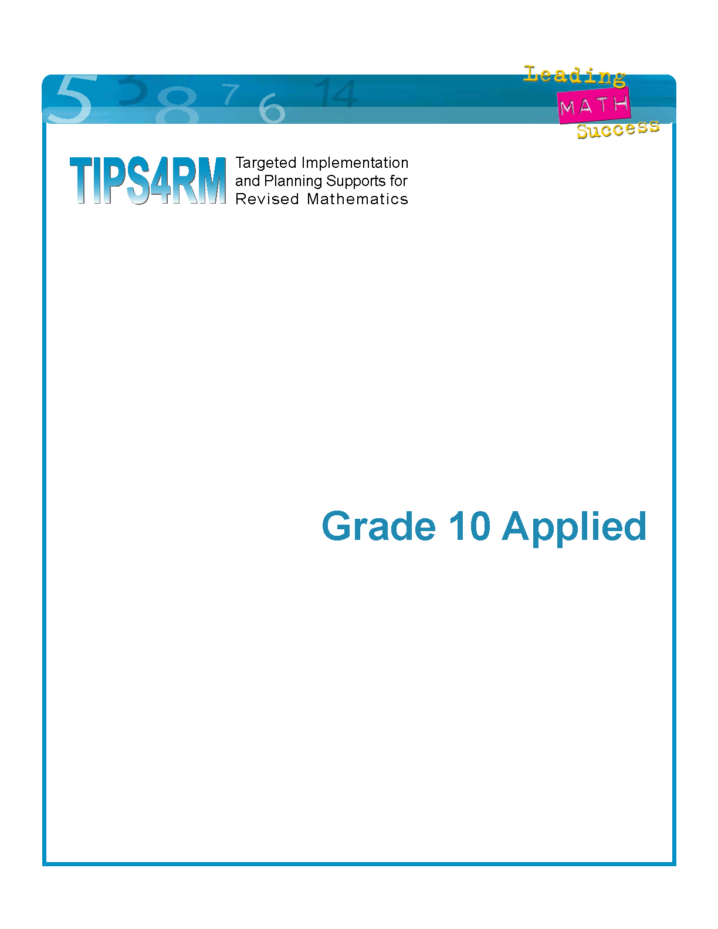
OAME/OMCA
GRADE 12 PROJECT
MHF4U
SUMMER, 2007

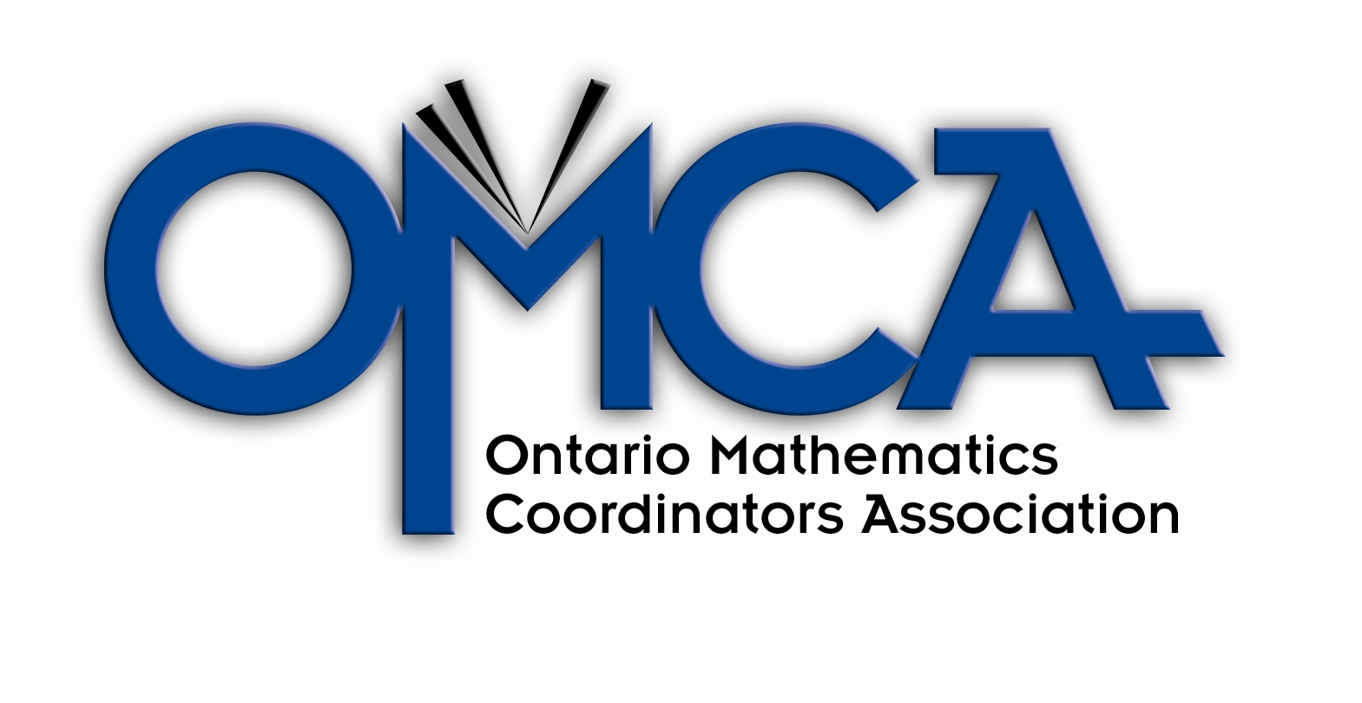

Insert OAME logo 

PROJECT

Course Lead: Jacqueline Hill, Durham DSB

Writers/ Reviewers | Board
Sue Melville | Rainbow DSB
Stephen Hudson | Durham DSB
Ann Michelle Stenning | Thames Valley DSB
Pamela Koster | Durham DSB
Joe Goulet | Windsor Essex CDSB
Laura Tonin | DSB Niagara
Duncan McIntyre | Durham DSB
Karen Bryan | Upper Canada DSB
Craig Hunt | Durham DSB
Frances Schatz | Retired
Ada Tsui | York Region DSB
Anne MacMillan | York Region DSB
Dwight Stead | Dufferin-Peel CDSB

Project Leads
Name | Board
Irene McEvoy | Peel DSB
Shelley Yearley | Trillium Lakelands DSB

Project Manager
Name | Board
Sue Hessey | OAME

Steering Committee
Name | Board/Association
Mike Davis | OMCA
Joyce Tonner | OMCA
Cheryl McQueen | OMCA
Jacqueline Hill | OAME
Dan Charbonneau | OAME
Myrna Ingalls | Ministry of Education
Shirley Dalrymple | Ministry of Education
Ross Isenegger | Ministry of Education

Funding provided by the Ministry of Education.

Grade 12 Advanced Functions (MHF4U)

Introduction
This package of materials has been created in response to the revised grade 12 mathematics curriculum to be implemented in September, 2007. The prepared lessons are not exhaustive, but rather were developed to give a flavour of the intended approach for this course. Attention was given to areas where there was a lack of resources, as well as to modelling how to bridge the understanding for students between the abstract and application. Teachers are encouraged to work together in school and board teams to develop lessons not included to extend their own learning as the writers in this project have done.

The following supports are included in this package.
- Unit outlines (Big Ideas; expectations; teaching notes)
- Lessons and BLMs for a majority of the course
- Electronic Resources (GSP sketches, Fathom Data files)

These resources are also posted on the OAME website: http://www.oame.on.ca:

Guiding Principles:
Writers and reviewers completed this resource package in order to:
- improve student success (model teaching considerations which support the profile of the learner)
- interweave and revisit the big idea of the course –properties and representations of functions as well as applications of algebra, trigonometry and geometry.
- emphasize problem solving and inquiry
- make the mathematical processes and literacy strategies explicit
- continue the use of TIPS4RM

Lesson Planning (Match Template)
The lessons and assessments have been created using the MATCH template from the TIPS4RM resource. The acronym MATCH is organized around a three part lesson, paying attention to:
Minds on getting students mentally engaged in the first few minutes of class
Action! the main portion of the lesson where students investigate new concepts
Consolidate/Debrief ideas for 'pulling out the math', and checking for understanding

Meaningful and appropriate follow-up to the lesson is provided in the Home Activity section.
The time allocation in the upper left corner suggests how much time should be devoted to each of the three parts of the lesson.
The materials section in the upper right corner identifies resources needed for the class.
The right hand column offers Tips for teachers such as instructional strategies, references to resources, literacy strategies used, and explanations.
The narrow column to the left of this suggests opportunities for assessment.
For further details about this organizer go to http://www.curriculum.org/lms/

Teaching Considerations
There are many considerations in the development of a positive learning environment which supports the grade 12 learner.
address visual, kinaesthetic and auditory learners
provide multiple opportunities for understanding and success
build community by engaging students in co-operative and active learning
vary assessment tools and instructional strategies
regularly incorporate effective use of learning tools (manipulatives, technology)
link content to prior knowledge and experiences
focus instruction and assessment on the big ideas of the course
A supportive and stimulating environment will:
use differentiated instruction
continue to develop literacy skills

Processes
The seven mathematical processes can be referred to as the ‘actions of math.’ In the revised curriculum, these process expectations have been highlighted in their importance since they support the acquisition and use of mathematical knowledge and skills. They can be mapped to three categories of the Achievement Chart – Thinking, Communication and Application. The fourth category, Knowledge and Understanding, connects to the overall and specific expectations of the course, which can be referred to as the ‘mathematical concepts’. Students apply the mathematical processes as they learn the content for the program.
The combination of the mathematical processes and expectations are embedded in the achievement chart as the following:

Knowledge and Understanding

Concept Understanding Procedural Fluency

Thinking

Problem Solving Reflecting Reasoning and Proving

Application

Selecting Tools and Computational Strategies Connecting

Communication

Communicating Representing

Students need multiple opportunities to engage in the processes. Lessons included in this project highlight these processes to be developed. The included performance task provides criteria for assessment on all the processes.
To assist students' development of these processes (instructional strategies, questions and feedback) see TIPS4RM Processes Package on the Leading Math Success website http://www.curriculum.org/lms/

Literacy Strategies
Mathematics is the most difficult content area material to read because there are more concepts per word, per sentence, and per paragraph than in any other subject; the mixture of words, numerals, letters, symbols, and graphics requires the reader to shift from one type of vocabulary to another.
Leading Math Success, Report of the Expert Panel for Mathematical Literacy Gr. 7 – 12

Improve student achievement demands an emphasis on developing literacy competencies linked to mathematics learning. To consolidate understanding, learners need opportunities to share their understanding both in oral as well as written form. Weakness in reading or writing skills provides barriers to success in problem solving. This resource explicitly embeds literacy strategies in the lessons.
Starting points for teachers:
- Use strategies to develop vocabulary and comprehension skills, including
  - word walls
  - Frayer model
  - concept circles
- Use strategies relating to the organization of information
  - “inking your thinking” – having students write down their thoughts
  - concept maps
  - anticipation guides
- Use strategies to help students understand features of textbooks and graphics
  - read problems aloud
  - highlight key words
  - think aloud
More details and strategies can be found in Think Literacy: Cross-Curricular Approaches, Mathematics, Grades 10-12, 2005, http://www.curriculum.org/thinkliteracy/library.html

Assessment
The primary purpose of assessment and evaluation is to improve student learning. Information gathered through assessment helps to provide feedback to students as well as guiding teachers' instruction.
Assessment must based on the four categories of the achievement chart and include the mathematical processes.
Assessment should be varied in nature. The chart below provides suggestions for a variety of assessment tools and the categories that they could be connected to.
Category | Assessment Tools
Knowledge and Understanding | Quiz, Test, Exam, Checkbric, Demonstration, Short Answer , True/False , Multiple Choice, Observation
Thinking | Editorials, Observations, Portfolio/Digital Portfolio, Essays, Articles, Debates, Report, Investigations, Graphic Organizers, Open-ended Questions, Performance Assessment Tasks, Video Tapes, Plays, Student /Teacher Conferences
Communication | Concept Map, Journals, Plays , Multi media presentations , Oral presentations , Drawings , Discussions, Explanations , Performance Task Assessment, Student/Teacher Conferences, Portfolio
Application | Concept Map, Debates, Editorials, Portfolio, Observation, Tests, Quizzes, Open-ended Questions, Design of Products, Models/Concrete Representations, Discussion

Note : This is by no means an exclusive or exhaustive list. It is only a guide.

Summative Tasks
One summative performance task is included in this resource. They provide opportunities to assess the important concepts in the course through the mathematical processes. It is important for teachers to be aware of the skills and knowledge expected of the students on those assessments at the beginning of the course, so that students are appropriately prepared for them by having similar opportunities during the course. A paper and pencil test at midterm and final exam can assess the Knowledge and Understanding category.

Manipulatives and Technology
Many expectations in the revised curriculum make reference to using a variety of tools, including manipulatives, calculators and computer software. All new learning should begin with exploration and use learning tools whenever possible to provide students with representations of abstract mathematical ideas in varied, concrete, tactile, and visually rich ways.
Information and communication technologies provide a range of tools that can significantly extend and enrich teachers' instructional strategies and support students' learning. Technology can reduce the time spent on routine mathematical tasks thus allowing students to devote more of their efforts to thinking and concept development.
The Ontario Curriculum, Grade 12 Mathematics, Revised, 2007
The lessons and assessment written for this support document identify these learning tools. Teachers need to make arrangements to have these materials available and for computer lab booking at the beginning of the course. The use of these learning tools should not be considered an extra to the instructional component of the course, nor should they be considered as only beneficial to a select few.

Online Resources
Ontario Resources
TIPS4RM, Leading Math Success and TIPS resources | http://www.edu.gov.on.ca/eng/studentsuccess/
Think Literacy Mathematics Grades 7 – 10 | www.oame.on.ca/main/index1.php?lang=en&code=ThinkLit
Ontario Association of Mathematics Educators | www.oame.on.ca
Statistics Canada | http://estat.statcan.ca/
Ontario Mathematics Coordinators Association | www.omca.ca

Learning Resources
Learning Math Series | www.learner.org
Math Forum | www.mathforum.org
NCTM | www.nctm.org
Regina University - Rich Math Tasks | http://mathcentral.uregina.ca
Rich Math Tasks - UK | www.nrich.maths.org.uk/

Virtual Manipulatives
National Library of Virtual Manipulatives | http://nlvm.usu.edu/en/nav/vlibrary.html

Unit 0 – Get Ready – Outline

Day | Lesson Title | Specific Expectations
1  (Lesson Included) | Introduction to Grade 12 | Grades 7 - 11
2  (Lesson Included) | Introduction to Grade 12 | Grade 11 U expectations
3 | Adding Precision to Graphical Models and Their Descriptions | D1.1, D1.1, D3.1, and setting up C1.2
4 | Adding Precision to Graphical Models and Their Descriptions -Day 2 | D1.1, D1.1, D3.1, and setting up C1.2
5 | Transformations Across Function Types | Setting up C1.6, A2.3
6 | Using Function Notation to Generalize Relationships | Setting up C1.6
7-8 | JAZZ DAY
9 | SUMMATIVE ASSESSMENT
TOTAL DAYS: |  | 9

Unit 1 – Polynomial Functions – Outline
Day | Lesson Title | Specific Expectations
1 | Average Rate of Change and Secants | D1.2, 1.6, both D1.1A’s
2-3 | Instantaneous Rate of Change and Tangents | D1.6, 1.4, 1.7, 1.5, both D1.1A’s
4 | Solving Problems Involving Average and Instantaneous Rate of Change Numerically and Graphically | D1.8, 1.1
5-6 | Characteristics of Polynomial Functions Through Numeric, Graphical, and Algebraic Representations | A1.1, 1.2, 1.3, 1.4
7  (Lesson included) | Using the Factored Form of a Polynomial Function to Sketch a Graph and Write Equations | A1.6, 1.8
8 | Transformations of f(x) = x³ and f(x) = x⁴ and Even and Odd Functions | A1.7, 1.9
9-10  (Lessons included) | Dividing Polynomials, The Remainder Theorem and The Factor Theorem | A2.1, A2.1A
11-12 | The Zeros of a Polynomial Function Graphically and Algebraically with Applications to Curve Fitting | A2.2, 2.3 ,2 4, 2.6
13-14 | Solving Polynomials Inequalities Graphically, Numerically, and Algebraically | A3.1, 3.2 3.3
15-16 | JAZZ DAY
17 | SUMMATIVE ASSESSMENT
TOTAL DAYS: |  | 17
Unit 2 – Rational Polynomial Functions – Outline

Day | Lesson Title | Specific Expectations
1  (Lesson Included) | Rational Functions and Their Essential Characteristics | C 2.1,2.2, 2.3
2  (Lesson Included) | Rational Functions and Their Essential Characteristics | C 2.1,2.2, 2.3
3  (Lesson Included) | Rational Functions and Their Essential Characteristics | C 2.1,2.2, 2.3
4 | Rationale Behind Rational Functions | C3.5, 3.6, 3.7 1, 3.2* not the expectations listed in Year at a Glance for this lesson
5  (Lesson Included) | Time for Rational Change | D1.1-2, 1.9* not the expectations listed in Year at a Glance for this lesson
6-7 | JAZZ DAY
8 | SUMMATIVE ASSESSMENT
TOTAL DAYS: |  | 8

Unit 3 –Trigonometric Functions I – Outline

Day | Lesson Title | Specific Expectations
1  (Lesson Included) | Radians and Degrees | B1.1, 1.3
2  (Lesson Included) | Radians and Special Angles | B1.4, 3.1
3  (Lesson Included) | Equivalent Trigonometric Expressions | B1.4, 3.1
4  (Lesson Included) | Sine and Cosine in Radians | B1.2, 1.3, 2.3, C2.1, 2.2
5  (Lesson Included) | Graphs of Sine & Cosine Reciprocals in Radians | B1.2, 1.3, 2.3, C2.1, 2.2
6  (Lesson Included) | Graphs of Tangent and Cotangent | B2.2, 2.3  C1.4, 2.1
7 | Trigonometric Functions and Rates of Change | D1.1-1.9 inclusive
8  (Lesson Included) | Trigonometric Rates of Change | D1.1-1.9 inclusive
9-10 | JAZZ DAY
11 | SUMMATIVE ASSESSMENT
TOTAL DAYS: |  | 11

Unit 4 – Trigonometric Functions II – Outline

Day | Lesson Title | Specific Expectations
1 | Transforming Trigonometric Functions | B2.4, 2.5, 3.1
2 | Transforming Sinusoidal Functions | B2.4, 2.5, 3.1
3 | Transforming Sinusoidal Functions - continued | B2.4, 2.5, 3.1
4 | Writing an Equation of a Trigonometric Function | B2.6, 3.1
5 | Real World Applications of Sinusoidal Functions | B2.7, 3.1
6 | Real World Applications of Sinusoidal Functions Day 2 | B2.7, 3.1
7 | Compound Angle Formulae | B 3.1. 3.2
8  (Lesson included) | Proving Trigonometric Identities | B3.3
9  (Lesson included) | Solving Linear Trigonometric Equations | B3.4
10  (Lesson included) | Solving Quadratic Trigonometric Equations | B3.4
11-12 | JAZZ DAY
13 | SUMMATIVE ASSESSMENT
TOTAL DAYS: |  | 13

Unit 5 - Exponential & Logarithmic Functions – Outline

Day | Lesson Title | Specific Expectations
1 – 2  (Lessons Included) | Characteristics of the Exponential Function and its Inverse, the Logarithmic Function | A1.1, 1.3, 2.1, 2.2
3  (Lesson Included) | Evaluation of Logarithms | A1.1, 1.2, 1.3
4 – 5  (Lessons Included) | Laws of Exponents and Logarithms | A1.4, 3.1
6 – 7  (Lessons Included) | Rates of Change of Exponential and Logarithmic Functions | D1.4 - 1.9 inclusive
8  (Lesson Included) | Solving Real World Problems Graphically | A2.4
9  (Lesson Included) | Solving Exponential and Logarithmic Equations | A3.2, 3.3
10 | Log Or Rhythm | A2.3
11  (Lesson Included) | Solving Real World Problems Algebraically | A3.4
12-13 | JAZZ DAY
14 | SUMMATIVE ASSESSMENT
TOTAL DAYS: |  | 14

