Final Summative: Life Coach Project |  |  |  | MEL4E
Minds On: 45 |  | Math Learning Goals:  Students will:  - use mathematical vocabulary and connect the concepts  - analyse a life scenario using vocabulary and concepts used within the course  - address the overall expectations in this course through the lens of a Life Coach  Note: Final Summative has been designed for 5 days. |  | Materials  - BLM F.1.1 to BLM F.1.7
Action: 255 |  |  |  | Materials  - BLM F.1.1 to BLM F.1.7
Consolidate: 75 |  |  |  | Materials  - BLM F.1.1 to BLM F.1.7
Total=  375 min |  |  |  | Materials  - BLM F.1.1 to BLM F.1.7
Assessment
Opportunities
 | Minds On… | Small Groups → Brainstorming  Pose the following: ‘Now that you are finished this course and will be soon leaving secondary school to take the next step, what kind of decisions will you need to be making that deal with occupation, accommodations, budgets, and other things like transportation? Record these thoughts on the placemat (BLM F.1.1), and possible sources to help make an informed decision.’  Whole Class → Discussion  Students share some of their decisions from the placemat activity. Ensure all key concepts in the course are addressed.  Present summative project, outlined on BLM F.1.3 and BLM F.1.4 to the class.  Whole Class → Demonstration  Model the expectations of the project using a sample scenario. See BLM F.1.5. |  | Sample Placemat BLM F.1.2.  ‘Life Coach’ may be new terminology to the students. This is a career that may interest some of the students. See teacher notes for more information.  BLM F.1.6
 | Action! | Individual → Summative Task  Students choose their personal scenario (samples BLM F.1.4). Encourage students to review notes and past assignments to compile a list of information sources for their project.  Curriculum Expectations/Performance Task/Rubric  Assess students using BLM F.1.4.  Mathematical Processes:  Connecting; Representing, Reasoning and Proving, Reflecting, and Communicating
 | Consolidate Debrief | Individual → Sharing  Students provide a summary of their client and select three of the aspects of the project to share with the class.

Home Activity or Further Classroom Consolidation
Apply their knowledge developed in the course to make informed decisions in their future.

BLM F.1.1 Decision-Making Placemat MEL4E

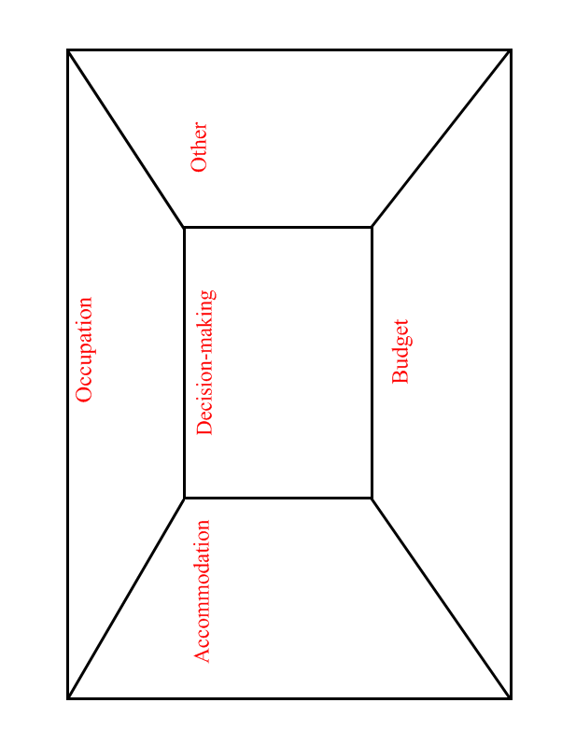

BLM F.1.2 Placemat (Sample Solutions) MEL4E

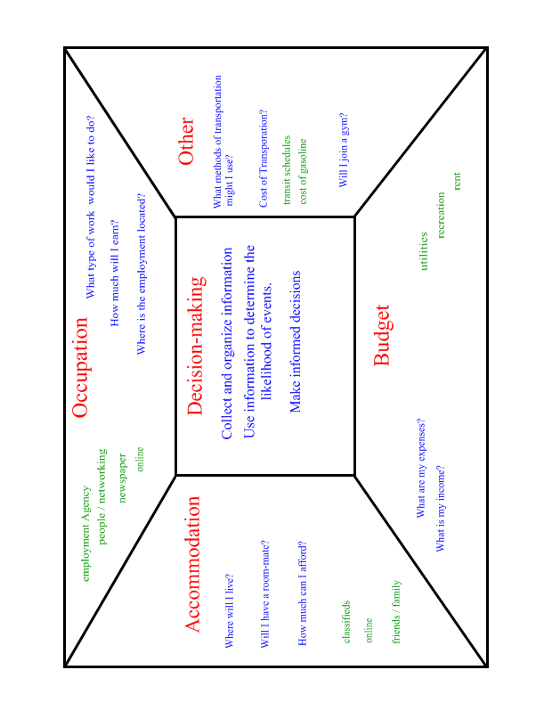

BLMF.1.3: Final Summative Project – Life Coach

For your final summative assignment in this course, you will take on the role of life coach to give advice to an individual client given a description of his/her current life scenario (class sample BLM 7.1.5). Once you have selected or have been assigned your client’s life scenario, you will be responsible for completing the following:

1. Review Accommodation:

a) Gather accommodation information for at least 3 different options using online listings, classified advertisements, etc.

b) Compare the options from part (a) with the needs of your client (e.g. proximity to work, school, frequented locations).

c) Advise your client with respect to a plan of action for accommodation.

2. Review the transportation options for your client’s scenario. Advise your client based on multiple factors (e.g. accommodation location, transportation cost, transit availability, etc.)

3. Additional Expenses:

Use this site to make decisions on expenses: http://www40.statcan.ca/l01/cst01/famil10d.htm

a) Select the table for Ottawa or Toronto depending upon the location of your client.
b) Based on the proportion of spending in the chart and the income of your client, predict additional expenses in each of the following categories:
i) Food
ii) Recreation
iii) Household Operation (i.e. utilities, phone, cable, etc.)
iv) Personal Care
v) Miscellaneous

4. Create a budget using the budget template created in class. Base your budget on the results of parts 1 to 3 and any other expenses of your client that are apparent in the scenario (e.g. education costs).

5. Reflect on the budget created in part 4. Ensure there is a savings component. Make adjustments and advise the client as necessary.

6. Create a plan for the client to file personal income tax next April.

a) Include a list of specific things to do.

b) Explain why he/she should file income tax.

c) Include an explanation of consequences for not filing income tax.

7. Provide advice for your client for the future renovation.

a) Your client has heard about and is interested in the renovation project that you completed in Unit #5 – Measurement of this course.

b) Refine your project and work from that unit to improve as necessary.

c) Provide a summary package of important information to present to your client for a future renovation of a similar type.

8. Summarize a final life plan for your client based on the work you have completed in parts 1 to 7 of this activity.

BLM F.1.4 Life Coach Project Rubric MEL4E

 | Level 1 | Level 2 | Level 3 | Level 4
Connecting
Collection of data that can be used to advise the client | Gathers data connected to the scenario but is inappropriate | Gathers data connected to the scenario and is somewhat appropriate | Gathers data connected to the scenario and is very appropriate | Gathers data connected to the scenario and is extremely appropriate
Representing
Creation of models to represent the data | Creates models that represent little of the data | Creates models that represent some of the data | Creates models that represent most of the data | Creates models that represent all of the data
Reasoning & Proving
Making inferences, conclusions and justifications | Justifications have limited connection to the scenario | Justifications have some connection to the scenario | Justifications have direct connection to the scenario | All justifications have direct connection to the scenario with evidence of reflection
Reflecting
Using metacognition to provide valuable advice | Applies metacognition with significant prompts | Applies metacognition with minor prompts | Applies metacognition without prompts | Applies metacognition with a broader view of scenario without prompts
Communicating
Degree of clarity in explanations and justifications in reporting | Explanations and justifications are partially understandable | Explanations and justifications are understandable by the teacher, but would likely be unclear to others | Explanations and justifications are clear for a range of audiences | Explanations and justifications are particularly clear and detailed
Correct and appropriate use of mathematical conventions and vocabulary | Sometimes uses mathematical conventions and vocabulary correctly | Usually uses mathematical conventions and vocabulary correctly | Consistently uses mathematical conventions and vocabulary correctly | Consistently & meticulously uses mathematical conventions and vocabulary correctly

BLM F.1.5 Class Scenario Sample MEL4E

Bart currently works at a Grocery Store part-time in his home town. His boss has agreed to hire him full-time for $15.50 per hour. He will not be attending college for now. Bart lives at home but has been informed that he will need to pay $350 for room and board. He would like to move out on his own. At the moment, Bart does not have a car. He either walks to work or rides his bicycle.

1. Review Accommodation: (Use information in BLM7.1.5A & BLM7.1.5B)

Decision with Justification: ____________________________________________________________________________________________________________________________________________________________________________________________________________________________________________________________________________________________________________________________________________________________________________________________________________________________________

2. Review the transportation options for your client’s scenario. Advise your client based on multiple factors (e.g. accommodation location, transportation cost, transit availability, etc.). Consider map BLM7.1.5B.

Decision with Justification: ____________________________________________________________________________________________________________________________________________________________________________________________________________________________________________________________________________________________________________________________________________________________________________________________________________________________________

3. Additional Expenses:

Use this site to make decisions on expenses: http://www40.statcan.ca/l01/cst01/famil10d.htm

After selecting Ottawa or Toronto, predict the cost to your client in each of the following categories:
i) Food

ii) Recreation

iii) Household Operation

iv) Personal Care

v) Miscellaneous

BLM F.1.5: Class Scenario Sample (continued) MEL4E

4. Create a budget using the budget template from unit 4. Base your budget on the results of parts 1 to 3 and any other expenses of your client that are apparent in the scenario (e.g. education costs).

5. Reflect on the budget created in part 4. Ensure there is a savings component. Make adjustments and advise the client as necessary.

Advice:
______________________________________________________________________________________________________________________________________________________________________________________________________________________________________________________________________________________________________________________________________________________________

6. Create a plan for the client to file personal income tax next April.

Advice:
______________________________________________________________________________________________________________________________________________________________________________________________________________________________________________________________________________________________________________________________________________________________

7. Provide advice for your client for the future renovation.

a) Your client has heard about and is interested in the renovation project that you completed in Unit #5 – Measurement of this course.

b) Refine your project and work from that unit to improve as necessary.

c) Provide a summary package of important information to present to your client for a future renovation of a similar type.

8. Summarize a final life plan for your client based on the work you have completed in parts 1 to 7 of this activity.

BLM F.1.5: Class Scenario Sample (continued) MEL4E

Accommodation Possibilities

Offer #1 One Bedroom Basement Apartment
Price: $675.00 per month Ad #2591

Charming, renovated, trendy one bedroom basement apartment in house located at Port Union and Lawrence.
- Nice, quiet residential neighborhood (West Hill)
- Private entrance
- Lots of light
- Modern all new kitchen with lots of storage
- 3 piece washroom
- VERY Close to TTC & GO Train
- Car Parking available
- High Speed Internet included
- Close to all Amenities (Grocery shopping, banks, library, schools, much more)

Offer #2 Comfortable room for rent.
Price: $550.00 Ad #804

The condition of the room is very good. The kitchen and the bathroom are in very good condition and the walls and floor are in good shape too. The apartment has air conditioning; electric; bus at doorstep; a block away from all your shopping needs; medical clinic across the street; shared kitchen; owners live in house; satellite tv.

Offer #3 Share Beautiful Clean Home
Price: $450-495.00 /mnth plus util Ad #3157

LOOKING FOR A GREAT PLACE TO LIVE?
Check out this awesome EXECUTIVE MIDHURST HOME with a huge backyard surrounded by beautiful mature trees, gardens and a serenity pond.
Inside you have 1600sqft to share, central air, cozy fireplace, 3 large bedrooms, 2 bathrooms, laundry, appliances & a reverse osmosis water system.
If that’s not enough, it’s a friendly, quiet environment, that’s partially furnished with plenty of parking, & just 5 minutes from the highway & malls.

ONLY $450-495 plus utilities
1st/last references required

If you are responsible, trustworthy & clean, you might be the lucky new occupant in August

BLM F.1.5B: Class Scenario Sample (continued) MEL4E
Home
Apartment 2
Apartment 1
Work
Apartment 3
2.33 km
4.66 km
1.59 km
3.49 km
15.5 km
17.8 km
1.65 km
4.76 km
3.6 km
Accommodation Map

Apartment
BLM F.1.6 Life Coach Project – Teacher Notes MEL4E

What is a life coach?
A life coach helps clients to set personal goals and to develop plans of action to achieve these goals. At the time of writing, different training programs exist but with no official regulatory standard. Internationally recognized standards and self-appointed accreditation bodies do exist. With no governed education or training standard at the time of writing, anyone can call themselves a Life Coach and can take on clients. (http://en.wikipedia.org/wiki/Life_coaching)

What is the vision of this project?
Students are empowered to take on a leadership role as a life coach, advising clients in realistic life scenarios, applying and connecting information and skills learned in this course. Students are encouraged to think critically throughout this project. Decisions should be realistic, affordable, and should be compatible with any previously made (e.g. Do accommodation and transportation choices now work together?).

How should students consider transportation options?
While making transportation decisions is not an overall expectation of this course, gathering data and making inferences are worthwhile life skills. For this reason, students are encouraged to research transit availability in their hometown (for the Class Bart Scenario) and/or their individual scenarios. Transit information will allow students to provide informed advice to their clients. Should the option of a car be considered, students may draw upon their own experience to make an informed decision or the teacher may provide information with respect to the average operating costs of a compact car.

How should students use STATSCAN data to predict additional expenses?
The link http://www40.statcan.ca/l01/cst01/famil10d.htm provides data on Average Household Expenditures for two metropolitan areas, Ottawa and Toronto. Students can use these statistics to calculate proportionality and predict expenditures for their clients. Additional tables of relevant community data may be available and may be used by students to critically modify their predictions.

How do students give tax advice?
Note that students are not completing an income tax return for their clients since they have done this in Unit #2 – Filing Taxes. As life coaches, students encourage their clients to develop a plan of action to file taxes at the appropriate time and to be aware of why they do so.

How else can students prepare for the project?
Students (or teachers) should retain work completed for the renovation project in Unit #5 – Measurement since it is used in this final summative project (see Part 7 of B LMF.1.5)

Are the sample scenarios that follow the only ones to be used by students?
Teachers may write original scenarios for their class based on the models included in this lesson. Alternatively, teachers may have students write scenarios to be used by future classes.

BLM F.1.7 Life Scenarios – Samples for Students MEL4E

Scenario A

Client Andrea has spent many years studying music and would like to continue in this field. She has found that the best place to further develop her love for music is Toronto where she plans to live and attend the Conservatory of Music.

Scenario B

Client Brendan will be attending Mohawk College in Brantford enrolling in a one year program to pursue a certificate in Advanced Security Management.

Scenario C

Client Kirby has just been accepted into a baker’s apprenticeship program with Buns Master Bakery in St. Catherine’s. The bakery is located on Carlton Street.

Scenario D

Client Dijong is a single parent with a child under the age of 2 living in Kingston. Dijong’s parents provide childcare free of charge during the day. Dijong currently lives in a bachelor apartment for $450, but knows that a larger apartment will be needed soon. The Lechee Restaurant and Tavern where Dijong works for minimum wage is located on Bath Street.

Scenario E

Client Mallory will be attending University of Ottawa to pursue a degree in Communication.

Scenario F

Client Fahad will be starting a new job at Costco in Brampton located near Steeles Avenue and Highway 410. He will be making $18.50 / h.

Scenario G

Client George will be working for his uncle as a Septic Tank Pumper in Kemptville He will on average pump 8 septic tanks a day at $300 a tank. His uncle offers him a 25% commission.

Scenario H

Client Habib and Sofi are parents of 3 children currently living in an apartment, where they pay $1250 for rent. They have been saving up to move into a house. Both Habib and Sofi work at the Windsor Casino making base salaries of $35000.

Scenario J

Client Joe has just been accepted in to an apprenticeship program for Auto Body and Collision Damage Repair at Mohawk College in Stoney Creek.

Scenario K

Client Karol is a self-employed plumber. He bases his salary on 35% of the previous year’s sales. Last year he generated $250000 in sales revenue. He currently lives in Timmins.

