Unit 1:Interpreting and Displaying Data MEL4E

Lesson Outline

BIG PICTURE

Students will:
- Read, interpret, various graphs
- Collect data, construct and interpret appropriate graphs
- Explore how data is related to proportional reasoning and unit rates

Day | Lesson Title | Math Learning Goals | Expectations
1 | About our community  (lesson included) | - Explore characteristics of your community based on data  - Discuss representation of the community characteristics in the  - classroom using proportional reasoning.  - Explain the distinction between the terms population and sample.  - Start a word wall. | RD1.2, AM3.3
2 | About ourselves  (lesson included) | - Collect data from the class. (e.g. employment, income, type of accommodation, language, number of pets, eye colour, wrist and thumb circumference, hand span, stride length)  - Discuss primary data vs secondary data. Add terms to word wall.  - Revisit the concepts of population and sample.  - Discuss why samples are used. | RD1.2, RD1.3, RD1.6
3 | All about graphs  (lesson included) | - Sort a collection of various graphs and explain criteria used. (e.g. group activity)  - Establish terminology for the sort (e.g. bar graph, circle graph, line graph, histogram, categorical data, ordinal data, continuous data). Add terms to the word wall.  - Refine process resorting as necessary. (eg. separating bar graphs and histograms)  - Interpret the graphs in your collection based on the sorting criteria. | RD1.1, RD1.3
4, 5 | Which graph is best?  (lesson included) | - Describe the characteristics and uses of the various types of graphs.  - Display categorical data appropriately, including data collected on Day 2 with and without technology. (e.g. eye colour)  - Distinguish between categorical and ordinal data. (e.g. type of pets versus number of pets) | RD1.4, RD1.3
6 | What is data good for?  (lesson included) | - Brainstorm why we collect data and what it is used for.  - Connect with how the media uses data.  - Discuss the misuse of data. (e.g. distorted graphs) | RD1.7, RD1.5
7 | Data collection using estimation  (lesson included) | - Use the hand span and stride length (both imperial and metric). Record the number of hand spans and stride lengths for various objects in a table.  - Complete the table to include both imperial and metric. Create a comparison bar graph that displays some of the items measured. (Horizontal axis - object Vertical axis – numeric scale that represents both the number of inches and the number of centimetres; Bar 1: cm, Bar2: inches)  - Use the graph to discuss the proportional relationship that exists between centimetres and inches. | RD1.6, RD.1.8, AM1.5
8 | Let’s get converted  (lesson included) | - Use the proportional relationship from Day 7 to perform some conversions.  - Explore other conversions. | AM1.2, AM1.4, AM1.5, AM3.2
9 | Unit rate data  (lesson included) | - Work with data that is given as unit rates. (eg. grocery store, gas consumption, currency exchange) | RD1.8, AM3.2
10 | Jazz
11 | Summative Assessment  (included) | - Collecting, organizing, and making analysis of data  - Start personal data collection log | RD1.6

Unit 1: Day 1: About our Community |  |  |  | MEL4E
Minds On: 10 |  | Learning Goal:  - Explore characteristics of your community based on data retrieved from ESTAT.  - Discuss representation of the community characteristics in the classroom using  proportional reasoning.  - Explain the distinction between the terms population and sample.  - Start a word wall. |  | Materials  - BLM 1.1.1 –BLM1.1.3  Internet access is highly recommended.
Action: 50
Consolidate:15
Total=75 min
Assessment
Opportunities
 | Minds On… | Whole Class → Discussion  Ask students to define the word “community.”  Small Groups → Anticipation Guide  Each group completes BLM1.1.1 to make some predictions about the make up of their community. |  | Possible definition:  A group of people living in a particular local area.  If possible, use data from your own community. To access the data  refer to the Statistics Canada website E-Stat  http://www12.statcan.ca/english/profil01/CP01/Index.cfm?Lang=E  Start word wall:  Community  Population  Sample
 | Action! | Whole Class → Guided Exploration  Establish that the data on BLM1.1.2 is from Statistics Canada – comparing the city of Barrie to the province.  Define the terms population and sample in context to the data on BLM1.1.2.  Demonstrate how to analyse the data by reading the table through a think aloud strategy. Ask questions that involve proportional reasoning.  Possible guiding questions: How does the median total income of persons 15 years of age and over for our community compare with the province? Is there a difference in earnings between males and females?  Small Group → Exploration  Provide each group with the set of data from BLM1.1.3.  Ask students to analyze the five different statements outlined on the Anticipation Guide BLM1.1.1 plus two other observations that they have made.  Process Expectations/Observations/Mental Note  Assess student’s ability to reason and prove.
 | Consolidate Debrief | Small Group→ Anticipation Guide  Ask students to complete the ‘After’ column of the Anticipation Guide BLM1.1.1. and share with their group any alterations they made.  Whole Class→ Sharing  Students share interesting observations about the data.
Exploration  Reflection |  | Home Activity or Further Classroom Consolidation  In your journal, respond to the following questions:  What did you find to be most interesting about the data?  Were your findings similar or different from what you expected?  What other community/province would you be interested in finding out about?

BLM 1.1.1: Anticipation Guide

Instructions
- Check Agree or Disagree, in ink, in the Before category beside each statement before you start the Exploring Our Community Data task.
- Compare your choice with your partner.
- Revisit your choices at the end of the investigation.

Before |  | Statement | After
Agree | Disagree | Statement | Agree | Disagree
 |  | 1. There are more people in our community over the age of 45 than below.
 |  | 2. The population of males and females in our community is equal for three different age groupings.
 |  | 3. The majority of our community is working for a manufacturer versus all other occupations combined.
 |  | 4. The average number of people in a dwelling is less in our community than Ontario’s average.
 |  | 5. The average income in our community is higher than the Ontario average by 10%.

BLM 1.1.2: Exploring Data
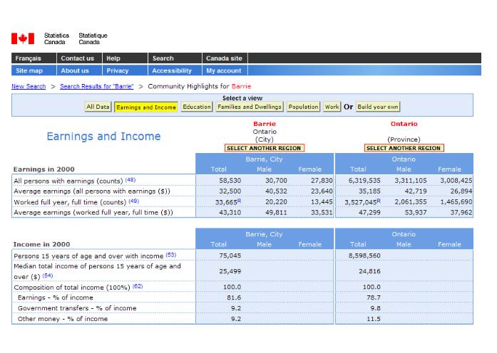

BLM 1.1.3: Exploring Data
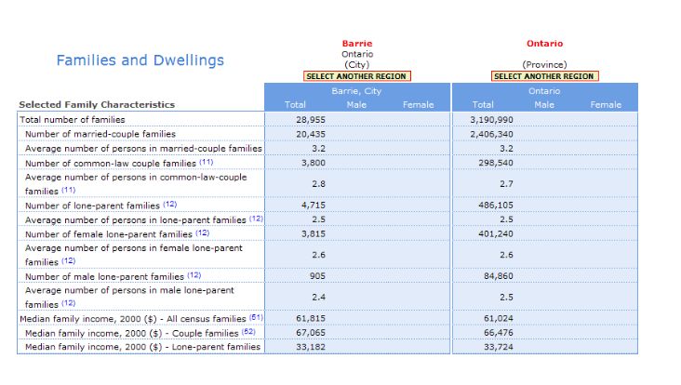
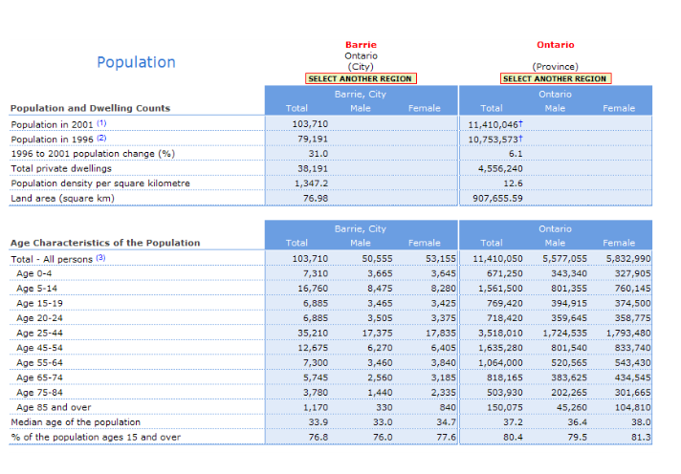

BLM 1.1.3: Exploring Data (continued)

BLM 1.1.3: Exploring Data (continued)
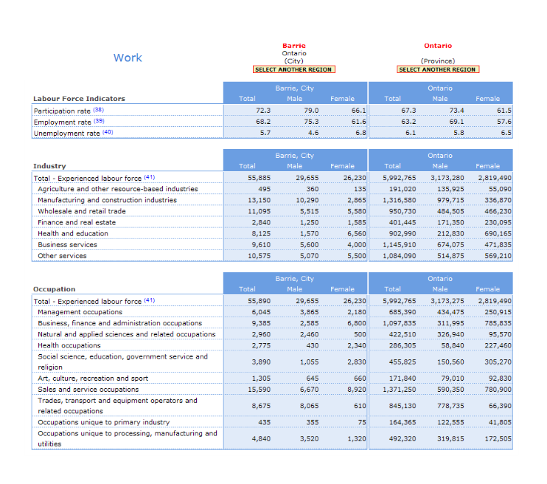

Unit 1: Day 2: About Ourselves |  |  |  | MEL4E
Minds On: 5 |  | Learning Goals:  - Collect data from the class. (e.g. employment, income, type of accommodation, language, number of pets, eye colour, wrist and thumb circumference, hand span, stride length)  - Discuss primary data vs. secondary data. Add terms to word wall.  - Revisit the concepts of population and sample.  - Discuss why samples are used. |  | Materials  - BLM 1.2.1  - BLM 1.2.2  - Imperial tape measure  - String  - Metric tape measure
Action: 50
Consolidate:20
Total=75 min
Assessment
Opportunities
 | Minds On… | Whole Class → Brainstorm  Students brainstorm types of data that they might be interested in gathering.  Determine if the data is something that they would obtain through a survey or a measurement. |  | Save BLM1.2.1 and BLM1.2.2 for Day 5  Primary sources:  (first hand)  Measurement  Survey  Observation  Experimentation  Secondary sources:  Newspaper  Magazine  Book  Internet  Company reports  Government census publication  Word wall:  Population  Sample  Secondary data  Primary data
 | Action! | Pairs → Data Collection  Pairs select one of the survey topics for which to gather data. Students use BLM1.2.1, to organize their collection and record some data analysis of their collection. Below is a list of possible topics:  Survey: Employment, Type of Accommodation, Language(s) Spoken at Home  Pets, Eye Colour  Whole Class→ Data Collection and Analysis  Students measure to obtain the following information and record on class chart (BLM1.2.2): Wrist circumference in inches, Thumb circumference in centimetres, Arm Span in centimetres, Height in centimetres.  Discuss observations of the data together. Possible observations: Wrist Circumference in inches and the Thumb Circumference in centimetres should be very close, as well as the arm span and the height.  The ratio of wrist (inches): thumb (centimetres) is the ratio conversion between inches and centimetres.  Mathematical Process Focus: Connecting
 | Consolidate Debrief | Whole Class → Discussion  Pose the question “What is the difference between the data that was looked at on Day 1 versus today?” Encourage students to make connections with the concept of secondary versus primary data.  Discuss the validity of their analysis.  Pose similar questions: “Has enough data been collected to provide a valid statement about a population greater than the classroom?”  “What recommendations would you make regarding the sample if you wanted to make a statement about the population of the entire school, community, province or all of Canada?”  Discuss ‘Why do we use samples?’  Add to word wall
Practice |  | Home Activity or Further Classroom Consolidation  Students fill in BLM1.2.3 to consolidate their understanding of population, sample, primary data sources and secondary data sources.

BLM 1.2.1: Survey Data

1. Choose one of the survey topics discussed. Survey your classmates and complete the accompanying chart.

Sample Question: What is your eye colour?

TOPIC | Choices | TALLY | FREQUENCY | PERCENTAGE
Eye Colour | Brown | //// //// | 10 | 50%
Eye Colour | Blue | //// | 4 | 20%
Eye Colour | Hazel | //// | 5 | 25%
Eye Colour | Green | / | 1 | 5%
Eye Colour | Total |  | 20 | 100%

Question:_______________________________________________

TOPIC | Choices | TALLY | FREQUENCY | PERCENTAGE

2. What do you notice about the data you collected?

BLM1.2.2: Measurement Data

Student | Wrist Circumference  (inches) | Thumb  Circumference  (cm) | Arm span  (cm) | Height  (cm)

BLM 1.2.3: Consolidation
Review of Key Terms

- Define the following terms:

Primary Source of Data: _____________________________________________________________________________________________________________________________________________________________________

Secondary Source of Data:
_____________________________________________________________________________________________________________________________________________________________________

Population:
_____________________________________________________________________________________________________________________________________________________________________

Sample:
_____________________________________________________________________________________________________________________________________________________________________

- Determine whether the following types of data are primary sources or secondary sources.

Data Source | Primary | Secondary
Sports scores taken from the Internet
Data gathered by asking each person in your class what music they like
Results from a questionnaire given to people in your neighbourhood
Information obtained from the newspaper

BLM 1.2.3: Consolidation (Continued)

- For the following samples, describe what the possible population could be. For of the following populations, describe what a possible sample should be. Justify your answer.

Sample | Population | Why?
Ten boys and ten girls from each grade level in your school are asked to participate in a questionnaire.
 | Each member of the football team was asked if they wanted new uniforms.
Fifty people are randomly chosen from the phone book and asked to participate in a survey.
 | Every employee was asked to undergo a physical check-up by the company physician.

- Given the following situations, describe the population and sample that best represents the situation. Also, describe a method that could be used to gather the data.

Situation | Population | Sample | Method
The most desired cafeteria food by the students in your school.
The opinion of the local residents about building a sports complex in your neighbourhood.
Will parents approve the implementation of uniforms at your school?

BLM 1.2.3: Consolidation (Teacher Notes)

Review of Key Terms

- Define the following terms:

Primary Source of Data:

Data gathered by the researcher in the act of conducting research.

Secondary Source of Data:

This is data that uses data gathered by someone other than the researcher.

Population:

A population comprises all members of a specified group

Sample:

A sample is that part of a population which is actually observed.

- Determine whether the following types of data are primary sources or secondary sources.

Data Source | Primary | Secondary
Sports scores taken from the Internet
Data gathered by asking each person in your class what music they like
Results from a questionnaire given to people in your neighbourhood
Information obtained from the newspaper

BLM 1.2.3: Consolidation (Teacher Notes)

- For the following samples, describe what the possible population could be. For of the following populations, describe what a possible sample should be. Justify your answer.

Sample | Population | Why?
Ten boys and ten girls from each grade level in your school are asked to participate in a questionnaire. | Entire school body | Could be all high school, but it is not…only asked about YOUR school
One player from each position | Each member of the football team was asked if they wanted new uniforms. | Representative of the entire team
Fifty people are randomly chosen from the phone book and asked to participate in a survey. | Everyone listed in the phone book. | One particular phone book could specify several communities. (We are only interested in the phone book in question.)
Employees in the first year of employment | Every employee was asked to undergo a physical check-up by the company physician. | The employees must work for the company. Also, as an extra consideration, these employees likely did not have a physical

- Given the following situations, describe the population and sample that best represents the situation. Also, describe a method that could be used to gather the data.

Situation | Population | Sample | Method
The most desired cafeteria food by the students in your school. | All students who eat in the cafeteria | 10 males and 10 females from each grade level who use the cafeteria | Survey the line outside of the cafeteria.
The opinion of the local residents about building a sports complex in your neighbourhood. | All residents of the neighbourhood as defined by the city | 2 or 3 households from each block | Door-to-door or telephone
Will parents approve the implementation of uniforms at your school? | All parents of the students attending the school | Parents of students from each grade level | Survey to be included in the school newsletter

Unit 1: Day 3: All About Graphs |  |  |  | MEL4E
Minds On: 15 |  | Learning Goal:  - Sort a collection of various graphs and explain criteria used. (e.g. group activity)  - Establish terminology for the sort (e.g. bar graph, circle graph, broken-line graph, histogram, categorical data, ordinal data, continuous data). Add terms to the word wall.  - Refine process resorting as necessary. (e.g. separating bar graphs and histograms)  - Interpret the graphs in your collection based on the sorting criteria. |  | Materials  - BLM 1.3..1 – BLM1.3.4
Action: 45 |  |  |  | Materials  - BLM 1.3..1 – BLM1.3.4
Consolidate:15 |  |  |  | Materials  - BLM 1.3..1 – BLM1.3.4
Total=75 min |  |  |  | Materials  - BLM 1.3..1 – BLM1.3.4
Assessment
Opportunities
 | Minds On… | Whole Class→ Review  Take up solutions to BLM1.2.3. Clarify any questions students have regarding population and sample. |  | Cut out graphs from BLM1.3.1.  Word wall  Bar graph  Pictograph  Broken-line graph  Histogram  Circle graph  Create a class BLM1.3.2 for students to complete when they present to the class.
 | Action! | Small Groups → Sorting Graphs  Students sort graphs from BLM1.3.1, according to group preference. Examples of a sort might be based on the information in the graph; how the data was gathered; type of graph.  Whole Class→ Discussion  Ask groups to share the criteria for their sort.  Establish terminology and properties regarding the type of graph: bar, circle, broken-line, histogram. Use BLM1.3.2 for an organizer. Ask students to refine their sort based on the knowledge of type of graphs, especially separating bar graphs and histograms.  Complete Venn Diagram on BLM 1.3.3 to compare bar graphs and histograms.  Small Groups → Analysing Graphs  Assign each group a different type of graph: bar, circle, broken-line and histogram. Ask each group to identify some of the characteristics of their assigned graph and record on BLM1.3.2.  Curriculum Expectations/Observations/Checklist  As students complete BLM 1.3.2 ascertain their achievement of the learning goals.  Small Group→ Presentation  Each group shares characteristics of the type of graph they have been assigned. Contribute to the discussion by introducing terminology for the type of data their graph is displaying: categorical, ordinal, or continuous.  Mathematical Process Focus: Representation
 | Consolidate Debrief | Individual → Practice  Complete “matching exercise” BLM 1.3.4 to reinforce terminology.
Application |  | Home Activity or Further Classroom Consolidation  Students select one graph of each type of graph from BLM1.3.1 and answer the following questions: What is the graph about? What observations can you make regarding the information on the graph?

BLM 1.3.1 Sorting Activity

BLM 1.3.1 Sorting Activity (Continued)
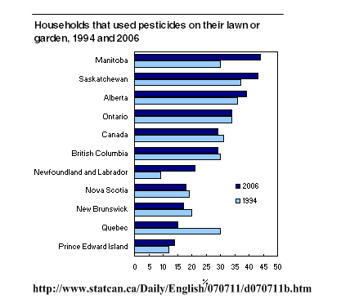
Percent

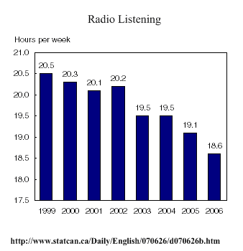

BLM 1.3.1 Sorting Activity (Continued)
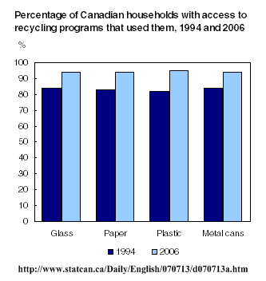

BLM 1.3.1 Sorting Activity (Continued)

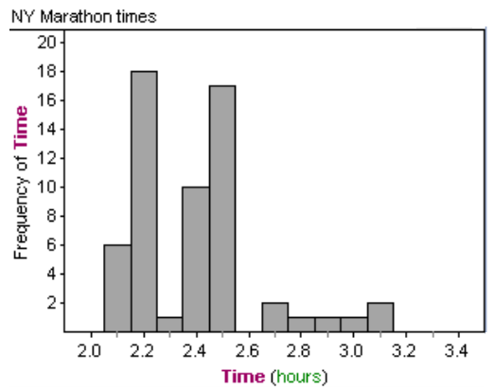

BLM 1.3.1 Sorting Activity (Continued)

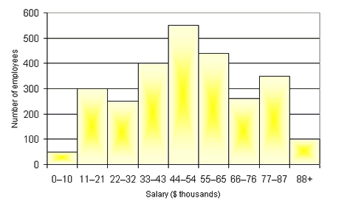

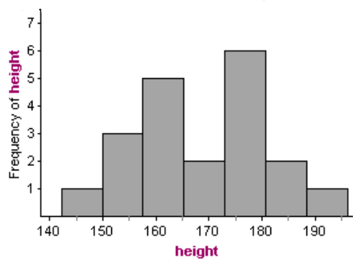

BLM 1.3.1 Sorting Activity (Continued

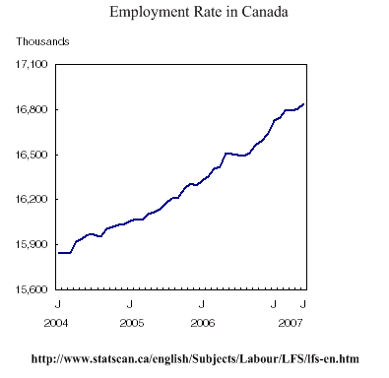

BLM 1.3.1 Sorting Activity (Continued
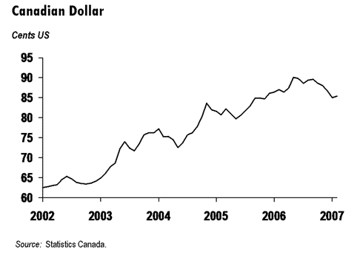

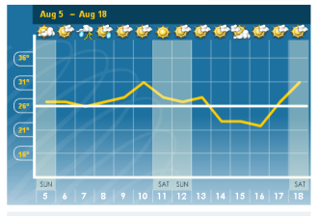

BLM 1.3.1 Sorting Activity (Continued)
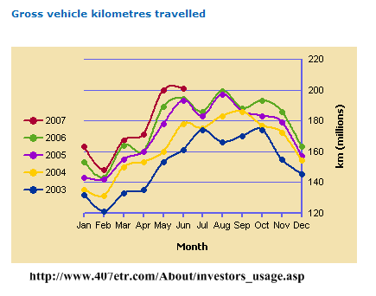
Hwy 407

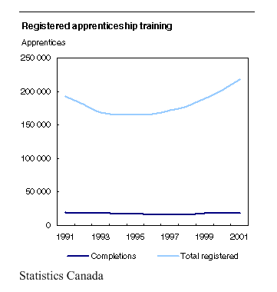

BLM 1.3.1 Sorting Activity (Continued)

Enrolment of Students at Secondary School in Ontario 2005-2006

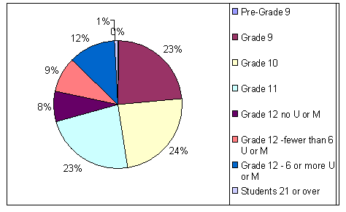
http://www.edu.gov.on.ca/eng/educationFacts.html

Music Preferences in young adults 14 to 19

BLM 1.3.1 Sorting Activity (Continued)
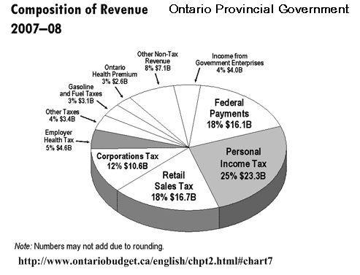

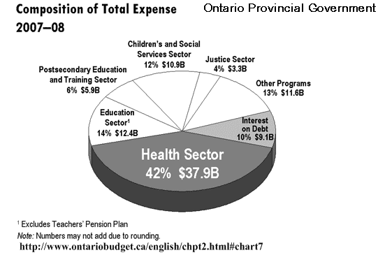

BLM 1.3.1 Sorting Activity (Continued)

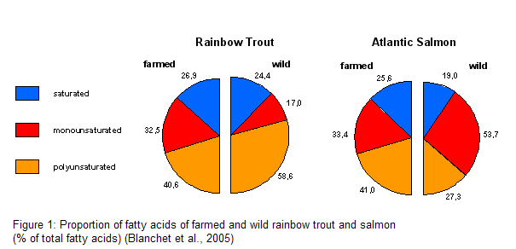

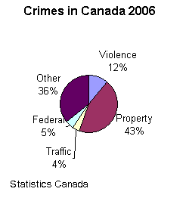

BLM 1.3.2: Types of Graphical Displays

Graph Type:_______________________  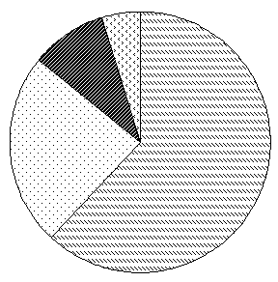  Characteristics of Graph:  ___________________________________  ___________________________________  ___________________________________  ___________________________________ | Graph Type:_______________________  Characteristics of Graph:  ___________________________________  ___________________________________  ___________________________________  ___________________________________
Graph Type:_______________________  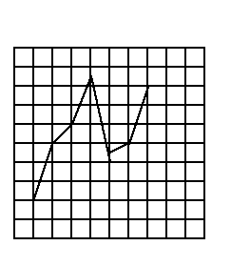  Characteristics of Graph:  ___________________________________  ___________________________________  ___________________________________  ___________________________________ | Graph Type:_______________________  Characteristics of Graph:  ___________________________________  ___________________________________  ___________________________________  ___________________________________

BLM 1.3.3: Venn Diagram

Complete the Venn diagram to compare bar graphs and histograms.

Bar Graph Histogram

BLM1.3.4: All about Graphs

Can You Make The Match?

Match the terms below to the definition that bests describe it. Give at least one example of every definition.

TERMS

Bar Graph | Line Graph | Histogram | Circle Graph | Categorical Data | Ordinal Data | Continuous Data
1 | 2 | 3 | 4 | 5 | 6 | 7

TERM | DEFINITIONS | EXAMPLE(S)
 | Data represented by individual values that can be ordered or assigned a specific rank on a scale
 | Data which has no breaks or spaces; data can be any value in between
 | Graph in which rectangles are used to represent frequencies of observations within each interval
 | A graphical display representing data in different categories or groups. The length of a rectangle or bar is used to represent the numerical amount
 | Data grouped according to some common property(ies) and the number of members of the group are recorded (eg, males/females, vehicle type)
 | A graphical representation using points connected by line segments to show how something changes over time
 | This graph is also called a pie chart. The circle represents the whole and each sector of the circle proportionately represents a part of the whole

BLM 1.3.4: All about Graphs (Teacher Notes)

Can You Make The Match?

Match the terms below to the definition that bests describe it. Give at least one example of every definition.

TERMS

Bar Graph | Line Graph | Histogram | Circle Graph | Categorical Data | Ordinal Data | Continuous Data
1 | 2 | 3 | 4 | 5 | 6 | 7

TERM | DEFINITIONS | EXAMPLE(S)
6 | Data represented by individual values that can be ordered or assigned a specific rank on a scale | Number of pets in a household
7 | Data which has no breaks or spaces; data can be any value in between | Temperatures throughout the day (Visit The Weather Network)
3 | Graph in which rectangles are used to represent frequencies of observations within each interval | Spread of class marks
1 | A graphical display representing data in different categories or groups. The length of a rectangle or bar is used to represent the numerical amount | Principal fuel used for home heating
5 | Data grouped according to some common property(ies) and the number of members of the group are recorded (eg, males/females, vehicle type) | Type of pet
2 | A graphical representation using points connected by line segments to show how something changes over time | Average monthly temperatures over the course of a year
4 | This graph is also called a pie chart. The circle represents the whole and each sector of the circle proportionately represents a part of the whole | Music preferences in young adults

Unit 1: Day 4: Which Graph Is Best? |  |  |  | MEL4E
Minds On: 15 |  | Learning Goal:  - Describe the characteristics and uses of the various types of graphs.  - Display categorical data appropriately, including data collected on Day 2 with and without technology. (e.g. eye colour) |  | Materials  - BLM 1.4.1  - BLM 1.4.2  - BLM1.4.3  - Rulers  - Colouried pencils  - Graph paper
Action: 50
Consolidate:10
Total=75 min
Assessment
Opportunities
 | Minds On… | Small Group → Discussion  Students select one graph of each type of graph from BLM1.3.1 to reflect on why this form of representation was used. Why was the information represented in this way? What is the creator trying to suggest?  Whole Class → Discussion  Select one graph of each type for students to share their responses to the above questions. |  | Gallery Walk: Students display their graphs at their desks and students circulate to visit each other’s work. Remind students to be respectful of other’s work.
 | Action! | Small Groups → Displaying Data  Students complete BLM1.4.1, deciding which graph to use for the data provided.  Students create at least one graph of each type: bar, broken-line, circle, histogram.  Curriculum Expectations/Questions/Mental Note  Ask students to explain their choice of graph.  Whole Class→ Gallery Walk  Each group displays their graphs from BLM 1.4.1 for everyone to view. Students will move around the room to highlight the “positive” characteristics of one graph from each group and record on BLM1.4.2.  Mathematical Process Focus: Representing
 | Consolidate Debrief | Whole Class → Discussion  Identify important aspects of graphs completed by groups. Collect some to post in the room.
Practice |  | Home Activity or Further Classroom Consolidation  Complete BLM 1.4.3, questions 1 – 3.

BLM 1.4.1: Which Graph Is Best?

Part A)
Given the following scenarios, decide which type of graph (Bar, Broken- Line, Circle, Histogram) you would use and justify your choice(s). You may use more than one type in some circumstances.

Scenario | Choice of Graph(s) | Why?
A) Here are the four most popular after-school activities based on a survey of the students at Workplace Secondary School:
Computer – 300 students
Sports – 250 students
Watching T.V. – 600 students
Listening to Music – 200 students
B)The information below describes the final year-end balance in Rich’s bank account over the past five years:
2001 - $1250
2002 - $3000
2003 - $750
2004 - $1750
2005 - $1100
C) Mrs. Math’s MEL 4E class had the following mark distribution:
0 – 24% (1 student)
25 – 49% (4 students)
50 – 74% (7students)
75 – 100% (13 students)
D) Ministry of Natural Resources has reported that in 2006 the cause of Wildfires were caused: 41% by human, 58% by lighting, 2% for unknown reasons

Part B) Create a graph for each of the above scenarios. Even though more than one type of graph could be used for a scenario, select only one type, but make sure that you have at least one graph of each type created overall.

BLM 1.4.1: Which Graph Is Best? (Continued)

Template for Circle Graph

Note: 1% is defined by the piece created from the center to two adjacent dots on the outer edge of the circle.

BLM 1.4.2: Looking at Graphs

Look at the graphs completed by the other groups in the class.

Fill in the chart below based on one graph for each group.

Group name | Graph  (question number) | Positive comments

BLM1.4.3: Constructing Graphs

- Based on the following information, create a bar graph to represent the data. Be sure to use equal spacing between the bars.

Type of Animal (pets) | Frequency
Dog | 10
Cat | 6
Bird | 2
Fish | 8
Snake | 1

BLM 1.4.3: Constructing Graphs (Continued)

- Based on the following information, create a line graph to represent the trend in pedestrian fatalities across Canada from 1975 to 2005.

Year | Number of Pedestrian Fatalities
1975 | 1,050
1980 | 900
1985 | 600
1990 | 525
1995 | 425
2000 | 425
2005 | 375

BLM 1.4.3: Constructing Graphs (Continued)

3.a) Use the following data to complete the chart:

Marks for MEL 4E Class - Ms. Math

(all marks are out of 100)

55, 70, 80, 87, 20, 83, 84, 73, 51, 95, 90, 89,
57, 86, 48, 69, 86, 49, 72, 83, 27, 80, 82, 32, 77

MARK INTERVAL | TALLY | FREQUENCY
0 – 24

25 – 49

50 – 74

75 – 100

b) Construct a histogram representing the data above in the space provided.

BLM 1.4.3: Constructing Graphs (Continued)

4. The Radical family earns a combined net income of $4000 per month. Their monthly expenses are listed below:
Mortgage - $1400
Utilities - $360
Groceries - $720
Transportation - $160
Entertainment - $300
Savings - $400
Miscellaneous - $660

a) Complete the table below.

Type of Expense | Amount ($) | Fraction of Total | Percentage of Total
Mortgage | 1400
Utilities | 360
Groceries | 720
Transportation | 160
Entertainment | 300
Savings | 400
Miscellaneous | 660
Total | 4000

BLM 1.4.3: Constructing Graphs (Continued)

- b) Use the information from the table in 4.a to construct a circle graph. Be sure to label each section with the appropriate name and percentage.

Unit 1: Day 5: Which Graph Is Best? Continued |  |  |  | MEL4E
Minds On: 10 |  | Learning Goal:  - Display categorical data appropriately, including data collected on Day 2 with and without technology. (e.g. eye colour)  - Distinguish between categorical and ordinal data. (e.g. type of pets versus number of pets). |  | Materials  - BLM 1.2.1  - BLM 1.2.2  - BLM1.4.3  - rulers  - colouring pencils  - calculator  - graph paper
Action: 55
Consolidate:10
Total=75 min
Assessment
Opportunities
 | Minds On… | Whole Class → Discussion  Review the skills needed to express quantities in both fraction and decimal form. Complete BLM 1.4.3, question 4 with the students.
 | Action! | Pairs → Practice  Students use the data they collected from their survey question on Day 2 to create an appropriate graph. See BLM1.2.1.  Whole Class→ Practice  Select student data from BLM1.2.2 and demonstrate how to organize the data to create a histogram.  Individual → Practice  Students select one of the remaining three data sets to create a histogram from BLM1.2.2.  Process Expectations/Observations/Checklist  Assess students on the processes - Selecting Tools and Computational Strategies, Representing
 | Consolidate Debrief | Whole Class → Discussion  Discuss and support any difficulties students had with displaying their data.  Reemphasize the difference between categorical, ordinal, and continuous data in respect to the graphs they created.
Practice |  | Home Activity or Further Classroom Consolidation  Complete BLM 1.5.1 for extra practice with graphing and interpreting circle graphs.

BLM1.5.1: Creating Circle Graphs

1. The Student Council made $6000 selling T-shirts.

Create a circle graph to show how they spent the money.

Graduation 27%
Dances 35%
Charity 18%
Concert 12%
Other 8%

If they spent the entire $6000, how much money was spent on each category. Show your work.
Graduation

Dances

Concert

Charity

- Create a circle graph to show how one hour of a radio station’s time is divided.

Commercials 20%
D.J. Talk 12%
News 16%
Sports 7%
Music 45%

How many minutes are used in each category? (Think: how many minutes are in an
hour?)

Commercials

News

Music

Sports

D.J. Talk

BLM 1.5.1: Creating Circle Graphs (Continued)

Unit 1: Day 6: What Is Data Good For? |  |  |  | MEL4E
Minds On: 10 |  | Learning Goal:  - Brainstorm why we collect data and what it is used for.  - Connect with how the media uses data.  - Discuss the misuse of data (e.g. distorted graphs). |  | Materials  - BLM 1.6.1  - BLM 1.6.2  - BLM 1.6.3  - BLM 1.6.4  - BLM 1.6.5
Action: 50
Consolidate:15
Total=75 min
Assessment
Opportunities
 | Minds On… | Think/Pair/Share→Brainstorm  Students brainstorm ‘Why is data collected, and what is it used for?’ and put their ideas on BLM 1.6.1. Students share their ideas with an elbow partner and then share with the class.
 | Action! | Small Groups → Discussion  Provide each group with one of the clouds on BLM1.6.2. Ask them to discuss, “Why does the media want us to know this information?”  Whole Class → Discussion  Each group shares with the class their thoughts from their discussion.  Discuss how the representation of data may sometimes be misleading. Show an overhead of BLM1.6.3. Ask students why the information is misleading?  Small Groups → Representing Data  Students complete BLM 1.6.4 to determine how data can be used to make a point which could be misleading.  Learning Skills/Observation/Checklist  As students work in groups, circulate to observe their teamwork skills.
 | Consolidate Debrief | Whole Class → Discussion  Take up BLM1.6.4.  Discuss “Why would someone create a misleading graph?”
Application |  | Home Activity or Further Classroom Consolidation  Complete BLM 1.6.5.

BLM 1.6.1: What Is Data Good For?

Take some time to reflect upon the following questions:

Why do we collect data? What is data used for?

In first the chart below, jot down your thoughts in response to the questions above. Then, in pairs add to your responses. Share your results with the class to decide on what the most popular responses were, and jot them down in the second chart.

Your Thoughts / Pair
Why is data collected? | What is data used for?

Thoughts from Entire Class
Why is data collected? | What is data used for?

BLM 1.6.2: How Media Uses Data

The following statistics are from the front page of The Globe and Mail, Wednesday July 18, 2007.
17.7%
Proportion of the population made up of children aged 14 and under – the lowest it has ever been
4.3 million
Number of citizens aged 65 or older, meaning that one in seven Canadians are now senior citizens.

15.4%
Proportion of seniors living in Saskatchewan – the highest in Canada
2016
Year by which Statscan predicts there will no longer be enough workers to replace retirees

6th
Canada’s rank among G8 countries in terms of proportion of seniors.
39.5
Median age in Canada, up from 25.4 in 1966.

BLM 1.6.3: Misleading Statistics

Number of People Attending a Transformers Convention

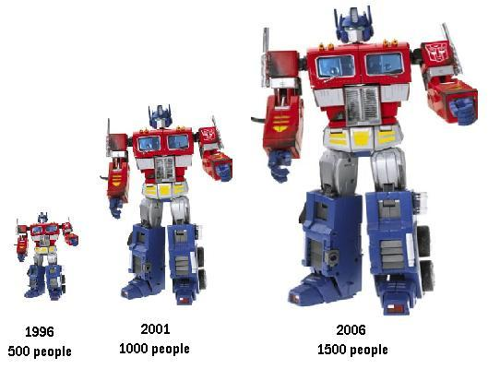

Why is the above information misleading?

BLM1.6.4: More Misleading Statistics

- Look at the data given in the table. This is the average annual salary for
Games R Us.
Year | Average Salary ($)
1 | 34 500
2 | 34 600
3 | 35 250
4 | 35 000
5 | 35 350
6 | 35 750

- Use the data to create a graph with a horizontal scale in years and a vertical scale for salary. Have the values on the vertical scale begin at 0 and go up by $5000.
Create an appropriate title for the graph to describe what is happening to salaries.

- Use the data to create another graph with a horizontal scale in years and a vertical scale for salary. Begin the vertical scale at $33 500, and go up by $500.

Create an appropriate title for this graph that describes what is happening to salaries.

- Do both graphs show the same information? Explain your thinking.

- Which graph would you use if you owned the company and wanted to show the improvement being made in salaries? Explain your reasoning.

- Which graph would you use if you were an employee of the company wanting a raise? Explain your reasoning.

BLM1.6.5: Analysing the Representation of Data

1. Consider the following figure:

Figure 1
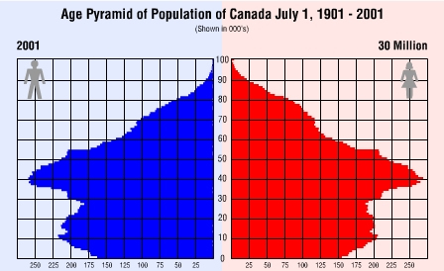

Source: Statistics Canada

a) What is being compared in the graph?

b) What information do you think Figure 1 is trying to portray?

c) Do you think that the type of figure used is an effective way to illustrate the
data? If so, why? If not, suggest an alternative way to represent the data.

d) Based on the figure, what conclusions can be drawn from the illustrated
information?

e) Predict what you think the figure will look like in the year 2101.

f) Who do you think might need the Figure 1 data, and for what purpose?

BLM1.6.5: Analysing the Representation of Data (Continued)
2. Figure 2 Fastest Slap Shots Since 1991 (NHL)

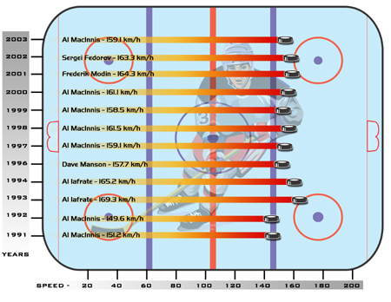
Source: Statistics Canada

a) What is being compared in the graph?

b) What information do you think Figure 2 is trying to portray?

c) Do you think that the type of figure used is an effective way to illustrate the
data? If so, why? If not, suggest an alternative way to represent the data.

d) Based on the figure, what conclusions can be drawn from the illustrated
information?

e) According to the figure, which player has the fastest slap shot speed on
record? When did this occur?

f) Who do you think might need the Figure 2 data, and for what purpose?
BLM1.6.5: Analysing the Representation of Data (Continued)

3. Why is this graph misleading?

- Draw a misleading graph that Mathy’s Pizza could use to indicate that their prices for a slice of pizza are increasing slightly.

Mathy’s Pizza Prices Over Time

Year | Cost ($)
1970 | 0.25
1980 | 0.50
1990 | 0.75
2000 | 1.25

Unit 1: Day 7: Data collection using estimation |  |  |  | MEL4E
Minds On: 10 |  | Learning Goal:  - Use the hand span and stride length (both imperial and metric) to estimate  measures of items in the school environment as an example of how data can be  used.  - Record the number of hand spans and stride lengths for various objects in a table.  - Complete the table to include both imperial and metric measures for each item.  - Create a comparison bar graph that displays some of the items measured.  (Horizontal axis - object Vertical axis – numeric scale that represents both the  number of inches and the number of centimetres; Bar 1: cm, Bar 2: inches)  - Use the graph to discuss the proportional relationship that exists between centimetres and inches. |  | Materials  - BLM 1.7.1  - Imperial and metric rulers, tape measures
Action: 55
Consolidate:10
Total=75 min
Assessment
Opportunities
 | Minds On… | Whole Class → Discussion  Discuss the fact that our personal measurement data can play a role in estimation.  Discuss each of the measurements outlined on BLM1.7.1 and have students measure and record each of their measures. Have students compare how close they are to the estimated measure. |  | Students’ arm span and stride length was collected on Day 2.  2.54 cm = 1 inch
 | Action! | Pairs → Experiment  Students estimate the measurement of a variety of objects using their hand span, stride length or any of the other measurements outlined on BLM1.7.1.  Students record their estimated measure in inches and in centimetres.  Students create a comparison bar graph for five objects measured. (BLM 1.7.1)  Curriculum Expectations/Observations/Checklist  Record student progress on the learning goals.  Mathematical Process Focus: Connecting
 | Consolidate Debrief | Whole Class → Discussion  Ask students what they notice with the bar graphs for centimetres and inches for each of the objects. If the estimate is reasonable, they should be proportional from object to object. Express the unit of centimetres to inches (cm/inch) for a couple of objects and determine how close it is to the rate of 2.54 cm/inch.
Reflection |  | Home Activity or Further Classroom Consolidation  In your journal, consider when you might need to use an estimate rather than the actual measurement.

BLM 1.7.1: Body Parts for Measurement

Cubit - distance from the elbow to the tip of the middle finger
- average adult male 18 inches long
- standard unit of length in Egypt
- often used in the context of building

Foot - average length of a man’s foot

Span - when hand is stretched out, it is the furthest distance from the
tip of the thumb to the tip of the last finger
- about half of a cubit (9 inches)

Handbreadth - width of the four fingers where they meet the palm
- approximately 4 inches
- height of horses usually expressed in so many hands

Digit - the width of a finger
- approximately 2 cm

Thumb - width of a thumb
- used as the basis of an inch

Fathom - also known as arm span
- the distance between the middle fingers when arms are
spread out as far as they can go

BLM1.7.2: Estimating Measures

1. Using any of the measurements outlined on BLM1.7.1, complete the following table. Some items have been included for you.

Object | How Object Was Measured (hand span etc.) | Metric Estimate  (cm) | Imperial Estimate  (inches)
Thickness of a Book

Height of Desk
Width of Door

- Create a comparison bar graph that displays five of the items measured. (Horizontal axis – object; Vertical axis – numeric scale that represents both the number of inches and the number of centimetres; Bar 1- cm, Bar2 - inches)

Unit 1: Day 8: Let’s Get Converted |  |  |  | MEL4E
Minds On: 5 |  | Learning Goal:  - Use the proportional relationship from Day 7 to perform some conversions.  - Explore other conversions. |  | Materials  - BLM 1.8.1  - BLM 1.8.2  - calculator
Action: 50 |  |  |  | Materials  - BLM 1.8.1  - BLM 1.8.2  - calculator
Consolidate:20 |  |  |  | Materials  - BLM 1.8.1  - BLM 1.8.2  - calculator
Total=75 min |  |  |  | Materials  - BLM 1.8.1  - BLM 1.8.2  - calculator
Assessment
Opportunities
 | Minds On… | Whole Class → Practice  Provide each of the students with a playing card for MATHO. Students practice converting between metric units, imperial units and among units based on the proportion established on Day 7, 1 inch = 2.54 cm.  Whole Class → Discussion  Discuss when conversion between units and among units is applicable in our everyday life (e.g., if traveling into the United States and we see that the price for gas is $1.50 per gallon and we are curious as to its equivalency in Ontario when we pay per litre). |  | Instructions for MATHO:  Place numbers 1 – 24 on separate pieces of paper and place in a paper bag. Randomly select students to select a number from the bag. That number is the question that everyone is to answer. Establish prior to the game what you are playing for: vertical line, horizontal line, diagonal line, the letter X etc. Students call MATHO when they have one of the criteria mentioned above. Students must have the answer on their question sheet in order to qualify.
 | Action! | Small Group → Jigsaw  First group established is the ‘home group’. Each member of the home group is assigned a number. Rearrange students so that all the students with like numbers from each home group are together, this is now the ‘expert group’. Provide each member of the expert group with a copy of their scenario. Each scenario is set up for a different type of conversion. Upon completion of that scenario, students return to their home group. Students continue to work on the other scenarios, seeking support from the expert in their group as needed.  Process Expectations/Observation/Rubric  Observe students to assess their skills with Selecting Tools and Computational Strategies
 | Consolidate Debrief | Whole Class → Discussion  Students discuss other types of conversions that might be useful to them at home or at work. Record students’ suggestions and post the environmental print for future reference.
Application |  | Home Activity or Further Classroom Consolidation  Complete conversion scenarios as required.

BLM 1.8.1: Practice Conversions

M | A | T | H | O
 |  | FREE

Randomly place the following answers in the empty boxes in the above grid.

0.25m, 0.5, 0.5m, 1 inch, 1m, 1 mile,
1km, 1.6, 2, 3, 3.3, 4,
4m, 4.5km, 9, 10, 12cm, 12.7,
20, 30cm, 48, 62, 200, 2000

BLM 1.8.1: Practice Conversions (Continued)
10 mm = 1 cm
100 cm = 1 m
1000 m = 1 km
12 inches = 1 foot
3 feet = 1 yard
1 inch = 2.54 cm
1 mile = 1609.344 m

Questions for MATHO

A) Convert each measurement to the unit specified.

1) 2 cm = __________ mm 2) 2 m = __________ cm

3) 2 km = __________ m 4) 500 m = __________km

5) 300 cm = __________ m 6) 10 000 mm = ________m

7) 24 inches = ________ feet 8) 4 feet = __________ inches

9) 12 feet = ________ yards 10) 3 yards = __________ feet

B) Circle the better measurement.

11) The length of this page is about 30 cm 30 mm 30 inches

12) The diameter of a CD is about 12 mm 12 cm 12 inches

13) The length of a car is about 4 m 40 m 4 feet

14) The width of a thumb is about 1 mm 1 cm 1 inch

C) Circle the greater measurement.

15) 450 m or 4.5 km 16) 1 m or 1 yard

17) 25 mm or 0.25 m 18) 1 mile or 1 km

19) 300 cm or 0.5 m 20) 1 km or 10 000 mm

D) Convert the following:
21) 1 mile = ______ km 22) 5 inches = ________ cm

23) 1 m = ______ feet 24) 100 km = ________ miles
BLM 1.8.2: Let’s Get Converted

Scenario 1: Monique is going to take a trip to Scotland and Europe to visit some family. Presently, one Canadian dollar is worth 0.497 British pounds, and one Canadian dollar is worth 0.65 Euro.
- If Monique would like to have 2500 British pounds, how much will it cost her in Canadian dollars?
- If Monique would like to transfer $1250 Canadian dollars into Euros, how many Euros can she get?

Scenario 2: Seaborn loves to go boating. He uses the following chart to know what speed he is going and during stormy conditions.

a) When his motor boat registers 24 knots, how many miles per hour is he traveling, and what is that equivalent to in kilometers per hour, if 100 km/h is approximately 60 mph?

b) If a hurricane is traveling at 97 knots, what is its equivalent speed in kilometers per hour?

c) A posting on the channel of Georgian Bay reads 9 km/h, at what speed should Seaborn be traveling in knots?

BLM 1.8.2: Let’s Get Converted (Continued)

Scenario 3: Krisna wants to try to make a macaroni and cheese dish. Krisna only has measuring tools in millilitres and the recipe calls for imperial measurement. What would be the approximate metric equivalent for each ingredient in the recipe?

Creamy Macaroni and Cheese
1 ¼ cups elbow macaroni
2 tsp margarine or butter
2 tbsp all purpose flour
2 cups 2% milk
½ tsp salt
Pinch freshly ground pepper
¼ tsp onion powder, optional
2 drops hot pepper sauce
1 ½ cups shredded, aged Cheddar cheese
2 tbsp dry bread crumbs

1 cup = 250ml
1 tbsp = 15ml
1 tsp = 5ml

Scenario 4: Kyla is a lifeguard at the town swimming pool. One of her responsibilities is to do a chemical test every morning. The ph level in the pool should be between 7.4 and 7.7, and if it is not then she needs to add a certain amount of chemicals. This morning when she checked the ph level it was at 6.7. On the chemical container it states that for a ph level between 6.6 and 6.8, 350 grams of the chemical is to be added to every 50 000 L of water. If the pool holds 45 000 gallons of water, how many grams of chemical will Kyla need to put in the pool to get the ph level back up? Note: 4.546 L = 1 gallon

Scenario 5: Sier has been looking at purchasing a newer vehicle. He is interested in the 2007 Volkswagen Jetta. The salesperson told him that the fuel consumption for this vehicle is 28 miles/gallon in the city and 40 miles/gallon on the highway. Sier isn’t quite sure how that compares with the vehicle that he is driving now. He knows that for his car he can travel approximately 600 km on 40 litres of gasoline. Use the following conversions to help Sier figure out his approximate fuel consumption in miles per gallon.

4.546 L = 1 gallon
100 km = 60 miles

Unit 1: Day 9: Unit Rate Data |  |  |  | MEL4E
Minds On: 20 |  | Learning Goal:  - Work with data that is given as unit rates. (eg. grocery store, gas consumption,  currency exchange). |  | Materials  - BLM 1.9.1  - grocery flyers  - highlighters
Action: 40 |  |  |  | Materials  - BLM 1.9.1  - grocery flyers  - highlighters
Consolidate:15 |  |  |  | Materials  - BLM 1.9.1  - grocery flyers  - highlighters
Total=75 min |  |  |  | Materials  - BLM 1.9.1  - grocery flyers  - highlighters
Assessment
Opportunities
 | Minds On… | Whole Class→ Guided Instruction  Provide students with a couple of examples of a rate: 99.4cents/litre, $1.50/200 grams.  Pairs→Analyse  Ask students to highlight on each of the scenarios provided on Day 8 rates that were used in the conversion exercise.  Whole Class→ Guided Instruction  Establish the difference between a rate and a unit rate. |  | Word Wall:  Rate  Unit rate  Current exchange rates for currency are available at www.x-rates.com
 | Action! | Individual → Practice  Students complete BLM1.9.1.  Curriculum Expectaions/Oral Questions/Checklist  Circulate and question students as they complete BLM 1.9.1.  Mathematical Process Focus: Connecting
 | Consolidate Debrief | Pairs → Self Assessment  Provide students with an answer key to BLM1.9.1 to mark their work.  Address any problems as needed with the whole class.
Exploration  Reflection |  | Home Activity or Further Classroom Consolidation  Students select two rates from a grocery flyer such that at least one is a unit rate. Students cut or copy from the flyer and post in their journal along with their response to:  “What is the advantage to knowing a unit rate when shopping?”

BLM 1.9.1: Working with Unit Rates

1. Find the unit cost of each item

a) 25 hockey sticks for $400

b) 25 m of tape for $0.95

c) 3.5 m of material for $32.50

2. What is each hourly rate?

a) $35 earned in 5 hours b) $170 earned in 20 hours

c) $236.25 earned in 35 hours

3. Whose rate of pay is the highest? Show your work.

Antoine earns $66 in 8 hours

Laurie earns $72 in 5 hours

Ken earns $51 in 5 hours

4. How much is earned?

a) 7 hours at $7.25 per hour b) 10 hours at $8.15 per hour

c) 18 hours at $9.25 per hour d) 25 hours at $7.75 per hour

5. Paul earned $300 per week by working 5 days per week and 8 hours per day. What was his hourly rate of pay?

BLM 1.9.1: Working with Unit Rates (Continued)

6. Write as a unit rate.

a) 48 hot dogs for 16 people

b) 120 words typed in 3 minutes

c) driving 240 km in 3 hours

d) $22.80 for 3 hours of work

e) $396 for a 6-day car rental

f) $98 tax on 14 barrels of oil

7. Fuel consumption is reported in litres per 100 km (L/100 km) by Transport Canada. The
smaller the value, the more fuel efficient the car is.

a) Calculate the fuel consumption of each car to the nearest tenth of a litre per hundred kilometres.

Car | Fuel Used  (L) | Distance Travelled (km) | Fuel Consumption  (L/100 km)
A | 26.5 | 500
B | 40.5 | 700
C | 33 | 600
D | 74 | 1000
E | 99 | 1500

b) Rank the cars from highest to lowest fuel consumption.

c) Another way to determine fuel efficiency is to find the number of kilometres travelled per litre of fuel (km/L). Which car would have the better fuel efficiency: Car A: 100 km/7.9L or Car B: 100 km/4.3L? Explain why.

BLM 1.9.1: Working with Unit Rates (Continued)

8. One Canadian dollar is worth 6.7 Hong Kong dollars.

On your trip to Hong Kong, you find a souvenir that you really want. It costs 75 Hong Kong dollars. How much is that in Canadian dollars?

9. One Canadian dollar is worth 1.15 Australian dollars. You are given a gift of 300 Australian dollars. How much is that in Canadian dollars?

10. One Canadian dollar is worth 40 Indian rupees.

In India, you find a perfect gift for your brother that costs 125 Indian rupees. How much is that in Canadian dollars?

11. One Canadian dollar is worth 0.497 United Kingdom pounds.

On your vacation in England, you find a souvenir that you want to buy. If it costs 45 United Kingdom pounds, how much is that in Canadian dollars?

