Unit 4
Rate of Change Problems Calculus and Vectors

Lesson Outline:

Day | Lesson Title | Math Goals | Expectations
1, 2, 3 | Rate of Change Problems  (Sample Lessons Included) | • Make connections between the concept of motion and the concept of the derivative in a variety of ways.  • Make connections between graphical and algebraic representations and real-world applications  • Solve problems in wide variety of contexts and interpret the results | B2.1
1, 2, 3 | Rate of Change Problems  (Sample Lessons Included) |  | B2.2, B2.3
4, 5, 6, 7, 8 | Optimization Problems | • Solve a variety of optimization problems given an algebraic model  • Solve a variety of optimization problems requiring the creation of an algebraic model | B2.4
9 | Solve problems from data | • Solve problems arising from real-world applications by applying a mathematical model and the concepts and procedures associated with the derivative to determine mathematical results, and interpret and communicate results.  • Revisit some of the rate of change and rate of flow problems from Unit 1 | B2.5
10 | Jazz Day
11, 12, 13 | Summative Assessment for Units 3 – 4  (Sample Assessment Included)

Note: The assessment on day 11 is available from the member area of the OAME website and from the OMCA website (www.omca.ca).

Unit 4: Day 1: Connecting Motion to Derivatives |  |  | MCV4U
Minds On: 5 |  | Learning Goal:  - Make connections between the concept of motion and the concept of the derivative in a variety of ways. | Materials  - Graphing calculator with overhead projection panel and CBR motion detector.  - A wooden board approximately 2 m long and wide enough for a large juice can to roll on it.  - A large juice can. A four-wheeled cart used in physics class can be used instead of the juice can.
Action: 50
Consolidate:20
Total=75 min
Assessment
Opportunities
 | Minds On… | Whole Class → Demonstration  Ask a volunteer (or two) to try the Distance Match application using a CBR, and the overhead projection panel. This activity activates prior knowledge of reading and interpreting displacement/time graphs. |  |  | Teacher should assess the class’ comfort level with the technology and may need to demonstrate the use of the calculator and CBR.
 | Action! | Groups → Experiment  In heterogeneous groups of 3 or 4 and using BLM. 4.1.1, students perform the experiment to observe the relationship among displacement/time, velocity/time and acceleration/time graphs  Learning Skills/Observation/Checklist  Assess students teamwork and work habits as you observe them completing the experiment.  Mathematical Process Focus: Representing, Connecting, Communicating
 | Consolidate Debrief | Whole Class → Discussion  Using an overhead projector and the data from one or more groups share and discuss findings with the class.
Application |  | Home Activity or Further Classroom Consolidation  Complete BLM 4.1.2 to practice concepts learned.

4.1.1 Ramp It Up!

In this activity, you will analyse the motion of a juice can rolling up and down a ramp. The graphing calculator will record its displacement/time graph and allow you to observe its velocity/time and acceleration/time graphs as well. You can apply what you know about functions and their derivatives to this context.

Materials:
- A wooden board approximately 2 m long and wide enough for a large juice can to roll on it.
- A large juice can. A four-wheeled cart used in physics class can be used instead of the juice can.
- A CBR (motion detector), a graphing calculator, and a link cable.
- Textbooks to support the ramp.

Set up:
Create a ramp using textbooks and the board as shown in the diagram below. You will place the motion detector at the top of the ramp.

Procedure:
- Run the “Ranger” program on the graphing calculator and use the following settings:

RealTime: No
Time: 5 seconds
Display: DIST
Begin On: ENTER
Smoothing: LIGHT

- One person will roll the juice can up the ramp so that it gets near the top and rolls back down. This person should practice a few times to make sure that they are able to roll the can smoothly and that it comes reasonably close to the motion detector.

- Another person will operate the graphing calculator. This person will start the CBR and tell the other person when to roll the can. The CBR should start recording just before the can starts to roll and end just after it is stopped.

- Look at the displacement/time graph. Make sure that you can see the entire motion of the can on the graph. If you cannot, adjust the time so that you get a good graph.
4.1.1 Ramp It Up! (Continued)

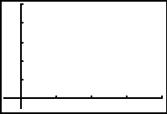
Analysis:
Once you have a good displacement/time graph, press ENTER. You can select the displacement/time, velocity/time and acceleration/time curves from this menu.

A Displacement/Time
1. Sketch the displacement/time graph.

2. Trace the curve with the cursor and find the time at which the displacement is at a minimum (i.e. when the can is closest to the motion detector. Record this time here:

________________

3. On which intervals of the graph is the distance increasing?

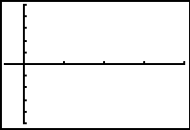
B Velocity/Time
6. Sketch the velocity/time graph.

7. Describe the shape of the curve for the interval when the can was in motion.

8. Use the cursor to find the point on this graph for the time you recorded in Part A.

9. What is the velocity at the point when the can was at the top of the roll, according to the graph? Explain what you found.

4.1.1 Ramp It Up! (Continued)

C Acceleration/Time
10. Sketch the acceleration/time graph.

11. Describe the acceleration of the object, for the interval when the can was in motion (i.e., from the time the can was released until it was caught again at the bottom of the ramp)

12. Was the acceleration positive or negative? How does this relate to the direction that the can was rolling?

This activity is adapted from one called: “What Goes Up: Displacement and Time for a Cart on a Ramp”, from the book, Real-World Math with the CBL™ System: Activities for the TI-83™ and TI-83 Plus™. Dallas, TX: Texas Instruments Inc., 1999. ISBN 1-886309-28-0.
4.1.2 More Work with Displacement, Velocity and Acceleration

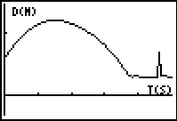
- A group of students rolled a cart up and down a ramp and recorded its motion. The motion detector was placed at the bottom of the ramp. The displacement/time graph they obtained is shown:

In your notes, sketch the velocity/time and acceleration/time graphs for this situation.

- The displacement time graph for an object moving back and forth in front of a motion detector is shown.
a) State the points where the velocity is zero.
b) At what time(s) is the acceleration zero?
c) State the intervals where the object is moving toward the motion detector.
d) At what time(s) are both the acceleration and the velocity negative?
e) Describe the motion of this object for the first 2.5 seconds. Make references to the characteristics of the function (increasing/decreasing, concavity etc.) as you explain the behaviour of the object.
Unit 4: Day 2: Applications of Derivatives - 1 |  |  |  | MCV4U
Minds On: 5 |  | Learning Goals:  - Make connections between the graphical or algebraic representations of derivatives and real-world applications.  - Solve problems, using derivatives, that involve instantaneous rates of change, including problems arising from real-world applications, given the equation of a function |  | Materials  - Graphing calculators  - BLM 4.2.1  - BLM 4.2.2
Action: 60 |  |  |  | Materials  - Graphing calculators  - BLM 4.2.1  - BLM 4.2.2
Consolidate:10 |  |  |  | Materials  - Graphing calculators  - BLM 4.2.1  - BLM 4.2.2
Total=75 min |  |  |  | Materials  - Graphing calculators  - BLM 4.2.1  - BLM 4.2.2
Assessment
Opportunities
 | Minds On… | Whole Class → Discussion  Lead a discussion where students recall examples of applications of derivatives that they have already seen.. Ask them to suggest other examples from the real-world where derivatives and properties of functions might be applied.  Tell students that during the next several classes they will become familiar with a variety of real life applications of derivatives. |  | More emphasis should be put on using algebraic methods asking students to develop one or more of the equations (e.g. the equation in part 2 of the activity, using the formula for the geometric series) in the models and /or the equations of the derivatives.  Alternatively, students may be provided with the pre-developed equations of the derivatives and asked to perform the analysis of the properties using graphic technology only.
 | Action! | Pairs→ A Coaches B  Students complete the problems on BLM 4.2.1 that features four examples of applications of derivatives. For each problem A will solve the problem while B coaches. Alternate roles for each problem. Students use both graphical and algebraic methods to solve the problems.  Process Expectation/Performance Task/Anecdotal  Provide feedback to students as they complete BLM 4.2.1 about their computational strategies as well as effective use of available tools.  Mathematical Process Focus: Selecting Tools and Computational Strategies
 | Consolidate Debrief | Whole Class → Teacher Led Discussion  Using BLM 4.2.2 as a guide, lead a discussion highlighting the importance of accurate interpretation of information derived from graphs in order to avoid confusions and misunderstanding.
Independent practice  Application |  | Home Activity or Further Classroom Consolidation  Complete selected problems.  Bring examples of a proper/improper interpretation from media or your own experience to class tomorrow.

4.2.1 Math is all around us (and Derivatives, too)

In this activity, you will explore several examples of applications of derivatives and will analyze real-world processes using graphs and properties of functions.

Problem 1: Revisiting Exponential Growth

At time t = 0 a population has size 1000. Suppose it grows exponentially, so that at time t (years) it has size S(t) = 1000a^{t} for some a and all t > 0.

a) Suppose that it doubles in size every 8 years. What is a?

b) After how many years is the population 32 000?

c) What is its instantaneous growth rate (individuals per year) at t = 10?

d) What is its instantaneous per capita growth rate at t = 10?

e) What is its instantaneous percentage growth rate at t = 10?
4.2.1 Math is all around us (and Derivatives, too) (Continued)

Problem 2: Time/Concentration Curve of a Single Dose of a Drug
The concentration, P(t), of a drug in the bloodstream t hours after the drug is injected into a muscle is modelled by the function $P(t)=t⋅e^{−0\text{.}\text{92}t}$. (P (t) is measured in mg per 100mL).
- Graph the function P(t) on a graphing calculator in the window [0,7] by [0,0.5]. Sketch the graph in your notes and label the axes accordingly.

- Using rules of differentiation, find the first and the second derivative of the function P(t).

- When does the drug concentration reach its maximum? What is the maximum concentration?

- State the intervals of increase and decrease of the function.

- Describe the graph in terms of the rate of increase /decrease. When is the rate of change the greatest? When is it the least?

- Graph P’(t) and P”(t) on the same window. (Enter these functions in the “Y=” editor of the graphing calculator). Sketch the graphs in your notes (you can use the same set of axes). Describe connections among the graphs of the three functions.

4.2.1 Math is all around us (and Derivatives, too)! (Continued)

Problem 3: Looking through an Economical Glass
The definitions below are from http://en.wikipedia.org/wiki/Consumer_price_index.
The word “inflation” refers to a persistent rise in the general price level, as measured against a standard level of purchasing power. Due to the fact that different prices affect different people, there are many varying measures of inflation in use. The most well known are the CPI which measures the change in nominal consumer prices, and the GDP (Gross Domestic Product) deflator, which measures inflation in new products and services created.

Disinflation is a decrease in the rate of inflation.

The graph shows an example of the customer price index changing from year 1990 (t=0) to year 2005 (t=15). It measures how much a basket of commodities (prices for the goods and services, rents, etc.) that cost $100 in 1990 would const at any given time, t, after 1990.
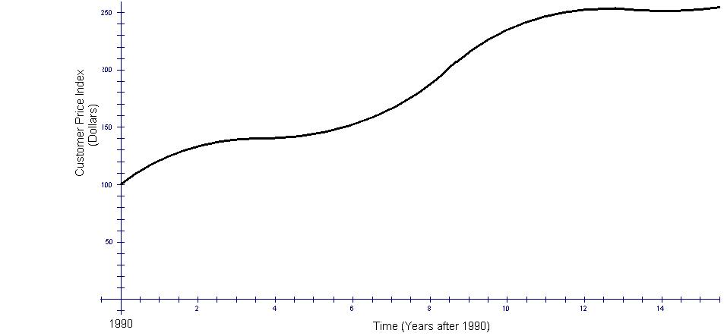
- In what year was the rate of increase of the CPI the greatest; in what year was it the least?

- State approximate periods of disinflation.

- Are there any periods of deflation?
- Compare the inflation rates in 1995 and 2000.
4.2.1 Math is all around us (and Derivatives, too)! (Continued)
Problem 4: Let There Be LIGHT!
The table below contains the hours of daylight throughout one year in Ottawa, ON, (45°N Lattitude).

Date | Jan 16 | Feb 16 | Mar 16 | Apr 16 | May 16 | Jun 16
Hours light | 8.95 | 10.18 | 11.62 | 13.27 | 14.65 | 15.40
Date | Jul 16 | Aug 16 | Sep 16 | Oct 16 | Nov 16 | Dec 16
Hours light | 15.10 | 13.90 | 12.30 | 10.71 | 9.30 | 8.60

* Data Source: http://www.orchidculture.com/COD/daylength.html#45N

- Plot the points. Use x-values from 0 to 12, for January 16 being x=0, December 16 being x=11 and January 16 again being x=12.
- Determine a sinusoidal function which models the daylight hours with respect to date in the year. Graph your function.

- Describe the rate of change of the graph in the following intervals:
  - January to March
  - March to June
  - June to September
  - September to December
- Find the equation of the first derivative of D(x).

- Graph the function D’(x) on the same screen. How do the answers to part C make sense in terms of the graph of D’(x)?
Beware of Traps
It is essential to learn how to interpret information about a function or a model from its graph accurately. Not only is it important to determine intervals of increase/decrease and critical points of a function. Often, the way the graph’s slope changes provides even more significant information about the modelled process or event.
Compare the graphs of four functions presented below:
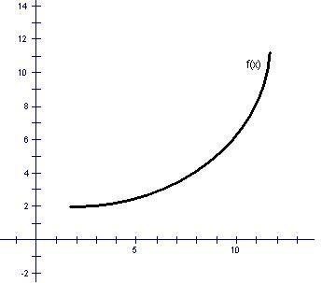  Increasing, at an increasing rate | 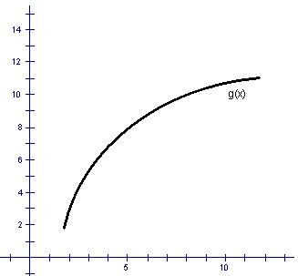  Increasing, at a decreasing rate
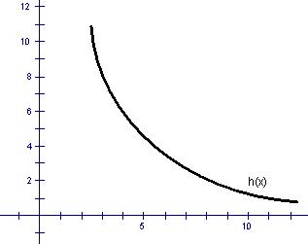  Decreasing, at an increasing rate | 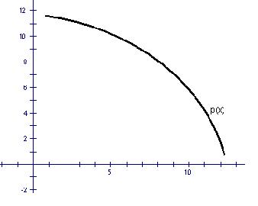  Decreasing, at a decreasing rate

Usually, we tend to associate increasing rates with graphs that become “steeper”. This is correct when the function is increasing itself and the slopes are positive. However, when the function is decreasing and the slopes are negative, the increase of the steepness of the graph means that
the magnitude of the slope increases, thus, the number becomes “more negative” and the actual value of the slope is decreasing.
Most misconceptions and inaccurate interpretations related to these comments occur in non-scientific and non-mathematical sources of information (e.g. media products or popular magazines). For instance, suppose the level of energy consumption in a selected community (named SAMPLE) for one year is given by a graph that is similar to the one of g(x) above. The community newspaper published the following message: “Municipal authorities reported that toward the end of last year our community has cut the increase of energy consumption compared to the beginning of the year.” For the general public, this message most likely would imply that the community used less energy in the end of the year. However, the message actually stated that there was a reduction of the rate of increase of the energy consumption, with the consumption still increasing, but slower.

Unit 4: Day 3: Applications of Derivatives - 2 |  |  |  | MCV4U
Minds On: 5 |  | Learning Goals:  - Make connections between the graphical or algebraic representations of derivatives and real-world applications.  - Solve problems, using derivatives, that involve instantaneous rates of change, including problems arising from real-world applications, given the equation of a function |  | Materials  - Graphing calculators  - BLM 4.3.1
Action: 65 |  |  |  | Materials  - Graphing calculators  - BLM 4.3.1
Consolidate: 5 |  |  |  | Materials  - Graphing calculators  - BLM 4.3.1
Total=75 min |  |  |  | Materials  - Graphing calculators  - BLM 4.3.1
Assessment
Opportunities
 | Minds On… | Pairs → Pair Share  Students coach each other as they complete a problem similar to the work from the previous class. (A coaches B, and B writes, then reverse roles) |  | Each pair of students has only one piece of paper and one writing instrument.  For more information on Jig Saw and other cooperative learning strategies see Beyond Monet by Barry Bennett
 | Action! | Groups → Jig Saw (Home Groups)  Form homogeneous home groups of 5 students. Using numbered heads, assign each member of the group one of the sub-sets of problems from BLM4.3.1.  Groups → Jig Saw (Expert Groups)  Form expert groups for each of the five topics listed. Each group solves their problem ensuring each member becomes an expert.  Groups → Jig Saw (Home Groups)  Students return to their home groups. Each expert presents to the group their solution to their problem. All students in the home group should ask questions and take notes for their own records..  Learning Skills/Observation/Rubric  Observe students’ on team work and provide feedback to them.  Mathematical Process Focus: Communicating and Problem Solving
 | Consolidate Debrief | Whole Class → Discussion  Ask students to reflect on what they have learned through the activity.  Have them comment on applications that they found most relevant with respect to their interests or future careers.
Independent practice  Application |  | Home Activity or Further Classroom Consolidation  Complete all problems from BLM 4.3.1.

4.3.1 More Applications of Derivatives

In this activity, you will explore several examples of applications of derivatives and will analyze real-world processes using graphs and properties of functions.

1. Exponential Model

Many processes in science, economics, and demography involve quantities that increase with time. If, at every instant, the rate of increase of the quantity is proportional to the quantity at that instant, it is said that the growth is exponential.

A typical example of exponential growth is the growth of a population of living organisms. The mathematical model that represents this process is represented by the equation$P=P_{0}e^{\text{ct}}$. Here P is the number pf individuals at time t, P₀ is the initial number of individuals at time t=0 and c is a constant that depends on the population and represents its relative rate of change.

A population of E. coli bacteria grows exponentially and doubles every 15 minutes. Suppose that at time t = 0 there are 800 cells.

- Determine the exponential model that represents the number of bacteria at time t. Write your equation in both the forms P = P₀r^{t} and P = P₀e^{ct}.

- Interpret the value of the constant c obtained in part (a).

- How long will it take for the population to reach 10200 cells?

- At what rate is the population growing initially? after 3 hours?

- At what rate is the population growing at the instant when it reaches 20000 cells?

4.3.1 More Applications of Derivatives (Continued)

2. Rational Expression Model

Let f(t) be the percent oxygen in a lake t days after sewage is dumped into a lake and suppose that f(t) is given approximately by $f(t)=1−\frac{\text{10}}{t+\text{10}}+\frac{\text{100}}{(t+\text{10})^{2}}$.

- Make graph of the model on your calculator. Sketch the graph.

- State the domain and range of the function for this context.

- At what time is the level of oxygen highest? Why?

- Determine the time it takes for the oxygen level to reach 50%

- At what time is the oxygen decreasing the fastest?

4.3.1 More Applications of Derivatives (Continued)

3. Periodic Model

A person’s blood pressure constantly fluctuates between its maximum value (called the systolic pressure) and its minimum value (called the diastolic pressure). “The systolic pressure is defined as the peak pressure in the arteries, which occurs near the beginning of the cardiac cycle; the diastolic pressure is the lowest pressure (at the resting phase of the cardiac cycle)” (www.wikipedia.org). A person’s blood pressure can be represented by a periodic function in terms of time t (in seconds) and can be modelled by the equation$P(t)=\text{100}+\text{20}\text{cos}(6t)$.

- What are the values of the systolic and the diastolic pressure, according to the model?

- What is the duration of one cardiac cycle, in seconds?

- Compare the rates of change of the blood pressure at the beginning of the cycle, after 1/5 of the cycle, after 3/5 of the cycle and at the end of the cycle.

4.3.1 More Applications of Derivatives (Continued)

4&5. Volume and Rates of Flow

Note: Expert 4 will do parts a to c and expert 5 will do parts d to f.

In all problems below, water is flowing at a constant rate into the containers. This means that constant volume is filled with water per unit time. You will be exploring the rate of change of the height of the water in the containers in terms of time.


a) Cylindrical container. Sketch a graph that could represent the depth of the water against time. Describe the rate of change of the height in terms of time.
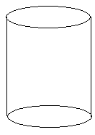

b) Conical container. Sketch a graph that could represent the depth of the water against time. Describe the rate of change of the height in terms of time.
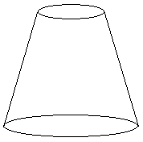

4.3.1 More Applications of Derivatives (Continued)

c) X-shaped container. Sketch a graph that could represent the depth of the water against time. Describe the rate of change of the height in terms of time.

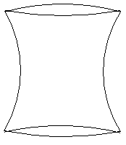

d) O-shaped container. Sketch a graph that could represent the depth of the water against time. Describe the rate of change of the height in terms of time. Mark on the graph the time at which the water reaches the widest point of the container.



4.3.1: More Applications (continued)

e) U-shaped container. Sketch a graph that could represent the depth of the water against time. Describe the rate of change of the height in terms of time. Mark on the graph the time at which the water reaches the corner of the container.
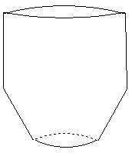

f) “Non-alphabet-shaped” container. Sketch a graph that could represent the depth of the water against time. Describe the rate of change of the height in terms of time. Mark on the graph the time at which the water reaches the corner of the container.

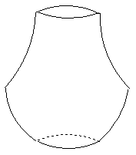

Problems 3 -5 in this activity have been modified from Hughes-Hallett, et al. Calculus. John Willey &Sons Inc., 1994.

