Unit 2 Calculus and Vectors Exploring Derivatives

Lesson Outline

Day | Lesson Title | Math Learning Goals | Expectations
1 | Key characteristics of instantaneous rates of change  (TIPS4RM Lesson) | • Determine intervals in order to identify increasing, decreasing, and zero rates of change using graphical and numerical representations of polynomial functions  • Describe the behaviour of the instantaneous rate of change at and between local maxima and minima | A2.1
2 | Patterns in the Derivative of Polynomial Functions  (TIPSRM Lesson) | • Use numerical and graphical representations to define and explore the derivative function of a polynomial function with technology,  • Make connections between the graphs of the derivative function and the function | A2.2
3 | Derivatives of Polynomial Functions  (Sample Lesson Included) | • Determine, using limits, the algebraic representation of the derivative of polynomial functions at any point | A2.3
4 | Patterns in the Derivative of Sinusoidal Functions  (Sample Lesson Included) | • Use patterning and reasoning to investigate connections graphically and numerically between the graphs of f(x) = sin(x), f(x) = cos(x), and their derivatives using technology | A2.4
5 | Patterns in the Derivative of Exponential Functions  (Sample Lesson Included) | • Determine the graph of the derivative of f(x) = a^{x} using technology  • Investigate connections between the graph of f(x) = a^{x} and its derivative using technology | A2.5
6 | Identify “e” (Sample Lesson Included) | • Investigate connections between an exponential function whose graph is the same as its derivative using technology and recognize the significance of this result | A2.6
7 | Relating f(x)= ln(x) and $f(x)=e^{x}$ (Sample Lesson Included) | • Make connections between the natural logarithm function and the function $f(x)=e^{x}$  • Make connections between the inverse relation of f(x) = ln(x) and $f(x)=e^{x}$ | A2.7
8 | Verify derivatives of exponential functions  (Sample Lesson Included) | • Verify the derivative of the exponential function f(x)=a^{x} is f’(x)=a^{x} ln a for various values of a, using technology | A2.8
9 | Jazz Day / Summative Assessment  (Sample Assessment Included)
10, 11 | Power Rule | • Verify the power rule for functions of the form f(x) = x^{n} (where n is a natural number)  • Verify the power rule applies to functions with rational exponents  • Verify numerically and graphically, and read and interpret proofs involving limits, of the constant, constant multiple, sums, and difference rules | A3.1, A3.2  A3.4
12 | Solve Problems Involving The Power Rule | • Determine the derivatives of polynomial functions algebraically, and use these to solve problems involving rates of change | A3.3
13, 14, 15 | Explore and Apply the Product Rule and the Chain Rule | • Verify the chain rule and product rule  • Solve problems involving the Product Rule and Chain Rule and develop algebraic facility where appropriate | A3.4 A3.5
16, 17 | Connections to Rational and Radical Functions (Sample Lessons Included) | • Use the Product Rule and Chain Rule to determine derivatives of rational and radical functions  • Solve problems involving rates of change for rational and radical functions and develop algebraic facility where appropriate | A3.4  A3.5
18, 19 | Applications of Derivatives | • Pose and solve problems in context involving instantaneous rates of change | A3.5
20 | Jazz Day
21 | Summative Assessment

Note: TIPS4RM Lesson refers to a lesson developed by writing teams funded by the Ministry of Education. These lessons are not included with this package. They will be available at a later date. Details will be posted on the OAME web site. (www.oame.on.ca)

Note: The assessment on day 9 is available from the member area of the OAME website and from the OMCA website (www.omca.ca).
Unit 2: Day 3 Algebraic Representation of the Derivative of Polynomial Functions |  |  |  | MCV4U
Minds On: 5 |  | Learning Goal:  - Determine the derivatives of polynomial functions by simplifying the algebraic expression $\frac{f(x+h)−f(x)}{h}$and then taking the limit of the simplified expression as 'h' approaches zero. |  | Materials  - Graphing calculators  - BLM 2.3.1  - BLM 2.3.2
Action: 55 |  |  |  | Materials  - Graphing calculators  - BLM 2.3.1  - BLM 2.3.2
Consolidate:10 |  |  |  | Materials  - Graphing calculators  - BLM 2.3.1  - BLM 2.3.2
Total=75 min |  |  |  | Materials  - Graphing calculators  - BLM 2.3.1  - BLM 2.3.2
Assessment
Opportunities
 | Minds On… | Pairs→ Think/Pair/Share  Students have 1 minute to think about and record their prior knowledge of average rates of change and approximations of instantaneous rates of change and how they relate to secant lines and tangent lines. They should then pair with a partner and share, editing their list during the discussion.  Whole Class → Discussion  Ask select students to share one point their partner had. |  | Students can be assigned varying values of h for comparison, or choose their own.  By storing the varying 'h' values in the different lists in the graphing calculators, the calculations can be done very quickly.
 | Action! | Groups → Investigation  In heterogeneous groups of 3 or 4, students complete BLM 2.3.1.  Whole Class → Debrief  Have students explain, in their own words, the relationship between the graph of a function and the graph of its derivative. Summarize the student thoughts on the blackboard.  Process Expectation/Oral Questions/Mental Note  As students explain their reasoning and respond to questions, assess their ability to make connections.  Mathematical Process Focus: Connecting  Whole Class → Teacher Led Discussion  Using BLM 2.3.2 as a guide, demonstrate how the first principles’ definition, $\underset{h→0}{\text{lim}}\frac{f(x+h)−f(x)}{h}$, can determine the derivative function for polynomial functions.
 | Consolidate Debrief | Groups → Discussion  In heterogeneous groups of 3 or 4, students discuss the meaning of a derivative at a given x-value. Students debate the most appropriate technique for calculating derivatives of polynomial functions (difference of squares for even powered polynomials, difference of cubes for polynomials with powers that are multiples of 3, binomial expansion).
Concept Practice |  | Home Activity or Further Classroom Consolidation  - Determine the derivatives of f(x) = x³, x⁴, x⁵ using first principles by factoring and by expanding.  - Determine the derivative of 4x³ using the most appropriate method.  - If f(x) = 3x⁵, find f / (2) and explain its meaning.
2.3.1 Connections Between the Graph of f(x) and f / (x).

1) Complete the following table.
2) Before completing the final column, vary the value of 'h' in the expression $\frac{f(x+h)−f(x)}{h}$ and then complete the table by hypothesizing a value for f / (x) as 'h' approaches zero.

x | f(x) = x² | (x, f(x)) | h | f(x+h) | $$\frac{f(x+h)−f(x)}{h}$$ | f / (x) = $\underset{h→0}{\text{lim}}\frac{f(x+h)−f(x)}{h}$
-2
-1
0
1
2
3) Graph f(x) = x².

4) How do the values in the final column of the table relate to the graph of f(x)?

5) Sketch the tangents to f(x) at each point plotted on the graph.

6) By using the x-coordinates given, and the entries in the final column of the table, graph the derivative of f(x) on a separate grid.

7) Find the equation of f / (x) from the graph.
2.3.2 Algebraic connection between f(x) and f / (x)

In order to verify your conclusion from 2.3.1 algebraically, consider:

1) f(x) = .

2) f(x+h) = .

3) so, without simplifying $\underset{h→0}{\text{lim}}\frac{f(x+h)−f(x)}{h}$= .

4) Now, simplify the expression by:
a) factoring the difference of squares in the numerator, simplifying and then reducing.

$\underset{h→0}{\text{lim}}\frac{f(x+h)−f(x)}{h}$ =

=

=

b) expanding the numerator, simplifying the numerator and then reducing.

$\underset{h→0}{\text{lim}}\frac{f(x+h)−f(x)}{h}$ =

=

=

5) If f(x) = 3x²:
a) find f / (x).

b) What is the value of f / (4).

c) What does f / (4) mean graphically?
Unit 2: Day 4: Patterns in the Derivative of Sinusoidal Functions |  |  |  | MCV4U
Minds On: 10 |  | Learning Goal:  - Determine, through investigation using technology, the graph of the derivative f/ (x) or $\frac{\text{dy}}{\text{dx}}$of a given sinusoidal function. (A2.4) |  | Materials  - chart paperGraphing calculator  - BLM 2.4.1  - BLM 2.4.2
Action: 50
Consolidate:15
Total=75 min
Assessment
Opportunities
 | Minds On… | Whole Class → Discussion  Using graphing calculators students review how to find the derivative of a polynomial function graphically and algebraically. Share the procedure to find the slope at a point:  - Enter y = x² into y₁ =  - Use a standard window  - Graph y = x²  - Trace $→$ 3 enter  - Calc $→$ $\frac{\text{dy}}{\text{dx}}$ $→$ 3 enter, repeat for 4 and 5  Students discuss what the graphing calculator tells them about steps 4 and 5 for y = x² . (e.g., you have now generated the slopes at x = 3, 4 and 5). |  | Students can re-draw the graphs from the BLM’s and/or plot points A-M on the graph.  Students continue to add to their understanding of trigonometric graphs and radian measures and relationships between slopes and instantaneous rates of change.
 | Action! | Small Groups → Experiment  In heterogenous groups of 3 or 4 students will use graphing calculators to complete BLM 2.4.1.  As students work on BLM 2.4.1, they should consider the guiding question ”Are there any patterns or similarities in the values of y = sin(x), y =cos(x), and their derivatives?”  Process Expectation/Observation/Checkbric  Observe students as they work and assess their ability to reason and prove as they make connections between the graph and the derivative.  Mathematical Process Focus: Reasoning and Proving, Selecting Tools and Computational Strategies
 | Consolidate Debrief | Small Group → Summarizing  With their group mates, students prepare a summary of their response to the guiding question on chart paper.  Whole Class → Presentation  Groups share their summaries.
Application |  | Home Activity or Further Classroom Consolidation  Complete BLM 2.4.2
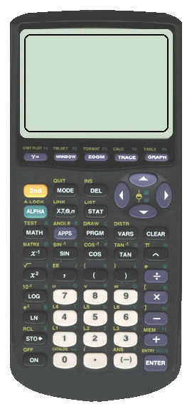
2.4.1 Looking for the Derivative of Sine and Cosine

- The graph of f(x) = sin(x) is shown.

- Complete the following chart (correct to 3 decimal places).

- Sketch the derivative of f(x) = sin(x) on the graph.

 | A | B | C | D | E | F | G | H | I | J | K | L | M
x (radians) | 0 | $$\frac{π}{6}$$ | $$\frac{π}{3}$$ | $$\frac{π}{2}$$ | $$\frac{2π}{3}$$ | $$\frac{5π}{6}$$ | $$π$$ | $$\frac{7π}{6}$$ | $$\frac{4π}{3}$$ | $$\frac{3π}{2}$$ | $$\frac{5π}{3}$$ | $$\frac{\text{11}π}{6}$$ | $$2π$$
F (x)
F / (x)

c) How does the graph of f’(x) compare to the graph of f(x)? Describe all similarities and differences that you observe.
2.4.1 Looking for the Derivative of Sine and Cosine (Continued)
- The graph of f(x) = cos(x) is shown.

- Complete the following chart (correct to 3 decimal places).

- Draw the derivative of f(x) = cos(x) on the graph.

 | A | B | C | D | E | F | G | H | I | J | K | L | M
x (radians) | 0 | $$\frac{π}{6}$$ | $$\frac{π}{3}$$ | $$\frac{π}{2}$$ | $$\frac{2π}{3}$$ | $$\frac{5π}{6}$$ | $$π$$ | $$\frac{7π}{6}$$ | $$\frac{4π}{3}$$ | $$\frac{3π}{2}$$ | $$\frac{5π}{3}$$ | $$\frac{\text{11}π}{6}$$ | $$2π$$
f (x)
F / (x)

c) How does the graph of f’(x) compare to the graph of f(x)? Describe all similarities and differences that you observe.

2.4.1 Looking for the Derivative of Sine and Cosine (Continued)

3. What is the derivative of f(x) = sin(x)?

4. What is the derivative of f(x) = cos(x)?

5. Summarize the graphical and numeric connections you found between the two functions.
2.4.2: Sinusoidal Problems

- Determine and interpret f(1.037) and f /(1.037)

- Determine and interpret f($\frac{3π}{4}$) and f /($\frac{3π}{4}$)

- An object moves so that at time t its position s is found using s(t) = 5∙cos(t).
  - For what values of 't' does the object change direction?
  - What is its maximum velocity?
  - What is its minimum distance from (0,1)?

- Are there any numbers x, , for which tangents to f(x) = sin(x) and f(x) = cos(x) are parallel? If so, find the values.

Unit 2: Day 5: Patterns in the Derivative of Exponential Function |  |  |  |  |  | MCV4U
Minds On: 25 |  |  | - Learning Goals:  Investigate connections between the graph of f(x)=a^{x} and its derivative using technology  Explore the ratio of f’(x)/f(x). |  |  | Materials  graphing calculators  BLM 2.5.1 - 2.5.3  Computer and data projector  BLM 2.5.4 (optional)
Action: 35
Consolidate:15
Total=75 min
Assessment
Opportunities
 | Minds On… | Pairs → Activity  Students work in pairs to complete BLM 2.5.1.  Whole Class → Discussion  Pairs share their solutions to BLM 2.5.1  Ask all students to compare the equation of a polynomial function f(x)=xª to the equation of the exponential function f(x)=a^{x} and consider similarities and differences.²  Ask for suggestions about possible ways to differentiate the exponential function. Review the process of finding the derivative using limits. |  |  | Notes:  A common misconception is to consider the polynomial and exponential functions to be similar.
 | Action! | Small Groups → Guided Exploration  - In heterogeneous groups of 3 or 4, students complete BLM 2.5.2.. Students may refer to BLM 2.5.4 for graphing calculator instructions.  Curriculum Expectations/Oral Questions/Mental Note  Assess student understanding of unit expectations with oral questions. Address common misconceptions immediately and during the consolidation time.  Mathematical Process Focus: Connecting, Representing |  |  | An alternative lesson is a whole class guided exploration, using TI Emulator or the GSP diagram R2.5.a_x_numeric.gsp).  Teacher notes for BLM 2.5.2 are included on BLM 2.5.3.
 | Consolidate Debrief | Whole Class → Discussion, Sharing, Completing Notes  Generalize student findings from the investigation activities to develop a method to calculate the slope of the tangents to the graph of f(x) at a given point.  - Apply the student generated method to some examples and revise as necessary.
Practice |  | Home Activity or Further Classroom Consolidation  Select practice questions from (teacher generated list).
2.5.1 Revisiting the Exponential Function

Function defined by an equation f(x) = a^{x} , where a is a real positive number, is called an Exponential Function.

There is a significant difference between the graphs and the properties of the function when a>1 and when 0<a<1.

Case 1: f(x)=a^{x}, a>1.

Domain:

Range:

Asymptote:

The function is …………………… over the whole domain

Case 2: f(x)=a^{x}, 0<a<1.

Domain:

Range:

Asymptote:

The function is …………………… over the whole domain

2.5.2: Exponential Derivatives
Use a graphing calculator to complete these tasks.
For each of the functions below:
- Graph the function from its equation.
- Create a table of values for x, f(x), and f’(x), for at least three values of x
(-1, 0, 1 is a suggested but not a mandatory choice).
- Calculate the ratio $\frac{f^{'}(x)}{f(x)}$.
- Draw the tangent to the graph of f(x) at x=0. Determine the slope of the tangent.
- Summarize your findings.

f(x)=$4^{x}$ | Slope of the tangent at x=0:…….  f’(0)=……..  Conclusion:…………………………………………
f(x)=$2\text{.}5^{x}$ | Slope of the tangent at x=0:…….  f’(0)=……..  Conclusion:…………………………………………
2.5.2: Exponential Derivatives (Continued)
f(x)=$0\text{.}2^{x}$ | Slope of the tangent at x=0:…….  f’(0)=……..  Conclusion:…………………………………………

In General:
Record what you noticed about each of the following:
- The derivative of the exponential function f(x)=a^{x}

- The ratio $\frac{f^{'}(x)}{f(x)}$

- The relationship between f(x) and f’(x)

- The slope of the tangent at x = 0

Examples:
1. Calculate the slope of the tangent to f(x)=0.2^{x} at x=12.5 , using ONLY the data from the activity.

2. For an exponential function f(x) the ratio $\frac{f^{'}(x)}{f(x)}$=1.946, determine the equation of the tangent line to the graph of the function at the point (0.5, 2.646).
2.5.3: Exponential Derivatives (Teacher Notes)

Minds On:

Recall the Limit Definition of the Derivative: $f^{'}(x)=\underset{h→0}{\text{lim}}\frac{f^{'}(x+h)−f(x)}{h}$

Apply to the exponential function, $f(x)=b^{x}$
$$\begin{aligned}f^{'}(x)=\underset{h→0}{\text{lim}}\frac{b^{x+h}−b^{x}}{h} \\ \underset{h→0}{\text{lim}}\frac{b^{x}b^{h}−b^{x}}{h} \\ \underset{h→0}{\text{lim}}\frac{b^{x}(b^{h}−1)}{h} \\ b^{x}\underset{h→0}{\text{lim}}\frac{b^{h}−1}{h}\end{aligned}$$ | $$f^{'}(x)=b^{x}\underset{h→0}{\text{lim}}\frac{b^{h}−1}{h}$$
So the derivative of the exponential function $f(x)=b^{x}$ is the factor $\underset{h→0}{\text{lim}}\frac{b^{h}−1}{h}$ multiplied by the original function.
Note that $f^{'}(0)=b^{0}\underset{h→0}{\text{lim}}\frac{b^{h}−1}{h}$ and $b^{0}=1$, so$f^{'}(0)=\underset{h→0}{\text{lim}}\frac{b^{h}−1}{h}$. In other words $\underset{h→0}{\text{lim}}\frac{b^{h}−1}{h}$ is the slope of the curve at the y-intercept.
---------------------------------------------------------------------------------------------------------
Notes:
1. Based on the results from the table, suggest a function that represents f’(x).

………………EXPONENTIAL or f’(x)=c.a^{x} +b……………………………….

1. Use the data from the table to calculate the ratio f’(x)/f(x):
X | -2 | -1 | 0 | 1 | 2
f’(x)/f(x) | 0.693 | 0.693 | 0.693 | 0.693 | 0.693

- What do you observe?

THE RATIO IS CONSTANT AND EQUALS THE VALUE OF f’(0)…………….

In General: (possible responses)

- The derivative of the exponential function f(x)=a^{x} is an exponential function.

- For each exponential function f(x), the ratio f’(x)/f(x) is constant, hence, the derivative function f’(x) relates to f(x) according to the equation f’(x)=f(x).const .

- The slope of the tangent at x=0 equals the ratio f’(x)/f(x) (or the constant from the equation) and depends on the base of the function, a.
2.5.4 “HOW TO” Hints for TI Graphing Calculators

Calculate f’(x) for a specific value of x
- Enter the equation of f(x) in the “Y=” editor.
- Graph the function.
- From CALC menu (2ND, TRACE), select 6: dy/dx.
- Type in the value of x, where you need the value of the tangent’s slope.
- Press ENTER.

Plot points (x, f’(x))
- Press STAT -> EDIT->1, ENTER. Enter the values of x in L1 and the values of f’(x) in L2.
- In STAT PLOT (2ND, Y=), turn PLOT1 ON and choose the first TYPE (scatter plot) to represent the points making sure Xlist is L₁ and YList is L₂
- . Plot the points by pressing GRAPH.

Use the regression modelling feature to find a function that approximately represents f’(x).
- After the points are plotted, enter the STAT CALC menu (STAT->CALC).
- Select an appropriate regression model, then press ENTER. Its name appears on the screen.
- Following the name of the model, enter the name of the Xlist (L1), Ylist (L2), and the function (Y2) where the regression equation is to be stored (VARS->Y-VARS, 1:Function, ENTER, 2:Y2).
- The regression equation can be seen in the “Y=” editor. To graph the regression function, make sure the “=” sign for Y2 in the “Y=” editor is highlighted, then press GRAPH.

Construct table of values from an equation of f(x)
- Enter the equation of f(x) in the “Y=” editor.
- Enter the TABLE SETUP menu (2ND, WINDOW). Set the initial value (TblStart) and the increment value (ΔTbl) for the independent variable x. Leave the parameters Indpnt and Depend to Auto.
- Press 2ND, GRAPH to construct the table of values.

Draw a tangent to the graph of f(x) at a given point
- Enter the equation of f(x) in the “Y=” editor.
- Graph the function.
- Enter the DRAW menu (2ND, PRGM) and select 5:Tangent. On the graph of the function, a point appears, and its coordinates are shown below the graph. To select another point, just type in the desired value of x. The tangent line and its equation appear on the screen.
Unit 2: Day 6: Identifying ‘e’ |  |  |  |  | MCV4U
Minds On: 15  Action: 55  Consolidate: 5  Total=75 min |  | Math Learning Goals  - Investigate connections between an exponential function whose graph is the same as its derivative using technology  - Determine an approximation of the number e and its significance |  |  | Materials  - Graphing Calculators  - Computer and data projector  - BLM 2.6.1 – 2.6.3  - BLM 2.6.4 (Optional)
Assessment
Opportunities
 | Minds On… | Whole Class → Discussion  Demonstrate using the GSP sketch the notion of the derivative of an exponential function being an exponential function with the same base as the original multiplied by a factor.  Pairs → Drawing Tangents  Students complete BLM 2.6.1 in pairs checking their accuracy with a partner. They should sketch the graphs and draw the tangent lines as accurately as possible. |  |  | Students could investigate in pairs.  *The limit definition of the derivative is required in A2.8. Its discussion here makes a good connection. By adjusting the base, students should determine that there is a particular base for which the derivative is identical to the original function, and its value is approx. 2.7.  BLM 2.6.3 provides some extensions on “e”. BLM 2.6.4 provides teacher notes.
 | Action! | Whole Class → Discussion  Discuss the derivative of the exponential function using the limit definition. and making connections to BLM 2.6.1.  Pairs → Evaluating Limits  Students complete the chart on BLM 2.6.2 in pairs checking their method with a partner.  Whole Class → Discussion  Discuss the approximation of the value of the base of the exponential function having a slope of 1 at the y-intercept.  Pairs → Evaluating Limits  Students complete of the conclusions on BLM 2.6.2 in pairs, discussing their responses with their partner.  Learning Skills/Observation/Anecdoctal  Observe students in order to assess their teamwork and work habits. Provide anecdotal feedback as appropriate.  Mathematical Process Focus: Reflecting, Reasoning and Proving, Connecting
 | Consolidate Debrief | Whole Class → Discussion  Show the graph of $y=e^{x}$ emphasizing the fact that the curve is as steep as the y-value at any point. Highlight the many applications of this behaviour, including population growth, investments, appreciation and depreciation of value, radioactive decay, and cooling and warming.
Application |  | Home Activity or Further Classroom Consolidation  Create transformations of $f(x)=e^{x}$and draw the corresponding graph.  .
2.6.1 Introducing the number “e”

Problem: How steep is the tangent line to the graph of an exponential function at its y-intercept?

For each function:
- draw the graph
- draw the tangent line to the graph at the y-intercept of the graph
- use your calculator to determine the slope of the tangent line to the graph at the y-intercept.

1. $y=2^{x}$
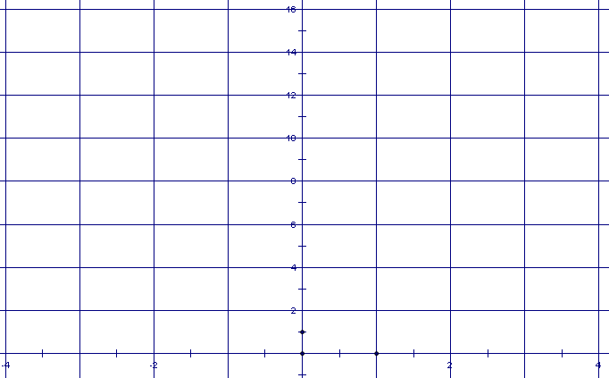 | $$\frac{\text{dy}}{\text{dx}}|_{x=0}=\text{____________}$$

2. $y=3^{x}$
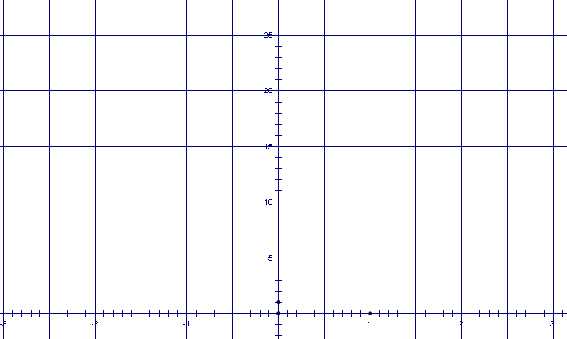 | $$\frac{\text{dy}}{\text{dx}}|_{x=0}=\text{____________}$$

2.6.2 The value of the limit

Test the limit on various values of b using your calculator or a spreadsheet:

a) Let b = 2 and evaluate $\underset{h→0}{\text{lim}}\frac{2^{h}−1}{h}$ |  |  | b) Let b = 3 and  evaluate $\underset{h→0}{\text{lim}}\frac{3^{h}−1}{h}$ |  |  | c) Guess a value for b so that the limit is as close to 1 as possible.  b = _____ $\underset{h→0}{\text{lim}}\frac{b^{h}−1}{h}$
H | $$\frac{b^{h}−1}{h}$$ |  | H | $$\frac{b^{h}−1}{h}$$ |  | h | $$\frac{b^{h}−1}{h}$$
1 |  |  | 1 |  |  | 1
0.5 |  |  | 0.5 |  |  | 0.5
0.1 |  |  | 0.1 |  |  | 0.1
0.01 |  |  | 0.01 |  |  | 0.01
0.001 |  |  | 0.001 |  |  | 0.001
0.0001 |  |  | 0.0001 |  |  | 0.0001

Conclusions:
- If $f(x)=2^{x}$ then $f^{'}(x)=$___________________

- If $f(x)=3^{x}$ then $f^{'}(x)=$___________________

- If $f(x)={\left(\text{___}\right)}^{x}$ then $f^{'}(x)\overset{˙}{=}$___________________

2.6.3 Extensions

Using a scientific calculator, evaluate these expressions:
- choose a large x value and substitute it into the expression ${\left(1+\frac{1}{x}\right)}^{x}$
x = _____________ ${\left(1+\frac{1}{x}\right)}^{x}=\text{________________}$
- choose a value of x very close to 0 and substitute it into the expression ${\left(1+x\right)}^{\frac{1}{x}}$

x = _____________ ${\left(1+x\right)}^{\frac{1}{x}}=\text{________________}$

- at least 7 terms of the series $1+\frac{1}{1!}+\frac{1}{2!}+\frac{1}{3!}+\text{.}\text{.}\text{.}$
number of terms:__________ sum: ________________
2.6.4 Extensions (Teacher Notes)

The value of b that makes $\underset{h→0}{\text{lim}}\frac{b^{h}−1}{h}=1$ is called Euler’s Number and is represented by the symbol “e”.
This special, irrational number is equivalent to the following fundamental limits and the infinite series:
i) $e=\underset{x→∞}{\text{lim}}{\left(1+\frac{1}{x}\right)}^{x}$ ii) $e=\underset{x→0}{\text{lim}}{\left(1+x\right)}^{\frac{1}{x}}$ iii) $e=1+\frac{1}{1!}+\frac{1}{2!}+\frac{1}{3!}+\text{.}\text{.}\text{.}$

Using a scientific calculator, evaluate these expressions:
- choose a large x value and substitute it into the expression ${\left(1+\frac{1}{x}\right)}^{x}$
x = 100
- choose a value of x very close to 0 and substitute it into the expression ${\left(1+x\right)}^{\frac{1}{x}}$
x = 0.0001

- at least 7 terms of the series $1+\frac{1}{1!}+\frac{1}{2!}+\frac{1}{3!}+\text{.}\text{.}\text{.}$

number of terms: 10 sum: 2.71828

Euler determined that the value of $e=2\text{.}\text{718281}\text{.}\text{.}\text{.}$ which does not repeat and does not terminate.
You can use your calculator to show this value with the $e^{x}$ key..
Unit 2: Day 7: The Natural Logarithmic Function |  |  |  |  | MCV4U
Minds On: 10 Action: 50 Consolidate: 15 Total = 75 min |  |  | - Learning Goal:  - Make connections between the natural logarithm function and the function f(x)=e^{x}.  - Make connections between the inverse relation of f(x) = ln x and f(x) = e^{x} including compositions of the two functions. |  | Materials  - Graphing calculators  - Ruler  - BLM 2.7.1  - BLM 2.7.2
Assessment
Opportunities
 | Minds On… | Individual → Investigation  - Ask students to create a function and determine its inverse using a graphing calculator or other method of choice.  Whole Class → Discussion  - Students should share their function and inverse with the class and discuss how the graph of a function and the graph of its inverse function are related.  Pose the guiding question for this lesson: Does the inverse of the natural exponential function exist and, if yes, what is it? Have students share their immediate reactions to this question.
 | Action! | Pairs → Investigation  - Students complete BLM 2.7.1.  Mathematical Process Focus: Connecting, Reflecting  Process Expectations/Observation/Mental Note  Observe students’ ability to reflect and connect during this activity. Highlight strong skills during the debrief.  Whole Class → Discussion  - Have students share their response to the guiding question. Through discussion of student ideas, confirm that log_{e}x, or ln x is the inverse of e^{x}, just as log_{a}x was determined to be the inverse of a^{x} in MHF4U.  Pairs → Consolidating concepts  - Students work on BLM 2.7.2.
 | Consolidate Debrief | Whole class → Discussion  - Have students summarize what they have learned from the activities using a graphic organizer.¹
Application  Concept Practice |  | Home Activity or Further Classroom Consolidation  Complete BLM 2.7.3.

2.7.1 It Is So Natural!

- A table of values is given for f(x)=e^{x}. On the grid, graph the following:
- f(x)=e^{x}
- f(x) = x (the line y = x)
- the reflection of the graph of f(x)=e^{x} in the line y = x.
(Hint: For each point (a, b) on the graph of f(x), the point (b, a) is its reflection image on the line y = x.)

Choose appropriate scales for the axes.

X | -2 | -1 | 0 | 1 | 2
e^{x}  (to the nearest hundredth) | 0.14 | 0.37 | 1 | 2.72 | 7.39


2.7.1 It Is So Natural! (Continued)

3. Does the graph of the reflection appear to represent a function? Explain.

4. Denote graph of the reflection g(x) and label the graphs accordingly. Complete the table below to compare the two graphs:

 | f(x) | g(x)
Domain

Range

Asymptote

x-intercept(s)

y-intercept(s)

Intervals where the function increases

Intervals where the function increases

5. Does the inverse of the natural exponential function exist and, if yes, what is it?
2.7.2: The Inverse Relationship: e^{x} and ln x!

1. Use the Inverse Function feature of the graphing calculator to show that f(x) = e^{x} and g(x) = ln x are inverse functions. Each partner needs a calculator.

Partner 1 | Partner 2
Enter f(x) = e^{x} as Y1 in the “Y=”editor.  Graph it.  From the DRAW menu (2ND, PRGM),  select 8: DrawInv.  Enter the parameter Y1  (VARS->Y-VARS; 1: Function; 1:Y1).  Press ENTER | Enter f(x) = ln(x) as Y1 in the “Y=”editor.  Graph it.  From the DRAW menu (2ND, PRGM),  select 8: DrawInv.  Enter the parameter Y1 (VARS->Y-VARS; 1: Function; 1:Y1).  Press ENTER

Compare your graphs with your partner. Explain to your partner how you constructed your graph.

How do the graphs of f(x) = e^{x} and its inverse and g(x) = ln x and its inverse compare?

2. Since f(x) = e^{x} and g(x) = ln x are inverse functions, then f(g(x)) = g(f(x)) = x. This is called the Identity Property for inverse functions.
a) What is ? On what domain is defined?

b) What is ln (e^{x})? On what domain is ln (e^{x})? defined?

3. Verifying the Identity properties using a graphing calculator.

a) Enter the function $f(x)=e^{\text{ln}x}$ in the “Y=” editor. Graph it. How does the function relate to the function f(x) = x? (Hint: consider the domain)

b) Repeat part a) for $f(x)=\text{ln}(e^{x})$

2.7.3 It Runs in the Family!

The natural exponential function f(x) =e^{x} belongs to the family of exponential functions f(x) =a^{x}, where a>1. Similarly, the natural logarithmic function f(x) =ln x belongs to the broader family of logarithmic functions where a>1. In fact,
- y = ln x is the inverse of x = e^{y} the same way as is the inverse of x=a^{y}. As a consequence, .

Laws of Logarithms applied to Natural Logarithms

Recall that for any real numbers a, b, x, y>0, the following LOG RULES hold:
Log of a Product Rule

Log of a Quotient Rule

Log of a Power Rule

Complete the table with these rules when a=e:

LN of a Product Rule

LN of a Quotient Rule

LN of a Power Rule

- Calculate (if possible) ln x for x=3; 0.31; -2; 0. Round to the nearest thousandth.

- Compare the values of the expressions A=, B=, C= and D =. Specify which of the Natural Logarithm Rules are applicable in each case.

Evaluate the following without technology.
- Find.
- Find.
- Simplify the following expressions:
a. b. c.
Unit 2: Day 8: Verify Derivatives of Exponential Functions |  |  |  | MCV4U
Minds On: 15 |  | Learning Goal:  - Verify, using technology, that the derivative of the exponential function f(x) = a ^{x} is f / (x) = a ^{x} lna for various values of a. |  | Materials  - Graphing Calculators  - Computer and data projector  - BLM 2.8.1  - Chart paper
Action: 45
Consolidate:15
Total=75 min
Assessment
Opportunities
 | Minds On… | Pairs → Brainstorm  Using chart paper, students will create a graphical organizer (e.g., mind map, concept circle) which communicates the graphical and algebraic connections between f (x) = a ^{x} and its derivative, and between f (x) = e ^{x} and its derivative. Upon completion, these should be posted around the room.  Whole Class → Gallery Walk  Students should circulate and review at least two other graphical organizers.  . |  | Students can also find f / (x) by using the nDeriv( function on the graphing calculator in the MATH menu. The syntax is:  nDeriv(expression, variable, value)  i.e. nDeriv(2^{x}, X, -2)
 | Action! | Small Groups → Investigation  In heterogeneous groups of 3 or 4, students use the graphing calculator and BLM 2.8.1 to explore the characteristics of an exponential function and its derivative. Different values of h can be assigned to different groups to determine if varying h has an effect on the outcome.  Curriculum Expectations/Observation/Checklist  Assess student understanding of the concept of derivative as developed to this point in the unit.  Mathematical Process Focus: Reasoning and Proving
 | Consolidate Debrief | Whole Class → Discussion  Have students share their conclusions. Ask students how they might verify these conclusions using the First Principles definition.  Use GSP sketch MCV_U23L8_GSP.gsp to verify the derivative for exponential functions.  Summarize the derivative of an exponential function and its properties.
Concept Practice  Application |  | Home Activity or Further Classroom Consolidation  - Prepare a summary of the concepts learned so far in the unit for the summative assessment next class  - Find the derivative of f (x) = 5 ^{x}, f (x) = 2(5) ^{x}, f (x) = 5(5) ^{x}  - If f (x) = 4 ^{x}, find f / (4) and explain its relation to the function.  - Verify numerically using the First Principles Definition that the derivative of f (x) = a ^{x} is f / (x) = a ^{x} ln(a).

2.8.1 Verifying Derivatives of Exponential Functions

(Note: the general equation of an exponential function is f(x) = a(b^{x}).)

1. Complete the chart for f (x) = 2 ^{x}.

X | f(x) | h | f (x + h)
-2
-1
0
1
2

- What is the significance of ?

- Looking at your table, discuss the relationship between f (x) and f / (x).

- What does the relationship between f (x) and f / (x) tell you about the derivative of f (x)?

- Is there a relationship between and ln 2? Explain.

- Make a conclusion about the derivative of f (x) = 2 ^{x}.
2.8.1 Verifying Derivatives of Exponential Functions (Continued)

1. Use the graphing calculator to complete the table for f(x) = e ^{x}.

X | Y₁ | Y₂ | Y₃
x | f (x) | nDeriv(Y₁, X, x)
-2
-1
0
1
2

- What is the significance of ?

- Looking at your table, discuss the relationship between f(x) and f /(x).

- What does the relationship between f (x) and f /(x) tell you about the derivative of f(x)?

- Is there a relationship between and ln e? Explain.

- What is the derivative of f(x) = e ^{x} ?

Unit 2: Day 16: Connections to Rational Functions |  |  |  | MCV4U
Minds On: 10 |  | Learning Goal:  - Use the Product Rule and the Chain Rule to determine derivatives of rational functions.  - Solve problems involving rates of change for rational functions and develop algebraic facility where appropriate. |  | Materials  - Graphing calculators and Viewscreen  - BLM 2.16.1  - BLM 2.16.2
Action: 35
Consolidate:30
Total=75 min
Assessment
Opportunities
 | Minds On… | Groups – Grafitti  Prepare chart paper with “Product Rule” and “Chain Rule: written in the center. Each group gets a different coloured marker. In heterogeneous groups of 4 or 5 each group writes all they know about the term on their paper. After one minute the papers are passed. Post and discuss. |  | Use nDeriv(Y1,X,X) to graph the derivative of Y1
 | Action! | Pairs – A Coaches B  Distribute BLM 2.16.1 and one graphing calculators per pair.. For each part of the activity A completes the question and B coaches. Alternate roles after each part.  Whole Class→ Teacher Led Demonstration/Note-Taking  Ask students who have used different processes when they applied the product rule (i.e., apply the rule first or simplify first) to share their solutions. Have students discuss the merits of each strategy.  Engage students in a discussion based on their responses to Question 4 of BLM 2.16.1. As students share, use the TI-83/84 to demonstrate the properties. Students will create their own summary note during this discussion.  Curriculum Expectations/Oral Questions/Mental Note  As students share their responses, ask probing questions to assess their understanding. Use of derivative rules is the focus but reflect on further examples and instruction if algebraic manipulation of the functions appears weak.  Mathematical Process Focus: Connecting |  | Use nDeriv(Y1,X,X) to graph the derivative of Y1
 | Consolidate Debrief | Individual → Practice  Students will apply the chain rule and product rule to find the derivatives of rational functions on BLM 2.16.2. |  | Use nDeriv(Y1,X,X) to graph the derivative of Y1
Concept Practice |  | Home Activity or Further Classroom Consolidation  Create three rational functions and determine the derivative of each using the chain rule and product rule.

2.16.1 The Product Rule Again

- Rewrite each rational function as a product (e.g., $\frac{x^{2}+3x}{x}=(x^{2}+3x)(x^{−1})$). State any restrictions on the domain and use the product rule to find the derivative.

Function | As a Product | Restrictions | Derivative

- Match the graph to the equation for each rational function. Consider restrictions on the domain.

i) ii) iii)

A | B | C
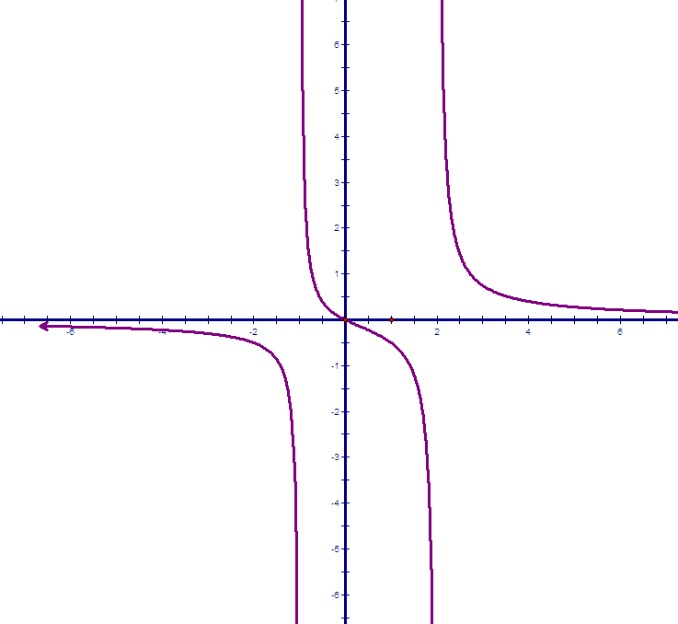 | 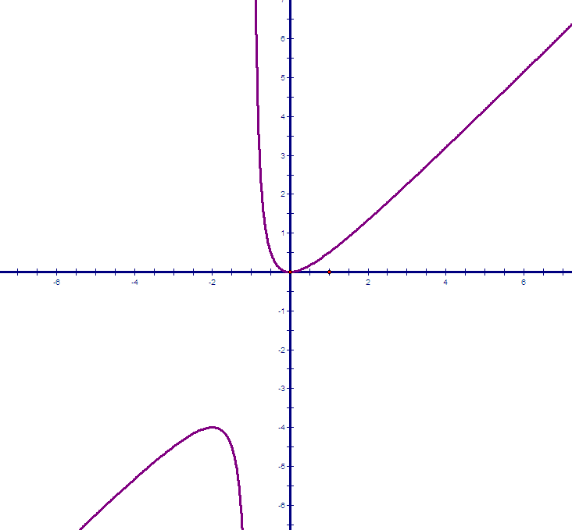 | 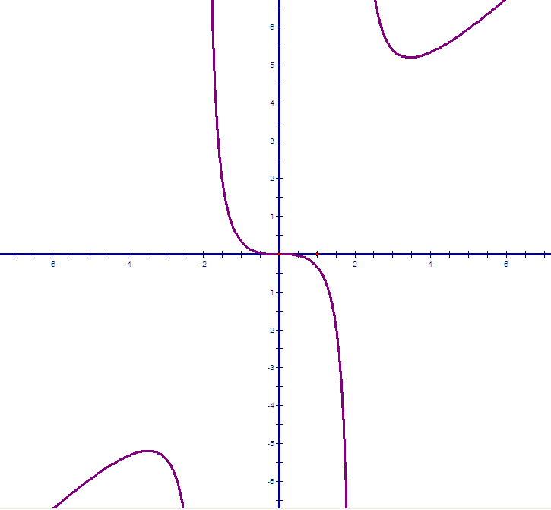

- Use nDeriv(Y1,X,X) to graph the derivative of each rational function in 2. Sketch the derivative on the graphs above.

- Summarize your findings of the derivatives of rational functions.
2.16.2: Derivatives of Rational Functions

- Apply the product rule and the chain rule to differentiate each function. Do not simplify yet. Verify your result by using the nDeriv() function on your graphing calculator.

- Find an equation of the tangent to the curve at the given point.
  - b)

2.16.2: Derivatives of Rational Functions (Continued)

- Mandy likes to coast to a stop on her bicycle. She always stops pedalling at 15 seconds before she reaches her garage door. The distance, d, in metres from her bike to her garage door at home as a function of time t, in seconds, is for .

  - When does her bike hit the garage door?

  - Find . What does this represent?

  - At what velocity does her bike strike the garage door?

  - What was the velocity of the bike when she stopped pedalling?

- The radius of a circular juice blot on a paper towel t seconds after the juice was spilled is modeled by the function where r is measured in centimetres.
  - Find the radius of the blot when it was first spilled.

  - Find the time when the radius was 1.5 cm.

  - What is the rate of increase of the blot when the radius was 1.5 cm? According to this model, will the radius ever reach 2 cm? Explain your answer.
Unit 2: Day 17: Radical Rationals |  |  |  | MCV4U
Minds On: 10 |  | Learning Goal:  - Use the Product Rule and the Chain Rule to determine derivatives of radical functions.  - Solve problem involving rates of change for radical functions and develop algebraic facility where appropriate. |  | Materials  - Graphing Calculators  - BLM 2.17.1  - BLM 2.17.2
Action: 35
Consolidate:30
Total=75 min
Assessment
Opportunities
 | Minds On… | Pairs → Pair Share  Have students each select one of their three rational functions from Day 16’s Home Activity.. Student A coaches Student B as (s)he determines the derivative of the selected function. Roles are reversed for Student B’s function..  Whole Class → Discussion  Ask students to complete a Frayer Model of rational exponents.  Have them conjecture what radical functions may look like. |  | The Frayer Model is found in Think Literacy! Grades 7 – 12.  .  .
 | Action! | Pairs→ Investigation  Students will complete BLM 2.17.1.  Mathematical Process Focus: Connecting, Reflecting  Whole Class → Discussion  Ask students to reflect on the derivative rules and their application to radical functions. Summarize their comments on the board. Have students apply their understanding by determining the derivative of select simple and complex radical functions. Encourage students to share different methods used. Students may wish to use the graphing calculator to demonstrate relationships between graphs of functions and their derivatives. In particular, students should note that a function with a vertical tangent has an asymptote at that point in its derivative.
 | Consolidate Debrief | Individual → Practice  Students complete BLM 2.17.2 to consolidate understanding.  Curriculum Expectation/Observation/Checklist  Circulate as students complete BLM 2.17.2 to assess their ability to determine a derivative using the product rule and chain rule.
Concept Practice |  | Home Activity or Further Classroom Consolidation  Complete practice questions from the selection as appropriate..

2.17.1 Introducing Radical Functions

Remember Rational Exponents?!
Rewrite using rational exponents and simplify if possible.

All about the Power

If then.

Describe this rule in words.

Off on another tangent
Compare the values of the slopes of the tangents to the given function with the values of the derivative function determined using the power rule.
- Choose 1 monomial function with rational exponents for the second table.
- Use the TANGENT function on your graphing calculator to determine the slope of the tangent at each point.
- Where are the tangents horizontal or vertical?
- What can you conclude about derivatives of radical functions?

x | Slope of Tangent | f’(x) |  | x | Slope of Tangent | f’(x)

Different Differentiating
Consider the function.
- Determine the derivative using the chain rule.
- Determine the derivative by simplifying the function first and then applying the product rule.
- Compare and contrast the two methods.

2.17.2 It’s Radical

- Determine the derivative of each function. Verify your answers.

2.17.2 It’s Radical (Continued)

- Many materials, such as metals, form an oxide coating (rust) on their surfaces that increases in thickness, x, in centimetres, over time, t, in years, according to the equation $x={\text{kt}}^{\frac{1}{2}}$.
  - Determine the growth rate, $G=\frac{\text{dx}}{\text{dt}}$, as a function of time.

  - If k = 0.02, calculate the growth rate after 4 years.

  - Using a graphing calculator or graphing software, graph both x and G for k=0.02. What happens to the thickness and growth rate as t increases?

  - Why is it very important to protect the new metal on cars from rusting (oxidizing) as soon as possible?

