Unit 6: Day 1: Circle Geometry |  |  |  | MCT 4C
Minds On: 15 |  | Learning Goal:  - Students use paper folding to learn the following vocabulary: arcs, tangents, secants, chords, segments, sectors, central angles, and inscribed angles of circles  - Students work with the properties of circles in real world applications |  | Materials  - BLM 6.1.1 – 6.1.7  - Scissors  - glue  - Pencil Crayons
Action: 50
Consolidate:10
Total=75 min
Assessment
Opportunities
 | Minds On… | Think/Pair → Activity  Students complete BLM 6.1.1 individually then share their responses with a partner. Have pairs share their responses with the class and fill in any missing responses. See Teacher Notes for answers and further information.  Think/Pair → Activity  Students complete BLM 6.1.3 individually then discuss their strategies with a partner. Pairs share solutions with class.  Whole Class → Discussion  Ask what students understand about chords and bisectors. Generate a mini-note with the definitions required. |  | Literacy strategy: During the Minds On, a Pair-Share is used to familiarize students with the terminology they will be using in the rest of the lesson.  Literacy strategy:  Verbal and Visual Word Association
 | Action! | Pairs → Think/Pair/Share  Each student is given BLM 6.1.4 and 5 minutes to find the centre of the circle, without using any aids.  Curriculum Expectations/Observation/Mental Note: Circulate to observe as students work in pairs. Ask questions to check understanding.  Whole Class→Discussion  Students discuss their strategies with the class and are reminded of the terms diameter, radius and circumference.  Students are to include the circle in their notes. Using coloured pencils label and where necessary, shade, the following lines and areas: an arc, a chord, a sector, a segment, an inscribed angle, a central angle. Also have students draw and label a secant and a tangent to the circle.
 | Consolidate Debrief | Pairs → Activity  Students complete BLM 6.1.5.  Mathematical Process Focus: Connecting – Students connect trigonometry to concepts involving circle geometry.  Pair/Square → Discussion  Each pair joins with another pair to validate their responses to BLM 6.1.5 and to complete any missing information.
Exploration  Application |  | Home Activity or Further Classroom Consolidation  Students complete BLM 6.1.7 “Circular Symbolism”
6.1.1: What are We????

How many of these objects can you identify? What is common to all of the pictures?

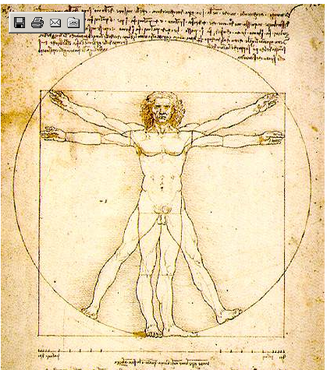  ________________ |   ________________ | 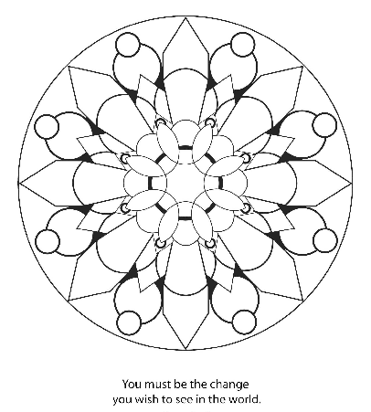  __________________
  _________________ | 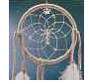  _________________ |   __________________
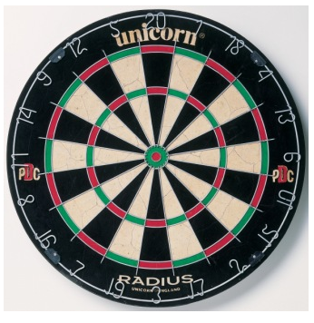  ________________ |   _________________ |   ________________________
  _________________ | 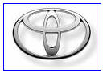  _____________________ | 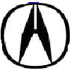 ________________________
6.1.2 What are We? (Teacher Notes)

Da Vinci’s Vitruvian Man | car hubcap | * mandala
Volkswagon cars | * Native American  dreamcatcher | * yin-yang symbol
dartboard | * peace symbol | Olympic rings
*Wheel of Dharma | Toyota cars | Acura car

*MANDALA: Mandala is the Sanskrit word for circle; the mandala is used to symbolize wholeness - the circle of eternity
*DREAMCATCHER : An American Indian magic spider-web inside a sacred circle
*YIN YANG: A Chinese Tao picture of universal harmony and the unity between complimentary opposites: light/dark, male/female, etc. Yin is the dark, passive, negative female principle.
*PEACE SYMBOL . Revived in the sixties by hippies and others who protested nuclear weapons, Western culture, and Christian values, it now symbolizes a utopian hope for a new age of global peace and earth-centered unity
*WHEEL OF DHARMA: Buddhist wheel of life and reincarnation

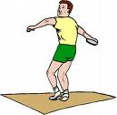
6.1.3 The Ancient Olympics

The Ancient Olympic Games were an athletic and religious
celebration held in the Greek town of Olympia from as early
as 776 BC to 393 AD.

The historical origins of the Ancient Olympic Games are lost in the fog of time, but several artefacts have been found that allow us to take a look back in time. One of the most popular events of the time was the discus throwing. Over the years the size and weight of the discus have changed as technology has advanced.

Your first task is to first cut out the fragmented ancient discus shown below. You are then to try and determine the full shape this discus would have been when it was used over 2000 years ago. In order to do this you need to find the centre of the disc and label it without the aid of any instruments (ruler, compass etc.).

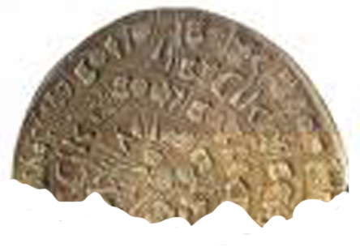


6.1.4: Circle Template



6.1.5: Circle Words
Use the following template to organize the circle vocabulary that you have learned in the paper folding exercise. The first one, arc, has been completed as an example.

Vocabulary Term | Visual Representation
Definition | Personal Association  ie. Where seen in real life

arc

- An arc is a portion of a circumference | - a portion of the rim of a cup from which you drink

tangent

secant

6.1.5: Circle Words (continued)

chord

segment

sector

6.1.5: Circle Words (continued)

central angle

inscribed angle


6.1.7: Circle Symbolism

“The circle is considered a symbol of unity, because all the regular polygons are embraced by the circle. It is also the symbol of infinity, without beginning or end, perfect, the ultimate geometric symbol.” -Paul Calter

Circles have been used as a tool to symbolize a person’s religious, cultural and personal beliefs. Your task is to:
- Use the circle below to create your own symbol using the parts of the circle discussed in class.
- List the parts of the circle that you used to create your symbol.
- Write a short description of the meaning of circle and how it relates to you personally.

Unit 6: Days 3 & 4: Circle Properties |  |  |  | MCT 4C
Minds On: 40 |  | Learning Goal:  - Investigate the properties of the circle associated with chords, central angles, inscribed angles and tangents using paper folding  - Investigate the properties of the circle associated with chords, central angles, inscribed angles and tangents using GSP |  | Materials  - Scissors  - rulers  - protractors  - glue  - mini-lab of computers with Geometer’s Sketchpad  - BLM 6.3.1  - BLM 6.3.2  - BLM 6.3.3
Action: 90
Consolidate:20
Total=150 min
Assessment
Opportunities
 | Minds On… | Pairs→ Activity  Students cut circles from BLM 6.3.1 and complete BLM 6.3.2.  Whole Class→ Discussion  Post chart paper with headings chord, inscribed and central angles, and tangent in the classroom. Assign each pair a specific heading and have them post their sketch and the property they discovered.  Have students explain their findings to the class. |  | A reminder that students have take home rights for The Geometer’s Sketchpad. Teachers should ask their OSAPAC representative as to the availability.
 | Action! | Pairs → Exploration  Students complete BLM 6.3.3 on the computer.  (Adapted from: Grade 12 Mathematics Training Spring 2007, Learning Tools)  Mathematical Process/Performance Task/Rubric  Assess students’ use of reasoning skills as they determine properties of circles.
 | Consolidate Debrief | Small Group → Discussion  Have students share findings.  Whole Class→ Discussion  Each group reports one finding to the class.
Exploration  Application |  | Home Activity or Further Classroom Consolidation  Create a poster that summarizes the findings of today’s lesson that would be helpful to a teacher who may teach this unit next year Use mathematical vocabulary and include the necessary diagrams.  Complete practice questions. |  | Literacy Strategy  Poster Creation

6.3.1: Circle Template


6.3.2: Criss-Crossing the Circle

Through the technique of paper folding you will discover several properties of circles.

Part 1: Chords of a Circle
(some word choices for the blanks: bisects, equal, centre, equidistant, equal, decreases, increases)

Instructions | Sketch
- cut out the circle from the circle template given
- find the centre of the circle using two diameters
- draw several lines (chords) parallel to one of these diameter folds

Properties:
- Which chord is the longest chord?_____________
- Complete the following statement:
“as the length of the chord increases, the distance from the centre ___________”

Instructions | Sketch
NOW:
- flip the circle over and draw 3 chords of the same length on the circle
- fold each of these chords with a perpendicular bisector to find the centre of the circle
- measure the distance from each chord to the centre of the circle

Properties:
- complete the following statements:
- “If chords are congruent (equal), then they must be _____________ from the centre of the circle”
OR
2. “if two chords are equidistant from the centre of a circle then they must be
___________”

3. “the perpendicular bisector of a chord goes through the ____________ of a
circle”

4. “the perpendicular to a chord through the _______ of a circle _________ the
chord”

6.3.2: Criss-Crossing the Circle (continued)

Part 2: Central Angles and Inscribed Angles

Instructions | Sketch
- cut out the circle from the circle template given
- fold the circle with two chords to create an inscribed angle
- create two more chords that open on the same arc as the chords above (subtend the same arc)
- measure the inscribed angles created

(repeat the above as many times as you need to in order to see the pattern)

Properties:
- complete the following statement:
“ the measure of inscribed angles opening onto the same arc or chord are ___________”

Instructions | Sketch
NOW:
- fold to make a chord on the circle and then fold to make another chord that shares one endpoint of the first chord
- you should have an inscribed angle from these two cords; trace the angle with a pencil
- find the centre of the circle, by folding along two diameter lines that share one endpoint of one of the chords; trace the radii with a pencil out from the centre point to the arc (a sketch has been provided to help with this construction)
- measure the i) inscribed angle
ii) central angle

Properties:
- complete the following statement:
” if a central angle and inscribed angle open onto the same arc length,
then the ratio of the measure of the central angle to the inscribed angle is
____: ____, “

6.3.2: Criss-Crossing the Circle (continued)

Part 3: Properties of Tangents to a Circle

Instructions | Sketch
- cut out the circle from the circle template given
- fold the circle to create any two diameter lines; trace two radii lines from these
- glue the circle you have been using on to a page in your notebook
- create two tangents to the circle at the radii endpoints
- mark the point where the two intersect
- fold the circle so the tangents coincide(unsure what you want here…the circle has been glued down as per instructions above)
- note the length of the segment from the point of intersection to the point where each tangent meets its radius (we will refer to these as tangent segments)
- note the angle at which the tangents meet the radii lines

Properties:
- complete the following statements:
- “the tangent segments to a circle are __________ in length”
- “the tangents meet the radii of the circle at ___________degrees”

6.3.3 Sketchpad and the Circle

Activity:
- Using The Geometers Sketchpad (GSP), you will investigate some properties of the circles associated with chords, central angles, inscribed angles and tangents
- Record your observations on the table provided

Method:
- Open GSP. Using EDIT Preferences set precision for angles and distances to “units”.
- Each investigation requires the construction of a circle with centre A.
- Pre-requisite knowledge and skills: definitions of parts of circles (e.g., chord, arc, tangent to a circle); use of basic GSP functions (e.g., constructing and measuring lines and angles; rotating a line about a point)
- Labels referred to in the investigations and screen captures may vary from your sketch.
Re-labelling your sketch is optional.

_____________________________________________________________________________

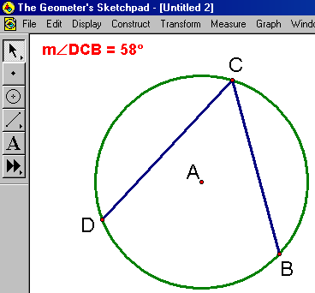
Part A - Investigating inscribed angles:

- Construct and measure inscribed angle BCD.
- Drag C along the circumference of the circle and observe the measure of angle BCD.
- Drag point B to create a different inscribed angle and repeat step 2.
- State a conclusion based on your investigation.

_____________________________________________________________________________

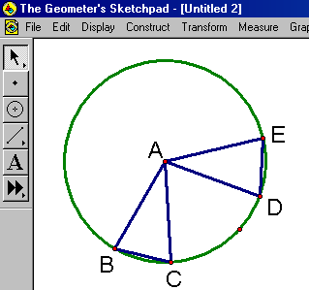
Part B- Investigating central angles:

- Construct chord BC. Construct and measure central angle BAC.
- Construct chord DE = BC*. Construct and measure central angle DAE.
- Measure arc CB and DE.
- Repeat #1-3 using a different pair of equal chords.
- State conclusions based on your investigation.

* rotate BC about A (use the angle of your choice)

6.3.3: Sketchpad and the Circle (continued)

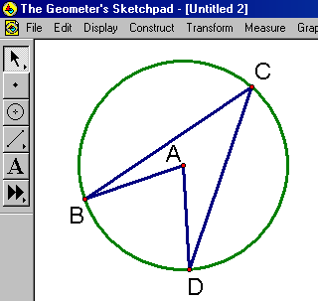
Part C- Comparing central angles and inscribed angles that
subtend the same arc:

1) Construct and measure inscribed angle BCD.
2) Construct and measure central angle BAD.
- Drag point B to create a different arc and observe angle measurements.
- State a conclusion based on your investigation.

___________________________________________________________________________

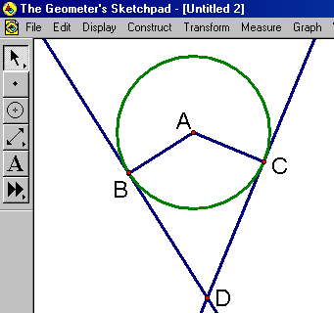
Part D - Investigating tangents:

- Construct radii AB and AC.
- Construct tangent lines to the circle at point B and C**.
- Construct point D at the point of intersection of the tangent lines.
- Measure angles DBA and DCA.
- Measure CD and BD.
- Drag point D to create different positions for B and C and observe angle and length measurements (as per #4 and #5).
- State conclusions based on your investigation.

** select 2 points on the circle and construct a line through these points, then drag one point
until it merges with the second point

6.3.3: Sketchpad and the Circle (continued)

OBSERVATIONS/CONCLUSIONS:

TOPIC | OBSERVED PROPERTY | SKETCH
PART A: Inscribed Angles

PART B: Central Angles

PART C: Central and Inscribed
angles subtending the
same arc

PART D: Tangents

Unit 6: Day 5: Problem Solving involving Circle Geometry |  |  |  | MCT 4C
Minds On: 15 |  | Learning Goal:  - Solve problems involving properties of circles.  - Use the properties of circles in real world applications. |  | Materials  - BLM 6.5.1  - BLM 6.5.2  - BLM 6.5.3  - BLM 6.5.4  - scissors
Action: 50
Consolidate:10
Total=75 min
Assessment
Opportunities
 | Minds On… | Individual → Four Corners  Each student receives a question from BLM 6.5.1 and using prior knowledge, decides which corner to go to based on which tool will aid in solving the problem. BLM 6.5.2 should be cut and each strategy posted in a corner.  Small Group → Discussion  Have students in each corner solve the problem and share their strategies and verify their solution.  Whole Class → Discussion  Selected students from each corner share their strategies and solution with the class. |  | Literacy Strategy:  The Four Corners strategy allows for review and consolidate of prior knowledge.
 | Action! | Pairs → Exploration  Have students complete BLM 6.5.3 in pairs and then present their solution to another pair.  Curriculum Expectations/Observation/Mental Note:  Circulate to observe as students work in pairs and in groups of four. Ask questions to check understanding.
 | Consolidate Debrief | Whole Class → Discussion  Groups share their solutions and strategies with the class.  Mathematical Process Focus: Connecting – Students apply and connect mathematics to contexts outside mathematics.
Exploration  Application |  | Home Activity or Further Classroom Consolidation  Complete BLM 6.5.4

6.5.1 Four Corners Student Questions


1. A surveyor, 33 m from a building, uses a transit to measure the angle of elevation to the top of a building. The angle of elevation is 37°. The transit is set at a height of 1.5 m.
a) Calculate the distance from the transit to the top of the building.
b) Calculate the height of the building.


2. The diagram below shows the layout of Rita’s backyard.

15.7 m

6.3 m 4.8 m

If Rita wishes to put new sod down throughout the backyard calculate the amount of sod she will need to purchase.

6.5.1 Four Corners Student Questions (continued)

3. Solve for the values of x and y below.


y
64°
x


4. The diagram below shows the view from above a lake. The arc formed between points A and B represents a path walked on a trial trail that is part of the lake. Using the information provided below calculate the length of the path.
B
85º
r = 0.75 km
A

6.5.2 Four Corners

Pythagorean
Theorem

Trigonometric Ratio


6.5.2 Four Corners (continued)

Angle

Theorems


Circle
Geometry

6.5.3 Bicycle Race

You have decided to take part in this year’s Secant Lake bicycle race. The race is run every year to raise money to preserve the wildlife in the area. You are able to raise $10 for every kilometre travelled on your bike and you hope to travel the course 3 times.

Secant Lake is a circular lake that has a diameter of 4 km, as shown in the diagram below. Points A and D are the opposite sides of Secant Lake and lie on a straight line through the centre of the lake, with each point 5 km from the centre. The course of the race is ABCD, where AB and CD are tangents to the lake and BC is an arc along the shore of the Secant Lake.
Using your knowledge of circle geometry and trigonometry determine the length of the route and the amount of money you can raise.

B C
Secant Lake

4 km

A D
5 km
5 km

6.5.4 Investigating Circle Geometry

Complete the following problems using the concepts and strategies discussed in class.

- Find the arc length to the nearest centimetre, of the sector of a circle with radius;
a) 7 m, if the sector angle is 120° | b) 90 cm, if the sector angle is 225°

- Two sectors of a circle have sector angles of and respectively. The arc length of the smaller sector is 17 cm. What is the arc length of the larger sector?

- The vent cover on a forced air heating system is in the form of a sector of a circle, as shown. Determine the area of sheet metal used to make the vent cover.
r = 7.2 cm
130°

6.5.4 Investigating Circle Geometry (continued)

- The belt on a photocopy machine is in contact with a drive cylinder over 105° of its surface, as shown.
Belt
Drive Cylinder
105°

If the length of the arc made between the drive cylinder and the belt is 5.62
cm, what is the radius of the drive cylinder?

