Unit 1: Day 1: Graphs of Exponential Functions |  |  |  | MCT 4C
Minds On: 10 |  | Learning Goal:  - Activate prior knowledge of exponential functions  - Determine through investigation with a graphing calculator the impact of changing the base on the graph of an exponential equation  - Determine through investigation with a graphing calculator the impact of changing the sign of the exponent on the graph of an exponential equation |  | Materials  - BLM 1.1.1  - BLM 1.1.2  - BLM 1.1.3  - Graphing calculator
Action: 50
Consolidate:15
Total=75 min
Assessment
Opportunities
 | Minds On… | Think/Pair → Anticipation Guide  Students complete BLM 1.1.1 to activate their prior knowledge of exponential functions. Students compare their choices and explanations with a partner.  Whole Class → Discussion  Discuss responses to BLM 1.1.1. Since students have seen exponential functions in grade 11, engage the class in a discussion around contexts that display exponential growth (populations, spread of disease, investments) and exponential decay (carbon dating, depreciation, populations). A discussion around the similarities and differences between linear growth/decay and exponential growth/decay can also be explored.  Use this opportunity to review functions, relations, domain and range. |  | An optional resource that can be used is story book The Kings Chessboard (Picture Puffins). Also, explore 19th century economist, Thomas Malthus, and his views on global population growth and resource depletion.  Use TI-Smartview to demonstrate some of the functions of the graphing calculator, if necessary.  Fathom can be substituted for the graphing calculator.  Use TI-Smartview to demonstrate the changes as the ideas from the investigation are discussed.  Discuss domain, range, asymptote, y-intercept and intervals of increase/decrease.
 | Action! | Individual → Investigation  Introduce the BLM 1.1.2. Review how to set the window settings and graph functions on the graphing calculator.  Students use the graphing calculator to complete BLM 1.1.2. Circulate to assist students as they work.  Curriculum Expectations/Observation/Scoring Guide  Observe students as they complete the investigation and assess their demonstrated understanding of the prior knowledge. This information may be used to inform instruction on the Jazz days.  Mathematical Process Focus: Reflecting
 | Consolidate Debrief | Whole Class → Discussion  Using the results of the investigation, students will discuss the impact of changing the base on the graph of an exponential function of the form $y=b^{x}$ for values of b > 1 and for values 0 < b < 1. In addition, students should explain the impact of changing the sign of the exponent on the graph of an exponential function of the form$y=b^{x}$.  Independent → Anticipation Guide  Students complete BLM 1.1.1.
Reflection  Concept Practice |  | Home Activity or Further Classroom Consolidation  Write a response in your journal. List the similarities and differences of the graphs of $y=3^{x}$, $y={\frac{1}{3}}^{x}$, an$y=3^{−x}$.  Complete BLM 1.1.3.

1.1.1 Do You Remember When?

Anticipation Guide

Instructions:

- Check “Agree” or “Disagree” beside each statement before you start the task.
- Compare your choice and explanation with a partner.
- Revisit your choices at the end of the task. Compare the choices that you would make after the task with the choices that you made before the task.

Before |  | Statement | After
Agree | Disagree | Statement | Agree | Disagree
1. All of the following are functions.
i. $x=y^{2}$ ii. $y=2x^{2}−5$
iii. $y=\frac{x}{4}+7$ iv. $y=3^{x}$
v. $2x+3y−5=0$
 |  | 2. The base of $y=2^{x}$ is x.
3. Audrey is paid $10/hour. The growth of her
earnings over the week is an example of exponential growth.
 |  | 4. $y=3^{x}$ is the same as $y=x^{3}$.
 |  | 5. The area, $y$, of a square floor with one side measuring $x$ can be modelled by the equation $y=2^{x}$
 |  | 6. If x = 0 in the relation $y=5^{x}$, then y = 0.
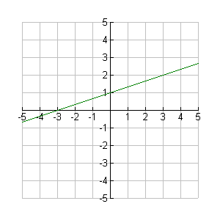
7. For the function on the grid below, the x-intercept is -3 and the y-intercept is 1.
 |  | 8. $y={\left(\frac{1}{5}\right)}^{x}$ is an exponential function.
 |  | 9. The domain of $y=2^{x}$ is $xεR$.
 |  | 10. The range of $y={\text{10}}^{x}$ is $y$> 0.

1.1.2 The Graphs of Exponential Functions

Step 1:
- Set your graphing calculator to the following window settings.

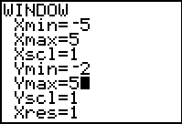

Step 2:
- Each of the equations is in the form: $y=b^{x}$
- For each part of the investigation graph the given equations on the same axes. Sketch the graphs in the grid provided.
- Complete the chart that follows.

Part 1:

$y=2^{x}$ $y=4^{x}$ $y={\text{10}}^{x}$

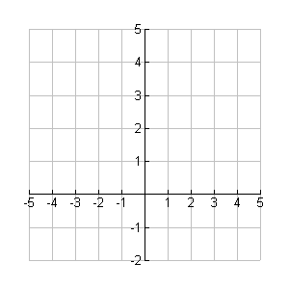

1.1.2 The Graphs of Exponential Functions (continued)

$$y=2^{x}$$ | $$y=4^{x}$$ | $$y={\text{10}}^{x}$$
y-intercept is  x-intercept is  function is increasing, decreasing or neither(circle one)  Domain is:  Range is: | y-intercept is  x-intercept is  function is increasing, decreasing or neither(circle one)  Domain is:  Range is: | y-intercept is  x-intercept is  function is increasing, decreasing or neither(circle one)  Domain is:  Range is:

- Describe what these graphs have in common.

- Describe the impact of changing the base on the graph of an exponential function.

Part 2:
$y=2^{x}$ $y={\frac{1}{2}}^{x}$ $y={\frac{1}{4}}^{x}$ $y={\frac{1}{\text{10}}}^{x}$Consider putting brackets around the fractional bases

1.1.2 The Graphs of Exponential Functions (continued)

$$y={\frac{1}{2}}^{x}$$ | $$y={\frac{1}{4}}^{x}$$ | $$y={\frac{1}{\text{10}}}^{X}$$
y-intercept is  x-intercept is  function is increasing, decreasing or neither(circle one)  Domain is:  Range is: | y-intercept is  x-intercept is  function is increasing, decreasing or neither(circle one)  Domain is:  Range is: | y-intercept is  x-intercept is  function is increasing, decreasing or neither(circle one)  Domain is:  Range is:

- Describe what these graphs have in common.

- Describe the impact of changing the base on the graph of an exponential function.

Part 3

$y=2^{x}$ $y=2^{−x}$ $y=4^{−x}$ $y={\text{10}}^{−x}$

1.1.2 The Graphs of Exponential Functions (continued)

$$y=2^{−x}$$ | $$y=4^{−x}$$ | $$y={\text{10}}^{−x}$$
y-intercept is  x-intercept is  function is increasing, decreasing or neither(circle one)  Domain is:  Range is: | y-intercept is  x-intercept is  function is increasing, decreasing or neither(circle one)  Domain is:  Range is: | y-intercept is  x-intercept is  function is increasing, decreasing or neither(circle one)  Domain is:  Range is:

- Describe what these graphs have in common with the graphs in part 2.

- Describe the impact of changing the sign of the exponent on the graph of an exponential function.

1.1.3 Matching Activity
Match each graph with an equation that best represents the relationship. For each graph, state the x-intercept, y-intercept, domain, range, and whether the graph is increasing, decreasing or neither.
a)
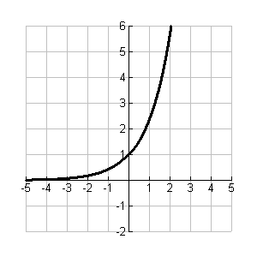
i) $y=3^{−x}$

ii) $y={\left(\frac{1}{4}\right)}^{x}$

iii) $y=5^{−x}$

iv) $y=2\text{.}4^{x}$

v) $y=5\text{.}5^{x}$

vi) $y=3\text{.}4^{x}$
b)
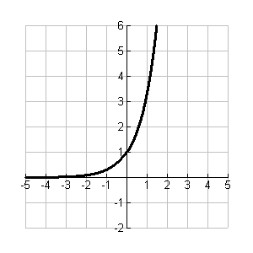

d)
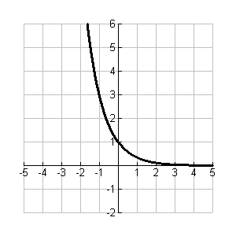
e)
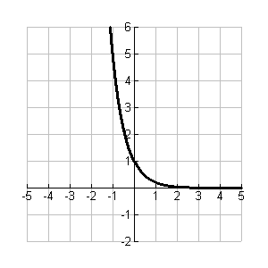
f)
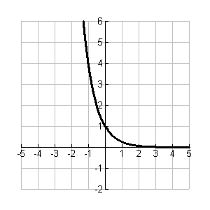
c)
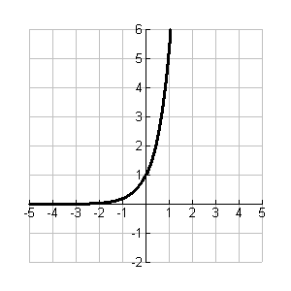

Unit 1: Day 3: Which One Grows Faster? |  |  |  | MCT 4C
Minds On: 10 |  | Learning Goal:  - Solve problems involving exponential equations graphically, including problems arising from real-world context.  - Find the point of intersection of two exponential functions.  - Explain the solution in terms of the real-life context. |  | Materials  - BLM 1.3.1  - BLM 1.3.2  - BLM 1.3.3  - Graphing calculator
Action: 35
Consolidate:30
Total=75 min
Assessment
Opportunities
 | Minds On… | Small Groups →Activity  Using BLM 1.3.1, give each student a slip of paper containing either an application, a system of two linear equations, a point, or a graph. Have the student with the graph to stand still while the other three students with the matching information find him/her. Students should explain why they matched their slip with others in the group.  Have students arrange the slips on a master chart to facilitate making connections. |  | Optional: Use a SMART Board to show the graph and the equations and point of intersection.
 | Action! | Pairs → Investigation  Students complete BLM 1.3.2 using graphing calculators  Learning Skill/Observation/Checklist  Assess students’ teamwork skills as they check each other’s calculators to be sure of accuracy of solutions.  Mathematical Process Focus: Connect the graphs to the real world application and the equations used to describe them.
 | Consolidate Debrief | Whole Class → Discussion  Students will share solutions to the application problem of an exponential system of equations. Have other students clarify explanations of the solution and connections, and ask probing questions..  Have students compare the similarities and differences of the applications questions to the non-application questions by considering the questions on BLM 1.3.3. Students summarize this information in a note.
Exploration  Application |  | Home Activity or Further Classroom Consolidation  Complete BLM 1.3.3. |  | Students will require a graphing calculator.

1.3.1: MATCH IT

Teacher Instructions: Photocopy the charts. Cut up the charts into its cells. Give each student a piece of the chart. Tell them to find the students who are holding the matching application, system of equations, solution to the system, and graph.

Liam bought a cell phone plan charging $40 per month for unlimited minutes. Isaac bought a plan charging $10 per month plus $0.15 per minute. How many minutes would they use if they paid the same amount on their monthly bill? | C = 40  C = 0.15t + 10 | (200, 40) | 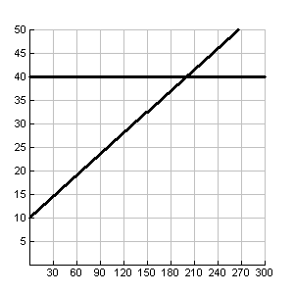
Ella ordered wedding invitations at her neighbourhood printing shop for $55 plus $2.50 per invitation. Lyndi ordered wedding invitations from her Uncle Shawn for $3 per invitation. How many invitations would have to be ordered so that the cost would be the same for both women? | C = 55 + 2.5x  C = 3x | (110, 330) | 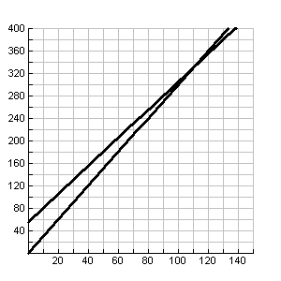
Sara states that the cost of driving her car for a year is $1000 plus $0.22 per kilometre. Gord states that the cost of driving his car is $700 plus $0.25 per kilometre. However, they both argue that the annual cost of driving their car is the least. How many kilometres driven would make their costs equal? | C = 1000 + 0.22x  C = 700 + 0.25x | (10000, 3200) | 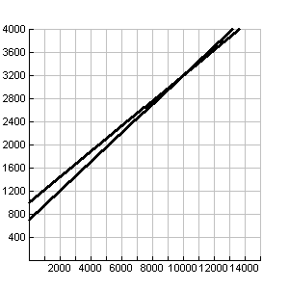
1.3.1: MATCH IT (continued)

The length of a rectangle is twice its width and its perimeter is 72 cm. Find the length and width. | y= 2x  2x + 2y = 72 | (12, 24) | 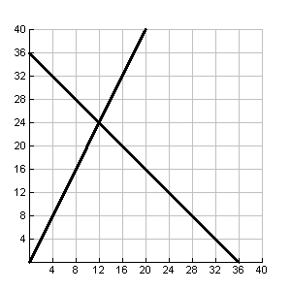
The club sold tickets and then counted their money. They had 46 coins, all loonies and toonies. The value of the money was $72 in total. How many of each kind of coin was there? | x + y = 46  x + 2y = 72 | (20, 26) | 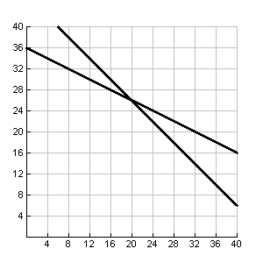
One store pays their workers $50 per week plus 10% of all their sales. A different store pays their employees $90 per week and 1% of all their sales. How much must an employee sell in order to be paid the same at both stores?(nearest $) | y = 0.1x + 50  y = 90 + 0.01x | (444, 94) | 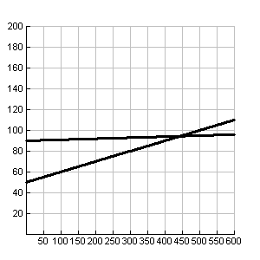

1.3.2: Comparing Growths

Investigation

Audrey invested $1000 at 9% per annum compounded annually. Her daughter invested $2000 at 2.5% per annum compounded annually at the same time. How long did it take for the investments to be of equal value?

Materials:
Graphing calculator, Formula for Amount of an Investment: $A=P(1+i)^{n}$

Method: Number Questions

- The equation for the amount of Audrey’s investment is ________________________

- The equation for the amount of Audrey’s daughter’s investment is_______________

- What type of function is each of the above? ___________________________

- Describe the expected shape of the graph of each.

___________________________________________________________________________

___________________________________________________________________________
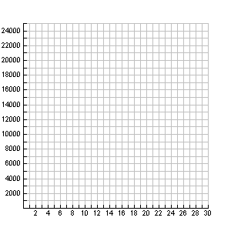
5. In the ! window, enter the two equations above.

Set the window as follows:

Sketch the graph from the graphing calculator on the grid at the right. (Possible alternate grid)

To find the point of intersection, press, 2nd , TRACE, 5:Intersect, then press ENTER three times.

6. The point of intersection is _________________.

7. Explain the significance of the point of intersection in relation to the question.

1.3.3: Crossing Curves

Use the method of graphing on the graphing calculator to answer the following questions. Adjust the window settings as appropriate for each question. Consider using ‘Zoom Fit’ to help with this.

- Determine the point of intersection of each pair of functions graphically.

a) and (0,5,1,0,500,50,1) | d) f(x) = 6^{-x} and f(x) = 8^{x+3}
b) and | e) and
c) f(x) = 6^{-x} and | f) and

- a) Consider question 1(a) and the solution you determined. How is the solution related to the expressions given for the exponents?

b) Suggest a rule for solving exponential equations without graphing.

c) Can you solve questions (b) through (e) in the same way? Why or why not?

- Al has saved $5000. He checked the website of a prominent bank. The rate for a savings account is 0.05% per annum, while the rate for a GIC is 3.85% per annum, both compounded annually. Al doesn’t believe he wants to invest all $5000 for 5 years. He compared saving $5000 in the savings account to saving $4500 in the GIC. How long will it take for the investments to be equal in value?

- The SarJen marketing company has determined that the effect on customers of a particular advertising campaign is modelled according to the following function$A=\text{100}(1\text{.}7^{−0\text{.}\text{08}x})$, where x is the time in weeks since the end of the advertising campaign and A is the value on their advertising rating scale. Calculate the number of weeks until the effect of the advertising will fall to half or a rating of 50 (represent the 50 with y = 50 as function #1 on the graphing calculator).

- For the following system of equations find the point of intersection.
i) $y=2x$ ii) $y=x^{2}$ iii) $y=2^{x}$

Check that the point of intersection found is actually a point on all three functions.
Describe the rate of increase for each of the three functions.

Unit 1: Day 6: Graphs of Exponential Functions |  |  |  | MCT 4C
Minds On: 10 |  | Learning Goal:  - Draw upon prior knowledge of interpreting graphs  - Recognize the logarithm of a number to a given base as the exponent to which the base must be raised to get the number  - Determine the approximate logarithm of a number to any base by using systematic trial |  | Materials  - BLM 1.6.1  - BLM 1.6.2  - BLM 1.6.3  - Scissors
Action: 45 |  |  |  | Materials  - BLM 1.6.1  - BLM 1.6.2  - BLM 1.6.3  - Scissors
Consolidate:20 |  |  |  | Materials  - BLM 1.6.1  - BLM 1.6.2  - BLM 1.6.3  - Scissors
Total=75 min |  |  |  | Materials  - BLM 1.6.1  - BLM 1.6.2  - BLM 1.6.3  - Scissors
Assessment
Opportunities
 | Minds On… | Individual → Reflect on Prior Learning  Students complete the BLM 1.6.1 to activate their prior knowledge of interpreting graphs  Pairs → Sharing  Students compare their answers and explanations to BLM 1.6.1 with a partner.
 | Action! | Individual → Investigation  Introduce BLM 1.6.2. Circulate to assist students as they work.  Small Groups → Discussion  In heterogeneous groups of 3 or 4, students discuss their reasoning as to how they would evaluate${\text{log}}_{2}6$, with and without using the graph.  Pairs → Activity  Provide each pair of students with a copy of BLM 1.6.3 and scissors. Students are to cut out terms and rearrange the terms so that they are in the proper place to reflect an exponential equation (leave out the “log” term for the time being). Once class has come to consensus as to the proper arrangement of the terms, ask students to rearrange the terms to reflect a logarithmic equation.  Learning Skills/Observation/Mental Note  Observe work habits and initiative as students work through the investigation individually.
 | Consolidate Debrief | Whole Class → Discussion  Ensure that students recognize that the logarithm of a number to a given base is the exponent to which the base must be raised to get the number.  Have the groups share their response as to how they would evaluate ${\text{log}}_{2}6$ without using the graph and their reasons for not being to provide a precise answer.  Mathematical Process Focus: Problem Solving.
Reflection |  | Home Activity or Further Classroom Consolidation  Respond to the following statement in your journal:  Your friend was away for today’s lesson. Write an email describing how to find the exact value of log ₂ 8 and the approximate value of the logarithm ${\text{log}}_{3}\text{28}$.

1.6.1 Interpreting Graphs

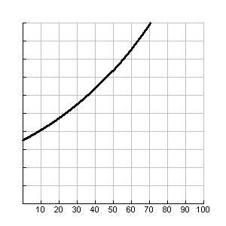
When Ed was born, his town of Edenville had a population of 35 000. The average yearly growth rate since then has been 1.5%. The population of the town is recorded in the graph below.
Population of Edenville
Years
Population
10000
20000
30000
40000
50000
60000
70000
80000
90000
100000

- Explain how the characteristics of the graph indicate exponential growth.

- Using the graph, what was the population of Edenville on Ed’s 30th birthday? Explain your reasoning.

- Using the graph, what was the population of Edenville on Ed’s 50th birthday? Explain your reasoning.

- How old will Ed be when the population of the town doubles in size from the time he was born?

1.6.2 Approximate Logarithms of a Number

Consider the graph of$y={\text{log}}_{2}x$.
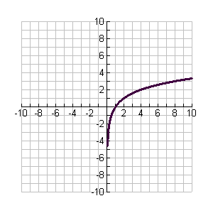

1. Using the graph of $y={\text{log}}_{2}x$, if $x=2$ determine the value of $y$.

2. Using the graph of $y={\text{log}}_{2}x$, if $x=4$ determine the value of $y$.

3. Using the graph of $y={\text{log}}_{2}x$, if $x=8$ determine the value of $y$.

4. How would you evaluate ${\text{log}}_{2}\text{32}$ without using the graph? Explain your reasoning.

5. In your groups, discuss how you would evaluate ${\text{log}}_{2}6$.both with and without the graph

1.6.3 Breaking Logs

Answer
Exponent
Base
=
log

Unit 1: Day 7: Graphs of Exponential Functions
Minds On: 15 |  | Learning Goal:  - Draw upon prior knowledge of exponential functions  - Make connections between related logarithmic and exponential equations through investigation |  | Materials  - BLM 1.7.1  - BLM 1.7.2  - BLM 1.7.3
Action: 30 |  |  |  | Materials  - BLM 1.7.1  - BLM 1.7.2  - BLM 1.7.3
Consolidate:30 |  |  |  | Materials  - BLM 1.7.1  - BLM 1.7.2  - BLM 1.7.3
Total=75 min |  |  |  | Materials  - BLM 1.7.1  - BLM 1.7.2  - BLM 1.7.3
Assessment
Opportunities
 | Minds On… | Individual → Activity  Have students complete BLM 1.7.1 to activate their prior knowledge of exponential functions.  Groups of 4 → Discussion  Have students share responses with their group for the different areas of the Frayer model and come to consensus. Provide each group with a blank Frayer model and ask them to complete a new one based on the consensus from the group. Ask a reporter from each group to present the group’s Frayer model. Post the models around the room.
 | Action! | Pairs → Investigation  Introduce BLM 1.7.2. Circulate to assist students as they work, ensuring that students include $\text{32}=2^{5}$and $5={\text{log}}_{2}\text{32}$ in their responses to questions 3 and 4  Remind students to reflect on yesterday’s lesson when solving $3^{x}=\text{10}$.
 | Consolidate Debrief | Whole Class → Discussion  Students will discuss the connections between exponential and logarithmic functions.  Curriculum Expectations/Performance Task/Checklist  Identify students who demonstrate a solid understanding of the learning goals for this lesson as they participate in the discussion.  Mathematical Process Focus: Connecting
Reflection |  | Home Activity or Further Classroom Consolidation  Complete BLM 1.7.3.

1.7.1: Frayer Model – Exponential Equations

Complete the Frayer Model
Essential Characteristics
Nonessential Characteristics
Examples
Non-examples Characteristics
Exponential
Equations

1.7.2: Connections Between Logarithmic and Exponential Equations

Consider the graphs of $y=2^{x}$ and $y={\text{log}}_{2}x$.
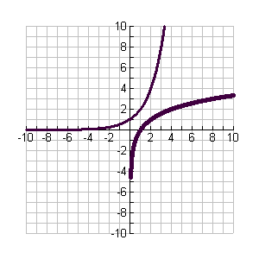
y = 2^{x}

- Using the graphs of $y=2^{x}$ and $y={\text{log}}_{2}x$ complete the following tables of values.

$$x$$ | $$y=2^{x}$$ |  | $$x$$ | $$y={\text{log}}_{2}x$$
0 |  |  | 1
2 |  |  | 4
3 |  |  | 8

- What relationship exists between $y=2^{x}$ and $y={\text{log}}_{2}x$ ? Explain your findings.

- If $x=5$ evaluate $y=2^{x}$.

1.7.2 Connections Between Logarithmic and Exponential Equations (continued)

- If $x=\text{32}$ evaluate $y={\text{log}}_{2}x$.

- For each function noted below determine the logarithmic equation.

$y=3^{x}$ $y=5^{x}$ $y={\text{11}}^{x}$

- For each function noted below determine the exponential function.

$y={\text{log}}_{4}x$ $y={\text{log}}_{8}x$ $y={\text{log}}_{\text{11}}x$

- If you were asked to solve $3^{x}=\text{10}$, how might you use the corresponding logarithmic equation to help you solve the equation? What other strategy would you consider using?

1.7.3 Coach and Be Coached

Instructions: One of you is partner A and the other is partner B. Go through each row by having partner A coach partner B by using appropriate math terms and procedures. Switch roles and continue through the entire set of questions.

A coaches B | B coaches A
If $x=\text{64}$ evaluate $y={\text{log}}_{2}x$ | If $x=\text{81}$ evaluate $y={\text{log}}_{3}x$
For the function $y=6^{x}$, determine the logarithmic equation. | For the function $y=8^{x}$, determine the logarithmic equation.
For the function $y={\text{log}}_{7}x$, determine the exponential equation. | For the function $y={\text{log}}_{9}x$, determine the exponential equation.
Solve $3^{x}=\text{32}$. | Solve $2^{x}=\text{20}$

Unit 1: Day 9: Which One Grows Faster?
Minds On: 15 |  | Learning Goal:  - Solve problems based on data collected.  - Connect the concepts learned about various types of functions |  |  | Materials  - Graphing calculators  - CBRs  - Link cables  - Ball  - BLM 1.9.1  - BLM 1.9.2  - BLM 1.9.3
Action: 45
Consolidate:15
Total=75 min
Assessment
Opportunities
 | Minds On… |  | Groups of 3 → Brainstorm  Each group is assigned one type of function from BLM 1.9.1 for which they will complete the corresponding row by including the key features of each function, such as how to identify the equation, domain, range, asymptotes, if all have the same y-intercept, etc.  Whole Class → Summary  When all groups are finished, the chart rows are be recorded on the blackboard/chart paper so all students can make a complete chart using BLM 1.9.1 |  | Squash balls produce good data.  Two classes may be spent on the collection and analysis of the data in order to allow the students additional time to reflect and analyse the data.  .
 | Action! |  | Small Groups → Investigation  Students complete BLM 1.9.2. They will use graphing calculators to collect the data and refer to BLM 1.9.1 as they work.  Write an explanation of why they have chosen one particular equation.  Mathematical Process – Reasoning/Observation/Mental Note: As students complete BLM 1.9.2, assess their reasoning skills by questioning their responses.
 | Consolidate Debrief |  | Small Groups→Discussion  Discuss the possibility of errors in collecting the data, the clarification of the regression instructions, and the suitability of their choices for the ‘best’ equation of the function.
 | Practice  Reflection |  | Home Activity or Further Classroom Consolidation  Answer questions 11 – 15 on BLM 1.9.2  Complete BLM 1.9.3 using your notes and textbook as reference. |  | .

1.9.1: What’s your function? – Key Features Chart

Name of function | Equation | Table of Values | Graph | Application
Linear
Quadratic
Exponential
Logarithmic

1.9.2 And How Do Your Bounces Grow?
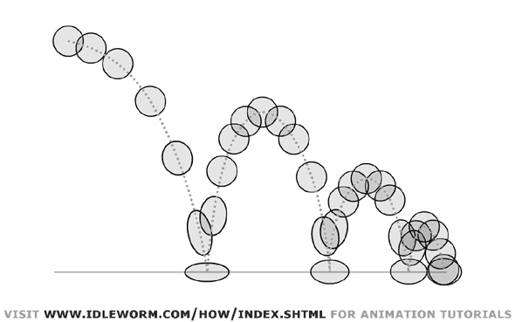

- In a group of 2 - 4 students, collect data on the bounces of a ball.
Materials needed: ball, CBR, graphing calculator each, link cable

- Connect a graphing calculator to a CBR. Press A, select CBL/CBR, press e, select RANGER, press e, select APPLICATIONS, select METERS, and select BALL BOUNCE

- Follow the directions on the screen of the calculator to collect data as the ball is dropped and record its bounces. Note that the ball is not caught after a bounce.

- The data, if collected without disturbances to the path of the ball or the collection area, should show a series of rounded arches – at least 5 are needed to be able to use the data.

- If the data does not seem to fit the shape expected, press ENTER, select REPEAT SAMPLE and try again. It may take a few tries to get the best data. It is best to use a different calculator each time in case the first set of data is the best.

- When the decision has been made about the best data to use, use the link cable to transfer the data to the other calculators in the group.

- In most cases, some of the data on the screen is unsuitable. To discard the unneeded data, use the PLOT TOOLS from the PLOT MENU, SELECT DOMAIN and using the left/right arrows, move the cursor to the start of the ‘good data’, press e. Then move the cursor to the end of the last bounce and press e to see a good graph of the bounces.

Consult the ‘KEY FEATURES’ chart
The whole graph appears to be close to a typical graph of a________________ function.
One bounce appears to be close to a typical graph of a ____________________ function.

The peak points, joined, appear to be close to a typical graph of a ___________function.

1.9.2 And How Do Your Bounces Grow? (continued)

- Choose a part of the curve which is a smooth arch (parabola). Use the TRACE feature to choose 6 significant points and record in the table of values below. Repeat with each of the other arches (parabolas). Then graph all points from all the arches in the designated space. Hints: You may want to change the heights to centimetres.
Significant Points | First parabola |  | Second Parabola |  | Third Parabola |  | Fourth Parabola |  | Fifth Parabola
Significant Points | Time | Height | Time | Height | Time | Height | Time | Height | Time | Height
Bottom Left
Other left point
Left about 2/3 up
Peak

Right 2/3 up
Other right point



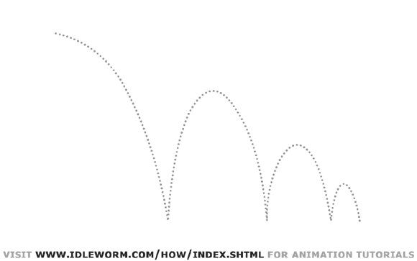

1.9.2 And How Do Your Bounces Grow? (continued)

- Choose one of the smooth arches. Enter the points into List 1 and List 2. Set the calculator to list the correlation coefficient by pressing the `, press 0 and scroll down to ‘Diagnostic On”, press e and e again. Then find the equation of the parabola using the regression features of the calculator. When the calculator lists the coefficients of the quadratic equation, an ‘r²’ value will appear at the bottom of the list. The closer the ‘r²’ value is to one, the better the fit of the regression equation.

Equation of the parabola: __________________________ r² = _______________

Plot the data using the STAT PLOT feature and then graph the equation in the
function editor. Describe how closely it fits?

- Draw a smooth curve through all of the peak points. Predict the type of function that would model these points. ______________Choose all the Peak points and enter the values into List 3 (the time that the peak occurs) and List 4 (the peak heights). . Use the exponential regression for those points. Colour them red on the graph in step 8.

Equation of the exponential regression: ____________________ r = ___________

Plot the data using the STAT PLOT feature and then graph the equation in the
function editor. Describe how closely it fits?

- Which of the above regressions gave the best fit? Compare the success of each.

- At what times is the height of the ball 10 centimetres?

- At what times is the height of the ball more than 20 centimetres?

- State the zeros of the function (include all bounces). What do they represent?

- Explain why the peak points form an exponential function by referring to the bounce height on each successive bounce.

1.9.3 FRAYER MODEL

In the oval in the centre of the first chart, write the words ‘Exponential Function’, then complete the chart with the appropriate information.
In the oval in the centre of the second chart, write the words ‘Logarithmic Function’, then complete the chart with the appropriate information.

Definition:

Facts/Characteristics:

Example:
Non-examples:

Definition:
Facts/Characteristics:
Examples:
Non-examples:

