Unit 6: Day 6: Primary Trigonometric Ratios and Obtuse Angles
Minds On: 15 |  | Learning Goal:  - Investigate connections between primary trigonometric ratios of acute angles and obtuse angles  - Determine the values of the sine ratio, cosine ratio, and tangent ratio for obtuse angles |  | Materials  - BLM 6.6.1  - BLM 6.6.2  - Geometer’s Sketchpad and GSP file
Action: 45
Consolidate:15
Total=75 min
Assessment
Opportunities
 | Minds On… | Groups → Placemat  Introduce today’s lesson topic - applying primary trigonometric ratios to obtuse angles. Students take a few minutes to think about and individually write down in their section of the placemat what they know about using trigonometry of right angled triangles to solve problems. (BLM 6.6.1) The group shares and summarizes the key ideas in the centre of the placemat.  Whole Class → Discussion & Note  Facilitate a class discussion about the results of the placemats. Give students a note on terminology by introducing the idea of placement of an angle in standard position with initial arm on the x-axis, vertex at the origin, and the contained angle between the initial and the terminal arm.  Mathematical Process Focus: Connecting: Students will hypothesise by connecting to prior knowledge of right-angled trigonometry.  Learning Skill (Teamwork)/Observation/Checkbric: Observe and record students’ collaboration skills. |  | Literacy Strategy: Placemat  Make GSP file: MAP_U6L6GSP1 accessible to students.  Refer to the teacher notes in BLM 6.6.2 for instructions on a paper and pencil investigation if Sketchpad is not available. A demonstration with a projector would be beneficial in this case.  You could add the trig ratios to a sketch after the investigation and demonstrate for the class that their conclusions are true for all obtuse angles.
 | Action! | Individual or in Pairs → Investigation  Students will work individually or in pairs depending on the availability of Geometer’s Sketchpad. Distribute BLM 6.6.2 and direct students to where they should find the GSP file (MAP_U6L6GSP1) for the investigation. Circulate to ensure students are making correct connections.  Curriculum Expectations/Performance Task/Anecdotal Comments: Observe students and make anecdotal comments as they complete the investigation.  Mathematical Process Focus: Reasoning & Proving: Students will discover relationships between primary trigonometric ratios of acute and obtuse angles. Make observations, articulate patterns and give reasons.
 | Consolidate Debrief | Groups →Placemat  Instruct students to return to their groups from the beginning of the class and have them reflect on the investigation and add or make changes to their placemat.  Whole Group → Discussion and Consolidation  As a class, summarize the patterns and conclusions found in the investigation.
Exploration  Application |  | Home Activity or Further Classroom Consolidation  Complete practice questions. |  | Find questions from a textbook for practice.

6.6.1: Placemat

Trigonometry of Right-angled Triangles

Trigonometric Ratios for Obtuse Angles

6.6.2: Investigating Obtuse Angles

Introduction to the Activity:

In this activity, you will use Geometer’s Sketchpad to investigate the trigonometric ratios of obtuse angles. Then, you will analyze the results to determine any patterns.

Equipment Needed:

- Computer lab equipped with Geometer’s Sketchpad and the Sketchpad activity file
- Calculator

Performing the Activity

- Launch Geometer’s Sketchpad. Open the GSP file provided by your teacher.

- Refer to the chart that follows. For each of the listed angles, use Geometer’s Sketchpad to drag point A to create each listed primary angle B. Then, use the side lengths and your calculator to determine the value of each primary trigonometric ratio in the chart.

- After you have completed the chart, answer the questions that follow.

Complete the following chart using Geometer’s Sketchpad and your calculator.
Round values to 3 decimal places. There will be some rounding error.

Primary Angle, B | sin B | cos B | tan B
5º | $\frac{\text{opp}}{\text{hyp}}≈$ 0.087 | $\frac{\text{adj}}{\text{hyp}}≈$ 0.996 | $\frac{\text{opp}}{\text{adj}}≈$ 0.087
10º
25º
30º
89º
91º
150º
155º
170º
175º

6.6.2: Investigating Obtuse Angles (Continued)

After you have completed the chart, answer the following questions.

- What do you notice about the signs (positive? negative?) of the values of sin B? Be as specific as possible. Why does this happen?

- What do you notice about the signs (positive? negative?) of the values of cos B? Be as specific as possible. Why does this happen?

- What do you notice about the signs ( positive? negative? ) of the values of tan B? Be as specific as possible. Why does this happen?

- Write down pairs of $∠B$ that have approximately the same value for sin B. Verify that the values are actually the same using your calculator. For example, check that sin 5º and sin 175º give the same value. How are the angles related to each other?

Using the same pairs of angles, what do you notice about the values of cos B? (Verify on your calculator if needed.)

Using the same pairs of angles, what do you notice about the values of tan B? (Verify on your calculator if needed.)

- Use sin⁻¹ on your calculator to solve for angle B in sin B = 0.5. What value does your calculator give?

What other value for B is possible?

How can you quickly determine the value of the second angle?

Complete the following using a calculator and what you have learned:

sin B ≈ 0.7660 B ≈ ____________ or B ≈ ____________

sin B ≈ 0.9205 B ≈ ____________ or B ≈ ____________

- If the radius if the circle was 1, how would the values of sin B and cos B be related to the co-ordinates of the point A on the terminal arm?
6.6.2: Investigating Obtuse Angles (Teacher Notes)

Using Geometer’s Sketchpad:

In this activity, students will use Geometer’s Sketchpad to investigate the trigonometric ratios of obtuse angles. A Sketchpad activity has been created for student use. Copy this file to a location for student access.

When they open the file, students will see the following screen:

It is designed to focus their attention on angles between 0º and 180º.

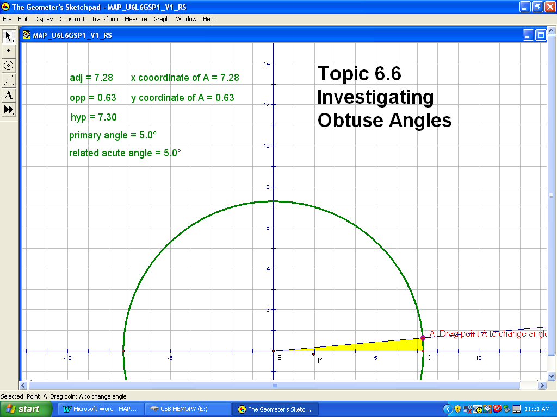
To complete the chart on BLM 6.6.1, students will click on point A and drag it until the primary angle measures the required size. For example, students may see the following for a primary angle of 5º:

6.6.2: Investigating Obtuse Angles (Teacher Notes)

A note on rounding: Because the primary angle in the Sketchpad activity is set to the nearest angle (with no decimal places), the measures of adj, opp and hyp will include some precision error and will vary slightly from student to student. Students can verify the exact values of the trigonometric ratios using their calculators.

Points to notice and/or discuss:
- Students can change the size of the circle when they move point A. The values of
sin B, cos B and tan B do not depend on the lengths of the sides!
- related acute angle = primary angle for primary angles between 0º and 90º
- related acute angle = 180º – primary angle for primary angles between 90º and 180º
- the x-coordinate of point A is the same as the adjacent side in the highlighted
right-angled triangle
- the y-coordinate of point A is the same as the opposite side in the highlighted
right-angled triangle

Paper and Pencil Method:

If students do not have access to Geometer’s Sketchpad, they can use graph paper, pencil, ruler, protractor and calculator to conduct the investigation.

- Distribute BLM 6.6.1 to students along with a copy of the initial screen from the Sketchpad activity. This screen will give them an idea of what they will be drawing.
- Instruct students to:
- Create a Cartesian plane on the graph paper.
- Draw each of the required primary angles in the activity chart being sure to pick an arbitrary point A on the terminal arm of the angle
- Identify the right-angled triangle formed by drawing a line segment from the point A to the closest x-axis.
- Measure and then record the values adj, opp and hyp within this right-angled triangle.
- Complete the rest of the activity as indicated on BLM 6.6.1

6.6.2: Investigating Obtuse Angles (Teacher Notes)

Solutions to Investigation Questions:

- What do you notice about the signs (positive? negative?) of the values of sin B? Be as specific as possible. Why does this happen?
All values are positive because both opp and hyp are positive.

- What do you notice about the signs (positive? negative?) of the values of cos B? Be as specific as possible. Why does this happen?
Values are positive for B between 0 and 90 because adj and hyp are positive.
Values are negative for B between 90 and 180 because adj is negative and hyp is positive.

- What do you notice about the signs ( positive? negative? ) of the values of tan B? Be as specific as possible. Why does this happen?
Values are positive for B between 0 and 90 because opp and hyp are positive.
Values are negative for B between 90 and 180 because opp is positive and adj is negative.

- Write down pairs of $∠B$ that have approximately the same value for sin B. Verify that the values are actually the same using your calculator. For example, check that sin 5º and sin 175º give the same value. How are the angles related to each other?
5º and 175º, 10º and 170º, 25º and 155º, 30º and 150º, 89º and 91º
Each pair of angles has a sum of 180º. They are supplementary?

Using the same pairs of angles, what do you notice about the values of cos B? (Verify on your calculator if needed.)
The values of cos B are the same, although one is positive and one is negative.

Using the same pairs of angles, what do you notice about the values of tan B? (Verify on your calculator if needed.)
The values of tan B are the same, although one is positive and one is negative.

- Use sin⁻¹ on your calculator to solve for angle B in sin B = 0.5. What value does your calculator give?
B = sin⁻¹ (0.5) ➔ B = 30º
What other value is possible? B can also be 150º

How can you quickly determine the value of the second angle?
You can subtract the calculator value from 180º

Complete the following using a calculator and what you have learned:

sin B ≈ 0.7660………… B ≈ 50º or B ≈ 130º
sin B ≈ 0.9205………… B ≈ 67º or B ≈ 113º
- If the radius if the circle was 1, how would the values of sin B and cos B be related to the co-ordinates of the point A on the terminal arm?
The x-coordinate of the point is the cosine of the angle and the y-coordinate of the point is the sine of the angle.

