Unit 4: Day 1: The Next 10 Years
Minds On: 10 |  | Learning Goal:  - Gather, interpret, and describe information about living costs, and estimate the living costs of different households in the local community.  - Connect career choice with estimated wages and living expenses for a certain time period (this may include scenario of marital status and number of dependents). |  | Materials  - Computer lab  - BLM 4.1.1  - BLM 4.1.2  - BLM 4.1.3  - BLM 4.1.4  - BLM 4.1.5
Action: 55
Consolidate:10
Total=75 min
Assessment
Opportunities
 | Minds On… | Think/Pair/Share → Brainstorm  Distribute BLM 4.1.1 and 4.1.2 to students and have them read the 3 different scenarios (college student, college grad and family). Have students brainstorm ideas on living costs on BLM 4.1.2 and then share their ideas with a partner.  From the brainstorming sessions, generate a master list of living costs for each case study on chart paper to be posted in the room for reference throughout the unit.  Mathematical Process Focus: Connecting - Students will connect financial concepts from their own life to the case studies given.  Whole Class → Discussion  Distribute BLM 4.1.3 to students and discuss the general scope of the project and ensure that students understand the portfolio they are required to hand in as their evaluation for the unit. Ensure students understand that this handout will be referenced throughout the unit and used as a guideline for the work they will submit |  | Teacher should read the entire teacher note attached first and understand the entire scope of the project.  When discussing the living costs for each scenario, it is important to include factors such as food, entertainment and clothing. For case study #1, OSAP may come into play. Also discuss special offers that companies have. For example, Rogers will give discounts if you have subscriptions to a cell phone, cable and internet with them. Bell Canada also offers bundle discounts.  Internet websites for salary research:  http://salary.monster.ca  http://www.oyap.com
 | Action! | Individual → Research  Distribute BLM 4.1.4 to students – this will tell them how to use the 2 websites listed. Direct students back to BLM 4.1.3 and highlight Part 1- Investigating Career Choices; this is the part they will be completing today. Circulate as they research their personal career choice using the internet and clarify any questions they have. See BLM 4.1.4 (teacher notes) for a step-by-step guide to the OYAP and Monster.ca websites.  Learning Skills (Initiative)/Observation/Rating Scale: Observe how the students individually demonstrate initiative as complete their research.  Mathematical Process Focus: Connecting - Students will connect real-world applications to financial calculations.
 | Consolidate Debrief | Whole Class → Discussion  Discuss some of the possible career choices that students have found as a class including points such as the current demand of the job, education requirements, etc.
Exploration  Reflection  Application |  | Home Activity or Further Classroom Consolidation  Finish your research on your career choice and create a write-up for Part 1 of your portfolio.

4.1.1: Case Studies

The following Case Studies will be used throughout the Personal Finance unit as a basis for discussions on living expenses and accommodations.

Case Study #1: Mike

Mike is 18 years old and just finished his last year in high school. He is really excited because he has been accepted into the Electrical Engineering Technician program at Cambrian College in Sudbury, Ontario. It is a three-year program and electricians are in high demand in Northern Ontario so he is not worried about finding a job after graduation.
Since Mike does not live in Sudbury, he will have to look for a place to live. It is now the end of June and he has to move in by the end of August. Mike has a full-time summer job that pays $12 per hour as an inventory clerk in a warehouse, which, after taxes and deductions, pays approximately $109.20 every 2 weeks. He has had this job since May 1st. He is looking to get a part-time job as soon as he moves to Sudbury.
He does not have any major financial responsibilities since he currently lives at home. He has a cell phone which costs around $33.75 each month. Mike does not have a car since he is still trying to earn enough money for his tuition this summer. His main source of transportation while in Sudbury will be the Greater Sudbury Transit ($2.50 one way).

Case Study #2: Emily

Emily is 23 years old. Last year, she graduated from George Brown College in Toronto, with a 3-year certificate in Culinary Management. She lives at home, but it is now time to move out! For the past three years she worked part-time as a waitress in a popular restaurant in Toronto. On average, she made $33.25 each night on salary and $120 in tips, working 4 nights a week. Within a calendar year, Emily took 2 weeks of vacation, and 4 weeks for her exam studies, but otherwise, she worked every week.
After graduation, she started working full-time as a sous-chef in a trendy restaurant on King Street West. Her annual salary is $ 24,960. After paying taxes and deductions, she takes home about $624 every 2 weeks. She bought a Honda Civic when she started her new job last year on a 4-year finance plan offering a “$0 down payment at 2.9% interest rate”. Her monthly payment for her car is approximately $590.66 and her car insurance is $215.58 per month. Because she drives to and from work, gas is an important factor and Emily pays approximately $162 for gas every month. She does not have to pay for parking since the restaurant has a small staff parking lot at the back of the restaurant.
Emily pays around $57.38 each month for her cell phone. She is looking to rent or to buy, whichever makes more sense according to her financial situation. If buying is in fact possible, she prefers to buy since it is a good investment. She does not have a preference over the type of accommodation, but she needs a parking spot with her accommodation.

4.1.1: Case Studies (Continued)

Case Study #3: Roger, Susan and Jack

Roger and Susan live in Belleville with their 2 year-old son Jack. Roger is an Employment Officer in the Federal Government office. He has been working for the Government for the last 8 years and he really enjoys his job. His annual salary is $72,548, and after paying taxes, deductions, RRSP contributions, and a family health benefits plan, his take home pay is $1521.94 every 2 weeks. Susan works as a legal secretary. Her annual salary is $59,173 and after paying taxes and deductions, she takes home $1475.54 every 2 weeks.
They currently rent an apartment, paying $1250 each month for rent and approximately $402.85 for utilities such as heat, electricity, water, phone (land line), cable, and internet. They also pay an annual $200 maintenance fee for the building.
Roger and Susan share one car which they have paid off. They purchased a Buick Rendevous 6 years ago with the Directions and Connections Plan from OnStar (which costs $579 each year). Annual maintenance cost for the van is approximately $550, which they expect will increase gradually over the next 5 years. They do not plan to buy a new car since they want to save money for a house. Car insurance costs $134.21 each month and fuel costs approximately $228 each month.
Both Roger and Susan have cell phones but they share a Family Plan which works out to be $93.76 each month. Baby Jack attends day care that costs $700 each month. Baby needs, such as diapers and food, is approximately $175 just for the baby alone. Jack is constantly growing and his clothes need to be replaced about every 6 months. Roger and Susan also want to buy him a tricycle soon because he is an active little kid!
Roger and Susan are looking into buying a house. They are open to the types of accommodations available (condominium, townhouse, detached home, etc). They will need at least one parking spot and they will need to be close to public transportation in case one of them decides to take the bus to work. They are hoping that their new house will have either a park or a playground near by.

4.1.2 Living Expenses

Brainstorm ideas for living expenses in the table below.

Living expenses for Case Study #1: College Student

Living expenses for Case Study #2: Employed College Graduate

Living expenses for Case Study #3: Married Couple with Baby

4.1.3: Career and Accommodations Portfolio
Due Date: _________________________
What will life be like when I start my career? What new responsibilities am I going to have to face when I move out into the “real world”? Will I make enough money to pay for all of the things I need?
Moving out on your own and starting a career can be a very exciting time in life. It can also be a very overwhelming time if you are not properly prepared to deal with all of the new decisions you will be required to make. By the end of this unit you will be more prepared to face those tough decisions.
More specifically, in this unit of study you will
- investigate a career of your choice, including an estimated starting salary
- consider your personal expenses and needs
- survey several rental properties that meet your needs
- survey several purchase properties that meet your needs
- create and revise a monthly budget based on estimated salary, expenses and chosen accommodations
Many parts of this activity will build on the work done in previous parts so it is important to keep all of your work organised in one place. At the end of the unit, you will be required to submit all of your work from each section. This will be evaluated using the accompanying rubric.

Part 1: Investigating Career Choices
Choose a career that you are interested in pursuing. Write a brief description including
- the education required to obtain a job in this field
(apprenticeship, college or university degree required?)
- what a person working in this career is required to do on a day to day basis
- the estimated starting salary for this career
- the location of the job (Will you be required to move to another city?)
You may choose to research more than one career if time allows. Write a complete description for each career researched.

Part 2: Considering your Expenses
Create a detailed list of the expenses you think you will have when you start your career. Consider what you will need (living space, transportation, clothing, food, etc.) as well as things you may want (internet, phone, entertainment, etc.). Estimate how much money you will spend on each of these items per month.

Part 3: Wants vs. Needs
Once you have decided where you would like to work, you must find a place to live. When you search for accommodations, you will most likely have more than one option to choose from. You will have to consider what you need and what you would like to have in your accommodations.
Create a list of features you think you will need and a list of features you think you will want to have in your future accommodations. Provide explanations where necessary.
4.1.3: Career and Accommodations Portfolio (Continued)

Part 4: Renting
Research possible rental properties in the area you will be working in. Keep in mind the list of needs you made in part 3.

Select five properties for rent that meet your needs. For each property selected summarize the associated costs (rent, hydro, parking, etc.) and the convenience factors (close to work, air conditioned, etc.).

Decide which rental property would best meet your needs and wants. Write a brief explanation of your choice.

Part 5: Buying
Research possible properties for sale in the area you will be working in. Keep in mind the list of needs you made in part 3.

Select five properties for sale that meet your needs. For each property selected summarize the associated costs and the convenience factors.

Decide which sale property would best meet your needs and wants. Write a brief explanation of your choice

Part 6: Renting or Buying?
Consider all of the information you have gathered thus far on renting or purchasing a home. You must decide whether you will rent the property selected in part 4 or purchase the property selected in part 5. Provide a detailed explanation for your choice. Make reference to your wants and needs lists created in part 3.

Part 7: Personal Budget
You should now have
- an estimated monthly income (part 1)
- estimated monthly expenses (part 2)
- estimated cost of living (part 6)
Use this information to create a monthly budget for yourself.

Part 8: Revised Budget
Critically look at your budget. Did you choose the right accommodations? Are there any places where you could make changes to reduce your monthly spending?

You will be given a scenario which will change your monthly income or expenses. Revise your budget, taking into account the scenario that has been given to you.
4.1.3: Portfolio: Evaluation Rubric

PORTFOLIO: PARTS 1, 2 & 3
Category: Application
Processes | Criteria | Level 1 | Level 2 | Level 3 | Level 4
Exploring and Reflecting | Collection of career data and exploration of associated living expenses | Gathers data that is connected to future careers and expenses, yet inappropriate for the inquiry | Gathers data that is appropriate and connected to future careers and expenses, yet missing many significant details | Gathers data that is appropriate and connected to future careers and expenses, including most significant details | Gathers data that is appropriate and connected to future careers and expenses, including all significant details as well as extreme cases
Reasoning and Proving | Degree of clarity in explanations and justifications for expenses | Explanations and justifications are partially understandable | Explanations and justifications are understandable by the teacher, but would likely be unclear to others | Explanations and justifications are clear for a range of audiences | Explanations and justifications are particularly clear and detailed
PORTFOLIO: PARTS 4, 5 & 6
Category: Thinking
Processes | Criteria | Level 1 | Level 2 | Level 3 | Level 4
Exploring and Reflecting | Collection of possible accommodations data and exploration of suitability | Gathers data that is connected to possible accommodations, yet does not meet any of the “needs” specified by the student | Gathers data that is appropriate and connected to possible accommodations, yet meets very few of the “needs” specified by the student | Gathers data that is appropriate and connected to possible accommodations, including most “needs” specified by the student | Gathers data that is appropriate and connected to possible accommodations, meeting all “needs” specified by the student
Reasoning and Proving | Degree of clarity in explanations and justifications in selecting one accommodation from collection of potential accommodations explored | Explanations and justifications are partially understandable | Explanations and justifications are understandable by the teacher, but would likely be unclear to others | Explanations and justifications are clear for a range of audiences | Explanations and justifications are particularly clear and detailed
Reasoning and Proving | Making inferences, conclusions and justifications | Justification of the choice of accommodation presented has a limited connection to the “wants”, “needs” and affordability specified by the student | Justification of the choice of accommodation has some connection to the “wants”, “needs” and affordability specified by the student | Justification of the choice of accommodation has a direct connection to the “wants”, “needs” and affordability specified by the student | Justification of the choice of accommodation has a direct connection to “wants”, “needs” and affordability specified by the student, with evidence of reflection
4.1.3: Career and Accommodations Portfolio: Evaluation Rubric (Continued)

PORTFOLIO: PARTS 7 & 8
Category: Application
Processes | Criteria | Level 1 | Level 2 | Level 3 | Level 4
Selecting Tools and Strategies | Select and use appropriate tools to create a budget | Selects and applies appropriate tools, with major errors, omissions, or mis-sequencing | Selects and applies appropriate tools, with minor errors, omissions or mis-sequencing | Selects and applies appropriate tools, accurately, and logically sequenced | Selects and applies the most appropriate tools, accurately and logically sequenced
Representing | Creation of a budget to represent the proposed living expenses | Creates a budget that represents little of the range of expenses | Creates a budget that represents some of the range of expenses | Creates a budget that represents most of the range of expenses | Creates a budget that represents the full range of expenses
Category: Thinking
Processes | Criteria | Level 1 | Level 2 | Level 3 | Level 4
Exploring and Reflecting | Ability to apply the processes of inquiry and problem solving to alter a budget i.e., reflecting, revising and revisiting to alter proposed living expenses | Applies the processes to revise a budget with significant prompts | Applies the processes to revise a budget with minor prompts | Applies the processes to revise a budget without prompts | Applies the processes to revise a budget without prompts, including a broader view of the revisions required
PORTFOLIO: OVERALL
Category: Communication
Communicating | Appropriate use of mathematical vocabulary throughout portfolio | Sometimes uses mathematical vocabulary correctly when expected | Often uses mathematical vocabulary correctly when expected | Consistently uses mathematical vocabulary correctly when expected | Consistently uses mathematical vocabulary correctly, recognizing novel opportunities for its use
Category: Application
Selecting Tools and Strategies | Select and use appropriate concrete, visual, and electronic tools to create a portfolio | Selects and applies appropriate tools, with major errors, omissions, or mis-sequencing | Selects and applies appropriate tools, with minor errors, omissions or mis-sequencing | Selects and applies appropriate tools, accurately, and logically sequenced | Selects and applies the most appropriate tools, accurately and logically sequenced
Category: Thinking
Connecting | Make connections within the portfolio among mathematical concepts and procedures | Makes weak connections | Makes simple connections | Makes appropriate connections | Makes strong connections

4.1.3: Unit Overview (Teacher Notes)

Most lessons in this unit will be related to either the case studies provided or the student portfolio, as indicated. Encourage students to keep all of their work together for their portfolio and to bring their portfolio materials to class every day. You may want to collect parts of the portfolio for assessment throughout the unit.

Day 1: (Case Study and Portfolio)

See Lesson plan given above.

Day 2: Looking at Rental Ads (Portfolio)
Newspaper, renters news and/or internet access required.

Learning Goals
- Establish residence criteria (eg. Cost, location, pets, laundry facility, parking, public transit, shopping, fitness facilities, school, furnishings, etc.)
- Establish wants versus needs
- Research in newspapers, internet
- Understand advertisement language and intent

Suggested Lesson
- Think/Pair/Share and brainstorm on the Wants / Needs for the 3 case studies given on Day 1
- Look at several examples of rental ads (newspaper, internet, etc.) to create and discuss a list of terms associated with renting
- Complete Parts 2 and 3 of the Portfolio (Create their own expenses list and wants/needs list)
* You may want to create a list of rental terms ahead of time for students to explore.

Day 3: Comparing Rental Options
Newspaper, renters news and/or internet access required.

Learning Goals
- Gather information about different rental accommodations in the local community (eg. Apartment, condominium, townhouse, detached home, room in a house, mobile home) such as availability, conditions for renting
- Establish pros and cons for each of the various options

Suggested Lesson
- Have students investigate rental ads for a specific region and complete a table similar to the one below
 | Apartment | Condo | Townhouse | Detached home | Room in a house | Mobile home
Pros
Cons
Rent($)
Availability
4.1.3: Unit Overview (Teacher Notes) (Continued)

Day 4: Determining Affordability of Accommodations (Case Study)

Learning Goals
- Identify and describe the factors to be considered in determining the affordability of accommodation in the local community, and consider the affordability of accommodation based on circumstances

Suggested Lesson
- Consider the 3 case studies given on Day 1 and determine which type of accommodation is most appropriate/affordable based on research table created on Day 3.
- Prepare and discuss other case studies with varying life circumstances, income and expenses. This lesson has a focus on rental options since students have not investigated purchasing property yet.

Day 5: Selecting a Rental Property (Portfolio)
Newspaper, renters news and/or internet access required.

Learning Goals
- Research rental costs (e.g. first and last rent, parking fee, laundry, heat and hydro, internet, cable, appliances, hot water tank, water)
- Survey rental properties and select 5 possible properties to meet given needs

Suggested Lesson
- Have students research online costs associated with rentals. Use the chalk board and have students ‘run up’ with new ideas that they have found.
- Discuss all costs as a class.
- Have students survey rental properties in local community (or community they would prefer to live and work in after graduating) and choose 5 properties for Part 4 of their portfolio.
Emphasize to students that the rental properties they select must meet the needs they specified in Part 3 of their portfolio.

Day 6: Selecting a Rental Property - continued (Portfolio)
Newspaper, renters news and/or internet access required.

Learning Goals
- Interpret the information from the five properties to make an informed decision in selecting a rental property that would suit given needs – include cost analysis (rental and other associated costs like transportation) and convenience factors

Suggested Lesson
- Discuss the convenience factors involved in their rental – i.e. location/laundry etc and how those may effect their monthly budget.
- Have students spend time choosing a property from the five selected on Day 5 and work on completing the written portion of Part 4 for their portfolio.

4.1.3: Unit Overview (Teacher Notes) (Continued)

Possible Jazz Day:

If time allows, this would be an excellent opportunity to invite a guest speaker (such as a real estate agent) to come and talk to the class about the costs and procedures involved in purchasing accommodations.

Day 7: Investigating Purchasing Property (Case Study)
Internet access strongly recommended OR gather resources prior to lesson

Learning Goals
- Gather and interpret information about procedures and costs involved in buying and owning accommodation in the local community (eg. Home inspection, survey, approval of mortgage, lawyer’s fees, taxes, location, size of home, etc…)

Suggested Lesson
- Brainstorm as a class or in groups on all extra expenses that could be involved in purchasing a home.
- Have students form expert groups to research procedures and costs involved in buying and owning accommodation in the local community
- Revisit case studies to determine which type of accommodation is most appropriate/affordable
You could create a list of purchasing terms ahead of time for students to explore.

Day 8: Selecting a Purchase Property (Portfolio)
Newspaper, real estate guides and/or internet access required.

Learning Goals
- Survey possible accommodations to purchase (eg. Detached, semi-detached, condominium, town house) and select five possible properties to meet their needs
- Interpret the information from the five properties to make an informed decision in selecting a property to purchase that would suit given needs – include cost analysis (purchase price and other associated costs like transportation), convenience factors

Suggested Lesson
- Students survey purchase properties in local community (or community they would prefer to live and work in after graduating) and choose 5 properties for Part 5 of their portfolio.
- Students spend time choosing a property from the five selected in order to complete the written portion of Part 5 for their portfolio

4.1.3: Unit Overview (Teacher Notes) (Continued)

Day 9: Renting or Buying? (Portfolio)

Learning Goals
- Compare renting accommodation with owning accommodation by describing the advantages and disadvantages of each
- Justify selection of accommodation between the rental choice and the purchase choice for given needs

Suggested Lesson
- Brainstorm pros and cons for renting vs. owning accommodations through Graffiti. – refer to the Think Literacy documents for more information about graffiti.
- Complete Part 6 for their portfolio (choice of renting or owning) remind students that they must fully justify their decision

Day 10: Creating a Savings Plan (Case Study)
Refer to BLM 4.12.2 for sample budgets for Case Studies

Learning Goals
- Design and present a savings plan to facilitate the achievement of a long-term goal

Suggested Lesson
- Use Case Studies as examples for Chalk and Talk

Day 11: Creating a Budget (Portfolio)

Learning Goals
- Design, explain and justify a monthly budget suitable for their scenario

Suggested Lesson
- Students spend time creating a personal budget to include for Part 7 of their portfolio

Day 12: Revising a Budget (Case Study)

See Unit 4 Day 12 Lesson and Black Line Masters.

Day 13: Revising a Budget - continued (Portfolio)
Refer to BLM 4.1.5 for sample income or expense altering circumstances.

Learning Goals
- Make adjustments to a budget to accommodate changes in circumstances

Suggested Lesson
- Students ensure their original budget is ready for submission.
- Students randomly select a scenario which alters their income.
- Students revise their personal budget accordingly.
- Spend time preparing portfolio to be handed in for evaluation.

4.1.4: Find out how much you will make!

As a student, it is really difficult to get a good idea on how much you will make when you enter a certain job. This website will help you!

Open up an internet browser and go to on of the following two sites:

1. http://salary.monster.ca/
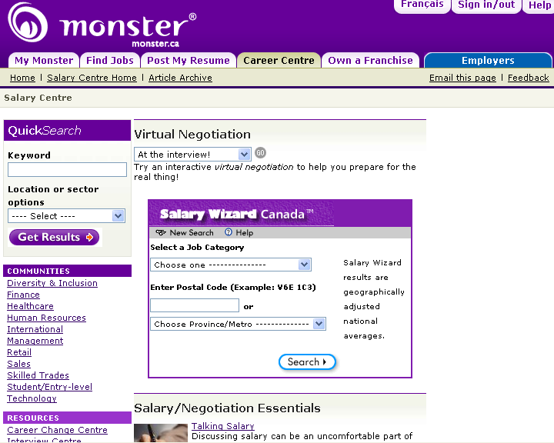
The centre is the Salary Wizard that you should use. Follow the directions on the screen and it will output a salary range for the career that you have chosen.

Not all cities in Canada are listed, only the major ones, so either pick the one that is closest to home or pick the city that you would like to live in.

The ENTRY LEVEL selection is also very helpful in finding entry level jobs. You may want to start there.

2. http://www.oyap.com
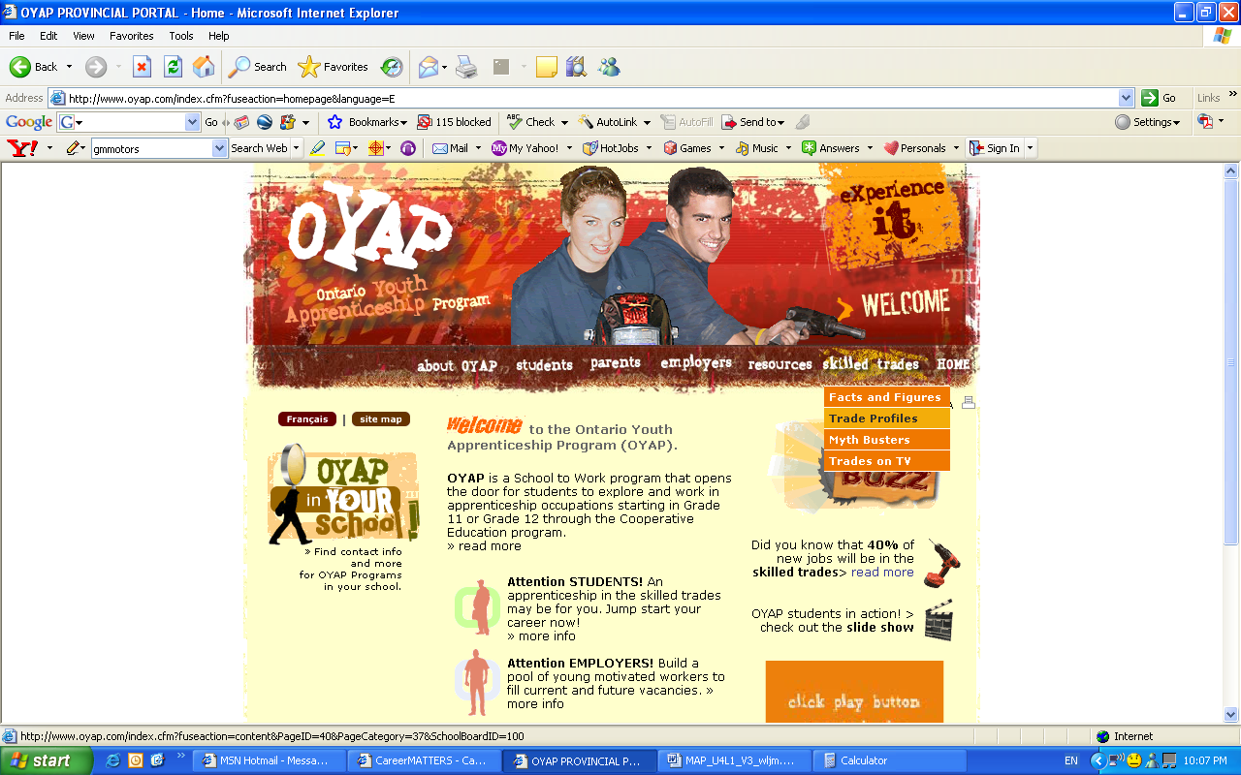
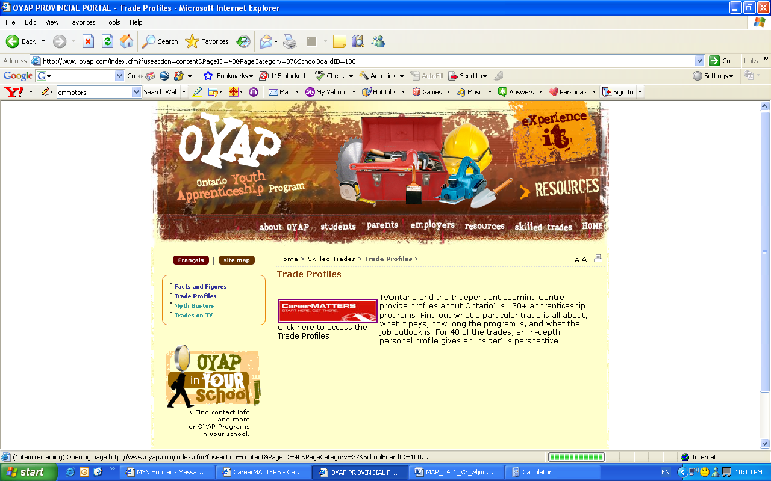
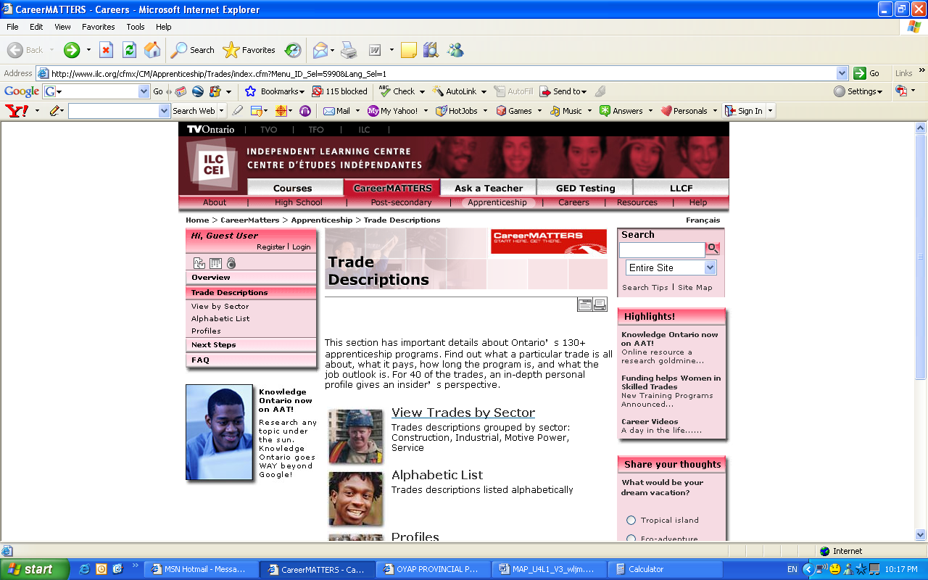
Mouse over Skilled Trades and choose Trade Profiles from the menu.

Click on “Click here to access the Trade Profiles”.

Another window will open.

Select either from “View Trades by Sector” or “Alphabetic List” to choose the career that you want.

Try it out and have fun!

- Have students investigate rental ads for a specific region and complete a table similar to the one below
4.1.3: Unit Overview (Teacher Notes)

4.1.4 Using the Websites (Teacher Notes)

Open any internet browser and on the address bar, type in http://salary.monster.ca/

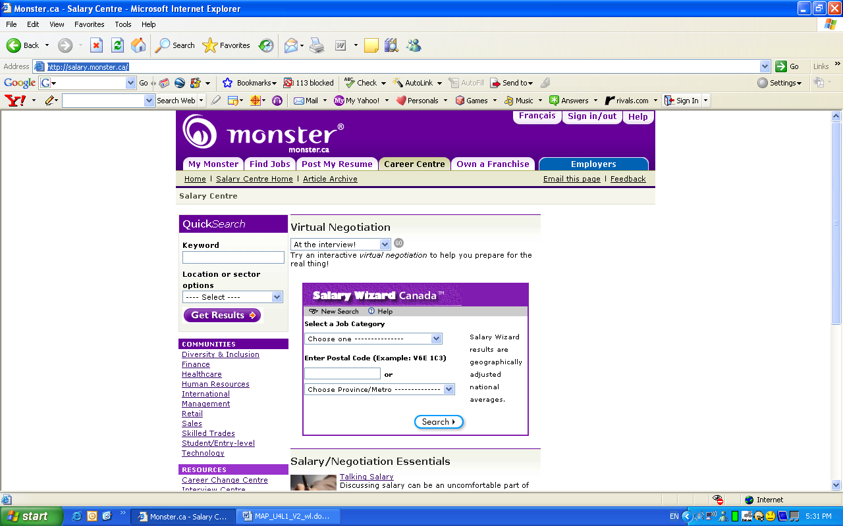

Under Select A Job Category, on the drop down menu, select a category. (Note that not all career categories are listed).

You can either choose to enter your postal code or select a main area by major cities from the drop down menu.

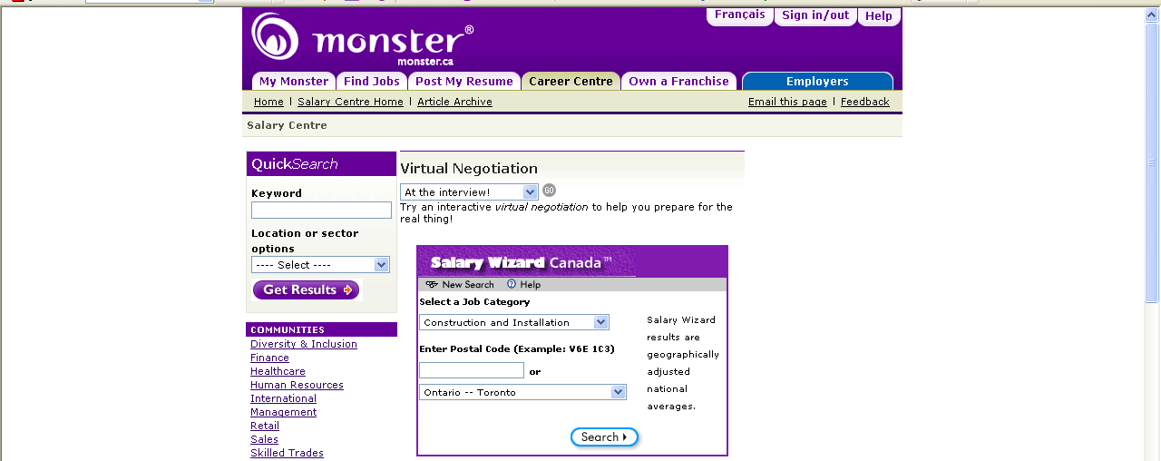

4.1.4 Using the Websites (Teacher Notes) (Continued)

Click on Search and a new screen will appear.

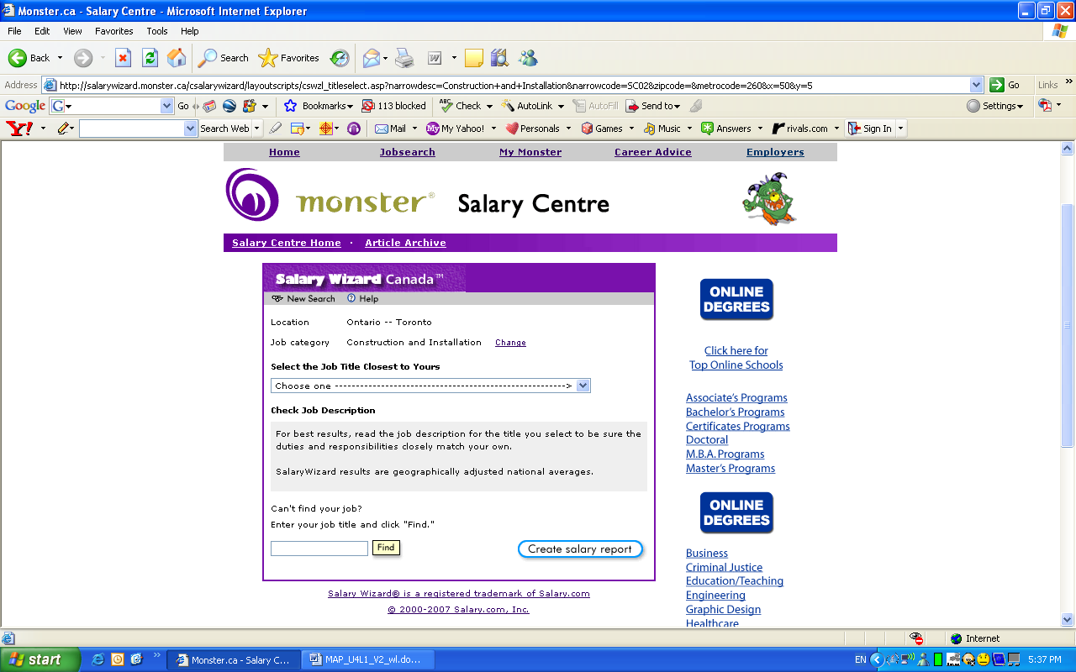

Under Select A Job Title Closest To Yours, from the drop down menu, choose a job title.
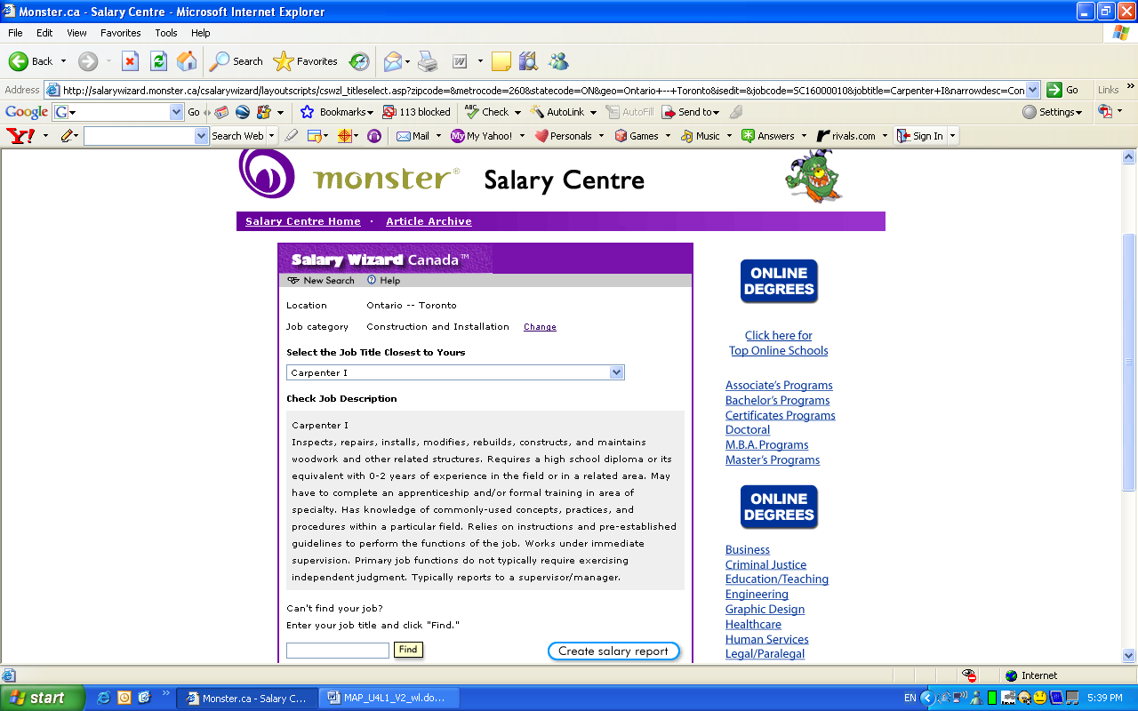

4.1.4 Using the Websites (Teacher Notes) (Continued)

A Job Description now appears in the window.

Click on Create Salary Report and a new window will appear with a graph.

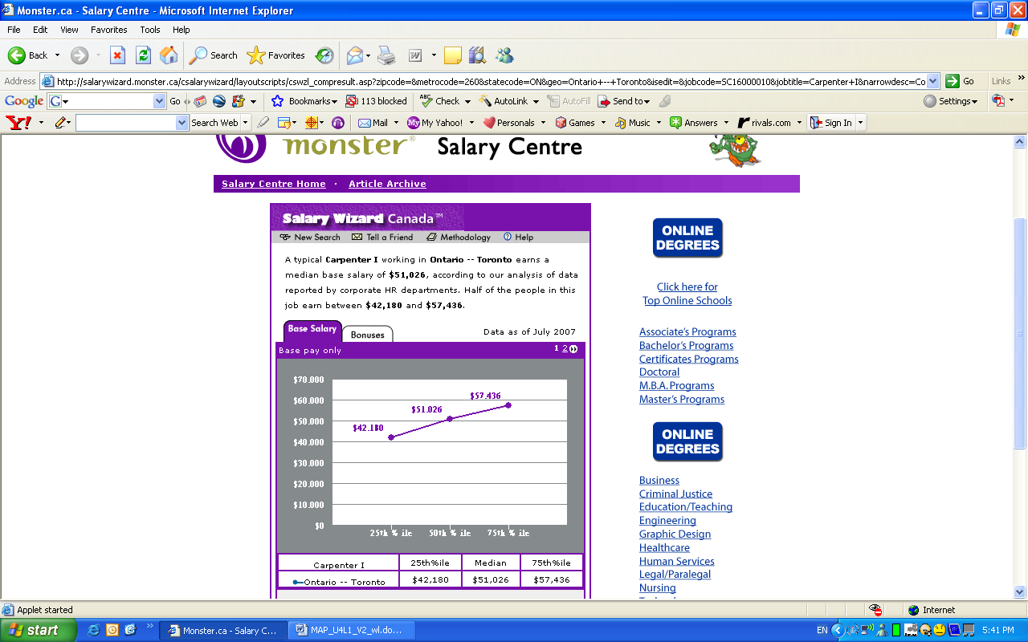

The lowest number is the salary for the first 25 percentile and the highest number for the 75 percentile of the job.

The OYAP website is also very informative. It has more career choices, however it does not separate the salaries into different cities. See instructions on the following pages.

4.1.4 Using the Websites (Teacher Notes) (Continued)

Open any internet browser and on the address bar, type in http://www.oyap.com/

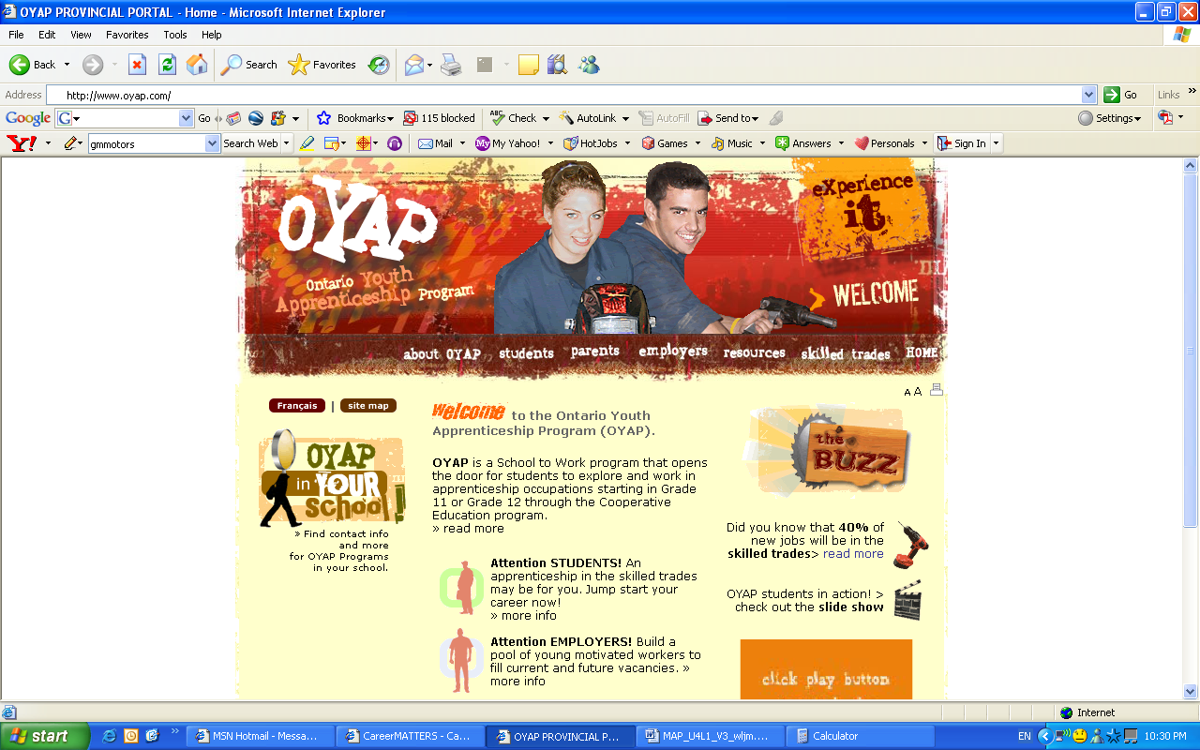

Mouse over Skilled Trades and from the menu that appears, select Trade Profiles

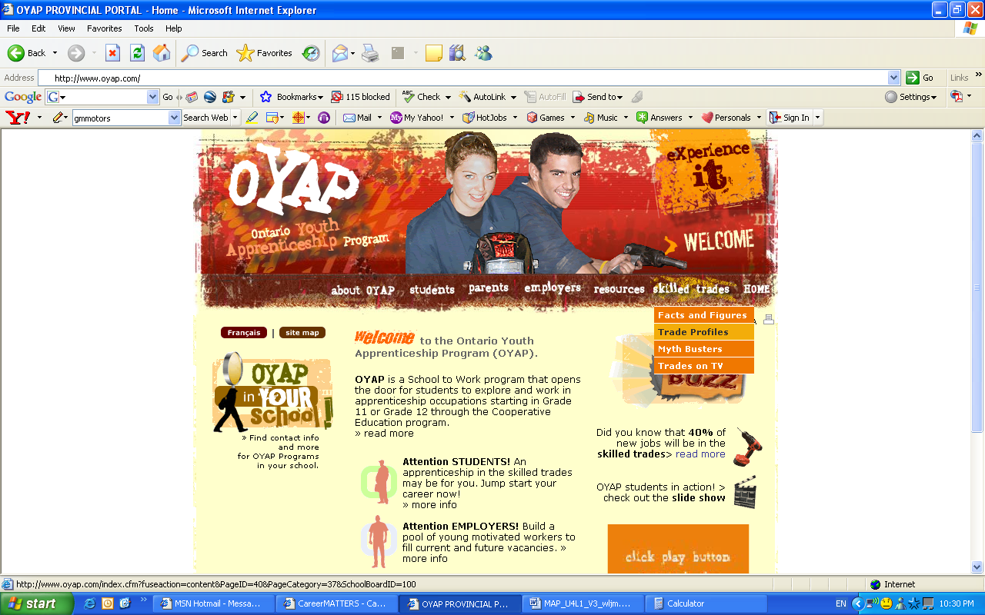
4.1.4 Using the Websites (Teacher Notes) (Continued)

Click on “Click here to access Trade Profiles”.
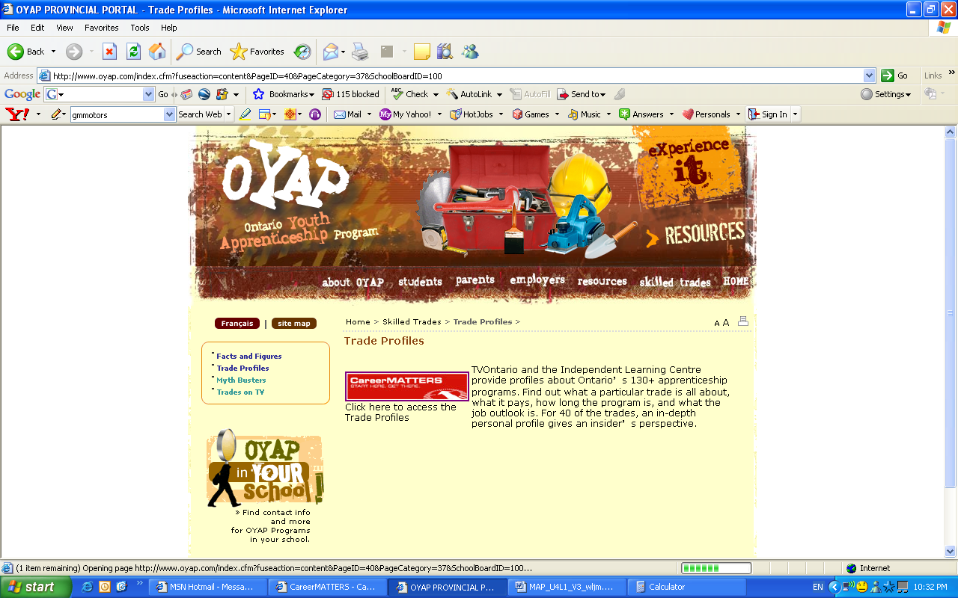
A new window will open. Students can choose from either “View Trades by Sector” or “Alphabetical List”. For example the student wants to look for a chef. The student can choose from the Alphabetical List.
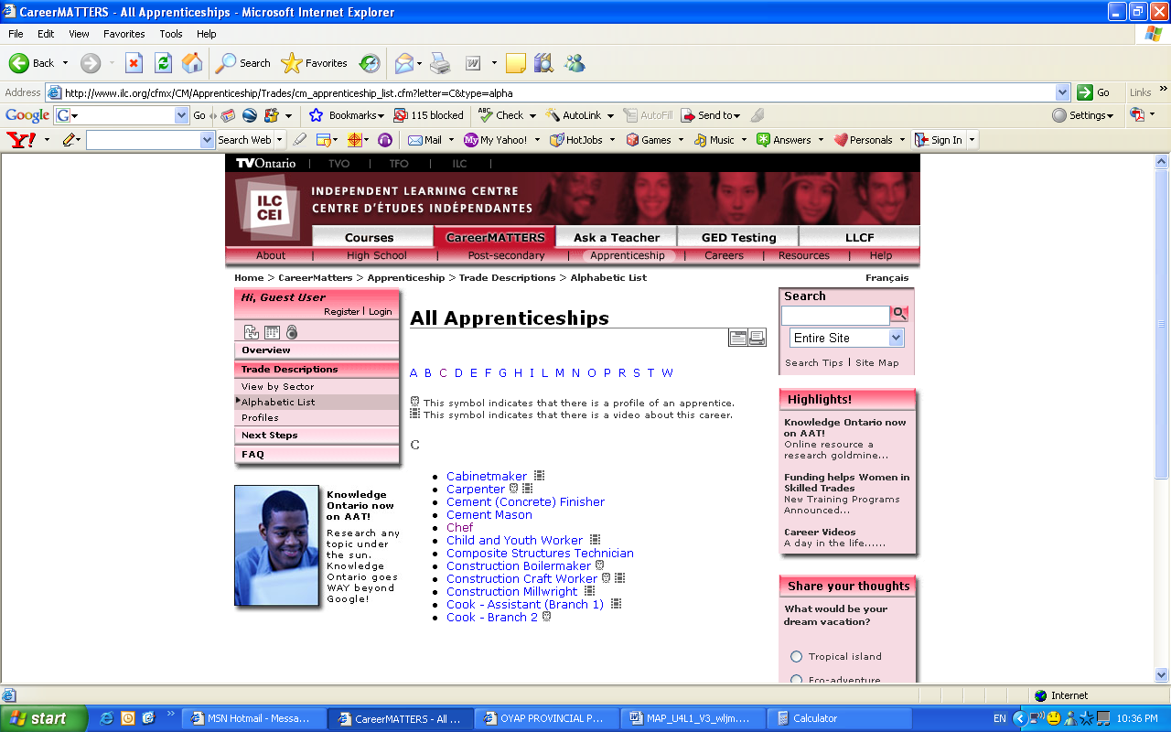
4.1.4 Using the Websites (Teacher Notes) (Continued)

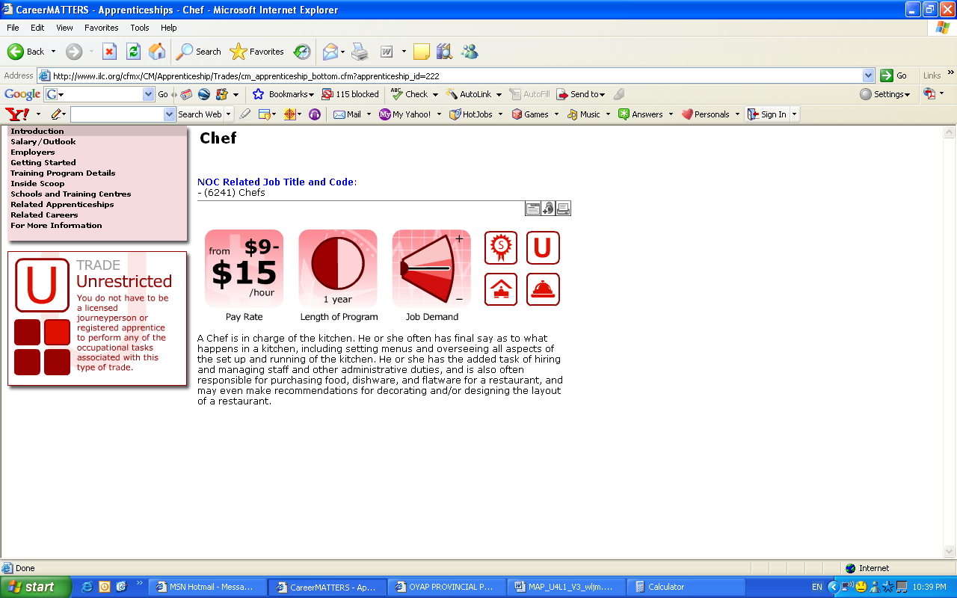

The first screen that appears will have a pay rate, however it is important to note the side bar, because a lot of important information is available to students if they want to find out a little bit more about the career.

4.1.5: Portfolio Sample Income/Expense Changes

Income and Expense Altering Scenarios (required for Part 8 of Portfolio)
Fill in the following with some dollar values, cut them out and place them in a hat. Have students select one of the scenarios and alter their budgets accordingly.

Congratulations! You are having a baby! This will increase your monthly expenses by

______________

Congratulations! You have received a promotion at work. Your monthly income will increase by

______________

Congratulations! You are getting married! You would like to put some money into a separate savings account to pay for your wedding. Each month, you would like to save

______________

Your hours have been cut back at work. Your monthly income will decrease by

______________

You have received a promotion at work, but you must move to another city. Your monthly income will increase by

______________

but your monthly living expenses will also increase by

______________

You have decided to move to a less expensive area of town. Your monthly living costs will decrease by

______________

Unit 4: Day 12: Revising a Budget
Minds On: 15 |  | Learning Goal:  - Make adjustments to a budget to accommodate changes in circumstances. |  | Materials  - BLM 4.12.1  - BLM 4.12.2 (Teacher Notes)  - BLM 4.12.3 (Teacher Notes)
Action: 45
Consolidate:15
Total=75 min
Assessment
Opportunities
 | Minds On… | Whole Group → Brainstorm  Lead the class in brainstorming a list of circumstances that could change income or expenses for a household. (eg. Promotion/raise at work, hours cut back at work, having a baby, changing accommodations, etc.) Begin this brainstorming by asking what changes might affect the budgets in the 3 case studies.  Mathematical Process Focus: Students will reflect on case study scenarios and hypothesize by connecting to prior knowledge of expenses and income. |  | Have students complete these activities using budgets made throughout the unit OR give students a copy of budgets given in BLM 4.12.2  BLM 4.12.3 provides a sample revised budget for each scenario.
 | Action! | Whole Class → Discussion  Distribute BLM 4.12.1 and lead the class in a discussion about the changes that could be made to the budget for case study #1 based on the circumstances outlined in BLM 4.12.1.  Pairs → Pair/Share  Pair students up to alter the budget for case study #2 given the circumstances outlined on BLM 4.12.1.  Mathematical Process Focus: Reasoning & Proving students will use reasoning to determine which expenses are necessary and which expenses could be altered to reflect required changes in income/expenses.  Problem Solving/Observation/Anecdotal: Circulate and give students verbal feedback on their work as the complete the budget alterations.
 | Consolidate Debrief | Whole Class → Pair/Share  Have pairs share their proposed budget changes with the class and discuss which changes seem to be most realistic &/or beneficial for Emily.  Communicating/presentation/anecdotal: Observe students and make anecdotal comments.
Reflection  Exploration  Application |  | Home Activity or Further Classroom Consolidation  Students will work on revising budget for case study #3 given circumstances outlined on BLM 4.12.1 in preparation for revising their own budget in tomorrow’s lesson for the final piece of their summative. This case study should also be taken up, if time allows today, or at the beginning of the period tomorrow.

4.12.1: Circumstances Altering Budgets: Case Studies

Case Study #1: Mike

One of Mike’s roommates has decided to pursue an apprenticeship opportunity in his hometown. As it is late in the summer, Mike’s roommates are having difficulty finding another person to live with. Most students have already found a place to live for the fall semester. Mike’s roommates will have to split all shared costs three ways instead of four. Revise Mike’s budget to reflect this change in expenses.

Case Study #2: Emily

Emily received her promotion!! She is now a chef, making an annual salary of $39 440. Her take home pay is $986 every two weeks. However, Emily has realized that even with her increased salary, she is using too much of her savings for living expenses. She will search for a roommate to share the expenses of rent, phone and cable. Assuming Emily finds a roommate, revise her monthly budget to reflect these changes.

Case Study #3: Roger, Susan and Jack

Roger and Susan are expecting another baby. Although Susan will still receive a portion of her salary while on maternity leave, it will be approximately 65% of her regular pay. Both children will receive government funding for $35 each month. Susan has decided to leave Jack in daycare 3 days a week, reducing the cost of daycare to $450 per week.

Susan would like to purchase another vehicle as she will be home most of the day with the two children. Roger and Susan found a used car from a well known local dealership. They will pay for the car out of their savings, however they will now have maintenance costs ($56.72 per month), insurance costs ($142.76 per month) and fuel costs ($123.00 per month) for the additional vehicle.

Over the course of the first year, diapers and food costs will double to account for the two children’s needs. Create a revised budget for Roger, Susan, Jack and their new baby.

4.12.2: Sample Budgets for Case Studies (Teacher Notes)

The following budgets are sample budgets and scenarios for the Case Studies given – these would have been filled out throughout the unit.

Case Study 1: Mike’s Monthly Budget

Mike has chosen to live in student housing in Sudbury. He is sharing a house with three other students. His rent is $400 per month and he splits the utilities with his roommates (approximately $40 per month per roommate). Mike and his roommates have decided they would like to share a phone line, internet and cable. They found a plan that offers all three services charging $120 per month. Mike estimates his monthly food costs to be approximately $195.

Mike has decided to keep his cell phone. He uses the Greater Sudbury Transit system to get to school and home each day. He will likely take one other trip using the Greater Sudbury Transit on weekends. Mike received $3000 from OSAP for the fall semester (September – December). He also found a job at a local grocery store paying $8.50 per hour. He works approximately 25 hours per week. Tuition for the fall semester is approximately $2500 (including textbooks).

Mike’s Monthly Budget: Fall to December

INCOME
Part time job (grocery store) | 920.83
OSAP | 750.00
Total Monthly Income | 1 670.83
EXPENSES
Tuition | 625.00
Rent and utilities | 440.00
Transportation | 130.00
Food | 195.00
Cell phone | 33.75
Cable, phone, internet | 30.00
Total Monthly Expenses | 1 453.75
INCOME - EXPENSES | 217.08

Calculations
Part time job
$8.50 x 25 hours/week x 52 weeks/year ÷12 months/year = $920.83/month
OSAP Tuition
$3000 ÷ 4 months = $750/month $2500 ÷ 4 months = $625/month
Transportation
$2.50 x 2 trips/day x 6 trips/week = $30/week
$30/week x 52 weeks/year ÷ 12 months/year = $130/month
Cable, Phone, Internet
$120 ÷ 4 = $30/month

4.12.2: Sample Budgets for Case Studies (Continued)

Case Study 2: Emily’s Monthly Budget
Emily could not afford to buy property, so she is renting an apartment in downtown Toronto. She makes a monthly rent payment of $1256.00 which includes utilities. She pays $15 per month for a parking space in the parking lot of the apartment.

Emily has maintained her job as a souse-chef with the promise of a promotion in the next 6 months. Her car payment and insurance remain the same as those originally specified. She pays $68 for gasoline monthly (reduced from $162) as she now lives much closer to her work. Emily has decided to cancel her cell phone but will pay for a home phone and cable ($88.24 per month). Her estimated grocery costs are $250 per month.

Emily also has approximately $29 500 in savings as she was able to live at home rent free during her time in school. She will use this savings to help her cover living expenses until she is able to work as a chef (at a higher salary).

Emily’s Monthly Budget

INCOME
Restaurant | 1 941.33
Total Monthly Income | 1 941.33
EXPENSES
Rent | 1 256.00
Parking | 15.00
Car payment | 590.66
Car insurance | 215.58
Fuel | 68.00
Home phone, cable | 88.24
Groceries | 250.00
Total Monthly Expenses | 2 483.48
INCOME - EXPENSES | - 542.15

Calculations
Restaurant
$896 bi-weekly x 26 bi-weekly payments/year ÷ 12 months/year = $1941.33/month

4.12.2: Sample Budgets for Case Studies (Continued)

Case Study : Roger, Susan and Jack’s Monthly Budget
Roger and Susan have found a house to buy for their family. It is close to a playground and a good elementary school for Jack. The house is within walking distance of the bus route. They are very pleased with their decision.

Their monthly mortgage payment will be $1275. They will pay $2920 per year in property taxes and $930.72 every 3 months for utilities. They pay $132.21 per month for phone, internet and cable. All other costs (transportation, day care, cell phones) will remain unchanged. They have estimated that they spend close to $450/month on groceries for themselves and another $150/month on entertainment/recreation.

Roger and Susan still have student loans (OSAP) they are paying off, a total of $535 per month.

Roger, Susan and Jack’s Monthly Budget
INCOME
Roger’s income | 3 927.54
Susan’s income | 3 197.00
Total Monthly Income | 7 124.54
EXPENSES
Mortgage | 1275.00
Property taxes | 243.33
Utilities | 310.24
Student Loans | 535.00
Phone, Internet, cable | 132.21
Car maintenance | 45.83
Car insurance | 134.21
Fuel | 228.00
Cell phones | 93.76
Day care | 700.00
Baby: Diapers and Food | 175.00
Groceries | 450.00
Miscellaneous (Recreation/Entertainment/Babysitter) | 500.00
Total Monthly Expenses | 4 822.58
INCOME – EXPENSES | 2 301.96

Calculations
Roger’s income
$1521.94 biweekly x 26 bi-weekly periods/year ÷ 12 months/year = $3 927.54/month
Susan’s income
$1475.54 biweekly x 26 bi-weekly periods/year ÷12 months/year = $3 197.00/month
Property taxes
2920 ÷ 12 months/year = $243.33/month
Utilities Car maintenance
930.72 ÷ 3 months = $310.24/month $550/year ÷12 months/year = $45.83/month
4.12.3: Sample Revised Budgets (Teacher’s Notes)

The following budgets are possible solutions given the case studies and income/expense altering circumstances. Solutions may vary.

Mike’s REVISED Monthly Budget: Fall to December

Most landlords would not increase the rent payment for each occupant, as the students most likely signed separate leases with a previously agreed upon rent amount. Utilities and phone/internet/cable will now have to be split three ways instead of four.

INCOME
Part time job (grocery store) | 920.83
OSAP | 750.00
Total Monthly Income | 1 670.83
EXPENSES
Tuition | 625.00
Rent and utilities | 453.33
Transportation | 130.00
Food | 195.00
Cell phone | 33.75
Cable, phone, internet | 40.00
Total Monthly Expenses | 1 477.08
INCOME - EXPENSES | 193.75

Calculations
Utilities Phone/internet/cable
$40 x 4 ÷3 = $53.33 per month $120 ÷ 3 = $40.00 per month
4.12.3: Sample Revised Budgets (Teacher’s Notes) (Continued)

Emily’s REVISED Monthly Budget

INCOME
Restaurant | 2 136.33
Total Monthly Income | 2 136.33
EXPENSES
Rent | 628.00
Parking | 15.00
Car payment | 590.66
Car insurance | 215.58
Fuel | 68.00
Home phone, cable | 44.12
Groceries | 250.00
Total Monthly Expenses | 1 811.36
INCOME - EXPENSES | 324.97

Calculations
Restaurant
$986 x 26 biweekly periods ÷ 12 months = $2136.33 per month
Rent
$1256 monthly ÷ 2 people = $628 per person per month
Phone/Cable
$88.24 monthly ÷ 2 people = $44.12 per person per month

4.12.3: Sample Revised Budgets (Teacher’s Notes) (Continued)

Roger, Susan and Jack’s REVISED Monthly Budget

INCOME
Roger’s income | 3 927.54
Susan’s income | 2 078.05
Government Funding | 70.00
Total Monthly Income | 6 075.59
EXPENSES
Mortgage | 1275.00
Property taxes | 243.33
Utilities | 310.24
Student Loans | 535.00
Phone, internet, cable | 132.21
Car maintenance | 102.55
Car insurance | 276.97
Fuel | 351.00
Cell phones | 93.76
Day care | 450.00
Baby: Diapers and Food | 350.00
Groceries | 450.00
Miscellaneous (Recreation/Entertainment/Babysitter) | 500.00
Total Monthly Expenses | 5 070.06
INCOME – EXPENSES | 1 005.53

Calculations
Susan’s income
$3 197.00/month x 0.65 =
Car maintenance
$45.83/month + $56.72/month = $102.55/month
Car insurance
$134.21/month + $142.76/month = $276.97/month
Fuel
$228.00/month + $123.00 /month = $351.00/month

