Ghost Paths Interactive GSP Exploration
Subject/Grade | Mathematics/Grade 3, 4, or 5
Total Time | 60 minutes
Materials | The Geometer’s Sketchpad Version 4 (dynamic geometry software)  BLM – Note the area Computer Instructions – the teacher may wish to include file management instructions or lab specific instructions
Description | Students move two ghost characters (Doug and Linda) around the screen to explore geometric concepts. Students discover connections between the ghosts’ constructed paths by comparing them and looking for similarities and differences.
Expectations | Geometry and Spatial Sense  3m55 investigate the attributes of three-dimensional figures and two-dimensional shapes using concrete materials and drawings  4m62 investigate the attributes of three-dimensional figures and two-dimensional shapes using concrete materials and drawings  3m65 compare and sort two-dimensional shapes according to two or more attributes  4m72 sort and classify two-dimensional figures according to shape  5m76 classify two-dimensional shapes according to angle and side properties (e.g., obtuse, scalene)  5m75 sort polygons according to the number of sides, angles, and vertices  5m65 identify, describe, compare, and classify geometric figures  3m60 use language effectively to describe geometric concepts, reasoning, and investigations  4m67 use language effectively to describe geometric concepts, reasoning, and investigations, and coordinate systems  4m77 use mathematical language to describe geometric ideas (e.g., line, angle)  5m70 use mathematical language effectively to describe geometric concepts, reasoning, and investigations, and coordinate systems  5m82 use mathematical language to describe geometric ideas (e.g., quadrilateral, scalene triangle)
Prior  Knowledge | Skills with Geometer’s Sketchpad  • open/close files  • select and drag a point  Vocabulary  • line segment, line, ray, circle, radius, hexagon, octagon
Assessment  Suggestions | Formative Assessment  • make anecdotal observations during the inquiry  • collect BLMs and give student feedback on communication skills  Summative Assessment  • after giving feedback on communication for questions 1 to 7 collect responses to question 8 – create a rubric for assessment
Extensions | Investigate hidden paths in real contexts.  Get students to create their own pathways and give descriptions so someone else can construct the paths.

Ghost Paths Teacher’s Notes
Introducing the Activity

Whole Class/Discussion
- Invite students to discuss real contexts where “hidden” pathways can be found (e.g. detectors for buried power cables, radar for flight paths, headlights of a vehicles at night, footprints on fresh snow, etc.)
- Were any of these pathways constructed using geometric concepts?
- Can any of the following geometric concepts be used to build paths? line segments, lines, rays, circles, polygons
- Give students advance warning that you will regroup for discussion at different times during the exploration.

Activity  Pairs/Exploration  - Students work in pairs at computers  - Students should click all Action! buttons  - Some sketches include I need some help. buttons – advise students to explore as much as possible before using these  - Students record observations on BLM or alternatively teacher records anecdotal comments after interviewing pairs  - Each sketch includes a Next Page button | 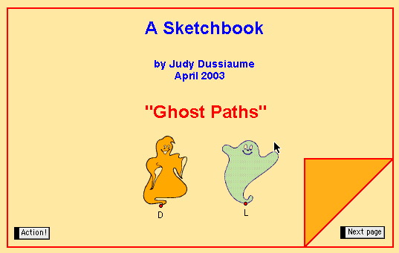
- The Introductions page is used to confirm that students know how to drag a point – note that there are no hidden constructions – Doug and Linda can move freely on the screen - the BLM includes questions to help students understand this | 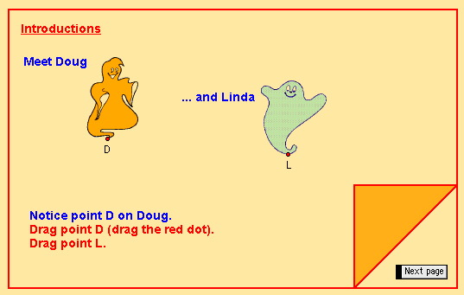
- Sample responses: | 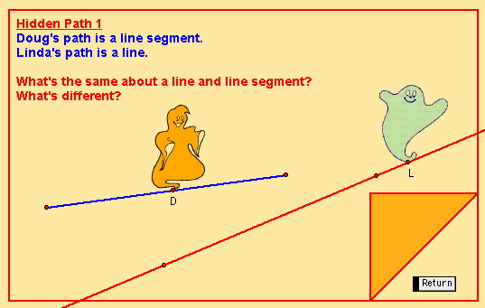
  What’s the same? | What’s different?
  - both straight  - both slant upward to the right | - different slant angles (slope)  - Doug’s path has a beginning and an end (the line segment has two endpoints); Linda’s path has no beginning or end (no endpoints)
Whole Class/Discussion  - During this activity regroup and pose some of these questions:  What advice would you give about dragging points?  (e.g. Make sure you drag as far as you can or you might not see that there is an endpoint.)  What did you notice about dragging the points in the first sketch on the introduction page?  (e.g. You could drag the points anywhere.) | 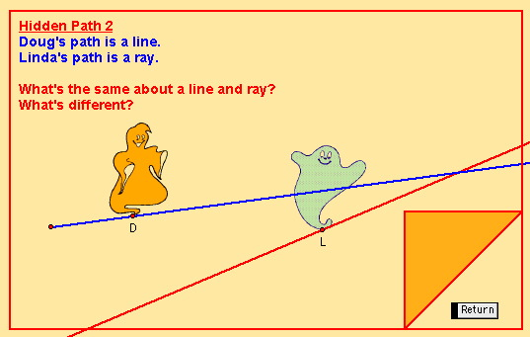
Pairs/Exploration  - Doug path is the circumference of a circle and Linda’s path is a line segment which is the radius of the same circle  - Students might find it difficult to recognize what’s the same (i.e. both paths are based on the same circle) | 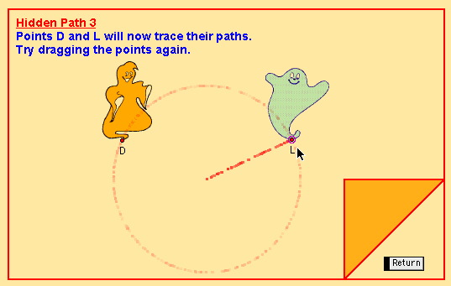
- Sample response: | 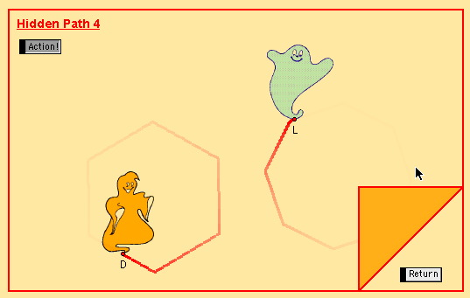
  What’s the same? | What’s different?
  - both perimeters of polygons  - both go straight for a bit then change direction  - both move in a counterclockwise direction | - Doug’s path is the perimeter of a hexagon; Linda’s is the perimeter of an octagon  - length of side  - angle between sides
Whole Class/Discussion  - The End page has a hidden activity  - Some students might notice that the Action! button on the last page makes Doug and Linda move as mirror images of each other - ask students where the line of symmetry would be for the paths | 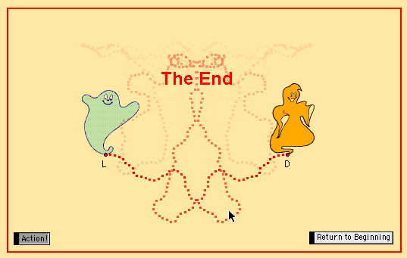
Consolidate/Debrief

Whole Class/Brainstorm
- Ensure that students understand the task in question 8 on BLM
What are some geometric concepts that could be used? What is an attribute? What is mathematical language?

Ghost Paths Student BLM
Computer Instructions

Introduction |  | 1. Can point D be dragged to inside the orange triangle? _______  2. Can point L be dragged to point D? _______  3. Can the points be dragged to any location on the screen? _______
Hidden Path 1 |  | 4. Complete the T-Chart for the paths:
  What’s the same? | What’s different?
Hidden Path 2 |  | 5. Sketch each of the following:  a) line segment  b) line  c) ray
Hidden Path 3 |  | 6. Complete the T-Chart for the paths:
  What’s the same? | What’s different?
Hidden Path 4 |  | 7. Complete the T-Chart for the paths:
  What’s the same? | What’s different?
Homework |  | 8. Draw two geometric paths that have two “same” attributes and two “different” attributes. Give a description of the paths. Use mathematical language.

