Maximum Area – Fixed Perimeter Sketch

1- Construct a line segment. The length of the line segment will one-half the perimeter
of our rectangle.

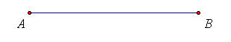
2- Select the line segment and, from the construct menu, choose a point on the
line segment.

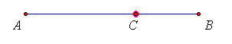

3- Select points C and B and, from the measure menu, choose Distance.
This will be the length of the width of our rectangle.

4- Select points A and C (order is important) and, from the Construct menu, choose
Circle by Center + Point.

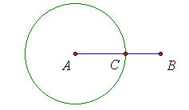

5- Select point A and the measure of CB (order is important) and, from the
Construct menu, choose Circle by Center + Radius.

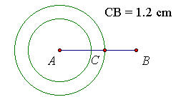

6- Select point A and line segment AB and from the construct menu, choose
Perpendicular line. Do the same for point C.

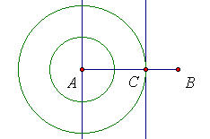

7- Where the first perpendicular line intersects the second circle (the circle whose radius does not depend on AC), construct another perpendicular line parallel to AC. We now have our rectangle.

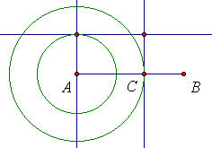

8- Select the four vertices of the rectangle and, from the Construct menu,
choose Quadrilateral interior.

9- Select the interior and from the Measure menu, choose Area.

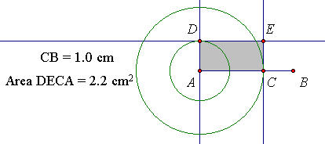

10- Select the measure of CB and the measure of the Area and, from the Graph menu,
choose Plot as (x, y). Under the Display menu, choose Trace Plotted Point.

11- If you slide point C back and forth, you will see the area and the width change.
You can determine the perimeter by selecting the interior of the quadrilateral and,
from the Measure menu, choose Perimeter.

12. Select the parts of the sketch that you wish to hide (i.e. circles) and, under the
Display menu, choose Hide Objects.

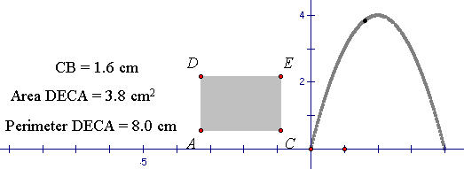

13- You can choose to animate point C as well as sliding it back and forth.

14- The obvious question would be, what values for the length and width give the
maximum area.

