Unit 1 Counting and Probability Mathematics of Data Management

Lesson Outline
Big Picture

Students will:
- solve problems involving probability of distinct events;
- solve problems using counting techniques of distinct items;
- apply counting principles to calculating probabilities;
- explore variability in experiments;
- demonstrate understanding of counting and probability problems and solutions by adapting/creating a children’s story/nursery rhyme in a Counting Stories project;
- explore a significant problem of interest in preparation for the Culminating Investigation.
Day | Lesson Title | Math Learning Goals | Expectations
1 | Introduction to Mathematical Probability  (Lesson Included) | - Investigate Probabilities of Distinct Events (outcomes, events, trials, experimental probability, theoretical probability  - Reflect on the differences between experimental and  theoretical probability and assess the variability in  experimental probability  - Recognise that the sum of the probabilities of all possible outcomes in the sample space is 1. | CP1.1, CP1.2, CP1.3, CP1.5
2 | Mathematical Probability  (Lesson Included) | - Investigate probabilities of distinct events (outcomes, events, trials, experimental probability, theoretical probability.  - Develop some strategies for determining theoretical probability (e.g., tree diagrams, lists)  - Use reasoning to develop a strategy to determine theoretical probability | CP1.1, CP1.2, CP1.3, CP1.5
3 | Using Simulations  (Lesson Included) | - Use mathematical simulations to determine if games are fair  - Reflect on how simulations can be used to solve real problems involving fairness | CP1.1, CP1.2, CP1.4
4 | “And”, “Or” events  (Lesson not included) | - Determine whether two events are dependent, independent, mutually exclusive or non-mutually exclusive  - Verify that the sum of the probabilities of all possible outcomes in the sample space is 1. | CP1.3, CP1.5, CP1.6
5 | Pick the Die  (Lesson Included) | - Use non-transitive dice to compare experimental and theoretical probability and note the tendency of experimental probability to approach theoretical probability as the number of trials in an experiment increases  - Draw tree diagrams for events where the branches in the tree diagram do not have the same probability | CP1.4, CP1.6
6 | Let’s Make A Deal  (Lesson Included) | - Use the Monty Hall problem to introduce conditional probability  - Use Venn diagrams to organize data to help determine conditional probability  - Use a formula to determine conditional probability | CP1.6

Day | Lesson Title | Math Learning Goals | Expectations
7 | Counting Arrangements and Selections  (Lesson Included) | - Solve problems that progress from small sets to more unwieldy sets and using lists, tree diagrams, role playing to motivate the need for a more formal treatment.  - See examples where some of the distinct objects are used and where all the distinct objects are used.  - Discuss how counting when order is important is different from when order is not important to distinguish between situations that involve, the use of permutations and those that involve the use of combinations. | CP2.1
8 | Counting Permutations  (Lesson Included) | - Develop, based on previous investigations, a method to calculate the number of permutations of all the objects in a set of distinct objects and some of the objects in a set of distinct objects.  - Use mathematical notation (e.g., n!, P(n, r)) to count. | CP2.1, CP2.2
9 | Counting Combinations  (Lesson Included) | - Develop, based on previous investigations, a method to calculate the number of combinations of some of the objects in a set of distinct objects.  - Make connection between the number of combinations and the number of permutations.  - Use mathematical notation (e.g., ) to count  - Ascribe meaning to .  - Solve simple problems using techniques for counting permutations and combinations, where all objects are distinct. | CP2.1, CP2.2
10 | Introduction to the counting stories project  (Lesson Included) | - Introduce and understand one culminating project, Counting Stories Project (e.g. student select children’s story/nursery rhyme to rewrite using counting and probability problems and solutions as per Strand A).  - Create a class critique to be used during the culminating presentation. | E2.3, E2.4
11 | Pascal’s Triangle  (Lesson Included) | - Investigate patterns in Pascal’s triangle and the relationship to combinations, establish counting principles and use them to solve simple problems involving numerical values for n and r.  - Investigate pathway problems | CP2.4
12 | Mixed Counting Problems  (Lesson not included) | - Distinguish between and make connections between situations involving the use of permutations and combinations of distinct items.  - Solve counting problems using counting principles – additive, multiplicative. | CP2.3
13 | Counting Stories Project  (Lesson not included) | - Use counting and probability problems and solutions to create first draft of Counting Stories Project. | CP1.1, CP1.3, CP1.5, CP1.6, CP2.1, CP2.2, CP2.3

Day | Lesson Title | Math Learning Goals | Expectations
14 | Probability  (Lesson Included) | - Solve probability problems using counting principles involving equally likely outcomes. | CP2.5
15 | Counting Stories Project  (Lesson not included) | - Complete final version of Counting Stories Project. | CP1.1, CP1.3, CP1.5, CP1.6, CP2.1, CP2.2, CP2.3, CP2.4, CP2.5, F2.4
16–17 | Jazz/Summative

Unit 1: Day 1:Introduction to Mathematical Probability |  |  |  | MDM4U
Minds On: 40 |  | Math Learning Goals:  - Investigate Probabilities of Distinct Events (outcomes, events, trials, experimental probability, theoretical probability  - Reflect on the differences between experimental and theoretical probability and assess the variability in experimental probability |  | Materials  - Admin handouts  - Course outline  - Brock Bugs game (coins, two colour counters, dice)  - BLM 1.1.1  - BLM 1.1.2
Action 15
Consolidate:20
Total=75 min
Assessment
Opportunities
 | Minds On… | Whole Class ➔Discussion  Discuss administrative details for the semester as well as the course outline and evaluation.  Use familiar opening day techniques designed to familiarize students with each other and your classroom procedures.  Think/Pair/Group of Four ➔Game  Describe the game of SKUNK . BLM 1.1.1. Play the game of SKUNK first game as a practice, second game so that individual students play on their own, third game as pairs so that each pair agrees whether to stand or sit, then lastly so that groups of four agree to stand or sit. Record the dice rolls on an overhead of BLM1.1.1or on the board for the games.  Discuss…choice and chance in life and how we make decisions when there is an element of chance involved. (e.g., peer pressure, weigh the risks) |  | Discuss computer lab rules if MDM4U is being taught in a lab  The game of SKUNK:  Mathematics Teaching in the Middle School; Vol. 1, No. 1 (April 1994), pp. 28-33.  http://illuminations.nctm.org/LessonDetail.aspx?id=L248  To view a sample game of SKUNK:  http://illuminations.nctm.org/LessonDetail.aspx?id=L248  To order Brock Bugs http://www.brocku.ca/mathematics/resources/  Planned Questions:  If you repeated the Brock Bugs game without changing the player’s counters, would each player earn the same number of wins?  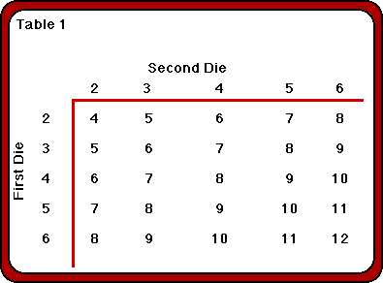
 | Action! | Pairs → Game  Play side 1 of Brock Bugs for 25 rolls of the dice. Students record wins.  Whole Class ➔Discussion  Lead a discussion about some of the things that they learned about the game. (e.g., totals of 1, 13, and 14 will not occur, it is better to have first pick of the game outcomes, some totals seem to occur more often than others)  Pairs → Game  Play side 2 of Brock Bugs for 25 rolls of the dice. Students record wins  Learning Skills/Teamwork/Checkbric: Observe students as they play the games.
 | Consolidate Debrief | Whole Class ➔Discussion  Debrief the game. Discuss students’ intuition about the game. Compute the theoretical probabilities for the sum of the dice (see chart) Discuss the variability of the game.  Define the terms used for probability. BLM1.1.2 Teacher Supplement.
Exploration |  | Home Activity or Further Classroom Consolidation  Flip a coin 25 times and record the number of times a head was shown  Roll a single die 48 times and tally the faces shown.
  1 | 2 | 3 | 4 | 5 | 6
1 | 2 | 3 | 4 | 5 | 6

1.1.1 The Game of Skunk

The object of SKUNK is to accumulate points by rolling dice. Points are accumulated by making several "good" rolls in a row but choosing to stop before a "bad" roll comes and wipes out all the points.
SKUNK will be played:
- individually
- in partners
- in groups of four

The Rules
To start each game students make a score sheet like this:

Each letter of SKUNK represents a different round of the game; play begins with the “S” column and continues through the "K" column. The object of SKUNK is to accumulate the greatest possible point total over five rounds. The rules for play are the same for each of the five rounds. (letters)
- At the beginning of each round, every player stands. Then, the teacher rolls a pair of dice and records the total on an overhead or at the board.
- Players record the total of the dice in their column, unless a "one" comes up.
- If a "one" comes up, play is over for that round only and all the player's points in that column are wiped out.
- If "double ones" come up, all points accumulated in prior columns are wiped out as well.
- If a "one" doesn't occur, players may choose either to try for more points on the next roll (by continuing to stand) or to stop and keep what he or she has accumulated (by sitting down). Once a player sits during a round they may not stand again until the beginning of the next round.
- A round is over when all the students are seated or a one or double ones show.

Note: If a "one" or "double ones" occur on the very first roll of a round, then that round is over and each player must take the consequences.

1.1.1 The Game of Skunk (Continued)

Record Sheet

S | K | U | N | K

1.1.2 Teacher Supplement

INTRODUCTION TO PROBABILITY
Probability is the mathematics of chance. There are three basic approaches.

Experimental Probability: is based on the results of previous observations. Experimental probabilities are relative frequencies and give an estimate of the likelihood that a particular event will occur.

Theoretical Probability: is based on the mathematical laws of probability. It applies only to situations that can be modelled by mathematically fair objects or experiments.

Subjective Probability: is an estimate of the likelihood of an event based on intuition and experience making an educated guess using statistical data.

A game is fair if:
- All players have an equal chance of winning or
- Each player can expect to win or lose the same number of times in the long run.

A trial is one repetition of an experiment

An event is a possible outcome of an experiment.

A simple event is an event that consists of exactly one outcome.

EXPERIMENTAL PROBABILITY:
- Is based on the data collected from actual experiments involving the event in question.
- An experiment is a sequence of trials in which a physical occurrence is observed
- An outcome is the result of an experiment
- The sample space is the set of all possible outcomes
- An event is a subset of the sample space – one particular outcome

Let the probability that an event E occurs be P(E) then

Examples:
- Suppose you flipped a coin 30 times and, tails showed 19 times. The outcomes are H or T, and the event E = tails. $P\left(E\right)=\frac{\text{19}}{\text{30}}$

- If you rolled two dice 20 times and a total of 7 showed up three times. Then $P\left(\text{Total} \text{of} 7\right)=\frac{3}{\text{20}}$
1.1.2 Teacher Supplement (Continued)

THEORETICAL PROBABILITY:
  - Assumes that all outcomes are equally likely
  - The probability of an event in an experiment is the ratio of the number of outcomes that make up that event over the total number of possible outcomes

Let the probability that an event A occurs be P(A) then $P\left(A\right)=\frac{n\left(A\right)}{n\left(S\right)}$ where n(A) is the number of times event A happens and n(S) is the number of possible outcomes in the sample space.

Examples:
- Rolling one die: Sample space = {1, 2, 3, 4, 5, 6}
  - If event A = rolling a 4 then $P\left(A\right)=\frac{1}{6}$
  - If event B = rolling an even number then $P\left(B\right)=\frac{3}{6}=\frac{1}{2}$
- Suppose a bag contains 5 red marbles, 3 blue marbles and 2 white marbles, then if event A = drawing out a blue marble then $P\left(A\right)=\frac{3}{\text{10}}$
Complementary events: The complement of a set A is written as A’ and consists of all the outcomes in the sample space that are NOT in A.

Example:
Rolling one die: Sample space = {1, 2, 3, 4, 5, 6}
If event A = rolling a 4 then $P\left(A\right)=\frac{1}{6}$ and A’ = not rolling a 4 then $P\left(A'\right)=\frac{5}{6}$

Generally: P(A’) = 1 – P(A)

- The minimum value for any probability is 0 (impossible)
- The maximum value for any probability is 1 (certain)
- Probability can be expressed as a ratio, a decimal or a percent

Unit 1: Day 2: Mathematical Probability |  |  |  | MDM4U
Minds On: 40 |  | Math Learning Goals:  - Investigate probabilities of distinct events (outcomes, events, trials, experimental probability, theoretical probability.  - Develop some strategies for determining theoretical probability (e.g., tree diagrams, lists)  - Use reasoning to develop a strategy to determine theoretical probability |  | Materials  - Coins  - Bingo chips  - HOPPER cards  - BLM1.2.1
Action: 15
Consolidate:20
Total=75 min
Assessment
Opportunities
 | Minds On… | Whole Class → Summary  Summarize homework questions:  Flip a coin 25 times and count heads:  Discuss individual results, expected number of heads and variability. Collect class results and display in a chart. Determine relative frequency; compare sample size for individual results and class results. Introduce the idea of a uniform distribution.  Roll a die 48 times and tally the faces shown:  Discuss individual results, expected outcomes and variability. Collect class results and display in a chart. Determine relative frequency; draw the histogram for the experimental results; compare sample size for individual results and class results; calculate the theoretical probability. Demonstrate that this is an example of a uniform distribution. |  | Planned Questions:  When flipping a coin 25 times How many heads do you expect to get? Explain.  What do you notice about the experimental results as the sample size gets larger?  (As the sample size increases the experimental probability of an event approaches the theoretical probability)  Class results can be collected using an overhead of the tally chart on BLM 1.2.1  The tree diagram helps students to see the results of each flip of the coin during the game and to determine the theoretical probability
 | Action! | Pairs ➔Game  Make game cards using BLM 1.2.1. Students play HOPPER (about 10 games) and tally their results in terms of player A and player B and the individual letters. See BLM 1.2.1  Mathematical Process/Reasoning and Proving/Observation/Mental Note: Observe students as they determine winning strategies. Note different ideas to develop during Consolidate Debrief.
 | Consolidate Debrief | Whole Class ➔Discussion  - Debrief the game using a tree diagram and describe characteristics of a tree diagram when the probability of each branch is the same. BLM 1.2.2 Teacher Supplement  - Review the probability for complementary events  - Demonstrate using a tree diagram using a second example (toss a fair coin three times) to determine the probability of certain events  - Use the HOPPER and the fair coin toss tree diagrams to discuss fair games (i.e., each player has an equal chance of winning)
Concept Practice  Skill Practice |  | Home Activity or Further Classroom Consolidation  Work on exercises to practice using tree diagrams to determine simple theoretical probabilities.

1.2.1 The HOPPER Game

HOPPER

K | J | I | H | I | J | K

- Place one marker on the letter H
- One player is player A the other is Player B. Player A wins if the marker ends on the letter I, player B wins if the marker lands on any other letter.
- Flip a coin, the winner chooses to be either Player A or Player B.
- To play - flip a coin exactly three times. After each flip, move the marker right if the coin shows heads and move it left if the coin shows tails. If the marker ends on I then A wins otherwise B wins.
- Play the game10 times and determine a strategy.

HOPPER

K | J | I | H | I | J | K

- Place one marker on the letter H
- One player is player A the other is Player B. Player A wins if the marker ends on the letter I, player B wins if the marker lands on any other letter.
- Flip a coin, the winner chooses to be either Player A or Player B.
- To play - flip a coin exactly three times. After each flip, move the marker right if the coin shows heads and move it left if the coin shows tails. If the marker ends on I then A wins otherwise B wins.
- Play the game10 times and determine a strategy.

Tally chart:

Player A | Player B
I | H | J | K

1.2.1 Teacher Supplement

Using a tree diagram to debrief the HOPPER game:

A wins
B wins
A wins
A wins
B wins
A wins
A wins
A wins
H
I
I
J
H
J
H
K
I
I
I
I
I
K
I

- Number of outcomes = 8
- Number of times A wins =6
- $$\begin{aligned}P\left(A \text{wins}\right)=\frac{6}{8}P\left(B \text{wins}\right)=\frac{2}{8} \\ =\frac{3}{4} =\frac{1}{4}\end{aligned}$$
- a tree diagram is used to represent the outcomes of an event that are the result of a sequence of similar events
- each branch of this tree diagram has the same probability of happening
- at each step the sum of the probabilities of the branches is one
- in this case, the outcome for each event has no influence on the outcome of the next event – events are said to be independent
- the final outcome is the product of the possible outcomes at each step of the sequence

Unit 1: Day 3: Using Simulations |  |  |  | MDM4U
Minds On: 10 |  | Math Learning Goals:  - Use mathematical simulations to determine if games are fair  - Reflect on how simulations can be used to solve real problems involving fairness |  | Materials  - Coins  - Overhead of BLB1.3.1  - BLM 1.3.2
Action: 45 |  |  |  | Materials  - Coins  - Overhead of BLB1.3.1  - BLM 1.3.2
Consolidate:15 |  |  |  | Materials  - Coins  - Overhead of BLB1.3.1  - BLM 1.3.2
Total=75 min |  |  |  | Materials  - Coins  - Overhead of BLB1.3.1  - BLM 1.3.2
Assessment
Opportunities
 | Minds On… | Whole Class → Four Corners  Use the overhead of BLM 1.3.1 to explain the game of “Rock, Paper, Scissors”. Have two students who are familiar with the game do a demonstration.  Ask: Is the game “Rock, Paper, Scissors” a game of skill or a game of chance?  Students move to the front left corner if they are sure it is a game of skill, to the front right corner if they think it might be a game of skill, to the back left corner if they think it might be a game of chance, and to the back right corner if they are sure it is a game of chance. While in their corners students discuss their reasoning. Ideas are shared with the whole class before students return to their seats. |  | http://en.wikipedia.org/wiki/Rock%2C_Paper%2C_Scissors  Article: Ivars Peterson: Mating Games and Lizards: Rock Paper Scissors  http://www.maa.org/mathland/mathland_4_15.html  .  Planned Questions  Do you think Rock Paper Scissors is Fair? Explain.  What does the bar graph tell us about the fairness of the game?  Is the World Series Rigged? Adapted from “Impact Math” Data Management and Probability, page 71  https://ozone.scholarsportal.info/bitstream/1873/2109/1/259037.pdf
 | Action! | Pairs ➔Game  Play Rock, Paper, Scissors until one of the partners records 50 wins. (Declare one partner to partner A and the other Partner B) Tally the results using a chart as shown on BLM 1.3.1  Whole Class → Discussion  Share results and build a class bar graph showing the categories: A wins, B wins, and Ties. Discuss what the simulation has taught us.  Pairs ➔Simulation  Show World Series Data from 1946 to 2006 and ask students if the World Series is rigged to go to 7 games or not. Have them declare by moving to the front of the class (rigged) or to the back of the class (not rigged). Simulate the world series following instructions on BLM 1.3.2  Mathematical Process/Reflecting/Observation/Mental Note: Observe students as they reflect on their simulations. Note important points that can be used during Consolidate Debrief.
 | Consolidate Debrief | Whole Class ➔Discussion  Debrief the World Series simulation and ask students to share their reflections. Discuss how simulations can be used to show fairness or to uncover fraud. Example: Brainstorm - how officials determined that lottery ticket distributors were cheating.
Concept Practice  Skill Practice  Reflection |  | Home Activity or Further Classroom Consolidation  Do assigned practice questions. Research to find other examples of how simulations have been used to develop understanding.
1.3.1 Is Rock Paper Scissors A Fair Game?

Rock Paper Scissors is played between two players. The players both count to three, each time raising one hand in a fist and swinging it down during the count. On the third count the players change their hands into one of three gestures.

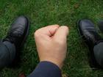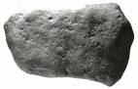



Paper
Represented by an open hand
Rock
Represented by a closed fist



Scissors
Represented by the index and middle fingers extended

The object of the game is to select a gesture that defeats the gesture of your opponent.
- Rock smashes scissors, rock wins
- Paper covers rock, paper wins
- Scissors cut paper, scissors win
- If both players select the same gesture, game is tied, play again.

This is a non-transitive game

Students play 50 games and record their wins/losses in a chart or tally sheet.
Students determine the experimental probability of winning Rock Paper Scissors and determine if Rock Paper Scissors is a fair game. (Is it a game of chance or a game of skill?)
A wins | B wins | Tie


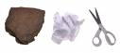

1.3.2 Is the World Series Rigged?

Another World Series Ends in 7!
Do you think the World Series is rigged to make it last 7 games?
The data shows that the World Series went to 7 games 26 times in 60 years

Number of Games in a World Series
1946 - 2006
 | 4 games | 5 games | 6 games | 7 games
Frequency | 11 | 10 | 13 | 26

Simulating the World Series
Use a simulation to determine the likelihood that the World Series will last 7 games. The World Series is a best “4-out-of-7” series. This means that two teams play until one team has won four games; that team is declared the winner.

Consider:
- List the possible outcomes of a World Series between team A and team B.

- Are the outcomes equally likely? Explain.

- Since the World Series goes to 7 games almost half the time, do you think that the World Series has been rigged? Justify your answer.

1.3.2 Is the World Series Rigged? (Continued)

Simulation:
Part A: Work with a partner
Flip a coin to simulate a World Series game (H means team A wins, T means team B wins). What assumption does this make?

Simulate 30 World Series and tally below: (You need 30 trials since each series is 1 trial, (each trial requires 4 to 7 flips of the coin) each trial will consist of the number of times the coin was flipped until 4H or 4T show).
 | 4 games (tosses) | 5 games  (tosses) | 6 games  (tosses) | 7 games  (tosses)
Frequency
Total

Part B: Work with another pair
Compile your results so that you have a simulation for 60 World Series.
 | 4 games | 5 games | 6 games | 7 games
Frequency
Total

- Draw the frequency histogram of your results.

- Determine the experimental probability that a World Series will end in 7 games.

- Compare your results with other groups and the actual results from 1946 - 2006 and record your observations.

- What conclusions can you draw about whether or not the World Series is rigged?
Unit 1: Day 5: Pick The Die |  |  |  | MDM4U
Minds On: 5 |  | Math Learning Goals:  - Use non-transitive dice to compare experimental and theoretical probability and note the tendency of experimental probability to approach theoretical probability as the number of trials in an experiment increases  - Draw tree diagrams for events where the branches in the tree diagram do not have the same probability |  | Materials  - Dice  - BLM 1.5.1
Action: 40 |  |  |  | Materials  - Dice  - BLM 1.5.1
Consolidate:30 |  |  |  | Materials  - Dice  - BLM 1.5.1
Total=75 min |  |  |  | Materials  - Dice  - BLM 1.5.1
Assessment
Opportunities
 | Minds On… | Whole Class → Brainstorming  Brainstorm how we make decisions in favour of a course of action. How does the media try to influence consumer purchases and lifestyle decisions? |  | Teacher Supplement BLM 1.5.2  Alternatively a spreadsheet based simulation can be used to model the game and to compare experimental and theoretical probability
 | Action! | Pairs → Game  Use an overhead of BLM 1.5.1 to provide students with instructions for playing the game. Students play each game, determine the best strategy for winning the game, and answer the questions at the end.  Learning Skills/Teamwork/Checkbric: Circulate and record students’ teamwork skills as they play the game and try to determine the best strategy for winning.
 | Consolidate Debrief | Whole Class → Discussion  Discuss student strategies. (Note: If students feel that one colour is most likely to win they will want to choose first so they can pick their colour but if they recognize that these dice are non-transitive then they will want to choose second so they can select the colour that is most likely to win against the their opponent’s choice. Since students played 10 times with each colour set, the sample size is very small so the discussion may bounce back and forth between the two options).  Collect everyone’s experimental data for each colour set and determine the experimental probability of winning for each set. Revisit the best strategy for winning based on the larger sample size. Calculate the theoretical probability for each colour combination. (BLM1.5.2 Teacher Supplement)
Application  Reflection |  | Home Activity or Further Classroom Consolidation  Anticipate the winning strategy for “Pick the Dice” (BLM 1.5.2) Draw the tree diagrams for the theoretical probability of “Pick the Dice”. Write a reflection in your journal about how the “Pick the Die/Dice” games relate to how we make decisions as discussed in Minds On.

1.5.1 Pick the Die

The game involves two players using two of three coloured dice. The faces of the die do not have the usual values. Students try all three-colour combinations to determine the best strategy for winning.

PICK THE DIE

YELLOW DIE: Four sides have a value of 4 (roll 1, 2, 3, 4 count as 4)
Two sides have a value of 11 (roll 5, 6 count as 11)

BLUE DIE: Four sides have a value of 9 (roll 1, 2, 3, 4 count as 9)
Two sides have a value of 0 (roll 5, 6 count as 0)

ORANGE DIE: Six sides have a value of 6 (roll 1, 2, 3, 4, 5, 6 count as 6)

Game 1:
- Person A picks a coloured die, person B selects a different colour
- Each person rolls their die, the highest roll wins
- Repeat 10 times and record wins/losses

Game 2:
- Two players choose a different combination of two coloured dice
- Roll the dice 10 times and record wins/losses

Game 3:
- Two players choose the last combination of two colours
- Roll the dice 10 times and record wins/losses

Determine the best strategy for winning this game: Which colour has the best chance of winning? Do you want to be able to choose the colour of die first or second? Explain why.

1.5.2 Teacher Supplement

Draw probability tree diagrams for each set. Do one together with the class and students complete the other two. Summarize, the non-transitive nature of the dice. (Compare to Rock, Paper , Scissors).
Orange plays Blue
Orange 6
Blue 9
Blue wins
Blue 0
Orange wins
Blue beats Orange
Odds in favour of blue are 2:1

Orange plays Yellow
Orange 6
Yellow 11
Yellow wins
Yellow 4
Orange wins
Orange beats Yellow
Odds in favour of Orange are 2:1

Yellow plays Blue
Yellow 4
Yellow 11
Blue 9
Blue 9
Blue 0
Blue 0
Blue wins
Yellow wins
Yellow wins
Yellow wins
Yellow wins:

Yellow beats Blue
Odds in favour of Yellow are 5:4

1.5.2 Teacher Supplement (Continued)

Home Activity or Further Classroom Consolidation

Pick the Dice

**The coloured dice have the same face values as Pick the Die

YELLOW DIE: Four sides have a value of 4 (roll 1, 2, 3, 4 count as 4)
Two sides have a value of 11 (roll 5, 6 count as 11)

BLUE DIE: Four sides have a value of 9 (roll 1, 2, 3, 4 count as 9)
Two sides have a value of 0 (roll 5, 6 count as 0)

ORANGE DIE: Six sides have a value of 6 (roll 1, 2, 3, 4, 5, 6 count as 6)

The Game:
- Person A chooses a pair of dice of the exact same colour, person B chooses a pair of a different colour (e.g., Person A choose two yellow and Person B chooses two Orange)
- Each person rolls their pair of dice, the highest total wins
- Do you think that playing with two dice of the same colour will be non-transitive? Predict which colours will win?
- Draw tree diagrams to determine the theoretical probability of each colour combination.

Notes:
Students start to guess at the results before they have played because of their knowledge from the previous game. Listen to their conversations as they realize that there are more options to consider and their intuition breaks down. For instance they will realize that the two orange dice will always have a total of 12, but blue could have totals of 0, 9 or 18 and yellow could have totals of 8, 15, or 22.

Once again the non-transitive property holds but it is in the opposite direction. Two yellow beats two orange - the odds in favour of yellow are 5:4; two orange beats two blue – the odds in favour of orange are 5:4 and two blue beats two yellow – the odds in favour of blue are 16:11.

Having students develop winning strategies based on mathematics helps them to see the significance and usefulness of mathematical probability. Once the probability of an event is calculated or estimated students can make informed decisions about what to do.

Unit 1: Day 6: Let’s Make a Deal |  |  |  | MDM4U
Minds On: 10 |  | Math Learning Goals:  - Use the Monty Hall problem to introduce conditional probability  - Use Venn diagrams to organize data to help determine conditional probability  - Use a formula to determine conditional probability |  | Materials  - Prepared card sets (BLM1.6.1)  - BLM 1.6.1
Action: 25 |  |  |  | Materials  - Prepared card sets (BLM1.6.1)  - BLM 1.6.1
Consolidate:40 |  |  |  | Materials  - Prepared card sets (BLM1.6.1)  - BLM 1.6.1
Total=75 min |  |  |  | Materials  - Prepared card sets (BLM1.6.1)  - BLM 1.6.1
Assessment
Opportunities
 | Minds On… | Groups of Four→ Homework Sharing  Students compare tree diagrams and reflections from the previous day’s Home Activity.  Whole Class→ Summary  Post tree diagram solutions to homework. Summarize key ideas arising from student reflections.  Whole Class→ Introduction to the Monty Hall Problem  Discuss the television game “Let’s Make a Deal”, and simulate one game using a set of three cards (doors) |  | See “Monty’s Dilemma: Should You Stick or Switch?” by M. Shaughnessy and T. Dick, Mathematics Teacher, April, 1991, page 252  http://illuminations.nctm.org/LessonDetail.aspx?id=L377  The Probability of winning increases as the strategies move from Always Stick to Always Switch.
 | Action! | Pairs → Game  Use an overhead of BLM 1.6.1 to guide the data collection for playing Let’s Make a Deal. Students play 20 games using their assigned strategy  Mathematical Process/Connecting/Observation/Mental Note: Circulate to observe as students play the game to simulate Let’s Make A Deal. Note comments and misunderstandings that can be addressed in Consolidate Debrief.
 | Consolidate Debrief | Whole Class → Discussion  Use the overhead of BLM 1.6.1 to record the class data by strategy. Lead a discussion about the probabilities that show in the chart.  Use a tree diagram to record the always stick strategy and compare it to the tree diagram for the always switch strategy to convince students about the correct strategy. Use the game as reference for a discussion on conditional probability. Venn diagrams and conditional probability can be introduced with further examples.
Concept Practice |  | Home Activity or Further Classroom Consolidation  Practice using assigned questions

1.6.1 Let’s Make a Deal!

Should You Stick or Switch?

- Use your set of three cards to simulate Let’s Make a Deal. (Sets can be made using a standard set of 52 cards: two cards will be normal and one will have a sticker of a car. Each pair will receive a set of 3 cards)
- Mix the cards so that your partner can only see the back of the three cards. Your partner points to the card of his choice. You show him one of the blank cards not the one chosen; your partner decides whether to stick with his original pick or switch.
- Play 5 games with your partner to get a feel for the game, record wins and losses (guess a strategy: stick or switch)
- A strategy will be assigned to you: follow the strategy, play 20 times and record wins and losses

Strategy | Won | Lost | Probability of Winning
Always stick
(never switch)
Flip a coin -
tails you switch
Roll a die – 1,2,3,4 you switch
Always switch

Conclusion:

Unit 1 : Day 7 : Counting, Arrangements, and Selections |  |  |  | MDM4U
Minds On: 15 |  | Description/Learning Goals  - Solve problems that progress from small sets to more unwieldy sets and using lists, tree diagrams, role playing to motivate the need for a more formal treatment.  - See examples where some of the distinct objects are used and where all the distinct objects are used.  - Discuss how counting when order is important is different than when order is not important. |  | Materials  - BLM 1.7.1  - BLM 1.7.2  - Coins  - Dice  - Chart paper
Action: 40
Consolidate:20
Total=75 min
Assessment
Opportunities
 | Minds On… | Small Groups → Exploration  Explore the flipping of a coin for 4 iterations and possible outcomes using a tree diagram. Students notice that the tree grows quickly and any patterns.  Continue to explore tree diagrams by rolling of a six-sided dice for 2 iterations. Students predict the size of the next iteration. Discuss observations from this activity.  In groups of 4, students choose a president, vice-president, secretary and treasurer for their group. How many different ways can this be done? Students draw tree diagrams on large paper to represent this situation. How does this differ from the previous examples? |  | Questions could also be answered as a communication assignment or in journals
 | Action! | Whole Class → Investigation  Choose three students to come to the front of the room. Try to choose people who are wearing different types of outfits.  As a class, construct a tree diagram of all the possible combinations of outfits that can be made from the clothes the students are wearing. For example: (red shirt (person 1), blue jeans (person 2), running shoes (person 3).  Students discuss what changes when you add more choices. (4 people, include socks). Continue with investigating putting all students in the class in a line. Students attempt to make a tree diagram and discuss the problems with the construction. Start over again using only 5 people from the class to be put in a line. “How many choices do we have for the first, second, third, fourth, and fifth?” Students discuss and compare the total number of choices for each experiment.  Curriculum Expectations/Observation/Mental Note  Observe students as they work on BLM1.6.1 to assess understanding of repeated & non-repeated elements.  Pairs → Connecting  Let’s look at a Postal Code. In Canada, we use the code LNL NLN. How many different possibilities for postal codes are there? How is this different from the previous example(numbers and letters can be repeated)  Pairs complete BLM 1.7.1.  Process Expectations: Connecting/Communicating: Students communicate with each other to hypothesize correct counting technique. Connect from their investigation to choose correct technique to apply to worksheet.
 | Consolidate Debrief | Whole Class → Discussion/Reflection  Engage students in a discussion as they respond to the following questions:  - When is a tree diagram appropriate to visually represent data and when isn’t it?  - What is different from when all objects are chosen versus some chosen?  - When do you think order is important and when is it not important and give an example in each case.
Application |  | Home Activity or Further Classroom Consolidation  Complete BLM 1.7.2
1.7.1 Counting Techniques

For each of the following questions, decide whether or not the elements can be repeated or not. Use the appropriate counting technique to solve the problem.

1. In Ontario, our licence plates consist of 4 letters followed by 3 numbers. Determine the number of licence plates that can be issued.

Repeated Elements Yes No

2. How many seven-digit telephone numbers can be made if the first three digits must be different?

Repeated Elements Yes No

3. The Math Club has 15 members. In how many ways can President, Vice-President, and Secretary be chosen?

Repeated Elements Yes No

4. The Junior Boys Volleyball team has six members. In how many ways can a starting line-up be chosen?

Repeated Elements Yes No

5. A committee of three is to be formed from five Math teachers and four English teachers. In how many ways can the committee be formed if there:

a. are no restrictions b. must be one math teacher
c. must be one English teacher d. must be only math teachers

Repeated Elements Yes No
1.7.2 I Can Count

1. How many different combinations can be used for a combination lock with 60 numbers

a. if it takes three numbers to unlock the lock?

b. if the three numbers must be unique?

2. Draw a tree diagram to illustrate the number of possible paths Bill can take to get to London, England, if he has three choices of flights from Toronto to Montreal, 2 choices from Montreal to St. John’s, and 4 choices from St. John’s to London.

3. In how many ways can you choose three Aces from a deck of cards one after the other

a. if the cards are not replaced between draws?

b. if the cards are replaced between draws?

4. Subs to Go offers 5 choices for meat, 4 choices for vegetables, 6 choices for bread, and 3 choices for cheese, assuming a sandwich must have one from each choice. Would you be able to eat a different sub everyday of the year?

Unit 1 : Day 8 : Counting Permutations |  |  |  | MDM4U
Minds On: 20 |  | Description/Learning Goals  - Develop, based on previous investigations, a method to count the number of permutations of all the objects in a set of distinct objects and some of the objects in a set of distinct objects.  - Use mathematical notation (e.g. n!, P(n,r)) to count. |  | Materials  - BLM1.8.1 – 1.8.7  - Linking cubes  - Jazz music CD
Action: 45
Consolidate:10
Total=75 min
Assessment
Opportunities
 | Minds On… | Whole Class/Pairs → Tap Your Toes  Students discuss what they know about jazz music and the idea of improvising music. Make the link of improvisation to music and play a piece of jazz music. Compare to making up stories on the spot and importance of the details in both stories and music. Consider the number of different rhythms that the jazz musician has to decide between when improvising. Use an acetate of BLM 1.8.1 to introduce the bar and beats.  Using BLM 1.8.1 and BLM 1.8.2, pairs of students find how many ways a musician can create a bar of music with four different ways of notating one beat. Students reflect on how a jazz musician must decide on rhythms in a split second when they are improvising. |  | Using the fractions note chart on BLM 1.8.2 teacher can help explain the value of one beat.  Students can cut out cards or use coloured linking cubes to represent the pictures when carrying out the investigation.  A Frayer Model is a visual organizer that helps students understand key concepts. Encourage students to use this organizer during assessments.
 | Action! | Pairs → Hang Ups  Students complete BLM 1.8.3 working in pairs and using the labelled cards. Students should understand the meaning of permutations, factorial notation and how to calculate total number of possible arrangements using P (n, r).  Pairs → Problem Solving  Use BLM 1.8.4 to help students recall prior learning on counting techniques and assist them in investigating the concept of factorial notation. After students have completed the page, discuss solutions with students.  Process Expectation/ /Observation/Anecdotal  Selecting Tools andComputational Strategies  Observe students and make note of which strategies they use to solve problems and if they are appropriate.
 | Consolidate Debrief | Whole Class → Discussion  A variety of problems should be discussed on the board that involve choosing all or some of the distinct objects. (BLM 1.8.5)  Students can demonstrate their understanding of permutations by completing a Frayer Model for Permutations. See example BLM 1.8.7.
Application |  | Home Activity or Further Classroom Consolidation  Students should demonstrate understanding of concepts through BLM 1.8.6 and explore the use of permutations to solve various problems.

1.8.1 Fractions of a Note

ONE BAR = FOUR BEATS

Whole Note

Half Notes
Quarter Notes

Eighth Notes
Sixteenth Notes

Using this chart, a drummer can choose different arrangements of notes for a bar of music as long as there are four beats. In music notation, this is called 4/4 time – four quarter notes in one bar.

1.8.2 Tap Your Toes

Rhythm is the drumbeat. When you tap your toes, you are hearing rhythm. These rhythms are grouped into recurring patterns that determine the piece of music. The basis of jazz music is called 4/4 time – four beats in a bar. For example, consider each space as one beat. This represents one bar of music that is made up of four beats.

There are different ways to notate one beat.
In your groups, experiment with permutations of the four different beats to create bars of music, without repeating a beat. Record them in the boxes below. Do not repeat a beat once it has been used in a bar.

1.8.2 Tap Your Toes (Continued)

How many different permutations of a bar can be made with the four different beats?

Cut out the following cards to help you arrange the beats in the bar.

1.8.3 Hang Ups

You have been given the job of hanging two pictures on the wall: A and B

B

A

Using the cards, try it out.
You should have found two different ways.

Are both ways the same? __________

Permutation: the order of the events are important and it matters which picture is hung first.

Combination: The order of the events doesn’t matter and it does not matter which picture is hung first.

This time you have three pictures to hang up: A, B and C.

A

B

C

Using the cards, determine how many ways you can hang three pictures on your wall. (in a row)

1.8.3 Hang Ups (Continued)

First picture:

or
or

1.7.3: Hang Ups (continued) MDM4U

Second picture:
or
or

Third picture: There is no choice, only one picture is left.

What are the six possible permutations? 3 x 2 x 1 = 6

A
What about 5 pictures?

B

C

D

E

Let’s use spaces: ___ ___ ___ ___ ___

Fill in each space, one at a time.

How many pictures can we choose from for the first space? ___
Now how many do we have left to choose from for the second space? ___ ___
Third?___ ___ ___
Fourth?___ ___ ___ ____
Fifth? ___ ___ ___ ___ ___

5 x 4 x 3 x 2 x 1 can be written as 5! and is read as “Five factorial”.
5! = ____

Aren’t you glad you didn’t have to draw them all out?
1.8.3 Hang Ups (Continued)

Okay, you are now given 8 pictures, but only want 3 of them on the wall.

How many arrangements are possible?

Here are the eight pictures and the three spaces:
A

B

C

D

E

F

G

H

How many choices for each space?

How many total choices are there? _____

What if you had 10 pictures and 4 spaces on the wall to hang them?

There is a formula for this calculation.
The total number of possible arrangements of r objects out of a set of n:

1.8.4 Who Goes First?

Suppose there are eight students that are running for class president (Adam, Bob, Christine, Darlene, Emmett, Francis, Greg and Helen). They each have the opportunity to give a brief speech. Consider how you could determine the number of different orders in which they speak.

a. If there are only two that are going to speak, list the possible orders in which they could speak.

b. If there are now three who wish to speak, list the possible orders in which they could speak.

c. If there are now four who wish to speak, list the possible orders in which they could speak.

d. Is there an easier method to organize the list, so that you include all the possibilities? Explain why or why not.

e. Could you use your method to predict the number of different orders in which all eight students could give speeches? Determine the number of different orders.

1.8.5 Factorials and Permutations

Example: The senior choir has rehearsed five songs for an upcoming assembly. In how many different orders can the choir perform the songs?

Solution: Listing 5 X 4 X 3 X 2 X 1 = ____

Factorial 5! = ____

Permutation: P(5,5) = _____ = ______

Complete the following three questions by the three above methods.

1. How many ways can you arrange the letters in the word ‘Factor’?

2. How many ways can Joe order four different textbooks on the shelf of his locker?

3. Seven children line up for a photograph. How many arrangements are possible?

1.8.6 Permutations

1. Find the number of arrangements of the word

a. PENCIL

b. BEETS

c. DINOSAUR

2. Find the number of 4 letter words that can be created from the word GRAPHITE.

3. A twelve-volume library of different books numbered from 1 to 12 is to be placed on a shelf. How many out-of-order arrangements of these books are there?

4. Mei is trying to choose a new phone number and needs to choose the last four digits of the number. Her favourite digits are 2, 5, 6, 8, 9. Each digit can be used at most once.

a. How many permutations are there that would include four of her favourite digits?

b. How many of these would be odd?

c. How many of these would end with the digit 2?

5. In a particular business, everyone has a three-letter designation after their name. What is the smallest number of people employed by the business if there must be at least two people with the same three-letter designation?

1.8.7 Example of Frayer Model

Definition:  A permutation of “n” distinct objects taken “r” at a time is an arrangement of “r” of the “n” objects in a definite order.  $P(n,r)=\frac{n!}{(n−r)!}$  Permutation | Facts/Characteristics:  Order matters in the arrangements of the objects.
Examples:  In how many ways can 10 people from 20 people be arranged in a line?  P(20,10) = 6.7 x 10¹¹ | Non examples:  In how many ways can 10 people be chosen for a committee from a group of 20 people. (Cannot do because order does not matter here.)

Unit 1: Day 9 : Counting Combinations |  |  |  | MDM4U
Minds On: 15 |  | Description/Learning Goals  - Develop, based on previous investigations, a method to calculate the number of combinations of some of the objects in a set of distinct objects.  - Make connection between the number of combinations and the number of permutations.  - Use mathematical notation (e.g., ) to count  - Ascribe meaning to .  - Solve simple problems using techniques for counting permutations and combinations, where all objects are distinct. |  | Materials  - BLM1.9.1 – 1.9.6  - Geoboards  - Dot Paper  - Chart paper, markers and tape  - Acetate sheets
Action: 50
Consolidate:10
Total=75 min
Assessment
Opportunities
 | Minds On… | Whole Class → Triangle Tally  Students use BLM 1.9.1 to solve a problem of finding different arrangements of three pegs to form triangles in a 4x4 grid. Students can use geoboards or dot paper to help with the problem. |  | Provide students with dot paper or geoboards for a more visual approach to the problem.  Literacy Strategy:  Four Corners  In this case, use three corners in the room with the signs: permutations, combinations, and neither. See p.72 in Think Literacy Mathematics, grades 10 – 12 for more on Four Corners.  Hypothesize solution to “neither” question (#3 from BLM1.9.4) but do not solve using a formula as of yet.  Save chart paper for use on day 11.
 | Action! | Pairs → Problem Solving  Students work through the problem on BLM 1.9.2 and discuss the similarities and differences between this problem and the previous day’s work on permutations.  Small Groups → A Novel Idea  Students in small groups work on the investigation on BLM 1.9.3 – A Novel Idea. Solutions are recorded on chart paper and shared with the whole class.  Small Group → Brainstorm  Each group should be given a piece of chart paper and a marker. Assign to each group $\left(\begin{matrix}n \\ n\end{matrix}\right),\left(\begin{matrix}n \\ 1\end{matrix}\right),\left(\begin{matrix}n \\ 0\end{matrix}\right)$. Have students discuss and reason what they think each of these combinations represent. Have students create a problem that could be modelled by each combination.  Mathematical Process/Connecting/Reason and Proving/Communicating: students had an opportunity to make the connection between permutations and combinations and their differences. Through their reasoning and communication, students developed meaning behind three specific combinations.
 | Consolidate Debrief | Small Group → Permutations or Combinations?  Four Corners (actually three). In three corners of the room put the titles Permutations, Combinations, and Neither.  Photocopy BLM 1.9.4 on an overhead and display to the class questions individually and have students stand in the corner they believe the question represents.  On the overhead place the consensus of the class. After finishing all five questions, answer each one as a group.
Concept Practice  Reflection |  | Home Activity or Further Classroom Consolidation  Complete BLM 1.9.5. Students complete a Frayer Model for Combinations (sample provided on BLM 1.9.6). |  | Students are encouraged to use their Frayer model for future assessments.

1.9.1 Triangle Tally

On a square peg board there are sixteen pegs, four pegs to a side.
If you connect any three pegs, how many triangles can you form?

You can use a geo-board to help you solve this problem.

1.9.2 Co-Chairs

Suppose the students at your school elect a council of eight members - two from each grade. This council then chooses two of its members to be co-chairpersons. How could you calculate the number of different pairs of members who could be chosen as the co-chairs?

Number of students to choose from | Number of possible ways to choose
2

3

4

5

6

7

8

1. What is the pattern emerging?

2. Use this pattern to predict the number of ways two co-chairs can be chosen from 10 students.

3. How does this differ from permutations?

1.9.3 A Novel Idea

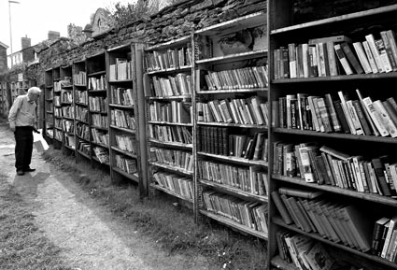

The Bargain Book Bin is having a sale on their paperback novels. They are charging $1.00 for its Mix ‘n Match selection, which allows you to choose three novels from the following genres: Romance, Science Fiction, Fantasy, Mystery, Biographies, and Humour.

How many different Mix ‘n Match selections are possible?

Brainstorm with your group how you will solve this problem. Do not forget to include “repeat” combinations such as three romance novels.

On the chart paper provided, show your group’s solution, clearly showing your steps. Include lists, tables, diagrams, pictures or calculations you have used to arrive at your answer.

Be prepared to share your work with the whole class.

1.9.4 Three Corners

1. How many groups of three toys can a child choose to take on vacation if the toy box contains 10 toys?

2. In how many ways can we choose a Prime Minister, Deputy Prime Minister and Secretary from a class of 20?

3. In how many ways can Kimberly choose to invite her seven friends over for a sleepover assuming that she has to invite at least one friend over?

4. In how many ways can the eight nominees for Prime Minister give their speeches at a rally?

5. In how many ways can a teacher select five students from the class of 30 to have a detention?

1.9.5 Combination Conundrums

1. In how many ways can a committee of 7 be chosen from 16 males and 10 females if

a. there are no restrictions?

b. they must be all females?

c. they must be all males?

2. From a class of 25 students, in how many ways can five be chosen to get a free ice cream cone?

3. In how many ways can six players be chosen from fifteen players for the starting line- up

a. if there are no restrictions

b. if Jordan must be on the starting line.

c. if Tanvir has been benched and can’t play.

1.9.6 Example of Frayer Model

Definition:  A selection from a group of items without regard to order is called a combination  $C(n,r)=\frac{n!}{(n−r)!r!}$  Combination | Facts/Characteristics:  Order does not matter in the arrangements of the objects.
Examples:  In how many ways could someone choose 20 songs to play at a dance from a selection of 30?  C(30,20) = 30,045,015  Any example where it is a selection from a group of items and order does not matter would be appropriate in this space. | Non examples:  In how many arrangements could 5 people give speeches at a student assembly? This can’t be done with combinations since order matters in this example.

Unit 1: Day 10: Introduction to Counting Stories Project |  |  |  |  | MDM4U
  75 min |  | Math Learning Goals  - Introduce and understand one culminating project, Counting Stories Project, e.g., student select children’s story/nursery rhyme to rewrite using counting and probability problems and solutions as per Strand A..  - Create a class critique to be used during the culminating presentation. |  |  | Materials  - BLM 1.10.1–1.10.5  - Notebook file  - ppt file
Assessment
Opportunities
 | Minds On… | Whole Class → Webbing Ideas  Lead students in a brainstorming session to generate a list of probability terms introduced thus far in the unit. Refer to Sample Mathematical Terminology Web (BLM 1.10.1).  Students construct a class mind map to make visual connections amongst the various terms, using Interactive White Board software, SMART Ideas™ or chart paper and markers.  Whole Class → Introduction of Project  Read a children’s story that illustrates a different perspective or has used mathematical terms, e.g., The True Story of the 3 Little Pigs, by Jon Scieszka (ISBN 0-670-82759-2), Fractured Math Fairy Tales (ISBN 0-439-51900-4)  Using BLM 1.10.2, introduce the count stories project to students, and discuss the description of the task and the assessment rubric (BLM 1.10.3). |  | Students make connections between terms, concepts and principles of probability and counting using a Mind Map (Think Literacy, Cross-Curricular Approaches, Mathematics,  Gr.7–12, p. 77)  SMART Ideas™ software is available to teachers as a free download.  As students write portions of the story, be attentive to the appropriateness of the story line. Encourage Character Education Traits, e.g., the wolf is not portrayed as a bully.  BLM 1.10.5 is an example of an extension to the story.  The Counting Story Project could be a multi-disciplinary (e.g., Math/English, Math/Art) project.
 | Action! | Whole Class → Counting Story Development  Using the SMART™ Notebook file, PowerPoint files, or BLM 1.10.4, and BLM 1.10.5 develop the counting story exemplar with student input. At the end of the presentation, model writing a component of the story with student input.  Small Groups → Further Development of Counting Story  In small groups, students complete an additional component of the story, e.g., independent events, dependent events, mutually exclusive events, non-mutually exclusive events or complementary events. Ensure that each group completes a different missing component, including mathematical justification.  The Math Processes/Observation/Checkbric: Observe students as they use a variety of computational strategies, make connections, and communicate their reasoning to complete components of the story; prompt students as necessary.
 | Consolidate Debrief | Whole Class → Gallery Walk  Each group shares their completed component of the story in a gallery walk. (Each group’s work is displayed and students walk around to read each other’s component parts.)  Think/Pair/Share → Brainstorming  Students generate criteria for critiquing stories during the final presentation gallery walk, e.g., math content matches story, story is engaging, illustrations help with understanding. Create a class critique for the presentations, using the criteria agreed on.
 |  | Home Activity or Further Classroom Consolidation  Select or create a story to begin your Counting Story Project. Begin to integrate mathematical components of the story already discussed in this unit. |  | Students continue to add to this project as they learn new concepts.
1.10.1 Sample Mathematical Terminology Web
for Counting Stories Project

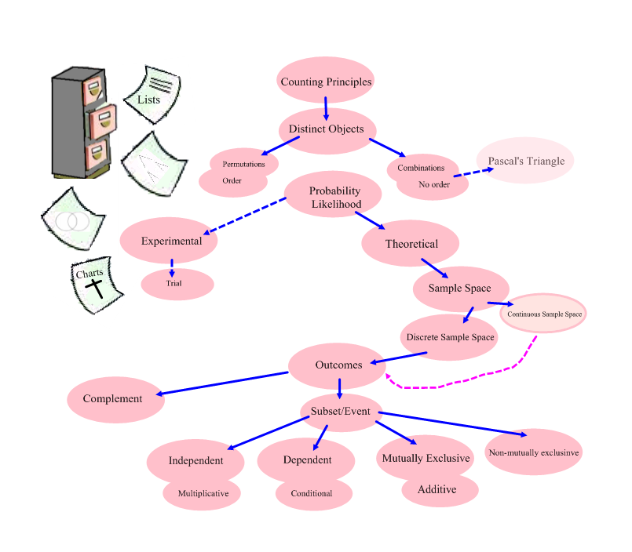

1.10.2 Counting Stories Project

You will re-write or create a children’s story, fairy tale, nursery rhyme, or song so that it includes probability and counting concepts and principles. The mathematics you introduce in the story must connect to the context of the story, and provide opportunities for decision making on the part of the characters within the story. The mathematics may be complex but try to keep the story simple. The assessment of this assignment will focus on the mathematics within the story line and the integration of narrative and mathematical forms in the story.

The following criteria will be assessed:

1. At least 12 of the following 19 concepts/principles are used to describe the decisions that the character(s) are asked to make.

- Additive Principle | - Combinations (no order)
- Complementary Events | - Conditional Probability
- Counting Techniques | - Dependent Events
- Events | - Experimental Probability
- Independent Events | - Multiplicative Principle
- Mutually Exclusive Events | - Non-Mutually Exclusive Events
- Outcomes | - Pascal’s Triangle
- Permutations (order) | - Sample Space
- Subset | - Theoretical Probability
- Trials

2. Appropriate organizational tools, e.g., Venn diagram, Charts, Lists, Tree diagrams, are used and illustrated.

3. Diagrams, words, and pictures illustrate the tools and computational strategies used and the choices available to the character(s).

Feedback on this assignment will include:
- Peer critiques of your story
- A level for each of the criteria in the Counting Stories Rubric

You will read the stories of others during a class gallery walk. Using the critiques developed by the class, each student critiques two of the stories of others, selected by random draw. These critiques provide peer feedback to the author of the story.

1.10.3 Counting Stories Project Rubric

Problem Solving
Criteria | Level 1 | Level 2 | Level 3 | Level 4
Applying mathematical processes and procedures correctly to solve the problems in the story. | - correctly applies some of the mathematical processes and procedures with major errors | - correctly applies many of the mathematical processes and procedures with some errors | - correctly applies the mathematical processes and procedures with few errors | - correctly applies the mathematical processes and procedures with precision and accuracy
Selecting Tools and Computational Strategies
Selecting and using tools and strategies to organize the mathematics presented in the story. | - selects and applies the counting organizers (Venn diagram, charts, lists, tree diagrams) with major errors or omissions | - selects and applies the counting organizers (Venn diagram, charts, lists, tree diagrams) with minor errors or omissions | - selects and applies the counting organizers (Venn diagram, charts, lists, tree diagrams) accurately | - selects and applies the most appropriate counting organizers (Venn diagram, charts, lists, tree diagrams) accurately
Connecting
Connecting the concepts/principles of counting and probability to the story line. | - incorporates permutations, combinations, and probability with weak connections to the story line | - incorporates permutations, combinations, and probability with simple connections to the story line | - incorporates permutations, combinations, and probability with appropriate connections to the story line | - incorporates permutations, combinations, and probability with strong connections to the story line
Representing
Creating an appropriate variety of mathematical representations within the story. | - few representations are embedded in the story | - some representations are embedded in the story | - an adequate variety of representations are embedded in the story | - an extensive variety of representations are embedded in the story
Communicating
Using mathematical symbols, labels, units and conventions related to counting and probability correctly across a range of media. | - sometimes uses mathematical symbols, labels, and conventions related to counting and probability correctly within the story | - usually uses mathematical symbols, labels, and conventions related to counting and probability correctly within the story | - consistently uses mathematical symbols, labels, and conventions related to counting and probability correctly within the story | - consistently and meticulously uses mathematical symbols, labels, and conventions related to counting and probability correctly and in novel ways within the story
Integrating narrative and mathematical forms of communication in the story. | - either mathematical or narrative form is present in the story but not both | - both mathematical and narrative forms are present in the story but the forms are not integrated | - both mathematical and narrative forms are present and integrated in the story | - a variety of mathematical and narrative forms are present and integrated in the story and are well chosen
1.10.4 Counting Stories Project Presentation File

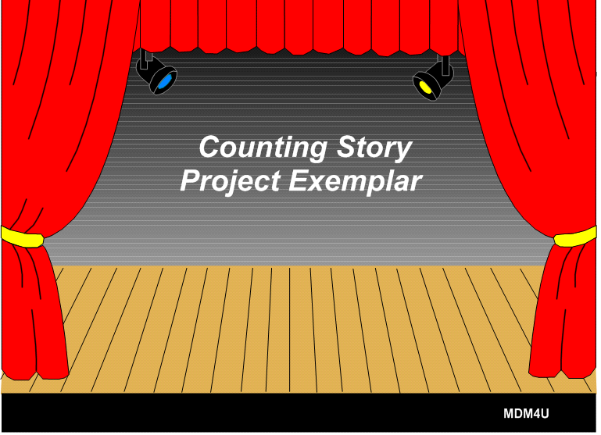Slide 1 | 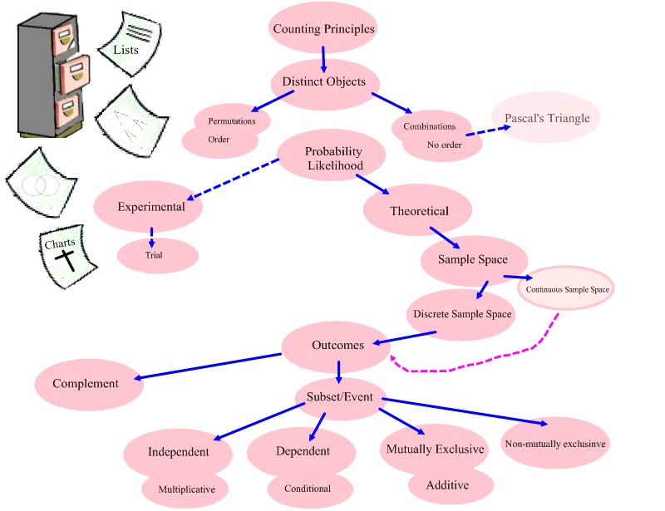Slide 2
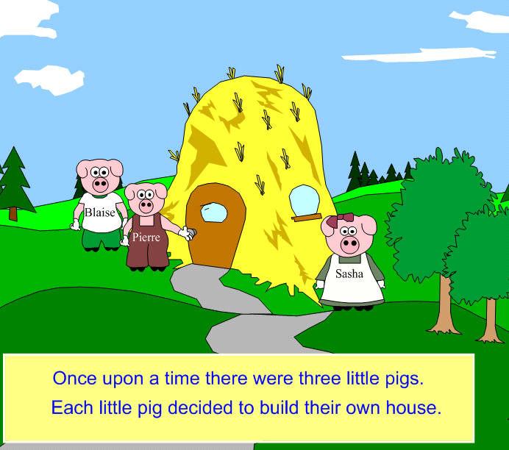  Slide 3 | 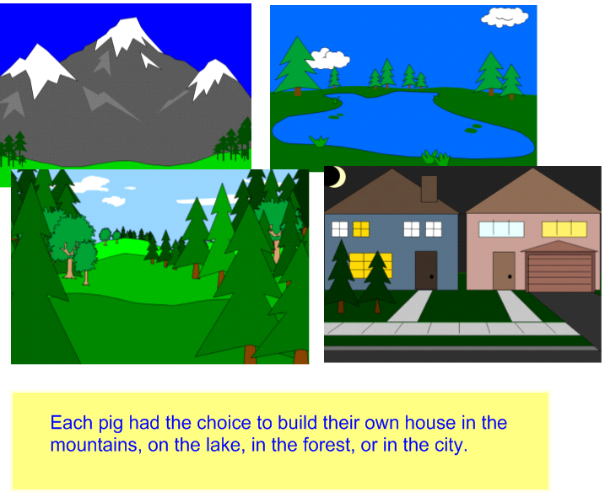  Slide 4
1.10.4 Counting Stories Project Presentation File (Continued)
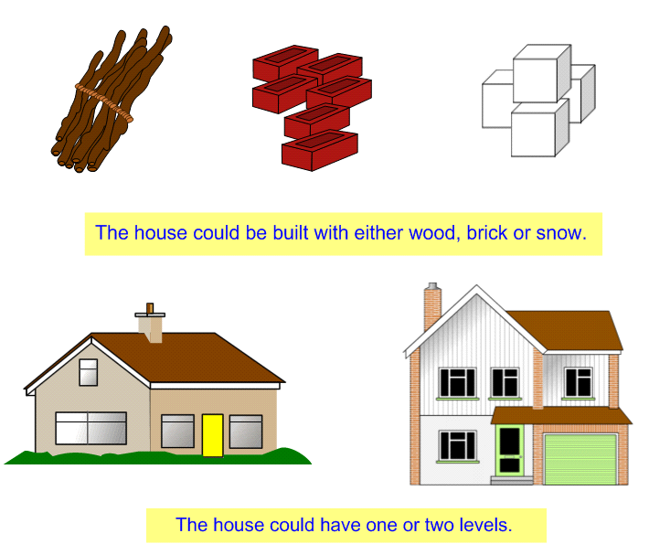  Slide 5 | 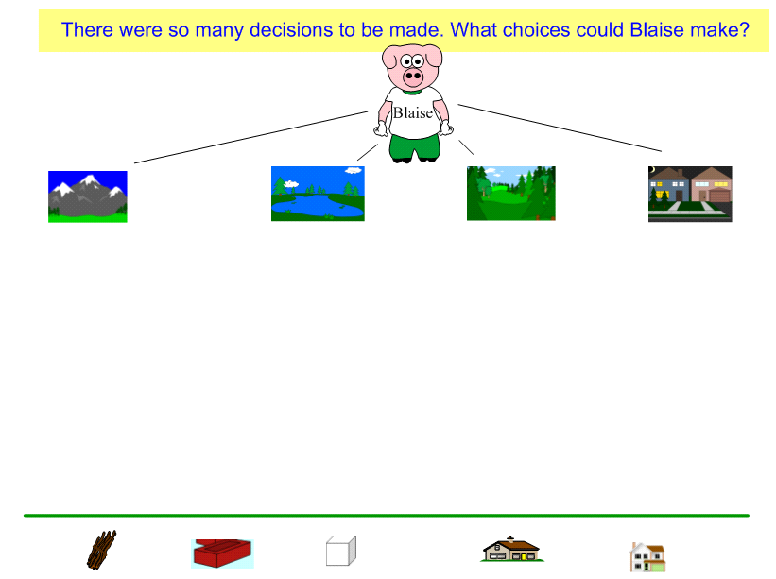  Slide 6
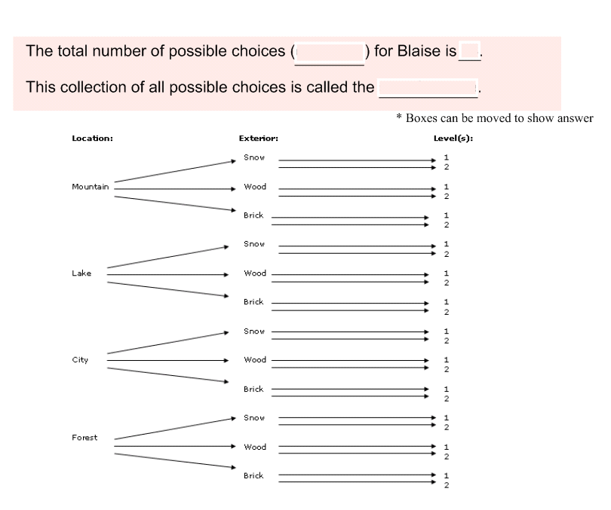  Slide 7 | 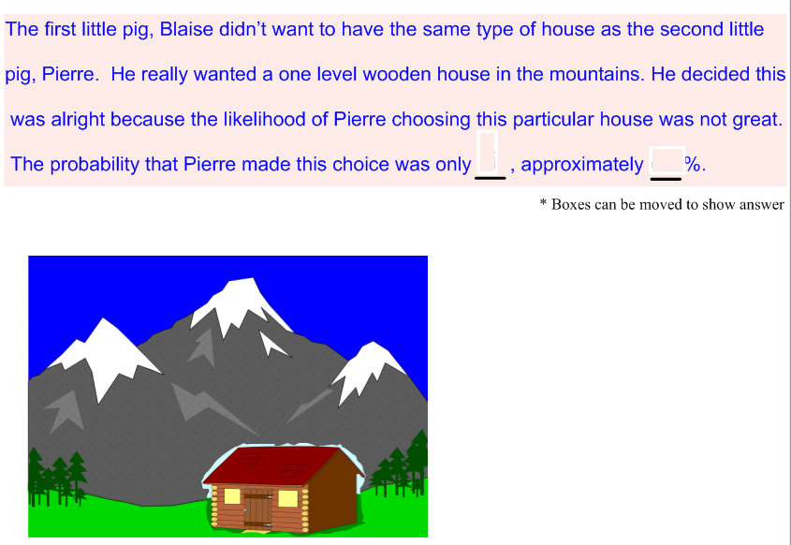  Slide 8
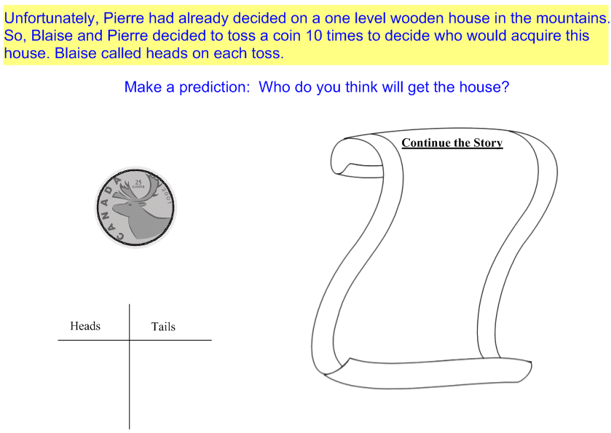  Slide 9 | 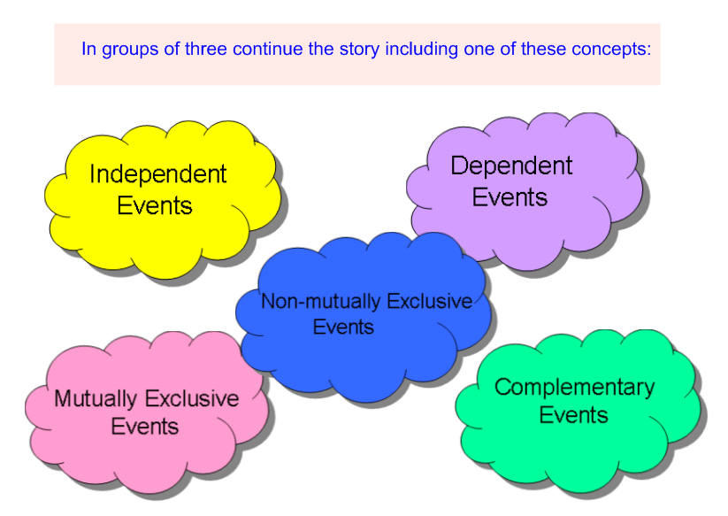  Slide 10
1.10.5 Sample Stories Extensions

Non-Mutually Exclusive Events
The third little pig, Sasha knows she will be happy with a house that is either in the forest or built of wood. How many possible houses can she have?

Her choice is far more likely to happen. The number of houses satisfying her event criteria
was 12.

Using the additive principle, Sasha observes that building a house in the forest made of wood are non-mutually exclusive events since the subset of building of wood in the forest is not empty.
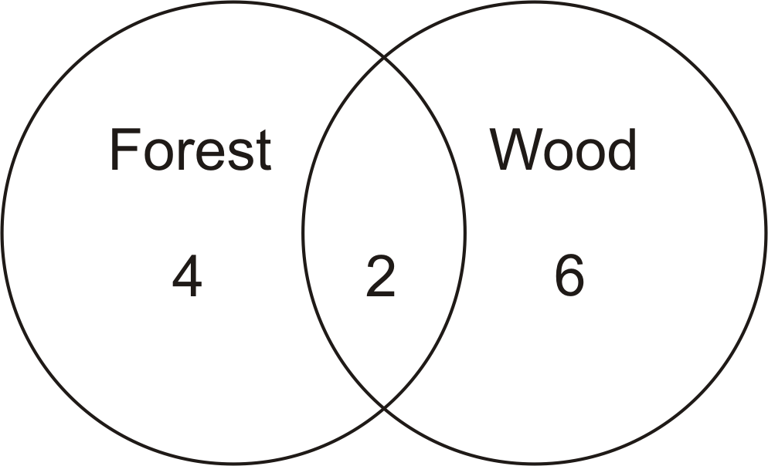

Independent Events
The probability that Sasha chooses a house in the forest built of wood is . The probability that Pierre chooses his one level house in the mountains is . According to the multiplicative principle, the probability of Sasha’s choice and Pierre’s choice occurring together is since they are independent events.

Unit 1 : Day 11 : Pascal’s Triangle |  |  |  | MDM4U
Minds On: 20 |  | Description/Learning Goals  - Investigate patterns in Pascal’s triangle and the relationship to combinations, establish counting principles and use them to solve simple problems involving numerical values for n and r.  - Investigate pathway problems |  | Materials  - BLM 1.11.1 – 1.11.5
Action: 45 |  |  |  | Materials  - BLM 1.11.1 – 1.11.5
Consolidate:10 |  |  |  | Materials  - BLM 1.11.1 – 1.11.5
Total=75 min |  |  |  | Materials  - BLM 1.11.1 – 1.11.5
Assessment
Opportunities
 | Minds On… | Small Groups → Experiment  Students are introduced to Pascal’s Triangle by conducting coin probability experiments. Students are given blank Pascal’s Triangle worksheets, a coin experiment recording sheet and five coins. To begin, give only one number on Pascal’s Triangle – the top 1. The rest of the number will be discovered as student flip coins. (BLM 1.11.1)  Students engage in a discussion on the numerical patterns seen with Pascal’s Triangle. |  | More on Pascal’s Triangle found at http://mathforum.org/workshops/usi/pascal/hs.color_pascal.html  Students cut out “slices” with toppings to help with the activity. .  Answers could be placed in a journal or collected for assessment.
 | Action! | Pairs → Pascal’s Pizza Party  Students investigate combinatoric patterns using BLM 1.11.2 and BLM 1.11.3.  Curriculum Expectations/Observation/Checklist  Assess students’ understanding of combinatoric patterns by observing and questioning them as they work.  Whole Class → Case of the Stolen Jewels  Students extend their knowledge of Pascal’s Triangle by solving the “Case of the Stolen Jewels” (BLM 1.11.4). They predict the number of paths from Canard’s house to the thief’s location and problem solve to find the number of paths in a grid, supporting their paths by listing the moves.  Using BLM 1.11.5 students practice using Pascal’s Triangle and combinatorics to solve pathway problems.  Mathematical Process/Problem Solving/Connecting: Students problem solve to find patterns within Pascal’s Triangle. Students make a connection between Pascal’s Triangle and combinations.
 | Consolidate Debrief | Whole Class → Discussion  Questions to consider:  What is the pattern that produces Pascal’s Triangle? t(n,r)=t(n-1,r-1)+t(n-1,r)  List three patterns found within Pascal’s Triangle.  What do combinations and Pascal’s Triangle have in common?t(n,r)=C(n,r)
Application |  | Home Activity or Further Classroom Consolidation  Read the book “Oh, the Places You’ll Go” by Dr. Seuss, and create your own map on a grid using the places mentioned in the book. Create a pathways problem (with solution) using this map.
1.11.1 Pascal’s Triangle

1
1 1
1 2 1
1 3 3 1
1 4 6 4 1
1 5 10 10 5 1
1 6 15 20 15 6 1
1 7 21 35 35 21 7 1
1 8 28 56 70 56 28 8 1
1 9 36 84 126 126 84 36 9 1
1 10 45 120 210 252 210 120 45 10 1

- What is the pattern used to create each row?

- What is the pattern in the second diagonal within Pascal’s triangle?

- What is the pattern in the third diagonal?

- Add the terms is the first row (row 0) _____
Add the terms is the second row (row 1) _____
Add the terms in the third row (row 2) _____
Add the terms in the fourth row (row 3) _____
Add the terms in the fifth row (row 4) _____

- What conclusion could you make about the sum of the terms in the row and the row number?

- Find another pattern within Pascal’s triangle.

1.11.2 Pascal’s Pizza Party



Pascal and his pals have returned home from their soccer finals and want to order a pizza. They are looking at the brochure from Pizza Pizzaz, but they cannot agree on what topping or toppings to choose for their pizza.
Pascal reminds them that there are only 8 different toppings to choose from. How many different pizzas can there be?
Descartes suggested a plain pizza with no toppings, while Poisson wanted a pizza with all eight toppings.
Fermat says, “What about a pizza with extra cheese, mushrooms and pepperoni?”
Pascal decides they are getting nowhere.
Here are the toppings they can choose from:
Pepperoni, extra cheese, sausage, mushrooms, green peppers, onions, tomatoes and pineapple.

Using the cut-out pizza slices, look for patterns and answer the following questions:

- How many pizzas can you order with no toppings?

- How many pizzas can you order with all eight toppings?

- How many pizzas can you order with only one topping?

- How many pizzas can you order with seven toppings?

- How many pizzas can you order with two toppings?

- How many pizzas can you order with six toppings?

- Can you find these numbers in Pascal’s triangle?

- Can you use Pascal’s triangle to help you find the number of pizzas that can be ordered if you wanted three, four, or five toppings on your pizza?

- How many different pizzas can be ordered at Pizza Pizazz in total?

1.11.2 Pascal’s Pizza Party (Continued)

Pascal could have asked the following questions to help the group decide on their order:

- Do you want pepperoni?
- Do you want extra cheese?
- Do you want sausage?
- Do you want mushrooms?
- Do you want green peppers?
- Do you want onions?
- Do you want tomatoes?
- Do you want pineapples?

How would you use the answers to these questions to find the total number of different pizzas that can be ordered?

1.11.3 Pizza Pizzaz Toppings

Cut out the different toppings and use the “slices” to help you with the activity.








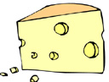
SAUSAGE
PEPPERONI
TOMATOES
ONIONS
GREEN PEPPERS
PINEAPPLE
MUSHROOMS
EXTRA CHEESE

1.11.4 The Case of the Stolen Jewels

Here is a street map of part of the city of London. Inspector Canard’s next case involved a million dollars worth of jewellery stolen from a hotel suite in the city. This map shows the hotel marked with the letter H. Inspector Canard is certain that the thieves and the jewels are located at the spot marked by the letter X. In order to catch the thieves, Canard must determine all the possible routes from H to X. The inspector is driving and all the streets are one-way going north or east. How many different routes do you think Inspector Canard has to check out?

X

H

North

East

1.11.5 Pathfinders

1. A

B

a. Count and draw the number of paths from A to B by only going south or east.

b. Starting at corner A begin placing Pascal’s Triangle. At each successive corner continue with Pascal’s Triangle pattern until corner B. How does the number at corner B relate to the number of paths you found in part a?

A

B

c. If n = the number of rows plus the number of columns (in grid AB) and r = the number of rows or columns. Find C(n,r). What do you notice?

1.11.5 Pathfinders (Continued)

2. Solve the following problems using both Pascal’s Triangle and/or Combinations.

a. A school is 5 blocks west and 3 blocks south of a student’s home. How many different routes could the student take from home to school by going west or south at each corner. Draw a diagram.

b. In the following arrangements of letters start at the top and then proceed to the next row by moving diagonally left or right. Determine the number of different paths that would spell the word PERMUTATION.
P
E E
R R R
M M M M
U U U U U
T T T T T T
A A A A A
T T T T
I I I
O O
N

A
c.

B

Find the number of paths from point A to Point B by only going south or west.

Unit 1 : Day 14 : Probability |  |  |  | MDM4U
Minds On: 15 |  | Description/Learning Goals  - Solve probability problems using counting techniques involving equally likely outcomes |  | Materials  - BLM 1.14.1 – 1.14.5  - Linking Cubes  - Counters  - dice  - chart paper
Action: 50
Consolidate:10
Total=75 min
Assessment
Opportunities
 | Minds On… | Whole Class → Feeling Lucky  Students read the BLM 1.14.1 and discuss the outcome of the Powerball lottery and use of the fortune cookies for the selection of numbers and the probability of winning a lottery.  Pairs → Lewis Carroll’s Pillow Problem  Using BLM 1.14.2, students try and solve the pillow problem in pairs. Solutions provided by Lewis Carroll are presented and students analyze them. |  | Manipulatives can be used to help solve this problem.  Students should use their prior knowledge on counting techniques to work through the solution to the Marble Mystery.
 | Action! | Small Groups → Marble Mystery  Students work through BLM 1.14.3 in groups. All work and solutions should be recorded on chart paper. Students will share their strategies and solutions with the whole class.  Linking cubes could be used with BLM 1.14.4 to determine experimental probability before theoretical probability is calculated.  Learning Skills/Observation/Rubric  Through observations during the investigation, assess students' teamwork skills.  Mathematical Process/Connecting/Selecting Tools/Problem Solving: students reflect on past learning and problem solving to incorporate the use of counting techniques.
 | Consolidate Debrief | Whole Class → Gallery Walk  All solutions to the Marble Mystery should be sorted and posted in groupings according to strategies used for different solutions. Students go on a Gallery Walk to reflect on alternate approaches to the final answer, different solutions, and other observations on probabilities. Students discuss the connections made to counting techniques, understanding of probabilities and application to real-world events such as sports, weather, game designs, lotteries, etc.
Application  Concept Practice |  | Home Activity or Further Classroom Consolidation  Play the game on BLM 1.14.5 with a partner. Record results on the table provided. Were you surprised with the results when you were playing the game? Can you explain the results of the game using probabilities?  Cross-Curricular Activity  Rosencrantz and Guildenstern are Dead

Who Needs Giacomo? Bet on the Fortune Cookie
BY Jennifer Lee
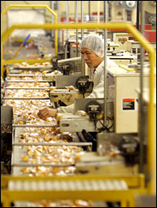
James Estrin/The New York Times
Many different brands of fortune cookies come from Wonton Food's Long Island City factory.

1.14.1 Feeling Lucky

May 12, 2005 , New York Times
Powerball lottery officials suspected fraud: how could 110 players in the March 30 drawing get five of the six numbers right? That made them all second-prize winners, and considering the number of tickets sold in the 29 states where the game is played, there should have been only four or five.
But from state after state they kept coming in, the one-in-three-million combination of 22, 28, 32, 33, 39.
It took some time before they had their answer: the players got their numbers inside fortune cookies, and all the cookies came from the same factory in Long Island City, Queens.
Chuck Strutt, executive director of the Multi-State Lottery Association, which runs Powerball, said on Monday that the panic began at 11:30 p.m. March 30 when he got a call from a worried staff member.
The second-place winners were due $100,000 to $500,000 each, depending on how much they had bet, so paying all 110 meant almost $19 million in unexpected payouts, Mr. Strutt said. (The lottery keeps a $25 million reserve for odd situations.)
Of course, it could have been worse. The 110 had picked the wrong sixth number - 40, not 42 - and would have been first-place winners if they did.
"We didn't sleep a lot that night," Mr. Strutt said. "Is there someone trying to cheat the system?"
He added: "We had to look at everything to do with humans: television shows, pattern plays, lottery columns."
Earlier that month, an ABC television show, "Lost," included a sequence of winning lottery numbers. The combination didn't match the Powerball numbers, though hundreds of people had played it: 4, 8, 15, 16, 23 and 42. Numbers on a Powerball ticket in a recent episode of a soap opera, "The Young and the Restless," didn't match, either. Nor did the winning numbers form a pattern on the lottery grid, like a cross or a diagonal. Then the winners started arriving at lottery offices.
"Our first winner came in and said it was a fortune cookie," said Rebecca Paul, chief executive of the Tennessee Lottery. "The second winner came in and said it was a fortune cookie. The third winner came in and said it was a fortune cookie."
Investigators visited dozens of Chinese restaurants, takeouts and buffets. Then they called fortune cookie distributors and learned that many different brands of fortune cookies come from the same Long Island City factory, which is owned by Wonton Food and churns out four million a day.
"That's ours," said Derrick Wong, of Wonton Food, when shown a picture of a winner's cookie slip. "That's very nice, 110 people won the lottery from the numbers."
The same number combinations go out in thousands of cookies a day. The workers put numbers in a bowl and pick them. "We are not going to do the bowl anymore; we are going to have a computer," Mr. Wong said. "It's more efficient."
1.14.2 Lewis Carroll’s Pillow Problem

Author Lewis Carroll had insomnia and used the time to create “pillow problems”.
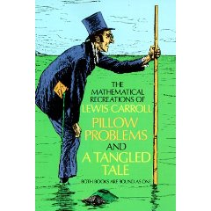
Here is an example of one of these problems:
A bag contains a counter, known to be either white or black. A white counter is put in, the bag is shaken, and a counter is drawn out, which proves to be white. What is now the chance of drawing a white counter?

1. Solve this problem with your partner. Justify your solution.

1.14.2 Lewis Carroll’s Pillow Problem (Continued)

Lewis Carroll provided two solutions to this problem:

Solution #1

As the state of the bag, after the operation, is necessarily identical with its state before it, the chance is just what it was, viz. 1/2.

Solution #2

Let B and W1 stand for the black or white counter that may be in the bag at the start and W2 for the added white counter. After removing white counter there are three equally likely states:
Inside bag | Outside bag
W1 | W2
W2 | W1
B | W2
In two of these states a white counter remains in the bag, and so the chance of drawing a white counter the second time is 2/3.

2. Which one is correct? Explain.

1.14.3 Marble Mystery


A bag contains two red marbles, three blue marbles, and four green
marbles. Yusra draws one marble from the jar, and then Chang draws a
marble from those remaining. What is the probability that Yusra draws a
green marble and Chang draws a blue marble? Express your answer as a
common fraction.

Remember that to find a basic probability, with all outcomes equally likely, we make a fraction that looks like this:

1.14.4 More on Probability

1. Find the probability of drawing two red cubes simultaneously from a box containing 3 red, 5 blue, and 3 white cubes.

2. Find the probability of drawing two red cubes from the same box. This time you draw one cube, note its colour, set it aside, shake the bag and draw another cube. (Hint: there are two events in this problem.)

3. Find the probability of choosing first a red cube, then a blue, then a white if:

a. each cube is replaced between choices.

b. each cube is not replaced between choices.

1.14.5 Something’s Fishy Game

Equipment Needed
- Game board for each player
- 6 counters (fish) for each player
- 2 dice per pair of players

Rules

1. Each player can place their fishes into any aquarium on their own game board. You can place one in each aquarium, or two in some aquariums and none in others, or even all six in one aquarium.

2. Take turns to roll the two dice. Calculate the difference between the two numbers. You can release one fish from the aquarium with that number. For example, if the difference is 2, you can release one fish from aquarium #2.

3. The winner is the first to release all their fish.

- Keep a record of where you place your fishes for each game, then record the ones that are winners.

 | Aquariums |  |  |  |  |  | Winners
 | 0 | 1 | 2 | 3 | 4 | 5

Fishes
1.14.5 Something’s Fishy Game Board

How do you place your fishes in these aquariums to release them quickly?
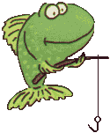








aquarium
0

aquarium
1
aquarium
2

aquarium
3

aquarium
4

aquarium
5

